Name of Journal: World Journal of Orthopedics
Manuscript NO: 67527
Manuscript Type: CASE REPORT

Allergic dermatitis after knee arthroscopy with repeated exposure to Dermabond Prineo™ in pediatric patients: Two case reports

Robinson J et al. Pediatric allergic dermatitis with Dermabond Prineo™

James Robinson, Kevin P Smidt, Garrett Houk, Janay McKie, R Shane Barton, Patrick Massey

James Robinson, Kevin P Smidt, R Shane Barton, Patrick Massey, Department of Orthopaedic Surgery, Louisiana State University, Shreveport, LA 71103, United States

Garrett Houk, School of Medicine, Louisiana State University, Shreveport, LA 71103, United States

Janay McKie, Department of Orthopaedic Surgery, Shriners Hospital for Children, Shreveport, LA 71103, United States

Author contributions: Robinson J, Smidt KP, Houk G, and Massey P drafted and revised the manuscript; McKie J, Massey P, and Barton RS supervised data collection, project progression and contributed to topic conceptualization; all authors issued final approval upon submission of the manuscript.

Corresponding author: Patrick Massey, MD, Director, Department of Orthopaedic Surgery, Louisiana State University, 1501 Kings Highway, Shreveport, LA 71103, United States. pmasse@lsuhsc.edu

Received: April 30, 2021
Revised: August 9, 2021
Accepted: September 19, 2021
Published online:

Abstract
BACKGROUND
Allergic contact dermatitis (ACD) secondary to Dermabond Prineo™ is rare, but documented. To our knowledge, there are no described reports of this ACD reaction within the pediatric population following arthroscopic surgery.

CASE SUMMARY
We report two cases of pediatric ACD upon second exposure to Dermabond Prineo™ after knee arthroscopy. Both cases presented within two weeks of the inciting second exposure. The cases resolved with differing described combinations of sterile cleaning, diphenhydramine, and antibiotic administration. No long-term sequelae were found.

CONCLUSION
This case report elucidates the rare complication of allergic dermatitis secondary to Dermabond Prineo™ repeat exposure use in pediatric arthroscopy.

Key Words: Dermabond; Prineo; Arthroscopy; Sports medicine; Contact dermatitis; Case report

Robinson J, Smidt KP, Houk G, McKie J, Barton RS, Massey P. Allergic dermatitis after knee arthroscopy with repeated exposure to Dermabond Prineo™ in pediatric patients: Two case reports. World J Orthop 2021; In press

Core Tip: Dermabond Prineo™ has shown to be advantageous as a wound closure device with regards to operative efficiency, cosmetic results, and decreased postoperative restrictions. With the increased use of Prineo™ as a wound closure alternative, surgeons should be aware of potential risks, especially in cases with previous exposure to Dermabond™ or Prineo™. Both cases in this series resolved with differing described combinations of sterile cleaning, diphenhydramine, and antibiotic administration.

INTRODUCTION
Efforts to decrease total operative time during a given surgical procedure are becoming more critical as both surgeons and administrators consider cost savings for hospital systems and surgical centers. It is estimated that one minute in the operating room can cost up to over $130 depending on the facility^{[1,2]}. With the advent of rapid wound closure products such as Dermabond™ and Dermabond Prineo™ (Ethicon Endo-Surgery, Cincinnati, OH), operative times can be shortened, resources saved, and operative efficiency and post-operative patient comfort increased^{[3–5]}.
Prineo™ is a wound closure system that utilizes a self-adhering polyester-based mesh in combination with a monomeric 2-octyl cyanoacrylate formulation and the colorant D&C Violet No. 2. The wound closure system is intended to be used in conjunction with deep dermal stitches. Reported benefits of Prineo™ include a protective microbial barrier, greater skin holding strength when compared to skin staples or subcuticular sutures, more evenly distributed tension away from wound edges, easy removal, and reduction in overall wound closure time^{[3,6–8]}.
While there are reported cases of post-operative allergic contact dermatitis (ACD) with the use of Dermabond™, there are few reported cases of such dermatitis associated with the Prineo™ wound closure system, and even fewer associated with a pediatric age group^{[9–11]}. This case report describes instances of ACD following exposure to Prineo™ in a pediatric age group.

CASE PRESENTATION
Chief complaints
Case 1: Six days after an arthroscopic left medial meniscus repair and bone marrow aspirate injection, a 15-year-old female reported increasing itching and a burning sensation around the incision sites that progressed to feeling like her left knee was “on fire.”

Case 2: The second patient is a 12-year-old female who presented one week after her left medial meniscal allograft transplantation and reconstruction of anterior cruciate ligament (ACL), posterior cruciate ligament (PCL), and medial collateral ligament (MCL) with complaints of two days of itching around her operative sites.

History of present illness
Case 1: The patient underwent an arthroscopic left medial meniscus repair and bone marrow aspirate injection in which the portal incision sites were closed with Prineo™. Thrombo-Embolus-Deterrent (TED) hose were applied after the surgical drapes were taken down. The procedure was uncomplicated. Upon the patient’s return for her one-week postoperative follow up appointment, she was noted to have large blisters covering the anterior portal sites (Figure 1A). The Prineo™ mesh dressing was removed and it was noted that there were large blisters to the anterior left knee.

Case 2: The patient underwent a left meniscal allograft transplantation with reconstruction of the ACL, PCL, and MCL for congenital absence of these structures. All incisions and portal sites were closed with Prineo™. Surgical drapes were taken down and TED hose were applied bilaterally. The procedure was uncomplicated. The patient then returned for her one-week postoperative follow-up appointment with a red papular rash surrounding the anterior knee and surgical sites. She complained of itching around these sites.

History of past illness
Case 1: This patient had a right knee ACL reconstruction two years prior in which the incisions were closed with Prineo™. There was no allergic reaction to the closure device at that time. She then sustained a left knee injury while playing softball. She was found to have a medial meniscus tear that was subsequently treated surgically as presented in this case.

Case 2: She had previously undergone a right medial meniscal allograft transplantation with ACL and MCL reconstruction a year and a half prior for congenital absence of these structures, performed by the senior author. Dermabond™ was used for wound closure during her first surgical procedure and Prineo™ was used in this case.

Personal and family history
Case 1: This patient had an unremarkable personal and family medical history.

Case 2: This patient had an unremarkable family medical history with a personal medical history of congenital absence of bilateral ACL, MCL and medial meniscus.

Physical examination
Case 1: The blisters were intact and raised. She also had pruritic scattered papules on the thigh and lower leg. She had a negative Homan sign and the remainder of her physical exam was unremarkable for her postoperative course.

Case 2: One week post-operatively, the dressings covering the operative knee were removed and she was noted to have significant skin inflammation with blisters and welts along the entirety of her surgical incisions (Figure 2A). She also had scattered papules from her groin to her left ankle that were erythematous but not draining nor pustular. The surgical incisions and portal sites were noted to be well approximated with no evidence of drainage.

FINAL DIAGNOSIS
The above cases demonstrate the occurrence of pediatric ACD upon second exposure to Prineo™. Both cases presented with this within one week of the surgical procedure.

TREATMENT
Case 1: She was prescribed diphenhydramine 25 mg twice daily and placed on doxycycline 100 mg daily for seven days for treatment of concurrent folliculitis. Her wounds were cleaned with sterile water and patted dry. They were then redressed with a nonadherent dressing over the blistering area followed by soft dressings over top. Her TED hose were discontinued until the blisters dried up.

Case 2: The patient’s TED hose were discontinued on the operative side (left) and the skin was cleaned above and below the incisions. The incision sites were then redressed with a non-adhesive dressing followed by soft dressings. She was placed on diphenhydramine 25 mg twice daily which was increased to four times per day as needed for persistent itching. She underwent daily dressing changes through postoperative day nine when the blisters became flaccid.

OUTCOME AND FOLLOW-UP
Case 1: At her 2-wk post-operative visit, the raised plaques had flattened, the erythema had decreased, and her pruritis had resolved (Figure 1B). She was followed weekly and noted to have significant improvement of the contact dermatitis at her three-week postoperative visit. Her blisters had resolved and no active drainage was appreciated on exam (Figure 1C). The patient was followed two years postoperatively and had no recurrence of any skin reaction surrounding the surgical incisions or elsewhere on her body.

Case 2: On postoperative day fifteen, all blisters had drained and epithelialization of the underlying skin was appreciated. At the patient’s three-week postoperative appointment, she was instructed to shower and refrain from using any lotions or creams as scabbing of the blisters was noted. At her six-week postoperative appointment, the allergic dermatitis was completely resolved (Figure 2B). The patient was followed regularly for two years postoperatively and had no recurrence of any skin reaction surrounding the surgical incisions or elsewhere on her body.

DISCUSSION
The occurrence of allergic reaction to Dermabond™ and Dermabond Prineo™ is rare and infrequently reported in the literature. Durando et al^{[12]} reported an incidence rate of 1.7% (15 of 912 patients) over a two-year span involving 912 total knee arthroplasty (TKA) cases using Dermabond™. Of these 15 patients who developed a suspected ACD, three agreed to participate in patch testing to determine if they were allergic to Dermabond™ or 28 other possible allergens. Prineo™ was not used in these patient’s cases and as such was not studied. Of the three who agreed to participate, two of the three developed a positive reaction to Dermabond™^{[12]}.
Chan et al^{[13]} reported 3 cases of allergic reaction to Prineo™ out of 366 patients (1.8%) that were managed by a single surgeon following TKA. Each of the cases presented within 4-9 d postoperatively and the reaction resolved between 4 wk to 12 wk postoperatively. Each patient was referred to a dermatologist and 2 of the 3 patients received a course of topical corticosteroids. Similar to our cases, no long-term sequelae, including recurrence or superficial or deep joint infection, occurred when followed for at least one year^{[13]}.
In a study examining wound complications after 2-octylcyanoacrylate skin closure following total joint arthroplasty, Michalowitz et al^{[14]} found a 19.2% superficial wound complication rate in hip and knee arthroplasty cases when Dermabond Prineo™ was used. As a retrospective cohort study, the specifics of what defined a superficial wound complication were not described^{[14]}.
Davis and Stuart^{[15]} reported a single case of a 72-year-old woman who was found to have severe ACD following a left TKA that subsequently was found to have an extreme patch test reaction to Prineo™ upon patch testing. This patient reported a similar but milder rash a year prior when she underwent right TKA. This case study provides further evidence that occurrence and severity of ACD to Dermabond Prineo™ may be related to second exposure. Similar to other reported cases, it should be noted that their patient’s symptoms resolved over a 3-4 wk treatment of topical corticosteroids^{[15]}.
Regarding current treatment standards, once surgical site infection is ruled out, the treatment of ACD requires an accurate severity assessment. In the post-operative setting, orthopaedic surgeons need to have a high index of suspicion for any dermatitis following the use of skin adhesives and treat immediately based on the severity of the dermatitis. In accordance with the International Contact Dermatitis Research Group classification, a mild reaction (1+ grade) has light erythema and is nonvesicular^{[16]}. Mild reactions can be monitored for progression and consideration can be given to remove the Prineo™ dressing^{[17]}. Conservative treatment entails dressing removal and oral antihistamines for pruritus. A moderate reaction (2+ grade) has edema, erythema, and discrete vesicles^{[16]}. The removal of the Prineo™ dressing is necessary and the ACD is treated with topical steroids and oral antihistamines^{[17]}. A severe reaction has coalescing vesiculobullous papules and is treated the same as a moderate reaction with the additional consideration of oral steroids^{[16,17]}. The current guidance from the American Academy of Allergy, Asthma, and Immunology is to use 0.5 to 1 mg/kg daily oral steroids for 7 d when more than 20% of the body surface area is affected^{[16]}. The selection of topical steroid potency is based on the location of the dermatitis, the lesion size, and the severity of the reaction^{[16]}. In orthopaedic cases that do not involve flexural surfaces, mid to high potency topical steroids, such as triamcinolone 0.1% or clobetasol 0.05%, are appropriate^{[18]}. Topical steroids application should be after hydration of the skin for optimal effectiveness^{[16]}. In our cases, we did not use corticosteroids due to concerns with wound complications that have been previously reported with steroid use and postoperative incisions^{[19,20]}.
In a case report by Dunst et al^{[21]}, a 44-year-old woman who underwent reduction mammoplasty with Prineo™ wound closure presented 10 d postoperatively complaining of severe itching with an extensive skin reaction in the vicinity of the Prineo™ skin closure device. She was referred to dermatology and underwent allergy testing where a moderate positive allergic reaction to both components of the Prineo™ wound closure device was noted. The authors described a noticeable reduction in operating time in their use of Prineo™ in over 50 cases of excisional body contouring procedures with this case being the only instance of any dermatitis complication^{[21]}.
While there are some reports of Prineo™ reactions, there are several studies demonstrating the benefits of shorter operative times. Shippert^{[1]} performed a randomized controlled trial showing decreased operative time, leading to decreased costs^{[1]}. Another randomized study concluded that Prineo™ has significantly faster closure and increased post-operative patient comfort^{[8]}. The low risk of adverse reaction to Prineo™ combined with the benefits of increased patient comfort and operative efficiency provide rationale for its continued use. In the current era with a focus on cost savings, Prineo™ can significantly decrease operative times leading to overall cost savings for hospital systems and surgical facilities. Any previous occurrence of allergic dermatitis following use of Dermabond™ or Prineo™, however, should prompt a thorough history and further use of Prineo™ should be carefully considered, if not completely avoided.

CONCLUSION
This case report elucidates the rare complication of allergic dermatitis following second exposure use of Prineo™. This case report also brings forth the first, to our knowledge, reported cases of such allergic dermatitis in response to Prineo™ within the pediatric population. With the increased use of Prineo™ as a wound closure alternative, surgeons should be aware of potential risks, especially in cases with previous exposure to Dermabond™ or Prineo™.

ACKNOWLEDGEMENTS
The authors would like to thank Samantha Vance for editing and manuscript preparation and Tammy Bradford for manuscript preparation.

REFERENCES
1 Shippert RD. A Study of Time-Dependent Operating Room Fees and How to save $100 000 by Using Time-Saving Products. Am J Cosmet Surg 2005; 22: 25-34 [DOI: 10.1177/074880680502200104]
2 Childers CP, Maggard-Gibbons M. Understanding Costs of Care in the Operating Room. JAMA Surg 2018; 153: e176233 [PMID: 29490366 DOI: 10.1001/jamasurg.2017.6233]
3 Blondeel PN, Richter D, Stoff A, Exner K, Jernbeck J, Ramakrishnan V. Evaluation of a new skin closure device in surgical incisions associated with breast procedures. Ann Plast Surg 2014; 73: 631-637 [PMID: 23722581 DOI: 10.1097/SAP.0b013e3182858781]
4 Huemer GM, Schmidt M, Helml GH, Shafighi M, Dunst-Huemer KM. Effective wound closure with a new two-component wound closure device (Prineo™) in excisional body-contouring surgery: experience in over 200 procedures. Aesthetic Plast Surg 2012; 36: 382-386 [PMID: 21964746 DOI: 10.1007/s00266-011-9819-4]
5 Richter D, Stoff A, Ramakrishnan V, Exner K, Jernbeck J, Blondeel PN. A comparison of a new skin closure device and intradermal sutures in the closure of full-thickness surgical incisions. Plast Reconstr Surg 2012; 130: 843-850 [PMID: 23018695 DOI: 10.1097/PRS.0b013e318262f237]
6 Anderson FL, Herndon CL, Lakra A, Geller JA, Cooper HJ, Shah RP. Polyester Mesh Dressings Reduce Delayed Wound Healing and Reoperations Compared with Silver-Impregnated Occlusive Dressings after Knee Arthroplasty. Arthroplast Today 2020; 6: 350-353 [PMID: 32566715 DOI: 10.1016/j.artd.2020.05.002]
7 DERMABOND® PRINEO® Skin Closure System. J&J Medical Devices. [cited 23 June 2020]. Available from: https://www.jnjmedicaldevices.com/en-US/product/dermabond-prineo-skin-closure-system
8 Lee JC, Ishtihar S, Means JJ, Wu J, Rohde CH. In Search of an Ideal Closure Method: A Randomized, Controlled Trial of Octyl-2-Cyanoacrylate and Adhesive Mesh vs Subcuticular Suture in Reduction Mammaplasty. Plast Reconstr Surg 2018; 142: 850-856 [DOI: 10.1097/prs.0000000000004726]
9 El-Dars LD, Chaudhury W, Hughes TM, Stone NM. Allergic contact dermatitis to Dermabond after orthopaedic joint replacement. Contact Dermatitis 2010; 62: 315-317 [PMID: 20536481 DOI: 10.1111/j.1600-0536.2010.01720.x]
10 Hivnor CM, Hudkins ML. Allergic contact dermatitis after postsurgical repair with 2-octylcyanoacrylate. Arch Dermatol 2008; 144: 814-815 [PMID: 18559785 DOI: 10.1001/archderm.144.6.814]
11 Lindsey RW, Harper A. Systemic and Cutaneous Immune Reactions Following Orthopaedic Procedures. JBJS Case Connect 2017; 7: e37 [PMID: 29244661 DOI: 10.2106/JBJS.CC.17.00132]
12 Durando D, Porubsky C, Winter S, Kalymon J, O'Keefe T, LaFond AA. Allergic contact dermatitis to dermabond (2-octyl cyanoacrylate) after total knee arthroplasty. Dermatitis 2014; 25: 99-100 [PMID: 24603507 DOI: 10.1097/DER.0000000000000018]
13 Chan FJ, Richardson K, Kim SJ. Allergic Dermatitis After Total Knee Arthroplasty Using the Prineo Wound-Closure Device: A Report of Three Cases. JBJS Case Connect 2017; 7: e39 [PMID: 29244677 DOI: 10.2106/JBJS.CC.17.00064]
14 Michalowitz A, Comrie R, Nicholas C, Wagner M, Kehoe J. Wound Complications after 2-Octyl Skin Closure Systems for Total Joint Arthroplasty. J Bone Jt Infect 2020; 5: 101-105 [PMID: 32455101 DOI: 10.7150/jbji.42079]
15 Davis MD, Stuart MJ. Severe Allergic Contact Dermatitis to Dermabond Prineo, a Topical Skin Adhesive of 2-Octyl Cyanoacrylate Increasingly Used in Surgeries to Close Wounds. Dermatitis 2016; 27: 75-76 [PMID: 26983096 DOI: 10.1097/DER.0000000000000163]
16 American Academy of Allergy, Asthma and Immunology.; American College of Allergy, Asthma and Immunology. Contact dermatitis: a practice parameter. Ann Allergy Asthma Immunol 2006; 97: S1-38 [PMID: 17039663 DOI: 10.1016/s1081-1206(10)60811-3]
17 Chalmers BP, Melugin HP, Sculco PK, Schoch JJ, Sierra RJ, Pagnano MW, Stuart MJ, Taunton MJ. Characterizing the Diagnosis and Treatment of Allergic Contact Dermatitis to 2-Octyl Cyanoacrylate Used for Skin Closure in Elective Orthopedic Surgery. J Arthroplasty 2017; 32: 3742-3747 [PMID: 28811110 DOI: 10.1016/j.arth.2017.07.012]
18 Usatine RP, Riojas M. Diagnosis and management of contact dermatitis. Am Fam Physician 2010; 82: 249-255 [PMID: 20672788]
19 Ismael H, Horst M, Farooq M, Jordon J, Patton JH, Rubinfeld IS. Adverse effects of preoperative steroid use on surgical outcomes. Am J Surg 2011; 201: 305-8; discussion 308-9 [PMID: 21367368 DOI: 10.1016/j.amjsurg.2010.09.018]
20 Merkler AE, Saini V, Kamel H, Stieg PE. Preoperative steroid use and the risk of infectious complications after neurosurgery. Neurohospitalist 2014; 4: 80-85 [PMID: 24707336 DOI: 10.1177/1941874413510920]
21 Dunst KM, Auboeck J, Zahel B, Raffier B, Huemer GM. Extensive allergic reaction to a new wound closure device (Prineo). Allergy 2010; 65: 798-799 [PMID: 19909297 DOI: 10.1111/j.1398-9995.2009.02243.x]

Footnotes
Informed consent statement: This project was undertaken as a case report at Shriners Hospital for Children and, as such, did not formally require further investigation by an Institutional Review Board. All patients and their families were informed that the data concerning their cases would be submitted for publication, and they provided consent.

Conflict-of-interest statement: The authors declare no conflict of interest.

CARE Checklist (2016) statement: The authors have read and reviewed the CARE Checklist (2016), and the manuscript was prepared and revised in compliance with the CARE Checklist (2016).

Open-Access: This article is an open-access article that was selected by an in-house editor and fully peer-reviewed by external reviewers. It is distributed in accordance with the Creative Commons Attribution NonCommercial (CC BY-NC 4.0) license, which permits others to distribute, remix, adapt, build upon this work non-commercially, and license their derivative works on different terms, provided the original work is properly cited and the use is non-commercial. See: http://creativecommons.org/Licenses/by-nc/4.0/

Manuscript source: Unsolicited manuscript

Peer-review started: April 30, 2021
First decision: July 28, 2021
Article in press:

Specialty type: Orthopedics
Country/Territory of origin: United States
Peer-review report’s scientific quality classification
Grade A (Excellent): 0
Grade B (Very good): 0
Grade C (Good): C, C
Grade D (Fair): D
Grade E (Poor): 0

P-Reviewer: Kim WJ, Li HY, Saracco M S-Editor: Fan JR L-Editor: A P-Editor:

Figure Legends
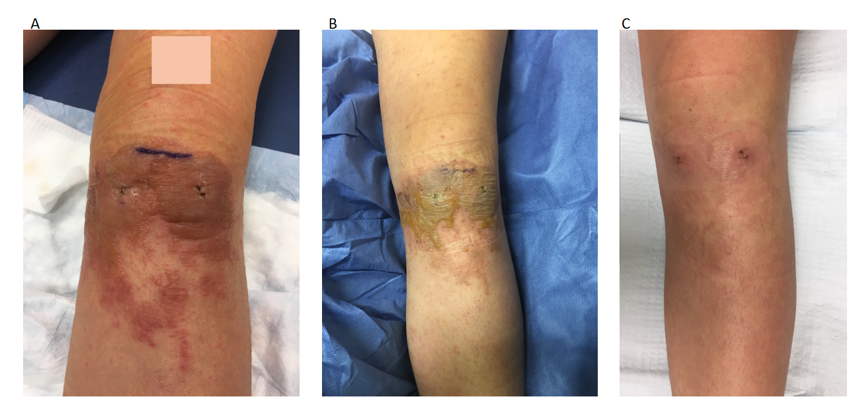
Figure 1 Patient 1. A: Left knee operative site, one week post-operation and use of Prineo™ for wound closure; B: Left knee operative site, two weeks post-operation; C: Left knee operative site, three weeks post-operation.
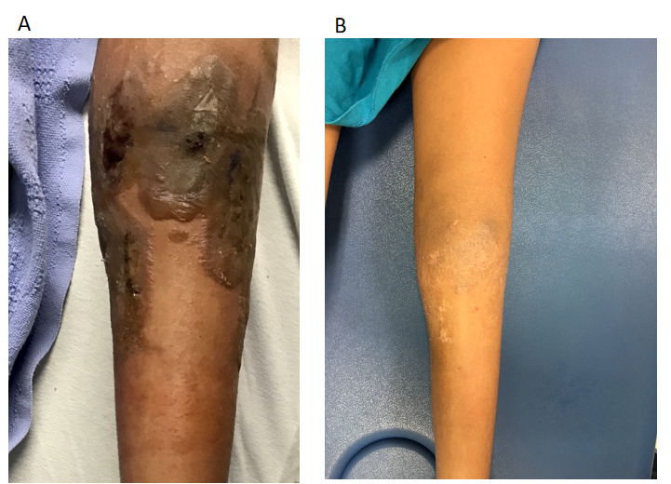
Figure 2 Patient 2. A: Left knee operative site, one week post-operation and use of Prineo™ for wound closure; B: Left knee operative site, six weeks post-operation.

