Name of Journal: World Journal of Clinical Cases
Manuscript NO: 69496
Manuscript Type: CASE REPORT

Primary mucosal-associated lymphoid tissue extranodal marginal zone lymphoma of the bladder from an imaging perspective: A case report

Jiang ZZ et al. Primary MALT lymphoma of the bladder

Zhen-Zhen Jiang, Yuan-Yuan Zheng, Chuan-Ling Hou, Xia-Tian Liu

Zhen-Zhen Jiang, Yuan-Yuan Zheng, Xia-Tian Liu, Department of Ultrasound, Shaoxing People’s Hospital (Shaoxing Hospital, Zhejiang University School of Medicine), Shaoxing 312000, Zhejiang Province, China

Chuan-Ling Hou, Department of Pathology, Shaoxing People’s Hospital (Shaoxing Hospital, Zhejiang University School of Medicine), Shaoxing 312000, Zhejiang Province, China

Author contributions: Jiang ZZ reviewed the literature, and contributed to manuscript drafting; Zheng YY interpreted the imaging findings; Hou CL interpreted the pathological images; Liu XT was responsible for the revision of the manuscript for important intellectual content; all authors issued final approval for the version to be submitted.

Supported by Shaoxing Medical Key Discipline, China, No. 2019SZD05.

Corresponding author: Xia-Tian Liu, MD, Chief Doctor, Department of Ultrasound, Shaoxing People’s Hospital (Shaoxing Hospital, Zhejiang University School of Medicine), No. 568 Zhongxing North Road, Shaoxing 312000, Zhejiang Province, China. lxt2015@126.com

Received: July 2, 2021
Revised: August 10, 2021
Accepted: September 19, 2021
Published online:

Abstract
BACKGROUND
Mucosal-associated lymphoid tissue extranodal marginal zone (MALT) lymphoma is a low-grade tumor that rarely occurs in the urinary bladder. There is currently no consensus on the common imaging findings or most appropriate treatment in MALT lymphoma in the urinary bladder due to the limited number of reports.

CASE SUMMARY
A 48-year-old woman was admitted to the hospital with a 1-year history of macroscopic hematuria. Imaging showed a large homogeneous mass with an unclear boundary and an irregular morphology in the bladder. The mass had an abundant blood supply. For further diagnosis, transurethral cystoscopic biopsy and bone marrow biopsy was performed, and the patient was finally diagnosed with primary MALT lymphoma of the bladder. R-CHOP chemotherapy was carried out. After three cycles of chemotherapy, the mass disappeared and the bladder wall thickness was only 4 mm, which indicated excellent therapeutic response to the chemotherapy. To date, the patient remains asymptomatic and she visits our hospital regularly for the completion of the remaining chemotherapy cycles.

CONCLUSION
Primary MALT lymphoma of the bladder is rare, and there are certain characteristics in the ultrasonographic findings. Imaging findings play an important role in evaluating the therapeutic efficacy and are critical during long-term follow-up after therapy.

Key Words: Mucosal-associated lymphoid tissue extranodal marginal zone lymphoma; Bladder; Ultrasonography; Computed tomography; Case report

Jiang ZZ, Zheng YY, Hou CL, Liu XT. Primary mucosal-associated lymphoid tissue extranodal marginal zone lymphoma of the bladder from an imaging perspective: A case report. World J Clin Cases 2021; In press

Core Tip: Mucosal-associated lymphoid tissue extranodal marginal zone (MALT) lymphoma is a rare tumor that rarely occurs in the urinary bladder. There is no consensus on imaging findings or treatment due to the limited number of reports. We present herein, a rare case of primary bladder MALT lymphoma in a female patient from an imaging perspective. This case summarizes the imaging features of bladder MALT lymphoma and highlights the role of different imaging modalities in evaluating therapeutic efficacy and long-term follow-up after the therapy.

INTRODUCTION
Mucosal-associated lymphoid tissue extranodal marginal zone (MALT) lymphoma is a rare tumor that mainly occurs in the gastrointestinal tract^{[1-3]} and has rarely been reported to occur in the urinary bladder, with a low prevalence of 0.2% of the extranodal lymphomas^{[4]}. To the best of our knowledge, there is no consensus on the common imaging findings or the best treatment due to the limited number of reports. Herein, we report the serial imaging findings and follow-up results of a patient with primary MALT lymphoma of the bladder. We also review the current literature to summarize the imaging findings to provide a detailed understanding of primary bladder MALT lymphoma.

CASE PRESENTATION
Chief complaints
A 48-year-old woman was admitted to the hospital with a 1-year history of macroscopic hematuria.

History of present illness
In the past year, the patient was found to have recurrent macroscopic hematuria. Her urine was intermittently bright red with blood clots. There were no accompanying symptoms, such as frequent urination, urgent urination, painful urination, fever, or weight loss.

History of past illness
The patient had no significant medical history.

Personal and family history
There were no special personal or family illness histories.

Physical examination
The physical examination revealed no abnormities. The patient had no percussion pain in the renal area bilaterally, and no tenderness in the ureteral and bladder areas.

Laboratory examinations
Tumor marker analysis revealed that the serum carbohydrate antigen 125 (CA125) level of the patient was elevated (67.44 U/mL), while other tumor markers were negative. Routine blood tests revealed that the percentage of neutrophils was 77.6%, which was slightly elevated. Routine urinary tests revealed that the patient had a urinary tract infection (the urine white blood cell count was 2510.5/mL, and the urine bacteria count was 27736/mL), accompanied by hematuria and proteinuria (the urine red blood cell count was 37.9/mL, and the urine protein level was 1+). The thrombin profile revealed that the patient had coagulation function abnormalities (the prothrombin time was 17.4 s, the international standardized ratio was 1.45, the activated partial thromboplastin time was 49.4 s, the activated partial thromboplastin ratio was 1.5, and thrombin time was 21.3 s).

Imaging examinations
Ultrasound examination revealed a large hypoechoic mass in the bladder, and the size of the mass was 128 mm × 78 mm. Its boundary was not clear, and the shape was irregular. The mass had a homogeneous hypoecho with fine linear echogenic strands distributed inside. No signs of calcification or large patches of necrosis were encountered. Color Doppler flow imaging showed rich blood flow signals in the mass. An artery was detected within the mass, and it had a maximum flow velocity (Vmax) of 22.9 cm/s and a resistance index of 0.57 (Figure 1). The right renal collection system was separated by 13 mm, and the right ureter was fully dilated. A contrast-enhanced computed tomography (CT) scan demonstrated that the bladder wall was thickened, and there were multiple low-density nodules in the bladder with unclear boundaries and irregular morphologies. A continuous enhancement of the nodules was observed. The ureteral and renal pelvis of the right kidney were dilated (Figure 2). The CT images indicated bladder carcinoma, and a biopsy was recommended.

FINAL DIAGNOSIS
For further diagnosis, a transurethral cystoscopic biopsy was performed. During the operation, multiple bulging bladder masses were found. Tumor tissue samples were collected, and histological findings revealed diffuse infiltration by atypical lymphoid cells. Immunohistochemical staining was positive for CD20, CD21, and CD79a and was negative for CD3, CD5, CD35, CD10, Bcl-6, CD45RO, Mum-1, and Cyclin D1, with a Ki-67 Labeling index of 10% (Figure 3). These data supported the diagnosis of MALT lymphoma. No primary or secondary lymphoma lesions were detected by imaging examinations. Additionally, a bone marrow biopsy revealed no signs of invasion of MALT lymphoma. The patient was diagnosed with primary MALT lymphoma of the bladder.

TREATMENT
Laboratory examinations indicated that the patient had a coagulation disorder and was unable to proceed with surgery. Based on the patient’s condition and treatment guidelines, R-CHOP chemotherapy was carried out.

OUTCOME AND FOLLOW-UP
The patient had a favorable outcome. After two-cycles of chemotherapy, ultrasonography showed that the mass had disappeared with localized thickening (13 mm) of the bladder wall. After three-cycles of chemotherapy, the bladder wall thickness was only 4 mm, which indicated an excellent therapeutic response to chemotherapy (Figure 4). To date, the patient remains asymptomatic and she visits our hospital regularly for the completion of the remaining chemotherapy cycles. After finishing all the chemotherapy cycles, CT follow-up will be performed to verify the final therapeutic effect.

DISCUSSION
MALT lymphoma is a unique subtype of B-cell lymphoma predominantly involving extranodal sites, such as the stomach, orbit, conjunctiva, salivary glands, thyroid and lungs^{[2,5-7]}. The bladder is rarely involved, accounting for only 0.2% of extranodal lymphomas^{[8]}. The risk factors include chronic inflammation, urinary tract infections and autoimmune diseases^{[9,10]}. As no naturally occurring lymphoid tissue exists in the bladder, the pathogenesis of primary bladder MALT lymphoma may be due to the accumulation of extranodal lymphoid tissue resulting from chronic inflammation, which is similar to the mechanism of gastric MALT lymphoma caused by Helicobacter pylori infection^{[1]}. In our case, although the patient did not mention a history of chronic inflammation, her laboratory examinations indicated the existence of a urinary tract infection, which was compatible with the reported risk factors.
The clinical features of bladder MALT lymphoma are nonspecific. It more commonly affects female patients, the most common presenting symptom is hematuria, and less frequent symptoms include recurrent urinary tract infection, dysuria, and urinary retention^{[11]}. Our patient was a 48-year-old woman with recurrent hematuria and evidence of a urinary tract infection; without the help of imaging and histological confirmation, it would have been difficult to make the correct diagnosis. However, a large mass in the bladder without any signs of peripheral metastatic infiltration should point toward the possibility of the diagnosis of lymphoma. Moreover, the presence of an elevated CA125 levels would increase the diagnostic confidence. As reported in the literature, CA125 is a glycoprotein expressed by epithelial ovarian tumors. Nevertheless, cytokines derived from malignant cells in patients with peritoneal involvement may also stimulate the secretion CA125 by mesothelial cells^{[12]}. It has already been shown that the measurement of serum CA125 is useful for staging, monitoring, and estimating the prognosis in non-Hodgkin's lymphoma patients^{[12,13]}.
To date, few studies have focused on the imaging findings of primary bladder MALT lymphoma because of its rarity. For the literature review, we summarized the imaging findings of reported cases of primary bladder MALT lymphoma in Table 1, including the present case. We found that most patients (9/13, 69.2%) presented with a solitary mass. The average size of the lesions that had been reported was 7.6 cm (3.4-12.8 cm). It has been reported that primary bladder lymphoma is more commonly seen in the lateral wall of the bladder, with only 10% of cases having a diffuse thickening of the bladder wall^{[14]}, which is consistent with our results (15% of cases had diffuse thickened wall). Some of the patients (6/13, 46.2%) had signs of hydronephrosis, which may be due to an obstruction of the urethral orifices caused by large masses. In our case, the patient presented with a large sessile solitary mass with thickening of the bladder wall and right hydronephrosis, which was thought to occur because the mass originated from the lateral wall of the bladder and obstructed the right ureteral outlet, and the hydronephrosis was not likely secondary to tumor invasion.
The general imaging manifestations of MALT lymphoma are solitary or multiple solid homogeneous masses without cysts, necrosis or calcification^{[15,16]}. The ultrasound features of MALT lymphoma could be described as interspersed linear echogenic strand patterns or segmental patterns, according to the thicknesses of the septa^{[17]}. The pathological basis for the formation of linear echo may be the expansion of lymphoma cells bordered by fibrous bands. If the fibrous bands are wide, the ultrasonic findings show a segmental pattern^{[16]}. In our present case, a homogeneous hypoecho mass with fine linear echogenic strands was found, and the ultrasound findings included a linear echogenic strand pattern. This may be consistent with the pathological basis of MALT lymphoma. As presented in Table 1, CT features in most cases contained homogeneously enhance solitary masses. Only one case described the magnetic resonance imaging features of primary bladder MALT lymphoma as a homogeneously enhancing mass with hypointensity in the T1-weighted phase, and intermediate intensityin the T2-weighted phase, and hyperintensity in the short tau inversion-recovery phase.
Primary bladder MALT lymphoma needs to be differentiated from bladder carcinoma, glandular cystitis, and metastatic lymphoma of the bladder. Comparisons of the imaging findings of these diseases are summarized in Table 2. Briefly, the ultrasound manifestations of bladder carcinoma are hypoecho masses with narrow base and rough boundaries. Glandular cystitis is characterized by a diffuse thickening or nodular eminence of the bladder wall with mild enhancement. The lesion does not invade the muscle layer and is hypovascular. Most patients with bladder metastatic lymphoma had a history of primary tumors and extensive abdominal lymphadenopathy.
The most effective therapeutic approach for primary bladder MALT lymphoma remains controversial. A complete resection of the tumor may not be required, as radiotherapy and chemotherapy can be useful and effective^{[18]}. In this case, R-CHOP chemotherapy was used and resulted in remission after taking into consideration the patient’s condition and the therapeutic efficacy of systemic chemotherapy.
In the follow-up of MALT lymphoma, imaging modalities, such as contrast-enhanced CT, are effective in detecting the lesion^{[19]}. The value of positron emission tomography/CT for the staging and response assessment of MALT lymphoma with multiple site involvement has also been reported^{[20]}. However, the optimal follow-up imaging modalities have not been determined due to the limited case number. In our experience, the therapeutic response or the presence of a relapse after the remission of a primary bladder MALT lymphoma could be evaluated by tracking the changes in the bladder wall thickness by ultrasound. In the long-term follow-up of MALT lymphoma in hollow organs, such as the stomach and bladder, ultrasonography can be a valuable tool for the evaluation of wall infiltration by measuring the wall thickness^{[21,22]}.

CONCLUSION
Primary MALT lymphoma of the bladder is rare, and the imaging findings have certain characteristics. The diagnosis of MALT lymphoma should be considered if a large mass has no signs of extravesical spread. Primary bladder MALT lymphoma is a low-grade, localized indolent tumor with a good prognosis, so early diagnosis can reduce unnecessary surgeries. In addition, ultrasound can be used as an imaging method for evaluating the therapeutic efficacy and is critical for long-term follow-up after therapy.

ACKNOWLEDGEMENTS
We thank the patient for allowing us to share details of her diagnosis and treatment.

REFERENCES
1 Matysiak-Budnik T, Jamet P, Ruskoné-Fourmestraux A, de Mascarel A, Velten M, Maynadié M, Woronoff AS, Trétarre B, Marrer E, Delafosse P, Ligier K, Lapôtre Ledoux B, Daubisse L, Bouzid L, Orazio S, Cowppli-Bony A, Monnereau A. Gastric MALT lymphoma in a population-based study in France: clinical features, treatments and survival. Aliment Pharmacol Ther 2019; 50: 654-663 [PMID: 31347731 DOI: 10.1111/apt.15409]
2 Zucca E, Arcaini L, Buske C, Johnson PW, Ponzoni M, Raderer M, Ricardi U, Salar A, Stamatopoulos K, Thieblemont C, Wotherspoon A, Ladetto M; ESMO Guidelines Committee. Electronic address: clinicalguidelines@esmo.org. Marginal zone lymphomas: ESMO Clinical Practice Guidelines for diagnosis, treatment and follow-up. Ann Oncol 2020; 31: 17-29 [PMID: 31912792 DOI: 10.1016/j.annonc.2019.10.010]
3 Wei YL, Min CC, Ren LL, Xu S, Chen YQ, Zhang Q, Zhao WJ, Zhang CP, Yin XY. Laterally spreading tumor-like primary rectal mucosa-associated lymphoid tissue lymphoma: A case report. World J Clin Cases 2021; 9: 3988-3995 [PMID: 34141757 DOI: 10.12998/wjcc.v9.i16.3988]
4 Matsuda I, Zozumi M, Tsuchida YA, Kimura N, Liu NN, Fujimori Y, Okada M, Hashimoto T, Yamamoto S, Hirota S. Primary extranodal marginal zone lymphoma of mucosa-associated lymphoid tissue type with malakoplakia in the urinary bladder: a case report. Int J Clin Exp Pathol 2014; 7: 5280-5284 [PMID: 25197410]
5 Suh C, Huh J, Roh JL. Extranodal marginal zone B-cell lymphoma of mucosa-associated lymphoid tissue arising in the extracranial head and neck region: a high rate of dissemination and disease recurrence. Oral Oncol 2008; 44: 949-955 [PMID: 18234544 DOI: 10.1016/j.oraloncology.2007.11.011]
6 Wenzel C, Fiebiger W, Dieckmann K, Formanek M, Chott A, Raderer M. Extranodal marginal zone B-cell lymphoma of mucosa-associated lymphoid tissue of the head and neck area: high rate of disease recurrence following local therapy. Cancer 2003; 97: 2236-2241 [PMID: 12712477 DOI: 10.1002/cncr.11317]
7 Zucca E, Conconi A, Pedrinis E, Cortelazzo S, Motta T, Gospodarowicz MK, Patterson BJ, Ferreri AJ, Ponzoni M, Devizzi L, Giardini R, Pinotti G, Capella C, Zinzani PL, Pileri S, López-Guillermo A, Campo E, Ambrosetti A, Baldini L, Cavalli F; International Extranodal Lymphoma Study Group. Nongastric marginal zone B-cell lymphoma of mucosa-associated lymphoid tissue. Blood 2003; 101: 2489-2495 [PMID: 12456507 DOI: 10.1182/blood-2002-04-1279]
8 Xu H, Chen Z, Shen B, Wei Z. Primary bladder mucosa-associated lymphoid tissue lymphoma: A case report and literature review. Medicine (Baltimore) 2020; 99: e20825 [PMID: 32664075 DOI: 10.1097/MD.0000000000020825]
9 Isaacson PG, Du MQ. MALT lymphoma: from morphology to molecules. Nat Rev Cancer 2004; 4: 644-653 [PMID: 15286744 DOI: 10.1038/nrc1409]
10 Munari F, Lonardi S, Cassatella MA, Doglioni C, Cangi MG, Amedei A, Facchetti F, Eishi Y, Rugge M, Fassan M, de Bernard M, D'Elios MM, Vermi W. Tumor-associated macrophages as major source of APRIL in gastric MALT lymphoma. Blood 2011; 117: 6612-6616 [PMID: 21527528 DOI: 10.1182/blood-2010-06-293266]
11 Szopiński TR, Sudoł-Szopińska I, Dzik T, Borówka A, Dembowska-Bagińska B, Perek D. Incidental sonographic detection of mucosa-associated lymphoid tissue lymphoma of the urinary bladder found in a very young woman: report of a case. J Clin Ultrasound 2011; 39: 233-235 [PMID: 21480290 DOI: 10.1002/jcu.20786]
12 Zacharos ID, Efstathiou SP, Petreli E, Georgiou G, Tsioulos DI, Mastorantonakis SE, Christakopoulou I, Roussou PP. The prognostic significance of CA 125 in patients with non-Hodgkin's lymphoma. Eur J Haematol 2002; 69: 221-226 [PMID: 12431241 DOI: 10.1034/j.1600-0609.2002.02771.x]
13 Benboubker L, Valat C, Linassier C, Cartron G, Delain M, Bout M, Fetissof F, Lefranq T, Lamagnere JP, Colombat P. A new serologic index for low-grade non-Hodgkin's lymphoma based on initial CA125 and LDH serum levels. Ann Oncol 2000; 11: 1485-1491 [PMID: 11142490 DOI: 10.1023/a:1026789232033]
14 Tasu JP, Geffroy D, Rocher L, Eschwege P, Strohl D, Benoit G, Paradis V, Bléry M. Primary malignant lymphoma of the urinary bladder: report of three cases and review of the literature. Eur Radiol 2000; 10: 1261-1264 [PMID: 10939486 DOI: 10.1007/s003300000343]
15 Maninderpal KG, Amir FH, Azad HA, Mun KS. Imaging findings of a primary bladder maltoma. Br J Radiol 2011; 84: e186-e190 [PMID: 21849361 DOI: 10.1259/bjr/66130737]
16 Ko KWS, Bhatia KS, Ai QYH, King AD. Imaging of head and neck mucosa-associated lymphoid tissue lymphoma (MALToma). Cancer Imaging 2021; 21: 10 [PMID: 33436095 DOI: 10.1186/s40644-020-00380-5]
17 Jeon EJ, Shon HS, Jung ED. Primary Mucosa-Associated Lymphoid Tissue Lymphoma of Thyroid with the Serial Ultrasound Findings. Case Rep Endocrinol 2016; 2016: 5608518 [PMID: 27099797 DOI: 10.1155/2016/5608518]
18 Hsu JS, Lin CC, Chen YT, Lee YC. Primary mucosa-associated lymphoid tissue lymphoma of the urinary bladder. Kaohsiung J Med Sci 2015; 31: 388-389 [PMID: 26162822 DOI: 10.1016/j.kjms.2015.04.001]
19 Kheterpal MK, Dai J, Geller S, Pulitzer M, Ni A, Myskowski PL, Moskowitz A, Kim J, Hong EK, Fong S, Hoppe RT, Kim YH, Horwitz SM. Role of imaging in low-grade cutaneous B-cell lymphoma presenting in the skin. J Am Acad Dermatol 2019; 81: 970-976 [PMID: 30703460 DOI: 10.1016/j.jaad.2019.01.037]
20 Vaxman I, Bernstine H, Kleinstern G, Hendin N, Shimony S, Domachevsky L, Gurion R, Groshar D, Raanani P, Gafter-Gvili A. FDG PET/CT as a diagnostic and prognostic tool for the evaluation of marginal zone lymphoma. Hematol Oncol 2019; 37: 168-175 [PMID: 30734341 DOI: 10.1002/hon.2578]
21 Yeh HZ, Chen GH, Chang WD, Poon SK, Yang SS, Lien HC, Chang CS, Chou G. Long-term follow up of gastric low-grade mucosa-associated lymphoid tissue lymphoma by endosonography emphasizing the application of a miniature ultrasound probe. J Gastroenterol Hepatol 2003; 18: 162-167 [PMID: 12542600 DOI: 10.1046/j.1440-1746.2003.02938.x]
22 Park BS, Lee SH. Endoscopic features aiding the diagnosis of gastric mucosa-associated lymphoid tissue lymphoma. Yeungnam Univ J Med 2019; 36: 85-91 [PMID: 31620618 DOI: 10.12701/yujm.2019.00136]
23 Morita K, Nakamura F, Nannya Y, Nomiya A, Arai S, Ichikawa M, Maeda D, Homma Y, Kurokawa M. Primary MALT lymphoma of the urinary bladder in the background of interstitial cystitis. Ann Hematol 2012; 91: 1505-1506 [PMID: 22297664 DOI: 10.1007/s00277-012-1419-0]
24 Bacalja J, Ulamec M, Rako D, Bošković L, Trnski D, Vrdoljak E, Krušlin B. Persistence of primary MALT lymphoma of the urinary bladder after rituximab with CHOP chemotherapy and radiotherapy. In Vivo 2013; 27: 545-549 [PMID: 23812229 DOI: 10.1038/gt.2013.7]
25 Simpson WG, Lopez A, Babbar P, Payne LF. Primary bladder lymphoma, diffuse large B-cell type: Case report and literature review of 26 cases. Urol Ann 2015; 7: 268-272 [PMID: 25837971 DOI: 10.4103/0974-7796.152947]
26 Kadam PD, Han HC, Kwok JL. An uncommon case of mucosa-associated lymphoid tissue (MALT) tumor of the bladder. Int Urogynecol J 2019; 30: 1017-1018 [PMID: 30511263 DOI: 10.1007/s00192-018-3813-1]

Footnotes
Informed consent statement: Informed written consent was obtained from the patient for publication of this report and any accompanying images.

Conflict-of-interest statement: The authors declare that they have no conflict of interest.

CARE Checklist (2016) statement: The authors have read the CARE Checklist (2016), and the manuscript was prepared and revised according to the CARE Checklist (2016).

Open-Access: This article is an open-access article that was selected by an in-house editor and fully peer-reviewed by external reviewers. It is distributed in accordance with the Creative Commons Attribution NonCommercial (CC BY-NC 4.0) license, which permits others to distribute, remix, adapt, build upon this work non-commercially, and license their derivative works on different terms, provided the original work is properly cited and the use is non-commercial. See: http://creativecommons.org/Licenses/by-nc/4.0/

Manuscript source: Unsolicited manuscript

Peer-review started: July 2, 2021
First decision: July 26, 2021
Article in press:

Specialty type: Radiology, nuclear medicine and medical imaging
Country/Territory of origin: China
Peer-review report’s scientific quality classification
Grade A (Excellent): 0
Grade B (Very good): B
Grade C (Good): C, C
Grade D (Fair): D
Grade E (Poor): 0

P-Reviewer: Akbulut S, Elpek GO, Harikrishnan S S-Editor: Yan JP L-Editor: A P-Editor:
Figure Legends

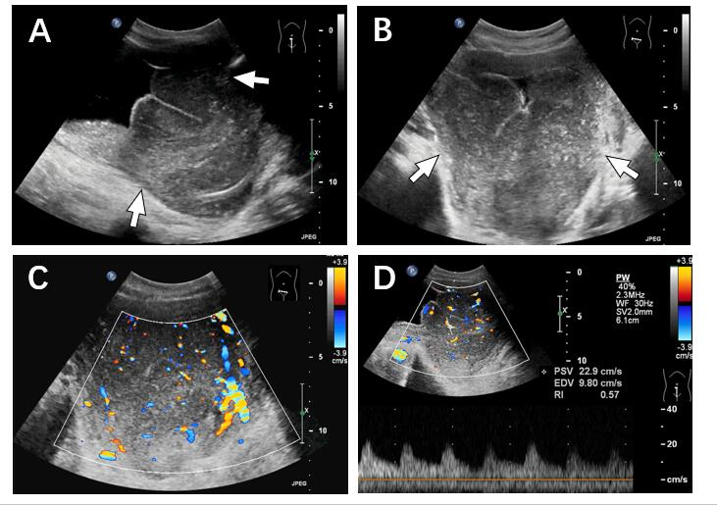
Figure 1 Ultrasonographic findings of the lesion. A and B: A large homogeneous hypoechoic mass was detected in the bladder (arrows), with an unclear boundary and irregular shape. There were fine linear echogenic strands distributed inside; C: Color Doppler flow imaging showed that there were rich blood flow signals in the mass; D: Spectral Doppler ultrasound imaging showed the artery spectrum detected within the mass (Vmax = 22.9 cm/s, resistance index: 0.57).

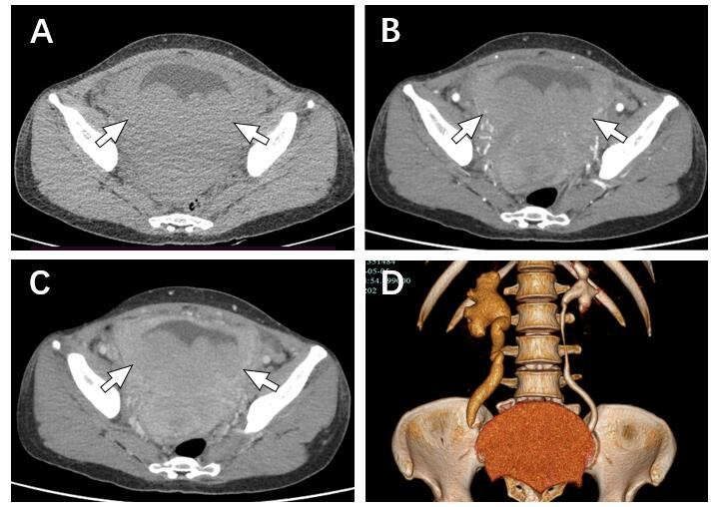

Figure 2 Computed tomography findings of the lesion. A: The bladder wall was thickened, and there were multiple low-density nodules in the bladder with unclear boundaries and irregular morphologies (arrow); B and C: Continuous enhancement of the mass was observed; D: The ureter and renal pelvis area of the right kidney was dilated.

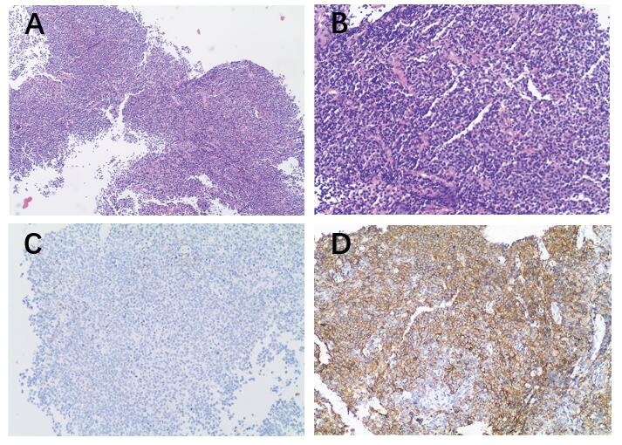
Figure 3 Histopathological findings of the mass tissues. There was diffuse infiltration of atypical lymphoid cells. A: Hematoxylin and eosin (HE) staining, magnification 40 ×; B: HE staining, magnification 100 ×; C: Immunohistochemical (IHC) staining, negative for CD3, magnification 100 ×; D: IHC staining, positive for CD20, magnification 100 ×.

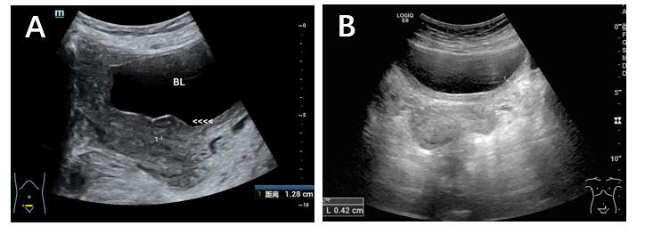
Figure 4 Ultrasonographic findings during the chemotherapy. A: After two cycles of chemotherapy, the mass had disappeared with localized thickening (13 mm) of the bladder wall; B: After three cycles of chemotherapy, bladder wall thickness was only 4 mm, which indicated excellent therapeutic response to the treatment.

Table 1 Imaging findings of the patients with primary bladder mucosal-associated lymphoid tissue extranodal marginal zone lymphoma ever reported (including the present case)
No. | Ref. | Solitary /multiple | Size (cm) | Location | Signs of ureteral obstruction | Imaging findings |  |  | Follow-up imaging methods
 |  |  |  |  |  | US | CT | MRI
1 | Tasu et al^{[14]} | Solitary | NA | Right lateral wall | No | Soft tissue mass | Soft tissue mass | No | NA
2 | Tasu et al^{[14]} | NA | NA | Entire wall | Yes | Circumferential thickening of the bladder wall | Circumferential thickening of the bladder wall | No | CT
3 | Tasu et al^{[14]} | Solitary | NA | Left wall | No | An isolated mass with local thickened bladder wall | An isolated mass with local thickened bladder wall | No | NA
4 | Maninderpal et al^{[15]} | Solitary | 11.2 | Trigone of the bladder | Yes | A hypoechoic soft tissue mass with local thickened bladder wall | A homogeneously enhancing mass with local thickened bladder wall | Homogeneously enhancing mass with hypointensity in T1WI, intermediate intense intensity in T2WI, and hyperintensity in STIR | CT
5 | Szopiński et al^{[11]} | Solitary | 3.6 | Posterior wall | No | Hypoechoic mass | No | No | US, CT
6 | Morita et al^{[23]} | Solitary | NA | NA | NA | No | Soft tissue mass with local thickened bladder wall | No | NA
7 | Bacalja et al^{[24]} | Solitary | 8.5 | Right posterolateral wall | No | Soft tissue mass | Expansive lesion of the bladder wall | No | CT, PET-CT
8 | Matsuda et al^{[4]} | Solitary | NA | Anterior to right side wall | Yes | No | Soft tissue mass with local thickened bladder wall | Soft tissue mass with local thickened bladder wall | US
9 | Simpson et al^{[25]} | Solitary | 6.3 | Anterior lateral | Yes | No | Soft tissue mass | No | PET-CT
10 | Hsu et al^{[18]} | NA | NA | Right wall | Yes | No | Eccentric thickened bladder wall | No | NA
11 | Kadam et al^{[26]} | Solitary | 3.4 | Posterior wall | NA | No | Soft tissue mass | No | NA
12 | Xu et al^{[8]} | Multiple | NA | NA | NA | Roughness in the inner bladder wall | Soft tissue mass | No | CT, PET-CT
13 | Present case | Multiple | 12.8 | Posterior wall | Yes | A mass had a homogeneous hypoecho with fine linear echogenic strands distributed inside | Continuous enhancing mass with thickened wall | No | US
NA: Not available; US: Ultrasonography; CT: Computed tomography; MRI: Magnetic resonance imaging; T1WI: T1-weighted imaging; T2WI: T2-weighted imaging; STIR: Short tau inversion-recovery; PET-CT: Positron emission tomography/computed tomography.

Table 2 Comparison of image findings among the present case, previously reported cases, typical bladder carcinoma and typical glandular cystitis
 | US | CT | MRI
Present case | Hypoecho mass with sharp boundaries | Solitary mass with continuously enhancement and thickened bladder wall | No
Common findings of cases reported | Hypoecho mass | Solitary mass with homogeneously enhancement | Homogeneously enhancing mass with hypointensity in T1WI, intermediate intense intensity in T2WI, hyperintensity in STIR
Common findings of bladder carcinoma | Hypoechoic masses with rough boundaries | Irregular solid mass with significantly heterogeneous enhancement | Early significantly enhancing mass with iso to hyperintensity in T1WI, intermediate intensity in T2WI, hyperintensity in DWI, and decreased ADC value
Common findings of glandular cystitis | Diffuse thickening or nodular eminence of the bladder wall | Thickened bladder wall with mild enhancement | Mild enhancing thickened bladder wall with intermediate intensity on T1W, hyperintense on T2W, and slightly hyperintense on DWI
NA: Not available; US: Ultrasound imaging; CT: Computed tomography; MRI: Magnetic resonance imaging; T1WI: T1-weighted imaging; T2WI: T2-weighted imaging; DWI: Diffusion-weighted imaging; ADC: Average diffusion coefficient.

