Name of journal: World Journal of Gastroenterology
ESPS Manuscript No: 9622
Columns: TOPIC HIGHLIGHTS

WJG 20th Anniversary Special Issues (3): Inflammatory bowel disease

Ulcerative colitis: from inflammation to cancer. Do estrogen receptors have a role?

Principi M et al. Ulcerative colitis, cancer and estrogen receptors

Mariabeatrice Principi, Michele Barone, Maria Pricci, Nicola De Tullio, Giuseppe Losurdo, Enzo Ierardi, Alfredo Di Leo

Mariabeatrice Principi, Maria Pricci, Nicola De Tullio, Giuseppe Losurdo, Enzo Ierardi, Alfredo Di Leo, Division of Gastroenterology, Department of Emergency and Organ Transplantation, University of Bari, 70124 Bari, Italy

Michele Barone, Division of Gastroenterology, Department of Medical and Surgical Sciences, University of Foggia, 71100 Foggia, Italy

Author contributions: Ierardi E, Di Leo A, Principi M and Barone M designed the study, revised the manuscript and approved the final version; Losurdo G, Pricci M and De Tullio N collected the data and revised the final version before approval.

Correspondence to: Enzo Ierardi, MD, Adjunct Professor, Associate Professor, Senior Scientist, Division of Gastroenterology, Department of Emergency and Organ Transplantation, University of Bari, Piazza Umberto I, 70124 Bari, Italy. enzo.ierardi@fastwebnet.it

Telephone: +39-80-5592577 Fax: +39-80-5593088
Received: February 20, 2014 Revised: March 29, 2014
Accepted: May 23, 2014

Published online:

Abstract
Ulcerative colitis (UC) is a condition at increased risk for colorectal carcinoma (CRC) development. Nowadays, screening and follow-up programs are routinely performed worldwide to promote the early detection of CRCs in subjects with well known risk factors (extent, duration and severity of the disorder). The diffusion of these procedures is presumably the main reason for the marked reduction of cancer incidence and mortality in the course of UC. In addition, chemoprevention has been widely investigated and developed in many medical fields, and aspirin has shown a preventive effect against CRC, while mesalazine has been strongly invoked as a potential chemopreventive agent inUC. However, available studies show some limitations due to the obvious ethical implications of drug withdrawal in UC in order to design a control group. The estrogen receptors (ER) alpha/beta balance seems to have a relevant influence on colorectal carcinogenesis and ER beta appears to parallel apoptosis, and hence an anti-carcinogenic effect. Phytoestrogens are compounds acting as ER beta agonists and have shown a promising chemopreventive effect on sporadic as well as genetically inherited CRC. There is evidence suggesting a role for ERs in UC-related carcinogenesis. In this perspective, since these substances can be considered as dietary supplements and are completely free from side effects, phytoestrogens could be an interesting option for CRC prevention, even when the disease is a consequence of long-term chronic inflammation, as in the course of UC. Further studies of their effects are warranted in both the basic research and clinical fields.

© 2014 Baishideng Publishing Group Inc. All rights reserved.

Key words: Ulcerative colitis; Epithelial dysplasia; Colorectal cancer; Estrogen receptors; Chemoprevention; Phytoestrogens; Dietary supplementation; Inflammatory bowel disease

Core tip: The present work outlines the main data regarding a possible involvement of estrogen receptors in colorectal carcinogenesis, paying particular attention to cancer arising in the course of ulcerative colitis. A protective role for beta receptors has been suggested by many studies. The challenge for the future could be to devise chemopreventive strategies against colorectal carcinoma employing estrogen receptor beta agonists, such as phytoestrogens.

Principi M, Barone M, Pricci M, De Tullio N, Losurdo G, Ierardi E, Di Leo A. Ulcerative colitis: from inflammation to cancer. Do estrogen receptors have a role? World J Gastroenterol 2014; In press

Ulcerative colitis: from inflammation to cancer
Ulcerative colitis (UC) is associated with an increased risk of colorectal cancer (CRC), which has been related to the long-standing chronic inflammation^{[1]}. However, the magnitude of the risk is difficult to estimate, as many factors may bias study results^{[2]} (i.e. patient selection, number of patients, completeness of case recruitment and ascertainment and duration of follow-up)^{[2,3]}.
Castaño-Milla et al^{[4]} reported an overall incidence rate of CRC in UC of 1.67/1000 per year of disease (PYD) and incidence rates per decade were estimated at 1.01/1000, 3.75/1000 and 5.85/1000 PYD for the first, second and third decades, respectively. In a meta-analysis of prospective population-based studies, Jess et al^{[5]} found that an average of 1.6% of patients with UC were diagnosed with CRC during the first 14 years of follow-up, and the estimated standardized incidence ratio (SIR) was 2.39 (2.1–2.7). Recent time-trend studies also demonstrate a decreasing risk of CRC in UC patients^{[6]}. In a recent meta-analysis^{[4]} the incidence rate was found to have decreased from 4.29/1000 PYD in studies published in the 1950s to 1.09/1000 PYD in the studies published between 2000 and 2011.
As known, reported risk factors for CRC include extensive disease^{[7,8]}, young age at diagnosis^{[9]}, a family history of CRC^{[10]}, co-existing primary sclerosing cholangitis (PSC)^{[11]} and persistent inflammation of the colon^{[12,13]}.
The pathophysiology of colitis-associated cancer suggests the action of numerous positive and negative regulators^{[14]}. Positive regulators are pro-carcinogenic cytokines such as tumor necrosis factor alpha (TNF alpha), that is over-expressed in a murine model of carcinoma arising on colitis^{[15]}, interleukin (IL)-6^{[16]} and IL-21^{[17]} and chemokines such as CCL2, whose expression is enhanced by TNF alpha, causing the recruitment of macrophages and monocytes^{[18]}. Negative regulators include IL-10^{[19,20]}, transforming growth factor beta (TGF beta)^{[21]} and MyD88, a Toll-like receptor adaptor, that has been found to significantly reduce tumor number and size in the Apc^{min/+} mouse model of intestinal tumorigenesis^{[22,23]}.
The progression from UC to CRC is a multistep process in which the accumulation of genetic mutations leads to the sequential evolution to low-grade dysplasia (LGD), high-grade dysplasia (HGD) and finally to cancer^{[24]}. The p53 tumor suppressor gene appears to be a key factor in the initial steps of UC-associated colorectal carcinogenesis, being the most frequent single founding mutation in UC associated CRC^{[25]}. p53 is overexpressed in 33%–67% of patients with dysplasia and in 83%–95% of patients with UC-associated CRC^{[26,27]}. Other genes that undergo mutation in the following stages of carcinogenesis are kRAS, DCC, cyclin D, COX, iNOS, APC and beta-catenin (Figure 1), in a sequence that is substantially different from the classical adenoma-carcinoma pathway^{[28,29]}.
The essential morphological features of dysplasia, are (1) nuclear alterations such as increased nuclear to cytoplasmic ratios and hyperchromasia; (2) depletion of goblet cells; and (3) abnormal architectural patterns corresponding to dysregulated cellular proliferation, such as glandular crowding, a villous architecture and diminished surface maturation. HGD differs from LGD in that there are additional alterations, i.e. impaired cellular polarity including loss of nuclear parallelism, stratification of nuclei patterns such as a cribriform architecture. In most cases, the nuclei in HGD show severe cytological aberrations such as irregular nuclear membranes, abnormally prominent nucleoli or atypical mitotic figures^{[30]}. The progression of such alterations is accompanied by both a progressive increase of epithelial proliferation and a reduction of apoptosis. This phenomenon starts as alterations of glandular architecture (i.e. shortening, loss of parallelism, ramification and branching) which anticipate the dysplasia onset^{[31]}.
The potential risk of malignant degeneration of UC to CRC has made it necessary to institute surveillance protocols to achieve early recognition and treatment of dysplastic lesions. The current evidence-based consensus for endoscopy in inflammatory bowel disease^{[32]} suggests that surveillance should start when the risk starts to increase, i.e. after 8–10 years from the onset of disease^{[7]}. This first colonoscopy also aims to reassess the extent of disease, since this parameter has an impact on the risk of CRC. After this first colonoscopy, patients with high risk features (stricture or dysplasia detected within the past 5 years, PSC, extensive colitis with severe active inflammation, or a family history of CRC in a first degree relative aged less than 50 years) should undergo surveillance colonoscopy annually. Conversely, patients with intermediate risk factors should have surveillance colonoscopy scheduled every 2 to 3 years and those without risk factors every 5 years. Biopsy sampling is fundamental: the American Gastroenterological Association recommends extensive sampling, of a minimum of 33 specimens^{[33]}, while, according to the British Society of Gastroenterology^{[34]},two to four random biopsies every 10 centimetres should be taken.
Compliance to surveillance protocols, as well as a correct clinical overview of UC and the adequate pharmacological management of the disease, have led to a decreasing CRC incidence and mortality in UC^{[35,36]}. In 1971, de Dombal^{[37]} reported a 5% cumulative risk of CRC in a population from Leeds with extensive UC after 10 years and 41.8% after 25 years. Thirty years later, the cumulative risks reported by Lakatos et al had dropped dramatically: 0.6% after 10 years, 5.4% after 20 years and 7.5% after 30 years of disease duration^{[38]}. These data testify to the exceptional impact of surveillance in the natural history of UC^{[39]}, but we must consider that it is not the only prevention strategy: other routes, such as chemoprevention, may have a remarkable effect.

Estrogen receptors
Modern medicine and oncology have been profoundly affected by the discovery of the estrogen receptors (ERs), a potential marker that plays a pivotal role in the pathogenesis, prognosis and therapy of various cancers, such as breast, prostate and colon. Estrogens can regulate the growth, differentiation, and function of various target tissues both within and outside the reproductive system^{[40,41]}. The most relevant event after the initial discovery of these receptors^{[42]} was the identification of two subtypes, ER alpha and ER beta, that are expressed at different levels in each organ of the human body^{[43]}. Variations in the phenotype of knock-out mice lacking ER alpha or ER beta suggested that these receptors have different biological activities^{[44]}. Moreover, in vitro and in vivo studies in ER beta knock-out mice demonstrated that ER beta is a modulator of ER activity, as it is able to reverse the effects of ER alpha and to inhibit estradiol-dependent proliferation^{[45,46]}. These experiments demonstrated that ER alpha is a positive regulator of cellular growth, while ER beta has an antagonist inhibitory function, mediated by the down-regulation of proto-oncogenes (c-myc and cyclins) and up-regulation of oncosuppressants (p21 and p27), resulting in cell cycle arrest^{[47]} (Figure 2). Experiments showing that in various cancers ER alpha is overexpressed and ER beta is down-regulated confirmed in vitro studies and demonstrated that cell proliferation is the result of a balance of ER alpha and ER beta^{[48,49]}.

Estrogen receptors and colorectal cancer
The hypothesis of a possible link between CRC and ERs was advanced after the publication of epidemiological studies showing that females have a lower rate of colonic adenomas and cancers than males before menopause and that the differences progressively lessen after menopause^{[50]}. Similarly, both observational and interventional data have shown that hormone replacement therapy decreases colonic adenoma and cancer risks^{[51,52]}: in the last 40 years, a reduction of deaths from large bowel carcinoma has been observed in the United States. This reduction was significantly higher in women (30%) as compared to men (7%). In the same study, a link was observed between oral contraceptive use and a reduction of colorectal cancer, whereas there was a higher than expected frequency of colorectal tumors among non users^{[53]}.
After the demonstration by our group that ERs are expressed in the colonic mucosa^{[54]}, Konstantinopoulos et al^{[55]} demonstrated that ER beta is highly expressed in normal colonic mucosa in humans, while it is significantly reduced in CRC; this reduction is more pronounced in the case of poorly differentiated tumors. Since the majority of CRCs are derived from adenomatous polyps (a precancerous condition) our group recently evaluated the expression of ER alpha and ER beta in the colonic tissue of 25 patients with adenomatous polyps of the colon and in 25 normal subjects^{[56]}. ERs expression was then correlated to proliferation and apoptosis. Our data confirmed that ER beta is the prevalent estrogen receptor in normal mucosa and shows a significantly reduced expression in adenomatous polyps (Figure 3). In a successive study, we confirmed that ER beta plays a primary role in the regulation of colonic mucosa proliferation in patients affected by Familial Adenomatous Polyposis (FAP)^{[57]}, an inherited disease characterized by an early inclination to develop hundreds of polyps and consequently CRC. Furthermore, ERs can even influence the prognosis of CRC, as it has been demonstrated that patients affected by CRCs with a minimal ERs expression had poor prognosis and short survival^{[58]}.
All these data confirm that sex steroid hormones are involved in CRC development and suggest that ER beta could play an important role in the early phase of the carcinogenic process and hence could be a target in the primary prevention of CRC^{[59]}.

Estrogen receptors expression in the progressive stages of ulcerative colitis-related carcinogenesis
ER beta has been suggested to exert anti-inflammatory and anti-tumorigenic effects in the colon, providing a translational potential to prevent and/or treat inflammatory bowel disease (IBD) and its progression to colitis-associated CRC^{[60,61]}. Most studies in this field used a consolidated animal model which accurately mimics the carcinogenic model related to chronic bowel inflammation in mice (i.e. Azoxymethane/Dextran Sodium Sulfate – AOM/DSS)^{[62,63]}.
Saleiro et al^{[64]} demonstrated that ER beta-deficient mice developed more severe clinical colitis compared to wild type mice, as evidenced by a significantly higher disease activity index after DSS treatment, as well as the inflammation score and grade of dysplasia. ER beta-deficient colons presented a greater number and size of polyps, and were characterized by a significant increase in IL-6, IL-17, TNF alpha and interferon-gamma mRNA levels as compared to wild type mice organs. Furthermore, higher protein expression levels of nuclear factor-kappa B, inducible nitric oxide synthase (iNOS), beta catenin, proliferating cell nuclear antigen, mucin-1, and significantly lower caveolin-1 and mucin-2 protein levels, were shown in ER beta knock-out mice compared to wild type. These data suggest a possible anti-inflammatory and anti-neoplastic mechanism of action of ER beta in UC-arisen CRC. These results suggest that ER beta may be protective in the AOM/DSS-induced CRC model in mice, supporting a preventive and/or therapeutic potential for the use of ER beta-selective agonists in IBD.
Fujii et al^{[65]} performed a study to clarify whether methylation analysis of the ER gene in non-neoplastic epithelium can contribute to the prediction of an increased neoplasia risk in UC patients. The study was based on the assumption that the ER gene shows an age-related methylation in the colorectal epithelium and this phenomenon is frequently found in sporadic colorectal neoplasia, suggesting that it may predispose to colorectal neoplasia. The results suggested that the analysis of ER gene hypermethylation may be a potentially useful marker for identifying individuals at increased risk of neoplasia among those with long-standing and extensive UC. The same group confirmed that the quantitative analysis of ER gene methylation in non-neoplastic epithelium is a marker for identifying individuals at increased risk of neoplasia in long-standing and extensive UC^{[66]}.
A preliminary report by our group^{[67]} assessed the pattern of ER-alpha/beta expression in relation to epithelial apoptosis and cell proliferation in long-lasting UC. We did not observe significant variations in ERs and their ratio in UC compared to UC- low degree dysplasia. However, there was a statistically significant progressive increase in apoptosis in UC and in UC-dysplasia that, despite Ki-67 expression, revealed a more marked significant increase at the same stages. This result, despite the small sample and the inclusion of only low-grade dysplasia, suggested that a possible ER-beta overseer of apoptosis/proliferation is operative until the investigated stage of carcinogenesis (Figure 1). In fact, in LGD we observed a high increase in cell proliferation with invariable levels of ER beta, accompanied by mild increased apoptosis, that was presumably unable to completely counter Ki-67 over-expression. Further, we investigated ER beta, ER alpha expression and their ratio in normal mucosa, in UC and in UC-low and high grade dysplasia and CRC. ERs did not show significant changes until LGD, while in HGD and UC-carcinoma there was a dramatic loss of ER beta expression and the ER beta/ER alpha ratio. Apoptosis and the TUNEL/Ki-67 ratio demonstrated a statistically significant progressive decrease from LGD to UC-carcinoma^{[68]}.

Is there a role for chemoprevention?
The main risk factors for colorectal cancer are not suitable targets for therapeutic intervention, but primary chemoprevention is an intriguing therapeutic option. The question whether mesalazine could exert a chemo-preventive effect has been raised and various studies have investigated this aspect.
The mechanisms by which aspirin or non-steroidal anti-inflammatory drugs (NSAIDs) act in the chemoprevention of CRC in non-IBD patients have not been entirely elucidated. However, data on the chemopreventive effect of aspirin and NSAIDs and CRC are supported by a series of independent lines of evidence. Indeed, several epidemiological studies have shown an inverse correlation between aspirin intake and the risk of CRC^{[69-71]}. Furthermore, studies on secondary chemoprevention reported that aspirin intake was associated with a decreased risk of adenoma recurrence^{[72,73]}. Aspirin and NSAIDs seem to act by inducing apoptosis in the colonic epithelium through the inhibition of cyclooxygenase (COX) activity and arachidonic acid accumulation^{[74]}. Recent evidence suggests that COX inhibition can also change the activity of mitogen-activated protein kinases and NFkB^{[75,76]}.
The analogies between acetyl-salicylic acid and mesalazine (5-amino-salcylic acid), and the results obtained by using acetyl-salicylic acid as a chemopreventive agent in patients with sporadic colorectal cancer have prompted the study of potential chemopreventive effects of mesalazine in inflammatory bowel disease. The results of both epidemiological and experimental studies have shown that long-term 5-amino-salicylic acid treatments appear to have a chemopreventive effect. We can cite two studies, by Eaden and Lashner, in which the relative risk of CRC was estimated to be 0.18 and 0.88, respectively ^{[77,78]}. In a group of patients affected by UC and PSC, the risk was 0.88^{[79]}. The evidence for this effect is provided by retrospective and case-control studies, however, whose results do not reach the highest grades for evidence-based recommendations. Indeed, not all clinical studies reported favorable results regarding CRC in IBD patients. Negative results were mainly reported in studies that elicited positive results with other drugs such as folate or ursodiol^{[80]}. The peculiarities of the cohorts enrolled in these studies (disease refractory to conventional therapy, consideration for treatment with experimental therapy, consultation for surgery) may account for the negative outcome.
Positive results are supported by a series of experimental studies demonstrating the multiplicity of actions of 5-amino-salicylic acid, although data regarding the chemopreventive effect of 5-amino-salicylic acid may not be rigorous enough to meet the criteria for the highest evidence-based medicine recommendations. A final consideration is that suitable evidence may not be rationally gained in this case, because discontinuation of 5-amino-salicylic acid treatment would be unethical in patients with UC^{[81]}.

Future perspectives of chemoprevention by beta receptor agonists
The data summarized in the previous sections suggest the hypothesis that the loss of ER beta expression could be a marker of colonic mucosa at increased risk for colonic neoplasia and that the induction of ER beta with ER beta-selective phytoestrogens could exert a chemopreventive effect against CRC.
Observational data also suggest that phytoestrogen intake may be associated with a decreased incidence of advanced lesions in both men and women^{[82-84]}. The mechanism of the putative protective effect of estrogens and phytoestrogens on colonic neoplasia is not fully understood, but it seems to be markedly different from the one underlying the detrimental effect of estrogens in breast cancer. In the breast, it is well established that the detrimental effect is due to estrogen binding to the pro-proliferative ER alpha, since a similar effect is not found in women with ER-negative breast cancers^{[85]}.
Barone et al^{[86]} have shown that the ER beta/ER alpha ratio was lower in the normal small intestinal mucosa of APC^{min/+} mice than in syngenic APC wild type and this phenomenon was associated with a decreased apoptotic activity. The ER beta/ER alpha ratio and apoptosis were normalized by supplementation with a combination of silymarin and insoluble fibers. The combination also markedly decreased the number and size of intestinal tumors in APC^{min/+} mice^{[86]}. Silymarin displays a full ER beta agonist activity^{[87,88]} and lignans also exert phytoestrogenic activity^{[89]}. Another study by our group^{[90]} was a randomized, double blind placebo-controlled trial in patients undergoing surveillance colonoscopy for previous sporadic colonic adenomas. Sixty eligible patients were randomized to receive a placebo or active dietary intervention with phytoestrogen supplements twice a day, for sixty days before surveillance colonoscopy. The phytoestrogen administration group showed a significant increase in ER beta protein and a general trend to an increase in ER beta, ER beta/ER alpha, TUNEL/Ki-67 ratio. Moreover, a significant increase of ER-beta protein, mRNA and labeling index (i.e. the percentage of ER-beta positive cells at immunohistochemistry) and a decrease of ER-alpha protein, as well as an increase in ER beta/ER beta protein were observed in phytoestrogen versus placebo group in patients without recurrent polyps. Therefore, the role of ER beta on the control of apoptosis, as well as its amenability to dietary intervention, were supported by this study.
Finally, 90-d supplementation with phytoestrogens was efficacious in reducing polyp number and size in recurrent duodenal adenomas of patients with FAP with an ileal pouch-anal anastomosis^{[91]}.

ConclusION
UC is a condition that increases affected patients’ risk for CRC development. Nowadays, specific screening and follow-up programs, based on epidemiological and clinical parameters, are routinely performed to promote the early detection of CRC onset. This practice has induced a marked reduction of the cancer incidence and mortality in subjects with UC.
Chemoprevention is an interesting topic which has been widely investigated and developed in many medical fields^{[92]}. Aspirin has shown a preventive effect on CRC onset, and mesalazine has been strongly invoked as a potential chemopreventive agent against carcinoma arising in UC^{[93]}.
The ER alpha/beta balance seems to have a relevant influence on colorectal carcinogenesis and ER beta appears to parallel apoptosis, thus exerting an anti-carcinogenic effect^{[94]}. In preliminary studies phytoestrogens, which are able to act as ER beta agonists, have shown promising chemopreventive effects on sporadic as well as genetically inherited CRC. In view of the strong evidence of a role for ERs in UC-related carcinogenesis, and taking into account the fact that phytoestrogens can be considered as dietary supplements and are completely free from side effects, they offer interesting prospects for CRC prevention even when the disease is the long term consequence of chronic inflammation.
In conclusion, ERs have a role in the development of all different types of CRC^{[95]} (sporadic, genetic and post-inflammatory). Their targeted use is, therefore, a fascinating field for both basic and clinical investigations in order to elucidate the underlying pathophysiological, prognostic and therapeutic aspects.

REFERENCES
1 Rubin DC, Shaker A, Levin MS. Chronic intestinal inflammation: inflammatory bowel disease and colitis-associated colon cancer. Front Immunol 2012; 3: 107 [PMID: 22586430 DOI: 10.3389/fimmu.2012.00107]
2 Lakatos PL, Lakatos L. Challenges in calculating the risk for colorectal cancer in patients with ulcerative colitis. Clin Gastroenterol Hepatol 2012; 10: 1179; author reply 1179-1180 [PMID: 22610004 DOI: 10.1016/j.cgh.2012.04.021]
3 Katsanos KH, Stamou P, Tatsioni A, Tsianos VE, Zoumbas S, Kavvadia S, Giga A, Vagias I, Christodoulou DK, Tsianos EV. Prevalence of inflammatory bowel disease related dysplasia and cancer in 1500 colonoscopies from a referral center in northwestern Greece. J Crohns Colitis 2011; 5: 19-23 [PMID: 21272799 DOI: 10.1016/j.crohns.2010.09.001]
4 Castańo-Milla C, Chaparro M, Gisbert JP. Has the risk of developing colorectal cancer in patients with ulcerative colitis been overstated? A meta-analysis. Gastroenterology 2012; 142: S-251
5 Jess T, Rungoe C, Peyrin-Biroulet L. Risk of colorectal cancer in patients with ulcerative colitis: a meta-analysis of population-based cohort studies. Clin Gastroenterol Hepatol 2012; 10: 639-645 [PMID: 22289873 DOI: 10.1016/j.cgh.2012.01.010]
6 Jess T, Simonsen J, Jørgensen KT, Pedersen BV, Nielsen NM, Frisch M. Decreasing risk of colorectal cancer in patients with inflammatory bowel disease over 30 years. Gastroenterology 2012; 143: 375-81.e1; quiz e13-4 [PMID: 22522090 DOI: 10.1053/j.gastro.2012.04.016]
7 Eaden JA, Abrams KR, Mayberry JF. The risk of colorectal cancer in ulcerative colitis: a meta-analysis. Gut 2001; 48: 526-535 [PMID: 11247898 DOI: 10.1136/gut.48.4.526]
8 Ekbom A, Helmick C, Zack M, Adami HO. Ulcerative colitis and colorectal cancer. A population-based study. N Engl J Med 1990; 323: 1228-1233 [PMID: 2215606 DOI: 10.1056/NEJM199011013231802]
9 Baars JE, Kuipers EJ, van Haastert M, Nicolaï JJ, Poen AC, van der Woude CJ. Age at diagnosis of inflammatory bowel disease influences early development of colorectal cancer in inflammatory bowel disease patients: a nationwide, long-term survey. J Gastroenterol 2012; 47: 1308-1322 [PMID: 22627504 DOI: 10.1007/s00535-012-0603-2]
10 Askling J, Dickman PW, Karlén P, Broström O, Lapidus A, Löfberg R, Ekbom A. Family history as a risk factor for colorectal cancer in inflammatory bowel disease. Gastroenterology 2001; 120: 1356-1362 [PMID: 11313305 DOI: 10.1053/gast.2001.24052]
11 Soetikno RM, Lin OS, Heidenreich PA, Young HS, Blackstone MO. Increased risk of colorectal neoplasia in patients with primary sclerosing cholangitis and ulcerative colitis: a meta-analysis. Gastrointest Endosc 2002; 56: 48-54 [PMID: 12085034 DOI: 10.1067/mge.2002.125367]
12 Rutter MD, Saunders BP, Wilkinson KH, Rumbles S, Schofield G, Kamm MA, Williams CB, Price AB, Talbot IC, Forbes A. Cancer surveillance in longstanding ulcerative colitis: endoscopic appearances help predict cancer risk. Gut 2004; 53: 1813-1816 [PMID: 15542520 DOI: 10.1136/gut.2003.038505]
13 Gupta RB, Harpaz N, Itzkowitz S, Hossain S, Matula S, Kornbluth A, Bodian C, Ullman T. Histologic inflammation is a risk factor for progression to colorectal neoplasia in ulcerative colitis: a cohort study. Gastroenterology 2007; 133: 1099-105; quiz 1340-1 [PMID: 17919486 DOI: 10.1053/j.gastro.2007.08.001]
14 Rizzo A, Pallone F, Monteleone G, Fantini MC. Intestinal inflammation and colorectal cancer: a double-edged sword? World J Gastroenterol 2011; 17: 3092-3100 [PMID: 21912451 DOI: 10.3748/wjg.v17.i26.3092]
15 Talero E, Sánchez-Fidalgo S, Villegas I, de la Lastra CA, Illanes M, Motilva V. Role of different inflammatory and tumor biomarkers in the development of ulcerative colitis-associated carcinogenesis. Inflamm Bowel Dis 2011; 17: 696-710 [PMID: 20722052 DOI: 10.1002/ibd.21420]
16 Atreya R, Mudter J, Finotto S, Müllberg J, Jostock T, Wirtz S, Schütz M, Bartsch B, Holtmann M, Becker C, Strand D, Czaja J, Schlaak JF, Lehr HA, Autschbach F, Schürmann G, Nishimoto N, Yoshizaki K, Ito H, Kishimoto T, Galle PR, Rose-John S, Neurath MF. Blockade of interleukin 6 trans signaling suppresses T-cell resistance against apoptosis in chronic intestinal inflammation: evidence in crohn disease and experimental colitis in vivo. Nat Med 2000; 6: 583-588 [PMID: 10802717 DOI: 10.1038/75068]
17 Stolfi C, Rizzo A, Franzè E, Rotondi A, Fantini MC, Sarra M, Caruso R, Monteleone I, Sileri P, Franceschilli L, Caprioli F, Ferrero S, MacDonald TT, Pallone F, Monteleone G. Involvement of interleukin-21 in the regulation of colitis-associated colon cancer. J Exp Med 2011; 208: 2279-2290 [PMID: 21987656 DOI: 10.1084/jem.20111106]
18 Popivanova BK, Kostadinova FI, Furuichi K, Shamekh MM, Kondo T, Wada T, Egashira K, Mukaida N. Blockade of a chemokine, CCL2, reduces chronic colitis-associated carcinogenesis in mice. Cancer Res 2009; 69: 7884-7892 [PMID: 19773434 DOI: 10.1158/0008-5472.CAN-09-1451]
19 Glocker EO, Kotlarz D, Boztug K, Gertz EM, Schäffer AA, Noyan F, Perro M, Diestelhorst J, Allroth A, Murugan D, Hätscher N, Pfeifer D, Sykora KW, Sauer M, Kreipe H, Lacher M, Nustede R, Woellner C, Baumann U, Salzer U, Koletzko S, Shah N, Segal AW, Sauerbrey A, Buderus S, Snapper SB, Grimbacher B, Klein C. Inflammatory bowel disease and mutations affecting the interleukin-10 receptor. N Engl J Med 2009; 361: 2033-2045 [PMID: 19890111 DOI: 10.1056/NEJMoa0907206]
20 Galatola M, Miele E, Strisciuglio C, Paparo L, Rega D, Delrio P, Duraturo F, Martinelli M, Rossi GB, Staiano A, Izzo P, De Rosa M. Synergistic effect of interleukin-10-receptor variants in a case of early-onset ulcerative colitis. World J Gastroenterol 2013; 19: 8659-8670 [PMID: 24379584 DOI: 10.3748/wjg.v19.i46.8659]
21 Becker C, Fantini MC, Neurath MF. TGF-beta as a T cell regulator in colitis and colon cancer. Cytokine Growth Factor Rev 2006; 17: 97-106 [PMID: 16298544 DOI: 10.1016/j.cytogfr.2005.09.004]
22 Rakoff-Nahoum S, Medzhitov R. Regulation of spontaneous intestinal tumorigenesis through the adaptor protein MyD88. Science 2007; 317: 124-127 [PMID: 17615359 DOI: 10.1126/science.1140488]
23 Fukata M, Abreu MT. Role of Toll-like receptors in gastrointestinal malignancies. Oncogene 2008; 27: 234-243 [PMID: 18176605 DOI: 10.1038/sj.onc.1210908]
24 Harpaz N, Ward SC, Mescoli C, Itzkowitz SH, Polydorides AD. Precancerous lesions in inflammatory bowel disease. Best Pract Res Clin Gastroenterol 2013; 27: 257-267 [PMID: 23809244 DOI: 10.1016/j.bpg.2013.03.014]
25 Leedham SJ, Graham TA, Oukrif D, McDonald SA, Rodriguez-Justo M, Harrison RF, Shepherd NA, Novelli MR, Jankowski JA, Wright NA. Clonality, founder mutations, and field cancerization in human ulcerative colitis-associated neoplasia. Gastroenterology 2009; 136: 542-50.e6 [PMID: 19103203 DOI: 10.1053/j.gastro.2008.10.086]
26 Gerrits MM, Chen M, Theeuwes M, van Dekken H, Sikkema M, Steyerberg EW, Lingsma HF, Siersema PD, Xia B, Kusters JG, van der Woude CJ, Kuipers EJ. Biomarker-based prediction of inflammatory bowel disease-related colorectal cancer: a case-control study. Cell Oncol (Dordr) 2011; 34: 107-117 [PMID: 21327897 DOI: 10.1007/s13402-010-0006-4]
27 Pozza A, Scarpa M, Ruffolo C, Polese L, Erroi F, Bridda A, Norberto L, Frego M. Colonic carcinogenesis in IBD: molecular events. Ann Ital Chir 2011; 82: 19-28 [PMID: 21657151]
28 Hardy RG, Meltzer SJ, Jankowski JA. ABC of colorectal cancer. Molecular basis for risk factors. BMJ 2000; 321: 886-889 [PMID: 11021873 DOI: 10.1136/bmj.321.7265.886]
29 Tanaka T. Development of an inflammation-associated colorectal cancer model and its application for research on carcinogenesis and chemoprevention. Int J Inflam 2012; 2012: 658786 [PMID: 22518340 DOI: 10.1155/2012/658786]
30 Magro F, Langner C, Driessen A, Ensari A, Geboes K, Mantzaris GJ, Villanacci V, Becheanu G, Borralho Nunes P, Cathomas G, Fries W, Jouret-Mourin A, Mescoli C, de Petris G, Rubio CA, Shepherd NA, Vieth M, Eliakim R. European consensus on the histopathology of inflammatory bowel disease. J Crohns Colitis 2013; 7: 827-851 [PMID: 23870728 DOI: 10.1016/j.crohns.2013.06.001]
31 Ierardi E, Principi M, Francavilla R, Passaro S, Noviello F, Burattini O, Francavilla A. Epithelial proliferation and ras p21 oncoprotein expression in rectal mucosa of patients with ulcerative colitis. Dig Dis Sci 2001; 46: 1083-1087 [PMID: 11341653 DOI: 10.1023/A: 1010774331331]
32 Annese V, Daperno M, Rutter MD, Amiot A, Bossuyt P, East J, Ferrante M, Götz M, Katsanos KH, Kießlich R, Ordás I, Repici A, Rosa B, Sebastian S, Kucharzik T, Eliakim R. European evidence based consensus for endoscopy in inflammatory bowel disease. J Crohns Colitis 2013; 7: 982-1018 [PMID: 24184171 DOI: 10.1016/j.crohns.2013.09.016]
33 Farraye FA, Odze RD, Eaden J, Itzkowitz SH. AGA technical review on the diagnosis and management of colorectal neoplasia in inflammatory bowel disease. Gastroenterology 2010; 138: 746-74, 774.e1-4; quiz e12-3 [PMID: 20141809 DOI: 10.1053/j.gastro.2009.12.035]
34 Cairns SR, Scholefield JH, Steele RJ, Dunlop MG, Thomas HJ, Evans GD, Eaden JA, Rutter MD, Atkin WP, Saunders BP, Lucassen A, Jenkins P, Fairclough PD, Woodhouse CR. Guidelines for colorectal cancer screening and surveillance in moderate and high risk groups (update from 2002). Gut 2010; 59: 666-689 [PMID: 20427401 DOI: 10.1136/gut.2009.179804]
35 van Rijn AF, Fockens P, Siersema PD, Oldenburg B. Adherence to surveillance guidelines for dysplasia and colorectal carcinoma in ulcerative and Crohn's colitis patients in the Netherlands. World J Gastroenterol 2009; 15: 226-230 [PMID: 19132774 DOI: 10.3748/wjg.15.226]
36 Reenaers C, Belaiche J, Louis E. Impact of medical therapies on inflammatory bowel disease complication rate. World J Gastroenterol 2012; 18: 3823-3827 [PMID: 22876033 DOI: 10.3748/wjg.v18.i29.3823]
37 de Dombal FT. Ulcerative colitis. Epidemiology and aetiology, course and prognosis. Br Med J 1971; 1: 649-650 [PMID: 4926950 DOI: 10.1136/bmj.1.5750.649]
38 Lakatos L, Mester G, Erdelyi Z, David G, Pandur T, Balogh M, Fischer S, Vargha P, Lakatos PL. Risk factors for ulcerative colitis-associated colorectal cancer in a Hungarian cohort of patients with ulcerative colitis: results of a population-based study. Inflamm Bowel Dis 2006; 12: 205-211 [PMID: 16534422 DOI: 10.1097/01.MIB.0000217770.21261.ce]
39 Andersen NN, Jess T. Has the risk of colorectal cancer in inflammatory bowel disease decreased? World J Gastroenterol 2013; 19: 7561-7568 [PMID: 24282346 DOI: 10.3748/wjg.v19.i43.7561]
40 Pettersson K, Gustafsson JA. Role of estrogen receptor beta in estrogen action. Annu Rev Physiol 2001; 63: 165-192 [PMID: 11181953 DOI: 10.1146/annurev.physiol.63.1.165]
41 Messa C, Russo F, Pricci M, Di Leo A. Epidermal growth factor and 17beta-estradiol effects on proliferation of a human gastric cancer cell line (AGS). Scand J Gastroenterol 2000; 35: 753-758 [PMID: 10972181 DOI: 10.1080/003655200750023444]
42 Jensen EV, DeSombre ER. Mechanism of action of the female sex hormones. Annu Rev Biochem 1972; 41: 203-230 [PMID: 4563437 DOI: 10.1146/annurev.bi.41.070172.001223]
43 Mosselman S, Polman J, Dijkema R. ER beta: identification and characterization of a novel human estrogen receptor. FEBS Lett 1996; 392: 49-53 [PMID: 8769313 DOI: 10.1016/0014-5793(96)00782-X]
44 Couse JF, Curtis Hewitt S, Korach KS. Receptor null mice reveal contrasting roles for estrogen receptor alpha and beta in reproductive tissues. J Steroid Biochem Mol Biol 2000; 74: 287-296 [PMID: 11162937 DOI: 10.1016/S0960-0760(00)00105-9]
45 Hall JM, McDonnell DP. The estrogen receptor beta-isoform (ERbeta) of the human estrogen receptor modulates ERalpha transcriptional activity and is a key regulator of the cellular response to estrogens and antiestrogens. Endocrinology 1999; 140: 5566-5578 [PMID: 10579320]
46 Liu MM, Albanese C, Anderson CM, Hilty K, Webb P, Uht RM, Price RH, Pestell RG, Kushner PJ. Opposing action of estrogen receptors alpha and beta on cyclin D1 gene expression. J Biol Chem 2002; 277: 24353-24360 [PMID: 11986316 DOI: 10.1074/jbc.M201829200]
47 Paruthiyil S, Parmar H, Kerekatte V, Cunha GR, Firestone GL, Leitman DC. Estrogen receptor beta inhibits human breast cancer cell proliferation and tumor formation by causing a G2 cell cycle arrest. Cancer Res 2004; 64: 423-428 [PMID: 14729654 DOI: 10.1158/0008-5472.CAN-03-2446]
48 Barone M, Lofano K, De Tullio N, Licinio R, Albano F, Di Leo A. Dietary, endocrine, and metabolic factors in the development of colorectal cancer. J Gastrointest Cancer 2012; 43: 13-19 [PMID: 22045273 DOI: 10.1007/s12029-011-9332-7]
49 Bardin A, Boulle N, Lazennec G, Vignon F, Pujol P. Loss of ERbeta expression as a common step in estrogen-dependent tumor progression. Endocr Relat Cancer 2004; 11: 537-551 [PMID: 15369453 DOI: 10.1677/erc.1.00800]
50 Koo JH, Leong RW. Sex differences in epidemiological, clinical and pathological characteristics of colorectal cancer. J Gastroenterol Hepatol 2010; 25: 33-42 [PMID: 19874446 DOI: 10.1111/j.1440-1746.2009.05992.x]
51 Woodson K, Lanza E, Tangrea JA, Albert PS, Slattery M, Pinsky J, Caan B, Paskett E, Iber F, Kikendall JW, Lance P, Shike M, Weissfeld J, Schatzkin A. Hormone replacement therapy and colorectal adenoma recurrence among women in the Polyp Prevention Trial. J Natl Cancer Inst 2001; 93: 1799-1805 [PMID: 11734596 DOI: 10.1093/jnci/93.23.1799]
52 Solimando R, Bazzoli F, Ricciardiello L. Chemoprevention of colorectal cancer: a role for ursodeoxycholic acid, folate and hormone replacement treatment? Best Pract Res Clin Gastroenterol 2011; 25: 555-568 [PMID: 22122771 DOI: 10.1016/j.bpg.2011.09.004]
53 American Cancer Society. Cancer fact figures. American Cancer Society, Atlanta 1995. Available from: URL: http://www.cancer.org/search/index?QueryText=Cancer+fact+figures
54 Francavilla A, Di Leo A, Polimeno L, Conte D, Barone M, Fanizza G, Chiumarulo C, Rizzo G, Rubino M. Nuclear and cytosolic estrogen receptors in human colon carcinoma and in surrounding noncancerous colonic tissue. Gastroenterology 1987; 93: 1301-1306 [PMID: 3678749]
55 Konstantinopoulos PA, Kominea A, Vandoros G, Sykiotis GP, Andricopoulos P, Varakis I, Sotiropoulou-Bonikou G, Papavassiliou AG. Oestrogen receptor beta (ERbeta) is abundantly expressed in normal colonic mucosa, but declines in colon adenocarcinoma paralleling the tumour's dedifferentiation. Eur J Cancer 2003; 39: 1251-1258 [PMID: 12763213 DOI: 10.1016/S0959-8049(03)00239-9]
56 Di Leo A, Barone M, Maiorano E, Tanzi S, Piscitelli D, Marangi S, Lofano K, Ierardi E, Principi M, Francavilla A. ER-beta expression in large bowel adenomas: implications in colon carcinogenesis. Dig Liver Dis 2008; 40: 260-266 [PMID: 18093886 DOI: 10.1016/j.dld.2007.10.018]
57 Barone M, Scavo MP, Papagni S, Piscitelli D, Guido R, Di Lena M, Comelli MC, Di Leo A. ERβ expression in normal, adenomatous and carcinomatous tissues of patients with familial adenomatous polyposis. Scand J Gastroenterol 2010; 45: 1320-1328 [PMID: 20446826 DOI: 10.3109/00365521.2010.487915]
58 Di Leo A, Messa C, Russo F, Misciagna G, Guerra V, Taveri R, Leo S. Prognostic value of cytosolic estrogen receptors in human colorectal carcinoma and surrounding mucosa. Preliminary results. Dig Dis Sci 1994; 39: 2038-2042 [PMID: 8082515 DOI: 10.1007/BF02088144]
59 Barone M, Tanzi S, Lofano K, Scavo MP, Guido R, Demarinis L, Principi MB, Bucci A, Di Leo A. Estrogens, phytoestrogens and colorectal neoproliferative lesions. Genes Nutr 2008; 3: 7-13 [PMID: 18850193 DOI: 10.1007/s12263-008-0081-6]
60 Harnish DC, Albert LM, Leathurby Y, Eckert AM, Ciarletta A, Kasaian M, Keith JC. Beneficial effects of estrogen treatment in the HLA-B27 transgenic rat model of inflammatory bowel disease. Am J Physiol Gastrointest Liver Physiol 2004; 286: G118-G125 [PMID: 12958017 DOI: 10.1152/ajpgi.00024.2003]
61 Kennelly R, Kavanagh DO, Hogan AM, Winter DC. Oestrogen and the colon: potential mechanisms for cancer prevention. Lancet Oncol 2008; 9: 385-391 [PMID: 18374292 DOI: 10.1016/S1470-2045(08)70100-1]
62 Tanaka T, Kohno H, Suzuki R, Yamada Y, Sugie S, Mori H. A novel inflammation-related mouse colon carcinogenesis model induced by azoxymethane and dextran sodium sulfate. Cancer Sci 2003; 94: 965-973 [PMID: 14611673 DOI: 10.1111/j.1349-7006.2003.tb01386.x]
63 De Robertis M, Massi E, Poeta ML, Carotti S, Morini S, Cecchetelli L, Signori E, Fazio VM. The AOM/DSS murine model for the study of colon carcinogenesis: From pathways to diagnosis and therapy studies. J Carcinog 2011; 10: 9 [PMID: 21483655 DOI: 10.4103/1477-3163.78279]
64 Saleiro D, Murillo G, Benya RV, Bissonnette M, Hart J, Mehta RG. Estrogen receptor-β protects against colitis-associated neoplasia in mice. Int J Cancer 2012; 131: 2553-2561 [PMID: 22488198 DOI: 10.1002/ijc.27578]
65 Fujii S, Tominaga K, Kitajima K, Takeda J, Kusaka T, Fujita M, Ichikawa K, Tomita S, Ohkura Y, Ono Y, Imura J, Chiba T, Fujimori T. Methylation of the oestrogen receptor gene in non-neoplastic epithelium as a marker of colorectal neoplasia risk in longstanding and extensive ulcerative colitis. Gut 2005; 54: 1287-1292 [PMID: 15870230 DOI: 10.1136/gut.2004.062059]
66 Tominaga K, Fujii S, Mukawa K, Fujita M, Ichikawa K, Tomita S, Imai Y, Kanke K, Ono Y, Terano A, Hiraishi H, Fujimori T. Prediction of colorectal neoplasia by quantitative methylation analysis of estrogen receptor gene in nonneoplastic epithelium from patients with ulcerative colitis. Clin Cancer Res 2005; 11: 8880-8885 [PMID: 16361578 DOI: 10.1158/1078-0432.CCR-05-1309]
67 Principi M, De Tullio N, Scavo MP, Piscitelli D, Marzullo A, Russo S, Albano F, Lofano K, Papagni S, Barone M, Ierardi E, Di Leo A. Estrogen receptors expression in long-lasting ulcerative pancolitis with and without dysplasia: a preliminary report. Scand J Gastroenterol 2012; 47: 1253-1254 [PMID: 22571385 DOI: 10.3109/00365521.2012.685757]
68 Principi M, Scavo MP, Piscitelli D, Villanacci V, Contaldo A, Neve V, Lofano K, Piacentino G, De Tullio N, Ierardi E, Di Leo A. The fall of estrogen receptors expression in long-lasting ulcerative-associated carcinoma. J Crohns Colitis 2013; 7: S15–S16 [DOI: 10.1016/S1873-9946(13)60036-7]
69 Smalley W, Ray WA, Daugherty J, Griffin MR. Use of nonsteroidal anti-inflammatory drugs and incidence of colorectal cancer: a population-based study. Arch Intern Med 1999; 159: 161-166 [PMID: 9927099 DOI: 10.1001/archinte.159.2.161]
70 Courtney ED, Melville DM, Leicester RJ. Review article: chemoprevention of colorectal cancer. Aliment Pharmacol Ther 2004; 19: 1-24 [PMID: 14687163 DOI: 10.1046/j.1365-2036.2003.01806.x]
71 Gwyn K, Sinicrope FA. Chemoprevention of colorectal cancer. Am J Gastroenterol 2002; 97: 13-21 [PMID: 11808936 DOI: 10.1111/j.1572-0241.2002.05435.x]
72 Baron JA, Cole BF, Sandler RS, Haile RW, Ahnen D, Bresalier R, McKeown-Eyssen G, Summers RW, Rothstein R, Burke CA, Snover DC, Church TR, Allen JI, Beach M, Beck GJ, Bond JH, Byers T, Greenberg ER, Mandel JS, Marcon N, Mott LA, Pearson L, Saibil F, van Stolk RU. A randomized trial of aspirin to prevent colorectal adenomas. N Engl J Med 2003; 348: 891-899 [PMID: 12621133 DOI: 10.1056/NEJMoa021735]
73 Benamouzig R, Deyra J, Martin A, Girard B, Jullian E, Piednoir B, Couturier D, Coste T, Little J, Chaussade S. Daily soluble aspirin and prevention of colorectal adenoma recurrence: one-year results of the APACC trial. Gastroenterology 2003; 125: 328-336 [PMID: 12891533 DOI: 10.1016/S0016-5085(03)00887-4]
74 Chan TA. Nonsteroidal anti-inflammatory drugs, apoptosis, and colon-cancer chemoprevention. Lancet Oncol 2002; 3: 166-174 [PMID: 11902503 DOI: 10.1016/S1470-2045(02)00680-0]
75 Schwenger P, Alpert D, Skolnik EY, Vilcek J. Activation of p38 mitogen-activated protein kinase by sodium salicylate leads to inhibition of tumor necrosis factor-induced IkappaB alpha phosphorylation and degradation. Mol Cell Biol 1998; 18: 78-84 [PMID: 9418855]
76 Kopp E, Ghosh S. Inhibition of NF-kappa B by sodium salicylate and aspirin. Science 1994; 265: 956-959 [PMID: 8052854 DOI: 10.1126/science.8052854]
77 Eaden J, Abrams K, Ekbom A, Jackson E, Mayberry J. Colorectal cancer prevention in ulcerative colitis: a case-control study. Aliment Pharmacol Ther 2000; 14: 145-153 [PMID: 10651654 DOI: 10.1046/j.1365-2036.2000.00698.x]
78 Lashner BA, Provencher KS, Seidner DL, Knesebeck A, Brzezinski A. The effect of folic acid supplementation on the risk for cancer or dysplasia in ulcerative colitis. Gastroenterology 1997; 112: 29-32 [PMID: 8978339 DOI: 10.1016/S0016-5085(97)70215-4]
79 Tung BY, Emond MJ, Haggitt RC, Bronner MP, Kimmey MB, Kowdley KV, Brentnall TA. Ursodiol use is associated with lower prevalence of colonic neoplasia in patients with ulcerative colitis and primary sclerosing cholangitis. Ann Intern Med 2001; 134: 89-95 [PMID: 11177311 DOI: 10.7326/0003-4819-134-2-200101160-00008]
80 Pardi DS, Loftus EV, Kremers WK, Keach J, Lindor KD. Ursodeoxycholic acid as a chemopreventive agent in patients with ulcerative colitis and primary sclerosing cholangitis. Gastroenterology 2003; 124: 889-893 [PMID: 12671884 DOI: 10.1053/gast.2003.50156]
81 Giannini EG, Kane SV, Testa R, Savarino V. 5-ASA and colorectal cancer chemoprevention in inflammatory bowel disease: can we afford to wait for 'best evidence'? Dig Liver Dis 2005; 37: 723-731 [PMID: 16023905 DOI: 10.1016/j.dld.2005.02.012]
82 Egeberg R, Olsen A, Loft S, Christensen J, Johnsen NF, Overvad K, Tjønneland A. Intake of wholegrain products and risk of colorectal cancers in the Diet, Cancer and Health cohort study. Br J Cancer 2010; 103: 730-734 [PMID: 20733580 DOI: 10.1038/sj.bjc.6605806]
83 Kuijsten A, Hollman PC, Boshuizen HC, Buijsman MN, van 't Veer P, Kok FJ, Arts IC, Bueno-de-Mesquita HB. Plasma enterolignan concentrations and colorectal cancer risk in a nested case-control study. Am J Epidemiol 2008; 167: 734-742 [PMID: 18192676 DOI: 10.1093/aje/kwm349]
84 Milder IE, Kuijsten A, Arts IC, Feskens EJ, Kampman E, Hollman PC, Van 't Veer P. Relation between plasma enterodiol and enterolactone and dietary intake of lignans in a Dutch endoscopy-based population. J Nutr 2007; 137: 1266-1271 [PMID: 17449591]
85 Chang EC, Frasor J, Komm B, Katzenellenbogen BS. Impact of estrogen receptor beta on gene networks regulated by estrogen receptor alpha in breast cancer cells. Endocrinology 2006; 147: 4831-4842 [PMID: 16809442 DOI: 10.1210/en.2006-0563]
86 Barone M, Tanzi S, Lofano K, Scavo MP, Pricci M, Demarinis L, Papagni S, Guido R, Maiorano E, Ingravallo G, Comelli MC, Francavilla A, Di Leo A. Dietary-induced ERbeta upregulation counteracts intestinal neoplasia development in intact male ApcMin/+ mice. Carcinogenesis 2010; 31: 269-274 [PMID: 19945967 DOI: 10.1093/carcin/bgp275]
87 Seidlová-Wuttke D, Becker T, Christoffel V, Jarry H, Wuttke W. Silymarin is a selective estrogen receptor beta (ERbeta) agonist and has estrogenic effects in the metaphysis of the femur but no or antiestrogenic effects in the uterus of ovariectomized (ovx) rats. J Steroid Biochem Mol Biol 2003; 86: 179-188 [PMID: 14568570 DOI: 10.1016/S0960-0760(03)00270-X]
88 El-Shitany NA, Hegazy S, El-Desoky K. Evidences for antiosteoporotic and selective estrogen receptor modulator activity of silymarin compared with ethinylestradiol in ovariectomized rats. Phytomedicine 2010; 17: 116-125 [PMID: 19577454 DOI: 10.1016/j.phymed.2009.05.012]
89 Begum AN, Nicolle C, Mila I, Lapierre C, Nagano K, Fukushima K, Heinonen SM, Adlercreutz H, Rémésy C, Scalbert A. Dietary lignins are precursors of mammalian lignans in rats. J Nutr 2004; 134: 120-127 [PMID: 14704303]
90 Principi M, Di Leo A, Pricci M, Scavo MP, Guido R, Tanzi S, Piscitelli D, Pisani A, Ierardi E, Comelli MC, Barone M. Phytoestrogens/insoluble fibers and colonic estrogen receptor β: randomized, double-blind, placebo-controlled study. World J Gastroenterol 2013; 19: 4325-4333 [PMID: 23885143 DOI: 10.3748/wjg.v19.i27.4325]
91 Calabrese C, Praticò C, Calafiore A, Coscia M, Gentilini L, Poggioli G, Gionchetti P, Campieri M, Rizzello F. Eviendep® reduces number and size of duodenal polyps in familial adenomatous polyposis patients with ileal pouch-anal anastomosis. World J Gastroenterol 2013; 19: 5671-5677 [PMID: 24039360 DOI: 10.3748/wjg.v19.i34.5671]
92 Burn J, Mathers JC, Bishop DT. Chemoprevention in Lynch syndrome. Fam Cancer 2013; 12: 707-718 [PMID: 23880960 DOI: 10.1007/s10689-013-9650-y]
93 Mill J, Lawrance IC. Prevention of cancer in IBD - a balancing act. Minerva Gastroenterol Dietol 2013; 59: 261-272 [PMID: 23867946]
94 Di Leo A, Linsalata M, Cavallini A, Messa C, Russo F. Sex steroid hormone receptors, epidermal growth factor receptor, and polyamines in human colorectal cancer. Dis Colon Rectum 1992; 35: 305-309 [PMID: 1582349 DOI: 10.1007/BF02048105]
95 Di Leo A, Messa C, Cavallini A, Linsalata M. Estrogens and colorectal cancer. Curr Drug Targets Immune Endocr Metabol Disord 2001; 1: 1-12 [PMID: 12476778 DOI: 10.2174/1568008013341749]

P-Reviewers: Fujimori S, Shi C S-Editor: Ma YJ L-Editor: E-Editor:
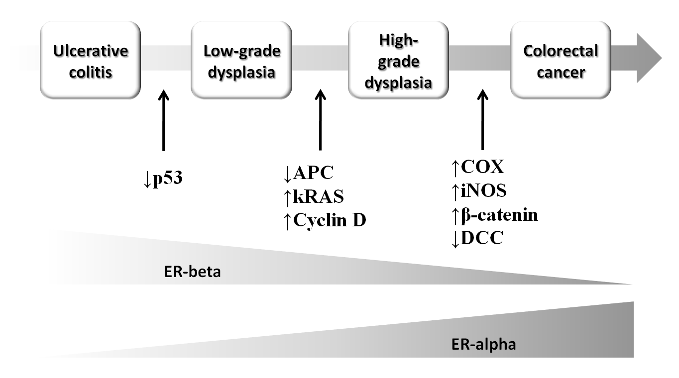
Figure 1 progressive steps of ulcerative colitis -related carcinogenesis, genetic pathways and estrogen receptors alpha and beta patterns.

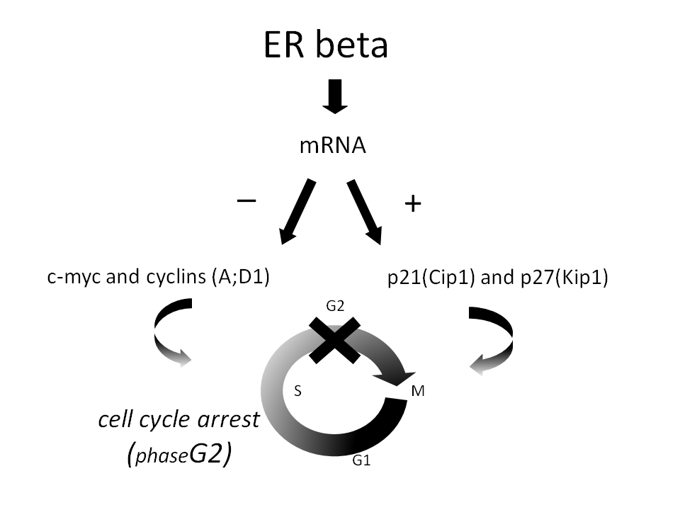
Figure 2 estrogen receptors beta and interactions with genes involved in the regulation of cell cycle. estrogen receptors (ER) beta has an antagonist inhibitory function, mediated by the down-regulation of proto-oncogenes c-myc and cyclins (as indicated by minus sign next to the arrow on the left side) and up-regulation of oncosoppressants p21 and p27 (as indicated by plus sign next to the arrow on the right side). In the lowest part of the figure is indicated the cell cycle phases and the site of its interaction with ER beta induced mediators (G2 phase).

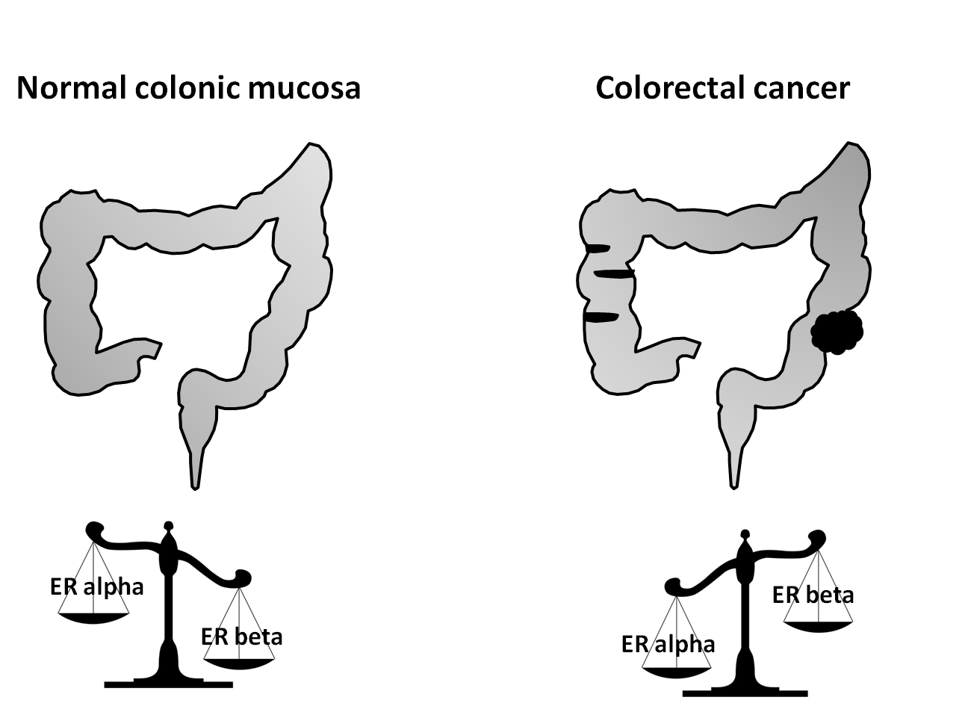
Figure 3 alpha and beta estrogen receptors balance in normal and neoplastic colon.

