Name of Journal: World Journal of Clinical Cases
Manuscript NO: 49442
Manuscript Type: CASE REPORT

Simultaneous Paragonimus infection involving the breast and lung: A case report

Oh MY et al. Simultaneous Paragonimus infection of the breast and lung

Moon Young Oh, Ajung Chu, Jeong Hwan Park, Jong Yoon Lee, Eun Youn Roh, Young Jun Chai, Ki-Tae Hwang

Moon Young Oh, Department of Surgery, Seoul National University Hospital, Seoul 156707, South Korea

Ajung Chu, Jong Yoon Lee, Department of Radiology, Seoul Metropolitan Government Seoul National University Boramae Medical Center, Seoul 156707, South Korea

Jeong Hwan Park, Department of Pathology, Seoul Metropolitan Government Seoul National University Boramae Medical Center, Seoul 156707, South Korea

Eun Youn Roh, Department of Laboratory Medicine, Seoul Metropolitan Government Seoul National University Boramae Medical Center, Seoul 156707, South Korea

Young Jun Chai, Ki-Tae Hwang, Department of Surgery, Seoul Metropolitan Government Seoul National University Boramae Medical Center, Seoul 156707, South Korea

ORCID number: Moon Young Oh (0000-0002-8939-1735); Ajung Chu (0000-0003-2018-6706); Jeong Hwan Park (0000-0003-4522-9928); Jong Yoon Lee (0000-0003-4972-2357); Eun Youn Roh (0000-0002-1787-7509); Young Jun Chai (0000-0001-8830-3433); Ki-Tae Hwang (0000-0001-6597-3119).

Author contributions: Hwang KT designed this study and supervised all processes of this work; Oh MY reviewed the literature and contributed to manuscript drafting; Chu A and Lee JY interpreted the imaging findings; Park JH interpreted the pathological findings; Roh EY provided the patient’s lab results; Chai YJ contributed to manuscript editing; all authors read and approved the final manuscript.

Informed consent statement: The institutional review boards approved this study (Seoul Metropolitan Government Seoul National University Boramae Medical Center, 30-2018-102) with a Waiver of Consent.

Conflict-of-interest statement: The authors declare that no actual or potential conflict of interest exists.

CARE Checklist (2016) statement: The manuscript was prepared and revised according to the CARE Checklist (2016).

Open-Access: This article is an open-access article which was selected by an in-house editor and fully peer-reviewed by external reviewers. It is distributed in accordance with the Creative Commons Attribution Non Commercial (CC BY-NC 4.0) license, which permits others to distribute, remix, adapt, build upon this work non-commercially, and license their derivative works on different terms, provided the original work is properly cited and the use is non-commercial. See: http://creativecommons.org/licenses/by-nc/4.0/

Manuscript source: Unsolicited manuscript

Corresponding author: Ki-Tae Hwang, MD, PhD, Doctor, Department of Surgery, Seoul Metropolitan Government Seoul National University Boramae Medical Center
39, Boramae-Gil, Dongjak-gu, Seoul 156707, South Korea. kiterius@snu.ac.kr
Telephone: +82-2-8702275
Fax: +82-2-8312826

Received: June 3, 2019
Peer-review started: June 5, 2019
First decision: October 24, 2019
Revised: November 22, 2019
Accepted: November 26, 2019
Article in press: November 26, 2019
Published online: December 26, 2019

Abstract
BACKGROUND
Paragonimiasis is a food-borne parasitic infection caused by lung flukes of the genus Paragonimus. Although the most common site of infection is the pleuropulmonary area, the parasite can also reach other parts of the body on its journey from the intestines to the lungs, ending up in locations such as the brain, abdomen, skin, and subcutaneous tissues. Ectopic paragonimiasis is difficult to diagnose due to the rarity of this disease.

CASE SUMMARY
Here, we report a rare case of simultaneous breast and pulmonary paragonimiasis in a woman presenting painless breast mass and lung nodule with a history of eating raw trout. To confirm the diagnosis, serologic testing and tissue confirmation of the breast mass were performed. The patient was treated with surgical resection of the mass and praziquantel medication.

CONCLUSION
Ectopic paragonimiasis is difficult to diagnose due to the rarity of this disease. Thus, thorough history-taking and clinical suspicion of parasitic infection are important.

Key words: Paragonimiasis; Paragonimus westermani; Parasitic infection; Breast mass; Lung nodule; Case report

© The Author(s) 2019. Published by Baishideng Publishing Group Inc. All rights reserved.

Core tip: Paragonimiasis is a parasitic infection caused by lung flukes of genus Paragonimus. Paragonimiasis is an important food-borne worldwide disease. It has been estimated that 22.8 million people worldwide are at risk of paragonimiasis. Here we present a rare case of simultaneous breast and pulmonary paragonimiasis in a woman presenting with a painless breast mass and a lung nodule, who has a history of eating raw trout. To confirm the diagnosis, serologic testing and tissue confirmation of the breast mass were performed. The patient was treated with surgical resection of the mass and praziquantel medication. Because of the rarity of ectopic paragonimiasis, history-taking and clinical suspicion of parasitic infection are important.

Citation: Oh MY, Chu A, Park JH, Lee JY, Roh EY, Chai YJ, Hwang KT. Simultaneous Paragonimus infection involving the breast and lung: A case report. World J Clin Cases 2019; 7(24): 4292-4298
URL: https://www.wjgnet.com/2307-8960/full/v7/i24/4292.htm
DOI: https://dx.doi.org/10.12998/wjcc.v7.i24.4292
INTRODUCTION
Paragonimiasis is a parasitic infection caused by lung flukes of genus Paragonimus. Paragonimus rudis was first reported in the lung of an otter by Diesing in 1885. Since then, 43 species of Paragonimus have been reported. Of many different species of Paragonimus, only 8 species are known to develop and cause disease in man, the most common one being Paragonimus westermani^{[1]}. Paragonimiasis is an important food-borne worldwide disease. It has been estimated that 22.8 million people worldwide are at risk of Paragonimiasis. Human beings are infected by ingesting raw or undercooked crabs, crayfish, and shrimps^{[2]}. The parasites produce toxic substances, which cause aseptic inflammation or granulomatous reaction^{[3]}. Pulmonary paragonimiasis is the most common clinical manifestation. Patients generally present with chronic productive cough and blood-tinged sputum. They may also present hemoptysis, chest pain, and dyspnea, although these symptoms are less frequent. The adult Paragonimus wanders around until it reaches the lungs, but during this migration process, other parts of the body such as the brain, abdomen, skin, heart, and subcutaneous tissues can also be involved^{[3,4]}. Only two cases of breast paragonimiasis have been reported so far^{[5,6]}. There is only one reported case of Paragonimus infection affecting two separate organs^{[7]}. We report a rare case of simultaneous Paragonimus infection involving the breast and lung with review of related literature.

CASE PRESENTATION
Chief complaints
A 43-year-old female patient presented to the hospital with a painless mass of the left breast.

History of present illness
The mass was palpable one month prior to the visit. She had already done a breast sonography at a local clinic. She was recommended to do a biopsy for the breast mass. She transferred to our hospital, a larger tertiary care hospital, for further evaluation. The patient did not remember consuming crabs or crayfish. However, she did mention that she had eaten raw trout recently.

History of past illness
The patient had no underlying disease.

Personal and Family history
The patient denied any family history.

Physical examination
On physical examination, the palpable mass of the left breast was about 1.5 cm in diameter, well-defined, and freely moveable. There was a small amount of nipple discharge. There was no evidence of skin color change or skin retraction.

Laboratory examinations
Enzyme-linked immunosorbent assay (ELISA) was initiated. Results came out positive for paragonimiasis.

Imaging examinations
Mammogram showed an asymmetry at the palpable site of the left inner breast (Figure 1A). Ultrasonogram revealed 2 cm sized circumscribed cystic space connected to the nipple. A 0.2 cm sized hypoechoic irregular tubular mass was demonstrated within the cystic cavity (Figure 1B). This tubular structure was seen to be freely moving within the cavity.

Surgical and pathological findings
A parasitic infection was suspected and excisional biopsy of the breast mass was performed. Inside the excised soft tissue mass, there was a cystic lesion with an irregular inner wall that was grayish white in color with about 2.3 cm for the longest diameter (Figure 2). Inside this cystic lesion was a red, oval-shaped figure that was about 5 mm in longest diameter. It was suspected to be a parasite. This specimen was sent to the Department of Parasitology. It was confirmed to be Paragonimus westermani (Figure 3). The pathology of the left breast mass excluding the parasite itself showed chronic granulomatous inflammation with eosinophilic infiltration, dense lymphoplasmacytic infiltration, and features suggesting parasitic eggs.

Further work-up
The patient was also referred to the Pulmonary Department of Internal Medicine. She complained of blood tinged sputum 3-4 wk prior to the visit. An 18 mm sized elongated nodule at left upper lobe of the lung was seen on chest computed tomography (CT) scan (Figure 4). Clinically, this nodule was considered as a paragonimiasis-related nodule.

FINAL DIAGNOSIS
The final diagnosis of the presented case is paragonimiasis of the breast and lung.

TREATMENT
The breast mass was excised and the patient was treated with praziquantel 25 mg/kg/d for 3 d.

OUTCOME AND FOLLOW-UP
The patient’s postoperative course was uneventful. Follow-up breast examinations and chest X-rays were normal.

DISCUSSION
Paragonimiasis is a food-borne parasitic disease caused by Paragonimus species, the most common one being Paragonimus westermani. These parasites are widely distributed worldwide, especially in Asia, West-Central Africa, Central America, and South America^{[2]}. The parasite causes pulmonary infections most of the time, although it sometimes causes extrapulmonary infections^{[1]}.
Adult worms of Paragonimus are usually encapsulated in the lungs and sometimes in other organs of definite hosts, including humans and other mammals. Eggs produced by these worms can exit the pulmonary system through bronchioles. They can be coughed out or expelled through feces, ultimately ending up in freshwater ponds, streams, or rivers. Their miracidia can then hatch from eggs and enter their first intermediate hosts such as snails to develop into sporocysts, then radiae, and eventually cercariae. Crabs or crayfish can ingest the infected snail. Then cercariae can penetrate crustacean hosts to become metacercariae. Their definitive hosts are known to be infected by eating raw or undercooked crabs or crayfish. These metacercariae will ultimately grow into adult worms^{[8]}. The patient in the reported case had a history of eating raw trout as a potential route of transmission.
When humans are infected, metacercariae can pass through the intestinal wall into the peritoneal cavity and through the diaphragm into the pleural cavity, eventually ending up in the lung parenchyma and finally grow into adult flukes^{[9]}. On its journey to the lungs, the parasite can reach other locations of the body such as the brain, abdomen, skin, heart, and subcutaneous tissues^{[10]}. The primary site of parasitic infection is the lung. Therefore, most patients present with respiratory symptoms such as cough, sputum, chest discomfort, and dyspnea. Subcutaneous paragonimiasis is rare compared to pulmonary and other ectopic manifestations. Its diagnosis is difficult due to rarity of the disease with various symptoms^{[9,11]}. In the present case, paragonimiasis manifested both in pulmonary and extrapulmonary forms, presenting as a breast mass and a lung nodule.
Mammography and ultrasonography examinations were used to diagnose the breast mass in our patient. Mammography revealed limited information of the mass, but the ultrasonography was able to reveal a cystic cavity as well as the real time imaging of the moving worm inside. On the other hand, the lung nodule was diagnosed with a chest CT scan. The main features of pleuropulmonary paragonimiasis on chest CT scans are mediastinal lymphadenopathy, and subfissural or subpleural nodules^{[12]}. Likewise, mediastinal lymph node enlargement was seen in our patient’s scan, and because the scan was performed after the pathological diagnosis of breast paragonimiasis, this nodule was clinically considered as a paragonimiasis-related nodule. Magnetic resonance imaging (MRI) scan would have also been a great diagnostic imaging tool, as it is a promising non-invasive parameter for the assessment of both breast masses and mediastinal masses^{[13]}. However, MRI scan is expensive compared to other imaging tools, bringing to question its cost-effectiveness, because parasitic infection of the breast was well diagnosed with ultrasonography in this case.
ELISA test, an immunodiagnostic method that can detect and measure antibodies in the blood, is known to be both highly sensitive and specific for diagnosing paragonimiasis^{[9,14]}. Infection by Paragonimus can be prevented by not eating raw or undercooked crabs and crayfish. Praziquantel is the first-line treatment for human paragonimiasis. It is proven to be highly effective^{[9,15,16]}. To the best of our knowledge, only two cases of paragonimiasis of the breast have been reported so far^{[6,7]}. Paragonimiasis was diagnosed by fine-needle aspiration biopsy in both cases and ELISA test was done only in one of these two cases. In both cases, patients were treated with praziquantel^{[6,7]}. In our patient, biopsy by surgical resection as well as ELISA test were performed for the diagnosis. For treatment, she was also prescribed praziquantel.
Up to now, only one case has been reported of Paragonimus infection that simultaneously involved two separate organs^{[7]}. In the mentioned case, a computed tomography scan of the patient revealed a pulmonary cavity lesion and an adrenal mass when he presented with hemotypsis. Both lesions were confirmed as Paragonimus infection by surgical resection^{[7]}. Our patient also presented with lesions of two different organs, a breast mass and a lung nodule. She first presented with a breast mass. She was diagnosed and treated for breast paragonimiasis. It was only after the management of the breast mass that she was referred to the Pulmonology Department for intermittent symptom of blood tinged sputum and clinically diagnosed with pulmonary paragonimiasis for the lung nodule seen on computed tomography scan. The breast mass was confirmed by surgical resection as a Paragonimus infection and the lung nodule was clinically considered as a paragonimiasis-related nodule. This is a first case of extrapulmonary paragonimiasis manifesting as a breast mass with simultaneous pulmonary Paragonimus infection.

CONCLUSION
The patient presented with a painless breast mass and a lung nodule as seemingly two unrelated manifestations. Thus, differential diagnosis of a painless breast mass along with a pulmonary nodule is important, especially to rule out malignancy and metastasis. Because of the rarity of subcutaneous paragonimiasis, clinical suspicion of parasitic infection is important and proper history-taking is of essence.

REFERENCES
1 Choi DW. Paragonimus and paragonimiasis in Korea. Kisaengchunghak Chapchi 1990; 28 Suppl: 79-102 [PMID: 2133425 DOI: 10.3347/kjp.2013.51.6.621]
2 Sah R, Khadka S. Case series of paragonimiasis from Nepal. Oxf Med Case Reports 2017; 2017: omx083 [PMID: 29230303 DOI: 10.1093/omcr/omx083]
3 Abdel Razek AA, Watcharakorn A, Castillo M. Parasitic diseases of the central nervous system. Neuroimaging Clin N Am 2011; 21: 815-841, viii [PMID: 22032501 DOI: 10.1016/j.nic.2011.07.005]
4 Roy P, Praharaj AK, Dubey S. An unusual case of human paragonimiasis. Med J Armed Forces India 2015; 71: S60-S62 [PMID: 26265873 DOI: 10.1016/j.mjafi.2013.02.008]
5 Fogel SP, Chandrasoma PT. Paragonimiasis in a cystic breast mass: case report and implications for examination of aspirated cyst fluids. Diagn Cytopathol 1994; 10: 229-231 [PMID: 8050330 DOI: 10.1002/dc.2840100308]
6 Jun SY, Jang J, Ahn SH, Park JM, Gong G. Paragonimiasis of the breast. Report of a case diagnosed by fine needle aspiration. Acta Cytol 2003; 47: 685-687 [PMID: 12920767 DOI: 10.1159/000326589]
7 Kwon YS, Lee HW, Kim HJ. Paragonimus westermani infection manifesting as a pulmonary cavity and adrenal gland mass: A case report. J Infect Chemother 2019; 25: 200-203 [PMID: 30213500 DOI: 10.1016/j.jiac.2018.08.005]
8 Liu Q, Wei F, Liu W, Yang S, Zhang X. Paragonimiasis: an important food-borne zoonosis in China. Trends Parasitol 2008; 24: 318-323 [PMID: 18514575 DOI: 10.1016/j.pt.2008.03.014]
9 Kim MJ, Kim SH, Lee SO, Choi SH, Kim YS, Woo JH, Yoon YS, Kim KW, Cho J, Chai JY, Chong YP. A Case of Ectopic Peritoneal Paragonimiasis Mimicking Diverticulitis or Abdominal Abscess. Korean J Parasitol 2017; 55: 313-317 [PMID: 28719956 DOI: 10.3347/kjp.2017.55.3.313]
10 Lee CH, Kim JH, Moon WS, Lee MR. Paragonimiasis in the abdominal cavity and subcutaneous tissue: report of 3 cases. Korean J Parasitol 2012; 50: 345-347 [PMID: 23230333 DOI: 10.3347/kjp.2012.50.4.345]
11 Kodama M, Akaki M, Tanaka H, Maruyama H, Nagayasu E, Yokouchi T, Arimura Y, Kataoka H. Cutaneous paragonimiasis due to triploid Paragonimus westermani presenting as a non-migratory subcutaneous nodule: a case report. J Med Case Rep 2014; 8: 346 [PMID: 25322860 DOI: 10.1186/1752-1947-8-346]
12 Shim SS, Kim Y, Lee JK, Lee JH, Song DE. Pleuropulmonary and abdominal paragonimiasis: CT and ultrasound findings. Br J Radiol 2012; 85: 403-410 [PMID: 22457403 DOI: 10.1259/bjr/30366021]
13 Abdel Razek AA, Soliman N, Elashery R. Apparent diffusion coefficient values of mediastinal masses in children. Eur J Radiol 2012; 81: 1311-1314 [PMID: 21439745 DOI: 10.1016/j.ejrad.2011.03.008]
14 Imai J. Evaluation of ELISA for the diagnosis of paragonimiasis westermani. Trans R Soc Trop Med Hyg 1987; 81: 3-6 [PMID: 3127958 DOI: 10.1016/0035-9203(87)90267-7]
15 Ibáñez N, Jara C. Experimental paragonimiasias: therapeutical tests with praziquantel--first report. Mem Inst Oswaldo Cruz 1992; 87 Suppl 1: 107 [PMID: 1343785 DOI: 10.1590/s0074-02761992000500022]
16 Kashida Y, Niiro M, Maruyama H, Hanaya R. Cerebral Paragonimiasis With Hemorrhagic Stroke in a Developed Country. J Stroke Cerebrovasc Dis 2018; 27: 2648-2649 [PMID: 30031686 DOI: 10.1016/j.jstrokecerebrovasdis.2018.05.033]

P-Reviewer: El-Razek AA S-Editor: Zhang L L-Editor: A E-Editor: Xing YX

Specialty type: Medicine, Research and Experimental
Country of origin: South Korea
Peer-review report classification
Grade A (Excellent): 0
Grade B (Very good): 0
Grade C (Good): C
Grade D (Fair): 0
Grade E (Poor): 0
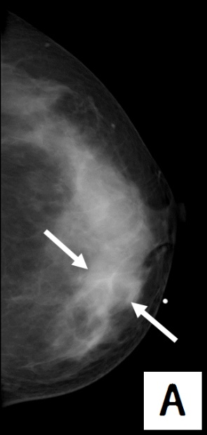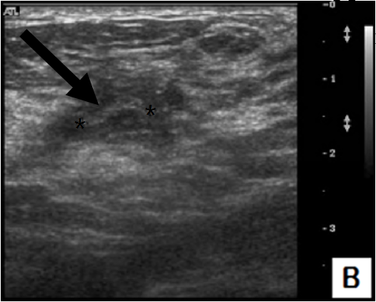
Figure 1 Breast mammography and ultrasonography findings. A: Mammography (craniocaudal view) shows an asymmetry at the palpable site of the left inner breast (white arrows); B: Ultrasonography shows a tubular structure inside, approximately 1 cm long and with a circular diameter of 0.2 cm (black arrow).

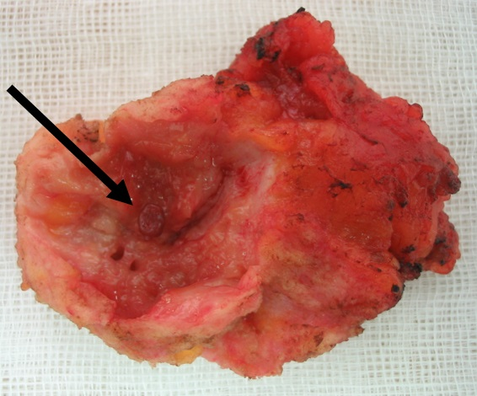
Figure 2 Gross specimen. A cystic lesion of the excised soft tissue mass, with an irregular inner wall, was about 2.3 cm in longest diameter, and grayish white in color. The parasite was oval-shaped, red in color, and measured to be about 5 mm in longest diameter (arrow).

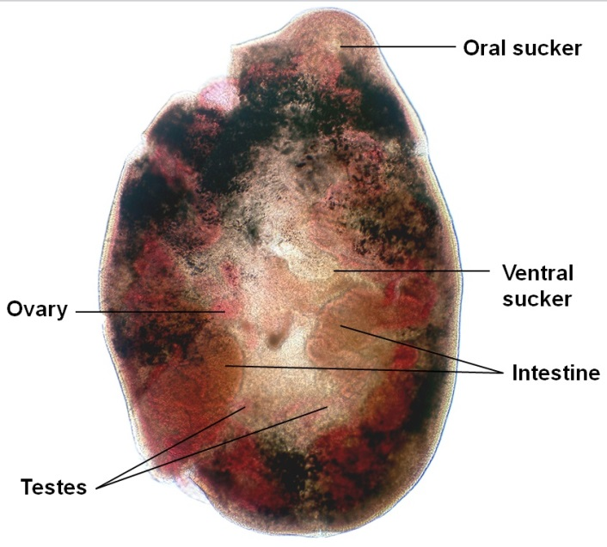
Figure 3 Paragonimus westermani juvenile worm. The oral sucker is located on one end of the worm, and the ventral sucker is located at its center. The ovary and testes are stained red, and are less finely branched compared to that of adult worms. The intestines of the worm take a brown color and occupy the lateral fields.

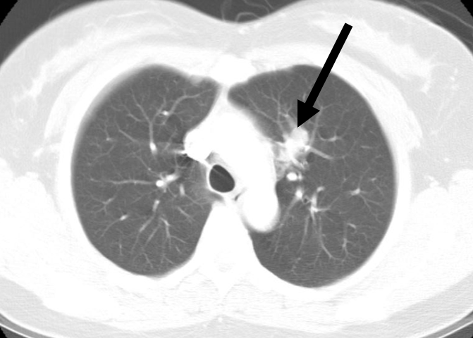
Figure 4 Chest computed tomography findings. 18 mm sized elongated nodule at left upper lobe of the lung (arrow).

