Name of Journal: World Journal of Cardiology
Manuscript NO: 61884
Manuscript Type: MINIREVIEWS

Large eustachian valve fostering paradoxical thromboembolism: Passive bystander or serial partner in crime?

Onorato EM. Prominent EV increases risk for left circulation thromboembolism

Eustaquio Maria Onorato

Eustaquio Maria Onorato, Invasive Cardiology Unit, Centro Cardiologico Monzino, Istituto di Ricovero e Cura a Carattere Scientifico, Milan 20138, Italy

Author contributions: Onorato EM analyzed the literature, prepared the figures and wrote the paper.

Corresponding author: Eustaquio Maria Onorato, MD, Consultant Physician-Scientist, Invasive Cardiology Unit, Centro Cardiologico Monzino, Istituto di Ricovero e Cura a Carattere Scientifico, Via C. Parea, 4, Milan 20138, Italy. eustaquio.onorato@gmail.com

Received: December 21, 2020
Revised: January 6, 2021
Accepted: March 26, 2021
Published online:

Abstract
Catheter-based closure of a patent foramen ovale (PFO) is more effective than medical therapy in the prevention of recurrent stroke^{[1]}. It is likely that a proportion of patients evaluated for potential transcatheter PFO closure actually have different anatomical variants that are common to the right atrium such as a eustachian valve (EV), Chiari network, thebesian valve, or crista terminalis. Notably, an EV may represent an increased risk of left circulation thromboembolism beyond that associated with PFO size and shunting. Such patients may benefit the most from a percutaneous closure procedure.

Key Words: Eustachian valve; Chiari network; Patent foramen ovale; Right-to-left shunt; Paradoxical embolism; Echocardiography

Onorato EM. Large eustachian valve fostering paradoxical thromboembolism: Passive bystander or serial partner in crime? World J Cardiol 2021; In press

Core Tip: A eustachian valve (EV) is usually considered to be a benign finding in the absence of associated cardiac anomalies. Moreover, an EV is frequently found in adult patients with septal abnormalities, mainly patent foramen ovale (PFO). It may actively facilitate the mechanism of paradoxical embolism by directing the blood from the inferior vena cava toward the interatrial septum and into the left atrium through the PFO. Therefore, the presence of such anatomic variant may itself increase the risk of left circulation thromboembolism.
INTRODUCTION
Bartolomeo Eustachio (San Severino Marche, Macerata 1507 (?)–Fossato di Vico, Perugia, Italy, 1574), also known by his latin name, Eustachius, was an Italian anatomist and one of the founders of human and comparative anatomy. He had a comprehensive humanistic education, in the course of which he acquired an excellent knowledge of Greek, Hebrew, and Arabic. Recognition of Eustachio's greatest contributions to anatomical science overcame many obstacles that kept his real merit from being recognized until long after his death. His greatest work, which he was unable to publish, is the “De dissensionibus et controversiis anatomicis” illustrated in the Anatomical Engravings (Tabulae). The copper plate engravings illustrate the results of Eustachio’s dissections. They were completed in 1552 but discovered only 162 years later in the early eighteenth century in the possession of a descendant of Pier Matteo Pini, to whom Eustachio had bequeathed them. They were later purchased by Pope Clement XI for 600 scudi and presented to Giovanni Maria Lancisi, his physician and the successor to Eustachio in the chair of anatomy at the Sapienza in Rome. Lancisi published the plates in 1714 together with eight smaller ones that had already appeared in 1564^{[2,3]} (Figure 1). Although devoid of Eustachio’s planned text, the plates alone assured him a distinguished position in the history of anatomy. The fact that his book became a bestseller more than a century after his death shows the extent of the religious restrictions on anatomists throughout the Renaissance. In his work on the azygos vein and its branches (Opuscula Anatomica, 1564), Eustachio described the thoracic duct and particularly the “valvula venae cavae inferioris” (known as the eustachian valve) that lies at the junction of the inferior vena cava and right atrium (RA) and which serves to direct the blood through the foramen ovale into the left atrium (LA), indicating a detailed and relatively advanced knowledge of the heart’s structure. His description of the fetal circulation was the most complete of the time and includes the most important structural differences between the circulatory apparatus of adults and children.
Incomplete regression of the right sinus valve of the sinus venosus results in a spectrum of vestiges such as the Chiari network, eustachian valve (EV), thebesian valve of the coronary sinus, and crista terminalis. In particular, the EV is a remnant of the embryonic valve of the inferior vena cava (IVC), which directs oxygenated blood (from the placenta) toward the foramen ovale of the fetal heart and into the systemic circulation. It appears as a crescent-shaped membrane that extends from the IVC to the lower part of the fossa ovalis. The shape, thickness, texture, and the extent to which the EV encroaches on neighboring structures such as the atrial septum are highly variable. Its average length is 3.6 mm, ranging from 1.5 to 23 mm^{[4]}. Over time, the EV disappears completely, being represented only by a thin ridge. It most often appears as a crescentic fold of endocardium arising from the anterior rim of the IVC orifice. The lateral horn of the crescent tends to meet the lower end of the crista terminalis, while the medial horn joins the thebesian valve, a semicircular valvular fold at the orifice of the coronary sinus (Figure 2). Sometimes, the EV persists as a mobile, elongated structure projecting deeply into the right atrial cavity and shows an undulating motion in real-time echocardiography. When it is quite large, it may be confused with right atrial tumors, thrombi, or vegetation. The superior vena cava, on the contrary, does not have a homologous valve.

What is the prevalence OF EV and ITS anatomical patterns?
The prevalence of EV in the general population is not known, as the diagnostic criteria vary in different studies. Yater^{[5]} reported finding a persisting EV in approximately 60% of 120 consecutive adult necropsies. Limacher et al^{[4]} found an incidence of approximately 70% in children of various ages. On transesophageal echocardiography (TEE), a persisting EV was found in 4.2% of the patients, and its prevalence was similar in men and in women^{[6]}. The features and the physiology of the EV have been well described by 2-dimensional/3-dimensional echocardiography^{[7,8]}.
Three different anatomical patterns have been described (Figures 3-6). (1) A Chiari network, found in 2%-3% of normal hearts at autopsy^{[9]}, is a reticular filamentous membrane that is attached to the upper wall of the RA along the ridge connecting the vena cava and atrial septum. It often appears as a web-like structure with a variable number of thread-like components^{[10]}. (2) A eustachian ridge (ER), also known as a sinus septum, is prominently located between the fossa ovalis and the coronary sinus ostium. The medial portion of the EV is inserted in that structure and continues in the tendon of Todaro, which continues on the ER toward the central fibrous body^{[11]}. (3) An EV, also called a valvula venae cavae inferioris, is characterized by a mobile fenestrated membrane without any anatomic connection^{[12]}, and is often misdiagnosed as an intra-atrial thrombus.

CLUES FROM CLINICAL FEATURES ASSOCIATED WITH INCREASED RISK OF PARADOXICAL EMBOLISM
A persisting EV in the absence of other structural heart diseases is believed to have no pathological importance. Nevertheless, EVs are frequently found in adult patients with septal abnormalities, mainly a patent foramen ovale (PFO) but also an atrial septal defect (ASD). It may participate in the mechanism of paradoxical embolism by maintaining an embryonic right atrial flow pattern into adult life and directing the blood from the IVC into the LA via the PFO. Therefore, the presence of a prominent, large EV may increase the chance of paradoxical embolization beyond that associated with the size of the PFO and the amount of shunting.
Several reports have documented cyanosis in patients with ASD without an increase in right heart pressure but in whom the congenital defect was associated with a prominent EV, which implicates the valve as the possible source of the right-to-left shunt^{[13]}. The findings support the hypothesis that patients with a cryptogenic stroke (CS) and an ASD or PFO combined with a prominent EV may benefit from interventional closure of the interatrial communication. A persisting EV, particularly a prominent one, has frequently been observed in cases of platypnea-orthodeoxia syndrome^{[14,15]}.
Furthermore, a large ER or a prominent EV may pose issues with device placement because those right atrial structures limit the available space over the fossa ovalis on the right atrial side and may cause a PFO device to sit away from the fossa ovalis. The disc may rest on the ER or EV and result in the PFO tunnel remaining open, with a persistent residual shunt. Comprehensive assessment on 2-dimensional/3-dimensional TEE imaging is needed to accurately assess how such structures will impact on device choice and size. An EV may also interfere with manipulation of the guidewire and it may be caught in the device during deployment, interfering with the occluder position. If drawn across the septum into the LA, the EV may increase the embolic risk. A case series report showed the practicability of using a steerable ablation catheter to deflect the EV away from the interatrial septum during the procedure^{[16]}.
Complications related to the presence of EV may occur such as obstruction of the IVC, thrombosis, and the possibility of a subsequent pulmonary embolism. Occasionally, the EV crosses the floor of the RA from the orifice of the IVC and inserts into the lower portion of the interatrial septum adjacent to the atrioventricular valves. Higher insertion of a very prominent EV mimicking the echocardiographic appearance of divided RA is very rare^{[17]}. Such a configuration of a large EV may also mimic a right atrial cystic tumor^{[18]}.

A SUMMARY OF ARGUMENTS SUPPORTING THE GUILT OF EVs AS A SERIAL PARTNER IN CRIME
An EV redirects flow from the IVC toward the interatrial septum and into the LA through a right-to-left shunt
That can account for left-side circulation and paradoxical thromboembolism. Indeed, a multivariate analysis showed that the presence of a prominent EV or Chiari network was independently related to CS and both have been included in risk prediction models to identify patients at the highest risk of paradoxical embolism^{[19]}. Specifically, the odds ratio for an EV or Chiari network as a factor related to CS was 4.47 in univariate analysis (P = 0.002) and 4.71 in multivariate analysis (P = 0.009).

An EV predicts the prognosis and outcome following percutaneous PFO closure
Large EVs were found to predict the occurrence of a residual shunt in patients who underwent PFO closure for cryptogenic cerebral ischemia^{[20]}. Inglessis et al^{[21]} found that the detection of an EV on transthoracic echocardiography (hazard ratio: 9.04; 95% confidence interval: 2.07 to 39.44; P < 0.0034) was significantly associated with the occurrence of cerebrovascular events after PFO closure. Interestingly, three patients with a prominent EV who suffered a recurrent event had persistent residual shunts after PFO closure.

An EV may be the nidus for thrombus formation
In situ thrombus formation or the adhesion of embolic material from a distant source such as lower extremity deep vein thrombosis places PFO patients with hypercoagulable states at very high risk.

An EV may be a nidus for tumors
Rare (myxomas, cystic tumors, fibroelastic papillomas).

An EV may interfere with device placement
Presence of either an EV or Chiari network may hinder the passage of guidewires, reduce the available space in the RA or even interfere with device placement^{[22]}.

An EV may interfere with IVC cannulation
A detailed echocardiographic inspection of right atrial anatomy can help, suggesting an alternative plan to prevent complications during surgery^{[23]}.

An EV may mimic an ASD rim
This presentation potentially complicates a simple percutaneous ASD device closure. The free end can be confused with the superior ASD rim on a TEE bicaval view^{[24,25]}. During surgery the EV could be mistaken for the true septum. Inadvertently incorporation into the patch could result in an iatrogenic right-to-left shunt because of diversion of the IVC blood flow into the LA^{[26]}.

CONCLUSION
Echocardiography plays a key role in the identification and understanding of EVs and the other structural abnormalities of the right atrium. It also helps to avoid misdiagnosis and the occurrence of complications of interventional PFO and ASD closure procedures. Large, prominent EVs have been found guilty at all the degrees of judgment of increasing the risk of paradoxical thromboembolism in patients with right-to-left shunting via a PFO. Bartolomeo Eustachio, the papal anatomist, would never have thought that his valve could have been identified as a serial partner in crime.

Acknowledgments
The Author would like to acknowledge Marta Clara Onorato who contributed in this minireview with the freehand drawing of the papal anatomist, Bartolomeo Eustachio.

REFERENCES
1 Ahmad Y, Howard JP, Arnold A, Shin MS, Cook C, Petraco R, Demir O, Williams L, Iglesias JF, Sutaria N, Malik I, Davies J, Mayet J, Francis D, Sen S. Patent foramen ovale closure vs. medical therapy for cryptogenic stroke: a meta-analysis of randomized controlled trials. Eur Heart J 2018; 39: 1638-1649 [PMID: 29590333 DOI: 10.1093/eurheartj/ehy121]

2 Conforti M. The Biblioteca Lancisiana and the 1714 edition of Eustachi’s anatomical plates. Maria Pia Donato and Jill Kraye. In: Donato MP, Kraye J, editors. Conflicting duties: Science, Medicine and Religion in Rome, 1550-1750, London, Warburg Institute; 2009: 303-317
2. Eustachi, Bartholomeo (d. 1574). Title: Tabulae anatomicae. Publication Information: Rome: P. Junchus, 1783. U.S. National Library of Medicine, 8600 Rockville Pike, Bethesda, MD 20894 National Institutes of Health, Health & Human Services Freedom of Information Act, NLM.

3 Simpson D. The papal anatomist: Eustachius in renaissance Rome. ANZ J Surg 2011; 81: 905-910 [PMID: 22507418 DOI: 10.1111/j.1445-2197.2011.05793.x]
4 Limacher MC, Gutgesell HP, Vick GW, Cohen MH, Huhta JH. Echocardiographic anatomy of the eustachian valve. Am J Cardiol 1986; 57: 363-365 [PMID: 3946237 DOI: 10.1016/0002-9149(86)90930-6]
5 Yater WM. Variations and anomalies of the venous valves of the right atrium of the human heart. Arch Pathol 1929; 7: 418-441
6 Marek D, Sovova E, Kocianova E. The prevalence of eustachian valve on transoesophageal echo examination. Biomed Pap Med Fac Univ Palacky Olomouc Czech Repub 2011; 155: 283-285 [PMID: 22286815 DOI: 10.5507/bp.2011.025]
7 Okamoto M, Beppu S, Nagata S, Park YD, Masuda Y, Sakakibara H, Nimura Y. [Echocardiographic features of the eustachian valve and its clinical significance (author's transl)]. J Cardiogr 1981; 11: 271-276 [PMID: 7264390]
8 Maeno YV, Boutin C, Benson LN, Nykanen D, Smallhorn JF. Three-dimensional transesophageal echocardiography for secundum atrial septal defects with a large eustachian valve. Circulation 1999; 99: E11 [PMID: 10338469 DOI: 10.1161/01.cir.99.20.e11]
9 Werner JA, Cheitlin MD, Gross BW, Speck SM, Ivey TD. Echocardiographic appearance of the Chiari network: differentiation from right-heart pathology. Circulation 1981; 63: 1104-1109 [PMID: 7471371 DOI: 10.1161/01.cir.63.5.1104]
10 Chiari H. Uber netzbildungen im rechten vorhof des herzens. Beitr Pathol Anat 1897; 22: 1-10
11 Faletra FF, Ho SY, Auricchio A. Anatomy of right atrial structures by real-time 3D transesophageal echocardiography. JACC Cardiovasc Imaging 2010; 3: 966-975 [PMID: 20846634 DOI: 10.1016/j.jcmg.2010.03.014]
12 De Dominicis E, Ometto R, Frigiola A, Menicanti L, Arfiero S, Vincenzi M. [Echocardiographic aspects of persistence of the right valve of the venous sinus]. G Ital Cardiol 1985; 15: 80-83 [PMID: 4007356]
13 Morishita Y, Yamashita M, Yamada K, Arikawa K, Taira A. Cyanosis in atrial septal defect due to persistent eustachian valve. Ann Thorac Surg 1985; 40: 614-616 [PMID: 4074009 DOI: 10.1016/s0003-4975(10)60359-1]
14 Blanche C, Noble S, Roffi M, Testuz A, Müller H, Meyer P, Bonvini JM, Bonvini RF. Platypnea-orthodeoxia syndrome in the elderly treated by percutaneous patent foramen ovale closure: a case series and literature review. Eur J Intern Med 2013; 24: 813-817 [PMID: 24007641 DOI: 10.1016/j.ejim.2013.08.698]
15 Teupe CH, Groenefeld GC. Platypnea-orthodeoxia due to osteoporosis and severe kyphosis: a rare cause for dyspnea and hypoxemia. Heart Int 2011; 6: e13 [PMID: 22049312 DOI: 10.4081/hi.2011.e13]
16 McMahon CJ, Pignatelli RH, Rutledge JM, Mullins CE, Grifka RG. Steerable control of the eustachian valve during transcatheter closure of secundum atrial septal defects. Catheter Cardiovasc Interv 2000; 51: 455-459 [PMID: 11108680 DOI: 10.1002/1522-726x(200012)51:4<455::aid-ccd17>3.0.co;2-e]
17 Martínez-Quintana E, Rodríguez-González F, Marrero-Santiago H, Santana-Montesdeoca J, López-Gude MJ. Cor triatriatum dexter versus prominent Eustachian valve in an adult congenital heart disease patient. Congenit Heart Dis 2013; 8: 589-591 [PMID: 22469336 DOI: 10.1111/j.1747-0803.2012.00648.x]
18 Malaterre HR, Kallee K, Périer Y. Eustachian valve mimicking a right atrial cystic tumor. Int J Card Imaging 2000; 16: 305-307 [PMID: 11219602 DOI: 10.1023/a:1026521306831]
19 Nakayama R, Takaya Y, Akagi T, Watanabe N, Ikeda M, Nakagawa K, Toh N, Ito H. Identification of High-Risk Patent Foramen Ovale Associated With Cryptogenic Stroke: Development of a Scoring System. J Am Soc Echocardiogr 2019; 32: 811-816 [PMID: 31130417 DOI: 10.1016/j.echo.2019.03.021]
20 Scacciatella P, Butera G, Meynet I, Giorgi M, D'Amico M, Pennone M, Alunni G, Frisenda V, Pelloni E, Marra S. Percutaneous closure of patent foramen ovale in patients with anatomical and clinical high-risk characteristics: long-term efficacy and safety. J Interv Cardiol 2011; 24: 477-484 [PMID: 21539612 DOI: 10.1111/j.1540-8183.2011.00652.x]
21 Inglessis I, Elmariah S, Rengifo-Moreno PA, Margey R, O'Callaghan C, Cruz-Gonzalez I, Baron S, Mehrotra P, Tan TC, Hung J, Demirjian ZN, Buonanno FS, Ning M, Silverman SB, Cubeddu RJ, Pomerantsev E, Schainfeld RM, Dec GW Jr, Palacios IF. Long-term experience and outcomes with transcatheter closure of patent foramen ovale. JACC Cardiovasc Interv 2013; 6: 1176-1183 [PMID: 24262618 DOI: 10.1016/j.jcin.2013.06.013]
22 Onorato E, Pera IG, Melzi G, Rigatelli G. Persistent redundant Eustachian valve interfering with Amplatzer PFO occluder placement: anatomico-clinical and technical implications. Catheter Cardiovasc Interv 2002; 55: 521-524 [PMID: 11948904 DOI: 10.1002/ccd.10141]
23 Sarupria A, Bhuvana V, Mani M, Kumar AS. Large Eustachian valve: an incidental finding yet perplexing. Ann Card Anaesth 2014; 17: 309-310 [PMID: 25281632 DOI: 10.4103/0971-9784.142073]
24 Raut MS, Maheshwari A, Dubey S, Shivnani G, Makhija A, Mohanty A. Eustachian valve - Masquerading ASD rim. Indian Heart J 2016; 68: 368-369 [PMID: 27316494 DOI: 10.1016/j.ihj.2016.03.026]
25 Krishnamoorthy KM, Gopalakrishnan A, Kumar DS, Sivasankaran SS. Eustachian valve-Masquerading ASD rim. Indian Heart J 2017; 69: 422-423 [PMID: 28648449 DOI: 10.1016/j.ihj.2017.04.011]
26 Desnick SJ, Neal WA, Nicoloff DM, Moller JH. Residual right-to-left shunt following repair of atrial septal defect. Ann Thorac Surg 1976; 21: 291-295 [PMID: 773318 DOI: 10.1016/s0003-4975(10)64313-5]

Footnotes
Conflict-of-interest statement: The authors declare that they have no competing interests.

Open-Access: This article is an open-access article that was selected by an in-house editor and fully peer-reviewed by external reviewers. It is distributed in accordance with the Creative Commons Attribution NonCommercial (CC BY-NC 4.0) license, which permits others to distribute, remix, adapt, build upon this work non-commercially, and license their derivative works on different terms, provided the original work is properly cited and the use is non-commercial. See: http://creativecommons.org/Licenses/by-nc/4.0/

Manuscript source: Unsolicited manuscript

Peer-review started: December 21, 2020
First decision: December 27, 2020
Article in press:

Specialty type: Cardiac and cardiovascular systems
Country/Territory of origin: Italy
Peer-review report’s scientific quality classification
Grade A (Excellent): 0
Grade B (Very good): B
Grade C (Good): C
Grade D (Fair): 0
Grade E (Poor): 0

P-Reviewer: Ciccone MM, Schoenhagen P S-Editor: Zhang L L-Editor: Filipodia P-Editor:

Figure Legends
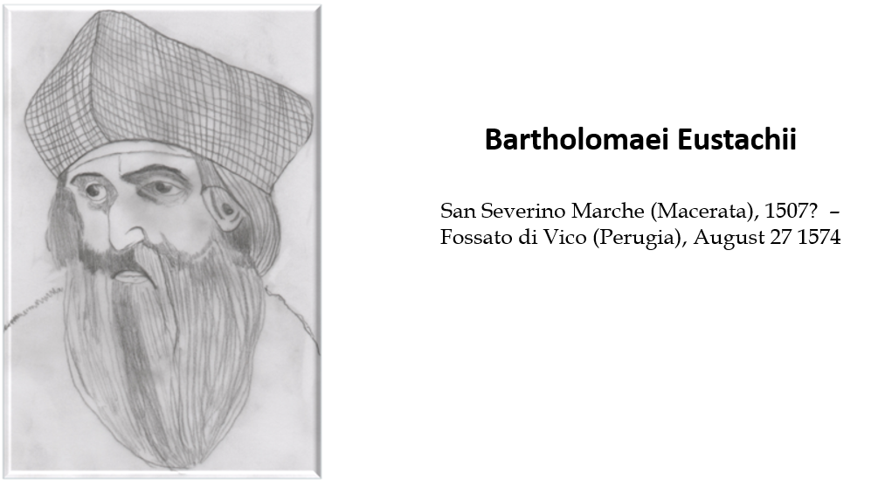
Figure 1 Bartolomeo Eustachio, also known by his latin name of Eustachius, was a distinguished physician of the Renaissance period, professor of anatomy at the medical faculty of Collegio della Sapienza in Rome, and one of the founders of the science of modern human anatomy.

In the Figure, Bartholomeo Eustachio instead of Bartholomaei Eustachii
The correct Figure 1.tiff is below. Legend is OK.

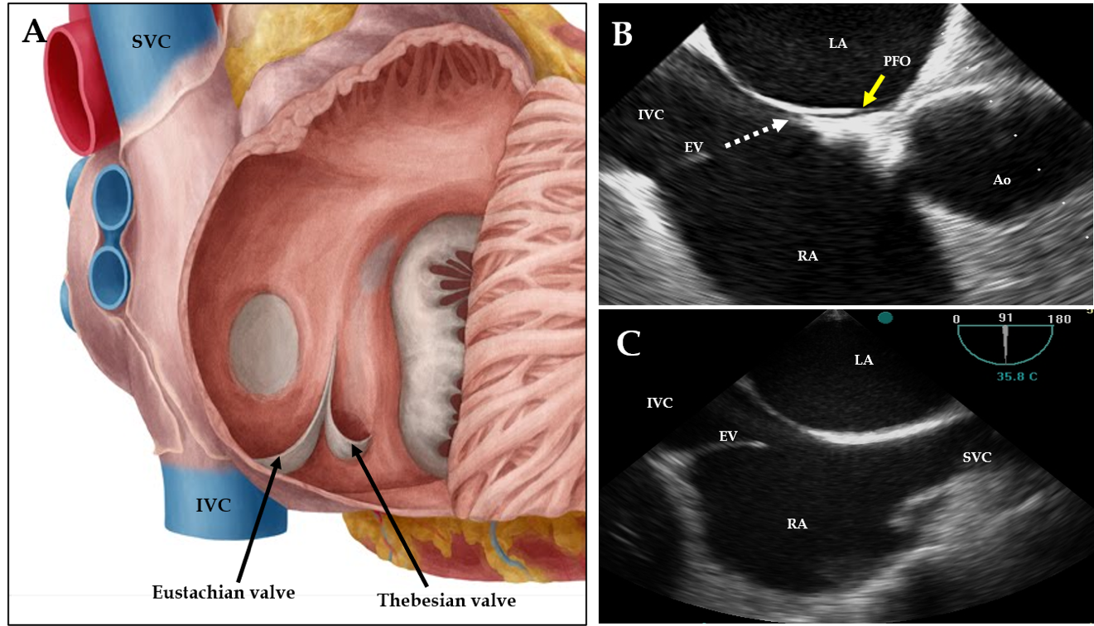

Figure 2 Eustachian valve anatomy. A: Anatomical illustration; B, C: Two-dimensional transesophageal echocardiogram in sagittal (B) and in bicaval views (C) showing the specific orientation of the eustachian valve (EV) directing the blood (orange dashed arrow) toward the interatrial septum and patent foramen ovale (PFO) (yellow line). Ao: Aorta; IVC: Inferior vena cava; LA: Left atrium; RA: Right atrium; SVC: Superior vena cava.
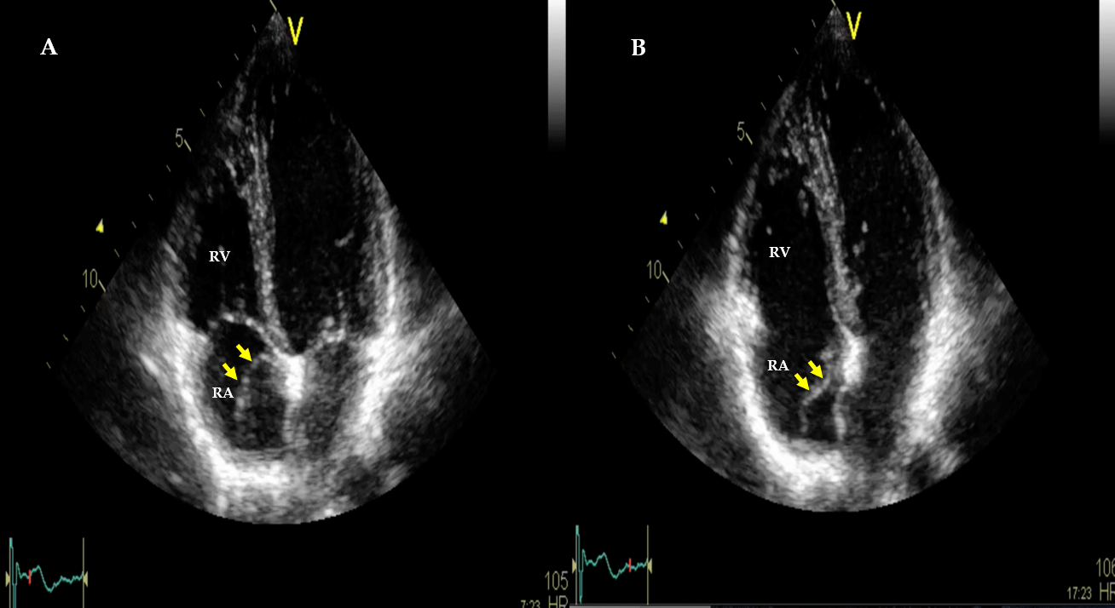
Figure 3 Two-dimensional transthoracic echocardiogram in apical four-chamber views showing the eustachian valve as an elongated mobile structure (orange arrows) projecting into the right atrial cavity, showing an undulating motion during cardiac cycles. A: Systole; B: Diastole. LA: Left atrium; RA: Right atrium.
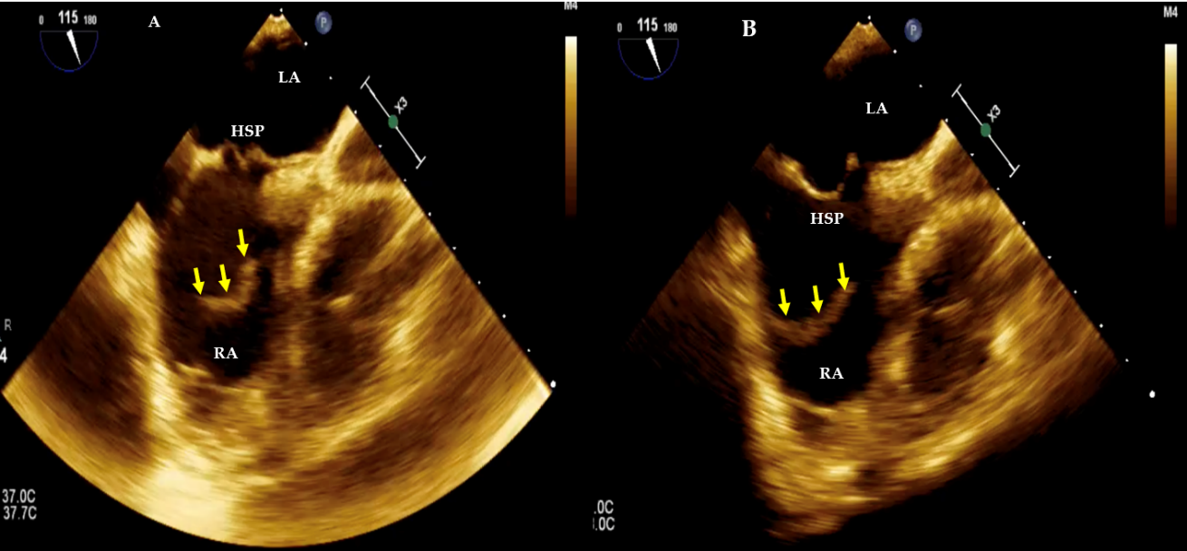
Figure 4 Two-dimensional transesophageal echocardiogram bicaval views. A, B: Systolic frame (A) and diastolic frame (B) showing a prominent elongated eustachian valve (yellow arrows) without any anatomic connection and pointing toward the hypermobile septum primum (HSP). LA: Left atrium; RA: Right atrium.

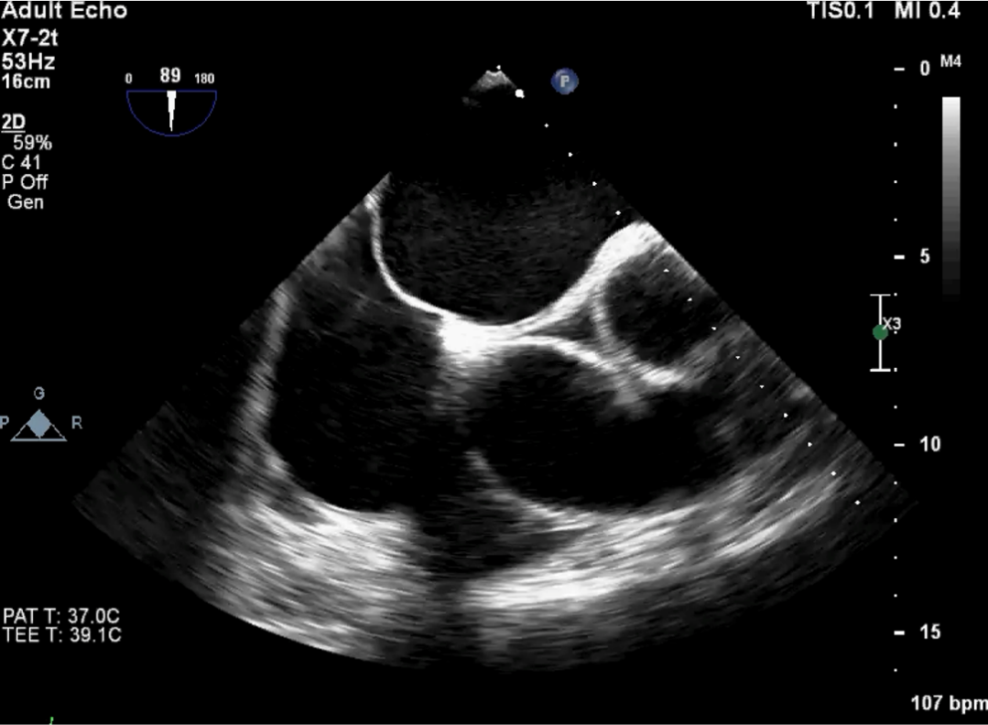
Figure 5 Two-dimensional transesophageal echocardiogram in bicaval view showing a large floppy eustachian valve.

Figure 5 is actually the Supplementary Video S1
(attached in the email reply)

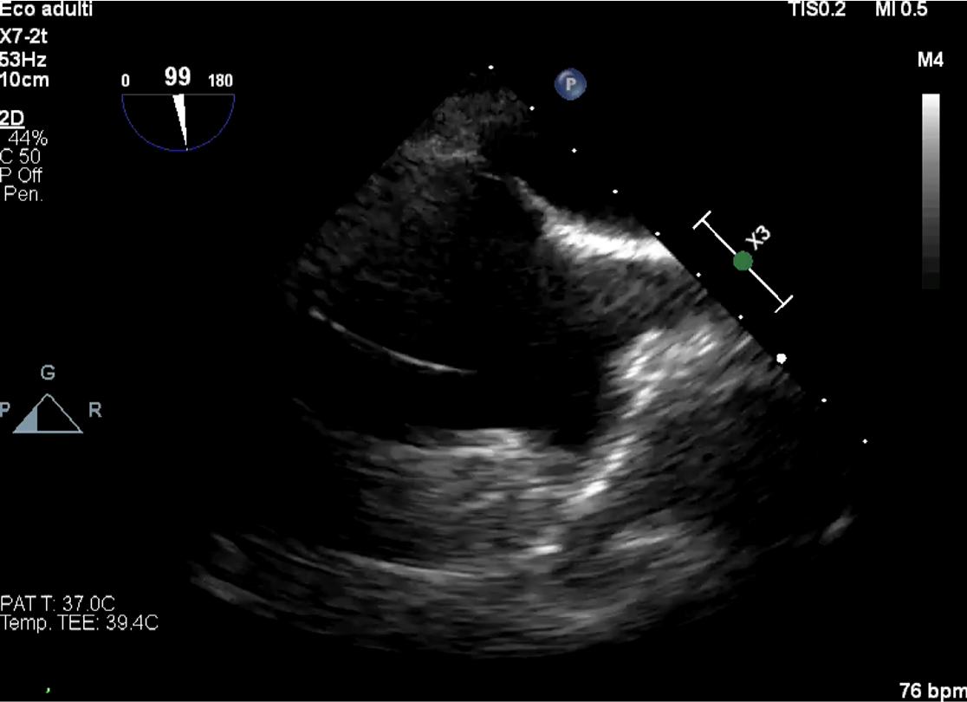
Figure 6 Two-dimensional transesophageal echocardiogram in bicaval view with the evidence of a very floppy and elongated eustachian valve projecting deeply into the right atrial cavity, showing an undulating motion.

Figure 6 is actually the Supplementary Video S2
(attached in the email reply)

