Name of journal: World Journal of Ophthalmology
ESPS Manuscript NO: 10082
Columns: Minireviews

Orthokeratology lenses related infections

Wan KH et al. Orthokeratology related infections

Kelvin Ho-Nam Wan, Vishal Jhanji, Alvin L Young

Kelvin Ho-Nam Wan, Vishal Jhanji, Alvin L Young, Department of Ophthalmology and Visual Sciences, Prince of Wales Hospital and Alice Ho Liu Ling Nethersole Hospital, Hong Kong, China

Kelvin Ho-Nam Wan, Vishal Jhanji, Alvin L Young, Department of Ophthalmology and Visual Sciences, The Chinese University of Hong Kong, Hong Kong, China

Author contributions: All the authors contributed to this paper.

Correspondence to: Dr. Alvin L Young, MMedSc (Hons), FRCSIrel, Chief of Service, Department of Ophthalmology and Visual Sciences, The Chinese University of Hong Kong, Prince of Wales Hospital, Shatin, Hong Kong, China. youngla@ha.org.hk

Telephone: +852-26322878 Fax: +852-26482943

Received: March 11, 2014 Revised: June 19, 2014
Accepted: June 27, 2014

Published online:

Abstract
Orthokeratology is a reversible technique that temporarily changes the curvature of the cornea with the aim of addressing refractive errors. The US Food and Drug Administration (FDA) granted approval in using reverse geometry contact lenses to correct myopia without any age restriction. Information from the pre-market applications to the FDA was rated as level II evidence. Another unapproved use of overnight orthokeratology is in the prevention of myopic progression. Although advocated to reduce myopic progression, there are limited long-term studies with substantial evidence of its benefits. Much of this evidence comes from non robust experimental studies using historical or self-selected controls with relative high dropout rates. Although some positive results have been published in temporarily reducing the myopic refractive error and its progression, the use of these lenses can be associated with serious complications such as microbial keratitis. Microbial keratitis is a potentially vision-threatening adverse response associated with contact lens wear. In fact, contact lens wear has been shown to be the predominant risk factor of microbial keratitis in some developed countries. Most of the published cases on overnight orthokeratology related microbial keratitis occurred in children or adolescents. Parents considering orthokeratology must make an informed decision about its temporary benefit and its potential for permanent loss of vision. The ophthalmic community should be reminded of the potential complications of orthokeratology.

© 2014 Baishideng Publishing Group Inc. All rights reserved.

Key words: Orthokeratology; Infections; Microbial keratitis; Cornea; Corneal ulcer; Contact lens; Myopia

Core tip: Orthokeratology uses specially designed rigid contact lenses to temporarily reshape the cornea to ameliorate refractive errors and it has also been suggested to slow the progression of myopia. None of the published studies to date in assessing its efficacy are rated as level I evidence. Orthokeratology carries the risk of microbial keratitis, which is potentially sight threatening and the safety of orthokeratology remains difficult to assess. Practitioners prescribing orthokeratology must receive appropriate training with respect to the local standards, patients and or parents must be fully informed of the potential risks, and ensure their patients’ compliance proper handling the day to day care of their lenses to minimize the infective risks.

Wan KH, Jhanji V, Young AL. Orthokeratology lenses related infections. World J Ophthalmol 2014; In press

INTRODUCTION
Orthokeratology is defined as the reduction, modification, or elimination of refractive anomalies by the programmed application of contact lenses^{[1]}. Modern day orthokeratology was first advocated during the Second World Contact Lens Congress in Chicago in 1962, where George Jessen, the father of orthokeratology, introduced fitted polymethyl methacrylate (PMMA) contact lenses which had a curve flatter than the cornea to alter the curvature of the cornea and reduce myopia^{[2]}. These lenses were worn during daytime and provided clear uncorrected vision for a few hours after they were removed in the afternoon. Over the next few decades, few other studies comparing daily wear of orthokeratology lens reported similar modest but not significantly different myopic reduction as compared with conventional alignment fitted lens. Disappointment began to set in as inducible corneal astigmatism was reported due to lens instability. Variable and temporary refractive outcomes were observed, requiring continuous use of retainer lens to maintain its refractive effectiveness and/stabilisation.
Re-emergence of interest in this technique came in the late 1980’s with the development of rigid gas permeable (RGP) lens that has a significantly higher oxygen transmission (Dk). Such material allows for a relatively safer closed-eye contact lens usage.^{[3]} This led to the concept of overnight orthokeratology (OOK) where lenses are worn during the night time and removed during the daytime, allowing unaided vision during waking hours. Computer-assisted corneal topographic mapping also provided more detailed assessment of the elevation and curvature of the cornea, allowing more accurate lens design and fitting. Conventional rigid lens surfaces are designed to have a central base surrounded with progressively flattening concentric curves. With the development of reverse geometry lenses, designed to have a flat-back central optical zone with steeper intermediate zone, more accelerated flattening of the central corneal zone is possible compared to the previous lens designs^{[4]}.
This review will highlight the published literature on the efficacy of orthokeratology and the potential limitations of the evidence as well as outlining the complications related to the use of these lenses.

PRINCIPLE AND EVIDENCE OF EFFICACY
Orthokeratology temporarily reduces the overall refractive power by flattening the central cornea to reduce the corneal sagittal height in order to reduce myopia^{[5]}. The corneal periphery becomes relatively thicker, enhancing the peripheral corneal curvature. There is conflicting evidence about the time sequences of these events, but the combined effect is proposed to be the mechanism behind the refractive changes^{[6]}. Thinning of central epithelium has been observed with optical coherence tomography^{[7]}. Correlating with the morphological changes, unaided vision usually improves on an average by 1 week, and stabilizes by 1 mo^{[1]}. However, such visual improvement is transient, unless retainer lenses are continuously used at night time to maintain the flattened central cornea, where the frequency of use would depend on the degree of myopia, and ranges from every 1-2 nights to maintain the flattening effect^{[1]}. The US Food and Drug Administration (FDA) approved the Paragon Corneal Refractive Therapy (CRT) for myopia reduction in 2002 based on their premarket study consisting of 205 subjects, only 24 were between the age of 12 and 18 years^{[8]}. During the evaluation, the FDA advisory panel commented that they would only recommend the approval of Paragon CRT be limited to patients 18 years and older, but FDA granted the approval of OOK without any age restriction. Later in 2004, Euclid Systems also received FDA approval for their orthokeratology to control myopia.
An unapproved use of OOK is in prevention of myopic progression. It is proposed that OOK prevents myopia progression via “peripheral hyperopic defocus” ^{[9]}. This theory suggests that the peripherally flatter cornea reduces peripheral hyperopia by aligning the image shell on to the mid peripheral retina, signalling the peripheral retina to control axial elongation. This controversial theory was tested in studies and found that relative peripheral hyperopia exerts little consistent influence on the rate of myopia progression or axial elongation^{[10]}. The reported reduction in axial length also may be attributed by the gradual slowing of myopic progression in the control group with age, which may be expected. The published studies so far were neither randomized nor prospective, leading to observer bias. Five studies using historical or self-selected controls reported relative slower myopic progression (by 32%–55%) in low-to-moderately myopic children wearing OK lenses compared with those wearing conventional eyeglasses^{[11-14]} or single-vision soft contact lenses^{[15]}. The dropout rate reported in these studies with orthokeratology varies from 6%^{[14]} to 30%^{[15]}. The Longitudinal Orthokeratology Research in Children trial studied 35 children in Hong Kong who wore OK lenses for 2 years^{[11]}. The authors found that the axial length in the orthokeratology group increased by 0.29 mm vs 0.54 mm for the control group. However, a major drawback in this study was that a historical control group of children wearing single vision lenses was used as the control. The Corneal Reshaping and Yearly Observation of Near-sightedness Pilot Study^{[15]} compared 28 participants using corneal reshaping contact lenses to a historical control subject who were randomly assigned to wear soft contact lenses during the Contact Lens and Myopia Progression study^{[16]}. Although the authors reported the annual rate of change in axial length was 0.16 mm per year less for corneal reshaping lens wearer than soft contact lenses (P = 0.00004), the low numbers of participants, the choice of control, as well as a 30% dropout rate limit the strength of the conclusions drawn from this study. Another study followed the OOK participants over 5 years and reported that changes in axial length over each year were significantly different; however by the end of year 5, the changes in axial length were no longer significantly different (P = 0.8633) ^{[13]}. A recently published randomized controlled trial attempted to determine whether OK was effective in slowing myopia progression^{[17]}. They found that subjects wearing OOK lenses had a slower axial elongation by 43% compared with those wearing single-vision glasses. Younger children less than 7 years of age had faster axial elongation and may have additional benefit from early OK treatment. However, the examiners measuring the axial lengths were not masked and a dropout rate of 27% was reported in the orthokeratology group. In addition, although the OK group had a reduction in axial length over the study 2-year period, corresponding changes in refraction were not reported and the clinical significance of an isolated reduction in axial elongation without refractive changes is not known.

SAFETY
A review by Watt and Swabrick analysed all cases of microbial keratitis (MK) associated with OOK since 2001 to 2007^{[18]}. Not surprisingly, most of the findings remains unchanged from the initial analysis of the first 50 cases^{[19]}. Microbial keratitis raised significant concerns in using OOK lenses. Majority of these infections were central and severe. Two of our own examples can be seen in Figure 1. The final best-corrected visual acuity (BCVA) after resolution of infection was reported in 93 cases, 18% of which was less than 20/200. Most cases occurred in children or adolescents: 55% of the cases were between 8-15 years old, 41% were between 16-25 years old, the remaining 4% were above 25 years of age. There is particular concern with OOK in children and young adults since this is the age group with the highest number of users^{[20]}. It would be ideal to stratify the OOK users by age cohorts and analyse the outcomes in terms of initial and final BCVA in order to identify risk factors associated within each cohort, and subsequently with strategies to reduce risk of MK. However, based on the information available related to lens design, material or fitting, lens care and compliance, it was difficult to draw conclusions about risk factors with regards to the specific cohorts by age group. In this review, Pseudomonas aeruginosa accounted for 37% of the cases while Acanthamoeba was responsible for 33%. Acanthamoeba is capable of causing corneal scarring, ultimately leading to significant vision loss. Acanthamoeba infections are known to be associated with contaminated water sources, which further raise the worry regarding the care of OK lenses. Thus it is crucial not to use any tap water during the cleansing of lenses. The prevalence of Acanthamoeba related MK is only reported to be 3%-5% in case series for other contact lens wearing modalities. The much higher prevalence of Acanthamoeba in OOK remains a cause of concern^{[21,22]}. Tear film immunoglobulin A level is found to be reduced in children and may contribute to increased risk of Acanthamoeba keratitis in this age group^{[23]}. No significant differences were reported in the ocular flora profile over time in patients with multiple conjunctival cultures before and during OOK use^{[24]}. It is likely the OOK related MK is related to opportunistic pathogens already present on the corneal surface infecting the compromised corneal epithelial health, related to the corneal physical reshaping and hypoxic stress from nocturnal wear. Apart from thinning of the cornea, OOK also changes the structural integrity of the epithelium, where the central epithelium significantly differs in cell shape and size. The deeper layers of cornea may also lose their normal plicae^{[25,26]}. Even with the most oxygen permeable lenses, animal studies found significant Pseudomonas adhesions to the cornea with the use of reverse geometry contact lens compared with alignment fit lenses. The enhanced binding is accompanied by thinning and reduced turnover of the epithelium. All these factors may attribute to the increase susceptibility of microbial invasion to the cornea^{[27]}. Clinical trials in human subjects with alignment fit RGP lenses using the highest Dk material did not report an increase in Pseudomonas binding after 30 nights of usage^{[28]}. This suggests that the reverse-geometry lens architecture may produce risk of Pseudomonas induced MK. The compressive forces of the reverse geometry lenses may lead to disrupted epithelial surfaces, the reverse geometry lenses may provide a reservoir for bacteria deposition, which is further aggravated by a compromised ocular surface from overnight wear^{[29,30]}. Pseudomonas is also associated with OOK related corneal ulcer in children. In an observational case series with children, 83% of cases were culture positive for P. aeruginosa. Although these ulcers were neither central nor paracentral, all patients suffered a loss in their best-corrected visual acuity with respect to the location of the corneal scar^{[31]}. East Asian ethnicity comprised roughly 95% of the disease population in a review on microbial keratitis associated with OOK^{[18]}. The reported demographic profile could either reflect ethnical susceptibility (as high proportion of East Asian children are myopic) or could just reflect the demographic profile of the worldwide OK lens wearing population since the usage in more affluent economies^{[32]}. The estimated myopia in urban Chinese children at the age of 18 years of age would be up to 2.0 dioptres higher than their parents, and their refractive errors at the age of 11 would already be similar to their parents. This suggests a strong environmental effect on myopia development as evident by this remarkable single-generation myopic shift. In addition, the genetic risk factors, and the environmental and lifestyle factors present in the Chinese population may lead to a lower threshold for the Chinese parents to allow their children to wear OK lens^{[33]}. Lin et al^{[34]} reported that there is a greater increase in epithelial permeability following overnight contact lens wear in Asian as compared to Caucasian subjects, which could lead to a more easily compromised epithelial barrier, however the rates of MK were not reported to be significantly different from the rest of the world^{[21]}. Further research is warranted to answer whether there is ethnical difference in MK susceptibility.

DISCUSSION
The cases of microbial keratitis associated with orthokeratology were largely documented by the review published in 2007^{[18]}. Since then, we identified another 12 cases via our literature search in PubMed^{[35-39]}. Table 1 summarizes the features from the 34 published reports on orthokeratology related microbial keratitis cases up to March 2014^{[29,31,35-66]}. Despite reported case series on MK with OOK, these do not help to determine the true incidence or the relative risks compared with other contact lens modalities. The number of cases reported in the literature likely represents an underestimation, as the values of publications on the same topic become relatively less once a few cases have already been reported in the literature, thus further publication on the same topic is less likely to be accepted by the respective journals, and the incentive for authors to prepare a manuscript also lessens. Without a good estimation of the denominator and numerator, it would be difficult to comment on the absolute risk of microbial keratitis associated with orthokeratology.
Assessment of the risks and adverse effects are limited, as none of the published literatures on OOK are level I evidence. Furthermore, the issue on safety could not truly be concluded from the small number of subjects in studies. Adverse effects are often under reported or inconsistently documented, due to poor indexing, making it more difficult to look up published literature on safety of treatment^{[67]}. The details of reported cases vary in between lens type, lens wearing regime, type of lens and compliance to cleansing regime. Despite the credentialing and training programs offered for OOK practices, a learning curve would exist. The interpretation of fluorescein patterns requires skill and experience; the central flat zone of a reverse-geometry contact lens is more discernible to experienced practitioners. Safety about usage and prescription of OOK raises scrutiny. FDA requires OOK practitioners to be certified to a minimal standard of orthokeratology education and granted the OOK approval without age restriction on the basis that no additional safety concerns are specific to adolescents as long as OOK is fitted by trained personnel and used accordingly^{[68]}. Manufacturers of OOK lenses launched online training program, which consists of certificate course and tests that can be completed in a short period of time. Whether such training program is adequate in providing proper knowledge and skills in the practice of orthokeratology warrants further investigations.
Contact lens use remains the commonest risk factor for microbial keratitis in the paediatric population and orthokeratology is one of the leading causes of contact lens related infection in East Asia^{[69]}. Although many of the cases published have reported data from children, it does not necessary mean children are at a greater risk of contracting MK. Given the potential theoretical benefit in reducing myopia progression, there may be more children using OOK than adults^{[11]}. Due to the larger number of cumulative years that a child may be exposed to potential risks, complications in children may be reported more frequently than adults. The FDA approval for overnight orthokeratology was based on the premarket study cohort where adolescents aged 12-17 years old comprise of 11% of the study sample. In fact, orthokeratology fits represents 28% of all contact lenses prescribed to minors^{[70]}. The FDA issued Section 522 in 2006, requiring manufacturer to conduct post-market surveillance to address “the relative risk of developing MK in persons under the age of 18 as compared to adults in patients undergoing overnight OK treatment”. This question was addressed in a retrospective study using a practitioner survey of 1317 OOK patients (51% children) ^{[20]}. They found 8 cases of corneal infiltrates associated with a painful red eye (six in children and two in adults). Two were classified as MK and occurred in children, but neither resulted in a loss of visual acuity. The overall estimated incidence of MK is 7.7 per 10000 years of wear (95%CI: 0.9-27.8). For children, the estimated incidence of MK is 13.9 per 10000 patient-years (95%CI: 1.7-50.4). While for adults, the estimated incidence of MK is 0 per 10000 patient-years (95%CI: 0-31.7). This is the largest study to quantify the risk of MK associated with OOK with 2599 patient-years of wears and worthy to note the difference between children and adult rates. Based on the incidence estimated in this study, the two FDA pre-market approval studies^{[8,71]} and another retrospective study of 296 patients by Lipson et al^{[72]} did not report any cases of MK. Although the confidence intervals between the adult and children groups overlap, it should not be interpreted as no difference in incidence among the 2 groups as true differences less than 50 cases per 10000 patient-years were beyond the power of that study^{[20]}.

CONCLUSION
Although MK exact incidence of infection associated with OK lenses is not known, it has the potential to compromise vision. Degree of damage (i.e., reduction in visual acuity) is only one aspect of risk evaluation. In order to maintain the control in myopia, patients have to continue indefinite application of OK lenses overnight. Despite using high oxygen permeable lenses, this will still put the patient at risk of MK, as the reduction of myopia is only temporary without regular overnight application. Comparing OOK with other myopia corrective devices, such as daytime contact lens wear, the risk of infectious keratitis is higher in overnight contact lens wear^{[73]}, and there is minimal risk in using spectacles wear. Comparing OOK with LASIK is inappropriate as the latter is an invasive procedure which is not FDA approved for children.
The therapeutic value of overnight orthokeratology remains unclear and many questions remain unanswered, such as the optimal treatment age and duration. Practitioners and end-users of OOK should work together to minimize the risk of MK by reinforcing compliance to proper cleansing techniques and minimizing exposure to contaminated water. OOK users should discontinue lens wear if they feel any pain and seek medical attention immediately. Practitioners must be competent in the prescription of OK lenses through accredited certification courses from appropriate statutory bodies. Better-designed prospective randomized clinical studies are needed to demonstrate the benefit of orthokeratology in reducing myopic progression and to adequately assess their safety, along with the contemporaneous reporting of adverse events. The reported dropout rates of more than 20% in the previous trials also raise concerns regarding tolerability and satisfaction in using OOK. Long term follow ups are needed as vision loss related to MK were only encountered in many patients who wore hard contact lens for more than 2 years. The genuine risk of severe microbial keratitis associated with poor long-term visual outcomes in children need to be highlighted to parents considering orthokeratology in an effort to avoid preventable visual loss.

REFERENCES
1 Swarbrick HA. Orthokeratology review and update. Clin Exp Optom 2006; 89: 124-143 [PMID: 16637967 DOI: 10.1111/j.1444-0938.2006.00044.x]
2 Jessen GN. Ortho Focus techniques. Contacto 1962: 200-4
3 MacKeen DL, Sachdev M, Ballou V, Cavanagh HD. A prospective multicenter clinical trial to assess safety and efficacy of Menicon SF-P RGP lenses for extended wear. CLAO J 1992; 18: 183-186 [PMID: 1499126]
4 Mountford J, Pesudovs K. An analysis of the astigmatic changes induced by accelerated orthokeratology. Clin Exp Optom 2002; 85: 284-293 [PMID: 12366349 DOI: 10.1111/j.1444-0938.2002.tb03084.x]
5 Alharbi A, Swarbrick HA. The effects of overnight orthokeratology lens wear on corneal thickness. Invest Ophthalmol Vis Sci 2003; 44: 2518-2523 [PMID: 12766051 DOI: 10.1167/iovs.02-0680]
6 Zhong X, Chen X, Xie RZ, Yang J, Li S, Yang X, Gong X. Differences between overnight and long-term wear of orthokeratology contact lenses in corneal contour, thickness, and cell density. Cornea 2009; 28: 271-279 [PMID: 19387227 DOI: 10.1097/ICO.0b013e318186e620]
7 Wang J, Fonn D, Simpson TL, Sorbara L, Kort R, Jones L. Topographical thickness of the epithelium and total cornea after overnight wear of reverse-geometry rigid contact lenses for myopia reduction. Invest Ophthalmol Vis Sci 2003; 44: 4742-4746 [PMID: 14578394 DOI: 10.1167/iovs.03-0239]
8 U.S. Food and Drug Administration Center for Devices and Radiological Health, Paragon Vision Sciences. Summary of safety and effectiveness data from premarket approval application supplement number P870024/S43, http: //www.accessdata.fda.gov/cdrh_docs/pdf/P870024S043b.pdf, last assessed March 3, 2014. 2002
9 Smith EL. Prentice Award Lecture 2010: A case for peripheral optical treatment strategies for myopia. Optom Vis Sci 2011; 88: 1029-1044 [PMID: 21747306 DOI: 10.1097/OPX.0b013e3182279cfa]
10 Mutti DO, Sinnott LT, Mitchell GL, Jones-Jordan LA, Moeschberger ML, Cotter SA, Kleinstein RN, Manny RE, Twelker JD, Zadnik K. Relative peripheral refractive error and the risk of onset and progression of myopia in children. Invest Ophthalmol Vis Sci 2011; 52: 199-205 [PMID: 20739476 DOI: 10.1167/iovs.09-4826]
11 Cho P, Cheung SW, Edwards M. The longitudinal orthokeratology research in children (LORIC) in Hong Kong: a pilot study on refractive changes and myopic control. Curr Eye Res 2005; 30: 71-80 [PMID: 15875367 DOI: 10.1080/02713680590907256]
12 Kakita T, Hiraoka T, Oshika T. Influence of overnight orthokeratology on axial elongation in childhood myopia. Invest Ophthalmol Vis Sci 2011; 52: 2170-2174 [PMID: 21212181 DOI: 10.1167/iovs.10-5485]
13 Hiraoka T, Kakita T, Okamoto F, Takahashi H, Oshika T. Long-term effect of overnight orthokeratology on axial length elongation in childhood myopia: a 5-year follow-up study. Invest Ophthalmol Vis Sci 2012; 53: 3913-3919 [PMID: 22577080 DOI: 10.1167/iovs.11-8453]
14 Santodomingo-Rubido J, Villa-Collar C, Gilmartin B, Gutiérrez-Ortega R. Myopia control with orthokeratology contact lenses in Spain: refractive and biometric changes. Invest Ophthalmol Vis Sci 2012; 53: 5060-5065 [PMID: 22729437 DOI: 10.1167/iovs.11-8005]
15 Walline JJ, Jones LA, Sinnott LT. Corneal reshaping and myopia progression. Br J Ophthalmol 2009; 93: 1181-1185 [PMID: 19416935 DOI: 10.1136/bjo.2008.151365]
16 Walline JJ, Jones LA, Mutti DO, Zadnik K. A randomized trial of the effects of rigid contact lenses on myopia progression. Arch Ophthalmol 2004; 122: 1760-1766 [PMID: 15596577 DOI: 10.1001/archopht.122.12.1760]
17 Cho P, Cheung SW. Retardation of myopia in Orthokeratology (ROMIO) study: a 2-year randomized clinical trial. Invest Ophthalmol Vis Sci 2012; 53: 7077-7085 [PMID: 22969068 DOI: 10.1167/iovs.12-10565]
18 Watt KG, Swarbrick HA. Trends in microbial keratitis associated with orthokeratology. Eye Contact Lens 2007; 33: 373-37; discussion 382 [PMID: 17975424 DOI: 10.1097/ICL.0b013e318157cd8d]
19 Watt K, Swarbrick HA. Microbial keratitis in overnight orthokeratology: review of the first 50 cases. Eye Contact Lens 2005; 31: 201-208 [PMID: 16163011 DOI: 10.1097/01.icl.0000179705.23313.7e]
20 Bullimore MA, Sinnott LT, Jones-Jordan LA. The risk of microbial keratitis with overnight corneal reshaping lenses. Optom Vis Sci 2013; 90: 937-944 [PMID: 23892491 DOI: 10.1097/OPX.0b013e31829cac92]
21 Lam DS, Houang E, Fan DS, Lyon D, Seal D, Wong E. Incidence and risk factors for microbial keratitis in Hong Kong: comparison with Europe and North America. Eye (Lond) 2002; 16: 608-618 [PMID: 12194077 DOI: 10.1038/sj.eye.6700151]
22 Cheng KH, Leung SL, Hoekman HW, Beekhuis WH, Mulder PG, Geerards AJ, Kijlstra A. Incidence of contact-lens-associated microbial keratitis and its related morbidity. Lancet 1999; 354: 181-185 [PMID: 10421298 DOI: 10.1016/S0140-6736(98)09385-4]
23 Alizadeh H, Apte S, El-Agha MS, Li L, Hurt M, Howard K, Cavanagh HD, McCulley JP, Niederkorn JY. Tear IgA and serum IgG antibodies against Acanthamoeba in patients with Acanthamoeba keratitis. Cornea 2001; 20: 622-627 [PMID: 11473164 DOI: 10.1097/00003226-200108000-00013]
24 Boost MV, Cho P. Microbial flora of tears of orthokeratology patients, and microbial contamination of contact lenses and contact lens accessories. Optom Vis Sci 2005; 82: 451-458 [PMID: 15976581 DOI: 10.1097/01.opx.0000168587.72893.ec]
25 Cheah PS, Norhani M, Bariah MA, Myint M, Lye MS, Azian AL. Histomorphometric profile of the corneal response to short-term reverse-geometry orthokeratology lens wear in primate corneas: a pilot study. Cornea 2008; 27: 461-470 [PMID: 18434851 DOI: 10.1097/ICO.0b013e318165642c]
26 Nieto-Bona A, González-Mesa A, Nieto-Bona MP, Villa-Collar C, Lorente-Velázquez A. Short-term effects of overnight orthokeratology on corneal cell morphology and corneal thickness. Cornea 2011; 30: 646-654 [PMID: 21282996 DOI: 10.1097/ICO.0b013e31820009bc]
27 Ladage PM, Yamamoto N, Robertson DM, Jester JV, Petroll WM, Cavanagh HD. Pseudomonas aeruginosa corneal binding after 24-hour orthokeratology lens wear. Eye Contact Lens 2004; 30: 173-178 [PMID: 15499241 DOI: 10.1097/01.ICL.0000133220.32701.C8]
28 Ren DH, Yamamoto K, Ladage PM, Molai M, Li L, Petroll WM, Jester JV, Cavanagh HD. Adaptive effects of 30-night wear of hyper-O(2) transmissible contact lenses on bacterial binding and corneal epithelium: a 1-year clinical trial. Ophthalmology 2002; 109: 27-39; discussion 39-40 [PMID: 11772575]
29 Young AL, Leung AT, Cheung EY, Cheng LL, Wong AK, Lam DS. Orthokeratology lens-related Pseudomonas aeruginosa infectious keratitis. Cornea 2003; 22: 265-266 [PMID: 12658097 DOI: 10.1097/00003226-200304000-00018]
30 Choo JD, Holden BA, Papas EB, Willcox MD. Adhesion of Pseudomonas aeruginosa to orthokeratology and alignment lenses. Optom Vis Sci 2009; 86: 93-97 [PMID: 19156013 DOI: 10.1097/OPX.0b013e318194e973]
31 Young AL, Leung AT, Cheng LL, Law RW, Wong AK, Lam DS. Orthokeratology lens-related corneal ulcers in children: a case series. Ophthalmology 2004; 111: 590-595 [PMID: 15019341 DOI: 10.1016/j.ophtha.2003.06.003]
32 Cho P, Cheung SW, Edwards MH, Fung J. An assessment of consecutively presenting orthokeratology patients in a Hong Kong based private practice. Clin Exp Optom 2003; 86: 331-338 [PMID: 14558855 DOI: 10.1111/j.1444-0938.2003.tb03129.x]
33 Liang YB, Lin Z, Vasudevan B, Jhanji V, Young A, Gao TY, Rong SS, Wang NL, Ciuffreda KJ. Generational difference of refractive error in the baseline study of the Beijing Myopia Progression Study. Br J Ophthalmol 2013; 97: 765-769 [PMID: 23590854 DOI: 10.1136/bjophthalmol-2012-302468]
34 Lin MC, Graham AD, Fusaro RE, Polse KA. Impact of rigid gas-permeable contact lens extended wear on corneal epithelial barrier function. Invest Ophthalmol Vis Sci 2002; 43: 1019-1024 [PMID: 11923242]
35 Arance-Gil Á, Gutiérrez-Ortega ÁR, Villa-Collar C, Nieto-Bona A, Lopes-Ferreira D, González-Méijome JM. Corneal cross-linking for Acanthamoeba keratitis in an orthokeratology patient after swimming in contaminated water. Cont Lens Anterior Eye 2014; 37: 224-227 [PMID: 24355444]
36 Greenwell TH, Loh RS, Chehade M, Mills RA. Misdiagnosis of orthokeratology-related Acanthamoeba keratitis as herpes simplex virus keratitis. Clin Experiment Ophthalmol 2013; 41: 418-420 [PMID: 23231627 DOI: 10.1111/ceo.12047]
37 Kim EC, Kim MS. Bilateral acanthamoeba keratitis after orthokeratology. Cornea 2009; 28: 348-350 [PMID: 19387241 DOI: 10.1097/ICO.0b013e31816b6a0b]
38 Shehadeh-Masha'our R, Segev F, Barequet IS, Ton Y, Garzozi HJ. Orthokeratology associated microbial keratitis. Eur J Ophthalmol 2009; 19: 133-136 [PMID: 19123161]
39 Tran T, Samarawickrama C, Petsoglou C, Watson S. Recent cluster of childhood microbial keratitis due to orthokeratology. Clin Experiment Ophthalmol 2014 [PMID: 24533751 DOI: 10.1111/ceo.12302]
40 Chen KH, Kuang TM, Hsu WM. Serratia Marcescens corneal ulcer as a complication of orthokeratology. Am J Ophthalmol 2001; 132: 257-258 [PMID: 11476690 DOI: 10.1016/S0002-9394(01)00931-X]
41 Lü L, Zou L, Wang R. [Orthokeratology induced infective corneal ulcer]. Zhonghua Yan Ke Za Zhi 2001; 37: 443-446 [PMID: 11840754]
42 Chen K, Hsu W, Li S. Corneal ulcers as a complication of orthokeratology. Clin Exp Ophthalmol 2002; 30 (suppl): A214
43 Hutchinson K, Apel A. Infectious keratitis in orthokeratology. Clin Experiment Ophthalmol 2002; 30: 49-51 [PMID: 11885797 DOI: 10.1046/j.1442-9071.2002.00483.x]
44 Keddie S. Bilateral Acanthameoba keratitis in juvenile night-wear orthokeratology treatment. Global Orthokeratology Symposium 2002; Course 6C: 1–3
45 Lin C, Su X, Xu T. Nocardia keratitis as a complication of orthokeratology. Chin Med J 2005; 115: 1014-5
46 Lau LI, Wu CC, Lee SM, Hsu WM. Pseudomonas corneal ulcer related to overnight orthokeratology. Cornea 2003; 22: 262-264 [PMID: 12658096 DOI: 10.1097/00003226-200304000-00017]
47 Poole TR, Frangouli O, Ionides AC. Microbial keratitis following orthokeratology. Eye (Lond) 2003; 17: 440-441 [PMID: 12724719 DOI: 10.1038/sj.eye.6700338]
48 Wang JC, Lim L. Unusual morphology in orthokeratology contact lens-related cornea ulcer. Eye Contact Lens 2003; 29: 190-192 [PMID: 12861117 DOI: 10.1097/01.ICL.0000075011.87891.39]
49 Xuguang S, Lin C, Yan Z, Zhiqun W, Ran L, Shiyun L, Xiuying J. Acanthamoeba keratitis as a complication of orthokeratology. Am J Ophthalmol 2003; 136: 1159-1161 [PMID: 14644232 DOI: 10.1016/S0002-9394(03)00635-4]
50 Hsiao CH, Yeh LK, Chao AN, Chen YF, Lin KK. Pseudomonas aeruginosa corneal ulcer related to overnight orthokeratology. Chang Gung Med J 2004; 27: 182-187 [PMID: 15148995]
51 Lang J, Rah M. Case report: central corneal ulcer with overnight orthokeratology. American Academy of Optometry annual meeting, 2003
52 Van Der Worp E, Nolf P. Case report. Pseudomonas infection. Global Orthokeratology Symposium 2004; Session 08B: 1-102004
53 Araki-Sasaki K, Nishi I, Yonemura N, Takatsuka H, Mutoh K, Matsumoto K, Asari S, Tanihara H. Characteristics of Pseudomonas corneal infection related to orthokeratology. Cornea 2005; 24: 861-863 [PMID: 16160505 DOI: 10.1097/01.ico.0000175411.05988.fa]
54 Macsai MS. Corneal ulcers in two children wearing paragon corneal refractive therapy lenses. Eye Contact Lens 2005; 31: 9-11 [PMID: 15665666 DOI: 10.1097/01.ICL.0000151947.99251.6D]
55 Hsiao CH, Lin HC, Chen YF, Ma DH, Yeh LK, Tan HY, Huang SC, Lin KK. Infectious keratitis related to overnight orthokeratology. Cornea 2005; 24: 783-788 [PMID: 16160492 DOI: 10.1097/01.ico.0000175412.13612.8a]
56 Tseng CH, Fong CF, Chen WL, Hou YC, Wang IJ, Hu FR. Overnight orthokeratology-associated microbial keratitis. Cornea 2005; 24: 778-782 [PMID: 16160491 DOI: 10.1097/01.ico.0000153101.81657.0b]
57 Wilhelmus KR. Acanthamoeba keratitis during orthokeratology. Cornea 2005; 24: 864-866 [PMID: 16160506 DOI: 10.1097/01.ico.0000175410.28859.bd]
58 Yepes N, Lee SB, Hill V, Ashenhurst M, Saunders PP, Slomovic AR. Infectious keratitis after overnight orthokeratology in Canada. Cornea 2005; 24: 857-860 [PMID: 16160504]
59 Lee SJ, Jeong HJ, Lee JE, Lee JS, Xuan YH, Kong HH, Chung DI, Ock MS, Yu HS. Molecular characterization of Acanthamoeba isolated from amebic keratitis related to orthokeratology lens overnight wear. Korean J Parasitol 2006; 44: 313-320 [PMID: 17170573 DOI: 10.3347/kjp.2006.44.4.313]
60 Priel A, Grinbaum A, Barequet IS. Severe Pseudomonas aeruginosa keratitis shortly after initiation of corneal refractive therapy. Eye Contact Lens 2006; 32: 1-2 [PMID: 16415684 DOI: 10.1097/01.ICL.0000159231.54780.E0]
61 Sun X, Zhao H, Deng S, Zhang Y, Wang Z, Li R, Luo S, Jin X. Infectious keratitis related to orthokeratology. Ophthalmic Physiol Opt 2006; 26: 133-136 [PMID: 16460313 DOI: 10.1111/j.1475-1313.2006.00381.x]
62 Voyatzis G. Pseudomonas keratitis in a 9 year old patient using orthokeratology. Contact Lens Anterior Eye 2006: 183
63 Ying-Cheng L, Chao-Kung L, Ko-Hua C, Wen-Ming H. Daytime orthokeratology associated with infectious keratitis by multiple gram-negative bacilli: Burkholderia cepacia, Pseudomonas putida, and Pseudomonas aeruginosa. Eye Contact Lens 2006; 32: 19-20 [PMID: 16415688 DOI: 10.1097/01.icl.0000167714.53847.8c]
64 Lee JE, Hahn TW, Oum BS, Choi HY, Yu HS, Lee JS. Acanthamoeba keratitis related to orthokeratology. Int Ophthalmol 2007; 27: 45-49 [PMID: 17377749 DOI: 10.1007/s10792-007-9055-8]
65 Robertson DM, McCulley JP, Cavanagh HD. Severe acanthamoeba keratitis after overnight orthokeratology. Eye Contact Lens 2007; 33: 121-123 [PMID: 17502745 DOI: 10.1097/01.icl.0000244110.70378.8c]
66 Watt KG, Boneham GC, Swarbrick HA. Microbial keratitis in orthokeratology: the Australian experience. Clin Exp Optom 2007; 90: 182-17; quiz 182-17; [PMID: 17425764 DOI: 10.1111/j.1444-0938.2006.00105.x]
67 Golder S, McIntosh HM, Duffy S, Glanville J. Developing efficient search strategies to identify reports of adverse effects in MEDLINE and EMBASE. Health Info Libr J 2006; 23: 3-12 [PMID: 16466494 DOI: 10.1111/j.1471-1842.2006.00634.x]
68 Schein OD. Microbial keratitis associated with overnight orthokeratology: what we need to know. Cornea 2005; 24: 767-769 [PMID: 16160488 DOI: 10.1097/01.ico.0000186535.57765.85]
69 Young AL, Leung KS, Tsim N, Hui M, Jhanji V. Risk factors, microbiological profile, and treatment outcomes of pediatric microbial keratitis in a tertiary care hospital in Hong Kong. Am J Ophthalmol 2013; 156: 1040-1044.e2 [PMID: 23972308]
70 Efron N, Morgan PB, Woods CA. Survey of contact lens prescribing to infants, children, and teenagers. Optom Vis Sci 2011; 88: 461-468 [PMID: 21336226 DOI: 10.1097/OPX.0b013e31820efa0f]
71 US Food and Drug Administration Center for Devices and Radiological Health. Euclid Systems Corporation, Summary of safety and effectiveness data from premarket approval application number P010062, http: //www.accessdata.fda.gov/cdrh_docs/pdf/P010062b.pdf, last assessed March 3, 2014. 2004.
72 Lipson MJ. Long-term clinical outcomes for overnight corneal reshaping in children and adults. Eye Contact Lens 2008; 34: 94-99 [PMID: 18327044 DOI: 10.1097/ICL.0b013e31811eba10]
73 Van Meter WS, Musch DC, Jacobs DS, Kaufman SC, Reinhart WJ, Udell IJ. Safety of overnight orthokeratology for myopia: a report by the American Academy of Ophthalmology. Ophthalmology 2008; 115: 2301-2313.e1 [PMID: 18804868]

P-Reviewers: Mimura T, Razeghinejad MR, Shih YF
S-Editor: Song XX L-Editor: E-Editor:

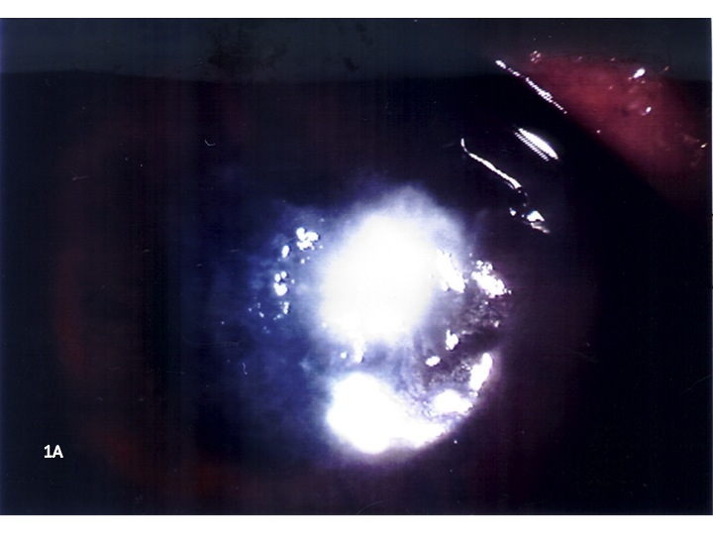
A
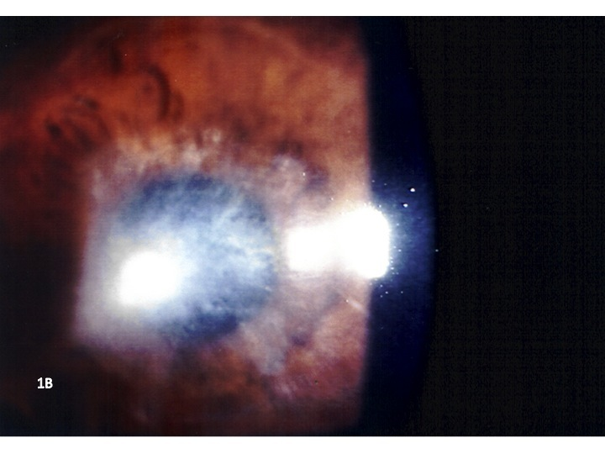
B
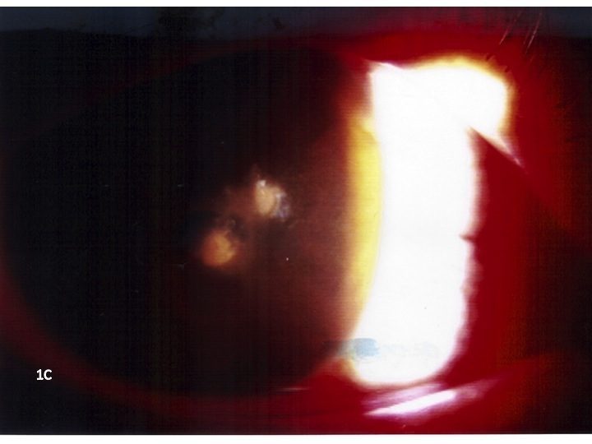
C
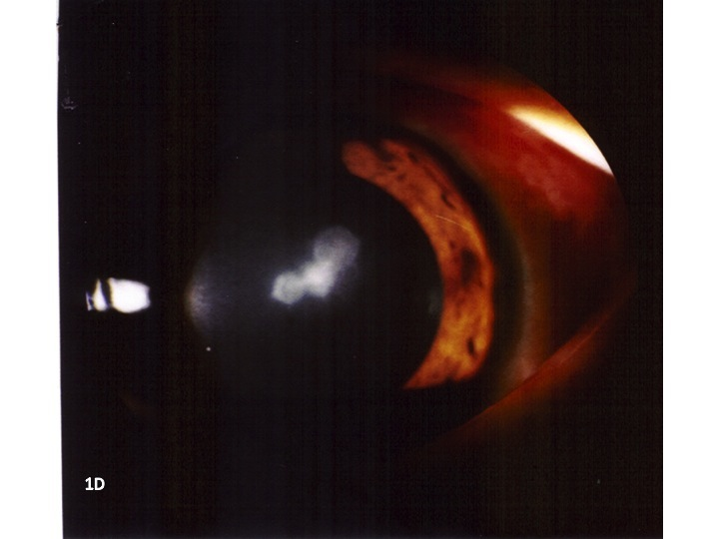
D

Figure 1 Microbial keratitis raised significant concerns in using overnight orthokeratology lenses. A: Presentation of a 13 years old girl who wore OKL for 36 mo with nocturnal wear at 10 h. Culture grew Pseudomonas aeruginosa; B: Post treatment of 13 years old girl with scar. Best corrected vision at 20/200 (plano/-5.00 × 165°); C: Presentation of a 12 years old boy who wore OKL for 7 mo with nocturnal wear at 10 h. Culture grew Pseudomonas aeruginosa; D: Post treatment of 12 years old boy with scar.

Table 1 Features of microbial keratitis published in literature
Ref. | Year of publication | Country of origin | Number of cases | Microbiology
Chen et al^{[40]} | 2001 | Taiwan | 1 | Serratia marcescens
Lu et al^{[41]} | 2001 | China | 16 | 7 = P. aeruginosa; 8 = Acanthamoeba; 1 fungus
Chen et al^{[42]} | 2002 | Taiwan | 1 | Pseudomonas putida
Hutchinson et al^{[43]} | 2002 | Australia | 2 | 1 = P. aeruginosa; 1 = Acanthamoeba, P. aeruginosa and Burkholderia cepacia
Keddie et al^{[44]} | 2002 | Canada | 2 | Acanthamoeba
Lin et al^{[45]} | 2002 | China | 1 | Nocardia sp.
Lau et al^{[46]} | 2003 | Taiwan | 2 | P. aeruginosa
Poole et al ^{[47]} | 2003 | United Kingdom | 1 | Not identified
Wang et al ^{[48]} | 2003 | Singapore | 1 | P. aeruginosa
Xugang et al ^{[49]} | 2003 | China | 4 | Acanthamoeba
Young et al ^{[29]} | 2003 | Hong Kong | 1 | P. aeruginosa
Hsiao et al ^{[50]} | 2004 | Taiwan | 7 | 6 = P. aeruginosa; 1 = Not identified
Lang et al ^{[51]} | 2004 | United States | 2 | 1 = P. aeruginosa; 1 = Not identified
Van Der Worp et al ^{[52]} | 2004 | Nether-lands | 1 | P. aeruginosa
Young et al ^{[31]} | 2004 | Hong Kong | 6 | 5 = P. aeruginosa; 1= Not identified
Araki-Sasaki et al ^{[53]} | 2005 | Japan | 1 | P. aeruginosa
Macsai et al ^{[54]} | 2005 | United States | 2 | 1 = P. aeruginosa; 1 = H.influenza
Hsiao et al ^{[55]} | 2005 | Taiwan | 21 | 9 = P. aeruginosa; 2 = coagulase-negative staphylococcus sp.; 1 = Serratia marcescens; 1 = Acanthamoeba
Tseng et al ^{[56]} | 2005 | Taiwan | 10 | 2 = Acanthamoeba; 1 = P. aeruginosa; 1 = non fermentative gram negative bacilli; 6 = Not identified
Wilhelmus et al ^{[57]} | 2005 | United States | 1 | Acanthamoeba
Yepes et al ^{[58]} | 2005 | Canada | 3 | 1 = P. aeruginosa; 1 = Serratia marcescens; 1 = Acanthamoeba
Lee et al ^{[59]} | 2006 | South Korea | 1 | Acanthamoeba
Priel et al ^{[60]} | 2006 | Israel | 1 | P. aeruginosa
Sun et al ^{[61]} | 2006 | China | 28 | 8 = P. aeruginosa; 13 = Acanthamoeba; 1 = Nocardia sp.; 1 = Providencia stuartii; 2 = fungus; 1 = gram negative rods; 2 = Not identified
Voyatzis et al ^{[62]} | 2006 | United Kingdom | 1 | P. aeruginosa
Ying-Cheng et al ^{[63]} | 2006 | Taiwan | 1 | Burkholderia cepacia, Pseudomonas putida, and P. aeruginosa
Lee et al ^{[64]} | 2007 | South Korea | 4 | 1 = Acanthamoeba; 1 = Acanthamoeba and trophozoites; 2 = not identified
Robertson et al ^{[65]} | 2007 | United States | 1 | Acanthamoeba
Watt et al ^{[66]} | 2007 | Australia | 9 | 4 = P. aeruginosa; 2 = Acanthamoeba; 3 = Not identified
Kim et al ^{[37]} | 2009 | South Korea | 1 | Acanthamoeba (bilateral)
Shehadeh-Masha'ou et al ^{[38]} | 2009 | Israel | 4 | P. aeruginosa
Arance-Gil et al ^{[35]} | 2013 | Spain | 1 | Acanthamoeba
Greenwell et al ^{[36]} | 2013 | Australia | 2 | Acanthamoeba
Tran et al^{[39]} | 2014 | Australia | 4 | 1 = Acanthamoeba; 1 = P. aeruginosa; 2 = not identified
P. aeruginosa: Pseudomonas aeruginosa; H. influenza: Haemophilus influenza; sp: Species.

