Name of Journal: World Journal of Clinical Cases
Manuscript NO: 57860
Manuscript Type: CASE REPORT

Pleural effusion and ascites in extrarenal lymphangiectasia caused by post-biopsy hematoma: A case report

Lin QZ et al. Perirenal hematoma-associated lymphogenic pleural effusion

Qiong-Zhen Lin, Hui-En Wang, Dong Wei, Yun-Feng Bao, Hang Li, Tao Wang

Qiong-Zhen Lin, Department of Nephrology, The Third Hospital of Hebei Medical University, Shijiazhuang 050051, Hebei Province, China

Hui-En Wang, Department of Thoracic Surgery, Hebei Provincial General Hospital, Shijiazhuang 050051, Hebei Province, China

Dong Wei, Department of Urology, Hebei Provincial General Hospital, Shijiazhuang 050051, Hebei Province, China

Yun-Feng Bao, Department of Medical Imaging, Hebei General Hospital, Shijiazhuang 050051, Hebei Province, China

Hang Li, Department of Nephrology, Peking Union Medical College Hospital, Beijing 100045, China

Tao Wang, Department of Nephrology, The First Hospital of Hebei Medical University, Shijiazhuang 050000, Hebei Province, China

Author contributions: Lin QZ reviewed the literature and contributed to manuscript drafting; Wang HE and Wei D are a thoracic surgeon and urologist, respectively, and both gave critical advice in the management of the patient and preparation of the revision; Bao YF prepared the medical imaging; Li H and Wang T revised the manuscript for important intellectual content; Wang T was the patient’s nephrologist and conceived the study; All authors issued final approval for the version to be submitted.

Corresponding author: Tao Wang, MD, PhD, Chief Physician, Professor, Department of Nephrology, The First Hospital of Hebei Medical University, No. 89 East Donggang Road, Shijiazhuang 050000, Hebei Province, China. yanzhang@hbmu.edu

Received: June 29, 2020
Revised: October 1, 2020
Accepted: November 4, 2020
Published online:

Abstract
BACKGROUND
The renal system has a specific pleural effusion associated with it in the form of “urothorax”, a condition where obstructive uropathy or occlusion of the lymphatic ducts leads to extravasated fluids (urine or lymph) crossing the diaphragm via innate perforations or lymphatic channels. As a rare disorder that may cause pleural effusion, renal lymphangiectasia is a congenital or acquired abnormality of the lymphatic system of the kidneys. As vaguely mentioned in a report from the American Journal of Kidney Diseases, this disorder can be caused by extrinsic compression of the kidney secondary to hemorrhage.

CASE SUMMARY
A 54-year-old man with biopsy-proven acute tubulointerstitial nephropathy experienced bleeding 3 d post hoc, which, upon clinical detection, manifested as a massive perirenal hematoma on computed tomography (CT) scan without concurrent pleural effusion. His situation was eventually stabilized by expeditious management, including selective renal arterial embolization. Despite good hemodialysis adequacy and stringent volume control, a CT scan 1 mo later found further enlargement of the perirenal hematoma with heterogeneous hypodense fluid, left side pleural effusion and a small amount of ascites. These fluid collections showed a CT density of 3 Hounsfield units, and drained fluid of the pleural effusion revealed a dubiously light-colored transudate with lymphocytic predominance (> 80%). Similar results were found 3 mo later, during which time the patient was free of pulmonary infection, cardiac dysfunction and overt hypoalbuminemia. After careful consideration and exclusion of other possible causative etiologies, we believed that the pleural effusion was due to the occlusion of renal lymphatic ducts by the compression of kidney parenchyma and, in the absence of typical dilation of the related ducts, considered our case as extrarenal lymphangiectasia in a broad sense.

CONCLUSION
As such, our case highlighted a morbific passage between the kidney and thorax under an extraordinarily rare condition. Given the paucity of pertinent knowledge, it may further broaden our understanding of this rare disorder.

Key Words: Urothorax; Pleural effusion; Perirenal hematoma; Renal lymphangiectasia; Lymphatic drainage; Case report

Lin QZ, Wang HE, Wei D, Bao YF, Li H, Wang T. Pleural effusion and ascites in extrarenal lymphangiectasia caused by post-biopsy hematoma: A case report. World J Clin Cases 2020; In press

Core Tip: It is known that obstructive uropathy or occlusion of the lymphatic ducts may lead to extravasated fluids (urine or lymph) crossing the diaphragm via innate perforations or lymphatic channels. Therein, this clinical phenomenon is addressed as the “urothorax”. Among the diverse etiologies, renal lymphangiectasia is a congenital or acquired abnormality of the lymphatic system of the kidneys. Under this instance, pleural effusion of lymphoid origin may develop when the renal parenchyma is tightly compressed by a perirenal hematoma. Arguably, tight compression of the renal parenchyma may keep the draining lymphatic vessels shut but not prevent the inflow from the capsular lymph plexus. Thus, our report has for the first time described this extremely rare scenario and raises clinical awareness of the underlying passage, through which upward spread of perirenal infection could result in lung abscess.
INTRODUCTION
The renal system has a specific pleural effusion associated with it in the form of “urothorax”, a condition where obstructive uropathy or occlusion of the lymphatic ducts leads to extravasated fluids (urine or lymph) crossing the diaphragm via innate perforations or lymphatic channels^{[1]}. In rare cases, this pleural effusion may be caused by renal lymphangiectasia, which is a congenital or acquired disorder of the lymphatic system of the kidneys^{[2]}. The exact etiology of this disorder remains unknown, whereas the most common hypothesis is the occlusion of draining lymphatic ducts secondary to trauma, scarring, infection, inflammation or malignant cells of the kidneys^{[3]}. There is only one report from the American Journal of Kidney Diseases^{[4]} describing extrinsic compression of the kidney by hemorrhage leading to extrarenal lymphangiectasia, and we hereby described such an extremely rare case with resultant pleural effusion. The study was approved by our institutional review board (No. 2020-22), and written informed consent was obtained from the patient.

CASE PRESENTATION
Chief complaints
A 54-year-old man was admitted for serum creatinine (Scr) elevation for 1 mo.

History of present illness
He initially visited a local clinic due to loss of appetite and was found to have an elevated Scr without dysuresia. Fluid infusion had indiscernible effect on the abnormal Scr and no evidence of secondary kidney disease was found. He was then referred to us, pending renal biopsy.

History of past illness
The patient was a capable farm hand ex ante without a known medical history.

Personal and family history
He denied any family history of hypertension, diabetes or kidney disease.

Physical examination
On arrival, his blood pressure was 150/90 mmHg, and he had a slightly anemic complexion. Otherwise, physical examination yielded no remarkable findings.

Laboratory examinations
Laboratory tests revealed a hemoglobin concentration of 108 g/L (reference: 130-150 g/L), platelet count of 202 × 10⁹/L (100-300 × 10⁹/L), plasma albumin of 41.3 g/L, Scr of 679.1 µmol/L (44.2-132.6 μmol/L), normal coagulation function including D-dimer and negative results for anti-nuclear antibody, anti-neutrophil cytoplasm antibody and immunofixation electrophoresis. Screening for hepatitis B and malignancy was negative. After the routine workup, renal biopsy confirmed the diagnosis of acute tubulointerstitial nephropathy.

Imaging examinations
Plain chest X-ray was clear. Furthermore, the kidneys appeared normal on sonography without aberrant echogenicity.

FINAL DIAGNOSIS
Acute tubulointerstitial nephropathy.

TREATMENT
Three days after the biopsy, however, the patient experienced bleeding, which, upon clinical detection, manifested as a large perirenal hematoma without concurrent pleural effusion (Figure 1A). Laboratory tests post hoc showed a surge in the Scr level to 1094.3 µmol/L (Figure 1, upper panel), whereas the hemoglobin concentration, platelet count and plasma albumin were 56 g/L, 166 × 10⁹/L and 36.7 g/L, respectively. Continuous renal replacement therapy was employed due to transient oliguria, and the patient’s situation was eventually stabilized by expeditious management, including selective renal arterial embolization.
While with good hemodialysis adequacy and under stringent volume control for Page kidney, computed tomography (CT) scan 1 mo later found further enlargement of the perirenal hematoma with heterogeneous hypodense fluid, massive left-sided pleural effusion and a small amount of ascites (Figure 1B). These fluid collections had a CT density of 3 Hounsfield units (HU), and drained fluid of the pleural effusion yielded a light-colored transudate with lymphocytic predominance (> 80%). Additionally, Scr remained elevated, and plasma albumin was generally stable, with a hemoglobin concentration of 97 g/L and platelet count of 240 × 10⁹/L. Furthermore, the pleural effusion and ascites consistently showed the same HU and lymphatic nature 4 mo later (Figure 1C), accompanied by lowering of the Scr and rise in the albumin. Of note, the patient was free of pulmonary infection and cardiac dysfunction during the whole episode.
As schematically outlined in Figure 2, tight compression of the renal parenchyma may keep the draining lymphatic vessels shut but not prevent the inflow from the capsular lymph plexus. On the basis of clinical features, imaging findings and laboratory tests, the diagnosis of extrarenal lymphangiectasia was made, as classified previously^{[4]}. The patient was then kept on hemodialysis, with a special focus on dry weight and urinary volume.

OUTCOME AND FOLLOW-UP
He was eventually detached from hemodialysis 10 mo after the hemorrhage and treated for chronic kidney disease stage 5, according to the ‘Kidney Disease: Improving Global Outcomes’ Guideline^{[5]}. His Scr fluctuated between 300-400 µmol/L and had a daily urinary volume of approximately 1000 mL.

DISCUSSION
Renal lymphangiectasia is a rare benign disorder characterized by abnormal and ectatic lymphatic vessels within and around the kidneys. The abnormal dilatation of these lymphatic ducts arises from their failure to communicate with larger retroperitoneal lymph vessels. Although it is bilateral in nature in more than 90% of cases^{[2]}, this disorder may also be unilateral or focal^{[6]}. The diagnosis is based mainly on imaging results, although perinephric/pleural fluid analysis and kidney biopsy are definitely helpful^{[2,4]}. As such, imaging findings of renal lymphangiectasia may include peripelvic cysts (intrarenal lymphangiectasia) and perinephric fluid collections (extrarenal lymphangiectasia)^{[4,7]}. However, locular cystic lesions within the renal sinuses may be absent in cases of perirenal compression of the kidney parenchyma or bilateral renal vein thrombosis^{[8,9]}. In addition to the perinephric and/or retroperitoneal fluid collection, it may also manifest ascites and, rarely, pleural effusion.
Renal lymphangiectasia may confer pleural effusion through the passage of “urothorax”. Under such circumstances, pleural drainage usually reveals chylous fluid with lymphocytic predominance (≥ 90%)^{[4]}, while occasionally, cell staining may prove colorless at gross examination^{[2]}. In another chance encounter supporting this finding, we recently admitted another patient on maintenance peritoneal dialysis for dyspnea on exertion. His discomfort was exacerbated after the infusion of peritoneal dialysate, and a CT scan found a large amount of right-sided pleural effusion (Supplementary Figure 1). After the addition of methylene blue to the dialysate, colored pleural drainage was observed. Indeed, urinary tract infection may spread upward and lead to lung abscess^{[10].} Taken together, our case highlighted a de novo morbific passage between the kidney and thorax under extraordinary conditions.
Clinically, renal lymphangiectasia is usually asymptomatic and incidentally diagnosed. When symptomatic, the most common presentations are abdominal pain (42%) and abdominal distension (21%), followed by fever, hematuria, fatigue, weight loss, hypertension and occasional deterioration in renal function^{[11]}. A unique entity, namely, the Page kidney, was considered in this case with the associated hypertension after subcapsular hematoma, and the management required sufficient fluid control^{[l2]}. In this respect, our patients on maintenance hemodialysis generally manifested good Kt/V in both a cross-sectional study^{[l3]} and 10-year follow-up^{[14]}, and the critically ill patients receiving continuous renal replacement therapy had fine volume control^{[15]}. Therefore, it is highly unlikely that the observed pleural effusion was derived from fluid overload. Of essential importance, caution regarding polycythemia and the associated deep venous thrombosis has been recommended in renal lymphangiectasia^{[2]}. In this regard, a detailed description of the differential diagnosis^{[2]} and therapeutic approach^{[4]} is available elsewhere.

CONCLUSION
In conclusion, we reported an extremely unusual case of pleural effusion caused by extrarenal lymphangiectasia, which resulted from occlusion of the lymphatic ducts due to compression of the renal parenchyma by a hematoma. Given the paucity of pertinent knowledge, these findings may further improve our understanding of this rare disorder.

REFERENCES
1 Jones GH, Kalaher HR, Misra N, Curtis J, Parker RJ. Empyema and respiratory failure secondary to nephropleural fistula caused by chronic urinary tract infection: a case report. Case Rep Pulmonol 2012; 2012: 595402 [PMID: 23198240 DOI: 10.1155/2012/595402]
2 Bazari H, Attar EC, Dahl DM, Uppot RN, Colvin RB. Case records of the Massachusetts General Hospital. Case 23-2010. A 49-year-old man with erythrocytosis, perinephric fluid collections, and renal failure. N Engl J Med 2010; 363: 463-475 [PMID: 20818867 DOI: 10.1056/NEJMcpc1004086]
3 Rastogi R, Rastogi UC, Sarikwal A, Rastogi V. Renal lymphangiectasia associated with chronic myeloid leukemia. Saudi J Kidney Dis Transpl 2010; 21: 724-727 [PMID: 20587880]
4 Wani NA, Kosar T, Gojwari T, Qureshi UA. Perinephric fluid collections due to renal lymphangiectasia. Am J Kidney Dis 2011; 57: 347-351 [PMID: 20888101 DOI: 10.1053/j.ajkd.2010.06.028]
5 Floege J, Barbour SJ, Cattran DC, Hogan JJ, Nachman PH, Tang SCW, Wetzels JFM, Cheung M, Wheeler DC, Winkelmayer WC, Rovin BH; Conference Participants. Management and treatment of glomerular diseases (part 1): conclusions from a Kidney Disease: Improving Global Outcomes (KDIGO) Controversies Conference. Kidney Int 2019; 95: 268-280 [PMID: 30665568 DOI: 10.1016/j.kint.2018.10.018]
6 Surabhi VR, Menias C, Prasad SR, Patel AH, Nagar A, Dalrymple NC. Neoplastic and non-neoplastic proliferative disorders of the perirenal space: cross-sectional imaging findings. Radiographics 2008; 28: 1005-1017 [PMID: 18635626 DOI: 10.1148/rg.284075157]
7 Varela JR, Bargiela A, Requejo I, Fernandez R, Darriba M, Pombo F. Bilateral renal lymphangiomatosis: US and CT findings. Eur Radiol 1998; 8: 230-231 [PMID: 9477271 DOI: 10.1007/s003300050368]
8 Al-Dofri SA. Renal lymphangiectasia presented by pleural effusion and ascites. J Radiol Case Rep 2009; 3: 5-10 [PMID: 22470619 DOI: 10.3941/jrcr.v3i10.317]
9 Riehl J, Schmitt H, Schäfer L, Schneider B, Sieberth HG. Retroperitoneal lymphangiectasia associated with bilateral renal vein thrombosis. Nephrol Dial Transplant 1997; 12: 1701-1703 [PMID: 9269653 DOI: 10.1093/ndt/12.8.1701]
10 O'Brien JD, Ettinger NA. Nephrobronchial fistula and lung abscess resulting from nephrolithiasis and pyelonephritis. Chest 1995; 108: 1166-1168 [PMID: 7555135 DOI: 10.1378/chest.108.4.1166]
11 Schwarz A, Lenz T, Klaen R, Offermann G, Fiedler U, Nussberger J. Hygroma renale: pararenal lymphatic cysts associated with renin-dependent hypertension (Page kidney). Case report on bilateral cysts and successful therapy by marsupialization. J Urol 1993; 150: 953-957 [PMID: 8345618 DOI: 10.1016/s0022-5347(17)35660-4]
12 Sterns RH, Rabinowitz R, Segal AJ, Spitzer RM. 'Page kidney'. Hypertension caused by chronic subcapsular hematoma. Arch Intern Med 1985; 145: 169-171 [PMID: 3970635 DOI: 10.1001/archinte.145.1.169]
13 Wang T, Zhang Y, Niu K, Wang L, Shi Y, Liu B. Association of the -449GC and -1151AC polymorphisms in the DDAH2 gene with asymmetric dimethylarginine and erythropoietin resistance in Chinese patients on maintenance hemodialysis. Clin Exp Pharmacol Physiol 2017; 44: 961-964 [PMID: 28590543 DOI: 10.1111/1440-1681.12793]
14 Wang T, Li Y, Wu H, Chen H, Zhang Y, Zhou H, Li H. Optimal blood pressure for the minimum all-cause mortality in Chinese ESRD patients on maintenance hemodialysis. Biosci Rep 2020; 40: BSR20200858 [PMID: 32756870 DOI: 10.1042/BSR20200858]
15 Wang T, Zhang Y, Li Q, Jia S, Shi C, Niu K, Liu B. Acute kidney injury in cancer patients and impedance cardiography-assisted renal replacement therapy: Experience from the onconephrology unit of a Chinese tertiary hospital. Exp Ther Med 2017; 14: 5671-5677 [PMID: 29285109 DOI: 10.3892/etm.2017.5244]

Footnotes
Informed consent statement: Informed written consent was obtained from the patient for publication of this report and any accompanying images.

Conflict-of-interest statement: The authors declare that they have no conflicts of interest.

CARE Checklist (2016) statement: The authors have read the CARE Checklist (2016), and the manuscript was prepared and revised according to the CARE Checklist (2016).

Open-Access: This article is an open-access article that was selected by an in-house editor and fully peer-reviewed by external reviewers. It is distributed in accordance with the Creative Commons Attribution NonCommercial (CC BY-NC 4.0) license, which permits others to distribute, remix, adapt, build upon this work non-commercially, and license their derivative works on different terms, provided the original work is properly cited and the use is non-commercial. See: http://creativecommons.org/Licenses/by-nc/4.0/

Manuscript source: Unsolicited manuscript

Peer-review started: June 26, 2020
First decision: September 24, 2020
Article in press:

Specialty type: Medicine, research and experimental
Country/Territory of origin: China
Peer-review report’s scientific quality classification
Grade A (Excellent): 0
Grade B (Very good): 0
Grade C (Good): C
Grade D (Fair): 0
Grade E (Poor): 0

P-Reviewer: Desai DJ S-Editor: Gao CC L-Editor: Filipodia P-Editor:

Figure Legends
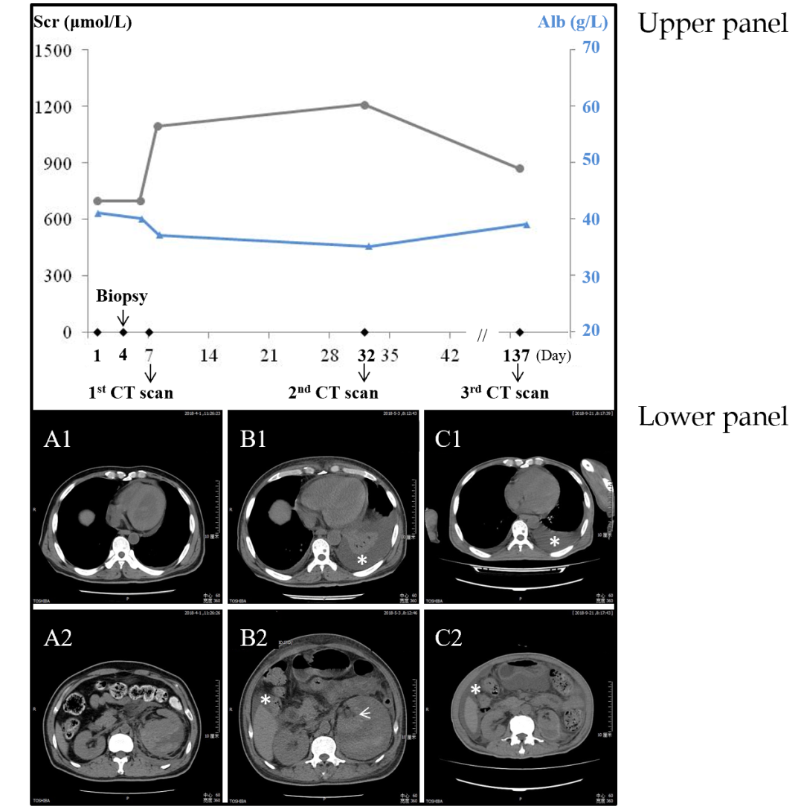
Figure 1 Evolution of the perirenal hematoma, pleural effusion and ascites in parallel with the corresponding serum creatinine and plasma albumin. Upper panel: Values of serum creatinine (circles connected by black lines) and plasma albumin (triangles connected by blue lines) at different time points; Lower panel: A: Computed tomography scan shortly after the detection of hemorrhage showing perirenal hematoma (A2), without pleural effusion (A1); B: Perirenal hematoma and small amount of ascites (B2), with pleural effusion (B1, asterisk) 1 mo after the hemorrhage, the compressed kidney is also visible (B1, arrow); C: Perirenal fluid retention and ascites (C2), with pleural effusion (C1, asterisk) 5 mo after the hemorrhage. Alb: Albumin; CT: Computed tomography; Scr: Serum creatinine.
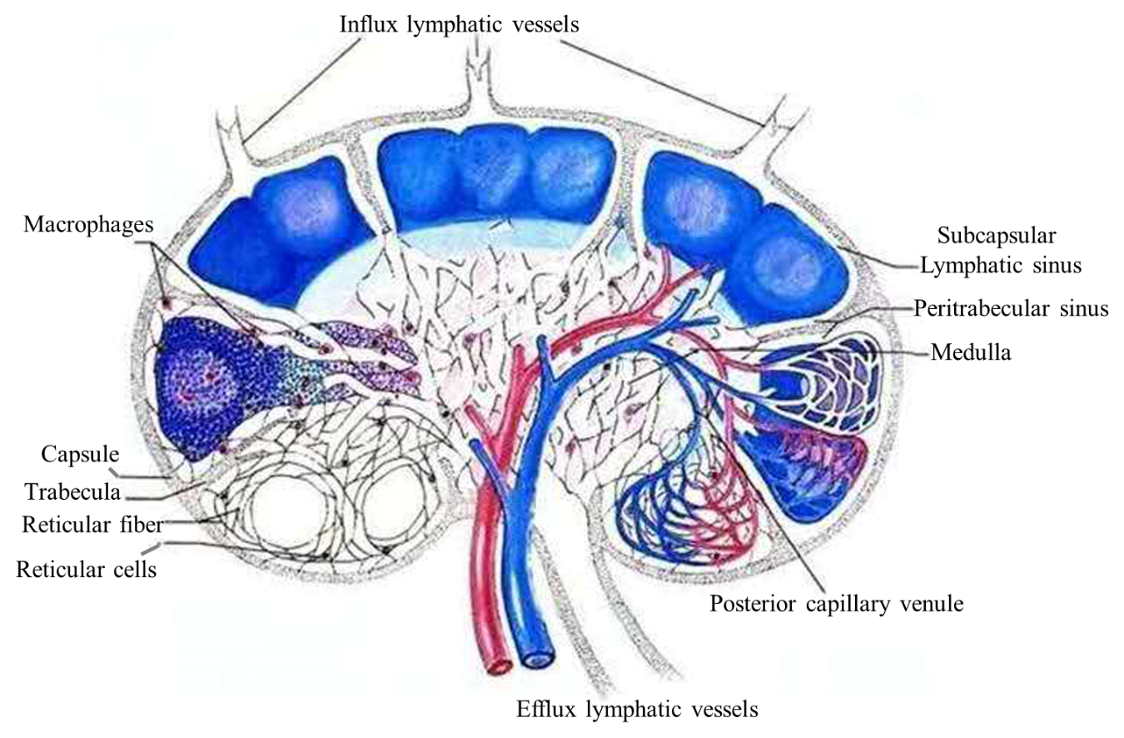
Figure 2 Schematic showing the flow of renal lymphatic fluid. Inflow from the capsular lymph plexus went through the renal parenchyma via subcapsular and peritrabecular lymphatic sinuses and pericapillary space and eventually made confluence at the efflux lymphatic vessels for out-draining.

