Name of Journal: World Journal of Gastroenterology
ESPS Manuscript NO: 32318
Manuscript Type: ORIGINAL ARTICLE

Basic Study
miR-382 functions as a tumor suppressor against esophageal squamous cell carcinoma

Feng J et al. miR-382 inhibits esophageal squamous cell carcinoma

Jie Feng, Bo Qi, Ling Guo, Ling-Yun Chen, Xiu-Feng Wei, Yu-Zhen Liu, Bao-Sheng Zhao

Jie Feng, Bo Qi, Ling Guo, Ling-Yun Chen, Xiu-Feng Wei, Yu-Zhen Liu, Bao-Sheng Zhao, Department of Thoracic Surgery, The First Affiliated Hospital of Xinxiang Medical University, Weihui 453100, Henan Province, China

Author contributions: Feng J and Qi B contributed equally to this work; Zhao BS and Liu YZ contributed to conception and design; Feng J and Qi B designed methods and performed the majority of experiments; Guo L, Chen LY and Wei XF contributed to revision for intellectual content; Liu YZ interpreted the results and wrote the paper.

Supported by Key Technologies R&D Program of Science and Technology Commission of Henan Province, No. 152102310110 to Zhao BS; and Key Science and Technique Fund of Xinxiang, No. ZG15018 to Zhao BS.

Institutional review board statement: This study was reviewed and approved by the First Affiliated Hospital of Xinxiang Medical University Institutional Review Board.

Conflict-of-interest statement: The authors declared that no conflict of interest exists in this study.

Data sharing statement: No additional data are available.

Open-Access: This article is an open-access article which was selected by an in-house editor and fully peer-reviewed by external reviewers. It is distributed in accordance with the Creative Commons Attribution Non Commercial (CC BY-NC 4.0) license, which permits others to distribute, remix, adapt, build upon this work non-commercially, and license their derivative works on different terms, provided the original work is properly cited and the use is non-commercial. See: http://creativecommons.org/licenses/by-nc/4.0/

Manuscript source: Unsolicited manuscript

Correspondence to: Bao-Sheng Zhao, MD, Professor of Surgery, Chief, Department of Thoracic Surgery, The First Affiliated Hospital of Xinxiang Medical University, Weihui 453100, Henan Province, China. zhaobscn@126.com
Telephone: +86-373-4404718
Fax: +86-373-4402573

Received: January 1, 2017
Peer-review started: January 4, 2017
First decision: February 9, 2017
Revised: March 14, 2017
Accepted: March 30, 2017
Article in press:
Published online:

Abstract
AIM
To explore the effect of miR-382 on esophageal squamous cell carcinoma cell in vitro and its possible molecular mechanism.

METHODS
Eca109 cells derived from human esophageal squamous cell carcinoma and Het-1A cells derived from human normal esophageal epithelium were used. Lentivirus-mediated miR-382 was overexpressed in Eca109 cells. The effect of miR-382 on cell proliferation was evaluated by MTT and colony formation assay. For cell cycle analysis, cells were fixed and stained for 30 min with Propidium Iodide (PI) staining buffer containing 10 mg/mL PI and 100 mg/mL RNase A and analyzed by BD FACSCalibur™ Flow cytometer. For cell apoptosis assay, cells were stained with an Annexin V-FITC/PI Apoptosis Detection Kit according to the manufacturer’s instructions and analyzed by a dual laser flow cytometer. Cell invasion and migration abilities were determined through using transwell chambers non-coated and pre-coated with matrigel. Levels of proteins related to cell growth and migration were examined by western blot.

RESULTS
Endogenous miR-382 was down-regulated in Eca109 cells comparing with Het-1A. Introduction of miR-382 not only significantly inhibited proliferation and colony formation, but also arrested cell cycle at G2/M phase, as well as promoted apoptosis and autophagy in Eca109 cells. Migration, invasion, and epithelial-mesenchymal transition of Eca109 cells were suppressed by overexpressing miR-382. Western blot results showed that miR-382 inhibited the phosphorylation of mTOR and 4E-BP1.

CONCLUSION
miR-382 functions as a tumor suppressor against esophageal squamous cell carcinoma (ESCC) development and metastasis, and could be considered as a potential drug source for the treatment of ESCC patients.

Key words: miR-382; Esophageal squamous cell carcinoma; Tumor suppressor; Proliferation; Migration; Invasion

© The Author(s) 2017. Published by Baishideng Publishing Group Inc. All rights reserved.

Core tip: Our previous study revealed that miR-382 was significantly down-regulated in esophageal squamous cell carcinoma (ESCC) patients with short term motility，thus implying that miR-382 may display antitumor function in ESCC development and metastasis. We presented here that miR-382 functions as a tumor suppressor by inhibiting proliferation, migration, invasion, and epithelial-mesenchymal transition, in addition to inducing cell cycle arrest, apoptosis, and autophagy in Eca109 cells. Inhibitory influence on protein translation mediated by mTOR/4E-BP1 signaling might be involved in the antitumor activity of miR-382 against ESCC. Thus, manipulation of miR-382 level can be a potentially therapeutic intervention for ESCC.

Feng J, Qi B, Guo L, Chen LY, Wei XF, Liu YZ, Zhao BS. miR-382 functions as a tumor suppressor against esophageal squamous cell carcinoma. World J Gastroenterol 2017; In press

INTRUDUCTION
MicroRNAs (miRNAs) are classes of small non-coding 17-25 nucleotides long RNAs that bind to the 3’ untranslated region of target genes to induce post-transcription suppression or translational repression^{[1]}. Evidence has demonstrated that miRNAs as either oncogenes or tumor suppressors are frequently dysregulated in many types of cancers and linked with its diagnosis and prognosis, thus implying that miRNAs play a substantial role in the pathogenesis of human cancers^{[2,3]}.
Esophageal cancer (EC) is one of the most common human malignancies^{[4]} and can be pathologically classified into two major types called esophageal squamous cell carcinoma (ESCC) and adenocarcinoma^{[5]}. It is especially prevalent amongst Asian populations with the most common type (90%) of EC in Asian countries being ESCC^{[6]}. Despite improvement in diagnosis and treatment, ESCC has become one of the major diseases that negatively impact overall health and quality of life, as manifested by its rising incidence and poor 5-year survival rate (19%)^{[7]}. ESCC is a complicated disease related to chromosomal instability, epigenetic variability, and expression abnormalities of genes, including both coding and noncoding genes^{[3]}. miRNA as a noncoding gene has been demonstrated as having an expression signature associated with ESCC development and progression^{[8,9]}. In our previous report, miRNA profiling results showed that 46 miRNAs were differentially expressed in ESCC tissues versus non-tumorous esophageal tissues, with further research demonstrating that four of these miRNAs affect the direction of patient outcomes^{[10]}. These results imply that altered expression of these miRNAs may be potential predictive biomarkers for both prognosis and treatment of ESCC.
MicroRNA-382 (miR-382) is a member of this metastatic signature found in our previous result. Recent studies have demonstrated that miR-382 is dysregulated in multiple types of cancer, including breast, osteosarcoma, colorectal, and ovarian cancer^{[11-14]}. We found that miR-382 was significantly down-regulated in ESCC patients with short term motility. Accordingly, in conjunction with relevant literature, our results indicate that low levels of miR-382 may contribute to the development and metastasis of ESCC^{[15]}. However, the possible roles and mechanisms of miR-382 in human ESCC are still not well established.
In the present study, we found that miR-382 expression in the ESCC cell line was lower than that of the normal esophageal epithelia cell line. We determined a functional role of miR-382 in ESCC tumor progression using the in vitro cell model by lentivirus-mediated miR-382 overexpression. We found that overexpression of miR-382 inhibited ESCC cell proliferation by promoting cell cycle arrest at the G2/M phase as well as at apoptosis. Moreover, we observed that overexpression of miR-382 suppressed ESCC cell migration and invasion via the mechanism associated with blocking the epithelial-mesenchymal transition (EMT) process. The mTOR/4E-BP1 signaling pathway and autophagy process might be involved in the antitumor activity of miR-382 on ESCC cells. Our study provides the evidence that miR-382 functions as a tumor suppressor against the development and metastasis of esophageal squamous cell carcinoma.

MATERIALS AND METHODS
Reagents and antibodies
3-(4, 5-dimethylthiazol-2-yl)-2, 5-diphenyl-tetrazolium bromide (MTT), Propidium Iodide (PI) Cell Cycle Assay Kit, Annexin V-FITC/PI Apoptosis Detection Kit, were purchased from Beyotime (Jiangsu, China). All-in-One™ First-Strand cDNA Synthesis Kit, All-in-One™ miRNA qRT-PCR Detection Kit and miRNA primers were purchased from Genecopoeia (Rockville, Maryland, USA). DMEM and fetal bovine serum were obtained from Thermo Fisher Scientific (Waltham, MA, USA). All primary antibodies including p21Cip1/Waf1, E-Cadherin, β-Catenin, Vimentin and Snail, mTOR, p-mTOR (Ser2448), p-4E-BP1 (Thr37/46), LC3 and β-actin were purchased from Cell Signal Technologies (Danvers, MA, USA). All other common chemicals and buffers were from Boster (Wuhan, China).

Cell culture and lentivirus infection
Eca109 and Het-1A were obtained from Cobioer Biosciences (Nanjing, China). Both cell lines were cultured in DMEM medium containing 10% fetal bovine serum in a humidified atmosphere under 5% CO₂ at 37 °C. Lentiviral vectors LV10-(U6/RFP & Puro) expressing a scrambled control (LV-Con) and mature miR-382 (MIMAT0000737, 5’­GAAGUUGUUCGUGGUGGAUUCG­3’, LV-miR-382) were generated from GenePharma (Shanghai, China). The Virus infection was carried out according to GenePharma’s recommendations. Expression of mature miR-382 was confirmed by real-time RT–PCR.

Reverse transcription and quantitative polymerase chain reaction
Total RNA was isolated using TRIzol reagent from Ambion (Austin, Texas, USA) according to the manufacturer’s protocol. All-in-One™ First-Strand cDNA Synthesis Kit and All-in-One™ miRNA quantitative polymerase chain reaction (qPCR) Detection Kit were used for reverse transcription and quantitative PCR (RT-qPCR) respectively and RT-qPCR was performed through Applied Biosystems QuantStudio™ 6 Flex Real-Time PCR System (Applied Biosystems, Foster City, CA). Expression of U6 was used to normalize the miR-382 level.

Cell proliferation and colony formation assay
MTT was used to measure cell proliferation. Eca109 cells (4 × 10³ cells /well) were seeded in 96-well culture plates and incubated overnight at 37 °C in a humidified 5% CO₂ incubator. At an indicated time, 10 µL of MTT dye was added to each well at a final concentration of 5 mg/mL. After 4 h incubation, the blue MTT formazan crystal was then dissolved in 100 µL/well of DMSO. The absorbance at 490 nm was measured on Multisken Spectrum (Thermo Fisher Scientific, Waltham, MA, USA) microplate reader. The amount of viable cells after infection with LV-miR-382 and LV-Con was measured in triplicate. For the colony formation assay，cells were seeded into 6-well plate with 1 × 10³ cells/well. After 10 d of culturing, cells were washed twice with PBS, then fixed with 4% paraformaldehyde for 15 min and stained with 0.5% crystal violet. The number of colonies was calculated with Image J software. The experiment was performed in triplicate.

Cell cycle and apoptosis analysis
Cells were seeded into 35-mm dish with 1 × 10⁵ cells/dish. After 72 h, harvested cells were washed with cold PBS for three times and fixed in 70% ethyl alcohol at 4 °C overnight. Cells were then treated with 10 µg /mL RNase and stained with 50 µg/mL PI for 30 min at room temperature in the dark. The cell cycle was then measured by BD FACS Calibur™ (BD Biosciences, San Jose, CA, USA) and the cell cycle distribution was analyzed by ModFit software (BD Biosciences, San Jose, CA, USA). For the apoptosis analysis, cells were stained with Annexin V-FITC/PI Apoptosis Detection Kit according to the manufacturer’s instructions. The apoptotic cells were detected by BD FACS Calibur™ (BD Biosciences, San Jose, CA, USA).

Transwell migration and invasion assay
A 24-well plate was used as a “feeder tray”. For the migration assay, 6.5 mm transwell chamber with 8 µm micro-pores (Corning Costar, Manassas, VA, USA) were used. For the invasion assay, the same filters were pre-coated with BD Matrigel (BD, Franklin Lakes, NJ, USA). 60 µL of 1mg/ml matrigel was briefly (specify the amount of time) added on top of the filter into the upper chamber of the 24-well transwell and incubated at 37 °C for 8 h, followed by removal of the excess solution. In both migration and invasion tests, 200 µl of cell suspension (at 1 × 10⁵ cells/ml) in serum-free medium was seeded on top of the filter which was then immersed into the feeder tray and incubated at 37 °C in 600 µL of complete medium. After allowing the cells to migrate for 24 h, the non-migrated cells or non-invaded cells on the upper surface of each membrane were cleaned with a cotton swab. Cells adhering to the bottom surface of each membrane were fixed and stained with 0.1% crystal violet. Migrated or invaded cells in five different fields were counted through a phase contrast microscope. Either migration assay or invasion assay was performed three times using triplicate wells.

Western blot analysis
Cell lysates were prepared with RIPA lysis buffer (50 mM Tris-HCl, 150 mM NaCl, 0.1% SDS, 1% NP40, 0.5% sodium deoxycholate, 1 mM phenylmethylsulfonyl fluoride, 100 µM leupeptin, and 2 µg/mL aprotinin, pH 8.0). 30 µg protein extract was subjected to SDS-polyacrylamide gel and transferred onto nitrocellulose membranes (Amersham Biosciences, Piscataway, NJ, USA). After being blocked with 5% nonfat dry milk, membranes were incubated at 4°C overnight with each of the following primary antibodies: p21Cip1/Waf1, E-Cadherin, β-Catenin, Vimentin, Snail, mTOR, p-mTOR (Ser2448), p-4E-BP1 (Thr37/46), LC3 (all 1:1000 dilution) and β-actin. Membranes were then washed with PBST and incubated with horseradish peroxidase-conjugated secondary antibodies. After incubation, the membranes were washed three times with TBST and immersed in SuperSignal West Pico Chemiluminescent Substrate detection kit (Thermo Fisher Scientific, Waltham, MA, USA) in accordance with the manufacturer’s instructions. Chemiluminescent detection of western blots was performed using AmershamTM Imager 600 system (GE Healthcare Bio-Sciences, Pittsburgh, PA, USA).

Statistical analysis
Data was analyzed using Student’s t-test, and all data was expressed as the mean ± SD. P < 0.05 was considered statistically significant.

RESULTS
Endogenous miR-382 was down-regulated in Eca109 cells
We have previously shown that miR­382 level was explicitly down-regulated in ESCC patients with poor outcome compared to those with good outcome. However, the functional role of miR-382 in human ESCC remains elusive. In this study, we sought to confirm the miR-382 down-regulation in Eca109 cell line derived from human ESCC tissue compared to Het-1A cell line derived from human normal esophageal epithelium. As shown in Figure 1A, endogenous miR-382 in Eca109 was 7.69-fold lower than that in Het-1A cells (P < 0.01). This result is consistent with our previous clinical finding. In order to further explore the function of miR-382, Eca109 cells were infected with lentivirus-mediated miR-382 (LV-miR-382). As indicated in Figure 1B, miR-382 levels of LV-miR-382 infected Eca109 cells were 24153.06-fold higher than that of LV-Con control cells. Therefore, we utilized this in vitro cell model to investigate the functional role of miR-382 in ESCC progression in the following experiments.

miR-382 inhibited Eca109 cell proliferation and colony formation
As the expression of endogenous miR-382 in Eca109 cells was down-regulated, we speculated that miR-382 might affect the proliferation rate of ESCC cells. Thus, we examined the effect of overexpression of miR-382 on the proliferation of Eca109 cells. As shown in Figure 2A, the cell proliferation rate of miR-382 overexpressed Eca109 cells was significantly inhibited when compared with that of the control cells at 72-hours culture time point (LV-miR-382 vs LV-Con, 312.01 ± 27.53 vs 176.76 ± 18.49, P < 0.01). Moreover, colony formation assay in Figure 2B and 2C showed that enforced expression of miR-382 resulted in a more than 69% decrease in colony numbers in miR-382 overexpressed Eca109 cells compared with control cells (LV-miR-382 vs LV-Con, 421.00 ± 41.24 vs 127.33 ± 27.46, P < 0.01). These results indicated that miR-382 inhibited Eca109 proliferation in vitro.

miR-382 induced cell cycle arrest at G2/M phase and apoptosis
To elucidate the possible mechanisms by which miR-382 inhibited the proliferation of ESCC cells, we studied the impact of miR-382 on Eca109 cell cycle progression and apoptosis. The cell cycle distribution analyzed by flow cytometry showed that the cell number at G2/M phase was increased in LV-miR-382 infected cells compared with LV-Con cells (Figure 3A, 3B and 3C, LV-miR-382 vs LV-Con, 100% ± 10.14 vs 215% ± 16.60, P < 0.05). Western blot analysis was performed to determine the expression of p21Cip1/Waf1, which is an important negative cell cycle regulator. The result in Figure 3D clearly indicated that the expression level of p21Cip1/Waf1 was augmented by miR-382 overexpression. These data suggested that miR-382 induced cell cycle arrest at G2/M phase in Eca109 cells may be mediated through p21Cip1/Waf1 downregulation. To investigate whether the anti-proliferative activity of miR-382 was related to an apoptotic effect, apoptosis was determined by flow cytometry after double staining with Annexin-V FITC/PI. As shown in Figure 4, either early or late apoptotic cell number of LV-miR-382 infected cells was clearly increased when compared to control cells (early: LV-miR-382 vs LV-Con, 1.00 ± 0.09 vs 5.50 ± 0.00, P < 0.05; late: LV-miR-382 vs LV-Con, 1.00 ± 0.72 vs 14.57 ± 1.84, P < 0.01). These results suggested that miR-382 inhibitory effect of miR-382 on Eca109 proliferation may be related to increased G2/M cell cycle arrest and active apoptosis.

miR-382- inhibited Eca109 cell migration and invasion
Cancer metastasis is greatly associated with cancer cell migratory and invasive abilities. To further investigate the influence of miR-382 over the migration and invasion of ESCC cells, migration transwell assay was initially performed to determine the migratory ability of the cells. As shown in Figure 5A and 5B , in the group infected with LV-miR-382 the rate of cell migration into the bottom chamber was significantly reduced by 32% compared with that of the scrambled control cells (LV-Con vs LV-miR-382, 433.50 ± 20.72 vs 292.25 ± 18.02, P < 0.05). Subsequently, matrigel invasion assay, a three dimensional model, was utilized to investigate the inhibitory effect of miR-382 on the invasive potency of the cells. The result shown in Figure 5C and 5D exhibited that miR-382 significantly suppressed invasion of Eca109 cells by 54% (LV-Con vs LV-miR-382, 603.80 ± 64.46 vs 273.80 ± 54.99, P < 0.01). These data indicated that miR-382 exerted an inhibitory effect on the migration and invasion of ESCC cells.
The role of miR-382 in regulating EMT was further studied by investigation of the protein expression of several key EMT effectors, including E-Cadherin, β-Catenin, vimentin and Snail. Interestingly, miR-382 attenuated expressions of three mesenchymal markers β-Catenin, Vimentin and Snail. Moreover, we also observed that the expression of E-Cadherin, which is one of the epithelial markers, was significant augmented in LV-miR-382 cells as shown in Figure 5E. Taken together, these results suggested that the inhibitory effect of miR-382 on the migration and invasion of ESCC cells may be mediated through restraining EMT processes in ESCC.

miR-382 inhibited mTOR signaling pathway and activated autophagy process
Mammalian target of rapamycin (mTOR) plays a key role in cell growth and homeostasis and may be abnormally regulated in tumors. To address the functional activation of mTOR regulated by miR-382, western blot analyses were performed to examine the phosphorylation level of both mTOR and translation repressor 4E binding protein 1 (4E-BP1), a target of mTOR known to bind to translation initiation factor eIF4E to inhibit cap-dependent translation. Overexpression of miR-382 noticeably inhibited the phosphorylation of both mTOR (Ser2448) and 4E-BP1 (Thr37/46) (Figure 6). Previous studies have indicated that autophagy has roles in various cellular functions, including cell proliferation and apoptosis. During autophagy, LC3-I is converted to LC3-II and recruited into the membrane of the phagophore, a double membrane required for the recycling of protein aggregates and organelles. To determine whether miR-382 might induce autophagy in Eca109, we examined the level of LC3 protein in LV-miR-382 infected Eca109 cells and control cells. As shown in Figure 6, increased levels of either LC3-I or LC3-II were detected in LV-miR-382 cells compared to control cells, indicating that miR-382 activated the autophagy process. These data suggested that inhibition of mTOR/4E-BP1 signaling pathway together with activation of the autophagy process may be important targets of miR-382 actions.

DISCUSSION
Accumulating evidence has revealed that miRNAs participate in the initiation and progression of human cancers. Thus, exploration of cancer-specific miRNAs contributes to the identification of novel biomarkers and therapeutic targets for human cancers. To date, correlation analyses between miRNAs and ESCC have shown that a number of dysregulated miRNAs levels correlate with ESCC patients’ outcomes. Human miR-382 (has–mir-382, MIMAT0000737, 5’-GAAGUUGUUCGUGGUGGAUUCG-3’) resides in a miRNA cluster in the imprinted DLK1-DIO3 region on the 14q32 locus, which hosts one of the largest miRNA clusters in the genome. Many of these miRNAs are differentially expressed in several pathologic processes, and various cancers, with recent studies reported that miR-382 was aberrantly regulated in several types of human malignancies. miR-382 levels were found to be decreased in ovarian cancer^{[13]} and osteosarcoma, but increased in breast cancer^{[16]} and acute myeloid leukemia tumor tissue^{[17]}. Based off these findings, the role of miR-382 in tumor development and metastasis is heterogeneous and in a cell-driven and tissue-driven manner.
Our earlier study discovered that decreased miR­382 expression in tumor tissues from ESCC patients was clinically correlated with short term motility, and significantly linked to poor patient outcome. This indicates that miR-382 may play anti-tumor functions in esophageal carcinogenesis, and could be a potential predictive biomarker for ESCC prognosis. On the other hand, the mechanism by which miR-382 functionally affects ESCC phenotype has not been elucidated; therefore in this study, we began by evaluating the expression of endogenous levels of miR-382 in Eca109 tumor cell line and Het-1A normal esophageal epithelia cell line. Consistent with our previous clinical results, we found that miR-382 was reduced in Eca109 cells when compared with Het-1A. Moreover, we found that lentivirus-mediated overexpression of miR-382 significantly inhibited Eca109 cell proliferation, colony formation, migration and invasion. These findings together with our previous result suggest that miR-382 functions as a tumor suppressor in ESCC.
Cell cycle arrest and apoptosis are closely linked to cell proliferation in mammalian cells. In the present study, we found overexpression of miR-382 significantly increased initiation of cell cycle arrest at G2/M phase and promoted apoptotic process of Eca109 cells. Therefore, the inhibitory influence of miR-382 on Eca109 proliferation seems to be related with increased G2/M cell cycle arrest and active apoptosis. In addition, it is known that cell cycle progression and apoptosis are regulated by numerous proteins, with one of these proteins being cyclin-dependent kinase inhibitor p21Cip1/Waf1, which facilitates cell cycle arrest in response to a variety of stimuli^{[18]}. Our results showed that miR-382 clearly increased p21Cip1/Waf1 expression, indicating that miR-382 induced cell cycle arrest in G2/M phase may be through regulation of p21Cip1/Waf1.
Epithelial–mesenchymal transition (EMT) comprises the process by which epithelial cells are transited into mesenchymal cells, and display reduced intracellular adhesion and increased motility^{[19]}. Most evidence supports EMT playing the integral roles through which epithelial cancers invade and metastasize. EMT process is related to a number of cellular and molecular events and is accompanied by the loss of epithelial markers (e.g., E-Cadherin) and the gain of mesenchymal markers (e.g., Vimentin, β-Catenin and Snail). Our study showed that miR-382 inhibited Eca109 cell migration, as well as invasion in vitro. Overexpression of miR-382 enhanced the level of E-Cadherin and reduced levels of vimentin, β-Catenin, and Snail. Accordingly, these data indicated that miR-382 might suppress the EMT process, so that Eca109 cell invasion and metastasis may be restrained.
Autophagy is a catabolic process for proteolytic degradation of damaged intracellular proteins and organelles in lysosomes. Autophagy dysfunction is associated with multiple human diseases, such as cancer. It has been reported that autophagy deficiency promotes cell proliferation, migration and invasion. Our data revealed that overexpression of miR-382 was able to upregulate the expression of two distinctive hallmarks of autophagy, LC3-I and LC3-II^{[20]} , in Eca109 cells, thus implying that miR-382 could induce autophagy in Eca109 cells.
The regulation of translation is critical for controlling many major cellular processes, including cell proliferation, apoptosis, and metastasis. mTOR signaling pathway plays a pivotal role in regulation of translation process, with one of the best-characterized downstream effectors of mTOR being 4E-BP1. mTOR phosphorylates 4E-BP1, which promotes the dissociation of eIF4E from 4E-BP1, consequently alleviating the inhibitory effect of 4E-BP1 on eIF4E dependent translation initiation^{[21]}. Therefore, overall translation levels are lowered when 4E-BP1 is active, which is thought to be regulated by mTOR dependent phosphorylation. Our results showed that miR-382 dramatically inhibited the phosphorylation of mTOR as well as 4E-BP1. These results indicated that miR-382 might suppress overall protein translation process through mTOR/4E-BP1, and could potentially function as a tumor suppressor against ESCC.
In conclusion, our results indicated that miR-382 was dramatically downregulated in ESCC cells. Overexpression of miR-382 inhibited proliferation, migration and invasion of Eca109 cells. mTOR/4E-BP1 signaling mediated inhibitory influence on protein translation may be involved in the antitumor activity of miR-382 against esophageal cancer. Our results could provide insights into a new therapeutic strategy for the treatment of ESCC through the upregulation of miR-382 expression.

COMMENTS
Background
MicroRNAs (miRNAs) are classes of small non-coding RNAs involved in the process of silencing gene expression. Evidence has shown that miRNAs are frequently dysregulated in many types of cancers and play a substantial role in the pathogenesis of human cancers. We previously found that miRNA-382 (miR-382) was significantly down-regulated in esophageal squamous cell carcinoma (ESCC) patients with short term motility, implying that miR-382 may contribute to the development and metastasis of ESCC. However, the possible roles and mechanisms of miR-382 in human ESCC are still not well established.

Innovations and breakthroughs
This study revealed that endogenous miR-382 was dramatically downregulated in ESCC cells in comparison to normal esophageal epithelial cells. This is consistent with our previous clinical data. Overexpression of miR-382 inhibited cell proliferation, migration and invasion of Eca109 cells. mTOR/4E-BP1 signaling mediated inhibitory influence on protein translation might be involved in the antitumor activity of miR-382 against esophageal carcinoma.

Applications
This study suggests that the miR-382 is downregulated in ESCC and plays an inhibitory role in the growth and invasion of ESCC. Because of this miR-382 is considered a tumor suppressor of ESCC, and provides new insights into a possible therapeutic strategy for ESCC through the upregulation of miR-382 expression.

Terminology
Previous literature indicates that miR-382 was reduced and associated with poor survival in osteosarcoma patients. In contrast, increased miR-382 levels were found in acute myeloid leukemia tumor tissue. These findings illustrate the role of miR-382 in tumor development and metastasis as a heterogeneous one that is cell-driven and tissue-driven.

Peer-review
This is an interesting topic aiming to reveal more advanced and detailed functions of miR-382 on ESCC. The authors demonstrated that overexpression of miR-382 inhibited cell proliferation and invasion, induced cell apoptosis, and cell autophagy. The anti-tumor activity of miR-382 might be initiated by inhibition of mTOR/4E-BP1 mediated protein translation process. Thus, manipulation of miR-382 level is a potential therapeutic strategy for ESCC.

REFERENCES
1 Lagos-Quintana M, Rauhut R, Lendeckel W, Tuschl T. Identification of novel genes coding for small expressed RNAs. Science 2001; 294: 853-858 [PMID: 11679670 DOI: 10.1126/science.1064921]
2 Bartel DP. MicroRNAs: target recognition and regulatory functions. Cell 2009; 136: 215-233 [PMID: 19167326 DOI: 10.1016/j.cell.2009.01.002]
3 Croce CM. Causes and consequences of microRNA dysregulation in cancer. Nat Rev Genet 2009; 10: 704-714 [PMID: 19763153 DOI: 10.1038/nrg2634]
4 Torre LA, Bray F, Siegel RL, Ferlay J, Lortet-Tieulent J, Jemal A. Global cancer statistics, 2012. CA Cancer J Clin 2015; 65: 87-108 [PMID: 25651787 DOI: 10.3322/caac.21262]
5 Holmes RS, Vaughan TL. Epidemiology and pathogenesis of esophageal cancer. Semin Radiat Oncol 2007; 17: 2-9 [PMID: 17185192 DOI: 10.1016/j.semradonc.2006.09.003]
6 Su M, Liu M, Tian DP, Li XY, Zhang GH, Yang HL, Fan X, Huang HH, Gao YX. Temporal trends of esophageal cancer during 1995-2004 in Nanao Island, an extremely high-risk area in China. Eur J Epidemiol 2007; 22: 43-48 [PMID: 17195051 DOI: 10.1007/s10654-006-9086-x]
7 Chen W, Zheng R, Baade PD, Zhang S, Zeng H, Bray F, Jemal A, Yu XQ, He J. Cancer statistics in China, 2015. CA Cancer J Clin 2016; 66: 115-132 [PMID: 26808342 DOI: 10.3322/caac.21338]
8 Yang M, Liu R, Sheng J, Liao J, Wang Y, Pan E, Guo W, Pu Y, Yin L. Differential expression profiles of microRNAs as potential biomarkers for the early diagnosis of esophageal squamous cell carcinoma. Oncol Rep 2013; 29: 169-176 [PMID: 23124769 DOI: 10.3892/or.2012.2105]
9 Yi Y, Lu X, Chen J, Jiao C, Zhong J, Song Z, Yu X, Lin B. Downregulated miR-486-5p acts as a tumor suppressor in esophageal squamous cell carcinoma. Exp Ther Med 2016; 12: 3411-3416 [PMID: 27882172 DOI: 10.3892/etm.2016.3783]
10 Zhao BS, Liu SG, Wang TY, Ji YH, Qi B, Tao YP, Li HC, Wu XN. Screening of microRNA in patients with esophageal cancer at same tumor node metastasis stage with different prognoses. Asian Pac J Cancer Prev 2013; 14: 139-143 [PMID: 23534712]
11 Fu L, Li Z, Zhu J, Wang P, Fan G, Dai Y, Zheng Z, Liu Y. Serum expression levels of microRNA-382-3p, -598-3p, -1246 and -184 in breast cancer patients. Oncol Lett 2016; 12: 269-274 [PMID: 27347136 DOI: 10.3892/ol.2016.4582]
12 Xu M, Jin H, Xu CX, Sun B, Mao Z, Bi WZ, Wang Y. miR-382 inhibits tumor growth and enhance chemosensitivity in osteosarcoma. Oncotarget 2014; 5: 9472-9483 [PMID: 25344865 DOI: 10.18632/oncotarget.2418]
13 Zhou B, Song J, Han T, Huang M, Jiang H, Qiao H, Shi J, Wang Y. MiR-382 inhibits cell growth and invasion by targeting NR2F2 in colorectal cancer. Mol Carcinog 2016; 55: 2260-2267 [PMID: 26800338 DOI: 10.1002/mc.22466]
14 Tan H, He Q, Gong G, Wang Y, Li J, Wang J, Zhu D, Wu X. miR-382 inhibits migration and invasion by targeting ROR1 through regulating EMT in ovarian cancer. Int J Oncol 2016; 48: 181-190 [PMID: 26575700 DOI: 10.3892/ijo.2015.3241]
15 Qi B, Lu JG, Yao WJ, Chang TM, Qin XG, Ji YH, Wang TY, Liu SG, Li HC, Liu YZ, Zhao BS. Downregulation of microRNA-382 is associated with poor outcome of esophageal squamous cell carcinoma. World J Gastroenterol 2015; 21: 6884-6891 [PMID: 26078564 DOI: 10.3748/wjg.v21.i22.6884]
16 Ho JY, Hsu RJ, Liu JM, Chen SC, Liao GS, Gao HW, Yu CP. MicroRNA-382-5p aggravates breast cancer progression by regulating the RERG/Ras/ERK signaling axis. Oncotarget 2016; : [PMID: 27705918 DOI: 10.18632/oncotarget.12338]
17 Li Z, Lu J, Sun M, Mi S, Zhang H, Luo RT, Chen P, Wang Y, Yan M, Qian Z, Neilly MB, Jin J, Zhang Y, Bohlander SK, Zhang DE, Larson RA, Le Beau MM, Thirman MJ, Golub TR, Rowley JD, Chen J. Distinct microRNA expression profiles in acute myeloid leukemia with common translocations. Proc Natl Acad Sci U S A 2008; 105: 15535-15540 [PMID: 18832181 DOI: 10.1073/pnas.0808266105]
18 Kang MR, Park KH, Yang JO, Lee CW, Oh SJ, Yun J, Lee MY, Han SB, Kang JS. miR-6734 Up-Regulates p21 Gene Expression and Induces Cell Cycle Arrest and Apoptosis in Colon Cancer Cells. PLoS One 2016; 11: e0160961 [PMID: 27509128 DOI: 10.1371/journal.pone.0160961]
19 Yang G, Yuan J, Li K. EMT transcription factors: implication in osteosarcoma. Med Oncol 2013; 30: 697 [PMID: 23975634 DOI: 10.1007/s12032-013-0697-2]
20 Li Y, Jiang W, Hu Y, Da Z, Zeng C, Tu M, Deng Z, Xiao W. MicroRNA-199a-5p inhibits cisplatin-induced drug resistance via inhibition of autophagy in osteosarcoma cells. Oncol Lett 2016; 12: 4203-4208 [PMID: 27895792 DOI: 10.3892/ol.2016.5172]
21 Li W, Chang J, Wang S, Liu X, Peng J, Huang D, Sun M, Chen Z, Zhang W, Guo W, Li J. miRNA-99b-5p suppresses liver metastasis of colorectal cancer by down-regulating mTOR. Oncotarget 2015; 6: 24448-24462 [PMID: 26259252 DOI: 10.18632/oncotarget.4423]
P-Reviewer: Arigami T, Lin Q S-Editor: Yu J L-Editor: E-Editor:
Specialty type: Gastroenterology and hepatology
Country of origin: China
Peer-review report classification
Grade A (Excellent): A
Grade B (Very good): 0
Grade C (Good): C
Grade D (Fair): 0
Grade E (Poor): 0

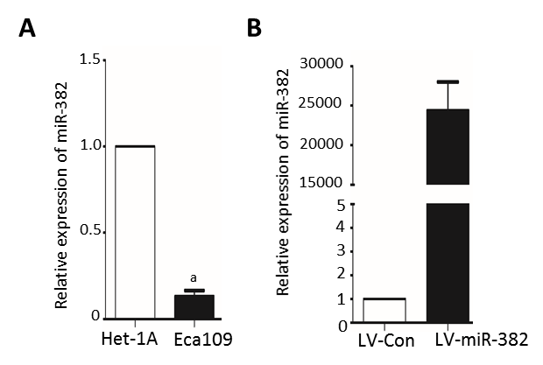

Figure 1 miR-382 was downregulated in ESCC cell line Eca109. A: The expression of miR-382 in Het-1A cells and Eca109 cells was examined by RT-qPCR; B: The relative expression level of miR-382 after introduction of either lentivirus-mediated miR-382 (LV-miR-382) or lentivirus-mediated scrambled control (LV-Con) into Eca109 cells was examined by RT-qPCR. The data in A and B is expressed as mean ± SD of three independent experiments. ªP < 0.01 vs control.

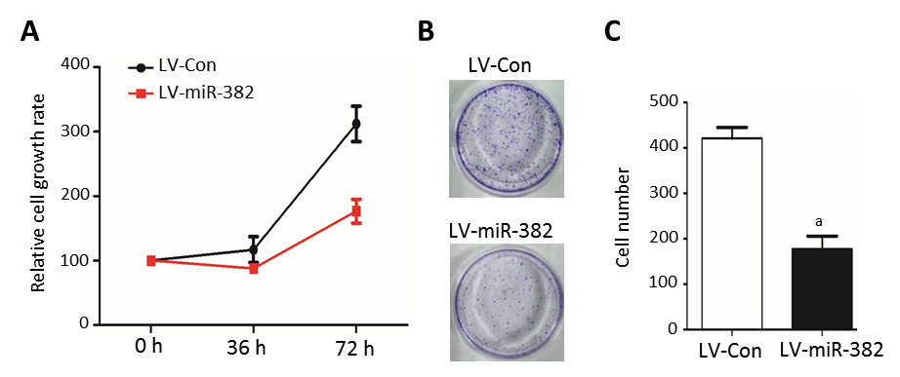
Figure 2 miR-382 inhibited Eca109 cell proliferation and colony formation. A: The proliferation of miR-382 overexpressed Eca109 cells and LV-Con control cells was measured by MTT. The Y axis represents the relative number of viable cells presented as mean ± SD, ªP < 0.01; B: Representative photomicrographs showed the colony formation in cultured LV-Con Eca109 cells and LV-miR-382 Eca109; C: Data is presented as mean ± SD, ªP < 0.01.

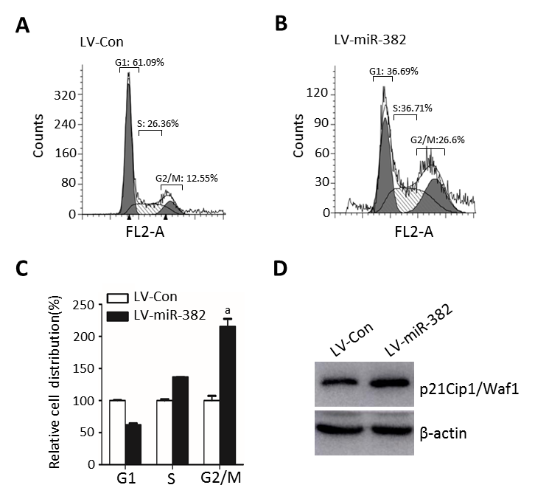

Figure 3 miR-382 induced cell cycle arrest at G2/M phase in Eca109 cells. A: Cell cycle distribution of miR-382 overexpressed Eca109 cells and control cells was analyzed by flow cytometry at post-culture 48 h; B: Relative cell distribution percentage of LV-miR-382 expressed Eca109 cells to LV-Con control cells in each cell cycle phase. The data presented is mean ± SD of three independent experiments. ªP < 0.05 vs control; C: Protein expression level of p21Cip1/Waf1 was examined in LV-Con Eca109 cells and LV-miR-382 Eca109 cells. β-actin was as a loading control.

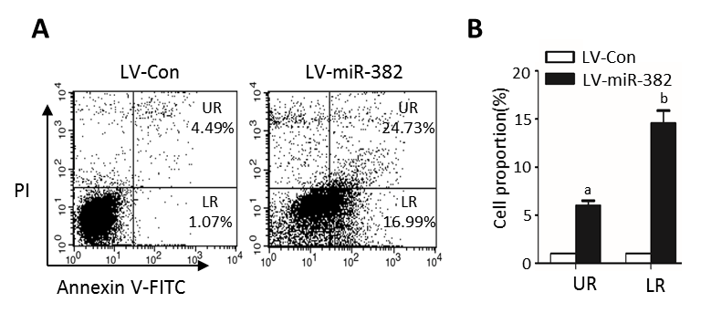
Figure 4 miR-382 promoted apoptotic process in Eca109 cells. A: Apoptosis of LV-Con Eca109 cells and LV-miR-382 Eca109 cells was negative cell cycle regulator measured using flow cytometry; B: Apoptotic cell values were expressed as mean ± SD of three experiments. ªP < 0.05 and ^{b}P < 0.01 vs control.

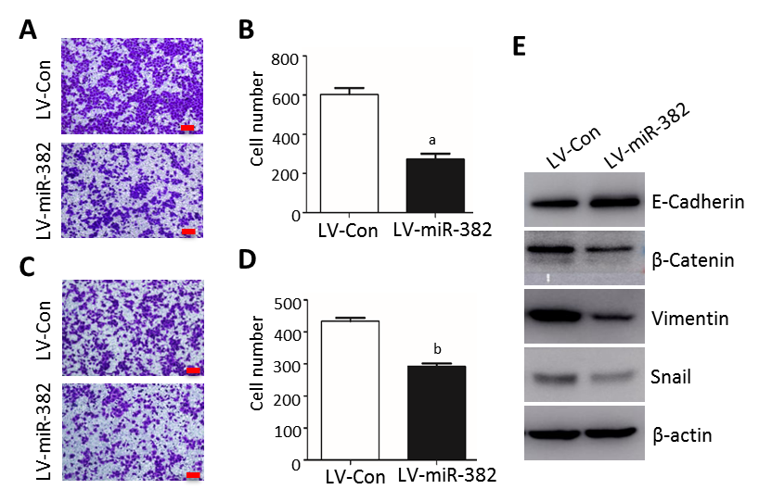
Figure 5 Overexpression miR-382 inhibited migration, invasion and EMT in Eca109 cells. A: Representative photomicrographs showed migrated cells stained with crystal violet after post-culture for 24 h in the transwell migration assay. The bars represent 200 µm; B: The migrated cells in five different fields were counted and the Y axis represented the migrated cell number from three independent experiments. Data were shown as mean ± SD, ªP < 0.01; C: Representative photomicrographs showed invaded cells stained with crystal violet after post-culture for 24 h in the transwell invasion assay. The bars are 200 µm; D: The invaded cells in five different fields were counted and the Y axis represented the invaded cell number from three independent experiments. Data were expressed as mean ± SD, ^{b}P < 0.5; E: Western blot analysis of the expression of epithelial marker E-cadherin, and mesenchymal markers β-catenin, vimentin and Snail in Eca109 cells infected with LV-miR-382 or LV-Con(c). β-actin served as a loading control.

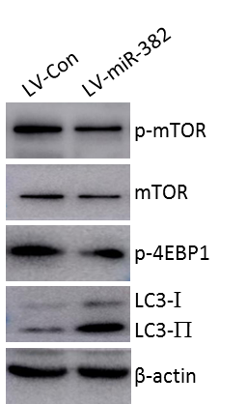

Figure 6 miR-382 inhibited mTOR and 4E-BP1 phosphorylation and activated autophagy. p-mTOR, mTOR, p-4E-BP1 and LC3 were evaluated by Western blot. Experiments performed in triplicate. Equal protein loading was confirmed by β-actin.

