Name of journal: World Journal of Gastroenterology
ESPS Manuscript NO: 4638
Columns: REVIEW

Transjugular intrahepatic portosystemic shunt for the management of acute variceal hemorrhage

Loffroy R et al. Transjugular intrahepatic portosystemic shunt for hemorrhage

Romaric Loffroy, Louis Estivalet, Violaine Cherblanc, Sylvain Favelier, Pierre Pottecher, Samia Hamza, Anne Minello, Patrick Hillon, Pierre Thouant, Pierre-Henri Lefevre, Denis Krausé, Jean-Pierre Cercueil

Romaric Loffroy, Louis Estivalet, Violaine Cherblanc, Sylvain Favelier, Pierre Pottecher, Pierre Thouant, Pierre-Henri Lefevre, Denis Krausé, Jean-Pierre Cercueil, Department of Vascular, Oncologic and Interventional Radiology, University of Dijon School of Medicine, Bocage Teaching Hospital, 21079 Dijon, France

Samia Hamza, Anne Minello, Patrick Hillon, Department of Intensive Care Medicine, Gastroenterology and Hepatology, University of Dijon School of Medicine, Bocage Teaching Hospital, 21079 Dijon, France

Author contributions: Loffroy R, Estivalet L, and Cherblanc V wrote the paper; Favelier S, Pottecher P, Hamza S, Minello A, Hillon P, Thouant P, Lefevre PH, Krausé D, and Cercueil JP revised the article for important intellectual content; all authors read and approved the final manuscript.

Correspondence to: Romaric Loffroy, MD, PhD, Professor, Department of Vascular, Oncologic and Interventional Radiology, University of Dijon School of Medicine, Bocage Teaching Hospital, 14 Rue Paul Gaffarel, BP 77908, 21079 Dijon Cedex, France.
romaric.loffroy@chu-dijon.fr

Telephone: +33-380-293-677 Fax: +33-380-295-455
Received: July 12, 2013 Revised: August 13, 2013
Accepted: August 20, 2013
Published online:

Abstract
Acute variceal hemorrhage, a life-threatening condition that requires a multidisciplinary approach for effective therapy, is defined as visible bleeding from an esophageal or gastric varix at the time of endoscopy, the presence of large esophageal varices with recent stigmata of bleeding, or fresh blood visible in the stomach with no other source of bleeding identified. Transfusion of blood products, pharmacological treatments and early endoscopic therapy are often effective; however, if primary hemostasis cannot be obtained or if uncontrollable early rebleeding occurs, transjugular intrahepatic portosystemic shunt (TIPS) is recommended as rescue treatment. The TIPS represents a major advance in the treatment of complications of portal hypertension. Acute variceal hemorrhage that is poorly controlled with endoscopic therapy is generally well controlled with TIPS, which has a 90% to 100% success rate. However, TIPS is associated with a mortality of 30% to 50% in such a setting. Emergency TIPS should be considered early in patients with refractory variceal bleeding once medical treatment and endoscopic sclerotherapy failure, before the clinical condition worsens. Furthermore, admission to specialized centers is mandatory in such a setting and regional protocols are essential to be organized effectively. This review article discusses initial management and then focuses on the specific role of TIPS as a primary therapy to control acute variceal hemorrhage, particularly as a rescue therapy following failure of endoscopic approaches.

© 2013 Baishideng. All rights reserved.

Key words: Cirrhosis; Portal hypertension; Transjugular intrahepatic portosystemic shunt; Variceal hemorrhage

Core tip: The transjugular intrahepatic portosystemic shunts (TIPS) is a highly effective treatment for bleeding esophageal and gastric varices with control of the bleeding in over 90% of the patients. Many papers have been published in the last decade that led to technical improvements and definition of the best indications for this promising treatment of complications of portal hypertension. The purpose of this article is to describe the different treatment options for patients with refractory esophageal and gastric varices bleeding and the role of TIPS as a rescue therapy. Technical aspects of this procedure and the current indications are also discussed.

Loffroy R, Estivalet L, Cherblanc V, Favelier S, Pottecher P, Hamza S, Minello A, Hillon P, Thouant P, Lefevre PH, Krausé D, Cercueil JP. Transjugular intrahepatic portosystemic shunt for the management of acute variceal hemorrhage. World J Gastroenterol 2013;
Available from: URL: http://www.wjgnet.com/
DOI: http://dx.doi.org/
INTRODUCTION
Acute variceal hemorrhage is a common clinical emergency and most often is caused by cirrhosis-related portal hypertension^{[1]}. Less common causes include splenic vein thrombosis, hepatic veno-occlusive disease, and primary biliary cirrhosis^{[1]}. It is defined as visible bleeding from an esophageal or gastric varix at the time of endoscopy, the presence of large esophageal varices with recent stigmata of bleeding or fresh blood visible in the stomach with no other source of bleeding identified^{[1]}. The frequency of gastroesophageal varices in cirrhosis varies from 30% to 70% with bleeding occurring in approximately one-third of patients^{[2]}. Twenty percent of cirrhotics with acute variceal hemorrhage die within six weeks^{[3]}. The rebleeding rates range from 30% to 40% at six weeks and the mortality from rebleeding reaches 30%^{[4]}. Gastroesophageal varices account for approximately 80% of all cases of variceal hemorrhage^{[2,5]}. The precipitating cause for hemorrhage, presumably an acute rise in portal pressure and subsequent variceal rupture, remains uncertain. However, several factors have been implicated including raised intra-abdominal pressure, bacterial infection, continued excess alcohol consumption and postprandial increase in splanchnic blood flow^{[4,5]}. Predictive factors for variceal hemorrhage include a hepatic venous pressure gradient (HVPG) of > 20 mmHg^{[6,7]}, the presence of large varices with red signs^{[8]} and underlying severe liver disease (Child–Pugh grade C)^{[2]}.
Optimal management of variceal hemorrhage requires a multidisciplinary approach involving a team of gastroenterologists, hepatologists, critical care physicians, surgeons, and interventional radiologists. The principal components of therapy include airway maintenance, hemodynamic stabilization, control of the variceal hemorrhage, and alteration of the hemodynamic effects of portal hypertension. Treatment options for the management of acute variceal hemorrhage include endoscopic therapy, use of vasoactive drugs, balloon tamponade and esophageal transaction. These various methods, either alone or in combination, are effective in controlling acute variceal hemorrhage in 80% to 90% of patients^{[3]}. Patients who do not respond to these measures are referred for rescue therapies, which include transjugular intrahepatic portosystemic shunt (TIPS) and surgical portosystemic shunts with or without splenectomy. Because of the higher mortality of surgery in the acute setting, TIPS is the favored rescue procedure for uncontrolled variceal hemorrhage^{[6]}.
The purpose of this review is to describe the different therapeutic options available to control acute variceal hemorrhage and then to focus on the potential role of TIPS as a primary therapy to control acute variceal hemorrhage, particularly as a rescue therapy following failure of endoscopic approaches.

INDICATIONS - Gastrointestinal bleeding
TIPS has been used to treat many complications related to portal hypertension. The relative efficacy of TIPS has been tested with randomized controlled trials, (variceal bleeding, refractory ascites), whereas other indications have been evaluated in uncontrolled case series.
The causes of gastrointestinal hemorrhage in a patient with portal hypertension may be variceal rupture, portal hypertension gastropathy, postsclerotherapy ulcers, peptic ulcer disease, hemorrhagic gastritis, and Mallory-Weiss tear. TIPS is generally accepted as a second-line therapy after failure of endoscopic and medical therapy of bleeding from gastroesophageal varices^{[9]}.

Primary prophylaxis of variceal bleeding
Bleeding from esophageal varices is a common and severe complication of portal hypertension. Prevention of the initial bleeding can be achieved in a number of cases by endoscopic variceal ligation or β-blocker treatment. However, TIPS has never been tested in this situation as the use of surgical portacaval shunts has demonstrated that this approach is associated with higher morbidity and mortality rates^{[10]}.
Bleeding from gastric varices is often severe and difficult to control, particularly when fundal varices are involved. The first-line treatment is endoscopic sclerotherapy with cyanoacrylate^{[11]}. TIPS has been used in a number of uncontrolled trials in patients in whom endoscopic therapy failed^{[12,13]}. A recent controlled trial has shown that TIPS is more efficient than cyanoacrylate in prevention of rebleeding (secondary prophylaxis) from large gastric varices^{[14]}. This finding, although interesting, must be confirmed by after a long-term follow-up. Importantly, due to the large size of fundal varices, the risk of rupture is still present even at a low portacaval gradient (< 12 mmHg) after TIPS^{[15]}. This is probably best explained by the relationship between the variceal tension (and therefore the risk of rupture) and the variceal size. For this reason, it is recommended to embolize gastric varices at the time of TIPS placement^{[10,16]}.

Acute variceal bleeding
When initial bleeding occurs, it is usually controlled with less invasive endoscopic treatment and/or pharmacological therapy. In the rare instance when bleeding remains uncontrollable, TIPS has been used as a rescue treatment with good results. However, prognosis relies on the general condition of the patient, the value of the liver function reserve, and the associated comorbidities^{[17-20]}. However, a recent randomized controlled trial evaluated the use of emergent TIPS as compared to standard medical therapy in patients with severe portal hypertension and a Child-Pugh score of 7 to 13^{[21]}. Treatment failure was more frequent in the medical group (50% vs 12%) and the survival rate was better in the TIPS group (11% vs 38%)^{[21]}. This approach could justify the use of TIPS early after bleeding in patients with moderate or severe liver failure and severe portal hypertension. Current evidence supports the use of TIPS not as a primary form of treatment, but rather as a rescue treatment for patients with bleeding esophageal varices who failed pharmacological and endoscopic treatments.

Secondary prophylaxis of variceal bleeding
The strongest evidence in favor of performing a TIPS procedure exists for the secondary prevention of variceal bleeding. Twelve randomized controlled trials have been published on this topic, describing results for 948 patients, 472 of whom received a TIPS^{[22,33]}. Recent meta-analyses found a more than threefold decrease in the risk of recurrent bleeding after insertion of a TIPS compared with various forms of endoscopic therapy (Table 1)^{[34,35]}. Rates of rebleeding after insertion of TIPS ranged from 9.0% to 40.6%. Conversely, continued endoscopic therapy resulted in a 20.5% to 60.6% rate of rebleeding. All-cause mortality rates were similar between the TIPS and endoscopic therapy groups. However, there was a more than twofold increase in the rate of development of hepatic encephalopathy after a TIPS procedure^{[22-33]}.

Ectopic varices
Varices may develop anywhere along the digestive tract in patients with portal hypertension (duodenum, jejunum, colon, rectum) and may bleed. Local treatments are either impossible or associated with a high rate of rebleeding. The best approach is the TIPS procedure, which can be combined with embolization of the varices^{[36,37]}.

Portal hypertensive gastropathy
These gastric lesions rarely induce problematic bleeding. Nonetheless, anecdotal case reports have suggested that TIPS may control bleeding in these patients^{[38]}.

Gastric antral vascular ectasia
Chronic bleeding from gastric antral vascular ectasia may be difficult to manage. However, TIPS does not help to control this type of hemorrhage, probably because these vascular lesions are related to liver disease and not to portal hypertension^{[38,39]}.

Other indications
Despite limited evidence, TIPS has found wider clinical use than just secondary prevention of variceal bleeding, treatment of refractory acute variceal bleeding and management of refractory ascites. These clinical indications include Budd-Chiari syndrome^{[40,41]}, hepatic veno-occlusive disease^{[42]}, hepatic hydrothorax^{[43-46]}, hepatorenal syndrome^{[47,48]}, and hepatopulmonary syndrome^{[49]}.

CONTRAINDICATIONS
Absolute contraindications to TIPS include right heart failure and pulmonary arterial hypertension. The TIPS survival benefit in patients with severe liver failure (Child-Pugh class C cirrhosis, model for end-stage liver disease score > 22, serum bilirubin > 3 mg/dL) also remains unclear. Relative contraindications include hepatic encephalopathy (which may worsen following TIPS creation), polycystic liver disease (technically challenging with a high incidence of hemorrhagic complications), active sepsis (poor outcomes), and chronic organized portal vein thrombosis (technically challenging for successful TIPS creation). Acute portal vein thrombus is not a contraindication for TIPS, but it necessitates extensive stenting to prevent shunt occlusion^{[50]}. The contraindications are summarized in Table 2.

PRE-TIPS TREATMENT OPTIONS FOR ACUTE VARICEAL BLEEDING
Initial management
As with all acutely unwell patients, the basic resuscitation pathway (airway, breathing, circulation) should be instigated. Initially, the airway and breathing should be assessed. Endotracheal intubation should be considered early, especially in patients who are deemed at high risk for aspiration, that is, those demonstrating signs of encephalopathy or ongoing severe uncontrolled hemorrhage. The adequacy of filling of the circulation should then be assessed and two large bore intravenous cannula inserted before placement of a central line. Plasma expanders and packed red blood cells should be used to replace volume loss and any underlying coagulopathy corrected with platelets and fresh-frozen plasma. Despite portal pressure correlating directly with plasma volume, all cirrhotic patients with variceal hemorrhage should be maintained at a normal central venous pressure, while avoiding under filling the circulation in order to “keep the portal pressure low”^{[51]}. Ideally, these patients should be admitted to an intensive care or high dependency unit where cardiac monitoring and high intensity nursing are readily available. All patients with cirrhosis and gastrointestinal bleeding are at an increased risk of bacterial infection and thus prophylactic antibiotics should be administered^{[52,53]}. Several meta-analyses have demonstrated a reduction in bacterial infections and improved survival attributed to the use of short-term prophylactic antibiotics^{[54]}. No consensus exists as to which antibiotic should be given but intravenous quinolones are generally recommended for five to seven days followed by oral quinolones^{[55-57]}.

Endoscopic therapy
Sclerotherapy and variceal band ligation are the two endoscopic interventions currently used. Endoscopic sclerotherapy involves a sclerosant such as ethanolamine injected directly into the bleeding varix. Variceal band ligation is associated with fewer side effects than sclerotherapy. Banding devices that allow multiple bands to be applied without repeated reintroduction of the endoscope should be used. Variceal band ligation is the preferred endoscopic therapy for the secondary prevention of esophageal variceal hemorrhage and most centers now also use band ligation to control acute bleeding^{[58]}.

Pharmacological treatment
Various pharmacological agents, including vasopressin, somatostatin, octreotide and terlipressin, are of benefit in acute variceal bleeding^{[59-61]}. These drugs cause splanchnic vasoconstriction and thus reduce portal flow. They are particularly useful when an out-of-hours endoscopy service is unavailable. Temporary cessation of bleeding and reduction in treatment failure has been reported with early administration of these drugs^{[62]}. An ongoing debate does continue about the efficacy of these agents, particularly vasopressin analogues, as they are not without significant side effects such as increased risk of mesenteric ischemia and myocardial infarction. These agents should therefore be used with caution in patients with known atheromatous disease. Vasopressin is no longer used alone and rarely with nitrates, with terlipressin being the current agent of choice. Because a significant proportion of patients suspected of variceal hemorrhage will actually be bleeding from nonvariceal sources, widespread use of vasoactive drugs before endoscopy should be discouraged, as is diagnostic endoscopy attempted by someone who is unable to perform band ligation or sclerotherapy. Combination therapy of these vasoactive agents and endoscopic therapy is becoming common but a meta-analysis of several studies, although demonstrating initial improvement in hemostasis, did not reveal a reduction in mortality with combination therapy^{[63]}.

Balloon tamponade
Balloon tamponade is invaluable in cases of uncontrolled hemorrhage when an endoscopy service is unavailable or when control cannot be achieved endoscopically. Balloon tamponade, however, is not without complications that include gross esophageal ulceration and esophageal perforation. To minimize complication rates, this procedure should be performed only by experienced staff and in the majority of cases, lone inflation of the gastric balloon should be sufficient. In the rare cases that the esophageal balloon requires inflation, inflation pressure should be closely monitored and regular deflation should also be performed. Nursing protocols should be produced and should include regular checks of the gastric balloon position and regular aspiration from both the gastric and esophageal ports. Medical staff should be alerted if blood aspiration volumes are increasing at either port. Panes et al^{[64]} examined the use of esophageal tamponade in 151 cases and reported that although balloon tamponade achieved hemostasis, 50% of patients experienced rebleeding on removal of the Stenstaken–Blackmore tube. It is essential therefore that balloon tamponade is considered only as a holding measure until a definitive procedure can be performed.

TIPS PROCEDURE
Timing of salvage therapy
Although the above studies illustrate the efficacy and applicability of TIPS in the setting of uncontrolled variceal bleeding, there remains a debate about the best time to perform the procedure. Although a convenient definition of uncontrolled variceal bleeding can be taken as failure of two endoscopic treatments, this does not necessarily indicate criteria for TIPS insertion. Patients with a Child-Pugh A score and whose bleeding does not appear life threatening may be managed by balloon tamponade followed by further sessions of endoscopic band ligation and generally do not require TIPS. Conversely, patients with advanced liver disease who have had a single massive bleed and unsuccessful endoscopic treatment on one occasion and require balloon tamponade, may be better treated by TIPS early rather than undergoing a second endoscopic therapy session. Monescillo et al^{[65]} showed that early insertion of TIPS might confer extra benefit. The basis of this is probably due to reducing the duration or risk of hypotension that is likely to be detrimental for patients with decompensated liver disease.

Pre-procedural imaging
Any prior imaging studies, (ultrasound, computed tomography, magnetic resonance imaging) should be reviewed to confirm portal vein patency and to assess the presence of gastroesophageal varices and other porto-systemic shunts that may compete with the TIPS. The location of the portal vein bifurcation should be determined based on prior imaging, as an extrahepatic portal vein bifurcation occurs in 25% of patients and accessing an extrahepatic portal vein during TIPS carries a high mortality^{[10,66]}. Imaging may also demonstrate the presence of splenic vein thrombosis, for which TIPS is not the treatment of choice, ascites, and general hepatic morphology. If there is large-volume ascites, pre-procedural paracentesis should be performed. If no imaging is available, Doppler ultrasound assessment of the portal vein is recommended before initiating the TIPS procedure^{[66]}. The procedure is performed under general anesthesia and thus an emergency consultation with anesthesia is initiated as soon as TIPS is considered.

Equipment specifications
The procedure room should have the necessary equipment for continuous hemodynamic monitoring as well as for anesthesia, with access to oxygen, anesthetic gases, and suction. The angiographic equipment should allow for high-resolution fluoroscopy, digital subtraction angiography (DSA), and operator-definable protocols for performing CO₂ DSA, low-frame-rate fluoroscopy, and road map imaging. A trained radiologic technologist who is familiar with the necessary catheters, guidewires, balloons, stents, and imaging equipment should be present. Anesthesia or nursing personnel are essential for patient monitoring and assistance with hemodynamic measurements. The physician operator should be an interventional radiologist who is trained in performing TIPS procedures, as these require a high level of technical expertise and knowledge of the equipment, materials, anatomy, physiology, pathology, appropriate technique, and potential complications. The operator must be able to cope with the difficulties that are often associated with emergency TIPS^{[6,9,50,66]}.

Shunt technique
Sets: Three types of TIPS sets are commercially available. Two sets, made by Cook Medical (Bloomington, IN, USA), include the “RingTIPS set” and the “Rosch-Uchida TIPS set.” The RingTIPS set has a 16-G curved Colapinto needle, while the Rosch-Uchida set has a 16-G curved blunt cannula through which a 5-Fr catheter with an inner needle is advanced to access the portal vein. After using the needle to advance the catheter, the needle is removed and the catheter is slowly withdrawn while maintaining suction in the catheter. There is also a cope version of the ring set, which uses a 20- to 21-G-long needle. Another set is made by AngioDynamics (Queensbury, NY, United States) and has a hollow 21-G needle that is passed through a hollow, curved cannula.

Steps: After entry into the internal jugular vein, a catheter is introduced and guided through the superior vena cava, right atrium, and inferior vena cava into a hepatic vein. The use of the proximal portion of the hepatic vein has two purposes. The first is to utilize, for shunt creation, the largest diameter of the hepatic vein to potentially prevent or delay any outflow shunt stenosis. The second is to be sure that one begins cephalad to the desired portal vein entry site. A needle inserted through the catheter is then used to puncture the liver from a central portion of the hepatic vein and enter the main portal branch, usually the right portal vein. In the right hepatic vein, the cannula is rotated approximately 90° anteriorly and then advanced and maintained with continual caudal pressure, so that it is wedged against the wall of the hepatic vein. When in the middle hepatic vein, the cannula is rotated posteriorly in the some way. Carbon dioxide wedged hepatic venography is used to identify the portal vein^{[67]}. Iodinated contrast medium can also be used. The puncture can be also navigated with ultrasonography. Depending on the anatomy, it might by possible to use a tract from the right hepatic vein to the left portal branch, and vice versa. The needle tract is then dilated by a balloon catheter, establishing a connection between the portal and systemic circulation directly inside the liver parenchyma. The parenchymal tract is kept open by insertion of an expandable metallic stent. A dedicated TIPS stent graft was designed to extend the covered portion to the orifice of the hepatic vein at the inferior vena cava^{[41]}. The only uncovered part of the stent graft, which is 2 cm long, is the section that protrudes into the portal vein. This both anchors the device and allows blood to flow through the interstices of the uncovered portion to the peripheral (parenchymal) portal vein branches. The alternative to the dedicated stent graft has been a self-expandable stent used for bridging portal and hepatic veins in a similar way. The bare stents are used for patients at high risk of hepatic encephalopathy or for recanalization of the portal vein. The shunt diameter is finalized by balloon dilatation of the deployed stent graft or stent. Depending on the diameter of the expandable stent or stent graft used for TIPS creation, various amounts of portal blood are diverted into the systemic circulation, resulting in the decompression of portal hypertension. The size of the balloon catheter is usually 8 mm. Depending on the pressure gradient measured between the portal vein and right atrium after stent or stent graft placement, a larger angioplasty balloon catheter is an option to achieve adequate stepwise decompression. For liver transplant candidates, precise positioning of both ends of the stent or stent graft is critical^{[6,50]}. The needle may exit the liver and lacerate the liver capsule or enter the hepatic artery. Embolization of the parenchymal tract is the first-line treatment to prevent hemoperitoneum. The TIPS tract must be intraparenchymal, or dilatation of the extrahepatic portion of the portal vein results in fast exsanguination, a complication that occurs in approximately 1% of procedures. Entry into the right or left portal vein branch should be at least 1 to 2 cm from the portal vein bifurcation. The direct injection into the dilated tract should be done as soon as possible to reveal potential extravasation. If it is positive, the balloon is again inflated and the stent graft placed to tamponade the extrahepatic leak. According to the patient’s blood pressure, fluid volume resuscitation is immediately initiated and the anesthesiologist is called^{[6,9,50,66]}. The final step of the TIPS procedure is placement of pigtail catheter over the portal vein guide wire for follow-up portography and blood pressure measurement within the main portal vein. Once the value is stabilized and recorded, the tip of the sheath or pigtail catheter is moved to the hepatic vein or the suprahepatic inferior vena cava, and the blood pressure is again recorded. Thus, at the completion of the TIPS procedure, at least four pressure values will have been obtained: those in the portal vein and hepatic vein (or inferior vena cava) before and after shunt placement. The different steps are summarized in Figure 1.

Embolization of varices
Embolization of the esophageal varices at the time of the TIPS is easily accomplished but its routine application has been also controversial. While embolization after TIPS occurs in 24% to 48% of patients^{[68,69]}, it is not clear whether the combination of TIPS and variceal embolization is more effective than TIPS alone. Some authors recommend transjugular embolization of the varices to increase the effect of the shunt with respect to acute hemostasis^{[68,70]}, and other authors do not perform embolization^{[71]}. In our clinical practice, we perform embolization of varices only if we observe persistent contrast flow into the varices in the control portography after TIPS. Variceal embolization is also indicated for patients with recurrent esophageal bleeding despite a patent shunt^{[68]}. Embolization of esophageal varices is most commonly performed with the use of metallic coils, but the use of liquid agents such as opacified enbucrilate and ethanol have also been described^{[17]}. The use of absolute ethanol is not recommended due to the possible adverse effects including cardiovascular collapse due to the possible venous channels between the portal system and the pericardium, mainly from the pericardiophrenic vein.

Post-procedural follow-up
Recurrence or worsening of the portal hypertension symptoms should prompt an ultrasound with Doppler to exclude TIPS stenosis. Shunt velocities between 50 cm/s and 250 cm/s are associated with high (> 90%) sensitivity and specificity for shunt dysfunction^{[72]}. In addition, most hepatologists order routine TIPS surveillance tests at regular intervals using ultrasound with Doppler in asymptomatic patients. Patients with a suspected TIPS dysfunction should undergo TIPS venography. If the original TIPS was created using a bare-metal stent, placement of a covered stent is likely to improve long-term shunt patency^{[73]}. Other commonly used measures include balloon angioplasty within the stents and the placement of additional stents in patients to extend cranial or caudal length of the stent. Hepatic encephalopathy refractory to medical management or progressive hepatic dysfunction after TIPS placement might require endovascular shunt reduction. A commonly used technique involves shunt catheterization by two parallel guidewires followed by simultaneous deployment of two stents within the shunt. One of the stents is a covered endograft through which blood flow will be conducted, whereas the second device is a balloon-expandable bare-metal stent, the diameter of which determines the ultimate shunt diameter. Usually, the bare-metal stent is placed along the cephalic aspect of the covered stent. This allows continued access to the balloon expandable stent if further reduction is necessary^{[74,75]}.

OUTCOMES
Complications
The TIPS procedure may lead to a number of adverse events (Table 3). Technical complications sustained at the time of TIPS placement can include transcapsular puncture, which may occur in as many as 33% of cases^{[10]}. The capsular perforation leads to significant intraperitoneal hemorrhage 1% to 2% of the time^{[10]}. Clinically significant hemobilia is also rarely observed after the procedure. The stent can be placed too far into the inferior vena cava or even into the right atrium at the cranial end or far into the main portal vein at the caudal end of the shunt in up to 20% of patients^{[10]}. On occasion, stents may migrate because of catheter and balloon manipulation^{[76]}. Diversion of portal venous flow through the shunt diminishes the metabolic filtering effect of the hepatic parenchyma, leading to new or worsened encephalopathy in 30% to 46% of patients^{[34,35]}. Chronic recurrent disabling hepatic encephalopathy can occur in 5% to 10% of patients and may lead to a complete loss of the patient’s autonomy^{[10,66]}. Several pre-TIPS parameters have been tested to predict post-TIPS hepatic encephalopathy (Table 4)^{[10,34,35]}. Deterioration of hepatic function in approximately 10% of patients^{[35]}, and hepatorenal syndrome is occasionally observed^{[77]}. TIPS stenosis and occlusion was the method of choice before wide acceptance of PTFE-covered stents (Viatorr; W.L. Gore and Associates, Flagstaff, AZ, United States). The most common site of shunt stenosis is at the hepatic venous end. The culprit of midstent stenosis is thought to be intimal hyperplasia within the bare-metal stent due to contact between traversed biliary radicles and stent lumen^{[76]}. The incidence of stenosis due to hyperplasia within the stent ranged from 18% to 78%^{[76]} for bare-metal stents, which led to recurrence of portal hypertension complications and required frequent invasive procedures for reconstitution of flow. The introduction of PTFE-covered stent grafts led to dramatic improvement in long-term TIPS patency. A randomized controlled trial published in 2007 established a PTFE-covered stent as the preferred device for TIPS^{[78]}. In that study, 80 patients were randomized to receive either a covered (n = 39) or a bare (n = 41) metal stent and were followed for two years after TIPS placement. Compared with patients treated with a bare-metal stent, patients with a PTFE-covered stent had a significantly lower rate of TIPS dysfunction (15% vs 44%), a higher rate of primary patency (76% vs 36%), a lower rate of clinical relapse (10% vs 29%), and were less likely to develop encephalopathy (33% vs 49%)^{[78]}. On the basis of these data, a PTFE-covered stent became the standard of care device for de novo TIPS. Patients who have a bare metal stent TIPS should undergo shunt revision with a PTFE-covered stent in the event of shunt dysfunction^{[76]}.

Mortality
Acute variceal hemorrhage that is poorly controlled with endoscopic therapy is generally well controlled with TIPS, which has a success rate of 90% to 100%. However, TIPS also has a mortality rate of 27% to 50%^{[19,66,79,80]}. Increased mortality is related to a Child-Pugh C clinical status, hemodynamic instability at the time of the TIPS procedure, and the presence of other comorbidities. In general, early TIPS intervention allows for better control of hemorrhage with decreased mortality. Patients with a high HVPG (> 20 mm Hg) and acute variceal bleeding have a better survival with TIPS than with endoscopic therapy^{[65]}. Most of the deaths of patients after emergency TIPS are related to hepatic failure, multiorgan failure, and sepsis, often accompanied by variceal and nonvariceal bleeding, while only a minority are related to recurrent variceal bleeding^{[13,69,81]}. Death occurring within 30 days of the procedure is most commonly caused by multiorgan failure, and death more than 30 d following the procedure is most commonly related to liver failure^{[81]}. Many studies reporting on emergency TIPS for the rescue treatment of acute esophageal varices bleeding have shown low survival rates and significantly higher mortality rates than patients undergoing elective TIPS^{[6,12,17,19,21,65]}. In one study, 42 of 123 (34.1%) of patients died within 30 d of TIPS for acute bleeding, while only 16.5% died following elective TIPS creation^{[82]}. As an independent predictor of mortality, patients bleeding at the time of TIPS creation were 2.9 times more likely to die than those associated with elective TIPS placement. Similar findings have been reported by Helton et al^{[83]} who reported a 56% in-hospital mortality rate for patients who were actively bleeding or hemodynamically unstable at the time of the TIPS vs 5.5% following nonemergency procedures. The reported mortality associated with TIPS varies widely because the inclusion criteria, timing of the TIPS, and the severity of liver disease. Many reports combine the results of patients actively bleeding during TIPS with those of the patients who were stable during the procedure. Several reports describing different prognostic factors associated with mortality after TIPS have been published^{[68,69,82]}. Prognostic factors are not intended to predict outcome or management on individual basis or to deny a patient a potentially lifesaving intervention, but are useful as guidelines to develop appropriate expectations and to weigh different therapeutic options. Final decisions are based on the individual patient needs and overall clinical condition^{[65,84]}. Many of these prognostic factors correlate with the mortality of patients undergoing elective TIPS. In patients with acute variceal bleeding, however, these predictors may fail because the hepatic reserve and renal function are difficult to evaluate in the acute setting^{[65]}. Events such as bleeding, infection, and high-dose diuretic therapy may affect the renal and liver function in a transient way. No single prognostic criterion is available to accurately select patients with a very high risk of death^{[85]}. However, several selection criteria have been described due to an increased amount of experience within the field with relation to TIPS^{[86]}.

Effect on liver and spleen stiffness
Variceal bleeding still remains the major cause of death in patients with cirrhosis, with increasing numbers of inpatient cases with advanced liver disease and portal hypertension. For those patients, TIPS has become the rescue treatment of choice, preferred over liver transplantation. Therefore, it is crucial to ensure that the inserted TIPS effectively decreases portal vein pressure to prevent variceal bleeding. Non-invasively assessing the pressure of the portal vein as a function of the TIPS has been a challenge. Color Doppler sonography can measure flow velocities in the TIPS, but it cannot reflect the pressure of the portal vein and its pitfalls and inaccuracies lead to a lack in necessary sensitivity^{[87]}. More recently, a novel ultrasound-based acoustic radiation force impulse (ARFI) elastography has been developed that can provide information on the local mechanical property of a tissue^{[88]}. An acoustic push pulse transmitted by the transducer toward the tissue produces an elastic shear wave that propagates through the tissue. The propagation of the shear wave is followed by detection pulses that are used to measure the velocity of the shear wave propagation, which is directly related to tissue elasticity. In other words, the speed of shear wave is dependent on the elasticity of the tissue^{[88]}.
Gao et al^{[89]} prospectively assessed the stiffness of the liver and spleen with ARFI imaging pre- and post-TIPS placement. The investigators measured stiffness of the liver and spleen with mean shear wave velocity (MSV, m/s) on ARFI imaging for 10 healthy volunteers and 10 patients who underwent TIPS placement for treatment of portal hypertension. The portal vein pressure was measured during TIPS placement. A significant difference in portal vein pressure was found for the pre- (27.67 ± 5.86 mmHg) and post- (18.00 ± 6.93 mmHg) TIPS insertion. Significant differences were also found in MSV of the liver and spleen between healthy subjects and patients with portal hypertension. There was no significant difference found in MSV of the liver pre- and post-TIPS placement. However, a statistically significant difference in MSV of the spleen pre- and post-TIPS placement was demonstrated. In addition, the authors reported a significant difference in spleen index between healthy subjects and patients with portal hypertension, as well as between pre- and post-TIPS placement. The MSV of the spleen measured with ARFI correlated well with portal vein pressure. Hence, the authors concluded that spleen stiffness determined by means of MSV on ARFI imaging could be used as a quantitative marker for monitoring the portal vein pressure as the function of the TIPS.
In this study, as well, the authors had prospectively shown a close correlation between the stiffness of the spleen and portal vein pressure. Based on these data, one can clearly note that the stiffness of the spleen measured with MSV changes as the portal vein pressure changes following TIPS placement. This is the first quantitative demonstration of the effectiveness of TIPS on the stiffness of the spleen measured with MSV value on ARFI imaging. One parameter that was not significantly affected by TIPS placement was the MSV value of the liver. The most plausible explanation for this finding is that TIPS can have a direct impact on the pressure of the portal vein but have no effect on the stiffness of a fibrotic liver. The tissue mechanical property of a cirrhotic liver is very hard due to the severe fibrosis developed in the liver parenchyma, which has poor elasticity. In addition, MSV of the spleen has potential to serve as an indicating marker with which to assess portal vein pressure. Finally, it may be used as a non-invasive predictor in screening for recurrent portal hypertension when TIPS malfunction develops.

Economic benefit
Early insertion of TIPS in high-risk patients with acute variceal hemorrhage reduces rebleeding and mortality. However, the economic benefit of utilizing this approach remains unclear. Harman et al^{[90]} retrospectively carried out a cost-effectiveness analysis of patients who may benefit from early TIPS insertion. The costs were calculated in a 12-month follow-up from index bleeding admission and compared to a theoretical 12-month follow-up cost related to early TIPS insertion. Over one year, 78 patients were admitted with variceal hemorrhage; 27 patients (35%) were eligible for early TIPS insertion. The actual cost for the 12-mo follow-up was £138 473.50. The authors estimated early TIPS insertion would save £534.70 per patient per year (P < 0.0001). According to sensitivity analysis, early TIPS was the dominant treatment modality up to a theoretical rebleeding rate of 6%, and the economic threshold of £15 000 per bleeding episode saved was achieved at a 12% yearly rebleeding rate, suggesting it would be financially viable to adopt early TIPS as an intervention up to a 12% yearly rebleeding rate. This study indicates strict patient selection is vital to reduce the rebleeding rate when utilizing early TIPS insertion. There is an important balance between selecting patients at high risk of rebleeding, who are likely to benefit from early TIPS insertion to prevent rebleeding, but also to exclude patients with the most severe hepatic dysfunction where early TIPS insertion is unlikely to alter the natural history of their disease. Strict patient selection reduces rebleeding-related admissions, thus reducing follow-up costs; this is a key concept for centers to focus on before introducing early TIPS as routine practice. Finally, Harman et al^{[90]} found 35% of their bleeding cohort were eligible for early TIPS insertion, further establishing early TIPS insertion as a cost-effective intervention. This has important implications for the future provision and organization of interventional radiology services. Future prospective studies evaluating early TIPS insertion are warranted, and including similar economic modeling will help to confirm the financial viability of introducing early TIPS insertion into routine clinical practice.

CONCLUSION
The TIPS procedure is now a well-established treatment for complications of portal hypertension. Technical advances and well-designed clinical studies provide a scientific basis to define the best indications. Patients with acute variceal bleeding with a Child-Pugh score > 12, APACHE score II > 18 points, hemodynamically unstable, receiving vasopressors and coagulopathy, and/or bilirubin > 6 mg/dL have a high risk of early death after TIPS. In specific, in some individual clinical situations it may be wise to withhold the TIPS because the mortality rate will be very high regardless of the therapy given. Every effort should be taken to stabilize the patient before TIPS, including the use of tamponade tubes and aggressive correction of coagulopathy. Once medical treatment and sclerotherapy fail, emergency TIPS should be considered early before the clinical condition worsens. Patients at high risk for early mortality after TIPS should be considered for expedited liver transplantation if available. Cost analysis must be performed in the future taking into account recent developments including technical improvements, better patient selection, and better post-TIPS management.

REFERENCES
1 Jalan R, Hayes PC. UK guidelines on the management of variceal haemorrhage in cirrhotic patients. British Society of Gastroenterology. Gut 2000; 46 Suppl 3-4: III1-III15 [PMID: 10862604]
2 . Prediction of the first variceal hemorrhage in patients with cirrhosis of the liver and esophageal varices. A prospective multicenter study. N Engl J Med 1988; 319: 983-989 [PMID: 3262200 DOI: 10.1056/NEJM198810133191505]
3 D'Amico G, Pagliaro L, Bosch J. The treatment of portal hypertension: a meta-analytic review. Hepatology 1995; 22: 332-354 [PMID: 7601427 DOI: 10.1002/hep.1840220145]
4 de Dombal FT, Clarke JR, Clamp SE, Malizia G, Kotwal MR, Morgan AG. Prognostic factors in upper G.I. bleeding. Endoscopy 1986; 18 Suppl 2: 6-10 [PMID: 3519197 DOI: 10.1055/s-2007-1018418]
5 Gores GJ, Wiesner RH, Dickson ER, Zinsmeister AR, Jorgensen RA, Langworthy A. Prospective evaluation of esophageal varices in primary biliary cirrhosis: development, natural history, and influence on survival. Gastroenterology 1989; 96: 1552-1559 [PMID: 2785470]
6 McAvoy NC, Hayes PC. The use of transjugular intrahepatic portosystemic stent shunt in the management of acute oesophageal variceal haemorrhage. Eur J Gastroenterol Hepatol 2006; 18: 1135-1141 [PMID: 17033431 DOI: 10.1097/01.meg.0000236877.98472.58]
7 Moitinho E, Escorsell A, Bandi JC, Salmerón JM, García-Pagán JC, Rodés J, Bosch J. Prognostic value of early measurements of portal pressure in acute variceal bleeding. Gastroenterology 1999; 117: 626-631 [PMID: 10464138 DOI: 10.1016/S0016-5085(99)70455-5]
8 Beppu K, Inokuchi K, Koyanagi N, Nakayama S, Sakata H, Kitano S, Kobayashi M. Prediction of variceal hemorrhage by esophageal endoscopy. Gastrointest Endosc 1981; 27: 213-218 [PMID: 6975734 DOI: 10.1016/S0016-5107(81)73224-3]
9 March RE, Kirwan JR, Davies PG, Winrow VR, Holborow EJ. Sensitive ELISA measurement of IgA, IgG and IgM antiglobulins in rheumatic and other diseases and a comparison of their specificity in rheumatoid arthritis and infectious mononucleosis. Scand J Rheumatol 1987; 16: 445-449 [PMID: 3501161 DOI: 10.1007/s00270-012-0493-y]
10 Pomier-Layrargues G, Bouchard L, Lafortune M, Bissonnette J, Guérette D, Perreault P. The transjugular intrahepatic portosystemic shunt in the treatment of portal hypertension: current status. Int J Hepatol 2012; 2012: 167868 [PMID: 22888442]
11 Irani S, Kowdley K, Kozarek R. Gastric varices: an updated review of management. J Clin Gastroenterol 2011; 45: 133-148 [PMID: 21135706 DOI: 10.1097/MCG.0b013e3181fbe249]
12 Barange K, Péron JM, Imani K, Otal P, Payen JL, Rousseau H, Pascal JP, Joffre F, Vinel JP. Transjugular intrahepatic portosystemic shunt in the treatment of refractory bleeding from ruptured gastric varices. Hepatology 1999; 30: 1139-1143 [PMID: 10534333 DOI: 10.1002/hep.510300523]
13 Chau TN, Patch D, Chan YW, Nagral A, Dick R, Burroughs AK. "Salvage" transjugular intrahepatic portosystemic shunts: gastric fundal compared with esophageal variceal bleeding. Gastroenterology 1998; 114: 981-987 [PMID: 9558287 DOI: 10.1016/S0016-5085(98)00640-4]
14 Lo GH, Liang HL, Chen WC, Chen MH, Lai KH, Hsu PI, Lin CK, Chan HH, Pan HB. A prospective, randomized controlled trial of transjugular intrahepatic portosystemic shunt versus cyanoacrylate injection in the prevention of gastric variceal rebleeding. Endoscopy 2007; 39: 679-685 [PMID: 17661241 DOI: 10.1055/s-2007-966591]
15 Tripathi D, Therapondos G, Jackson E, Redhead DN, Hayes PC. The role of the transjugular intrahepatic portosystemic stent shunt (TIPSS) in the management of bleeding gastric varices: clinical and haemodynamic correlations. Gut 2002; 51: 270-274 [PMID: 12117893 DOI: 10.1136/gut.51.2.270]
16 Tesdal IK, Filser T, Weiss C, Holm E, Dueber C, Jaschke W. Transjugular intrahepatic portosystemic shunts: adjunctive embolotherapy of gastroesophageal collateral vessels in the prevention of variceal rebleeding. Radiology 2005; 236: 360-367 [PMID: 15955858 DOI: 10.1148/radiol.2361040530]
17 Azoulay D, Castaing D, Majno P, Saliba F, Ichaï P, Smail A, Delvart V, Danaoui M, Samuel D, Bismuth H. Salvage transjugular intrahepatic portosystemic shunt for uncontrolled variceal bleeding in patients with decompensated cirrhosis. J Hepatol 2001; 35: 590-597 [PMID: 11690704]
18 D'Amico G, Luca A. TIPS is a cost effective alternative to surgical shunt as a rescue therapy for prevention of recurrent bleeding from esophageal varices. J Hepatol 2008; 48: 387-390 [PMID: 18199520 DOI: 10.1016/j.jhep.2007.12.009]
19 Sanyal AJ, Freedman AM, Luketic VA, Purdum PP, Shiffman ML, Tisnado J, Cole PE. Transjugular intrahepatic portosystemic shunts for patients with active variceal hemorrhage unresponsive to sclerotherapy. Gastroenterology 1996; 111: 138-146 [PMID: 8698192 DOI: 10.1053/gast.1996.v111.pm8698192]
20 Vangeli M, Patch D, Burroughs AK. Salvage tips for uncontrolled variceal bleeding. J Hepatol 2002; 37: 703-704 [PMID: 12399244 DOI: 10.1016/S0168-8278(02)00321-5]
21 García-Pagán JC, Caca K, Bureau C, Laleman W, Appenrodt B, Luca A, Abraldes JG, Nevens F, Vinel JP, Mössner J, Bosch J. Early use of TIPS in patients with cirrhosis and variceal bleeding. N Engl J Med 2010; 362: 2370-2379 [PMID: 20573925 DOI: 10.1056/NEJMoa0910102]
22 Rössle M, Haag K, Ochs A, Sellinger M, Nöldge G, Perarnau JM, Berger E, Blum U, Gabelmann A, Hauenstein K. The transjugular intrahepatic portosystemic stent-shunt procedure for variceal bleeding. N Engl J Med 1994; 330: 165-171 [PMID: 8264738 DOI: 10.1056/NEJM199401203300303]
23 Cello JP, Ring EJ, Olcott EW, Koch J, Gordon R, Sandhu J, Morgan DR, Ostroff JW, Rockey DC, Bacchetti P, LaBerge J, Lake JR, Somberg K, Doherty C, Davila M, McQuaid K, Wall SD. Endoscopic sclerotherapy compared with percutaneous transjugular intrahepatic portosystemic shunt after initial sclerotherapy in patients with acute variceal hemorrhage. A randomized, controlled trial. Ann Intern Med 1997; 126: 858-865 [PMID: 9163286 DOI: 10.7326/0003-4819-126-11-199706010-00002]
24 Sanyal AJ, Freedman AM, Luketic VA, Purdum PP, Shiffman ML, Cole PE, Tisnado J, Simmons S. Transjugular intrahepatic portosystemic shunts compared with endoscopic sclerotherapy for the prevention of recurrent variceal hemorrhage. A randomized, controlled trial. Ann Intern Med 1997; 126: 849-857 [PMID: 9163285 DOI: 10.7326/0003-4819-126-11-199706010-00001]
25 Cabrera J, Maynar M, Granados R, Gorriz E, Reyes R, Pulido-Duque JM, Rodriguez SanRoman JL, Guerra C, Kravetz D. Transjugular intrahepatic portosystemic shunt versus sclerotherapy in the elective treatment of variceal hemorrhage. Gastroenterology 1996; 110: 832-839 [PMID: 8608893 DOI: 10.1053/gast.1996.v110.pm8608893]
26 Sauer P, Theilmann L, Stremmel W, Benz C, Richter GM, Stiehl A. Transjugular intrahepatic portosystemic stent shunt versus sclerotherapy plus propranolol for variceal rebleeding. Gastroenterology 1997; 113: 1623-1631 [PMID: 9352865 DOI: 10.1053/gast.1997.v113.pm9352865]
27 Jalan R, Forrest EH, Stanley AJ, Redhead DN, Forbes J, Dillon JF, MacGilchrist AJ, Finlayson ND, Hayes PC. A randomized trial comparing transjugular intrahepatic portosystemic stent-shunt with variceal band ligation in the prevention of rebleeding from esophageal varices. Hepatology 1997; 26: 1115-1122 [PMID: 9362350 DOI: 10.1002/hep.510260505]
28 Merli M, Salerno F, Riggio O, de Franchis R, Fiaccadori F, Meddi P, Primignani M, Pedretti G, Maggi A, Capocaccia L, Lovaria A, Ugolotti U, Salvatori F, Bezzi M, Rossi P. Transjugular intrahepatic portosystemic shunt versus endoscopic sclerotherapy for the prevention of variceal bleeding in cirrhosis: a randomized multicenter trial. Gruppo Italiano Studio TIPS (G.I.S.T.). Hepatology 1998; 27: 48-53 [PMID: 9425916 DOI: 10.1002/hep.510270109]
29 Rössle M, Deibert P, Haag K, Ochs A, Olschewski M, Siegerstetter V, Hauenstein KH, Geiger R, Stiepak C, Keller W, Blum HE. Randomised trial of transjugular-intrahepatic-portosystemic shunt versus endoscopy plus propranolol for prevention of variceal rebleeding. Lancet 1997; 349: 1043-1049 [PMID: 9107241]
30 García-Villarreal L, Martínez-Lagares F, Sierra A, Guevara C, Marrero JM, Jiménez E, Monescillo A, Hernández-Cabrero T, Alonso JM, Fuentes R. Transjugular intrahepatic portosystemic shunt versus endoscopic sclerotherapy for the prevention of variceal rebleeding after recent variceal hemorrhage. Hepatology 1999; 29: 27-32 [PMID: 9862845 DOI: 10.1002/hep.510290125]
31 Pomier-Layrargues G, Villeneuve JP, Deschênes M, Bui B, Perreault P, Fenyves D, Willems B, Marleau D, Bilodeau M, Lafortune M, Dufresne MP. Transjugular intrahepatic portosystemic shunt (TIPS) versus endoscopic variceal ligation in the prevention of variceal rebleeding in patients with cirrhosis: a randomised trial. Gut 2001; 48: 390-396 [PMID: 11171831 DOI: 10.1136/gut.48.3.390]
32 Narahara Y, Kanazawa H, Kawamata H, Tada N, Saitoh H, Matsuzaka S, Osada Y, Mamiya Y, Nakatsuka K, Yoshimoto H, Koizumi N, Sakamoto C, Kobayashi M. A randomized clinical trial comparing transjugular intrahepatic portosystemic shunt with endoscopic sclerotherapy in the long-term management of patients with cirrhosis after recent variceal hemorrhage. Hepatol Res 2001; 21: 189-198 [PMID: 11673103 DOI: 10.1016/S1386-6346(01)00104-8]
33 Gülberg V, Schepke M, Geigenberger G, Holl J, Brensing KA, Waggershauser T, Reiser M, Schild HH, Sauerbruch T, Gerbes AL. Transjugular intrahepatic portosystemic shunting is not superior to endoscopic variceal band ligation for prevention of variceal rebleeding in cirrhotic patients: a randomized, controlled trial. Scand J Gastroenterol 2002; 37: 338-343 [PMID: 11916197 DOI: 10.1080/003655202317284255]
34 Burroughs AK, Vangeli M. Transjugular intrahepatic portosystemic shunt versus endoscopic therapy: randomized trials for secondary prophylaxis of variceal bleeding: an updated meta-analysis. Scand J Gastroenterol 2002; 37: 249-252 [PMID: 11916185 DOI: 10.1080/003655202317284138]
35 Zheng M, Chen Y, Bai J, Zeng Q, You J, Jin R, Zhou X, Shen H, Zheng Y, Du Z. Transjugular intrahepatic portosystemic shunt versus endoscopic therapy in the secondary prophylaxis of variceal rebleeding in cirrhotic patients: meta-analysis update. J Clin Gastroenterol 2008; 42: 507-516 [PMID: 18344888 DOI: 10.1097/MCG.0b013e31815576e6]
36 Vangeli M, Patch D, Terreni N, Tibballs J, Watkinson A, Davies N, Burroughs AK. Bleeding ectopic varices--treatment with transjugular intrahepatic porto-systemic shunt (TIPS) and embolisation. J Hepatol 2004; 41: 560-566 [PMID: 15464235 DOI: 10.1016/j.jhep.2004.06.024]
37 Vidal V, Joly L, Perreault P, Bouchard L, Lafortune M, Pomier-Layrargues G. Usefulness of transjugular intrahepatic portosystemic shunt in the management of bleeding ectopic varices in cirrhotic patients. Cardiovasc Intervent Radiol 2006; 29: 216-219 [PMID: 16284702 DOI: 10.1007/s00270-004-0346-4]
38 Kamath PS, Lacerda M, Ahlquist DA, McKusick MA, Andrews JC, Nagorney DA. Gastric mucosal responses to intrahepatic portosystemic shunting in patients with cirrhosis. Gastroenterology 2000; 118: 905-911 [PMID: 10784589 DOI: 10.1016/S0016-5085(00)70176-4]
39 Spahr L, Villeneuve JP, Dufresne MP, Tassé D, Bui B, Willems B, Fenyves D, Pomier-Layrargues G. Gastric antral vascular ectasia in cirrhotic patients: absence of relation with portal hypertension. Gut 1999; 44: 739-742 [PMID: 10205216 DOI: 10.1136/gut.44.5.739]
40 Garcia-Pagán JC, Heydtmann M, Raffa S, Plessier A, Murad S, Fabris F, Vizzini G, Gonzales Abraldes J, Olliff S, Nicolini A, Luca A, Primignani M, Janssen HL, Valla D, Elias E, Bosch J. TIPS for Budd-Chiari syndrome: long-term results and prognostics factors in 124 patients. Gastroenterology 2008; 135: 808-815 [PMID: 18621047 DOI: 10.1053/j.gastro.2008.05.051]
41 Hernández-Guerra M, Turnes J, Rubinstein P, Olliff S, Elias E, Bosch J, García-Pagán JC. PTFE-covered stents improve TIPS patency in Budd-Chiari syndrome. Hepatology 2004; 40: 1197-1202 [PMID: 15486923 DOI: 10.1002/hep.20436]
42 Azoulay D, Castaing D, Lemoine A, Hargreaves GM, Bismuth H. Transjugular intrahepatic portosystemic shunt (TIPS) for severe veno-occlusive disease of the liver following bone marrow transplantation. Bone Marrow Transplant 2000; 25: 987-992 [PMID: 10800068 DOI: 10.1038/sj.bmt.1702386]
43 Dhanasekaran R, West JK, Gonzales PC, Subramanian R, Parekh S, Spivey JR, Martin LG, Kim HS. Transjugular intrahepatic portosystemic shunt for symptomatic refractory hepatic hydrothorax in patients with cirrhosis. Am J Gastroenterol 2010; 105: 635-641 [PMID: 19904245 DOI: 10.1038/ajg.2009.634]
44 Siegerstetter V, Deibert P, Ochs A, Olschewski M, Blum HE, Rössle M. Treatment of refractory hepatic hydrothorax with transjugular intrahepatic portosystemic shunt: long-term results in 40 patients. Eur J Gastroenterol Hepatol 2001; 13: 529-534 [PMID: 11396532 DOI: 10.1097/00042737-200105000-00011]
45 Wilputte JY, Goffette P, Zech F, Godoy-Gepert A, Geubel A. The outcome after transjugular intrahepatic portosystemic shunt (TIPS) for hepatic hydrothorax is closely related to liver dysfunction: a long-term study in 28 patients. Acta Gastroenterol Belg 2007; 70: 6-10 [PMID: 17619531]
46 Spencer EB, Cohen DT, Darcy MD. Safety and efficacy of transjugular intrahepatic portosystemic shunt creation for the treatment of hepatic hydrothorax. J Vasc Interv Radiol 2002; 13: 385-390 [PMID: 11932369 DOI: 10.1016/S1051-0443(07)61741-2]
47 Brensing KA, Textor J, Perz J, Schiedermaier P, Raab P, Strunk H, Klehr HU, Kramer HJ, Spengler U, Schild H, Sauerbruch T. Long term outcome after transjugular intrahepatic portosystemic stent-shunt in non-transplant cirrhotics with hepatorenal syndrome: a phase II study. Gut 2000; 47: 288-295 [PMID: 10896924 DOI: 10.1136/gut.47.2.288]
48 Testino G, Ferro C, Sumberaz A, Messa P, Morelli N, Guadagni B, Ardizzone G, Valente U. Type-2 hepatorenal syndrome and refractory ascites: role of transjugular intrahepatic portosystemic stent-shunt in eighteen patients with advanced cirrhosis awaiting orthotopic liver transplantation. Hepatogastroenterology 2003; 50: 1753-1755 [PMID: 14696397]
49 Martinez-Palli G, Drake BB, Garcia-Pagan JC, Barbera JA, Arguedas MR, Rodriguez-Roisin R, Bosch J, Fallon MB. Effect of transjugular intrahepatic portosystemic shunt on pulmonary gas exchange in patients with portal hypertension and hepatopulmonary syndrome. World J Gastroenterol 2005; 11: 6858-6862 [PMID: 16425397]
50 Fidelman N, Kwan SW, LaBerge JM, Gordon RL, Ring EJ, Kerlan RK. The transjugular intrahepatic portosystemic shunt: an update. AJR Am J Roentgenol 2012; 199: 746-755 [PMID: 22997364 DOI: 10.2214/AJR.12.9101]
51 Kravetz D, Bosch J, Arderiu M, Pilar Pizcueta M, Rodés J. Hemodynamic effects of blood volume restitution following a hemorrhage in rats with portal hypertension due to cirrhosis of the liver: influence of the extent of portal-systemic shunting. Hepatology 1989; 9: 808-814 [PMID: 2714733 DOI: 10.1002/hep.1840090603]
52 Bernard B, Cadranel JF, Valla D, Escolano S, Jarlier V, Opolon P. Prognostic significance of bacterial infection in bleeding cirrhotic patients: a prospective study. Gastroenterology 1995; 108: 1828-1834 [PMID: 7768389 DOI: 10.1016/0016-5085(95)90146-9]
53 Goulis J, Armonis A, Patch D, Sabin C, Greenslade L, Burroughs AK. Bacterial infection is independently associated with failure to control bleeding in cirrhotic patients with gastrointestinal hemorrhage. Hepatology 1998; 27: 1207-1212 [PMID: 9581672 DOI: 10.1002/hep.510270504]
54 Bernard B, Grangé JD, Khac EN, Amiot X, Opolon P, Poynard T. Antibiotic prophylaxis for the prevention of bacterial infections in cirrhotic patients with gastrointestinal bleeding: a meta-analysis. Hepatology 1999; 29: 1655-1661 [PMID: 10347104 DOI: 10.1002/hep.510290608]
55 Blaise M, Pateron D, Trinchet JC, Levacher S, Beaugrand M, Pourriat JL. Systemic antibiotic therapy prevents bacterial infection in cirrhotic patients with gastrointestinal hemorrhage. Hepatology 1994; 20: 34-38 [PMID: 8020902 DOI: 10.1002/hep.1840200107]
56 Selby WS, Norton ID, Pokorny CS, Benn RA. Bacteremia and bacterascites after endoscopic sclerotherapy for bleeding esophageal varices and prevention by intravenous cefotaxime: a randomized trial. Gastrointest Endosc 1994; 40: 680-684 [PMID: 7859964]
57 Hsieh WJ, Lin HC, Hwang SJ, Hou MC, Lee FY, Chang FY, Lee SD. The effect of ciprofloxacin in the prevention of bacterial infection in patients with cirrhosis after upper gastrointestinal bleeding. Am J Gastroenterol 1998; 93: 962-966 [PMID: 9647029 DOI: 10.1111/j.1572-0241.1998.00288.x]
58 Young MF, Sanowski RA, Rasche R. Comparison and characterization of ulcerations induced by endoscopic ligation of esophageal varices versus endoscopic sclerotherapy. Gastrointest Endosc 1993; 39: 119-122 [PMID: 8495829 DOI: 10.1016/S0016-5107(93)70049-8]
59 Levacher S, Letoumelin P, Pateron D, Blaise M, Lapandry C, Pourriat JL. Early administration of terlipressin plus glyceryl trinitrate to control active upper gastrointestinal bleeding in cirrhotic patients. Lancet 1995; 346: 865-868 [PMID: 7564670 DOI: 10.1016/S0140-6736(95)92708-5]
60 Avgerinos A, Nevens F, Raptis S, Fevery J. Early administration of somatostatin and efficacy of sclerotherapy in acute oesophageal variceal bleeds: the European Acute Bleeding Oesophageal Variceal Episodes (ABOVE) randomised trial. Lancet 1997; 350: 1495-1499 [PMID: 9388396 DOI: 10.1016/S0140-6736(97)05099-X]
61 Calès P, Masliah C, Bernard B, Garnier PP, Silvain C, Szostak-Talbodec N, Bronowicki JP, Ribard D, Botta-Fridlund D, Hillon P, Besseghir K, Lebrec D. Early administration of vapreotide for variceal bleeding in patients with cirrhosis. N Engl J Med 2001; 344: 23-28 [PMID: 11136956 DOI: 10.1056/NEJM200101043440104]
62 Sung JJ, Chung SC, Yung MY, Lai CW, Lau JY, Lee YT, Leung VK, Li MK, Li AK. Prospective randomised study of effect of octreotide on rebleeding from oesophageal varices after endoscopic ligation. Lancet 1995; 346: 1666-1669 [PMID: 8551824 DOI: 10.1016/S0140-6736(95)92840-5]
63 Bañares R, Albillos A, Rincón D, Alonso S, González M, Ruiz-del-Arbol L, Salcedo M, Molinero LM. Endoscopic treatment versus endoscopic plus pharmacologic treatment for acute variceal bleeding: a meta-analysis. Hepatology 2002; 35: 609-615 [PMID: 11870374 DOI: 10.1053/jhep.2002.31354]
64 Panés J, Terés J, Bosch J, Rodés J. Efficacy of balloon tamponade in treatment of bleeding gastric and esophageal varices. Results in 151 consecutive episodes. Dig Dis Sci 1988; 33: 454-459 [PMID: 3280273 DOI: 10.1007/BF01536031]
65 Monescillo A, Martínez-Lagares F, Ruiz-del-Arbol L, Sierra A, Guevara C, Jiménez E, Marrero JM, Buceta E, Sánchez J, Castellot A, Peñate M, Cruz A, Peña E. Influence of portal hypertension and its early decompression by TIPS placement on the outcome of variceal bleeding. Hepatology 2004; 40: 793-801 [PMID: 15382120 DOI: 10.1002/hep.20386]
66 Kalva SP, Salazar GM, Walker TG. Transjugular intrahepatic portosystemic shunt for acute variceal hemorrhage. Tech Vasc Interv Radiol 2009; 12: 92-101 [PMID: 19853227 DOI: 10.1053/j.tvir.2009.08.003]
67 Maleux G, Nevens F, Heye S, Verslype C, Marchal G. The use of carbon dioxide wedged hepatic venography to identify the portal vein: comparison with direct catheter portography with iodinated contrast medium and analysis of predictive factors influencing level of opacification. J Vasc Interv Radiol 2006; 17: 1771-1779 [PMID: 17142707 DOI: 10.1097/01.RVI.0000242185.26944.60]
68 Lopera JE. Role of emergency transjugular intrahepatic portosystemic shunts. Semin Intervent Radiol 2005; 22: 253-265 [PMID: 21326703 DOI: 10.1055/s-2005-925551]
69 Rubin RA, Haskal ZJ, O'Brien CB, Cope C, Brass CA. Transjugular intrahepatic portosystemic shunting: decreased survival for patients with high APACHE II scores. Am J Gastroenterol 1995; 90: 556-563 [PMID: 7717310]
70 Sahagun G, Benner KG, Saxon R, Barton RE, Rabkin J, Keller FS, Rosch J. Outcome of 100 patients after transjugular intrahepatic portosystemic shunt for variceal hemorrhage. Am J Gastroenterol 1997; 92: 1444-1452 [PMID: 9317060]
71 Bizollon T, Dumortier J, Jouisse C, Rode A, Henry L, Boillot O, Valette PJ, Ducerf C, Souquet JC, Baulieux J, Paliard P, Trepo C. Transjugular intra-hepatic portosystemic shunt for refractory variceal bleeding. Eur J Gastroenterol Hepatol 2001; 13: 369-375 [PMID: 11338064 DOI: 10.1097/00042737-200104000-00011]
72 Zizka J, Eliás P, Krajina A, Michl A, Lojík M, Ryska P, Masková J, Hůlek P, Safka V, Vanásek T, Bukac J. Value of Doppler sonography in revealing transjugular intrahepatic portosystemic shunt malfunction: a 5-year experience in 216 patients. AJR Am J Roentgenol 2000; 175: 141-148 [PMID: 10882264 DOI: 10.2214/ajr.175.1.1750141]
73 Jirkovsky V, Fejfar T, Safka V, Hulek P, Krajina A, Chovanec V, Raupach J, Lojik M, Vanasek T, Renc O, Ali SM. Influence of the secondary deployment of expanded polytetrafluoroethylene-covered stent grafts on maintenance of transjugular intrahepatic portosystemic shunt patency. J Vasc Interv Radiol 2011; 22: 55-60 [PMID: 21106389 DOI: 10.1016/j.jvir.2010.09.016]
74 Sze DY, Hwang GL, Kao JS, Frisoli JK, Kee ST, Razavi MK, Ahmed A. Bidirectionally adjustable TIPS reduction by parallel stent and stent-graft deployment. J Vasc Interv Radiol 2008; 19: 1653-1658 [PMID: 18823797 DOI: 10.1016/j.jvir.2008.08.011]
75 Fanelli F, Salvatori FM, Rabuffi P, Boatta E, Riggio O, Lucatelli P, Passariello R. Management of refractory hepatic encephalopathy after insertion of TIPS: long-term results of shunt reduction with hourglass-shaped balloon-expandable stent-graft. AJR Am J Roentgenol 2009; 193: 1696-1702 [PMID: 19933667 DOI: 10.2214/AJR.09.2968]
76 Boyer TD, Haskal ZJ. American Association for the Study of Liver Diseases Practice Guidelines: the role of transjugular intrahepatic portosystemic shunt creation in the management of portal hypertension. J Vasc Interv Radiol 2005; 16: 615-629 [PMID: 15872315 DOI: 10.1097/01.RVI.0000157297.91510.21]
77 D'Amico G, Luca A, Morabito A, Miraglia R, D'Amico M. Uncovered transjugular intrahepatic portosystemic shunt for refractory ascites: a meta-analysis. Gastroenterology 2005; 129: 1282-1293 [PMID: 16230081 DOI: 10.1053/j.gastro.2005.07.031]
78 Bureau C, Pagan JC, Layrargues GP, Metivier S, Bellot P, Perreault P, Otal P, Abraldes JG, Peron JM, Rousseau H, Bosch J, Vinel JP. Patency of stents covered with polytetrafluoroethylene in patients treated by transjugular intrahepatic portosystemic shunts: long-term results of a randomized multicentre study. Liver Int 2007; 27: 742-747 [PMID: 17617116 DOI: 10.1111/j.1478-3231.2007.01522.x]
79 Bañares R, Casado M, Rodríguez-Láiz JM, Camúñez F, Matilla A, Echenagusía A, Simó G, Piqueras B, Clemente G, Cos E. Urgent transjugular intrahepatic portosystemic shunt for control of acute variceal bleeding. Am J Gastroenterol 1998; 93: 75-79 [PMID: 9448179 DOI: 10.1111/j.1572-0241.1998.075_c.x]
80 Gerbes AL, Gülberg V, Waggershauser T, Holl J, Reiser M. Transjugular intrahepatic portosystemic shunt (TIPS) for variceal bleeding in portal hypertension: comparison of emergency and elective interventions. Dig Dis Sci 1998; 43: 2463-2469 [PMID: 9824135 DOI: 10.1023/A: 1026686232756]
81 LaBerge JM, Somberg KA, Lake JR, Gordon RL, Kerlan RK, Ascher NL, Roberts JP, Simor MM, Doherty CA, Hahn J. Two-year outcome following transjugular intrahepatic portosystemic shunt for variceal bleeding: results in 90 patients. Gastroenterology 1995; 108: 1143-1151 [PMID: 7698582 DOI: 10.1016/0016-5085(95)90213-9]
82 Rajan DK, Haskal ZJ, Clark TW. Serum bilirubin and early mortality after transjugular intrahepatic portosystemic shunts: results of a multivariate analysis. J Vasc Interv Radiol 2002; 13: 155-161 [PMID: 11830621 DOI: 10.1016/S1051-0443(07)61932-0]
83 Helton WS, Belshaw A, Althaus S, Park S, Coldwell D, Johansen K. Critical appraisal of the angiographic portacaval shunt (TIPS). Am J Surg 1993; 165: 566-571 [PMID: 8488938 DOI: 10.1016/S0002-9610(05)80436-2]
84 McCormick PA, Dick R, Panagou EB, Chin JK, Greenslade L, McIntyre N, Burroughs AK. Emergency transjugular intrahepatic portasystemic stent shunting as salvage treatment for uncontrolled variceal bleeding. Br J Surg 1994; 81: 1324-1327 [PMID: 7953401 DOI: 10.1002/bjs.1800810922]
85 Bosch J. Salvage transjugular intrahepatic portosystemic shunt: is it really life-saving? J Hepatol 2001; 35: 658-660 [PMID: 11690713 DOI: 10.1016/S0168-8278(01)00238-0]
86 Ferral H, Patel NH. Selection criteria for patients undergoing transjugular intrahepatic portosystemic shunt procedures: current status. J Vasc Interv Radiol 2005; 16: 449-455 [PMID: 15802443 DOI: 10.1097/01.RVI.0000149508.64029.02]
87 Owens CA, Bartolone C, Warner DL, Aizenstein R, Hibblen J, Yaghmai B, Wiley TE, Layden TJ. The inaccuracy of duplex ultrasonography in predicting patency of transjugular intrahepatic portosystemic shunts. Gastroenterology 1998; 114: 975-980 [PMID: 9558286 DOI: 10.1016/S0016-5085(98)70317-8]
88 Hirooka M, Ochi H, Koizumi Y, Kisaka Y, Abe M, Ikeda Y, Matsuura B, Hiasa Y, Onji M. Splenic elasticity measured with real-time tissue elastography is a marker of portal hypertension. Radiology 2011; 261: 960-968 [PMID: 21926379 DOI: 10.1148/radiol.11110156]
89 Gao J, Ran HT, Ye XP, Zheng YY, Zhang DZ, Wang ZG. The stiffness of the liver and spleen on ARFI Imaging pre and post TIPS placement: a preliminary observation. Clin Imaging 2012; 36: 135-141 [PMID: 22370134 DOI: 10.1016/j.clinimag.2011.11.014]
90 Harman DJ, McCorry RB, Jacob RP, Lim TR, O'Neill R, Ryder SD, James MW, Aithal GP, Guha IN. Economic modelling of early transjugular intrahepatic portosystemic shunt insertion for acute variceal haemorrhage. Eur J Gastroenterol Hepatol 2013; 25: 201-207 [PMID: 23089879 DOI: 10.1097/MEG.0b013e32835a4cb0]

P-Reviewers Abenavoli L, Morales-Gonzalez JA S-Editor Gou SX
L-Editor E-Editor

Figure 1 Conventional transjugular intrahepatic portosystemic shunt creation technique. A: Schematic diagram shows transjugular intrahepatic portosystemic shunt (TIPS) connecting the right hepatic vein to the right portal vein. The shunt extends from main portal vein to confluence of right hepatic vein and inferior vena cava; B: Right hepatic venogram shows course of hepatic vein; C: Transhepatic portogram using iodinated contrast material shows course of portal veins; D: Injection of contrast medium through Colapinto needle confirms needle position within portal vein before passage of guidewire; E: Dilatation of a tract through the hepatic parenchyma that is interposed between the hepatic and portal veins; F: Portal venogram obtained after TIPS insertion shows flow through the FLUENCY polytetrafluoroethylene-covered stent. Peripheral portal vein branches are no longer opacified because of reversal of flow.

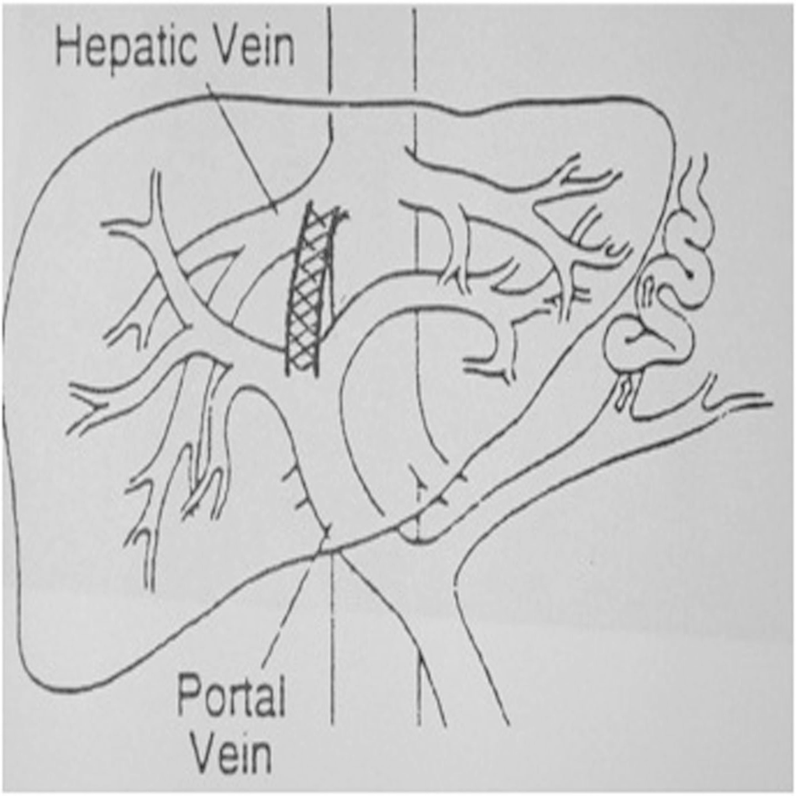
(A)

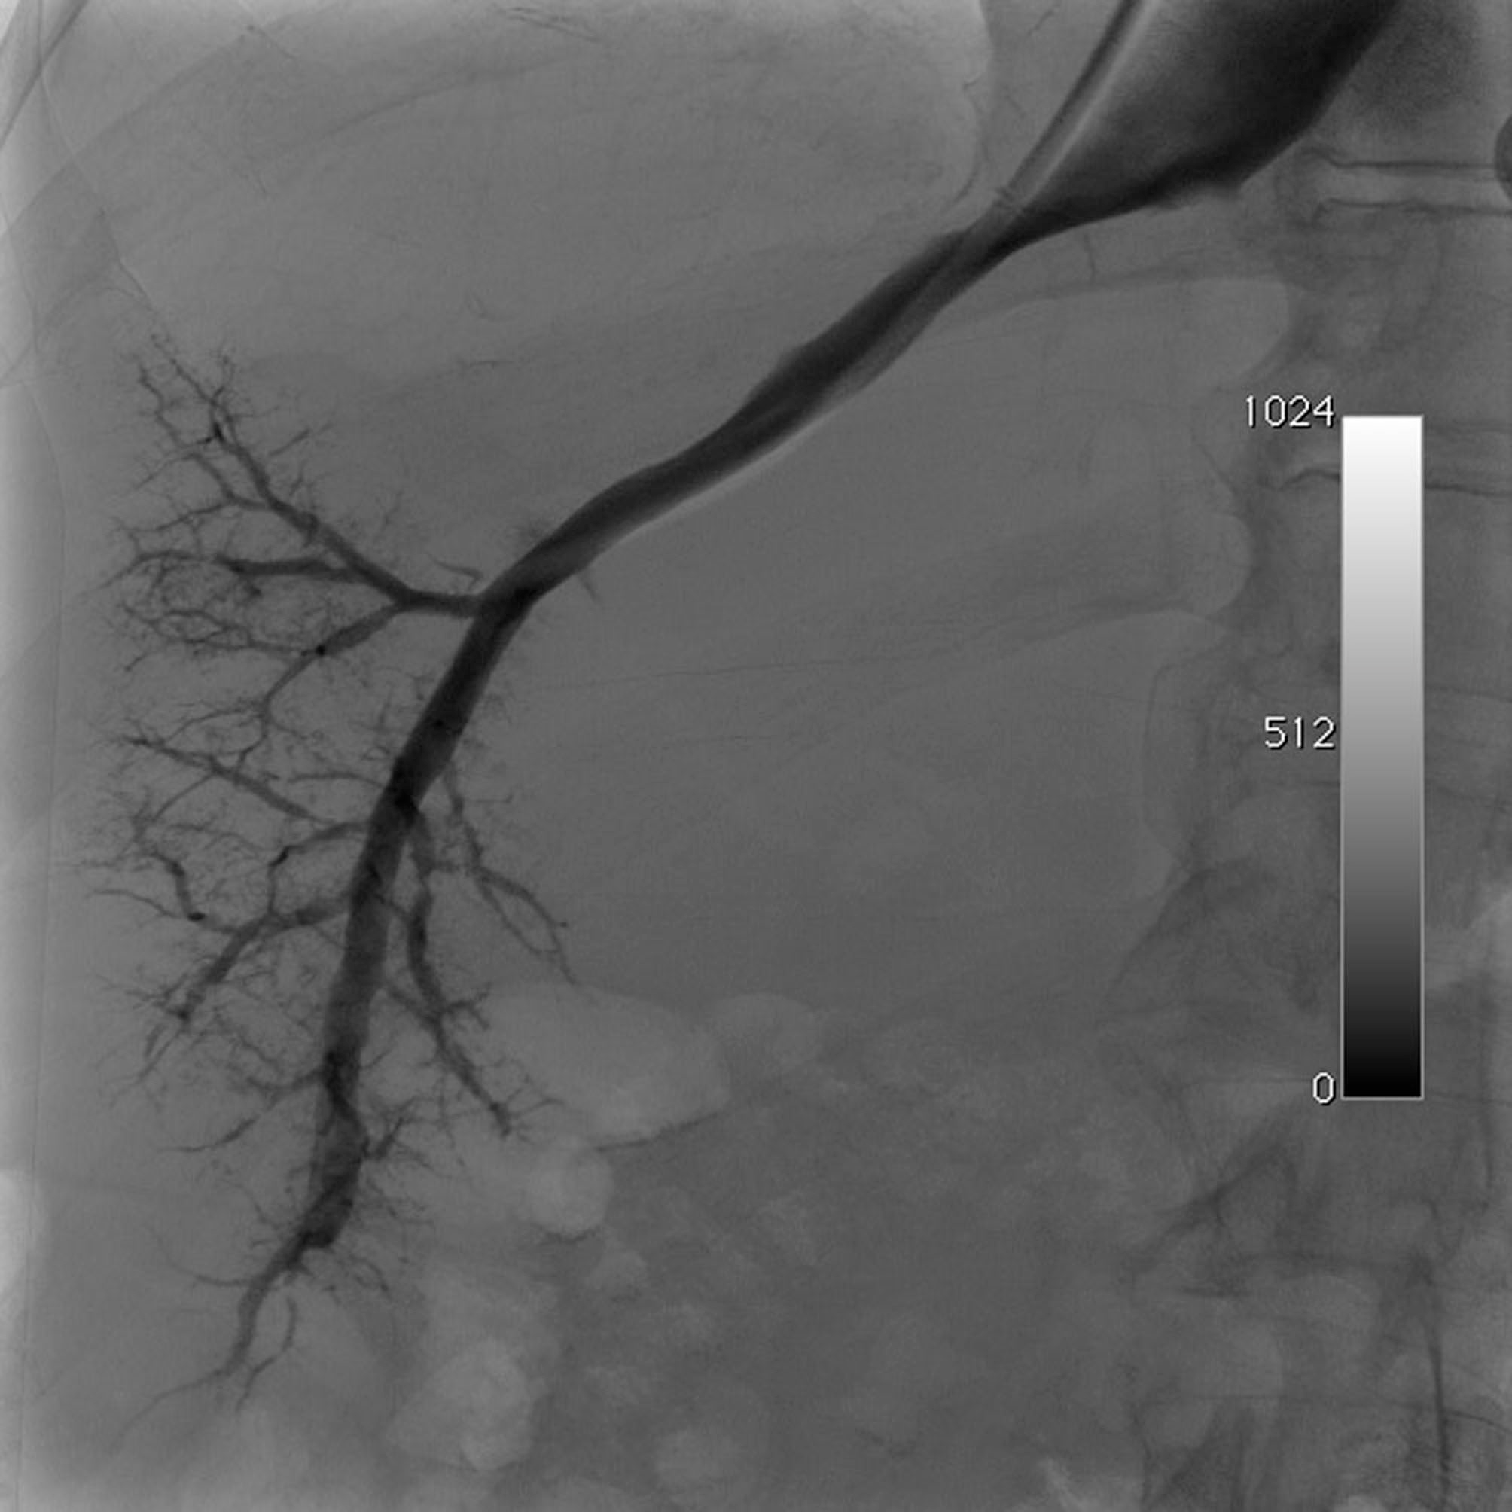
(B)

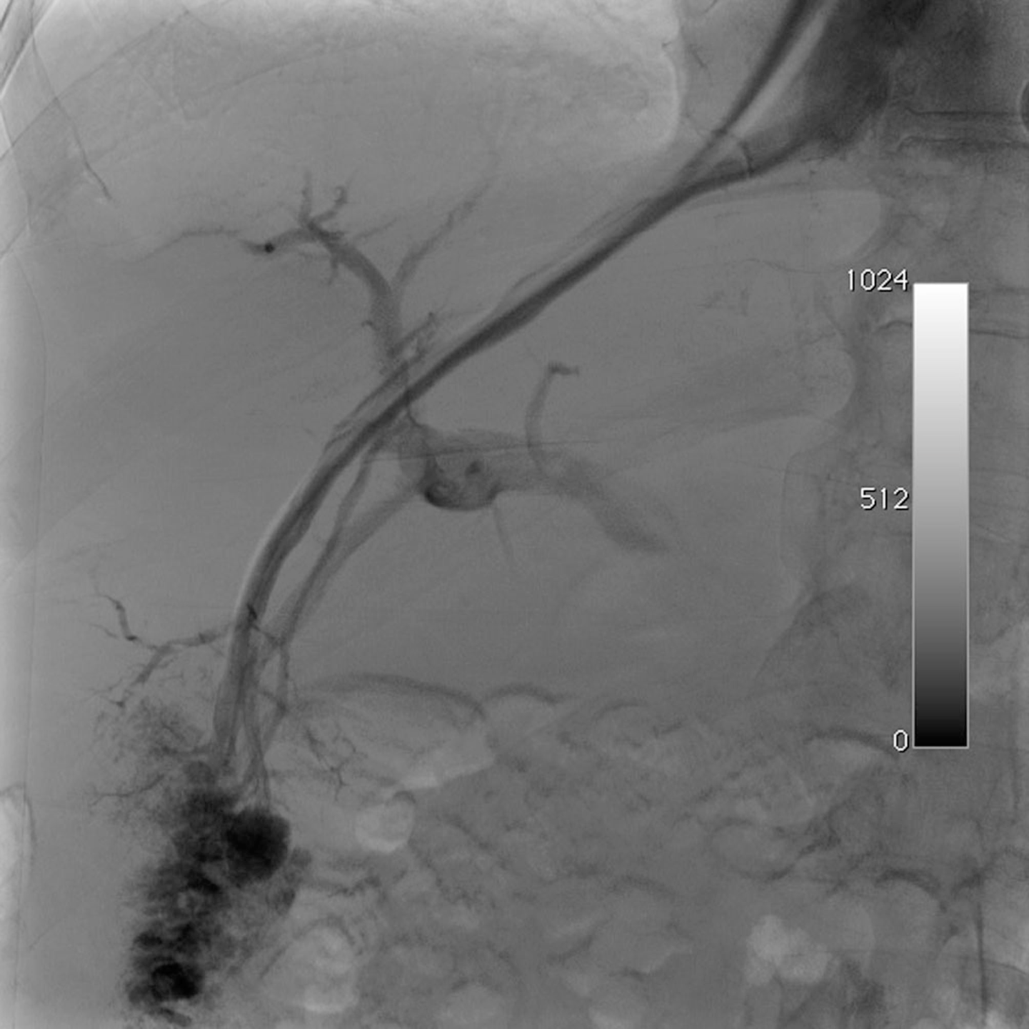
(C)

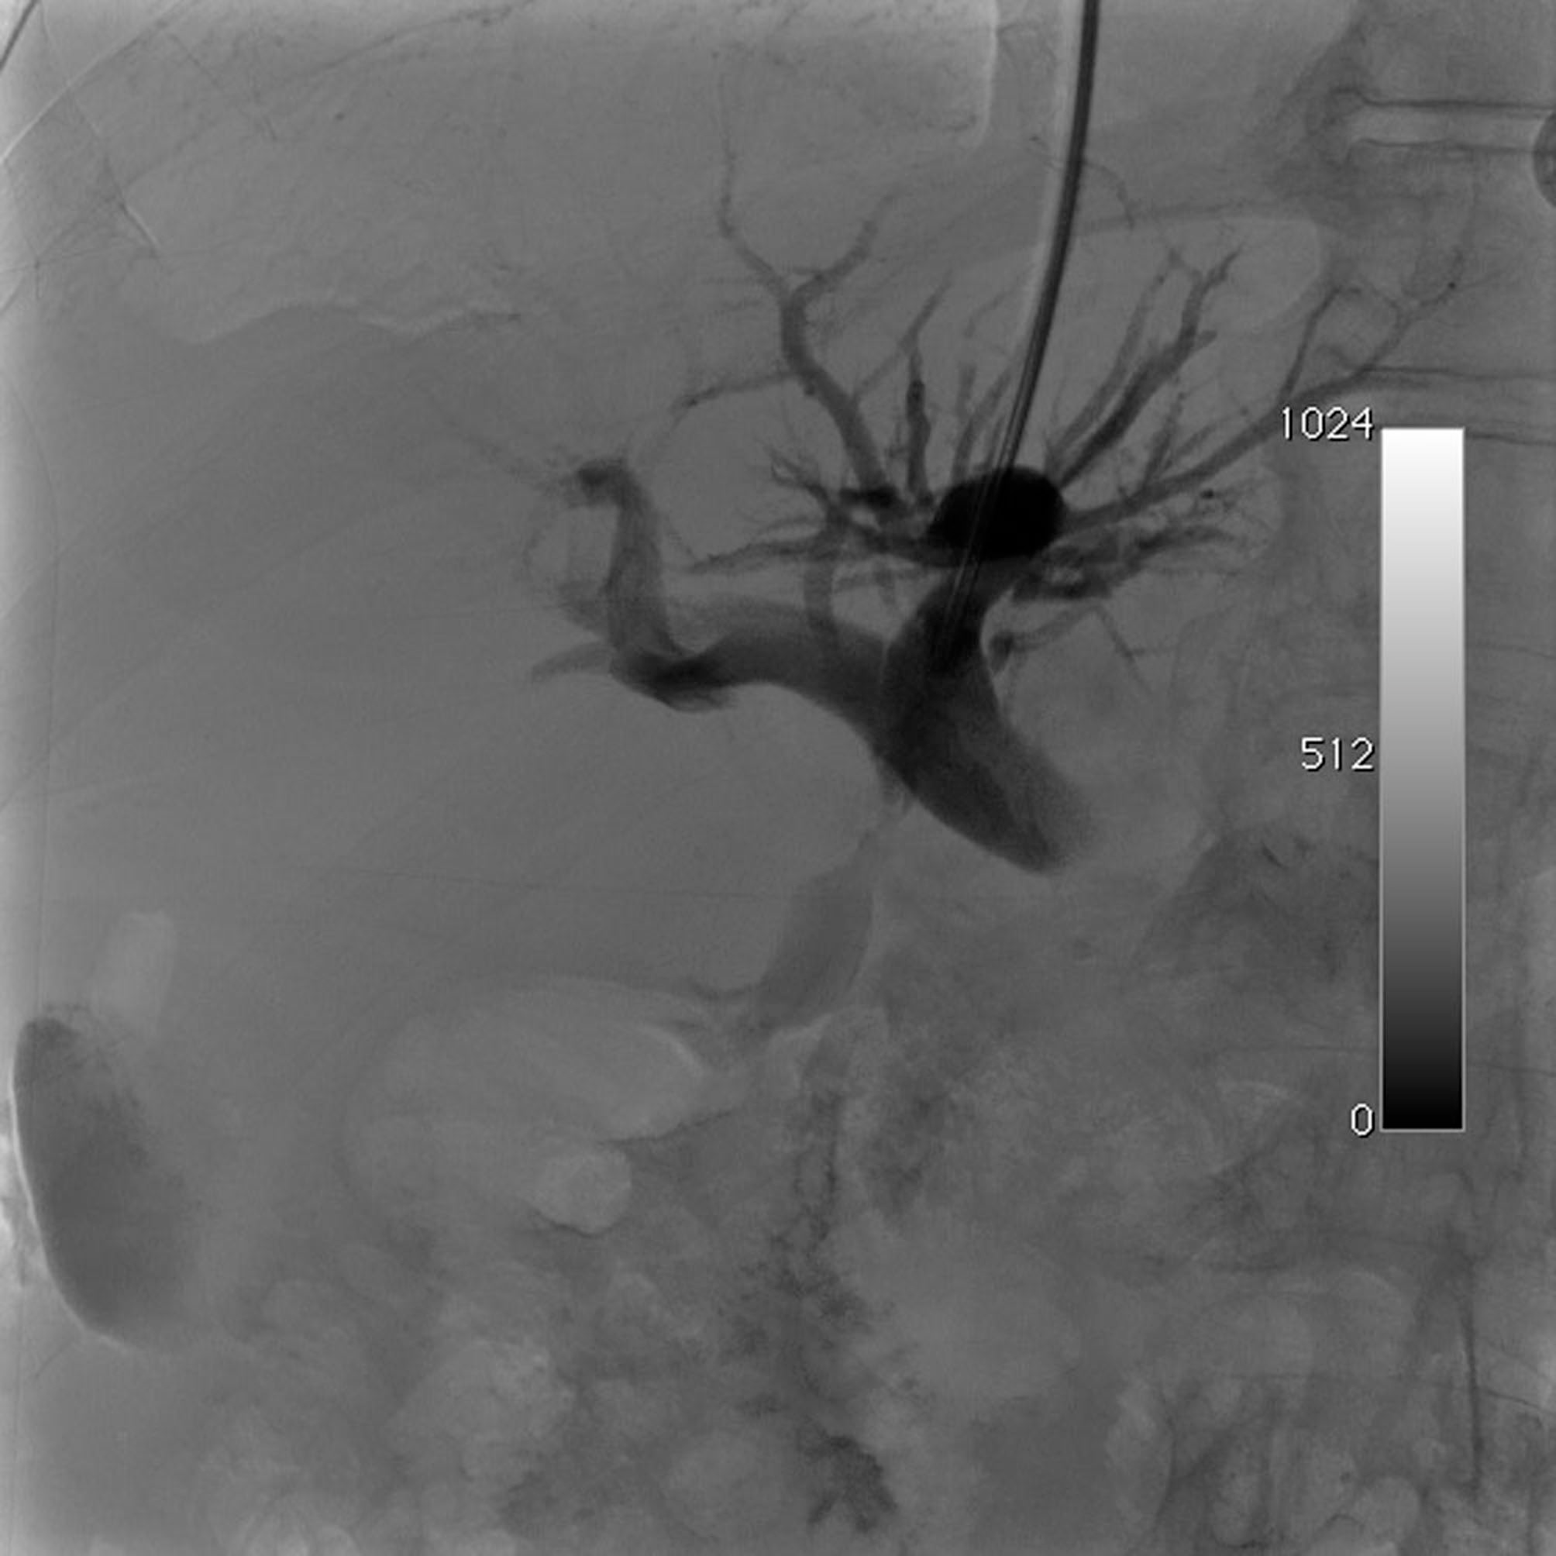
(D)

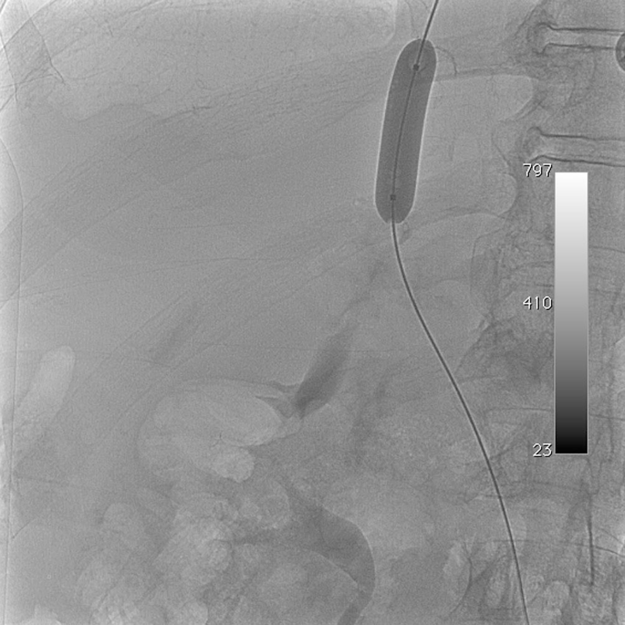
(E)

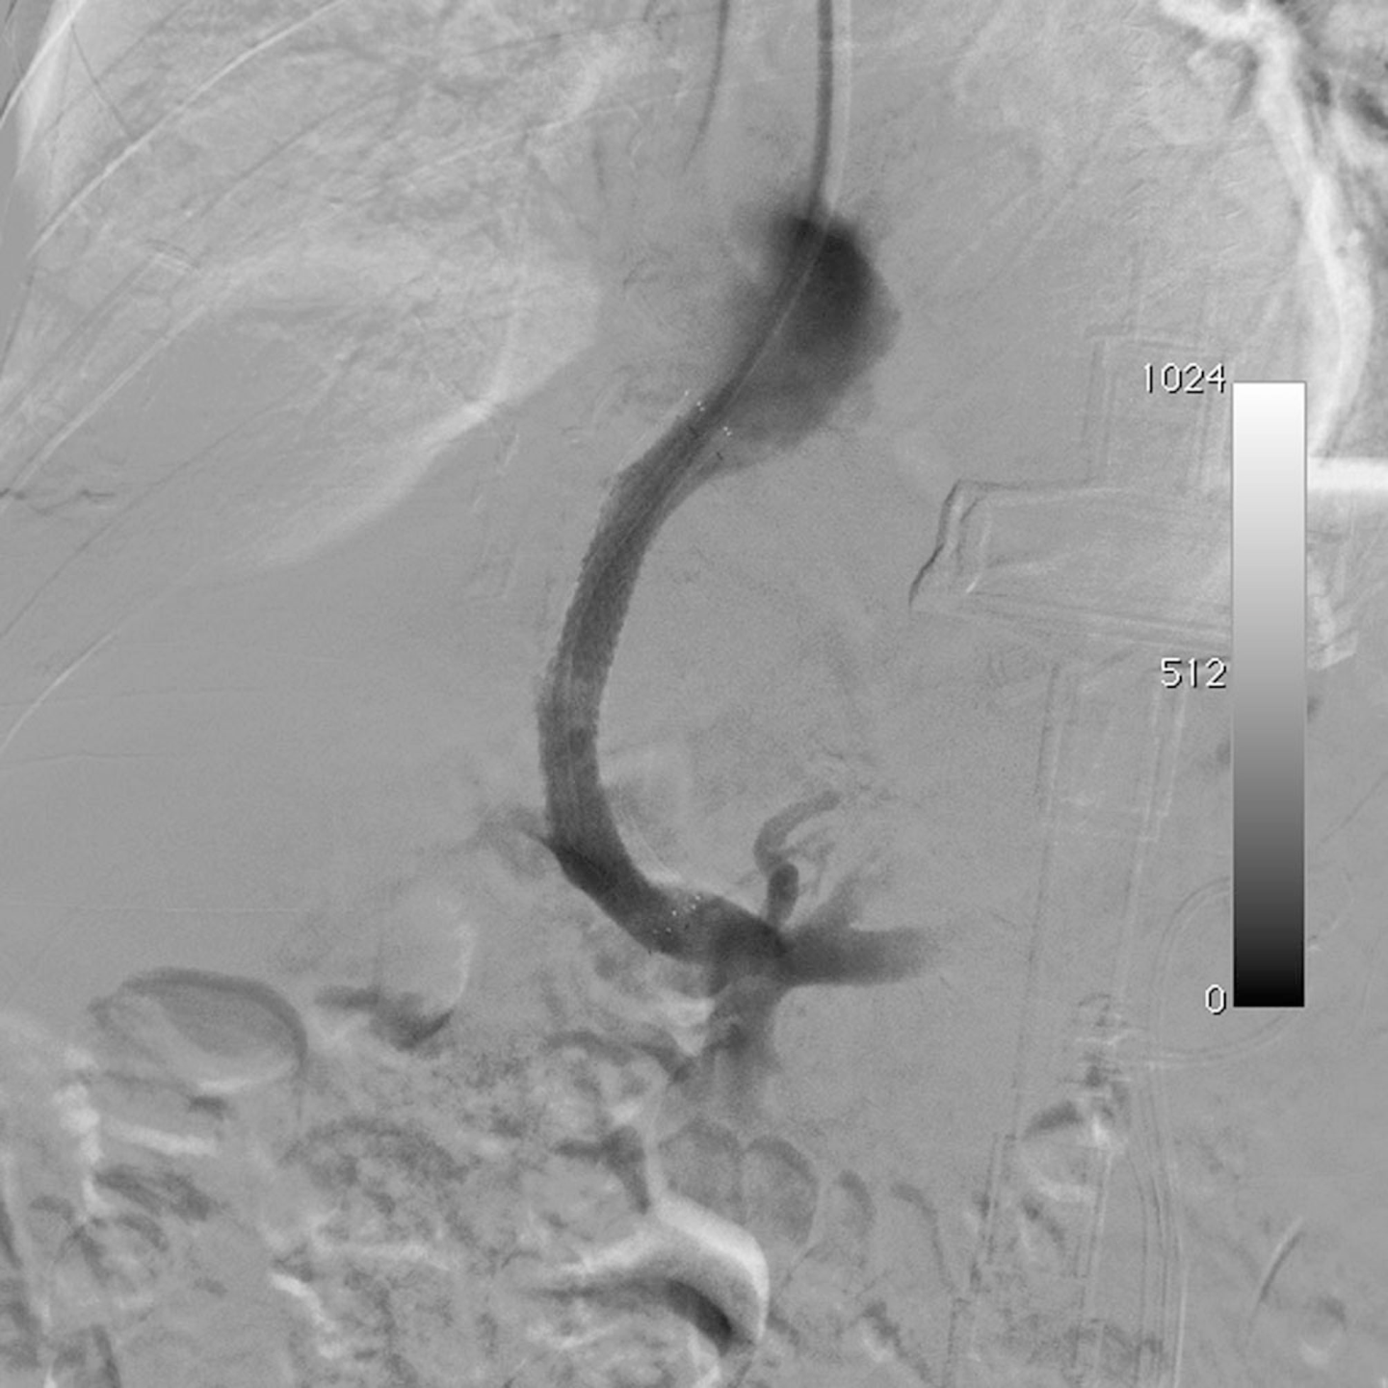
(F)

Table 1 Transjugular intrahepatic portosystemic shunt vs endoscopic therapy in the prevention of rebleeding: results from meta-analyses n (%)
 | Reference, value
Study finding | Burroughs et al^{[34]} | Zheng et al^{[35]}
Patients | 948 | 883
TIPS | 472 | 440
Endoscopic therapies | 476 | 443
Randomized controlled trials | 13 | 12
Recurrent bleeding
TIPS | 88 (18.6) | 86 (19.0)
Endoscopic therapy | 210 (44.1) | 194 (43.8)
OR (95%CI) for TIPS | 0.30 (0.21-0.44) | 0.32 (0.24-0.43)
Post-treatment encephalopathy
TIPS | 134 (28.4) | 148 (33.6)
Endoscopic therapy | 83 (17.4) | 86 (19.4)
OR (95%CI) for TIPS | 2.08 (1.49-2.94) | 2.21 (1.61-3.03)
All-cause mortality
TIPS | 130 (27.5) | 111 (25.2)
Endoscopic therapy | 118 (24.8) | 98 (22.1)
OR (95% CI) for TIPS | 1.14 (0.85-1.54) | 1.17 (0.85-1.61)
TIPS: Transjugular intrahepatic portosystemic shunt.

Table 2 Contraindications to placement of a transjugular intrahepatic portosystemic shunt
Absolute | Relative
Congestive heart failure | Portal vein thrombosis
Severe pulmonary hypertension | Hepatocellular carcinoma
Severe systemic sepsis | Severe coagulopathy
Unrelieved biliary obstruction | Hepatic encephalopathy
Severe tricuspid regurgitation | Obstruction of all hepatic veins

Table 3 Acute and chronic complications after transjugular intrahepatic portosystemic shunt placement
Acute complications |  | Chronic complications
Minor or moderate | Life-threatening | Portal vein thrombosis
Stent displacement | Hemobilia | Congestive heart failure
Neck hematoma | Hemoperitoneum | Progressive liver failure
Arrhythmia | Cardiac failure | Chronic recurrent encephalopathy
Shunt thrombosis | Liver ischemia | Stent dysfunction
Hepatic vein obstruction | Sepsis

Table 4 Risk factors for post-transjugular intrahepatic portosystemic shunt encephalopathy
Risk factors
Age
Sex
Cause
Child-Pugh score
Hepatic encephalopathy history TIPS
Porto-hepatic gradient
Stent diameter
Indication
Creatinine

