Name of Journal: World Journal of Clinical Cases
Manuscript NO: 58774
Manuscript Type: CASE REPORT

Gastric mixed adenoma-neuroendocrine tumor: A case report

Kohno S et al. Gastric mixed adenoma-NET

Shuzo Kohno, Hiroaki Aoki, Masayuki Kato, Masaich Ogawa, Kazuhiko Yoshida

Shuzo Kohno, Hiroaki Aoki, Kazuhiko Yoshida, Masaich Ogawa, Department of Surgery, The Jikei University Katsushika Medical Center, Tokyo 125-8506, Katsushika-ku, Japan

Masayuki Kato, Department of Endoscopy, The Jikei University Katsushika Medical Center, Tokyo 125-8506, Katsushika-ku, Japan

Author contributions: Kohno S wrote the paper; Kato M contributed to endoscopic diagnosis and explanation; Aoki H, Ogawa M and Yoshida K revised the manuscript for final submission.

Corresponding author: Shuzo Kohno, MD, PhD, Associate Professor, Department of Surgery, The Jikei University Katsushika Medical Center, 6-41-2 Aoto, Tokyo 125-8506, Katsushika-ku, Japan. s-kohno@jikei.ac.jp

Received: August 6, 2020
Revised: September 12, 2020
Accepted: September 23, 2020
Published online: November 26, 2020

Abstract
BACKGROUND
Gastric mixed adenoma-neuroendocrine tumors (NETs) are quite rare. In the 2019 world health organization classification of tumors of the digestive system, these were designated as a combination of grade 1 or grade 2 NETs and adenomas or tubular adenomas. There are no treatment guidelines for these tumors, and pathological and clinical studies are ongoing. Herein, we review previous case reports and present a case of gastric mixed adenoma-NET.

CASE SUMMARY
A 66-year-old man underwent gastrointestinal endoscopy for the evaluation of upper abdominal pain. Histopathological examination of the biopsy specimen indicated the possibility of gastric cancer. A histopathological examination by endoscopic submucosal dissection showed a mixed adenoma-NET that was completely excised by endoscopic submucosal dissection. No recurrence was observed on gastrointestinal endoscopy at the 6-mo follow-up.

CONCLUSION
Clinicians' awareness of this rare tumor is important for its timely diagnosis and treatment.

Key Words: Adenoma; Neuroendocrine tumor; Diagnosis; Pathology; Stomach treatment; Case report

Citation: Kohno S, Aoki H, Kato M, Ogawa M, Yoshida K. Gastric mixed adenoma-neuroendocrine tumor: A case report. World J Clin Cases 2020; 8(22): 5744-5750
URL: https://www.wjgnet.com/2307-8960/full/v8/i22/5744.htm
DOI: https://dx.doi.org/10.12998/wjcc.v8.i22.5744

Core Tip: Neuroendocrine tumors are rare tumors, and analysis and classification of tumors have progressed due to recent advances in immunostaining and gene analysis. The mixture of gastric adenoma or adenocarcinoma with neuroendocrine tumor is quite rare, and it is interesting to investigate the mechanism of tumor development and differentiation. We experienced a case of mixed adenoma- neuroendocrine tumors and considered problems in diagnosis and treatment, so we will report it together with other reported cases.
INTRODUCTION
Neuroendocrine tumors (NETs) are a rare type of gastric tumor. Moreover, lesions with a combination of endocrine tumors and gastric adenomas have a very low incidence^{[1]}. There are few case reports^{[1-8]} of gastric mixed adenoma-NETs, and the clinical features are unknown. Advances in immunohistochemical staining and genetic analysis have led to their classification as mixed adenoma-NETs^{[9]}. Gastric mixed adenoma-NETs are not commonly recognized by clinicians and are difficult to diagnose from a forceps biopsy specimen^{[1,7]}. Herein, we report a case of gastric mixed adenoma-NET and review it together with 10 case reports.

CASE PRESENTATION
Chief complaints
A 66-year-old man presented with upper abdominal pain in September 2019.

History of present illness
The patient was receiving outpatient treatment to hypertension. In September 2019, he went to the clinic complaining intermittent epigastric pain and underwent gastrointestinal endoscopy.

History of past illness
The patient had a history of hypertension, hyperlipidemia, and colorectal polyps.

Personal and family history
There is nothing special to mention in personal and family history.

Physical examination
Physical examination was normal.

Laboratory examinations
Laboratory examinations are almost normal.

Imaging examinations
Endoscopy showed a superficial-elevated (0-IIa) granular lesion with a maximum diameter of 10 mm on the anterior wall of the gastric body (Figure 1).

Histopathological examinations
Histopathological examination revealed the proliferation of intestinal-type glands within the gastric mucosa and irregular branching in some of the glands. Despite mild nuclear stratification and enlargement, most of the visible glands were those of adenomas, although some had structurally atypical glands suggestive of a well-differentiated adenocarcinoma (Figure 2). The change in the surrounding mucosa was diagnosed as atrophic gastritis.

FINAL DIAGNOSIS
These cells resected by endoscopic submucosal dissection (ESD) were categorized as grade 1 (G1) NET cells. There was no submucosal invasion. Based on the histopathological features, the lesion was interpreted as a mixed adenoma-NET.

TREATMENT
Therefore, the patient underwent ESD in November 2019. The ESD-resected specimen measured 30 mm × 30 mm, and hematoxylin and eosin staining showed slightly elevated lesions with many superficial tubular or dilated glands without fusing. The glands were lined by moderately atypical epithelial cells, indicating a diagnosis of tubular adenomas (Figure 3). Immunohistochemically, these atypical cells were weakly positive for p-53, and scattered neuroendocrine cells (synaptophysin + chromogranin A) were present in the deep adenoma. Many cords and sheets of small neuroendocrine-type cells that formed small clusters or sheets were observed. These cells were diffusely positive for synaptophysin and keratin. Staining for chromogranin A occasionally tested positive, whereas testing for Ki-67 was rarely positive (< 1%), and for p-53 was negative (Figure 4). No molecular pathological examination was performed.

OUTCOME AND FOLLOW-UP
After ESD, the patient was discharged from the hospital without complications. Endoscopic examination conducted 6 mo after ESD showed no tumor recurrence.

DISCUSSION
Composite glandular carcinoid tumors of the digestive tract was first reported in 1988 by Moyana et al^{[10]} Owing to research progress, the definition of this lesion has changed over time. This lesion has received multiple names, including carcinoid tumor in adenoma, NET in adenoma, mixed adenoma well-differentiated neuroendocrine tumor, and mixed adenoma-NET^{[1-8]}. Tumors with a mixture of glandular and neuroendocrine components in the gastrointestinal tract were classified as mixed neuroendocrine-non-neuroendocrine neoplasms (MiNEN) or mixed adenoma-NET following the 2019 World Health Organization (WHO) classification^{[9]}. MiNEN includes mixed adenocarcinoma-neuroendocrine carcinoma or mixed adenoneuroendocrine carcinoma and mixed adenocarcinoma-NET. Mixed adenoma-NET has been classified separately from MiNEN in the 2019 WHO classification based on characteristic findings that were identified through advances in immunohistochemical staining and genetic testing^{[9]}. Gastric mixed adenoma-NET is a rare tumor that is composed of G1 or grade 2 (G2) NETs as well as adenomas or tubulovillous adenomas. According to the 2019 WHO classification, neuroendocrine tumors (well-differentiated NETs with relatively low malignancy) are designated as G1 and G2 NETs. G1 and G2 are classified by the Ki-index^{[11,12]}. As a typical pathological feature, the neuroendocrine component is generally located within the deep central portion of the polyp, whereas the adenomatous component occupies most of the periphery^{[1]}.
Although gastric lesions with mixed adenomas and NETs are rare, there are several reports showing similar cases^{[1-8]}. 1 shows a report of gastric mixed adenoma-NETs. Eleven cases, including our case, have been reported. The average age was 65.1 years, and one of the cases was a female and the remaining cases were males. The average length of the tumor was 14.7 mm. The depth of invasion of the tumor was submucosal in 2 cases, mucosal in 8 cases, and unknown in 1 case. Treatment was ESD in 5 cases, polypectomy in 3 cases, gastrectomy in 2 cases, and unknown in the last case. No deaths were observed during the follow-up period. Endoscopic macroscopic findings included sessile polyps in 5 cases, 0-Ⅱa type polyp in 1 case, the endoscopic findings were unknown in 5 cases. Gastric adenoma-NET was diagnosed by forceps biopsy in 3 cases and by evaluation of the pathological specimen obtained by polypectomy in 2 cases. One case was diagnosed as adenoma, another case was suspected to be an adenocarcinoma, and the diagnoses of the remaining four cases were unknown. According to Lee et al^{[7]}, who reported three cases among the unknown cases, the pathological diagnosis of mixed adenoma-NET by forceps biopsy was difficult (Table 1).
In our case, an early gastric cancer was suspected before ESD, but histopathological examination led to a final diagnosis of gastric mixed adenoma-NET. This lesion may be misdiagnosed as an adenocarcinoma due to the mixture and fusion of the gastric adenoma and neuroendocrine cells in some areas^{[1,7]}. When an adenoma is investigated by endoscopy, malignant findings are often unevenly distributed and it is difficult to reliably diagnose the presence of malignancy or NET component by biopsy^{[1,7,13,14]}. Localized endocrine neoplasia occurs frequently in both benign and malignant gastrointestinal tumors, whereas a truly mixed glandular endocrine neoplasia is a very rare tumor. Moreover, an accurate diagnosis based on histopathological examination of the biopsy specimen is difficult due to the presence of similar characteristics in MiNEN^{[15]}. Mixed adenoma-NETs are considered difficult to diagnose by biopsy. To avoid a missed diagnosis, recognition of this disease is important. Consequently, diagnosis often requires histopathological examination by excision in addition to forceps biopsy^{[1]}.
The optimal treatment should be selected based on detailed results of the histopathological examination of the resected lesion. G1 NET is considered a low malignant potential tumor, although a few cases of lymph node metastasis in the same lesion have been reported, further research is required to ascertain the malignant potential of NETs^{[16,17]}.
To date, there are no therapeutic guidelines for mixed gastric adenoma and NET lesions. Hence, treatment is directed at the more aggressive and invasive lesions of the two components. Complete resection is the only treatment when the adenomatous part of the stomach is the more aggressive component. After the gastric cancer component is diagnosed as more aggressive, it is classified as MiNEN, and the treatment is performed following treatment for gastric cancer^{[18]}. In cases where the NET component has a stronger or more aggressive malignant potential, we treated for NET following the recommended treatment methods^{[16,19]}. Lymph node dissection is useful for lesions that are at high risk for lymph node metastasis^{[16]}. Resection with lymph node dissection is recommended in accordance with the NET classification and tumor size^{[16]}. In NETs, the possibility of lymph node metastasis is defined by the size and depth of invasion; therefore, preoperative diagnosis is essential for lymph node dissection during tumor resection. Among NETs < 1 cm that invade the lamina propria or submucosa, the incidence of lymph node metastasis is reported to be 3.4%. Endoscopic resection may be appropriate for intraepithelial tumors < 2 cm, and perhaps tumors < 1 cm invading into the lamina propria or submucosa^{[16]}. Thus, we believe that a combined therapeutic strategy and the application of current knowledge would lead to better treatment. Given that this is a rare disease, accurate diagnosis through histopathological analysis of the lesions and scrutinization of recent information is important to determine the treatment plan.

CONCLUSION
Mixed adenoma-NET may be found in gastric polyps, and its recognition is necessary for diagnosis and treatment.

ACKNOWLEDGEMENTS
We would like to thank Dr. Nomura K in the Department of Pathology for his guidance on the diagnosis of pathological tissues and the interpretation of lesions.

REFERENCES
1 La Rosa S, Uccella S, Molinari F, Savio A, Mete O, Vanoli A, Maragliano R, Frattini M, Mazzucchelli L, Sessa F, Bongiovanni M. Mixed Adenoma Well-differentiated Neuroendocrine Tumor (MANET) of the Digestive System: An Indolent Subtype of Mixed Neuroendocrine-NonNeuroendocrine Neoplasm (MiNEN). Am J Surg Pathol 2018; 42: 1503-1512 [PMID: 30001239 DOI: 10.1097/PAS.0000000000001123]
2 Lehtola J, Karttunen T, Krekelä I, Niemelä S, Räsänen O. Gastric carcinoids with minimal or no macroscopic lesion in patients with pernicious anemia. Hepatogastroenterology 1985; 32: 72-76 [PMID: 4007765]
3 Ito H, Ito M, Tahara E. Minute carcinoid arising in gastric tubular adenoma. Histopathology 1989; 15: 96-99 [PMID: 2767625 DOI: 10.1111/j.1365-2559.1989.tb03046.x]
4 Harada T, Imura M, Masutani M, Konno S, Miyazaki H, Nomura A, Okushiba S, Katoh H, Itoh T, Shimizu M, Kawakami Y. Carcinoid tumor detected in gastric adenoma during long-term follow-up. Gastrointest Endosc 2001; 53: 804-806 [PMID: 11375597 DOI: 10.1067/mge.2001.114960]
5 De Marco L, Carlinfante G, Botticelli L, Di Maira PV, Putrino I, Cavazza A. [Mixed neoplasia of the stomach: description of a case of tubular adenoma combined with carcinoid]. Pathologica 2003; 95: 214-216 [PMID: 14577207]
6 Coyne JD, O'Connor B. Mixed adenoma-endocrine tumour of the stomach. Histopathology 2010; 57: 492-494 [PMID: 20840678 DOI: 10.1111/j.1365-2559.2010.03630.x]
7 Lee SM, Ahn S, Lee YK, Jang KT, Park CK, Kim KM. Neuroendocrine tumor in gastric adenoma: a diagnostic pitfall mimicking invasive adenocarcinoma. Diagn Pathol 2012; 7: 102 [PMID: 22894753 DOI: 10.1186/1746-1596-7-102]
8 Matsubara T, Hirahara N, Tabara H. A case report of a gastric neuroendocrine tumor arising from gastric adenoma. Int Surg 2020; In press [DOI: 10.9738/INTSURG-D-20-00004.1]
9 WHO Classification of Tumors Editorial Board. WHO Classification of Tumors. Digestive System Tumors, 5th ed. International Agency for Research on Cancer (LARC): Lyon, France, 2019
10 Moyana TN, Qizilbash AH, Murphy F. Composite glandular-carcinoid tumors of the colon and rectum. Report of two cases. Am J Surg Pathol 1988; 12: 607-611 [PMID: 3400791 DOI: 10.1097/00000478-198808000-00001]
11 de Mestier L, Cros J, Neuzillet C, Hentic O, Egal A, Muller N, Bouché O, Cadiot G, Ruszniewski P, Couvelard A, Hammel P. Digestive System Mixed Neuroendocrine-Non-Neuroendocrine Neoplasms. Neuroendocrinology 2017; 105: 412-425 [PMID: 28803232 DOI: 10.1159/000475527]
12 Nagtegaal ID, Odze RD, Klimstra D, Paradis V, Rugge M, Schirmacher P, Washington KM, Carneiro F, Cree IA; WHO Classification of Tumours Editorial Board. The 2019 WHO classification of tumours of the digestive system. Histopathology 2020; 76: 182-188 [PMID: 31433515 DOI: 10.1111/his.13975]
13 Kasuga A, Yamamoto Y, Fujisaki J, Okada K, Omae M, Ishiyama A, Hirasawa T, Chino A, Tsuchida T, Igarashi M, Hoshino E, Yamamoto N, Kawaguchi M, Fujita R. Clinical characterization of gastric lesions initially diagnosed as low-grade adenomas on forceps biopsy. Dig Endosc 2012; 24: 331-338 [PMID: 22925285 DOI: 10.1111/j.1443-1661.2012.01238.x]
14 Kim MS, Kim SG, Chung H, Kim J, Hong H, Lee HJ, Kim HJ, Kim MA, Kim WH, Jung HC. Clinical Implication and Risk Factors for Malignancy of Atypical Gastric Gland during Forceps Biopsy. Gut Liver 2018; 12: 523-529 [PMID: 29938460 DOI: 10.5009/gnl18006]
15 Frizziero M, Chakrabarty B, Nagy B, Lamarca A, Hubner RA, Valle JW, McNamara MG. Mixed Neuroendocrine Non-Neuroendocrine Neoplasms: A Systematic Review of a Controversial and Underestimated Diagnosis. J Clin Med 2020; 9: [PMID: 31963850 DOI: 10.3390/jcm9010273]
16 Saund MS, Al Natour RH, Sharma AM, Huang Q, Boosalis VA, Gold JS. Tumor size and depth predict rate of lymph node metastasis and utilization of lymph node sampling in surgically managed gastric carcinoids. Ann Surg Oncol 2011; 18: 2826-2832 [PMID: 21455598 DOI: 10.1245/s.10434-011-1652-0]
17 Soga J. Early-stage carcinoids of the gastrointestinal tract: an analysis of 1914 reported cases. Cancer 2005; 103: 1587-1595 [PMID: 15742328 DOI: 10.1002/cncr.20939]
18 Japanese Gastric Cancer Association. Japanese gastric cancer treatment guidelines 2018 (5th edition). Gastric Cancer 2020 [PMID: 32060757 DOI: 10.1007/s10120-020-01042-y]
19 Shen C, Chen H, Chen H, Yin Y, Han L, Chen J, Tang S, Yin X, Zhou Z, Zhang B, Chen Z. Surgical treatment and prognosis of gastric neuroendocrine neoplasms: a single-center experience. BMC Gastroenterol 2016; 16: 111 [PMID: 27613657 DOI: 10.1186/s12876-016-0505-5]

Footnotes
Informed consent statement: We have obtained the patient's consent for this case report.

Conflict-of-interest statement: The authors declare no conflicts of interest.

CARE Checklist (2016) statement: The authors have read the CARE Checklist (2016), and the manuscript was prepared and revised according to the CARE Checklist (2016).

Open-Access: This article is an open-access article that was selected by an in-house editor and fully peer-reviewed by external reviewers. It is distributed in accordance with the Creative Commons Attribution NonCommercial (CC BY-NC 4.0) license, which permits others to distribute, remix, adapt, build upon this work non-commercially, and license their derivative works on different terms, provided the original work is properly cited and the use is non-commercial. See: http://creativecommons.org/Licenses/by-nc/4.0/

Manuscript source: Unsolicited manuscript

Peer-review started: August 6, 2020
First decision: August 22, 2020
Article in press: September 23, 2020

Specialty type: Medicine, research and experimental
Country/Territory of origin: Japan
Peer-review report’s scientific quality classification
Grade A (Excellent): 0
Grade B (Very good): 0
Grade C (Good): C
Grade D (Fair): 0
Grade E (Poor): 0

P-Reviewer: Yu C S-Editor: Zhang L L-Editor: A P-Editor: Li JH
Figure Legends
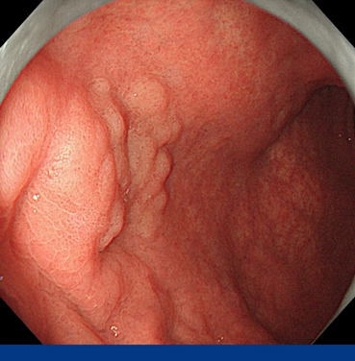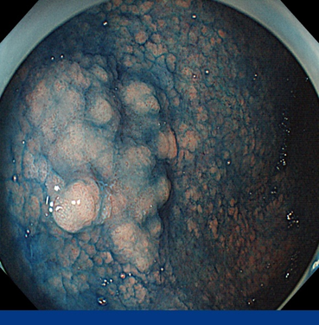
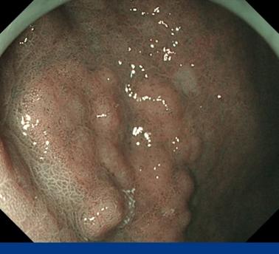
Figure 1 Gastroendoscopy findings. Endoscopic findings showed granular superficial elevated (0-IIa) lesion with a maximum diameter of 10 mm on the anterior wall of the gastric body.
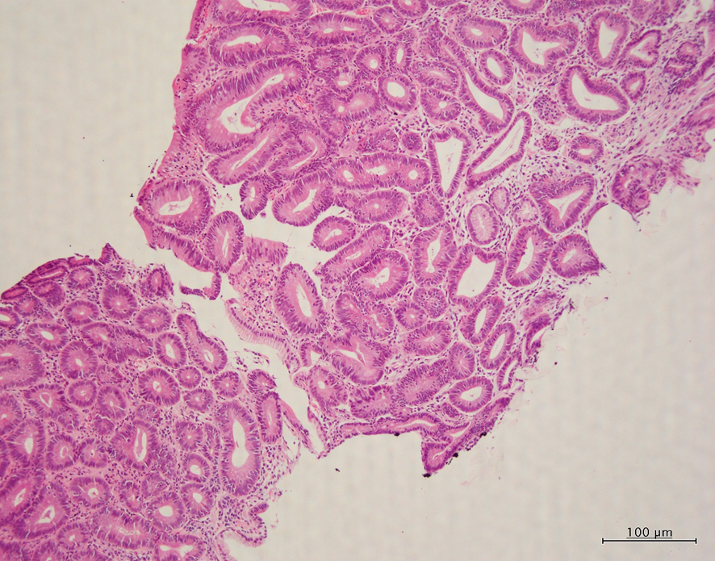
Figure 2 Pathologic examination. Microscopic examination (hematoxylin and eosin-stain) of biopsy specimen showed many ducts for adenomas, but some of them have structural atypical ducts, suggesting well-differentiated adenocarcinoma.
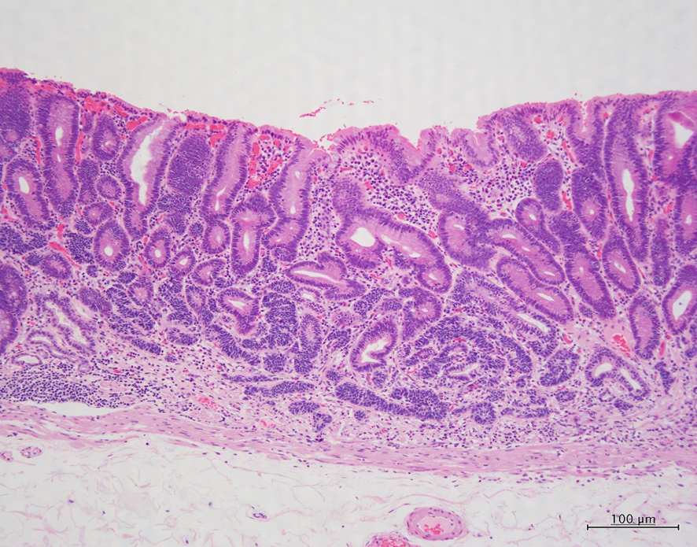
Figure 3 Pathologic examination. Microscopic examination (hematoxylin and eosin -stain) of resected gastric membrane showed mixture of superficial mucosal adenoma and deep mucosal neuroendocrine tumor.

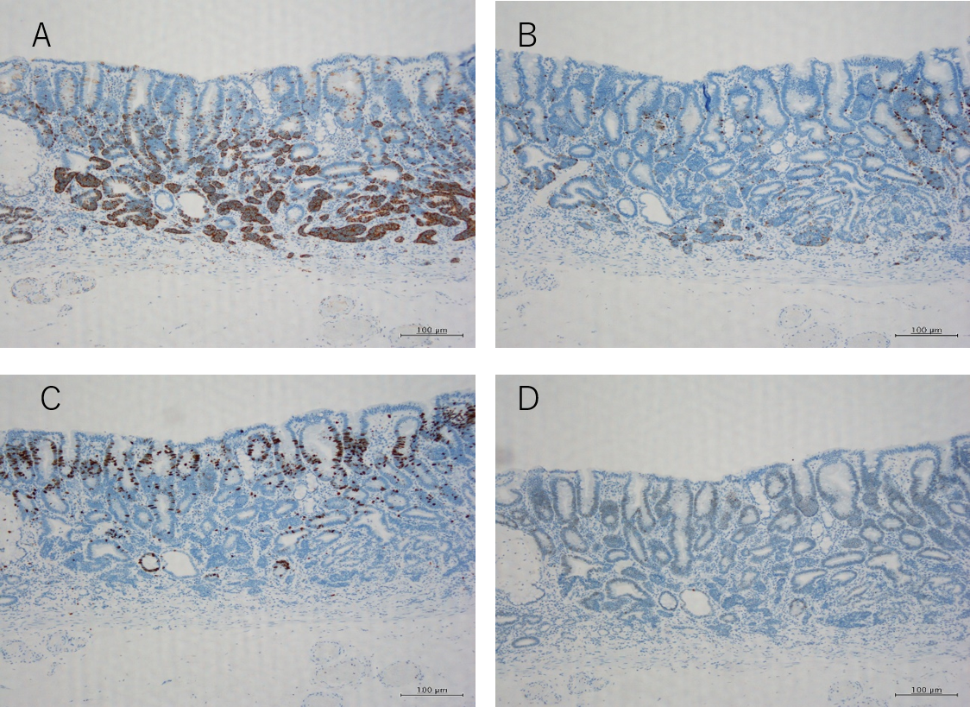
Figure 4 Immunohistochemical staining for synaptophysin, chromogranin, Ki-67, and p-53. A: Immunohistochemical staining with synaptophysin showed diffuse staining in the cytoplasm of neuroendocrine tumor (NET); B: Immunohistochemical staining with chromogranin slightly stained the NET cytoplasm; C: Immunohistochemical staining with Ki-67 showed a MIB-1 index of 1% or less in the NET region; D: Immunohistochemical staining with p-53 showed almost no staining.

Table 1 Review of the literature, clinicopathological features of gastric mixed adenoma- neuroendocrine tumor
No | Ref. | Age | Sex | Size (mm) | Location | Polyp type | Adenoma type | NET grade | Forceps biopsy diagnosis | Depth | Procedure | Follow-up
1 | Lehtola et al^{[2]} | NA | M | 5 | Body | 0-Ⅰs | TA, NA | NA | Gastric mixed adenoma-NET | NA | Polypectomy | AFD (1 yr)
2 | Ito et al^{[3]} | 54 | M | 20 | Body | 0-Ⅰs | TA, LG | NA | By polypectomy | MM | Subtotal Gx | AFD (19 yr)
3 | Harada et al^{[4]} | 72 | M | 10 | Body LC, GC | 0-Ⅰs | NA | NA | Gastric mixed adenoma-NET | LP | Bx→ESD | AFD (13 yr)
4 | De Marco et al^{[5]} | 76 | M | 10 | Body | 0-Ⅰs | TA, LG | G1 | By polypectomy | MM | Polypectomy | AFD (10 mo)
5 | Coyne and O'Connor^{[6]} | 68 | F | 11 | NA | NA | TA, LG | G1 | Gastric mixed adenoma-NET | SM | Bx→polypectomy | NA
6 | Lee et al^{[7]} | 64 | M | 6 | Body PW | NA | TA, NA | NA | NA | MM | ESD | AFD (2 yr)
7 | Lee et al^{[7]} | 63 | M | 40 | Antrum | NA | TA, NA | NA | NA | LP | ESD | AFD (2 yr)
8 | Lee et al^{[7]} | 52 | M | 18 | Body PW | NA | TA, NA | NA | NA | MM | ESD | AFD (2 yr)
9 | La Rosa et al^{[1]} | 55 | M | 15 | NA | NA | TA, HG | G1 | NA | MM | NA | AFD (27 yr)
10 | Matsubara et al^{[8]} | 69 | M | 5 | Body AW | 0-Ⅰs | NA | G2 | Adenoma | SM | ESD→proximal Gx | NA
11 | Case | 66 | M | 22 | Body AW | 0-Ⅱa | TA, HG | G1 | Adenocarcinoma susp | MM | ESD | AFD (6 mo)
AFD: Indicates alive free of disease; AW: Anterior wall; Bx: Biopsy; F: Female; HG: High grade; GC: Great curvature; Gx: Gastrectomy; LC: Lesser curvature; LG: Low grade; LP: Lamina propria; M: Male; MM: Muscularis mucosae; NA: Not available; NET: Neuroendocrine tumor; PW: Posterior wall; SM: Submucosa; TA: Tubular adenoma; 0-Ⅰs: Sessile polyp.

