The ARRIVE Guidelines Checklist

Animal Research: Reporting In Vivo Experiments

Xian-Wen Guo, Yun-Xiao Liang, Peng-Yu Huang, Lie-Xin Liang, Yi-Qing Zeng, Zhen Ding

Xian-Wen Guo, Zhen Ding, Department of Gastroenterology, Union Hospital, Tongji Medical College, Huazhong University of Science and Technology, Wuhan 430022, Hubei Province,China

Xian-Wen Guo, Yun-Xiao Liang, Peng-Yu Huang, Lie-Xin Liang, Yi-Qing Zeng, Department of Gastroenterology,The People’s Hospital of Guangxi Zhuang Autonomous Region, Nanning 530021, Guangxi Province,China

 | ITEM | RECOMMENDATION
Title | 1 | Snare-assisted flexible endoscope in trans-gastric endoscopic gallbladder-preserving surgery: a pilot animal study.
Abstract | 2 | BACKGROUND  Natural orifice transluminal endoscopic surgery (NOTES) gallbladder-preserving surgery by flexible endoscopy is an emerging technology. However, the gallbladder fails to obtain traction and positioning functions during the operation.  AIM  This study aimed to evaluate the feasibility and safety of a new surgical method, “snare-assisted pure NOTES gallbladder-preserving surgery”.  METHODS  Eight miniature pigs were randomly divided into the experimental group (NOTES gallbladder-preserving surgery using the snare device, SA) and the control group (NOTES gallbladder-preserving surgery without using the snare device, NC), with four cases in each group. The differences between the two groups of animals in operating time, operating workload, complications, adverse events, white blood cells, and liver function were determined.  RESULTS  No differences were found in the surgical success rate, gallbladder incision closure, white blood cell count, or liver function between the two groups. The total operating time, gallbladder incision blood loss, gallbladder disorientation time, gallbladder incision closure time, and workload scores on the National Aeronautics and Space Administration-Task Load Index (NASA-TLX) were significantly reduced in the SA group (P<0.05).  CONCLUSION  These results indicated that snare-assisted pure NOTES gallbladder-preservation surgery using standard endoscopic instruments reduced the difficulty of operation, shortened operation time, and did not increase complications in pigs. A new method for pure NOTES gallbladder-preservation surgery was provided.
INTRODUCTION
Background | 3 | With the development of medicine, the operation and concept of preserving the gallbladder and curing benign gallbladder diseases are now widely supported. As an emerging technology, gallbladder-preservation surgery via natural orifice transluminal endoscopic surgery (NOTES) has obvious advantages in the complete resection of gallbladder polyps, removal of gallbladder stones, improvement of gallbladder inflammation, and preservation of gallbladder function. However, there are some technical obstacles to the clinical application of this operation. For example, the gallbladder bed is close to the liver, is obscured by fatty tissue, and has a poor field of vision, indicating that it can be difficult to locate the gallbladder. In addition, the gallbladder collapses and shrinks quickly after incision, and the instruments used for gallbladder operation lose their focus, thereby making the operation very difficult.
Objectives | 4 | The single-channel flexible endoscope for gallbladder-preservation surgery via NOTES requires additional navigation and traction. We proposed a new operative method that involved using a snare to assist in the traction and positioning of the gallbladder. This study aimed to evaluate the feasibility and safety of a new surgical method, “snare-assisted pure NOTES gallbladder-preserving surgery”.
METHODS
Ethical statement | 5 | This study was conducted in the Experimental Center of the People's Hospital of Guangxi Zhuang Autonomous Region. The research protocol was reviewed and approved by the Ethics Committee of the People's Hospital of Guangxi Zhuang Autonomous Region. The approval number is KY-LW-2019-4.
Study design | 6 | 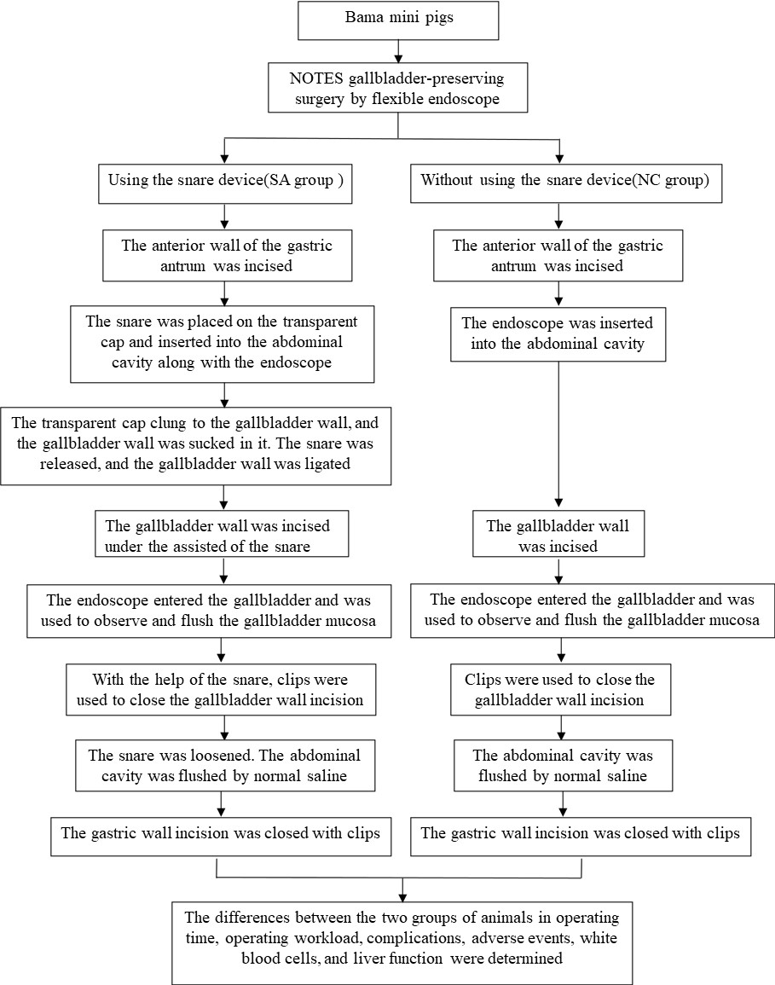
Experimental procedures | 7 | Snare assisted (SA) group: Each generally anesthetized pig was placed on its left side on the operating table. Each one wore a sterile mouth ring and was covered with sterile towels. An ordinary gastroscope was preinserted into the stomach. The stomach, esophagus, and duodenum were flushed with normal saline (>1000 ml). A transparent cap was placed on the front end of the sterile gastroscope, and the anterior wall of the gastric antrum was incised using a hook knife and IT knife (Figure 1A). The snare was placed on the transparent cap and inserted into the abdominal cavity along with the endoscope (Figure 1B). The liver and gallbladder were examined (Figure 1C). The transparent cap clung to the gallbladder wall, and the gallbladder wall was sucked in it. The snare was released, and the gallbladder wall was ligated (Figure 1D). Under this ligation state (Figure 1E), a hook knife and IT knife were used to make an incision of approximately 13 mm in the gallbladder wall (Figure 1F-G). The endoscope entered the gallbladder and was used to observe and flush the gallbladder mucosa. Metal clips were employed to close the gallbladder incision (Figure 1H). The snare was loosened (Figure 1I-J). The abdominal cavity was flushed with normal saline (>2000 ml). Further observation was performed to ensure that there was no bleeding or bile leakage at the gallbladder incision. Then, the gastric wall incision was closed with clips.  Control group (NC)：Except for the fact that the snare was not used, the operating procedures performed for this group were the same as those mentioned above.
Experimental animals | 8 | Bama mini pigs weighing 15–20 kg, which were in good health (with qualified certification).
Housing and husbandry | 9 | Animal Experiment Center of Guangxi Medical University
Sample size | 10 | Eight Bama mini pigs were chosen.
Allocating animals to experimental groups | 11 | The eight animals were randomly divided into two groups: the experimental group (NOTES gallbladder-preserving surgery using the snare device, SA) and the control group (NOTES gallbladder-preserving surgery without using the snare device, NC). Each group had four animals.
Experimental outcomes | 12 | The operation was completed on all animals, and a success rate of 100% was achieved.
Statistical methods | 13 | Quantitative data are expressed as the mean ± SD. The results were analyzed by SPSS 23.0 statistical software. The significance of the data was determined by Student’s t-test. P value <0.05 was considered statistically significant.
RESULTS
Baseline data | 14 | There were no significant difference in the sex and body weight between the two groups.
Numbers analysed | 15 | 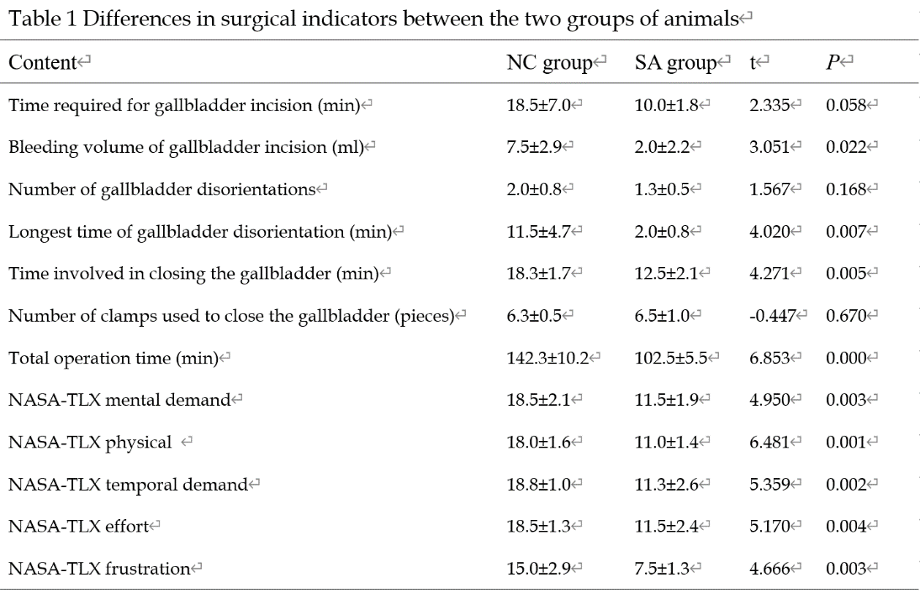  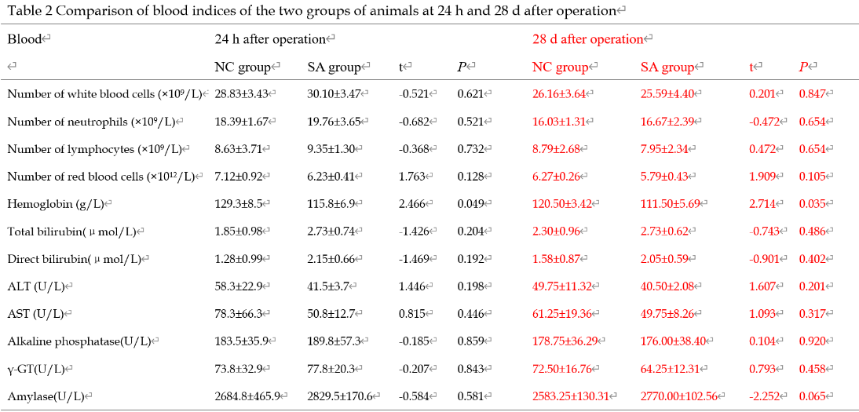
Outcomes and estimation | 16 | we successfully performed a flexible endoscopic gallbladder-preserving operation on pigs through pure NOTES. The use of a snare to assist the operation can reduce the difficulty of the operation and shorten the operation time; it does not increase the risk of the operation.
Adverse events | 17 | However, removal of the clip was needed in 50% (2/4) of the animals in the NC group due to the incorrect placement of the clip; this situation did not occur in the SA group.  During the operation, 75% (3/4) of the animals in the NC group showed a significant decrease in the “blood oxygen index” of the ear skin, which returned to normal after the gas in the abdominal cavity was sucked through an endoscope. However, the animals in the SA group did not show these adverse events.  In addition, 100% (4/4) of the animals in the NC group had electric burn scars on their livers (Figure 3), whereas only 25% (1/4) of the animals in the SA group showed a similar condition.  All animals survived, and their body weight increased appropriately (an increase of 1.88±0.69 kg) until euthanasia on Day 28. The follow-up found that the animals in the SA group were normal after the operation, and no complications occurred.  A small number of omental adhesions existed on the gastric serosal surface of all animals. After the adhesions were released, the gastric wall incisions healed well.  There were some adhesions around the gallbladder incisions, and the metal clip was wrapped in it.
DISCUSSION
Interpretation/scientific implications | 18 | The gallbladder has an irreplaceable role in the digestion process of the human body. Many complications and adverse reactions can occur after gallbladder resection[5-8]. Therefore, both physicians and patients expect to find a better treatment that will preserve the gallbladder and cure gallbladder stones and polyps. This paper reports the successful application of flexible endoscopy via NOTES gallbladder-preservation surgery. This seems to be a promising new surgery for patients who wish to preserve the gallbladder without scarring of the abdominal wall.  In previous single-channel flexible endoscopy via NOTES gallbladder-preservation surgery, the gallbladder was not effectively tracted and navigated, and the gallbladder and gallbladder incision were often lost during the operation, thereby significantly prolonging the operation time and increasing the damage to the surrounding organs[13]. These disadvantages make it extremely difficult to promote this kind of surgery. If the gallbladder and gallbladder incision can be positioned quickly and accurately during the operation and the gallbladder can be pulled safely and effectively, then the difficulty and risk of the operation will be greatly reduced, and the operation time will be shortened. Both physicians and the patients will benefit.  We applied the snare device to gallbladder-preserving surgery, which is called “snare‑assisted pure NOTES gallbladder-preserving surgery by flexible endoscope.” Compared with the non-snare group, the use of the snare significantly reduced the duration and difficulty of the operation. Moreover, the workload score of Endoscopist was significantly reduced, and no adverse reactions and complications occurred.
Generalisability/translation | 19 | Translating this new technology to human subjects seems straightforward and has great practical value in the clinic.
Funding | 20 | Supported by the National Natural Science Foundation of China, No. 82060104; and Construction of Guangxi Clinical Medical Research Center for Digestive Diseases, No. AD17129027.

