Name of Journal: World Journal of Methodology
Manuscript NO: 65702
Manuscript Type: REVIEW

Fascinating history of groin hernias: comprehensive recognition of anatomy, classic considerations for herniorrhaphy, and current controversies in hernioplasty

Hori T et al. Important anatomy and surgical repair

Tomohide Hori, Daiki Yasukawa

Tomohide Hori, Department of Surgery, Shiga General Hospital, Moriyama 524-8524, Shiga, Japan

Daiki Yasukawa, Department of Surgery, Shiga University of Medical Science, Otsu 520-2192, Japan

Author contributions: Hori T and Yasukawa D wrote this review; historical turning points was investigated by Hori T; Yasukawa D originally drew all illustrations and schemas; Hori T and Yasukawa D assessed important papers; Hori T supervised this review; Hori T and Yasukawa D contributed equally to this work.

Corresponding author: Tomohide Hori, FACS, MD, PhD, Academic Fellow, Attending Doctor, Director, Surgeon, Department of Surgery, Shiga General Hospital, 5-4-30 Moriyama, Moriyama 524-8524, Shiga, Japan. horitomo55office@yahoo.co.jp

Received: March 13, 2021
Revised: April 2, 2021
Accepted: May 15, 2021
Published online: July 20, 2021

Abstract
Groin hernias include indirect inguinal, direct inguinal, femoral, obturator, and supravesical hernias. Here, we summarize historical turning points, anatomical recognition and surgical repairs. Groin hernias have a fascinating history in the fields of anatomy and surgery. The concept of tension-free repair is generally accepted among clinicians. Surgical repair with mesh is categorized as hernioplasty, while classic repair without mesh is considered herniorrhaphy. Although various surgical approaches have been developed, the surgical technique should be carefully chosen for each patient. Regarding as interesting history, crucial anatomy and important surgeries in the field of groin hernia, we here summarized them in detail, respectively. Points of debate are also reviewed; important points are shown using illustrations and schemas. We hope this systematic review is surgical guide for general surgeons including residents. Both a skillful technique and anatomical knowledge are indispensable for successful hernia surgery in the groin.

Key Words: inguinal hernia; groin; history; anatomy; hernioplasty; herniorrhaphy

©The Author(s) 2021. Published by Baishideng Publishing Group Inc. All rights reserved.

Citation: Hori T, Yasukawa D. Fascinating history of groin hernias: comprehensive recognition of anatomy, classic considerations for herniorrhaphy, and current controversies in hernioplasty. World J Methodol 2021; 11(4): 160-186
URL: https://www.wjgnet.com/2222-0682/full/v11/i4/160.htm
DOI: https://dx.doi.org/10.5662/wjm.v11.i4.160

Core Tip: Groin hernias include indirect inguinal, direct inguinal, femoral, obturator, and supravesical hernias. Groin hernias have a fascinating history in the fields of anatomy and surgery, and the concept of tension-free repair is generally accepted among clinicians. Although various surgical approaches have been developed, the surgical technique should be carefully chosen for each patient. Surgical repair with mesh is categorized as hernioplasty, while classic repair without mesh is considered herniorrhaphy. Points of debate are also reviewed; important points are shown using illustrations and schemas. Overall, both a skillful technique and anatomical knowledge are indispensable for successful hernia surgery in the groin.

INTRODUCTION
The etymology of the term “hernia” originates from the Latin word for “prolapse,” and the earliest evidence of an inguinal hernia was recorded in approximately 1552 BC in ancient Egypt^{[1,2]}. In the early 1950s, the term “groin hernia” was first used by Henri Fruchaud (1894–1960)^{[3]}. Hernias in the groin include indirect inguinal, direct inguinal, femoral, obturator, and supravesical hernias^{[4]}. Herniorrhaphy has been performed to treat inguinal and femoral hernias since the 18th century. Edoardo Bassini (1844–1924) established a modern herniorrhaphy technique^{[5]}; thereafter, groin herniorrhaphy became the most common technique performed in the field of general surgery^{[4]}. Recent studies have shown that approximately 750000 patients undergo this procedure yearly in the United States^{[4,6]}; the direct annual cost is 2.5 billion dollars^{[4]}.
In 1804, Astley Cooper (1768–1841) stated, “No disease of the human body, belonging to the province of the surgeon, requires in its treatment a greater combination of accurate anatomical knowledge with surgical skill than hernia in all its varieties.”^{[7]} Notably, herniorrhaphy treatment of pediatric patients is useful for accurate evaluation of the skills of general surgeons and residents^{[8]}. Sir William Heneage Ogilvie (1887–1971) once stated, “I know more than a hundred surgeons whom I would cheerfully allow to remove my gallbladder but only one to whom I should like to expose my inguinal canal.”^{[9]} Notably, both technical skill and anatomical recognition are crucial for safe and reliable surgery. Irving L. Lichtenstein (1920–2000) established the concept of tension-free repair (TFR) in 1986^{[10,11]}. Various meshes, including biological mesh, are currently available for groin surgery^{[12]}. Surgical repair with mesh is categorized as hernioplasty, while classic repairs without mesh are termed herniorrhaphy. Many physicians focus on the preperitoneal (posterior) space (PPS)^{[3,7,13-21]}, topographic nerves^{[22-31]}, and regional vessels^{[4,32-34]}.
This review discusses existing knowledge regarding groin hernia. It summarizes historical turning points in the anatomy and surgery of groin hernias, described the current status of anatomical recognition and surgical repair, examines points of contention, and considers future perspectives. Despite the current global pandemic due to Chinese Wuhan pneumonia (so-called COVID 2019), general surgeons including residents thrive. We hope that this review including milestones of history, anatomy, and surgery will be informative for surgeons involved in the treatment of groin hernias.

ETIOLOGY
Inguinal hernias constitute 75% of abdominal wall hernias and have the lifetime risks of inguinal hernias are 27% in men and boys and 3% in women and girls^{[35]}. Indirect (external or lateral) inguinal hernias (IIHs) outnumber direct (internal or inner) inguinal hernias (DIHs) by a ratio of approximately 2:1^{[35]}. Suspected congenital causes for persistent patency of processus vaginalis include cryptorchidism, lack of carbachol response, absence of cholinergic receptors, absence of myofibroblasts, absence of apoptotic nuclei, failed apoptosis of smooth muscle, catecholaminergic activity related to luteinizing and gonadotropin-releasing hormones, and deficiencies involving epithelial–mesenchymal transition^{[36-42]}. Possible risk factors for groin hernias include elevated abdominal pressure (e.g., by constipation, coughing, and obesity)^{[6]}, diabetes^{[6]}, smoking^{[6]}, collagen distribution^{[43,44]}, peritoneal dialysis^{[45]}, radical prostatectomy^{[46]}, and family history^{[47]}.

SYMPTOMS AND EVALUATION
Groin hernias are extremely common and can often be diagnosed by simple anamnesis collection and a physical examination^{[48]}. Surgical repair is elective unless incarceration or strangulation is present^{[48]}. Palpation of both testes in the scrotal sac should be performed during the clinical examination to rule out cryptorchid testis^{[49]}. Local pain in the scrotal sac, which may indicate testicular torsion, should never be overlooked. From an immunological perspective, testicular torsion requires urgent surgery^{[50]}. An undescended testicle harbors an increased risk of infertility and malignancy; thus, it requires orchiopexy in early childhood^{[48]}. The development of autoimmune antisperm antibody induced by testicular torsion influences testicular function and subsequently causes male sterility^{[50]}.
The inguinal canal (IC) is traversed by the spermatic cord (SC) in men and boys, and by the round ligament (RL) of the uterus in women and girls. The RL is attached to the uterus and is accompanied by a pouch of parietal peritoneum in the IC, known as the canal of Nuck^{[51]}. A hydrocele of the canal of Nuck is a differential diagnosis for groin hernia^{[51]}. Hydroceles of the SC and testis are also differential diagnoses for groin hernia; deliberate surgery is required for SC hydroceles^{[52]}. Hydroceles in infancy may resolve without surgery^{[48]}.
The bladder may be involved in groin hernias^{[53,54]}; thus, injury to the urinary tract should be avoided. Notably, immature infants at birth may easily develop bladder prolapse^{[55]}; therefore, the body weight at birth should be checked before surgery to avoid serious iatrogenic injuries^{[56]}.
In 1559, Caspar Stromayr (1530–1567) classified inguinal hernias as either IIH or DIH^{[57]}. Inguinal hernias are currently classified as indirect or direct and primary or recurrent^{[6]}. Some classifications are based on anatomical findings in relation to the development of the hernia (e.g., posterior floor integrity, enlarged inguinal rings, and hernia size)^{[58,59]}. The severity of the groin hernia may be difficult to determine prior to surgery; size alone may not be associated with severity in some patients^{[6]}. However, the size of the groin hernia affects the choice of the surgical approach because surgeries performed under local or conduction anesthesia are contraindicated for huge hernias^{[59]}. The European Hernia Society has proposes a simple classification (based on Aachen’s classification^{[60]}), which is used worldwide^{[61,62]}. Briefly, this classification is based on orifice size and anatomical localization^{[60,61]}. The size of the hernia orifice is recorded as 1 (≤ 1 finger), 2 (1-2 fingers), or 3 (≥ 3 fingers)^{[60]}. Thus, a hernia orifice of 2.5 cm is considered a size 2 hernia^{[60]}. For anatomical localization, the criteria are lateral (L), medial (M), and femoral (F)^{[60,61]}. In addition, hernias are regarded as primary (P) or recurrent (R)^{[60,61]}.

HISTORY
Groin hernias have an interesting anatomical and surgical history^{[1,11,63-65]} (Table 1). Pierre Franco (1500–1561) and Ambroise Paré (1510–1590) used conservative treatments with a strong bandage^{[1,66]}. Specific anatomical structures in the IC were clarified in the 18th century^{[1]}; the first report of successful transabdominal repair was described in 1716 by Demetrius Cantemir (1673–1723)^{[1]}. Lorenz Heister (1683–1758) first reported successful bowel resection via laparotomy for a strangulated hernia^{[67]}.
Franz Kaspar Hesselbach (1759–1816) was the first to describe various anatomical structures [e.g., cribriform fascia (Hesselbach’s fascia) and interfoveolar ligament (Hesselbach’s ligament)]. Hesselbach also defined the inguinal triangle (i.e., “Hesselbach’s triangle”), which is superolaterally bounded by the inguinal ligament (IL), the exterior border of the abdominal rectus muscle, and the inferior epigastric vessels^{[68,69]}.
Henry O. Marcy (1837–1924) stated that failure to close the internal (deep) inguinal ring (IIR), or low ligation of the hernia sac, could result in recurrence; he described an accurate reconstruction technique in 1871^{[70]}. Marcy’s repair was the first implementation of high ligation of the sac and closure of the IIR^{[70]}.
Bassini^{[5]} elucidated the anatomy of the anterior IC in 1884, then ushered safe and effective surgery into the modern era by describing Bassini’s repair in 1887^{[5,71]}. Notably, Bassini advocated the importance of Marcy’s theory and emphasized floor reconstruction involving approximation of the internal abdominal oblique muscle (IAOM) and transverse abdominal muscle with the transversalis fascia (TF), combined with a shelving edge of the IL^{[5,71]}.
William Stewart Halsted (1852–1922) and Edmund W. Andrews (1824–1904) modified Bassini’s repair^{[72-74]}. The antiseptic concept was accelerated in the 19th century after Joseph Lister (1827–1912) introduced antisepsis^{[72]}; additionally, Halsted was the first to use surgical gloves for aseptic technique during surgery^{[75]}. Modified Bassini’s repair (i.e., “North American Bassini” repair) was implemented worldwide, although its use was associated with a higher recurrence rate^{[76]}. Subsequently, Arthur Keith (1866–1955) described a shutter mechanism in 1923^{[13]}.
Chester Bidwell McVay (1911–1987) first employed Cooper’s ligament for repair in 1939^{[77]}; McVay’s method involved repair of a femoral hernia through the posterior wall of the IC^{[78]}. McVay and Barry J. Anson (1894–1874) focused on the importance of the TF^{[79]}. Initially, the arch of the transverse abdominal muscle was approximated to Cooper’s ligament, the iliopubic tract (IPT), and the IL. Subsequently, a relaxing incision was placed in the anterior rectus sheath.
In 1919, George La Roque (1876–1934) utilized abdominal and cutaneous incisions, then ligated the retracted hernia sac from the abdominal cavity^{[1]}. In 1936, Arnold Henry (1886–1962) devised an analogous approach by means of a lower abdominal midline incision. In 1920, a totally extraperitoneal approach was first executed by George Lenthal Cheatle (1865–1951) as a radical curative operation for both inguinal and femoral hernias using a lower mid-abdominal preperitoneal approach^{[80]}.
Lloyd M Nyhus (1923–2008) introduced IPT repair in 1959^{[15]}, in accordance with the concept of the preperitoneal (posterior) approach^{[81]}. The anterior rectus sheath was divided, and the abdominal rectus muscle was retracted medially; the TF was then exposed and the PPS was accessed. The IIH sac was ligated, and the defect was closed by approximating the conjoint tendon to the IPT and IL. Thereafter, based on the concept of the preperitoneal approach, prosthetic reinforcement in the PPS was first described by Jean Rives (1873–1985) in 1965 for unilateral hernias^{[16]} and by René Stoppa (1921–2006) in 1969 for bilateral inguinal hernias^{[82]}.
Edward Earle Shouldice (1890–1965) introduced a multiple layer repair of the posterior inguinal wall in 1953^{[14]}. The TF was divided from the IIR to the pubic tubercle and lifted from the peritoneum. Shouldice’s repair proposed an imbrication of the TF and strengthening of the posterior wall of the IC by using four layers of the fascia and aponeuroses of the IAOM. Henri Fruchaud clarified the preperitoneal anatomy in the early 1950s^{[3]}; preperitoneal and laparoscopic approaches were thereafter realized based on his work.
Jean Rives placed mesh into the PPS in 1965^{[16]}, and René Stoppa used a large Dacron prosthesis to reinforce the TF^{[83]}. In 1986, Irving L. Lichtenstein first introduced a mesh plug made by rolling a piece of flat polypropylene into the shape of a cigarette to fill a femoral defect^{[10,11]}. The mesh was fixated with interrupted sutures; this “cigarette plug” was used to repair inguinal, femoral, and recurrent hernias. Hence, Lichtenstein established a TFR technique that ushered a new surgical era^{[10,11]}. Classic hernia repairs used sutures under tension, which led to a high recurrence rate; TFR dramatically improved the rates of recurrence and infection^{[84]}. Prosthetic mesh was used to reinforce the TF; specifically, polypropylene mesh was superiorly fixed to the IL, lateral edge of the rectus sheath, and conjoint tendon. Francis Usher (1908–1980) introduced the use of monofilament polypropylene mesh in 1958^{[85,86]} and parietalized the SC^{[87]}. Thereafter, Arthur I Gilbert (1913–2001) improved TFR with a sutureless technique^{[88,89]}. Lichtenstein was first to coin the term “tension-free hernioplasty”^{[90]}; the concept of TFR revolutionized hernia surgery^{[11,63]}. The advantageous simplicity of “mesh-plug hernioplasty” was first described in 1993^{[91]}; thereafter, this procedure became preferable and spread worldwide^{[92,93]}.
Although Lichtenstein’s repair produced excellent results, George E Wantz (1923–2000) warned that polypropylene mesh did not cover the entire myopectineal orifice (MO) and that Lichtenstein’s repair was therefore inadequate to prevent a femoral hernia^{[94]}. Notably, he also stated that incomplete coverage of the MO by the mesh could predispose patients to subsequent DIH^{[94]}.

WALL LAYERS
Petrus Camper (1722–1789), Antonio Scarpa (1752–1832), and Franz Kaspar Hesselbach provided detailed descriptions of inguinal structures, particularly of important ligaments^{[1]}. Following elaborate anatomical studies, François Poupart (1661–1709) in 1695 recognized the importance in hernia pathology of the IL^{[1]}, which had been described previously by Gabriele Falloppio (1523–1562)^{[1]}. Astley P. Cooper published original anatomical views regarding the IC in 1804 and 1807^{[1]}. Part of the aponeurosis of the external abdominal oblique muscle composes the IL, although the IAOM is observed under the aponeurosis of the external abdominal oblique muscle at the groin. The IL is also known as the Fallopian ligament or Poupart’s ligament.
The abdominal wall at the groin is classically considered to have nine layers^{[95]}: skin, subcutaneous fat, superficial fasciae (Camper’s and Scarpa’s fasciae), innominate (unnamed or untitled) fascia, IL, IAOM, TF, PPS [superficial parietal layer (SPL) and deeper visceral layer (DVL)], and peritoneum. This classification involves the innominate (unnamed or untitled) fascia, which is a thin membrane on the IL, and does not indicate division of the PPS into the SPL (i.e., anterior subperitoneal fascia) and DVL (i.e., posterior subperitoneal fascia) (Figure 1). The PPS comprises preperitoneal fat.
The IC is a passage in the anterior abdominal wall that conveys the SC in men and boys, whereas it conveys the RL in women and girls. The IL is bordered by the aponeurosis of the external abdominal oblique muscle anteriorly, the IAOM and transverse abdominal muscle superiorly, the IL and lacunar ligaments inferiorly, and the TF posteriorly.

PREPERITONEAL (POSTERIOR) SPACE AND MYOPECTINEAL ORIFICE
In the early 1950s, Henri Fruchaud reported that all hernias at the groin result from a defect of the TF and pass through the myopectineal orifice (MO) (all three triangles of the groin)^{[3]}. The oval-shaped MO is the origin of all groin hernias^{[4]} (Figure 2). In 1965, Jean Rives proposed reinforcement of the TF with a prosthesis placed in the preperitoneal (posterior) space (PPS), if local structures are weak^{[16]}. Although an “on-lay patch,” (placed on the anterior side of the TF) was historically used, the importance of an “under-lay (in-lay) patch” placed between the TF and peritoneum is now widely accepted. Hence, general surgeons commonly recognize the concept of optimal repair at the PPS. The PPS is observed between the TF and peritoneum; adequate creation of an extended PPS is important for optimal surgery^{[64,96]}. Several physicians [Astley P. Cooper in 1807^{[7]}, William James Lytle (1896–1986) in 1945^{[13]}, Edward Earle Shouldice in 1953^{[14]}, Henri Fruchaud in 1956^{[3]}, Lloyd M. Nyhus in 1959^{[15]}, Jean Rives in 1965^{[16]}, R. Fowler Jr. in 1975^{[17]}, René Stoppa in 1977^{[18,19]}, Raymond C. Read in 1992^{[20]}, and Maurice E. Arregui in 1997^{[21]}] historically made mention of this important space^{[97]} (Table 2). In particular, anatomical recognition of the SPL and DVL was a milestone for further developments of surgical repair techniques^{[97]}. The anterior subperitoneal fascia is recognized as the SPL, while the posterior subperitoneal fascia is recognized as the DVL^{[29]} (Figure 3).
Anatomical recognition of the MO is also crucial for reliable treatment^{[98,99]}, and laparoscopic exploration easily reveals this orifice^{[4]}. Full coverage of the MO is considered optimal surgery^{[98-100]}. This orifice should be fully reinforced in a TFR manner to prevent IIHs, DIHs, femoral hernias, and obturator hernias^{[98-102]}. Mesh implantation into an extended cavity of the PPS is currently considered optimal surgery^{[98-102]}.
Some physicians have performed detailed investigations of the layer in which the bladder exists^{[19,21,103]} (Figure 4). The terms “spermatic sheath” and “urogenital fascia” established by René Stoppa^{[19]} and “umbilical prevesical fascia” established by Maurice E. Arregui^{[21]} have become widespread.

PEDIATRIC HERNIORRHAPHY
Many pediatric surgeons focus on herniorrhaphy in infants and children^{[104-107]}. Notably, a contralateral hernia develops after unilateral surgery in 8% to 11% of patients^{[108,109]}. The low incidence of contralateral hernia after unilateral herniorrhaphy does not justify routine contralateral groin exploration^{[108,109]}.
Just Lucas-Championnière (1843–1913) described a simple high ligation technique in 1892^{[110]}. William Mitchell Banks (1842–1904) in 1882^{[111]} and Willis J. Potts (1895–1968) in 1950^{[104,107]} described high ligation by means of a partial incision of the IC without opening the external (superficial) inguinal ring. Alexander Hug Ferguson (1853–1912) added anterior wall repair in 1899^{[112]}.
P. Turner in 1912^{[113]} and A. MacLennon in 1914^{[114]} advised simple removal of the sac to the IIR through a very small incision. In 1925, Robert Hamilton Russell (1860–1933) strongly emphasized surgical removal of the sac solely in infants and children^{[115]}. In 1938, Gertrude Marianne Amalia Herzfeld (1890–1981) used a small incision over the external inguinal ring, pulled down and ligated the sac, and closed the external inguinal ring with a single stitch^{[116]}. In 1945, Jerome S. Coles (1911–1996) advised transfixation and ligation of the proximal end as high as possible^{[117]}.
Willis J. Potts performed a high ligation in 1945^{[104,107,118]}; and Potts’ method thereafter spread as the standard surgical technique worldwide. Charles Everett Koop (1916–2013) immobilized the edge of a high ligation by suturing the dorsal side of the IAOM. Koop’s fixation prevented postoperative infertility due to uterine retroflexion and reduced postoperative recurrence^{[119]}. The bilateral RLs are cut during herniorrhaphy for bilateral inguinal hernias; thus, Koop’s fixation should be routinely performed for bilateral inguinal hernias in female patients^{[120]}.
In the field of pediatric herniorrhaphy, surgeons also recognize the importance of the PPS. Laparoscopy has been used to assist repair in the PPS^{[121,122]}; and Takehara et al^{[123]} first described laparoscopic percutaneous extraperitoneal closure in 2006. Laparoscopic percutaneous extraperitoneal closure is a simple technique that includes ligation around the IIR by means of a unique needle. This surgery avoids opening of the IC and involves minimal dissection around the testicular vessels and vas deferens (VD).

HERNIA SURGERY IN THE CURRENT ERA
Beginning in the latter half of the 20th century, prosthetic mesh was routinely used in accordance with the TFR concept; many surgeons recognized the importance of the PPS. Laparoscopy and endoscopy have therapeutic potential for hernia surgeries.
Laparoscopic transabdominal preperitoneal (TAPP) repair is based on the same principle (i.e., therapeutic feasibility of the transperitoneal approach for groin hernia) as the technique published by Lawson Tait (1845–1899) in 1891^{[124]}. P. Fletcher first employed a laparoscope to repair a groin hernia in 1979^{[64]}. Subsequently, Ralph Ger in 1982^{[125]}, S. Bogojavalensky in 1989^{[126]}, Leonard Schultz in 1990^{[127]}, and Maurice E. Arregui in 1992 and 1993^{[128,129]} reported their respective TAPP repair techniques.
Endoscopic totally extraperitoneal repair is based on the preperitoneal anatomy clarified by Henri Fruchaud in 1956^{[3]}. Jean Louis Dulucq first reported mesh implantation into the PPS in 1991^{[130]}; thereafter, George S. Ferzli in 1992^{[131]}, Jacques M. Himpens in 1992^{[132]}, and John Barry McKernan in 1993^{[133]} performed this procedure. Edward H. Phillips was the first to use the term “totally extraperitoneal” in 1993^{[134]}.
Laparoscopic intraperitoneal on-lay mesh repair does not involve groin dissection. Frederick K. Toy and Roy T. Smoot described this procedure in 1991^{[135]}, while Muhammed A. Memon et al. employed this procedure beginning in 1991^{[136]}.
Surgeons can now choose from among several approaches (e.g., open vs laparoscopic/endoscopic and anterior vs preperitoneal), planes in which the mesh is placed (e.g., layer in front of the TF vs the PPS), fixation devices (e.g., suture, sutureless, tack, or glue), and prostheses (e.g., soft vs hard meshes and sheeted vs three-dimensional meshes)^{[137]}.

TYPES OF MESHES AND TENSION-FREE HERNIOPLASTY
Many meshes are currently available^{[12]}. Hernia repair with mesh is regarded as hernioplasty, while traditional repairs without mesh are regarded as herniorrhaphy. The TFR concept by Irving L. Lichtenstein was a breakthrough idea^{[10,11,64]}, and the use of surgical mesh is superior to other techniques^{[138]}. Mesh is inherently a foreign body;thus, postoperative removal may be required because of complications such as refractory infection^{[139]}.
In 1890, Theodor Billroth (1829–1894) used various prosthetic materials for hernia repair^{[140]}, although all failed due to infection, rejection, and recurrence^{[12]}. Suitable materials for surgical procedures were seriously needed. The turning point in hernia surgery was the discovery of synthetic polymers (e.g., nylon) by Wallace Hume Carothers (1896–1937) in 1935^{[11]}. Francis Usher (1908–1980) introduced the use of monofilament polypropylene mesh in 1958^{[85,87]}; he later compared nylon, orlon, Darcon, and teflon^{[141]}. Monofilament polypropylene meshes (e.g., Prolene; Ethicon, Inc., Cincinnati, OH USA) are available from many manufacturers in the current era. One of the first synthetic meshes used was Marlex, which comprised crystalline polypropylene and high-density polyethylene. Irving L. Lichtenstein first introduced a mesh plug that consisted of polypropylene mesh in 1986^{[10,11]}. Polypropylene, polyester, and expanded polytetrafluoroethylene were initially used; thereafter, polyglactin 910, cellulose, polyvinylidene fluoride, poliglecaprone 25, omega 3, titanium, and collagen were employed as additional materials.
Current meshes are chemically and physically inert; they are also nontoxic, stable, and nonimmunogenic^{[12]}. However, none are biologically inert, due to the mesh physiology^{[12]}. The introduction of a foreign material into the body triggers a healing response characterized by one of three reactions: destruction, tolerance, or rejection^{[12]}. All meshes have their own characteristics with respect to elasticity (tensile strength), pore size, weight (density), constitution, and material absorption^{[12]}.
Double-sided polypropylene mesh is designed as a bilayer polypropylene mesh with a connector between the layers; this mesh is fixated with fewer sutures than a monolayer polypropylene mesh. This system enables coverage of the MO and can repair IIHs, DIHs, and femoral hernias from an anterior approach. The on-lay patch covers the entire floor of the IC, while the under-lay patch is placed into the PPS. Robert Kugel placed a sutureless mesh in the PPS in 1999, and this mesh is known as the “Kugel hernia patch”^{[142]}. This patch was later modified to a so-called “direct Kugel patch” for placement of the mesh by means of a minimal incision in the IL. Double-sided polypropylene mesh (e.g., Prolene Hernia System; Ethicon, Inc.) and the direct Kugel patch have become widespread on a commercial basis. Furthermore, polypropylene mesh itself is currently employed in surgeries for other diseases^{[143]}.
Inguinal hernia repair is associated with a low incidence of complications that can be influenced by the type of mesh^{[144]}. In terms of postoperative complication, lightweight and heavyweight meshes showed no differences regarding seromas, infections, erosion, and testicular atrophy^{[145-147]}. Lightweight mesh may contribute to recurrence in patient with inguinal hernias^{[146]}, but has advantages in terms of chronic pain and foreign body sensations^{[145-147]}. Moreover, partially absorbable synthetic mesh improves postoperative chronic pain, functional outcomes, and quality of life^{[148,149]}.
Surface modification methods and nanofiber-based technology are actively under exploration to retain material strength and biocompatibility^{[12]}. Biological mesh has superior biocompatibility to the above-described meshes and does not trigger an inflammatory response from the body, although higher cost has hampered its widespread acceptance^{[12]}. In patients who experience complications, biological meshes can be placed for temporary or permanent closure of defects after mesh removal due to chronic pain or infection^{[150,151]}.
Hence, mesh materials are currently well-developed, but each mesh should be used in the correct manner12 Many types of meshes are available, and surgeons should follow the manufacturers’ instructions to avoid malfunctions^{[12]}. Surgeons must also ensure that their knowledge is regularly updated regarding mesh applications^{[12]}.

RECURRENT HERNIA
Postoperative recurrence is a critical issue^{[47,152]}. The reasons for inguinal hernia recurrence are most likely multifactorial and include both technical and nontechnical patient-related risk factors^{[47]}. In one study, the overall reoperation rate was reportedly 3.8%^{[47]}, while the reoperation rates for IIH and DIH were 2.7% and 5.2%, respectively^{[47]}. Notably, the right side has a higher recurrence rate than the left side^{[4,47,152]}.
Iatrogenic recurrence caused by lack of anatomical knowledge and inappropriate techniques should be avoided^{[47]}. All surgeons, including trainees and residents, should ensure professional technique in clinical practice to reduce the risk of recurrence. Nontechnical patient-related factors that influence the risk of recurrence after surgery have not been studied in detail^{[47]}. Female sex, DIH at the time of initial surgery, surgical treatment of a recurrent inguinal hernia, and smoking are considered risk factors for postoperative recurrence^{[47]}. A significant relationship between the type of hernia at the time of initial surgery and reoperation has been identified with respect to hernia recurrence^{[47]}.
Surgical repair is generally indicated^{[58,59]}, and a laparoscopic approach is strongly recommended for surgical repair of recurrent hernia^{[59]}.

OBTURATOR HERNIA
Obturator hernias are internal herniations through the obturator foramen, bordered by the obturator vessels and nerve. This type of hernia was first described by Pierre Roland Arnaud de Ronsil in 1724^{[153]}, although a patient had been described by Le Maire in 1718^{[153]}. Notably, the Howship-Romberg sign [named after John Howship (1781–1841) and Moritz Heinrich Romberg (1795–1873)] is associated with obturator hernia^{[154]}; however, this rare hernia generally exhibits nonspecific signs and symptoms^{[155]}. Hence, the usefulness of computed tomography for diagnosis was suggested in 1983^{[156]}. Actual image findings are shown in Figure 5A.
Obturator hernia should be considered a bilateral disease^{[157]}; thus, unilateral repair may be inadequate^{[158,159]}. The normal diameter of the obturator foramen is approximately 1.0 cm^{[160]}. Hence, the bilateral obturator foramina should be routinely checked during surgery^{[157-159]}; bilateral repair is required if even only a subtle dilation of the contralateral obturator foramen is observed during surgery^{[157-159]}.

SPECIAL SITUATIONS
Lorenz Heister was the first to successfully repair a strangulated hernia.67 Thereafter, August Gottlieb Richter (1742–1812) produced a two-volume treatise regarding hernias from 1777 to 1779, which included the first description of a strangulated hernia involving only part of the intestine.
Incarcerations of the ovary and appendix are often observed. Although ovarian resection is not required for ovary incarceration, incarceration of the appendix (known as “Amyand’s hernia”, which is an inguinal hernia that traps the appendix) sometimes requires appendectomy. In 1735, Claudius Amyand (1660–1749) performed the first successful appendectomy^{[161]}, which concerned an incarcerated hernia involving a swollen and perforated appendix. The reported incidence of Amyand’s hernia among patients with appendicitis is < 0.1%^{[162]}, and left-sided Amyand’s hernias have rarely been reported^{[163]}. Amyand’s hernia leads to further complications (e.g., strangulation and perforation)^{[162]}, with a mortality rate of 14% to 30%^{[162]}. Incarceration of the appendix may result in delayed perforation. Appendectomy should be considered^{[162,164]}, although it is not always necessary if a normal, uninflamed appendix is observed^{[162]}.
Pathophysiological hypotheses for prolapse of the uterus and its appendages have been proposed for both girls and women^{[165,166]}. However, groin hernias involving the uterus and/or its appendages have not been described. The appendix has characteristic features and is completely distinct from the ileum, colon, and rectum^{[167]}. In patients who exhibit a giant hernia involving incarceration of the ileocecal portion of the intestinal tract, only the appendix does not recover from ischemic changes, despite resolution of the strangulation (Figure 6). Thus, incarceration of the appendix has several reasons for a distinctive name (i.e., Amyand’s hernia).
In women and girls, the RL is attached to the uterus, near the origin of the fallopian tubes, and the extension of the parietal peritoneum follows the RL as it passes to the IC through the IIR^{[168]}. A hydrocele of the canal of Nuck is a differential diagnosis for groin hernia^{[51,168,169]}, although this hydrocele is not conclusively diagnosed until surgery is performed on a suspected inguinal hernia^{[168]}. Ultrasound is a powerful tool for making an accurate diagnosis and determining indications for surgical treatment^{[169]}. Although hydrocele in infancy may resolve without surgical treatment^{[48]}, such treatment is generally indicated because of symptoms (e.g., swelling and pain)^{[52,168,169]}. Moreover, hydrocele of the canal of Nuck often accompanies with ectopic endometriosis^{[52,168,169]}. Hydrocele with persistent patency of the processus vaginalis requires resection^{[168,169]}; this surgery prevents recurrences^{[168]}. The genital branch of the genitofemoral nerve (Gb-GFN) and RL should be preserved^{[169]}. The IIR is often enlarged by hydrocele; therefore, intentional closure of the IIR by Marcy’s repair^{[70]} is generally required^{[168,169]}.

POSTOPERATIVE COMPLICATIONS
Recurrence of groin hernias is extremely challenging for general surgeons, and neuropathy may be intractable^{[161,170,171]}. Injury of the SC or VD results in refractory pain with burning^{[172]}. Potential complications include testicular ischemia^{[173]}, testicular atrophy^{[174]}, bowel obstruction and/or necrosis due to mesh adhesion^{[175,176]}, vascular injury^{[177]}, visceral injury^{[176,177]}, wound infections^{[173]}, and hematomas^{[173]}. Rarely, patients with groin hernias have experienced fatal outcomes^{[178,179]}.

AGENESIS AND STERILITY
Postoperative agenesis is a critical issue. In female patients, Koop’s fixation should be routinely performed for bilateral inguinal hernias to prevent retroflexion of the uterus, which may cause female agenesis^{[120]}. It is suggested to avoid division of the round ligament in open repair^{[60,61]}. In male patients, both the surgical technique and mesh material can influence the integrity of the SC and testicular function^{[180-182]}. Contact with the mesh material may cause sterility in male patients^{[183]}. Meshes inherently cause varying degrees of postoperative atrophy; therefore, biomechanical stability is extremely important^{[184]}. Soft and hard meshes may result in unidirectional or matrix-like atrophy^{[12,185,186]}. Soft mesh reduces chronic pain, but increases atrophic changes^{[12]}. Biological mesh is predicted to become a powerful tool in the near future, although its cost remains high^{[12,187,188]}. Testicular necrosis induces the formation of autoimmune antibodies to the body’s own sperm^{[173]}, subsequently causing male sterility^{[50]}.

TOPOGRAPHIC NERVES AND NEUROPATHY
Thorough knowledge of peritoneal innervation is important because neurarchy has clinical implications. Some authors have extensively described the anatomy of the nerves located in the groin^{[22-31]} (Figures 7 and 8). The peritoneum has both somatic and autonomic innervations, which are involved in various abdominal pathologies^{[29]}. The parietal peritoneum receives its innervation from the spinal nerves of the 10th thoracic spine through the 1st lumbar spine^{[29-31]}. This innervation is somatic and allows for the sensation of pain and temperature^{[29-31]}. The visceral peritoneum receives autonomic innervation from the vagus nerve and sympathetic innervation that results in difficulty localizing abdominal sensations triggered by organ distension^{[29-31]}.
Precise knowledge of the topography of these nerves is essential for performance of high-quality repair with optimal patient outcomes^{[4,22-31,34]}. Six nerves are of particular interest in the field of groin hernia repair^{[4,22-31,34]}, and the inguinal neuroanatomy should be thoroughly understood by all surgeons^{[34]} (Figures 7 and 8). These six nerves of interest are the iliohypogastric, ilioinguinal, femoral (including the anterior cutaneous branch), genitofemoral (GFN) (femoral and genital branches), lateral femoral cutaneous (LFCN), and obturator nerves (Figure 8). The reported incidence of postoperative pain and/or discomfort ranges from 14.7% to 17.3%, but the intensity of persistent chronic pain or discomfort after surgery is not sufficiently severe to disturb daily activities in most patients^{[34,189]}. However, a lack of anatomical knowledge and the use of an inadequate surgical technique may result in poor outcomes with refractory neuropathy and intractable chronic pain^{[4,22-31,34]}. Notably, intractable and refractory pain may be an indication for removal of mesh and/or resection of entrapped nerves^{[190]}.
The femoral nerve is generally well protected by the psoas tendon. Therefore, injury to this nerve during surgery is extremely rare^{[34]}. Additionally, intraoperative injury to the obturator nerve is only anecdotal because this nerve is well hidden^{[34]}.
Although branches of the GFNs course to the lower limbs, more common nerve injuries are observed in GFN branches in the trunk, as well as the LFCN^{[4,34]} (Figure 8). The estimated risks of intraoperative injuries are 58.2% in the LFCN, 31.2% in the femoral branch of the GFN (Fb-GFN), and 4.7% in the Gb-GFN^{[34]}. Although the courses of the obturator and femoral motor nerves are largely predictable and consistent, the courses of the sensory nerves (i.e., GFN and LFCN) demonstrate great variability and are involved in refractory symptoms (e.g., chronic and continuous pain)^{[34]}. Wide variation in the number and course of sensory nerves that traverse the PPS creates considerable potential for overlap with the Gb-GFN, Fb-GFN, and LFCN^{[4,34]}. Notably, the ilioinguinal nerve has a wide area in which injury can occur^{[4,34]}. Respecting these proper dissection planes and ensuring knowledge of relevant neuroanatomy will minimize contact and corresponding risk of injury^{[4,34]}.
Injury to the iliohypogastric nerve results in postoperative neuralgia and muscular atrophy^{[191]} (Figure 8). Additionally, injury to the ilioinguinal nerve may cause refractory pain^{[4,34]} (Figure 8).
Nerve preservation during surgery requires a carefully considered approach^{[4,34,192]}. Subtle factors during surgery (e.g., skeletonization, direct detection, countertraction, and mesh contact) may cause postoperative neuropathy and chronic pain^{[34,190,192,193]}. Unnecessary procedures for nerve identification should be avoided if possible; anatomical recognition of the route of each nerve (without direct exposure or complete skeletonization) is generally sufficient during surgery^{[4,34,192]}.

PLICAE AND FOSSAE
The initial laparoscopic view of the groin reveals five plicae (perineal folds) that serve as guiding landmarks^{[4,34]}. The median umbilical plica, observed at the midline, contains the obliterated urachus and is less clinically relevant to surgical repair^{[4,34]}. The medial umbilical plica (MUP) is the most prominent landmark present on the initial view^{[4,34]}. This plica is easily recognized and contains remnant umbilical vessels^{[4,34]}. The MUP should not be routinely cut because the umbilical vessels may still be patent and cause bleeding^{[4,34]}. Although the lateral umbilical plica may be difficult to identify depending on the body habitus and fat distribution, recognition of this plica is important^{[4,34]}. This plica contains the inferior epigastric vessels, which divide the groin into a medial compartment (i.e., space of Retzius) and a lateral compartment (i.e., space of Bogros)^{[4,34]}. External palpation of the surface anatomy allows precise localization of the anterior superior iliac spine and pubic tubercle, thereby delineating the IPT that divides the groin into an upper and a (critical) lower part^{[4,34]}. The space of Bogros extends laterally from the space of Retzius toward the anterior superior iliac spine^{[4]}. These spaces must be developed to allow adequate room for hernia repair and mesh placement^{[4]}.
These plicae create three flat fossae recognizable on each side, corresponding to possible hernia defects^{[4,34]}. The hernia presentation can be more easily evaluated by a laparoscopic view than by endoscopic or anterior view^{[4,34]} (Figure 9). The lateral fossa, located in the triangle between the lateral umbilical plica and IPT, corresponds to the point of the IIR from which an IIH originates^{[4,34]}. The medial fossa is located between the lateral umbilical plica and MUP; this fossa is inferiorly limited by the IPT^{[4,34]}. A DIH is located in this region, passing through Hesselbach’s triangle^{[4,34]}. The supravesical fossa is located medial to the MUP and cranial to the IPT, pubic bone, and urinary bladder^{[4,34]}. This weak point may rarely become the origin of a supravesical hernia^{[4,34]}. A femoral hernia develops within the region of the femoral canal (i.e., the triangle below the IPT, medial to the femoral vein, and superior to the pubic bone and Cooper’s ligament)^{[4,34]}.
The pubic symphysis, a cartilaginous joint between the superior pubic rami, symphysis denotes the midline^{[4]}. Cooper’s ligament, a lateral extension of the lacunar ligament, forms the periosteum of the superior pubic rami^{[4]}.

SIGNATURE TRIANGLE
Although the IIH enters the IIR lateral to the inferior epigastric vessels, a DIH protrudes through Hesselbach’s triangle medial to the inferior epigastric vessels^{[4]}. Important nerves are located on the lateral side of the IIR and travel from the pelvic interior to the thigh, coursing under the IPT^{[4,34]}. In contrast, most important vessels course on the internal side of the IIR^{[4,34]}. The VD travels downward, crossing the iliac vessels medially^{[4,34]}. Hence, the VD comprises the “preperitoneal loop” in the DVL. Thereafter, the VD changes its direction at a 90-degree angle and dives down to the urogenital space to join the prostate gland^{[4,34]}.
The basic anatomical principles of the laparoscopic view were first described by Albert T. Spaw and Lynn P. Spaw in 1991, based on human cadaveric dissections^{[194]}. They coined the term the “triangle of doom,” which delineates the region between the VD and spermatic vessels. However, the neuroanatomy in the PPS was not considered^{[194]}. Thereafter, James Rosser first described the inguinal neuroanatomy in 1994 and roughly delineated the anatomical course of the inguinal nerves^{[22]}. Arnold S. Seid and Edwin Amos provided a more precise description of the nerves^{[23]}; they postulated that the “triangle of doom” should be extended further laterally to the anterior superior iliac spine. Currently, the “triangle of doom” is regarded as an inverted V-shaped area bound laterally by the gonadal vessels (in both sexes) and medially by the VD (in men and boys) or RL (in women and girls)^{[4,32-34]}. The external iliac artery and vein, deep circumflex iliac vein, Gb-GFN, and femoral nerve are involved in this area^{[4,32-34]} (Figure 10).
In 1993, the most comprehensive analysis of inguinal neuroanatomy was performed by Riccardo Annibali, Thomas Quinn, and Robert J. Fitzgibbons Jr.^{[24,25]} They defined the “triangle of pain” as the area lateral to the testicular vessels and inferior to the IPT^{[24,25]}. Reinhard Bittner used the term “trapezoid of disaster” for this area^{[34]}. The course of the nerves and their variations were recently described in detail^{[26-28]}. The “triangle of pain” involves the Fb-GFN, LFCN, femoral nerve, and anterior cutaneous branch of the femoral nerve^{[4,32-34]}. Notably, subtle injury (or greater) to the nerves located within the “triangle of pain” is a risk factor for intractable pain^{[4,32-34]} (Figure 11).
The iliac vessels are accompanied by fatty tissue and lymph nodes^{[4,32-34]}, and over-dissection may lead to bleeding, potential nerve injury, or lymphatic leakage^{[4,32-34]}. Dissection of this region should be performed with substantial caution regarding identification of the corona mortis, a vascular connection between the epigastric and obturator vessels^{[4,32-34]}. The corona mortis is classically defined as an arterial anastomosis between the obturator and inferior epigastric arteries by means of the ectopic obturator artery^{[4,32-34]}. The existence of the obturator artery results in annular communication among the inferior epigastric, common iliac, internal iliac, external iliac, and obturator arteries^{[4,32-34]} (Figure 12). The frequency of this variant ranges from 20% to 30%^{[34]}; moreover, several variants of anastomosing vascular branches may exist between the pubic artery/vein and the epigastric and obturator vessels^{[4,32-34]}. Collectively, this variable deep venous circle is regarded as the “circulation of Bendavid.” It is composed of the suprapubic, retropubic, deep inferior epigastric, and rectusial veins.4 These small vascular tributaries may form a network investing the pubic bone, Cooper’s ligament, and the direct and femoral spaces^{[4,32-34]}. These vessels and the underlying pubic bone are covered by a very thin membrane (i.e., DVL) that should not be disrupted^{[4,32-34]}. Brisk bleeding is difficult to control because of the dual vascular supply from the obturator and iliac vessels^{[4,32-34]}.

PERSPECTIVE FOR THE FUTURE
Although TAPP and totally extraperitoneal repairs have a higher cost than conventional repair^{[4,195]}, the cost-effectiveness of TAPP repair has been documented in other medically advanced countries (e.g., nations in Europe, as well as the United States and Japan)^{[196,197]}. The direct cost and contribution margin are nearly equivalent between robotic and laparoscopic surgery^{[198]}, although robotic surgery results in a higher cost for unilateral groin hernia^{[199]}.
Robotic surgery is employed in the field of hernia repair^{[200-202]}; the articulate robotic arms are advantageous for approaches without any visual disturbance by the medial umbilical ligament and bowels. Moreover, a single­port robotic surgery system (da Vinci SP system; Intuitive Surgical, Inc., Sunnyvale, CA, United States) is currently available. General surgeons thus have a very promising frontier in this field.
Although the cost of biological mesh is still high^{[12,187,188]}, this mesh may resolve critical problems (e.g., female agenesis, male sterility, neuropathy, and chronic pain) associated with synthetic mesh^{[203,204]}. Currently, surgeons await less expensive, ethically responsible biological mesh to arrive on the world market. The advantages of biological mesh, compared with synthetic mesh, require long-term assessment in a large, multicenter, well-designed, and randomized controlled trial^{[205,206]}.

DISCUSSION
Some organizations (e.g., the European Hernia Society and the Society of American Gastrointestinal and Endoscopic Surgeons) currently provide comprehensive inguinal hernia guidelines, and well-known surgeons have discussed herniology in detail^{[207-214]}. However, many physicians may feel that no definitive criteria are available for the selection of surgical procedures. Indeed, the physician’s choice, commercial basis, or cost-effective reasoning may be unchallenged in most instances. The surgical procedure should be carefully chosen based on sex (male or female) and age (pediatric, reproductive adult, or older adult). From the perspective of female fertility and male virility, female agenesis and male sterility should be avoided. Mesh material inherently causes varying degrees of postoperative atrophy^{[12,101,184-186]}; moreover, mesh contact is associated with female agenesis, male sterility, neuropathy, and chronic pain^{[101,139,180-183]}. Direct contact with mesh may also cause obstruction of the VD and SC^{[101]}. Retroflexion of the uterus may cause female agenesis (Figure 5B). Only biological mesh can resolve these critical problems^{[203,204]}. Although the TFR concept is important^{[11,64,90]}, careless use of synthetic mesh should be avoided in younger patients of reproductive age^{[180-183]}. Potts’ repair (accompanied by Koop’s fixation in female patients) may be the optimal first choice for younger patients of reproductive age, as well as adolescents and children.
Based on its TFR concept and technical simplicity, so-called “mesh-plug hernioplasty” has spread worldwide^{[91-93]}. However, the mesh should entirely reinforce the MO. Incomplete coverage of the MO results in long-term hernia recurrence after hernioplasty^{[94]}. A DIH or femoral hernia may become a recurrent hernia, especially in female patients, who intrinsically have a wide pelvic space^{[94]}. Female patients should undergo surgical repair at the PPS that fully covers the entire MO, as well as the obturator foramen^{[94]}, although “mesh-plug hernioplasty” is effective in men of advanced age^{[92]}.
Notably, from the perspective of technical skills, pediatric herniorrhaphy actually reflects the individual ability of each surgeon^{[8]}. Antibiotics are not routinely administered after surgery^{[215]}. Although antibiotics are not indicated for elective surgery using synthetic material^{[185]}, antibiotics may be appropriate if a trainee or resident performed surgery with a prolonged operative time and using synthetic material^{[216]}. Administration of antibiotic prophylaxis in open mesh repair in high-risk patients in a low-risk environment is suggested^{[60,61]}.
Thorough knowledge of the inguinal anatomy is mandatory for successful herniorrhaphy and hernioplasty, and high-quality repair is required in the treatment of groin hernias. Surgical repair performed solely to prevent prolapse is inadequate and places patients with groin hernia at high risk. Important nerves and vessels should be carefully preserved. Hernia repair without careful consideration (i.e., hernia repair that involves reinforcement of the abdominal wall alone) causes intractable symptoms, such as neuropathy and agenesis. Complacency may lead surgeons to presume that the learning curves for herniorrhaphy and hernioplasty are very short. High-quality repair is of utmost importance for groin hernias. Additionally, a combination of anatomical knowledge and high surgical skill level is crucial and indispensable for successful treatment of groin hernias. The frontier is large for general surgeons including residents.

CONCLUSION
Both anatomical recognition and a skillful technique are essential for successful herniorrhaphy and hernioplasty for groin hernias. In particular, in-depth anatomical knowledge of the nerves and vessels at the PPS and MO is a critical consideration. Surgeons must also avoid female agenesis, male sterility, neuropathy, and chronic pain. The optimal surgical technique should be carefully chosen based on sex and age (pediatric, reproductive adult, or older adult).

REFERENCES
1 Van Hee R. History of inguinal hernia repair. Jurnalul de chirurgie 2011; 7: 301-319
2 Ebbell B. The ebers papyrus. The greatest egyptian medical document. London: H. Milford and Oxford University Press, 1937
3 Stoppa R. [Henri Fruchaud (1894-1960), man of courage, anatomist and surgeon]. Hist Sci Med 1997; 31: 281-286 [PMID: 11625212]
4 Nguyen H. Laparoscopic inguinal herniorrhaphy. In: Cameron J, Cameron A. Current Surgical Therapy. Philadelphia: Elsevier Saunders, 2014: 1325-1334
5 Bassini E. Sulla cura radicale dell'ernia inguinale. Arch Soc Ital Chir 1887; 4: 380
6 Holzheimer RG. Inguinal Hernia: classification, diagnosis and treatment--classic, traumatic and Sportsman's hernia. Eur J Med Res 2005; 10: 121-134 [PMID: 15851379]
7 Cooper A. The anatomy and surgical treatment of crural and umbilical hernia. Lodon: Longman, 1807
8 Okinaga K, Inaba T. [Inguinal hernia repair]. Nihon Geka Gakkai Zasshi 2006; 107: 146-149 [PMID: 16734274]
9 Goel A, Bansal A, Kumar D, Pathak A. A comparison of Lichtenstein repair versus posterior wall repair plus mesh repair for direct inguinal hernias. Int Surg J 2018; 5: 228-231 [DOI:10.18203/2349-2902.isj20175900]
10 Shulman AG, Amid PK, Lichtenstein IL. The 'plug' repair of 1402 recurrent inguinal hernias. 20-year experience. Arch Surg 1990; 125: 265-267 [PMID: 2302067 DOI: 10.1001/archsurg.1990.01410140143025]
11 Legutko J, Pach R, Solecki R, Matyja A, Kulig J. [The history of treatment of groin hernia]. Folia Med Cracov 2008; 49: 57-74 [PMID: 19140492]
12 Baylón K, Rodríguez-Camarillo P, Elías-Zúñiga A, Díaz-Elizondo JA, Gilkerson R, Lozano K. Past, Present and Future of Surgical Meshes: A Review. Membranes (Basel) 2017; 7 [PMID: 28829367 DOI: 10.3390/membranes7030047]
13 Lytle W. The internal inguinal hernia. Br J Surg 1945; 32: 441-445 [DOI: 10.1002/bjs.18003212802]
14 Shouldice EE. The treatment of hernia. Ontario Med Rev 1953; 20: 670-684
15 Nyhus LM, Stevenson JK, Listerud MB, Harkins HN. Preperitoneal herniorrhaphy; a preliminary report in fifty patients. West J Surg Obstet Gynecol 1959; 67: 48-54 [PMID: 13636181]
16 Rives J, Nicaise H. A propos du traitement chirurgical des hernies de l'aine et de leurs recidives. Semin Hop 1965; 31: 1932-1934
17 Fowler R. The applied surgical anatomy of the peritoneal fascia of the groin and the "secondary" internal inguinal ring. Aust N Z J Surg 1975; 45: 8-14 [PMID: 239671 DOI: 10.1111/j.1445-2197.1975.tb05714.x]
18 Diarra B, Stoppa R, Venhaeghe P, Mertl P. About prolongation of the urogenital fascia into the pelvis. Hernia 1977; 1: 191-196 [DOI: 10.1007/BF01234757]
19 Stoppa R, Diarra B, Mertl P. The retroperitoneal spermatic sheath - An anatomical structures of surgical interest. Hernia 1997; 1: 55-59 [DOI: 10.1007/BF02426390]
20 Read RC. Cooper's posterior lamina of transversalis fascia. Surg Gynecol Obstet 1992; 174: 426-434 [PMID: 1570623]
21 Arregui ME. Surgical anatomy of the preperitoneal fascia and posterior transversalis in the inguinal hernia. Hernia 1997; 1: 101-110 [DOI: 10.1007/BF02427673]
22 Rosser J. The anatomical basis for laparoscopic hernia repair revisited. Surg Laparosc Endosc 1994; 4: 36-44 [PMID: 8167862]
23 Seid AS, Amos E. Entrapment neuropathy in laparoscopic herniorrhaphy. Surg Endosc 1994; 8: 1050-1053 [PMID: 7992173 DOI: 10.1007/BF00705717]
24 Annibali R, Quinn T, Fitzgibbons RJ. Nerve injury in the course of laparoscopic hernia repair: Introducing the 'triangle of pain'. Clin Anat 1993; 6: 370-371
25 Annibali R. Anatomy of the groin-transperitoneal (laparoscopic) perspektive. In: Bittner R. Laparoskopische Hernioplastik. Stuttgart: Hippokratis Verlag, 1995: 41-62
26 Rosenberger RJ, Loeweneck H, Meyer G. The cutaneous nerves encountered during laparoscopic repair of inguinal hernia: new anatomical findings for the surgeon. Surg Endosc 2000; 14: 731-735 [PMID: 10954819 DOI: 10.1007/s004640000137]
27 Loeweneck H. Neuroanatomy of the groin with special reference to laparoendoscopic operation techniques. In: Bittner R, Leibl B, Ulrich M. Chirurgie der Leistenhernie. Basel: Karger Verlag, 2006: 1-19
28 Reinpold W, Schroeder AD, Schroeder M, Berger C, Rohr M, Wehrenberg U. Retroperitoneal anatomy of the iliohypogastric, ilioinguinal, genitofemoral, and lateral femoral cutaneous nerve: consequences for prevention and treatment of chronic inguinodynia. Hernia 2015; 19: 539-548 [PMID: 26082397 DOI: 10.1007/s10029-015-1396-z]
29 Kalra A, Tuma F. Anatomy, Abdomen and Pelvis, Peritoneum. Treasure Island: StatPearls, 2019
30 Sheehan D. The Afferent Nerve Supply of the Mesentery and its Significance in the Causation of Abdominal Pain. J Anat 1933; 67: 233-249 [PMID: 17104420]
31 Yang XF, Liu JL. Anatomy essentials for laparoscopic inguinal hernia repair. Ann Transl Med 2016; 4: 372 [PMID: 27826575 DOI: 10.21037/atm.2016.09.32]
32 Colborn GL, Skandalakis JE. Laparoscopic cadaveric anatomy of the inguinal area. Prob Gen Surg 1995; 12: 13-20
33 Brick WG, Colborn GL, Gadacz TR, Skandalakis JE. Crucial anatomic lessons for laparoscopic herniorrhaphy. Am Surg 1995; 61: 172-177 [PMID: 7856981]
34 Bittner R. Laparoscopic view of surgical anatomy of the groin. Int J Abdom Wall Hernia Surg 2018; 1: 24-31 [DOI: 10.4103/ijawhs.ijawhs_1_18]
35 Kingsnorth A, LeBlanc K. Hernias: inguinal and incisional. Lancet 2003; 362: 1561-1571 [PMID: 14615114 DOI: 10.1016/S0140-6736(03)14746-0]
36 Favorito LA, Costa WS, Sampaio FJ. Relationship between the persistence of the processus vaginalis and age in patients with cryptorchidism. Int Braz J Urol 2005; 31: 57-61 [PMID: 15763011 DOI: 10.1590/s1677-55382005000100012]
37 Somuncu S, Somuncu ÖS, Ballıca B, Tabandeh B. Deficiency of epithelial-mesenchymal transition causes child indirect inguinal hernia. J Pediatr Surg 2020; 55: 665-671 [PMID: 31288923 DOI: 10.1016/j.jpedsurg.2019.06.020]
38 Momoh JT. Obliteration of processus vaginalis and inguinal hernial sacs in children. Can J Surg 1982; 25: 483-485 [PMID: 7116248]
39 Tanyel FC, Sara Y, Ertunç M, Onur R, Büyükpamukçu N. Lack of carbachol response indicates the absence of cholinergic receptors in sacs associated with undescended testis. J Pediatr Surg 1999; 34: 1339-1344 [PMID: 10507425 DOI: 10.1016/s0022-3468(99)90007-6]
40 Tanyel FC, Müftüoglu S, Dagdeviren A, Kaymaz FF, Büyükpamukçu N. Myofibroblasts defined by electron microscopy suggest the dedifferentiation of smooth muscle within the sac walls associated with congenital inguinal hernia. BJU Int 2001; 87: 251-255 [PMID: 11167652 DOI: 10.1046/j.1464-410x.2001.02028.x]
41 Tanyel FC, Erdem S, Büyükpamukçu N, Tan E. Smooth muscle within incomplete obliterations of processus vaginalis lacks apoptotic nuclei. Urol Int 2002; 69: 42-45 [PMID: 12119438 DOI: 10.1159/000064359]
42 Tanyel FC. Obliteration of processus vaginalis: aberrations in the regulatory mechanism result in an inguinal hernia, hydrocele or undescended testis. Turk J Pediatr 2004; 46 Suppl: 18-27 [PMID: 15499794]
43 Henriksen NA. Systemic and local collagen turnover in hernia patients. Dan Med J 2016; 63 [PMID: 27399987]
44 Koruth S, Narayanaswamy Chetty YV. Hernias- Is it a primary defect or a systemic disorder? Role of collagen III in all hernias- A case control study. Ann Med Surg (Lond) 2017; 19: 37-40 [PMID: 28626580 DOI: 10.1016/j.amsu.2017.05.012]
45 Sodo M, Bracale U, Argentino G, Merola G, Russo R, Sannino G, Strazzullo T, Russo D. Simultaneous abdominal wall defect repair and Tenckhoff catheter placement in candidates for peritoneal dialysis. J Nephrol 2016; 29: 699-702 [PMID: 26621104 DOI: 10.1007/s40620-015-0251-8]
46 Miyajima A. Inseparable interaction of the prostate and inguinal hernia. Int J Urol 2018; 25: 644-648 [PMID: 29923274 DOI: 10.1111/iju.13717]
47 Burcharth J. The epidemiology and risk factors for recurrence after inguinal hernia surgery. Dan Med J 2014; 61: B4846 [PMID: 24814748]
48 Lao OB, Fitzgibbons RJ Jr, Cusick RA. Pediatric inguinal hernias, hydroceles, and undescended testicles. Surg Clin North Am 2012; 92: 487-504, vii [PMID: 22595705 DOI: 10.1016/j.suc.2012.03.017]
49 Hutson JM, Vikraman J, Li R, Thorup J. Undescended testis: What paediatricians need to know. J Paediatr Child Health 2017; 53: 1101-1104 [PMID: 29148186 DOI: 10.1111/jpc.13744]
50 MacDonald C, Kronfli R, Carachi R, O'Toole S. A systematic review and meta-analysis revealing realistic outcomes following paediatric torsion of testes. J Pediatr Urol 2018; 14: 503-509 [PMID: 30404723 DOI: 10.1016/j.jpurol.2018.09.017]
51 Sarkar S, Panja S, Kumar S. Hydrocele of the Canal of Nuck (Female Hydrocele): A Rare Differential for Inguino-Labial Swelling. J Clin Diagn Res 2016; 10: PD21-PD22 [PMID: 27042529 DOI: 10.7860/JCDR/2016/16710.7284]
52 Mirilas P, Mentessidou A. Microsurgical subinguinal varicocelectomy in children, adolescents, and adults: surgical anatomy and anatomically justified technique. J Androl 2012; 33: 338-349 [PMID: 21835913 DOI: 10.2164/jandrol.111.013052]
53 Elkbuli A, Narvel RI, McKenney M, Boneva D. Inguinal bladder hernia: A case report and literature review. Int J Surg Case Rep 2019; 58: 208-211 [PMID: 31078993 DOI: 10.1016/j.ijscr.2019.04.040]
54 Moufid K, Touiti D, Mohamed L. Inguinal bladder hernia: four case analyses. Rev Urol 2013; 15: 32-36 [PMID: 22919550 DOI: 10.4103/2156-7514.97758]
55 Tröbs RB, Yilmaz B, Roll C, Alrefai M. Direct bladder hernia after indirect hernia repair in extremely low birth weight babies: two case reports and a review of the literature. J Med Case Rep 2017; 11: 15 [PMID: 28088918 DOI: 10.1186/s13256-016-1171-5]
56 Aloi IP, Lais A, Caione P. Bladder injuries following inguinal canal surgery in infants. Pediatr Surg Int 2010; 26: 1207-1210 [PMID: 20820790 DOI: 10.1007/s00383-010-2707-1]
57 Brar N, Singh A, Bajwa R. Prospective studies on clinical outcomes of Lichtenstein’s tension free inguinal hernioplasty under local anaesthesia. Int Surg J 2017; 4: 3474-3476 [DOI:10.18203/2349-2902.isj20174676]
58 Śmietański M, Szczepkowski M, Alexandre JA, Berger D, Bury K, Conze J, Hansson B, Janes A, Miserez M, Mandala V, Montgomery A, Morales Conde S, Muysoms F. European Hernia Society classification of parastomal hernias. Hernia 2014; 18: 1-6 [PMID: 24081460 DOI: 10.1007/s10029-013-1162-z]
59 Japanese Hernia Society. Practice guideline for inguinal hernia. Tokyo: Kanehara, 2015
60 Schumpelick V, Treutner KH, Arlt G. [Classification of inguinal hernias]. Chirurg 1994; 65: 877-879 [PMID: 7821048]
61 Miserez M, Alexandre JH, Campanelli G, Corcione F, Cuccurullo D, Pascual MH, Hoeferlin A, Kingsnorth AN, Mandala V, Palot JP, Schumpelick V, Simmermacher RK, Stoppa R, Flament JB. The European hernia society groin hernia classification: simple and easy to remember. Hernia 2007; 11: 113-116 [PMID: 17353992 DOI: 10.1007/s10029-007-0198-3]
62 Muysoms FE, Miserez M, Berrevoet F, Campanelli G, Champault GG, Chelala E, Dietz UA, Eker HH, El Nakadi I, Hauters P, Hidalgo Pascual M, Hoeferlin A, Klinge U, Montgomery A, Simmermacher RK, Simons MP, Smietański M, Sommeling C, Tollens T, Vierendeels T, Kingsnorth A. Classification of primary and incisional abdominal wall hernias. Hernia 2009; 13: 407-414 [PMID: 19495920 DOI: 10.1007/s10029-009-0518-x]
63 Read RC. Herniology: past, present, and future. Hernia 2009; 13: 577-580 [PMID: 19908107 DOI: 10.1007/s10029-009-0582-2]
64 Read RC. Milestones in the history of hernia surgery: prosthetic repair. Hernia 2004; 8: 8-14 [PMID: 14586774 DOI: 10.1007/s10029-003-0169-2]
65 Lau WY. History of treatment of groin hernia. World J Surg 2002; 26: 748-759 [PMID: 12053232 DOI: 10.1007/s00268-002-6297-5]
66 Franco P. Traité des Hernies, contenant une ample declaration de toutes leurs especes, & autres excellentes parties de la Chirurgie. Lyon: Thibauld Payan, 1561
67 Ulhoorn H. Laurens Heisters Heelkundige Onderwyzingen. Amsterdam: Janssoons van Waesberge, 1741
68 Hesselbach F. Neueste anatomisch-pathologische Untersuchungen über den Ursprung und das Fortschreiten der Leisten- und Schenkelbrüche. Würzburg: Baumgartner, 1814
69 Hesselbach F. Anatomisch-chirurgische Abhandlung über den Urspurng der Leistenbrüche. Würzburg: Baumgärtner, 1806
70 Marcy H. A new use of carbolized catgut ligatures. Boston Med Surg J 1871; 85: 315-316 [DOI: 10.1056/NEJM187111160852002]
71 Bassini E. Nuovo metodo per la cura radicale dell’ernia inguinale. Atti Congr Assoc Med ltal 1887; 2: 179-182
72 Read RC. Preperitoneal herniorrhaphy: a historical review. World J Surg 1989; 13: 532-9; discussion 539-40 [PMID: 2683399 DOI: 10.1007/BF01658866]
73 Nano M. Technique for inguinal hernia repair in the elderly patient. Am J Surg 1983; 146: 373-375 [PMID: 6614330 DOI: 10.1016/0002-9610(83)90419-1]
74 Ravitch MM, Hitzrot JM 2nd. The operations for inguinal hernia. I. Bassini, Halsted, Andrews, Ferguson. Surgery 1960; 48: 439-466 [PMID: 14436580]
75 Zdravković D, Bilanović D, Dikić S, Zdravković M, Milinić N. [William Stewart Halsted--110 years of the use of surgical gloves]. Med Pregl 2007; 60: 405-408 [PMID: 17853718 DOI: 10.2298/MPNS0702085Z]
76 Elsebae MM, Nasr M, Said M. Tension-free repair versus Bassini technique for strangulated inguinal hernia: A controlled randomized study. Int J Surg 2008; 6: 302-305 [PMID: 18573702 DOI: 10.1016/j.ijsu.2008.04.006]
77 McVay C. A fundamental error in the Bassini operation for direct inguinal hernia; a preliminary report. Univ Hosp Bull Ann Arbor 1939; 5: 14
78 McVay CB, Anson BJ. Inguinal and femoral hernioplasty. Surg Gynecol Obstet 1949; 88: 473-485 [PMID: 18113315]
79 Anson BJ, Morgan EH, McVay CB. The anatomy of the hernial regions; inguinal hernia. Surg Gynecol Obstet 1949; 89: 417-423 [PMID: 18147501]
80 Cheatle GL. An operation for the radical cure of inguinal and femoral hernia. Br Med J 1920; 2: 68-69 [PMID: 20769941 DOI: 10.1136/bmj.2.3107.68]
81 Nyhus LM. The posterior (preperitoneal) approach and iliopubic tract repair of inguinal and femoral hernias - an update. Hernia 2003; 7: 63-67 [PMID: 12820025 DOI: 10.1007/s10029-002-0113-x]
82 Stoppa R, editor Technique de cure de certaines hernies de l'aine par voie médiane extrapéritonéale. Film 16 mm, 71 ème. Paris: Congrès Français de Chirurgie, 1969
83 Stoppa RE, Rives JL, Warlaumont CR, Palot JP, Verhaeghe PJ, Delattre JF. The use of Dacron in the repair of hernias of the groin. Surg Clin North Am 1984; 64: 269-285 [PMID: 6233733 DOI: 10.1016/S0039-6109(16)43284-6]
84 Lichtenstein IL. Herniorrhaphy. A personal experience with 6,321 cases. Am J Surg 1987; 153: 553-559 [PMID: 3296805 DOI: 10.1016/0002-9610(87)90153-X]
85 Usher FC, Wallace SA. Tissue reaction to plastics; a comparison of nylon, orlon, dacron, teflon, and marlex. AMA Arch Surg 1958; 76: 997-999 [PMID: 13532148 DOI: 10.1001/archsurg.1958.01280240155026]
86 Usher FC, Hill JR, Ochsner JL. Hernia repair with Marlex mesh. A comparison of techniques. Surgery 1959; 46: 718-724 [PMID: 13840514]
87 Usher FC. Hernia repair with knitted polypropylene mesh. Surg Gynecol Obstet 1963; 117: 239-240 [PMID: 14048019]
88 Gilbert AI. Sutureless repair of inguinal hernia. Am J Surg 1992; 163: 331-335 [PMID: 1539767 DOI: 10.1016/0002-9610(92)90015-J]
89 Gilbert AI, Graham MF. Sutureless technique: second version. Can J Surg 1997; 40: 209-212 [PMID: 9194782]
90 Lichtenstein IL, Shulman AG, Amid PK, Montllor MM. The tension-free hernioplasty. Am J Surg 1989; 157: 188-193 [PMID: 2916733 DOI: 10.1016/0002-9610(89)90526-6]
91 Robbins AW, Rutkow IM. The mesh-plug hernioplasty. Surg Clin North Am 1993; 73: 501-512 [PMID: 8497799 DOI: 10.1016/S0039-6109(16)46033-0]
92 Gossetti F, Massa S, Abbonante F, Calabria M, Ceci F, Viarengo MA, Manzi E, D'Amore L, Negro P. New "all-in-one" device for mesh plug hernioplasty: the Trabucco repair. Ann Ital Chir 2015; 86: 570-574 [PMID: 26900048]
93 Pangeni A, Shakya VC, Shrestha ARM, Pandit R, Byanjankar B, Rai S. Femoral hernia: reappraisal of low repair with the conical mesh plug. Hernia 2017; 21: 73-77 [PMID: 27169589 DOI: 10.1007/s10029-016-1500-z]
94 Wantz GE. Giant prosthetic reinforcement of the visceral sac. The Stoppa groin hernia repair. Surg Clin North Am 1998; 78: 1075-1087 [PMID: 9927985 DOI: 10.1016/S0039-6109(05)70370-4]
95 Francis D. Hernias. In: Tjandra J, Clunie G, Kanye A, Smith J. Textbook of Surgery. New York: John Wiley & Sons, 2006: 345-359 [DOI: 10.1002/9780470757819.ch40]
96 Ferzli GS, Rim S, Edwards ED. Combined laparoscopic and open extraperitoneal approach to scrotal hernias. Hernia 2013; 17: 223-228 [PMID: 22843081 DOI: 10.1007/s10029-012-0970-x]
97 Mirilas P, Colborn GL, McClusky DA 3rd, Skandalakis LJ, Skandalakis PN, Skandalakis JE. The history of anatomy and surgery of the preperitoneal space. Arch Surg 2005; 140: 90-94 [PMID: 15655212 DOI: 10.1001/archsurg.140.1.90]
98 Daes J, Felix E. Critical View of the Myopectineal Orifice. Ann Surg 2017; 266: e1-e2 [PMID: 27984213 DOI: 10.1097/SLA.0000000000002104]
99 Wolloscheck T, Konerding MA. Dimensions of the myopectineal orifice: a human cadaver study. Hernia 2009; 13: 639-642 [PMID: 19763741 DOI: 10.1007/s10029-009-0559-1]
100 Zanella S, Vassiliadis A, Buccelleti F, Ricci F, Verma S, Bali RS, Agarwal PN, Singh R, Popkiewicz F, Williams S, Garrett W, Ndungu B, Koech A, Tharao M, Morrison J, Iuamoto L, Kato J, Meyer A, Lalán JG, Fernández EM, Vázquez LL. Topic: Inguinal Hernia - Influence of guidelines on daily practice. Hernia 2015; 19 Suppl 1: S261-S263 [PMID: 26518819 DOI: 10.1007/BF03355367]
101 Shin D, Lipshultz LI, Goldstein M, Barmé GA, Fuchs EF, Nagler HM, McCallum SW, Niederberger CS, Schoor RA, Brugh VM 3rd, Honig SC. Herniorrhaphy with polypropylene mesh causing inguinal vasal obstruction: a preventable cause of obstructive azoospermia. Ann Surg 2005; 241: 553-558 [PMID: 15798455 DOI: 10.1097/01.sla.0000157318.13975.2a]
102 Valenti G, Baldassarre E, Torino G. Vas deferens obstruction due to fibrosis after plug hernioplasty. Am Surg 2006; 72: 137-138 [PMID: 16536243 DOI: 10.1177/000313480607200208]
103 Kux M. Anatomy of the groin: A view from the surgeon. Hernia 2002; 5: 45-53
104 Potts WJ, Riker WL, Lewis JE. The treatment of inguinal hernia in infants and children. Trans Meet Am Surg Assoc Am Surg Assoc 1950; 68: 246-256 [PMID: 14788156]
105 Potts WJ. Inguinal hernia in infants. Pediatrics 1948; 1: 772-776 [PMID: 18866961]
106 Goldstein IR, Potts WJ. Inguinal hernia in female infants and children. Ann Surg 1958; 148: 819-822 [PMID: 13595542 DOI: 10.1097/00000658-195811000-00013]
107 Potts WJ, Riker WL, Lewis JE. The treatment of inguinal hernia in infants and children. Ann Surg 1950; 132: 566-576 [PMID: 15433221 DOI: 10.1097/00000658-195009000-00020]
108 Maillet OP, Garnier S, Dadure C, Bringuier S, Podevin G, Arnaud A, Linard C, Fourcade L, Ponet M, Bonnard A, Breaud J, Lopez M, Piolat C, Sapin E, Harper L, Kalfa N. Inguinal hernia in premature boys: should we systematically explore the contralateral side? J Pediatr Surg 2014; 49: 1419-1423 [PMID: 25148751 DOI: 10.1016/j.jpedsurg.2014.01.055]
109 Ballantyne A, Jawaheer G, Munro FD. Contralateral groin exploration is not justified in infants with a unilateral inguinal hernia. Br J Surg 2001; 88: 720-723 [PMID: 11350448 DOI: 10.1046/j.1365-2168.2001.01744.x]
110 Lucas Championniere J. Cure radical des hernies. Paris: Ruerr et Cie, 1892: 192-196
111 Mitchell Banks W. On the radical cure of hernia, by removal of the sac and stitching together the pillars of the ring. Br Med J 1882; 18: 192-196
112 Ferguson A. The technic of modern operations for hernia. Chicago: Cleveland Press, 1907
113 Turner P. The Radical Cure of Inguinal Hernia in Children. Proc R Soc Med 1912; 5: 133-140 [PMID: 19976338 DOI: 10.1177/003591571200501547]
114 MacLennon A. The radical cure of inguinal hernia in children. Br J Surg 1922; 9: 445 [DOI: 10.1002/bjs.1800093510]
115 Russel R. Inguinal hernia and operative procedure. Surg Gynec Obst 1925; 41: 605
116 Herzfeld G. Hernia in infancy. Am J Surg 1938; 39: 422 [DOI: 10.1016/S0002-9610(38)91256-5]
117 Coles J. Operative cure of inguinal hernia in infancy and childhood. Am J Surg 1945; 69: 366 [DOI: 10.1016/S0002-9610(45)90401-6]
118 Baffes TG. Willis J. Potts: his contributions to cardiovascular surgery. Ann Thorac Surg 1987; 44: 92-96 [PMID: 3300584 DOI: 10.1016/S0003-4975(10)62371-5]
119 Koop CE. Inguinal herniorrhaphy in infants and children. Surg Clin North Am 1957; 37: 1675-1682 [PMID: 13495881 DOI: 10.1016/S0039-6109(16)35343-9]
120 Imaizumi S. Recent progress in the treatments of inguinal hernias in infancy and childfood. J Tokyo Wom Med Univ 1975; 45: 1-8
121 Chen Y, Wang F, Zhong H, Zhao J, Li Y, Shi Z. A systematic review and meta-analysis concerning single-site laparoscopic percutaneous extraperitoneal closure for pediatric inguinal hernia and hydrocele. Surg Endosc 2017; 31: 4888-4901 [PMID: 28389795 DOI: 10.1007/s00464-017-5491-3]
122 Yamoto M, Morotomi Y, Yamamoto M, Suehiro S. Single-incision laparoscopic percutaneous extraperitoneal closure for inguinal hernia in children: an initial report. Surg Endosc 2011; 25: 1531-1534 [PMID: 20976481 DOI: 10.1007/s00464-010-1430-2]
123 Takehara H, Yakabe S, Kameoka K. Laparoscopic percutaneous extraperitoneal closure for inguinal hernia in children: clinical outcome of 972 repairs done in 3 pediatric surgical institutions. J Pediatr Surg 2006; 41: 1999-2003 [PMID: 17161191 DOI: 10.1016/j.jpedsurg.2006.08.032]
124 Glenn J, Irvine LM. Dr Robert Lawson Tait: the forgotten gynaecologist. J Obstet Gynaecol 2011; 31: 695-696 [PMID: 22085056 DOI: 10.3109/01443615.2011.613497]
125 Ger R. The management of certain abdominal herniae by intra-abdominal closure of the neck of the sac. Preliminary communication. Ann R Coll Surg Engl 1982; 64: 342-344 [PMID: 7114772]
126 Bogojavlensky S, editor. Laparoscopic treatment of inguinal and femoral hernias. Proceedings of the 18th Annual meeting of the American Association of Gynecological Laparoscopists; Washington, DC: 1989
127 Schultz L, Graber J, Pietrafitta J, Hickok D. Laser laparoscopic herniorraphy: a clinical trial preliminary results. J Laparoendosc Surg 1990; 1: 41-45 [PMID: 2151857 DOI: 10.1089/lps.1990.1.41]
128 Arregui ME, Navarrete J, Davis CJ, Castro D, Nagan RF. Laparoscopic inguinal herniorrhaphy. Techniques and controversies. Surg Clin North Am 1993; 73: 513-527 [PMID: 8497800 DOI: 10.1016/S0039-6109(16)46034-2]
129 Arregui ME, Davis CJ, Yucel O, Nagan RF. Laparoscopic mesh repair of inguinal hernia using a preperitoneal approach: a preliminary report. Surg Laparosc Endosc 1992; 2: 53-58 [PMID: 1341501]
130 Dulucq J. Traitement des hernies de l'aine par la mise en place d'un patch prothetique par laparoscopie. Voi totalement extraperitoneale. Cah Chir 1991; 79: 15-16
131 Ferzli GS, Massad A, Albert P. Extraperitoneal endoscopic inguinal hernia repair. J Laparoendosc Surg 1992; 2: 281-286 [PMID: 1489992 DOI: 10.1089/lps.1992.2.281]
132 Himpens JM. Laparoscopic hernioplasty using a self-expandable (umbrella-like) prosthetic patch. Surg Laparosc Endosc 1992; 2: 312-316 [PMID: 1341552]
133 McKernan JB, Laws HL. Laparoscopic repair of inguinal hernias using a totally extraperitoneal prosthetic approach. Surg Endosc 1993; 7: 26-28 [PMID: 8424228 DOI: 10.1007/BF00591232]
134 Phillips EH, Carroll BJ, Fallas MJ. Laparoscopic preperitoneal inguinal hernia repair without peritoneal incision. Technique and early clinical results. Surg Endosc 1993; 7: 159-162 [PMID: 8503071 DOI: 10.1007/BF00594098]
135 Toy FK, Smoot RT Jr. Toy-Smooth laparoscopic hernioplasty. Surg Laparosc Endosc 1991; 1: 151-155 [PMID: 1669394]
136 Memon MA, Feliu X, Sallent EF, Camps J, Fitzgibbons RJ Jr. Laparoscopic repair of recurrent hernias. Surg Endosc 1999; 13: 807-810 [PMID: 10430691 DOI: 10.1007/s004649901105]
137 Campanelli G, Canziani M, Frattini F, Cavalli M, Agrusti S. Inguinal hernia: state of the art. Int J Surg 2008; 6 Suppl 1: S26-S28 [PMID: 19186115 DOI: 10.1016/j.ijsu.2008.12.021]
138 EU Hernia Trialists Collaboration. Repair of groin hernia with synthetic mesh: meta-analysis of randomized controlled trials. Ann Surg 2002; 235: 322-332 [PMID: 11882753 DOI: 10.1097/00000658-200203000-00003]
139 Sharma R, Fadaee N, Zarrinkhoo E, Towfigh S. Why we remove mesh. Hernia 2018; 22: 953-959 [PMID: 30382481 DOI: 10.1007/s10029-018-1839-4]
140 Billroth T. The medical sciences in the German universities. In: Welch W. A study in the history of civilization. New York: Macmillan, 1924
141 Usher FC, Fries JG, Ochsner JL, Tuttle LL Jr. Marlex mesh, a new plastic mesh for replacing tissue defects. II. Clinical studies. AMA Arch Surg 1959; 78: 138-145 [PMID: 13605405 DOI: 10.1001/archsurg.1959.04320010140023]
142 Kugel RD. Minimally invasive, nonlaparoscopic, preperitoneal, and sutureless, inguinal herniorrhaphy. Am J Surg 1999; 178: 298-302 [PMID: 10587187 DOI: 10.1016/S0002-9610(99)00181-6]
143 Sarı R, Kuş M, Arer İM, Yabanoğlu H. A single-center experience of clinical outcomes of surgical management for rectocele disease. Turk J Colorectal Dis 2019; 29: 183-187 [DOI: 10.4274/tjcd.galenos.2019.2019-4-1]
144 Canonico S, Benevento R, Perna G, Guerniero R, Sciaudone G, Pellino G, Santoriello A, Selvaggi F. Sutureless fixation with fibrin glue of lightweight mesh in open inguinal hernia repair: effect on postoperative pain: a double-blind, randomized trial versus standard heavyweight mesh. Surgery 2013; 153: 126-130 [PMID: 22862902 DOI: 10.1016/j.surg.2012.06.024]
145 Montgomery A. Systematic review and meta-analysis of the use of lightweight versus heavyweight mesh in open inguinal hernia repair (Br J Surg 2012; 99: 29-37). Br J Surg 2012; 99: 37-38 [PMID: 22135171 DOI: 10.1002/bjs.7769]
146 Li J, Ji Z, Cheng T. Lightweight versus heavyweight in inguinal hernia repair: a meta-analysis. Hernia 2012; 16: 529-539 [PMID: 22689249 DOI: 10.1007/s10029-012-0928-z]
147 Sajid MS, Leaver C, Baig MK, Sains P. Systematic review and meta-analysis of the use of lightweight versus heavyweight mesh in open inguinal hernia repair. Br J Surg 2012; 99: 29-37 [PMID: 22038579 DOI: 10.1002/bjs.7718]
148 Lee SD, Son T, Lee JB, Chang YS. Comparison of partially-absorbable lightweight mesh with heavyweight mesh for inguinal hernia repair: multicenter randomized study. Ann Surg Treat Res 2017; 93: 322-330 [PMID: 29250512 DOI: 10.4174/astr.2017.93.6.322]
149 Öberg S, Andresen K, Rosenberg J. Absorbable Meshes in Inguinal Hernia Surgery: A Systematic Review and Meta-Analysis. Surg Innov 2017; 24: 289-298 [PMID: 28492358 DOI: 10.1177/1553350617697849]
150 Montgomery A, Kallinowski F, Köckerling F. Evidence for Replacement of an Infected Synthetic by a Biological Mesh in Abdominal Wall Hernia Repair. Front Surg 2015; 2: 67 [PMID: 26779487 DOI: 10.3389/fsurg.2015.00067]
151 Moszkowicz D, Bouillot JL. Biological mesh: From concept to clinical reality. J Visc Surg 2018; 155: 347-348 [PMID: 30181082 DOI: 10.1016/j.jviscsurg.2018.07.002]
152 Fathi A, Novitsky Y. Laparoscopic repair of recurrent inguinal hernias. In: Cameron J, Cameron A. Current Surgical Therapy. Philadelphia: Elsevier Saunders, 2014: 1334-1337
153 Losanoff JE, Richman BW, Jones JW. Obturator hernia. J Am Coll Surg 2002; 194: 657-663 [PMID: 12022607 DOI: 10.1016/S1072-7515(02)01137-7]
154 Tateno Y, Adachi K. Sudden knee pain in an underweight, older woman: obturator hernia. Lancet 2014; 384: 206 [PMID: 25016996 DOI: 10.1016/S0140-6736(14)60883-7]
155 Nasir BS, Zendejas B, Ali SM, Groenewald CB, Heller SF, Farley DR. Obturator hernia: the Mayo Clinic experience. Hernia 2012; 16: 315-319 [PMID: 22138700 DOI: 10.1007/s10029-011-0895-9]
156 Meziane MA, Fishman EK, Siegelman SS. Computed tomographic diagnosis of obturator foramen hernia. Gastrointest Radiol 1983; 8: 375-377 [PMID: 6642157 DOI: 10.1007/BF01948155]
157 Bernardé A, Rochereau P, Matres-Lorenzo L, Brissot H. Surgical findings and clinical outcome after bilateral repair of apparently unilateral perineal hernias in dogs. J Small Anim Pract 2018; 59: 734-741 [PMID: 30259995 DOI: 10.1111/jsap.12920]
158 Hatipoğlu E, Dal F, Umman V, Demiryas S, Demirkıran O, Ertem M, Ergüney S, Pekmezci S. Rare case of bilateral incarcerated obturator hernia: a case report. Ulus Travma Acil Cerrahi Derg 2018; 24: 278-280 [PMID: 29786826 DOI: 10.5505/tjtes.2018.36559]
159 Abdulfattah Abdullah AS, Abdelhady A, Alhammoud A. Bilateral asymmetrical hip dislocation with one side obturator intra-pelvic dislocation. Case report. Int J Surg Case Rep 2017; 33: 27-30 [PMID: 28262592 DOI: 10.1016/j.ijscr.2017.02.012]
160 Kenmotsu M, Sato Y, Morishita N, Ishii H, Murakami T, Tsunemitsu K. Computed tomographic diagnosis of non strangulated obturator hernia. The Journal of the Japan Surgical Association 2001; 62: 353-357 [DOI: 10.3919/jjsa.62.2_353]
161 Amyand C. Of an inguinal rupture, with a pin in the appendix caeci, incrusted with stone; and some observations on wounds in the guts. Phil Trans R Soc Lond 1736; 39: 329-342 [DOI: 10.1098/rstl.1735.0071]
162 Ivanschuk G, Cesmebasi A, Sorenson EP, Blaak C, Loukas M, Tubbs SR. Amyand's hernia: a review. Med Sci Monit 2014; 20: 140-146 [PMID: 24473371 DOI: 10.12659/MSM.889873]
163 Al Maksoud AM, Ahmed AS. Left Amyand's hernia: An unexpected finding during inguinal hernia surgery. Int J Surg Case Rep 2015; 14: 7-9 [PMID: 26196311 DOI: 10.1016/j.ijscr.2015.06.029]
164 Michalinos A, Moris D, Vernadakis S. Amyand's hernia: a review. Am J Surg 2014; 207: 989-995 [PMID: 24280148 DOI: 10.1016/j.amjsurg.2013.07.043]
165 Wiley J, Chavez HA. Uterine adnexa in inguinal hernia in infant females: report of a case involving uterus; both uterine tubes and ovaries. West J Surg Obstet Gynecol 1957; 65: 283-285 [PMID: 13468391]
166 Takezoe T, Sato K, Watanabe T, Ohno M. A female infant with an inguinal hernia containing the uterus and bilateral ovaries. J Pediatr Surg Case Rep 2015; 3: 46-47 [DOI: 10.1016/j.epsc.2014.11.021]
167 Hori T, Machimoto T, Kadokawa Y, Hata T, Ito T, Kato S, Yasukawa D, Aisu Y, Kimura Y, Sasaki M, Takamatsu Y, Kitano T, Hisamori S, Yoshimura T. Laparoscopic appendectomy for acute appendicitis: How to discourage surgeons using inadequate therapy. World J Gastroenterol 2017; 23: 5849-5859 [PMID: 28932077 DOI: 10.3748/wjg.v23.i32.5849]
168 Topal U, Sarıtaş AG, Ülkü A, Akçam AT, Doran F. Cyst of the canal of Nuck mimicking inguinal hernia. Int J Surg Case Rep 2018; 52: 117-119 [PMID: 30342391 DOI: 10.1016/j.ijscr.2018.09.053]
169 Biggs D, Patwa A, Gohsler S. Hydroceles-Not Just For Men. J Emerg Med 2017; 53: 388-390 [PMID: 28416252 DOI: 10.1016/j.jemermed.2017.03.023]
170 Vuilleumier H, Hübner M, Demartines N. Neuropathy after herniorrhaphy: indication for surgical treatment and outcome. World J Surg 2009; 33: 841-845 [PMID: 19156462 DOI: 10.1007/s00268-008-9869-1]
171 Ndiaye A, Diop M, Ndoye JM, Konaté I, Ndiaye AI, Mané L, Nazarian S, Dia A. Anatomical basis of neuropathies and damage to the ilioinguinal nerve during repairs of groin hernias. (about 100 dissections). Surg Radiol Anat 2007; 29: 675-681 [PMID: 17985072 DOI: 10.1007/s00276-007-0272-7]
172 Sampath P, Yeo CJ, Campbell JN. Nerve injury associated with laparoscopic inguinal herniorrhaphy. Surgery 1995; 118: 829-833 [PMID: 7482269 DOI: 10.1016/S0039-6060(05)80272-7]
173 Deysine M. Inguinal herniorrhaphy: 25-year results of technical improvements leading to reduced morbidity in 4,029 patients. Hernia 2006; 10: 207-212 [PMID: 16758149 DOI: 10.1007/s10029-006-0091-5]
174 Nagraj S, Sinha S, Grant H, Lakhoo K, Hitchcock R, Johnson P. The incidence of complications following primary inguinal herniotomy in babies weighing 5 kg or less. Pediatr Surg Int 2006; 22: 500-502 [PMID: 16736217 DOI: 10.1007/s00383-006-1695-7]
175 Asano H, Yajima S, Hosoi Y, Takagi M, Fukano H, Ohara Y, Shinozuka N, Ichimura T. Mesh penetrating the cecum and bladder following inguinal hernia surgery: a case report. J Med Case Rep 2017; 11: 260 [PMID: 28903762 DOI: 10.1186/s13256-017-1435-8]
176 Peach G, Tan LC. Small bowel obstruction and perforation due to a displaced spiral tacker: a rare complication of laparoscopic inguinal hernia repair. Hernia 2008; 12: 303-305 [PMID: 18026897 DOI: 10.1007/s10029-007-0289-1]
177 Ossendorp RR, Koelemay MJ, Vermeulen J. Rare complication of pediatric inguinal hernia repair: case report of transection of the femoral vein. Hernia 2016; 20: 585-587 [PMID: 27388891 DOI: 10.1007/s10029-016-1514-6]
178 Ginelliová A, Farkaš D, Farkašová Iannaccone S, Vyhnálková V. Unexpected fatal outcome of laparoscopic inguinal hernia repair. Forensic Sci Med Pathol 2016; 12: 178-180 [PMID: 27076122 DOI: 10.1007/s12024-016-9775-z]
179 Yang C, Zhu L. Sudden death caused by acute pulmonary embolism after laparoscopic total extraperitoneal inguinal hernia repair: a case report and literature review. Hernia 2017; 21: 481-486 [PMID: 28176033 DOI: 10.1007/s10029-017-1587-x]
180 Junge K, Binnebösel M, Kauffmann C, Rosch R, Klink C, von Trotha K, Schoth F, Schumpelick V, Klinge U. Damage to the spermatic cord by the Lichtenstein and TAPP procedures in a pig model. Surg Endosc 2011; 25: 146-152 [PMID: 20532568 DOI: 10.1007/s00464-010-1148-1]
181 Lee SL, DuBois JJ, Rishi M. Testicular damage after surgical groin exploration for elective herniorrhaphy. J Pediatr Surg 2000; 35: 327-330 [PMID: 10693689 DOI: 10.1016/S0022-3468(00)90033-2]
182 Peiper C, Junge K, Klinge U, Strehlau E, Ottinger A, Schumpelick V. Is there a risk of infertility after inguinal mesh repair? Experimental studies in the pig and the rabbit. Hernia 2006; 10: 7-12 [PMID: 16362230 DOI: 10.1007/s10029-005-0055-1]
183 Dilek ON. Hernioplasty and testicular perfusion. Springerplus 2014; 3: 107 [PMID: 24616842 DOI: 10.1186/2193-1801-3-107]
184 Schwab R, Schumacher O, Junge K, Binnebösel M, Klinge U, Becker HP, Schumpelick V. Biomechanical analyses of mesh fixation in TAPP and TEP hernia repair. Surg Endosc 2008; 22: 731-738 [PMID: 17623239 DOI: 10.1007/s00464-007-9476-5]
185 Guérin G, Bourges X, Turquier F. Biomechanical evaluation of three fixation modalities for preperitoneal inguinal hernia repair: a 24-hour postoperative study in pigs. Med Devices (Auckl) 2014; 7: 437-444 [PMID: 25525396 DOI: 10.2147/MDER.S71035]
186 Gonzalez R, Ramshaw BJ. Comparison of tissue integration between polyester and polypropylene prostheses in the preperitoneal space. Am Surg 2003; 69: 471-6; discussion 476-7 [PMID: 12852503]
187 Seefeldt CS, Meyer JS, Knievel J, Rieger A, Geißen R, Lefering R, Heiss MM. BIOLAP: biological versus synthetic mesh in laparo-endoscopic inguinal hernia repair: study protocol for a randomized, multicenter, self-controlled clinical trial. Trials 2019; 20: 55 [PMID: 30651127 DOI: 10.1186/s13063-018-3122-5]
188 Hodde J, Hiles M. Constructive soft tissue remodelling with a biologic extracellular matrix graft: overview and review of the clinical literature. Acta Chir Belg 2007; 107: 641-647 [PMID: 18274177 DOI: 10.1080/00015458.2007.11680139]
189 Inaba T, Okinaga K, Fukushima R, Ikeda Y, Yamazaki E, Koide T, Horikawa M, Inoue T, Ogawa E. Chronic pain and discomfort after inguinal hernia repair. Surg Today 2012; 42: 825-829 [PMID: 22382853 DOI: 10.1007/s00595-012-0153-5]
190 Nikkolo C, Lepner U. Chronic pain after open inguinal hernia repair. Postgrad Med 2016; 128: 69-75 [PMID: 26567717 DOI: 10.1080/00325481.2016.1121090]
191 Shadhu K, Ramlagun D, Chen S, Liu L. Neuralgia due to iliohypogastric nerve injury after inguinal hernioplasty: a case report. BMC Surg 2018; 18: 59 [PMID: 30115060 DOI: 10.1186/s12893-018-0391-6]
192 Bischoff JM, Aasvang EK, Kehlet H, Werner MU. Does nerve identification during open inguinal herniorrhaphy reduce the risk of nerve damage and persistent pain? Hernia 2012; 16: 573-577 [PMID: 22782363 DOI: 10.1007/s10029-012-0946-x]
193 Charalambous MP, Charalambous CP. Incidence of chronic groin pain following open mesh inguinal hernia repair, and effect of elective division of the ilioinguinal nerve: meta-analysis of randomized controlled trials. Hernia 2018; 22: 401-409 [PMID: 29550948 DOI: 10.1007/s10029-018-1753-9]
194 Spaw AT, Ennis BW, Spaw LP. Laparoscopic hernia repair: the anatomic basis. J Laparoendosc Surg 1991; 1: 269-277 [PMID: 1834279 DOI: 10.1089/lps.1991.1.269]
195 Mongelli F, Ferrario di Tor Vajana A, FitzGerald M, Cafarotti S, Lucchelli M, Proietti F, Di Giuseppe M, La Regina D. Open and Laparoscopic Inguinal Hernia Surgery: A Cost Analysis. J Laparoendosc Adv Surg Tech A 2019; 29: 608-613 [PMID: 30807244 DOI: 10.1089/lap.2018.0805]
196 Rana G, Armijo PR, Khan S, Bills N, Morien M, Zhang J, Oleynikov D. Outcomes and impact of laparoscopic inguinal hernia repair versus open inguinal hernia repair on healthcare spending and employee absenteeism. Surg Endosc 2020; 34: 821-828 [PMID: 31139991 DOI: 10.1007/s00464-019-06835-6]
197 Ielpo B, Nuñez-Alfonsel J, Duran H, Diaz E, Fabra I, Caruso R, Malavé L, Ferri V, Barzola E, Quijano Y, Vicente E. Cost-effectiveness of Randomized Study of Laparoscopic Versus Open Bilateral Inguinal Hernia Repair. Ann Surg 2018; 268: 725-730 [PMID: 30095476 DOI: 10.1097/SLA.0000000000002894]
198 Waite KE, Herman MA, Doyle PJ. Comparison of robotic versus laparoscopic transabdominal preperitoneal (TAPP) inguinal hernia repair. J Robot Surg 2016; 10: 239-244 [PMID: 27112781 DOI: 10.1007/s11701-016-0580-1]
199 Abdelmoaty WF, Dunst CM, Neighorn C, Swanstrom LL, Hammill CW. Robotic-assisted versus laparoscopic unilateral inguinal hernia repair: a comprehensive cost analysis. Surg Endosc 2019; 33: 3436-3443 [PMID: 30535936 DOI: 10.1007/s00464-018-06606-9]
200 Aiolfi A, Cavalli M, Micheletto G, Bruni PG, Lombardo F, Perali C, Bonitta G, Bona D. Robotic inguinal hernia repair: is technology taking over? Systematic review and meta-analysis. Hernia 2019; 23: 509-519 [PMID: 31093778 DOI: 10.1007/s10029-019-01965-1]
201 Huerta S, Timmerman C, Argo M, Favela J, Pham T, Kukreja S, Yan J, Zhu H. Open, Laparoscopic, and Robotic Inguinal Hernia Repair: Outcomes and Predictors of Complications. J Surg Res 2019; 241: 119-127 [PMID: 31022677 DOI: 10.1016/j.jss.2019.03.046]
202 Pokala B, Armijo PR, Flores L, Hennings D, Oleynikov D. Minimally invasive inguinal hernia repair is superior to open: a national database review. Hernia 2019; 23: 593-599 [PMID: 31073960 DOI: 10.1007/s10029-019-01934-8]
203 Majumder A, Winder JS, Wen Y, Pauli EM, Belyansky I, Novitsky YW. Comparative analysis of biologic versus synthetic mesh outcomes in contaminated hernia repairs. Surgery 2016; 160: 828-838 [PMID: 27452954 DOI: 10.1016/j.surg.2016.04.041]
204 Antoniou SA, Köhler G, Antoniou GA, Muysoms FE, Pointner R, Granderath FA. Meta-analysis of randomized trials comparing nonpenetrating vs mechanical mesh fixation in laparoscopic inguinal hernia repair. Am J Surg 2016; 211: 239-249.e2 [PMID: 26316363 DOI: 10.1016/j.amjsurg.2015.06.008]
205 Fang Z, Ren F, Zhou J, Tian J. Biologic mesh versus synthetic mesh in open inguinal hernia repair: system review and meta-analysis. ANZ J Surg 2015; 85: 910-916 [PMID: 26183816 DOI: 10.1111/ans.13234]
206 Bittner JG 4th, El-Hayek K, Strong AT, LaPinska MP, Yoo JS, Pauli EM, Kroh M. First human use of hybrid synthetic/biologic mesh in ventral hernia repair: a multicenter trial. Surg Endosc 2018; 32: 1123-1130 [PMID: 28726148 DOI: 10.1007/s00464-017-5715-6]
207 Scott Davis S Jr, Dakin G, Andrew Bates A. The SAGES manual of hernia surgery. In: Jacob B. 2nd ed. Cham: Springer, 2019 [DOI: 10.1007/978-3-319-78411-3]
208 Novitsky YW. Hernia surgery: Current principles. Cham: Springer, 2016 [PMID: 27452954 DOI: 10.1007/978-3-319-27470-6]
209 Roumen R, Boelens O, Van Assen T, Scheltinga M, Wijerathne S, Agarwal N, Ramzi A, Liem D, Lomanto D, Simon T, Buechler MW, Koeckerling F, Siawash M, de Jager-Kieviet JW, Roumen RM, Scheltinga MR, Lincourt A, Augenstein V, Kercher K, Heniford B, Andresen K, Burcharth J, Hupfeld L, Fonnes S, Rothman JP, Winther D, Deigaard SL, Sørensen FS, Bjerg J, Therkildsen R, Errebo M, Hauge D, Rosenberg J, Fischer J, Fox J, Basta M, Kovach S, East B, Krejci T, Hoch J, Jorgensen LN, Kullman E, Tollens T, Nienhuijs S, Doerhoff C, Muzi MG, Hopson S, Velanovich V, Muysoms F, Leblanc K, Schwartz M, Berrevoet F, Holihan J, Nguyen DH, Flores-Gonzalez JR, Alawadi ZM, Nguyen MT, Kao LS, Liang MK, Hassan S, Raslan C, Henley N, Van Veenendaal N, Poelman MM, Van den Heuvel B, Schreurs H, Dwars B, Bonjer HJ, Kaufmann R, Halm JA, Nieuwenhuizen J, Klitsie P, Eker HH, van Geldere D, Simons MP, Van't Riet M, Jeekel J, Lange JF, Pathania B. Trial & Guidelines. Hernia 2015; 19 Suppl 1: S43-S49 [PMID: 26518859 DOI: 10.1007/BF03355325]
210 Bittner R, Bain K, Bansal VK, Berrevoet F, Bingener-Casey J, Chen D, Chen J, Chowbey P, Dietz UA, de Beaux A, Ferzli G, Fortelny R, Hoffmann H, Iskander M, Ji Z, Jorgensen LN, Khullar R, Kirchhoff P, Köckerling F, Kukleta J, LeBlanc K, Li J, Lomanto D, Mayer F, Meytes V, Misra M, Morales-Conde S, Niebuhr H, Radvinsky D, Ramshaw B, Ranev D, Reinpold W, Sharma A, Schrittwieser R, Stechemesser B, Sutedja B, Tang J, Warren J, Weyhe D, Wiegering A, Woeste G, Yao Q. Update of Guidelines for laparoscopic treatment of ventral and incisional abdominal wall hernias (International Endohernia Society (IEHS))-Part A. Surg Endosc 2019; 33: 3069-3139 [PMID: 31250243 DOI: 10.1007/s00464-019-06907-7]
211 Bittner R, Bain K, Bansal VK, Berrevoet F, Bingener-Casey J, Chen D, Chen J, Chowbey P, Dietz UA, de Beaux A, Ferzli G, Fortelny R, Hoffmann H, Iskander M, Ji Z, Jorgensen LN, Khullar R, Kirchhoff P, Köckerling F, Kukleta J, LeBlanc K, Li J, Lomanto D, Mayer F, Meytes V, Misra M, Morales-Conde S, Niebuhr H, Radvinsky D, Ramshaw B, Ranev D, Reinpold W, Sharma A, Schrittwieser R, Stechemesser B, Sutedja B, Tang J, Warren J, Weyhe D, Wiegering A, Woeste G, Yao Q. Update of Guidelines for laparoscopic treatment of ventral and incisional abdominal wall hernias (International Endohernia Society (IEHS)): Part B. Surg Endosc 2019; 33: 3511-3549 [PMID: 31292742 DOI: 10.1007/s00464-019-06908-6]
212 Campanelli G. Hernia in the time of COVID-19. Hernia 2020; 24: 431 [PMID: 32350734 DOI: 10.1007/s10029-020-02197-4]
213 LaPinska M, Kleppe K, Webb L, Stewart TG, Olson M. Robotic-assisted and laparoscopic hernia repair: real-world evidence from the Americas Hernia Society Quality Collaborative (AHSQC). Surg Endosc 2021; 35: 1331-1341 [PMID: 32236756 DOI: 10.1007/s00464-020-07511-w]
214 Rognoni C, Cuccurullo D, Borsoi L, Bonavina L, Asti E, Crovella F, Bassi UA, Carbone G, Guerini F, De Paolis P, Pessione S, Greco VM, Baccarini E, Soliani G, Sagnelli C, Crovella C, Trapani V, De Nisco C, Eugeni E, Zanzi F, De Nicola E, Marioni A, Rosignoli A, Silvestro R, Tarricone R, Piccoli M. Clinical outcomes and quality of life associated with the use of a biosynthetic mesh for complex ventral hernia repair: analysis of the "Italian Hernia Club" registry. Sci Rep 2020; 10: 10706 [PMID: 32612131 DOI: 10.1038/s41598-020-67821-w]
215 Gilbert AI, Felton LL. Infection in inguinal hernia repair considering biomaterials and antibiotics. Surg Gynecol Obstet 1993; 177: 126-130 [PMID: 8251018]
216 Ismaila BO, Alayande BT, Ojo EO, Sule AZ. Inguinal hernia repair in Nigeria: a survey of surgical trainees. Hernia 2019; 23: 625-629 [PMID: 30656498 DOI: 10.1007/s10029-019-01885-0]

Footnotes
Conflict-of-interest statement: None of the authors has a potential conflict of interest.

Open-Access: This article is an open-access article that was selected by an in-house editor and fully peer-reviewed by external reviewers. It is distributed in accordance with the Creative Commons Attribution NonCommercial (CC BY-NC 4.0) license, which permits others to distribute, remix, adapt, build upon this work non-commercially, and license their derivative works on different terms, provided the original work is properly cited and the use is non-commercial. See: http://creativecommons.org/Licenses/by-nc/4.0/

Manuscript source: Unsolicited manuscript

Corresponding Author’s Membership in Professional Societies: American Association for the Study of Liver Diseases; American College of Surgeons; Japan Surgical Society; The Japanese Society of Gastroenterological Surgery; Association for Academic Surgery; and Japan Society for Endoscopic Surgery.

Peer-review started: March 13, 2021
First decision: March 31, 2021
Article in press: May 15, 2021

Specialty type: Surgery
Country/Territory of origin: Japan
Peer-review report’s scientific quality classification
Grade A (Excellent): A
Grade B (Very good): 0
Grade C (Good): C
Grade D (Fair): 0
Grade E (Poor): 0

P-Reviewer: Eaupanitcharoen S, Mannelli L S-Editor: Gong ZM L-Editor: A P-Editor: Yuan YY

Figure Legends
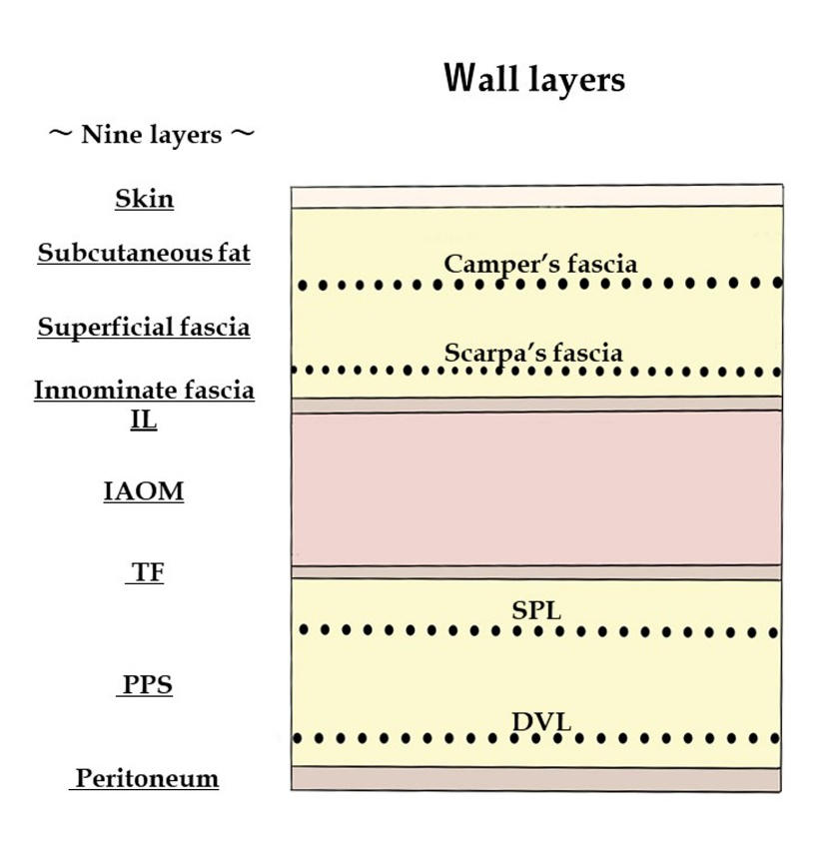
Figure 1 Wall layers. The abdominal wall at the groin contains the following components: skin, subcutaneous fat, superficial fasciae (Camper’s and Scarpa’s fasciae), innominate (unnamed or untitled) fascia, IL, IAOM, TF, PPS [SPL (anterior subperitoneal fascia) and DVL (posterior subperitoneal fascia)], and peritoneum. DVL: deeper visceral layer; IAOM: internal abdominal oblique muscle; IL: inguinal ligament; PPS: preperitoneal space; SPL: superficial parietal layer; TF: transversalis fascia.
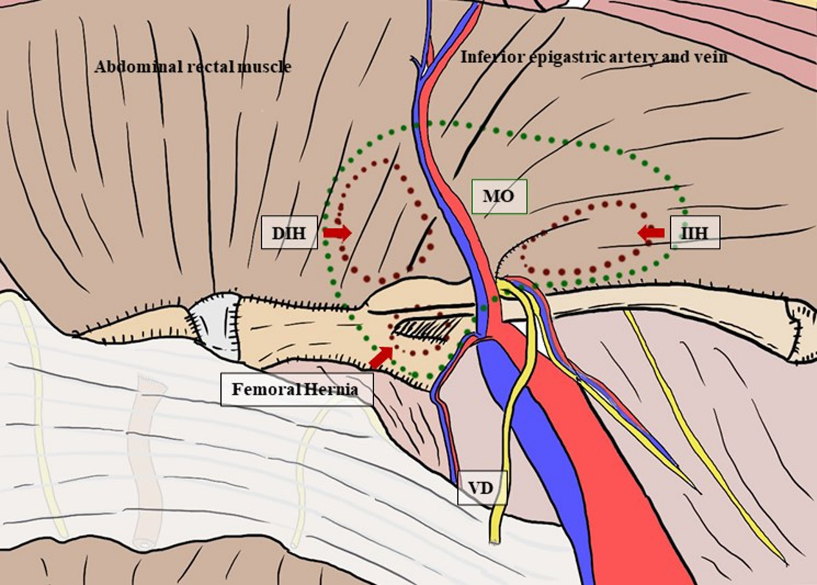
Figure 2 Myopectineal orifice. The oval-shaped myopectineal orifice (green dotted circle) is the origin of all groin hernias (brown dotted circles). DIH: direct inguinal hernia; IIH: indirect inguinal hernia; MO: myopectineal orifice; VD: vas deferens.
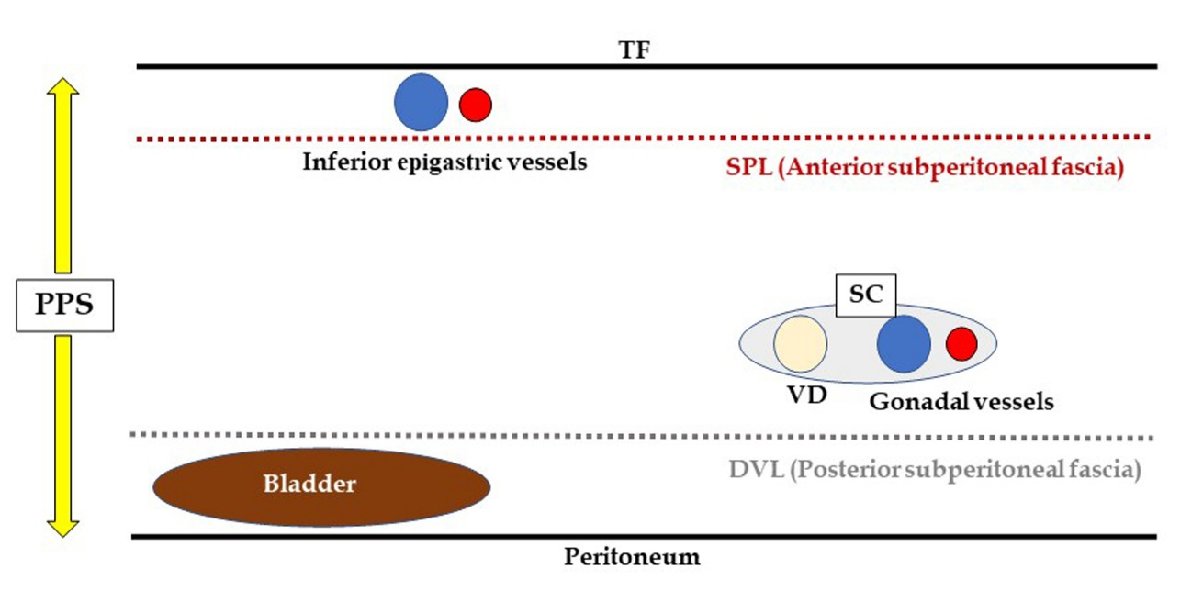
Figure 3 Preperitoneal space. DVL: deeper visceral layer; PPS: preperitoneal space; SC: spermatic cord; SPL: superficial parietal layer; TF: transversalis fascia; VD: vas deferens.
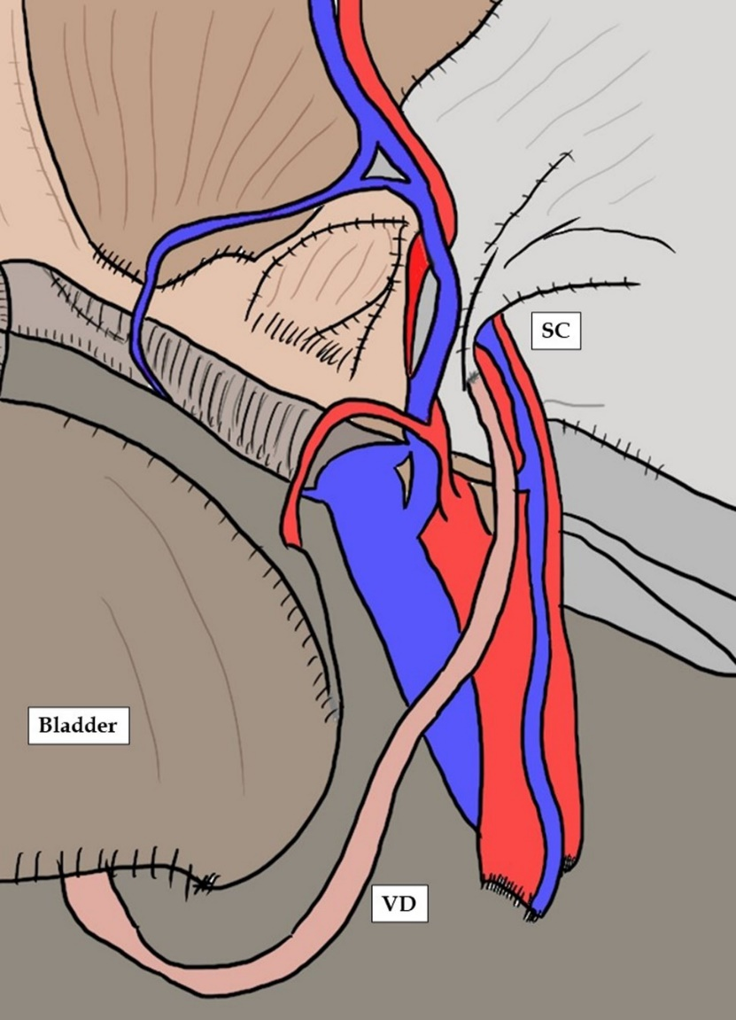
Figure 4 Vas deferens, spermatic cord and bladder. The vas deferens courses as the “preperitoneal loop” in the deeper visceral layer (DVL). The bladder exists in the DVL. DVL: deeper visceral layer; PPS: preperitoneal space; SC: spermatic cord; SPL: superficial parietal layer; TF: transversalis fascia; VD: vas deferens.
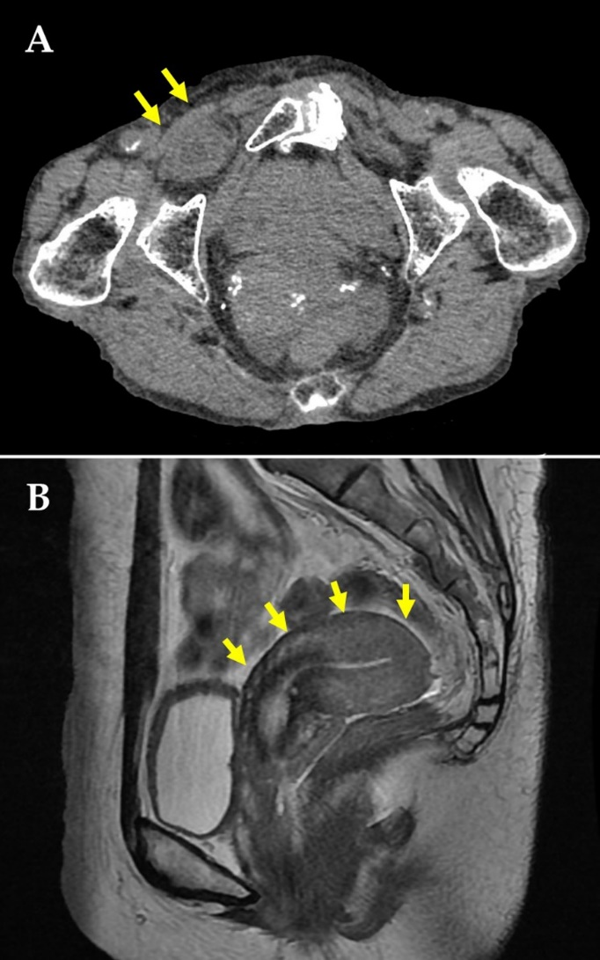
Figure 5 Actual image findings. Actual image findings of obturator hernia in computed tomography (A, orange arrows) and retroflexion of the uterus in magnetic resonance imaging (B, orange arrows) are shown, respectively.
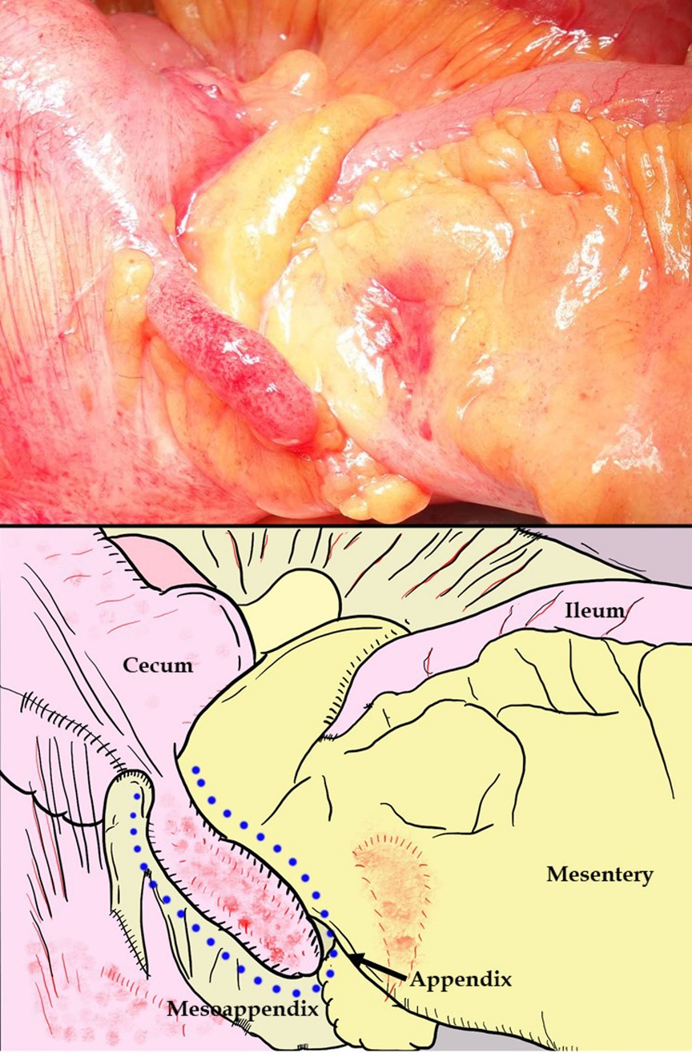
Figure 6 Amyand’s hernia. Amyand’s hernia is considered as an inguinal hernia that traps the appendix. In patients who exhibit a giant hernia involving incarceration of the ileocecal portion of the intestinal tract, only the appendix does not recover from ischemic changes, despite resolution of the strangulation.
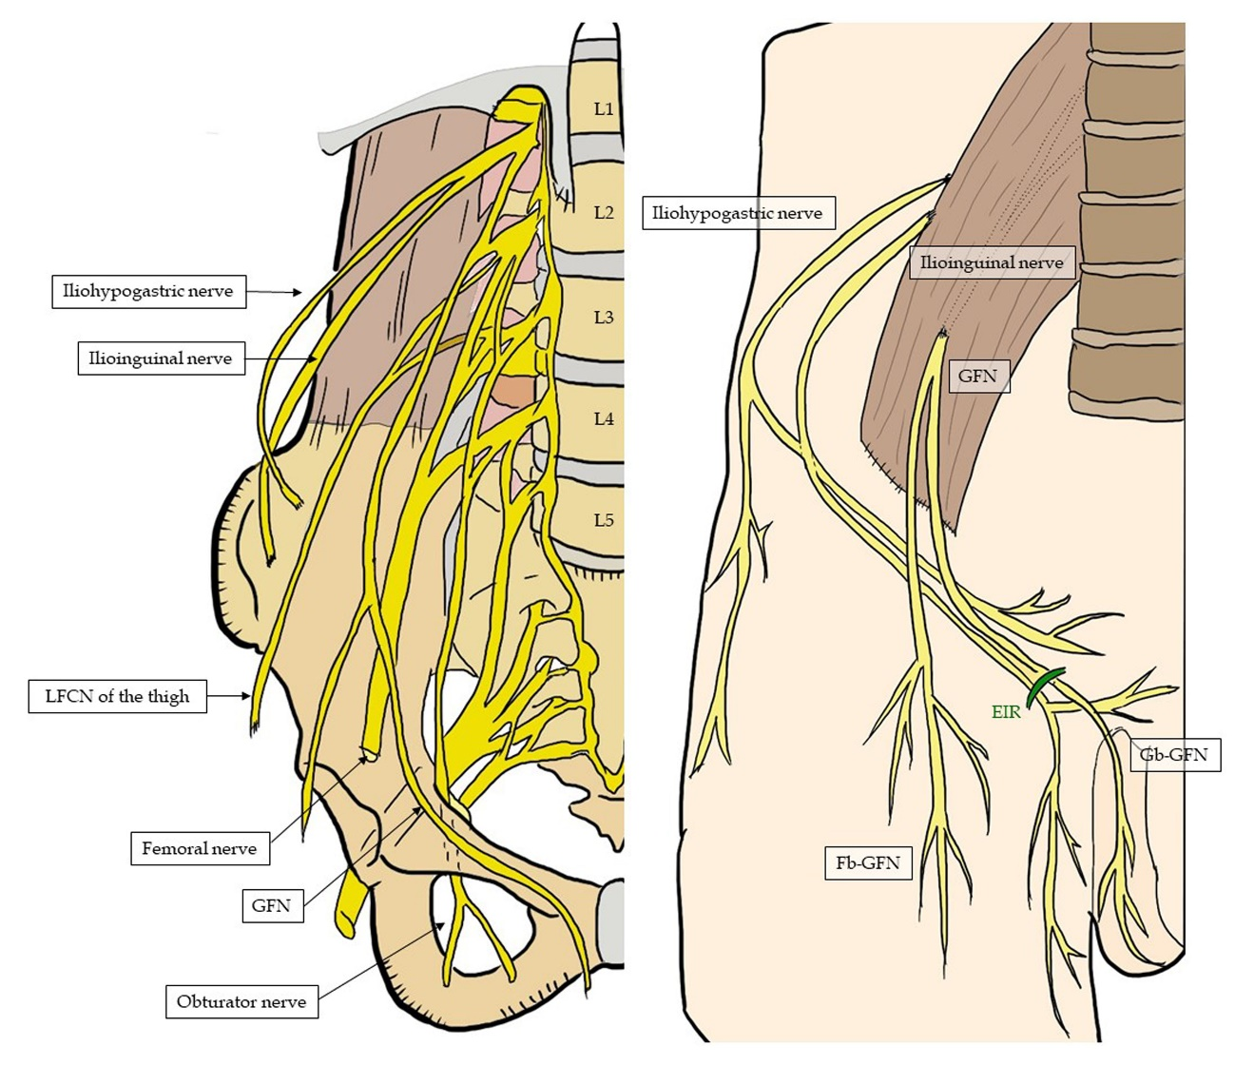
Figure 7 Topographic nerves located in the groin. These six nerves of interest are the iliohypogastric, ilioinguinal, femoral (including the anterior cutaneous branch), genitofemoral (femoral and genital branches), lateral femoral cutaneous of the thigh, and obturator nerves. EIR: external inguinal ring; GFN: genitofemoral nerve; Fb-GFN: the femoral branch of the GFN; Gb-GFN: the genital branch of the GFN; LFCN: lateral femoral cutaneous nerve.
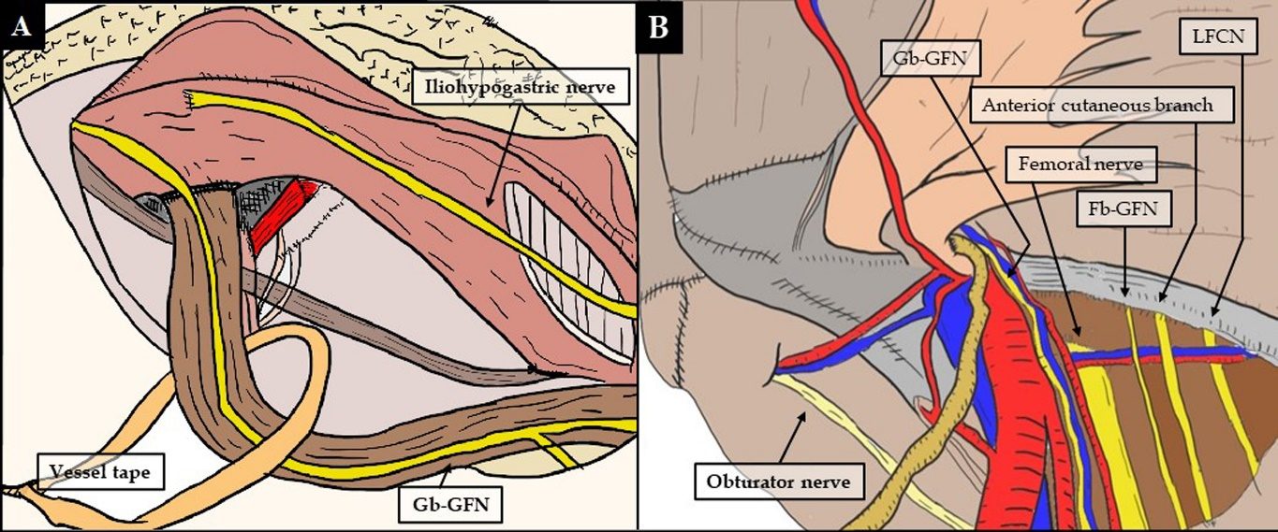
Figure 8 Topographic nerves located in the groin. Respective anterior (A) and laparoscopic (B) views are shown. Fb-GFN: the femoral branch of the genitofemoral nerve; Gb-GFN: the genital branch of the genitofemoral nerve; LFCN: lateral femoral cutaneous nerve.
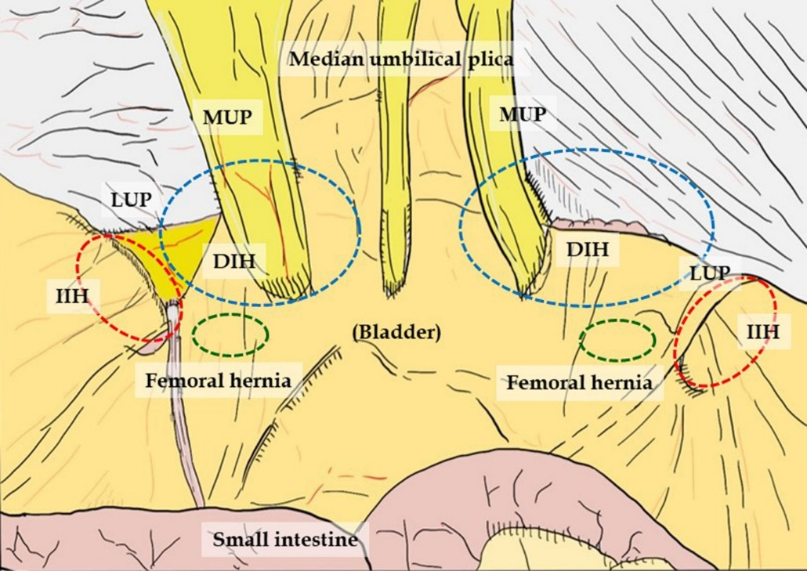
Figure 9 Plicae and fossae. Plicae create three flat fossae recognizable on each side, corresponding to possible hernia defects. Hernia presentation can be more easily evaluated by a laparoscopic view than by an endoscopic or anterior view. DIH: direct inguinal hernia; IIH: indirect inguinal hernia; LUP: lateral umbilical plica; MUP: medial umbilical plica.
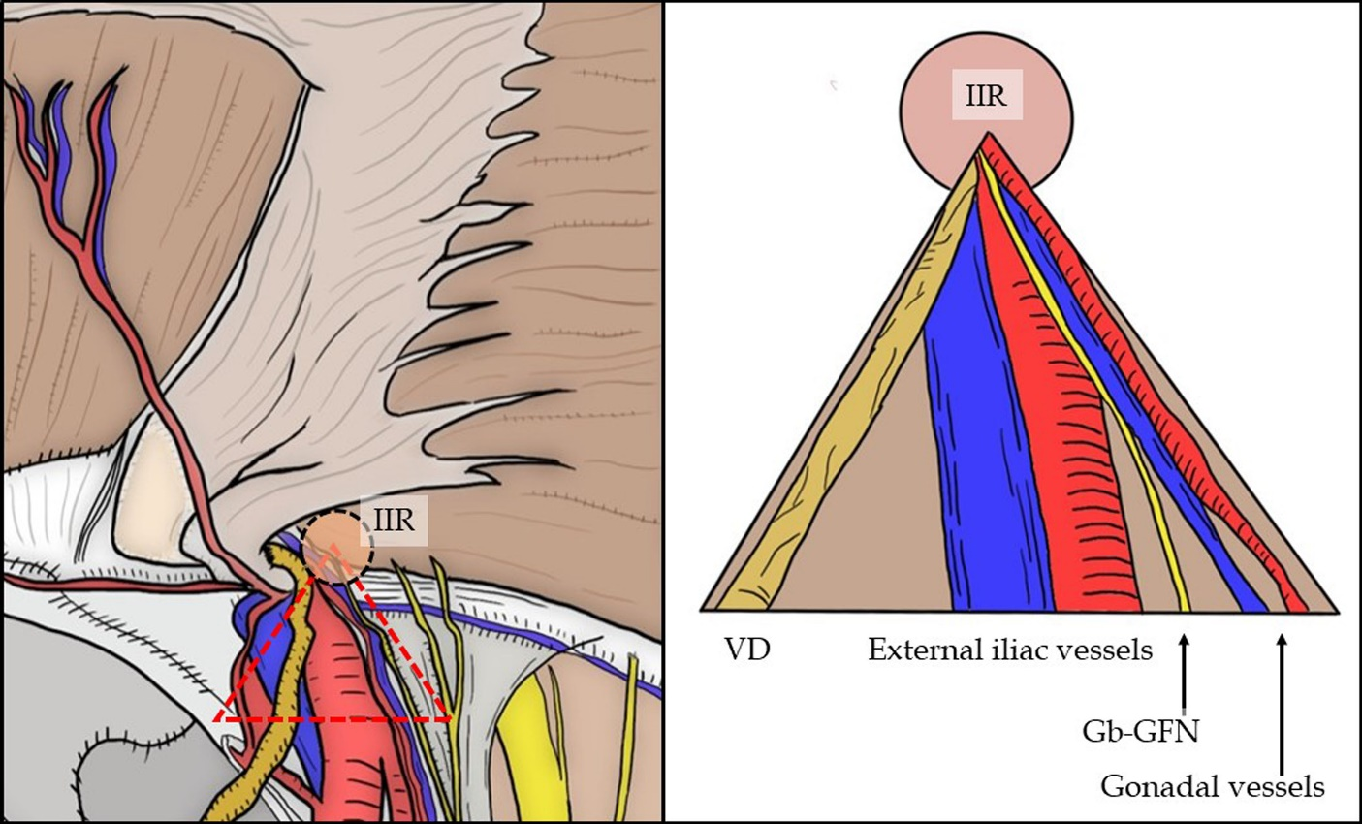
Figure 10 “Triangle of doom”. The “triangle of doom” (orange dotted triangle) delineates the region between the VD and spermatic vessels. Currently, the “triangle of doom” is regarded as an inverted V-shaped area bound laterally by the gonadal vessels (in both sexes) and medially by the VD (in men and boys) or RL (in women and girls). Gb-GFN: the genital branch of the genitofemoral nerve; IIR: internal inguinal ring; RL: round ligament; VD: vas deferens.
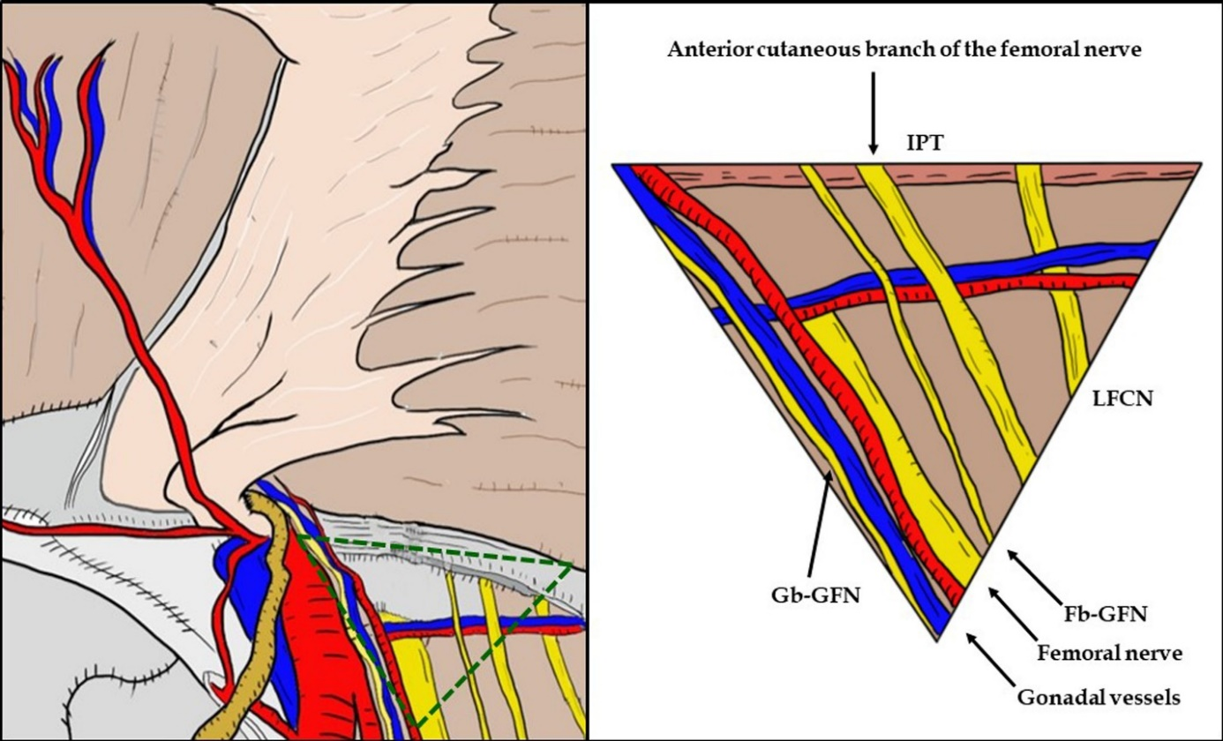
Figure 11 “Triangle of pain”. The “triangle of pain” (orange dotted triangle) is defined as the area lateral to the testicular vessels and inferior to the iliopubic tract. The “triangle of pain” involves the femoral branch of the genitofemoral nerve, lateral femoral cutaneous nerve, femoral nerve, and anterior cutaneous branch of the femoral nerve. Subtle injury (or greater) to the nerves located within the “triangle of pain” is a risk factor for intractable pain. Fb-GFN: the femoral branch of the genitofemoral nerve; Gb-GFN: the genital branch of the genitofemoral nerve; IPT: iliopubic tract; LFCN: lateral femoral cutaneous nerve.
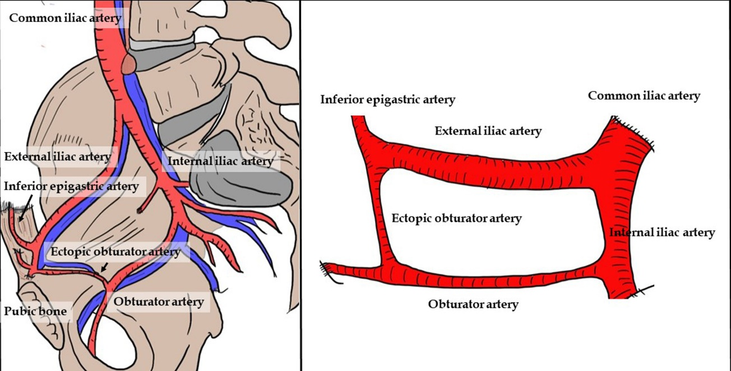
Figure 12 Corona mortis. The corona mortis is classically defined as the arterial anastomosis between the obturator and the inferior epigastric arteries by means of the ectopic obturator artery. The existence of the obturator artery results in annular communication among the inferior epigastric, common iliac, internal iliac, external iliac, and obturator arteries. Brisk bleeding is difficult to control because of the dual vascular supply from the obturator and iliac vessels.

Table 1 History of anatomy and surgery for groin hernia
Name | Year | Remarks
G. Falloppio (1523-1562) |  | Importance of the IL (Etiology)
F. Poupart (1661- 1709) |  | Poupart’s ligament (i.e., the inguinal ligament)
P. Camper (1722-1789) |  | Camper’s fascia (Anatomy)
A. Scarpa (1752-1832) |  | Scarpa’s fascia (Anatomy)
D. Cantemir (1673-1723) | 1716 | Successful surgery (via a laparotomy)
L. Heister (1683-1758) |  | Bowel resection for strangulated hernia
P. Roland Arnaud de Ronsil | 1724 | Obturator hernia
C. Amyand (1660-1749) | 1735 | Amyand’s hernia
AG. Richter (1742-1812) | 1777 | Strangulated hernia
AP. Cooper (1768-1841) |  | Cooper’s ligament (Anatomy)
HO. Marcy (1837-1924) | 1806 | Marcy’s repair (Anterior approach)
FK. Hesselbach (1759-1816) | 1871 | Hesselbach’s triangle (Anatomy)
WJ. Mitchell Banks (1842–1904) | 1882 | Simple high ligation in infants and children
E. Basssini (1844-1924) | 1887 | Bassini’s repair (Anterior approach)
WS. Halsted (1852-1922) |  | Modified Bassini’s repair
EW. Andrews (1824-1904) |  | Modified Bassini’s repair
L. Tait (1845-1899) | 1891 | Transabdominal approach
J. Lucas Championniere (1843-1913) | 1892 | Simple high ligation in infants and children
G. La Roque (1876-1934) | 1919 | Transabdominal approach
GL. Cheatle (1865-1951) | 1920 | TEP approach
RH. Russel (1860-1933) | 1925 | Sac removal in infants and children
A. Henry (1886-1962) | 1936 | Transabdominal approach
CB. McVay (1911–1987) | 1939 | McVay’s repair (Anterior approach)
BJ. Anson (1894-1874) |  | Importance of the TF
WJ. Potts (1895-1968) | 1945 | Potts’ method in infants and children
EE. Shouldice (1981-1965) | 1953 | Shouldice’s repair (Anterior approach)
H. Fruchaud (1894-1960) | 1956 | The PPS (Anatomy)
CE. Koop (1916-2013) | 1957 | Koop’s fixation
FC. Usher (1908-1980) | 1958 | Monofilament polypropylene mesh (Anterior approach)
LM. Nyhus (1923-2008) | 1959 | IPT repair (Preperitoneal approach)
J. Rives (1873-1985) | 1965 | Mesh placement in the PPS (Preperitoneal approach)
RE. Stoppa (1921-2006) | 1969 | Prosthetic reinforcement in the PPS (Preperitoneal approach)
P. Fletcher | 1979 | Laparoscope use (Laparoscopic approach)
R. Gel | 1982 | Laparoscopic repair (Laparoscopic approach)
IL. Lichtenstein (1920-2000) | 1986 | Mesh plug (Anterior approach)
 |  | The concept of TFR
S. Bogojavalensky | 1989 | Laparoscopic repair with mesh plug (Laparoscopic approach)
L. Schultz | 1990 | The first series of laparoscopic repair (Laparoscopic approach)
JL. Dulucq | 1991 | Mesh placement in the PPS (Endoscopic approach)
FK. Toy and RT. Smoot, Jr. | 1991 | Intraperitoneal onlay mesh repair (Laparoscopic approach)
RJ. Fitzgibbons, Jr. | 1991 | Intraperitoneal onlay mesh repair (Laparoscopic approach)
AT. Spaw and LP. Spaw | 1991 | Triangle of doom (Anatomy)
AI. Gilbert | 1992 | Sutureless technique (Anterior approach)
ME. Arregui | 1992 | TAPP repair (Laparoscopic approach)
GS. Ferzli | 1992 | TEP repair (Endoscopic approach)
JM. Himpens | 1992 | TEP repair (Endoscopic approach)
JB. McKernan and HL. Laws | 1993 | TEP repair (Endoscopic approach)
EH. Phillips | 1993 | TEP repair (Endoscopic approach)
R. Annibali, TH. Quinn and RJ. Fitzgibbons Jr. | 1993 | Triangle of pain (Anatomy)
IL: inguinal ligament; IPT: iliopubic tract; PPS: preperitoneal (posterior) space; TAPP: transabdominal preperitoneal; TEP: totally extraperitoneal; TF: transversalis fascia; TFR: tension-free repair.
Table 2 Preperitoneal (posterior) space and myopectineal orifice
Name | Year | SPL (Posterior sub-peritoneal fascia) | DVL (Anterior sub-peritoneal fascia)
AP. Cooper | 1807 | TF-inner portion | -
WJ. Lytle | 1945 | Preperitoneal fascia | -
EE. Shouldice | 1953 | Preperitoneal fascia | -
H. Fruchaud | 1956 | PPS at the MO | -
LM. Nyhus | 1959 | PPS | -
J. Rives | 1965 | Inguinal PPS | -
R. Fowler | 1975 | Preperitoneal fascia-membranous layer | Preperitoneal fascia-areolar layer
RE. Stoppa | 1977 | Urogenital fascia | Urogenital fascia
 |  | Umbilico-prevesical fascia | Umbilico-prevesical fascia
 |  | Spermatic sheath | Spermatic sheath
RC. Read | 1992 | TF-posterior lamina | -
ME. Arregui | 1997 | Attenuated rectus sheath | Umbilical prevesicular fascia
 |  | TF-posterior lamina | Preperitoneal fascia
DVL: deeper visceral layer; MO: myopectineal orifice; PPS: preperitoneal (posterior) space; SPL: superficial parietal layer; TF: transversalis fascia.

Published by Baishideng Publishing Group Inc
7041 Koll Center Parkway, Suite 160, Pleasanton, CA 94566, USA
Telephone: +1-925-3991568
E-mail: bpgoffice@wjgnet.com
Help Desk: https://www.f6publishing.com/helpdesk
https://www.wjgnet.com

© 2021 Baishideng Publishing Group Inc. All rights reserved.

