Name of journal: World Journal of Gastroenterology
Manuscript NO: 41485
Manuscript type: ORIGINAL ARTICLE

Observational Study
Endoscopic identification of endoluminal esophageal landmarks for radial and longitudinal orientation and lesions location

Emura F et al. Endoscopic esophageal landmarks for endoluminal orientation

Fabian Emura, Rene Gomez-Esquivel, Carlos Rodriguez-Reyes, Petros Benias, Javier Preciado, Michael Wallace, Luis Giraldo-Cadavid

Fabian Emura, Division of Gastroenterology, Universidad de La Sabana, Bogotá DC 140013, Colombia

Fabian Emura, Advanced Gastrointestinal Endoscopy, Emura Center Latino America, Bogotá DC 110121, Colombia

Fabian Emura, Emura Foundation for the Promotion of Cancer Research, Bogotá DC 110121, Colombia

Fabian Emura, Unidad de Endoscopia Digestiva, Clínica Pediátrica Colsanitas, Bogotá DC 110121, Colombia

Rene Gomez-Esquivel, Morsani College of Medicine, University of South Florida, Tampa, FL 33612, United States

Carlos Rodriguez-Reyes, Division of Gastroenterology, Universidad de La Sabana, Bogotá DC 53753, Colombia

Petros Benias, Division of Gastroenterology, North Shore-Long Island Jewish Medical Center. New York, NY 11030, United States

Javier Preciado, Unidad de Exploraciones Digestivas, Clinica Universitaria Colombia, Bogotá DC 110121, Colombia

Michael Wallace, Department of Gastroenterology and Hepatology, Mayo Clinic, Jacksonville, FL 32224, United States

Luis Giraldo-Cadavid, Department of Internal Medicine. Universidad de La Sabana, Bogotá DC 140013, Colombia

ORCID number: Fabian Emura (0000-0002-6544-1435); Rene Gomez-Esquivel (0000-0003-4666-1544); Carlos Rodriguez-Reyes (0000-0002-2325-9707); Petros Benias (0000-0001-9369-8329); Javier Preciado (0000-0002-9460-7748); Michael Wallace (0000-0002-6446-5785); Luis Giraldo-Cadavid (0000-0002-7574-7913).

Supported by (in part) a grant in aid from the Emura Foundation for the Promotion of Cancer Research, No. 01221.

STROBE Statement: The authors have read the STROBE Statement -checklist of items, and the manuscript was prepared and revised according to the STROBE Statement -checklist of items

Open-Access: This article is an open-access article which was selected by an in-house editor and fully peer-reviewed by external reviewers. It is distributed in accordance with the Creative Commons Attribution Non Commercial (CC BY-NC 4.0) license, which permits others to distribute, remix, adapt, build upon this work non-commercially, and license their derivative works on different terms, provided the original work is properly cited and the use is non-commercial. See: http://creativecommons.org/licenses/by-nc/4.0/

Manuscript source: Unsolicited manuscript

Corresponding author to: Fabian Emura MD, PhD, FASGE, Director, EmuraCenter LatinoAmerica, Calle 134 No. 7-83. Consultorio 341. Edificio Altos del Bosque, Bogota DC 110121, Colombia. fabian.emura@unisabana.edu.co
Telephone: +57-3168340598

Received: September 30, 2018
Peer-review started: September 30, 2018
First decision: November 15, 2018
Revised: December 3, 2018
Accepted: December 19, 2018
Article in press:
Published online:

Abstract
AIM
To characterize esophageal endoluminal landmarks to permit radial and longitudinal esophageal orientation and accurate lesions location.

METHODS
Distance from the incisors and radial orientation was estimated for the main left bronchus and the left atrium landmarks in 207 consecutive patients using white light examination. A sub-study was additionally performed using white light followed by endoscopic ultrasound (EUS) on 25 consecutive patients to confirm the findings. The scope orientation throughout the exam was maintained at natural axis, where the left esophageal quadrant corresponds to the area between 6 and 9 o’clock. Once an anatomical landmark was identified, it was recorded with a photograph and its quadrant orientation and distance from the incisors were obtained. The reference points to obtain the distances and radial orientation were: the midpoint of the left main bronchus and the most intense pulsatile zone of the left atrium. With the video processor system set to moderate insufflation, measurements were obtained at the end of the patients’ air expiration.

RESULTS
The left main bronchus and left atrium esophageal landmarks were identified using white light in 99% and 100% of subjects at a mean distance of 25.8 (SD 2.3), and 31.4 cm (SD 2.4) from the incisors, respectively. The left main bronchus landmark was found as a tubular, concave, non-pulsatile, esophageal external compression, occupying approximately 1/4 of the circumference. Meanwhile, the left atrium landmark was identified as a round, convexe, pulsatile, esophageal external compression, occupying approximately 1/4 of the circumference. Both landmarks were identified using white light on the anterior esophageal quadrant. In the sub-study, the left main bronchus was identified in 24 (92%) of patients at 25.4 (SD 2.1) and 26.7 cm (SD 1.9) from the incisors, by white light and EUS respectively. The left atrium was recognized in all patients at 30.5 (SD 1.9), and 31.6 cm (SD 2.3) from the incisors, by both white light and EUS respectively. EUS confirmed the landmarks corresponded to these two structures respectively, and that they were located on the anterior esophageal wall. The Bland-Altman plot demonstrated a high agreement among the white light and EUS measurements.

CONCLUSION
This study provides an endoscopic characterization of esophageal landmarks corresponding to the left main bronchus and left atrium, to permit radial and longitudinal orientation and accurate lesions location.

Key words: Esophagus; natural landmark; radial orientation; longitudinal orientation; four-quadrants; left main bronchus; left atrium

© The Author(s) 2018. Published by Baishideng Publishing Group Inc. All rights reserved.

Core tip: Although accurate photo documentation of endoscopic landmarks and a careful description of the location of an esophageal lesion are included in endoscopy quality guidelines, clinical practice lacks these essentials. This study has characterized two esophageal landmarks to permit radial and longitudinal orientation and accurate lesions location. The left main bronchus and left atrium landmarks were identified in 99% and 100% of patients on the anterior esophageal quadrant and at a mean distance of 25.8 and 31.4 cm from the incisors, respectively. The endoscopic ultrasound sub-study confirmed these findings and the anterior orientation of the landmarks.

Emura F, Gomez-Esquivel R, Rodriguez-Reyes C, Benias P, Preciado J, Wallace M, Giraldo-Cadavid L. Endoscopic identification of endoluminal esophageal landmarks for radial and longitudinal orientation and lesions location. World J Gastroenterol 2018; In press

Introduction
Esophageal lesions are traditionally described according to the distance from the incisors^{[1,2]}. This measure, while helpful to roughly describe large lesions, lacks radial orientation and is inaccurate for precise location of dysplastic lesions and small flat tumors. Endoscopic resection/ablation procedures as well as newer advanced procedures, such as per-oral endoscopic myotomy (POEM), are facilitated by accurate longitudinal and radial anatomic orientation^{[3,4]}. Furthermore, commonly used esophageal divisions comprising cervical, thoracic, and abdominal segments are unrecognized during an upper GI examination, making this surgical division meaningless for endoscopists^{[5,6]}. Since esophageal endoluminal anatomy has been poorly studied, current endoscopy practice lacks these essentials; offering vague lesion’s identification to a second intervening endoscopist. Anatomical and cross-sectional radiological studies, however, have identified two esophageal landmarks, the left main bronchus and the left atrium, and revealed their anterior location to the esophagus^{[7,8]}. Although we recently postulated these landmarks can be used to divide the esophageal length in three thirds as part of the systematic alphanumeric coded endoscopic approach^{[9,10]}, an endoscopic study characterizing these landmarks has never been reported. The aim of this study is to determine these landmarks frequency, distance from the incisors and their quadrant orientation using white light endoscopy, and to confirm these findings by endoscopic ultrasound (EUS).

MATERIAL AND METHODS
Patients
Two hundred and thirty-four patients were enrolled in the main study from March to December 2012 at EmuraCenter LatinoAmerica, Bogotá DC, Colombia. Endoscopy was indicated for both dyspeptic patients and screening purposes. Exclusion criteria consisted of patients with previous history of esophageal strictures, scleroderma, achalasia, Barrett’s esophagus, cardiac or esophageal motility disorders, and esophageal or gastric surgery. Those patients endoscopically diagnosed with peptic esophagitis, esophageal candidiasis, esophageal varices, and neoplastic lesions were also excluded from analysis. In the sub-study performed to confirm that the left main bronchus and left atrial indentations, truly represented those structures, 25 consecutive patients scheduled for upper EUS were enrolled between June and July 2016 at the Mayo Clinic, Jacksonville, USA. Informed consent was obtained from all patients and this two-center study was approved by the respective institutional review boards.

Morphometric measurements
The patients’ weight were determined using a digital weight scale and recorded in kilograms. Standing height from heel to vertex was determined using a conventional meter and estimated in centimeters. The BMI of each patient was determined by dividing the weight over the squared height.

Endoscopic examination
White light examinations were performed by an expert endoscopist (FE) using H180 or Q180 gastroscopes (Olympus Optical, Tokyo, Japan), and an Olympus EVIS EXERA II HD video processor. An expert EUS endoscopist (MW) conducted the sub-study. White light examinations were performed with an H180 gastroscope, and EUS examinations with a 360° scanning range radial echoendoscope (Olympus America Inc., Center Valley, PA, United States), and an Olympus EVIS EXERA II HD video processor. All scopes have identical demarcations in centimeters, and visible numbers every five centimeters as reference. The video processor system was set to moderate insufflation mode (Mode M) during the entire procedure in all examinations. Once in the esophagus, the lumen was additionally rinsed with water to remove any overlying surface mucous/saliva. Light conscious sedation with intravenous midazolam or propofol was used in selected subjects examined by white light endoscopy, and in all patients that underwent EUS.

Endoscope’s radial orientation
Once in the esophageal lumen, the endoscope was oriented with the left esophageal quadrant between 6 and 9 o´clock. This position was confirmed as follows: with the patient in left lateral position, 3 mL of 0.25% Indigo Carmine (Chromoendoscopia, Colombia) was poured into the esophageal lumen using an irrigation catheter (PW-205V, Olympus, Japan). Utilizing gravity, the pooled water identified the left quadrant of the esophageal circumference (Figure 1). This endoluminal orientation, also known as natural esophageal axis^{[8]} is achieved when the examiner’s left hand maintains the head of the endoscope horizontally and the right hand slightly torques to the right.

Esophageal quadrants
Esophageal quadrants during an upper GI examination were previously described by us^{[9]}. By positioning the left quadrant between the 6 and 9 o’clock as aforementioned, the other three quadrants were defined as follows: Anterior quadrant: the portion of the circumference between the 9 and 12 o’clock; Right quadrant: the portion of the circumference contralateral to the left quadrant and located between the 12 and 3 o´clock. Posterior quadrant: portion of the circumference contralateral to the anterior quadrant and located between the 3 and 6 o´clock.

Protocol for measurement of distances
Once an anatomical landmark was identified, the natural axis position of the endoscope was confirmed. Then, it was recorded with a photograph, and its quadrant orientation was identified. The reference points to obtain the distance from the incisors were: the midpoint of the left main bronchus and the most protruded pulsatile zone of the left atrium. After identifying the radial orientation of the landmark, the distance from the incisors was calculated as follows: first, the endoscope tip was positioned immediately at the reference point, then, the distance was estimated using the standard demarcation of the endoscope located every 5 cm as a primary reference, and finally, for precise estimation, a flexible ruler marked in millimeters was positioned between the incisors and the closest endoscope’s mark. Each measurement was determined at the end of the patients’ air expiration.

Statistical analysis
Data were analyzed using the IBM-SPSS version 20 (IBM Corporation, Armonk, NY, United States). The results are presented as absolute numbers and proportions for qualitative variables and means ± SDs for continuous variables. The coefficient of variation was used as an additional statistic of measurements’ precision, and calculated as: standard deviation/mean. Differences between groups were analyzed using the chi-square test for categorical variables, and the one-way analysis of variance (ANOVA) or the Kruskal-Wallis test for continuous variables. A two-tailed P value < 0.05 was considered significant. The Bland-Altman plot was used to asses agreement between white light and EUS measurements (95%CI). The statistical methods of this study were reviewed by a statistician (LG) of Universidad de La Sabana.

Sub-study sample size
The sub-study sample size was calculated to detect differences ≥ 5% between the subjects with 95% confidence level, 80% power, 1:4 ratio and 2.5 cm SD.

RESULTS
Two hundred and thirty-four patients were examined in the main study using white light endoscopy; 21 patients with peptic esophagitis, 3 with esophageal varices, 2 with incomplete data, and 1 with squamous cell carcinoma were excluded. Finally, a total of 207 subjects were analyzed (Figure 2). Meanwhile, according to a calculated sample size of twenty-four for the sub-study, twenty-five subjects were enrolled and analyzed.

Morphometric measurements
In the main study, the mean age was 54 years and the ratio female:male was 1.4:1. The mean of the weight, height and BMI was 162 cm, 66 Kg and 25, respectively. As for the sub-study, the mean age was 64 years and the ratio female:male was 1.8:1. The mean of weight, height, and BMI was 170 cm, 79 Kg and 27.3, respectively. Patients’ morphometric characteristics are shown in Table 1. There were no statistical differences among the groups.

Description of endoscopic findings
The left main bronchus and left atrium esophageal landmarks were endoscopically identified using white light in 205 (99%) and 100% of patients at a mean distance of 25.8 (SD 2.3), and 31.4 cm (SD 2.4) from the incisors, respectively. The left main bronchus landmark was found as a tubular convexe, non-pulsatile esophageal external compression, occupying approximately 1/4 of the circumference. The left atrium landmark was identified as a rounded concave, pulsatile esophageal external compression, occupying also approximately 1/4 of the circumference. In all subjects, the radial orientation of both landmarks was identified on the anterior esophageal quadrant (Figure 3). In the sub-study, the left main bronchus was identified in twenty-three (92%) of patients at 25.4 (SD 2.1) and in twenty-four (96%) of patients at 26.7 cm (SD 1.9) from the incisors, by white light and EUS respectively. On the other hand, the left atrium was recognized in all patients at 30.5 (SD 1.9), and 31.6 cm (SD 2.3) from the incisors, by both white light and EUS respectively. Both landmarks were also identified on the anterior esophageal quadrant. EUS confirmed the landmarks corresponded to these two structures respectively, and that they were located on the anterior esophageal wall (Figure 4). There were no significant differences between the distances measured by the methods (Table 2).

Plot of differences between white light and EUS measurements
The Bland-Altman limits of agreement plot showed a mean difference of -1.1 and -1.4 cm for the left main bronchus and the left atrium when using white light and EUS, respectively (Figure 5).

DISCUSSION
This study for first time characterized the endoscopic nature, frequency, distance from the incisors and quadrant orientation of two external compressions along the esophageal length.
There are several factors that reliably support the results obtained in this study. First, the evidence of previous anatomical and radiological studies that highlighted the existence of these landmarks^{[5,7,8]}. Second, the reliable identification of these landmarks with consistent distances from the incisors, and third, the constant anterior radial orientation of the landmarks by white light, and their confirmation by EUS.
The distance measurements from the incisors were consistent among the three cohort of patients with similar coefficients of variation to those found as in any other anatomical study. Although some anatomical variations might explain the non-observation of the left main bronchus landmark in two patients using white light in the main study, and in one patient using EUS, additional studies in larger subpopulations are warranted to further explain these findings. As for the 2 patients in which the left main bronchus was not observed using white light but seen during the subsequent EUS exam, a probable explanation can be credited to an unrecognized light extrinsic compression over the esophageal wall. Further studies however, are also necessary to explain these observations.
In order to compare the differences between the measures, we carried out the Bland-Altman plot that demonstrated a high agreement among the white light and EUS measurements with an EUS mean difference of -1.1 and -1.4 cm measured for the left main bronchus and the left atrium, respectively. Although this small difference can be explained simply by human precision error, the major reason can be attributed to the type of radial echoendoscope used, which has an additional extension at the scope´s tip given by the ultrasound transducer, thereby explaining in part the difference obtained by EUS. Even though cadaveric studies have estimated the esophageal relationships to external organs^{[5,11]}, no other endoscopic studies have been conducted to characterize the left atrium landmark. As for the left main bronchus's landmark, a Korean study that evaluated the endoscopic esophageal length in 196 individuals reported a similar distance of 27.7 cm from the incisors^{[12]}.
In order to reliably identify the radial orientation of the landmarks, we first identified the anatomical distributions of the 4-quadrants by gravity identification of the left quadrant using Indigo Carmine, and then, defined other names according to described anatomical nomenclature^{[7]}. After allocating the left quadrant between 6 and 9 o’clock, the right quadrant was therefore, allocated at the contralateral side between the 12 and 3 o’clock, and the anterior and posterior quadrants were intercalated between the aforementioned quadrants. Once the natural axis position was achieved, we applied clock face-distribution for precise quadrant identification. In all white light examinations, both identified landmarks were radially oriented at the anterior esophageal quadrant between the 9 to 12 o’clock. We conducted EUS examinations to confirm these findings obtaining the same results.
Even though anthropometric measurements in Colombian patients were lower compared to USA patients, there were no differences when the distances from the incisor were compared. Similar to a previous study that reported a direct association between height and esophageal total length^{[12,13]}, we found a direct association between height and both the left main bronchus and the left atrium measurements (p < 0.001). Further studies are warranted to predict esophageal length using height as the most relevant external parameter.
Although these endoscopic measurements need to be tested in further inter observer validation studies, they are probably vulnerable to the same limitations as the measurements made for human anatomical studies. For distances estimation, possible confounding influences can be attributed to low or excessive insufflation of the esophagus that might reduce endoluminal visibility and to respiratory movements, that might modify the measurements.
Even when considerably less patients were examined in the sub-study compared to those examined using white light, the calculated statistical power was enough (> 80%), to detect differences > 4.5% between the methods, indicating that a larger sample was unnecessary. A limitation for clinical application is that, at present, endoscopists are not trained to recognize these anatomical landmarks and therefore, their identification and the consequent esophageal radial and longitudinal orientation requires basic training.
The long tubular esophageal shape has limited our ability to accurately orientate and assess the location of esophageal lesions. Traditionally, esophageal lesions have been described according to the distance from the incisors^{[1,2]} and their location, as proposed by surgeons, in cervical, thoracic or abdominal segments^{[5,6]}. On one hand, using only the estimation of distance from the incisors lacks accuracy to radially locate suspicious esophageal lesions and tumors, and on the other hand, the surgical esophageal divisions are unrecognizable during upper GI exams.
The two landmarks herein characterized, can be potentially used to overcome the mentioned limitations. First, when taken together along with the cricopharyngeus narrowing and the esophagogastric (EG) junction landmarks reported at a distance of 15.7 ± 1.4 and 40.9 ± 2.8 cm from the incisors respectively^{[14,15]}, constitutes the fundaments for the systematic alphanumeric endoscopic proposal to evaluate the esophagus^{[9,10]}, and can be used, as reported by us, to improve longitudinal orientation by dividing the esophagus into three non-equal but practical endoscopic thirds: the upper third, located between the cricopharyngeus narrowing and the left main bronchus; the middle third, located between the left main bronchus and the left atrium; and the distal third, extending from the left atrium downward to the EG junction^{[9]} (Figure 6). The potential usefulness of this endoscopic classification must be further studied, but it currently provides clinically relevant data to fulfill published guidelines by major gastroenterology societies that recommend accurate photo documentation of endoscopic landmarks and a careful description of the location of a lesion to allow subsequent therapeutic applications and future surveillance^{[16,17]}. Furthermore, an appropriate recognition of the main left bronchus and/or the left atrium landmarks and their anterior location to the esophagus, may significantly improve radial quadrant orientation. Along with the identification of the left esophageal quadrant as herein described, the landmarks can be potentially used to properly distinguish the 4-quadrants in any esophageal portion including the EG junction. Once this proper radial orientation is achieved, a clock face-distribution can be used to precisely locate any abnormality in the esophageal circumference.
Previous studies have highlighted the importance of radial orientation at the EG junction, and reported a preponderance of mucosal erosive changes, HGD and Barretts’s cancer between the 12 to 3 o’clock^{[18,19]}. In these observations, however, esophageal quadrants were not defined based on natural anatomy but according to the examiners’ view of the endoscopic field. Other study reported a preponderance of Barrett’s neoplasia at the 2-5 o’clock and used the “neutral position” of the endoscope as reference for radial orientation, emphasizing a lack of a universal standardized radial orientation^{[20]}. What is worse, recent surveillance guidelines for BE recommends random 4-quadrant biopsies to be performed every 1 to 2 cm in the columnar segment together with biopsies of any visible lesions^{[21-23]}. In our opinion, without proper radial and longitudinal orientation and anatomical quadrants identification, these recommendations cannot be fulfilled and are currently a source of confusion among practitioners.
These observations when externally validated, may fulfill in part, the lack of current reliable performance measures to gauge the quality of an esophageal endoscopy examination. Recognition of these landmarks can improve radial orientation for both standardization of anterior or posterior approaches in POEMs procedures^{[3,4]}, and localization of Barrett’s esophagus with dysplasia and small squamous cell carcinomas, increasing opportunities to diagnose and treat cancer in early stages^{[22,24,25]}.
In summary, this study provides an endoscopic identification of endoluminal esophageal landmarks corresponding to the left main bronchus and left atrium to permit radial and longitudinal orientation and accurate lesions location.

ARTICLE HIGHLIGHTS
Research background
Esophageal lesions are traditionally described according to the distance from the incisors. This measure, while helpful to roughly describe large lesions, lacks radial orientation and is inaccurate for precise location of dysplastic lesions and small flat tumors. Furthermore, commonly used esophageal divisions comprising cervical, thoracic, and abdominal segments are unrecognized during an upper GI examination, making this surgical division meaningless for endoscopists. Since esophageal endoluminal anatomy has been poorly studied, current endoscopy practice lacks these essentials; offering vague lesion’s identification to a second intervening endoscopist.

Research motivation
Although anatomical and cross-sectional radiological studies, have identified two esophageal landmarks, the left main bronchus and the left atrium, and revealed their anterior location to the esophagus, the long tubular esophageal shape has limited our ability to accurately orientate and assess the location of esophageal lesions. Even though we have postulated these landmarks can be used to divide the esophageal length in three thirds as part of the upper systematic alphanumeric coded endoscopic approach, an endoluminal study characterizing these landmarks has never been reported.

Research objectives
Our study aims to determine these landmarks frequency, distance from the incisors and their quadrant orientation using white light endoscopy, and to confirm these findings by endoscopic ultrasound (EUS).

Research methods
Quadrant orientation and distance from the incisors was estimated in 207 consecutive patients using white light examination. A sub-study was additionally performed using white light followed by EUS on 25 consecutive patients to confirm the findings. Once in the esophageal lumen, the endoscope was oriented with the left esophageal quadrant between 6 and 9 o´clock. This position was confirmed as follows: with the patient in left lateral position, 3 mL of 0.25% Indigo Carmine was poured into the esophageal lumen using an irrigation catheter. Utilizing gravity, the pooled water identified the left quadrant of the esophageal circumference. By positioning the left quadrant between the 6 and 9 o’clock as aforementioned, the other three quadrants were defined as follows: Anterior quadrant: the portion of the circumference between the 9 and 12 o’clock; Right quadrant: the portion of the circumference contralateral to the left quadrant and located between the 12 and 3 o ´clock. Posterior quadrant: portion of the circumference contralateral to the anterior quadrant and located between the 3 and 6 o´clock. This esophageal orientation was defined as natural axis and was maintained throughout the exam. After identifying the radial orientation of the landmark, the distance from the incisors was estimated using the standard demarcation of the endoscope located every 5 cm as a primary reference, and finally, for precise estimation, a flexible ruler marked in millimeters was positioned between the incisors and the closest endoscope’s mark.

Research results
The left main bronchus and left atrium esophageal landmarks were identified using white light in 99% and 100% of subjects at a mean distance of 25.8 (SD 2.3), and 31.4 cm (SD 2.4) from the incisors, respectively. The left main bronchus landmark was found as a tubular, concave, non-pulsatile, esophageal external compression, occupying approximately 1/4 of the circumference. Meanwhile, the left atrium landmark was identified as a round, convexe, pulsatile, esophageal external compression, occupying approximately 1/4 of the circumference. Both landmarks were identified using white light on the anterior esophageal quadrant. In the substudy, the left main bronchus was identified in 24 (92%) of patients at 25.4 (SD 2.1) and 26.7 cm (SD 1.9) from the incisors, by white light and EUS respectively. The left atrium was recognized in all patients at 30.5 (SD 1.9), and 31.6 cm (SD 2.3) from the incisors, by both white light and EUS respectively. EUS confirmed the landmarks corresponded to these two structures respectively, and that they were located on the anterior esophageal wall. The Bland-Altman plot demonstrated a high agreement among the white light and EUS measurements.

Research conclusions
Although these endoscopic measurements need to be tested in further inter observer validation studies, this study provides an endoscopic characterization of esophageal landmarks corresponding to the left main bronchus and left atrium, to permit radial and longitudinal orientation and accurate lesions location.

Research perspectives
Endoscopic recognition of these two landmarks might have different clinical applications. First, when taken together along with the cricopharynxgeus narrowing and the esophagogastric (EG) junction landmarks, constitutes the fundaments for the systematic alphanumeric endoscopic proposal to evaluate the esophagus, and can be used, as reported by us, to improve longitudinal orientation by dividing the esophagus into three non-equal but practical endoscopic thirds: the upper third, located between the cricopharyngeus narrowing and the left main bronchus; the middle third, located between the left main bronchus and the left atrium; and the distal third, extending from the left atrium downward to the EG junction. The potential usefulness of this endoscopic classification must be further studied, but it currently provides clinically relevant data to fulfill published guidelines by major gastroenterology societies that recommend accurate
photo documentation of endoscopic landmarks and a careful description of the location of a lesion to allow subsequent therapeutic applications and future surveillance. Second, an appropriate recognition of the main left bronchus and/or the left atrium landmarks and their anterior location to the esophagus, may significantly improve radial quadrant orientation for both standardization of anterior or posterior approaches in POEMs procedures, and precise localization of Barrett’s esophagus with dysplasia and small squamous cell carcinomas. Furthermore, after identification of the left esophageal quadrant as herein described, these landmarks can be potentially used to properly distinguish the 4-quadrants in any esophageal portion including the EG junction. Once this proper radial orientation is achieved, a clock face-distribution can be used to precisely locate any abnormality in the esophageal circumference.

Acknowledgements
The authors would like to thank Harker Wade and Anne Shiwa for editing this manuscript.

REFERENCES
1 McClave SA, Boyce HW Jr, Gottfried MR. Early diagnosis of columnar-lined esophagus: a new endoscopic diagnostic criterion. Gastrointest Endosc 1987; 33: 413-416 [PMID: 3443258 DOI: 10.1016/S0016-5107(87)71676-9]
2 Csendes A, Maluenda F, Braghetto I, Csendes P, Henriquez A, Quesada MS. Location of the lower oesophageal sphincter and the squamous columnar mucosal junction in 109 healthy controls and 778 patients with different degrees of endoscopic oesophagitis. Gut 1993; 34: 21-27 [PMID: 8432446]
3 Tan Y, Lv L, Wang X, Zhu H, Chu Y, Luo M, Li C, Zhou H, Huo J, Liu D. Efficacy of anterior versus posterior per-oral endoscopic myotomy for treating achalasia: a randomized, prospective study. Gastrointest Endosc 2018; 88: 46-54 [PMID: 29571969 DOI: 10.1016/j.gie.2018.03.009]
4 Ramchandani M, Nabi Z, Reddy DN, Talele R, Darisetty S, Kotla R, Chavan R, Tandan M. Outcomes of anterior myotomy versus posterior myotomy during POEM: a randomized pilot study. Endosc Int Open 2018; 6: E190-E198 [PMID: 29399617 DOI: 10.1055/s-0043-121877]
5 Gray H. Mediastinum. In: Susan S, editor. Gray's Anatomy: The Anatomical Basis of Clinical Practice. Fortieth ed. New York: Churchill Livingstone Elsevier, 2008: 939-57 [DOI.org/10.1016/B978-0-323-05283-2.00073-2]
6 Vaezi M. The esophagus: anatomy, physiology, and diseases. In: Flint P, editor. Otolaryngology Head and Neck Surgery. Fifth ed. Philadelphia: Mosby - Elsevier, 2010: 953-980
7 Skandalakis JE, Skandalakis LJ, Skandalakis PN. Esophagus. In: Surgical Anatomy and Technique. New York, NY: Springer, 2000: 257-309 [DOI.org/10.1007/978-1-4615-7993-9_6]
8 Chevallier JM, Vitte E, Derosier C, Aupart M, Jeanbourquin D, Sarcy JJ, Hannoun L, Parc R. The thoracic esophagus: sectional anatomy and radiosurgical applications. Surg Radiol Anat 1991; 13: 313-321 [PMID: 1803543]
9 Emura F, Gralnek I, Baron TH. Improving early detection of gastric cancer: a novel systematic alphanumeric-coded endoscopic approach. Rev Gastroenterol Peru 2013; 33: 52-58 [PMID: 23539057]
10 Machaca Quea NR, Emura F, Barreda Bolaños F, Salvador Arias Y, Arévalo Suárez FA, Piscoya Rivera A. Effectiveness of systematic alphanumeric coded endoscopy for diagnosis of gastric intraepithelial neoplasia in a low socioeconomic population. Endosc Int Open 2016; 4: E1083-E1089 [PMID: 27747283]
11 Netter FH. The Ciba collection of medical illustrations. 5th ed. 34. Summit, NJ: Ciba Pharmaceutical, 1979
12 Song TJ, Kim YH, Ryu HS, Hyun JH. Correlation of esophageal lengths with measurable external parameters. Korean J Intern Med 1991; 6: 16-20 [PMID: 1742251 DOI: 10.3904/kjim.1991.6.1.16]
13 Otsianyi WK, Mutie T, Kioko H. The Correlation of Esophageal Body Length with Measure of External Body Parameters. Int J Morphol 2011; 29: 895-898 [DOI: 10.4067/S0717-95022011000300038]
14 Sivarao DV, Goyal RK. Functional anatomy and physiology of the upper esophageal sphincter. Am J Med 2000; 108 Suppl 4a: 27S-37S [PMID: 10718448]
15 Boyce HW. Endoscopic definitions of esophagogastric junction regional anatomy. Gastrointest Endosc 2000; 51: 586-592 [PMID: 10805847]
16 Bisschops R, Areia M, Coron E, Dobru D, Kaskas B, Kuvaev R, Pech O, Ragunath K, Weusten B, Familiari P, Domagk D, Valori R, Kaminski MF, Spada C, Bretthauer M, Bennett C, Senore C, Dinis-Ribeiro M, Rutter MD. Performance measures for upper gastrointestinal endoscopy: a European Society of Gastrointestinal Endoscopy (ESGE) Quality Improvement Initiative. Endoscopy 2016; 48: 843-864 [PMID: 27548885 DOI: 10.1055/s-0042-113128]
17 Cohen J, Safdi MA, Deal SE, Baron TH, Chak A, Hoffman B, Jacobson BC, Mergener K, Petersen BT, Petrini JL, Rex DK, Faigel DO, Pike IM. Quality indicators for esophagogastroduodenoscopy. Gastrointest Endosc 2006; 63: S10-S15 [PMID: 16564907 DOI: 10.1016/j.gie.2006.02.018]
18 Edebo A, Vieth M, Tam W, Bruno M, van Berkel AM, Stolte M, Schoeman M, Tytgat G, Dent J, Lundell L. Circumferential and axial distribution of esophageal mucosal damage in reflux disease. Dis Esophagus 2007; 20: 232-238 [PMID: 17509120 DOI: 10.1111/j.1442-2050.2007.00678.x]
19 Pech O, Gossner L, Manner H, May A, Rabenstein T, Behrens A, Berres M, Huijsmans J, Vieth M, Stolte M, Ell C. Prospective evaluation of the macroscopic types and location of early Barrett's neoplasia in 380 lesions. Endoscopy 2007; 39: 588-593 [PMID: 17611912]
20 Kariyawasam VC, Bourke MJ, Hourigan LF, Lim G, Moss A, Williams SJ, Fanning SB, Chung AM, Byth K. Circumferential location predicts the risk of high-grade dysplasia and early adenocarcinoma in short-segment Barrett's esophagus. Gastrointest Endosc 2012; 75: 938-944 [PMID: 22381529]
21 Murphy SJ, Johnston BT, Murray LJ. British Society of Gastroenterology guidelines for the diagnosis of Barrett's oesophagus: are we casting the net too wide? Gut 2006; 55: 1821-1822 [PMID: 17124164]
22 Wang KK, Sampliner RE; Practice Parameters Committee of the American College of Gastroenterology. Updated guidelines 2008 for the diagnosis, surveillance and therapy of Barrett's esophagus. Am J Gastroenterol 2008; 103: 788-797 [PMID: 18341497 DOI: 10.1111/j.1572-0241.2008.01835.x]
23 American Gastroenterological Association, Spechler SJ, Sharma P, Souza RF, Inadomi JM, Shaheen NJ. American Gastroenterological Association medical position statement on the management of Barrett's esophagus. Gastroenterology 2011; 140: 1084-1091 [PMID: 21376940 DOI: 10.1053/j.gastro.2011.01.030]
24 Hirota WK, Zuckerman MJ, Adler DG, Davila RE, Egan J, Leighton JA, Qureshi WA, Rajan E, Fanelli R, Wheeler-Harbaugh J, Baron TH, Faigel DO; Standards of Practice Committee, American Society for Gastrointestinal Endoscopy. ASGE guideline: the role of endoscopy in the surveillance of premalignant conditions of the upper GI tract. Gastrointest Endosc 2006; 63: 570-580 [PMID: 16564854 DOI: 10.1016/j.gie.2006.02.004]
25 ASGE Standards of Practice Committee, Evans JA, Early DS, Fukami N, Ben-Menachem T, Chandrasekhara V, Chathadi KV, Decker GA, Fanelli RD, Fisher DA, Foley KQ, Hwang JH, Jain R, Jue TL, Khan KM, Lightdale J, Malpas PM, Maple JT, Pasha SF, Saltzman JR, Sharaf RN, Shergill A, Dominitz JA, Cash BD; Standards of Practice Committee of the American Society for Gastrointestinal Endoscopy. The role of endoscopy in Barrett's esophagus and other premalignant conditions of the esophagus. Gastrointest Endosc 2012; 76: 1087-1094 [PMID: 23164510 DOI: 10.1016/j.gie.2012.08.004]

P-Reviewer: Guo YM, José Luis SS S-Editor: Gong ZM
L-Editor: E-Editor:
Specialty type: Gastroenterology and hepatology
Country of origin: Colombia
Peer-review report classification
Grade A (Excellent): 0
Grade B (Very good): B
Grade C (Good): C
Grade D (Fair): 0
Grade E (Poor): 0

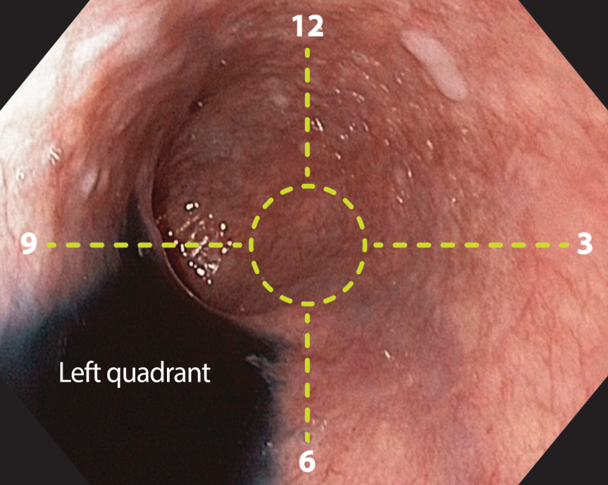
Figure 1 Identification of the left esophageal quadrant. After pouring Indigo Carmine (Chromoendoscopia Colombia, Bogota DC) into the esophageal lumen and utilizing gravity, the pooled water identified the left quadrant of the esophageal circumference.
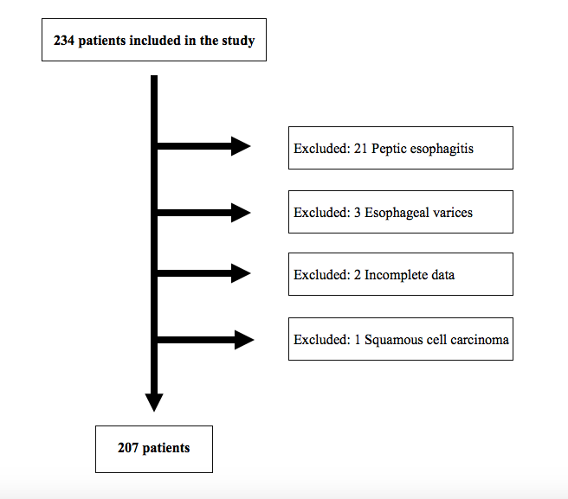
Figure 2 Patient’s selection. The chart shows the enrolled, excluded and final number of patients for analysis.

A
B
Figure 3 Identification of the left main bronchus and left atrium landmarks. A: A concave, non-pulsatile, extrinsic esophageal compression (blue lines) is observed at 25 cm from the incisors. The landmark is radially oriented at the anterior esophageal quadrant, between the 9 and 12 o´clock. B: A convexe, pulsatile, extrinsic esophageal compression (blue lines) is observed at 31 cm from the incisors. The landmark is radially oriented at the anterior esophageal quadrant, between the 9 and 12 o´clock.

A
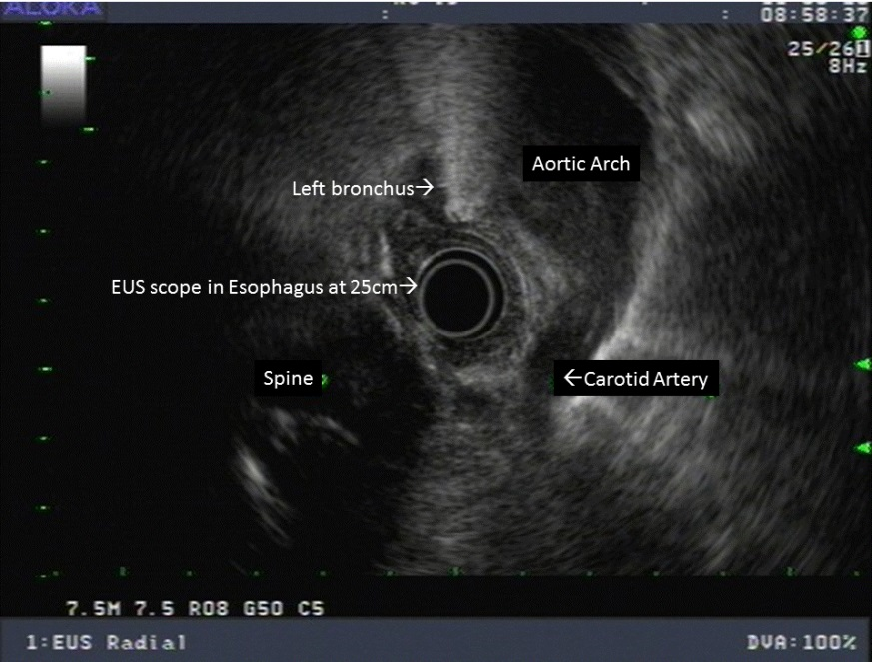
B
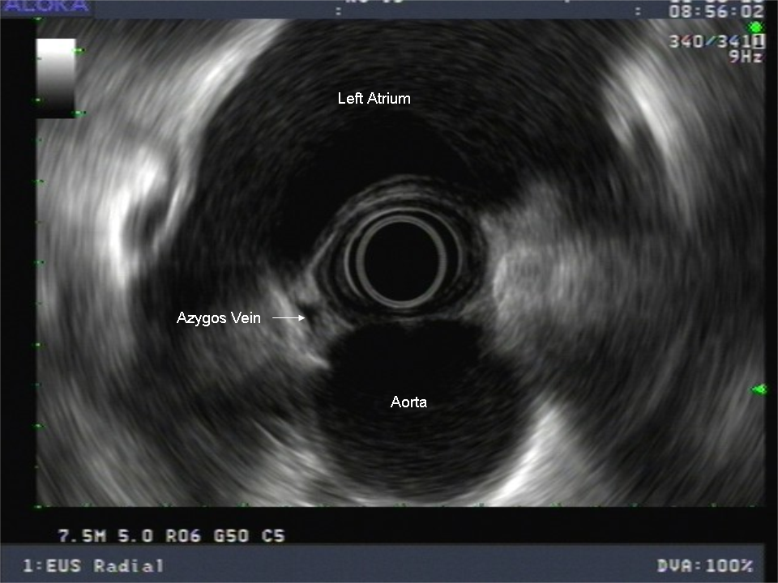
Figure 4 Identification of landmarks by endoscopic ultrasound. A: endoscopic ultrasound (EUS) image showing the left main bronchus located on the anterior esophageal quadrant at a distance of 25 cm from the incisors. B: EUS image showing the left atrium located on the anterior esophageal quadrant at a distance of 30 cm from the incisors.

A
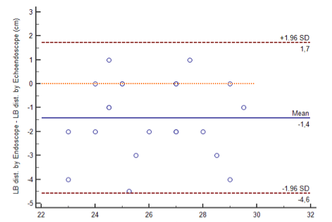
B
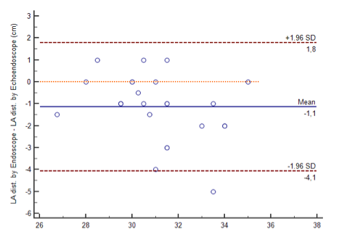
Figure 5 The Bland-Altman plot. A high agreement (IC 95%) is observed between white light and EUS measurements of the sub-study. A: Left main bronchus. B: Left atrium.

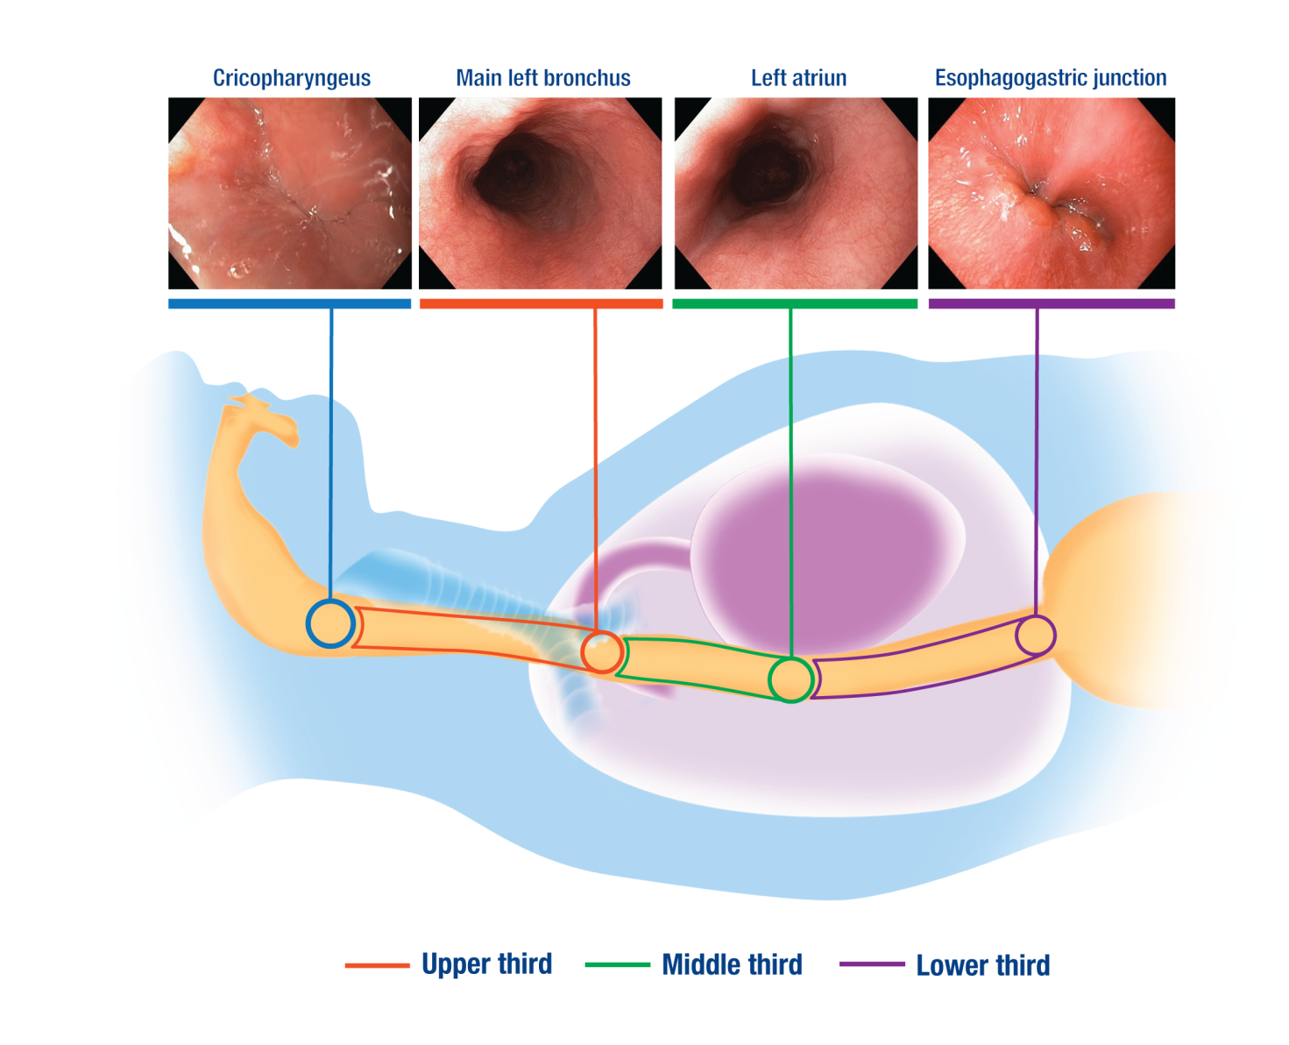
Figure 6 Usefulness of the landmarks for longitudinal orientation. Esophageal landmarks are represented in colored circles: cricopharyngeus (blue circle), left main bronchus (red circle), left atrium (green circle) and the Esophagogastric junction (purple circle); esophageal thirds are represented as colored segments: upper third (red segment), middle third (green segment) and lower third (purple segment).

Table 1 Morphometric characteristics of patients
Factor | Study (n = 207), mean ± SD (CV) | Sub-study (n = 25), Mean ± SD (CV)
Age (yr) | 54 ± 10 (0.2) | 64 ± 14 (0.2)
Height (cm) | 162 ± 9 (0.05) | 169 ± 8 (0.05)
Weight (kg) | 66 ± 12 (0.18) | 78 ± 16 (0.21)
BMI | 25 ± 4 (0.16) | 27 ± 4 (0.17)
SD: standard deviation; CV: Coefficient of variation,

Table 2 Landmarks distance from the incisors
Landmark | Study (n = 207) | Sub-study (n = 25) |  | P value | Power to detect differences > 4.5% (confidence 95%)
 | WL, mean ± SD (CV) | WL, mean ± SD (CV) | EUS, mean ± SD (CV)
Left main bronchus | 25.8 ± 2.3 (0.09) | 25.4 ± 2.1 (0.08) | 26.7 ± 1.9 (0.07) | 0.16 | 82.9%
Left atrium | 31.4 ± 2.4 (0.08) | 30.5 ± 1.9 (0.06) | 31.6 ± 2.3 (0.07) | 0.1 | 80.1%
One-way ANOVA test with P < 0.05 considered significant. Mean distances are expressed in cm. SD: standard deviation; CV: coefficient of variation.

