Name of journal: World Journal of Clinical Cases
ESPS Manuscript NO: 18266
Manuscript Type: Case Report

Littoral cell angioma: A case report

Bailey A et al. LCA: A case report and review

Amanda Bailey, Jeffrey Vos, Jon Cardinal

Amanda Bailey, Jon Cardinal, Department of Surgery, West Virginia University, Morgantown, WV 26508-9238, United States

Jeffrey Vos, Department of Pathology, West Virginia University, Morgantown, WV 26508-9238, United States

Author contributions: Bailey A wrote the case report and compiled the table; Vos J contributed the pathology analysis and provided the collection of pathological images; Cardinal J critically revised the intellectual content and contributed to the design of the table.

Institutional review board statement: This study has been approved by West Virginia University.

Conflict-of-interest statement: There are no conflicts of interest to be declared by the authors of this paper.

Open-Access: This article is an open-access article which was selected by an in-house editor and fully peer-reviewed by external reviewers. It is distributed in accordance with the Creative Commons Attribution Non Commercial (CC BY-NC 4.0) license, which permits others to distribute, remix, adapt, build upon this work non-commercially, and license their derivative works on different terms, provided the original work is properly cited and the use is non-commercial. See: http://creativecommons.org/licenses/by-nc/4.0/

Correspondence to: Amanda Bailey, DO (General Surgery Resident), Department of Surgery, West Virginia University, P.O. Box 9238 HSCS, Morgantown, WV 26508-9238, United States. aobailey@hsc.wvu.edu
Telephone: +1-904-3030223

Received: April 14, 2015
Peer-review started: April 14, 2015
First decision: June 3, 2015
Revised: June 21, 2015
Accepted: August 4, 2015
Article in press:
Published online:

Abstract
Primary splenic lesions are rare entities among which littoral cell angioma (LCA) is a recently described, uncommon vascular lesion that is unique to the spleen. It has heretofore been described primarily in pathologic series and has been found mostly to behave as a benign entity. A few reports of malignant variants have been reported. We present a case report of a solitary LCA discovered after splenectomy for an incidentally discovered splenic lesion, along with a literature review.

Key words: Littoral cell angioma; Splenic tumor

© The Author(s) 2015. Published by Baishideng Publishing Group Inc. All rights reserved.

Core tip: Littoral cell Angioma (LCA) is a rare benign vascular lesion of the spleen. LCA can range from no symptoms to a vague set of symptoms such as: abdominal pain, splenomegaly, thrombocytopenia, anemia, fever, chills, weakness and fatigue. Diagnosis is made by histopathology after splenectomy.

Bailey A, Vos J, Cardinal J. Littoral cell angioma: A case report. World J Clin Cases 2015; In press

INTRODUCTION
Primary splenic tumors are uncommon and are classified as lymphoid tumors, non-lymphoid tumors, and tumor like lesions^{[1-12]} (Table 1). Among non-lymphoid tumors, vascular neoplasms are the most common and arise from the vascular elements that compose the splenic red pulp. Conversely, the lymphatic tissue containing splenic white pulp is from where lymphoid neoplasms arise. In regards to vascular tumors of the spleen, the biologic behavior can be both benign and malignant.
Littoral cell angioma (LCA) of the spleen is a rare vascular tumor that was first described in 1991 by Falk et al^{[13]}. Initially thought to be benign, the biologic behavior of LCA has not been firmly established, as there have been several reports of LCA with malignant features^{[14,15]}. LCA may occur at any age and has no gender predilection. To date, a total of 110 cases have been reported in the literature with 4 published pathologic series and 3 published case series^{[13,16-32]}.
LCA is discovered as a splenic lesion in patients who are undergoing a workup for laboratory evidence of anemia or thrombocytopenia^{[33-36]}. Imaging findings of LCA are nonspecific and splenomegaly, to a varying degree, is a common finding. Due to the nonspecific findings that often result from the diagnostic workup, splenectomy is often performed for both diagnostic and therapeutic purposes. In the present report, a case of an incidentally discovered LCA is described.

CASE REPORT
A 65-year-old female presented to the outpatient oncology surgery clinic for surgical evaluation of a 2.2 cm splenic lesion. The lesion was discovered incidentally on a computed tomography (CT) abdomen/pelvis study to evaluate recurrent urinary tract infections (Figure 1). Also, the CT scan revealed a second incidental finding of a 1.1 cm right adrenal nodule. The patient was asymptomatic without abdominal pain, persistent fever, chills, weight loss, or other constitutional symptoms. Her past medical history included hypertension, diabetes mellitus, gout and peripheral neuropathy. Physical examination was unremarkable except for abdominal wall scars from prior open hysterectomy, cholecystectomy and left nephrectomy, the latter of which which was performed at a young age for a nonfunctioning left kidney secondary to congenital ureteropelvic junction obstruction. A biochemical workup to exclude a functioning adrenal tumor was performed and included serum renin and aldosterone levels as well as 24 h urinary fractionated metanephrine and cortisol levels, all of which were within the limits of normal. Of note, she was not leukopenic, anemic or thrombocytopenic.
Given the size of her incidentally discovered splenic lesion, she was offered operative resection for diagnostic purposes. Based on her extensive prior surgical history, an open approach to the splenectomy was planned. The patient received preoperative pneumococcal, meningococcal and haemophilus B vaccinations. The operation and recovery were uneventful and the patient was discharged to home on postoperative day four.
Grossly, the spleen weighed 270 g and measured 23.3 cm × 18.1 cm × 7.2 cm. The splenic lesion measured 2 cm × 2 cm × 2 cm. Histopathologically, the tumor was found to have anastomosing vascular channels with large cyst formations which were lined predominately by tall, histiocytoid cells which projected into the vascular spaces along with interspersed flat endothelial cells (Figures 2 and 3). Immunohistochemically, the cells compromising the tumor stained positive for CD68 and lysozyme (Figures 4A and B). The specimen also showed variable expression of S100. CD34 and CD31 stains were positive on the endothelial cells, however negative on the histiocytoid cells (Figures 4C and D). Final pathologic diagnosis was littoral cell angioma.

DISCUSSION
LCA is a rare vascular neoplasm of the spleen. It has been found to affect both men and women in an equal distribution. Given the relative lack of symptom specificity, LCA is most often found incidentally as a splenic mass on abdominal imaging; however, two cases of LCA presenting with splenic rupture and hemoperitoneum have been reported^{[37,38]}. The sonographic appearance of LCA is variable, and ranges from a hypoechoic to a hyperechoic mass with a mottled texture^{[14]}. On contrast enhanced CT, LCA is isodense to slightly hypodense as related to the surrounding splenic parenchyma in both the arterial and early portal venous phase^{[39,40]}. MRI characteristically shows a T1 and T2 hypointense mass. LCA is often multifocal and lesions can be variable in size^{[14]}. The differential diagnosis of lesions that can mimic LCA on imaging includes lymphangioma, hamartoma, lymphoma, Kaposi's sarcoma, and hemangioma. Therefore, a definitive diagnosis can only be obtained pathologically^{[41]}.
Pathologically, LCA is a vascular tumor of the spleen that represents a tumoral counterpart of the normally present littoral cells that line the splenic sinus channels of the red pulp^{[30]}. First described by Falk et al^{[33]} in 1991 in a pathologic series of 17 cases, this new entity was described histologically as consisting of anastomosing vascular channels with cyst like spaces and papillary projections. The endothelial cells lining the channels are tall and plump compared to the flat endothelial cells lining the channels in a normal spleen. Immunohistochemically, LCA is characteristically CD 34 negative, CD 68 positive, CD 21 positive and CD 8 negative^{[22]}. Additionally, the epithelial cells in LCA do occasionally express S-100 protein^{[16]}. High expression of formin homology domain protein 1 (FHOD1) distinguished littoral cells from LCA. FHOD1 protein is expressed by normal littoral cells, not by LCA^{[42]}. Further research has been done evaluating molecular markers and LCA to help aide in the accurate diagnosis of LCA tumors. O’Malley et al^{[43]}, looked at splenic lesions and the activity of the Ets Related Gene (ERG) and the Wilms Tumor-1 gene (WT-1). They found that LCA splenic lesions had a pattern of ERG positive and WT-1 negative^{[43]}. Of the other types of splenic lesions evaluated cavernous hemangiomas were found to have the same pattern, therefore these markers are not specific enough alone to make the diagnosis of LCA.
LCA has most commonly been described as a benign process. However, observations of malignant behavior have been described^{[41]}. In one case, metastatic lesions were found in the liver and retroperitoneum four years after splenectomy for LCA^{[44]}. This case initially had symptoms of ureteral obstruction and renal failure. In comparison, our patient did not have ureteral obstruction however did have recurrent UTI’s and a history of congenital ureteropelvic junction obstruction. Kranzfelder et al^{[45]}, showed a case of familial individuals with LCA and primary splenic angiosarcoma, raising the question of possible malignant transformation. There were no similar signs and symptoms between their case and the presented case. Harmon et al^{[17]}, published a case report of a patient with transitional cell carcinoma of the bladder with suspected splenic metastasis. The pathology revealed LCA and not splenic metastasis. Ben-Izhak et al^{[14]}, showed a case of malignant littoral cell tumor naming it littoral cell hemangioendothelioma. This case report featured a symptomatic patient with liver metastasis eight years after splenectomy. In reviewing all of these cases, the immunohistochemical pattern was similar giving the diagnosis of LCA.
LCA has been shown to be rarely associated with visceral malignancies including colorectal adenocarcinoma, pancreatic cystadenocarcinoma, pancreatic neuroendocrine tumor, renal cell cancer, hepatocellular carcinoma, non-small cell lung cancer, seminoma, ovarian cystadenocarcinoma, papillary thyroid cancer and transitional cell carcinoma of the bladder^{[17]}. Furthermore, there have been a few reports describing an association of LCA with immunological disorders, such as, ankylosing spondylitis, myelodysplastic syndrome, non-Hodgkin lymphoma, Crohn's disease, Wiskott Aldrich syndrome, chronic glomerulonephritis, aplastic anemia and Gaucher's disease^{[17,22,46]}. Given the association of LCA with other malignancies as well as the few reported cases of malignant behavior, patients should undergo close follow up after splenectomy; however, no established postoperative surveillance guidelines exist.
Littoral Cell Angioma is a rare vascular tumor of the splenic red pulp, and is typically an incidental finding on abdominal imaging. The splenic lesion can only truly be differentiated from other splenic masses by histologic examination. Splenectomy is the appropriate treatment, as LCA has a variable behavior pattern of which malignant tendencies are worrisome. Furthermore, longitudinal surveillance in the postoperative phase is recommended.

COMMENTS
Case characteristics
Littoral cell angioma (LCA) can range from no symptoms to a vague set of symptoms such as: abdominal pain, splenomegaly, thrombocytopenia, anemia, fever, chills, weakness and fatigue.

Clinical diagnosis
The main clinical finding is a splenic lesion.

Differential diagnosis
The differential diagnosis of a splenic lesion is lymphoid, vascular, non lymphoid and tumor like which can be distinguished by pathology.

Laboratory diagnosis
There are no consistent laboratory tests to diagnose LCA.

Imaging diagnosis
Ultrasound, CT and MRI are all acceptable modalities for imaging and diagnosing a splenic tumor; all of which are non-specific for LCA.

Pathological diagnosis
The splenic specimen is analyzed for abnormal littoral cells along with immunohistochemical stains to provide definitive diagnosis of LCA.

Treatment
Treatment is surgical resection with close surveillance as a malignant variant is possible.

Related reports
Over a hundred cases of LCA have been reported since 1991, research continues into the realm of pathological markers and surveillance is new territory with cases of malignant variants being reported.

Term explanation
Hemangioendothelioma is a term to describe a vascular neoplasm that may be considered benign as well as malignant.

Experiences and lessons
This case teaches that there is malignant potential for LCA lesions of the spleen.

Peer-review
This is the well-written case report of littoral cell angioma (LCA).
REFERENCES
1 Abbott RM, Levy AD, Aguilera NS, Gorospe L, Thompson WM. From the archives of the AFIP: primary vascular neoplasms of the spleen: radiologic-pathologic correlation. Radiographics 2004; 24: 1137-1163 [PMID: 15256634 DOI: 10.1148/rg.244045006]
2 Fotiadis C, Georgopoulos I, Stoidis C, Patapis P. Primary tumors of the spleen. Int J Biomed Sci 2009; 5: 85-91 [PMID: 23675122]
3 Kaza RK, Azar S, Al-Hawary MM, Francis IR. Primary and secondary neoplasms of the spleen. Cancer Imaging 2010; 10: 173-182 [PMID: 20713317 DOI: 10.1102/1470-7330.2010.0026]
4 Rajabi P, Noorollahi H, Hani M, Bagheri M. Inflammatory pseudotumor of spleen. Adv Biomed Res 2014; 3: 29 [PMID: 24592376 DOI: 10.4103/2277-9175.124679]
5 Perry-Thornton E, Verly GP, Karkala J, Walker M. An unusual presentation of multiple myeloma: primary plasmacytoma of the spleen. J Natl Med Assoc 1989; 81: 1095-106, 1099 [PMID: 2681801]
6 Popp JA, Jones TC. Fibrosarcoma, Spleen. In Hemopoietic System. Berlin: Springer, 1990: 216-219 [DOI: 10.1007/978-3-642-84110-1_34]
7 Lee JKT, Sagel S, Stanley RJ, Heiken JP. Computed Body Tomography with MRI Correlation. 4th ed. Lippincott William and Wilkins, 2006: 984-991
8 Palas J, Matos AP, Ramalho M. The spleen revisited: an overview on magnetic resonance imaging. Radiol Res Pract 2013; 2013: 219297 [PMID: 24377046]
9 Mikami T, Saegusa M, Akino F, Machida D, Iwabuchi K, Hagiwara S, Okayasu I. A Kaposi-like variant of splenic angiosarcoma lacking association with human herpesvirus 8. Arch Pathol Lab Med 2002; 126: 191-194 [PMID: 11825116]
10 Valls C, Cañas C, Turell LG, Pruna X. Hepatosplenic AIDS-related Kaposi's sarcoma. Gastrointest Radiol 1991; 16: 342-344 [PMID: 1936779 DOI: 10.1007/BF01887385]
11 Colović MD, Janković GM, Colović RB, Martinović-Cemerikić VM. Non-secretory solitary plasmacytoma of the spleen. Med Oncol 1998; 15: 286-288 [PMID: 9951695 DOI: 10.1007/BF02787215]
12 Harris NL, Aisenberg AC, Meyer JE, Ellman L, Elman A. Diffuse large cell (histiocytic) lymphoma of the spleen. Clinical and pathologic characteristics of ten cases. Cancer 1984; 54: 2460-2467 [PMID: 6388805 DOI: 10.1002/1097-0142(19841201)54: 11<2460: : AID-CNCR2820541125>3.0.CO; 2-K]
13 Bhatt S, Huang J, Dogra V. Littoral cell angioma of the spleen. AJR Am J Roentgenol 2007; 188: 1365-1366 [PMID: 17449783 DOI: 10.2214/AJR.06.1157]
14 Ben-Izhak O, Bejar J, Ben-Eliezer S, Vlodavsky E. Splenic littoral cell haemangioendothelioma: a new low-grade variant of malignant littoral cell tumour. Histopathology 2001; 39: 469-475 [PMID: 11737304 DOI: 10.1046/j.1365-2559.2001.01242.x]
15 Meybehm M, Fischer HP. [Littoral cell angiosarcoma of the spleen. Morphologic, immunohistochemical findings and consideration of histogenesis of a rare splenic tumor]. Pathologe 1997; 18: 401-405 [PMID: 9432677 DOI: 10.1007/s002920050233]
16 Bhatt S, Simon R, Dogra VS. Littoral cell angioma: sonographic and color Doppler features. J Ultrasound Med 2007; 26: 539-542 [PMID: 17384054]
17 Harmon RL, Cerruto CA, Scheckner A. Littoral cell angioma: a case report and review. Curr Surg 2006; 63: 345-350 [PMID: 16971207 DOI: 10.1016/j.cursur.2006.06.011]
18 Ramdall RB, Alasio TM, Cai G, Yang GC. Primary vascular neoplasms unique to the spleen: littoral cell angioma and splenic hamartoma diagnosis by fine-needle aspiration biopsy. Diagn Cytopathol 2007; 35: 137-142 [PMID: 17304535 DOI: 10.1002/dc.20568]
19 Rana N, Ming Z, Hui MS, Bin Y. Case Report: Littoral cell angioma of spleen. Indian J Radiol Imaging 2009; 19: 210-212 [PMID: 19881088 DOI: 10.4103/0971-3026.54886]
20 Tee M, Vos P, Zetler P, Wiseman SM. Incidental littoral cell angioma of the spleen. World J Surg Oncol 2008; 6: 87 [PMID: 18713469 DOI: 10.1186/1477-7819-6-87]
21 Chourmouzi D, Psoma E, Drevelegas A. Littoral cell angioma, a rare cause of long standing anaemia: a case report. Cases J 2009; 2: 9115 [PMID: 20062692 DOI: 10.1186/1757-1626-2-9115]
22 Johnson C, Goyal M, Kim B, Wasdahl D, Nazinitsky K. Littoral cell angioma. Clin Imaging 2007; 31: 27-31 [PMID: 17189843 DOI: 10.1016/j.clinimag.2006.09.021]
23 Cosme A, Tejada A, Bujanda L, Vaquero M, Elorza JL, Ojeda E, Goikoetxea U. Littoral-cell angioma of the spleen: a case report. World J Gastroenterol 2007; 13: 6603-6604 [PMID: 18161935 DOI: 10.3748/wjg.13.6603]
24 Qu ZB, Liu LX, Wu LF, Zhao S, Jiang HC. Multiple littoral cell angioma of the spleen: a case report and review of the literature. Onkologie 2007; 30: 256-258 [PMID: 17460421]
25 Tatli S, Cizginer S, Wieczorek TJ, Ashley SW, Silverman SG. Solitary littoral cell angioma of the spleen: computed tomography and magnetic resonance imaging features. J Comput Assist Tomogr 2008; 32: 772-775 [PMID: 18830109 DOI: 10.1097/RCT.0b013e31815614a2]
26 Ertan G, Tekes A, Mitchell S, Keefer J, Huisman TA. Pediatric littoral cell angioma of the spleen: multimodality imaging including diffusion-weighted imaging. Pediatr Radiol 2009; 39: 1105-1109 [PMID: 19597808 DOI: 10.1007/s00247-009-1339-x]
27 Suvajdzić N, Cemerikić-Martinović V, Saranović D, Petrović M, Popović M, Artiko V, Cupić M, Elezović I. Littoral-cell angioma as a rare cause of splenomegaly. Clin Lab Haematol 2006; 28: 317-320 [PMID: 16999722 DOI: 10.1111/j.1365-2257.2006.00801.x]
28 Priego P, Rodríguez Velasco G, Griffith PS, Fresneda V. Littoral cell angioma of the spleen. Clin Transl Oncol 2008; 10: 61-63 [PMID: 18208795 DOI: 10.1007/s12094-008-0155-3]
29 Mac New HG, Fowler CL. Partial splenectomy for littoral cell angioma. J Pediatr Surg 2008; 43: 2288-2290 [PMID: 19040956 DOI: 10.1016/j.jpedsurg.2008.07.031]
30 Wang YJ, Li F, Cao F, Sun JB, Liu JF, Wang YH. Littoral cell angioma of the spleen. Asian J Surg 2009; 32: 167-171 [PMID: 19656757 DOI: 10.1016/S1015-9584(09)60389-4]
31 Bi CF, Jiang LL, Li Z, Liu WP. [Littoral cell angioma of spleen: a clinicopathologic study of 17 cases]. Zhonghua Bing Li Xue Za Zhi 2007; 36: 239-243 [PMID: 17706114]
32 Nagarajan P, Cai G, Padda MS, Selbst M, Kowalski D, Proctor DD, Chhieng D, Aslanian HR, Harigopal M. Littoral cell angioma of the spleen diagnosed by endoscopic ultrasound-guided fine-needle aspiration biopsy. Diagn Cytopathol 2011; 39: 318-322 [PMID: 21488173 DOI: 10.1002/dc.21384]
33 Falk S, Stutte HJ, Frizzera G. Littoral cell angioma. A novel splenic vascular lesion demonstrating histiocytic differentiation. Am J Surg Pathol 1991; 15: 1023-1033 [PMID: 1928554 DOI: 10.1097/00000478-199111000-00001]
34 Levy AD, Abbott RM, Abbondanzo SL. Littoral cell angioma of the spleen: CT features with clinicopathologic comparison. Radiology 2004; 230: 485-490 [PMID: 14752189 DOI: 10.1148/radiol.2302030196]
35 Ziske C, Meybehm M, Sauerbruch T, Schmidt-Wolf IG. Littoral cell angioma as a rare cause of splenomegaly. Ann Hematol 2001; 80: 45-48 [PMID: 11233776 DOI: 10.1007/s002770000223]
36 Goldfeld M, Cohen I, Loberant N, Mugrabi A, Katz I, Papura S, Noi I. Littoral cell angioma of the spleen: appearance on sonography and CT. J Clin Ultrasound 2002; 30: 510-513 [PMID: 12242742 DOI: 10.1002/jcu.10101]
37 Pilz JB, Sperschneider T, Lutz T, Loosli B, Maurer CA. Littoral cell angioma in main and accessory intrapancreatic spleen presenting as splenic rupture. Am J Surg 2011; 201: e15-e17 [PMID: 20409532 DOI: 10.1016/j.amjsurg.2009.11.013]
38 Yamane H, Ohashi K, Suwaki T, Takigawa N. Ruptured littoral cell angiosarcoma causing hemoperitoneum. Intern Med 2012; 51: 337-338 [PMID: 22293817 DOI: 10.2169/internalmedicine.51.6663]
39 Bisceglia M, Sickel JZ, Giangaspero F, Gomes V, Amini M, Michal M. Littoral cell angioma of the spleen: an additional report of four cases with emphasis on the association with visceral organ cancers. Tumori 1998; 84: 595-599 [PMID: 9862523]
40 Hanna T, Baumgarten D, Friedman T. Littoral Cell Angioma: a case and review of the literature. Radiology Case reports 2011; 6: 324-326
41 Arber DA, Strickler JG, Chen YY, Weiss LM. Splenic vascular tumors: a histologic, immunophenotypic, and virologic study. Am J Surg Pathol 1997; 21: 827-835 [PMID: 9236839 DOI: 10.1097/00000478-199707000-00011]
42 Ogembo JG, Milner DA, Mansfield KG, Rodig SJ, Murphy GF, Kutok JL, Pinkus GS, Fingeroth JD. SIRPα/CD172a and FHOD1 are unique markers of littoral cells, a recently evolved major cell population of red pulp of human spleen. J Immunol 2012; 188: 4496-4505 [PMID: 22490440 DOI: 10.4049/jimmunol.1103086]
43 O'Malley DP, Kim YS, Weiss LM. Distinctive immunohistochemical staining in littoral cell angioma using ERG and WT-1. Ann Diagn Pathol 2015; 19: 143-145 [PMID: 25792460 DOI: 10.1016/j.anndiagpath.2015.02.007]
44 Fernandez S, Cook GW, Arber DA. Metastasizing splenic littoral cell hemangioendothelioma. Am J Surg Pathol 2006; 30: 1036-1040 [PMID: 16861977 DOI: 10.1097/00000478-200608000-00016]
45 Kranzfelder M, Bauer M, Richter T, Rudelius M, Huth M, Wagner P, Friess H, Stadler J. Littoral cell angioma and angiosarcoma of the spleen: report of two cases in siblings and review of the literature. J Gastrointest Surg 2012; 16: 863-867 [PMID: 22068970 DOI: 10.1007/s11605-011-1773-6]
46 Rosso R, Paulli M, Gianelli U, Boveri E, Stella G, Magrini U. Littoral cell angiosarcoma of the spleen. Case report with immunohistochemical and ultrastructural analysis. Am J Surg Pathol 1995; 19: 1203-1208 [PMID: 7573679 DOI: 10.1097/00000478-199510000-00011]
P-Reviewer: Kai K, MuellerWC, Sergi C S-Editor: Tian YL
L-Editor: E-Editor:

Table 1 Classification of splenic tumors with associated clinical, pathological and radiological factors^{[1-12]}
Category | Type | Clinical | Pathological | Radiological
 | Non Hodgkin Lymphoma | Fevers, sweats, change in weight are common symptoms | Derived from B or T cells, lympho-proliferative | CT: Hypodense nodules, diffuse or military distribution  MRI: Isotense on precontrast images, Hypotense on postcontrast images
Lymphoid | Hodgkins lymphoma | Spleen is a rare primary site | Nodular sclerosis subtype, Reed-Sternberg cells | CT: Hypodense nodules with nodular sclerosis
 | Inflammatory Pseudotumor | Secondary to inflammatory response to infection or injury. Benign. | Spindle cells, lymphocytes in fibroblastic stroma | CT: well circumscribed +/- calcifications, hypoattenuating  MRI: Hypo- or isointense on T1 images. Variable signaling on T2 images
 | Plasmacytoma | Rare diagnosis | Diffuse infiltration of plasma cells | Not well categorized findings
 | Histocytic Lymphoma | Non specific symptoms, elevated ESR | Nodules with central necrosis | US: Cystic appearance  CT: Sharply demarcated with central necrosis
 | Hemangioma | Benign, slow growth, asymptomatic | Sinusoidal epithelium, proliferation of vascular channels | Solid to cystic components  US: echogenic solid to complex mass  CT: Iso- to hypoattenuation associated with calcification  MRI: Hypo- to isointense on T1 images, Hyperintense on T2 images
 | Hamartoma | Benign, asymptomatic. Associated with tuberous sclerosis and Wiskott Aldrich | Solid nodules, well circumscribed, well defined gross appearance. Unorganized vascular channels with fibrotic cords | US: More sensitive than CT, solid mass +/- calcification  CT: Isoattenuating  MRI: Isointense on T1 images, Hyperintense
 | Lymphangioma | Asymptomatic, benign, mostly in children | Multiple solitary nodules, Flattened endothelium with proteinaceous material in a capillary, cavernous or cystic presentation | US: splenic cysts hypoechoic septations  CT: Thin walled low attenuation masses, subcapsular location  MRI: Hypointense on T1 images, Hyperintense on T2 images
Vascular | Littoral Cell Angioma | Asymptomatic, benign with malignant potential | Well delineated nodules of anastomosing vascular channels with endothelial cells | US: Hypoechoic to hyperechoic  CT: iso to hypoattenuating with contrast enhancement  MRI: low intensity lesions
 | Angiosarcoma | Older patients, malignant, nonspecific symptoms | Diffuse involvement of spleen arises from sinus endothelial cells, high mitotic rate | US: Complex mass, heterogenous, necrotic degeneration  CT: Ill-defined mass with heterogenous enhancement, punctate calcification  MRI: Mixed signal intensity on T1 and T2
 | Hemangioendothelioma | Nonspecific symptoms, young adults | Variable morphologic appearance | US: Hypoechoic mass  CT: low attenuated mass with enhancement of solid portions  MRI: Heterogenous solid mass. Hypointense on T1 and T2 images
 | Fibrosarcoma | Asymptomatic | Well differentiated, spindle shaped, fibroblasts, collagen is commonly present | Non specific imaging findings
Non- Lymphoid | Lipoma | Asymptomatic | Adipose tissue, no atypia, Cytoplasmic vacuoles | CT: well defined fat density mass
 | Kaposi sarcoma | Associated with HIV/AIDS +/- skin lesions | Spindle cell proliferation, spongelike vascular channels | CT: ill-defined nodules, homogeneous  US: Hyperechoic nodules
 | Peliosis | Associated with anabolic steroid, TB, AIDS, cancer. Asymptomatic | Cyst like blood filled cavities within splenic parenchyma | US: Echogenic mass  CT: Hypoattenuating, multiloculated with septa
Tumor Like | Nonparasitic cysts | Congenital or neoplastic in origin. Benign. | Varies according to type of cyst including dermoid cyst | US: Cystic lesions with solid components  CT: Hypoattenuating lesions, well defined
 | Granulomas | Associated with Chronic Granulomatous disease and Sarcoidosis | Granulomas non-necrotizing or necrotizing | CT: Hypodense nodules  MRI: Hypointense T1 and T2
ESR: Erythrocyte sedimentation rate; CT: Computed tomography; MRI: Magnetic resonance imaging; US: Ultrasound; HIV: Human immunodeficiency virus; AIDS: Acquired immunodeficiency syndrome; TB: Tuberculosis.

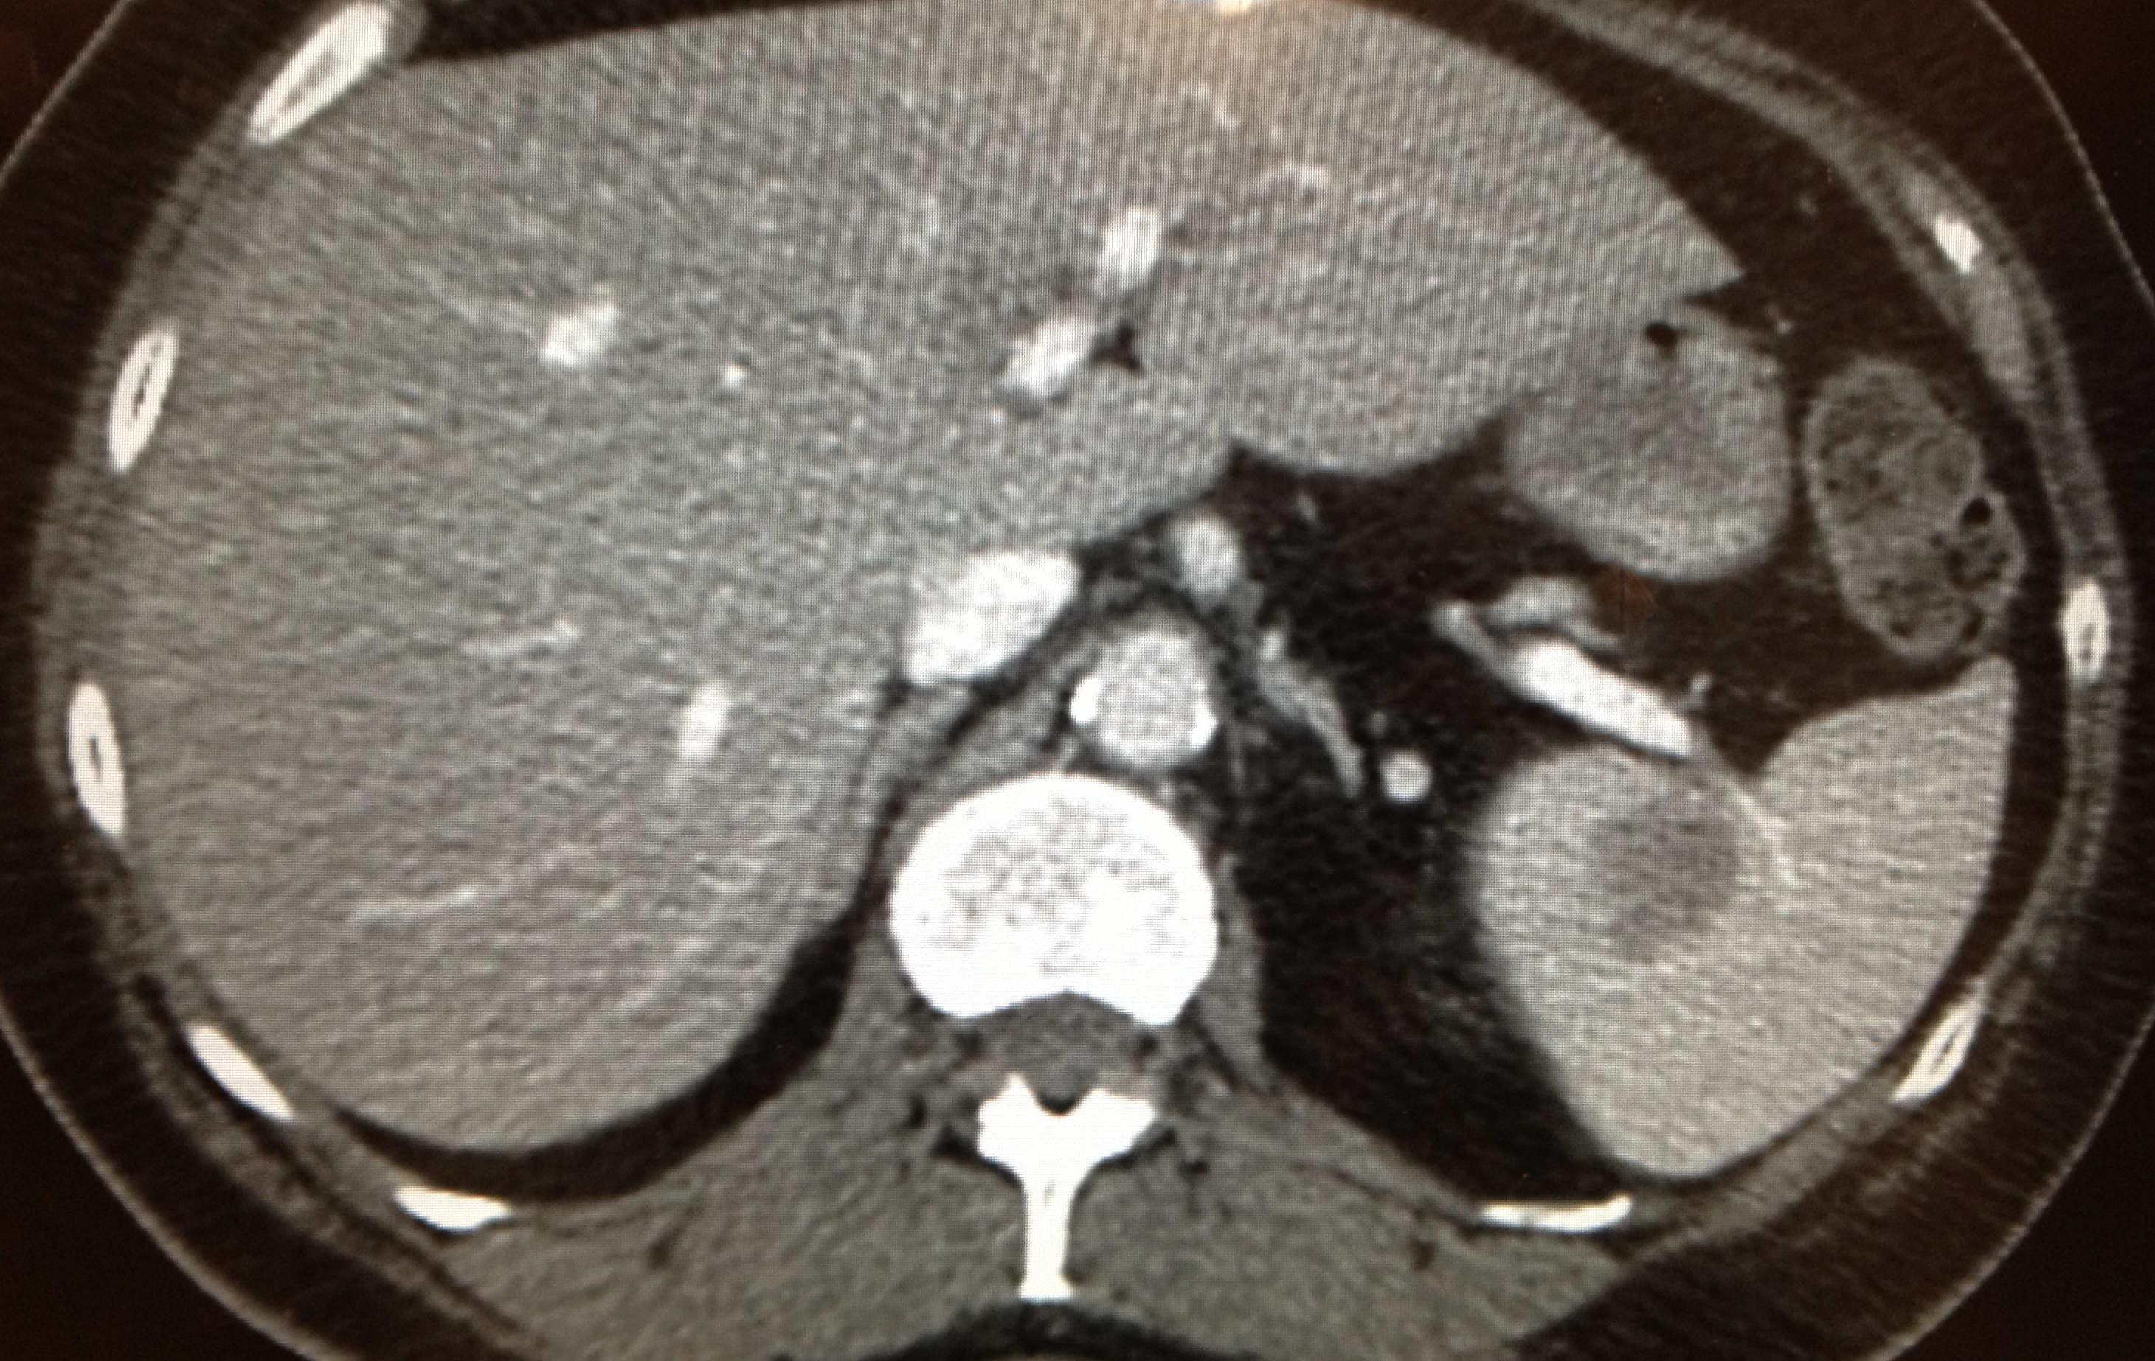

Figure 1 Computed tomography abdomen and pelvis, axial view of hypodense splenic lesion.

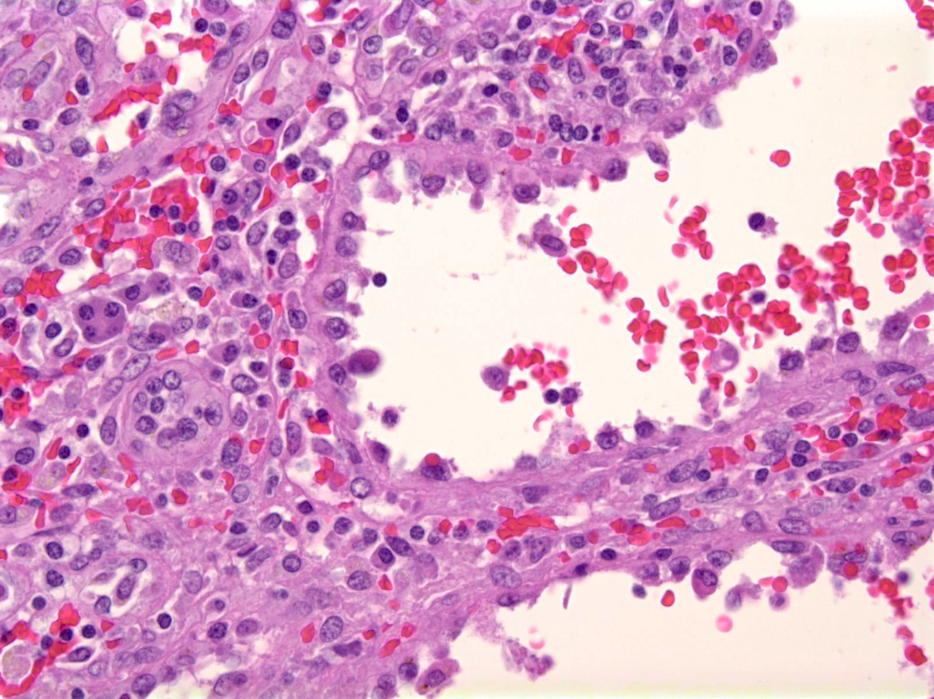

Figure 2 High power view of the tumor demonstrates tall columnar endothelial cells that line the cyst-like spaces. These cells show no cytologic, nuclear atypia or mitotic figures (H and E stain, X 400).

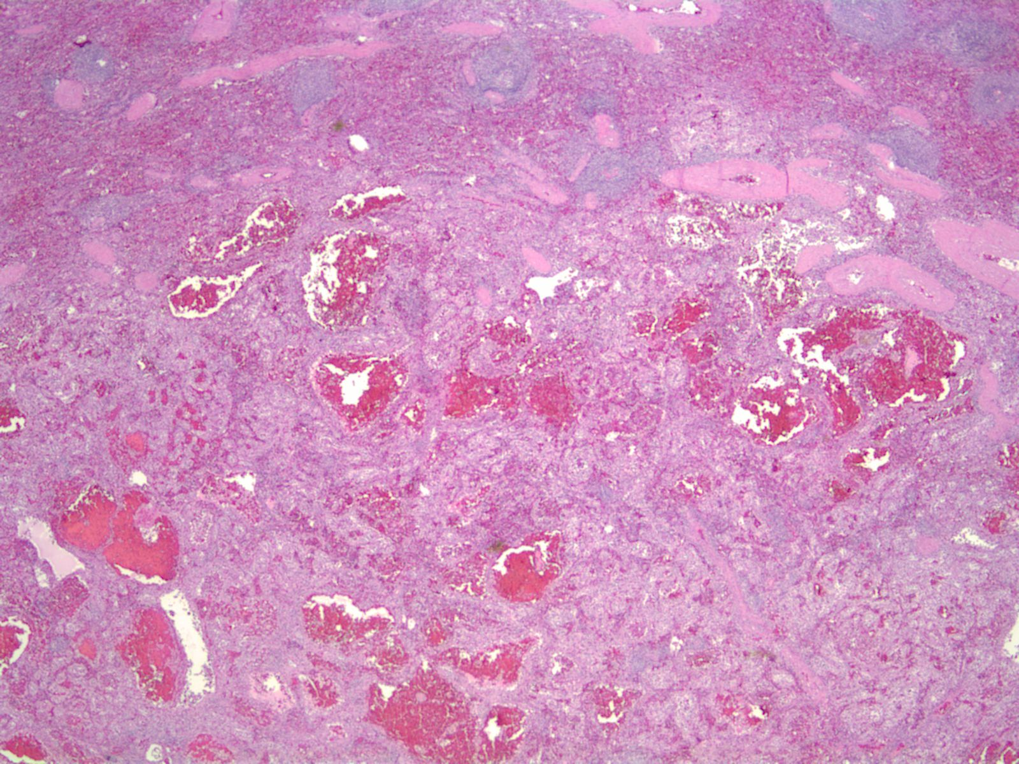

Figure 3 Low power view of the well-demarcated tumor with uninvolved spleen. The tumor has anastomosing vascular channels and cyst-like hemorrhagic spaces.

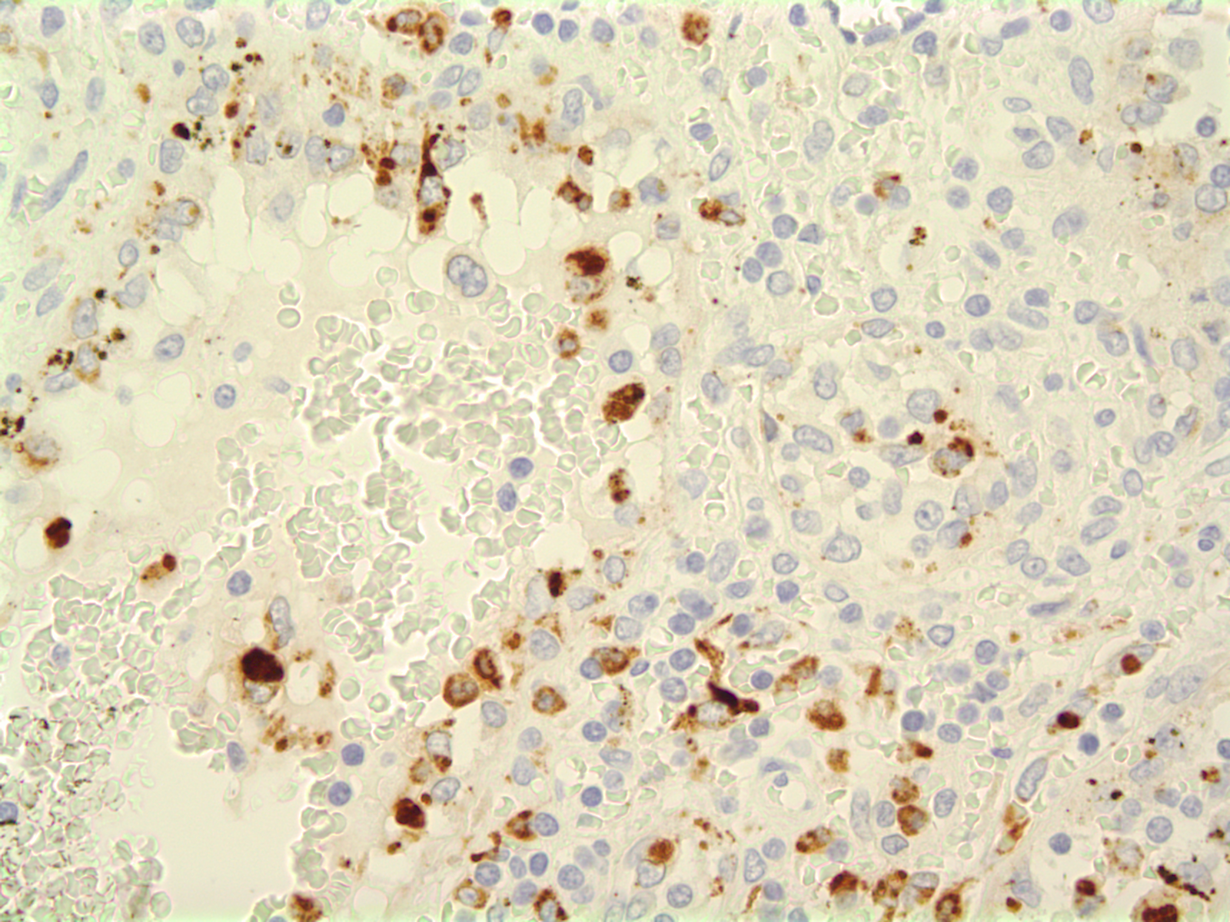
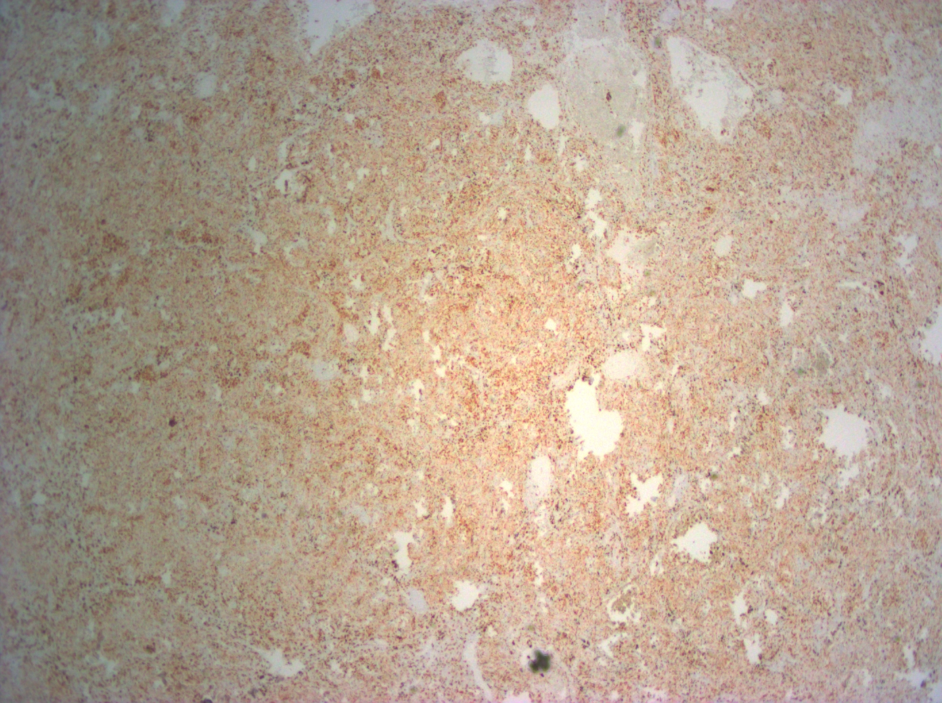

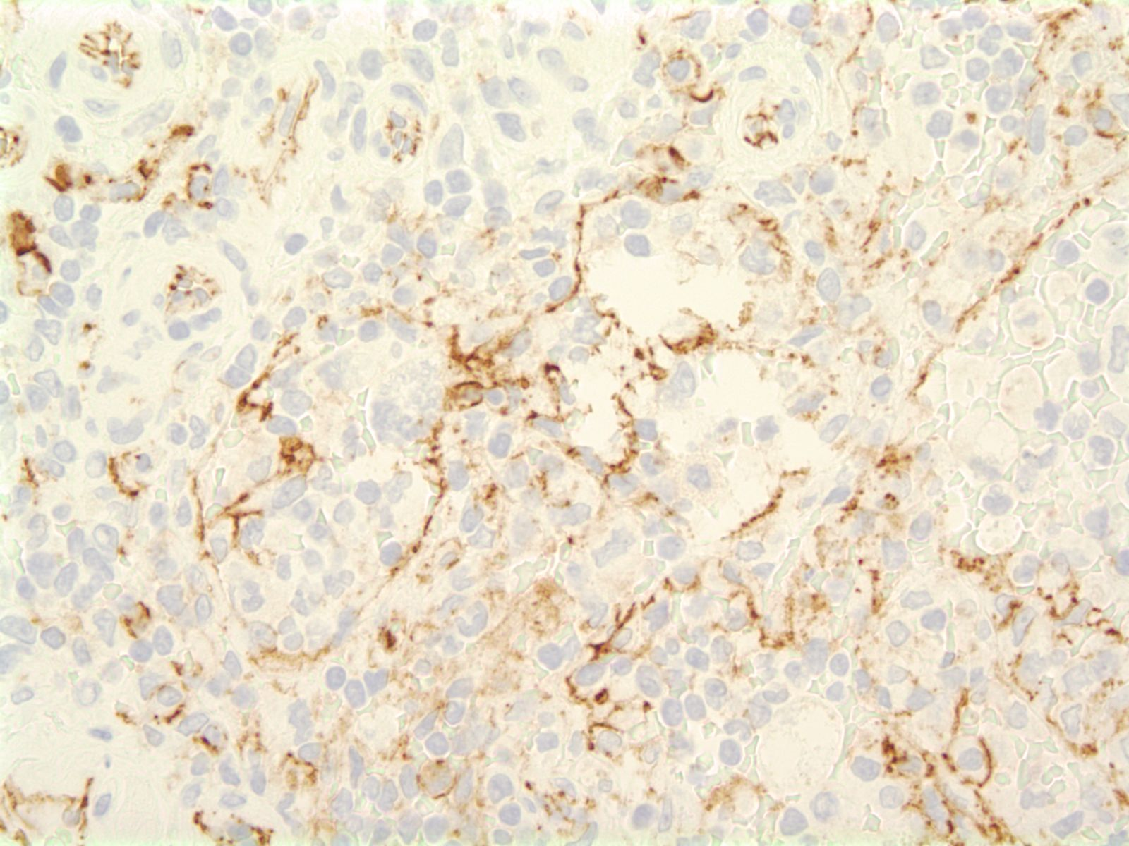
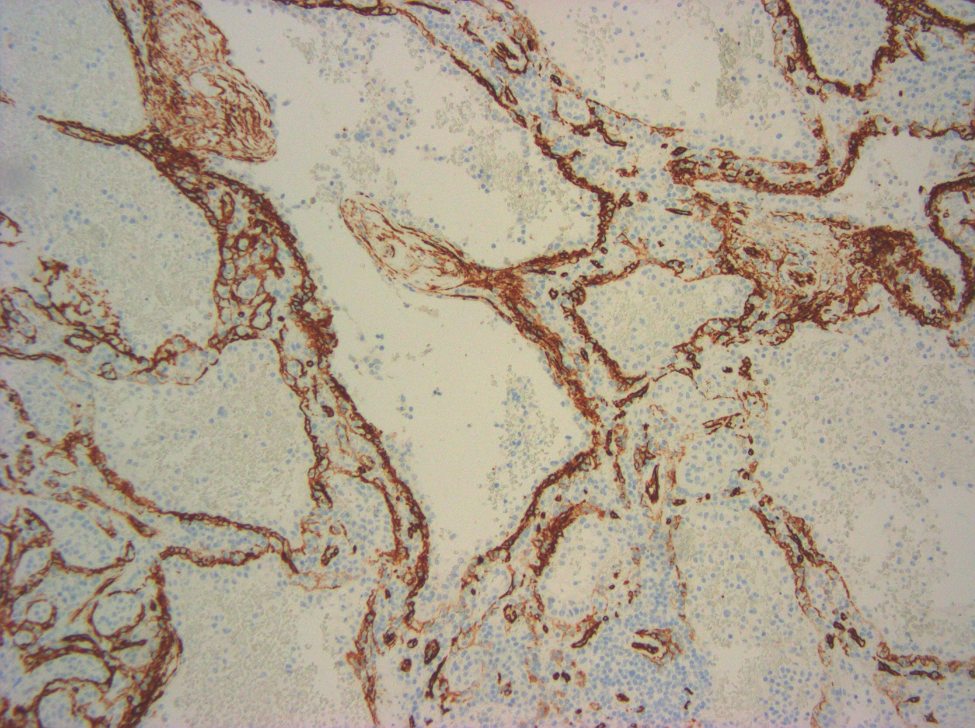

Figure 4 Endothelial cells lining the cyst-like spaces are immunoreactive. A: CD68 (CD68 stain, X 100); B: Histiocytic marker lysozyme (lysozyme stain, X 400); C: Endothelial marker CD34 and the histocytoid cells are negative for CD34 (CD34 stain, X 400); D: Endothelial marker CD31 (CD31 stain, X400).

