Name of Journal: World Journal of Orthopedics
Manuscript NO: 79608
Manuscript Type: ORIGINAL ARTICLE

Retrospective Cohort Study
Can immediate postoperative radiographs predict outcomes in pediatric clubfoot?

Leeprakobboon D. Radiographs predict outcomes in pediatric clubfoot

Duangjai Leeprakobboon

Duangjai Leeprakobboon, Department of Orthopedic, Khon Kaen Hospital, Muang 40000, Khon Kaen, Thailand

Author contributions: Leeprakobboon D solely contributed to this paper.

Corresponding author: Duangjai Leeprakobboon, MD, Surgeon, Department of Orthopedic, Khon Kaen Hospital, Sri-chan Road, Muang 40000, Khon Kaen, Thailand. dleeprakobboon@gmail.com

Received: August 29, 2022
Revised: October 29, 2022
Accepted: November 2, 2022
Published online:

Abstract
BACKGROUND
The goal of treatment for pediatric idiopathic clubfoot is to enable the patient to comfortably walk on his or her soles without pain. However, currently accepted treatment protocols are not always successful. Based on the abnormal bone alignment reported in this disease, some studies have noted a correlation between radiographic characteristics and outcome, but this correlation remains debated.

AIM
To assess the correlation between immediately postoperative radiographic parameters and functional outcomes and to identify which best predicts functional outcome.

METHODS
To predict the outcome and prevent early failure of the Ponseti’s method, we used a simple radiographic method to predict outcome. Our study included newborns with idiopathic clubfoot treated with Ponseti’s protocol from November 2018 to August 2022. After Achilles tenotomy and a long leg cast were applied, the surgeon obtained a single lateral radiograph. Radiographic parameters included the tibiocalcaneal angle (TiCal), talocalcaneal angle (TaCal), talofirst metatarsal angle (Ta1st) and tibiotalar angle (TiTa). During the follow-up period, the Dimeglio score and functional score were examined 1 year after surgery. Additionally, recurring events were reported. The correlation between functional score and radiographic characteristics was analyzed using sample and multiple logistic regression, and the optimal predictor was also identified.

RESULTS
In total, 54 feet received approximately 8 manipulations of casting and Achilles tenotomy at a mean age of 149 days. The average TiCal, TaCal, Ta1st, and TiTa angles were 75.24, 28.96, 7.61, and 107.31 degrees, respectively. After 12 mo of follow up, we found 66% excellent-to-good and 33.3% fair-to-poor functional outcomes. The Dimeglio score significantly worsened in the poor outcome group (P value < 0.001). Tical and TaCal showed significant differences between each functional outcome (P value < 0.05), and the TiCal strongly correlated with outcome, with a smaller angle indicating a better outcome, each 1 degree decrease improved the functional outcome by 10 percent. The diagnostic test revealed that a TiCal angle of 70 degrees predicts an inferior functional outcome.

CONCLUSION
The TiCal, derived from lateral radiographs immediately after Achilles tenotomy, can predict functional outcome at 1 year postoperatively, justifying its use for screening patients who need very close follow-up.

Key Words: Idiopathic clubfoot; Radiograph; Functional outcome; Tenotomy; Prognostic; Tibiocalcaneal angle

Leeprakobboon D. Can immediate postoperative radiographs predict outcomes in pediatric clubfoot? World J Orthop 2022; In press

Core Tip: Idiopathic clubfoot is an abnormality of bone alignment. Current treatment strategies are associated with recurrence, which results in pain and poor quality of life. Radiography-assisted outcome prediction must be harmless in young children. The lateral tibiocalcaneal angle was directly related to functional outcomes, as a smaller angle was associated with a better outcome. A lateral tibiocalcaneal angle exceeding 70 degrees immediately after Achilles tenotomy predicted an inferior outcome.

INTRODUCTION
Talipes equinovarus, known as idiopathic clubfoot, is a complexity inside the bone of the foot, with a birth prevalence of approximately 1-3 cases per thousand born^{[1,2]}. The treatment goals are painlessness and a plantigrade walk. Currently, Ponseti’s technique, which includes casting, Achilles tenotomy and bracing, is the accepted treatment strategy, but up to 11%-48% recurrence has been found^{[3-7]}.
However, Ponseti noted that radiography cannot predict prognosis because it is not associated with clinical appearance^{[8]}. Nevertheless, some reports identified a significant relationship between preoperative radiographs and treatment decisions. For example, a lateral tibiocalcaneal angle > 80 degrees indicates a need for Achilles tenotomy^{[9]}. In 2015, a retrospective study found that a preoperative dorsiflex angle > 16.6 degrees did not require reoperation and was related to recurrence^{[10]}. Furthermore, a lateral tibiocalcaneal angle > 77 degrees and lateral talocalcaneal angle < 29 degrees at the time of brace withdrawal predicts reoperation^{[11]}.
The purposes of this study were as follows: To demonstrate the correlation between immediately postoperative radiographic parameters and functional outcome. To identify the radiographic parameter that best predicts functional outcome.

MATERIALS AND METHODS
Population
This work was a retrospective cohort study conducted from November 2018 to August 2022. Any newborn patient who was diagnosed with idiopathic clubfoot was included. Exclusion criteria included syndromic clubfoot, recurrent cases and patients who had received previous treatment. All patients underwent weekly manipulation of their feet according to the Ponseti technique, followed by Achilles tendon tenotomy and long leg cast application. Immediately after this procedure, the surgeon took one radiograph of the lateral foot and ankle.

Radiography and clinical parameters
In an attempt to predict the outcome and prevent early failure of the Ponseti’s method, we used a simple radiographic method to predict outcome because radiographic postoperative studies are lacking and radiographic assessment is not associated with disadvantages^{[12]}.
Radiographic parameters included the tibiocalcaneal angle (TiCal), talocalcaneal angle (TaCal), talofirst metatarsal angle (Ta1st) and tibiotalar angle (TiTa) (Figure 1). Foot characteristics were evaluated according to the Dimeglio classification, and functional scores were assessed 1 year after surgery, as described by Ponseti, and interpreted as follows: A total score < 70, 70-79, 80-89, and 90-100 represents poor, fair, good, and excellent outcomes, respectively^{[13]}. Additionally, recurring events were reported if further surgery was needed. Data were analyzed by 2 observers, a fourth-year resident orthopedic training and pediatric orthopedic surgeon, and interrater reliability was confirmed using the kappa statistic.

Statistical analysis
All statistical analyses were performed using STATA 11 statistical software (Stata Corp., College Station, TX, United States). The chi-squared test and Fisher's exact test were used to assess independence between two dichotomous variables. The chi-squared test was applied under the assumption that the sample was large. When more than 20 percent of cells had expected frequencies < 5, the Fisher's exact test was run for small-sized samples. The two-sample t-test was used to compare the mean of continuous variables, and the Mann-Whitney U test was used when the variable did not have a normal distribution. Logistic regression by using a penalized maximum likelihood estimation method was used to determine factors associated with functional scores, P value < 0.05 was considered statistically significant and the magnitude of association was shown as crude odds ratios (OR), adjusted OR, and 95% confidence intervals (CI).

RESULTS
The study included 54 feet from 35 newborn patients with clubfoot. All feet received manipulation, and a long leg cast was applied approximately 8 times on average. Then, the Achilles tenotomy procedure was performed at an average age of 149 days. Immediately after surgery and cast application, we obtained radiographs and found that the average TiCal, TaCal, Ta1st, and TiTa angles were 75.24, 28.96, 7.61, and 107.31 degrees, respectively. After the last cast was removed, the brace protocol was utilized as usual, and the Dimeglio score significantly worsened in the poor outcome group (P value < 0.001), which was clearly evident 6 mo postoperatively. After 12 mo of follow up, 24% of cases required further surgery, 66% of cases had an excellent-to-good functional outcome and 33.3% of cases had a fair-to-poor functional outcomes. Demographic data did not significantly differ between groups, as shown in Table 1.
Table 2 presents the significant differences in the Tical and TaCal angles between each functional outcome (P value < 0.05), and the TiCal angle was strongly predictive of outcome, as shown in Table 3. Furthermore, the study shows that a lower TiCal angle corresponded to a better outcome, with an adjusted odds ratio of 0.90 (0.83-0.99). Specifically, each 1 degree decrease improved the functional outcome by 10 percent. The diagnostic test revealed that a TiCal angle of 70 degrees predicts an inferior functional outcome, with 88.9% sensitivity, 41.7% specificity, and 0.56 ROC area (95%CI: 0.42-0.70).

DISCUSSION
Idiopathic clubfoot is the most common multifactorial irreducible foot problem in newborns^{[2,14]}. To date, the Ponseti protocol is widely utilized to treat this condition, in which the deformity is corrected sequentially by Achilles tenotomy and a brace is applied. However, a previous study showed a 33%-41% rate of recurrence^{[15,16]}. Clubfoot is pathogenically characterized by abnormal bone alignment and abnormal radiographic features compared with normal feet, including bony abnormalities from incorrect treatment, whereas radiographic features from correct treatment are obviously better than pre-treatment^{[17,18]}.
This study found a correlation between radiographic data, lateral tibiocalcaneal and talocalcaneal angles derived immediately postoperation, and functional outcomes at the 12 mo follow-up. This finding is in agreement with a previous report that supports the use of radiographs for treatment guidance, especially in residual deformity correction, such as complete subtalar release or posteromedial release procedures^{[19-21]}.
The tibiocalcaneal angle was the most reliable feature for predicting outcome in the present study, as a smaller angle predicted a better outcome based on the plantigrade ability. We found that a cutoff point of > 70 degrees could predict fair-to-poor functional outcome at walking age with 88.9% sensitivity, similar to the equinus position, which results in a poor quality of life. Similarly, previous studies recommended using this angle to predict risk of relapse and decide the surgical type, such as Achilles tenotomy, soft tissue release, and even reconstructive procedures for recurrent clubfoot, to improve functional outcome, but these studies investigated older children^{[8,10,11,22,23]}. Additionally, a close relationship of clinical and talocalcaneal and talo-1st metatarsal angles was found in some studies^{[17,24,25]}.
Although a later study from 2017 discovered that radiographic abnormalities are not indicative of clinical abnormalities and that the Ponseti method can improve foot shape but cannot correct bone deformities, the treatment protocol needs to be based on various data sources^{[8,26]}. Radiography is a criterion to screen patients who need very close follow-up.
This study has the following strengths: (1) We used functional outcome as the end result instead of recurrence because recurrence is a subjective assessment that the surgeon utilizes to determine whether to perform additional interventions; (2) We analyzed only ossified bone to provide more accurate results; and (3) We based our analysis on one lateral view radiograph, which is harmless to patients, as shown in a previous study^{[12]}.

Limitations of the study
The small sample analyzed in this study precludes large effect sizes between groups. Furthermore, we calculated the angle based on only ossified bone in a small child for accuracy reasons. Consequently, we may lack information from other nonossified bone.

CONCLUSION
The tibiocalcaneal angle, derived from lateral radiographs immediately after Achilles tenotomy and casting, can predict functional outcome at 1 year postoperatively and provide a sufficient rationale for screening patients who need very close follow-up.

ARTICLE HIGHLIGHTS
Research background
Idiopathic clubfoot is an abnormal bone alignment and there are currently failure cases resulting from the currently acceptable treatment protocol. Postoperative radiographs are expected to predict outcomes beginning at the prewalking age.

Research motivation
To predict the outcome and early prevention in cases that may fail with Ponseti’s method, considering the lack of radiographic postoperative studies and almost none of the disadvantages of radiation taken once, we decided to use the simple radiographic method for outcome prediction.

Research objectives
To assess the correlation between immediately postoperative radiographic parameters and functional outcomes.

Research methods
Patients with idiopathic clubfoot were assessed for radiographic parameters immediately postoperatively, and functional scores were assessed at follow-up.

Research results
The tibiocalcaneal and talocalcaneal angles showed significant differences between each functional outcome, and the tibiocalcaneal angle had a strong effect, with a smaller angle seeming better.

Research conclusions
The tibiocalcaneal angle, derived from lateral radiographs immediately after Achilles tenotomy and cast, can predict functional outcome at 1 year postoperatively.

Research perspectives
A larger population and long-term follow-up of 5 to 10 years would provide a better correlation of the radiographic parameters and functional outcomes.

ACKNOWLEDGEMENTS
We would like to acknowledge Mr. Saksin Simsin for his expert advice regarding biostatistics.

REFERENCES
1 Pavone V, Bianca S, Grosso G, Pavone P, Mistretta A, Longo MR, Marino S, Sessa G. Congenital talipes equinovarus: an epidemiological study in Sicily. Acta Orthop 2012; 83: 294-298 [PMID: 22489891 DOI: 10.3109/17453674.2012.678797]
2 Society for Maternal-Fetal Medicine., McKinney J, Rac MWF, Gandhi M. Congenital talipes equinovarus (clubfoot). Am J Obstet Gynecol 2019; 221: B10-B12 [PMID: 31787157 DOI: 10.1016/j.ajog.2019.09.022]
3 Morcuende JA, Abbasi D, Dolan LA, Ponseti IV. Results of an accelerated Ponseti protocol for clubfoot. J Pediatr Orthop 2005; 25: 623-626 [PMID: 16199943 DOI: 10.1097/01.bpo.0000162015.44865.5e]
4 Ponseti IV, Smoley EN. Congenital club foot: the results of treatment. Iowa Orthop J 1984; 4: 24-33
5 Ponseti IV. Relapsing clubfoot: causes, prevention, and treatment. Iowa Orthop J 2002; 22: 55-56 [PMID: 12180612]
6 Morcuende JA, Dolan LA, Dietz FR, Ponseti IV. Radical reduction in the rate of extensive corrective surgery for clubfoot using the Ponseti method. Pediatrics 2004; 113: 376-380 [PMID: 14754952 DOI: 10.1542/peds.113.2.376]
7 Hosseinzadeh P, Kiebzak GM, Dolan L, Zionts LE, Morcuende J. Management of Clubfoot Relapses With the Ponseti Method: Results of a Survey of the POSNA Members. J Pediatr Orthop 2019; 39: 38-41 [PMID: 28178093 DOI: 10.1097/bpo.0000000000000953]
8 Baghdadi T, Bagheri N, Najafi A, Mansouri P, Farzan M. Ponseti Casting Method in Idiopathic Congenital Clubfoot and Its Correlation with Radiographic Features Abstract. Arch Bone Jt Surg 2017; 5: 168-173 [PMID: 28656164]
9 Kang S, Park SS. Lateral tibiocalcaneal angle as a determinant for percutaneous achilles tenotomy for idiopathic clubfeet. J Bone Joint Surg Am 2015; 97: 1246-1254 [PMID: 26246259 DOI: 10.2106/jbjs.o.00076]
10 O'Halloran CP, Halanski MA, Nemeth BA, Zimmermann CC, Noonan KJ. Can Radiographs Predict Outcome in Patients With Idiopathic Clubfeet Treated With the Ponseti Method? J Pediatr Orthop 2015; 35: 734-738 [PMID: 25393569 DOI: 10.1097/bpo.0000000000000354]
11 Shabtai L, Hemo Y, Yavor A, Gigi R, Wientroub S, Segev E. Radiographic Indicators of Surgery and Functional Outcome in Ponseti-Treated Clubfeet. Foot Ankle Int 2016; 37: 542-547 [PMID: 26704175 DOI: 10.1177/1071100715623036]
12 Radler C, Manner HM, Suda R, Burghardt R, Herzenberg JE, Ganger R, Grill F. Radiographic evaluation of idiopathic clubfeet undergoing Ponseti treatment. J Bone Joint Surg Am 2007; 89: 1177-1183 [PMID: 17545419 DOI: 10.2106/jbjs.f.00438]
13 Laaveg SJ, Ponseti IV. Long-term results of treatment of congenital club foot. J Bone Joint Surg Am 1980; 62: 23-31 [PMID: 7351412 DOI: 10.2106/00004623-198062010-00004]
14 Pavone V, Chisari E, Vescio A, Lucenti L, Sessa G, Testa G. The etiology of idiopathic congenital talipes equinovarus: a systematic review. J Orthop Surg Res 2018; 13: 206 [PMID: 30134936 DOI: 10.1186/s13018-018-0913-z]
15 Haft GF, Walker CG, Crawford HA. Early clubfoot recurrence after use of the Ponseti method in a New Zealand population. J Bone Joint Surg Am 2007; 89: 487-493 [PMID: 17332096 DOI: 10.2106/jbjs.f.00169]
16 Ramírez N, Flynn JM, Fernández S, Seda W, Macchiavelli RE. Orthosis noncompliance after the Ponseti method for the treatment of idiopathic clubfeet: a relevant problem that needs reevaluation. J Pediatr Orthop 2011; 31: 710-715 [PMID: 21841450 DOI: 10.1097/BPO.0b013e318221eaa1]
17 Prasad P, Sen RK, Gill SS, Wardak E, Saini R. Clinico-radiological assessment and their correlation in clubfeet treated with postero-medial soft-tissue release. Int Orthop 2009; 33: 225-229 [PMID: 17768623 DOI: 10.1007/s00264-007-0448-0]
18 Addosooki A, Tammam H, Morsy AF, Marzouq A, Ahmed EH, Ahmed AM, Said E. Correlation of radiographic parameters with clinical correction in idiopathic congenital talipes equinovarus undergoing Ponseti treatment. Int Orthop 2021; 45: 3139-3146 [PMID: 34313808 DOI: 10.1007/s00264-021-05138-7]
19 Tarraf YN, Carroll NC. Analysis of the components of residual deformity in clubfeet presenting for reoperation. J Pediatr Orthop 1992; 12: 207-216 [PMID: 1552024 DOI: 10.1097/01241398-199203000-00011]
20 Yamamoto H, Furuya K. One-stage posteromedial release of congenital clubfoot. J Pediatr Orthop 1988; 8: 590-595 [PMID: 3170741 DOI: 10.1097/01241398-198809000-00018]
21 Thometz J, Manz R, Liu XC, Klein J, Manz-Friesth B. Reproducibility of radiographic measurements in assessment of congenital talipes equinovarus. Am J Orthop (Belle Mead NJ) 2009; 38: 617-620 [PMID: 20145787]
22 Moerman S, Zijlstra-Koenrades N, Reijman M, Kempink DRJ, Bessems JHJM, de Vos-Jakobs S. The Predictive Value of Radiographs and the Pirani Score for Later Additional Surgery in Ponseti-Treated Idiopathic Clubfeet, an Observational Cohort Study. Children (Basel) 2022; 9 [PMID: 35740802 DOI: 10.3390/children9060865]
23 Li J, Xu C, Li Y, Liu Y, Xu H, Canavese F. Are early antero-posterior and lateral radiographs predictive of clubfoot relapse requiring surgical intervention in children treated by Ponseti method? J Child Orthop 2022; 16: 35-45 [PMID: 35615392 DOI: 10.1177/18632521221080478]
24 Ponseti IV, El-Khoury GY, Ippolito E, Weinstein SL. A radiographic study of skeletal deformities in treated clubfeet. Clin Orthop Relat Res 1981: 30-42 [PMID: 7285433 DOI: 10.1097/00003086-198110000-00003]
25 Uglow MG, Clarke NM. The functional outcome of staged surgery for the correction of talipes equinovarus. J Pediatr Orthop 2000; 20: 517-523 [PMID: 10912611 DOI: 10.1097/01241398-200007000-00018]
26 Cohen-Sobel E, Caselli M, Giorgini R, Giorgini T, Stummer S. Long-term follow-up of clubfoot surgery: analysis of 44 patients. J Foot Ankle Surg 1993; 32: 411-423 [PMID: 8251997]

Footnotes
Institutional review board statement: This study was approved by the Research Ethics Committee, No. KEF64035.

Informed consent statement: All study participants or their legal guardian provided informed written consent regarding personal and medical data collection prior to study enrollment.

Conflict-of-interest statement: All author reports no conflicts of interest, financial or otherwise, with regard to the materials or methods used or the findings described in this study.

Data sharing statement: The original anonymous dataset is available on request from the corresponding author at dleeprakobboon@gmail.com

STROBE statement: The guidelines of the STROBE Statement have been adopted.

Open-Access: This article is an open-access article that was selected by an in-house editor and fully peer-reviewed by external reviewers. It is distributed in accordance with the Creative Commons Attribution NonCommercial (CC BY-NC 4.0) license, which permits others to distribute, remix, adapt, build upon this work non-commercially, and license their derivative works on different terms, provided the original work is properly cited and the use is non-commercial. See: https://creativecommons.org/Licenses/by-nc/4.0/

Provenance and peer review: Unsolicited article; Externally peer reviewed.
Peer-review model: Single blind

Peer-review started: August 29, 2022
First decision: October 24, 2022
Article in press:

Specialty type: Orthopedics
Country/Territory of origin: Thailand
Peer-review report’s scientific quality classification
Grade A (Excellent): 0
Grade B (Very good): B
Grade C (Good): C
Grade D (Fair): 0
Grade E (Poor): 0

P-Reviewer: Pop TL, Romania; Stogov MV, Russia S-Editor: Wang LL L-Editor: A P-Editor: Wang LL

Figure Legends
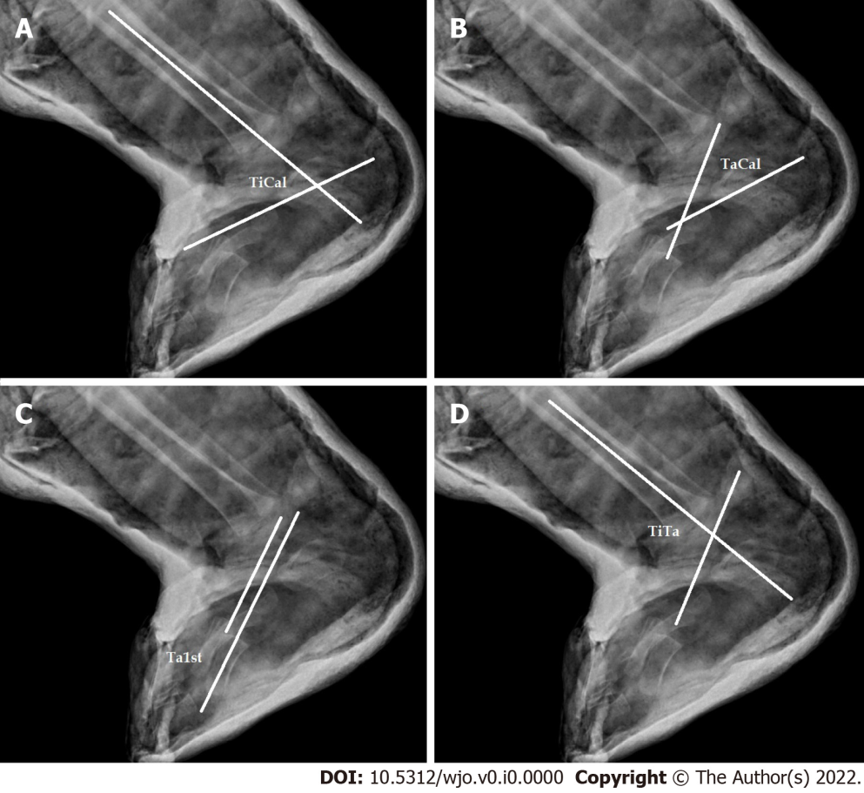
Figure 1 Radiographic angles. A: The tibiocalcaneal angle was defined as the angle between the axis of the tibia and the axis of the calcaneus; B: The talocalcaneal angle was defined as the angle between the talus axis and the calcaneus axis'; C: Talofirst metatarsal angle was defined as the angle between the axis of the talus and the axis of the 1st metatarsal bone; D: The tibiotalar angle was defined as the angle between the axis of the tibia and the axis of the talus.

Table 1 Demographic data for the excellent/good and fair/poor functional groups
Demographic data | Excellent and good group (n = 36) | Fair and poor group (n = 18) | Mean different (95%CI) | P value
Male, n (%) | 26 (72.22) | 11 (61.11) | - | 0.407^{b}
Number of casts | 8.69 (3.05) | 8.33 (3.39) | -0.36 (-2.19, 1.47) | 0.6950ª
Age at tenotomy (d), Mean (SD) | 144 (53.52) | 161.55 (69.11) | 17.55 (-16.66, 51.77) | 0.3081ª
Brace compliance, n (%) | 29 (80.56) | 17 (94.44) | - | 0.245^{c}
ªIndependent samples t test.
^{b}Pearson chi square test.
^{c}Fisher's exact test. SD: Standard error.

Table 2 Mean range of each radiographic angle in clubfeet patients after surgery in lateral view
Angle | Excellent and good group Mean (SD) | Fair and poor group Mean (SD) | Mean different (95%CI) | P valueª
Tibiocalcaneal angle | 72.55 (10.36) | 80.61 (7.76) | 8.05 (2.49, 13.61) | 0.0053
Talocalcaneal angle | 31.66 (11.92) | 23.55 (12.00) | -8.11 (-15.03, -1.18) | 0.0225
Talofirst metatarsal angle | 7.72 (7.83) | 7.38 (5.23) | -0.33 (-4.44, 3.77) | 0.8713
Tibiotalar angle | 107.72 (11.73) | 106.50 (15.53) | -1.22 (-8.80, 6.36) | 0.7478
ªIndependent samples t test.

Table 3 Correlation of radiographic parameters and functional outcomes
Angle | Functional score, excellent and good group (n = 36), Fair and poor group (n = 18)
 | Crude odds ratio (95%CI) ª | Adjusted odds ratio (95%CI) | P value^{b}
Tibiocalcaneal angle | 0.90 (0.84-0.97) | 0.90 (0.83-0.99) | 0.031
Talocalcaneal angle | 1.06 (1.00-1.12) | 1.04 (0.97-1.11) | 0.199
Talofirst metatarsal angle | 1.00 (0.92-1.09) | 0.99 (0.89-1.10) | 0.916
Tibiotalar angle | 1.00 (0.96-1.05) | 1.01 (0.95-1.07) | 0.707
ªSimple logistic regression.
^{b}Multiple logistic regression. CI: Confidence interval.

