Name of Journal: World Journal of Gastrointestinal Endoscopy
Manuscript NO: 82287
Manuscript Type: ORIGINAL ARTICLE

Retrospective Cohort Study
Role of endoscopic ultrasound in the characterization of solid pseudopapillary neoplasm of the pancreas

Pawlak KM et al. EUS in the characterization of SPN of the pancreas

Katarzyna M Pawlak, Nadeem Tehami, Ben Maher, Shujaath Asif, Krishn Kant Rawal, Daniel Vasile Balaban, Mohammed Tag-Adeen, Fahd Ghalim, Wael A Abbas, Elsayed Ghoneem, Khaled Ragab, Mahmoud El-Ansary, Shanil Kadir, Sunil Amin, Keith Siau, Anna Wiechowska-Kozlowska, Klaus Mönkemüller, Dalia Abdelfatah, Abeer Abdellatef, Sundeep Lakhtakia, Hussein Hassan Okasha

Katarzyna M Pawlak, Endoscopy Unit, Department of Gastroenterology, Hospital of The Ministry of Interior and Administration, Szczecin 01-218, Poland

Nadeem Tehami, Ben Maher, Interventional Endoscopy Unit, University Hospital Southampton NHS Foundation Trust, 3AX PO, United Kingdom

Shujaath Asif, Sundeep Lakhtakia, Consultant Gastroenterologist, AIG Hospitals, Hyderabad 500032, India

Krishn Kant Rawal, Department of Gastroenterology, Prime Institute of Digestive Sciences, Rajkot 360001, India

Daniel Vasile Balaban, Department of Gastroenterology, Central Military Emergency University Hospital, Carol Davila University of Medicine and Pharmacy, Bucharest 010011, Romania

Mohammed Tag-Adeen, Division of Gastroenterology and Hepatology, Department of Internal Medicine, Qena Faculty of Medicine, South Valley University, Qena 83511, Egypt

Mohammed Tag-Adeen, Department of Endoscopy, Shefa Al-Orman Hospital, Luxor 85951, Egypt

Fahd Ghalim, Interventional Endoscopy Unit, Sainte Marie Hospital, OSNY 95520, France

Wael A Abbas, Department of Internal Medicine, Gastroenterology Unit, Faculty of Medicine, Assuit University, Assuit 71511, Egypt

Elsayed Ghoneem, Department of Gastroenterology and Hepatology, Faculty of Medicine, Mansoura University, Mansoura 35511, Egypt

Khaled Ragab, Department of Hepatology and Gastroenterology, Theodor Bilharz Research Institute, Giza 12511, Egypt

Mahmoud El-Ansary, Department of Hepatology & Gastroenterology, Theodor Bilharz Research Institute, Giza 12511, Egypt

Shanil Kadir, Department of Gastroenterology, Liaquat National Hospital & Medical College, Karachi 75900, Pakistan

Sunil Amin, Division of Digestive and Liver Diseases, Department of Medicine, University of Miami Miller School of Medicine, Miami, FL 32118, United States

Keith Siau, Department of Gastroenterology, Royal Cornwall Hospitals NHS Trust, Truro, Cornwall, United Kingdom

Anna Wiechowska-Kozlowska, Endoscopy Unit, Hospital of the Ministry of Interior and Administration, Szczecin 71-146, Poland

Klaus Mönkemüller, Department of Gastroenterology, Virginia Tech Carilion School of Medicine, Roanoke, Virginia, AL 35294, United States

Dalia Abdelfatah, Department of Cancer Epidemiology and Biostatistics, National Cancer Institute, Cairo University, Cairo 11511, Egypt

Abeer Abdellatef, Department of Internal Medicine, Division of Gastroenterology and Hepatology, Kasr Al-Aini School of Medicine, Faculty of Medicine, Cairo University, Cairo 11511, Egypt

Hussein Hassan Okasha, Department of Internal Medicine, Division of Gastroenterology and Hepatology, Kasr Al-Aini School of Medicine, Faculty of Medicine, Cairo University, Cairo 11451, Egypt

Author contributions: Pawlak KM, Tehami N, Maher B, Asif S, Rawal KK, El-Ansary M, Kadir S, Abdelfatah D, Awad A, and Lakhtakia S have been involved equally in writing the manuscript; Balaban DV, Tag-Adeen M, Ghalim F, Abbas W, Ghoneem E, and Ragab K have been involved equally in collecting the data; Amin S, Siau K, Wiechowska-Kozłowska A, and Mönkemüller K have been involved equally in reading and revising the manuscript; Okasha HH revised and approved the final manuscript; All authors have read and approved the final manuscript.

Corresponding author: Hussein Hassan Okasha, MD, Professor, Department of Internal Medicine, Division of Gastroenterology and Hepatology, Kasr Al-Aini Hospitals, Cairo University, PO: 11451, Kasr Al-Aini Street, Cairo 11451, Egypt. hussein_okasha@kasralainy.edu.eg

Received: December 22, 2022
Revised: February 17, 2023
Accepted: March 29, 2023
Published online:

Abstract
BACKGROUND
Solid pseudopapillary neoplasm (SPN) is an uncommon pathology of the pancreas with unpredictable malignant potential. Endoscopic ultrasound (EUS) assessment plays a vital role in lesion characterization and confirmation of the tissue diagnosis. However, there is a paucity of data regarding the imaging assessment of these lesions.

AIM
To determine the characteristic EUS features of SPN and define its role in preoperative assessment.

METHODS
This was an international, multicenter, retrospective, observational study of prospective cohorts from 7 large hepatopancreaticobiliary centers. All cases with postoperative histology of SPN were included in the study. Data collected included clinical, biochemical, histological and EUS characteristics.

RESULTS
One hundred and six patients with the diagnosis of SPN were included. The mean age was 26 years (range 9 to 70 years), with female predominance (89.6%). The most frequent clinical presentation was abdominal pain (80/106; 75.5%). The mean diameter of the lesion was 53.7 mm (range 15 to 130 mm), with the slight predominant location in the head of the pancreas (44/106; 41.5%). The majority of lesions presented with solid imaging features (59/106; 55.7%) although 33.0% (35/106) had mixed solid/cystic characteristics and 11.3% (12/106) had cystic morphology. Calcification was observed in only 4 (3.8%) cases. Main pancreatic duct dilation was uncommon, evident in only 2 cases (1.9%), whilst common bile duct dilation was observed in 5 (11.3%) cases. One patient demonstrated a double duct sign at presentation. Elastography and Doppler evaluation demonstrated inconsistent appearances with no emergence of a predictable pattern. EUS guided biopsy was performed using three different types of needles: Fine needle aspiration (67/106; 63.2%), fine needle biopsy (37/106; 34.9%), and Sonar Trucut (2/106; 1.9%). The diagnosis was conclusive in 103 (97.2%) cases. Ninety-seven patients were treated surgically (91.5%) and the post-surgical SPN diagnosis was confirmed in all cases. During the 2-year follow-up period, no recurrence was observed.

CONCLUSION
SPN presented primarily as a solid lesion on endosonographic assessment. The lesion tended to be located in the head or body of the pancreas. There was no consistent characteristic pattern apparent on either elastography or Doppler assessment. Similarly SPN did not frequently cause stricture of the pancreatic duct or common bile duct. Importantly, we confirmed that EUS-guided biopsy was an efficient and safe diagnostic tool. The needle type used does not appear to have a significant impact on the diagnostic yield. Overall SPN remains a challenging diagnosis based on EUS imaging with no pathognomonic features. EUS guided biopsy remains the gold standard in establishing the diagnosis.

Key Words: Solid pseudopapillary neoplasm; SPN; Frantz tumor; Endoscopic ultrasound features; EUS-guided biopsy; Fine needle aspiration/biopsy

Pawlak KM, Tehami N, Maher B, Asif S, Rawal KK, Balaban DV, Tag-Adeen M, Ghalim F, Abbas WA, Ghoneem E, Ragab K, El-Ansary M, Kadir S, Amin S, Siau K, Wiechowska-Kozlowska A, Mönkemüller K, Abdelfatah D, Abdellatef A, Lakhtakia S, Okasha HH. Role of endoscopic ultrasound in the characterization of solid pseudopapillary neoplasm of the pancreas. World J Gastrointest Endosc 2023; In press

Core Tip: Solid pseudopapillary neoplasm (SPN) presented primarily as a solid lesion on endosonographic assessment. The lesion tended to be located in the head or body of the pancreas. There was no consistent characteristic pattern apparent on either elastography or Doppler assessment. Similarly SPN did not frequently cause stricture of the pancreatic duct or common bile duct. Importantly, we confirmed that Endoscopic ultrasound (EUS) -guided biopsy was an efficient and safe diagnostic tool. The needle type used does not appear to have a significant impact on the diagnostic yield. Overall SPN remains a challenging diagnosis based on EUS imaging with no pathognomonic features. EUS guided biopsy remains the gold standard in establishing the diagnosis.

INTRODUCTION
Solid pseudopapillary neoplasm is a rare tumor of the pancreas which may demonstrate both solid and cystic imaging characteristics. In contrast to other cystic tumors such as serous or mucinous cystic neoplasms that contain a true epithelial lining or intraductal papillary mucinous neoplasm with cystically dilated pancreatic duct or branches filled with mucin, Solid pseudopapillary neoplasm (SPN) is a low-grade malignant tumor, histologically forming solid and pseudopapillary structures with an absence of specific line pancreatic epithelial differentiation^{[1]}.
Historically, most SPN were detected in patients presenting with abdominal pain or non-specific abdominal symptoms. At present, due to the wider application of advanced imaging techniques, the majority of these lesions are recognized incidentally^{[2]}. As a result, the incidence of SPN is increasing, now equating to approximately 6% of all exocrine pancreatic neoplasms^{[2]}. Although SPN usually demonstrates indolent behavior, higher grades of malignancy may be encountered and metastases have been reported in up to 20% of cases^{[2]}. Therefore, detection and diagnosis of SPN mandate surgical referral, for consideration of resection. Importantly, SPN are cured by complete surgical resection alone^{[3]}.
Despite advances in imaging, pseudocysts, cystic neuroendocrine tumors and other cystic neoplasms may demonstrate similar imaging characteristic, making a pre-operative diagnosis challenging^{[4]}. Furthermore, differentiation of SPN from other pancreatic neoplasms, such as pancreatic neuroendocrine tumors, acinar cell carcinomas, or ductal adenocarcinomas is important because SPN have a significantly improved prognosis compared with other malignant pancreatic tumors^{[5]}.
Traditionally computed tomography and magnetic resonance imaging have been considered the key preliminary diagnostic imaging tools for SPN. However, obtaining a final diagnosis remains dependent on cytohistological analysis^{[6]}. The proximity of the pancreas to the stomach and duodenum facilitates endoscopic ultrasound (EUS) examination and the ability to obtain tissue through the fine needle aspiration/biopsy (FNA/FNB), in assessment of SPN. However, given the relative rareness of SPN, there remains a relative paucity of data regarding the role of EUS-guided biopsy rather than pre-operative assessment of the imaging features^{[7-9]}. Therefore, we sought to define the characteristic EUS findings and their role in the preoperative assessment of SPN.

MATERIALS AND METHODS
Participating centers
This was an international, multicenter, retrospective observational, open-label study involving seven endoscopy units from India, Egypt, Poland, United Kingdom, France, Romania, and Pakistan. The data has been collected by high-volume endoscopy centers, performing in the region of 1000 diagnostic and interventional EUS procedures per year, including EUS-guided biopsy. In all centers, the evaluation was performed by an expert endosonographer who was defined as having performed at least 1000 HPB EUS procedures.

Population data collection
All patients who underwent EUS during a ten year period who ultimately were diagnosed with SPN, (2010-2022), confirmed by histopathological assessment were enrolled in the study. Anonymized data was collected including patient demographics, symptoms, endosonographic features and histological results including EUS-guided biopsy result and surgical confirmation.

Endosonography of SPN
All patients were referred to EUS evaluation due to the non-metastatic, growing locally pancreatic tumor recognized in computed tomography for establishing the diagnosis. Information on EUS, images, EUS-guided biopsy including the number of passes, type of needle and fluid biochemistry analysis (amylase, CA 19.9 and mucin stain) from cystic component were recorded using a collective database. In all cases, surgical resection was the treatment of choice, providing definitive histological SPN confirmation.
The study was conducted and carried out in accordance with the Helsinki declaration as revised in 1989. Based on the anonymized data collection, the Institutional Review Board of Pomeranian Medical University in Szczecin granted approval. The study was conducted in the line with the STROBE guidelines.

Statistical analysis
Data management and analysis were performed using Statistical Package for Social Sciences (SPSS) version 28. Numerical data was summarized using mean and standard deviations or medians and/or ranges as appropriate. Categorical data was summarized as numbers and percentages. Estimates of the frequency were done using the numbers and percentages. Numerical data was explored for normality using Kolmogrov-Smirnov test and Shapiro-Wilk test. Chi square or Fisher’s tests were used to compare between the independent groups with respect to categorical data as appropriate. Comparisons between two groups for normally distributed numeric variables were done using the Student’s t-test while for non-normally distributed numeric variables, comparisons were done by Mann-Whitney test. Comparison between more than 2 groups was performed by Kruskal-Wallis for non-normally distributed variables. All tests were two tailed & Probability (P value) ≤ 0.05 was considered significant.

RESULTS
Clinical characteristics of SPN patients
One hundred and six cases with SPN were included. The median age was 26 years (range 9 to 70), with similar incidence in both genders when compared by age, but with general female predominance (95 females, 89.6%) (Table 1). The majority of patients presented symptomatically (82.1%), among which the most frequent was abdominal pain (75.5%). However, a history of previous acute pancreatitis episodes was only recorded in one patient. Other symptoms included obstructive jaundice (3.8%), vomiting (1.9%) and weight loss (0.9%) (Table 2). In all patients the tumor marker CA 19.9 was normal.
EUS characteristics of solid pseudopapillary tumors: The mean size of the lesion was 52.8 mm (range 15-130 mm), with the predominant location in the head of the pancreas (44/106; 41.5%). Detailed endoscopic ultrasound evaluation was performed identifying lesions with solid (60/106; 56.1%), mixed (43/106; 40.2%), and cystic (3/106; 2.8%) morphology (Figure 1). In terms of endosonographic echotexture, the tumors considered as solid were mainly hypoechoic, heterogeneous, well-demarcated with regular border (Figure 2A). In three cases presented as a solid mass, hyperechoic echotexture corresponding to calcification was observed (Figure 2B). Also, one tumor with pancreatic head location caused a portal vein confluence thrombosis due to external compression and expansile growth. Cystic lesions presented mainly with a multilocular appearance with septations but without mural nodules or honeycomb pattern (Figure 2C). In one case, circumferential calcification was observed. Mixed tumors included both components; however, the solid part demonstrated soft-tissue stiffness on EUS elastography assessment (Figure 3). In addition, Doppler assessment did not demonstrate significant intralesional vascularity or hypervascular infiltration of surrounding structures. Dilation of the main pancreatic duct (MPD) was reported in 2 cases (2/106; 1.9%) of solid SPN (mean size 46 mm; pancreatic head location) measuring up to 10 mm (mean 8.5 mm), while the common bile duct was dilated in 5 cases (5/106; 54.7%) of solid tumors (mean size 61.4 mm; pancreatic head location) with no previous cholecystectomy. Also, there was no correlation between size of the tumor, consistency and anatomical location. The results are summarized in Tables 3-4 and Figure 1.
Technical aspects of EUS-guided biopsy, therapeutic strategy: EUS guided biopsy was performed using three different types of needle: FNA in 67 (63.2%), FNB in 37 (34.9%), Trucut in 2 (1.9%) lesions. For the later, the size 18G and 22G were selected. The 22G and 19G size was mainly selected (94.0%) for the FNA needle type, and 22G for the FNB needle (89.2%). The mean number of passes was 2 and 3 for FNA and FNB needle respectively. Data regarding the needle type used are presented in Table 5.

Cythopathological results
The tissue samples were conclusive in 103 (97.2%) cases (Figure 4). The mucin stain was negative in all cases. Three lesions without conclusive FNA (diagnosed nonspecifically as hemorrhagic material, inflammatory cells and neuroendocrine tumor suspicion) were definitively validated by surgical resection. Consequently a histological diagnosis was reached in all cases (Table 6).
Ninety-seven (91.5%) patients were treated surgically (Figure 5). Whipple's/pancreatoduodenectomy was performed in 47 (44.3%), central pancreatectomy in 29 (27.4%) and distal pancreatosplenectomy in 21 (19.8%). Post-surgical SPN confirmation was determined in all cases. Follow up varied according to local protocol and within the 2 year research period, no cases of recurrence or metastatic disease were recorded.

DISCUSSION
In this study, we found that SPN presented as moderately large lesions without other clinically specific features or typical endosonographic appearance including the size, echotexture, impact on the main ducts (CBD and MPD), and growth pattern. In addition there was no consistent pattern evident in the ancillary EUS features of calcification, vascularity or stiffness (elastography).
The distribution of SPN was in all anatomic components of the pancreas, with a slight dominance in the pancreatic head (41.5%), followed by pancreatic body (40.6%), consistent with the previous published work which has been unable to conclusively demonstrate atypical location for SPN^{[2,10,11]}. Interestingly, of the 44 cases presenting in the head of the pancreas, only four led to a local complication resulting in jaundice and double duct sign was only evident in one case. Importantly, some lesions grew to a significant size without significant symptoms. We performed logistic regression analysis and could not find any correlation between size and symptoms or tumor appearance. Additionally, even the largest tumor with pancreatic head location (130 mm) did not cause double duct sign and most of them did not infiltrate surrounding structures despite such large size, which was in agreement with previous literature^{[2,11]}.
In our study group, only one tumor located in the pancreatic head with the size of 42 mm had an expansile growth pattern leading to the compression of portal vein confluence and thrombosis, but without an impact on the bile duct or pancreatic duct. In our cohort, we did not observe infiltrative SPN nature. We believe that the lack of ductal changes may be due to the inherent parenchymal localization of the tumor, with specific growth dynamics that induces a preferential growth away from the pancreas and not towards the main pancreatic duct or bile duct.
Also, there were no typical findings regarding EUS imaging ancillary features such as elastography and Doppler assessment.
Confirming previous reports, we found that the majority of patients were female with a 9:1 ratio^{[12]}. Other features, age, size, and tumor appearance were similar, with no statistical significance. Although variation was demonstrated between genders and lesion location (male – head, female – body predominance), these results were not statistically significant.
Previously, Marchegiani et al^{[13]} found that expansive growth pattern had a statistically significant association with recurrence of SPN. However, during our period of assessment, no cases of local recurrence or metastatic disease were identified. Clearly ongoing surveillance of this group will be of interest.
Importantly, we found that EUS-guided tissue acquisition was an efficient and safe diagnostic tool regardless of biopsy needle type. Consistently a high preoperative diagnostic yield was achieved. We were able to reach a preoperative diagnosis in 97% the patients, confirmed by resected specimen.
Our study has potential shortcomings, including its retrospective design. In addition we did not perform a comparison between the needle type, size and number of passes in terms of the efficiency.
Finally, to our knowledge, this represents the largest multicenter study of SPN to date, with the advantage of varied international geographic location.

CONCLUSION
In conclusion, we found that SPN presented mainly as solid endosonographic lesions, with slight dominance of pancreatic head location without pathognomonic EUS features that would permit a definitive imaging diagnosis. Despite their large size, SPN do not tend to impinge on the pancreatic duct and more frequently demonstrate a parenchymatous growth. Importantly, we confirmed that EUS-guided biopsy is an efficient and safe diagnostic tool, regardless of needle type, with high preoperative diagnostic yield. We propose that a prospective international study of SPN would further improve our understanding of this rare tumor.

ARTICLE HIGHLIGHTS
Research background
Solid pseudopapillary neoplasm (SPN) is an uncommon pathology of the pancreas with unpredictable malignant potential. Endoscopic ultrasound (EUS) assessment plays a vital role in lesion characterization and confirmation of the tissue diagnosis.

Research motivation
There is a paucity of data regarding the imaging assessment of these lesions.

Research objectives
To determine the characteristic EUS features of SPN and define its role in preoperative assessment.

Research methods
This was an international, multicenter, retrospective, observational study of prospective cohorts from 7 large hepatopancreaticobiliary centers. All cases with postoperative histology of SPN were included in the study. Data collated included clinical, biochemical, histological and EUS characteristics.

Research results
One hundred and six patients with the diagnosis of SPN were included. The mean age was 26 years (range 9 to 70 years), with female predominance (89.6%). The most frequent clinical presentation was abdominal pain (80/106; 75.5%). The mean diameter of the lesion was 53.7 mm (range 15 to 130 mm), with the slight predominant location in the head of the pancreas (44/106; 41.5%). The majority of lesions presented with solid imaging features (59/106; 55.7%) although 33.0% (35/106) had mixed solid/cystic characteristics and 11.3% (12/106) had cystic morphology. Calcification was observed in only 4 (3.8%) cases. Main pancreatic duct dilation (MPD) was uncommon, evident in only 2 cases (1.9%), whilst common bile duct dilation was observed in 5 (11.3%) cases. One patient demonstrated a double duct sign at presentation. Elastography and Doppler evaluation demonstrated inconsistent appearances with no emergence of a predictable pattern. EUS guided biopsy was performed using three different types of needles: FNA (67/106; 63.2%), FNB (37/106; 34.9%), and Sonar Trucut (2/106; 1.9%). The diagnosis was conclusive in 103 (97.2%) cases. Ninety-seven patients were treated surgically (91.5%) and the post-surgical SPN diagnosis was confirmed in all cases. During the 2-year follow-up period, no recurrence was observed.

Research conclusions
SPN presented primarily as a solid lesion on endosonographic assessment. The lesion tended to be located in the head or body of the pancreas. There was no consistent characteristic pattern apparent on either elastography or Doppler assessment. Similarly SPNs did not frequently cause stricture of the pancreatic duct or common bile duct. Importantly, we confirmed that EUS-guided biopsy was an efficient and safe diagnostic tool. The needle type used did appear to have a significant impact on the diagnostic yield. Overall SPN remains a challenging diagnosis based on EUS imaging with no pathognomonic features. EUS guided biopsy remains the gold standard in establishing the diagnosis.

Research perspectives
We propose that a prospective international study of SPN would further improve our understanding of this rare tumor.

ACKNOWLEDGEMENTS
We would like to acknowledge our hospitals, and their workers, nurses and staff members, for all the support and help in this study and throughout our careers.

REFERENCES
1 La Rosa S, Bongiovanni M. Pancreatic Solid Pseudopapillary Neoplasm: Key Pathologic and Genetic Features. Arch Pathol Lab Med 2020; 144: 829-837 [PMID: 31958381 DOI: 10.5858/arpa.2019-0473-RA]
2 Papavramidis T, Papavramidis S. Solid pseudopapillary tumors of the pancreas: review of 718 patients reported in English literature. J Am Coll Surg 2005; 200: 965-972 [PMID: 15922212 DOI: 10.1016/j.jamcollsurg.2005.02.011]
3 Antoniou EA, Damaskos C, Garmpis N, Salakos C, Margonis GA, Kontzoglou K, Lahanis S, Spartalis E, Patsouras D, Kykalos S, Garmpi A, Andreatos N, Pawlik TM, Kouraklis G. Solid Pseudopapillary Tumor of the Pancreas: A Single-center Experience and Review of the Literature. In Vivo 2017; 31: 501-510 [PMID: 28652415 DOI: 10.21873/invivo.11089]
4 Roskell DE, Buley ID. Fine needle aspiration cytology in cancer diagnosis. BMJ 2004; 329: 244-245 [PMID: 15284126 DOI: 10.1136/bmj.329.7460.244]
5 Lakhtakia R, Al-Wahaibi K, Zahid KF, Malik KA, Burney IA. Solid pseudopapillary neoplasm of the pancreas: a case report with review of the diagnostic dilemmas and tumor behavior. Oman Med J 2013; 28: 441-444 [PMID: 24223249 DOI: 10.5001/omj.2013.122]
6 Terris B, Cavard C. Diagnosis and molecular aspects of solid-pseudopapillary neoplasms of the pancreas. Semin Diagn Pathol 2014; 31: 484-490 [PMID: 25524568 DOI: 10.1053/j.semdp.2014.08.010]
7 Mirminachi B, Farrokhzad S, Sharifi AH, Nikfam S, Nikmanesh A, Malekzadeh R, Pourshams A. Solid Pseudopapillary Neoplasm of Pancreas; A Case Series and Review Literature. Middle East J Dig Dis 2016; 8: 102-108 [PMID: 27252816 DOI: 10.15171/mejdd.2016.14]
8 Sheikh ZA, Alali AA, Almousawi FAS, Das DK. Solid pseudo-papillary tumor of the pancreas: Diagnosis by endoscopic ultrasound-guided fine needle aspiration cytology and immunocytochemistry. Diagn Cytopathol 2021; 49: E242-E246 [PMID: 33372731 DOI: 10.1002/dc.24689]
9 Lanke G, Ali FS, Lee JH. Clinical update on the management of pseudopapillary tumor of pancreas. World J Gastrointest Endosc 2018; 10: 145-155 [PMID: 30283597 DOI: 10.4253/wjge.v10.i9.145]
10 Yu PF, Hu ZH, Wang XB, Guo JM, Cheng XD, Zhang YL, Xu Q. Solid pseudopapillary tumor of the pancreas: a review of 553 cases in Chinese literature. World J Gastroenterol 2010; 16: 1209-1214 [PMID: 20222163 DOI: 10.3748/wjg.v16.i10.1209]
11 Law JK, Ahmed A, Singh VK, Akshintala VS, Olson MT, Raman SP, Ali SZ, Fishman EK, Kamel I, Canto MI, Dal Molin M, Moran RA, Khashab MA, Ahuja N, Goggins M, Hruban RH, Wolfgang CL, Lennon AM. A systematic review of solid-pseudopapillary neoplasms: are these rare lesions? Pancreas 2014; 43: 331-337 [PMID: 24622060 DOI: 10.1097/MPA.0000000000000061]
12 Cruz MAA, Moutinho-Ribeiro P, Costa-Moreira P, Macedo G. Solid Pseudopapillary Neoplasm of the Pancreas: Unfolding an Intriguing Condition. GE Port J Gastroenterol 2022; 29: 151-162 [PMID: 35702168 DOI: 10.1159/000519933]
13 Marchegiani G, Andrianello S, Massignani M, Malleo G, Maggino L, Paiella S, Ferrone CR, Luchini C, Scarpa A, Capelli P, Mino-Kenudson M, Lillemoe KD, Bassi C, Castillo CF, Salvia R. Solid pseudopapillary tumors of the pancreas: Specific pathological features predict the likelihood of postoperative recurrence. J Surg Oncol 2016; 114: 597-601 [PMID: 27471041 DOI: 10.1002/jso.24380]

Footnotes
Institutional review board statement: The study was conducted and carried out in accordance with the Helsinki declaration as revised in 1989. Based on the anonymized data collection, the Institutional Review Board of Pomeranian Medical University in Szczecin granted approval. SVU, MED018.

Conflict-of-interest statement: All the authors declare that they have no conflict of interest.

Data sharing statement: No additional data are available.

STROBE statement: The authors have read the STROBE Statement – checklist of items, and the manuscript was prepared and revised according to the STROBE Statement – checklist of items.

Open-Access: This article is an open-access article that was selected by an in-house editor and fully peer-reviewed by external reviewers. It is distributed in accordance with the Creative Commons Attribution NonCommercial (CC BY-NC 4.0) license, which permits others to distribute, remix, adapt, build upon this work non-commercially, and license their derivative works on different terms, provided the original work is properly cited and the use is non-commercial. See: https://creativecommons.org/Licenses/by-nc/4.0/

Provenance and peer review: Invited article; Externally peer reviewed.
Peer-review model: Single blind

Peer-review started: December 22, 2022
First decision: February 8, 2023
Article in press:

Specialty type: Gastroenterology and hepatology
Country/Territory of origin: Egypt
Peer-review report’s scientific quality classification
Grade A (Excellent): 0
Grade B (Very good): B
Grade C (Good): C
Grade D (Fair): 0
Grade E (Poor): 0

P-Reviewer: Sugimoto M, Japan; Yildirim M, Turkey S-Editor: Liu JH L-Editor: A P-Editor: Liu JH
Figure Legends
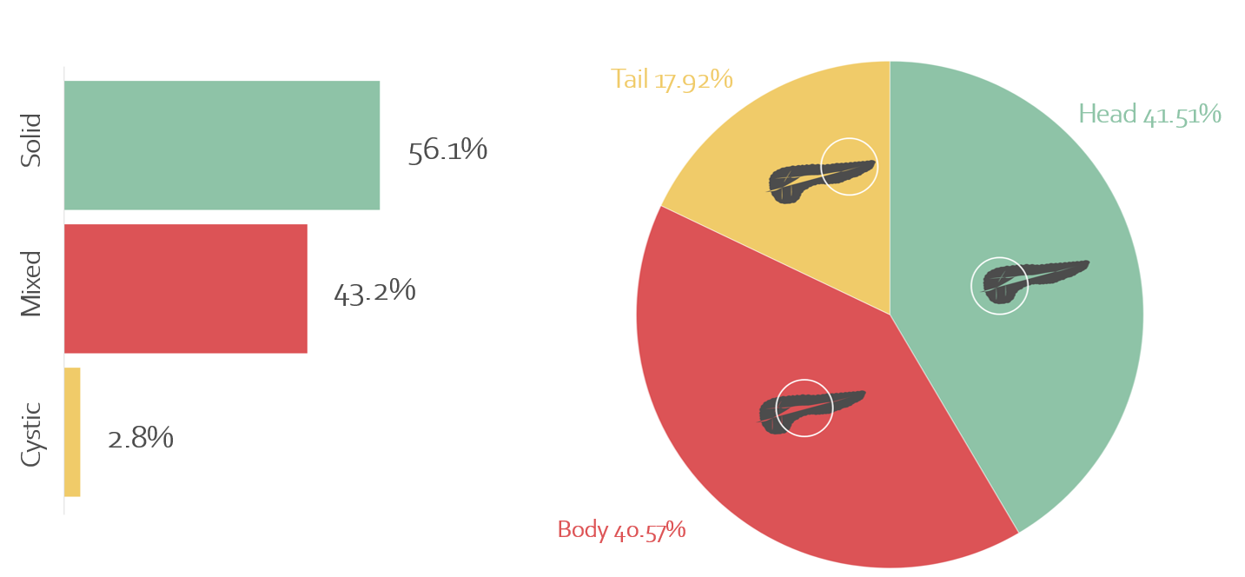
Figure 1 Endoscopic ultrasound characteristic of solid pseudopapillary tumors.
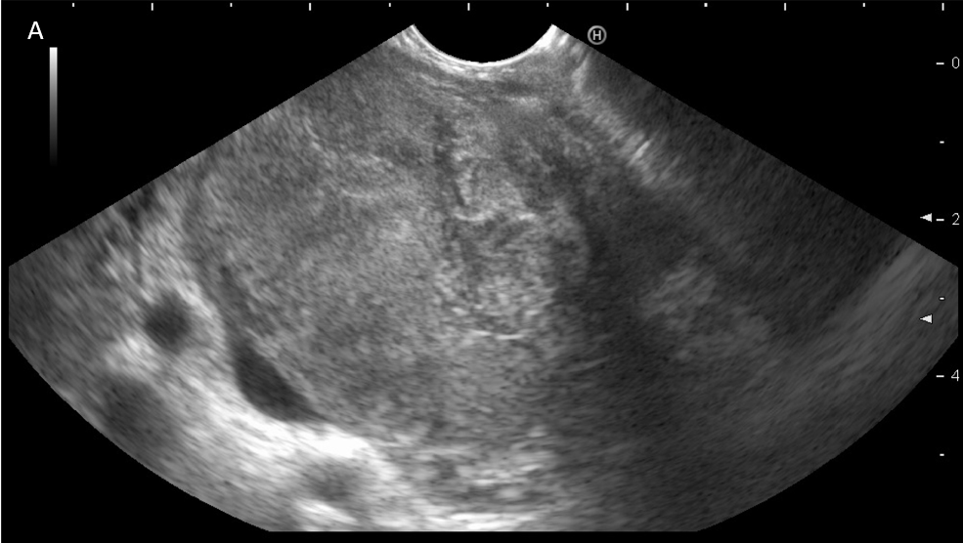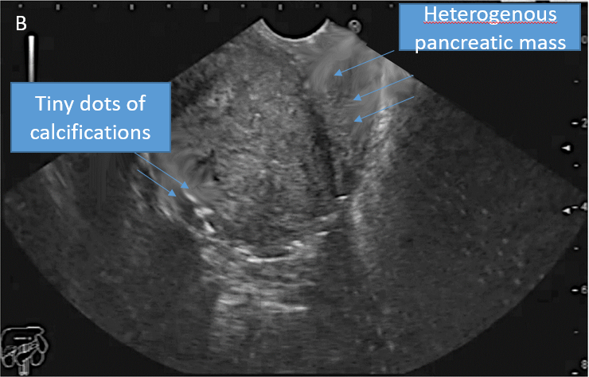
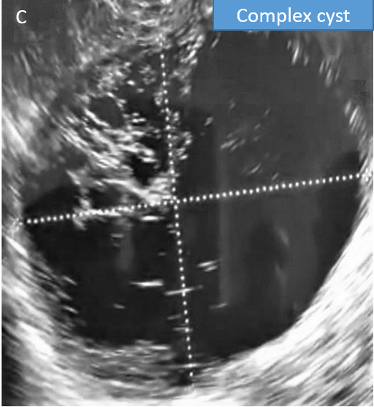
Figure 2 Endoscopic ultrasound. A: A large heterogeneous solid pseudopapillary neoplasm in the pancreatic head; B: A large heterogeneous solid pseudopapillary neoplasm with calcific spots in the pancreatic head; C: A cystic solid pseudopapillary neoplasm in the pancreatic body.
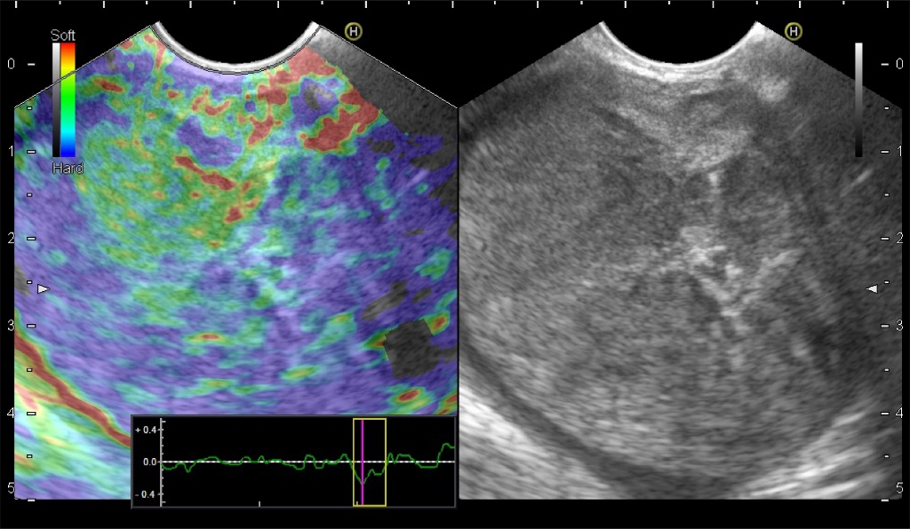
Figure 3 A large heterogeneous firm solid pseudopapillary neoplasm in the pancreatic head with dominant blue color denoting grade 3 Elasticity score.
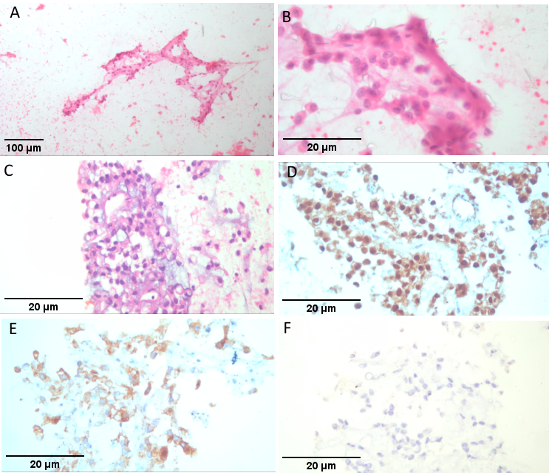
Figure 4 Smears of solid pseudopapillary pancreatic tumor. A and B: Clusters of uniform epithelioid cells arranged in a vague papillary like formation (Hematoxylin & Eosin × 40); C: Cell block of same tumor (Hematoxylin & Eosin × 400); D: Positive nuclear B-Catenin immunoreaction in tumor cells (Hematoxylin & Eosin × 400); E: Positive cytoplasmic Synatophysin immunoreaction in tumor cells (Hematoxylin & Eosin × 400); F: Negative Chromogranin immunoreaction (Hematoxylin & Eosin × 400).
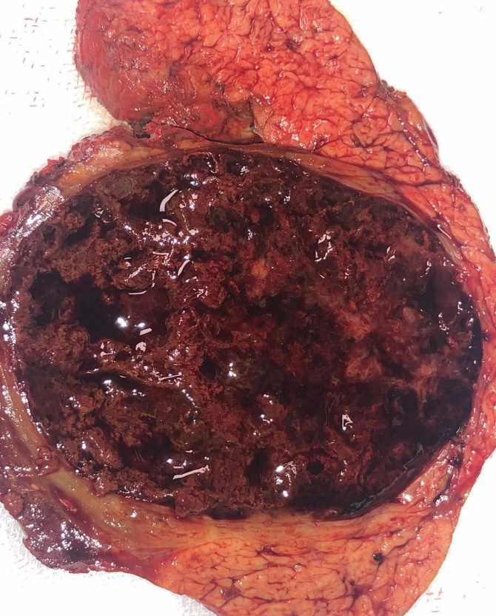
Figure 5 A post-operative specimen of mixed solid pseudopapillary neoplasm with solid and cystic areas.

Table 1 Sociodemographic characteristics, n (%)
 | n = 106 (%)
Age
mean ± SD | 26.4 ± 13
Sex
Female | 95 (89.6)
Male | 11 (10.4)
Country
Egypt | 48 (45.3)
India | 39 (36.8)
Poland | 5 (4.7)
France | 4 (3.8)
United Kingdom | 5 (4.7)
Romania | 3 (2.8)
Pakistan | 2 (1.9)

Table 2 Clinical manifestation
 | n (%)
Symptoms
Yes | 87 (82.1)
No | 19 (17.9)
Presentation
Asymptomatic | 19 (17.9)
Abdominal pain | 80 (75.5)
Weight loss | 1 (0.9)
Obstructive jaundice | 4 (3.8)
Vomiting | 2 (1.9)

Table 3 Endoscopic ultrasound characteristic of solid pseudopapillary tumors
 | n (%)
Location
Head | 44 (41.5)
Body | 43 (40.6)
Tail | 19 (17.9)
Consistency
Solid | 60 (56.1)
Mixed | 43 (40.2)
Cystic | 3 (2.8)
Additional findings
Calcification | 4 (3.8)
CBD dilation
Yes | 5 (4.7)
No | 101 (95.3)
PD dilation
Yes | 2 (1.9)
No | 104 (98.1)
Size
mean ± SD | 52.8 ± 23.1
Median (range) | 50 (15-130)
CBD: Common bile duct; PD: Pancreatic duct; SD: Standard deviation.

Table 4 Correlation between size of the tumor, consistency and location
Consistency/appearance |  |  |  | P value
 | Cystic | Solid | Mixed
 | Median (range) | Median (range) | Median (range)
Size | 52.5 (36-130) | 45 (15-120) | 54 (17-95) | 0.365
Location
 | Head | Body | Tail
 | Median (range) | Median (range) | Median (range)
Size | 51.5 (15-130) | 45 (19-100) | 60 (17-125) | 0.400
SD: Standard deviation, P value < 0.05 is considered significant.

Table 5 Endoscopic ultrasound needle characteristic
 | n (%)
Needle type
FNA | 67 (63.2)
FNB | 37 (34.9)
Tru cut | 2 (1.9)
Needle size
19 G | 9 (8.5)
22 G | 88 (83)
18 G | 1 (0.9)
20 G | 2 (1.9)
25 G | 6 (5.7)
No of passes
Median (range) | 3 (1-3)
FNA | n = 67 (%)
Needle size
19 G | 9 (13.4)
22 G | 54 (80.6)
25 G | 4 (6)
 | Median (range)
No of passes | 2 (1-3)
FNB | n = 37 (%)
Needle size
22 G | 33 (89.2)
20 G | 1 (2.7)
25 G | 3 (8.1)
 | Median (range)
No of passes | 3 (1-3)
Trucut | n = 2 (%)
Needle size
22 G | 1 (50)
18 G | 1 (50)
No of passes | 2
FNA: Fine needle aspiration; FNB: Fine needle biopsy.

Table 6 Cytopathology
 | n (%)
Cytopathology
Non-diagnostic | 3 (2.8)
SPN (conclusive) | 103 (97.2)
Surgery
Yes | 97 (91.5)
No | 9 (8.5)
Surgery
Central pancreatectomy | 29 (27.4)
Distal pancreatosplenectomy | 21 (19.8)
Whipple's panceatoduodenectomy | 47 (44.3)
Refused | 9 (8.5)
SPN: Solid pseudopapillary neoplasm.

