Name of journal: World Journal of Gastroenterology
ESPS Manuscript NO: 9512
Columns: ORIGINAL ARTICLE

Polyethylene glycol rinse solution: An effective way to prevent ischemia-reperfusion injury

Zaouali MA et al. New rinse solution for preventing IRI

Mohamed Amine Zaouali, Mohamed Bejaoui, Maria Calvo, Emma Folch-Puy, Eirini Pantazi, Gianfranco Pasut, Antoni Rimola, Hassen Ben Abdennebi, René Adam, Joan Roselló-Catafau

Mohamed Amine Zaouali, Mohamed Bejaoui, Emma Folch-Puy, Eirini Pantazi, Joan Roselló-Catafau, Experimental Hepatic Ischemia-Reperfusion Unit, IIBB-CSIC, CSIC-IDIBAPS, 08036 Barcelona, Spain

Maria Calvo, Serveis Cientifico-Tècnics, Universitat de Barcelona, 08036 Barcelona, Spain

Gianfranco Pasut, Pharmaceutical and Pharmacological Department, University of Padova, 35122 Padova, Italy

Antoni Rimola,Joan Roselló-Catafau, Hospital Clínic, Networked Biomedical Research Center of Hepatic and Digestive Diseases (CiberEHD), 08036 Barcelona, Spain

Mohamed Amine Zaouali, Hassen Ben Abdennebi, Molecular Biology and Anthropology Applied to Development and Health (UR12ES11), Faculty of Pharmacy, University of Monastir, 1002 Monastir, Tunisia
René Adam, APHP Hôpital Paul Brousse, Univ Paris-Sud Villejuif, 75008 Paris, France

Author contributions: Zaouali MA, Bejaoui M, Folch-Puy E, and Pantazi E carried out the experimental work; Zaouali MA and Calvo M carried out the confocal microscopy analysis; Abdennebi HB, Pasut G, and Rimola A provided protocols and analyzed data; Abdennebi HB and Adam R established the animal experimental model and contributed to the critical analyses of the data; Zaouali MA and Roselló-Catafau J designed the study, coordinated the experiments, and wrote the paper.

Supported by the Ministerio de Sanidad y Consumo No. PIO81988 (Madrid, Spain); Eirini Pantazi wishes to thank the Agència de Gestió d’Ajuts Universitaris i de Recerca No.2012FI_B00382; Mohamed Bejaoui thanks CSIC No. I-COOP05 for their fellowships

Correspondence to: Joan Roselló-Catafau, PhD, Experimental Hepatic Ischemia-Reperfusion Unit, IIBB-CSIC, CSIC-IDIBAPS, C/ Rosselló 161, 7th floor, 08036 Barcelona, Spain. joan.rosello@iibb.csic.es
Telephone: +34-93-3638333 Fax: +34-93-3638301

Received : February 14, 2014 Revised : May 2, 2014
Accepted : June 12, 2014

Published on line :

Abstract
AIM: To test whether a new rinse solution containing polyethylene glycol 35 (PEG-35) could prevent ischemia-reperfusion injury (IRI) in liver grafts.

METHODS: Sprague-Dawley rat livers were stored in University of Wisconsin preservation solution and then washed with different rinse solutions before ex vivo perfusion with Ringer’s lactate solution and a new rinse solution enriched with PEG-35 at either 1 or 5 g/L. We assessed the following: liver injury (transaminase levels), mitochondrial damage (glutamate dehydrogenase), liver function (bile output and vascular resistance), oxidative stress (malondialdehyde), nitric oxide, liver autophagy (Beclin-1 and LCB3) and cytoskeleton integrity (filament and globular actin fraction); as well as levels of metalloproteinases (MMP2 and MMP9), adenosine monophosphate-activated protein kinase (AMPK), heat shock protein 70 (HSP70) and heme oxygenase 1 (HO-1).

RESULTS: When we used the PEG-35 rinse solution, reduced hepatic injury and improved liver function were noted after reperfusion. The PEG-35 rinse solution prevented oxidative stress, mitochondrial damage, and liver autophagy. Further, it increased the expression of cytoprotective heat shock proteins such as HO-1, HSP70, and AMPK, and contributed to the restoration of cytoskeleton integrity after IRI.

CONCLUSION: Using the rinse solution containing PEG-35 was effective for decreasing liver graft vulnerability against IRI.

Key words: Liver washout; Liver transplantation; Rinse solution; Ischemia-reperfusion injury; Polyethylene glycol 35; Nitric oxide; Adenosine monophosphate-activated protein kinase; Heme oxygenase 1; Heat shock protein 70; Metalloproteinases

Core tip : Research into optimal rinse solutions for graft washout is limited, and their clinical application is dependent on surgeon preference. We present a new rinse solution containing polyethylene glycol 35 (PEG-35) that is not only suitable for washing liver grafts after cold preservation, but also provided good graft protection against reperfusion injury. Using PEG-35 in the rinse solution resulted in less hepatic injury, a significant induction of cytoprotective proteins, and the preservation of cytoskeletal integrity. Thus, PEG-35 supplemented rinse solutions may contribute to liver graft protection against ischemia-reperfusion injury.

Zaouali MA, Bejaoui M, Calvo M, Folch-Puy E, Pantazi E, Pasut G, Rimola A, Abdennebi HB, Adam R, Roselló-Catafau J. Polyethylene glycol rinse solution: An effective way to prevent ischemia-reperfusion injury. World J Gastroenterol 2014; In press

INTRODUCTION
Liver transplantation (LT) has had a profound impact on patient outcomes in end-stage liver disease, representing the most effective treatment for many patients with acute or chronic liver failure ^{[1]}. Ischemia-reperfusion injury (IRI) is an inherent risk of LT, and is often responsible for early graft failure within the first week of surgery^{[2-4]}. IRI is initiated when the liver is recovered from the donor and placed in cold storage, it continues when the graft is re-warmed prior to LT, and persists at graft revascularization after LT^{[3,4]}. Research has identified several strategies to reduce the impact of these multifactorial processes on graft function.
Maintaining organ viability during cold storage (i.e., preservation) is an important prerequisite for a successful outcome after LT^{[1,5]}. For this reason, the composition of organ preservation solutions is crucial; during cold storage, the solution must prevent cell swelling, impaired energy metabolism, acidosis, and the accumulation of precursors of reactive oxygen intermediates^{[1,5]}. Currently, the University of Wisconsin solution (UW) is the most commonly used for LT^{[6,7]}. However, several studies have reported that its composition is limited by: (1) the high concentration of K+ ions in preserved grafts that could cause cardiac arrest in the recipient at reperfusion^{[8]}; (2) the oncotic agent, hydroxyl-ethyl starch (HES), which confers high viscosity with incomplete distribution of the UW solution in the liver graft, particularly between the intravascular space and liver parenchyma; and (3) the hyper-aggregating effects of HES on erythrocytes, which may hamper liver graft reperfusion^{[9-11]}. These limitations have led physicians to rinse grafts before revascularization to remove the K⁺ ions, HES, and toxins that accumulate during preservation, and to ensure optimal conditions for graft revascularization and viability.
Current studies on rinse solutions for organ washout are limited, particularly for the liver. Ringer’s lactate solution (RLS) was initially used, before a more effective alternative was proposed by Adam et al^{[12]} that used a macromolecular albumin solution to restrict reperfusion damage. Later, the Carolina rinse (CR) solution was shown to prevent IRI^{[13-15]}, but it has a complex composition and contains HES, which induced red blood cell aggregation and incomplete washout^{[11]}. Despite some reductions in liver injury, the optimal washout solution has yet to be established and current practice depends mostly on physician preference.
In previous studies, we have used polyethylene glycol (PEG) 35 as an oncotic agent in Institut Georges Lopez (IGL-1) preservation solutions for the liver graft conservation^{[16-18]}. PEG-35 is a non-toxic, water-soluble polymer that prevents red blood cell aggregation when compared to HES^{[1,11]}. PEG has shown protective effects in different organs and can reduce oxidative stress through the preservation or restoration of membrane integrity^{[19]}. Moreover, several studies have demonstrated the efficiency of PEG in kidney^{[20]}, heart^{[21]}, liver^{[22]}, pancreas^{[23]}, and small bowel^{[24]} preservation in experimental models and clinical studies.
In the present study, we investigated the efficacy of liver washout with a new PEG-35 rinse solution after graft cold preservation in UW solution.

MATERIALS AND METHODS
Animals
Male Sprague-Dawley rats (250 g body weight) were anesthetized under isoflurane inhalation anesthesia according to European Union regulations (Directive 86/609 EEC), surgery was performed as previously reported^{[25]}. Animals were randomly distributed into groups as described below.

Liver washout
After 24 h cold storage in UW solution, the liver grafts were subjected to normothermic washout with different rinsing solutions (Table 1) and then re-perfused for 2 h at 37ºC. The experimental groups were as follows: Group 1 (Ringer’s lactate solution: RLS) (n = 8): Control 1 (Cont 1). The liver grafts were flushed with RLS (15 min; room temperature) and then re-perfused for 2 h at 37ºC. Group 2 (Base Solution: BS) (n = 8). Same as Group 1, but flushed with the BS, as indicated in Table 1. Group 3 (BS+PEG1) (n = 8). Same as Group 1, but flushed with BS supplemented with PEG 35 at 1 g/L. Group 4 (BS+PEG5) (n = 8). Same as Group 1, but flushed with the BS supplemented with PEG 35 at 5 g/L.

Model of isolated perfused rat liver
After cold storage in UW solution, the liver grafts were rinsed at room temperature for 15 min using one of the rinse solutions indicated above. Then livers were connected via the portal vein to a recirculating perfusion system for 2 h at 37ºC. Time zero was the point at which the portal catheter was satisfactorily connected to the circuit. As previously reported, during the first 15 min of perfusion (initial equilibration period), the flow was steadily increased until we achieved stabilization of the portal pressure at 12 mm Hg (Pressure Monitor BP-1; World Precision Instruments, Sarasota, Florida). The flow was controlled by a peristaltic pump (Minipuls 3; Gilson, France)^{[26,27]}. The reperfusion liquid consisted of a cell culture medium (William’s medium E; BioWhittaker, Barcelona, Spain) with a Krebs-Heinseleit-like electrolyte composition enriched with 5% albumin for oncotic pressure^{[28]}. Before entering the liver, the buffer was exposed to a mixture of 95% O₂ and 5% CO₂, a heat exchanger (37ºC), and a bubble trap^{[27,28]}. During normothermic reperfusion lasting 120 min, the effluent was collected at 30 min intervals to measure the liver aminotransferase levels and the liver function (bile, vascular resistance). Biochemical parameters were measured 2 h after reperfusion.

Biochemical determinations
Transaminase assay: Hepatic injury was assessed by transaminase levels using commercial kits from RAL (Barcelona, Spain). Briefly, 200 µL of effluent perfusate was added to the substrate provided by the commercial kit and the levels of aspartate aminotransferase (AST) and alanine aminotransferase (ALT) were determined at 365 nm with an ultraviolet spectrometer and calculated according to the manufacturer’s instructions^{[27,29]}.

Bile Output: Liver function was assessed by measuring bile production. Bile was collected through a cannulated bile duct and output was reported as microliter per gram of liver (µL/g liver)^{[26]}.

Vascular resistance: Liver circulation was assessed by measuring perfusion flow rate and vascular resistance. The perfusion flow rate was assessed continuously during reperfusion (expressed as mL/min/g liver). Vascular resistance was defined as the ratio of portal venous pressure to flow rate (expressed as mmHg/min/g liver/mL)^{[26]}.

Glutamate dehydrogenase activity: The mitochondrial enzyme Glutamate Dehydrogenase (GLDH)was used as an indirect measure of mitochondrial damage as previously reported^{[28]}.

Lipid peroxidation assay: Lipid peroxidation in the liver was used as an indirect measure of the oxidative injury induced by ROS. Lipid peroxidation was determined by measuring the formation of malondialdehyde (MDA) with the thiobarbiturate reaction^{[28]}.

Determination of nitrites and nitrates: Nitric oxide (NO) production by the liver was determined by measuring tissue accumulation of nitrites and nitrates, as previously reported^{[28]}.

Western blot analysis
Liver tissue was homogenized as previously described^{[28]}. Total protein was loaded in Laemmli buffer onto a SDS-polyacrylamide gel in a Mini Cell (Bio-Rad). The proteins were transferred to polyvinylidene difluoride membranes and blocked in 1 × phosphate buffered saline (PBS)/0.05% Tween 20/5% non-fat dry milk. Membranes were immunoblotted with antibodies directed against phospho-AMPK (adenosine monophosphate-activated protein kinase) (Thr172), total AMPK, Beclin-1, and LCB3 (Cell Signaling Technology Inc, Beverly, Massachusetts); anti-endothelial NO synthase (eNOS) and heat shock protein (HSP) 70 (BD Transduction Laboratories, Lexington, Kentucky); and β-Actin, actin, and heme oxygenase-1 (HO-1; Sigma Chemical, St. Louis, Missouri). The secondary antibody was added for 1 h and the membranes were developed using enhanced chemiluminescence reagents from Bio-Rad (Hercules, California) and quantified by scanning densitometry.

Zymography
Frozen tissue samples were homogenized with a lysis buffer and centrifuged as described elsewhere^{[30]}. Supernatants were used for extraction of gelatinolytic activity with Gelatin-Sepharose 4B (Amersham Biosciences, Uppsala, Sweden). Extracted liver samples were used to perform gelatin zymography using gelatinase zymography standards. The gels were stained in 0.1% amido black in a 1:3:6 ratio of acetic acid:methanol:water for 30 min and destained in the solvent, followed by a final wash in distilled water. Gelatinolytic enzymes were detected as transparent bands on the gel^{[30]}.

Confocal fluorescence microscopy
The liver was fixed, cryoprotected with sucrose, embedded in optimal cutting temperature (OCT) media, and frozen on a copper plate on dry ice. Cryosections (5 µm) were cut in a cryostat and post fixed in 4% buffered paraformaldehyde for 10 min and then permeabilized with PBS containing 0.1% Triton X-100 and 1% bovine serum albumin (BSA) for 30 min. For actin visualization, the slides were incubated with tetramethylrhodamine-phalloidin (TRITC-phalloidin, Sigma; dilution 2 µmol/L) in PBS with 1% BSA and 0.2% Triton X-100 for 30 min. Slides were washed 3 times for 15 min with PBS. The last PBS wash included Hoechst 33342 (Invitrogen; dilution 1µmol/L). Finally, cryosections were mounted using Mowiol (Calbiochem).
Confocal images were acquired with a Leica TCS SP5 laser scanning microscope (Leica Microsystems, Germany) equipped with a 63x NA1.4 oil-immersion objective. Hoechst-33342 and Phalloidin-A555 images were acquired sequentially using an acousto-optical beam splitter with 405 and 561 nm laser lines and emission detection ranges of 415-450 and 570-650 nm respectively. The confocal pinhole was set at 1 Airy unit and when 3-dimensional reconstruction was required, stacks of images every 0.3 mm were acquired. The sinusoids circularity of livers (based on Phalloidin staining) was quantified on ImageJ (Wayne Rasband, National Institute of Health, United States) as 4π × [(Area)]/[(Perimeter)2]. Briefly, the red channel (phalloidin-A555 staining) was mean filtered (radius 1), before thresholding, conversion to a binary image, and inversion. Sinusoids were selected and circularity was measured (in 16 mm² of each sample). A value of 1.0 indicated a perfect circle; as the value approached 0.0, an increasingly elongated shape was more likely.

Statistical analysis
Data were expressed as mean ± standard error, and were compared statistically by variance analysis, followed by the Student–Newman–Keuls test (Graph Pad Prism software). P < 0.05 was considered significant.

RESULTS
Liver injury
Effluent fluid was collected to determine ALT and AST levels after 2 h of reperfusion as a predictor of organ damage after cold IRI. Figure 1 shows the AST and ALT profiles of the liver grafts subjected to washout with RLS, BS, and BS+PEG-35 solutions (Table 2). Use of the BS solution supplemented with PEG-35 prevented AST and ALT release after 2 h of reperfusion when compared to both the RLS and BS solutions. No differences were found when BS+PEG1 (1 g/L) and BS+PEG5 (5 g/L) solutions were compared.

Liver function
Liver function was assessed by measuring bile production and vascular resistance. As indicated in Figure 2A, a significant increase was observed in bile production after 2 h of reperfusion in liver grafts flushed with BS+PEG1 and BS+PEG5 rinse solutions when compared to RLS and BS alone. These results were consistent with a reduced vascular resistance after 2 h of reperfusion, as shown by the profiling studies reported in Figure 2B.

Oxidative stress and mitochondrial injury in the liver
To evaluate the effect of PEG-35 rinse solutions in oxidative stress and mitochondrial damage, we measured levels of MDA, a lipoperoxidation marker. We observed a significant MDA reduction with the PEG-35 rinse solutions when compared to BS alone (Figure 3A). This preventive effect was more marked when compared to RLS. These results were consistent with liver mitochondrial damage measured by GLDH activity in liver perfusate at the end of the 2 h reperfusion period. Livers rinsed with RLS showed the highest GLDH activity when compared to those rinsed with BS alone (Figure 3B). PEG-35 (either 1 g/L or 5 g/L) added to BS significantly reduced GLDH levels when compared to RLS and BS alone. No differences were observed between the PEG-35 groups.

Cell signaling pathways implicated in liver protection
We evaluated the cytoprotective cell signaling pathways involved in liver grafts by assessing the effect of PEG-35 rinse solutions on AMPK phosphorylation. We found a significant increase in phosphorylated AMPK levels in liver grafts rinsed with PEG-35 containing solutions when compared to RLS and BS (Figure 4A). This was concomitant with increases in nitrite/nitrate levels and eNOS activation (Figures 4B and 4C).
In addition, we examined the effect of PEG-35 rinse solutions in the induction of heme oxygenase-1 (HO-1) and HSP70 (known cytoprotective proteins involved in the reduction of liver damage after IRI). The highest HO-1 protein levels were observed in livers rinsed with PEG-35 solution when compared to RLS and BS alone. Major differences were observed between the 5g/L and 1g/L concentrations of PEG-35 (Figure 5A). The HSP70 protein expression pattern was similar to that described for HO-1 expression (Figure 5 B).

Liver cytoskeleton alteration
Next, we evaluated the impact of PEG-35 rinse solutions on liver cytoskeleton distribution by assessing changes in filamentous actin (F-actin) and globular actin (G-actin). Our results demonstrated that the greatest G-actin fraction was observed in livers rinsed with the RLS when compared to BS and PEG-35 solutions (Figure 6). Conversely, the F-actin fraction was higher in the PEG-35 solution than in either RLS or BS alone (Figure 6). This was consistent with the metalloproteinase (MMP) activation shown in Figure 7. In fact we observed a significant reduction in MMP9 activity in livers flushed with PEG-35 solutions when compared to those flushed only with RLS or BS. No differences were found between the PEG-35 solutions. In addition we observed an increased MMP2 activity only when BS was used. However, no differences were found between the PEG-35 solutions and RLS (Figure 7B). The alterations in the actin cytoskeleton resulted in changes in cell shape and adhesiveness: we observed sinusoidal shape changes in livers rinsed with RLS as opposed to a normal hexagonal morphology in livers rinsed with the PEG-35 solutions (Figure 8).

Liver autophagy
In liver grafts subjected to 24 h of UW cold preservation and 2 h of reperfusion, we evaluated the incidence of liver graft autophagy by measuring the levels of established markers, Beclin-1 and LCB3. As evidenced in Figure 9, Beclin-1 and LCB3 levels fell significantly in livers washed with PEG 35 rinse solutions compared to those washed with either RLS or BS alone.

DISCUSSION
Several rinse solutions have been proposed for the efficient washout of liver grafts before transplantation. In this paper we demonstrate that the washout step is necessary for both the removal of remaining preservation solution, but also for protecting the liver graft against IRI. Following our experience in the use of PEG-35 for fatty liver preservation^{[17,28,29]} we have explored its use as a rinse solution. Due to the fact that PEG-35 is the oncotic agent at low concentrations in the IGL-1 preservation solution, we compared rinse solutions supplemented with PEG-35 at 1 g/L and 5 g/L.
PEG polymers are water-soluble, biocompatible, non-toxic materials that are commercially available at different molecular weights^{[1,19]}. PEG is approved for use in humans by the FDA, and its applications range from use as an excipient in drug formulations, cosmetics, and food preparations to use as a conjugating polymer for therapeutic protein delivery^{[31]}. To date, the use of PEG in preservation solution has been associated with several advantages, but it has not yet been tested in rinse solutions. In this study, we demonstrated that the PEG-35 rinse solution prevented liver injury after 2 h of reperfusion when compared to the grafts flushed with either RLS or BS alone. This effective protection was concomitant with the subsequent improvement in hepatic function, reflected by bile production as a marker of biliary epithelial cell integrity after ischemia^{[17]}, and a significant reduction in vascular resistance. These results are consistent with previous reports evidencing the protective role of different PEG molecules for organ preservation^{[16,20,28]}.
A growing body of evidence indicates that mitochondrial dysfunction is a critical pathological process in liver IRI. Impaired mitochondrial function results in defective energy use and excessive reactive oxygen species generation^{[32]}. Here we evidenced that the addition of PEG-35 to a rinse solution prevented mitochondrial damage and oxidative stress, when compared to either RLS or BS solutions. Our results are in line with previously reported data demonstrating the effective antioxidant role of PEG, through the suppression of lipid peroxidation, after rewarming cold-stored hepatocytes ^{[33]}. This prevention was also accompanied by subsequent increases in HSP70 and HO-1 expression. Overexpression of both HSPs, well known markers of graft survival after transplantation^{[34]}, was more relevant for PEG-35 at 5 g/L when compared to 1 g/L suggesting that the higher concentration was more suitable for increasing liver graft tolerance to IRI.
In our study, the PEG-35 rinse solution increased phosphorylated AMPK levels. AMPK is an enzyme involved in cellular energy balance that regulates the downstream signalling pathways towards an energy-conserving state ^{[35]}. AMPK activation before or during organ preservation helps to limit organ injury and maintain graft quality^{[36,37]}. We have previously reported that AMPK inducers ameliorated fatty liver graft preservation when added to preservation solutions^{[38]}. We have now demonstrated that PEG-35 rinse solutions contribute to AMPK activation; furthermore, rinsing liver grafts with solutions containing PEG-35 resulted in activation of constitutive eNOS and subsequent NO generation^{[36,37]}. NO is a gaseous vasodilator that protects liver endothelial cells against IRI^{[39]}. Its activation is consistent with the observed decreases in vascular resistance after washing out with PEG-35 rinse solutions, which are associated with NO generation and contribute to preventing microcirculation alterations after liver graft revascularization.
Changes in cytoskeletal structure and cell morphology occur in the liver following IRI that can ultimately lead to graft dysfunction^{[40-42]}. Recently, it has been reported that PEG contributes to the regulation of endothelial cell barrier by rearranging the actin cytoskeleton^{[43]}. Subcellular F-actin is an important component of the cytoskeleton, and the balance between F-actin and monomeric G-actin largely determine the functional outcome. It is important to note that F-actin forms microfilaments in liver cells, which are involved in intracellular processes, the maintenance of cell morphology, and bile canalicular motility necessary for bile secretion^{[42,44,45]}. With this in mind, we explored the effects of PEG-35 rinse solutions on the liver cytoskeleton by measuring F and G actin distribution and ultra-structural changes by confocal microscopy. Livers subjected to washout with RLS and BS showed low F-actin content reflecting actin cytoskeletal derangement, probably associated with ischemia. In contrast, PEG-35 use reversed the loss of F-actin by increasing its polymerization, as reflected by an increased F-actin ratio. This confirms the protective effect of PEG-35 rinse solution in preventing the loss of cell integrity during IRI.
Extracellular matrix turnover, influenced by MMP9 and MMP2, occurs during tissue remodelling after IRI^{[46,47]}. In experimental models of hepatic IRI, inhibiting MMP2 and MMP9 has also reduced tissue damage^{[30,48]}. In this study, we demonstrated that the PEG-35 rinse solutions inhibited MMP9 and MMP2 activity, suggesting cytoskeletal stability compared to either RLS or BS. This fact is consistent with the reduction of morphological alterations on confocal microscopy. Specifically, we observed that liver graft cells rinsed with RLS or BS acquired a slightly deformed round shape, while those washed with PEG-35 rinse solutions demonstrated normal morphology.
Our results suggest that cytoskeletal integrity is better preserved by the presence of PEG-35 in rinse solutions. This is consistent with another study where high-molecular-weight PEG physically bound to cardiac myocyte plasma membranes was observed to activate signalling pathways that protect against hypoxia-reoxygenation associated cell death^{[49]}. It has also been reported that PEG joints various regulatory elements of the endothelial cell barrier, providing thus beneficial effects on the architecture of the endothelial cytoskeleton^{[43]}.
Autophagy is associated with the turnover of long-lived proteins, cytosolic components, or damaged organelles. It is a highly regulated process involving the formation and delivery of autophagosomes to lysosomes for degradation. Based on growing evidence linking autophagy to IRI^{[50-52]}, we evaluated its potential involvement during liver graft washout process. Indeed, autophagy has long been recognized to occur in organs under stress conditions such as IRI^{[52,53]}, although its precise role remains unclear and controversial. Although we know that the activation of autophagy during ischemia is essential for cell survival and maintaining organ function, through AMPK dependent mechanisms, its role during reperfusion could be detrimental^{[52,54,55]}. Autophagy in reperfusion is accompanied by a robust up-regulation of Beclin-1, which in turn is exacerbated by the generation of reactive oxygen species, leading to a massive degradation of vital molecules and autophagic cell death^{[55,56]}.
In this study, we demonstrated that liver graft washout using a rinse solution containing PEG-35 prevented liver autophagy. This is demonstrated through diminished Beclin-1 and LC3B levels, similarly to that reported for post-conditioning in a rat brain model^{[57]}. The data reported here are consistent with studies carried out by Gotoh et al^{[58]}, who implicated autophagy in the initiation of graft dysfunction after rat liver transplantation. Thus, we can speculate that the prevention of mitochondrial damage and ROS production by PEG-35 could explain the decreases in Beclin-1 and LC3B after liver graft washout. The overall benefits of using PEG-35 as a rinse solution are summarized in Figure 10.
In conclusion, we have demonstrated that the use of a new rinse solution containing PEG-35 protects liver grafts against IRI being a useful tool for increasing liver graft protection against reperfusion injury.

ACKNOWLEDGMENTS
We are grateful to the Language Advisory Service of the University of Barcelona for revising the English text.

COMMENTS
Background
Ischemia-reperfusion injury (IRI) is a determinant factor of graft function during and after liver transplantation. IRI is a complex process accompanied by oxidative stress, loss of cell membrane integrity, and cell death. Liver graft washout prior to revascularization is an obligatory step to remove any remaining preservation solution; however, this practice is dependent on individual surgical practices. Liver graft washout strategies are not standardized and have not been investigated in detail. Here, we propose a new rinse solution containing polyethylene glycol (PEG) 35 as suitable for liver graft protection against IRI. In addition, the underlying mechanisms of IRI are investigated.

Research frontiers
PEG is a non-toxic, water soluble polymer that has been associated with beneficial effects after various insults, including IRI. PEG is known to decrease reactive oxygen species, to protect liver mitochondria, to protect against cell death, and to help preserve cell membrane integrity. The presence of PEG 35 (35000 k-daltons) in the novel Institut Georges Lopez (IGL) 1 preservation solution (as an oncotic agent) has been associated with the prevention of hepatic IRI. The benefits are due, in part, to adenosine monophosphate protein kinase (AMPK) and endothelial nitric oxide synthase (eNOS) activation. Thus, we added PEG-35 to a rinse solution to evaluate the potential benefits in washing-out and increased graft protection against IRI.

Innovations and breakthroughs
The authors provide evidence that washing out the liver grafts prior to reperfusion with a rinse solution that contains PEG-35 is an effective tool for providing a more effective protection against IRI. This is confirmed by decreases in hepatic injury and oxidative stress, ameliorated hepatic function, and more efficient preservation of liver endothelial integrity.

Applications
Liver graft washout with a PEG-35 rinse solution is a useful strategy for efficient graft rinse and provide superior prevention before graft revascularization in clinical practice.

Terminology
Rinse solution is used for removing the remaining preservation solution and any toxic agents produced during cold storage of the graft. The use of rinse solution favors the most suitable graft revascularization and survival after transplantation.

Peer review
In this study, the authors studied a new rinse solution containing PEG-35 for preventing IRI in the liver graft. Using biochemical determinations, Western Blot Analysis, zymography and confocal fluorescence microscopy, they studied the function of PEG-35 in the processes of liver injury, liver function, Oxidative stress, mitochondrial injury, liver cytoskeleton alteration and liver autophagy. While the role of PEG-35 in the protection against IRI is not surprising, I believe that there are merits in this study because it may give some cues for future researches and clinical application in LT.
REFERENCES
1 Zaouali MA, Ben Abdennebi H, Padrissa-Altés S, Mahfoudh-Boussaid A, Roselló-Catafau J. Pharmacological strategies against cold ischemia reperfusion injury. Expert Opin Pharmacother 2010; 11: 537-555 [PMID: 20163266 DOI: 10.1517/14656560903547836]
2 Weigand K, Brost S, Steinebrunner N, Büchler M, Schemmer P, Müller M. Ischemia/Reperfusion injury in liver surgery and transplantation: pathophysiology. HPB Surg 2012; 2012: 176723 [PMID: 22693364 DOI: 10.1155/2012/176723]
3 Bzeizi KI, Jalan R, Plevris JN, Hayes PC. Primary graft dysfunction after liver transplantation: from pathogenesis to prevention. Liver Transpl Surg 1997; 3: 137-148 [PMID: 9346727 DOI: S1527646597000233]
4 Busuttil RW, Tanaka K. The utility of marginal donors in liver transplantation. Liver Transpl 2003; 9: 651-663 [PMID: 12827549 DOI: 10.1053/jlts.2003.50105]
5 Belzer FO, Southard JH. Principles of solid-organ preservation by cold storage. Transplantation 1988; 45: 673-676 [PMID: 3282347 DOI: 10.1097/00007890-198804000-00001]
6 Klar E, Angelescu M, Zapletal C, Kraus T, Bredt M, Herfarth C. Definition of maximum cold ischemia time without reduction of graft quality in clinical liver transplantation. Transplant Proc 1998; 30: 3683-3685 [PMID: 9838617 DOI: S0041-1345(98)01193-2]
7 Todo S, Nery J, Yanaga K, Podesta L, Gordon RD, Starzl TE. Extended preservation of human liver grafts with UW solution. JAMA 1989; 261: 711-714 [PMID: 2642982 DOI: 10.1001/jama.261.5.711]
8 Mor E, Schwartz ME, Sheiner PA, Menesses P, Hytiroglou P, Emre S, Kishikawa K, Chiodini S, Miller CM. Prolonged preservation in University of Wisconsin solution associated with hepatic artery thrombosis after orthotopic liver transplantation. Transplantation 1993; 56: 1399-1402 [PMID: 8279010 DOI: 10.1097/00007890-199312000-00024]
9 Morariu AM, Vd Plaats A, V Oeveren W, 'T Hart NA, Leuvenink HG, Graaff R, Ploeg RJ, Rakhorst G. Hyperaggregating effect of hydroxyethyl starch components and University of Wisconsin solution on human red blood cells: a risk of impaired graft perfusion in organ procurement? Transplantation 2003; 76: 37-43 [PMID: 12865783 DOI: 10.1097/01.TP.0000068044.84652.9F]
10 van der Plaats A, 't Hart NA, Morariu AM, Verkerke GJ, Leuvenink HG, Ploeg RJ, Rakhorst G. Effect of University of Wisconsin organ-preservation solution on haemorheology. Transpl Int 2004; 17: 227-233 [PMID: 15146313 DOI: 10.1007/s00147-004-0705-8]
11 Mosbah IB, Franco-Gou R, Abdennebi HB, Hernandez R, Escolar G, Saidane D, Rosello-Catafau J, Peralta C. Effects of polyethylene glycol and hydroxyethyl starch in University of Wisconsin preservation solution on human red blood cell aggregation and viscosity. Transplant Proc 2006; 38: 1229-1235 [PMID: 16797270 DOI: 10.1016/j.transproceed.2006.02.068]
12 Adam R, Astarcioglu I, Castaing D, Bismuth H. Ringer's lactate vs serum albumin as a flush solution for UW preserved liver grafts: results of a prospective randomized study. Transplant Proc 1991; 23: 2374-2375 [PMID: 1926391]
13 Currin RT, Caldwell-Kenkel JC, Lichtman SN, Bachmann S, Takei Y, Kawano S, Thurman RG, Lemasters JJ. Protection by Carolina rinse solution, acidotic pH, and glycine against lethal reperfusion injury to sinusoidal endothelial cells of rat livers stored for transplantation. Transplantation 1996; 62: 1549-1558 [PMID: 8970606 DOI: 10.1097/00007890-199612150-00004]
14 Gao W, Takei Y, Marzi I, Currin RT, Lemasters JJ, Thurman RG. Carolina rinse solution increases survival time dramatically after orthotopic liver transplantation in the rat. Transplant Proc 1991; 23: 648-650 [PMID: 1990634]
15 Gao WS, Takei Y, Marzi I, Lindert KA, Caldwell-Kenkel JC, Currin RT, Tanaka Y, Lemasters JJ, Thurman RG. Carolina rinse solution--a new strategy to increase survival time after orthotopic liver transplantation in the rat. Transplantation 1991; 52: 417-424 [PMID: 1897011 DOI: 10.1097/00007890-199109000-00005]
16 Mosbah IB, Zaouali MA, Martel C, Bjaoui M, Abdennebi HB, Hotter G, Brenner C, Roselló-Catafau J. IGL-1 solution reduces endoplasmic reticulum stress and apoptosis in rat liver transplantation. Cell Death Dis 2012; 3: e279 [PMID: 22402603 DOI: cddis201212]
17 Ben Mosbah I, Roselló-Catafau J, Franco-Gou R, Abdennebi HB, Saidane D, Ramella-Virieux S, Boillot O, Peralta C. Preservation of steatotic livers in IGL-1 solution. Liver Transpl 2006; 12: 1215-1223 [PMID: 16724331 DOI: 10.1002/lt.20788]
18 Franco-Gou R, Mosbah IB, Serafin A, Abdennebi HB, Roselló-Catafau J, Peralta C. New preservation strategies for preventing liver grafts against cold ischemia reperfusion injury. J Gastroenterol Hepatol 2007; 22: 1120-1126 [PMID: 17608858 DOI: 10.1111/j.1440-1746.2006.04495.x]
19 Hauet T, Eugene M. A new approach in organ preservation: potential role of new polymers. Kidney Int 2008; 74: 998-1003 [PMID: 18633345 DOI: 10.1038/ki.2008.336]
20 Hauet T, Goujon JM, Baumert H, Petit I, Carretier M, Eugene M, Vandewalle A. Polyethylene glycol reduces the inflammatory injury due to cold ischemia/reperfusion in autotransplanted pig kidneys. Kidney Int 2002; 62: 654-667 [PMID: 12110031 DOI: 10.1046/j.1523-1755.2002.00473.x]
21 Wicomb WN, Collins AB, Tokunaga Y, Esquivel C. Choice of cation in solutions for hypothermic storage of liver and heart. High-sodium versus high-potassium. Transplantation 1991; 51: 281-282 [PMID: 1987702 DOI: 10.1097/00007890-199101000-00050]
22 Ben Abdennebi H, Elrassi Z, Scoazec JY, Steghens JP, Ramella-Virieux S, Boillot O. Evaluation of IGL-1 preservation solution using an orthotopic liver transplantation model. World J Gastroenterol 2006; 12: 5326-5330 [PMID: 16981262]
23 Zheng TL, Lanza RP, Soon-Shiong P. Prolonged pancreas preservation using a simplified UW solution containing polyethylene glycol. Transplantation 1991; 51: 63-66 [PMID: 1987707 doi: 10.1097/00007890-199101000-00009]
24 Yandza T, Tauc M, Canioni D, Rogel-Gaillard C, Bernard G, Bernard A, Gugenheim J. Effect of polyethylene glycol in pig intestinal allotransplantation without immunosuppression. J Surg Res 2012; 176: 621-628 [PMID: 22137987 DOI: 10.1016/j.jss.2011.10.012]
25 Zaouali MA, Bardag-Gorce F, Carbonell T, Oliva J, Pantazi E, Bejaoui M, Ben Abdennebi H, Rimola A, Roselló-Catafau J. Proteasome inhibitors protect the steatotic and non-steatotic liver graft against cold ischemia reperfusion injury. Exp Mol Pathol 2013; 94: 352-359 [PMID: 23305864 DOI: 10.1016/j.yexmp.2012.12.005]
26 Zaoualí MA, Reiter RJ, Padrissa-Altés S, Boncompagni E, García JJ, Ben Abnennebi H, Freitas I, García-Gil FA, Rosello-Catafau J. Melatonin protects steatotic and nonsteatotic liver grafts against cold ischemia and reperfusion injury. J Pineal Res 2011; 50: 213-221 [PMID: 21108657 DOI: 10.1111/j.1600-079X.2010.00831.x]
27 Zaouali MA, Padrissa-Altés S, Ben Mosbah I, Alfany-Fernandez I, Massip-Salcedo M, Casillas-Ramirez A, Bintanel-Morcillo M, Boillot O, Serafin A, Rimola A, Rodés J, Roselló-Catafau J, Peralta C. Improved rat steatotic and nonsteatotic liver preservation by the addition of epidermal growth factor and insulin-like growth factor-I to University of Wisconsin solution. Liver Transpl 2010; 16: 1098-1111 [PMID: 20818748 DOI: 10.1002/lt.22126]
28 Zaouali MA, Ben Mosbah I, Boncompagni E, Ben Abdennebi H, Mitjavila MT, Bartrons R, Freitas I, Rimola A, Roselló-Catafau J. Hypoxia inducible factor-1alpha accumulation in steatotic liver preservation: role of nitric oxide. World J Gastroenterol 2010; 16: 3499-3509 [PMID: 20653058 DOI: 10.3748/wjg.v16.i28.3499]
29 Zaouali MA, Padrissa-Altés S, Ben Mosbah I, Ben Abdennebi H, Boillot O, Rimola A, Saidane-Mosbahi D, Roselló-Catafau J. Insulin like growth factor-1 increases fatty liver preservation in IGL-1 solution. World J Gastroenterol 2010; 16: 5693-5700 [PMID: 21128318 DOI: 10.3748/wjg.v16.i45.5693]
30 Padrissa-Altés S, Zaouali MA, Franco-Gou R, Bartrons R, Boillot O, Rimola A, Arroyo V, Rodés J, Peralta C, Roselló-Catafau J. Matrix metalloproteinase 2 in reduced-size liver transplantation: beyond the matrix. Am J Transplant 2010; 10: 1167-1177 [PMID: 20353474 DOI: 10.1111/j.1600-6143.2010.03092.x]
31 Pasut G, Veronese FM. State of the art in PEGylation: the great versatility achieved after forty years of research. J Control Release 2012; 161: 461-472 [PMID: 22094104 DOI: 10.1016/j.jconrel.2011.10.037]
32 Caraceni P, Bianchi C, Domenicali M, Maria Pertosa A, Maiolini E, Parenti Castelli G, Nardo B, Trevisani F, Lenaz G, Bernardi M. Impairment of mitochondrial oxidative phosphorylation in rat fatty liver exposed to preservation-reperfusion injury. J Hepatol 2004; 41: 82-88 [PMID: 15246212 DOI: 10.1016/j.jhep.2004.03.022]
33 Mack JE, Kerr JA, Vreugdenhil PK, Belzer FO, Southard JH. Effect of polyethylene glycol on lipid peroxidation in cold-stored rat hepatocytes. Cryobiology 1991; 28: 1-7 [PMID: 2015757 DOI: 0011-2240(91)90002-6]
34 Redaelli CA, Tian YH, Schaffner T, Ledermann M, Baer HU, Dufour JF. Extended preservation of rat liver graft by induction of heme oxygenase-1. Hepatology 2002; 35: 1082-1092 [PMID: 11981758 DOI: 10.1053/jhep.2002.33067]
35 Bouma HR, Ketelaar ME, Yard BA, Ploeg RJ, Henning RH. AMP-activated protein kinase as a target for preconditioning in transplantation medicine. Transplantation 2010; 90: 353-358 [PMID: 20571465 DOI: 10.1097/TP.0b013e3181e7a3aa]
36 Carrasco-Chaumel E, Roselló-Catafau J, Bartrons R, Franco-Gou R, Xaus C, Casillas A, Gelpí E, Rodés J, Peralta C. Adenosine monophosphate-activated protein kinase and nitric oxide in rat steatotic liver transplantation. J Hepatol 2005; 43: 997-1006 [PMID: 16085333 DOI: 10.1016/j.jhep.2005.05.021]
37 Peralta C, Bartrons R, Serafin A, Blázquez C, Guzmán M, Prats N, Xaus C, Cutillas B, Gelpí E, Roselló-Catafau J. Adenosine monophosphate-activated protein kinase mediates the protective effects of ischemic preconditioning on hepatic ischemia-reperfusion injury in the rat. Hepatology 2001; 34: 1164-1173 [PMID: 11732006 DOI: 10.1053/jhep.2001.29197]
38 Ben Mosbah I, Massip-Salcedo M, Fernández-Monteiro I, Xaus C, Bartrons R, Boillot O, Roselló-Catafau J, Peralta C. Addition of adenosine monophosphate-activated protein kinase activators to University of Wisconsin solution: a way of protecting rat steatotic livers. Liver Transpl 2007; 13: 410-425 [PMID: 17326058 DOI: 10.1002/lt.21059]
39 Ben Abdennebi H, Zaoualí MA, Alfany-Fernandez I, Tabka D, Roselló-Catafau J. How to protect liver graft with nitric oxide. World J Gastroenterol 2011; 17: 2879-2889 [PMID: 21734799 DOI: 10.3748/wjg.v17.i24.2879]
40 Benkoël L, Dodero F, Hardwigsen J, Campan P, Botta-Fridlund D, Lombardo D, Le Treut YP, Chamlian A. Effect of ischemia-reperfusion on bile canalicular F-actin microfilaments in hepatocytes of human liver allograft: image analysis by confocal laser scanning microscopy. Dig Dis Sci 2001; 46: 1663-1667 [PMID: 11508665 DOI: 10.1023/A:1010693218680]
41 Sergi C, Gross W, Mory M, Schaefer M, Gebhard MM. Biliary-type cytokeratin pattern in a canine isolated perfused liver transplantation model. J Surg Res 2008; 146: 164-171 [PMID: 17631899 DOI: 10.1016/j.jss.2007.05.024]
42 Shinohara H, Tanaka A, Fujimoto T, Hatano E, Satoh S, Fujimoto K, Noda T, Ide C, Yamaoka Y. Disorganization of microtubular network in postischemic liver dysfunction: its functional and morphological changes. Biochim Biophys Acta 1996; 1317: 27-35 [PMID: 8876624 DOI: 10.1016/0925-4439(96)00031-2]
43 Chiang ET, Camp SM, Dudek SM, Brown ME, Usatyuk PV, Zaborina O, Alverdy JC, Garcia JG. Protective effects of high-molecular weight polyethylene glycol (PEG) in human lung endothelial cell barrier regulation: role of actin cytoskeletal rearrangement. Microvasc Res 2009; 77: 174-186 [PMID: 19121327 DOI: 10.1016/j.mvr.2008.11.007]
44 Feldmann G. The cytoskeleton of the hepatocyte. Structure and functions. J Hepatol 1989; 8: 380-386 [PMID: 2659657 DOI: 10.1016/0168-8278(89)90038-X]
45 Fisher MM, Phillips MJ. Cytoskeleton of the hepatocyte. Prog Liver Dis 1979; 6: 105-121 [PMID: 396551]
46 Kuyvenhoven JP, Molenaar IQ, Verspaget HW, Veldman MG, Palareti G, Legnani C, Moolenburgh SE, Terpstra OT, Lamers CB, van Hoek B, Porte RJ. Plasma MMP-2 and MMP-9 and their inhibitors TIMP-1 and TIMP-2 during human orthotopic liver transplantation. The effect of aprotinin and the relation to ischemia/reperfusion injury. Thromb Haemost 2004; 91: 506-513 [PMID: 14983226 DOI: 10.1160/TH03-05-0272]
47 Viappiani S, Sariahmetoglu M, Schulz R. The role of matrix metalloproteinase inhibitors in ischemia-reperfusion injury in the liver. Curr Pharm Des 2006; 12: 2923-2934 [PMID: 16918422 DOI: 10.2174/138161206777947560]
48 Defamie V, Laurens M, Patrono D, Devel L, Brault A, Saint-Paul MC, Yiotakis A, Barbry P, Gugenheim J, Crenesse D, Dive V, Huet PM, Mari B. Matrix metalloproteinase inhibition protects rat livers from prolonged cold ischemia-warm reperfusion injury. Hepatology 2008; 47: 177-185 [PMID: 18008367 DOI: 10.1002/hep.21929]
49 Malhotra R, Valuckaite V, Staron ML, Theccanat T, D'Souza KM, Alverdy JC, Akhter SA. High-molecular-weight polyethylene glycol protects cardiac myocytes from hypoxia- and reoxygenation-induced cell death and preserves ventricular function. Am J Physiol Heart Circ Physiol 2011; 300: H1733-H1742 [PMID: 21335476 DOI: ajpheart.01054.2010]
50 Rautou PE, Mansouri A, Lebrec D, Durand F, Valla D, Moreau R. Autophagy in liver diseases. J Hepatol 2010; 53: 1123-1134 [PMID: 20810185 DOI: 10.1016/j.jhep.2010.07.006]
51 Sciarretta S, Hariharan N, Monden Y, Zablocki D, Sadoshima J. Is autophagy in response to ischemia and reperfusion protective or detrimental for the heart? Pediatr Cardiol 2011; 32: 275-281 [PMID: 21170742 DOI: 10.1007/s00246-010-9855-x]
52 Matsui Y, Kyoi S, Takagi H, Hsu CP, Hariharan N, Ago T, Vatner SF, Sadoshima J. Molecular mechanisms and physiological significance of autophagy during myocardial ischemia and reperfusion. Autophagy 2008; 4: 409-415 [PMID: 18227645]
53 Sadoshima J. The role of autophagy during ischemia/reperfusion. Autophagy 2008; 4: 402-403 [PMID: 18367869 DOI: 5924]
54 Matsui Y, Takagi H, Qu X, Abdellatif M, Sakoda H, Asano T, Levine B, Sadoshima J. Distinct roles of autophagy in the heart during ischemia and reperfusion: roles of AMP-activated protein kinase and Beclin 1 in mediating autophagy. Circ Res 2007; 100: 914-922 [PMID: 17332429 DOI: 01.RES.0000261924.76669.36]
55 Hariharan N, Zhai P, Sadoshima J. Oxidative stress stimulates autophagic flux during ischemia/reperfusion. Antioxid Redox Signal 2011; 14: 2179-2190 [PMID: 20812860 DOI: 10.1089/ars.2010.3488]
56 Takagi H, Matsui Y, Sadoshima J. The role of autophagy in mediating cell survival and death during ischemia and reperfusion in the heart. Antioxid Redox Signal 2007; 9: 1373-1381 [PMID: 17627477 DOI: 10.1089/ars.2007.1689]
57 Gao L, Jiang T, Guo J, Liu Y, Cui G, Gu L, Su L, Zhang Y. Inhibition of autophagy contributes to ischemic postconditioning-induced neuroprotection against focal cerebral ischemia in rats. PLoS One 2012; 7: e46092 [PMID: 23029398 DOI: 10.1371/journal.pone.0046092]
58 Gotoh K, Lu Z, Morita M, Shibata M, Koike M, Waguri S, Dono K, Doki Y, Kominami E, Sugioka A, Monden M, Uchiyama Y. Participation of autophagy in the initiation of graft dysfunction after rat liver transplantation. Autophagy 2009; 5: 351-360 [PMID: 19158494 DOI: 10.4161/auto.5.3.7650]

P-Reviewers: Li YH S-Editor: Qi Y L-Editor: E-Editor:

Figure 1 Alanine aminotransferase (A) and aspartate aminotransferase (B) levels in the perfusate of livers rinsed with different washout solutions (RLS, BS, BS+PEG1, and BS+PEG5) and subjected to 2 h of normothermic reperfusion. ªP < 0.05 vs RLS; ^{c}P < 0.05 vs BS. Please see BS composition in Scheme 1. PEG: Polyethylene glycol; RLS: Ringer’s lactate solution; BS: Base Solution; BS+PEG1: BS with PEG-35 at 1 g/L; BS+PEG5: BS with PEG-35 at 5 g/L.
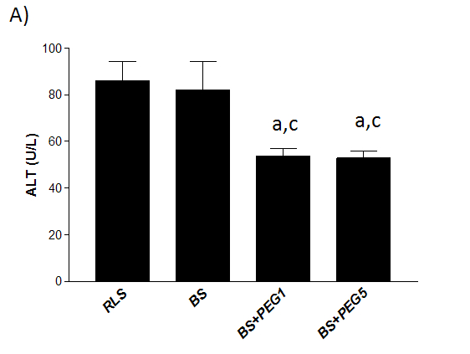
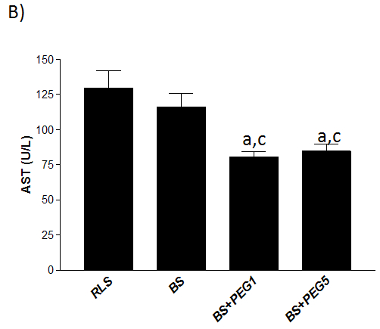

Figure 2 Bile production and vascular resistance (A), in livers rinsed with different washout solutions (RLS, BS, BS+PEG1, and BS+PEG5) and subjected to 2 h of normothermic reperfusion (B). ªP < 0.05 vs RLS; ^{c}P < 0.05 vs BS. PEG: polyethylene glycol; RLS: Ringer’s lactate solution; BS: Base Solution; BS+PEG1: BS with PEG-35 at 1 g/L; BS+PEG5: BS with PEG-35 at 5 g/L.
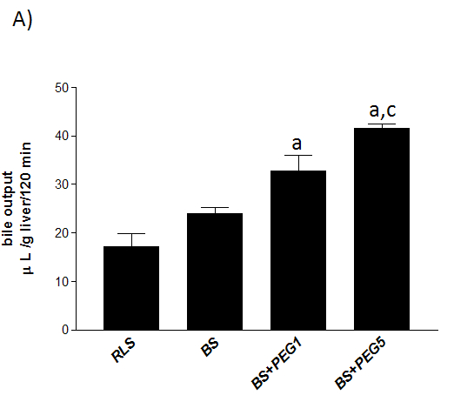
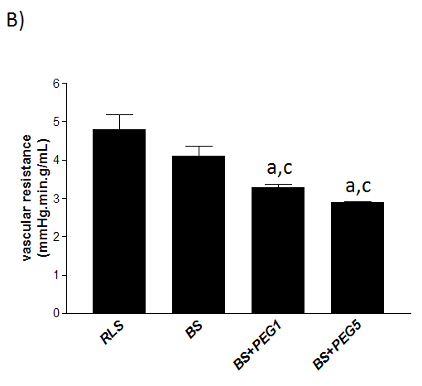

Figure 3 Hepatic malondialdehyde (A) and Glutamate dehydrogenase (B) in livers rinsed with different washout solutions (RLS, BS, BS+PEG1, and BS+PEG5) and subjected to 2 h of normothermic reperfusion. ªP < 0.05 vs RLS; ^{c}P < 0.05 vs BS. PEG: Polyethylene glycol; RLS: Ringer’s lactate solution; BS: Base Solution; BS+PEG1: BS with PEG-35 at 1 g/L; BS+PEG5: BS with PEG-35 at 5 g/L.
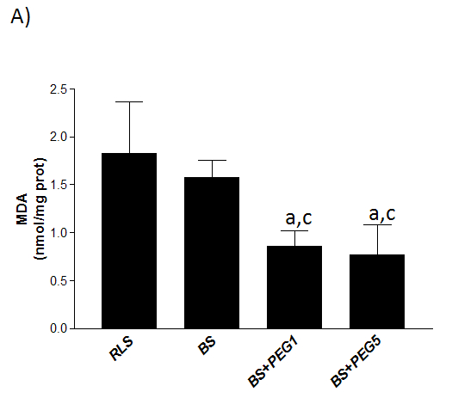
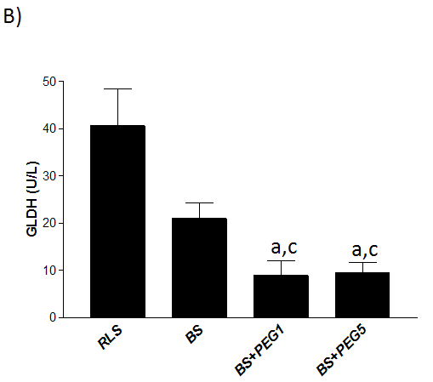

Figure 4 Phosphorylated adenosine monophosphate-activated protein kinase protein levels (A), e-NOS protein levels (B) and nitrites and nitrates (C) in livers flushed with different washout solutions (RLS, BS, BS+PEG1, and BS+PEG5) and subjected to 2 h of normothermic reperfusion. ªP < 0.05 vs RLS; ^{c}P < 0.05 vs BS. PEG: Polyethylene glycol; RLS: Ringer’s lactate solution; BS: Base Solution; BS+PEG1: BS with PEG-35 at 1 g/L; BS+PEG5: BS with PEG-35 at 5 g/L.
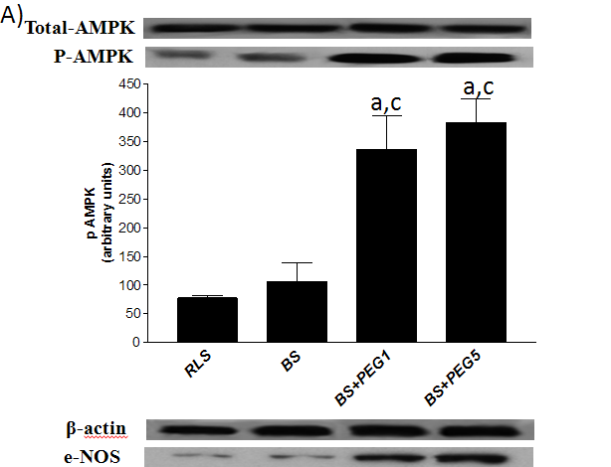
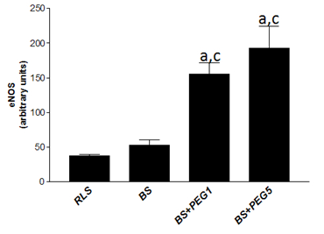
B
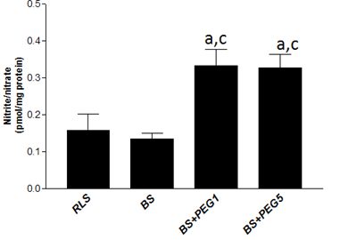
C

Figure 5 Heme oxygenase 1 (HO-1) (A) and HSP70 (B) protein levels in livers flushed with different washout solutions (RLS, BS, BS+PEG1, and BS+PEG5) and subjected to 2 h of normothermic reperfusion. ªP < 0.05 vs RLS; ^{c}P < 0.05 vs BS; ^{e}P < 0.05 vs BS+PEG1. PEG: Polyethylene glycol; RLS: Ringer’s lactate solution; BS: Base Solution; BS+PEG1: BS with PEG-35 at 1 g/L; BS+PEG5: BS with PEG-35 at 5 g/L.
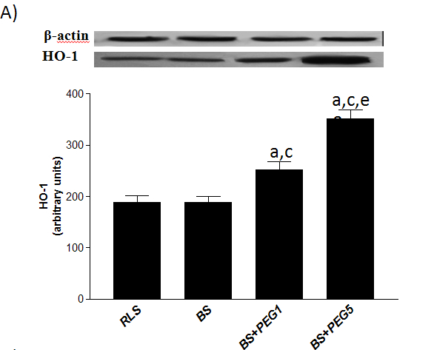

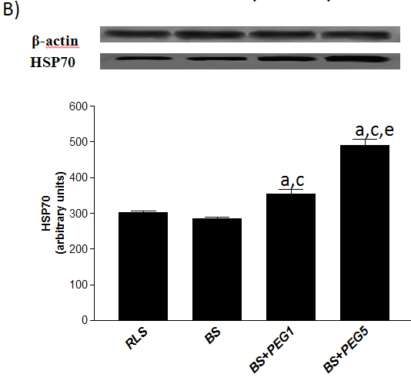

Figure 6 Effects of washout on liver cytoskeleton changes: changes in filamentous actin (F-actin) and globular actin (G -actin) ratio in livers flushed with different washout solutions (RLS, BS, BS+PEG1, and BS+PEG5) and subjected to 2 h of normothermic reperfusion. ªP < 0.05 vs RLS; ^{c}P < 0.05 vs BS; ^{e}P < 0.05 vs BS+PEG1. PEG: Polyethylene glycol; RLS: Ringer’s lactate solution; BS: Base Solution; BS+PEG1: BS with PEG-35 at 1 g/L; BS+PEG5: BS with PEG-35 at 5 g/L.
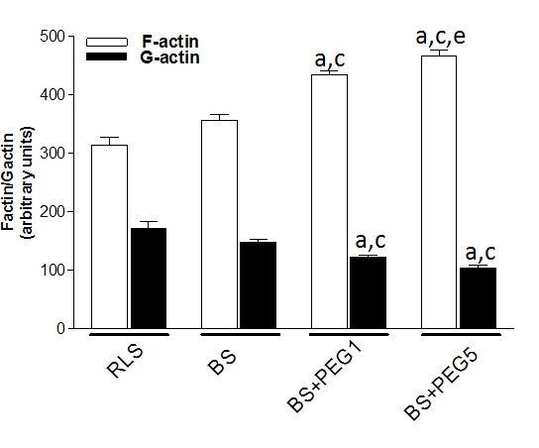

Figure 7 Effects of washout on metalloproteinases MMP2 (A) and MMP9 (B) protein activity levels in livers flushed with different washout solutions (RLS, BS, BS+PEG1, and BS+PEG5) and subjected to 2 h of normothermic reperfusion. ªP < 0.05 vs RLS; ^{c}P < 0.05 vs BS; ^{e}P < 0.05 vs BS+PEG1. PEG: Polyethylene glycol; RLS: Ringer’s lactate solution; BS: Base Solution; BS+PEG1: BS with PEG-35 at 1 g/L; BS+PEG5: BS with PEG-35 at 5 g/L.
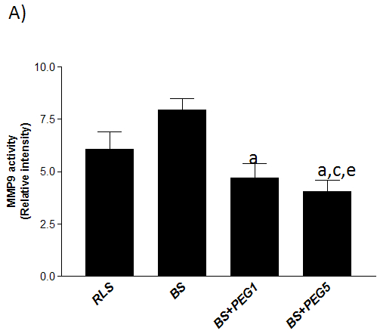

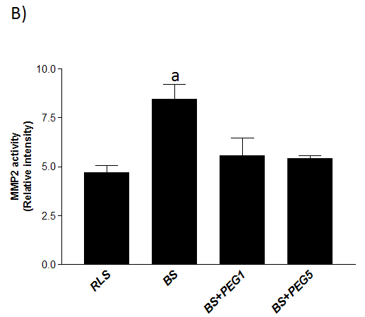

Figure 8 Confocal microscopy findings of a sinusoidal shape when livers were rinsed in a 5 g/L concentration of the polyethylene glycol 35 (PEG-35) solution.
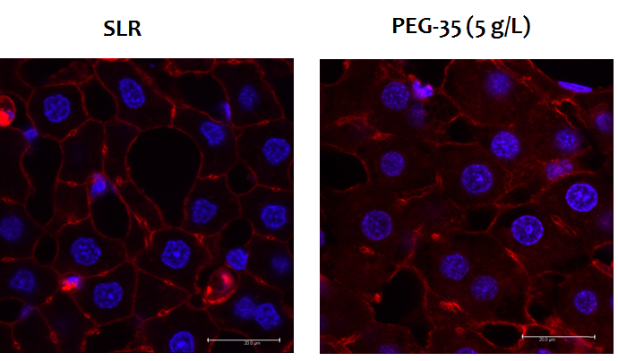
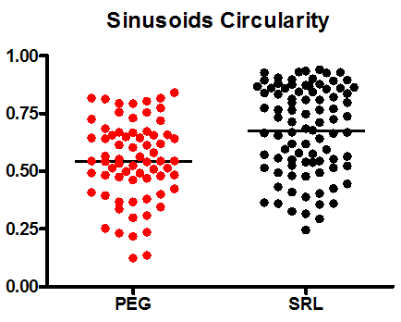

Figure 9 Effects of washout solution on liver graft autophagy: Beclin 1 (A) and LCB3 (B) protein levels in liver rinsed with different washout solutions (RLS, BS, BS+PEG1, and BS+PEG5). ªP < 0.05 vs RLS; ^{c}P < 0.05 vs BS; ^{e}P < 0.05 vs BS+PEG1. PEG: polyethylene glycol; RLS: Ringer’s lactate solution; BS: Base Solution; BS+PEG1: BS with PEG-35 at 1 g/L; BS+PEG5: BS with PEG-35 at 5 g/L.
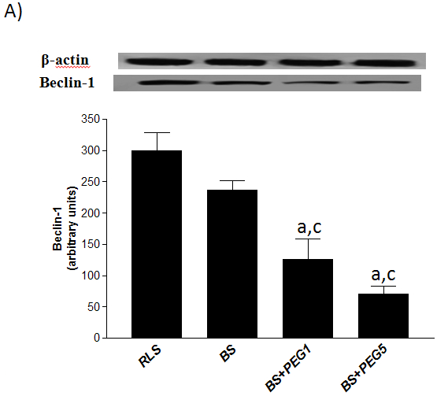
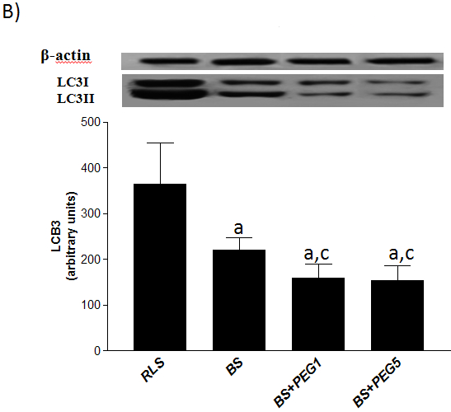

Table 1 Composition of the different rinse solutions used: Ringer’s lactate solution, Base Solution, BS with PEG-35 at 1 g/L, and BS with PEG-35 at 5 g/L
Ringer lactate solution
Composition | Concentration (mg/100 mL)
NaCl | 600
KCl | 40
CaCl₂.2H₂O | 27
NaC₃H₅O₃ | 312
Osmolarity (mOsm/L) | 277
PH | 5,0-7

Table 2 Benefits of polyethylene glycol 35 washout solution
Base solution
Composition | Concentration (mmol/L )
CaCl₂.2H₂O | 1.3
KH₂PO₄ | 5
NaH₂PO₄ | 20
MgSO₄.7H₂O | 5
Lactobionic acid | 100
Raffinose | 30
PH | 7.4
Osmolarity mOsm/L | 320

