Name of Journal: World Journal of Clinical Cases
Manuscript NO: 69258
Manuscript Type: CASE REPORT

Severe mediastinitis and pericarditis after endobronchial ultrasound-guided transbronchial needle aspiration: A case report

Koh JS et al. Mediastinitis and pericarditis after EBUS-TBNA

Jeong Suk Koh, Yoon Joo Kim, Da Hyun Kang, Jeong Eun Lee, Song-I Lee

Jeong Suk Koh, Yoon Joo Kim, Da Hyun Kang, Jeong Eun Lee, Song-I Lee, Department of Pulmonary and Critical Care Medicine, Chungnam National University Hospital, Daejeon 35015, South Korea

Author contributions: Koh JS and Lee SI, the patient’s attending physicians, reviewed the literature and contributed to manuscript drafting; Kim YJ reviewed the literature and contributed to manuscript drafting; Kang DH analyzed and interpreted the imaging findings; Koh JS, Kang DH, Lee JE, and Lee SI were responsible for the revision of the manuscript for important intellectual content; all authors issued final approval for the version to be submitted.

Corresponding author: Song-I Lee, MD, Adjunct Professor, Department of Pulmonary and Critical Care Medicine, Chungnam National University Hospital, 282 Munhwa-ro, Jung-gu, Daejeon 35015, South Korea. newcomet01@naver.com

Received: June 28, 2021
Revised: July 29, 2021
Accepted: October 8, 2021
Published online: October 14, 2021

Abstract
BACKGROUND
Endobronchial ultrasound-guided transbronchial needle aspiration (EBUS-TBNA) is a safe and minimally invasive diagnostic tool for mediastinal and hilum evaluation. However, infectious complications may occur after EBUS-TBNA. Among these, mediastinitis and pericarditis are rare.

CASE SUMMARY
A 67-year-old woman was referred to our hospital due to paratracheal lymph node enlargement on chest computed tomography (CT). EBUS-TBNA was performed on the lymph node lesions, and prophylactic oral antibiotics were administered. Seven days after EBUS-TBNA, the patient visited the emergency room with a high fever and chest pain. Laboratory test results revealed leukocytosis with a left shift and elevated C-reactive protein level (25.7 mg/dL). Chest CT revealed the formation of a mediastinal abscess in the right paratracheal lymph node and pericardial and bilateral pleural effusions. The patient received intravenous antibiotic treatment, cardiac drainage through pericardiocentesis, and surgical management. The patient recovered favorably and was discharged 31 d after the operation.

CONCLUSION
Mediastinitis and pericarditis after EBUS-TBNA are rare but should be considered even after the use of prophylactic antibiotics.

Key Words: Endoscopic ultrasound-guided fine needle aspiration; Complication; Mediastinitis; Pericarditis; Antibiotics; Case report

Koh JS, Kim YJ, Kang DH, Lee JE, Lee SI. Severe mediastinitis and pericarditis after endobronchial ultrasound-guided transbronchial needle aspiration: A case report. World J Clin Cases 2021; In press

Core Tip: Acute mediastinitis and pericarditis are rare complications of endobronchial ultrasound-guided transbronchial needle aspiration (EBUS-TBNA). This case presented with acute mediastinitis and pericarditis that developed despite prophylactic antibiotic use after EBUS-TBNA and improved after antibiotic and surgical management.

INTRODUCTION
Endobronchial ultrasound-guided transbronchial needle aspiration (EBUS-TBNA) is used to biopsy enlarged lymph nodes in the mediastinum and hilum to stage patients with lung cancer and to provide a definitive diagnosis of lymphadenopathy. Although EBUS-TBNA is a safer and less invasive procedure than mediastinoscopy, severe complications can occur; A major complication rate of 0.3% was found in one meta-analysis^{[1]}. Complications such as massive bleeding, cardiac tamponade, hemomediastinum, pneumomediastinum and pneumothorax have been reported as a complication of TBNA^{[1,2]}. However, mediastinitis and pericarditis rarely occur after EBUS-TBNA. Here, we report the successful use of cardiac drainage and exploratory thoracotomy for drainage of a mediastinal abscess in a patient who developed acute severe mediastinitis with pericarditis after EBUS-TBNA.

CASE PRESENTATION
Chief complaints
The patient presented with a high fever and chest pain. Seven days after EBUS-TBNA, she visited the emergency room.

History of present illness
A 67-year-old woman was referred to our hospital because of lymph node enlargement on chest computed tomography (CT) (Figure 1). EBUS-TBNA of the right paratracheal lymph node was performed using a 22-gauge needle to obtain the tissue core. A total of 11 punctures were performed due to insufficient tissue cores. Prophylactic antibiotics (amoxicillin/clavulanate) were administered to prevent infectious complications after the procedure. Histological examination of the specimen revealed negative malignant cells and no bacteria.

History of past illness
The patient had no comorbidities.

Personal and family history
The patient and families were previously healthy.

Physical examination
On physical examination, the patient appeared acutely ill with a clear mental status. The patient was febrile (37.8°C) and had a stable blood pressure of 100/68 mmHg, pulse rate of 107 bpm, respiratory rate of 18/min, and body temperature of 37.8°C. The breath sounds on the left side of the chest were decreased.

Laboratory examinations
Laboratory tests revealed leukocytosis with a left shift and the following results: White blood cell count: 14410/mm³; neutrophils: 81.3%; hemoglobin: 9.8 g/dL; platelet count: 198000/mm³. Blood chemistry showed elevated total bilirubin (1.40 mg/dL), aspartate aminotransferase (132 U/L), and alanine aminotransferase (137 U/L) levels in a normal renal panel. The cardiac enzyme level was normal, and the NT-proBNP level was slightly high (562.6 pg/mL). C-reactive protein level was elevated (25.7 mg/dL) and lactic acid level was within the normal range.

Imaging examinations
Chest radiography revealed left lung field haziness with pleural effusion and cardiomegaly (Figure 2). Emergency echocardiography revealed pericardial effusion of > 1 cm, and the blood pressure dropped (85/51 mmHg) after emergency echocardiography; cardiac drainage through the pericardiocentesis was performed. Chest CT showed a mediastinal abscess formation in the right paratracheal lymph node and pericardial and bilateral pleural effusions (Figure 2).

FINAL DIAGNOSIS
The final diagnosis in the present case was mediastinitis and pericarditis after EBUS-TBNA.

TREATMENT
Intravenous antibiotic treatment was initiated. Exploratory thoracotomy was performed by consulting the thoracic and cardiovascular surgery department. Surgical observation revealed whole lung adhesions, mediastinal abscesses, and effusions in the lymph node area. Surgery was completed after adhesiolysis, irrigation, and drainage.
Postoperatively, laboratory findings and the patient’s general condition gradually improved. The cardiac drainage tube and chest drainage were removed 4 d and 16 d postoperatively, respectively (Figure 3). No bacterial pathogens were detected in the specimens obtained from the pericardial and abscess drainage.

OUTCOME AND FOLLOW-UP
The patient recovered favorably and was discharged 31 d after the operation. There was no evidence of recurrence within the 12 mo follow-up period.

DISCUSSION
Convex-probe EBUS-TBNA is a minimally invasive diagnostic technique for peritracheal and peribronchial areas^{[3]}. EBUS-TBNA identifies the puncture site through real-time ultrasound guidance, allowing accurate sampling from lesions and cytological and histological diagnosis. The cumulative sensitivity of EUBS-TBNA is 88%-93% and the cumulative specificity is 100% in lymph node staging of lung cancer^{[4,5]}.
The overall major complication rate of this procedure was found to be 0.23%-1.23% in a previous meta-analysis^{[1,2]}. Pneumothorax, hemopericardium, and infections such as mediastinitis, pericarditis, and abscesses are reportedly caused by EBUS-TBNA^{[1,2]}. In 7345 EBUS-TBNA cases in Japan, hemorrhage was the most frequent complication (0.68%), followed by infection (0.19%, mediastinitis, n = 7; pneumonia, n = 4; pericarditis, n = 1; cyst infection, n = 1) and pneumothorax (0.03%)^{[2]}. As such, the probability of mediastinitis and pericarditis occurring as a complication of EBUS-TBNA is very low. In addition, case reports revealing the occurrence of mediastinitis or pericarditis after EBUS-TBNA are rare^{[6-12]}.
Antibiotic prophylaxis is not used in most EBUS-TBNA cases. However, in this case, mediastinitis and pericarditis occurred even with the use of prophylactic antibiotics. Antibacterial precautions are not recommended for routine diagnostic bronchoscopy, unless there is a previous history of spleen removal, artificial heart valves, or endocarditis^{[13]}. This patient with an enlarged, homogeneous right paratracheal lymph node underwent diagnostic EBUS-TBNA with a 22-gauge needle to obtain the tissue core. A total of 11 punctures were performed because of insufficient tissue cores. Multiple needle passes would have caused mediastinitis and pericarditis in this patient. There are no definitive guidelines regarding which prophylactic antibiotics should be used and for which patients. Despite the use of amoxicillin/clavulanate in this patient, infectious complications occurred; therefore, further research is needed to determine the optimal antibiotic course.
In this case, the patient recovered with the help of antibiotics, pericardial drainage, and surgery. Mediastinitis, with a mortality rate of approximately 50%, is a life-threatening condition that requires aggressive treatment with both broad-spectrum antibiotics and surgical intervention^{[14]}. Appropriate antibiotic therapy and pericardial drainage may be helpful in treating infectious pericarditis. If vital signs are unstable, immediate pericardial drainage can help prevent pericardial tamponade in patients^{[15]}.

CONCLUSION
In conclusion, we reported a patient who developed mediastinitis and pericarditis as complications of EBUS-TBNA, even after the use of prophylactic antibiotics. Although EBUS-TBNA is a minimally invasive diagnostic and treatment option, the possibility of serious complications needs to be considered. Further research is needed to determine which type of prophylactic antibiotic should be used in at-risk patients.

REFERENCES
1 Holty JE, Kuschner WG, Gould MK. Accuracy of transbronchial needle aspiration for mediastinal staging of non-small cell lung cancer: a meta-analysis. Thorax 2005; 60: 949-955 [PMID: 15994251 DOI: 10.1136/thx.2005.041525]
2 Asano F, Aoe M, Ohsaki Y, Okada Y, Sasada S, Sato S, Suzuki E, Semba H, Fukuoka K, Fujino S, Ohmori K. Complications associated with endobronchial ultrasound-guided transbronchial needle aspiration: a nationwide survey by the Japan Society for Respiratory Endoscopy. Respir Res 2013; 14: 50 [PMID: 23663438 DOI: 10.1186/1465-9921-14-50]
3 Yasufuku K, Chiyo M, Sekine Y, Chhajed PN, Shibuya K, Iizasa T, Fujisawa T. Real-time endobronchial ultrasound-guided transbronchial needle aspiration of mediastinal and hilar lymph nodes. Chest 2004; 126: 122-128 [PMID: 15249452 DOI: 10.1378/chest.126.1.122]
4 Gu P, Zhao YZ, Jiang LY, Zhang W, Xin Y, Han BH. Endobronchial ultrasound-guided transbronchial needle aspiration for staging of lung cancer: a systematic review and meta-analysis. Eur J Cancer 2009; 45: 1389-1396 [PMID: 19124238 DOI: 10.1016/j.ejca.2008.11.043]
5 Shen Y, Qin S, Jiang H. Endobronchial ultrasound-guided transbronchial needle aspiration combined with either endoscopic ultrasound-guided fine-needle aspiration or endoscopic ultrasound using the EBUS scope-guided fine-needle aspiration for diagnosing and staging mediastinal diseases: a systematic review and meta-analysis. Clinics (Sao Paulo) 2020; 75: e1759 [PMID: 33084766 DOI: 10.6061/clinics/2020/e1759]
6 Inoue T, Nishikawa T, Kunimasa K, Tamiya M, Kuhara H, Nishino K, Fujiwara M, Fujita M, Imamura F, Kumagai T. Infectious pericarditis caused by Gemella sanguinis induced by Endobronchial Ultrasound-guided Transbronchial Needle Aspiration (EBUS-TBNA): A case report. Respir Med Case Rep 2020; 30: 101057 [PMID: 32346508 DOI: 10.1016/j.rmcr.2020.101057]
7 Jahoor A, Ghamande S, Jones S, Boethel C, White HD. Mediastinitis Following Endobronchial Ultrasound-guided Transbronchial Needle Aspiration. J Bronchology Interv Pulmonol 2017; 24: 323-329 [PMID: 28195963 DOI: 10.1097/LBR.0000000000000370]
8 Jain A, Nayyar P, Chitkeshi V, Bahl A. An unusual complication after endobronchial ultrasound-guided transbronchial needle aspiration: Case report. Breathe (Sheff) 2018; 14: e6-e11 [PMID: 29928465 DOI: 10.1183/20734735.014717]
9 Lee HY, Kim J, Jo YS, Park YS. Bacterial pericarditis as a fatal complication after endobronchial ultrasound-guided transbronchial needle aspiration. Eur J Cardiothorac Surg 2015; 48: 630-632 [PMID: 25500728 DOI: 10.1093/ejcts/ezu477]
10 Liu W, Wang Y, Zhang W, Wu H, Liu Z. Pneumonia, pleurisy, mediastinitis, and mediastinal cyst infection secondary to endobronchial ultrasound-guided transbronchial needle aspiration: A case report. Medicine (Baltimore) 2021; 100: e25973 [PMID: 34011084 DOI: 10.1097/MD.0000000000025973]
11 Matsuoka K, Ito A, Murata Y, Sakane T, Watanabe R, Imanishi N, Matsuoka T, Nagai S, Ueda M, Miyamoto Y. Severe Mediastinitis and Pericarditis After Transbronchial Needle Aspiration. Ann Thorac Surg 2015; 100: 1881-1883 [PMID: 26522531 DOI: 10.1016/j.athoracsur.2014.12.093]
12 Yokoyama Y, Nakagomi T, Shikata D, Higuchi R, Oyama T, Goto T. Surgical treatment for mediastinal abscess induced by endobronchial ultrasound-guided transbronchial needle aspiration: a case report and literature review. World J Surg Oncol 2017; 15: 130 [PMID: 28709438 DOI: 10.1186/s12957-017-1206-4]
13 British Thoracic Society Bronchoscopy Guidelines Committee, a Subcommittee of Standards of Care Committee of British Thoracic Society. British Thoracic Society guidelines on diagnostic flexible bronchoscopy. Thorax 2001; 56 Suppl 1: i1-21 [PMID: 11158709 DOI: 10.1136/thorax.56.suppl_1.i1]
14 Prado-Calleros HM, Jiménez-Fuentes E, Jiménez-Escobar I. Descending necrotizing mediastinitis: Systematic review on its treatment in the last 6 years, 75 years after its description. Head Neck 2016; 38 Suppl 1: E2275-E2283 [PMID: 26829352 DOI: 10.1002/hed.24183]
15 Imazio M, Gaita F, LeWinter M. Evaluation and Treatment of Pericarditis: A Systematic Review. JAMA 2015; 314: 1498-1506 [PMID: 26461998 DOI: 10.1001/jama.2015.12763]

Footnotes
Informed consent statement: Written informed consent was obtained from the patient for publication of this report and any accompanying images.

Conflict-of-interest statement: The authors declare that they have no conflicts of interest.

CARE Checklist (2016) statement: The authors have read the CARE Checklist (2016), and the manuscript was prepared and revised according to the CARE Checklist (2016).

Open-Access: This article is an open-access article that was selected by an in-house editor and fully peer-reviewed by external reviewers. It is distributed in accordance with the Creative Commons Attribution NonCommercial (CC BY-NC 4.0) license, which permits others to distribute, remix, adapt, build upon this work non-commercially, and license their derivative works on different terms, provided the original work is properly cited and the use is non-commercial. See: http://creativecommons.org/Licenses/by-nc/4.0/

Manuscript source: Unsolicited manuscript

Peer-review started: June 28, 2021
First decision: July 26, 2021
Article in press: October 8, 2021

Specialty type: Respiratory system
Country/Territory of origin: South Korea
Peer-review report’s scientific quality classification
Grade A (Excellent): 0
Grade B (Very good): B
Grade C (Good): C
Grade D (Fair): 0
Grade E (Poor): 0

P-Reviewer: Fusaroli P S-Editor: Wu YXJ L-Editor: A P-Editor: Wu YXJ

Figure Legends
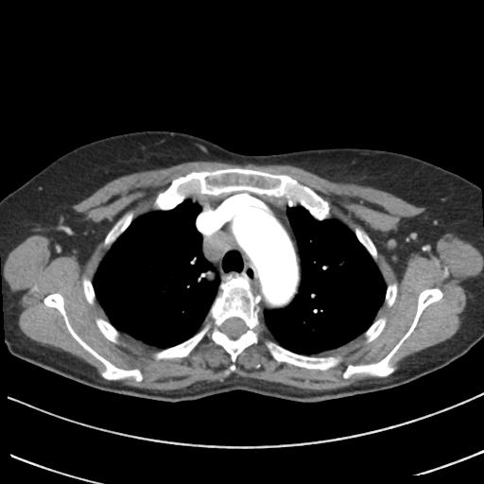
Figure 1 Chest computed tomography before endobronchial ultrasound-guided transbronchial needle aspiration demonstrated enlargement of the right paratracheal lymph node.

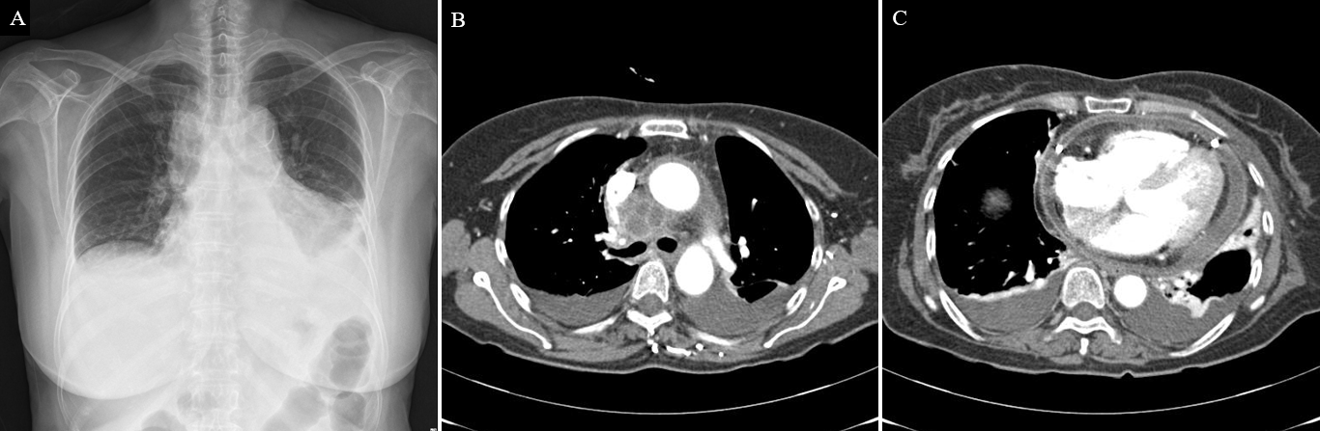
Figure 2 Chest X-ray radiograph and computed tomography. A: Chest X-ray radiograph showed both pleural effusion and cardiomegaly; B and C: Chest computed tomography performed 7 d after ultrasound-guided transbronchial needle aspiration demonstrating (B) an increased size and mediastinal abscess formation in the right paratracheal area and (C) newly developed moderate amounts of pericardial effusion with diffuse pericardial thickening.

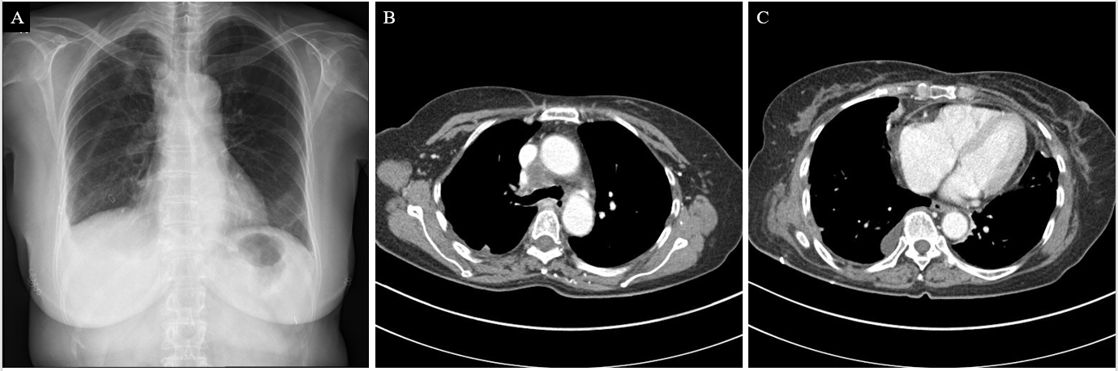
Figure 3 Chest X-ray radiograph and computed tomography. A: Chest X-ray radiograph findings improved after removal of the chest tube and drainage catheter; B and C: Chest computed tomography demonstrated (B) a decrease in size of the right paratracheal lymph node and (C) decreased amount of pericardial effusion and improvement in diffuse pericardial thickening.

