Name of journal: World Journal of Transplantation
ESPS Manuscript NO: 14882
Columns: Case Report

Successful endovascular treatment of transplant intrarenal artery stenosis in renal transplant recipients: Two case reports

Koukoulaki M et al. endovascular treatment of transplant artery stenosis

Maria Koukoulaki, Elias Brountzos, Ioannis Loukopoulos, Maria Pomoni, Eleni Antypa, Vasileios Vougas, Spiros Drakopoulos

Maria Koukoulaki, Ioannis Loukopoulos, Eleni Antypa, Vasileios Vougas, Spiros Drakopoulos, Transplant Unit, Evangelismos General Hospital of Athens, 10676 Athens, Greece

Elias Brountzos, Maria Pomoni, Research Unit of Radiology and Medical Imaging, Eugenideion Hospital, University of Athens, 11141 Athens, Greece

Author contributions: Koukoulaki M, Loukopoulos I, Vougas V and Drakopoulos S designed the report; Brountzos E, Pomoni M and Antypa E performed the radiologic assessment and procedures; Koukoulaki M, Loukopoulos I, Vougas V and Drakopoulos S collected the patient’s clinical data; Koukoulaki M and Loukopoulos I analyzed the data and wrote the paper.

Ethics approval: Ethics approval was not required.

Informed consent: Informed consent was obtained prior to initiation of procedure.

Conflict-of-interest: None.

Open-Access: This article is an open-access article which selected by an in-house editor and fully peer-reviewed by external reviewers. It distributed in accordance with the Creative Commons Attribution Non Commercial (CC BY-NC 4.0) license, which permits others to distribute, remix, adapt, build upon this work non-commercially, and license their derivative works on different terms, provided the original work is properly cited and the use is non-commercial. See: http://creativecommons.org/licenses/by-nc/4.0/

Correspondence to: Maria Koukoulaki, MD, MPhil (Cantab), PhD, Renal Transplant Unit, Evangelismos General Hospital of Athens, 45-47 Ipsilantou street, 10676 Athens, Greece. mkoukoulaki@gmail.com

Telephone: +30-210-7233422
Fax: +30-210-7233421

Received: October 29, 2014
Peer-review started: October 31, 2014
First decision: November 14, 2014
Revised: February 2, 2015
Accepted: March 18, 2015
Article in press:
Published online:

Abstract
Transplant renal artery stenosis (TRAS) is a relatively rare complication after renal transplantation. The site of the surgical anastomosis is most commonly involved, but sites both proximal and distal to the anastomosis may occur, as well. Angioplasty is the gold standard for the treatment of the stenosis, especially for intrarenal lesions. We report two cases of intrarenal TRAS and successful management with angioplasty without stent placement. Both patients were male, 44 and 55 years old respectively, and they presented with elevated blood pressure or serum creatinine within three months after transplantation. Subsequently, they have undergone angioplasty balloon dilatation with normalization of blood pressure and serum creatinine returning to baseline level. Percutaneous transluminal balloon renal angioplasty is a safe and effective method for the treatment of the intrarenal TRAS.

Key words: Transplant renal artery stenosis; Intrarenal stenosis; Hypertension; Renal transplantation; Allograft dysfunction; Angioplasty; Endovascular treatment

© The Author(s) 2015. Published by Baishideng Publishing Group Inc. All rights reserved.

Core tip: Transplant renal artery stenosis is a relatively rare complication after renal transplantation and usually affects the site of the surgical anastomosis. Intrarenal stenosis is rather uncommon, manifesting with uncontrolled hypertension and rise in serum creatinine. Angioplasty is the gold standard for the treatment of the stenosis, especially for intrarenal lesions.

Koukoulaki M, Brountzos E, Loukopoulos I, Pomoni M, Antypa E, Vougas V, Drakopoulos S. Successful endovascular treatment of transplant intrarenal artery stenosis in renal transplant recipients: Two case reports. World J Transplantation 2015; In press

INTRODUCTION
Transplant renal artery stenosis (TRAS) is a common complication after renal transplantation. Its incidence varies between 2.7%-23%^{[1]}. Its clinical consequences are renal dysfunction which occurs with elevation in serum creatinine or refractory hypertension. The ultrasound is the first tool for the diagnosis of the stenosis but the angiography is method of choice for the confirmation of the diagnosis^{[2]}. Angioplasty is the gold standard for the treatment of the disease and allows the placement of intraluminal stents to maintain patency of the stenosed segments^{[3,4]}. It can be localized at the site of the anastomosis, proximal or distal to the anastomosis at the iliac artery. Rarely the site of the stenosis can be localized into the renal parenchyma. We present two patients who underwent renal transplantation from cadaveric donors and who developed renal artery stenosis at the intrarenal segment of the transplant artery during the early postoperative period.

CASE REPORT
Case 1
A 44 years old man received a first cadaveric renal allograft. He suffered end-stage renal disease due to chronic pyelonephritis. Demographic characteristics are shown in Table 1. Immunosuppression included induction therapy with basiliximab and triple regimen (cyclosporine, mycophenolate mofetyl and corticosteroids). The patient had immediate recovery of graft function. The ultra-sound routinely performed on day 3 was normal. Four months after transplantation the patient presented with elevated blood pressure (180/100 mmHg) and elevated serum creatinine (4.2 mg/dL) and readmitted to the hospital. The ultrasound revealed a severe stenosis at the midportion of the renal transplant artery. Angiography confirmed 70% stenosis at the intrarenal portion of the branch which supplies the middle and lower portion of the kidney (Figure 1A), and angioplasty was performed using a 3.5 mm balloon (Figure 2A). One week after the transplantation the serum creatinine was at 2.3 mg/dL and the blood pressure was normal. Sequential values of serum creatinine are plotted in Figure 3. Since then the recipient has good renal graft function during follow-up for 14 mo.

Case 2
A 55 years old man with end stage renal disease due to membranous glomerulopathy received a cadaveric kidney. Induction therapy was administered with basiliximab followed by triple immunosuppressive regimen (cyclosporine, mycophenolate mofetyl and corticosteroids). Two months after transplantation during the routine follow-up, an elevated serum creatinine was discovered (4.7 mg/dL). An ultrasonography raised suspicion of severe stenosis at the intrarenal portion of the two main branches of the renal transplant artery. The finding was confirmed by angiography (Figure 1B) and subsequently the patient was submitted to angioplasty dilatation using a 5 f balloon (Figure 2B). Five days after the angioplasty the serum creatinine was 1.8 mg/dL. Sequential values of serum creatinine are plotted in Figure 3. During a one year follow-up the patient is well with satisfactory renal graft function.

DISCUSSION
The incidence of TRAS varies between 2.7% to 23%^{[1]}. Risk factors for its development are poor anastomotic technique, traction injuries on the renal artery at the time of retrieval, intimal damage at the time of perfusion and atheroma at the site of the anastomosis. The role of acute rejection is controversial but chronic allograft nephropathy may play a role^{[5]}. In our study both of the recipients were not older than 55 years old, there was not acute rejection episode, the stenosis was located distal to the anastomosis and into the renal parenchyma, and it occurred early after the transplantation. So it is difficult to consider one of the above mentioned factors as responsible for the arterial stenosis.
The clinical presentations of stenotic lesions are variable. Most of them present with progressive accelerated hypertension with or without biochemical evidence of renal allograft dysfunction, or they discovered incidentally during the routine follow-up examination^{[3]}.
The Doppler and color flow Duplex ultrasound are highly sensitive for the diagnosis of TRAS^{[6,7]}. Of course both of them are operator dependent, but are also non invasive and can give some extra information of anatomical details. In our study the ultrasound was able to demonstrate not only the stenosis but also to pinpoint the exact segment and the degree of the stenosis.
Angiography is still the method of choice for the confirmation of the diagnosis of a stenosis, even in cases that non invasive methods have demonstrated its existence. It allows the complete visualization of the graft vasculature, and also the proximal ipsilateral arterial segments. There are potential complications, such as thromboembolism, haematoma formation, pseudoaneurysm and AV fistula formation. None of these complications occurred in our patients.
Percutaneous transluminal balloon renal angioplasty is considered to be the gold standard for the treatment of TRAS. Moreover there is the possibility of intraluminal stent placement for the preservation of the patency of the vessel lumen mainly in cases of refractory or recurrent stenosis. The success of the procedure is manifested by the improvement of the blood pressure control, the discontinuation of the anti-hypertensive medications and the normalization of the serum creatinine levels. The success rate immediately after the procedure has been reported to be greater than 80%^{[5,8]}. Long term follow-up at one year is reported to be 63%-82%, with the rate of recurrence stenosis after PTA range from 10% to 36%^{[8-10]}.
In both of our cases, the PTA procedure was successful in controlling the blood pressure and normalization of the serum creatinine levels without stent placement, and this result is maintaining more than one year follow-up. No complications such as haematoma, aneurysm thrombosis were observed, although in the first case there was a longitudinal stenosis, and in the second there were two separate stenosis in the renal parenchyma.
The other option for the confrontation of TRAS would be the surgical procedure. The short term success results after surgery is reported to be 81%-95% and the long term patency is maintained in 63%-92% of cases^{[1]}. It must be emphasized however that despite these good success rates surgery is difficult to repair surgically in cases that the location of the stenosis is into the renal parenchyma. In such cases the PTA with or without stent placement is probably the only procedure which could resolve the problem.
Renal graft artery stenosis is a relatively rare complication after renal transplantation, the localization of the stenosis into the renal parenchyma is rather uncommon. The PTRA offers the possibility for a safe treatment with good long term results in such cases were it would be difficult or even impossible for a surgical procedure to be undertaken.

COMMENTS
Case characteristics
Two renal transplant recipients presenting shortly after renal transplantation with uncontrolled blood pressure and elevated serum creatinine.

Clinical diagnosis
Renal transplant artery stenosis.

Differential diagnosis
Renal allograft rejection, CNI toxicity, Interstitial nephritis, Recurrence of primary renal disease.

Laboratory diagnosis
Case 1: Serum Creatinine: 4.2 mg/dL; Case 2: Serum Creatinine 4.7 mg/dL.

Imaging diagnosis
Ultrasound revealed severe stenosis after the orifice of the renal transplant artery.

Angiography diagnosis
Angiography showed 70% stenosis at the intrarenal portion of the branch of renal transplant artery.

Treatment
Angioplasty with balloon dilatation.

Related reports
Intrarenal transplant artery stenosis in rather rare in renal transplant recipients especially when diagnosed relatively recently post renal transplantation.

Term explanation
Angioplasty is the method of choice in repairing renal transplant artery stenosis especially for intrarenal lesions.

Experiences and lessons
Uncontrolled blood pressure in renal transplant recipients should prompt for laboratory exams and further imaging studies.

Peer-review
Authors refer two cases of post-transplant intrarenal artery stenosis leading to renal insufficiency and once elevated blood pressure as well. The applied percutaneous transluminal angioplasty in this condition looks to be safe and long-lasting solution even without stent implantation, so the described cases are worth to be published.

REFERENCES
1 Fervenza FC, Lafayette RA, Alfrey EJ, Petersen J. Renal artery stenosis in kidney transplants. Am J Kidney Dis 1998; 31: 142-148 [PMID: 9428466 DOI: 10.1053/ajkd.1998.v31.pm9428466]
2 O'neill WC, Baumgarten DA. Ultrasonography in renal transplantation. Am J Kidney Dis 2002; 39: 663-678 [PMID: 11920331 DOI: 10.1053/ajkd.2002.31978]
3 Akbar SA, Jafri SZ, Amendola MA, Madrazo BL, Salem R, Bis KG. Complications of renal transplantation. Radiographics 2005; 25: 1335-1356 [PMID: 16160115 DOI: 10.1148/rg.255045133]
4 Beecroft JR, Rajan DK, Clark TW, Robinette M, Stavropoulos SW. Transplant renal artery stenosis: outcome after percutaneous intervention. J Vasc Interv Radiol 2004; 15: 1407-1413 [PMID: 15590798 DOI: 10.1097/01.RVI.0000141338.62574.F4]
5 Wong W, Fynn SP, Higgins RM, Walters H, Evans S, Deane C, Goss D, Bewick M, Snowden SA, Scoble JE, Hendry BM. Transplant renal artery stenosis in 77 patients--does it have an immunological cause? Transplantation 1996; 61: 215-219 [PMID: 8600626 DOI: 10.1097/00007890-199601270-00009]
6 Goel MC, LaPerna L, Whitelaw S, Modlin CS, Flechner SM, Goldfarb DA. Current management of transplant renal artery stenosis: clinical utility of duplex Doppler ultrasonography. Urology 2005; 66: 59-64 [PMID: 15992877 DOI: 10.1016/j.urology.2005.01.031]
7 Voiculescu A, Schmitz M, Hollenbeck M, Braasch S, Luther B, Sandmann W, Jung G, Mödder U, Grabensee B. Management of arterial stenosis affecting kidney graft perfusion: a single-centre study in 53 patients. Am J Transplant 2005; 5: 1731-1738 [PMID: 15943633 DOI: 10.1111/j.1600-6143.2005.00927.x]
8 Sankari BR, Geisinger M, Zelch M, Brouhard B, Cunningham R, Novick AC. Post-transplant renal artery stenosis: impact of therapy on long-term kidney function and blood pressure control. J Urol 1996; 155: 1860-1864 [PMID: 8618274 DOI: 10.1016/S0022-5347(01)66030-0]
9 Fauchald P, Vatne K, Paulsen D, Brodahl U, Sødal G, Holdaas H, Berg KJ, Flatmark A. Long-term clinical results of percutaneous transluminal angioplasty in transplant renal artery stenosis. Nephrol Dial Transplant 1992; 7: 256-259 [PMID: 1315000]
10 Bruno S, Ferrari S, Remuzzi G, Ruggenenti P. Doppler ultrasonography in posttransplant renal artery stenosis: a reliable tool for assessing effectiveness of revascularization? Transplantation 2003; 76: 147-153 [PMID: 12865801 DOI: 10.1097/01.TP.0000071849.78031.13]

P- Reviewer: Fulop T, Nemcsik J S- Editor: Song XX L- Editor: E- Editor:

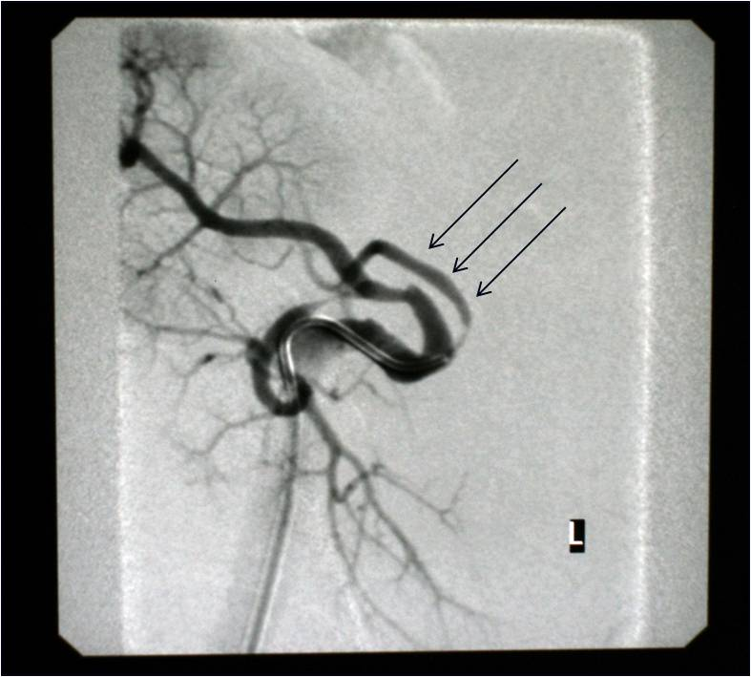
A

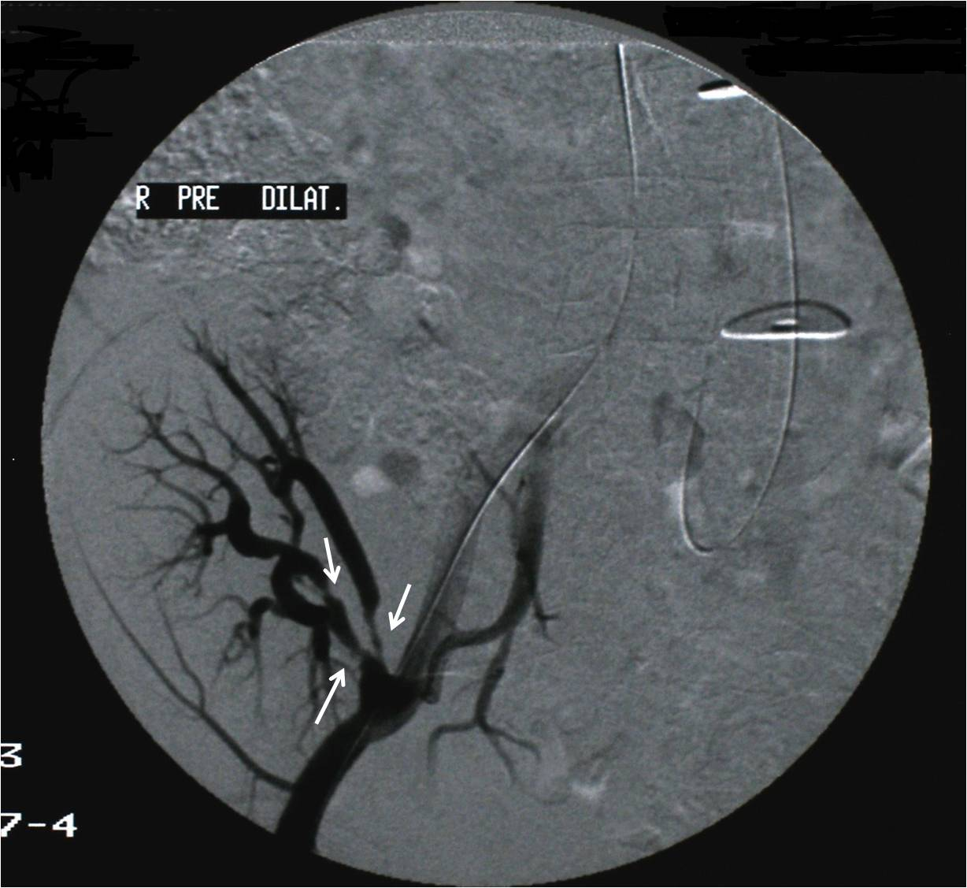
B
Figure 1 Angiography of renal allograft. A: Angiography of renal allograft (Case patient 1) showing significant stenosis of intrarenal branches of renal artery indicated by black arrows; B: Angiography of renal allograft (Case patient 2) showing significant stenosis of intrarenal branches of renal artery indicated by white arrows.

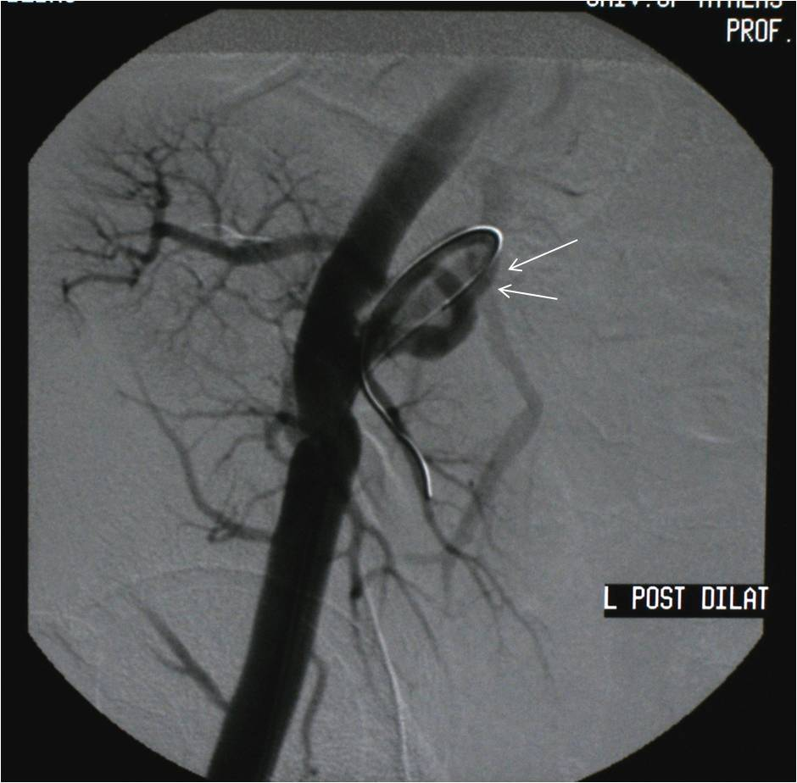
A
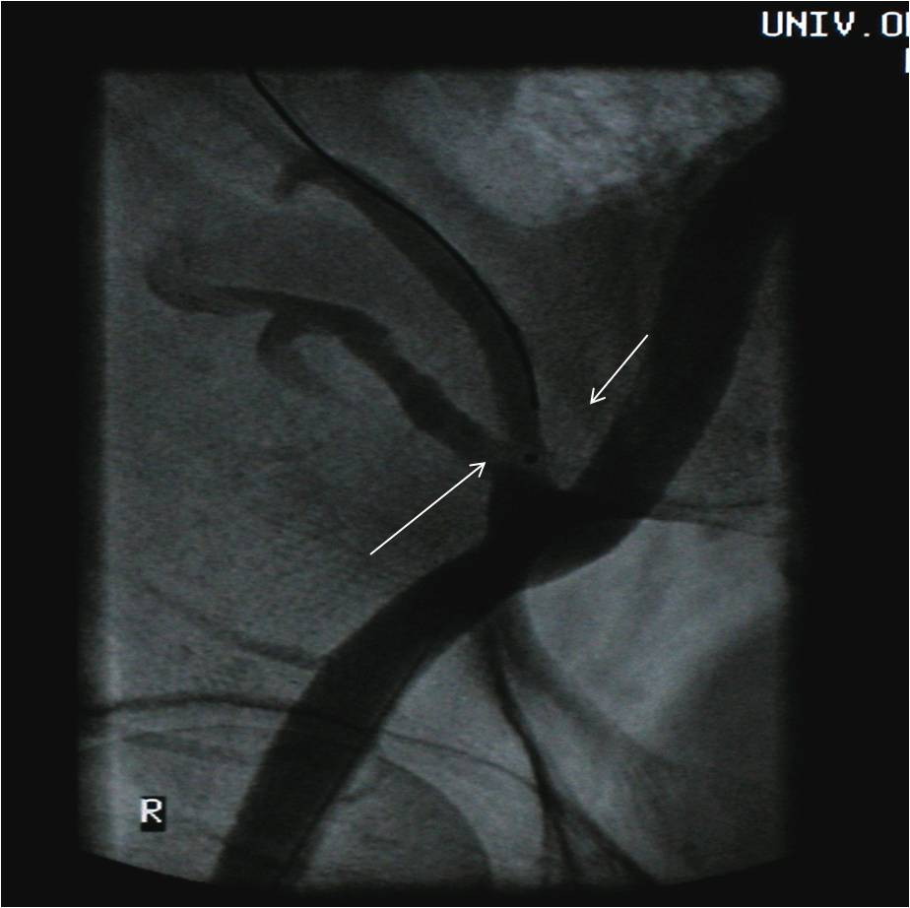
B
Figure 2 Angioplasty with balloon dilatation of stenotic intrarenal lesion and restoration of patency of renal allograft artery. A: Angioplasty with balloon dilatation of stenotic intrarenal lesion and restoration of patency of renal allograft artery indicated by white arrows; B: Angioplasty with balloon dilatation of two stenotic intrarenal lesions and restoration of patency of renal allograft artery indicated by two white arrows.
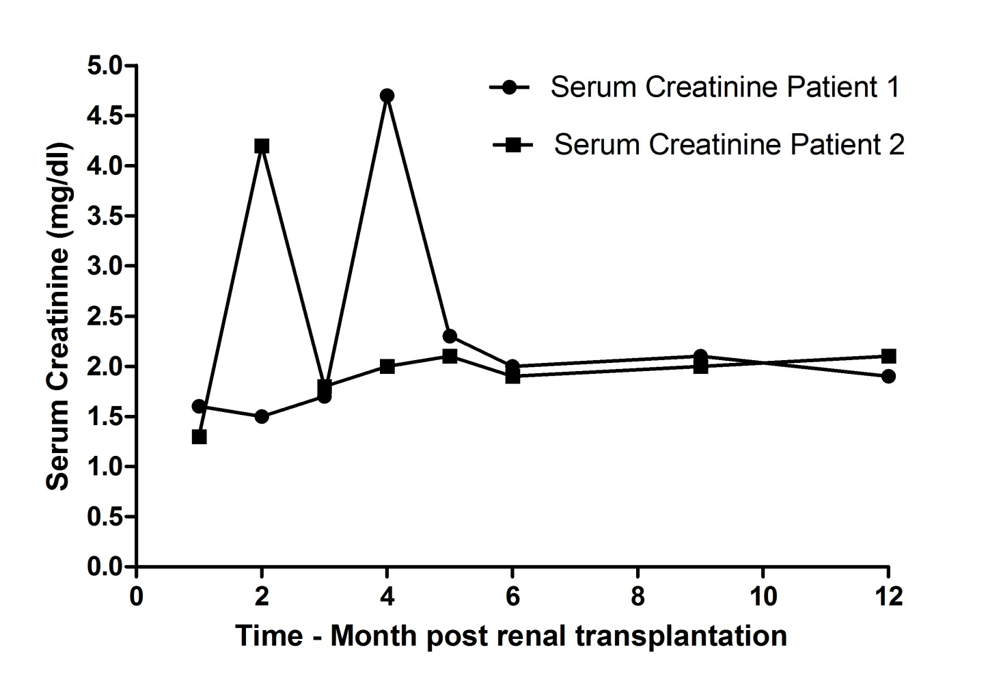
Figure 3 Sequential values of serum creatinine during one year of follow-up post renal transplantation.

Table 1 Demographic characteristics
 | Case patient 1 | Case patient 2
Donor type | Cadaveric | Cadaveric
Donor age (yr) | 67 | 42
Donor gender | Male | Male
Donor co-morbidities | Hypertension | None reported
Donor smoking habit | No | Yes
Recipient age (yr) | 44 | 55
Recipient gender | Male | Male
Recipient primary renal disease | Chronic pyelonephritis | Membranous Glomerulopathy
Time on hemodialysis | 5 yr | 7 yr
Number of antihypertensive agents following repair of intrarenal transplant artery stenosis | One (amlodipine) | One (amlodipine)

