Name of Journal: World Journal of Translational Medicine
ESPS Manuscript NO: 20824
Manuscript Type: Original Article

Basic Study
New categorization of human vascular endothelial cells by pro- vs anti-proliferative phenotypes

Nishio M et al. Pro- and anti-proliferative endothelial cells

Miwako Nishio, Masako Nakahara, Chikako Sato, Koichi Saeki, Hidenori Akutsu, Akihiro Umezawa, Kazuyuki Tobe, Kazuki Yasuda, Akira Yuo, Kumiko Saeki

Miwako Nishio, Masako Nakahara, Chikako Sato, Akira Yuo, Kumiko Saeki, Department of Disease Control, Research Institute, National Center for Global Health and Medicine, Tokyo 162-8655, Japan

Koichi Saeki, Section of Cell Engineering, Department of Basic Research, DNAVEC Center, ID Pharma Co., Ltd., Ibaraki 300-2611, Japan

Hidenori Akutsu, Akihiro Umezawa, Department of Reproductive Biology, National Research Institute for Child Health and Development, Tokyo 157-8535, Japan

Kazuyuki Tobe, First Department of Internal Medicine, School of Medicine, Toyama University, Toyama 930-0194, Japan

Kazuki Yasuda, Department of Metabolic Disorder, Diabetes Research Center, Research Institute, National Center for Global Health and Medicine, Tokyo 162-8655, Japan

Kumiko Saeki, PRESTO, Japan Science and Technology Agency, Saitama 332-0012, Japan

Author contributions: Nishio M, Nakahara M and Sato C performed the experiments and analyzed the data; Saeki K, Akutsu H and Umezawa A contributed to the establishment of human iPS cells, Tobe K, Yasuda K and Yuo A coordinated the research; Saeki K designed the research and wrote the paper.

Supported by A Grant-in-Aid from the Ministry of Health, Labour and Welfare of Japan (KHD1017); a Grant-in-Aid from JST and PRESTO.

Institutional review board statement: The study was performed after having received an approval by the Japanese Government and the institutional review board of National Center for Global Health and Medicine.

Conflict-of-interest statement: None of the authors has any potential financial conflict of interest to be declared regarding this manuscript.

Data sharing statement: Technical appendix and dataset are available from the corresponding author.

Open-Access: This article is an open-access article which was selected by an in-house editor and fully peer-reviewed by external reviewers. It is distributed in accordance with the Creative Commons Attribution Non Commercial (CC BY-NC 4.0) license, which permits others to distribute, remix, adapt, build upon this work non-commercially, and license their derivative works on different terms, provided the original work is properly cited and the use is non-commercial. See: http://creativecommons.org/licenses/by-nc/4.0/

Correspondence to: Kumiko Saeki, MD, PhD, Division Chief, Department of Disease Control, Research Institute, National Center for Global Health and Medicine, 1-21-1 Toyama Shinjuku-ku, Tokyo 162-8655, Japan. saeki@ri.ncgm.go.jp
Telephone: +81-3-32027181
Fax: +81-3-32027364

Received: June 24, 2015
Peer-review started: June 29, 2015
First decision: August 10, 2015
Revised: September 24, 2015
Accepted: October 12, 2015
Article in press:
Published online:

Abstract
AIM: To integrally understand the effects of human vascular endothelial cells (VECs) on the proliferation of vascular smooth muscle cells (VSMCs).

METHODS: Various kinds of human VECs of different origins were co-cultured with human aortic smooth muscle cells, a representative of human VSMCs. To exclude the irrelevant effects due to growth competition between VECs and VSMCs, the proliferation of VECs had previously been arrested via a low-dose gamma ray irradiation. To discriminately analyze the proliferation of VSMCs from that of VECs, the former cells were labeled with red fluorescent dye while the latter cells were labeled with green fluorescent dye before performing co-culture experiments. After 4 d, total cells were harvested and subjected to flow cytometric analyses. Decrements in red fluorescence intensities due to proliferation-mediated dilutions were measured and mathematically processed using a specific software to quantitatively evaluate the proliferation of VSMCs. The findings obtained from the flow cytometry-based analyses were further validated by microscopic observations.

RESULTS: Commercially available primary cultured human VECs exclusively promoted VSMC proliferation regardless of their tissue origins and we termed these pro-proliferative VECs as “type-I”. By contrast, VECs freshly generated from human bone marrow-derived endothelial progenitors cells (EPC) or human pluripotent stem cells including embryonic stem cells (hESC) and induced pluripotent stem cells (hiPSC) suppressed VSMC proliferation and we termed these anti-proliferative VECs as “type-II”. Repetitive subcultures as well as oxidative stress induced “type-II VECs to type-I” conversion along with an induction of Regulator of G-protein signaling 5 (RGS5). Compatibly, anti-oxidant treatments suppressed both the subculture-dependent “type-II to type-I” conversion and an induction of RGS5 gene. Immunostaining studies of clinical specimens indicated that RGS5 protein expressions in endothelial layers were low in normal arteries but they were up-regulated in pathological arteries including hypertension, atherosclerosis and autoimmune vasculitis in a dose-dependent manner. Overexpression and knockdown of RGS5 caused that “type-II to type-I” and “type-I to type-II” phenotype conversions of VECs, respectively.

CONCLUSION: Human VECs are categorized into two types: pro-proliferative RGS5^{high} VECs (type-I) and anti-proliferative RGS5^{low} VECs (type-II).

Key words: Vascular endothelial cells; Vascular smooth muscle cells; Human induced pluripotent stem cells; Human embryonic stem cells; Regulator of G-protein signaling 5; Oxidative stress

© The Author(s) 2015. Published by Baishideng Publishing Group Inc. All rights reserved.

Core tip: There is a longstanding controversy over the effects of vascular endothelial cells (VECs) on the proliferation of vascular smooth muscle cells (VSMCs). Since the controversy came from lack of systematic studies, we performed an integrated analysis using various human VECs to quantitatively evaluate their effects on VSMC proliferation. Here we report that (1) human VECs are classified into two groups: “pro-proliferative (type-I) vs “anti-proliferative” (type-II), (2) oxidative stress and ageing induced “type-II to type-I” conversion; (3) RGS5 is the responsible gene for VEC phenotype determinations. Thus, human VECs are categorized into pro-proliferative RGS5^{high} (type-I) and anti-proliferative RGS5^{low} (type-II) VECs.

Nishio M, Nakahara M, Sato C, Saeki K, Akutsu H, Umezawa A, Tobe K, Yasuda K, Yuo A, Saeki K. New categorization of human vascular endothelial cells by pro- vs anti-proliferative phenotypes. World J Transl Med 2015; In press

INTRODUCTION
Ischemic diseases are caused by stenosis of the artery (i.e., arteriostenosis). Although cholesterol medications have produced remarkable results by reducing the rate of atherosclerosis, there still remain problems including medication-resistant patients and cases with restenosis after stent therapies. It is well known that the pathological basis of arteriostenosis is the hyperproliferation of vascular smooth muscle cell (VSMC). However, roles for vascular endothelial cells (VEC) in the development of arteriostenosis remain elusive. Controversial ideas have been raised regarding the effects of VECs on the proliferation of VSMC. From a clinical standpoint, it has been suggested that VECs prevent the proliferation of VSMC because VSMC proliferation is usually observed under circumstances where VECs are lost or dysfunctional. In accordance with this idea, VECs of hypertensive rats, but not those of normal counterparts, reportedly promote VSMC proliferation^{[1]}. On the other hand, in vitro co-culture experiments using fetal human umbilical vein endothelial cells (HUVEC) and bovine aortic smooth muscle cells showed that VECs enhanced VSMC proliferation^{[2]}. Nevertheless, this finding requires detailed validation. First, it must be re-validated by co-culture experiments using the cells of the identical species (e.g., human VSMCs and human VECs). Secondly, it must be re-checked by co-culture experiments using adult samples because dynamic vasculogenesis with active VSMC proliferations occurs during fetal development. In addition, physiological events during the fetal development often resemble to pathological events in the adult life such as fetal gene expression profiles in angiosarcoma^{[3]}, coronary artery disease^{[4]}, diabetic retinopathy^{[5]} and arteriostenosis^{[6]} in adults. Thirdly, it must be re-validated by co-culture experiments using freshly produced VECs because characters of the cells often change during the process of ex vivo subcultures. For example, the quality of ex vivo-expanded primary cultured human cells becomes considerably lower than that of freshly differentiated human embryonic stem cells (ESC) or induced pluripotent stem cells (iPSC)^{[7]}.
To address all those issues, we performed VEC/VSMC co-culture experiments using various kinds of human VECs of diverse origins. Furthermore, we performed microarray analyses to identify the key gene that determines the phenotypes of human VECs.

MATERIALS AND METHODS
Cells, tissues and reagents
Human umbilical vein endothelial cells (HUVEC), human neonatal dermal microvascular endothelial cells (HMVEC), human adult aortic endothelial cells (HAEC) and human adult coronary arterial endothelial cells (HCAEC) were purchased from Dainippon Sumitomo Pharma Co., Ltd. (Osaka Japan). Human EPCs were provided as follows: Two lots of human adult bone marrow mononuclear cell-derived endothelial progenitor outgrowth cells (EPOCs) at 4th passage were purchased from BioChain Institute, Inc., Hayward, CA. Two lots of human umbilical cord blood endothelial colony forming cells (ECFC) were purchased from Lonza Group Ltd., Basel, Switzerland, and one lot of human cord blood-derived EPOCs at 4th passage, were purchased from BioChain Institute, Inc. The cells were cultured on 0.1% gelatin-coated plates using EGM®-2 BulletKit (Lonza Group Ltd. Basel, Switzerland). Human aortic smooth muscle cells of different donors were purchased from Lonza Group Ltd. (Basel, Switzerland) and cultured using SmGM™-2 BulletKit™ (Lonza Group Ltd.). Cells were re-seeded at split ratios of 1:3-1:4 twice a week. VECs within 8th passage were used in all experiments. The hESC lines (KhES-1, -3, -5) were established by the Institute for Frontier Medical Science, Kyoto University^{[8]}. SeV-hiPSCs were established from HUVEC^{[9]} and BJ fibroblast^{[9]} by using iPS-Tune™ (ID Pharma Co., Ltd., Ibaraki, Japan). Ret-hiPSC lines were provided as follows: 253G1^{[10]} and 201B7^{[11]} were provided by CiRA at Kyoto University; #25 was provided by National Research Institute for Child Health and Development as used elsewhere^{[7]}. Astaxanthin (A3236, Sigma-Aldrich Co. LLC. St. Louis, MO 63178, United States) was dissolved by DMSO at the concentration of 5mM. Frozen sections of clinical specimens were purchase from BioChain Institute, Inc.: normal human artery (Cat: T5595-4763 Lot: L11052523C11052523), arteries of hypertension patients (Cat: T1236013Hd-2 Lot: B502175), arteries of systemic lupus erythematosus (Cat: T1236013LUP Lot: A804253), arteries of arteriosclerosis (Cat: T1236013Hd-4 Lot: B502176).

Quantitative evaluations of VSMC proliferation
VECs were -irradiated (5 Gy) and stained with carboxyfluorescein diacetate, succinimidyl ester (CFDA-SE) by using CFSE Cell Division Assay Kit (Cayman Chemical Co., Ann Arbor, MI), while VSMCs were stained with PKH26 by using PKH26 Red Fluorescent Cell Linker Kit (Sigma-Aldrich Co. LLC., St. Louis, MO 63178) according to the manufacturer’s guidance. For contact co-culture, irradiated and CFSE-stained VECs were seeded at the density of 2 × 10⁵ cells/well on 0.1% gelatin-coated 24-well culture plates, and on the following day, PKH26-stained VSMCs were seeded at the density of 3.75 × 10³ cells/well on VEC layers or gelatin layers as control. After 4 d, total cells were harvested and subjected to flow cytometry analyses by FACSCaliburTM (BD Biosciences, San Jose, CA) and FL1 and FL2 fluorescence intensities were measured by CellQuest™ Pro software (BD Biosciences). FL2 (PKH26) fluorescence intensities were further analyzed mathematically by ModFit LT™ software (Verity Software House Inc., Topsham, ME) to calculate the proliferation index. Regarding experiments on astaxanthin treatments, VECs were stained by PKH26 and VSMCs were treated with CFSE because of red colored-fluorescence interference by astaxanthin.

Microarray analyses
Total RNAs were isolated by using TRIzoL® Reagent (Life Technologies, Inc., Grand Island, NY) and subjected to GeneChip® Gene 1.0 ST array (Affymetrix, Inc., Santa Clara, CA, United States) by Pharma Frontier Co. Ltd. (Tokyo, Japan). Alterations in gene expressions were estimated as significant if > 2.0-fold increments or < 0.5-fold decrements in signal intensities were detected. Functional analyses were performed using IPAⓇ Ingenuity Pathways Analysis software ver. 14855783 (Ingenuity Systems, Inc. Redwood City, CA) and hierarchical clustering was executed using GeneSpring GX 12.0 software (Agilent Technologies, Santa Clara, CA). All analyses were performed by Chemicals Evaluation and Research Institute (CERI, Tokyo, Japan)

RT-PCR
Total RNA was extracted from VECs using TRIzol® Reagent (Life Technologies, Inc.). First strand DNA was synthesized by using SuperScriptTMIII First-Strand Synthesis System kit (Life Technologies, Inc.). PCR was performed using GeneAmp® PCR system 9700 (Life Technologies, Inc) and Ex-Taq (Takara Shuzo Co. Ltd., Shiga, Japan) with a following program: the initial denaturation at 94 ℃ for 5 min, 24-28 cycles and 20-22 cycles of amplification process for RGS5 and -actin, respectively, renature (55 ℃, 30 s), extension (72 ℃, 30 s) and denature (94 ℃, 30 s) with a final extension (72 ℃, 10 min). Primers used for RGS5 were Fw:CTGGATTGCCTGTGAGGATT and Rv:TCAGGGCATGGATTCTTTTC and those for -actin were Fw: GCAGGAGATGGCCACGGCGGC Rv: TCTCCTTCTGCATCCTGTCAGC. The RT-PCR products were subjected to 1.5% agarose gel electrophoresis and the amplified DNA bands were visualized by ethidium bromide staining.

Quantitative RT-PCR
Total RNA was extracted from VECs using TRIzol® Reagent (Life Technologies, Inc.). Complementary DNA was prepared from 1 g of RNA using SuperScriptTMIII First-Strand Synthesis System kit (Life Technologies, Inc.), and used in quantitative PCR reactions with FAST SYBR® Green Master Mix (Applied Biosystems® from Life Technologies, Inc.). qRT-PCR was performed using the StepOnePlusTM PCR machine (Applied Biosystems® from Life Technologies, Inc.). Primers used for RGS5 were Fw:GGAGGCTCCTAAAGAGGTGA and Rv:GGGAAGGTTCCACCAGGTTC, and primers used for GAPDH were Fw: CCACTCCTCCACCTTTGAC and Rv:ACCCTGTTGCTGTAGCCA.

Immunostaining
Cultured cells and clinical specimens were fixed by methanol/acetone (1:1) for 10 min on ice. The 1st antibody reactions were performed by using a 1:200-diluted chicken polyclonal anti-human RGS5 antibody (ab14265, Abcam plc., Cambridge, United States) and/or a 1:50-diluted rabbit polyclonal anti-human PECAM antibody (sc-8306, Santa Cruz Biotechnology Inc.) and the 2nd antibody reactions were performed by using an Alexa Fluor® 594-conjugated goat anti-chicken IgG (A11042, Life Technologies, Inc) and/or Alexa Fluor® 488-conjugated goat anti-rabbit IgG (A11008, Life Technologies, Inc). Photomicrographs were taken by Olympus BX51 Fluorescence Phase contrast Microscope (Olympus Optical Co. Ltd.) equipped with DP-2 TWAIN digital camera system (Olympus Optical Co. Ltd.) and cellSens® standard imaging software (Olympus Optical Co. Ltd.). Regarding clinical specimens, white balance was adjusted so that autofluorescence from lamina elastic became white.

Western blotting
The 1 × 10⁵ VECs were lysed by using 20 μL sample buffer solution [(2ME+) (× 2), (Cat. 196-11022) and (WAKO Pure Chemical Industries, Osaka, Japan)]. The first antibody reaction was performed by using a 1:1000-diluted anti-human RGS5 antibody (ab83230, Abcam, Cambridge, United States) or a 1:1000-diluted anti-human -tubulin antibody（sc-9104, Santa Cruz Biotechnology Inc., Santa Cruz, CA, United States）and the second antibody reaction was performed by using a 1:2000-diluted anti-rabbit IgG HRP-linked antibody (#7074S) (Cell Signaling Technology, Inc.).

Nucleofection
Expression vectors for shRNA against RGS5 were purchased from OriGene Technologies Inc. (Rockville, MD, United States). A Homo sapiens cDNA, FLJ96402, which corresponds to Homo sapiens regulator of G-protein signaling 5 (RGS5), transcript variant 1, mRNA (NM_003617.3), with two nucleotide substitutions, was purchased from National Institute of Technology and Evaluation (Tokyo, Japan), and the two substituted nucleotides were corrected by using KOD-Plus-Mutagenesis Kit (Toyobo Co. Ltd., Osaka, Japan) to become identical to the nucleotide sequences in NM_003617.3. The RGS5 cDNA was inserted into pmaxCloning™ expression vector (Lonza Group Ltd. Basel, Switzerland). Transfection was performed by using a Nucleofector™ (Lonza Group Ltd., Basel, Switzerland) according the manufacturer’s guidance. The Amaxa HUVEC Nucleofector Kit (#VPB-1002, Lonza Group Ltd.) was used for HUEVC and the Amaxa Basic Nucleofector Kit Primary Endothelial Cells (#VPI-1001, Lonza Group Ltd.) was used for EPCdECs, hESdECs and hiPSdECs.

Statistical analysis
Experiments were performed independent three experiments (n = 3) and the data were analyzed according Student t-test. Results were shown as averages (AV) ± SD.

RESULTS
Studies on commercially available primary cultured human VECs
The effects of VECs on the proliferation of VSMCs were quantitatively evaluated by a flow cytometry-based technique (Figure 1A and B). Briefly, “contact” or “non-contact” (i.e., Boyden) co-culture experiments were performed using various kinds of human VECs, whose growths were previously arrested by a low dose gamma ray irradiation, and adult human VSMCs. After 4 d, VSMC proliferation was assessed by mathematically processing the reduction degree of the red fluorescence intensity using ModFit LT™ software.
First, the effects of commercially available primary cultured VECs were examined. As previously reported^{[2]}, the proliferation of VSMCs was up-regulated by both “contact” and “non-contact” co-cultures with HUVEC (Figure 1C and D), indicating that HUVEC enhanced VSMC proliferation via a soluble factor(s). These findings were confirmed by microscopic observations (Figure 1E). Similar results were obtained from human aortic endothelial cells (HAEC), adult human coronary arterial endothelial cells (HCAEC) and newborn human dermal microvascular endothelial cells (HMVEC) (Figure 1F). Thus, commercially available primary cultured human VECs exclusively enhance VSMC proliferation via a soluble factor(s).

Studies on VECs generated from human endothelial progenitor cells
We next evaluated the effects of VECs that were produced from commercially available human endothelial progenitor cells (EPCs). Adult bone marrow mononuclear cell-derived EPCs at passage 4 were purchased. Then, EPC-derived mature VECs (EPCdECs) were prepared after additional three passages using a specialized medium (totally at passage 7) and subjected to co-culture experiments. Surprisingly, EPCdECs of the first donor (EPC1dEC) suppressed the proliferation of VSMCs under contact co-culture (Figure 2A and C). By contrast, EPC1dEC enhanced VSMC proliferation under non-contact culture (Figure 2A, right panel; Figure 2B, gray column), indicating that a potent growth-inhibitory activity, which was stronger than the growth-promoting activity of the soluble factor, was transmitted via cell-cell interactions. We confirmed that EPC1dEC purchased as an independent package after a half year provided similar findings (data not shown), guaranteeing the high reproducibility of our assay system. Interestingly, anti-proliferative potentials of EPC1dEC were considerably attenuated at passage 8 (Figure 2D, middle column) and finally nullified at passage 12 (Figure 2D, right column), indicating that the anti-proliferative capacity is susceptible to subculture-dependent stresses. In addition, anti-proliferative potentials could not be detected when fixed VECs were used (data not shown), indicating that living VECs were required for transmitting the anti-proliferative capacity. We termed VECs with anti-proliferative capacities as “type-II”, whereas we termed VECs with pro-proliferative capacities as “type-I”.
We further examined the effects of EPCdECs of different donors. In contrast to EPC1dECs, donor 2 EPC-derived VEC (EPC2dEC) showed type-I phenotype from the earliest phase (i.e., at passage 7) (Figure 2E). Moreover, all the other commercially available EPCdECs were exclusively type-I VECs (data not shown). Thus, EPCs that could produce type-II VECs belonged to a rather rare population among commercially available EPC sources. We also examined the phenotypes of VECs generated from fetal umbilical cord-derived EPCs (UCEPCdECs) and found that they were exclusively “type-I” VECs (data not shown), reflecting dynamic vasculogenesis during fetal development.

RGS5 is the causative gene for phenotype conversion of human VECs
To determine the responsible gene for “type-I vs type-II” phenotyping of human VECs, microarray analyses were performed using “type-II” VECs, which were EPC1dEC[P7] of the two independent packages, and “type-I” VECs, which were HUVEC, HAEC, HMVEC, EPC1dEC[P12], EPC2dEC[P7] and UCEPC1dEC (GEO Accession ID: GSE60999). We found that regulator of G-protein signaling 5 (RGS5) was the only gene that showed a discriminating expression pattern between “type-II” and “type-I” VECs. The results of the microarray were confirmed by quantitative RT-PCR (qRT-PCR): about one-order up-regulations of RGS5 expressions in “type-I” EPC1dEC[P11] and EPC2dEC[P8] and almost two-order up-regulations of RGS5 expression in HUVEC, HAEC and HMVEC compared to EPC1dEC[P6] (Figure 3A). Immunostaining (Figure 3B) and Western blotting (Figure 3C) further confirmed the findings. In addition, clinical relevance of RGS5 induction was evidenced by immunostaining studies using human specimens: undetectable expression in normal subjects, mild inductions in patients suffering from hypertension or systemic lupus erythematosus (SLE) and high-level inductions in patients with arteriosclerosis (Figure 3D). In the specimen of arteriosclerosis, RGS5 protein was even detected in neointima especially at perimeters of vasa vasorum, which were recognized as hollow spaces. The distribution pattern of RGS5 was highly analogous to that of oxidative stress-damaged cells^{[12]}, suggesting that oxidative stress is one of the major triggers of the “type-II to type-I” conversion of VECs.
The involvement of RGS5 in the phenotype conversion of VECs was verified by gene knockdown studies. As shown in Figure 3E, “type-I” EPC1dEC[P9] was converted into “type-II” VECs by an introduction of shRNA-RGS5 expression vector (Figure 3E). Regarding HUVEC, pro-proliferative capacities were lowered by RGS5 knockdown (Figure 3F). Although a shRNA-RGS5 introduction into HUEVC effectively lowered the levels of RGS5 message expression (Figure 3G) and protein expression (Figure 3H), its effect on phenotype alteration was rather mild probably due to particularly high RGS5 expression in HUVEC (Figure 3A). Nevertheless, the results were reproducible when distinct shRNA-RGS5 with different nucleotide sequences were introduced (data not shown). Thus, RGS5 is the causative gene for the “type-II to type-I” conversion of VECs.

Studies on VECs generated from human pluripotent stem cells
Although we discovered the existence of “type-II” VECs for the first time in the world, their applications were highly limited because EPC1dEC[P7] could not be expanded without losing type-II phenotype and because commercially available EPCdECs of other donors were exclusively type-I VECs. To find an alternative source for the production of type-II VECs, we examined the phenotypes of VECs that were produced from human embryonic stem cells (ESCs) or induced pluripotent stem cells (iPSCs). High-purity subculturable VECs were generated without a contamination by mural cells based on our previously reported method^{[13,14]}. We found that human ESC-derived VECs (ESdECs) showed exclusively “type-II” phenotypes at their early passages; however, they were converted into “type-I” VECs after a few rounds of subcultures (Figure 4A) with up-regulated expressions of RGS5 message (Figure 4B) and protein (Figure 4C and D) although the timing of conversion differed depending on lines. Because an involvement of oxidative stress in RGS5 induction was suggested by the similarity in tissue-distributing profiles between RGS5-positive cells (Figure 3D) and oxidative stress-damaged cells^{[12]}, we examined the effect of hydrogen peroxide treatments on RGS5 gene expression. We found that hydrogen peroxide treatments induced RGS5 expressions in type-II ESdECs (Figure 4E) and a treatment with astaxanthin, which is the most potent anti-oxidant whose singlet oxygen-quenching activity^{[15]} and its anti-lipid peroxidation activity are reportedly superior to vitamin E by two-order^{[16]}, suppressed RGS5 inductions (Figure 4F). Moreover, astaxanthin treatment significantly delayed the timing of “type-II to type-I” conversion (Figure 4G), suggesting that oxidative stress is one of the major causes of RGS5 induction.
Because astaxanthin treatment could not completely block RGS5 induction in type-II ESdECs after repetitive subcultures (Figure 4F), we searched for still other candidates for type-II VECs. Since the timing of the “type-II to type-I” conversion was latest in the VECs produced from KhES-5, which was established latest among the three lines of human ESCs, we hypothesized that “the more recently human iPSC lines are established, the more stably type-II phenotype will be maintained”. Since we recently established two lines of Sendai virus vector-based iPSCs (SeV-iPSCs) from HUVEC and BJ fibroblast^{[9]}, we produced VECs from these SeV-iPSCs (SeV-iPSdECs) and examined their characters. At the same time, we generated VECs from widely distributed conventional retrovirus vector-based iPSCs (Ret-iPSCs) including #25^{[7,17]}, 253G1^{[7,17,18]} and 201B7^{[7,17,19,20]} and examined the phenotypes of these Ret-iPSC-derived VECs (Ret-iPSdECs). Regarding #25 and 253G1, anti-proliferative potentials were undetectable even at early passages (Figure 5A, upper and middle); nevertheless, VSMC proliferations were suppressed under contact co-culture conditions compared to non-contact co-culture conditions. Therefore, weak anti-proliferative potentials were transmitted from these Ret-iPSdECs. Regarding 201B7, anti-proliferative potentials were clearly detected at early passages (Figure 5A, lower) as in the case of ESdECs (Figure 4A). In all three lines of Ret-iPSdECs, pro-proliferative capacities were augmented after repetitive subcultures (Figure 5A). Thus, comparable results were obtained from Ret-iPSdECs to ESdECs as a whole. On the other hand, SeV-iPSdECs well preserved anti-proliferative capacities until later passages (Figure 5B) without an induction of RGS5 gene (Figure 5C and D). They also showed high resistance to oxidative stress-induced RGS5 induction (Figure 5E), supporting the idea that the most recently established human pluripotent stem cells provide the most effectual type-II VECs.
Collectively, human pluripotent stem cells provide an excellent source for the production of anti-proliferative type-II VECs.

DISCUSSION
In the current study, we presented a new concept for the categorization of human VECs based on their effects on VSMC proliferation: pro-proliferative RGS5^{high} VEC (type-I) and anti-proliferative RGS5^{low} VECs (type-II) (Figure 6). Since oxidative stresses and subculture-dependent mechanochemical stresses induced “type-II to type-I” conversion along with an induction of RGS5 expression, “type-I” RGS5^{high} VECs may well be regarded as degenerative VECs. It might be shocking that widely used commercially available primary cultured human VECs exclusively belong to type-I VECs. However, there is a rational reason for this idea because primary cultured cells have inevitably received multiple kinds of stresses during the process of their preparations including tissue removal, cell dissociation and cell expansion. It is almost impossible for them to preserve every character that they had in in vivo environments. Indeed, commercially available primary cultured human VECs preserve fundamental functions of VECs such as cord-forming activities and acetylated low density lipoprotein (Ac-LDL)-up-taking capacities; however, they may have possibly lost certain sophisticated functions before they are on the distribution routes. The type-II anti-proliferative capacity may be one of such refined functions.
We have also shown that RGS5 is a causative gene for “type-II to type-I” conversion. Because EPC2dEC at passage 7 (EPC2dEC[P7]) was larger in size and showed longer doubling time than EPC1dEC passage 7 (EPC1dEC[P7]) (data not shown), EPC2dEC might be in ageing states. This idea was supported by the cluster analysis of the microarray data (GEO Accession ID: GSE61000): EPC2dEC[P7] was located closer to EPC1dEC[P12] than EPC1dEC[P7] (Supplementary Figure 1A) and the gene function item “senescence” marked the highest value in the matching rate (Supplementary Figure 1B and 1C). Thus, the “type-II to type-I” phenotype conversion may well be considered as an ageing-associated degeneration. Nevertheless, “type-II to type-I” conversion is not an identical concept to senescence because type-I primary cultured human VECs show no signs of senescence. Rather, it should be considered as a sign of degeneration. A clinical study supported this idea, showing that VECs of the subcutaneous vessels of normal individuals are negative for RGS5 expression while those of scleroderma patients are positive for RGS5 expression along with an induction of interferon alpha gene^{[21]}. Similar to the case of human VECs, murine VECs are reportedly negative for RGS5 expression^{[23]}. Thus, RGS5 induction in VECs may provide a useful marker for degenerative vessels.
RGS5 plays beneficial roles depending on the kinds of cells. Lack of RGS5 expression in VECs is advantageous as reported in RGS5-deficient mice, which show an advantageous phenotype with normalization of tumor vasculatures^{[24]}. However, up-regulated expressions of RGS5 in VSMCs reportedly bring about favorable outcomes such as angiogenesis promotion^{[25]} and atherosclerosis improvements^{[26,27]}. It seems that opposite effects are exerted by RGS5 between VECs and VSMCs. Thus, we have to be careful enough in performing RGS5-targetted drug discovery to avoid the side effects due to reduced RGS5 expression in VSMCs.
Although “type-II to type-I” conversion is usually a one-way process, “type-I” primary cultured human VECs can be converted into “type-II” VECs via “iPSC establishment and subsequent VEC differentiation” (Figure 5B). We showed that VECs generated from freshly established SeV-iPSCs bare high resistance to stress-induced “type-II to type-I” conversion (Figure 5E), and thus, they may provide an excellent tool for the transplantation therapy for the treatments of refractory arteriostenosis.

ACKNOWLEDGMENTS
Authors would like to thank Mr. Shinnosuke Suzuki and Mr. Yoshinori Yanagi for technical assistance and Dr. Jiro Takahashi at Fuji Chemical Industry Co., Ltd. (Toyama, Japan) and Dr. Yasuhiro Furuichi at GeneCare Research Institute Co., Ltd. (Kanagawa, Japan) for valuable discussions. Chikako Sato moved to Faculty of Engineering/Graduate School of Science and Engineering, Yamagata University after she had finished her work in National Center for Global Health and Medicine, Tokyo, Japan.

COMMENTS
Background
Ischemia leads to the development of life-threatening diseases including ischemic heart disease and stroke. It is caused by narrowing of arteries (i.e., arteriostenosis), whose pathological basis is hyperproliferation of vascular smooth muscle cells. Although roles for vascular smooth muscle cells (VSMCs) and macrophages in the development of arteriostenosis are well understood, those for vascular endothelial cells (VECs) remain controversial. Toward the development of new therapeutics, however, involvements of VECs in the progression of arteriostenosis should be elucidated.

Research frontiers
There is a longstanding controversy over the effect of VECs on the proliferation of VSMCs: Clinical observations suggest that VECs prevent the proliferation of VSMCs while in vitro co-culture experiments showed that human umbilical cord VECs enhanced the proliferation of bovine VSMCs.

Innovations and breakthroughs
The controversy came from lack of systematic studies, and thus, the authors performed an integrated analysis to quantitatively evaluate the effects various kinds of adult human VECs on the proliferation of adult human VSMCs. The authors have discovered for the first time that human VECs are categorized into two groups by their effects on VSMC proliferation and expression levels of Regulator of G-protein signaling 5 (RGS5): pro-proliferative RGS5^{high} VECs (type-I) and anti-proliferative RGS5^{low} VECs (type-II). Clinical relevance of our finding was supported by the fact that VECs of pathological arteries with tunica media thickening were RGS5^{high} while VECs of normal arteries were RGS5^{low}.

Applications
RGS5 expression in VECs provides a useful indicator for the drug discovery for the treatment of ischemic diseases. Furthermore, human pluripotent stem cell-derived type-II VECs will provide a useful tool for transplantation therapy of arteriostenosis.

Terminology
Regulator of G-protein signaling 5 (RGS5) is known as an inhibitory molecules against the signaling from G protein- coupled receptor (GPCR). It is reportedly involved in the regulation of VEC-VEC interaction via VE-cadherin and VEC-VSMC interaction via N-cadherin.

Peer-review
Authors tried to solve the controversy in human vascular endothelial cells (VEC) to the proliferation of human vascular smooth muscle cells (VASMC) by characterize the human VECs from various sources in two groups as either pro-proliferative or antiproliferative. The studies presented herein implicate regulator of G-protein signaling 5 (RGS5) as a modulator of VEC phenotype, where VECs expressing high RGS5 are pro-proliferative and VECs expressing low RGS5 are anti-proliferative. Oxidative stress induces RGS5 expression and shifts VECs into a pro-proliferative phenotype. The studies are novel and the manuscript is well written.

REFERENCES
1 Lu MH, Chao CF, Huang CG, Chang LT. Coculture of vascular endothelial cells and smooth muscle cells from spontaneously hypertensive rats. Clin Exp Hypertens 2003; 25: 413-425 [PMID: 14596366]
2 Shinoda E, Yui Y, Hattori R, Tanaka M, Inoue R, Aoyama T, Takimoto Y, Mitsui Y, Miyahara K, Shizuta Y, Sasayama S. Tissue factor pathway inhibitor-2 is a novel mitogen for vascular smooth muscle cells. J Biol Chem 1999; 274: 5379-5384 [PMID: 10026147]
3 Miettinen M, Sarlomo-Rikala M, Lasota J. KIT expression in angiosarcomas and fetal endothelial cells: lack of mutations of exon 11 and exon 17 of C-kit. Mod Pathol 2000; 13: 536-541 [PMID: 10824925]
4 Baldinger A, Brehm BR, Richter P, Bossert T, Gruen K, Hekmat K, Kosmehl H, Neri D, Figulla HR, Berndt A, Franz M. Comparative analysis of oncofetal fibronectin and tenascin-C expression in right atrial auricular and left ventricular human cardiac tissue from patients with coronary artery disease and aortic valve stenosis. Histochem Cell Biol 2011; 135: 427-441 [PMID: 21479812 DOI: 10.1007/s00418-011-0809-z]
5 Khan ZA, Cukiernik M, Gonder JR, Chakrabarti S. Oncofetal fibronectin in diabetic retinopathy. Invest Ophthalmol Vis Sci 2004; 45: 287-295 [PMID: 14691186]
6 Watanabe N, Kurabayashi M, Shimomura Y, Kawai-Kowase K, Hoshino Y, Manabe I, Watanabe M, Aikawa M, Kuro-o M, Suzuki T, Yazaki Y, Nagai R. BTEB2, a Krüppel-like transcription factor, regulates expression of the SMemb/Nonmuscle myosin heavy chain B (SMemb/NMHC-B) gene. Circ Res 1999; 85: 182-191 [PMID: 10417400]
7 Nakamura N, Saeki K, Mitsumoto M, Matsuyama S, Nishio M, Saeki K, Hasegawa M, Miyagawa Y, Ohkita H, Kiyokawa N, Toyoda M, Akutsu H, Umezawa A, Yuo A. Feeder-free and serum-free production of hepatocytes, cholangiocytes, and their proliferating progenitors from human pluripotent stem cells: application to liver-specific functional and cytotoxic assays. Cell Reprogram 2012; 14: 171-185 [PMID: 22384928 DOI: 10.1089/cell.2011.0064]
8 Suemori H, Yasuchika K, Hasegawa K, Fujioka T, Tsuneyoshi N, Nakatsuji N. Efficient establishment of human embryonic stem cell lines and long-term maintenance with stable karyotype by enzymatic bulk passage. Biochem Biophys Res Commun 2006; 345: 926-932 [PMID: 16707099]
9 Nishio M, Yoneshiro T, Nakahara M, Suzuki S, Saeki K, Hasegawa M, Kawai Y, Akutsu H, Umezawa A, Yasuda K, Tobe K, Yuo A, Kubota K, Saito M, Saeki K. Production of functional classical brown adipocytes from human pluripotent stem cells using specific hemopoietin cocktail without gene transfer. Cell Metab 2012; 16: 394-406 [PMID: 22958922 DOI: 10.1016/j.cmet.2012.08.001.]
10 Nakagawa M, Koyanagi M, Tanabe K, Takahashi K, Ichisaka T, Aoi T, Okita K, Mochiduki Y, Takizawa N, Yamanaka S. Generation of induced pluripotent stem cells without Myc from mouse and human fibroblasts. Nat Biotechnol 2008; 26: 101-106 [PMID: 18059259]
11 Takahashi K, Tanabe K, Ohnuki M, Narita M, Ichisaka T, Tomoda K, Yamanaka S. Induction of pluripotent stem cells from adult human fibroblasts by defined factors. Cell 2007; 131: 861-872 [PMID: 18035408]
12 Martinet W, Knaapen MW, De Meyer GR, Herman AG, Kockx MM. Elevated levels of oxidative DNA damage and DNA repair enzymes in human atherosclerotic plaques. Circulation 2002; 106: 927-932 [PMID: 12186795]
13 Saeki K, Yogiashi Y, Nakahara M, Nakamura N, Matsuyama S, Koyanagi A, Yagita H, Koyanagi M, Kondo Y, Yuo A. Highly efficient and feeder-free production of subculturable vascular endothelial cells from primate embryonic stem cells. J Cell Physiol 2008; 217: 261-280 [PMID: 18551514 DOI: 10.1002/jcp.21502.]
14 Nakahara M, Nakamura N, Matsuyama S, Yogiashi Y, Yasuda K, Kondo Y, Yuo A, Saeki K. High-efficiency production of subculturable vascular endothelial cells from feeder-free human embryonic stem cells without cell-sorting technique. Cloning Stem Cells 2009; 11: 509-522 [PMID: 20025522 DOI: 10.1089/clo.2009.0023.]
15 Miki, W. Biological functions and activities of animal carotenoids. Pure Appl Chem 1991; 63:141-146 [DOI: 10.1351/pac199163010141]
16 Nishida Y, Yamashita E, Miki W. Quenching Activities of Common Hydrophilic and Lipophilic Antioxidants against Singlet Oxygen Using Chemiluminescence Detection System. Carot Sci 2007; 11:16-20
17 Gokoh M, Nishio M, Nakamura N, Matsuyama S, Nakahara M, Suzuki S, Mitsumoto M, Akutsu H, Umezawa A, Yasuda K, Yuo A, Saeki K. Early senescence is not an inevitable fate of human-induced pluripotent stem-derived cells. Cell Reprogram 2011; 13: 361-370 [PMID: 21718107 DOI: 10.1089/cell.2011.0004.]
18 Hayashi R, Ishikawa Y, Ito M, Kageyama T, Takashiba K, Fujioka T, Tsujikawa M, Miyoshi H, Yamato M, Nakamura Y, Nishida K. Generation of corneal epithelial cells from induced pluripotent stem cells derived from human dermal fibroblast and corneal limbal epithelium. PLoS One 2012; 7: e45435 [PMID: 23029008 DOI: 10.1371/journal.pone.0045435]
19 Homma K, Sone M, Taura D, Yamahara K, Suzuki Y, Takahashi K, Sonoyama T, Inuzuka M, Fukunaga Y, Tamura N, Itoh H, Yamanaka S, Nakao K. Sirt1 plays an important role in mediating greater functionality of human ES/iPS-derived vascular endothelial cells. Atherosclerosis 2010; 212: 42-47 [PMID: 20488443 DOI: 10.1016/j.atherosclerosis.2010.04.021]
20 Nori S, Okada Y, Yasuda A, Tsuji O, Takahashi Y, Kobayashi Y, Fujiyoshi K, Koike M, Uchiyama Y, Ikeda E, Toyama Y, Yamanaka S, Nakamura M, Okano H. Grafted human-induced pluripotent stem-cell-derived neurospheres promote motor functional recovery after spinal cord injury in mice. Proc Natl Acad Sci USA 2011; 108: 16825-16830 [PMID: 21949375 DOI: 10.1073/pnas.1108077108]
21 Fleming JN, Nash RA, McLeod DO, Fiorentino DF, Shulman HM, Connolly MK, Molitor JA, Henstorf G, Lafyatis R, Pritchard DK, Adams LD, Furst DE, Schwartz SM. Capillary regeneration in scleroderma: stem cell therapy reverses phenotype? PLoS One 2008; 3: e1452 [PMID: 18197262 DOI: 10.1371/journal.pone.0001452]
22 Fleming JN, Nash RA, Mahoney WM, Schwartz SM. Is scleroderma a vasculopathy? Curr Rheumatol Rep 2009; 11: 103-110 [PMID: 19296882]
23 Nisancioglu MH, Mahoney WM, Kimmel DD, Schwartz SM, Betsholtz C, Genové G. Generation and characterization of rgs5 mutant mice. Mol Cell Biol 2008; 28: 2324-2331 [PMID: 18212066 DOI: 10.1128/MCB.01252-07]
24 Hamzah J, Jugold M, Kiessling F, Rigby P, Manzur M, Marti HH, Rabie T, Kaden S, Gröne HJ, Hämmerling GJ, Arnold B, Ganss R. Vascular normalization in Rgs5-deficient tumours promotes immune destruction. Nature 2008; 453: 410-414 [PMID: 18418378 DOI: 10.1038/nature06868]
25 Arnold C, Feldner A, Pfisterer L, Hödebeck M, Troidl K, Genové G, Wieland T, Hecker M, Korff T. RGS5 promotes arterial growth during arteriogenesis. EMBO Mol Med 2014; 6: 1075-1089 [PMID: 24972930 DOI: 10.15252/emmm.201403864.]
26 Gunaje JJ, Bahrami AJ, Schwartz SM, Daum G, Mahoney WM. PDGF-dependent regulation of regulator of G protein signaling-5 expression and vascular smooth muscle cell functionality. Am J Physiol Cell Physiol 2011; 301: C478-C489 [PMID: 21593453 DOI: 10.1152/ajpcell.00348.2010]
27 Takata Y, Liu J, Yin F, Collins AR, Lyon CJ, Lee CH, Atkins AR, Downes M, Barish GD, Evans RM, Hsueh WA, Tangirala RK. PPARdelta-mediated antiinflammatory mechanisms inhibit angiotensin II-accelerated atherosclerosis. Proc Natl Acad Sci USA 2008; 105: 4277-4282 [PMID: 18337495 DOI: 10.1073/pnas.0708647105]

P-Reviewer: Yeligar SM, Zhang L S-Editor: Qiu S L-Editor: E-Editor:

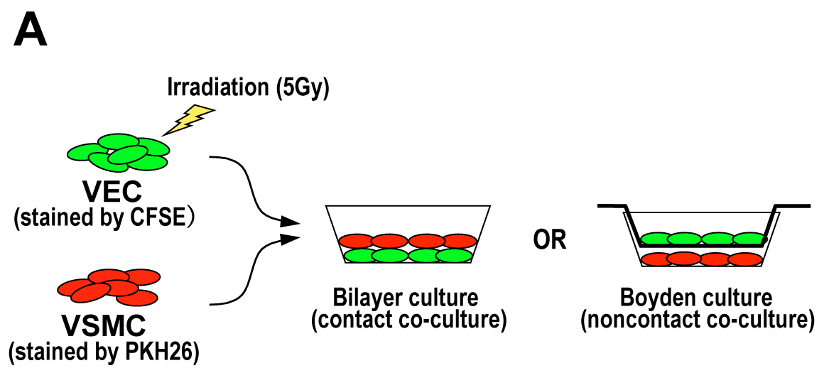
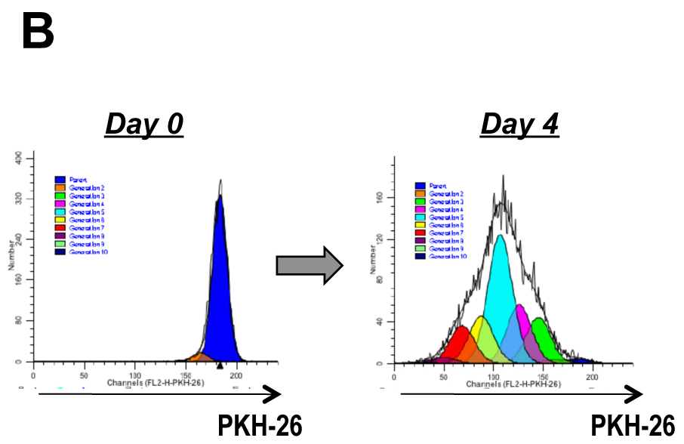
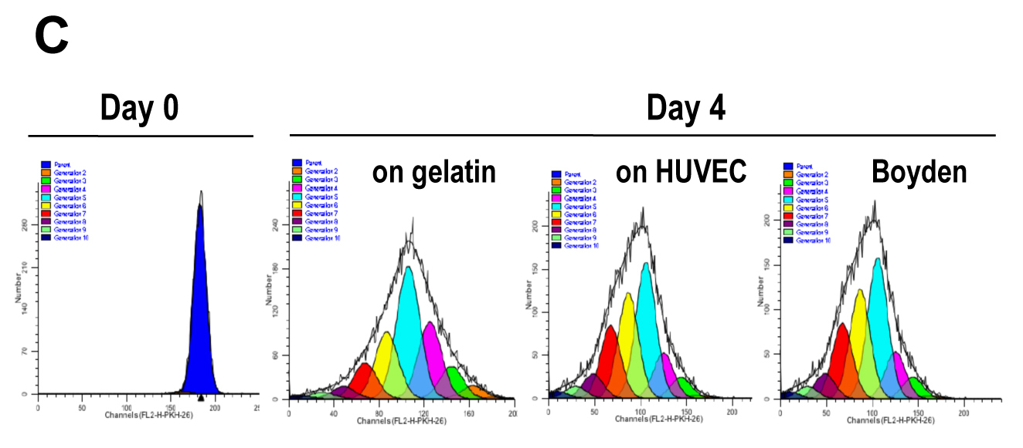
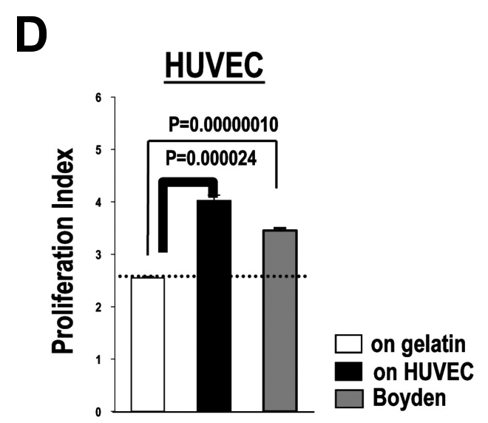
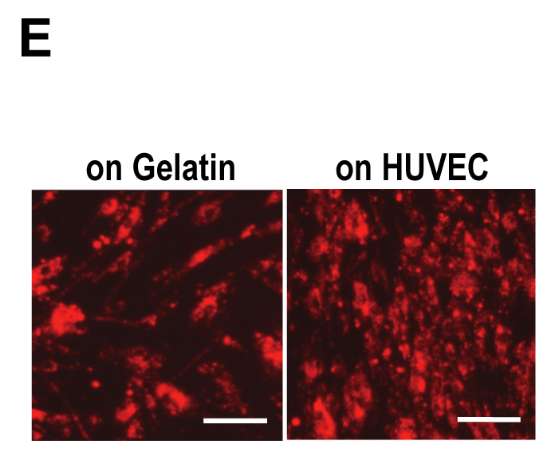
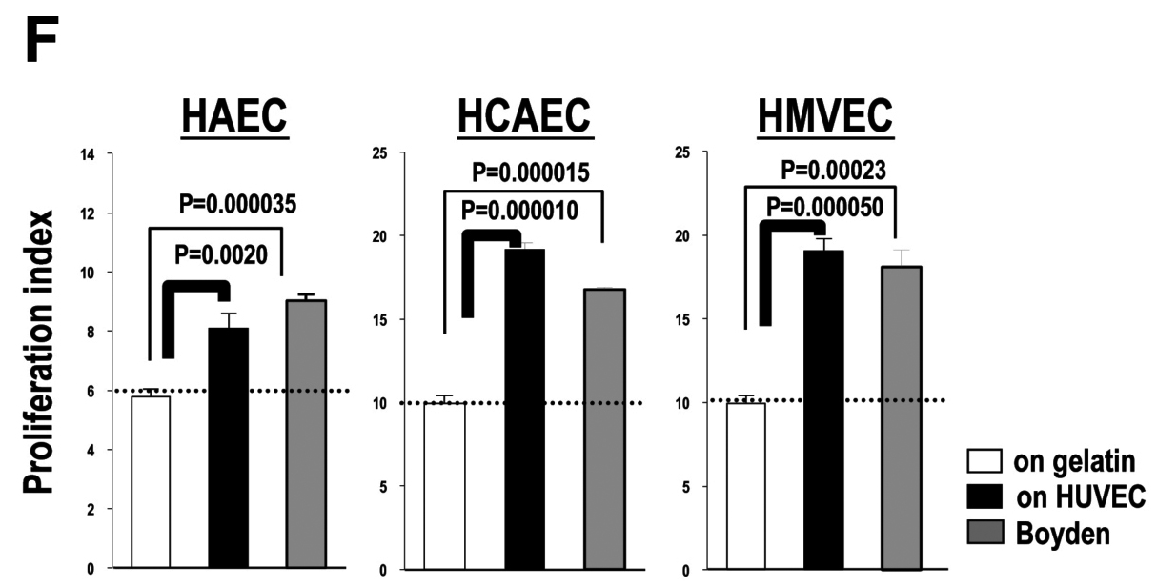
Figure 1 Phenotype determination of primary cultured human vascular endothelial cells. A and B: Illustrations of the method to calculate proliferation indexes of VEC-co-cultured VSMC via ModFit LT™ software-based analyses; C: Results of flow cytometric analyses of HUVEC-co-cultured VSMC with ModFit LT™ analyses; D: Results in C were statistically evaluated (n = 3); E: Fluorescent microscopy of PKH-26-stained VSMC subjected to contact co-culture with HUVEC; F: Results of VSMC-co-culture experiments using HAEC, HCAEC and HMVEC (n = 3). VEC: Vascular endothelial cells; HAEC: Human umbilical artery endothelial cells; HCAEC: Human coronary artery endothelial cells; HUVEC: Human umbilical vein endothelial cells; HMVEC: Human microvascular endothelial cell; VSMC: Vascular smooth muscle cell.
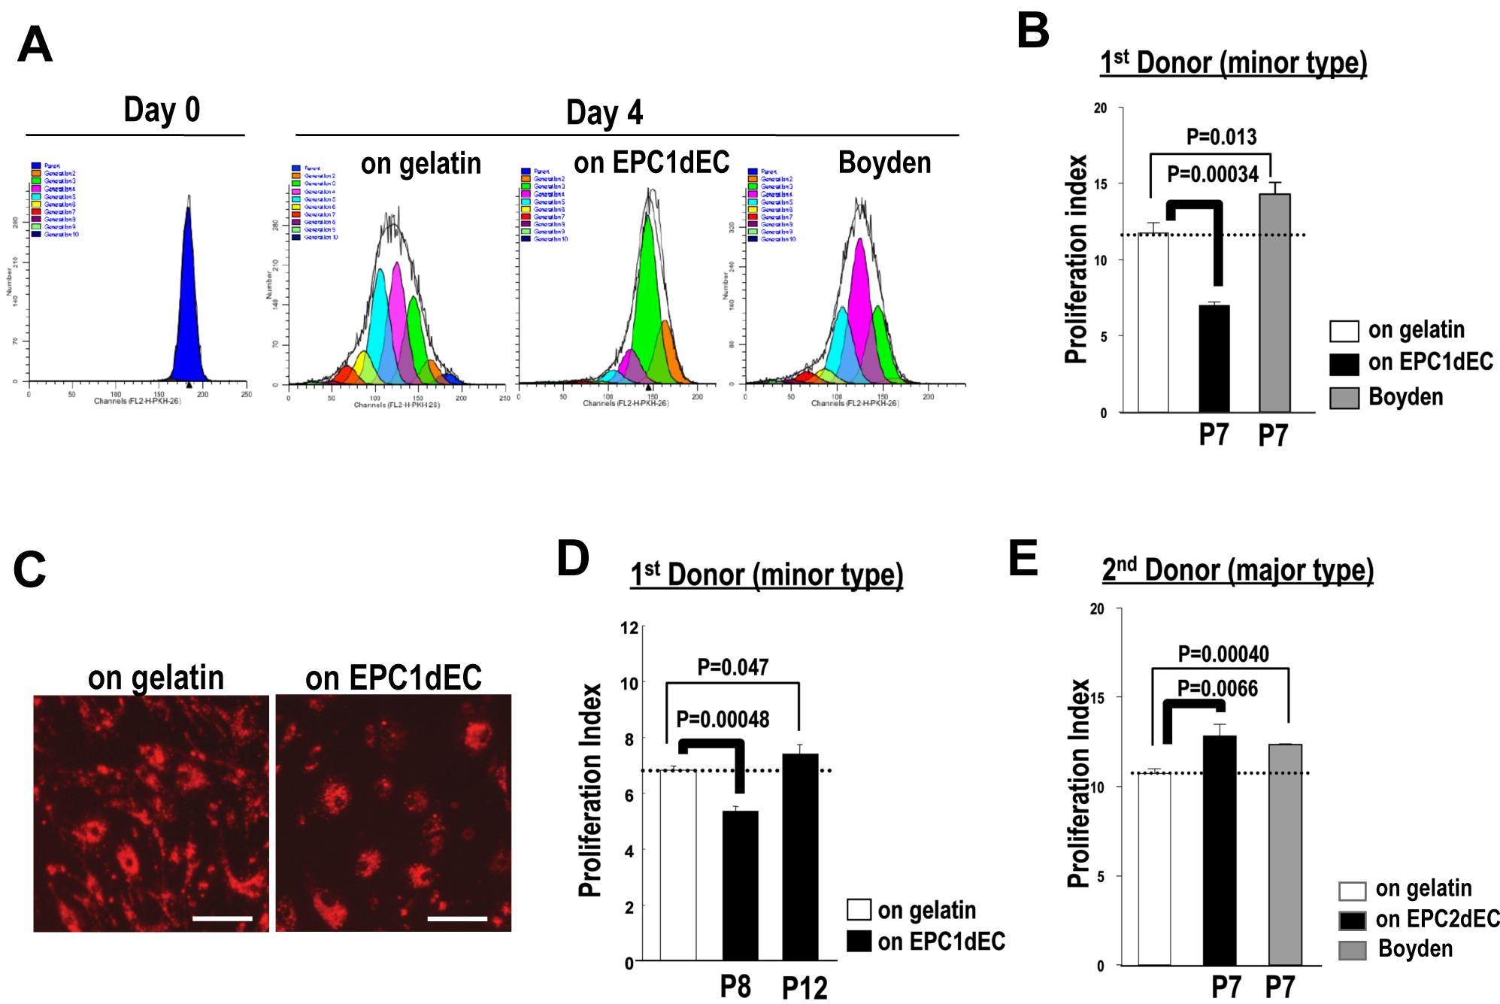

Figure 2 Phenotype determination of human embryonic stem cell-derived vascular endothelial cells. A: Results of flow cytometric analyses of hEPC1dEC[P7]-co-cultured VSMC with ModFit LT™ analyses; B: Results in (A) were statistically evaluated (n = 3); C: Fluorescent microscopy of PKH-26-stained VSMC subjected to contact co-culture with hEPC1dEC[P7]; D: Results of VSMC-co-culture experiments on the layer of hEPC1dEC at passage 8 and on that of hEPC1dEC passage 12; E: Results of VSMC-co-culture experiments using hEPC2dEC[P7] (n = 3). VSMC: Vascular smooth muscle cell; VEC: Vascular endothelial cell; iPSC: Induced pluripotent stem cell; PCR: Polymerase chain reaction; DMSO: Dimethylsulfoxide; RGS5: Regulator of G-protein signaling 5; HUVEC: Human umbilical vein endothelial cell.

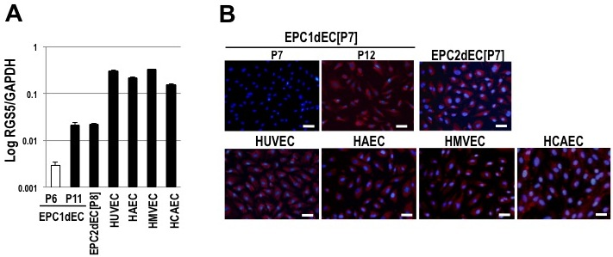
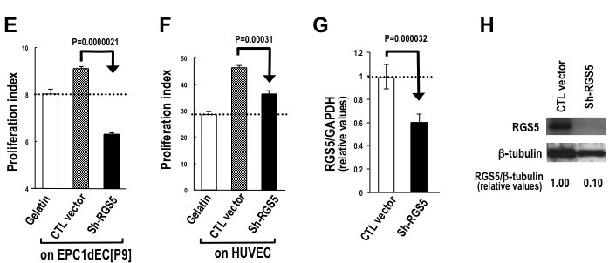
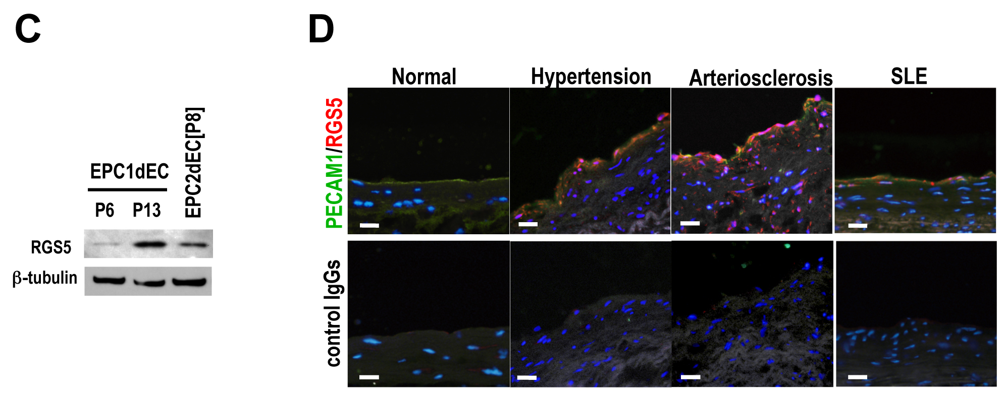
Figure 3 Regulator of G-protein signaling 5 is involved in the phenotype conversion of vascular endothelial cells. A: qRT-PCR results of RGS5 message expression were shown with normalization by GAPDH. The horizontal axis was demonstrated as logarithm; B: Immunostaining of indicated cells by using an anti-RGS5 antibody (red) with DAPI counterstaining (blue); C: Western blotting of RGS5 protein; D: Clinical specimens of the artery were subjected to immunostaining studies by using an anti-RGS5 antibody (red) and an anti-human PECAM1 antibody (green) with nuclear counterstaining with DAPI (blue); E, F and G: RGS5 knockdown experiments. An expression vector for shRNA against RGS5 (Sh-RGS5) or control RNA (CTL RNA) were transfected into EPC1dEC[P9] E or HUVEC F. The results of VSMC co-cultured experiments (E and F) along with qRT-PCR (RGS5/GAPDH) G and Western blotting H regarding HUVEC were shown. GAPDH: Glyceraldehyde-phosphate dehydrogenase; VSMC: Vascular smooth muscle cell; VEC: Vascular endothelial cell; iPSC: Induced pluripotent stem cell; PCR: Polymerase chain reaction; RGS5: Regulator of G-protein signaling 5; HUVEC: Human umbilical vein endothelial cell.

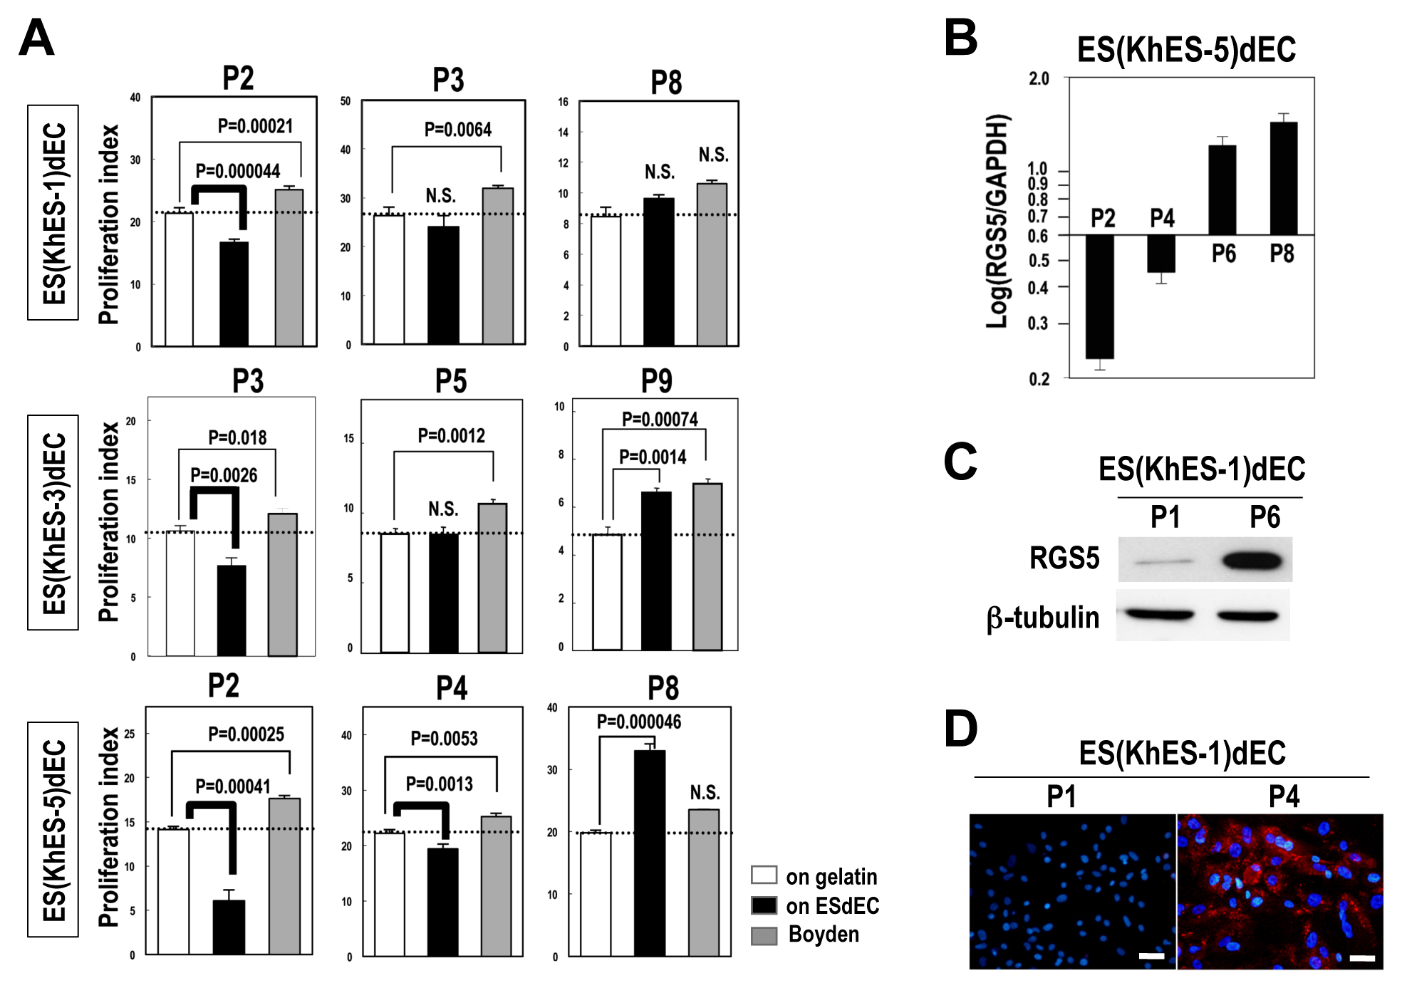
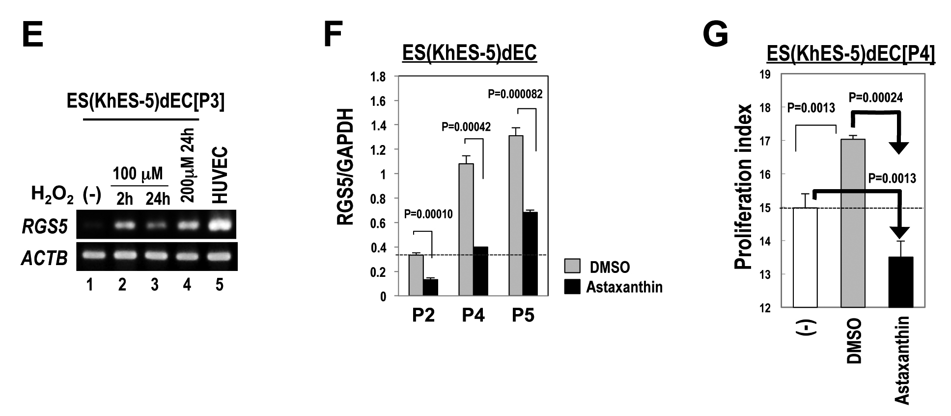

Figure 4 Phenotype evaluation of human embryonic stem cell-derived vascular endothelial cells. A: VSMC-co-culture experiments of VECs generated from three lines of hESCs (KhES-1, khES-3, khES-5) at indicated passage number (n = 3); B: qRT-PCR of RGS5 message of khES-5-derived VECs [ES (KhES-5) dEC] at indicated passage numbers; C: Western blotting of RGS5 protein in KhES-1-derived VECs [ES (KhES-1) dEC] at passage 1 and passage 6; D: Immunostaining of RGS5 protein in ES (KhES-1) dEC at passage 1 (upper) and passage 4 (lower); E: ES (KhES-5) dECs were treated with hydrogen peroxide and RGS5 message expressions were examined by RT-PCR. Lane 1: no treatment; lane 2: 100 mol/L H₂O₂ treatment for 2 h; lane 3: 100 μmol/L H₂O₂ treatment for 24 h; lane 4: 200 mol/L H₂O₂ treatment for 24 h; lane 5: HUVEC; F: qRT-PCR of RGS5 message of ES (KhES-5) dECs subcultured in the presence of DMSO (gray column) or 10 mol/L astaxanthin (closed columns); G: VSMC-co-culture experiments of ES (KhES-5) dECs maintained with culture medium (open column), in the presence of DMSO (gray column) or 10 mol/L astaxanthin (closed column). VSMC: Vascular smooth muscle cell; VEC: Vascular endothelial cell; iPSC: Induced pluripotent stem cell; PCR: Polymerase chain reaction; DMSO: Dimethylsulfoxide; RGS5: Regulator of G-protein signaling 5; HUVEC: Human umbilical vein endothelial cell.

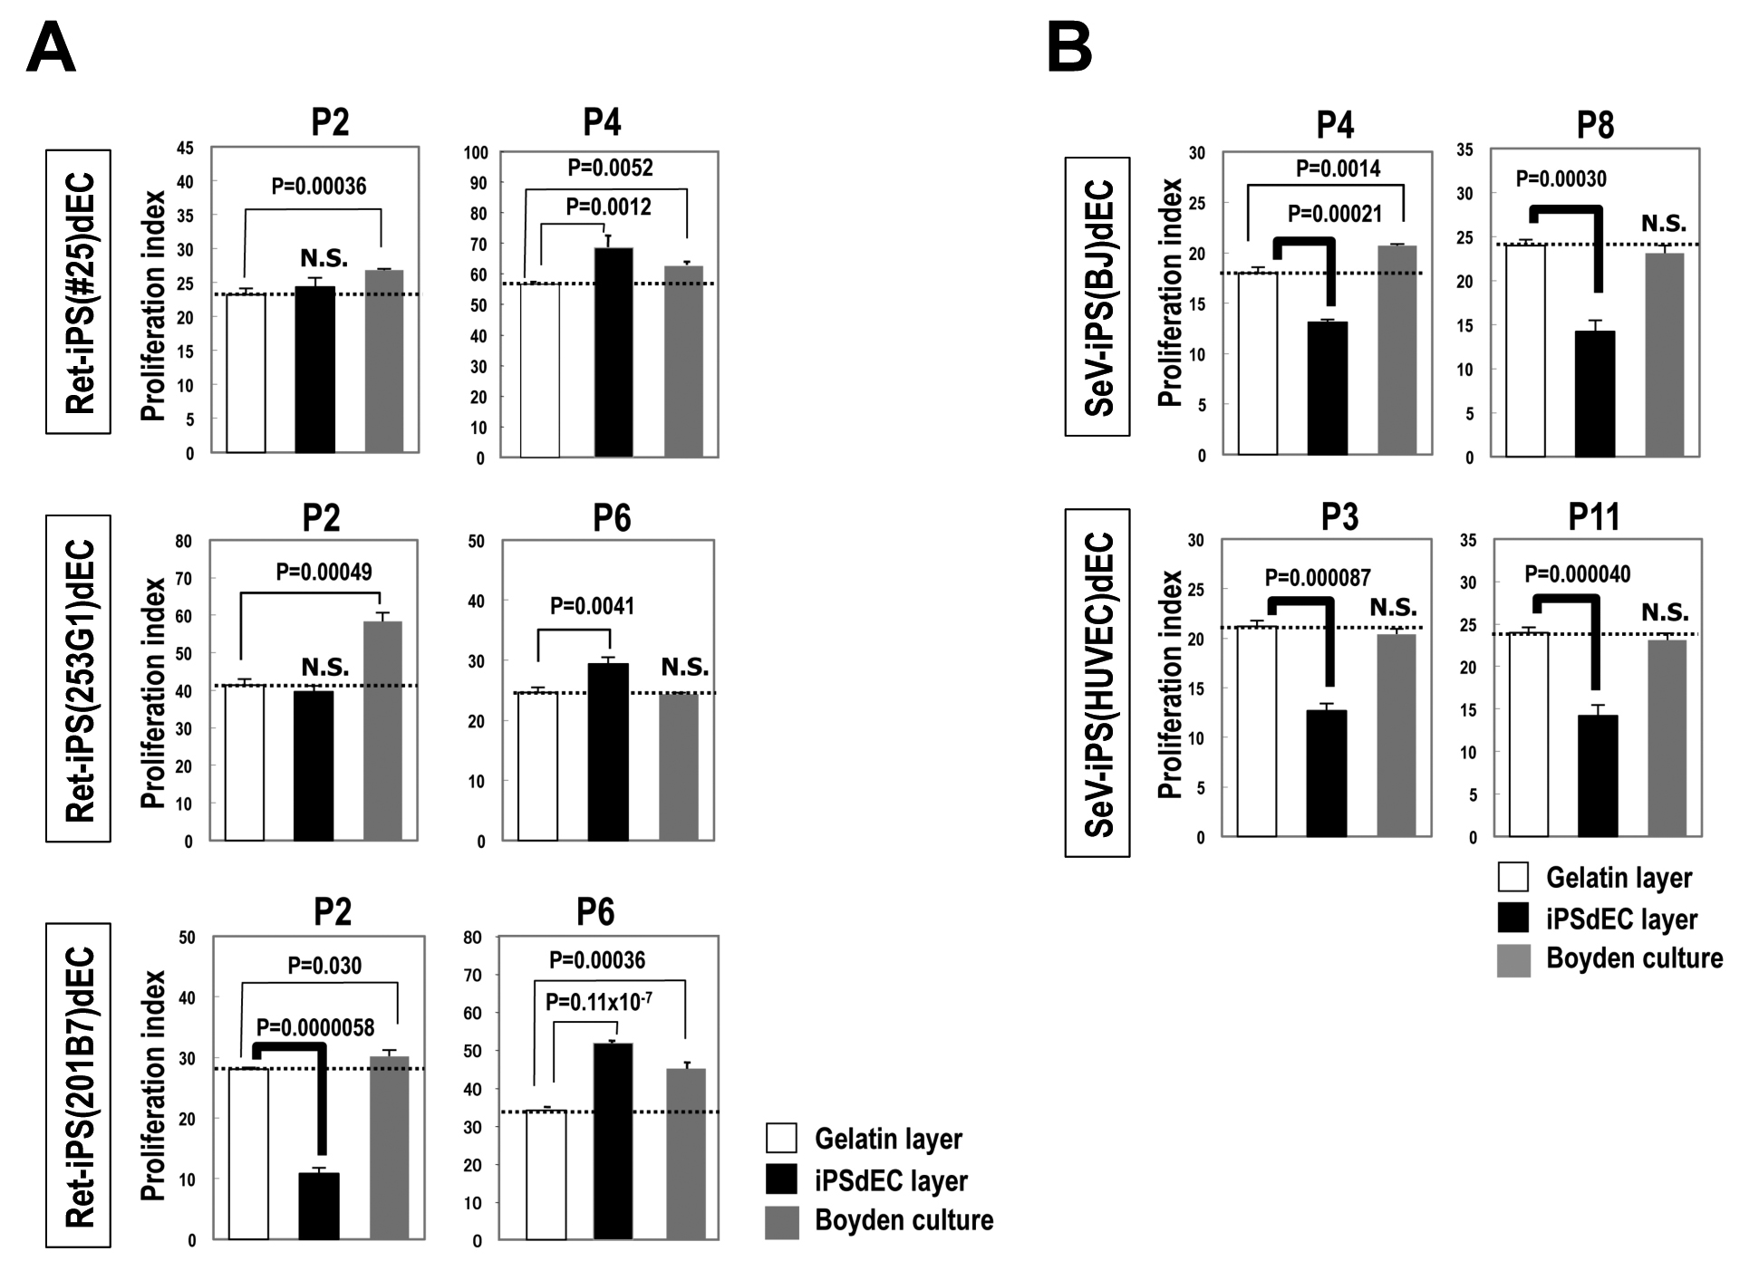

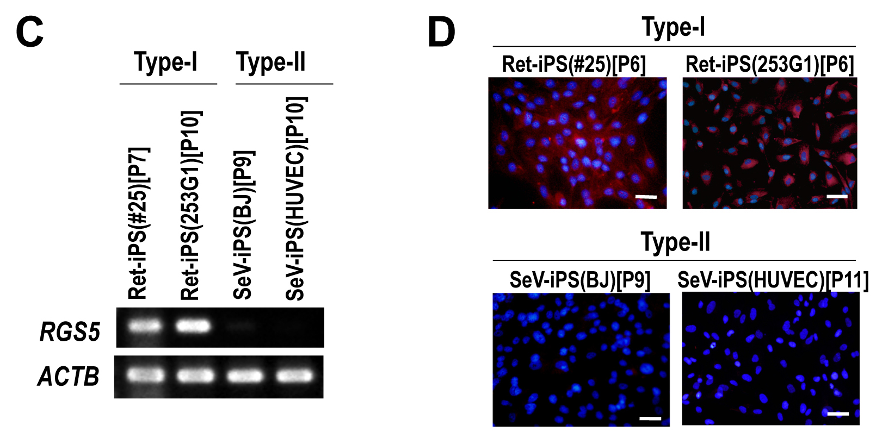

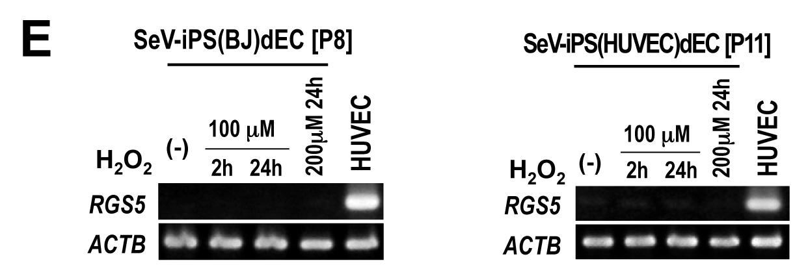

Figure 5 Phenotype evaluation of human induced pluripotent stem cells -derived vascular endothelial cells. A and B: VSMC-co-culture experiments of VECs generated from three lines of Ret-iPSCs (#25, 253G1 and 201B7); A and those from two lines of SeV-iPSCs (SeV-iPS(BJ) and SeV-iPS(HUVEC) B at indicated passage number (n = 3); C: RT-PCR of RGS5 message of Ret-iPSdECs (type-I) and SeV-iPSdECs (type-II; D: RGS5 immunostaining studies of Ret-iPSdECs (upper) and SeV-iPSdECs (lower); E: H₂O₂-treating experiments were performed in type-II SeV-iPSdECs as in Figure 4E. VSMC: Vascular smooth muscle cell; VEC: Vascular endothelial cell; iPSC: Induced pluripotent stem cell; PCR: Polymerase chain reaction; RGS5: Regulator of G-protein signaling 5; HUVEC: Human umbilical vein endothelial cell.

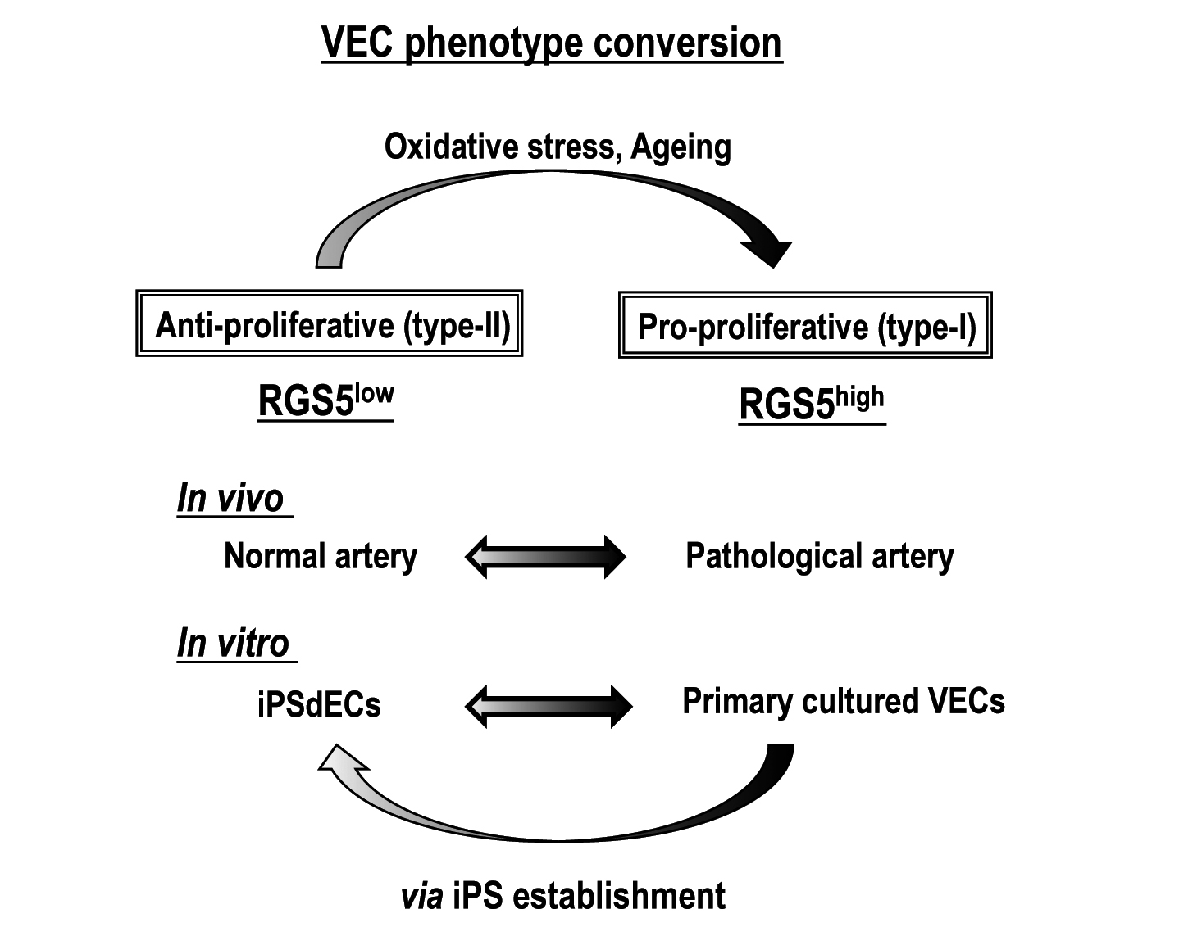

Figure 6 A model for the type-I vs type-II phenotype regulation of human vascular endothelial cells. RGS5: Regulator of G-protein signaling 5; VEC: Vascular endothelial cell; iPSC: Induced pluripotent stem cell.

