Name of Journal: World Journal of Gastroenterology
Manuscript NO: 74894
Manuscript Type: ORIGINAL ARTICLE

Observational Study
Impact of sodium glucose cotransporter-2 inhibitors on liver steatosis/fibrosis/inflammation and redox balance in non-alcoholic fatty liver disease

Bellanti F et al. SGLT2-I and NAFLD

Francesco Bellanti, Aurelio Lo Buglio, Michał Dobrakowski, Aleksandra Kasperczyk, Sławomir Kasperczyk, Palok Aich, Shivaram P Singh, Gaetano Serviddio, Gianluigi Vendemiale

Francesco Bellanti, Aurelio Lo Buglio, Gaetano Serviddio, Gianluigi Vendemiale, Department of Medical and Surgical Sciences, University of Foggia, Foggia 71122, Italy

Michał Dobrakowski, Aleksandra Kasperczyk, Sławomir Kasperczyk, Department of Biochemistry, Medical University of Silesia in Katowice, Zabrze 41-808, Poland

Palok Aich, School of Biological Sciences, National Institute of Science Education and Research, Khurdha 752050, India

Shivaram P Singh, Department of Gastroenterology, SCB Medical College, Cuttack 753007, India

Author contributions: Bellanti F and Vendemiale G designed and coordinated the study; Bellanti, F, Lo Buglio A, Dobrakowsky M, and Kasperczyk A performed the experiments, acquired and analyzed data; Bellanti F, Lo Buglio A, Dobrakowsky M, Kasperczyk A, Kasperczyk S, Serviddio G, Singh SP, Aich P, and Vendemiale G interpreted the data; Bellanti F wrote the manuscript; Kasperczyk S, Serviddio G, Singh SP, Aich P, and Vendemiale G supervised the manuscript; and all authors approved the final version of the article.

Corresponding author: Francesco Bellanti, MD, PhD, Associate Professor, Department of Medical and Surgical Sciences, University of Foggia, viale Pinto, 1, Foggia 71122, Italy. francesco.bellanti@unifg.it

Received: January 10, 2022
Revised: March 18, 2022
Accepted: June 18, 2022
Published online:

Abstract
BACKGROUND
Sodium glucose cotransporter-2 inhibitors (SGLT2-I) are the most recently approved drugs for type 2 diabetes (T2D). Recent clinical trials of these compounds reported beneficial cardiovascular (CV) and renal outcomes. A major cause of vascular dysfunction and CV disease in diabetes is hyperglycemia associated with inflammation and oxidative stress. Pre-clinical studies demonstrated that SGLT2-I reduce glucotoxicity and promote anti-inflammatory effects by lowering oxidative stress.

AIM
To investigate the effects of SGLT2-I on markers of oxidative stress, inflammation, liver steatosis, and fibrosis in patients of T2D with non-alcoholic fatty liver disease (NAFLD).

METHODS
We referred fifty-two consecutive outpatients treated with metformin monotherapy and exhibiting poor glycemic control to our centre. We introduced the outpatients to an SGLT2-I (dapagliflozin, empagliflozin, or canagliflozin; n = 26) or a different hypoglycemic drug [other glucose-lowering drugs (OTHER), n = 26]. We evaluated circulating interleukins and serum hydroxynonenal (HNE)- or malondialdehyde (MDA)-protein adducts, fatty liver index (FLI), NAFLD fibrosis score, aspartate aminotransferase (AST)/alanine aminotransferase (ALT) ratio, AST-to-platelet-ratio index (APRI), and fibrosis-4 on the day before (T0) and following treatment for six months (T1). We also performed transient elastography at T0 and T1.

RESULTS
Add-on therapy resulted in improved glycemic control and reduced fasting blood glucose in both groups. Of note, following treatment for six months, a reduction of FLI and APRI, as well as of the FibroScan result, was reported in patients treated with SGLT2-I, but not in the OTHER group; furthermore, in the SGLT2-I group, we reported lower circulating levels of interleukin (IL)-1β, IL-6, tumor necrosis factor, vascular endothelial growth factor, and monocyte chemoattractant protein-1, and higher levels of IL-4 and IL-10. We did not observe any modification in circulating interleukins in the OTHER group. Finally, serum HNE- and MDA-protein adducts decreased significantly in SGLT2-I rather than OTHER patients and correlated with liver steatosis and fibrosis scores.

CONCLUSION
The present data indicate that treatment with SGLT2-I in patients with T2D and NAFLD is associated with improvement of liver steatosis and fibrosis markers and circulating pro-inflammatory and redox status, more than optimizing glycemic control.

Key Words: Sodium glucose cotransporter-2 inhibitors; Non-alcoholic fatty liver disease; Oxidative stress; Type 2 diabetes; Liver fibrosis; Inflammation

Bellanti F, Lo Buglio A, Dobrakowski M, Kasperczyk A, Kasperczyk S, Aich P, Singh SP, Serviddio G, Vendemiale G. Impact of sodium glucose cotransporter-2 inhibitors on liver steatosis/fibrosis/inflammation and redox balance in non-alcoholic fatty liver disease. World J Gastroenterol 2022; In press

Core Tip: Non-alcoholic fatty liver disease (NAFLD) is the most common hepatic disorder, and it is often associated with type 2 diabetes mellitus (T2DM). Diabetic patients often suffer from advanced NAFLD and are keen on progressing toward severe fibrosis and end-stage liver disease. There is no approved treatment for NAFLD, but new drug classes introduced to treat T2DM can exert favorable effects beyond glucose control. This pilot study demonstrates that treatment with sodium glucose cotransporter-2 inhibitors in patients with T2DM and NAFLD is associated with improving liver steatosis and fibrosis markers and circulating pro-inflammatory and redox status.

INTRODUCTION
Patients affected by type 2 diabetes mellitus (T2DM) present with an increased risk of cardiovascular (CV) disease, which is associated with a high mortality rate and low quality of life^{[1,2]}. T2DM is strongly associated with non-alcoholic fatty liver disease (NAFLD), whose prevalence in diabetic patients is over 60%^{[3,4]}. NAFLD is the most common chronic liver disease, characterized by a broad spectrum of hepatic disorders, ranging from simple steatosis to steatohepatitis (non-alcoholic steatohepatitis), fibrosis, and cirrhosis^{[5]}. The co-existence of NAFLD and T2DM pushes the progression of liver damage, increasing the risk of advanced fibrosis^{[6]}. Besides, NAFLD is an independent risk factor of CV disease. Patients with T2DM and NAFLD present a higher CV risk than diabetic patients without NAFLD, suggesting that these conditions share common pathophysiological mechanisms, including low-grade systemic inflammation and oxidative stress^{[7]}.
Studies using new classes of antidiabetic drugs, such as sodium-glucose co-transporter-2 inhibitors (SGLT2-I) and glucagon-like peptide-1 receptor agonists (GLP1-RA), demonstrated definite CV advantage in patients with T2D^{[8]}. Several clinical trials suggest that both classes also ameliorate liver steatosis and inflammation, potentially reversing fibrosis in NAFLD^{[9]}. The currently approved SGLT2-I are dapagliflozin, canagliflozin, empagliflozin, and ertugliflozin, which increase urinary glucose excretion and improve glycemic control independent of insulin. Furthermore, these drugs reduce body weight, visceral adiposity, blood pressure, and arterial stiffness^{[10]}. Real-world CVD-REAL and CVD-REAL 2 studies have demonstrated that the benefits of SGLT2-I on CV outcomes observed in clinical trials may be attributed to a class effect and may be extended to a broad range of patients^{[11,12]}. Despite clinical evidence on the efficacy of SGLT2-I in both the reduction of CV events and the improvement of hepatic damage in NAFLD, human mechanistic trials remain elusive.
Pre-clinical studies demonstrated that dapagliflozin, empagliflozin, and canagliflozin attenuate inflammation in apolipoprotein E knockout mice^{[13-15]}, reduce oxidative stress and improve mitochondrial function through direct pleiotropic and epigenetic effects^{[16,17]}. Furthermore, these compounds may also exert antifibrotic effects in diabetic and non-diabetic cardiopathy or nephropathy^{[18-20]}. Such results strongly encourage clinical studies to clarify the impact of SGLT2-I on systemic inflammation, oxidative stress, and liver fibrosis in diabetic patients with NAFLD. Thus, the present investigation was aimed to evaluate the effects of SGLT2-I addition to metformin on circulating markers of inflammation and oxidative protein damage in patients affected by uncontrolled T2DM and NAFLD and compare these outcomes with other glucose-lowering drugs (OTHER).

MATERIALS AND METHODS
Study design
We collected and analyzed data from 204 patients affected by T2DM who underwent outpatient consultation between June 2017 and June 2018 at the University Internal Medicine clinic of the “Policlinico Riuniti” in Foggia (Italy). We designed the investigation as an observational pilot study considering the problematic setting, the limited scale, and the multiple outcome parameters. Patients aged > 18 years old who were: (1) Diagnosed with NAFLD; and (2) Presented with glycated hemoglobin equal to or greater than 7% after at least three months of treatment with metformin monotherapy at the maximal tolerated dosage were assessed for eligibility. NAFLD was suspected on previous ultrasound imaging and/or altered liver function tests^{[21]}. We did not consider subjects diagnosed with viral or autoimmune hepatitis, atherosclerotic CV disease, chronic inflammatory disorders, or those diagnosed with active cancer for the study. Further exclusion criteria were alcohol consumption > 20 g/d (women) or > 30 g/d (men), anemia, severe hepatic failure, glomerular filtration rate < 60 mg/min/m², use of drugs affecting redox balance, use of anti-inflammatory medications or corticosteroids during the observational period, use of medications associated with fatty liver (amiodarone, tamoxifen, sodium valproate, methotrexate), current smoker status, and prescription of a glucagon-like peptide-1 agonist (Supplementary Figure 1).
52 patients were finally referred to a combination therapy; of these, 26 patients were treated with an SGLT2-I, while 26 patients were treated with OTHER. The combination therapy was not randomized, and the second compound was chosen according to the standard of medical care in diabetes - 2017, considering the clinical characteristics of patients to maximize therapeutic advantages and minimize risks and side effects^{[22]}. Compliance and adverse events were assessed by a verbal questionnaire. The frequency and distribution of the different compounds prescribed are reported in the Supplementary Table 1. For the study purposes, patients enrolled were assessed at baseline (T0) and after six months (T1). Our Institutional Review Board approved the study at the Policlinico Riuniti in Foggia (reference number 2325/2018) and performed it according to the Declaration of Helsinki. All patients gave written informed consent.

Laboratory measurements
Blood samples were obtained from a brachial vein between 8:00 and 9:00 AM, after an overnight fast, and immediately processed. Standard laboratory measurements included glycated hemoglobin A1c (HbA1c), fasting serum glucose, serum triglycerides, serum aspartate aminotransferase (AST), alanine aminotransferase (ALT) and gamma-glutamyl transpeptidase (gamma-GT) activities, platelet count, and serum albumin. The concentrations of serum cytokines and growth factors, including several interleukins (IL), such as IL-1α, IL-1β, IL-2, IL-4, IL-6, IL-8, IL-10, tumor necrosis factor (TNF), interferon-γ (IFN-γ), monocyte chemoattractant protein-1 (MCP-1), epidermal growth factor (EGF), and vascular endothelial growth factor (VEGF), were measured using the EV 3513 cytokine biochip array and competitive chemiluminescence immunoassays (Randox Laboratories Ltd, Crumlin, United Kingdom), according to the manufacturer’s instructions, using the Randox Evidence Investigator^{[23]}. As previously reported, serum fluorescent adducts formed between peroxidation-derived aldehydes [hydroxynonenal (HNE) and malondialdehyde (MDA)] and proteins were measured by spectrofluorimetry^{[24]}.

Non-invasive markers of liver steatosis and fibrosis
Patients were assessed at baseline and after six months of treatment for the following parameters: Fatty liver index (FLI), calculated according to the formula e^{y} / (1 + e^{y}) × 100, where “y” = 0.953 × ln(triglycerides, mg/dL) + 0.139 × body mass index (BMI), kg/m² + 0.718 × ln (gamma-GT, U/L) + 0.053 × waist circumference, cm - 15.745^{[25]}; AST-to-platelet ratio index (APRI), calculated according to the formula AST, IU/L/AST upper limit of normal, IU/L/platelets, 10⁹/L^{[26]}; NAFLD fibrosis score, calculated according to the formula - 1.675 + 0.037 × age, years + 0.094 × BMI, kg/m² + 1.13 × impaired fasting glucose or diabetes (yes = 1, no = 0) + 0.99 × AST/ALT ratio - 0.013 × platelets, 10⁹/L - 0.66 × albumin, g/dL^{[27]}. The cut-off values chosen to categorize fibrosis grades F0-F2 or F3-F4 were < -1.455 and > 0.675, respectively; fibrosis-4 (FIB-4), calculated according to the formula (age, years × AST, IU/L)/(platelets, 10⁹/L × rad ALT, IU/L)^{[28]}. The cut-off values chosen to categorize fibrosis grades F0-F1 or F3-F4 were < -1.30 and > 2.67, respectively; AST/ALT ratio, whose cut-off value > 0.8 is associated with advanced disease^{[29]}.

Transient elastography
Transient elastography (TE) was performed by a Fibroscan (Echosense, Paris) on supine patients with the right arm elevated. The probe tip was put on the intercostal space at the level of the right liver lobe. The Fibroscan probe contains an ultrasound transducer and a mechanical device that provides a controlled vibrating external shot on the body surface to generate shear waves. TE measures liver stiffness (LS) in 1 cm cylindric volume (width: 25-65 mm, M probe; 35-75 mm, XL probe) below the skin surface. Criteria for a valid examination were as follows: (1) At least 10 valid measurements; (2) A success rate [(valid + invalid measurements)/total measurements] > 70%; and (3) An interquartile range < 30% of the median value. Measurements were expressed as KPa^{[30]}.

Statistical analysis
Data were expressed as count and percentages for categorical variables and as mean ± SDM for quantitative variables. Gaussian distribution of the samples was evaluated by Kolgomorov-Smirnov test. The significance of differences between the 2 treatment groups (SGLT2-I vs OTHER) at baseline was assessed by student’s t-test (continuous variables) or in contingency tables by Pearson’s Chi-squared test and Fisher’s exact test (categorical variables). The significance of differences between the 2 treatment groups between the beginning (T0) and the end of the observational period (T1) was assessed by the two-way analysis of variance to test the main effects of time and treatment as a between-subject factor; the interaction time × treatment was studied, and a Tukey test was applied as post hoc test for multiple comparisons. The correlation analysis between changes in non-invasive markers of hepatic steatosis and fibrosis with fasting serum glucose or HbA1c, serum interleukins, or serum HNE- and MDA-protein adducts was performed using Pearson correlation test followed by linear regression. All tests were 2-sided, and P < 0.05 were considered statistically significant. Statistical analysis was performed with the Statistical Package for Social Sciences version 23.0 (SPSS, Inc., Chicago, IL) and Graph-Pad Prism 6.0 for Windows (GraphPad Software, Inc., San Diego, CA).

RESULTS
Baseline characteristics of the subjects included in the SGLT2-I or the OTHER group are represented in Table 1. The two groups were comparable in terms of clinical and biochemical features. No side effects in both groups were reported. After six months of treatment, a lowering effect on both fasting serum glucose (time factor: F_{(1, 100)} = 16.04, P < 0.0001) and HbA1c (time factor: F_{(1, 100)} = 14.83, P < 0.0001) was observed, with a significant reduction from T0 to T1 in both groups (Figures 1A and B). No significant variations were reported as regards serum triglycerides after 6 mo of treatment (Figure 1C). Interestingly, we observed an impact of time, treatment and interaction on body mass index (time factor: F_{(1, 100)} = 4.146, P = 0.0444; treatment factor: F_{(1, 100)} = 4.169, P = 0.0438; interaction factor: F_{(1, 100)} = 5.650, P = 0.0194), and the post hoc analysis resulted in significant differences between the two treatment groups at T1, and between T0 and T1 in the SGLT2-I group (Figure 1D). These data suggest that 6 mo of add-on treatment to metformin improves glycemic control compared to baseline; nevertheless, this improvement is not related to a particular drug class. Furthermore, a beneficial impact on weight loss is exerted by SGLT2-I but not by other glucose-lowering agents.

Effect of different add-on therapies on liver function tests and non-invasive markers of hepatic steatosis/fibrosis
We then compared the impact of combined treatment with SGLT2-I vs OTHER on circulating liver enzymes. The effect of treatment was significant for serum AST level (F_{(1, 100)} = 7.703, P = 0.0066), and the post hoc analysis showed lower values in SGLT2-I rather than the OTHER group at T1 (Figure 2A). No significant variations were reported for serum ALT and gamma-GT activities (Figures 2B and 2C). Non-invasive liver steatosis and fibrosis markers were further evaluated at baseline and after 6 mo of therapy in both groups. We observed the effect of both time and treatment on FLI (time factor: F_{(1, 100)} = 8.279, P = 0.0049 and treatment factor: F_{(1, 100)} = 5.113, P = 0.0259), but after 6 mo it decreased only in the SGLT2-I group - and not in OTHER patients - with respect to baseline (Figure 3A). A significant effect of treatment was also observed for the APRI (F_{(1, 100)} = 5.309, P = 0.0233), with a lower value in SGLT2-I rather than OTHER group at T1 (Figure 3B). The proportion of patients affected by a fibrotic form of liver disease according to NAFLD fibrosis score, FIB-4, and AST/ALT ratio reduced significantly after 6 mo of therapy in the SGLT2-I group rather than in the OTHER group (Table 2). Finally, we observed a significant effect of time (F_{(1, 100)} = 7.996, P = 0.0057) and interaction (F_{(1, 100)} = 4.772, P = 0.0313) on hepatic elastometry, and LS in patients treated with SGLT2-I for six months was lower with respect to baseline and to the OTHER group (Figure 3C).

Effect of different add-on therapies on circulating markers of inflammation and oxidative stress
We further analyzed markers of systemic inflammation, such as circulating interleukins and growth factors. Table 3 summarizes the results related to serum levels of 12 different cytokines and growth factors evaluated at baseline (T0) and after 6 mo of therapy (T1) in both treatment groups. We could not observe any significant impact of time, treatment, or interaction on IL-1α, IL-2, IL-8, IFN-γ, and EGF. On the contrary, the time effect was observed for IL-1β, IL-4, IL-10, and TNF; the treatment effect was reported for IL-4, IL-6, IL-10, and TNF; the interaction effect was described for IL-1β, IL-6, IL-10, VEGF, and MCP-1. According to the post-hoc analysis, SGLT2-I patients at T1 showed: (1) Lower values of the pro-inflammatory cytokines IL-1β and TNF, and VEGF than T0; (2) Lower values of the pro-inflammatory cytokines IL-6 and TNF, VEGF, and MCP-1 than OTHER patients at T1; and (3) Higher values of the anti-inflammatory cytokines IL-4 and IL-10 as compared to SGLT2-I at T0 and OTHER at T1.
We evaluated systemic oxidative stress markers changes by measuring serum HNE- and MDA-protein adducts. A significant effect of treatment and interaction was observed for both HNE-protein adducts (treatment factor: F_{(1, 100)} = 7.924, P = 0.0059; interaction factor: F_{(1, 100)} = 4.820, P = 0.0305) and MDA-protein adducts (treatment factor: F_{(1, 100)} = 10.17, P = 0.0019; interaction factor: F_{(1, 100)} = 5.844, P = 0.0174). The post hoc analysis showed that, after 6 mo of therapy, circulating markers of oxidative stress were lower in the SGLT2-I group rather than OTHER patients; furthermore, HNE-protein adducts were significantly reduced from T0 to T1 in SGLT2-I patients (Figures 4A and 4B).

Reduction of liver steatosis and fibrosis markers is associated with decreased circulating oxidative stress in patients treated with SGLT2-I
We then focused on patients treated with SGLT2-I. We performed a Pearson’s correlation analysis on non-invasive markers of hepatic steatosis and fibrosis, circulating parameters of glucose metabolism, inflammation, and oxidative stress after 6 mo of therapy. Of note, the FLI, the APRI, and LS showed: (1) A positive bivariate relationship with pro-inflammatory cytokines (IL-1β, IL6, TNF); and (2) A negative correlation with the anti-inflammatory cytokines (IL-4 and IL-10). Interestingly, all the non-invasive liver steatosis and fibrosis markers were strongly related to HNE- and MDA-protein adducts (Supplementary Table 2).
To verify whether the improvement of non-invasive markers of liver steatosis and fibrosis reported in patients treated with SGLT2-I after 6 mo of therapy was associated with the observed reduction of serum HNE- and MDA-protein adducts, a linear regression analysis on T1-T0 difference values was performed. Further, SGLT2-I treatment related alterations in both markers of circulating oxidative stress were directly related to variations in FLI, APRI, and LS (Figures 5A, 5B and 5C).

DISCUSSION
The present study demonstrates that the addition of an SGLT2-I - as compared to dipeptidyl peptidase-4 inhibitors (DPP4-I) or pioglitazone - to metformin monotherapy exerts a positive impact on systemic inflammation and circulating oxidative stress in patients with T2DM and NAFLD. It is associated with favorable changes in the non-invasive hepatic steatosis and fibrosis markers. The incidence of T2DM is exponentially increasing worldwide^{[31]}. T2DM often presents associated with NAFLD since insulin resistance accounts for the alteration of lipid homeostasis, favoring hepatic fat accumulation by induction of lipogenesis and inhibition of very-low-density lipoprotein secretion^{[32,33]}. Furthermore, hyperglycemia in diabetic patients worsens insulin resistance through mechanisms induced by glucose toxicity^{[34]}. In addition, the efficacy of several antidiabetic drugs is lost during the time, leading to the progression of T2DM, which could worsen NAFLD^{[35]}. There are currently no approved therapies for the treatment for NAFLD. Several compounds tested in phase 2 and phase 3 clinical trials target metabolic stress as a critical factor for the initiation and progression of hepatic injury. Data on the effects of antidiabetic drugs in NAFLD are limited although pioglitazone and GLP1-RA have demonstrated some protective effects^{[36]}. SGLT2-I are molecules with direct action on the kidney, reduce the reabsorption of filtered glucose and significantly decrease blood glucose levels both in fasting and post-prandial conditions, with consequent decline of glucose toxicity and improvement of insulin resistance^{[37]}. Moreover, these drugs may interfere with several mechanisms involved in the progression of T2DM, such as dysfunction or apoptosis of pancreatic β-cells^{[38]}.
Clinical studies testing the efficacy of SGLT2-I on NAFLD demonstrated that this class of drugs reduces both hepatic steatosis, as evaluated by several imaging techniques, and serum liver enzymes^{[39]}. Our study confirms these observations since we report that the addition of SGLT2-I to metformin reduces both the FLI and serum AST after 6 mo; this effect is not observed when pioglitazone or DPP4-I are added to metformin. Furthermore, our data show that six months of therapy with an SGLT2-I are associated with reducing hepatic fibrosis - which occurs mainly in NAFLD patients with higher fibrosis grade - as suggested by decrease in NAFLD fibrosis score, FIB-4, as well as LS measured by TE. These results are comparable to the reported outcome in a similar study, suggesting that SGLT2-I are superior to other oral hypoglycemic agents in reducing hepatic steatosis and fibrosis^{[40]}.
Among other glucose-lowering agents, pioglitazone and GLP1-RA were demonstrated to reduce hepatic steatosis, inflammation, and fibrosis^{[41,42]}. We designed this study by excluding patients treated with GLP1-RA, even though 38.5% of patients of the OTHER group were treated with pioglitazone added to metformin. Despite this subgroup of patients in the comparison group, SGLT2-I improved non-invasive liver steatosis and fibrosis markers. A previous randomized trial compared the SGLT2-I ipragliflozin against pioglitazone, showing that both treatments were equivalent in reducing liver fat infiltration and serum aminotransferase levels, even though ipragliflozin effected a reduction in body weight and abdominal fat area^{[43]}. However, it is worth noting that more than one-third of patients included in our study showed a high grade of steatosis and fibrosis as assessed by non-invasive markers. In contrast, previous studies using pioglitazone enrolled patients with milder hepatic injury. More than potentially explaining differences between the present results and those of different studies, our results suggest that SGLT2-I treatment would be more beneficial in T2DM patients with advanced NAFLD.
Mechanisms explaining the benefits of SGLT2-I therapy in T2DM and NAFLD are primarily undefined, but the results of this study lead to several speculations. Even though SGLT2-I significantly controls blood glucose, an improvement in glucose metabolism was described in all patients treated with additional drugs. However, other studies could not demonstrate that amelioration of NAFLD after SGLT2-I treatment was dependent on improved circulating glucose concentration^{[44-46]}. Weight loss induced by non-pharmacological interventions such as diet, exercise, or bariatric surgery, may ameliorate liver damage in NAFLD^{[47]}. SGLT2-I decreases body weight and fat mass, reducing hepatic steatosis and serum liver enzymes^{[48]}. Our data show that SGLT2-I effectively promoted weight loss after 6 mo of therapy in patients with T2DM and NAFLD. However, there was no relationship between BMI reduction and the improvement of non-invasive markers of hepatic steatosis and fibrosis.
Besides, previous studies have also shown improved liver function tests, and steatosis irrespective of weight loss in patients affected by T2DM and NAFLD treated with SGLT2-I^{[49,50]}. The evidence so far indicated that SGLT2-I would induce different beneficial mechanisms than glucose control and weight loss in NAFLD. The present results further revealed that SGLT2-I - and not pioglitazone or DPP4-I - favorably modulate circulating cytokines, switching from pro-inflammatory to anti-inflammatory patterns, and reducing systemic markers of oxidative stress. These results are further buttressed by pre-clinical studies providing proving2-I inhibits pro-inflammatory cytokine secretion and reduces oxidative stress^{[16,51,52]}. Our study clearly demonstrates a significant association between improving hepatic steatosis/fibrosis markers and reducing circulating oxidative stress in patients treated with SGLT2-I for 6 mo. On the other hand, we could not find any relationship between changes in circulating cytokines and reduction of liver injury markers. Reactive oxygen species (ROS) and reactive nitrogen species (RNS) represent physiological products of cellular metabolism, which are normally counteracted by endogenous antioxidants. When ROS/RNS production overwhelms the antioxidant defense, oxidative stress occurs with consequent injury of macromolecules such as nucleic acids (DNA oxidation), lipids (lipoperoxidation), and proteins, which in turn leads to an impairment of normal cellular functions^{[53]}. Oxidative stress promotes the generation of HNE and MDA, lipid peroxidation products which are able to generate adducts with cellular and circulating proteins, which may be used as systemic markers of injury. Oxidative stress is considered one of the main determinants of NAFLD pathogenesis and progression^{[54]}. For the first time, our study provides evidence that the reduction of circulating oxidative stress induced by SGLT2-I is related to improved markers of hepatic damage in T2DM patients with NAFLD, suggesting a potential protective mechanism by this drug class. Studies to define how SGLT2-I modulate molecular pathways that impact redox balance need to be designed.
This study suffers from the following limitations: (1) It was not designed as a randomized placebo-controlled trial since the type of combined treatment was decided according to a patient-centered approach (of note, the newest Standards of Medical Care in Diabetes were not available at the time of enrolment); (2) Patients treated with GLP-1 agonists were not included; (3) Since this study was performed at a single-center, it may have presented some bias, resulting in slightly larger intervention effects than multicenter studies; (4) Our small pilot study was not designed to determine the impact of single compounds; and (5) Liver histology was not performed to evaluate steatosis, inflammation, and fibrosis.

CONCLUSION
In conclusion, treatment with SGLT2-I in T2DM patients affected by NAFLD is associated with a rapid improvement of non-invasive markers of hepatic steatosis and fibrosis, providing insights into the mechanisms by which such class of antidiabetic drugs may reduce liver damage in humans. More extensive randomized controlled trials are encouraged to confirm these preliminary observations, and fundamental studies are needed to define the molecular mechanisms underlying the effects of SGLT2-I in NAFLD.

ARTICLE HIGHLIGHTS
Research background
Clinical trials of sodium glucose cotransporter-2 inhibitors (SGLT2-I), recently approved drugs for type 2 diabetes (T2D), reported beneficial cardiovascular (CV) and renal outcomes.

Research motivation
Inflammation and oxidative stress are major causes of vascular dysfunction and CV disease in diabetes and pre-clinical studies demonstrated that SGLT2-I promote anti-inflammatory effects by lowering oxidative stress.

Research objectives
To investigate the effects of SGLT2-I on markers of oxidative stress, inflammation, liver steatosis, and fibrosis in patients of T2D with non-alcoholic fatty liver disease (NAFLD).

Research methods
Observational prospective study enrolling 52 consecutive outpatients treated with metformin monotherapy and exhibiting poor glycemic control, which were introduced to an SGLT2-I (n = 26) or a different hypoglycemic drug (n = 26). Circulating interleukins and serum hydroxynonenal (HNE)- or malondialdehyde (MDA)-protein adducts, fatty liver index (FLI), NAFLD fibrosis score, aspartate aminotransferase (AST)/alanine aminotransferase (ALT) ratio ratio, AST-to-platelet-ratio index (APRI), and fibrosis-4, as well as transient elastography (FibroScan) on the day before (T0) and following treatment for six months (T1) were evaluated.

Research results
With respect to other hypoglycemic drugs, treatment with SGLT2-I resulted in a reduction of FLI and APRI, as well as of the FibroScan result, as well as lower circulating levels of interleukins (IL)-1β, IL-6, tumor necrosis factor, vascular endothelial growth factor, and monocyte chemoattractant protein-1, higher levels of IL-4 and IL-10, decreased serum HNE- and MDA-protein adducts. Markers of circulating oxidative stress correlated with liver steatosis and fibrosis scores.

Research conclusions
This study indicates that, more than optimizing glucose control, treatment with SGLT2-I in patients with T2D and NAFLD is associated with improvement of liver steatosis and fibrosis markers and circulating pro-inflammatory and redox status.

Research perspectives
This study encourages extensive randomized controlled trials to confirm these preliminary observations, and basic investigations to define the molecular mechanisms underlying the effects of SGLT2-I in NAFLD.

REFERENCES
1 Redekop WK, Koopmanschap MA, Stolk RP, Rutten GE, Wolffenbuttel BH, Niessen LW. Health-related quality of life and treatment satisfaction in Dutch patients with type 2 diabetes. Diabetes Care 2002; 25: 458-463 [PMID: 11874930 DOI: 10.2337/diacare.25.3.458]
2 Rao Kondapally Seshasai S, Kaptoge S, Thompson A, Di Angelantonio E, Gao P, Sarwar N, Whincup PH, Mukamal KJ, Gillum RF, Holme I, Njølstad I, Fletcher A, Nilsson P, Lewington S, Collins R, Gudnason V, Thompson SG, Sattar N, Selvin E, Hu FB, Danesh J; Emerging Risk Factors Collaboration. Diabetes mellitus, fasting glucose, and risk of cause-specific death. N Engl J Med 2011; 364: 829-841 [PMID: 21366474 DOI: 10.1056/NEJMoa1008862]
3 Younossi ZM, Loomba R, Rinella ME, Bugianesi E, Marchesini G, Neuschwander-Tetri BA, Serfaty L, Negro F, Caldwell SH, Ratziu V, Corey KE, Friedman SL, Abdelmalek MF, Harrison SA, Sanyal AJ, Lavine JE, Mathurin P, Charlton MR, Chalasani NP, Anstee QM, Kowdley KV, George J, Goodman ZD, Lindor K. Current and future therapeutic regimens for nonalcoholic fatty liver disease and nonalcoholic steatohepatitis. Hepatology 2018; 68: 361-371 [PMID: 29222911 DOI: 10.1002/hep.29724]
4 Younossi Z, Tacke F, Arrese M, Chander Sharma B, Mostafa I, Bugianesi E, Wai-Sun Wong V, Yilmaz Y, George J, Fan J, Vos MB. Global Perspectives on Nonalcoholic Fatty Liver Disease and Nonalcoholic Steatohepatitis. Hepatology 2019; 69: 2672-2682 [PMID: 30179269 DOI: 10.1002/hep.30251]
5 Hardy T, Oakley F, Anstee QM, Day CP. Nonalcoholic Fatty Liver Disease: Pathogenesis and Disease Spectrum. Annu Rev Pathol 2016; 11: 451-496 [PMID: 26980160 DOI: 10.1146/annurev-pathol-012615-044224]
6 Younossi Z, Anstee QM, Marietti M, Hardy T, Henry L, Eslam M, George J, Bugianesi E. Global burden of NAFLD and NASH: trends, predictions, risk factors and prevention. Nat Rev Gastroenterol Hepatol 2018; 15: 11-20 [PMID: 28930295 DOI: 10.1038/nrgastro.2017.109]
7 Caussy C, Aubin A, Loomba R. The Relationship Between Type 2 Diabetes, NAFLD, and Cardiovascular Risk. Curr Diab Rep 2021; 21: 15 [PMID: 33742318 DOI: 10.1007/s11892-021-01383-7]
8 Sajja AP, Dey AK, Guha A, Elnabawi Y, Joshi AA, Kalra A. SGLT-2 Inhibitors and GLP-1 Agonists: First-Line Therapy for Diabetes With Established Cardiovascular Disease. J Cardiovasc Pharmacol Ther 2019; 24: 422-427 [PMID: 31064213 DOI: 10.1177/1074248419838511]
9 Dougherty JA, Guirguis E, Thornby KA. A Systematic Review of Newer Antidiabetic Agents in the Treatment of Nonalcoholic Fatty Liver Disease. Ann Pharmacother 2021; 55: 65-79 [PMID: 32571083 DOI: 10.1177/1060028020935105]
10 Wu JH, Foote C, Blomster J, Toyama T, Perkovic V, Sundström J, Neal B. Effects of sodium-glucose cotransporter-2 inhibitors on cardiovascular events, death, and major safety outcomes in adults with type 2 diabetes: a systematic review and meta-analysis. Lancet Diabetes Endocrinol 2016; 4: 411-419 [PMID: 27009625 DOI: 10.1016/S2213-8587(16)00052-8]
11 Kosiborod M, Cavender MA, Fu AZ, Wilding JP, Khunti K, Holl RW, Norhammar A, Birkeland KI, Jørgensen ME, Thuresson M, Arya N, Bodegård J, Hammar N, Fenici P; CVD-REAL Investigators and Study Group*. Lower Risk of Heart Failure and Death in Patients Initiated on Sodium-Glucose Cotransporter-2 Inhibitors Versus Other Glucose-Lowering Drugs: The CVD-REAL Study (Comparative Effectiveness of Cardiovascular Outcomes in New Users of Sodium-Glucose Cotransporter-2 Inhibitors). Circulation 2017; 136: 249-259 [PMID: 28522450 DOI: 10.1161/CIRCULATIONAHA.117.029190]
12 Kosiborod M, Lam CSP, Kohsaka S, Kim DJ, Karasik A, Shaw J, Tangri N, Goh SY, Thuresson M, Chen H, Surmont F, Hammar N, Fenici P; CVD-REAL Investigators and Study Group. Cardiovascular Events Associated With SGLT-2 Inhibitors Versus Other Glucose-Lowering Drugs: The CVD-REAL 2 Study. J Am Coll Cardiol 2018; 71: 2628-2639 [PMID: 29540325 DOI: 10.1016/j.jacc.2018.03.009]
13 Leng W, Ouyang X, Lei X, Wu M, Chen L, Wu Q, Deng W, Liang Z. The SGLT-2 Inhibitor Dapagliflozin Has a Therapeutic Effect on Atherosclerosis in Diabetic ApoE^{-/-} Mice. Mediators Inflamm 2016; 2016: 6305735 [PMID: 28104929 DOI: 10.1155/2016/6305735]
14 Han JH, Oh TJ, Lee G, Maeng HJ, Lee DH, Kim KM, Choi SH, Jang HC, Lee HS, Park KS, Kim YB, Lim S. The beneficial effects of empagliflozin, an SGLT2 inhibitor, on atherosclerosis in ApoE ^{-/-} mice fed a western diet. Diabetologia 2017; 60: 364-376 [PMID: 27866224 DOI: 10.1007/s00125-016-4158-2]
15 Nasiri-Ansari Ν, Dimitriadis GK, Agrogiannis G, Perrea D, Kostakis ID, Kaltsas G, Papavassiliou AG, Randeva HS, Kassi E. Canagliflozin attenuates the progression of atherosclerosis and inflammation process in APOE knockout mice. Cardiovasc Diabetol 2018; 17: 106 [PMID: 30049285 DOI: 10.1186/s12933-018-0749-1]
16 Steven S, Oelze M, Hanf A, Kröller-Schön S, Kashani F, Roohani S, Welschof P, Kopp M, Gödtel-Armbrust U, Xia N, Li H, Schulz E, Lackner KJ, Wojnowski L, Bottari SP, Wenzel P, Mayoux E, Münzel T, Daiber A. The SGLT2 inhibitor empagliflozin improves the primary diabetic complications in ZDF rats. Redox Biol 2017; 13: 370-385 [PMID: 28667906 DOI: 10.1016/j.redox.2017.06.009]
17 Lahnwong S, Chattipakorn SC, Chattipakorn N. Potential mechanisms responsible for cardioprotective effects of sodium-glucose co-transporter 2 inhibitors. Cardiovasc Diabetol 2018; 17: 101 [PMID: 29991346 DOI: 10.1186/s12933-018-0745-5]
18 Das NA, Carpenter AJ, Belenchia A, Aroor AR, Noda M, Siebenlist U, Chandrasekar B, DeMarco VG. Empagliflozin reduces high glucose-induced oxidative stress and miR-21-dependent TRAF3IP2 induction and RECK suppression, and inhibits human renal proximal tubular epithelial cell migration and epithelial-to-mesenchymal transition. Cell Signal 2020; 68: 109506 [PMID: 31862399 DOI: 10.1016/j.cellsig.2019.109506]
19 Quagliariello V, De Laurentiis M, Rea D, Barbieri A, Monti MG, Carbone A, Paccone A, Altucci L, Conte M, Canale ML, Botti G, Maurea N. The SGLT-2 inhibitor empagliflozin improves myocardial strain, reduces cardiac fibrosis and pro-inflammatory cytokines in non-diabetic mice treated with doxorubicin. Cardiovasc Diabetol 2021; 20: 150 [PMID: 34301253 DOI: 10.1186/s12933-021-01346-y]
20 Zeng S, Delic D, Chu C, Xiong Y, Luo T, Chen X, Gaballa MMS, Xue Y, Chen X, Cao Y, Hasan AA, Stadermann K, Frankenreiter S, Yin L, Krämer BK, Klein T, Hocher B. Antifibrotic effects of low dose SGLT2 Inhibition with empagliflozin in comparison to Ang II receptor blockade with telmisartan in 5/6 nephrectomised rats on high salt diet. Biomed Pharmacother 2022; 146: 112606 [PMID: 34968924 DOI: 10.1016/j.biopha.2021.112606]
21 European Association for the Study of the Liver (EASL); European Association for the Study of Diabetes (EASD); European Association for the Study of Obesity (EASO). EASL-EASD-EASO Clinical Practice Guidelines for the management of non-alcoholic fatty liver disease. J Hepatol 2016; 64: 1388-1402 [PMID: 27062661 DOI: 10.1016/j.jhep.2015.11.004]
22 Standards of Medical Care in Diabetes-2017: Summary of Revisions. Diabetes Care 2017; 40: S4-S5 [PMID: 27979887 DOI: 10.2337/dc17-S003]
23 Molloy RM, Mc Connell RI, Lamont JV, FitzGerald SP. Automation of biochip array technology for quality results. Clin Chem Lab Med 2005; 43: 1303-1313 [PMID: 16309365 DOI: 10.1515/CCLM.2005.224]
24 Bellanti F, Romano AD, Lo Buglio A, Castriotta V, Guglielmi G, Greco A, Serviddio G, Vendemiale G. Oxidative stress is increased in sarcopenia and associated with cardiovascular disease risk in sarcopenic obesity. Maturitas 2018; 109: 6-12 [PMID: 29452783 DOI: 10.1016/j.maturitas.2017.12.002]
25 Koehler EM, Schouten JN, Hansen BE, Hofman A, Stricker BH, Janssen HL. External validation of the fatty liver index for identifying nonalcoholic fatty liver disease in a population-based study. Clin Gastroenterol Hepatol 2013; 11: 1201-1204 [PMID: 23353640 DOI: 10.1016/j.cgh.2012.12.031]
26 Tapper EB. The aspartate aminotransferase-to-platelet ratio and the evaluation of non-alcoholic fatty liver disease. Gastroenterol Rep (Oxf) 2014; 2: 326-327 [PMID: 25371483 DOI: 10.1093/gastro/gou080]
27 Angulo P, Hui JM, Marchesini G, Bugianesi E, George J, Farrell GC, Enders F, Saksena S, Burt AD, Bida JP, Lindor K, Sanderson SO, Lenzi M, Adams LA, Kench J, Therneau TM, Day CP. The NAFLD fibrosis score: a noninvasive system that identifies liver fibrosis in patients with NAFLD. Hepatology 2007; 45: 846-854 [PMID: 17393509 DOI: 10.1002/hep.21496]
28 Shah AG, Lydecker A, Murray K, Tetri BN, Contos MJ, Sanyal AJ; Nash Clinical Research Network. Comparison of noninvasive markers of fibrosis in patients with nonalcoholic fatty liver disease. Clin Gastroenterol Hepatol 2009; 7: 1104-1112 [PMID: 19523535 DOI: 10.1016/j.cgh.2009.05.033]
29 McPherson S, Stewart SF, Henderson E, Burt AD, Day CP. Simple non-invasive fibrosis scoring systems can reliably exclude advanced fibrosis in patients with non-alcoholic fatty liver disease. Gut 2010; 59: 1265-1269 [PMID: 20801772 DOI: 10.1136/gut.2010.216077]
30 Wong VW, Vergniol J, Wong GL, Foucher J, Chan HL, Le Bail B, Choi PC, Kowo M, Chan AW, Merrouche W, Sung JJ, de Lédinghen V. Diagnosis of fibrosis and cirrhosis using liver stiffness measurement in nonalcoholic fatty liver disease. Hepatology 2010; 51: 454-462 [PMID: 20101745 DOI: 10.1002/hep.23312]
31 Chatterjee S, Khunti K, Davies MJ. Type 2 diabetes. Lancet 2017; 389: 2239-2251 [PMID: 28190580 DOI: 10.1016/S0140-6736(17)30058-2]
32 Poulsen MK, Nellemann B, Stødkilde-Jørgensen H, Pedersen SB, Grønbæk H, Nielsen S. Impaired Insulin Suppression of VLDL-Triglyceride Kinetics in Nonalcoholic Fatty Liver Disease. J Clin Endocrinol Metab 2016; 101: 1637-1646 [PMID: 26829441 DOI: 10.1210/jc.2015-3476]
33 Smith GI, Shankaran M, Yoshino M, Schweitzer GG, Chondronikola M, Beals JW, Okunade AL, Patterson BW, Nyangau E, Field T, Sirlin CB, Talukdar S, Hellerstein MK, Klein S. Insulin resistance drives hepatic de novo lipogenesis in nonalcoholic fatty liver disease. J Clin Invest 2020; 130: 1453-1460 [PMID: 31805015 DOI: 10.1172/JCI134165]
34 Luo W, Ai L, Wang BF, Zhou Y. High glucose inhibits myogenesis and induces insulin resistance by down-regulating AKT signaling. Biomed Pharmacother 2019; 120: 109498 [PMID: 31634780 DOI: 10.1016/j.biopha.2019.109498]
35 Evans JL, Goldfine ID. Aging and insulin resistance: just say iNOS. Diabetes 2013; 62: 346-348 [PMID: 23349542 DOI: 10.2337/db12-1239]
36 Snyder HS, Sakaan SA, March KL, Siddique O, Cholankeril R, Cummings CD, Gadiparthi C, Satapathy SK, Ahmed A, Cholankeril G. Non-alcoholic Fatty Liver Disease: A Review of Anti-diabetic Pharmacologic Therapies. J Clin Transl Hepatol 2018; 6: 168-174 [PMID: 29951362 DOI: 10.14218/JCTH.2017.00050]
37 Chao EC. SGLT-2 Inhibitors: A New Mechanism for Glycemic Control. Clin Diabetes 2014; 32: 4-11 [PMID: 26246672 DOI: 10.2337/diaclin.32.1.4]
38 Terami N, Ogawa D, Tachibana H, Hatanaka T, Wada J, Nakatsuka A, Eguchi J, Horiguchi CS, Nishii N, Yamada H, Takei K, Makino H. Long-term treatment with the sodium glucose cotransporter 2 inhibitor, dapagliflozin, ameliorates glucose homeostasis and diabetic nephropathy in db/db mice. PLoS One 2014; 9: e100777 [PMID: 24960177 DOI: 10.1371/journal.pone.0100777]
39 Scheen AJ. Effect of sodium-glucose cotransporter type 2 inhibitors on liver fat in patients with type 2 diabetes: hepatic beyond cardiovascular and renal protection? Ann Transl Med 2018; 6: S68 [PMID: 30613643 DOI: 10.21037/atm.2018.10.39]
40 Arai T, Atsukawa M, Tsubota A, Mikami S, Ono H, Kawano T, Yoshida Y, Tanabe T, Okubo T, Hayama K, Nakagawa-Iwashita A, Itokawa N, Kondo C, Kaneko K, Emoto N, Nagao M, Inagaki K, Fukuda I, Sugihara H, Iwakiri K. Effect of sodium-glucose cotransporter 2 inhibitor in patients with non-alcoholic fatty liver disease and type 2 diabetes mellitus: a propensity score-matched analysis of real-world data. Ther Adv Endocrinol Metab 2021; 12: 20420188211000243 [PMID: 33815743 DOI: 10.1177/20420188211000243]
41 Musso G, Cassader M, Paschetta E, Gambino R. Thiazolidinediones and Advanced Liver Fibrosis in Nonalcoholic Steatohepatitis: A Meta-analysis. JAMA Intern Med 2017; 177: 633-640 [PMID: 28241279 DOI: 10.1001/jamainternmed.2016.9607]
42 Lv X, Dong Y, Hu L, Lu F, Zhou C, Qin S. Glucagon-like peptide-1 receptor agonists (GLP-1 RAs) for the management of nonalcoholic fatty liver disease (NAFLD): A systematic review. Endocrinol Diabetes Metab 2020; 3: e00163 [PMID: 32704576 DOI: 10.1002/edm².163]
43 Ito D, Shimizu S, Inoue K, Saito D, Yanagisawa M, Inukai K, Akiyama Y, Morimoto Y, Noda M, Shimada A. Comparison of Ipragliflozin and Pioglitazone Effects on Nonalcoholic Fatty Liver Disease in Patients With Type 2 Diabetes: A Randomized, 24-Week, Open-Label, Active-Controlled Trial. Diabetes Care 2017; 40: 1364-1372 [PMID: 28751548 DOI: 10.2337/dc17-0518]
44 Cefalu WT, Leiter LA, Yoon KH, Arias P, Niskanen L, Xie J, Balis DA, Canovatchel W, Meininger G. Efficacy and safety of canagliflozin vs glimepiride in patients with type 2 diabetes inadequately controlled with metformin (CANTATA-SU): 52 wk results from a randomised, double-blind, phase 3 non-inferiority trial. Lancet 2013; 382: 941-950 [PMID: 23850055 DOI: 10.1016/S0140-6736(13)60683-2]
45 Kuchay MS, Krishan S, Mishra SK, Farooqui KJ, Singh MK, Wasir JS, Bansal B, Kaur P, Jevalikar G, Gill HK, Choudhary NS, Mithal A. Effect of Empagliflozin on Liver Fat in Patients With Type 2 Diabetes and Nonalcoholic Fatty Liver Disease: A Randomized Controlled Trial (E-LIFT Trial). Diabetes Care 2018; 41: 1801-1808 [PMID: 29895557 DOI: 10.2337/dc18-0165]
46 Lee PCH, Gu Y, Yeung MY, Fong CHY, Woo YC, Chow WS, Tan K, Lam KSL. Dapagliflozin and Empagliflozin Ameliorate Hepatic Dysfunction Among Chinese Subjects with Diabetes in Part Through Glycemic Improvement: A Single-Center, Retrospective, Observational Study. Diabetes Ther 2018; 9: 285-295 [PMID: 29322486 DOI: 10.1007/s13300-017-0355-3]
47 Hannah WN Jr, Harrison SA. Effect of Weight Loss, Diet, Exercise, and Bariatric Surgery on Nonalcoholic Fatty Liver Disease. Clin Liver Dis 2016; 20: 339-350 [PMID: 27063273 DOI: 10.1016/j.cld.2015.10.008]
48 Koutoukidis DA, Koshiaris C, Henry JA, Noreik M, Morris E, Manoharan I, Tudor K, Bodenham E, Dunnigan A, Jebb SA, Aveyard P. The effect of the magnitude of weight loss on non-alcoholic fatty liver disease: A systematic review and meta-analysis. Metabolism 2021; 115: 154455 [PMID: 33259835 DOI: 10.1016/j.metabol.2020.154455]
49 Komiya C, Tsuchiya K, Shiba K, Miyachi Y, Furuke S, Shimazu N, Yamaguchi S, Kanno K, Ogawa Y. Ipragliflozin Improves Hepatic Steatosis in Obese Mice and Liver Dysfunction in Type 2 Diabetic Patients Irrespective of Body Weight Reduction. PLoS One 2016; 11: e0151511 [PMID: 26977813 DOI: 10.1371/journal.pone.0151511]
50 Sattar N, Fitchett D, Hantel S, George JT, Zinman B. Empagliflozin is associated with improvements in liver enzymes potentially consistent with reductions in liver fat: results from randomised trials including the EMPA-REG OUTCOME® trial. Diabetologia 2018; 61: 2155-2163 [PMID: 30066148 DOI: 10.1007/s00125-018-4702-3]
51 Mancini SJ, Boyd D, Katwan OJ, Strembitska A, Almabrouk TA, Kennedy S, Palmer TM, Salt IP. Canagliflozin inhibits interleukin-1β-stimulated cytokine and chemokine secretion in vascular endothelial cells by AMP-activated protein kinase-dependent and -independent mechanisms. Sci Rep 2018; 8: 5276 [PMID: 29588466 DOI: 10.1038/s41598-018-23420-4]
52 Lee DM, Battson ML, Jarrell DK, Hou S, Ecton KE, Weir TL, Gentile CL. SGLT2 inhibition via dapagliflozin improves generalized vascular dysfunction and alters the gut microbiota in type 2 diabetic mice. Cardiovasc Diabetol 2018; 17: 62 [PMID: 29703207 DOI: 10.1186/s12933-018-0708-x]
53 Sies H. Oxidative stress: a concept in redox biology and medicine. Redox Biol 2015; 4: 180-183 [PMID: 25588755 DOI: 10.1016/j.redox.2015.01.002]
54 Chen Z, Tian R, She Z, Cai J, Li H. Role of oxidative stress in the pathogenesis of nonalcoholic fatty liver disease. Free Radic Biol Med 2020; 152: 116-141 [PMID: 32156524 DOI: 10.1016/j.freeradbiomed.2020.02.025]

Footnotes
Institutional review board statement: The study was reviewed and approved by the Institutional Review Board at the University of Foggia.

Informed consent statement: All study participants, or their legal guardian, provided informed written consent prior to study enrollment.

Conflict-of-interest statement: All the authors report no relevant conflicts of interest for this article.

Data sharing statement: No additional data are available.

STROBE statement: The Authors have read the STROBE statement - checklist of items, and the manuscript was prepared and revised according to the STROBE statement - checklist of items.

Open-Access: This article is an open-access article that was selected by an in-house editor and fully peer-reviewed by external reviewers. It is distributed in accordance with the Creative Commons Attribution NonCommercial (CC BY-NC 4.0) license, which permits others to distribute, remix, adapt, build upon this work non-commercially, and license their derivative works on different terms, provided the original work is properly cited and the use is non-commercial. See: https://creativecommons.org/Licenses/by-nc/4.0/

Provenance and peer review: Invited article; Externally peer reviewed
Peer-review model: Single blind

Peer-review started: January 10, 2022
First decision: March 8, 2022
Article in press:

Specialty type: Gastroenterology and hepatology
Country/Territory of origin: Italy
Peer-review report’s scientific quality classification
Grade A (Excellent): 0
Grade B (Very good): B
Grade C (Good): C
Grade D (Fair): 0
Grade E (Poor): 0

P-Reviewer: Boscá L, Spain; Zhao XK, China S-Editor: Wang JJ L-Editor: A P-Editor: Wang JJ

Figure Legends
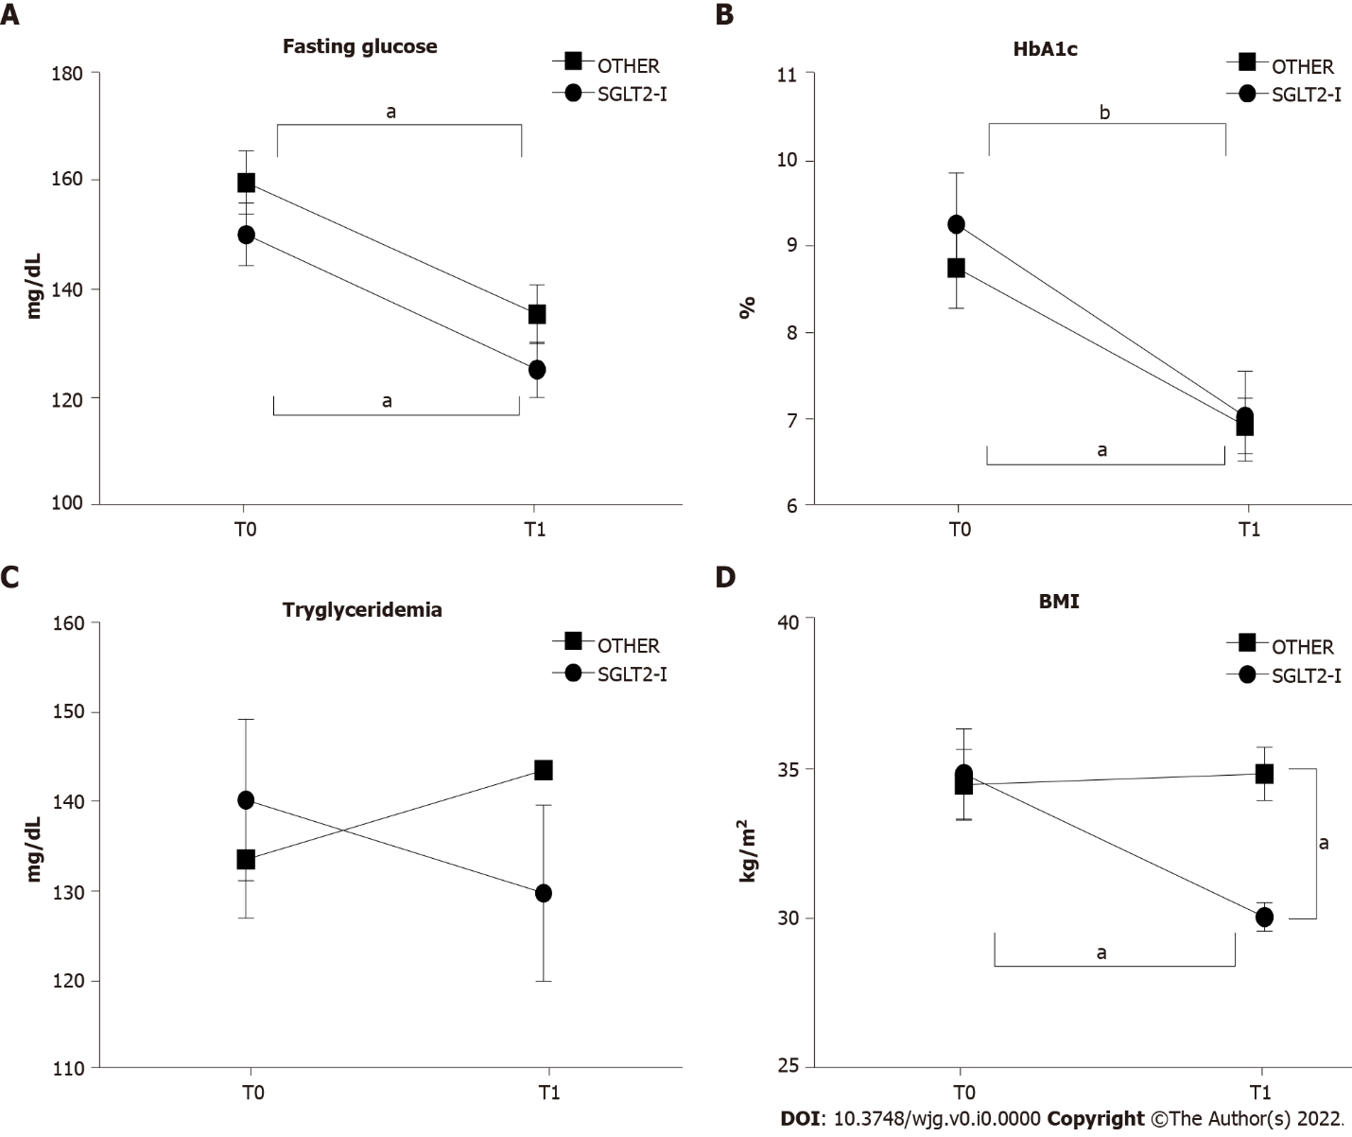
Figure 1 Glycemic control and body weight in patients enrolled in the study and included in groups treated with the sodium-glucose co-transporter-2 inhibitors or other glucose-lowering drugs before (T0) and after 1 wk of treatment (T1). A: Serum fasting glucose; B: Serum hemoglobin A1c; C: Serum triglycerides; D: Body mass index in patients observed in the study, grouped according to the assigned treatment. Data in the graphs are represented as mean ± SEM. Two-way analysis of variance and Tukey assessed statistical differences as post hoc test. ªP < 0.05, ^{b}P < 0.001. HbA1c: Hemoglobin A1c; SGLT2-I: Sodium-glucose co-transporter-2 inhibitor; OTHER: Other glucose lowering drug; BMI: Body mass index.
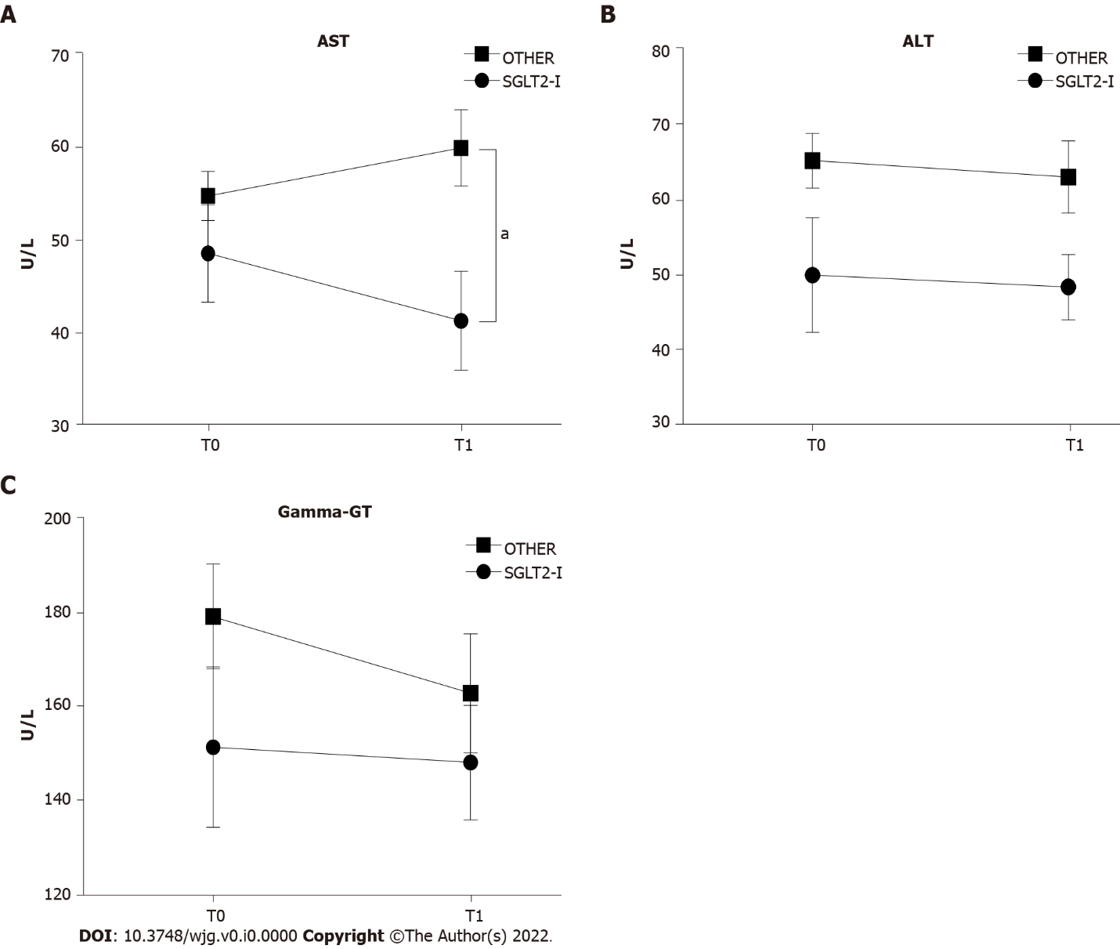
Figure 2 Serum liver enzyme activities in patients enrolled in the study and included in groups treated with the sodium-glucose co-transporter-2 inhibitors or other glucose-lowering drugs before (T0) and after 1 wk of treatment (T1). A: Serum aspartate aminotransferase; B: Serum alanine aminotransferase; C: Serum gamma-glutamyl transpeptidase activities in patients observed in the study, grouped according to the assigned treatment. Data in the graphs are represented as mean ± SEM. Two-way analysis of variance and Tukey assessed statistical differences as posthoc test. ªP < 0.05. AST: Aspartate aminotransferase; ALT: Alanine aminotransferase; Gamma-GT: Gamma-glutamyl transpeptidase; SGLT2-I: Sodium-glucose co-transporter-2 inhibitor; OTHER: Other glucose lowering drug.
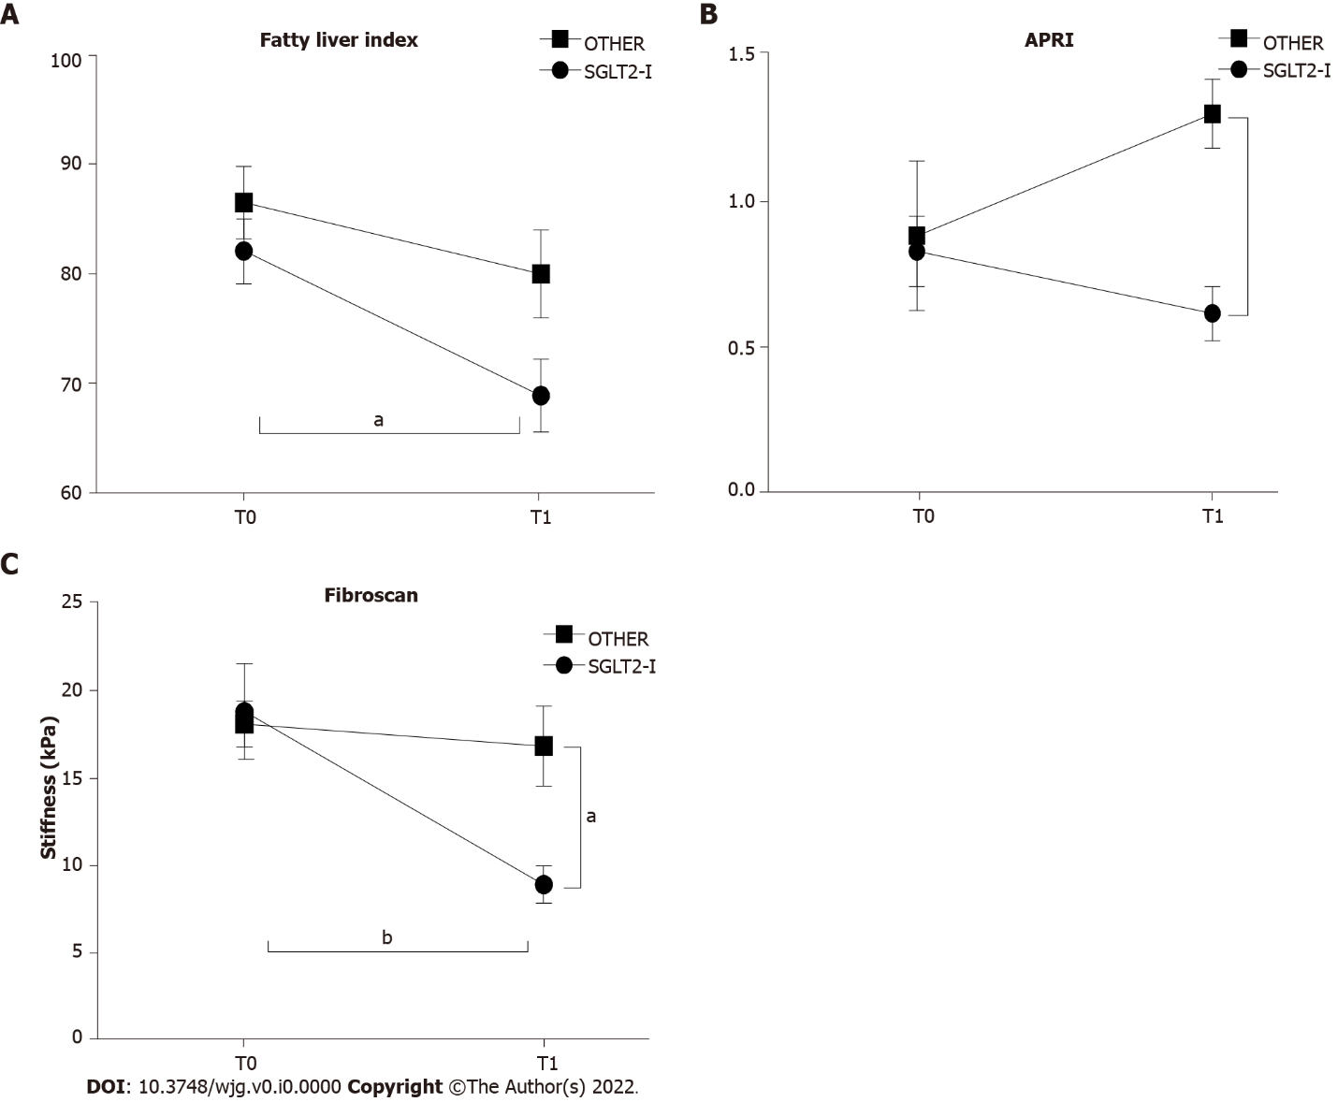
Figure 3 Non-invasive markers of liver steatosis and fibrosis in patients enrolled in the study and included in groups treated with the sodium-glucose co-transporter-2 inhibitors or other glucose glucose-lowering before (T0) and after 1 wk of treatment (T1). A: Fatty liver index; B: Aspartate aminotransferase-to-platelet ratio index; C: Hepatic elastometry in patients observed in the study grouped according to the assigned treatment. Data in the graphs are represented as mean ± SEM. Two-way analysis of variance and Tukey assessed statistical differences as posthoc test. ªP < 0.05, ^{b}P < 0.01. SGLT2-I: Sodium-glucose co-transporter-2 inhibitor; OTHER: Other glucose lowering drug; APRI: Aspartate aminotransferase-to-platelet ratio index.

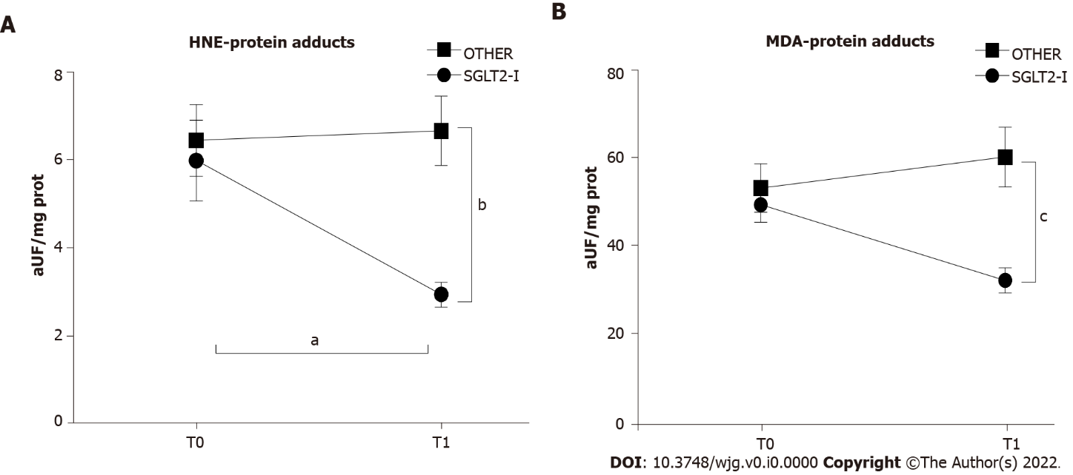
Figure 4 Circulating markers of oxidative stress in patients enrolled in the study and included in groups treated with the sodium-glucose co-transporter-2 inhibitors or other glucose-lowering drugs before (T0) and after 1 wk of treatment (T1). Data in the graphs are represented as mean ± SEM. Two-way analysis of variance and Tukey assessed statistical differences as a post hoc test. ªP < 0.05, ^{b}P < 0.01, ^{c}P < 0.001. HNE: Hydroxynonenal; MDA: Malondialdehyde; SGLT2-I: Sodium-glucose co-transporter-2 inhibitor; OTHER: Other glucose lowering drug.

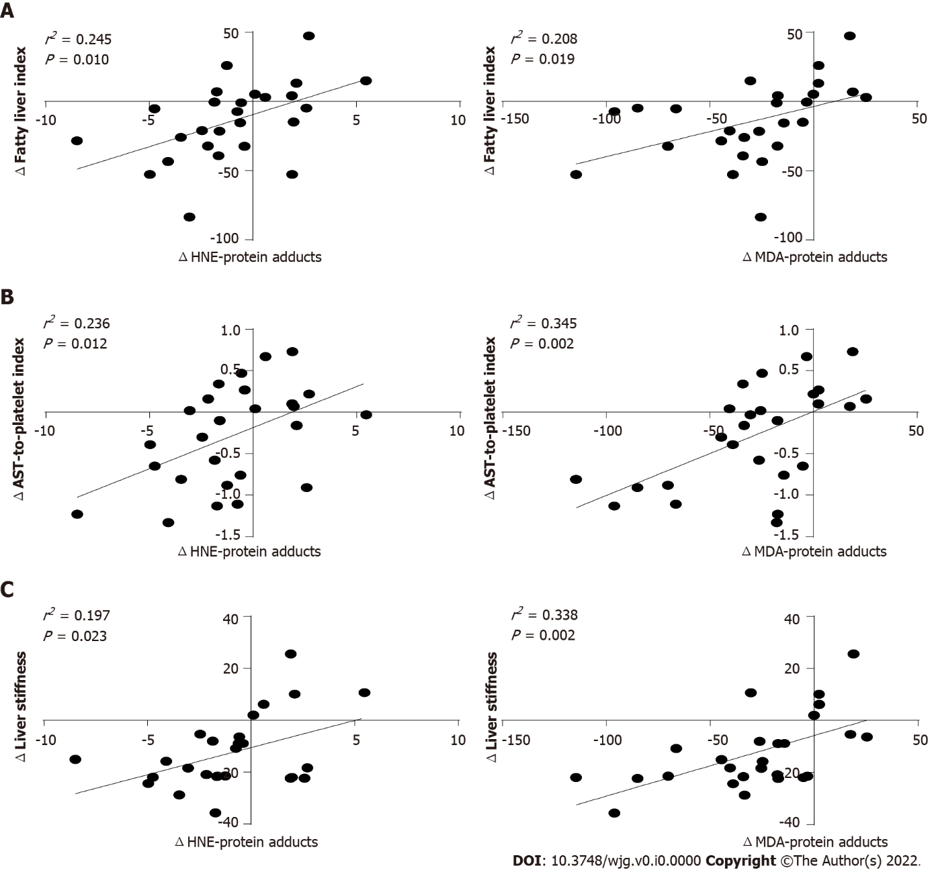
Figure 5 Linear regression analysis between the variation of circulating oxidative stress parameters and non-invasive markers of hepatic steatosis or fibrosis in patients treated with the sodium-glucose co-transporter-2 inhibitors. Data in the graphs represent scatterplots of hydroxynonenal- or malondialdehyde-protein adducts A: Fatty liver index; B: Aspartate aminotransferase-to-platelet ratio index; C: Liver stiffness. HNE: Hydroxynonenal; AST: Aspartate aminotransferase; MDA: Malondialdehyd.

Table 1 Baseline characteristics of patients observed in the study (n = 52) and included in groups treated with the sodium-glucose co-transporter-2 inhibitors or other glucose lowering drugs
Variable | SGLT2-I (n = 26) | OTHER (n = 26) | P value
Age (yr) | 60.6 ± 6.78 | 63.4 ± 10.4 | 0.246
Sex (male/female) | 15/11 | 15/11 | 1.000
BMI (kg/m²) | 34.8 ± 7.7 | 34.5 ± 5.9 | 0.875
No comorbidities, n (%) | 2 (7.7) | 2 (7.7) | 1.000
Dyslipidemia, n (%) | 13 (50.0) | 15 (57.7) | 0.578
Hypertension, n (%) | 10 (38.5) | 15 (57.7) | 0.165
Chronic heart failure, n (%) | 8 (30.8) | 3 (11.5) | 0.089
Chronic kidney disease, n (%) | 9 (34.6) | 4 (15.4) | 0.109
AST (U/L) | 48.5 ± 26.6 | 54.7 ± 13.3 | 0.293
ALT (U/L) | 49.6 ± 39.2 | 65.0 ± 18.7 | 0.077
Gamma-GT (U/L) | 151.3 ± 87.2 | 179.2 ± 56.9 | 0.178
Tryglycerides (mg/dL) | 140.2 ± 45.9 | 133.5 ± 33.2 | 0.549
Fasting glucose (mg/dL) | 150.1 ± 45.9 | 159.7 ± 49.8 | 0.473
HbA1c (%) | 9.24 ± 3.01 | 8.73 ± 2.31 | 0.496
Creatininemia (mg/dL) | 1.01 ± 0.44 | 0.88 ± 0.32 | 0.229
eGFR (mL/min/1.73 m²) | 61.4 ± 38.9 | 73.2 ± 24.6 | 0.197
Albuminemia (g/dL) | 3.91 ± 0.44 | 4.08 ± 0.47 | 0.184
Platelets (n, × 10³/mm³) | 175.7 ± 113.1 | 179.7 ± 76.7 | 0.882
BMI: Body mass index; AST: Aspartate aminotransferase; ALT: Alanine aminotransferase; Gamma-GT: Gamma-glutamyl transpeptidase; HbA1c: Hemoglobin A1c; eGFR: Epidermal growth factor receptor; SGLT2-I: Sodium-glucose co-transporter-2 inhibitor; OTHER: Other glucose lowering drug.

Table 2 Non-invasive markers of hepatic fibrosis in patients observed in the study (n = 52) and included in groups treated with the sodium-glucose co-transporter-2 inhibitors or other glucose lowering drugs at baseline (T0) and after 6 mo of therapy (T1)
 |  | T0 | T1 | P value
NAFLD fibrosis score (F3/4), n (%) | SGLT2-I (n = 26) | 9 (34.6) | 4 (15.4) | 0.042
 | OTHER (n = 26) | 7 (26.9) | 7 (26.9)
FIB-4 (F3/4), n (%) | SGLT2-I (n = 26) | 11 (42.3) | 6 (23.1) | 0.036
 | OTHER (n = 26) | 7 (26.9) | 7 (26.9)
AST/ALT ≥ 0.8, n (%) | SGLT2-I (n = 26) | 15 (57.7) | 6 (23.1) | 0.001
 | OTHER (n = 26) | 10 (38.5) | 11 (42.3)
NAFLD: Non-alcoholic fatty liver disease; FIB-4: Fibrosis-4; AST: Aspartate aminotransferase; ALT: Alanine aminotransferase; SGLT2-I: Sodium-glucose co-transporter-2 inhibitor; OTHER: Other glucose lowering drug.

Table 3 Circulating interleukin levels in patients enrolled in the study and included in groups treated with the sodium-glucose co-transporter-2 inhibitors or other glucose lowering drugs before (T0) and after 1 wk of treatment (T1)
Variable | SGLT2-I (n = 26) |  | OTHER (n = 26) |  | Fisher’s test (1, 100)
 | T0 | T1 | T0 | T1 | Time | Treatment | Interaction
IL-1α (pg/mL) | 1.35 ± 1.64 | 1.58 ± 1.30 | 1.44 ± 1.88 | 1.59 ± 1.56 | 0.373 | 0.026 | 0.016
IL-1β (pg/mL) | 9.90 ± 2.39 | 7.31 ± 3.51e | 8.84 ± 2.54 | 9.15 ± 2.42 | 4.455ª | 0.521 | 7.207^{b}
IL-2 (U/mL) | ≤ 0.5 | ≤ 0.5 | ≤ 0.5 | ≤ 0.5 | - | - | -
IL-4 (pg/mL) | 5.39 ± 4.20 | 8.54 ± 3.51^{d} | 4.89 ± 3.54 | 5.94 ± 3.66 | 8.207^{b} | 4.471ª | 2.052
IL-6 (pg/mL) | 9.41 ± 4.21 | 6.92 ± 1.98 | 11.4 ± 5.41 | 13.7 ± 9.01^{h} | 0.007 | 15.4^{c} | 4.516ª
IL-8 (pg/mL) | 428 ± 216 | 409 ± 271 | 412 ± 296 | 449 ± 204 | 0.338 | 0.060 | 0.327
IL-10 (pg/mL) | 1.33 ± 1.02 | 2.31 ± 1.12e | 1.29 ± 1.06 | 1.32 ± 1.04^{g} | 5.894ª | 6.130ª | 5.214ª
TNF (pg/mL) | 6.82 ± 3.02 | 4.61 ± 2.01^{d} | 7.94 ± 3.14 | 7.81 ± 3.56^{g} | 3.989ª | 13.59^{c} | 3.151
VEGF (pg/mL) | 262 ± 162 | 142 ± 109^{d} | 244 ± 201 | 268 ± 147^{f} | 2.393 | 3.029 | 5.384ª
IFN-γ (pg/mL) | 0.53 ± 0.23 | 0.57 ± 0.57 | 0.50 ± 0.39 | 0.61 ± 0.44 | 0.809 | 0.004 | 0.176
MCP-1 (pg/mL) | 411 ± 168 | 291 ± 156 | 389 ± 154 | 414 ± 184^{f} | 2.131 | 2.408 | 4.964ª
EGF (pg/mL) | 25.7 ± 13.7 | 22.2 ± 12.1 | 24.9 ± 20.1 | 23.6 ± 18.6 | 0.553 | 0.009 | 0.116
ªP < 0.05.
^{b}P < 0.01.
^{c}P < 0.001.
^{d}P < 0.05 vs sodium-glucose co-transporter-2 inhibitor T0.
^{e}P < 0.01 vs sodium-glucose co-transporter-2 inhibitor T0.
^{f}P < 0.05 vs sodium-glucose co-transporter-2 inhibitor T1.
^{g}P < 0.01 vs sodium-glucose co-transporter-2 inhibitor T1.
^{h}P < 0.001 vs sodium-glucose co-transporter-2 inhibitor T1.
Data are expressed as mean ± SD. Statistical differences were assessed by two-way analysis of variance. VEGF: Vascular endothelial growth factor; MCP-1: Monocyte chemoattractant protein-1; EGF: Epidermal growth factor; SGLT2-I: Sodium-glucose co-transporter-2 inhibitor; OTHER: Other glucose lowering drug; IL: Interleukin; TNF: Tumor necrosis factor; IFN: Interferon.

