Name of Journal: World Journal of Clinical Cases
Manuscript NO: 62279
Manuscript Type: CASE REPORT

Separated root tip formation associated with a fractured tubercle of dens evaginatus: A case report

Wu ZF et al. Separated root tip formation

Zhi-Fang Wu, Ling-Jiao Lu, Hai-Yan Zheng, Yan Tu, Ying Shi, Zi-Huai Zhou, Lin-Xian Fang, Bai-Ping Fu

Zhi-Fang Wu, Lin-Xian Fang, Department of Pediatric Dentistry, The Affiliated Hospital of Stomatology, School of Stomatology, Zhejiang University School of Medicine, Key Laboratory of Oral Biomedical Research of Zhejiang Province, Hangzhou 310006, Zhejiang Province, China

Ling-Jiao Lu, Hai-Yan Zheng, Ying Shi, Zi-Huai Zhou, Bai-Ping Fu, Department of Prosthodontics, The Affiliated Hospital of Stomatology, School of Stomatology, Zhejiang University School of Medicine, Key Laboratory of Oral Biomedical Research of Zhejiang Province, Hangzhou 310006, Zhejiang Province, China

Yan Tu, Department of Endodontics, The Affiliated Hospital of Stomatology, School of Stomatology, Zhejiang University School of Medicine, Key Laboratory of Oral Biomedical Research of Zhejiang Province, Hangzhou 310006, Zhejiang Province, China

Author contributions: Wu ZF and Tu Y were the patient’s dentists, reviewed the literature and contributed to manuscript drafting; Lu LJ, Zheng HY and Zhou ZH reviewed the literature and contributed to manuscript drafting; Shi Y and Fang LX analyzed and interpreted the imaging findings; Fu BP were responsible for the revision of the manuscript for important intellectual content; All authors issued final approval for the version to be submitted.

Supported by National Natural Science Foundation of China, No. 81801028; and Natural Science Foundation of Zhejiang Province, No. LQ19H140001.

Corresponding author: Bai-Ping Fu, PhD, Director, Professor, Department of Prosthodontics, The Affiliated Hospital of Stomatology, School of Stomatology, Zhejiang University School of Medicine, Key Laboratory of Oral Biomedical Research of Zhejiang Province, No. 395 Yan’an Road, Hangzhou 310006, Zhejiang Province, China. fbp@zju.edu.cn

Received: January 7, 2021
Revised: January 25, 2021
Accepted: February 24, 2021
Published online:

Abstract
BACKGROUND
Several previous studies have reported an unusual root formation in which a fractured apical fragment of an immature root continued to develop independent of the main root after trauma to an immature tooth. To date, there have been only rare reports of the continuing apical formation of the fractured root associated with dens evaginatus (DE). This paper presents a case of a separated root tip formation associated with a fractured tubercle of DE.

CASE SUMMARY
An 11-year-old boy was referred for gingival sinus on the buccal side of the right mandibular second premolar (tooth # 45). Clinically, tooth # 45 was free of caries, but there was a sign of a fractured tubercle of DE on the occlusal surface. Radiography showed that the root canal of tooth # 45 was widely radiolucent. A separated root apex was found apically under the main root and was nearly completely formed with an apical orifice at the apical tip. Tooth # 45 was diagnosed as tubular fracture of DE with chronic apical periodontitis. A revascularization technique was recommended to treat the tooth. At 3-mo and 1-yr follow-up, the patient remained asymptomatic. Periapical radiography revealed that the separated root tip distally drifted with closure of the apex. However, the root length and thickness of the main root did not increased.

CONCLUSION
Clinicians should be aware that even if tubercle of DE is fractured in an immature tooth, the root tip may be separated from the main root and completely formed.

Key Words: Separated root tip; Dens evaginatus; Tubercle fracture; Young permanent tooth; Revascularization; Case report

Wu ZF, Lu LJ, Zheng HY, Tu Y, Shi Y, Zhou ZH, Fang LX, Fu BP. Separated root tip formation associated with a fractured tubercle of dens evaginatus: A case report. World J Clin Cases 2021; In press

Core Tip: Studies have reported an unusual root formation where a fractured apical fragment of an immature root continued to develop independent of the main root after trauma to an immature tooth. There are only rare reports of continuing apical formation of the fractured root associated with dens evaginatus. We present a case of a separated root tip formation associated with a fractured tubercle of dens evaginatus. The case highlights that clinicians should be aware that even if the tubercle of dens evaginatus is fractured in an immature tooth, the root tip may be separated from the main root and completely formed.
INTRODUCTION
Dens evaginatus (DE) is an odontogenic developmental anomaly and occurs in both primary and permanent dentition^{[1]}. It is defined as a supernumerary tubercule of tooth structure located in the palatal or lingual surfaces of anterior teeth and the central groove or on the buccal or lingual cusps of premolars or molars^{[1]}. However, its exact etiology remains undetermined^{[1,2]}. The prevalence of DE varies with different race and different diagnostic criteria^{[1,2]}. DE occurs more frequently in premolars, particularly in the mandibular second premolar^{[1,2]}. A previous study reported that DE occurs in bilateral dentitions of approximately half of all cases^{[1,2]}. Tubercles of DE are usually fractured or worn by the opposing tooth, and inflammation or infection of the pulp and even periapical abscess most likely ensue^{[1]}.
It is well known that completion of root development and apex closure occurs up to 3 years after tooth eruption. Thus, once the pulp is inflamed or necrosed during this period, the root formation is interrupted, which results in an open apex and thin root canal wall. The continuing formation of the affected root is a great challenge for dentists^{[3]}. Several previous studies reported an unusual root formation in which a fractured apical fragment of an immature root continued to develop independent of the main root after a trauma to an immature tooth^{[4-8]}. Hertwig’s epithelial root sheath and mesenchymal stem cells are believed to be responsible for the root development^{[9]}. Although the stemness of the apical papilla cells remains to be further investigated^{[10]}, it is believed that stem cells from the apical papilla (SCAPs) play a pivotal role in continuing root development in the erupting teeth with immature roots^{[11]}. The authors hypothesize that this continuing development of the apex is accompanied by SCAPs that are separated by trauma to cause detachment of SCAPs and Hertwig’s epithelial root sheath^{[4-8]}. Jung et al^{[12]} reported that a separated apex continued to develop without any direct traumatic episode. However, the exact underlying mechanism is still unclear. To date, there are only rare reports of continuing apical formation of a fractured root associated with DE.

CASE PRESENTATION
Chief complaints
An 11-year-old boy was referred to his dentist for gingival sinus on the buccal side of the right mandibular second premolar.

History of present illness
The boy experienced intermittent spontaneous pain in the affected part for about 2 mo. His initial dentist referred the boy to our clinic for an incompletely formed root associated with a large radiolucency.

History of past illness
Any trauma of the tooth was denied by his parents.

Personal and family history
His parents denied any personal and family history.

Physical examination
The clinical signs were described as follows. Tooth # 45 was free of caries, but there was a sign of a fractured tubercle of DE on the occlusal surface. The tooth mobility was grade I, and there was a gingival fistula on the buccal side. The pyogenic fluids flowed out of the fistula under palpation (Figure 1A). Tooth percussion was sensitive. The probing depths of the affected tooth were within a normal range.

Imaging examinations
Initial panoramic radiography at his first visit showed that the root of tooth # 45 was fractured. A separated root apex was found apically under the main root and was almost completely formed. The main root remained immature with a thin root wall and was associated with a large radiolucency. However, the root of tooth # 35 was not erupted, and the second primary molar remained. The root development was graded as Nolla 8 (Figure 1B).

FINAL DIAGNOSIS
Tooth # 45 was diagnosed as tubular fracture of DE with chronic apical periodontitis.

TREATMENT
A revascularization technique was recommended to treat the tooth as follows. The tooth was isolated with a rubber dam, and the access cavity was made. The pulp was found to be completely necrotic. The root canal was cleaned, gently prepared with K-files under root canal microscopy and irrigated with copious (20 mL) 1% NaClO and 0.9% saline solution in turn for 5 min. The canals were dried with sterilized paper tips (GAPADENT, Tianjin, China) and inserted with freshly mixed metronidazole paste (Klus Pharma, Sichuan Province, China). The open access was then filled with glass ionomer cement (GC, Japan). The patient was followed up 2 wk later without any symptoms or pain. The fistula was undetectable, and the mobility of the affected tooth was within a normal range (Figure 2A). The access was reopened, and the root canal was slowly irrigated with 20 mL 1% NaClO and 0.9% saline solution in turn. A size # 20 K10/6-file was used to gently irritate the tissue to induce fresh bleeding into the canal. The bleeding was left undisturbed to allow blood clotting. A blood clot was produced to the level of the cementoenamel junction. Then iRoot BP Plus (Innovative BioCeramix Inc., Vancouver, BC, Canada) was placed carefully over the blood clot, and subsequently glass ionomer cement was placed. Dental radiography was undertaken to secure the treatment (Figure 2B).

OUTCOME AND FOLLOW-UP
At the 3 mo follow-up, the patient was asymptomatic. Periapical radiography revealed that the large radiolucency was completely resolved, and the separated root tip was slightly distally drifted with closure of the apex (Figure 3A). At the 1 yr follow-up, the patient was still asymptomatic, and the tooth had good clinical function. Dental radiography revealed that the separated root tip was more distally drifted than after the 3 mo follow-up. However, the main root of tooth # 45 did not increase in root length and dentin thickness (Figure 3B).

DISCUSSION
SCAPs and Hertwig’s epithelial root sheath are believed to be responsible for root development^{[9]}. The tissues are attached to the apex of the developing root loosely, but they can be easily detached by an external force^{[13]}. Several studies have reported separate root formation. However, most cases were associated with a traumatic history, particularly avulsion^{[4-8]}. Other studies have reported that after apexification treatment a separately growing root was formed^{[12,14]}. The authors inferred that the separation may have been caused by the mechanical and chemical procedures performed during apexification. Jung et al^{[12]} reported a case without a clear traumatic history and showed at initial examination that the root was separated into two segments and the root tip was already present. However, the time and the cause of the fractured root are unknown. Jung et al^{[12]} speculated that the separation might have been caused by tooth mobility resulting from tissue swelling. However, the separate root tip formation associated with a fractured tubercle of DE has rarely been reported.
A previous study described an anomalous and unusual root formation in a premolar DE^{[15]}. In that study, the tooth was extracted due to the gingival communication with the pulp space^{[15]}. Reichart et al^{[16]} reported a tooth with a similar radiographic appearance, but they interpreted it as a root fracture. Radiographic examination showed that development in the coronal part of the root had ceased, and the apical root segment was completely formed. They speculated that this may have been due to a low-grade infection that was sufficiently virulent to interrupt root development of the coronal part but could allow the continued apical root formation^{[15]}. In our study, a separated root tip associated with a fractured tubercle of DE was formed. The precise time and exact cause of the fractured root could not be determined. As the mobility of the tooth was less and the root length of the coronal part was about half that of tooth # 44, the revascularization treatment procedure was performed for tooth # 45.
Few studies have reported the exact histology of the newly formed separate tissues. Yang et al^{[14]} reported that the separate newly formed part of the root was composed of pulp tissue, odontoblasts, predentin and cementum. Another study reported that the separated root segment revealed a narrow necrotic pulp with some evidence of calcification^{[15]}.
DE results from abnormal tooth development^{[1]}. Several prophylactic treatment methods are recommended for DE, such as selective grinding of the tubercles and application of resin to reinforce the tubercles^{[1]}. However, in the clinic, the fractured tubercle is frequently observed prior to complete root formation and leads to dental complications such as pulpal necrosis and apical periodontitis. This could interfere with root development and even influence survival of the affected tooth^{[1]}. If the tubercle is fractured and the pulp is affected in the immature tooth, then apexification is strongly recommended to treat the tooth^{[17]}. Although apexification treatment is reported to have high endodontic clinical success, these teeth are prone to post-treatment fracture due to the thin fragile root canal walls^{[18]}. In addition, the treatment protocol needs time for treatment execution, which requires a compliant patient^{[19]}.
Revascularization is another viable option^{[19]}. Revascularization is a regenerative treatment that allows root maturation by continued deposition of dentin and a cementum-like structure along the root walls^{[19]}. In the present case, we used revascularization to promote root development. At the 3 mo follow-up, radiographic examination showed complete resolution of the radiolucency. The success of regenerative endodontic procedures, as defined by the American Association of Endodontics, is categorized as follows: (1) primary goal (elimination of symptoms and evidence of bony healing); (2) secondary goal [increased root wall thickness and/or root length (desired but perhaps not essential)]; and (3) tertiary goal (a positive response to vitality testing)^{[20]}. Although the root length and dentin thickness of the main root did not increased after 1 yr, the primary goal was achieved^{[20]}. In this case, the root development may take longer, and additional follow-up is recommended. Compared to the initial visit radiography, the completely formed root tip was slightly drifted (Figure 3A). After 1 yr, the root tip was more distally drifted than before (Figure 3B). This phenomenon is in accordance with a previous report^{[14]}. There is a common finding that there is a strong tendency of the teeth to drift mesially even before they appear in the oral cavity^{[14]}. That is why the separated root tip was located distoapically to the original main root.

CONCLUSION
There are only rare reports about the continuing apical formation of a fractured root associated with DE. The present case highlights that clinicians should be aware that even if a tubercle of DE is fractured in an immature tooth, the root tip may be separated from the main root and completely formed. Increased awareness of this will allow clinicians to make correct preventive and therapeutic decisions.

REFERENCES
1 Chen JW, Huang GT, Bakland LK. Dens evaginatus: Current treatment options. J Am Dent Assoc 2020; 151: 358-367 [PMID: 32209245 DOI: 10.1016/j.adaj.2020.01.015]
2 Pritchard B, Tefaghi FA, Makdissi J. Dens evaginatus. Br Dent J 2020; 228: 397 [PMID: 32221422 DOI: 10.1038/s41415-020-1441-x]
3 Wen PH, Liou JU, Duh BR. Apexification of nonvital immature mandibular premolars using two different techniques. J Dent Sci 2009; 4: 96-101 [DOI: 10.1016/S1991-7902(09)60014-3]
4 Gibson AC. Continued root development after traumatic avulsion of partly-formed permanent incisor. Br Dent J 1969; 126: 356-357 [PMID: 5255742 DOI: 10.1016/j.ultras.2008.04.011]
5 Barker BC, Mayne JR. Some unusual cases of apexification subsequent to trauma. Oral Surg Oral Med Oral Pathol 1975; 39: 144-150 [PMID: 234007 DOI: 10.1016/0030-4220(75)90405-3]
6 Burley MA, Reece RD. Root formation following traumatic loss of an immature incisor. A case report. Br Dent J 1976; 141: 315-316 [PMID: 1069586 DOI: 10.1038/sj.bdj.4803843]
7 Smith BE, Thaler MN. Detached root apexogenesis. Oral Surg Oral Med Oral Pathol 1992; 73: 129 [PMID: 1603555 DOI: 10.1016/0030-4220(92)90173-n]
8 Welbury R, Walton AG. Continued apexogenesis of immature permanent incisors following trauma. Br Dent J 1999; 187: 643-644 [PMID: 10654438 DOI: 10.1038/sj.bdj.4800356]
9 Pashley DH, Liewehr FR. Structure and functions of the dentin-pulp complex. In: Cohen S, Hargreaves KM. Pathways of the pulp. St Louis: Mosby Elsevier; 2006: 460-511
10 Tziafas D, Kodonas K. Differentiation potential of dental papilla, dental pulp, and apical papilla progenitor cells. J Endod 2010; 36: 781-789 [PMID: 20416419 DOI: 10.1016/j.joen.2010.02.006]
11 Huang GT, Sonoyama W, Liu Y, Liu H, Wang S, Shi S. The hidden treasure in apical papilla: the potential role in pulp/dentin regeneration and bioroot engineering. J Endod 2008; 34: 645-651 [PMID: 18498881 DOI: 10.1016/j.joen.2008.03.001]
12 Jung IY, Kim ES, Lee CY, Lee SJ. Continued development of the root separated from the main root. J Endod 2011; 37: 711-714 [PMID: 21496677 DOI: 10.1016/j.joen.2011.01.015]
13 Sonoyama W, Liu Y, Yamaza T, Tuan RS, Wang S, Shi S, Huang GT. Characterization of the apical papilla and its residing stem cells from human immature permanent teeth: a pilot study. J Endod 2008; 34: 166-171 [PMID: 18215674 DOI: 10.1016/j.joen.2007.11.021]
14 Yang SF, Yang ZP, Chang KW. Continuing root formation following apexification treatment. Endod Dent Traumatol 1990; 6: 232-235 [PMID: 2133316 DOI: 10.1111/j.1600-9657.1990.tb00425.x]
15 Moule AJ, Natkin E. Unusual root formation in a premolar with dens evaginatus. Aust Dent J 1987; 32: 354-356 [PMID: 3481256 DOI: 10.1111/j.1834-7819.1987.tb00601.x]
16 Reichart P, Tantiniran D. Dens evaginatus in the Thai. An evaluation of fifty-one cases. Oral Surg Oral Med Oral Pathol 1975; 39: 615-621 [PMID: 1054469 DOI: 10.1016/0030-4220(75)90203-0]
17 Chu FC, Sham AS, Yip KH. Fractured dens evaginatus and unusual periapical radiolucency. Dent Traumatol 2002; 18: 339-341 [PMID: 12656869 DOI: 10.1034/j.1600-9657.2002.00090.x]
18 Cvek M. Prognosis of luxated non-vital maxillary incisors treated with calcium hydroxide and filled with gutta-percha. A retrospective clinical study. Endod Dent Traumatol 1992; 8: 45-55 [PMID: 1521505 DOI: 10.1111/j.1600-9657.1992.tb00228.x]
19 Bukhari S, Kohli MR, Setzer F, Karabucak B. Outcome of Revascularization Procedure: A Retrospective Case Series. J Endod 2016; 42: 1752-1759 [PMID: 27726882 DOI: 10.1016/j.joen.2016.06.021]
20 Kim SG, Malek M, Sigurdsson A, Lin LM, Kahler B. Regenerative endodontics: a comprehensive review. Int Endod J 2018; 51: 1367-1388 [PMID: 29777616 DOI: 10.1111/iej.12954]

Footnotes
Informed consent statement: Informed written consent was obtained from the patient for publication of this report and any accompanying images.

Conflict-of-interest statement: The authors declare that they have no conflict of interest.

CARE Checklist (2016) statement: The authors have read the CARE Checklist (2016), and the manuscript was prepared and revised according to the CARE Checklist (2016).

Open-Access: This article is an open-access article that was selected by an in-house editor and fully peer-reviewed by external reviewers. It is distributed in accordance with the Creative Commons Attribution NonCommercial (CC BY-NC 4.0) license, which permits others to distribute, remix, adapt, build upon this work non-commercially, and license their derivative works on different terms, provided the original work is properly cited and the use is non-commercial. See: http://creativecommons.org/Licenses/by-nc/4.0/

Manuscript source: Unsolicited manuscript

Peer-review started: January 7, 2021
First decision: January 24, 2021
Article in press:

Specialty type: Medicine, research and experimental
Country/Territory of origin: China
Peer-review report’s scientific quality classification
Grade A (Excellent): 0
Grade B (Very good): 0
Grade C (Good): C
Grade D (Fair): 0
Grade E (Poor): 0

P-Reviewer: Chen S S-Editor: Gao CC L-Editor: Filipodia P-Editor:
Figure Legends
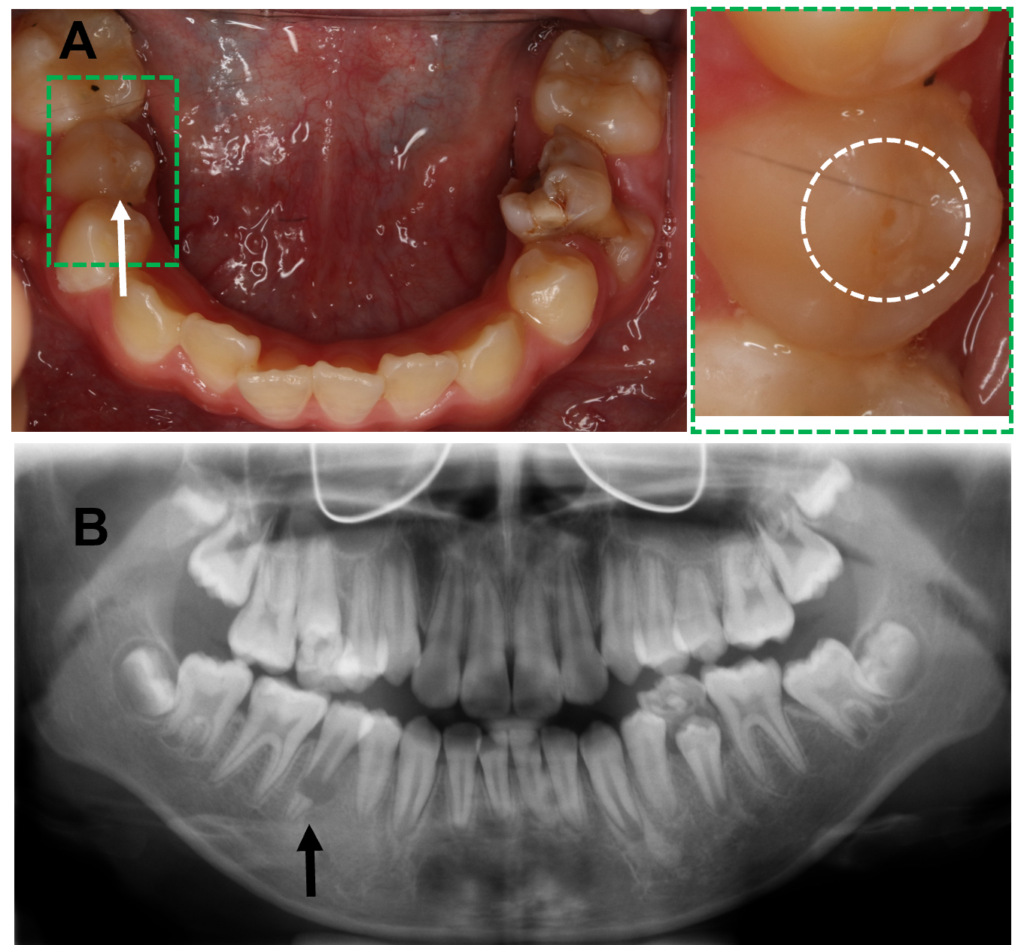
Figure 1 Preoperative clinical and radiographic evaluation. A: Overview of mandibular dentition shows a gingival sinus (white arrow) on the buccal side of tooth # 45. The right column is a local enlarged image of the green dotted area with the white circle showing the fractured tubercle of dens evaginatus on the occlusal surface of tooth # 45; B: Panoramic radiograph at the initial visit showing that the root of tooth # 45 was fractured and separated. The separated root apex was almost completely formed, and the main root remained immature with thin root walls associated with a large radiolucency (black arrow).
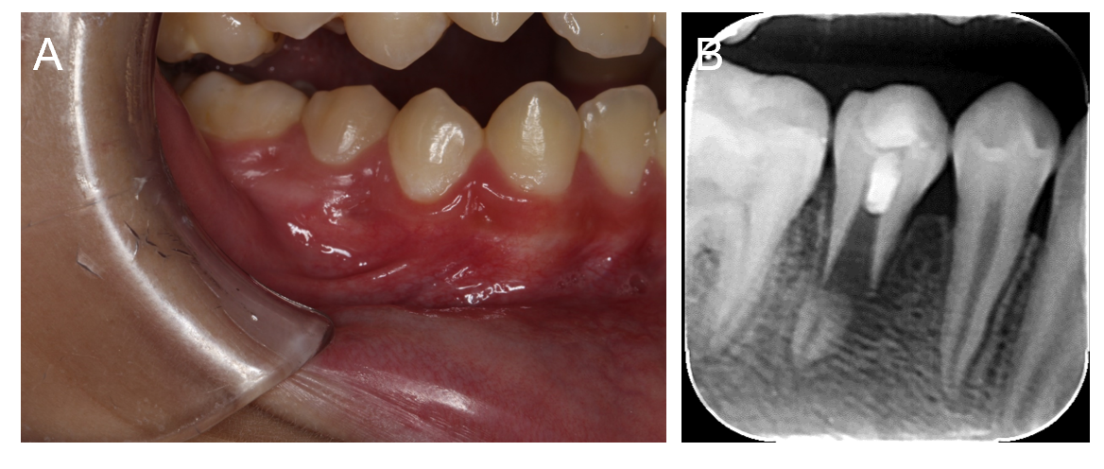
Figure 2 Clinical evaluation at the 2 wk follow-up and periapical radiograph after revascularization. A: Clinical evaluation at the 2 wk follow-up showing that the fistula was completely resolved (subsided); B: Periapical radiograph after revascularization showing iRoot Bp Plus was placed below the cementoenamel junction.

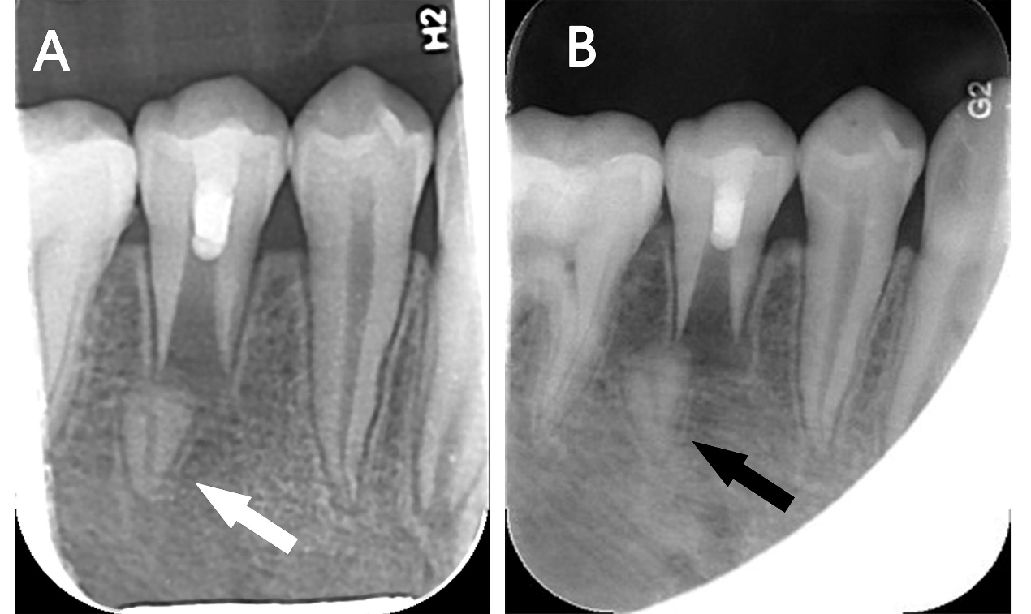
Figure 3 Periapical radiograph during the follow-up period. A: Periapical radiograph at the 3 mo follow-up demonstrated complete resolution of the radiolucency and a drifting root tip (white arrow); B: Periapical radiograph at the 1 yr follow-up showed that the separated root tip (black arrow) was more distally drifted than before. The root length and dentin thickness of the main root did not increase.

