Name of Journal: World Journal of Clinical Cases
Manuscript NO: 91654
Manuscript Type: CASE REPORT

Small intestine angioleiomyoma as a rare cause of perforation: A case report

Hou TY et al Angioleiomyoma-related bowel perforation

Teng-Yuan Hou, Wei-Juo Tzeng, Pei-Hang Lee

Teng-Yuan Hou, Wei-Juo Tzeng, Department of General Surgery, Kaohsiung Chang Gung Memorial Hospital, Kaohsiung 833, Taiwan

Pei-Hang Lee, Department of Anatomical Pathology, Kaohsiung Chang Gung Memorial Hospital, Kaohsiung 833, Taiwan

Author contributions: Hou TY designed the report; Lee PH analyzed the histological images; Tzeng WJ analyzed the data and wrote the paper; All authors read and approved the final manuscript.

Corresponding author: Wei-Juo Tzeng, MD, Surgeon, Surgical Oncologist, Department of General Surgery, Kaohsiung Chang Gung Memorial Hospital, No. 123 Dapi Road, Niaosong District, Kaohsiung 833, Taiwan. Jbkim22004@gmail.com

Received: January 8, 2024
Revised: February 13, 2024
Accepted: March 25, 2024
Published online:

Abstract
BACKGROUND
Angioleiomyoma is a rare and benign stromal tumor typically found in subcutaneous tissue. It rarely occurs in the gastrointestinal tract. Among the reported cases, the most common complication was gastrointestinal bleeding. Perforation has only been reported as a complication in the last few decades.

CASE SUMMARY
This case report detailed the discovery of intestinal angioleiomyoma in a 47-year-old male presenting with abdominal pain that had persisted for 3 d. After suspecting hollow organ perforation, surgical intervention involving intestinal resection and anastomosis was performed.

CONCLUSION
The report underscores the significance of early surgical intervention in effectively treating angioleiomyoma while emphasizing the pivotal role of timely and appropriate measures for favorable outcomes.

Key Words: Angioleiomyoma; Intestinal perforation; Abdomen; Acute; Diarrhea; Case report

Hou TY, Tzeng WJ, Lee PH. Small intestine angioleiomyoma as a rare cause of perforation: A case report. World J Clin Cases 2024; In press

Core Tip: Here we report the first case of angioleiomyoma in the small intestine with a complication of perforation. This type of complication is extremely rare as the last published report of a perforation complication related to angioleiomyoma was published 30 years ago in Russian.

INTRODUCTION
Angioleiomyomas are a vascular subtype of leiomyomas, categorized as benign smooth muscle tumors. The tumor itself is characterized by inclusion of vessel and smooth muscle cells^{[1]}. Angioleiomyomas mostly arise from the wall of a vein. The majority of cases occur at 30 years to 60 years of age, with female predominance and location in a lower extremity^{[2]}. Although, angioleiomyomas have been found in different organs^{[3-5]}. Within the gastrointestinal tract, occurrences of angioleiomyomas are exceptionally rare^{[6]}. This case report presents the inaugural instance documented in the English literature and details a patient who exhibited hollow organ perforation attributable to angioleiomyoma.

CASE PRESENTATION
Chief complaints
A 47-year-old male presented with lower abdominal pain and diarrhea.

History of present illness
The patient reported that his symptoms started 3 d prior to presentation, with both gradually progressing over that period. He also reported having a fever that would go up to 39 °C for 1 wk.

History of past illness
The patient had a medical history of controlled hypertension for many years.

Personal and family history
The patient’s personal and family history was unremarkable.

Physical examination
The physical examination revealed the following: Body temperature, 36.7 °C; heart rate, 105 beats/min; respiratory rate, 18 breaths/min; and blood pressure, 125/80 mmHg. The skin and mucous membranes were free of yellow staining, rash, bleeding spots, liver palms, and spider nevus. Chest breathing was normal. However, the tenderness over the low abdomen and rebounding pain was mentioned.

Laboratory examinations
Laboratory tests indicated elevated C-reactive protein (335 mg/L; normal range: < 5 mg/L) and increased creatinine (1.81 mg/dL; normal range: 0.64 mg/dL-1.27 mg/dL).

Imaging examinations
Computed tomography (CT) showed pneumoperitoneum and a mass over the pelvic area (Figure 1).

FINAL DIAGNOSIS
Ileum angioleiomyoma with complications of perforation and pneumoperitoneum.

TREATMENT
We initially suspected a perforation associated with sigmoid colon cancer. Therefore, surgical intervention was initiated approximately 7 h after admission. An exploratory laparotomy revealed a tumor, measuring 8 cm × 5 cm, located 70 cm from the ileocecal valve. It was surrounded by an abscess formation (Figure 2). A thorough examination of the stomach, intestine, and colon did not reveal additional perforation. The tumor was excised followed by end-to-end anastomosis.

OUTCOME AND FOLLOW-UP
Postoperatively, the patient was transferred to the ward for continued care and was discharged 2 wk after the operation. The patient returned to our clinic for follow-up after 2 wk without complaint of abdominal pain, nausea nor vomiting. The immunohistochemical analysis of the resected specimen corroborated the diagnosis of angioleiomyoma.

DISCUSSION
Leiomyomas are most frequently located in the uterine myometrium (95.0%), followed by the skin (3.0%) and the gastrointestinal tract (1.5%)^{[6]}. In 1969, the World Health Organization defined leiomyomas as well-circumscribed benign tumors composed of bundles of mature smooth muscle cells. The World Health Organization classification includes three main groups: Solid leiomyoma; vascular leiomyoma (angioleiomyoma); and epithelioid leiomyoma (leiomyoblastoma)^{[7]}. Angioleiomyoma, initially described by Stout^{[8]} in 1937, commonly affects the skin and subcutaneous tissue of the lower extremities. Its presence in the gastrointestinal tract is exceptionally rare. Angioleiomyomas in the gastrointestinal tract occur predominantly in the jejunum (44%), followed by the ileum (37%) and the duodenum (19%).
Four distinct subtypes of angioleiomyoma have been identified^{[2]}. The first type is capillary or solid angioleiomyomas. They are characterized by a rich stratification of smooth muscle cells surrounding a few slit-like vascular channels. This subtype is the most common. The second type is venous angioleiomyomas, which is distinguished by more vascular channels and walls that are thicker compared to capillary angioleiomyomas. The third type is cavernous angioleiomyomas, and this subtype features widened vascular channels surrounded by a thin layer of smooth muscle cells. The fourth type is combined capillary and venous angioleiomyomas^{[9,10]}.
Our patient was diagnosed with cavernous angioleiomyoma based on histological findings. Sections showed ileal tissue with a well-circumscribed subserosal tumor composed of proliferative spindle smooth muscle cells bearing brightly eosinophilic cytoplasm and arranged in fascicles, punctuated by variable-sized vascular channels. The vessels were irregularly dilated with attenuated walls. There was also a lack of a thick muscular wall (Figure 3).
The clinical presentation of angioleiomyoma is diverse. Uncomplicated cases are typically asymptomatic. However, a limited number of reported cases exhibit rare clinical presentations. Therefore, it is challenging to establish comprehensive clinical features and complication rates. Only 10 cases of gastrointestinal angioleiomyoma have been documented in the literature. Table 1 compares these cases with our own.
Gastrointestinal bleeding is the most commonly reported complication associated with angioleiomyoma. Past cases have reported other complications, such as intussusception and prolapse. Notably, our case represents the first reported instance of angioleiomyoma-related perforation in the English literature.
In our case, preoperative imaging, specifically CT, revealed a lesion located in the pelvic region accompanied by pneumoperitoneum. We initially suspected malignancy-related hollow organ perforation. Despite the absence of tarry or bloody stool reported by the patient, CT indicated a tumor of 9.5 cm × 6.5 cm × 6.4 cm in size that was surrounded by abscess.
Surgical resection of the affected bowel segment is the typical treatment to manage the angioleiomyoma and any accompanying complications. Resection is typically followed by side-to-side anastomosis, which was also performed in our case. Given the initial suspicion of hollow organ perforation, a comprehensive inspection of the entire abdomen was essential to identify potential perforations caused by other etiologies. This thorough examination was crucial to ensure an accurate diagnosis and appropriate intervention.

CONCLUSION
In summary, small bowel angioleiomyoma is a rare occurrence. Perforation is also a rare complication related to angioleiomyoma. Nonetheless, early surgical intervention plays a crucial role in the effective treatment of angioleiomyoma. Timely and appropriate surgical measures are pivotal for a favorable outcome in such cases.

REFERENCES
1 Beissert M, Kenn W, Schultz G, Keberle M, Eck M, Hahn D. Hepatic angiomyoma: CT and MRI findings. Abdom Imaging 2002; 27: 40-42 [PMID: 11740605 DOI: 10.1007/s00261-001-0028-5]
2 Hachisuga T, Hashimoto H, Enjoji M. Angioleiomyoma. A clinicopathologic reappraisal of 562 cases. Cancer 1984; 54: 126-130 [PMID: 6722737 DOI: 10.1002/1097-0142(19840701)54:1<126::aid-cncr2820540125>3.0.co;2-f]
3 Matsuyama A, Hisaoka M, Hashimoto H. Angioleiomyoma: a clinicopathologic and immunohistochemical reappraisal with special reference to the correlation with myopericytoma. Hum Pathol 2007; 38: 645-651 [PMID: 17270242 DOI: 10.1016/j.humpath.2006.10.012]
4 Brooks JK, Nikitakis NG, Goodman NJ, Levy BA. Clinicopathologic characterization of oral angioleiomyomas. Oral Surg Oral Med Oral Pathol Oral Radiol Endod 2002; 94: 221-227 [PMID: 12221390 DOI: 10.1067/moe.2002.125276]
5 Jamiyan T, Kuroda H, Luvsan G, Munkhnyam T, Kakumoto A, Enkhbat B. Primary Hepatic Angioleiomyoma: A Case Report. Am J Case Rep 2023; 24: e938645 [PMID: 36805667 DOI: 10.12659/AJCR.938645]
6 Veeresh M, Sudhakara M, Girish G, Naik C. Leiomyoma: A rare tumor in the head and neck and oral cavity: Report of 3 cases with review. J Oral Maxillofac Pathol 2013; 17: 281-287 [PMID: 24250094 DOI: 10.4103/0973-029X.119770]
7 Enzinger FM, Lattes R, Torloni H. Histological typing of soft tissue tumors. International histological classification of tumors. No. 3, Geneva. World Health Organization, 1969: 42. Available from: https://scholar.google.com/scholar?q=Enzinger+FM+Lattes+R+Torloni+H+Histological+Typing+of+Soft+Tissue+Tumours+1969+Geneva+World+Health+Organization+30+1+
8 Stout AP. Solitary Cutaneous and Subcutaneous Leiomyoma. Am J Cancer 1937; 29: 435-69 [DOI: 10.1158/ajc.1937.435]
9 Sadat U, Theivacumar NS, Vat J, Jah A. Angioleiomyoma of the small intestine - a rare cause of gastrointestinal bleeding. World J Surg Oncol 2007; 5: 129 [PMID: 17996042 DOI: 10.1186/1477-7819-5-129]
10 Agaimy A, Wünsch PH. True smooth muscle neoplasms of the gastrointestinal tract: morphological spectrum and classification in a series of 85 cases from a single institute. Langenbecks Arch Surg 2007; 392: 75-81 [PMID: 17021790 DOI: 10.1007/s00423-006-0092-y]
11 Valnicek V. [Angioleiomyoma of the small intestine as a cause of severe melena]. Rozhl Chir 1959; 38: 848-880 [PMID: 13840923]
12 Gădăleanu V, Popescu V. Angiomyoma and vascular ectasia of the small bowel as a cause of intestinal bleeding. Pathol Res Pract 1988; 183: 519-523 [PMID: 3263631 DOI: 10.1016/s0344-0338(88)80108-0]
13 Sapelkin OS. [Angioleiomyoma of the small intestine complicated by perforation]. Klin Khir (1962) 1989: 61-62 [PMID: 2724819]
14 Pidoprigora AP, Chmeruk SP, Fedorchuk LI, Shuldik SI. [Angioleiomyoma of the small intestine as a cause of recurrence of hemorrhage]. Klin Khir 1995: 48 [PMID: 8640514]
15 Nakatani M, Fujiwara Y, Kameda N, Okazaki H, Watanabe T, Tominaga K, Arakawa T, Noda E, Inoue T, Maeda K, Hirakawa K, Wakasa K. Angioleiomyoma of the small intestine detected by double-balloon enteroscopy. Gastrointest Endosc 2010; 72: 187-8; discussion 188 [PMID: 20421103 DOI: 10.1016/j.gie.2009.12.037]
16 Turan M, Karadayi K, Duman M, Ozer H, Arici S, Yildirir C, Koçak O, Sen M. Small bowel tumors in emergency surgery. Ulus Travma Acil Cerrahi Derg 2010; 16: 327-333 [PMID: 20849049]
17 Stanojević GZ, Mihailović DS, Nestorović MD, Radojković MD, Jovanović MM, Stojanović MP, Branković BB. Case of rectal angioleiomyoma in a female patient. World J Gastroenterol 2013; 19: 2114-2117 [PMID: 23599634 DOI: 10.3748/wjg.v19.i13.2114]
18 Gachabayov M, Mityushin P. Recurrent Midgut Bleeding due to Jejunal Angioleiomyoma. Case Rep Surg 2016; 2016: 4569781 [PMID: 27668116 DOI: 10.1155/2016/4569781]
19 Shao XD, Liang ZD, Guo XZ. A Small Jejunal Angioleiomyoma Detected by Double-Balloon Enteroscopy: A Case Report. Am J Case Rep 2018; 19: 1126-1128 [PMID: 30245504 DOI: 10.12659/AJCR.910884]

Footnotes
Informed consent statement: Informed written consent was obtained from the patient for publication of this report and any accompanying images.

Conflict-of-interest statement: The authors declare having no conflicts of interest.

CARE Checklist (2016) statement: The authors have read the CARE Checklist (2016), and the manuscript was prepared and revised according to the CARE Checklist (2016).

Open-Access: This article is an open-access article that was selected by an in-house editor and fully peer-reviewed by external reviewers. It is distributed in accordance with the Creative Commons Attribution NonCommercial (CC BY-NC 4.0) license, which permits others to distribute, remix, adapt, build upon this work non-commercially, and license their derivative works on different terms, provided the original work is properly cited and the use is non-commercial. See: https://creativecommons.org/Licenses/by-nc/4.0/

Provenance and peer review: Unsolicited article; Externally peer reviewed.

Peer-review model: Single blind

Peer-review started: January 8, 2024
First decision: January 23, 2024
Article in press:

Specialty type: Medicine, research and experimental
Country/Territory of origin: Taiwan
Peer-review report’s scientific quality classification
Grade A (Excellent): 0
Grade B (Very good): 0
Grade C (Good): C, C
Grade D (Fair): 0
Grade E (Poor): 0

P-Reviewer: Ikura Y, Japan S-Editor: Che XX L-Editor: A P-Editor:
Figure Legends
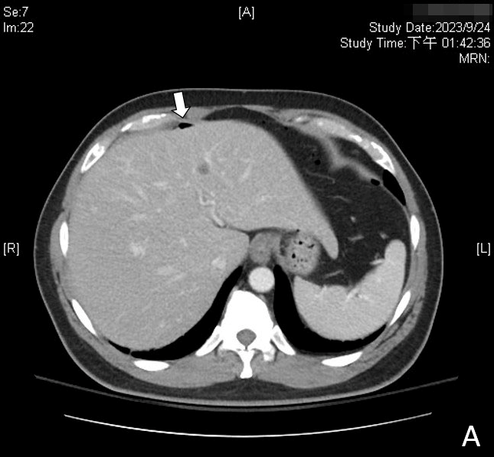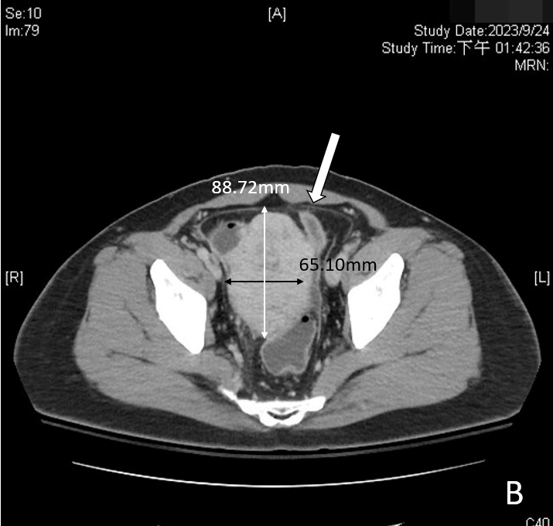
Figure 1 Computed tomography before the operation. A: Pneumoperitoneum (white arrow); B: One 6.8 cm × 6.5 cm mass over the pelvic area (white arrow).

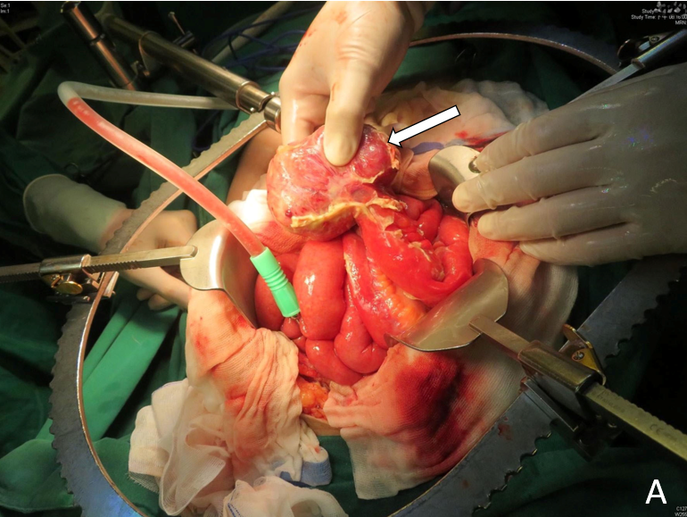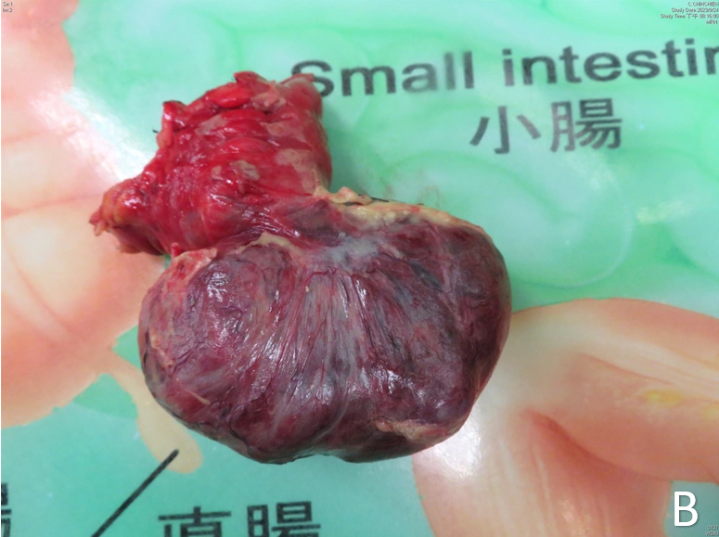
Figure 2 Gross appearance during the operation. A: Pelvic mass surrounded by an abscess (white arrow); B: The tumor and a small section of the ileum was resected.

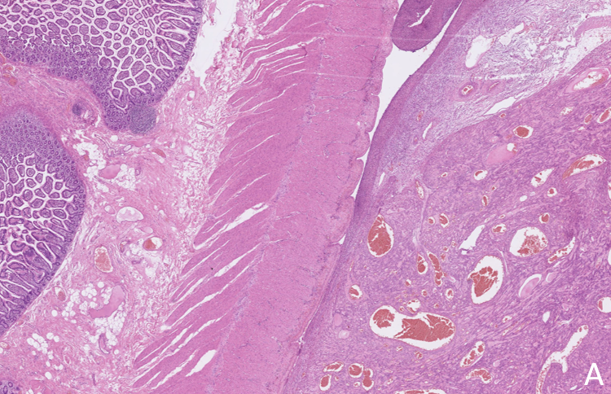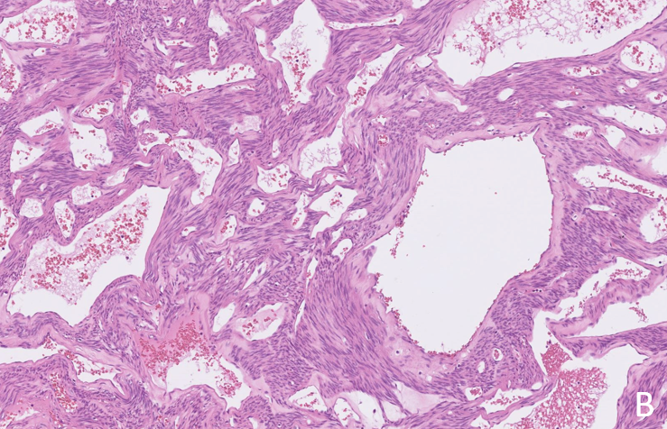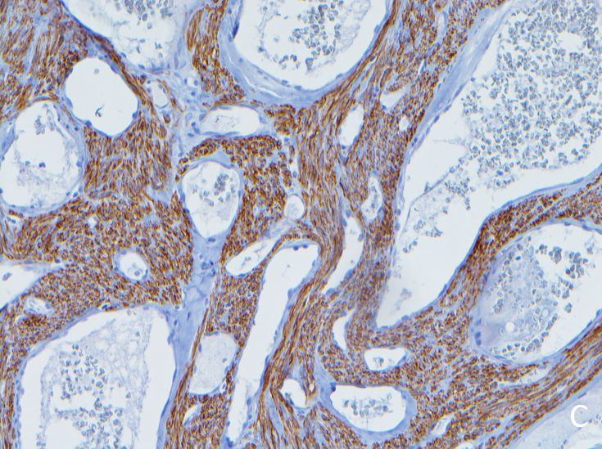
Figure 3 Histopathology of angioleiomyoma. A: Ileal tissue with a well-circumscribed subserosal tumor; B: Proliferative spindle smooth muscle cells bearing brightly eosinophilic cytoplasm and arranged in fascicles, punctuated by variable-sized vascular channels. The vessels were irregularly dilated with attenuated walls; C: The proliferative smooth muscle cells were highlighted by desmin immunostaining, while the cavernous vascular channels lacked a well-formed muscular wall.

Table 1 Case list of angioleiomyoma in the gastrointestinal tract
Ref. | Age, sex | Location | Complication | Diagnosis | Treatment
Valnicek^{[11]}, 1959 | NA | Small bowel | GIB | NA | NA
Gădăleanu and Popescu^{[12]}, 1988 | 31, female | Duodenojejunal flexture | GIB | Laparotomy | 2 stages: (1) Tumor vascular pedicle ligation; and (2) Resection
Sapelkin^{[13]}, 1989 | NA | Small bowel | Perforation | NA | NA
Pidoprigora et al^{[14]}, 1995 | NA | Small bowel | GIB | NA | NA
Sadat et al^{[9]}, 2007 | 58, female | Ileum | GIB | Angiography | Resection
Nakatani et al^{[15]}, 2010 | 45, female | Ileum | GIB | Capsule endoscopy + double-balloon enteroscopy | Resection
Turan et al^{[16]}, 2010 | Age not known, female | Ileum | Intussusception | CT | Resection
Stanojević et al^{[17]}, 2013 | 40, female | Rectum | Prolapse | Clinical | Tumor excision
Gachabayov and Mityushin ^{[18]}, 2016 | 21, male | Jejunum | GIB | CT | Resection
Shao et al^{[19]}, 2018 | 42, male | Jejunum | GIB | Double balloon enteroscopy | Resection
Our case | 47, male | Ileum | Perforation | CT | Resection
CT: Computed tomography; GIB: Gastrointestinal bleeding; NA: Not available.

