Name of Journal: World Journal of Clinical Cases
Manuscript NO: 76245
Manuscript Type: MINIREVIEWS

Anatomy of the anterolateral ligament of the knee joint

Park JG et al. Anatomy of the anterolateral ligament

Jun-Gu Park, Seung-Beom Han, Hye Chang Rhim, Ok Hee Jeon, Ki-Mo Jang

Jun-Gu Park, Seung-Beom Han, Ki-Mo Jang, Department of Orthopaedic Surgery, Anam Hospital, Korea University College of Medicine, Seoul 02841, South Korea

Hye Chang Rhim, Department of Medicine, MetroWest Medical Center/Tufts University School of Medicine, Framingham, MA 02111, United States

Ok Hee Jeon, Department of Biomedical Sciences, Korea University College of Medicine, Seoul 02841, South Korea

Author contributions: Jang KM and Park JG wrote the paper; Park JG, Han SB, and Jang KM performed data collection and analysis; Jang KM, Rhim HC, Jeon OH and Han SB performed review and editing.

Supported by a grant of Korea University Anam Hospital, Seoul, Republic of Korea, No. K2209741.

Corresponding author: Ki-Mo Jang, MD, PhD, Associate Professor, Doctor, Staff Physician, Surgeon, Department of Orthopaedic Surgery, Anam Hospital, Korea University College of Medicine, 73 Inchon-Ro, Seongbuk-gu, Seoul 02841, South Korea. kimo98@hanmail.net

Received: March 8, 2022
Revised: April 26, 2022
Accepted: June 3, 2022
Published online:

Abstract
Despite remarkable improvements in clinical outcomes after anterior cruciate ligament reconstruction, the residual rotational instability of knee joints remains a major concern. The anterolateral ligament (ALL) has recently gained attention as a distinct ligamentous structure on the anterolateral aspect of the knee joint. Numerous studies investigated the anatomy, function, and biomechanics of ALL to establish its potential role as a stabilizer for anterolateral rotational instability. However, controversies regarding its existence, prevalence, and femoral and tibial insertions need to be addressed. According to a recent consensus, ALL exists as a distinct ligamentous structure on the anterolateral aspect of the knee joint, with some anatomic variations. The aim of this article was to review the updated anatomy of ALL and present the most accepted findings among the existing controversies. Generally, ALL originates slightly proximal and posterior to the lateral epicondyle of the distal femur and has an anteroinferior course toward the tibial insertion between the tip of the fibular head and Gerdy’s tubercle below the lateral tibial plateau.

Key Words: Knee joint; Anatomy; Anterolateral ligament; Anterior cruciate ligament; Anterolateral rotational instability; Anterolateral ligament reconstruction

Park JG, Han SB, Rhim HC, Jeon OH, Jang KM. Anatomy of the anterolateral ligament of the knee joint. World J Clin Cases 2022; In press

Core Tip: Although there are some anatomical variations in the anterolateral ligament (ALL), the most recent studies agree that it exists as a distinct ligamentous structure on the anterolateral aspect of the knee joint. ALL reconstruction can be a solution for residual rotational instability after anterior cruciate ligament reconstruction. Further investigations are necessary to resolve the controversies regarding ALL anatomy and to establish appropriate ALL reconstruction techniques.

INTRODUCTION
The anterolateral ligament (ALL) has recently gained attention because of its discovery as a new ligament structure, as well as its potential role in the anterolateral rotational stability^{[1,2]}. However, the anterolateral structures defined as ALL were not newly discovered by Claes et al^{[3]}. ALL has previously been described as the anterior band of the lateral collateral ligament (LCL), the mid-third-capsular ligament, the anterior oblique band, and the capsular-osseous layer of the iliotibial tract in previous studies to present the anterolateral structure that tightens during the internal rotation of the tibia between 30° to 60° knee flexion^{[4-6]}. After the "re-discovery" of ALL, its clinical significance was demonstrated in several biomechanical studies, suggesting that its possible association with the rotational stability of the knee joint^{[2]}.
Although the outcomes after anterior cruciate ligament (ACL) reconstruction have improved with a better understanding of the anatomy of the ACL and advances in surgical technique, some patients complain of residual anterolateral rotational instability (ALRI) even after successful ACL reconstruction, which presents with a persistent “pivot shift test.” ALL reconstruction has recently gained attention as an alternative option to control ALRI in ACL-injured patients. Many studies have shown that ALL reconstruction combined with ACL reconstruction significantly decreases the rate of ACL retear and ALRI, in addition to improving patient-reported outcomes^{[7]}.
However, there are still inconsistent findings regarding the anatomy of the ALL, including its prevalence, femoral origin, tibial insertion, and relationship with the surrounding structures. Several cadaveric studies reported that ALL was identified as a distinct ligamentous structure, separate from the anterolateral capsule. However, some studies reported only a thickening of the articular capsule or a complex of fibrous tissue on the anterolateral capsule^{[3,8]}. With these inconsistent findings, questions regarding the anatomical implications of ALL reconstruction for the restoration of rotatory stability, and the surgical technique for proper tunnel placement may emerge. Therefore, there is a need for detailed understanding of the ALL anatomy to ensure proper diagnosis and treatment of knee joint pathology. This article aimed to review recent studies regarding the anatomy of ALL and present the most accepted findings among several controversies.

HISTORICAL REVIEW OF ALL
In 1879, Paul Segond described “a pearly, resistant, fibrous band, which invariably showed extreme amounts of tension during forced knee internal rotation,” and suggested that this structure is related to avulsion fractures in the tibial anterolateral aspect^{[9]}. Nowadays, this avulsion fracture, named the “Segond fracture,” is recognized as a pathognomonic sign of ACL injury^{[10]}. However, this anterolateral structure was not initially described by Segond. In 1752, Weithbrecht noted “fibrous bunches that reinforce the capsule and bands that supplement the fixation of semicircular cartilage” in his desmography book^{[11]}. In 1872, Friedrich Henle noted a structure wherein the most anterior fibers of the lateral collateral ligament curved forward at a nearly right angle and disappeared into the edge of the meniscus, which was later found to correspond to the ALL^{[12]}. Thereafter, this anatomic structure has been investigated by several researchers and described by different terms such as “deep external lateral ligament,” “lateral epicondylo-meniscal ligament,” “lateral capsular ligament,” “mid-third lateral capsular ligament,” “anterior oblique band of the LCL”. ALL was first named by Vincent et al^{[13]} in 2012. In 2013, Claes et al^{[3]} identified a well-defined ligamentous structure (ALL) that was clearly distinguishable from the anterolateral joint capsule in human cadaveric knees. In a subsequent study, the tibial insertion site of the ALL on a cadaver was compared with the location of the Segond fracture on magnetic resonance imaging (MRI) images, and a high correlation between the two locations was demonstrated, which suggested that the Segond fracture is a bony avulsion of the ALL^{[14]}.

PREVALENCE OF ALL
One of the debatable issues regarding ALL is whether it is a distinct ligamentous structure or a simple capsular thickening. This controversy resulted from the inconsistent findings related to the presence of ALL in previous cadaveric studies, which ranged from 0% to 100%^{[8,15,16]}. In a study reported by Claes et al^{[3]}, ALL was identified in almost all the cadaveric knees (40 of 41, 97.6%). Thereafter, numerous cadaveric studies reported various prevalence rates of the ALL, and some studies insisted that it does not exist as a distinct ligamentous structure^{[17]}. However, a recent systematic review found that ALL was identified in 83.0% of the 39 cadaveric dissection studies of 952 specimens, indicating a high prevalence^{[18]}. Ariel de Lima et al^{[18]} suggested that different dissection preservation methods could affect ALL identification. They demonstrated that ALL prevalence was low in embalmed cadaveric studies, whereas it was high in fresh-frozen cadavers^{[18]}. This is because the anterolateral structures, including LCL, ALL, iliotibial band (ITB), and biceps, have a complex relationship, and their insertions are often merged together. In addition, the clear identification of ALL could be restricted in the embalmed specimen. Several studies have demonstrated that the anatomical structure of the ALL varies from a distinct ligamentous structure to a sheet-like structure^{[14,15,19]}. Most studies reported ALL as a true ligamentous structure; however, in some cases it may only be palpated as bundles of tense capsular tissue^{[15,19,20]}. Olewnik et al^{[19]} classified the ALL structure into five types, and demonstrated that type 1 corresponds to the typical description of ALL. After considering the differences in race, sex, preservation method, and dissection techniques, the current consensus is that ALL exists at the anterolateral aspect of the knee joint in the most people, as a distinct ligamentous structure that tightens when tibial internal rotation with 30° to 60° knee flexion is applied.

ANATOMY OF THE ALL
Anterolateral complex
The structures related to the anterolateral aspect of the knee joint constitute the anterolateral complex. This complex consists of the superficial ITB and iliopatellar band, deep ITB (Kaplan fibers, retrograde condylar attachment continuous with the capsulo-osseous layer), and ALL. The first layer consists of the superficial ITB, the second layer consists of the iliopatellar band, and the third layer is comprised of ALL. Within the third layer of the anterolateral capsule, the ALL is the superficial lamina, and the deep lamina is the true capsule of the knee joint. Several dissection techniques for identifying ALL have been introduced, and Ariel de Lima et al^{[21]} and Daggett et al^{[22]} suggested that a uniform and standardization dissection technique can improve ALL identification. With antegrade dissection, they were able to identify ALL in all fresh-frozen cadavers.
For anterograde dissection, ITB was transversely cut at 10 cm proximal to the lateral femoral epicondyle and bluntly dissected until its insertion into Gerdy’s tubercle in the anterolateral aspect of the tibia by cutting the Kaplan fibers. This step must be done carefully because the deep part of the ITB can closely adhere to ALL, towards the lateral femoral epicondyle. Inadequate dissection does not separate the deep ITB and ALL, which may result to confusion in distinguishing them. However, the ITB is connected to the distal femur with Kaplan fibers, and has no attachment to the lateral femoral epicondyle. ALL is a ligamentous structure that is clearly distinct from the ITB. Both the “deep layer” (Kaplan’s fibers) and “capsulo-osseous layer” of ITB should not be confused with ALL. After reflection of ITB, the anteroinferior trajectory parallel fibers on the anterolateral capsule, which originate from around the lateral epicondyle and extend distally in a fan-like fashion, are inserted into the tibia between the Gerdy’s tubercle and the fibular head. With a tibial internal rotation at 30° to 60° knee flexion, this structure becomes more obvious and distinct. ALL is anteriorly merged with the anterior capsule and posteriorly close to the LCL. Since the origins of the LCL and ALL are closely located, and ALL overlaps the LCL at the lateral epicondyle, careful dissection should be performed to separate the LCL and ALL. After excision of the capsule anterior to ALL, the entire ALL can be isolated (Figure 1).
The length of ALL reported in previous studies varied from 30 mm to 59 mm^{[13,18,23,24]}. A recent systematic review demonstrated that the length of ALL is typically between 33.0 and 42.0 mm in most studies^{[18]}. The length of ALL increased with knee flexion and tibial internal rotation^{[23,25]}. The thickness of ALL ranged from 1.0 to 2.5 mm, and the width of ALL varied between 4.0 and 7.0 mm^{[18]}.

Proximal attachment site: Femoral origin
Another controversial issue regarding the anatomy of the ALL is the exact location of its femoral origin. This issue arises from the complexity of the close origins of the ALL and LCL at the lateral epicondyle of the distal femur. Claes et al^{[3]} described that ALL originated slightly anterior to LCL. However, in subsequent studies, there were various descriptions about the femoral origin of ALL, using references to LCL’s femoral origin or the lateral femoral epicondyle. These studies described the origin of ALL as (1) proximal and posterior to the lateral femoral epicondyle^{[8,15,21,23,25-28]}; (2) the center of the lateral epicondyle^{[27]}; or (3) anterior to the LCL femoral origin^{[3,24,29,30]}. Recently, most studies have reported the origin to be proximal and posterior to the lateral epicondyle (Table 1). Even though there are some variations, the current consensus is that the femoral origin of ALL is typically located proximal and posterior to the lateral femoral epicondyle^{[18]}.

Distal attachment site: Tibial insertion
Although there are controversies regarding the femoral origin of ALL, most studies agree that the tibial attachment site of ALL is located halfway between Gerdy’s tubercle and the tip of the fibular head. The tibial insertion site of ALL is approximately 5-10 mm below the lateral tibial plateau^{[2,25]}.

Meniscal attachment
On the anteroinferior course between the distal femur and proximal tibia, the ALL has a branch of dense collagen fibers attached to the lateral meniscus at the joint level. Helito et al^{[31]} demonstrated that the meniscal insertion of ALL was located between the anterior horn and the body of the lateral meniscus (specifically beginning at 36.0% and ending at 41.9% of the circumference of the lateral meniscus), and that the mean attachment length was 5.6 mm. Kosy et al^{[32]} demonstrated that an attachment to the lateral meniscus was identified in all 94 cases, wherein ALL was visualized using MRI. They reported four types of variations of meniscal attachment (complete, central, bipolar, and inferior-only).

HISTOLOGY OF THE ALL
Several studies have demonstrated that ALL consists of well-organized dense collagen fibers, and that its mechanical properties resemble those of ligaments^{[13,24,33]}. Redler et al^{[33]} reported that the ALL consists of dense collagen fibers oriented in the longitudinal and transverse directions of the fiber bundles. However, Patel et al^{[15]} showed that this ligamentous characteristic was only observed when ALL was identified as a distinct ligamentous structure; otherwise, the properties of ALL resembled those of the anterolateral capsule, suggesting the variability in the microstructural and mechanical properties of the ALL. Macchi et al^{[34]} reported that ALL is composed primarily of type I collagen (90%), followed by type III collagen (5%), type IV collagen (3%), and scarce elastic fibers (1%). Several studies have demonstrated peripheral nerve innervation and type 1 mechanoreceptors in ALL^{[16,34]}.

IMAGING OF THE ALL
MRI is the most useful imaging tool for evaluating the ALL and its combined pathology. MRI evaluation of ALL could be limited due to its complex relationship with other adjacent structures, small thickness and width, and anatomical variability. However, most of the previous studies demonstrated relatively high detection rates of ALL on MRI, which ranged from 51% to 100%^{[16,35]}.
The most useful sequences for evaluating ALL are coronal and axial proton density sequences with fat saturation. Considering the anteroinferior trajectory of the ALL, it is easier to identify ALL on coronal images (Figure 2). The lateral inferior genicular artery is a reproducible landmark for identification of ALL^{[36]}. On coronal images, this artery is seen as a small dot and the meniscal attachment fiber of the ALL is easily found proximal to it. The femoral origin of ALL is not clearly distinguished from that of the adjacent lateral collateral ligament. Instead, just below the lateral epicondyle, ALL can be found as a long, thin, low-signal ligamentous structure that runs distally deep into the ITB and anterior to the LCL. The tibial insertion just distal to the joint line was more clearly identified than the femoral insertion^{[37]}. Several studies using MRI have shown a high rate of ALL in the ACL-injured patients, which ranges between 40% and 80%^{[38]}.
Identification of the femoral and tibial ALL insertions on plain radiographs may be helpful for tunnel placement in ALL reconstruction. Several authors have found radiographic anatomic references on lateral radiographs. Although there are some differences, most studies described that the femoral origin is approximately 50% of the anteroposterior distance from the posterior femoral cortex and slightly distal (3.7 to 9.0 mm) to the Blumensaat line, and that the tibial insertion is approximately 50% of the anteroposterior distance from the anterior edge of the tibial plateau^{[39]}.

FUNCTION OF THE ALL
Several previous cadaveric and clinical studies have demonstrated that ALL functions as a secondary stabilizer to ACL when it resists the anterior translation and internal rotation of the tibia^{[40]}. Although most studies have found important roles of ALL in the anterolateral rotational stability of the knee joint, some studies have also demonstrated that it has a limited role in rotational stability^{[2,40]}. Therefore, further biomechanical and clinical studies are needed to clarify the exact role of ALL and its long-term clinical effects.

CONCLUSION
Sound anatomical knowledge is essential for treating various musculoskeletal disorders, and pathologic findings can be identified after a thorough understanding of the normal anatomy has been established. Even though there are some anatomical variations, most recent anatomical studies agree that ALL exists as a distinct ligamentous structure on the anterolateral aspect of the knee joint. Typically, ALL originates from the proximal and posterior to the lateral epicondyle of the distal femur, and it has an anteroinferior course towards tibial insertion between the tip of the fibular head and Gerdy’s tubercle below the lateral tibial plateau. Further cadaveric and imaging investigations are necessary to resolve several controversial issues regarding the anatomy of ALL, and to establish additional insights for appropriate ALL reconstruction techniques.

REFERENCES
1 Vundelinckx B, Herman B, Getgood A, Litchfield R. Surgical Indications and Technique for Anterior Cruciate Ligament Reconstruction Combined with Lateral Extra-articular Tenodesis or Anterolateral Ligament Reconstruction. Clin Sports Med 2017; 36: 135-153 [PMID: 27871655 DOI: 10.1016/j.csm.2016.08.009]
2 Ahn JH, Patel NA, Lin CC, Lee TQ. The anterolateral ligament of the knee joint: a review of the anatomy, biomechanics, and anterolateral ligament surgery. Knee Surg Relat Res 2019; 31: 12 [PMID: 32660576 DOI: 10.1186/s43019-019-0012-4]
3 Claes S, Vereecke E, Maes M, Victor J, Verdonk P, Bellemans J. Anatomy of the anterolateral ligament of the knee. J Anat 2013; 223: 321-328 [PMID: 23906341 DOI: 10.1111/joa.12087]
4 Irvine GB, Dias JJ, Finlay DB. Segond fractures of the lateral tibial condyle: brief report. J Bone Joint Surg Br 1987; 69: 613-614 [PMID: 3611168 DOI: 10.1302/0301-620X.69B4.3611168]
5 Hughston JC, Andrews JR, Cross MJ, Moschi A. Classification of knee ligament instabilities. Part II. The lateral compartment. J Bone Joint Surg Am 1976; 58: 173-179 [PMID: 1254620]
6 Campos JC, Chung CB, Lektrakul N, Pedowitz R, Trudell D, Yu J, Resnick D. Pathogenesis of the Segond fracture: anatomic and MR imaging evidence of an iliotibial tract or anterior oblique band avulsion. Radiology 2001; 219: 381-386 [PMID: 11323461 DOI: 10.1148/radiology.219.2.r01ma23381]
7 Ariel de Lima D, de Lima LL, de Souza NGR, de Moraes Perez RA, Sobrado MF, Guimarães TM, Helito CP. Clinical outcomes of combined anterior cruciate ligament and anterolateral ligament reconstruction: a systematic review and meta-analysis. Knee Surg Relat Res 2021; 33: 33 [PMID: 34556187 DOI: 10.1186/s43019-021-00115-1]
8 Nasu H, Nimura A, Yamaguchi K, Akita K. Morphology of the anterolateral ligament: a complex of fibrous tissues spread to the anterolateral aspect of the knee joint. Anat Sci Int 2020; 95: 470-477 [PMID: 32347456 DOI: 10.1007/s12565-020-00543-1]
9 Segond P. Recherches cliniques et expérimentales sur les épanchements sanguins du genou par entorse. Progrès Med 1879; 7: 297-341
10 Flores DV, Smitaman E, Huang BK, Resnick DL. Segond fracture: an MR evaluation of 146 patients with emphasis on the avulsed bone fragment and what attaches to it. Skeletal Radiol 2016; 45: 1635-1647 [PMID: 27662848 DOI: 10.1007/s00256-016-2479-3]
11 Weitbrecht J. Desmographie, ou, Description des ligamens du corps humain [electronic resource]: Avec figures/Weitbrecht, Josias. [S.l.]: A Paris: Chez Durand, Libraire, rue Saint Jacques, au Griffon. 1752
12 Henle J. Handbuch der systematischen Anatomie des Menschen. Braunschweig 8vo. 1872
13 Vincent JP, Magnussen RA, Gezmez F, Uguen A, Jacobi M, Weppe F, Al-Saati MF, Lustig S, Demey G, Servien E, Neyret P. The anterolateral ligament of the human knee: an anatomic and histologic study. Knee Surg Sports Traumatol Arthrosc 2012; 20: 147-152 [PMID: 21717216 DOI: 10.1007/s00167-011-1580-3]
14 Claes S, Luyckx T, Vereecke E, Bellemans J. The Segond fracture: a bony injury of the anterolateral ligament of the knee. Arthroscopy 2014; 30: 1475-1482 [PMID: 25124480 DOI: 10.1016/j.arthro.2014.05.039]
15 Patel RM, Castile RM, Jenkins MJ, Lake SP, Brophy RH. Microstructural and Mechanical Properties of the Anterolateral Ligament of the Knee. Am J Sports Med 2021; 49: 172-182 [PMID: 33381993 DOI: 10.1177/0363546520974381]
16 Caterine S, Litchfield R, Johnson M, Chronik B, Getgood A. A cadaveric study of the anterolateral ligament: re-introducing the lateral capsular ligament. Knee Surg Sports Traumatol Arthrosc 2015; 23: 3186-3195 [PMID: 24929656 DOI: 10.1007/s00167-014-3117-z]
17 Iseki T, Rothrauff BB, Kihara S, Novaretti JV, Shea KG, Tuan RS, Fu FH, Alexander PG, Musahl V. Paediatric knee anterolateral capsule does not contain a distinct ligament: analysis of histology, immunohistochemistry and gene expression. J ISAKOS 2021; 6: 82-87 [PMID: 33832981 DOI: 10.1136/jisakos-2019-000339]
18 Ariel de Lima D, Helito CP, Lacerda de Lima L, de Castro Silva D, Costa Cavalcante ML, Dias Leite JA. Anatomy of the Anterolateral Ligament of the Knee: A Systematic Review. Arthroscopy 2019; 35: 670-681 [PMID: 30612770 DOI: 10.1016/j.arthro.2018.09.006]
19 Olewnik Ł, Gonera B, Kurtys K, Podgórski M, Polguj M, Sibiński M, Topol M. The Anterolateral Ligament of the Knee: A Proposed Classification System. Clin Anat 2018; 31: 966-973 [PMID: 30144325 DOI: 10.1002/ca.23267]
20 Watanabe J, Suzuki D, Mizoguchi S, Yoshida S, Fujimiya M. The anterolateral ligament in a Japanese population: Study on prevalence and morphology. J Orthop Sci 2016; 21: 647-651 [PMID: 27423811 DOI: 10.1016/j.jos.2016.06.004]
21 Ariel de Lima D, Helito CP, Daggett M, Neto FMM, de Lima LL, Leite JAD, Cavalcante MLC. Anterolateral ligament of the knee: a step-by-step dissection. BMC Musculoskelet Disord 2019; 20: 142 [PMID: 30947710 DOI: 10.1186/s12891-019-2517-0]
22 Daggett M, Busch K, Sonnery-Cottet B. Surgical Dissection of the Anterolateral Ligament. Arthrosc Tech 2016; 5: e185-e188 [PMID: 27274451 DOI: 10.1016/j.eats.2015.10.019]
23 Dodds AL, Halewood C, Gupte CM, Williams A, Amis AA. The anterolateral ligament: Anatomy, length changes and association with the Segond fracture. Bone Joint J 2014; 96-B: 325-331 [PMID: 24589786 DOI: 10.1302/0301-620X.96B3.33033]
24 Helito CP, Demange MK, Bonadio MB, Tírico LE, Gobbi RG, Pécora JR, Camanho GL. Anatomy and Histology of the Knee Anterolateral Ligament. Orthop J Sports Med 2013; 1: 2325967113513546 [PMID: 26535259 DOI: 10.1177/2325967113513546]
25 Goncharov EN, Koval OA, Bezuglov EN, Goncharov NG. Anatomical features and significance of the anterolateral ligament of the knee. Int Orthop 2018; 42: 2859-2864 [PMID: 29971706 DOI: 10.1007/s00264-018-4049-x]
26 Kennedy MI, Claes S, Fuso FA, Williams BT, Goldsmith MT, Turnbull TL, Wijdicks CA, LaPrade RF. The Anterolateral Ligament: An Anatomic, Radiographic, and Biomechanical Analysis. Am J Sports Med 2015; 43: 1606-1615 [PMID: 25888590 DOI: 10.1177/0363546515578253]
27 Daggett M, Ockuly AC, Cullen M, Busch K, Lutz C, Imbert P, Sonnery-Cottet B. Femoral Origin of the Anterolateral Ligament: An Anatomic Analysis. Arthroscopy 2016; 32: 835-841 [PMID: 26725451 DOI: 10.1016/j.arthro.2015.10.006]
28 Neri T, Palpacuer F, Testa R, Bergandi F, Boyer B, Farizon F, Philippot R. The anterolateral ligament: Anatomic implications for its reconstruction. Knee 2017; 24: 1083-1089 [PMID: 28800853 DOI: 10.1016/j.knee.2017.07.001]
29 Stijak L, Bumbaširević M, Radonjić V, Kadija M, Puškaš L, Milovanović D, Filipović B. Anatomic description of the anterolateral ligament of the knee. Knee Surg Sports Traumatol Arthrosc 2016; 24: 2083-2088 [PMID: 25380973 DOI: 10.1007/s00167-014-3422-6]
30 Shetty A, Prabhath S, Alappatt K, Krishna Kn L, Bhat N, Sumalatha S. Lateral collateral ligament and anterolateral ligament of the knee - A morphological analysis with orthopedic significance. Knee 2021; 28: 202-206 [PMID: 33421692 DOI: 10.1016/j.knee.2020.12.002]
31 Helito CP, Bonadio MB, Soares TQ, da Mota e Albuquerque RF, Natalino RJ, Pécora JR, Camanho GL, Demange MK. The meniscal insertion of the knee anterolateral ligament. Surg Radiol Anat 2016; 38: 223-228 [PMID: 26246342 DOI: 10.1007/s00276-015-1533-5]
32 Kosy JD, Mandalia VI, Anaspure R. Characterization of the anatomy of the anterolateral ligament of the knee using magnetic resonance imaging. Skeletal Radiol 2015; 44: 1647-1653 [PMID: 26205762 DOI: 10.1007/s00256-015-2218-1]
33 Redler A, Miglietta S, Monaco E, Matassa R, Relucenti M, Daggett M, Ferretti A, Familiari G. Ultrastructural Assessment of the Anterolateral Ligament. Orthop J Sports Med 2019; 7: 2325967119887920 [PMID: 31897411 DOI: 10.1177/2325967119887920]
34 Macchi V, Porzionato A, Morra A, Stecco C, Tortorella C, Menegolo M, Grignon B, De Caro R. The anterolateral ligament of the knee: a radiologic and histotopographic study. Surg Radiol Anat 2016; 38: 341-348 [PMID: 26476833 DOI: 10.1007/s00276-015-1566-9]
35 Claes S, Bartholomeeusen S, Bellemans J. High prevalence of anterolateral ligament abnormalities in magnetic resonance images of anterior cruciate ligament-injured knees. Acta Orthop Belg 2014; 80: 45-49 [PMID: 24873084]
36 Patel KA, Chhabra A, Goodwin JA, Hartigan DE. Identification of the Anterolateral Ligament on Magnetic Resonance Imaging. Arthrosc Tech 2017; 6: e137-e141 [PMID: 28373952 DOI: 10.1016/j.eats.2016.09.015]
37 Porrino J Jr, Maloney E, Richardson M, Mulcahy H, Ha A, Chew FS. The anterolateral ligament of the knee: MRI appearance, association with the Segond fracture, and historical perspective. AJR Am J Roentgenol 2015; 204: 367-373 [PMID: 25615760 DOI: 10.2214/AJR.14.12693]
38 Song Y, Yang JH, Choi WR, Lee JK. Magnetic Resonance Imaging-Based Prevalence of Anterolateral Ligament Abnormalities and Associated Injuries in Knees with Acute Anterior Cruciate Ligament Injury. J Knee Surg 2019; 32: 866-871 [PMID: 30189439 DOI: 10.1055/s-0038-1669449]
39 Patel RM, Brophy RH. Anterolateral Ligament of the Knee: Anatomy, Function, Imaging, and Treatment. Am J Sports Med 2018; 46: 217-223 [PMID: 28320209 DOI: 10.1177/0363546517695802]
40 Bonasia DE, D'Amelio A, Pellegrino P, Rosso F, Rossi R. Anterolateral Ligament of the Knee: Back to the Future in Anterior Cruciate Ligament Reconstruction. Orthop Rev (Pavia) 2015; 7: 5773 [PMID: 26330991 DOI: 10.4081/or.2015.5773]

Footnotes
Conflict-of-interest statement: All the authors report no relevant conflicts of interest for this article.

Open-Access: This article is an open-access article that was selected by an in-house editor and fully peer-reviewed by external reviewers. It is distributed in accordance with the Creative Commons Attribution NonCommercial (CC BY-NC 4.0) license, which permits others to distribute, remix, adapt, build upon this work non-commercially, and license their derivative works on different terms, provided the original work is properly cited and the use is non-commercial. See: https://creativecommons.org/Licenses/by-nc/4.0/

Provenance and peer review: Invited article; Externally peer reviewed.
Peer-review model: Single blind

Peer-review started: March 8, 2022
First decision: April 13, 2022
Article in press: May 25, 2022

Specialty type: Orthopedics
Country/Territory of origin: South Korea
Peer-review report’s scientific quality classification
Grade A (Excellent): 0
Grade B (Very good): B
Grade C (Good): C
Grade D (Fair): 0
Grade E (Poor): 0

P-Reviewer: Abulsoud MI, Egypt; Nambi G, Saudi Arabia A-Editor: Zhu JQ, China S-Editor: Gong ZM L-Editor: A P-Editor: Gong ZM

Figure Legends
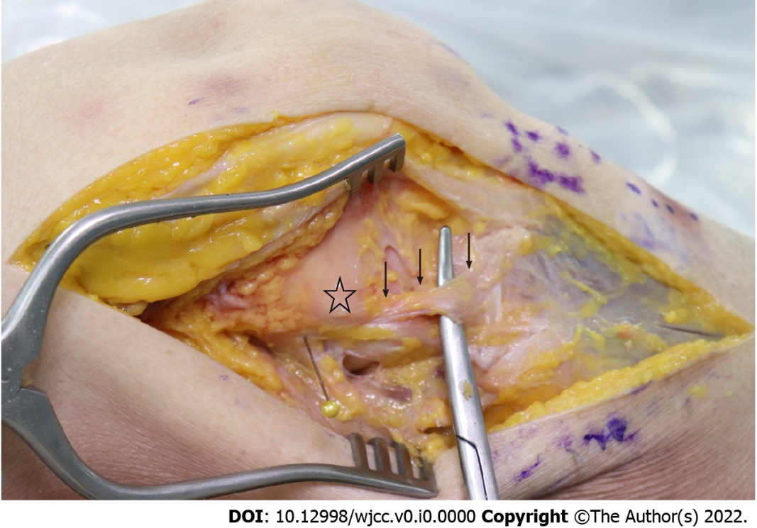
Figure 1 Photograph showing isolation of the anterolateral ligament (black arrows) in a cadaveric right knee joint. The asterisk indicates the lateral epicondyle of the distal femur.

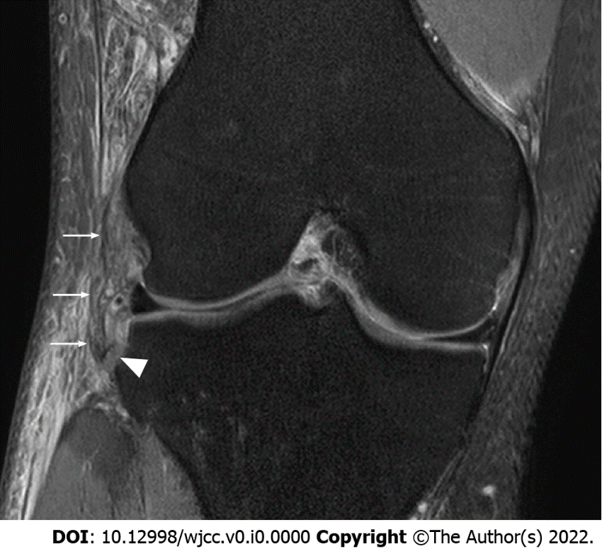
Figure 2 A coronal magnetic resonance image showing the anterolateral ligament (white arrows) which is attached to a Segond fracture fragment. The white arrow head indicates a Segond fracture.

Table 1 Summary of recent anatomical cadaveric studies of the anterolateral ligament
Ref. | Years | Preservation method | Prevalence of the ALL | Femoral origin | Tibial origin | Length of the ALL
Vincent et al^{[13]} | 2012 | Fresh-frozen cadaver | 100% | Anterior to the popliteus tendon insertion | Posterior to GT | 34.1 ± 3.4 mm
Claes et al^{[3]} | 2013 | Embalmed cadaver | 100% | Anterior to LCL | Between GT and FH | 38.5 ± 6.1 mm (0°)
 |  |  |  |  |  | 41.5 ± 6.7 (90°)
Helito et al^{[24]} | 2013 | Fresh-frozen cadaver | 100% | Anterior and distal to LCL | Between GT and FH | 37.3 ± 4.0 mm
Dodds et al^{[23]} | 2014 | Fresh-frozen cadaver | 83% | Proximal and posterior to LFE | Between GT and FH | 59.0 ± 4.0 mm
 |  |  |  |  |  | Tightened at internal rotation and flexion
Caterine et al^{[16]} | 2015 | Fresh-frozen cadaver | 100% | Proximal and posterior to LCL | Between GT and FH | 40.3 ± 6.2 mm (0°)
Kennedy et al^{[26]} | 2015 | Fresh-frozen cadaver | 100% | Proximal and posterior to LFE | Between GT and FH | 36.8 mm (0°)
 |  |  |  |  |  | 41.6 mm (90°)
Watanabe et al^{[20]} | 2016 | Embalmed cadaver | 37% | Type I (ALL) | Between GT and FH (Type II-b, lateral aspect of tibial plateau) | N/A
 |  |  |  | Overlapped LCL origin
 |  |  |  | Posterior to LCL origin
 |  |  |  | Anterior to LCL origin
 |  |  |  | Type II (ALLT)
 |  |  |  | Anterior to posterior of LCL origin
Stijak et al^{[29]} | 2016 | Embalmed cadaver | 50% | Anterior to LCL | Between GT and FH | 41.0 ± 3.0 mm
Daggett et al^{[27]} | 2016 | Fresh-frozen cadaver | 100% | Center of LFE, proximal and posterior to LFE | Between GT and FH | N/A
Neri et al^{[28]} | 2017 | Fresh-frozen cadaver | 95% | Proximal and posterior to LFE | Posterior and proximal to GT, anterior and proximal to FH, and distal to ACT | 50.4 ± 6.6 mm
Goncharov et al^{[25]} | 2018 | Fresh-frozen cadaver | 68% women | 65% proximal and posterior to LFE | Between GT and FH | 38.5 ± 4.4 mm
 |  |  | 42% men | 24% anterior to the origin of the LCL |  | Tightened in internal rotation and flexion
 |  |  |  | 12% popliteus tendon insertion
Olewnik et al^{[19]} | 2018 | Embalmed cadaver | 64% | Type I, proximal and anterior to LCL | Type I, II-a, II-b, posterior to GT | 35.5 ± 7.3 mm
 |  |  |  | Type II-a, proximal and posterior to LCL | Type III, blends with deep fascia
 |  |  |  | Type II-b, proximal and posterior to LCL | Type IV, posterior to GT and deep fascia
 |  |  |  | Type IV, LFE and anterior to LCL | Type V, posterior to GT
 |  |  |  | Type V, LCL
Lima et al^{[21]} | 2019 | Fresh-frozen cadaver | 100% | Proximal and posterior to LFE | Between GT and FH (4.0 mm to 7.0 mm below the tibial plateau) | 40.0 ± 0.4 mm
Nasu et al^{[8]} | 2020 | Embalmed cadaver | 0% (Complex of fibrous tissues with a sheet-like structure) | Proximal and posterior to LFE | Lateroposterior area to the GT | N/A
Shetty et al^{[30]} | 2021 | Embalmed cadaver | 9% (Two types, membranous wideband and cord-like ALL) | Anterior to LCL, proximal to LFE | GT | 35 ± 0.9 mm
Patel et al^{[15]} | 2021 | Fresh-frozen cadaver | 12% | Proximal and posterior to LFE | Between GT and FH | N/A
ACT: Articular cartilage of the tibia; ALL: Anterolateral ligament; FH: Fibular head; GT: Gerdy’s tubercle; LCL: Lateral collateral ligament; LFE: Lateral femoral epicondyle; N/A: Not applicable.

