Name of Journal: World Journal of Gastrointestinal Surgery
Manuscript NO: 89732
Manuscript Type: ORIGINAL ARTICLE

Observational Study
Burden of gallstone disease in the United States population: Prepandemic rates and trends

Unalp-Arida A et al. Burden of gallstone disease in United States

Aynur Unalp-Arida, Constance E Ruhl

Aynur Unalp-Arida, National Institute of Diabetes and Digestive and Kidney Diseases, National Institutes of Health, Bethesda, MD 20892-5458, United States

Constance E Ruhl, Social & Scientific Systems, Inc., DLH Holdings Corp Company, Silver Spring, MD 20910, United States

Author contributions: Unalp-Arida A and Ruhl CE conceived and designed the study and analyzed and interpreted the data; Ruhl CE drafted the manuscript; Unalp-Arida A critically revised the manuscript for important intellectual content; both authors have read and approved the final manuscript.

Corresponding author: Constance E Ruhl, MD, PhD, Senior Researcher, Social & Scientific Systems, Inc., DLH Holdings Corp Company, 8757 Georgia Avenue, 12th Floor, Silver Spring, MD 20910, United States. constance.ruhl@dlhcorp.com

Received: November 14, 2023
Revised: January 23, 2024
Accepted: March 20, 2024
Published online:
Abstract
BACKGROUND
Gallstone disease is one of the most common digestive disorders in the United States and leads to significant morbidity, mortality, and health care utilization.

AIM
To expand on earlier findings and investigate prepandemic rates and trends in the gallstone disease burden in the United States using national survey and claims databases.

METHODS
The National Ambulatory Medical Care Survey, National Inpatient Sample, Nationwide Emergency Department Sample, Nationwide Ambulatory Surgery Sample, Vital Statistics of the United States, Optum Clinformatics® Data Mart, and Centers for Medicare and Medicaid Services Medicare 5% Sample and Medicaid files were used to estimate claims-based prevalence, medical care including cholecystectomy, and mortality with a primary or other gallstone diagnosis. Rates were age-adjusted (for national databases) and shown per 100000 population.

RESULTS
Gallstone disease prevalence (claims-based, 2019) was 0.70% among commercial insurance enrollees, 1.03% among Medicaid beneficiaries, and 2.09% among Medicare beneficiaries and rose over the previous decade. Recently, in the United States population, gallstone disease contributed to approximately 2.2 million ambulatory care visits, 1.2 million emergency department visits, 625000 hospital discharges, and 2000 deaths annually. Women had higher medical care rates with a gallstone disease diagnosis, but mortality rates were higher among men. Hispanics had higher ambulatory care visit and hospital discharge rates compared with Whites, but not mortality rates. Blacks had lower ambulatory care visit and mortality rates, but similar hospital discharge rates compared with whites. During the study period, ambulatory care and emergency department visit rates with a gallstone disease diagnosis rose, while hospital discharge and mortality rates declined. Among commercial insurance enrollees, rates were higher compared with national data for ambulatory care visits and hospitalizations, but lower for emergency department visits. Cholecystectomies performed in the United States included 605000 ambulatory laparoscopic, 280000 inpatient laparoscopic, and 49000 inpatient open procedures annually. Among commercial insurance enrollees, rates were higher compared with national data for laparoscopic procedures.

CONCLUSION
The gallstone disease burden in the United States is substantial and increasing, particularly among women, Hispanics, and older adults with laparoscopic cholecystectomy as the mainstay treatment. Current practice patterns should be monitored for better health care access.

Key Words: Gallstone disease; Burden; Cholecystectomy; Mortality; Health care use; Cholelithiasis; Gallstones; Epidemiology

Unalp-Arida A, Ruhl CE. Burden of gallstone disease in the United States population: Prepandemic rates and trends. World J Gastrointest Surg 2024; In press

Core Tip: We used national survey and claims databases to investigate prepandemic rates and trends in the United States gallstone disease burden. Gallstone disease prevalence (claims-based, 2019) ranged from 0.70% to 2.09% and rose over a decade. Gallstone disease contributed to approximately 2.2 million ambulatory care visits, 1.2 million emergency department visits, 625000 hospital discharges, and 2000 deaths annually. Medical care was higher among women, Hispanics, and older adults and lower among Blacks. Ambulatory care and emergency department visit rates with gallstone disease rose while hospital discharge and mortality rates declined. Cholecystectomies performed included 605000 ambulatory laparoscopic, 280000 inpatient laparoscopic, and 49000 inpatient open procedures annually.

INTRODUCTION
Gallstones (cholelithiasis) are concretions, usually composed of cholesterol or bilirubin, which develop in the gallbladder. Gallstones may form if bile contains excess cholesterol or bilirubin or insufficient bile salts. Most gallstones in the United States and western countries are cholesterol gallstones. Risk factors include older age, female sex, Native American and Hispanic ethnicity, overweight or obesity, diabetes, smoking, higher parity among women, rapid weight loss, and genetic factors. Non-Hispanic black race-ethnicity, greater alcohol consumption, increased serum cholesterol, and greater physical activity are associated with lower risk^{[1]}. Though the majority remain asymptomatic, gallstones can block bile ducts causing acute right upper quadrant pain and if untreated, can lead to complications, including choledocholithiasis, cholangitis, and cholecystitis. Symptomatic gallstones are usually treated by cholecystectomy. Over the long-term, gallstone disease may negatively impact survival. In the United States population over a 20-year period, persons with gallstone disease had increased mortality overall and from cardiovascular disease and cancer^{[2]}. This relationship was found for both ultrasound-diagnosed gallstones and cholecystectomy. Among over a million persons with an electronic health record gallstone disease diagnosis, mortality was 15.1% compared with 9.7% for the whole electronic health record sample^{[3]}.
Gallstones are common and lead to significant morbidity, mortality, and health care utilization in the United States and worldwide. More than 20 million people in the United States have ultrasound-detected gallbladder disease^{[1]}. The prevalence of symptomatic gallstone disease has doubled in the United States population over the past three decades^{[4]}. There were an estimated 1.8 million ambulatory care visits with an all-listed gallstone diagnosis in 2004 and rates were relatively stable over time^{[5]}. There were 622000 overnight hospitalizations with an all-listed gallstone diagnosis in 2004. Hospitalization rates declined by 40% from 1991 due to the shift to outpatient laparoscopic cholecystectomy^{[5]}. There were 2155 deaths with gallstones as underlying or other cause in 2004 and mortality rates fell between 1979 and 2004 by 70%^{[5,6]}. Based on data from the National Survey of Ambulatory Surgery conducted by the National Center for Health Statistics of the Centers for Disease Control and Prevention, gallstone disease resulted in 503000 laparoscopic cholecystectomies in 2006^{[7]}. Gallstone disease health care use and mortality varied among demographic groups. Urgent action is needed to address healthcare disparities across population groups^{[8]}.
A more recent report on the burden of gastrointestinal, liver, and pancreatic disease in the United States found that cholelithiasis was the physician diagnosis for 863000 office visits and 327000 emergency department visits in the United States in 2016^{[9]}. Cholelithiasis and cholecystitis was the 10th most common among all-listed digestive disease diagnoses from emergency department visits in 2018 with 1.5 million visits and the 5th most common among all-listed digestive disease diagnoses in United States hospitals in 2018 with 741000 admissions^{[9]}.
Current estimates of the gallstone disease burden in the United States are useful to all multidisciplinary clinicians, researchers, public health professionals, and policy makers for better planning. We used national survey and claims databases to expand on earlier findings and estimate current trends in the gallstone disease burden in the United States.

MATERIALS AND METHODS
Data sources
The National Ambulatory Medical Care Survey (NAMCS), Healthcare Cost and Utilization Project (HCUP) National Inpatient Sample (NIS), HCUP Nationwide Emergency Department Sample (NEDS), HCUP Nationwide Ambulatory Surgery Sample (NASS), Vital Statistics of the United States, Optum Clinformatics® Data Mart (CDM), and the Centers for Medicare and Medicaid Services (CMS) Medicare 5% Sample and Medicaid databases were used to estimate claims-based prevalence, medical care including cholecystectomy, mortality, and years of potential life lost prior to age 75 years with a primary or other gallstone diagnosis.

National databases
The NAMCS is conducted in the United States by the National Center for Health Statistics of the Centers for Disease Control and Prevention (CDC)^{[10]}. It is an annual nationally representative sample survey of office-based outpatient visits to non-federal health care providers. It is a multistage stratified probability sample of geographically defined areas, physician practices within these areas, and patient visits within physician practices.
The HCUP NIS, NEDS, and NASS are maintained by the Agency for Healthcare Research and Quality. The NIS consists of a nationally representative sample of discharges from all participating non-federal hospitals collected annually^{[11]}. It contains data from more than 7 million hospital stays each year (unweighted) and estimates more than 35 million hospitalizations nationally (weighted). Data collected include up to 15 diagnoses and 7 surgical procedures.
The HCUP NEDS consists of a nationally representative sample of hospital-owned emergency department visits from non-federal hospitals collected annually regardless of whether they result in admission^{[12]}. It contains data from over 30 million emergency department visits each year (unweighted) and estimates approximately 145 million emergency department visits (weighted).
The HCUP NASS consists of a nationally representative sample of major ambulatory surgery encounters performed in hospital-owned facilities^{[13]}. It contains approximately 7.8 million ambulatory surgery encounters each year and approximately 10.8 million ambulatory surgery procedures (unweighted) and estimates approximately 10.3 million ambulatory surgery encounters and 13.5 million ambulatory surgery procedures (weighted). Major ambulatory surgeries are defined as selected major therapeutic procedures that require the use of an operating room, penetrate or break the skin, and involve regional anesthesia, general anesthesia, or sedation to control pain.
The Vital Statistics of the United States: Multiple Cause-of-Death Data are managed by CDC and include all deaths occurring within the United States collected annually^{[14]}. An underlying cause and up to 20 contributing causes of death were derived from death certificates.

Claims databases
Optum’s CDM is comprised of administrative health care claims for members of large commercial health plans^{[15]}. Administrative claims submitted by providers and pharmacies are verified, adjudicated, and de-identified before inclusion in CDM. The population includes individuals in all 50 states. The database includes approximately 17 to 19 million annual covered individuals for over 68 million unique members from January 2007 through December 2020. Most commercial insurance enrollees are employed persons who receive health insurance through their employer.
CMS created the Medicare 5% sample to be representative of the entire population of Medicare beneficiaries and it is housed in the CMS Chronic Conditions Data Warehouse^{[16]}. Data are linked by a unique, unidentifiable beneficiary key.
The CMS Medicaid files include the entire population of Medicaid beneficiaries and are housed in the CMS Chronic Conditions Data Warehouse^{[6]}. Data are linked by a unique, unidentifiable beneficiary key. Medicaid eligibility is based on income below a certain level that varies among states, so Medicaid beneficiaries represent a low-income population.

Gallstone disease and cholecystectomy definitions
Gallstone disease morbidity was identified by an International Classification of Diseases (ICD), Ninth Revision, Clinical Modification (ICD-9-CM) code of 574 or an ICD, Tenth Revision, Clinical Modification (ICD-10-CM) code of K80, and gallstone disease mortality by an ICD, Tenth Revision (ICD-10) code of K80. The first-listed diagnosis was considered the primary diagnosis and all remaining diagnoses were considered secondary and included under ‘all-listed’. For national event-level data sources, diagnoses were counted only once under the all-listed category, irrespective of the number of actual diagnoses listed on a medical record or death certificate. In other words, if there was more than one gallstone disease diagnosis listed on a medical record or death certificate, only one diagnosis was counted for the ‘all-listed’ category.
Laparoscopic cholecystectomy was identified by a Current Procedural Terminology (CPT®) code of 47562, 47563 or 47564, an ICD-9 Procedure Coding System (PCS) code of 51.23 or 51.24, or an ICD-10-PCS code of 0FT44 or 0FB44. Open cholecystectomy was identified by a CPT® code of 47600, 47605, 47610, 47612 or 47620, an ICD-9-PCS code of 51.21 or 51.22, or an ICD-10-PCS code of 0FB40, 0FB43, or 0FT40.

Statistical analysis
Because of potential short-term effects of the coronavirus disease 2019 (COVID-19) pandemic on gallstone disease healthcare utilization and mortality, statistics highlighted in the text are for 2019, while figures present trends through 2020.

National databases
Estimates for the total population and by age, sex, race, and Hispanic origin were calculated for each year of national data. Event counts are shown as number in thousands. For calculating United States population rates, annual population data were derived from the national population estimates program of the United States Census Bureau and the CDC. For all rate calculations, population estimates used as the denominator were mid-year population counts by age, sex, race, and Hispanic origin. Rates were age-adjusted by direct standardization using the year 2000 population estimates and are shown per 100000 population^{[17]}. NAMCS, NIS, NEDS, and NASS data were weighted to generate national estimates. Ambulatory care visit (NAMCS) data points were 3-year averages to provide more stable estimates. Ambulatory care numbers and rates represent visits, not persons with a visit. Hospital numbers and rates represent discharges, not persons with an inpatient stay.

Claims databases
Enrollees/beneficiaries were considered gallstone disease patients if they had one or more claims with an ICD-9-CM or ICD-10-CM diagnostic code indicative of gallstone disease in any diagnostic code field. The claims-based prevalence was calculated as the percentage of privately insured enrollees/beneficiaries who qualified as gallstone disease patients in a given year. Estimates were reported overall and stratified by age, gender, race/ethnicity, and region.
Optum© CDM member eligibility files containing birth year, demographics, and eligibility period were linked to inpatient confinement (acute care hospital or skilled nursing facility stay), medical (health care professional services), medical diagnosis, and pharmacy claims files. Privately insured enrollees were included if they: (1) Had a single consistent birth year recorded in CDM; (2) Resided in the United States; and (3) Were continuously enrolled for at least one full calendar year. Inpatient hospitalizations were defined as having an inpatient hospital place of service. Ambulatory visits were evaluation and management visits with an office, outpatient hospital, or ambulatory surgical center place of service.
The CMS Medicare 5% sample study population/denominator consisted of beneficiaries who were 65 years or older as of January 1st of the year, resided in the 50 United States states or Washington DC, and were enrolled in fee-for-service Part A or Part B Medicare benefits or in the Medicare Advantage program (Part C/Health Maintenance Organization benefits) at any time during the year. The denominator file which contains demographic and enrollment data was linked by the beneficiary unique identifier to institutional (hospital inpatient stays, hospital outpatient services, skilled nursing facilities, home health agencies and hospice care organizations) or non-institutional (also called Part B; health care professionals, supplies, and services) medical claims files. Estimates from the 5% sample are multiplied by 20 to represent national estimates.
The CMS Medicaid study population/denominator consisted of beneficiaries who were 19 to 64 years as of January 1st of the year, resided in the 50 United States states or Washington DC, and were enrolled in Medicaid benefits at any time during the year. The denominator file which contains demographic and enrollment data was linked by the beneficiary unique identifier to institutional or non-institutional medical claims files. Medicaid eligibility is based on income below a certain level that varies among states, so Medicaid beneficiaries represent a low-income population.

RESULTS
Claims-based prevalence
Among 13.7 million commercial insurance enrollees, 96000 had a gallstone disease diagnosis resulting in a claims-based prevalence of 0.70% (2019). Claims-based prevalence was higher among 39.6 million Medicaid beneficiaries, of whom 408000 had a gallstone disease diagnosis for a claims-based prevalence of 1.03% (2019). Claims-based prevalence was highest among Medicare beneficiaries. Among 54.4 million Medicare beneficiaries, 1.1 million had a gallstone disease diagnosis resulting in a claims-based prevalence of 2.09% (2019). Prevalence increased with age among all three groups. Prevalence was higher among women compared with men among commercial insurance enrollees and Medicaid beneficiaries but was higher among male Medicare beneficiaries in recent years. Among commercial insurance enrollees, prevalence was highest among Hispanics, followed by Blacks, then Whites, and was lowest among Asians. Among Medicaid beneficiaries, prevalence was highest among American Indians/Alaska natives and lowest among Asians. It was intermediate among Hispanics, Whites, Hawaiians/Pacific Islanders, and Blacks in that order. Among Medicare beneficiaries, prevalence was higher among Whites compared with Blacks. Prevalence rose by over 60% (0.43 to 0.70 from 2007 to 2019) among commercial insurance enrollees and by almost a third (1.59 to 2.09 from 2006 to 2019) among Medicare beneficiaries. This increasing trend was seen among each sex and race-ethnicity group but was primarily limited to persons 65 years and older (Tables 1-3, Figures 1A-C, 2A and B).

Health care utilization - national data
Gallstones contributed to 2.2 million ambulatory care visits (3-year average for 2014 to 2016), 1.2 million emergency department visits (2019), and 625000 hospital discharges (2019). Ambulatory care visit, emergency department visit, and hospital discharge rates were all higher among women compared with men. Ambulatory care visit rates and hospital discharge rates were highest among Hispanics. Ambulatory care visit rates were higher among Whites compared with Blacks, but hospital discharge rates were similar. Ambulatory care visit rates increased with age. Emergency department visit rates were highest among older adults and similar among middle aged and younger adults. Hospital discharge rates increased with age, especially among persons 65+ years. Hospital discharge rates underestimate the actual burden because most hospitalizations with gallstones were for cholecystectomy and a high proportion of cholecystectomies were performed laparoscopically without an overnight stay, and therefore, were not included in hospitalization statistics (Table 4, Figure 3A-I).
From 2005 to 2016, the ambulatory care visit rate (all-listed per 100000) increased by almost 50% overall (434 to 642) and among sex, racial-ethnic, and age groups. From 2006 to 2019, the emergency department visit rate (all-listed per 100000) increased by more than a third (248 to 339). A rise was seen in both women and men and among all age groups. In contrast, the hospital discharge rate (all-listed per 100000) decreased by 17% (203 to 168) from 2006 to 2019. A decline was seen among each sex, race, and ethnic group, but primarily among older adults (Table 4, Figure 3A-I).

Health care utilization - commercial insurance data
Among commercial insurance enrollees, rates (all-listed per 100000) were higher compared with national data for ambulatory care visits (799 vs 642 in 2015) and hospitalizations (230 vs 168 in 2019), but lower for emergency department visits (167 vs 339 in 2019). Ambulatory care visit and hospital discharge rates were higher among Hispanics compared with Whites. In contrast to national data, Blacks had higher medical care rates compared with Whites among the commercially insured. Medical care rates were lowest for Asians. Medical care rates increased among commercial insurance enrollees, primarily due to increases among persons 65 years and over (Table 1, Figure 1D-M).

Health care utilization - Medicare data
Among Medicare beneficiaries, rates (all-listed per 100000) were higher compared with national data for ambulatory care visits (2221 vs 642 in 2015), emergency department visits (1134 vs 339 in 2019) and hospitalizations (509 vs 168 in 2019). Ambulatory care visit rates were higher among women, but in contrast to national data that included persons of all ages, emergency department visit and hospitalization rates were higher among male compared with female Medicare beneficiaries. Ambulatory care visit rates were higher among Whites compared with Blacks, but in contrast to national data, hospitalization rates were generally higher among Black compared with White Medicare beneficiaries. Emergency department visit rates were also higher among Blacks compared with Whites (Table 2, Figure 2C-I).

Health care utilization - Medicaid data
Among Medicaid beneficiaries aged 19 to 64 years, rates (all-listed per 100000) were higher compared with national data for emergency department visits (577 vs 339 in 2019) and hospitalizations (202 vs 168 in 2019). Among Medicaid beneficiaries, health care utilization rates were highest among Hispanics and American Indians/Alaska natives, intermediate among Whites and Hawaiians/Pacific Islanders, and lowest among Blacks and Asians (Table 3).

Mortality
Gallstones contributed to 2000 deaths in the United States (2019). Mortality rates were higher among men compared with women and much higher among persons 65+ years compared with younger adults. Rates were lower for Blacks compared with Whites and slightly lower for Hispanics compared with Whites after a steeper decline. From 2006 through 2019, the mortality rate (underlying or other cause per 100000) decreased by more than a quarter overall (0.63 to 0.45) and among each sex and racial-ethnic group, but primarily among adults 65+ years (Table 4, Figures 3J-L, 2J and K).

Cholecystectomy - national data
In 2019, cholecystectomies performed in the United States included 605000 ambulatory laparoscopic, 280000 inpatient laparoscopic, 49000 inpatient open, and 1000 ambulatory open procedures. Rates (per 100000) were highest for ambulatory laparoscopic (178), followed by inpatient laparoscopic (78), inpatient open (13), and ambulatory open (0.4) procedures. Laparoscopic cholecystectomy rates were higher among women compared with men. Inpatient laparoscopic procedure rates were higher among Hispanics and lower among Blacks compared with Whites. Ambulatory laparoscopic cholecystectomy rates were highest among middle-aged adults, followed by young adults and older adults. In contrast, both inpatient laparoscopic and open rates increased with age. From 2005 to 2019, inpatient cholecystectomy rates decreased overall by 30% for laparoscopic (112 to 78) and 60% for open (32 to 13) procedures and by sex, race-ethnicity, and age groups (Table 5, Figure 4A-D).

Cholecystectomy - commercial insurance data
Among commercial insurance enrollees, rates (per 100000 in 2019) were higher compared with national data for ambulatory laparoscopic (223 vs 178) and inpatient laparoscopic (96 vs 78) cholecystectomies, and similar for inpatient open procedures (12 vs 13). Among commercial insurance enrollees, laparoscopic cholecystectomy rates were highest among Hispanics and lowest among Asians. Ambulatory laparoscopic rates were higher among Whites compared with Blacks. In contrast to national cholecystectomy rates that declined over the years studied, a decline was seen only for ambulatory laparoscopic procedures among commercial insurance enrollees, and only for women, Whites, and Blacks while rates increased among men and Hispanics (Table 6, Figure 4E-K).

Cholecystectomy - Medicare data
Among Medicare beneficiaries, rates (per 100000 in 2019) were higher compared with national data for ambulatory laparoscopic (204 vs 178), inpatient laparoscopic (158 vs 78), and inpatient open (25 vs 13) cholecystectomies. Ambulatory laparoscopic cholecystectomy rates were higher among women, but in contrast to national data inpatient laparoscopic and open cholecystectomy rates were higher among male compared with female Medicare beneficiaries. Among Medicare beneficiaries, laparoscopic cholecystectomy rates were higher among Whites compared with Blacks, especially for ambulatory procedures (Table 7, Figure 4L-P).

Cholecystectomy - Medicaid data
Among Medicaid beneficiaries, rates (per 100000 in 2019) were higher compared with national data for ambulatory laparoscopic (261 vs 178) and inpatient laparoscopic (112 vs 78) cholecystectomies, but lower for inpatient open procedures (9 vs 13). Among Medicaid beneficiaries, laparoscopic cholecystectomy rates were highest among American Indians/Alaska natives, intermediate among Whites and Hawaiians/Pacific Islanders, and lowest among Blacks and Asians (Table 8).

DISCUSSION
In this report, we expanded on earlier findings and investigated current trends in the gallstone disease burden in the United States using national survey and claims databases^{[18]}. We found that the gallstone disease burden in the United States is substantial and increasing, particularly among women, Hispanics, and older adults. The prevalence of gallstone disease has increased, especially among older adults, based on claims diagnoses among both commercial insurance and Medicare enrollees. This is consistent with our previous findings using data from the National Health and Nutrition Examination Survey of a doubling of the gallstone disease prevalence in the United States population over the past three decades, possibly because of the worsening of metabolic risk factors and growth of laparoscopic cholecystectomy^{[4]}. In the current report, prevalence was higher among older adults, women, American Indians/Alaska natives and Hispanics, and lower among Blacks (except among commercial insurance enrollees) and Asians, consistent with known risk factors. Among the three claims data sources used in the current analysis, prevalence was highest among Medicare beneficiaries (2.09%) as expected given that older age is a risk factor for gallstone disease. Prevalence was higher among Medicaid beneficiaries compared with commercial insurance enrollees (1.03% vs 0.70%). This may be because Medicaid beneficiaries represent a lower income group compared with persons with commercial insurance and gallstone disease was associated with lower socioeconomic status in the United States^{[4]}.
The mortality rate associated with gallstone disease is low, but the economic burden on the health care system is high. Because cholecystectomy is one of the most common procedures in the United States, gallstone disease and other biliary tract diseases are the most expensive digestive condition. According to a recent report, biliary tract diseases accounted for the highest health care expenditure ($16.9 billion) out of 23 digestive conditions that resulted in a total expenditure of $119.6 billion in 2018^{[9]}. Gallstone disease mortality has continued to decline in recent years resulting in an approximately 80% lower mortality rate over the past four decades, primarily due to a decrease among older adults^{[6]}. Although gallstone disease is more common among women and women had higher medical care rates, the mortality rate was higher among men. Sex differences in gallbladder disease severity may be a factor. Men were found more likely to present with complicated gallbladder disease suggesting a more advanced stage of disease while women were more likely to present with uncomplicated gallbladder disease^{[19]}. Hispanics had higher ambulatory care visit and hospital discharge rates compared with Whites, but not mortality rates. The Hispanic population in the United States is younger compared with the non-Hispanic White population. Hispanics experience lower mortality than non-Hispanic Whites overall^{[20]}. In addition, Hispanics may die of other causes first and gallstone disease may not be captured even among all-listed causes of death.
In contrast to mortality, rates of both ambulatory care visits to physicians’ offices and emergency department visits with gallstone disease increased since the mid-2000s. Hospital discharge rates declined beginning in the early 1990s due to the shift to outpatient laparoscopic cholecystectomy, then stabilized between 2000 and 2011, after which they again decreased^{[5]}. The decline in recent years was primarily among older adults (Figure 3H) and may be the result of two decades of widespread use of laparoscopic cholecystectomy. Hospital discharge rates underestimate the actual burden because most hospitalizations with gallstones were for cholecystectomy and a high proportion of cholecystectomies were performed laparoscopically without an overnight stay, and therefore, were not included in hospitalization statistics. In contrast to national hospitalization data, among commercial insurance enrollees hospitalization rates increased. Blacks had lower ambulatory care visit and mortality rates, but similar hospital discharge rates compared with whites. Blacks may be in lower socioeconomic groups and have less access to care. They may also receive care in later stages of gallstone disease that may require inpatient hospitalization.
Most cholecystectomies are now performed laparoscopically in an ambulatory setting. Ambulatory laparoscopic cholecystectomy rates varied by race-ethnicity and were generally highest in Hispanics, lower in Blacks compared with Whites, and lowest in Asians. These rate differences are consistent with gallstone disease prevalence among racial-ethnic groups. Ambulatory cholecystectomy rate differences could also reflect disparities in access to care. Racial and ethnic minorities may have a higher likelihood of receiving inpatient as compared to ambulatory cholecystectomy^{[21]}. This may contribute to lower ambulatory laparoscopic cholecystectomy rates among Blacks compared with Whites. It may also help to explain lower ambulatory and higher inpatient laparoscopic cholecystectomy rates among Hispanic compared with White Medicaid beneficiaries. Because ambulatory cholecystectomy is associated with lower morbidity and costs relative to inpatient cholecystectomy, continued monitoring of practice patterns among racial-ethnic groups is warranted for better health care access and optimizing surgical care for gallstone disease. Ambulatory laparoscopic cholecystectomy rates also differed by sex. They were higher among women compared with men, reflecting the higher prevalence of gallstone disease among women. Sex differences in gallbladder disease complexity may also be a factor. Women were found more likely to present with uncomplicated gallbladder disease while men were more likely to present with complicated gallbladder disease suggesting a more advanced stage of disease^{[19]}.
The data used in this report have limitations. For national data sources, ambulatory care numbers and rates represent visits, not persons with a visit and hospital numbers and rates represent discharges, not persons with an inpatient stay. National health care data do not include care in federal facilities and NEDS and NASS include only hospital-owned emergency departments and ambulatory surgery facilities, respectively; therefore, rates based on the United States population are underestimates. The NAMCS sample is limited to office-based physicians, a group that has become a less inclusive source for ambulatory care and samples are small, so estimates are less statistically reliable. HCUP data sources do not include all states and not all participating states collect data on race-ethnicity. Mortality data are dependent on the accuracy of death certificates. This may vary by condition and chronic diseases that contribute to mortality are frequently underreported.
The limitations are offset by the following strengths. NAMCS data were obtained from provider records. HCUP data sources are the largest all-payer inpatient, emergency department, and ambulatory surgery databases in the United States. National health care and Medicare data were weighted to provide national estimates, and mortality data include all deaths occurring in the United States. CDM, Medicare, and Medicaid data are person-level and claim-based prevalence can be calculated. Medicare covers approximately 96 percent of all United States citizens aged 65 years and over permitting generalization to the United States older adult population^{[22]}. CDM includes information on Asians and Medicaid on Asians, American Indians/Alaska natives, and Hawaiians/Pacific Islanders, groups for which data are less commonly available.
Because of potential short-term effects of the COVID-19 pandemic on gallstone disease healthcare utilization and mortality, we calculated trends using rates for 2019, while figures present data through 2020. Between 2019 and 2020, there were generally small decreases in medical care use with gallstone disease and increases in gallstone disease mortality. Whether these changes represent only temporary fluctuations will become clearer when additional years of data are available.

CONCLUSION
The burden of gallstone disease in the United States is considerable and rising. Although the gallstone disease mortality rate has decreased over the past four decades leading to a low case fatality rate, medical care devoted to gallstone disease is significant. Cholecystectomy is one of the most common digestive disease surgical procedures. Gallstone disease prevalence (claims based), ambulatory care visit, and emergency department visit rates are increasing, and the appearance of decreasing hospitalization rates is deceptive because of the shift from inpatient open cholecystectomy to ambulatory laparoscopic procedures. Significant disparities exist with a disproportionately high gallstone disease burden among women, Hispanics, American Indians/Alaska natives, and older adults. Current practice patterns should be monitored post-pandemic for better health care access. Public health measures are needed to address the substantial and increasing gallstone disease burden.

ACKNOWLEDGEMENTS
The authors thank Bryan Sayer, MHS, for statistical analysis and Helen Corns, MPH, for statistical programming and figure creation. The work was supported by a contract from the National Institute of Diabetes and Digestive and Kidney Diseases, No. 75N94022F00050.

REFERENCES
1 Everhart JE, Khare M, Hill M, Maurer KR. Prevalence and ethnic differences in gallbladder disease in the United States. Gastroenterology 1999; 117: 632-639 [PMID: 10464139 DOI: 10.1016/s0016-5085(99)70456-7]
2 Ruhl CE, Everhart JE. Gallstone disease is associated with increased mortality in the United States. Gastroenterology 2011; 140: 508-516 [PMID: 21075109 DOI: 10.1053/j.gastro.2010.10.060]
3 Unalp-Arida A, Der JS, Ruhl CE. Longitudinal Study of Comorbidities and Clinical Outcomes in Persons with Gallstone Disease Using Electronic Health Records. J Gastrointest Surg 2023; 27: 2843-2856 [PMID: 37914859 DOI: 10.1007/s11605-023-05861-z]
4 Unalp-Arida A, Ruhl CE. Increasing gallstone disease prevalence and associations with gallbladder and biliary tract mortality in the US. Hepatology 2023; 77: 1882-1895 [PMID: 36631004 DOI: 10.1097/HEP.0000000000000264]
5 Everhart JE, Ruhl CE. Burden of digestive diseases in the United States Part III: Liver, biliary tract, and pancreas. Gastroenterology 2009; 136: 1134-1144 [PMID: 19245868 DOI: 10.1053/j.gastro.2009.02.038]
6 Everhart JE. Gallstones. In: Everhart JE, editor. Digestive diseases in the United States: epidemiology and impact. US Department of Health and Human Services, Public Health Service, National Institutes of Health, National Institute of Diabetes and Digestive and Kidney Diseases. Washington, DC: US Government Printing Office, 1994; NIH Publication No. 94–1447: 647–690
7 Cullen KA, Hall MJ, Golosinskiy A. Ambulatory surgery in the United States, 2006. Natl Health Stat Report 2009: 1-25 [PMID: 19294964]
8 National Institute of Diabetes and Digestive and Kidney Diseases. NIDDK Strategic Plan for Research. [cited 10 October 2023]. Available from: https://www.niddk.nih.gov/about-niddk/strategic-plans-reports/niddk-strategic-plan-for-research
9 Peery AF, Crockett SD, Murphy CC, Jensen ET, Kim HP, Egberg MD, Lund JL, Moon AM, Pate V, Barnes EL, Schlusser CL, Baron TH, Shaheen NJ, Sandler RS. Burden and Cost of Gastrointestinal, Liver, and Pancreatic Diseases in the United States: Update 2021. Gastroenterology 2022; 162: 621-644 [PMID: 34678215 DOI: 10.1053/j.gastro.2021.10.017]
10 Centers for Disease Control and Prevention. National Center for Health Statistics. [cited 10 October 2023]. Available from: https://www.cdc.gov/nchs/ahcd/index.htm
11 Agency for Healthcare Research and Quality. [cited 10 October 2023]. Available from: https://www.hcup-us.ahrq.gov/nisoverview.jsp#whats
12 Agency for Healthcare Research and Quality. [cited 10 October 2023]. Available from: https://www.hcup-us.ahrq.gov/nedsoverview.jsp
13 Agency for Healthcare Research and Quality. [cited 10 October 2023]. Available from: https://www.hcup-us.ahrq.gov/nassoverview.jsp
14 National Bureau of Economic Research. Mortality Data - Vital Statistics NCHS Multiple Cause of Death Data. [cited 10 October 2023]. Available from: https://www.nber.org/research/data/mortality-data-vital-statistics-nchs-multiple-cause-death-data
15 OPTUM®. Clinformatics® Data Mart Database. [cited 10 October 2023]. Available from: https://www.optum.com/content/dam/optum/resources/productSheets/Clinformatics_for_Data_Mart.pdf
16 Chronic Conditions Data Warehouse. Centers for Medicare & Medicaid Services. [cited 10 October 2023]. Available from: https://www2.ccwdata.org/web/guest/home/
17 Anderson RN, Rosenberg HM. Age standardization of death rates: implementation of the year 2000 standard. Natl Vital Stat Rep 1998; 47: 1-16, 20 [PMID: 9796247]
18 Unalp-Arida A, Ruhl CE. The Burden of Digestive Diseases in the United States Population. medRxiv 2023 [PMID: 37662308 DOI: 10.1101/2023.08.16.23294166]
19 Bailey KS, Marsh W, Daughtery L, Hobbs G, Borgstrom D. Sex Disparities in the Presentation of Gallbladder Disease. Am Surg 2022; 88: 201-204 [PMID: 33502230 DOI: 10.1177/0003134821989044]
20 Fenelon A, Chinn JJ, Anderson RN. A comprehensive analysis of the mortality experience of hispanic subgroups in the United States: Variation by age, country of origin, and nativity. SSM Popul Health 2017; 3: 245-254 [PMID: 29349222 DOI: 10.1016/j.ssmph.2017.01.011]
21 Janeway MG, Sanchez SE, Rosen AK, Patts G, Allee LC, Lasser KE, Dechert TA. Disparities in Utilization of Ambulatory Cholecystectomy: Results From Three States. J Surg Res 2021; 266: 373-382 [PMID: 34087621 DOI: 10.1016/j.jss.2021.03.052]
22 Research Data Assistance Center. Getting Started with CMS Data. [cited 15 October 2023]. Available from: https://resdac.org/getting-started-cms-data

Footnotes
Institutional review board statement: The study used only secondary de-identified data. Because there were no experimental protocols including human subjects, our study does not qualify as human subjects research. Consequently, there were no institutional approval requirements.

Informed consent statement: The study used only secondary de-identified data. Because there were no experimental protocols including human subjects, our study does not qualify as human subjects research. Consequently, there were no individual patient consent requirements.

Conflict-of-interest statement: All the authors report no relevant conflicts of interest for this article.

Data sharing statement: Vital Statistics of the United States data are publicly available at https://www.nber.org/research/data/mortality-data-vital-statistics-nchs-multiple-cause-death-data. The National Ambulatory Medical Care Survey data are available at https://www.cdc.gov/nchs/ahcd/index.htm. Restricted data are available through the National Center for Health Statistics Research Data Center (http://www.cdc.gov/rdc). Healthcare Cost and Utilization Project National Inpatient Sample, Nationwide Emergency Department Sample, and Nationwide Ambulatory Surgery Sample data were purchased from the Agency for Healthcare Research and Quality with a data use agreement and cannot be made available to other researchers (https://hcup-us.ahrq.gov/). The Medicare 5% Sample and Medicaid data were used through a data use agreement with the Centers for Medicare and Medicaid Services and cannot be made available to other researchers (https://resdac.org/). Optum Clinformatics® Data Mart data were used through a contract between the National Institute of Diabetes and Digestive and Kidney Diseases and Optum and a third-party agreement with DLH. Optum electronic health records are proprietary and cannot be made available to other researchers. https://www.optum.com/content/dam/optum/resources/productSheets/Clinformatics_for_Data_Mart.pdf.

STROBE statement: The authors have read the STROBE Statement-checklist of items, and the manuscript was prepared and revised according to the STROBE Statement-checklist of items.

Open-Access: This article is an open-access article that was selected by an in-house editor and fully peer-reviewed by external reviewers. It is distributed in accordance with the Creative Commons Attribution NonCommercial (CC BY-NC 4.0) license, which permits others to distribute, remix, adapt, build upon this work non-commercially, and license their derivative works on different terms, provided the original work is properly cited and the use is non-commercial. See: https://creativecommons.org/Licenses/by-nc/4.0/

Provenance and peer review: Invited article; Externally peer reviewed.
Peer-review model: Single blind

Peer-review started: November 14, 2023
First decision: January 5, 2024
Article in press:

Specialty type: Gastroenterology and hepatology
Country/Territory of origin: United States
Peer-review report’s scientific quality classification
Grade A (Excellent): 0
Grade B (Very good): B
Grade C (Good): C, C
Grade D (Fair): D
Grade E (Poor): 0

P-Reviewer: Ker CG, Taiwan; Qiao T, China; Reshetnyak VI, Russia; Yang LY, China S-Editor: Wang JJ L-Editor: A P-Editor:

Figure Legends
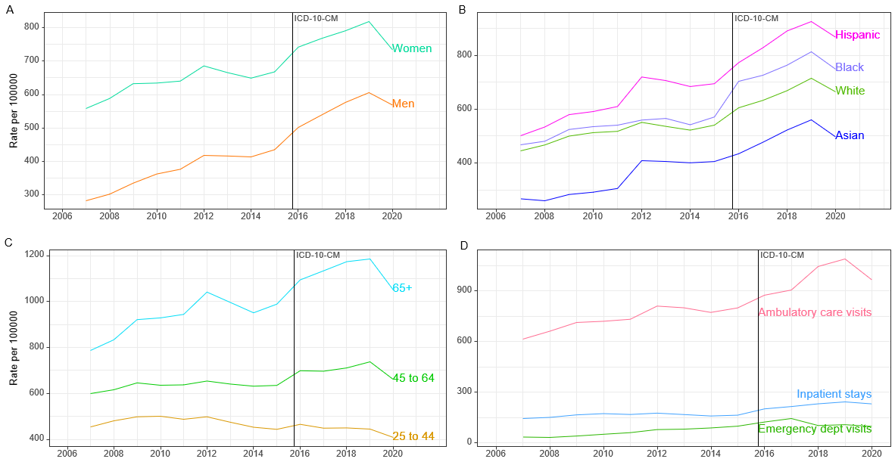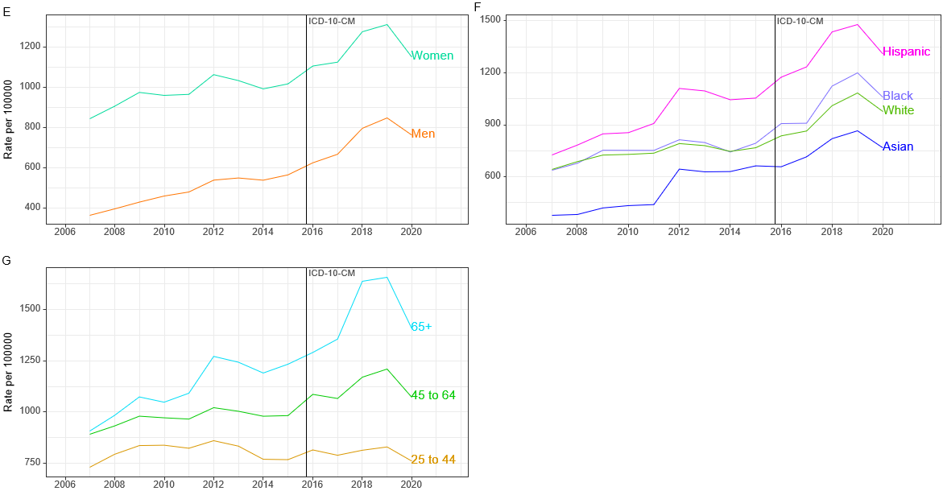
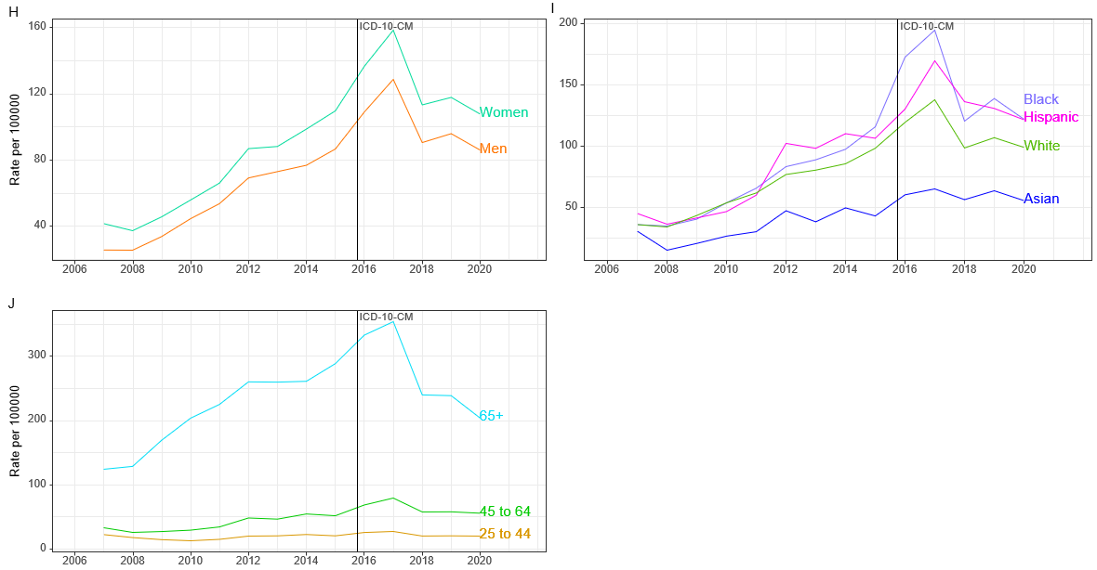
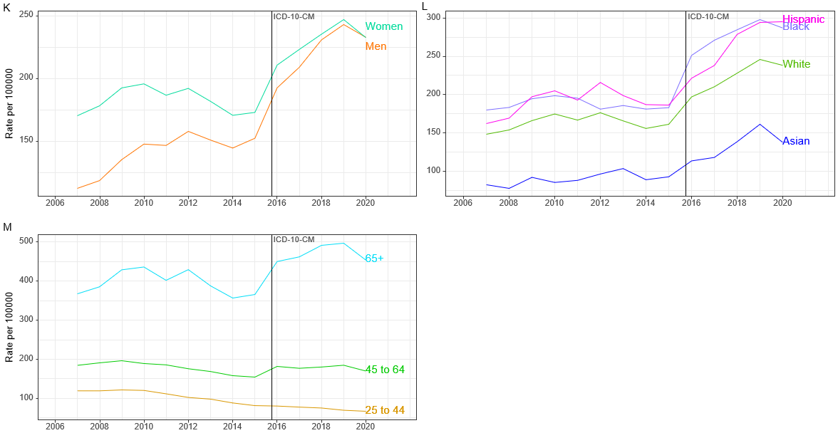
Figure 1 Rates with all-listed gallstone disease diagnoses among persons with commercial insurance in the United States, 2007-2020. A: Claims-based prevalence by sex; B: Claims-based prevalence by race-ethnicity; C: Claims-based prevalence by age; D: Total visits; E: Ambulatory care visits by sex; F: Ambulatory care visits by race-ethnicity; G: Ambulatory care visits by age; H: Emergency department visits by sex; I: Emergency department visits by race-ethnicity; J: Emergency department visits by age; K: Inpatient stays by sex; L: Inpatient stays by race-ethnicity; M: Inpatient stays by age. Source: Optum Clinformatics® Data Mart. ICD: International Classification of Diseases.

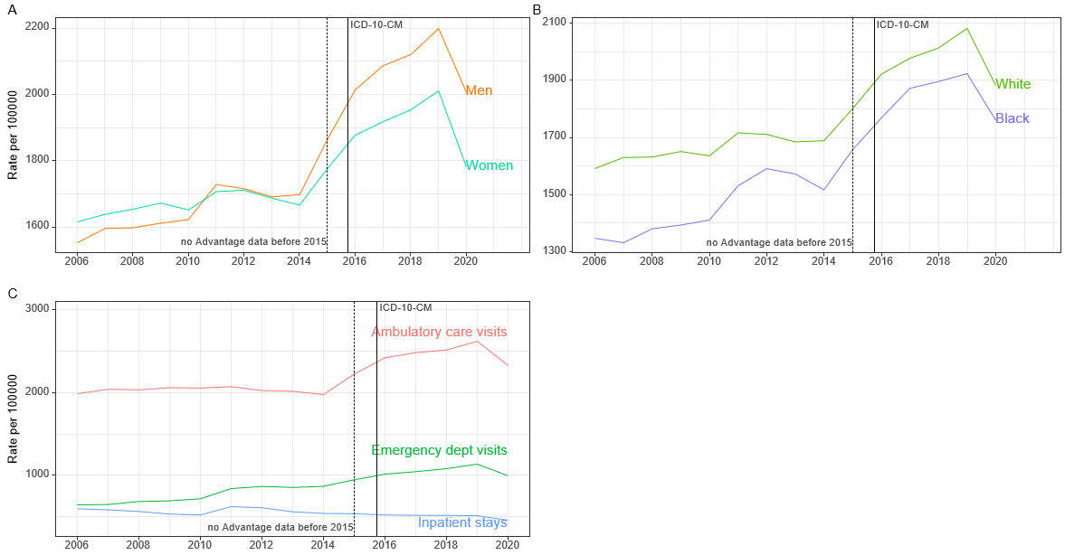
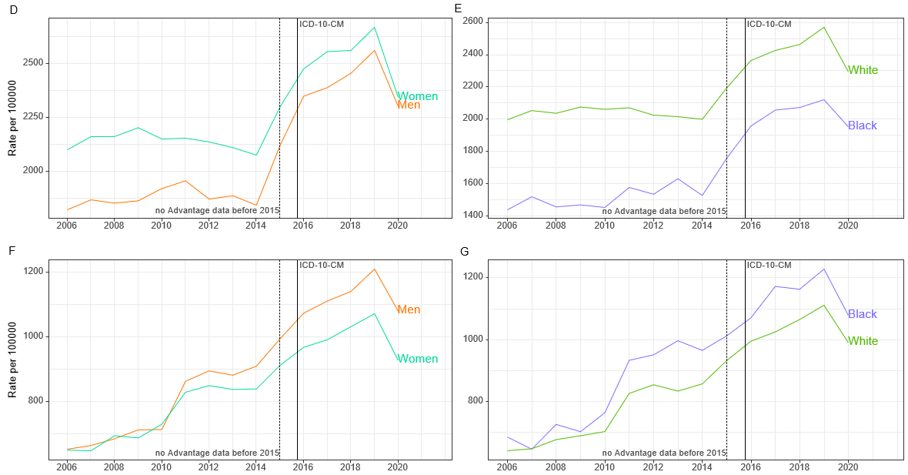
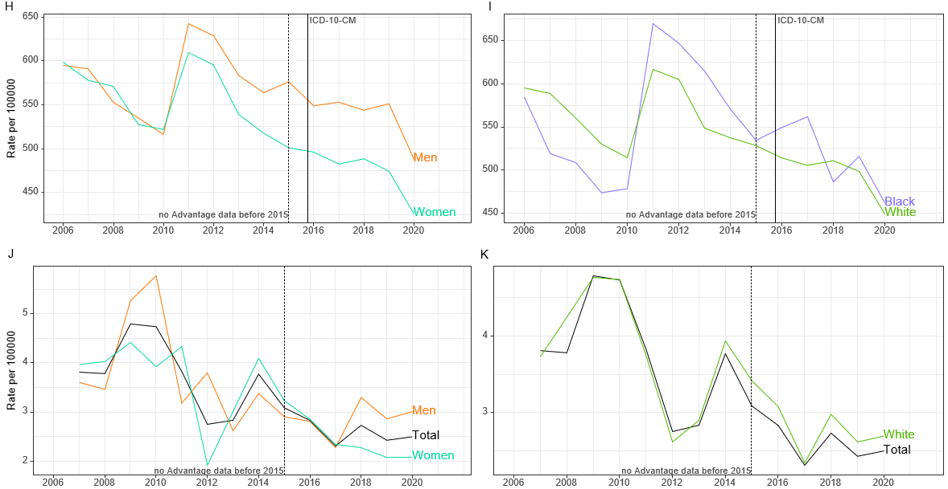
Figure 2 Rates with all-listed gallstone disease diagnoses among age-eligible fee-for-service and Advantage Medicare beneficiaries in the United States, 2006-2020. A: Claims-based prevalence by sex; B: Claims-based prevalence by race; C: Total visits; D: Ambulatory care visits by sex; E: Ambulatory care visits by race; F: Emergency department visits by sex; G: Emergency department visits by race; H: Inpatient stays by sex; I: Inpatient stays by race; J: Mortality by sex; K: Mortality by race. Source: Medicare 5% file. ICD: International Classification of Diseases.

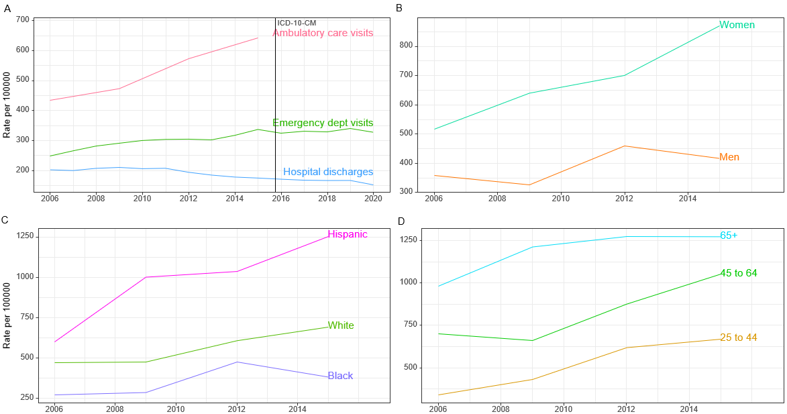
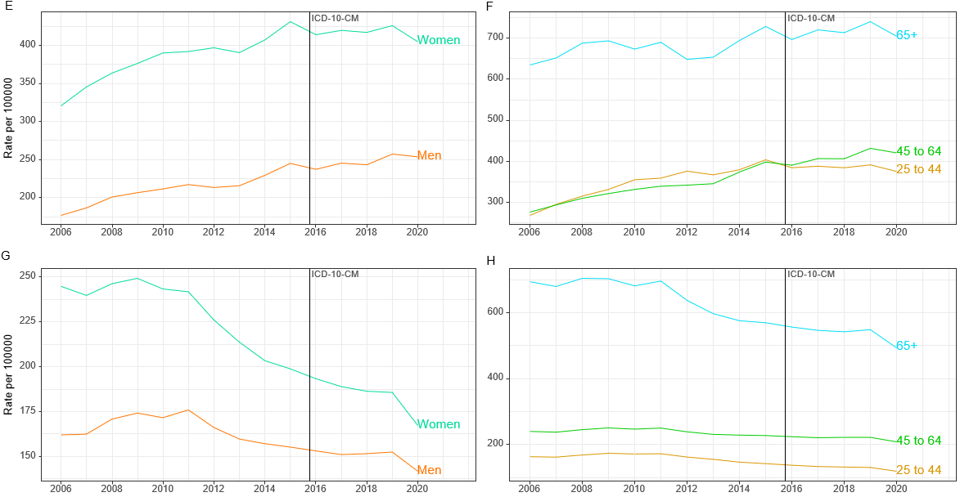
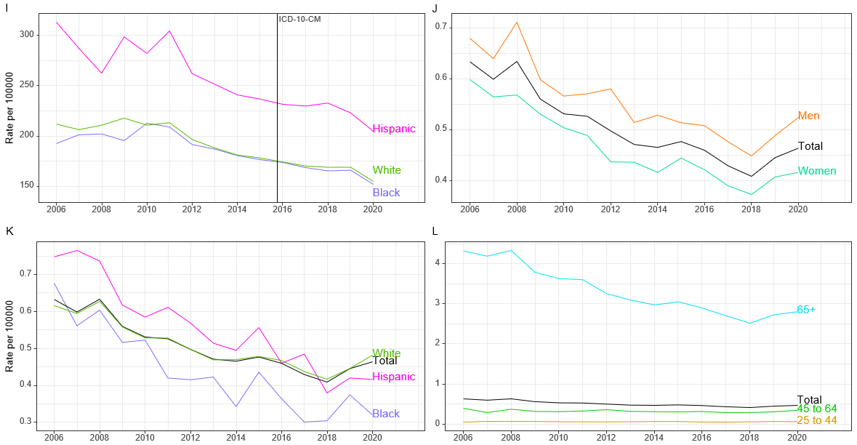
Figure 3 Age-adjusted rates with all-listed gallstone disease diagnoses in the United States. A: Total visits; B: Ambulatory care visits by sex; C: Ambulatory care visits by race-ethnicity; D: Ambulatory care visits by age; E: Emergency department visits by sex; F: Emergency department visits by age; G: Hospital discharges by sex; H: Hospital discharges by age; I: Hospital discharges by race-ethnicity; J: Mortality by sex; K: Mortality by race-ethnicity; L: Mortality by age. Source: National Ambulatory Medical Care Survey, 2005-2016 (3-year averages, 2005-2007, 2008-2010, 2011-2013, 2014-2016); Healthcare Cost and Utilization Project (HCUP) Nationwide Emergency Department Sample, 2006-2020; HCUP National Inpatient Sample, 2006-2020; and Vital Statistics of the United States, 2006-2020. ICD: International Classification of Diseases.

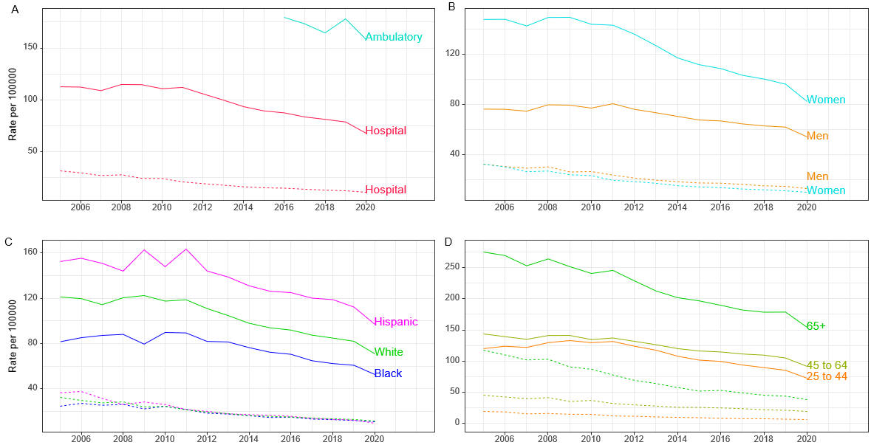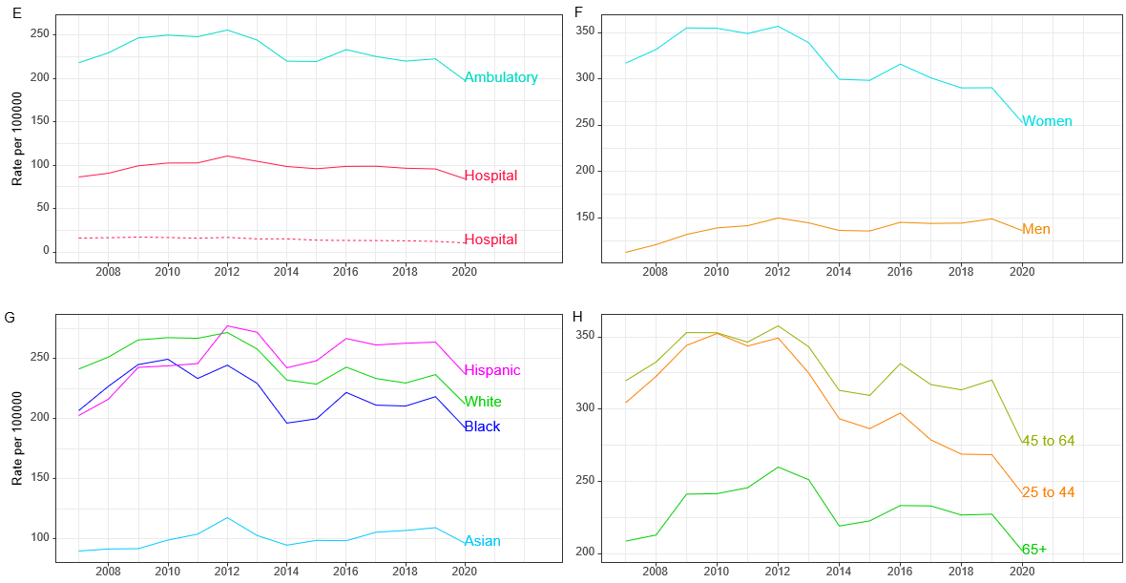
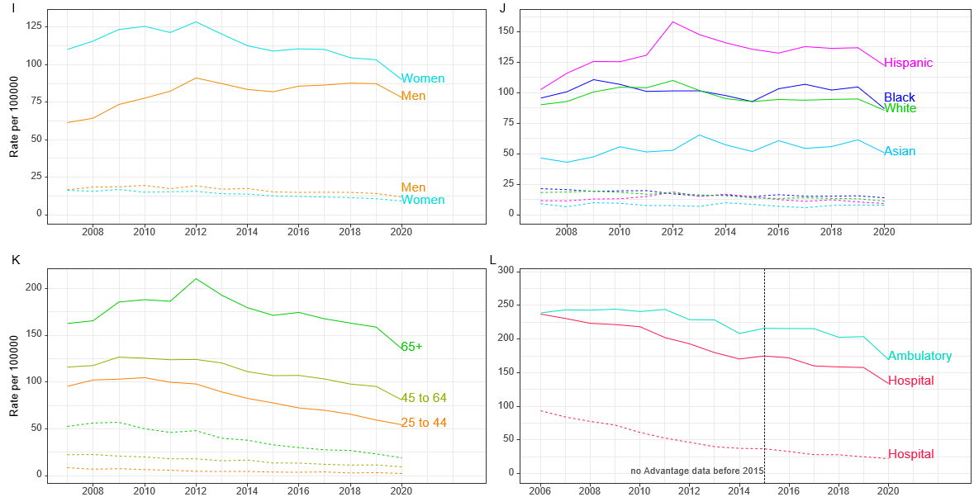
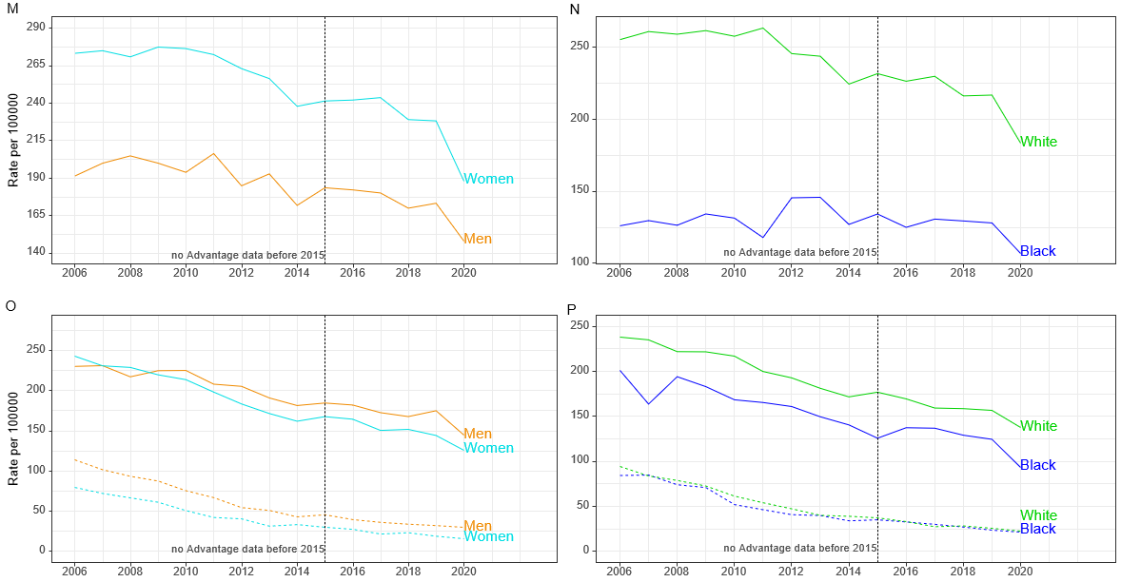
Figure 4 Cholecystectomy rates in the United States. A: National total cholecystectomies; B: National hospital cholecystectomy by sex; C: National hospital cholecystectomy by race-ethnicity; D: National hospital cholecystectomy by age; E: Optum total cholecystectomies; F: Optum ambulatory laparoscopic cholecystectomy by sex; G: Optum ambulatory laparoscopic cholecystectomy by race-ethnicity; H: Optum ambulatory laparoscopic cholecystectomy by age; I: Optum hospital cholecystectomy by sex; J: Optum hospital cholecystectomy by race-ethnicity; K: Optum hospital cholecystectomy by age; L: Medicare total cholecystectomies; M: Medicare ambulatory laparoscopic cholecystectomy by sex; N: Medicare ambulatory laparoscopic cholecystectomy by race; O: Medicare hospital cholecystectomy by sex; P: Medicare hospital cholecystectomy by race. Source: Healthcare Cost and Utilization Project (HCUP) Nationwide Ambulatory Surgery Sample, 2016-2020; HCUP National Inpatient Sample, 2006-2020; Optum Clinformatics® Data Mart, 2007-2020; Medicare 5% file, 2006-2020.

Table 1 Number and age-adjusted rates of claims-based prevalence, ambulatory care visits, emergency department visits, and inpatient stays with gallstone disease (all-listed diagnosis) by age, sex, race-ethnicity, and region among persons with commercial insurance in the United States, 2019
Demographic characteristics | Number of enrollees | Number of enrollees with disease | Claims-based prevalence (%) | Ambulatory care visits |  | Emergency department visits |  | Inpatient stays
 |  |  |  | Number | Rate per 100000 | Number | Rate per 100000 | Number | Rate per 100000
Age (yr)
0 to 11 | 1151595 | 74 | 0.01 | 166 | 14 | 1 | 0 | 21 | 2
12 to 24 | 1513615 | 1746 | 0.12 | 3130 | 207 | 89 | 6 | 319 | 21
25 to 44 | 2751143 | 12191 | 0.44 | 21940 | 797 | 703 | 26 | 1884 | 68
45 to 54 | 1522133 | 9860 | 0.65 | 16064 | 1055 | 773 | 51 | 1944 | 128
55 to 64 | 1683723 | 13626 | 0.81 | 20042 | 1190 | 1966 | 117 | 3776 | 224
65 to 74 | 2676036 | 27435 | 1.03 | 34291 | 1281 | 8425 | 315 | 9121 | 341
75+ | 2448780 | 31352 | 1.28 | 34847 | 1423 | 11055 | 451 | 14610 | 597
Sex
Female | 7184225 | 57525 | 0.80 | 83108 | 1157 | 12915 | 180 | 16716 | 233
Male | 6562800 | 38759 | 0.59 | 47372 | 722 | 10097 | 154 | 14959 | 228
Race-ethnicity
White | 8855438 | 61929 | 0.70 | 83162 | 939 | 15179 | 171 | 20686 | 234
Black | 1279712 | 10245 | 0.80 | 12817 | 1002 | 2912 | 228 | 3663 | 286
Hispanic | 1562580 | 13974 | 0.89 | 20433 | 1308 | 2832 | 181 | 4140 | 265
Asian | 623622 | 3392 | 0.54 | 4986 | 800 | 542 | 87 | 928 | 149
Unknown | 1425673 | 6744 | 0.47 | 9082 | 637 | 1547 | 109 | 2258 | 158
Region
Northeast | 1512196 | 11049 | 0.73 | 14288 | 945 | 2738 | 181 | 4146 | 274
Midwest | 3262384 | 19830 | 0.61 | 26775 | 821 | 5077 | 156 | 6714 | 206
South | 5749137 | 44952 | 0.78 | 60159 | 1046 | 10882 | 189 | 14558 | 253
West | 3223308 | 20453 | 0.63 | 29258 | 908 | 4315 | 134 | 6257 | 194
Total | 13747025 | 96284 | 0.70 | 130480 | 949 | 23012 | 167 | 31675 | 230
Source: Optum Clinformatics® Data Mart.

Table 2 Number and age-adjusted rates of claims-based prevalence, ambulatory care visits, emergency department visits, and inpatient stays with gallstone disease (all-listed diagnosis) by age, sex, race, and region among Medicare beneficiaries in the United States, 2019
Demographic characteristics | Number of enrollees | Number of enrollees with disease | Claims-based prevalence (%) | Ambulatory care visits |  | Emergency department visits |  | Inpatient Stays
 |  |  |  | Number | Rate per 100000 | Number | Rate per 100000 | Number | Rate per 100000
Age (yr)
65 to 69 | 20237900 | 308820 | 1.53 | 423580 | 2093 | 141260 | 698 | 61100 | 302
70 to 74 | 13266460 | 267640 | 2.02 | 352280 | 2655 | 132480 | 999 | 58240 | 439
75 to 79 | 9036280 | 222320 | 2.46 | 281200 | 3112 | 117780 | 1303 | 52500 | 581
80 to 84 | 5891120 | 167340 | 2.84 | 195480 | 3318 | 99660 | 1692 | 47100 | 800
85+ | 5976720 | 173720 | 2.91 | 173100 | 2896 | 126000 | 2108 | 58040 | 971
Sex
Female | 29919040 | 601540 | 2.01 | 798340 | 2668 | 320720 | 1072 | 142000 | 475
Male | 24489440 | 538300 | 2.20 | 627300 | 2562 | 296460 | 1211 | 134980 | 551
Race
White | 41376760 | 861180 | 2.08 | 1062720 | 2568 | 459580 | 1111 | 206300 | 499
Black | 4973980 | 95700 | 1.92 | 105460 | 2120 | 61140 | 1229 | 25640 | 515
Other | 8057740 | 182960 | 2.27 | 257460 | 3195 | 96460 | 1197 | 45040 | 559
Region
Northeast | 9949240 | 216300 | 2.17 | 274340 | 2757 | 111840 | 1124 | 48920 | 492
Midwest | 11818160 | 231920 | 1.96 | 279940 | 2369 | 130720 | 1106 | 57740 | 489
South | 20410320 | 437300 | 2.14 | 550700 | 2698 | 233980 | 1146 | 109480 | 536
West | 12230760 | 254320 | 2.08 | 320660 | 2622 | 140640 | 1150 | 60840 | 497
Total | 54408480 | 1139840 | 2.09 | 1425640 | 2620 | 617180 | 1134 | 276980 | 509
Source: CMS Medicaid.

Table 3 Number and age-adjusted rates of claims-based prevalence, ambulatory care visits, emergency department visits, and inpatient stays with gallstone disease (all-listed diagnosis) by age, sex, race-ethnicity, and region among Medicaid beneficiaries in the United States, 2019
Demographic characteristics | Number of enrollees | Number of enrollees with disease | Claims-based prevalence (%) | Ambulatory care visits |  | Emergency department visits |  | Inpatient stays
 |  |  |  | Number | Rate per 100000 | Number | Rate per 100000 | Number | Rate per 100000
Age (yr)
19 to 34 | 18016135 | 138819 | 0.77 | 169416 | 940 | 100163 | 556 | 28456 | 158
35 to 44 | 8135908 | 80155 | 0.99 | 88679 | 1090 | 46780 | 575 | 15519 | 191
45 to 54 | 6837507 | 86815 | 1.27 | 88868 | 1300 | 41658 | 609 | 16890 | 247
55 to 64 | 6606519 | 102452 | 1.55 | 96526 | 1461 | 39721 | 601 | 19125 | 289
Sex
Female | 23368766 | 286708 | 1.23 | 341646 | 1462 | 170220 | 728 | 54372 | 233
Male | 16227303 | 121533 | 0.75 | 101843 | 628 | 58102 | 358 | 25618 | 158
Race-ethnicity
White | 16266919 | 173456 | 1.07 | 196304 | 1207 | 91310 | 561 | 30701 | 189
Black | 7392713 | 62358 | 0.84 | 57154 | 773 | 37617 | 509 | 12727 | 172
Hispanic | 6279192 | 84023 | 1.34 | 95940 | 1528 | 54029 | 860 | 19315 | 308
Asian | 1800629 | 13259 | 0.74 | 16320 | 906 | 4911 | 273 | 2202 | 122
American Indian/Alaska native | 571976 | 7821 | 1.37 | 8035 | 1405 | 4041 | 706 | 2050 | 358
Hawaiian/Pacific Islander | 207441 | 2033 | 0.98 | 1940 | 935 | 1286 | 620 | 378 | 182
Multiracial/unknown | 7077199 | 65291 | 0.92 | 67796 | 958 | 35128 | 496 | 12617 | 178
Region
Northeast | 8712132 | 82116 | 0.94 | 87273 | 1002 | 40923 | 470 | 17035 | 196
Midwest | 7836180 | 80735 | 1.03 | 94764 | 1209 | 43962 | 561 | 13226 | 169
South | 11095989 | 114258 | 1.03 | 115694 | 1043 | 64653 | 583 | 22782 | 205
West | 11951768 | 131132 | 1.10 | 145758 | 1220 | 78784 | 659 | 26947 | 225
Total | 39596069 | 408241 | 1.03 | 443489 | 1120 | 228322 | 577 | 79990 | 202
Source: CMS Medicaid.

Table 4 Number and age-adjusted rates of ambulatory care visits, emergency department visits, hospital discharges, deaths, and years of potential life lost (to age 75) with gallstone disease (all-listed diagnosis) by age, sex, race, and ethnicity in the United States
Demographic characteristics | Ambulatory care visits (2015) |  | Emergency department visits (2019) |  | Hospital discharges (2019) |  | Mortality (2019)
 | Number in thousands | Rate per 100000 | Number in thousands | Rate per 100000 | Number in thousands | Rate per 100000 | Number of deaths | Rate per 100000
Age (yr)
0 to 11 | 2 | 4 | 2 | 5 | 2 | 3 | 0 | 0
12 to 24 | 148 | 263 | 95 | 172 | 28 | 51 | 3 | 0
25 to 44 | 565 | 669 | 343 | 392 | 114 | 130 | 61 | 0.1
45 to 54 | 467 | 1084 | 170 | 417 | 75 | 185 | 66 | 0.2
55 to 64 | 414 | 1015 | 190 | 447 | 109 | 256 | 190 | 0.5
65 to 74 | 389 | 1415 | 179 | 570 | 126 | 399 | 307 | 1.0
75+ | 218 | 1080 | 221 | 977 | 171 | 759 | 1169 | 5.2
Sex
Female | 1466 | 870 | 756 | 426 | 356 | 186 | 959 | 0.4
Male | 738 | 418 | 444 | 257 | 269 | 152 | 837 | 0.5
Race
White | 1901 | 691 | - | - | 508 | 169 | 1517 | 0.5
African American | 172 | 380 | - | - | 74 | 166 | 154 | 0.4
Other | 131 | 519 | - | - | 49 | 190 | 125 | 0.5
Hispanic origin
Hispanic | 600 | 1254 | - | - | 111 | 223 | 157 | 0.4
Not Hispanic | 1604 | 554 | - | - | 521 | 159 | 1639 | 0.5
Total | 2204 | 642 | 1200 | 339 | 625 | 168 | 1796 | 0.5
Source: National Ambulatory Medical Care Survey (3-year average, 2014-2016), Healthcare Cost and Utilization Project Nationwide Emergency Department Sample and National Inpatient Sample, and Vital Statistics of the United States. The Nationwide Emergency Department Sample does not include information on race-ethnicity.

Table 5 Number and age-adjusted rates of ambulatory and inpatient laparoscopic and open cholecystectomy by age, sex, race, and ethnicity in the United States, 2019
Demographic characteristics | Ambulatory |  |  |  | Inpatient
 | Number in thousands¹ | Rate per 100000¹ | Number in thousands² | Rate per 100000² | Number in thousands¹ | Rate per 100000¹ | Number in thousands² | Rate per 100000²
Age (yr)
0 to 11 | 720 | 2 | 0 | 0 | 615 | 1 | 395 | 1
12 to 24 | 57257 | 104 | 83 | 0.1 | 20435 | 37 | 1020 | 2
25 to 44 | 217271 | 248 | 365 | 0.4 | 74860 | 86 | 6005 | 7
45 to 54 | 109649 | 268 | 294 | 0.7 | 40125 | 98 | 6485 | 16
55 to 64 | 105287 | 248 | 301 | 0.7 | 47175 | 111 | 11440 | 27
65 to 74 | 78051 | 248 | 246 | 0.8 | 48685 | 155 | 13585 | 43
75+ | 37144 | 165 | 168 | 0.7 | 47655 | 211 | 9995 | 44
Sex
Female | 440796 | 260 | 872 | 0.5 | 172020 | 96 | 22265 | 11
Male | 164542 | 96 | 584 | 0.3 | 107520 | 62 | 26660 | 15
Race
White | - | - | - | - | 232640 | 82 | 40298 | 13
African American | - | - | - | - | 27545 | 61 | 5485 | 12
Other | - | - | - | - | 21967 | 82 | 3626 | 14
Hispanic origin
Hispanic | - | - | - | - | 60436 | 112 | 5893 | 12
Not Hispanic | - | - | - | - | 221716 | 72 | 43516 | 13
Total | 605379 | 178 | 1456 | 0.4 | 279550 | 78 | 48925 | 13
¹Laparoscopic.
²Open.
Source: Healthcare Cost and Utilization Project Nationwide Ambulatory Surgery Sample and National Inpatient Sample. The Nationwide Ambulatory Surgery Sample does not include information on race-ethnicity.

Table 6 Number and age-adjusted rates of ambulatory and inpatient laparoscopic and open cholecystectomy by age, sex, race-ethnicity, and region among persons with commercial insurance in the United States, 2019
Demographic characteristics | Ambulatory |  |  |  | Inpatient
 | Number in thousands¹ | Rate per 100000¹ | Number in thousands² | Rate per 100000² | Number in thousands¹ | Rate per 100000¹ | Number in thousands² | Rate per 100000²
Age (yr)
0 to 24 | 1306 | 49 | 2 | 0.1 | 293 | 11 | 10 | 0
25 to 44 | 7383 | 268 | 22 | 0.8 | 1641 | 60 | 85 | 3
45 to 64 | 10270 | 320 | 62 | 1.9 | 3059 | 95 | 380 | 12
65+ | 11646 | 227 | 137 | 2.7 | 8147 | 159 | 1202 | 24
Sex
Female | 20830 | 290 | 111 | 1.5 | 7410 | 103 | 756 | 11
Male | 9775 | 149 | 112 | 1.7 | 5730 | 87 | 921 | 14
Race-ethnicity
White | 20966 | 237 | 151 | 1.7 | 8406 | 95 | 1147 | 13
Black | 2791 | 218 | 27 | 2.1 | 1339 | 105 | 201 | 16
Hispanic | 4125 | 264 | 22 | 1.4 | 2140 | 137 | 168 | 11
Asian | 680 | 109 | 7 | 1.1 | 382 | 61 | 50 | 8
Unknown | 2043 | 143 | 16 | 1.1 | 873 | 61 | 111 | 8
Region
Northeast | 2383 | 158 | 22 | 1.5 | 1364 | 90 | 182 | 12
Midwest | 7787 | 239 | 43 | 1.3 | 2697 | 83 | 413 | 13
South | 14904 | 259 | 123 | 2.1 | 6277 | 109 | 775 | 14
West | 5531 | 172 | 35 | 1.1 | 2802 | 87 | 307 | 10
Total | 30605 | 223 | 223 | 1.6 | 13140 | 96 | 1677 | 12
¹Laparoscopic.
²Open.
Source: Optum Clinformatics® Data Mart.

Table 7 Number and age-adjusted rates of ambulatory and inpatient laparoscopic and open cholecystectomy by age, sex, race, and region among Medicare beneficiaries in the United States, 2019
Demographic characteristics | Ambulatory |  |  |  | Inpatient
 | Number in thousands¹ | Rate per 100000¹ | Number in thousands² | Rate per 100000² | Number in thousands¹ | Rate per 100000¹ | Number in thousands² | Rate per 100000²
Age (yr)
65 to 69 | 44920 | 222 | 240 | 1.2 | 23360 | 115 | 4060 | 20
70 to 74 | 31080 | 234 | 300 | 2.3 | 21260 | 160 | 3380 | 26
75 to 79 | 19840 | 220 | - | - | 17720 | 196 | 2480 | 27
80 to 84 | 9640 | 164 | - | - | 12600 | 214 | 1840 | 31
75+ | 5280 | 88 | - | - | 11060 | 185 | 1760 | 29
Sex
Female | 68280 | 228 | 460 | 1.5 | 43220 | 145 | 5780 | 19
Male | 42480 | 174 | 460 | 1.9 | 42780 | 175 | 7740 | 32
Race
White | 89580 | 217 | 740 | 1.8 | 64800 | 157 | 10480 | 25
Black | 6380 | 128 | - | - | 6200 | 125 | 1160 | 23
Other | 14800 | 184 | - | - | 15000 | 186 | 1880 | 23
Region
Northeast | 15480 | 156 | - | - | 12720 | 128 | 2480 | 25
Midwest | 25100 | 212 | 280 | 2.4 | 17620 | 149 | 3020 | 26
South | 49260 | 241 | 280 | 1.4 | 36280 | 178 | 5860 | 29
West | 20920 | 171 | - | - | 19380 | 159 | 2160 | 18
Total | 110760 | 204 | 920 | 1.7 | 86000 | 158 | 13520 | 25
¹Laparoscopic.
²Open.
Source: CMS Medicare 5% file. Counts less than 200 are not reported.

Table 8 Number and age-adjusted rates of ambulatory and inpatient laparoscopic and open cholecystectomy by age, sex, race-ethnicity, and region among Medicaid beneficiaries in the United States, 2019
Demographic characteristics | Ambulatory |  |  |  | Inpatient
 | Number in thousands¹ | Rate per 100000¹ | Number in thousands² | Rate per 100000² | Number in thousands¹ | Rate per 100000¹ | Number in thousands² | Rate per 100000²
Age (yr)
19 to 34 | 48231 | 268 | - | - | 19107 | 106 | 712 | 4.0
35 to 44 | 22854 | 281 | - | - | 9345 | 115 | 704 | 8.7
45 to 54 | 17784 | 260 | - | - | 8105 | 119 | 950 | 13.9
55 to 64 | 14468 | 219 | - | - | 7698 | 117 | 1235 | 18.7
Sex
Female | 84647 | 362 | - | - | 33167 | 142 | 1825 | 7.8
Male | 18690 | 115 | - | - | 11088 | 68 | 1776 | 10.9
Race-ethnicity
White | 52396 | 322 | 252 | 1.5 | 17112 | 105 | 1690 | 10.4
Black | 11598 | 157 | - | - | 6005 | 81 | 600 | 8.1
Hispanic | 17567 | 280 | - | - | 11268 | 179 | 484 | 7.7
Asian | 1892 | 105 | - | - | 1182 | 66 | - | -
American Indian/Alaska native | 2173 | 380 | - | - | 1038 | 182 | - | -
Hawaiian/Pacific Islander | 459 | 221 | - | - | 233 | 112 | - | -
Multiracial/unknown | 17252 | 244 | - | - | 7417 | 105 | 631 | 8.9
Region
Northeast | 17392 | 200 | - | - | 8986 | 103 | 617 | 7.1
Midwest | 25378 | 324 | - | - | 7661 | 98 | 887 | 11.3
South | 33066 | 298 | 237 | 2.1 | 11824 | 107 | 1133 | 10.2
West | 27501 | 230 | - | - | 15784 | 132 | 964 | 8.1
Total | 103337 | 261 | 521 | 1.3 | 44255 | 112 | 3601 | 9.1
¹Laparoscopic.
²Open.
Source: CMS Medicaid. Counts less than 200 are not reported.

