Name of Journal: World Journal of Clinical Cases

Manuscript NO: 72680

Manuscript Type: CASE REPORT

Subcutaneous infection caused by Mycobacterium abscessus following cosmetic injections of botulinum toxin: A case report

Deng L et al. Subcutaneous infection caused by Mycobacterium abscessus

Lin Deng, Ying-Zhi Luo, Fang Liu, Xiao-Hong Yu

Lin Deng, Ying-Zhi Luo, Xiao-Hong Yu, Department of Dermatology, Affiliated Hangzhou First People’s Hospital, Zhejiang University School of Medicine, Hangzhou 310006, Zhejiang Province, China

Fang Liu, Department of Dermatology, Jinling Hospital, Nanjing 210002, Jiangsu Province, China

Author contributions: Yu XH and Deng L were the patient’ dermatologists; Deng L collected the data; Luo YZ and Liu F contributed to manuscript drafting and literature review.

Corresponding author: Yu XH, MD, Doctor, Professor, Department of Dermatology, Affiliated Hangzhou First People’s Hospital, Zhejiang University School of Medicine, No. 261 Huansha Street, Hangzhou 310006, Zhejiang Province, China. 1191656901@qq.com

Received: October 26, 2021
Revised: December 27, 2021
Accepted: April 28, 2022
Published online:

Abstract

BACKGROUND
In recent years, the cosmetic intervention related infections caused by nontuberculous mycobacteria (NTM) are increasing as the informal cosmetic treatments are performed. However, many dermatologists are inexperienced in the diagnosis and management of similar cases. Here we report a case of subcutaneous infection caused by Mycobacterium abscessus (M. abscessus) following cosmetic injections of botulinum toxin.

CASE SUMMARY
A 53-year-old woman presented with multiple abscesses and nodules on her forehead and both temporal sites for half a month after cosmetic injections of botulinum toxin. Her lesions did not show any alleviation after 2-wk prescription of antibiotics. Laboratory examinations indicated that she had no sign of immunodeficiency and the whole body of computed tomography did not find any systemic infection or diseases. The pathology of skin tissue showed inflammatory cell infiltration with the negative results of Periodic acid Schiff (PAS) and Acid-fast staining and the culture yielded no microbiome. Afterwards, the puncture on abscess was performed and M. abscessus was successfully isolated. The pathogen was identified by acid-fast staining and DNA sequencing. The patient was treated with the strategy of clarithromycin, ofloxacin, and amikacin according to the result of drug sensitivity test and got complete remission of the lesions.

CONCLUSION
The case presents the whole process of diagnosis and management of NTM infection after cosmetic intervention and highlights the diagnostic thoughts. In a word, the mycobacterium infection should be aware in patients after cosmetic performance.

Key Words: Mycobacterium abscesses; Skin infection; Cosmetic injection; Nontuberculous mycobacteria; Case report

Deng L, Luo YZ, Liu F, Yu XH. Subcutaneous infection caused by Mycobacterium abscessus following cosmetic injections of botulinum toxin: A case report. World J Clin Cases 2022; In press

Core Tip: The article reports a case of subcutaneous infection caused by Mycobacterium abscessus after cosmetic intervention. We present the medical history and whole process of diagnosis and management of the case and made a literature review of similar infections. The paper is trying to provide some more experience for dermatologists.

INTRODUCTION
Nontuberculous mycobacteria (NTM) refer to mycobacteria other than Mycobacterium tuberculosis and leprosy with the common involved organs of the lung, bone, soft tissues, skin, and lymph nodes^{[1]}. Mycobacterium abscessus (M. abscessus) is one of the common pathogens in NTM, which is a fast-growing mycobacterium causing skin and soft tissue infections. Meanwhile, the atypical mycobacterial infections are increasing at injection-related sites as the informal cosmetic treatments are performed, which deserves the attention of the cosmetic and medical supervision^{[2-4]}. The case presented here is a subcutaneous infection caused by M. abscessus following cosmetic injections of botulinum toxin.

CASE PRESENTATION

Chief complaints
A 53-year old female patient visited our department with the complaint of multiple nodules for half a month on the forehead and both temporal sites after the injection of botulinum toxin (Figure 1A-C).

History of present illness
The lesions initially presented with erythema after 10 d of the injection then developed to nodules and abscesses after half a month. The patient did not have any concomitant symptoms such as fever, cough, fatigue, sweats, or diarrhea. She was prescribed with antibiotics for 2 wk without alleviation of the lesions.

History of past illness

The patient did not have any underlying disease or take any drugs in the past.

Personal and family history

Nothing special.

Physical examination
Physical examination indicated multiple red papules, nodules, and abscesses on the forehead and both temporal sites with a diameter of 1-3 cm.

Laboratory examinations
The routine blood, urine, and stool tests as well as kidney and liver function tests were in normal levels. The levels of C3, C4 and C-reactive protein were normal. The patient was negative for syphilis, HIV, antinuclear antibodies, and rheumatoid factor. CD3 and CD4 counts were done to check for any immunodeficiency and were within normal limits (Supplementary Table 1).

Imaging examinations
Computed tomography (CT) of the whole body did not find any systemic infection or diseases.

FINAL DIAGNOSIS
The patient underwent skin biopsy on the nodules of left temporal site. The pathology of skin tissue showed a large number of inflammatory cells including neutrophils, lymphocytes, and multinucleated giant cells distributed in the derma (Figure 2A and 2B). However, periodic acid Schiff (PAS) and acid-fast staining were negative. Meanwhile, the skin tissue did not yield any microbiome after culture on different media for bacteria, fungus, or mycobacterium. Considering the low biopsy- and culture-positive rate of some microorganisms, a puncture on abscess of right temporal site was further performed. Gray-white colonies were yielded after being cultured on Mycobacterium Roche's Medium (MRM) for 5 days at 35 °C (Figure 3A). Meanwhile, the pus was positive for acid-fast staining and M. abscessus was identified by DNA sequencing (Figure 3B). The drug sensitivity test indicated that the microbiome was sensitive to clarithromycin, moxifloxacin, azithromycin, cefoxitin, and amikacin, and was resistant to isoniazid, streptomycin, dapsone, and rifampicin (Supplementary Table 2).

TREATMENT
The patient was initially intramuscularly injected with amikacin 0.2 g and given oral clarithromycin 0.25 g twice a day for 2 wk and then adjusted to moxifloxacin 0.4 g per day and clarithromycin 0.25 g twice a day because of dizziness and vomiting caused by amikacin.

OUTCOME AND FOLLOW-UP
The patient did not show any side effects and presented complete remission of the lesions during the subsequent treatment for 7 mo (Figure 1D-F).

DISCUSSION
With the development of un-standard invasive performance in cosmetic industry, related iatrogenic complications are increasing in the last two decades. Injection pain, local edema, erythema, and transient nausea are common complications with mild symptoms. Life-threatening complications are rarely seen, while severe idiosyncratic reactions can cause patients to die from shock and pseudoaneurysm of the superficial temporal artery may break and cause bleeding to death^{[5]}. Infections are also common complications, which usually can be easily cured with empiric antibiotic therapy. However, atypical mycobacterial infections are increasing these years and resistant to regular antibiotic treatment. To meet the challenge of NTM diagnosis and management, we should learn more about it. In Table 1, previous cases of mycobacterial infections caused by cosmetic performance are reviewed^{[2-4,6-14]}, the results of which are consistent with the previous studies^{[1]}. It is common to be seen in female patients aged 25 to 45 years. This phenomenon can be attributed to the fact that these people are more often seeking invasive cosmetic performance.
The rare pathogen of M. abscessus is the main mycobacteria isolated from lesions cultured, which can involve the skin, soft tissue, and lymph nodes in immunocompetent or immunosuppressed patients^{[1,15]}. The cutaneous infection caused by M. abscessus generally occurs following surgery, subcutaneous injection, or acupuncture^{[16]}. Because M. abscessus has a hydrophobic biofilm, by which M. abscessus can be resistant to disinfectants and heavy metals, and lead to nosocomial infections^{[17]}. The lesions of the patient presented here develop at the injected point of botulinum toxin. We suspected that the infection may be caused by the non-standard aseptic operation and injection, surgery, equipment contamination, or intraoperative infection. Iatrogenic infections have become one of the common causes of fast-growing mycobacterial infection because of the unstandardized aseptic operation during injection and surgery causing an increase in opportunistic infections and great pain to patients. Therefore, when managing such cases, attention should be paid to these agents.
The skin lesions can be the initial symptoms or secondary to disseminated infections, which often present with multiple papules, herpes, nodules, erythema, or abscesses^{[1]}. The initial symptoms of our patient presented as multiple erythema then developed to nodules and abscess. She was prescribed with multiple antibiotics but without remission of the lesions. The unspecific infection caused by fungus, M. tuberculosis, or NTM was suspected. Finally, the patient was diagnosed as having subcutaneous infection caused by M. abscessus. The golden standard for diagnosing NTM infections is histopathology and mycobacteria culture. Acid-fast staining is the most convenient and common laboratory test, while PCR sequencing and DNA chip technology have emerged as fast and accurate methods in identifying NTM^{[15]}. However, the acid-fast staining of nodule of this patient was negative and did not yield any culture on MRM. Fortunately, the puncture fluid of abscess was positive for acid-fast staining and M. abscessus was yielded and identified by PCR sequencing. Therefore, once NTM infection is clinically suspected, multiple specimens should be tested by histopathology, culture, and molecular biology identification. The successful diagnosis of this patient depended on the awareness of mycobacterial infections and attitude of insistence.
NTM are intracellular colonies whose high hydrophobicity on the cell surface and cell wall permeability barrier make them resistant to traditional anti-tuberculosis drugs and difficult to treat^{[17]}. M. abscessus is the most resistant strain of mycobacterium, and is highly resistant to traditional anti-tuberculosis drugs; hence, it needs to be tested for drug susceptibility when yielding positive cultures. M. abscessus is often sensitive to clarithromycin, amikacin, and cefoxitin. However, a single drug is easy to induce drug resistance according to the guidelines of the American Thoracic Society and the American Society of Infectious Diseases, therefore the combination of two kinds of sensitive drugs is recommended for treatment until the lesions are completely healed^{[18]}. Meanwhile, drug susceptibility testing needs to be performed once culture of NTM is yielded to ensure the effective treatment.

CONCLUSION
NTM infection should be aware in patients with refractory lesions, particularly followed by cosmetic procedure. Moreover, the drug sensitivity test needs to be performed to obtain early diagnosis and appropriate treatment to avoid dissemination and deformity.

REFERENCES
1 Chirasuthat P, Triyangkulsri K, Rutnin S, Chanprapaph K, Vachiramon V. Cutaneous nontuberculous mycobacterial infection in Thailand: A 7-year retrospective review. Medicine (Baltimore) 2020; 99: e19355 [PMID: 32150075 DOI: 10.1097/MD.0000000000019355]
2 Chen X, Jin Y, Torres KMT, Li B, Zhuo F, Ding X, Cai L, Zhang J, Zhou C. Mycobacterium abscessus cutaneous infection secondary to botulinum toxin injection: A report of 2 cases. JAAD Case Rep 2019; 5: 982-984 [PMID: 31709291 DOI: 10.1016/j.jdcr.2019.09.017]
3 Mello RB, Moreira DN, Pereira ACG, Lustosa NR. Cutaneous infection by Mycobacterium lentiflavum after subcutaneous injection of lipolytic formula. An Bras Dermatol 2020; 95: 511-513 [PMID: 32522448 DOI: 10.1016/j.abd.2019.11.013]
4 Tan LC, Li XY, Lu YG. Nontuberculous Mycobacteria Infection After Autologous Fat Grafting for Cosmetic Breast Augmentation. Ann Plast Surg 2020; 85: 358-362 [PMID: 32032112 DOI: 10.1097/SAP.0000000000002234]
5 Skaf GS, Domloj NT, Salameh JA, Atiyeh B. Pseudoaneurysm of the superficial temporal artery: a complication of botulinum toxin injection. Aesthetic Plast Surg 2012; 36: 982-985 [PMID: 22527583 DOI: 10.1007/s00266-012-9881-6]
6 Yeon J, Chan RCF, Fallah H. Infection with Mycobacterium immunogenum following botulinum toxin injection. Australas J Dermatol 2020 [PMID: 32720313 DOI:10.1111/ajd.13406]
7 Fang RY, Sun QN. Mycobacterium abscessus infections following injection of botulinum toxin. J Cosmet Dermatol 2020; 19: 817-819 [PMID: 31402555 DOI: 10.1111/jocd.13094]
8 Thanasarnaksorn W, Rattakul B, Suvanasuthi S, Sutthipisal N. Botulinum toxin type A injection-related suppurative granuloma: a case report. J Cosmet Laser Ther 2019; 21: 422-424 [PMID: 31711325 DOI: 10.1080/14764172.2019.1690663]
9 Saeb-Lima M, Solis-Arreola GV, Fernandez-Flores A. Mycobacterial infection after cosmetic procedure with botulinum toxin a. J Clin Diagn Res 2015; 9: WD01-WD02 [PMID: 26023629 DOI: 10.7860/JCDR/2015/11741.5756]
10 Hammond SE, Al-Bayati A, Joumblat N, Salgado CJ. Mycobacterium Chelonae Infection of the Buttocks Secondary to Lipofilling: A Case Report and Review of the Literature. Aesthetic Plast Surg 2017; 41: 1150-1154 [PMID: 28526906 DOI:10.1007/s00266-017-0890-3]
11 Yoo SJ, Lee KH, Jung SN, Heo ST. Facial skin and soft tissue infection caused by Mycobacterium wolinskyi associated with cosmetic proc edures. BMC Infect Dis 2013; 13: 479 [PMID: 24131522 DOI:10.1186/1471-2334-13-479]
12 Fiore R 2nd, Miller R, Coffman SM. Mycobacterium mucogenicum infection following a cosmetic procedure with poly-L-lactic acid. J Drugs Dermatol 2013; 12: 353-357 [PMID: 23545922]
13 Eustace K, Jolliffe V, Sahota A, Gholam K. Cutaneous Mycobacterium abscessus infection following hair transplant. Clin Exp Dermatol 2016; 41: 768-770 [PMID: 27663154 DOI: 10.1111/ced.12900]
14 Yang P, Lu Y, Liu T, Zhou Y, Guo Y, Zhu J, Jia C, Chen L, Yang Q. Mycobacterium abscessus Infection After Facial Injection With Autologous Fat: A Case Report. Ann Plast Surg 2017; 78: 138-140 [PMID: 27220017 DOI: 10.1097/SAP.0000000000000837]
15 Griffith DE, Aksamit T, Brown-Elliott BA, Catanzaro A, Daley C, Gordin F, Holland SM, Horsburgh R, Huitt G, Iademarco MF, Iseman M, Olivier K, Ruoss S, von Reyn CF, Wallace RJ Jr, Winthrop K; ATS Mycobacterial Diseases Subcommittee; American Thoracic Society; Infectious Disease Society of America. An official ATS/IDSA statement: diagnosis, treatment, and prevention of nontuberculous mycobacterial diseases. Am J Respir Crit Care Med 2007; 175: 367-416 [PMID: 17277290 DOI: 10.1164/rccm.200604-571ST]
16 Suganeswari G, Shah D, Anand AR. Intravitreal piperacillin-tazobactam in endophthalmitis caused by Mycobacterium abscessus in silico n e-filled eye: A case report. Indian J Ophthalmol 2020; 68: 1471-1473 [PMID: 32587202 DOI: 10.4103/ijo.ijo_1886_19]
17 Henry F, Piérard-Franchimont C, Piérard GE. [Clinical case of the month. Atypical mycobacteria and mesotherapy] Rev Med Liege 2005; 60: 7-10 [PMID: 15771310]
18 Lyu J, Jang HJ, Song JW, Choi CM, Oh YM, Lee SD, Kim WS, Kim DS, Shim TS. Outcomes in patients with Mycobacterium abscessus pulmonary disease treated with long-term injectable drugs. Respir Med 2011; 105: 781-787 [PMID: 21211956 DOI: 10.1016/j.rmed.2010.12.012]

Footnotes

Informed consent statement: Informed consent was obtained from the patient for publication of this case report.

Conflict-of-interest statement: The authors declare that they have no conflicts of interest to disclose.

CARE Checklist (2016) statement: The authors have read the CARE Checklist (2016), and the manuscript was prepared and revised according to the CARE Checklist (2016).

Open-Access: This article is an open-access article that was selected by an in-house editor and fully peer-reviewed by external reviewers. It is distributed in accordance with the Creative Commons Attribution NonCommercial (CC BY-NC 4.0) license, which permits others to distribute, remix, adapt, build upon this work non-commercially, and license their derivative works on different terms, provided the original work is properly cited and the use is non-commercial. See: https://creativecommons.org/Licenses/by-nc/4.0/

Provenance and peer review: Unsolicited article; Externally peer reviewed.

Peer-review model: Single blind

Peer-review started: October 26, 2021

First decision: December 17, 2021
Article in press:

Specialty type: Infectious diseases

Country/Territory of origin: China

Peer-review report’s scientific quality classification

Grade A (Excellent): A
Grade B (Very good): 0
Grade C (Good): C, C
Grade D (Fair): 0
Grade E (Poor): 0

P-Reviewer: Corvino A, Italy; Hosoya S, Japan; Malekzadegan A, Iran S-Editor: Xing YX L-Editor: Wang TQ P-Editor: Xing YX

Figure Legends

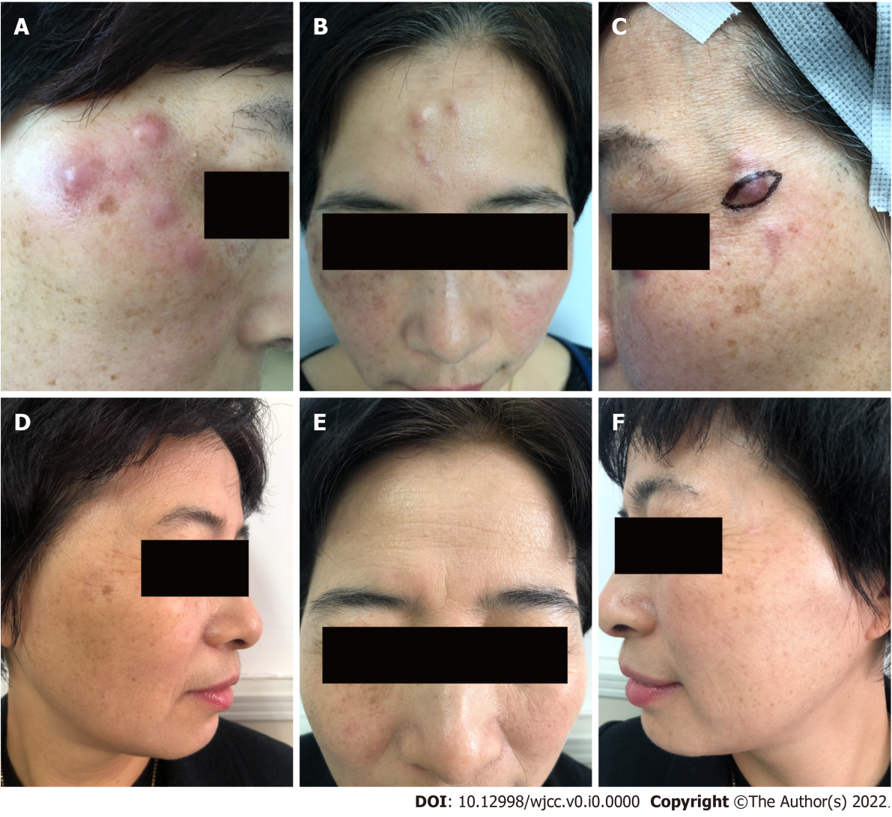
Figure 1 Patient’s photographs before and after treatment. A-C: Multiple red papules, nodules, and abscesses were seen on the forehead and both temporal sites with a diameter of 1 cm-3 cm; D-F: The lesions were cured after the treatment for 7 mo.
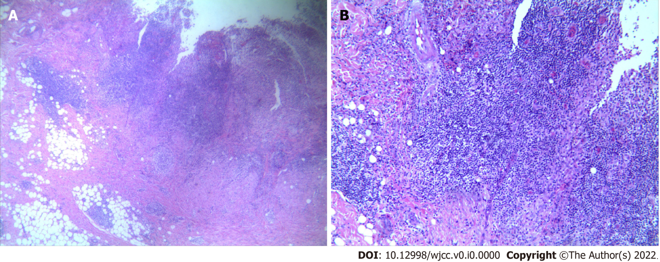
Figure 2 Histopathology. The histopathology indicated a large number of mixed inflammatory cell infiltrates in the deep dermis, including neutrophils, histiocytes, and lymphocytes (A: HE × 40, B: HE × 100).
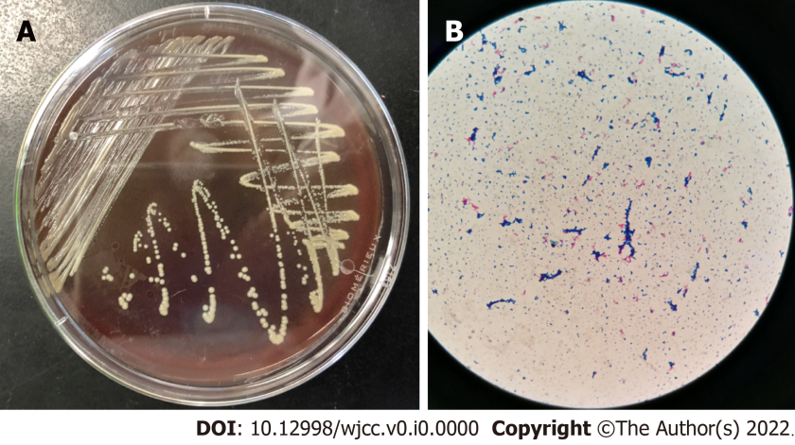
Figure 3 Microbiological evidence. A: Cultures on Mycobacterium Roche's Medium yielded cream-colored, yeast-like colonies within 5 d at 35 °C; B: Scattered pink rod-shaped bacteria after acid-fast staining (× 100).

Table 1 Patients’ information statistics for subcutaneous infection caused by nontuberculous mycobacteria following cosmetic procedures
No | Ref. | Sex/Age  (yr) | Duration after injection (mo/wk/d) | Skin symptoms | Site of infection | Culture | Treatment and course | Outcome
P1 | The present case | F/53 | Botulinum toxin (1.5 mo) | Erythematous  nodules | Cheek, forehead | M. abscessus | Clarithromycin, moxifloxacin, amikacin 2/d (7 mo) | Cure
P2 | Chen et al^{[2]} | F/32 | Botulinum toxin (2 mo) | Nodules and abscesses | Forehead and  periorbial areas | M. abscessus | Clarithromycin 250 mg 2/d, rifampicin 450 mg 1/d, and ethambutol 250 mg 3/d (3 mo) | Cure
P3 | Chen et al^{[2]} | F/34 | Botulinum toxin (10 d) | Painful papules and nodules | Lower jaw, malar, and temple regions | M. abscessus | Clarithromycin 250 mg 2/d, rifampicin 450 mg 1/d (6 mo) | Cure
P4 | Mello et al^{[3]} | F/28 | Sunflower oil, deoxycholate, sinetrol, and caffeine subcutaneous application (4 wk) | Pain and erythema | Abdomen and flanks | M. lentiflavum | Clarithromycin, 500 mg 2/d and levofloxacin 500 mg 1/d (8 mo) | Cure
P5 | Tan et al^{[4]} | F/36.6 (28-45) (5 cases) | Autologous fat grafting for cosmetic breast augmentation (20 d) | Erythema, breast contour disruption, breast asymmetry | Breast | M. Fortuitum (2), M. abscessus (1), and M. chelonei (2) | Clarithromycin 500 mg 2/d, amikacin 800 mg 1/d, and imipenem 500 mg 4/d (54 wk) Azithromycin 500 mg 1/d, ethambutol 750 mg 1/d, rifampicin 600 mg 1/d (6 mo), and surgical debridement | Cure
P6 | Yeon et al^{[6]} | F/34 | Botulinum toxin (3.5 mo) | Erythematous  nodules | Left mandible | M. immunogemom | Clarithromycin 500 mg 2/d (7 m) | Cure
P7 | Fang et al^{[7]} | F/28 | Botulinum toxin (2 wk) | Erythema  and painful nodules | Lower extremities | M. abscessus | Clarithromycin, moxifloxacin, and rifampicin (6 mo) | Cure
P8 | Thanas arnaksorn et al^{[8]} | F/42 | Botulinum toxin (5 wk) | Erythematous nodules | Frontalis area and right orbicularis oculi area | Histopathologically confirmed | Clarithromycin 500 mg/d and levofloxacin500 mg/d (6 mo) | Cure
P9 | Saeb-Lima et al^{[9]} | F/45 | Botulinum toxin (5 mo) | Erythematous  plaques and nodules | Procerus muscle zone and the pars externa of orbicularis oculi muscle | Histopathologically confirmed | Clarithromycin, azithromycin, and rifampicin (40 d) | Cure
P10 | Hammond et al^{[10]} | F/40 | Lipofilling (2 mo) | Multiple painful nodules | Buttock | M. chelonae | Clarithromycin 500 mg 2/d (2.5 mo), ciprofloxacin 500mg 2/d (3 mo), and surgery | Cure
P11 | Yoo et al^{[11]} | F/56 | Filler injections (3 mo) | Nodules | Cheek | M. volinskyi | Doxycycline 100 mg 2/d and ciprofloxacin 750 mg 6/d (5 mo) | Cure
P12 | Fiore et al^{[12]} | F/31 | Poly-L-lactic acid (3 mo) | Erythematous nodules | Cheek | M. mucogenicum | Ciprofloxacin 500 mg and clarithromycin 500 mg 2/d (6 mo) | Cure
P13 | Eustace et al^{[13]} | M/28 | Hair transplant (2 mo) | Nodules | Sculp | M. abscessus | Clarithromycin 250 mg 2/d, doxycycline 100 mg 1/d (3 mo), and drainage | Cure
P14 | Yang et al^{[14]} | F/29 | Facial injection with autologous fat (9 mo) | Abscesses | Temporal and lower orbital regions | M. abscessus | Moxifloxacin, clarithromycin, and ethambutol (12 mo) | Cure
F: Female; M: Male; M. abscessus: Mycobacterium abscessus.

