Name of Journal: World Journal of Clinical Cases
Manuscript NO: 51541
Manuscript Type: CASE REPORT

Role of a wireless surface electromyography in dystonic gait in functional movement disorders: A case report

Oh MK et al. Surface electromyography in dystonic gait

Min-Kyun Oh, Hyeong Seop Kim, Yun Jeong Jang, Chang Han Lee

Min-Kyun Oh, Hyeong Seop Kim, Yun Jeong Jang, Chang Han Lee, Department of Rehabilitation Medicine, Gyeongsang National University School of Medicine and Gyeongsang National University Hospital, Jinju 52727, Gyeongsangnam-do, South Korea

Author contributions: Lee CH and Oh MK contributed equally to this work; Lee CH and Oh MK designed research, performed research, contributed new reagents/analytic tools, analyzed data and wrote the paper; Kim HS and Jang YJ revised the paper.

Corresponding author: Chang Han Lee, MD, Assistant Professor, Department of Rehabilitation Medicine, Gyeongsang National University School of Medicine and Gyeongsang National University Hospital, 90 Chilamdong, Jinju 52727, Gyeongsangnam-do, South Korea. ychkhk1407@gmail.com

Received: September 26, 2019
Revised: December 25, 2019
Accepted: January 1, 2020
Published online: January 26, 2020

Abstract
BACKGROUND
Dystonic gait (DG) is one of clinical symptoms associated with functional dystonia in the functional movement disorders (FMDs). Dystonia is often initiated or worsened by voluntary action and associated with overflow muscle activation. There is no report for DG in FMDs caused by an abnormal pattern in the ankle muscle recruitment strategy during gait.

CASE SUMMARY
A 52-year-old male patient presented with persistent limping gait. When we requested him to do dorsiflexion and plantar flexion of his ankle in the standing and seating positions, we didn’t see any abnormality. However, we could see the DG during the gait. There were no evidences of common peroneal neuropathy and L5 radiculopathy in the electrodiagnostic study. Magnetic resonance imaging of the lumbar spine, lower leg, and brain had no definite finding. No specific finding was seen in the neurologic examination. For further evaluation, a wireless surface electromyography (EMG) was performed. During the gait, EMG amplitude of left medial and lateral gastrocnemius (GCM) muscles was larger than right medial and lateral GCM muscles. When we analyzed EMG signals for each muscle, there were EMG bursts of double-contraction in the left medial and lateral GCM muscles, while EMG analysis of right medial and lateral GCM muscles noted regular bursts of single contraction. We could find a cause of DG in FMDs.

CONCLUSION
We report an importance of a wireless surface EMG, in which other examination didn’t reveal the cause of DG in FMDs.

Key words: Gait disorders; Dystonic gait; Surface electromyography; Functional movement disorders; Case report

Citation: Oh MK, Kim HS, Jang YJ, Lee CH. Role of a wireless surface electromyography in dystonic gait in functional movement disorders: A case report. World J Clin Cases 2020; 8(2): 313-317
URL: https://www.wjgnet.com/2307-8960/full/v8/i2/313.htm
DOI: https://dx.doi.org/10.12998/wjcc.v8.i2.313

Core tip: Dystonic gait occur as one of clinical symptoms associated with functional dystonia in the functional movement disorders. Dystonia is often initiated by voluntary action and associated with persistent muscle activation. In the functional movement disorders, mere presence of an abnormal gait does not confirm a functional etiology. We report an importance of a wireless surface electromyography when it comes to diagnosis the dystonic gait in functional movement disorders, in which other examination didn’t reveal the cause of dystonic gait.

INTRODUCTION
Functional dystonia is the second most common type of functional movement disorder (FMD)^{[1]}. It may affect any part of the body or be generalized. Dystonic gait (DG) occur as one of clinical symptoms associated with functional dystonia in the FMDs. Dystonia is often initiated by voluntary action and associated with persistent muscle activation. DG can be manifested in the limping gait^{[2,3]}. In functional gait orders of FMDs, there are many types of gait patterns such as excessive trunk sway, too much slowness and stiffness, tightrope walking, knock-kneed, and habitual limping^{[2,4]}. The mere presence of an abnormal gait does not confirm a functional etiology. And walking is often bizarre and dose not conform to any of the usual patterns observed with neurologic gait diseases^{[5]}. So there is no gold standard test for confirming the diagnosis of DG in FMD.
So far, DG caused by an abnormal pattern in the ankle muscle recruitment strategy during gait has never been reported through a wireless surface electromyography (EMG) findings. Herein we report an importance of a wireless surface EMG when it comes to diagnosis the DG in FMD, in which other examination didn’t reveal the cause of DG.

CASE PRESENTATION
Chief complaints
A 52-year-old male patient was referred by the neurology department to the rehabilitation department because of a 6-mo history of left limping gait.

History of present illness
The abrupt onset of his symptom started after severe stress. Since then his symptom persisted but He didn’t complain any numbness or tingling sensation on the left lateral side of the lower leg and dorsum of the foot.

History of past illness
He had no history of any tumor, trauma, and other diseases.

Personal and family history
He had no specific personal or family history of neurologic disease.

Physical examination on admission
The Medical Research Council scale for weakness showed the normal grade. When we requested him to do dorsiflexion and plantarflexion of his ankle in the standing and seating positions, we didn’t see the any abnormality. However, we could see the DG during the gait. He had no lower back pain and the straight leg raise reached 80° on both sides. No specific finding occurred in the neurologic examination.

Laboratory examinations
Laboratory finding, including a complete blood count, erythrocyte sedimentation rate, C-reactive protein, creatine kinase, lactic dehydrogenase, and liver function tests were within normal ranges.

Imaging examination
We requested the nerve conduction studies with needle EMG. There were no evidences of common peroneal neuropathy and L5 radiculopathy in nerve conduction studies and needle EMG. Magnetic resonance imaging (MRI) of the lumbar spine showed no remarkable finding. In addition, lower leg MRI was conducted to rule out the muscle origin. There was no definite finding. MRI of brain was performed to rule out a central origin. There was no specific finding except a few tiny unidentified bright object in the both cerebral white matters. For further evaluation, a wireless surface EMG (Noraxon, TELEmyo DTS, USA) was performed. Gel-type, 20-mm diameter, Ag/AgCl alloy dual electrodes (Noraxon Dual EMG Electrode, USA) were attached to tibialis anterior (TA), medial gastrocnemius (GCM), and lateral GCM muscles of both sides (left and right) after cleaning the sites with alcohol to reduce skin impedance. The surface EMGs were amplified 500 times, sampled at 1.5 kHz and digitized using a 16-bit analogue to digital converter. Signals were filtered at a bandwidth of 10-500 Hz to eliminate noise recorded during the data collection process, and root mean square window of 50 ms was used for signal smoothing. Mean of each period was calculated during the test. At first he was told to walk on the spot from right foot during 13 s. EMG amplitude of left medial and lateral GCM muscles was larger than right medial and lateral GCM muscles. EMG amplitude was similar at the both TA muscles. When we analyzed EMG signals for each muscle during 13 s, there were EMG bursts of double-contraction in the left medial and lateral GCM muscles, while EMG analysis of right medial and lateral GCM muscles noted regular bursts of single contraction. EMG analysis of both TA muscles were shown in similar bursts (Figure 1). Secondly he was told to walk forward from right foot during 20 s. EMG amplitude of left medial and lateral GCM muscles was also larger than right medial and lateral GCM muscles. EMG amplitude of left TA muscle was slightly larger than the one of right TA muscle. EMG analysis of both GCM muscles were alike in that walking on the spot. The bursts of left TA muscle were slightly higher and more than the ones of right TA muscle (Figure 2).

FINAL DIAGNOSIS
We could find a cause of DG associated FMDs with a wireless surface EMG. We recommended motion analysis for more precise analysis and department of psychiatry to rule out for a psychiatric cause. He refused our suggestion.

TREATMENT
He received an intramuscular injection with botulinum toxin A 30 U to left medial and lateral GCM under ultrasound guidance to minimize discomfort in walking.

OUTCOME AND FOLLOW-UP
After botulinum toxin injection, his symptom improved after about 30 min. We recommended again a department of psychiatry to rule out for a psychiatric cause in the 3 mo follow-up. He refused our suggestion and did not come to our clinic after that time.

DISCUSSION
FMDs are clinical syndromes defined by the occurrence of abnormal involuntary movements that are incongruent with a known neurologic cause^{[5]}. DG is one of clinical symptoms associated with functional dystonia in the FMDs^{[2]}. In a retrospective review of 279 patients with various types of FMD, 118 patients had a functional gait disturbance. Among these patients, excessive slowness was the most frequent gait patterns, followed by DG, bizarre gait, astasia-abasia, and knee buckling^{[6]}. There is no gold standard test for confirming the diagnosis of FMD. However, we had a few examinations such as the nerve conduction studies with needle EMG and MRI of the lumbar spine, lower leg, and brain to diagnose other organic or neurologic disease. No definite abnormality was not present. In the neurologic examination, there was no abnormality in our case although patients with a functional gait disturbance had more frequent excessive slowing of movements on finger to nose testing and finger or foot tapping.
Surface EMG is a non-invasive technique for measuring muscle electrical activity that occurs during muscle contraction and relaxation cycles. It is the electromyographic analysis that makes it possible to obtain an electrical signal from a muscle in a moving body^{[7,8]}. A few studies for surface EMG reported normative data in adults during walking^{[9,10]}. Although a recent analysis including TA and GCM showed that amplitude and timing of muscle co-contraction are correlated with age and velocity in healthy adult walking, a wide literature reported that TA and GCM act as pure agonist/antagonists for ankle plantar/dorsiflexion (no co-contractions) in about 20% of strides and co-contractions appear in early stance, mid stance, and swing phase of strides^{[11]}. Muscle co-contraction is the stimultaneous contraction of agonist and antagonist muscles crossing a joint. It is commonly to augment function in maintenance of joint stability, providing resistance to rotation at a joint^{[12]}. Significantly increased complexity in muscle recruitment strategy beyond the activation as pure ankle plantar/dorsiflexors suggests that co-contractions are likely functional to further physiological tasks as foot inversion, balance improvement, control of ankle stability and knee flexion. So when looking at the gait cycle, the part of the gait cycle that involves most dorsiflexion action would be heel contact of the foot at 10% of gait cycle, and the entire swing phase. During propulsive phase (toe off) of the gait cycle the plantar flexor muscles contract concentrically, pushing the foot into plantar flexion and propelling the body forward^{[9]}. In our case, we could assess an abnormal pattern of the ankle muscle recruitment strategy during normal gait through a wireless surface EMG. Although motion analysis has not been conducted, we could identify EMG bursts of double-contraction in the left medial and lateral GCM muscles immediately after bursts of single contraction in the right medial and lateral GCM muscles in the analyzed EMG signals. It was the reason why the patient had presented left DG. Contrary to walking on the spot, the bursts of left TA muscle were slightly higher and more than the ones of right TA muscle while the patient was walking forward. It was interpreted as a compensatory action of left TA muscle to move forward in the period of push off in the gait cycle.

CONCLUSION
DG is a rare condition. This case illustrates the need to consider a wireless surface EMG for diagnosis of cause in a patient presenting with DG in FMDs, particularly in the absence of other obvious causes.

REFERENCES
1 Portera-Cailliau C, Victor D, Frucht S, Fahn S. Movement disorders fellowship training program at Columbia University Medical Center in 2001-2002. Mov Disord 2006; 21: 479-485 [PMID: 16250019 DOI: 10.1002/mds.20740]
2 Peckham EL, Hallett M. Psychogenic movement disorders. Neurol Clin 2009; 27: 801-819, vii [PMID: 19555832 DOI: 10.1016/j.ncl.2009.04.008]
3 Fahn S, Williams DT. Psychogenic dystonia. Adv Neurol 1988; 50: 431-455 [PMID: 3400501]
4 Keane JR. Hysterical gait disorders: 60 cases. Neurology 1989; 39: 586-589 [PMID: 2927686 DOI: 10.1212/wnl.39.4.586]
5 Snijders AH, van de Warrenburg BP, Giladi N, Bloem BR. Neurological gait disorders in elderly people: clinical approach and classification. Lancet Neurol 2007; 6: 63-74 [PMID: 17166803 DOI: 10.1016/s1474-4422(06)70678-0]
6 Baik JS, Lang AE. Gait abnormalities in psychogenic movement disorders. Mov Disord 2007; 22: 395-399 [PMID: 17216648 DOI: 10.1002/mds.21283]
7 Basmajian JV, de Luca CJ. Muscles Alive: their functions revealed by electromyography. Postgrad Med J 1963; 39: 162 [DOI: 10.1002/ar.1091470317]
8 Massó N, Rey F, Romero D, Gual G, Costa L, Germán A. Surface electromyography applications. Apunts Med Esport 2010; 45: 127-136
9 Perry J, Burnfield JM. Gait Analysis: Normal and Pathological Function. J Sports Sci Med 2010; 9: 353 [DOI: 10.1097/01241398-199211000-00023]
10 Sutherland DH. The evolution of clinical gait analysis part l: kinesiological EMG. Gait Posture 2001; 14: 61-70 [PMID: 11378426 DOI: 10.1016/s0966-6362(01)00100-x]
11 Hortobágyi T, Solnik S, Gruber A, Rider P, Steinweg K, Helseth J, DeVita P. Interaction between age and gait velocity in the amplitude and timing of antagonist muscle coactivation. Gait Posture 2009; 29: 558-564 [PMID: 19147360 DOI: 10.1016/j.gaitpost.2008.12.007]
12 Di Nardo F, Mengarelli A, Maranesi E, Burattini L, Fioretti S. Assessment of the ankle muscle co-contraction during normal gait: a surface electromyography study. J Electromyogr Kinesiol 2015; 25: 347-354 [PMID: 25465985 DOI: 10.1016/j.jelekin.2014.10.016]

Footnotes
Informed consent statement: Informed written consent was obtained from the patient for publication of this report.

Conflict-of-interest statement: The authors declare that there is no conflict of interest.

CARE Checklist (2016) statement: The authors have read the CARE Checklist (2016), and the manuscript was prepared and revised according to the CARE Checklist (2016).

Open-Access: This article is an open-access article which was selected by an in-house editor and fully peer-reviewed by external reviewers. It is distributed in accordance with the Creative Commons Attribution Non Commercial (CC BY-NC 4.0) license, which permits others to distribute, remix, adapt, build upon this work non-commercially, and license their derivative works on different terms, provided the original work is properly cited and the use is non-commercial. See: http://creativecommons.org/licenses/by-nc/4.0/

Manuscript source: Unsolicited Manuscript

Peer-review started: September 26, 2019
First decision: October 24, 2019
Article in press:

Specialty type: Medicine, research and experimental
Country of origin: South Korea
Peer-review report classification
Grade A (Excellent): 0
Grade B (Very good): 0
Grade C (Good): C
Grade D (Fair): 0
Grade E (Poor): 0

P-Reviewer: Karayiannakis AJ S-Editor: Wang YQ L-Editor: A E-Editor: Xing YX

Figure Legends
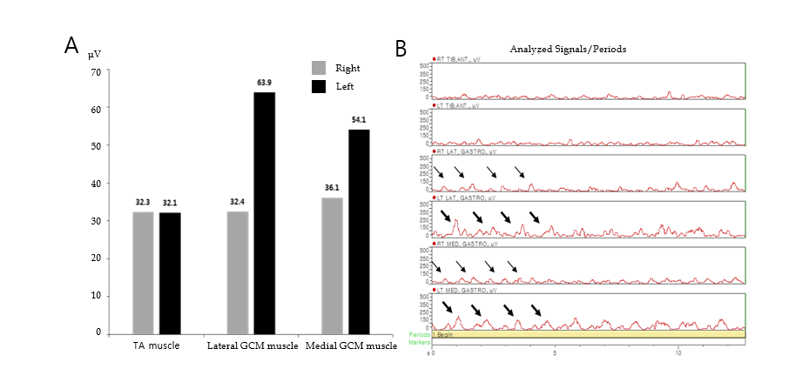
Figure 1 Mean amplitude of a wireless surface electromyography activity and graphic display of analyzed electromyography signals during walking on the spot. A: Electromyography (EMG) amplitude of left medial and lateral gastrocnemius (GCM) muscles was larger than right medial and lateral GCM muscles. EMG amplitude was similar at the both tibialis anterior muscles; B: During 13 s, there were EMG bursts of double-contraction (thick arrow) in the left medial and lateral GCM muscles, while EMG analysis of right medial and lateral GCM muscles noted regular bursts of single contraction (thin arrow). EMG analysis of both tibialis anterior muscles were shown in similar bursts.

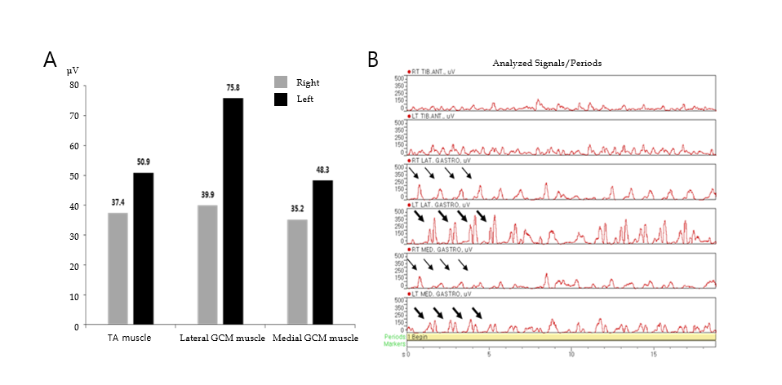
Figure 2 Mean amplitude of a wireless surface electromyography activity and graphic display of analyzed electromyography signals during forward walking. A: Electromyography (EMG) amplitude of left medial and lateral gastrocnemius (GCM) muscles was larger than right medial and lateral GCM muscles. EMG amplitude of left tibilis anterior (TA) muscle was slightly larger than the one of right TA muscle; B: When we analyzed EMG signals for each muscle during 20 s, there were EMG bursts of double-contraction (thick arrow) in the left medial and lateral GCM muscles, while EMG analysis of right medial and lateral GCM muscles noted regular bursts of single contraction (thin arrow). The bursts of left TA muscle were slightly higher and more than the ones of right TA muscle.

