Name of Journal: World Journal of Clinical Cases
Manuscript NO: 82725
Manuscript Type: REVIEW

Superior mesenteric artery syndrome: Diagnosis and management

Oka A et al. SMA syndrome

Akihiko Oka, Muyiwa Awoniyi, Nobuaki Hasegawa, Yuri Yoshida, Hiroshi Tobita, Norihisa Ishimura, Shunji Ishihara

Akihiko Oka, Nobuaki Hasegawa, Norihisa Ishimura, Shunji Ishihara, Department of Internal Medicine II, Shimane University Faculty of Medicine, Izumo 693-8501, Shimane, Japan

Muyiwa Awoniyi, Department of Gastroenterology, Hepatology and Nutrition, Digestive Disease and Surgery Institute, Hepatology Section, Cleveland Clinic, Cleveland, OH 44195, United States

Yuri Yoshida, Clinical Laboratory Division, Shimane University Hospital, Izumo 693-8501, Shimane, Japan

Hiroshi Tobita, Division of Hepatology, Shimane University Hospital, Izumo 693-8501, Shimane, Japan

Author contributions: All the authors solely contributed to this paper; Oka A, Awoniyi M, Hasegawa N, and Yoshida Y drafted the manuscript; Tobita H, Ishimura N, and Ishihara S are the supervisors of study.

Corresponding author: Akihiko Oka, MD, PhD, Assistant Professor, Department of Internal Medicine II, Shimane University Faculty of Medicine, 89-1, Izumo 693-8501, Shimane, Japan. aoka@med.shimane-u.ac.jp

Received: December 29, 2022
Revised: February 13, 2023
Accepted: April 18, 2023
Published online: May 26, 2023

Abstract
Superior mesenteric artery (SMA) syndrome (also known as Wilkie's syndrome, cast syndrome, or aorto-mesenteric compass syndrome) is an obstruction of the duodenum caused by extrinsic compression between the SMA and the aorta. The median age of patients is 23 years old (range 0-91 years old) and predominant in females over males with a ratio of 3:2. The symptoms are variable, consisting of postprandial abdominal pain, nausea and vomiting, early satiety, anorexia, and weight loss and can mimic anorexia nervosa or functional dyspepsia. Because recurrent vomiting leads to aspiration pneumonia or respiratory depression via metabolic alkalosis, early diagnosis is required. The useful diagnostic modalities are computed tomography as a standard tool and ultrasonography, which has advantages in safety and capability of real-time assessments of SMA mobility and duodenum passage. The initial treatment is usually conservative, including postural change, gastroduodenal decompression, and nutrient management (success rates: 70%-80%). If conservative therapy fails, surgical treatment (i.e., laparoscopic duodenojejunostomy) is recommended (success rates: 80%-100%).

Key Words: Superior mesenteric artery syndrome; Wilkie’s syndrome; Cast syndrome; Aorto-mesenteric compass syndrome

©The Author(s) 2023. Published by Baishideng Publishing Group Inc. All rights reserved.

Citation: Oka A, Awoniyi M, Hasegawa N, Yoshida Y, Tobita H, Ishimura N, Ishihara S. Superior mesenteric artery syndrome: Diagnosis and management. World J Clin Cases 2023; 11(15): 3369-3384
URL: https://www.wjgnet.com/2307-8960/full/v11/i15/3369.htm
DOI: https://dx.doi.org/10.12998/wjcc.v11.i15.3369

Core Tip: To summarize, superior mesenteric artery syndrome (SMAS) is a rare condition that occurs when the superior mesenteric artery compresses the third part of the duodenum. This compression can cause obstructive symptoms and weight loss. SMAS can be caused by a variety of factors, including abnormal anatomy, rapid weight loss, and previous abdominal surgery. It is most commonly seen in young, thin females, but can occur in males and people of any age or body type. Treatment may involve dietary modifications, medications, and surgery to correct the underlying cause. If left untreated, SMAS can lead to serious complications, including malnutrition and intestinal damage.
INTRODUCTION
Superior mesenteric artery (SMA) syndrome is a rare cause of duodenal obstruction by extrinsic compression between SMA and the aorta (SMA-Ao) (Figure 1), and a morbid entity when the diagnosis is delayed^{[1-3]}. Von Rokitansky^{[1]} first described this entity in his textbook with a case presentation in 1842. Later, Wilkie^{[2]} described pathological and diagnostic findings in details with 75 cases of his own in 1927, thus SMA syndrome is also known as Wilkie’s syndrome. The other names are reported as cast syndrome, aorto-mesenteric compass syndrome, or mesenteric duodenal obstruction^{[3]}. A cast, which is used to treat certain congenital deformities such as scoliosis and hip displacement, is a major cause of SMA syndrome^{[4-6]}. By the year 2022, more than 730 articles with approximately 2400 cases of SMA syndrome had been reported (author’s review in PubMed). Initial conservative therapy occasionally fails, and surgical or, more recently, endoscopic surgical duodenojejunostomy is successfully performed. This review provides clinical information of SMA syndrome in details.

EPIDEMIOLOGY AND ETIOLOGY
SMA syndrome frequently concerns young adult female^{[2,7-12]}. Our review found the median age is 23 years old (inter-quartile range: 16-39) but any age can be affected (range 0-91 years old), with increasing trends of elder patients with SMA syndrome in recent literatures (Figure 2). The affected age seems to be related to underlying patients’ conditions (i.e., congenital scoliosis at children or weight loss due to chemotherapy). Whereas the affected gender is, as reported previously, predominant in females over males with a ratio of 3:2. The incidence of SMA syndrome in the general population has been estimated at 0.013%-0.78% based on radiographic studies^{[7,13-16]}, though an accurate prevalence of the disease is unknown, depending on under- or over-diagnosis in clinical practice and each patient’s condition^{[10,17]} (Table 1)^{[12,18-34]}. A prospective case-control study conducted by Xu et al^{[27]} found the incidence of SMA syndrome is 2.67% (26/973 admissions for 9 years). Scoliosis and burn injuries are well-known etiologies of SMA syndrome and clinicians should be aware of this entity. In contrast, in functional dyspepsia patients, the incidence is much higher (10.8%) than in the general population, which is explained by clinicians under-diagnosing.

PATHOPHYSIOLOGY
Decreasing SMA-Ao angle causes compression to the third part of the duodenum (see “DIAGNOSIS” part). Decreases in the SMA-Ao angle can be either congenital or acquired (Table 2)^{[2,4-6,17-19,22,25,30,33-60]}. The major causes of SMA syndrome involve body weight loss and resulting loss of mesenteric fat tissue between SMA-Ao, which in turn, makes a narrower angle between the vessels. The reasons for weight loss include several types of dietary conditions (eating disorders and malabsorptive diseases), hypermetabolism (drugs and burns), and cachexia causing conditions (tuberculosis and malignancy). Especially in severe injuries and burns, prolonged bedrest in a supine position increases risk of compression of the duodenum. Scoliosis treatments (surgery and cast) and scoliosis itself are well-known causes of SMA syndrome. The lengthening of the spine during scoliosis surgery is thought to be the underlying pathophysiology. Intestinal surgeries including ileal pouch-anal anastomosis and colectomy are also well-described causes, reducing the SMA-Ao angle due to pulling on the mesentery. Congenitally short or hypertrophic ligament of Treitz is a major cause in children.
Although it is not pure SMA syndrome, aortic artery aneurysm (AAA) and surgery near or around the SMA and 3rd duodenum induces “pseudo-” SMA syndrome. AAA-related SMA syndrome was first reported by Dr. Osler as aortoduodenal syndrome^{[57-59]}.

SYMPTOMS
Patients with SMA syndrome suffer from vague and nonspecific symptoms, such as nausea, vomiting, epigastric pain, early satiety and post-prandial discomfort, bloating (abdominal distension), and weight loss, which can mimic anorexia nervosa and functional dyspepsia^{[8,12,61]}. The epigastric pain and discomfort are more severe in a supine position and relieved in the lateral decubitus position (positioning knees to the chest) which reduces tension on the small bowel mesentery^{[61]}. Especially in acute phase, severe duodenal obstruction leads to severe symptoms and life-threatening dilatation of the stomach^{[8,12,61]}. In contrast, in chronic phase, the recurrent nausea and vomiting leads to inadequate food intake, resulting in severe weight loss and thus, aggravation of the syndrome^{[8,12,61]}.

COMPLICATIONS AND COMORBIDITIES
Various complications of SMA syndrome have been reported (Table 3)^{[35,62-86]}. Notably, unrecognized or severe cases may progress to life-threatening complications, such as hypovolemic shock, aspiration pneumonia, and sudden death, even in young patients. Mechanisms of sudden death remain unclear, and several hypotheses, however, can be raised based on published cases including autopsies - arrhythmia by severe hypokalemia, severe compression of the inferior vena cava by dilated duodenum, or severe pulmonary depression induced by alkalosis and increased abdominal pressure. Thus, immediate corrections of blood election and volume and early reduction of intestinal pressure should be required in severe cases. The most frequent complication is gastrointestinal injury caused by retained or refluxed peptic acid and bile acid as well as elevated intraluminal pressure. The incidence of mucosal injury has been reported as 25%-59% in patients with SMA syndrome^{[62,73]}. Inadequately treated or chronic mucosal injuries may progress to emphysema, necrosis, portal venous gas, and pneumoperitoneum. Elevated intraluminal pressure at the second portion of the duodenum disturbs the flow of pancreatic juice, occasionally resulting in elevated pancreatic enzymes and acute pancreatitis. Vomiting itself can increase serum amylase (mainly from salivary glands), so pancreatic amylase isozyme and lipase should help to recognize pancreatic abnormalities. Recurrent vomiting also leads to aspiration pneumonia, dehydration, electrolyte abnormalities, and severe malnutrition. SMA syndrome sometimes co-exists with other vascular compression diseases (Table 3)^{[87-90]}. Of these, nutcracker phenomenon is the most frequent based on anatomic location to the SMA. It is a condition that occurs when the left renal vein becomes compressed between the aorta and SMA with similar symptoms as SMA syndrome.

DIAGNOSIS
Due to its non-specific symptoms, SMA syndrome might be overlooked in clinical practice^{[26,91]}. Even in radiologists, the duodenum seems to be a neglected segment in the intestine^{[92]}. SMA syndrome requires a high degree of clinical suspicion and few teaching methods have been reported^{[93,94]}. The diagnosis is based on clinical symptoms supported by radiological evidence of duodenal obstruction. Traditional criteria for SMA syndrome are based on barium X-ray studies (Figure 3): (1) Dilatation of the first and second parts of the duodenum with or without gastric dilatation; (2) abrupt vertical or oblique compression of the third part of the duodenum; (3) reverse flow of contrast proximal to the obstruction; (4) significant delay (4-6 h) in gastroduodenal transit; and (5) relief of obstruction after postural changes (the prone knee-chest or lateral decubitus position)^{[17,18,95]}. Recently, in addition to barium studies, various imaging modalities have been used to confirm SMA syndrome, such as computed tomography (CT), abdominal ultrasound (US), magnetic resonance imaging (MRI), endoscopy and endoscopic ultrasonography (EUS), etc. (Table 4). Many cases are diagnosed by these modalities, which can directly visualize the SMA compression of the duodenum without barium studies. The standard diagnostic modality is CT scan (Figure 4) which allows for both diagnosis of SMA syndrome with measurement of the SMA-Ao angle and distance as well as detection of complications, such as gastric necrosis, portal vein gas, acute pancreatitis etc. 3D-CT is more helpful in recognizing the anatomy of SMA, the aorta and duodenum^{[96]}. The normal SMA-Ao angle is between 38 to 65 degrees and has a distance of 10 to 33 mm^{[5,97]}. Unal et al^{[97]} reported the cutoff value is 22 degrees on the SMA-Ao angle and 8 mm on a distance with a 42.8% sensitivity and 100% specificity. Abdominal US is another modality that provides a convenient, quick, noninvasive tool to diagnose SMA syndrome^{[97-99]}. The sensitivity of abdominal US in diagnosis of SMA syndrome has been confirmed in a comparison study with CT findings^{[97]}. Abdominal US benefits from an improvement of image resolution and can clearly visualize the duodenum and SMA-Ao angle (Figure 5 and Video 1). Endoscopy can detect gastrointestinal complications, such as mucosal injury, bleeding, and bezoar, etc. (Figures 6A and B). It can also reveal extrinsic compression (by SMA) at the 3rd portion of duodenum (Figure 6C). Further, EUS with mini-probes can be used to confirm the compression by SMA and also measure SMA-Ao distance^{[36,100]}. Recently, linear EUS has been used for measuring the SMA-Ao angle and also endoscopic duodenojejunostomy (see TREATMENTS). Laboratory tests are not diagnostic, but they are necessary to identify the presence of electrolytic complications and pancreato-biliary abnormalities. As for differential diagnosis, almost all disorders mimicking SMA syndrome are summarized in Table 5^{[14,26,44,55-59,86,101-127]}. Patients with eating disorders, functional dyspepsia, and peptic ulcer disease present non-specific symptoms masquerading as SMA syndrome. In addition, many diseases that potentially involve or compress duodenum should be suspected of and ruled out by CT, abdominal US, or other modalities.

TREATMENTS
The therapeutic options are summarized in Table 6. The initial treatment is usually managed conservatively by decompression of dilated stomach and duodenum by postural change and/or nasal gastric tube suction^{[128,129]}. Positioning the patient in the left lateral or sitting position should be helpful^{[95,130]}. However, the best position for each patient may vary because recent studies revealed there is a variation of the SMA position and movement^{[131-133]}. In addition to gastric tube suction, intravenous metoclopramide can enhance gastrointestinal motility and help decompression^{[134,135]}. After decompression therapy, gaining weight to increase adipose tissue between SMA and aorta should be considered. Nasal gastric feeding is effective, but the jejunal tube is more ideal while endoscopic assistant should be considered^{[136]}. Total parenteral nutrition is a useful option for initial nutrient treatment and if the intestinal feedings are impossible. These nutrition managements contribute to the restoration of adipose tissue to increase the angle at the origin of the SMA^{[28]}.
Surgical therapy, however, can be recommended if conservative therapies fail especially in elder patients with multiple abdominal operation histories, immobility (bed rest), long history of SMA syndrome and arteriosclerosis of SMA. Surgical therapy might be considered earlier before a patient’s conditions worsen and complications occur^{[129]}. The best timing for transition to surgical options is not clear. Shin et al^{[137]} recommend 6 wk at least of conservative therapy based on the average response rate to this method. There is currently no randomized study conservative vs surgical therapy. A recent large cohort with 80 patients with SMA syndrome by Lee et al^{[128]} revealed the overall success and recurrence rates of conservative therapy were 71.3 and 15.8%, respectively. The need for surgical therapy was 18.7% of patients (15/80 cases), which is similar to other recent cohorts 11.5%-22.2%^{[8,138,139]}. These recent operation rates are lower than previously reported (70%) in 1974^{[140]}, likely due to advances in nutritional therapies and medications^{[128]}. Various surgical procedures include laparoscopic, laparotomic, or robotic gastrojejunostomy, gastroduodenostomy and duodenojejunostomy, Strong’s procedure (a division of the ligament of Treitz), anterior transposition of the third part of duodenum, duodenal lowering, Ladd's procedure, and transabdominal duodenojejunostomy^{[141-145]}. Since 1998, when the first successful laparoscopic duodenojejunostomy was performed, most surgeons prefer laparoscopic duodenojejunostomy because of its safety and effectiveness (success rates: 80%-100%)^{[141-143]}. Laparoscopic approach has been reported to shorten post-operative length of hospital stay^{[129,142]}. Most recently, a new technique of endoscopic gastrojejunostomy (so called lumen-apposing metal stent) has also been reported in several case reports as a safe and effective therapeutic option^{[146-148]}.

CONCLUSION
In conclusion, superior mesenteric syndrome is a serious condition that requires prompt diagnosis and treatment to prevent long-term complications. Diagnosis can be challenging and may involve imaging studies, such as CT or MR, and upper gastrointestinal endoscopy. Due to the non-specific nature of clinical obstructive presentations, recognition of risk factors such as rapid weight loss, previous abdominal surgery (typically bariatric surgery), trauma or congenital anomalies can predispose patients toward the development of SMA syndrome. These conditions are typically driven by a reduction in the mesenteric fat pad or an abnormal angle between the SMA and duodenum. Early diagnosis and treatment are essential to prevent complications and ensure a successful outcome.

ACKNOWLEDGEMENTS
We thank Masuzaki K and Adachi Y for the excellent reference contribution.

REFERENCES
1 von Rokitansky C. Handbuch der pathologischen Anatomie. 1st edition. Vienna Branmuller and Seidel, 1842; 187
2 Wilkie B. Chronic duodenal ileus. Am J Med Sci 1927; 173: 643–650 [DOI: 10.1097/00000441-192705000-00006]
3 Grauer FW. Duodenal ileus (Wilkie's syndrome) arterio-mesenteric ileus. Bull Vanc Med Assoc 1948; 24: 116-118 [PMID: 18914505]
4 Dorph MH. The cast syndrome; review of the literature and report of a case. N Engl J Med 1950; 243: 440-442 [PMID: 14775856 DOI: 10.1056/NEJM195009212431203]
5 Hearn JB. Duodenal ileus; with reference to superior mesenteric artery compression. Md State Med J 1965; 14: 65-68 [PMID: 14267372 DOI: 10.1148/86.2.305]
6 Berk RN, Coulson DB. The body cast syndrome. Radiology 1970; 94: 303-305 [PMID: 5412795 DOI: 10.1148/94.2.303]
7 Ylinen P, Kinnunen J, Höckerstedt K. Superior mesenteric artery syndrome. A follow-up study of 16 operated patients. J Clin Gastroenterol 1989; 11: 386-391 [PMID: 2760427 DOI: 10.1097/00004836-198908000-00007]
8 Biank V, Werlin S. Superior mesenteric artery syndrome in children: a 20-year experience. J Pediatr Gastroenterol Nutr 2006; 42: 522-525 [PMID: 16707974 DOI: 10.1097/01.mpg.0000221888.36501.f2]
9 Pedoto MJ, O'Dell MW, Thrun M, Hollifield D. Superior mesenteric artery syndrome in traumatic brain injury: two cases. Arch Phys Med Rehabil 1995; 76: 871-875 [PMID: 7668961 DOI: 10.1016/S0003-9993(95)80555-9]
10 Barner HB, Sherman CD Jr. Vascular compression of the duodenum. Int Abstr Surg 1963; 117: 103-118 [PMID: 14047737]
11 Gustafsson L, Falk A, Lukes PJ, Gamklou R. Diagnosis and treatment of superior mesenteric artery syndrome. Br J Surg 1984; 71: 499-501 [PMID: 6733420 DOI: 10.1002/bjs.1800710706]
12 Mandarry MT, Zhao L, Zhang C, Wei ZQ. A comprehensive review of superior mesenteric artery syndrome. Eur Surg 2010; 42: 229-236 [DOI: 10.1007/s10353-010-0561-y]
13 Yamamoto T, Okada K, Kasugai M, Kato M, Kan S. Laboratory and clinical studies on cefatrizine (author's transl). Jpn J Antibiot 1977; 30: 763-769 [PMID: 592480 DOI: 10.1001/jama.196.12.1091]
14 Anderson JR, Earnshaw PM, Fraser GM. Extrinsic compression of the third part of the duodenum. Clin Radiol 1982; 33: 75-81 [PMID: 7067340 DOI: 10.1016/S0009-9260(82)80358-9]
15 Rosa-Jiménez F, Rodríguez González FJ, Puente Gutiérrez JJ, Muñoz Sánchez R, Adarraga Cansino MD, Zambrana García JL. Duodenal compression caused by superior mesenteric artery: study of 10 patients. Rev Esp Enferm Dig 2003; 95: 485-489, 480-484 [PMID: 12952509]
16 GOIN LS, WILK SP. Intermittent arteriomesenteric occlusion of the duodenum. Radiology 1956; 67: 729-737 [PMID: 13370885 DOI: 10.1148/67.5.729]
17 Hines JR, Gore RM, Ballantyne GH. Superior mesenteric artery syndrome. Diagnostic criteria and therapeutic approaches. Am J Surg 1984; 148: 630-632 [PMID: 6496852 DOI: 10.1016/0002-9610(84)90339-8]
18 Lee CS, Mangla JC. Superior mesenteric artery compression syndrome. Am J Gastroenterol 1978; 70: 141-150 [PMID: 717365]
19 Munns SW, Morrissy RT, Golladay ES, McKenzie CN. Hyperalimentation for superior mesenteric-artery (cast) syndrome following correction of spinal deformity. J Bone Joint Surg Am 1984; 66: 1175-1177 [PMID: 6436250 DOI: 10.2106/00004623-198466080-00004]
20 Zhu Z, Qiu Y, Wang B, Yu Y. Superior mesenteric artery syndrome following scoliosis surgery: its risk indicators and treatment strategy. Stud Health Technol Inform 2006; 123: 610-614 [PMID: 17108497]
21 Gore RM, Mintzer RA, Calenoff L. Gastrointestinal complications of spinal cord injury. Spine (Phila Pa 1976) 1981; 6: 538-544 [PMID: 7336276 DOI: 10.1097/00007632-198111000-00002]
22 Ogbuokiri CG, Law EJ, MacMillan BG. Superior mesenteric artery syndrome in burned children. Am J Surg 1972; 124: 75-79 [PMID: 4625377 DOI: 10.1016/0002-9610(72)90172-9]
23 Lescher TJ, Sirinek KR, Pruitt BA Jr. Superior mesenteric artery syndrome in thermally injured patients. J Trauma 1979; 19: 567-571 [PMID: 469969 DOI: 10.1097/00005373-197908000-00004]
24 Reckler JM, Bruck HM, Munster AM, Curreri PW, Pruitt BA Jr. Superior mesenteric artery syndrome as a consequence of burn injury. J Trauma 1972; 12: 979-985 [PMID: 4629265 DOI: 10.1097/00005373-197211000-00008]
25 Watters A, Gibson D, Dee E, Mascolo M, Mehler PS. Superior mesenteric artery syndrome in severe anorexia nervosa: A case series. Clin Case Rep 2020; 8: 185-189 [PMID: 31998513 DOI: 10.1002/ccr3.2577]
26 Kawanishi K, Shojima K, Nishimoto M, Abe H, Kakimoto T, Yasuda Y, Hara T, Kato J. Superior Mesenteric Artery Syndrome May Be Overlooked in Women with Functional Dyspepsia. Intern Med 2017; 56: 2549-2554 [PMID: 28883239 DOI: 10.2169/internalmedicine.8647-16]
27 Xu L, Yu WK, Lin ZL, Jiang J, Feng XB, Li N. Predictors and outcomes of superior mesenteric artery syndrome in patients with constipation: a prospective, nested case-control study. Hepatogastroenterology 2014; 61: 1995-2000 [PMID: 25713901]
28 Welsch T, Büchler MW, Kienle P. Recalling superior mesenteric artery syndrome. Dig Surg 2007; 24: 149-156 [PMID: 17476104 DOI: 10.1159/000102097]
29 Sinagra E, Raimondo D, Albano D, Guarnotta V, Blasco M, Testai S, Marasà M, Mastrella V, Alaimo V, Bova V, Albano G, Sorrentino D, Tomasello G, Cappello F, Leone A, Rossi F, Galia M, Lagalla R, Midiri F, Morreale GC, Amvrosiadis G, Martorana G, Spampinato MG, Virgilio V, Midiri M. Superior Mesenteric Artery Syndrome: Clinical, Endoscopic, and Radiological Findings. Gastroenterol Res Pract 2018; 2018: 1937416 [PMID: 30224915 DOI: 10.1155/2018/1937416]
30 Xia L, Li N, Wang D, Liu M, Li JW, Bao DM, Li P. One-stage Posterior Spinal Osteotomy in Severe Spinal Deformities: A Total of 147 Cases. Clin Spine Surg 2017; 30: E448-E453 [PMID: 28437351 DOI: 10.1097/BSD.0000000000000227]
31 Altiok H, Lubicky JP, DeWald CJ, Herman JE. The superior mesenteric artery syndrome in patients with spinal deformity. Spine (Phila Pa 1976) 2005; 30: 2164-2170 [PMID: 16205341 DOI: 10.1097/01.brs.0000181059.83265.b2]
32 Zhu ZZ, Qiu Y. Superior mesenteric artery syndrome following scoliosis surgery: its risk indicators and treatment strategy. World J Gastroenterol 2005; 11: 3307-3310 [PMID: 15929190 DOI: 10.3748/wjg.v11.i21.3307]
33 Hod-Feins R, Copeliovitch L, Abu-Kishk I, Eshel G, Lotan G, Shalmon E, Anekstein Y, Mirovsky Y, Masharawi Y. Superior mesenteric artery syndrome after scoliosis repair surgery: a case study and reassessment of the syndrome's pathogenesis. J Pediatr Orthop B 2007; 16: 345-349 [PMID: 17762674 DOI: 10.1097/BPB.0b013e32826d1d9b]
34 Tsirikos AI, Jeans LA. Superior mesenteric artery syndrome in children and adolescents with spine deformities undergoing corrective surgery. J Spinal Disord Tech 2005; 18: 263-271 [PMID: 15905772]
35 Ko KH, Tsai SH, Yu CY, Huang GS, Liu CH, Chang WC. Unusual complication of superior mesenteric artery syndrome: spontaneous upper gastrointestinal bleeding with hypovolemic shock. J Chin Med Assoc 2009; 72: 45-47 [PMID: 19181598 DOI: 10.1016/S1726-4901(09)70020-6]
36 Lippl F, Hannig C, Weiss W, Allescher HD, Classen M, Kurjak M. Superior mesenteric artery syndrome: diagnosis and treatment from the gastroenterologist's view. J Gastroenterol 2002; 37: 640-643 [PMID: 12203080 DOI: 10.1007/s005350200101]
37 Sun Z, Rodriguez J, McMichael J, Walsh RM, Chalikonda S, Rosenthal RJ, Kroh MD, El-Hayek K. Minimally invasive duodenojejunostomy for superior mesenteric artery syndrome: a case series and review of the literature. Surg Endosc 2015; 29: 1137-1144 [PMID: 25701058 DOI: 10.1007/s00464-014-3775-4]
38 Jain V, Singal AK, Ramu C, Raghunaathan KD. Superior mesenteric artery syndrome: a rare complication in a child with Marfan syndrome. Arch Dis Child 2013; 98: 754-755 [PMID: 23814081 DOI: 10.1136/archdischild-2013-304321]
39 Ortiz C, Cleveland RH, Blickman JG, Jaramillo D, Kim SH. Familial superior mesenteric artery syndrome. Pediatr Radiol 1990; 20: 588-589 [PMID: 2251002 DOI: 10.1007/BF02129061]
40 Iwaoka Y, Yamada M, Takehira Y, Hanajima K, Nakamura T, Murohisa G, Hirai R, Kitagawa M. Superior mesenteric artery syndrome in identical twin brothers. Intern Med 2001; 40: 713-715 [PMID: 11518108 DOI: 10.2169/internalmedicine.40.713]
41 Green P, Swischuk LE, Hernandez JA. Delayed presentation of malrotation and midgut volvulus: imaging findings. Emerg Radiol 2007; 14: 379-382 [PMID: 17710454 DOI: 10.1007/s10140-007-0662-5]
42 Shin J, Shin PJ, Bartolotta RJ. SMA-like syndrome with variant mesenteric venous anatomy. Clin Imaging 2018; 48: 86-89 [PMID: 29055874 DOI: 10.1016/j.clinimag.2017.03.013]
43 Neto NI, Godoy EP, Campos JM, Abrantes T, Quinino R, Barbosa AL, Fonseca CA. Superior mesenteric artery syndrome after laparoscopic sleeve gastrectomy. Obes Surg 2007; 17: 825-827 [PMID: 17879585 DOI: 10.1007/s11695-007-9125-z]
44 Lin JA, Woods ER, Bern EM. Common and Emergent Oral and Gastrointestinal Manifestations of Eating Disorders. Gastroenterol Hepatol (N Y) 2021; 17: 157-167 [PMID: 34035776]
45 Limaye CS, Karande SP, Aher SP, Pati KA. Superior mesenteric artery syndrome secondary to tuberculosis induced cachexia. J Assoc Physicians India 2011; 59: 670-671 [PMID: 22479754]
46 Ushiki A, Koizumi T, Yamamoto H, Hanaoka M, Kubo K, Matsushita M. Superior mesenteric artery syndrome following initiation of cisplatin-containing chemotherapy: a case report. J Med Case Rep 2012; 6: 14 [PMID: 22248296 DOI: 10.1186/1752-1947-6-14]
47 Girotra M, Shah HR, Rego RF. An intriguing cause of intractable nausea and vomiting. Saudi J Gastroenterol 2013; 19: 190-191 [PMID: 23828751 DOI: 10.4103/1319-3767.114510]
48 Philip PA. Superior mesenteric artery syndrome: an unusual cause of intestinal obstruction in brain-injured children. Brain Inj 1992; 6: 351-358 [PMID: 1638268 DOI: 10.3109/02699059209034949]
49 Laffont I, Bensmail D, Rech C, Prigent G, Loubert G, Dizien O. Late superior mesenteric artery syndrome in paraplegia: case report and review. Spinal Cord 2002; 40: 88-91 [PMID: 11926421 DOI: 10.1038/sj.sc.3101255]
50 Kwon OY, Lim SG, Park SH. Mitochondrial encephalomyopathy, lactic acidosis, and stroke-like episode leading to recurrent superior mesenteric artery syndrome. Am J Emerg Med 2014; 32: 951.e1-951.e2 [PMID: 24655600 DOI: 10.1016/j.ajem.2014.01.059]
51 Neuman A, Desai B, Glass D, Diab W. Superior mesenteric artery syndrome in a patient with cerebral palsy. Case Rep Med 2014; 2014: 538289 [PMID: 25053950 DOI: 10.1155/2014/538289]
52 Padhan P, Moses V, Moses V, Danda D. Superior mesenteric artery syndrome in an adult rheumatoid arthritis patient. Int J Rheum Dis 2012; 15: e4-e5 [PMID: 22324964 DOI: 10.1111/j.1756-185X.2011.01647.x]
53 Kremers PW, Scholz FJ, Schoetz DJ Jr, Veidenheimer MC, Coller JA. Radiology of the ileoanal reservoir. AJR Am J Roentgenol 1985; 145: 559-567 [PMID: 3895866 DOI: 10.2214/ajr.145.3.559]
54 Gonzalez DO, Nwomeh BC. Complications in children with ulcerative colitis undergoing ileal pouch-anal anastomosis. Semin Pediatr Surg 2017; 26: 384-390 [PMID: 29126508 DOI: 10.1053/j.sempedsurg.2017.10.008]
55 Kitaura K, Harima K. Superior mesenteric artery syndrome with vascular calcification in a maintenance hemodialysis patient. Clin Nephrol 2009; 71: 228-230 [PMID: 19203523 DOI: 10.5414/cnp71228]
56 Okazaki Y, Higashi Y, Takigawa H. Unusual Complication of Frailty: Superior Mesenteric Artery Syndrome. Intern Med 2019; 58: 2119-2120 [PMID: 30918196 DOI: 10.2169/internalmedicine.2493-18]
57 Osler W. Aneurysm of the abdominal aorta. Lancet 1905; 166: 1089-1096 [DOI: 10.1016/S0140-6736(01)69613-2]
58 Saigusa S, Ohi M, Imaoka H, Inoue Y. Aortoduodenal syndrome in a patient receiving maintenance haemodialysis. BMJ Case Rep 2014; 2014 [PMID: 25388892 DOI: 10.1136/bcr-2014-206326]
59 Sudo G, Takagi H, Nakahara S, Goto A, Hinoda Y, Nakase H. Gastrointestinal: Abdominal aortic aneurysm caused symptoms mimicking superior mesenteric artery syndrome. J Gastroenterol Hepatol 2021; 36: 43 [PMID: 32627232 DOI: 10.1111/jgh.15149]
60 Lin CY, Lin BY, Kang PL. Duodenal obstruction after elective abdominal aortic aneurysm repair: a case report. Kaohsiung J Med Sci 2004; 20: 501-505 [PMID: 15553810 DOI: 10.1016/s1607-551x(09)70249-9]
61 Marecek GS, Barsness KA, Sarwark JF. Relief of superior mesenteric artery syndrome with correction of multiplanar spinal deformity by posterior spinal fusion. Orthopedics 2010; 33: 519 [PMID: 20608618 DOI: 10.3928/01477447-20100526-26]
62 Anderson WC, Vivit R, Kirsh IE, Greenlee HB. Arteriomesenteric duodenal compression syndrome. Its association with peptic ulcer. Am J Surg 1973; 125: 681-689 [PMID: 4710191 DOI: 10.1016/0002-9610(73)90165-7]
63 Uemura S, Suzuki K, Katayama N, Imai H. Superior mesenteric artery syndrome leading to reversible mucosal gangrene. Acute Med Surg 2017; 4: 375-376 [PMID: 29123896 DOI: 10.1002/ams2.283]
64 Doski JJ, Priebe CJ Jr, Smith T, Chumas JC. Duodenal trichobezoar caused by compression of the superior mesenteric artery. J Pediatr Surg 1995; 30: 1598-1599 [PMID: 8583333 DOI: 10.1016/0022-3468(95)90165-5]
65 Tsai CL, Chen MJ, Tan CK, Chan KS, Cheng KC. Superior mesenteric artery syndrome with hepatic portal venous gas. Med J Aust 2007; 186: 48 [PMID: 17229038 DOI: 10.5694/j.1326-5377.2007.tb00794.x]
66 Lim JE, Duke GL, Eachempati SR. Superior mesenteric artery syndrome presenting with acute massive gastric dilatation, gastric wall pneumatosis, and portal venous gas. Surgery 2003; 134: 840-843 [PMID: 14639366 DOI: 10.1016/S0039-6060(02)21677-3]
67 Kensinger CD, Mukherjee K, Nealon WH, Solorzano CC. Superior mesenteric artery syndrome presenting with pneumoperitoneum and pneumomediastinum. Am Surg 2013; 79: E240-E242 [PMID: 23711260 DOI: 10.1177/000313481307900611]
68 Lee CI, Wu YH. Pneumatosis intestinalis and pneumoretroperitoneum post steroid use in a patient with superior mesenteric artery syndrome. Am J Emerg Med 2019; 37: 1993.e1-1993.e3 [PMID: 31262624 DOI: 10.1016/j.ajem.2019.06.040]
69 Majumder S, Shergill S, Loftus CG. A Young Man With Abdominal Pain, Weight Loss, and Jaundice. Gastroenterology 2017; 152: 1836-1838 [PMID: 28478143 DOI: 10.1053/j.gastro.2016.12.044]
70 Jeune F, d'Assignies G, Sauvanet A, Gaujoux S. A rare cause of obstructive jaundice and gastric outlet obstruction. World J Gastrointest Surg 2013; 5: 192-194 [PMID: 23805363 DOI: 10.4240/wjgs.v5.i6.192]
71 Bohanon FJ, Nunez Lopez O, Graham BM, Griffin LW, Radhakrishnan RS. A Case Series of Laparoscopic Duodenojejunostomy for the Treatment of Pediatric Superior Mesenteric Artery Syndrome. Int J Surg Res 2016; 2016: 1-5 [PMID: 27747293 DOI: 10.19070/2379-156X-SI01001]
72 Banerjee A, O'Neil R, Bidstrup H. Adult respiratory distress syndrome caused by superior mesenteric artery syndrome. Anaesth Intensive Care 1994; 22: 602-604 [PMID: 7818068 DOI: 10.1177/0310057x9402200519]
73 Haas PA, Akhtar J, Kobylak L. Compression of the duodenum by the root of the mesentery. Henry Ford Hosp Med J 1982; 30: 85-89 [PMID: 7129947]
74 Abu-Zidan FM, Hefny AF, Saadeldinn YA, El-Ashaal YI. Sonographic findings of superior mesenteric artery syndrome causing massive gastric dilatation in a young healthy girl. Singapore Med J 2010; 51: e184-e186 [PMID: 21140106]
75 Mohammad Kazmin NE, Kamaruzaman L, Wong Z, Fong VK, Mohd R, Mustafar R. Acute Kidney Injury Caused by Superior Mesenteric Artery Syndrome. Case Rep Nephrol 2020; 2020: 8364176 [PMID: 32328326 DOI: 10.1155/2020/8364176]
76 Shajani-Yi Z, Lee HK, Cervinski MA. Hyponatremia, Hypokalemia, Hypochloremia, and Other Abnormalities. Clin Chem 2016; 62: 898 [PMID: 27235468 DOI: 10.1373/clinchem.2015.249292]
77 Thieme ET, Postmus R. Superior mesenteric artery syndrome. Ann Surg 1961; 154 (Suppl 6): 139-143 [PMID: 13920640 DOI: 10.1097/00000658-196112000-00017]
78 Iko BO, Monu JU, Orhue A, Sarkar SK. The superior mesenteric artery syndrome in pregnancy: a case resulting in recurrent pregnancy loss. Eur J Obstet Gynecol Reprod Biol 1986; 21: 233-236 [PMID: 3709922 DOI: 10.1016/0028-2243(86)90021-3]
79 Sato H, Tanaka T. Acute gastric dilatation due to a superior mesenteric artery syndrome: an autopsy case. BMC Gastroenterol 2014; 14: 37 [PMID: 24555911 DOI: 10.1186/1471-230X-14-37]
80 Ratjen E. Concomitant arterio-mesenteric obstruction of the duodenum and chronic oesophagitis; case report. Acta radiol 1952; 37: 369-373 [PMID: 14933218 DOI: 10.3109/00016925209139893]
81 Hamdeh S, Haddad TM, Kabach A. Image of the month: A Rare Case of Superior Mesenteric Artery Syndrome Causing Upper Gastrointestinal Bleeding. Am J Gastroenterol 2015; 110: 1653 [PMID: 26673491 DOI: 10.1038/ajg.2015.141]
82 Murakami C, Irie W, Sasaki C, Nakamaru N, Sakamoto M, Nagato J, Satoh F. Extensive gastric necrosis secondary to acute gastric dilatation: A case report. Leg Med (Tokyo) 2019; 36: 85-88 [PMID: 30448603 DOI: 10.1016/j.legalmed.2018.11.007]
83 Moyer K, Thompson GH, Poe-Kochert C, Splawski J. Superior Mesenteric Artery Syndrome Complicated by Gastric Mucosal Necrosis Following Congenital Scoliosis Surgery: A Case Report. JBJS Case Connect 2019; 9: e0380 [PMID: 31584907 DOI: 10.2106/JBJS.CC.18.00380]
84 Rod J, Sarnacki S, Petit T, Ravasse P. Portal venous gas and thrombosis complicating superior mesenteric artery syndrome (Wilkie's syndrome) in a child. J Pediatr Surg 2010; 45: 826-829 [PMID: 20385295 DOI: 10.1016/j.jpedsurg.2010.01.007]
85 Petrosyan M, Estrada JJ, Giuliani S, Williams M, Rosen H, Mason RJ. Gastric perforation and pancreatitis manifesting after an inadvertent nissen fundoplication in a patient with superior mesenteric artery syndrome. Case Rep Med 2009; 2009: 426162 [PMID: 19730743 DOI: 10.1155/2009/426162]
86 Amadi C, Anderson S. Refractory coeliac disease: or is it? BMJ Case Rep 2017; 2017 [PMID: 28928249 DOI: 10.1136/bcr-2017-219271]
87 Oh MJ. Superior Mesenteric Artery Syndrome Combined with Renal Nutcracker Syndrome in a Young Male: A Case Report. Korean J Gastroenterol 2017; 70: 253-260 [PMID: 29161795 DOI: 10.4166/kjg.2017.70.5.253]
88 Diab S, Hayek F. Combined Superior Mesenteric Artery Syndrome and Nutcracker Syndrome in a Young Patient: A Case Report and Review of the Literature. Am J Case Rep 2020; 21: e922619 [PMID: 32772039 DOI: 10.12659/AJCR.922619]
89 Farina R, Gozzo C, Foti PV, Conti A, Vasile T, Pennisi I, Venturini M, Basile A. A man with the rare simultaneous combination of three abdominal vascular compression syndromes: median arcuate ligament syndrome, superior mesenteric artery syndrome, and nutcracker syndrome. Radiol Case Rep 2021; 16: 1264-1270 [PMID: 33854661 DOI: 10.1016/j.radcr.2021.02.065]
90 Tseng CK, Su WB, Lai HC, Chou JW, Feng CL, Peng CY, Chen YF. Superior mesenteric artery syndrome caused by celiac axis compression syndrome: a case report and review of the literature. Eur J Gastroenterol Hepatol 2008; 20: 578-582 [PMID: 18467920 DOI: 10.1097/MEG.0b013e3282f172fa]
91 Elbadaway MH. Chronic superior mesenteric artery syndrome in anorexia nervosa. Br J Psychiatry 1992; 160: 552-554 [PMID: 1571759 DOI: 10.1192/bjp.160.4.552]
92 Reghunath A, Kabilan K, Mittal MK. Exploring the neglected segment of the intestine: the duodenum and its pathologies. Pol J Radiol 2020; 85: e230-e244 [PMID: 32612721 DOI: 10.5114/pjr.2020.95477]
93 Han F, Cheng H, Hou M, Liu R. Application of the "Hand as Foot" teaching method in superior mesenteric artery syndrome. Asian J Surg 2021; 44: 1562-1563 [PMID: 34635413 DOI: 10.1016/j.asjsur.2021.08.070]
94 Yongqing N, Chen D, Rui L, Linlin L. The "Hand as Foot" teaching method in superior mesenteric artery syndrome. Asian J Surg 2022; 45: 618-619 [PMID: 34895954 DOI: 10.1016/j.asjsur.2021.10.008]
95 Neri S, Signorelli SS, Mondati E, Pulvirenti D, Campanile E, Di Pino L, Scuderi M, Giustolisi N, Di Prima P, Mauceri B, Abate G, Cilio D, Misseri M, Scuderi R. Ultrasound imaging in diagnosis of superior mesenteric artery syndrome. J Intern Med 2005; 257: 346-351 [PMID: 15788004 DOI: 10.1111/j.1365-2796.2005.01456.x]
96 Raman SP, Neyman EG, Horton KM, Eckhauser FE, Fishman EK. Superior mesenteric artery syndrome: spectrum of CT findings with multiplanar reconstructions and 3-D imaging. Abdom Imaging 2012; 37: 1079-1088 [PMID: 22327421 DOI: 10.1007/s00261-012-9852-z]
97 Unal B, Aktaş A, Kemal G, Bilgili Y, Güliter S, Daphan C, Aydinuraz K. Superior mesenteric artery syndrome: CT and ultrasonography findings. Diagn Interv Radiol 2005; 11: 90-95 [PMID: 15957095]
98 Le D, Stirparo JJ, Magdaleno TF, Paulson CL, Roth KR. Point-of-care ultrasound findings in the diagnosis and management of Superior Mesenteric Artery (SMA) syndrome. Am J Emerg Med 2022; 55: 233.e1-233.e4 [PMID: 35241297 DOI: 10.1016/j.ajem.2022.02.018]
99 Chin LW, Chou MC, Wang HP. Ultrasonography diagnosis of superior mesenteric artery syndrome in the ED. Am J Emerg Med 2007; 25: 864.e5-864.e6 [PMID: 17870516 DOI: 10.1016/j.ajem.2005.09.012]
100 Gottlieb K. Doppler-endosonography with the GF-UE 160 electronic radial echoendoscope - current use and future potential. J Gastrointestin Liver Dis 2007; 16: 455-461 [PMID: 18193133]
101 Su MC, Lee CH, Wang CC. Education and Imaging. Gastrointestinal: Superior mesenteric artery syndrome initially presenting like reflux esophagitis. J Gastroenterol Hepatol 2010; 25: 645 [PMID: 20370735 DOI: 10.1111/j.1440-1746.2010.06259.x]
102 Dimopoulou A, Zavras N, Alexopoulou E, Fessatou S, Dimopoulou D, Attilakos A. Superior mesenteric artery syndrome mimicking cyclic vomiting syndrome in a healthy 12-year-old boy. J Paediatr Child Health 2020; 56: 168-170 [PMID: 31408239 DOI: 10.1111/jpc.14592]
103 Arbell D, Gross E, Koplewitz BZ, Vromen A, Bar-Ziv J, Udassin R. Superior mesenteric artery syndrome masquerading as recurrent biliary pancreatitis. Isr Med Assoc J 2006; 8: 441-442 [PMID: 16833180]
104 Shah D, Naware S, Thind S, Kuber R. Superior mesenteric artery syndrome: an uncommon cause of abdominal pain mimicking gastric outlet obstruction. Ann Med Health Sci Res 2013; 3: S24-S26 [PMID: 24349841 DOI: 10.4103/2141-9248.121214]
105 Sisodiya R, Ramachandra L. Tubercular duodenal, jejunal and ileocecal stricture in a patient. BMJ Case Rep 2013; 2013 [PMID: 24334467 DOI: 10.1136/bcr-2013-200347]
106 Upadhyaya VD, Kumar B, Lal R, Sharma MS, Singh M, Rudramani. Primary duodenal tuberculosis presenting as gastric-outlet obstruction: Its diagnosis. Afr J Paediatr Surg 2013; 10: 83-86 [PMID: 23860052 DOI: 10.4103/0189-6725.115028]
107 Fromm S, Cash JM. Superior mesenteric artery syndrome: an approach to the diagnosis and management of upper gastrointestinal obstruction of unclear etiology. S D J Med 1990; 43: 5-10 [PMID: 2263953]
108 Harada T, Machida H, Ito S, Aihara Y, Yokota S. Henoch-Schonlein purpura presenting duodenal involvement similar to superior mesenteric artery syndrome in a girl. Eur J Pediatr 2007; 166: 489-490 [PMID: 17009000 DOI: 10.1007/s00431-006-0254-5]
109 Harada T, Ito S, Mori M, Yokota S. Anatomical condition mimicking superior mesenteric artery syndrome might cause duodenal involvement in Henoch-Schönlein purpura. Pediatr Int 2012; 54: 579 [PMID: 22830554 DOI: 10.1111/j.1442-200X.2012.03659.x]
110 Fujii Y, Kino M, Kimata T, Kaneko K. Abdominal pain in Henoch-Schönlein purpura and its association with superior mesenteric artery syndrome. Pediatr Int 2012; 54: 313 [PMID: 22507166 DOI: 10.1111/j.1442-200X.2012.03582.x]
111 Lourenço LC, Martins A, Oliveira AM, Horta DV, Reis J. Wilkie Syndrome behind Crohn Disease? Superior Mesenteric Artery Syndrome Mimicking and Complicating Crohn Disease of the Upper Gastrointestinal Tract. GE Port J Gastroenterol 2017; 24: 50-52 [PMID: 28848781 DOI: 10.1159/000450873]
112 Cicero G, D'Angelo T, Bottari A, Costantino G, Visalli C, Racchiusa S, Marino MA, Cavallaro M, Frosina L, Blandino A, Mazziotti S. Superior Mesenteric Artery Syndrome in Patients with Crohn's Disease: A Description of 2 Cases Studied with a Novel Magnetic Resonance Enterography (MRE) Procedure. Am J Case Rep 2018; 19: 431-437 [PMID: 29643328 DOI: 10.12659/ajcr.908273]
113 Verma R, Abraham DT, Joseph P, Nayak S, Agarwal S. Ectopic pancreas mimicking superior mesenteric artery syndrome. Indian J Gastroenterol 2003; 22: 105-106 [PMID: 12839387]
114 Lambert CJ, Fitts FO Jr, Turk R. Duodenal diverticula. An unusual cause of "secondary superior mesenteric artery syndrome". Am J Surg 1961; 101: 808-811 [PMID: 13758444 DOI: 10.1016/0002-9610(61)90732-2]
115 Goto S, Ookawara S, Sugai M. Superior mesenteric artery syndrome due to duodenal edema in a chronic renal failure patient: a case report. CEN Case Rep 2014; 3: 14-17 [PMID: 28509237 DOI: 10.1007/s13730-013-0076-z]
116 Gopal M, Fisher R. A case report of B-cell lymphoma masquerading as superior mesenteric artery syndrome. J Pediatr Surg 2007; 42: 1926-1927 [PMID: 18022448 DOI: 10.1016/j.jpedsurg.2007.07.026]
117 Basu S, Srivastava V, Singh PK, Srivastava A, Shukla VK. Duodenojejunal junction web masquerading as Wilkie's syndrome: report of a case. Surg Today 2011; 41: 409-411 [PMID: 21365426 DOI: 10.1007/s00595-010-4258-4]
118 Chung SC, Leung JW, Li AK. Phytobezoar masquerading as the superior mesenteric artery syndrome: successful endoscopic treatment using a colonoscope. J R Coll Surg Edinb 1991; 36: 405-406 [PMID: 1774711]
119 Cho YP, Ahn JH, Jang HJ, Kim YH, Lee SG. Superior mesenteric artery syndrome after successful coil embolization of a ruptured pancreaticoduodenal artery aneurysm: report of a case. Surg Today 2004; 34: 276-278 [PMID: 14999545 DOI: 10.1007/s00595-003-2681-5]
120 Shen A, Tabello D, Merchant N, Portereiko JV, Croteau A, Gates JD. Functional Superior Mesenteric Artery Syndrome Induced by an Optional IVC Filter. Case Rep Surg 2019; 2019: 6543934 [PMID: 31485366 DOI: 10.1155/2019/6543934]
121 Blouhos K, Boulas KA, Paraskeva A, Triantafyllidis A, Kariotis I, Hatzigeorgiadis A. A misdiagnosed cause of early postoperative bowel obstruction. Clin Case Rep 2019; 7: 832-833 [PMID: 30997096 DOI: 10.1002/ccr3.2052]
122 Hussain Ashraf T, Chandra A, Jauhari RK, Kumar Singh S, Noushif M. Rosai-Dorfman disease with exclusive intra-abdominal lymphadenopathy masquerading as Wilkie's syndrome. Arab J Gastroenterol 2014; 15: 40-41 [PMID: 24630515 DOI: 10.1016/j.ajg.2013.10.005]
123 Siddiqui MN, Ahmad T, Jaffary A. Retroperitoneal fungal abscess presenting as superior mesenteric artery syndrome. Postgrad Med J 1996; 72: 433-434 [PMID: 8935607 DOI: 10.1136/pgmj.72.849.433]
124 Reed JK, McGiin RF, Gorman JF, Thomford NR. Traumatic mesenteric arteriovenous fistula presenting as the superior mesenteric artery syndrome. Arch Surg 1986; 121: 1209 [PMID: 3767653 DOI: 10.1001/archsurg.1986.01400100121023]
125 Moreno MA, Smith MS. Anorexia in a 14-year-old girl: why won't she eat? J Adolesc Health 2006; 39: 936-938 [PMID: 17116532 DOI: 10.1016/j.jadohealth.2006.05.017]
126 Jinnouchi T, Sakurai Y, Miyoshi K, Koizumi C, Waki H, Kubota N, Yamauchi T. Chronic Intestinal Pseudo-obstruction with Mitochondrial Diseases. Intern Med 2022; 61: 469-474 [PMID: 34393166 DOI: 10.2169/internalmedicine.7714-21]
127 Guthrie RH Jr. Wilkie's syndrome. Ann Surg 1971; 173: 290-293 [PMID: 5100100 DOI: 10.1097/00000658-197102000-00017]
128 Lee TH, Lee JS, Jo Y, Park KS, Cheon JH, Kim YS, Jang JY, Kang YW. Superior mesenteric artery syndrome: where do we stand today? J Gastrointest Surg 2012; 16: 2203-2211 [PMID: 23076975 DOI: 10.1007/s11605-012-2049-5]
129 Merrett ND, Wilson RB, Cosman P, Biankin AV. Superior mesenteric artery syndrome: diagnosis and treatment strategies. J Gastrointest Surg 2009; 13: 287-292 [PMID: 18810558 DOI: 10.1007/s11605-008-0695-4]
130 Evarts CM, Winter RB, Hall JE. Vascular compression of the duodenum associated with the treatment of scoliosis. Review of the literature and report of eighteen cases. J Bone Joint Surg Am 1971; 53: 431-44 passim [PMID: 5580004 DOI: 10.2106/00004623-197153030-00002]
131 Dounas GD, Cundy TP, Smith ML, Gent R, Antoniou G, Sutherland LM, Cundy PJ. The coronal aorto-mesenteric orientation theory for post-operative nausea and vomiting following scoliosis surgery in children: a pilot study. ANZ J Surg 2021; 91: 174-178 [PMID: 33244810 DOI: 10.1111/ans.16438]
132 Khan H, Al-Jabbari E, Shroff N, Barghash M, Shestopalov A, Bhargava P. Coexistence of superior mesenteric artery syndrome and nutcracker phenomenon. Radiol Case Rep 2022; 17: 1927-1930 [PMID: 35401899 DOI: 10.1016/j.radcr.2022.03.063]
133 Miyata J, Eshak ES, Yoshioka T, Iso H. Movement of the superior mesenteric artery in patients with superior mesenteric artery syndrome: A case-reference study. Clin Anat 2022; 35: 891-898 [PMID: 35417615 DOI: 10.1002/ca.23885]
134 Applegate GR, Cohen AJ. Dynamic CT in superior mesenteric artery syndrome. J Comput Assist Tomogr 1988; 12: 976-980 [PMID: 3183134 DOI: 10.1097/00004728-198811000-00013]
135 Ahmed AR, Taylor I. Superior mesenteric artery syndrome. Postgrad Med J 1997; 73: 776-778 [PMID: 9497945 DOI: 10.1136/pgmj.73.866.776]
136 Kim J, Yang S, Im YC, Park I. Superior mesenteric artery syndrome treated successfully by endoscopy-assisted jejunal feeding tube placement. BMJ Case Rep 2021; 14 [PMID: 34785514 DOI: 10.1136/bcr-2021-245104]
137 Shin MS, Kim JY. Optimal duration of medical treatment in superior mesenteric artery syndrome in children. J Korean Med Sci 2013; 28: 1220-1225 [PMID: 23960451 DOI: 10.3346/jkms.2013.28.8.1220]
138 Wan S, Zhang L, Yang J, Gao X, Wang X. Superior Mesenteric Artery Syndrome Improved by Enteral Nutritional Therapy: A Retrospective Case-Series Study in a Single Institution. Ann Nutr Metab 2020; 76: 37-43 [PMID: 32172254 DOI: 10.1159/000506620]
139 Shiu JR, Chao HC, Luo CC, Lai MW, Kong MS, Chen SY, Chen CC, Wang CJ. Clinical and nutritional outcomes in children with idiopathic superior mesenteric artery syndrome. J Pediatr Gastroenterol Nutr 2010; 51: 177-182 [PMID: 20601910 DOI: 10.1097/MPG.0b013e3181c7bdda]
140 Burrington JD. Vascular compression of the duodenum. Surgery 1976; 80: 655 [PMID: 982286]
141 Pottorf BJ, Husain FA, Hollis HW Jr, Lin E. Laparoscopic management of duodenal obstruction resulting from superior mesenteric artery syndrome. JAMA Surg 2014; 149: 1319-1322 [PMID: 25353279 DOI: 10.1001/jamasurg.2014.1409]
142 Fredericks C, Alex G, Kumar V, Luu M. Laparoscopic Duodenojejunostomy for Superior Mesenteric Artery Syndrome. Am Surg 2016; 82: e176-e177 [PMID: 27457852 DOI: 10.1177/000313481608200719]
143 Jain N, Chopde A, Soni B, Sharma B, Saini S, Mishra S, Mishra S, Gupta R, Bhojwani R. SMA syndrome: management perspective with laparoscopic duodenojejunostomy and long-term results. Surg Endosc 2021; 35: 2029-2038 [PMID: 32342220 DOI: 10.1007/s00464-020-07598-1]
144 Bing L, Shun-Lin X, Ji-Hua O, Wei-Bing C, Ye-Bo W. Laparascopic Ladd's procedure as treatment alternative, when parenteral or prolonged hospital nutrition is not an option for superior mesenteric artery syndrome. J Pediatr Surg 2020; 55: 554-557 [PMID: 30376960 DOI: 10.1016/j.jpedsurg.2017.07.004]
145 STRONG EK. Mechanics of arteriomesentric duodenal obstruction and direct surgical attack upon etiology. Ann Surg 1958; 148: 725-730 [PMID: 13595530 DOI: 10.1097/00000658-195811000-00001]
146 Kouanda A, Watson R, Binmoeller KF, Nett A, Hamerski C. EUS-guided gastroenterostomy for duodenal obstruction secondary to superior mesenteric artery syndrome. VideoGIE 2021; 6: 14-15 [PMID: 33490746 DOI: 10.1016/j.vgie.2020.09.008]
147 Bronswijk M, Fransen L, Vanella G, Hiele M, van der Merwe S. Successful treatment of superior mesenteric artery syndrome by endoscopic ultrasound-guided gastrojejunostomy. Endoscopy 2021; 53: 204-205 [PMID: 32559775 DOI: 10.1055/a-1190-3228]
148 Kawabata H, Sone D, Yamaguchi K, Inoue N, Okazaki Y, Ueda Y, Hitomi M, Miyata M, Motoi S. Endoscopic Gastrojejunostomy for Superior Mesenteric Artery Syndrome Using Magnetic Compression Anastomosis. Gastroenterology Res 2019; 12: 320-323 [PMID: 31803313 DOI: 10.14740/gr1229]

Footnotes
Conflict-of-interest statement: All authors have no conflict-of-interest.

Open-Access: This article is an open-access article that was selected by an in-house editor and fully peer-reviewed by external reviewers. It is distributed in accordance with the Creative Commons Attribution NonCommercial (CC BY-NC 4.0) license, which permits others to distribute, remix, adapt, build upon this work non-commercially, and license their derivative works on different terms, provided the original work is properly cited and the use is non-commercial. See: https://creativecommons.org/Licenses/by-nc/4.0/

Provenance and peer review: Invited article; Externally peer reviewed.
Peer-review model: Single blind

Peer-review started: December 29, 2022
First decision: February 2, 2023
Article in press: April 18, 2023

Specialty type: Gastroenterology and hepatology
Country/Territory of origin: Japan
Peer-review report’s scientific quality classification
Grade A (Excellent): A, A
Grade B (Very good): 0
Grade C (Good): C, C
Grade D (Fair): 0
Grade E (Poor): 0

P-Reviewer: Kharlamov AN, Netherlands; Osatakul S, Thailand; So Taa Kum A, Brazil S-Editor: Yan JP L-Editor: A P-Editor: Chen YX
Figure Legends
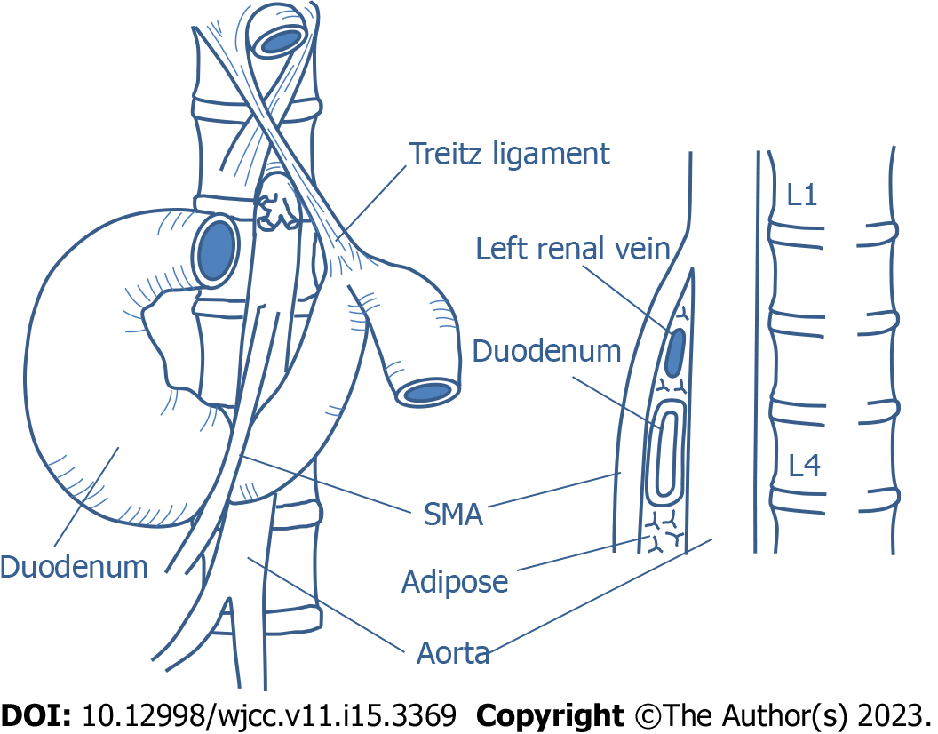
Figure 1 Anatomy related to superior mesenteric artery syndrome. SMA: Superior mesenteric artery.
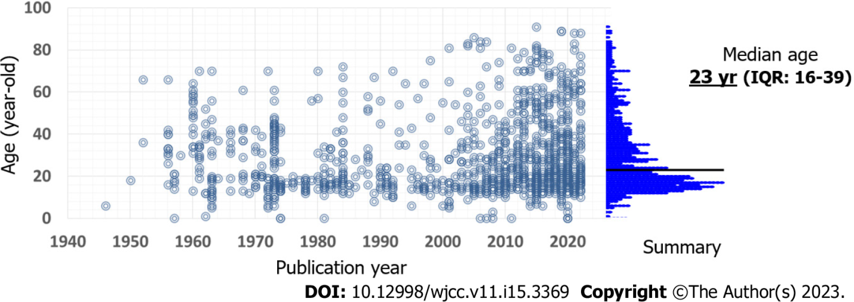
Figure 2 Published patient age. Dot indicates an individual case. The data is based on our review. IQR: Interquartile range.

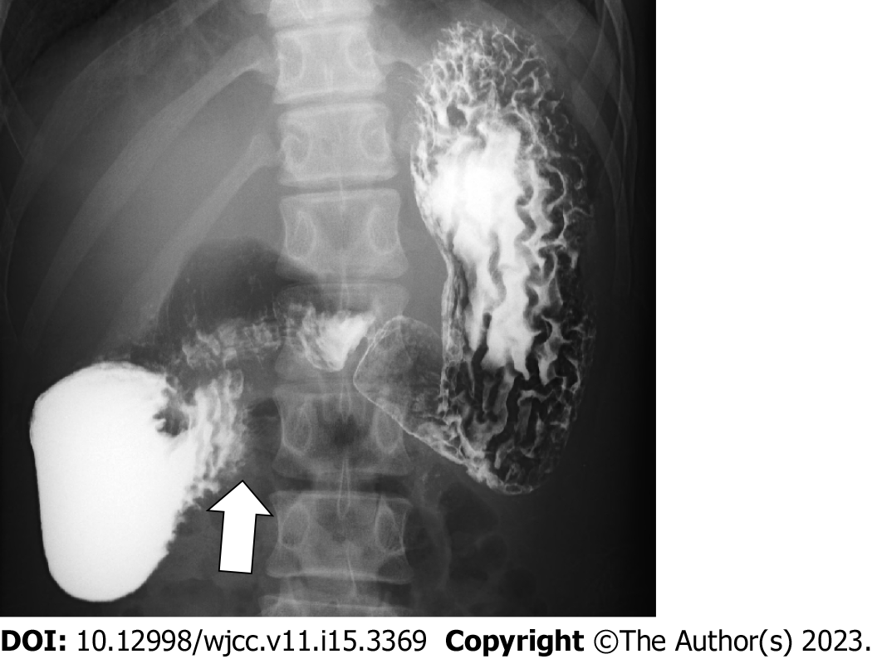
Figure 3 Upper gastrointestinal series (barium X-ray) of a 16-year-old male with superior mesenteric artery syndrome. Arrow indicates obstructive compression of the third portion of the duodenum.
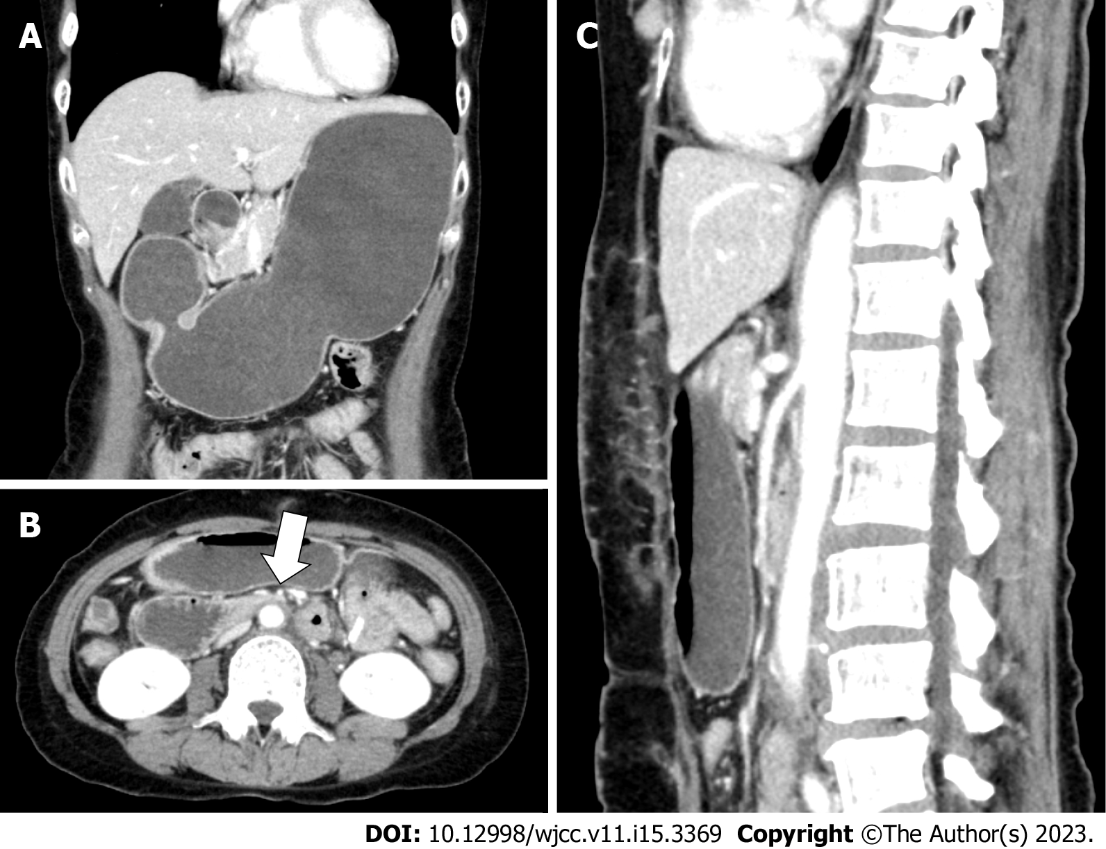
Figure 4 Enhanced computed tomography images of a 56-year-old female with superior mesenteric artery syndrome. A: Coronal view; B: Axial view; C: Sagittal view. Computed tomography images show a markedly distended stomach and proximal duodenum by extrinsic compression between the superior mesenteric artery (arrow in panel B) and aorta.

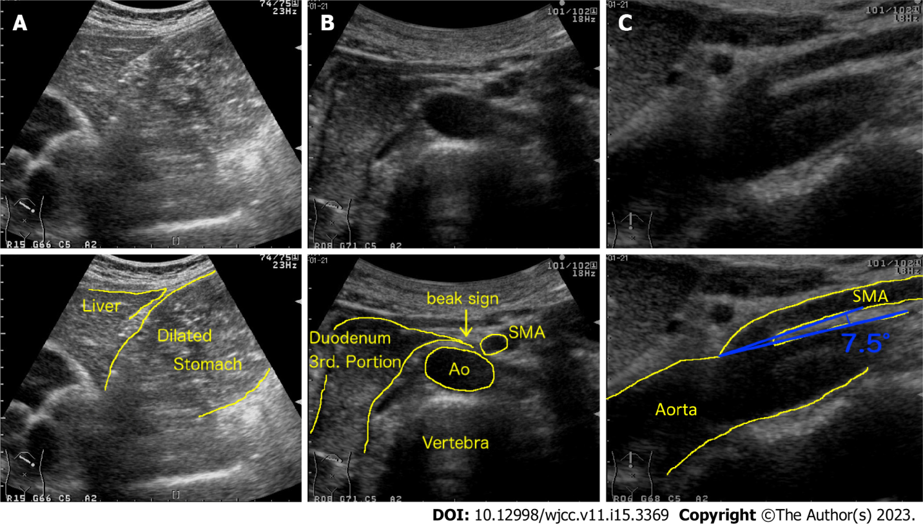
Figure 5 Abdominal ultrasonographic images of a 53-year-old female with superior mesenteric artery syndrome. A and B: Upper abdominal ultrasonography shows a markedly dilated stomach (A) and obstruction of duodenum (B, which looks like beak, beak sign) by extrinsic compression between the superior mesenteric artery (SMA) and aorta (Ao); C: The SMA-Ao angle (7.5 degree) and distance (5 mm) are decreased. SMA: Superior mesenteric artery; Ao: Aorta.
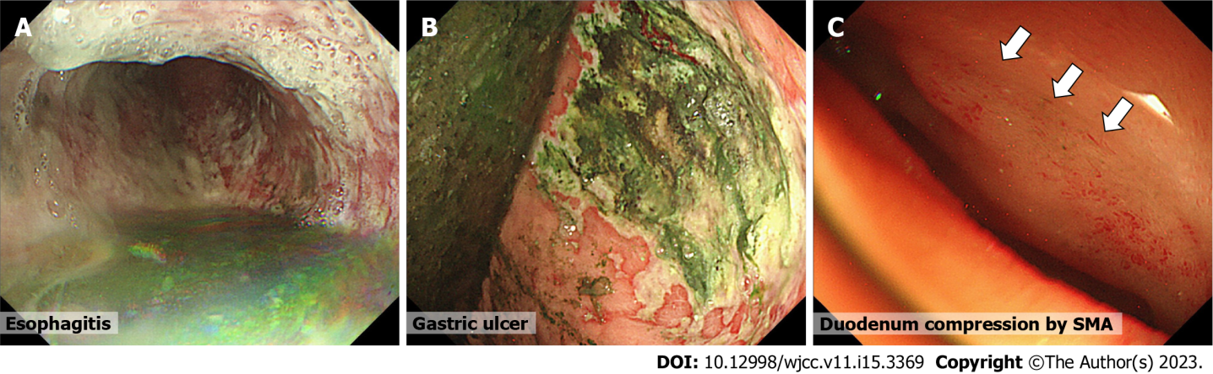
Figure 6 Endoscopic findings of patients with superior mesenteric artery syndrome. A and B: Esophagitis (A) and gastric ulcer (B) with retained luminal contents; C: compression area in the third portion of the duodenum.

Table 1 Incidence of superior mesenteric artery syndrome in several populations
Population | Incidence (%) | Ref.
Acute general hospitals | 0.001-0.0052 | [18]
Chronic-care hospital | 0.097 | [18]
Hospital admissions | 0.05-2.67 | [12,27,28]
Upper gastrointestinal endoscopy | 0.48 | [29]
Post-scoliosis surgery + cast | 0.5-3.4 | [19,30-34]
Spinal cord injury | 0.53 | [21]
Burn injury | 1.0-1.12 | [22-24]
Anorexia nervosa (admitted) | 2.73 | [25]
Functional dyspepsia | 10.8 | [26]

Table 2 Etiology of superior mesenteric artery syndrome
Etiology |  | Ref.
Congenital
 | Short or high insertion of Treitz ligament | [60]
 | Low origin of the SMA | [35]
 | Spinal deformity (Scoliosis, Marfan, etc.) | [36,37]
 | Familial | [38,39]
 | Malrotation of SMA and SMV | [40,41]
 | Malrotation of intestine | [2]
Body weight loss
 | Diet and obesity surgery (sleeve surgery) | [5,42]
 | Eating disorders (anorexia nervosa, anorexia bulimia) | [25,36]
 | Malabsorption | [17]
 | Malignancy | [17,18,35]
 | Tuberculosis | [44]
 | Chemotherapy | [45,46]
 | Trauma (Burn injury, brain injury, spinal cord injuries, etc.) | [22,47,48]
 | Neural disorders (ALS, MELAS, paraplegia, cerebral palsy, etc.) | [49,50]
 | Drug or alcohol abuse | [36]
 | Rheumatoid arthritis | [51]
Scoliosis surgery |  | [19,30-34]
Intestinal surgery (IPAA, colectomy, etc.) |  | [36,52,53]
Aging (bed rest, frail, vascular calcification, etc.) |  | [54,55]
Body cast |  | [4-6]
"Pseudo-" SMA syndrome
 | Aortic artery aneurysm (Aortoduodenal syndrome) | [56-58]
 | Surgery near or around the SMA and 3rd duodenum | [59]
SMA: Superior mesenteric artery; SMV: Superior mesenteric vein; ALS: Amyotrophic lateral sclerosis; MELAS: Mitochondrial myopathy, encephalopathy, lactic acidosis, and stroke-like episodes; IPAA: Ileal pouch-anal anastomosis.

Table 3 Complications and comorbidities of superior mesenteric artery syndrome
Complications |  |  | Ref.
 | Gastrointestinal complications 25%-59% in SMA syndrome |  | [62,73]
 |  | Esophageal inflammation, bleeding, and ulcer | [60,80,81]
 |  | Gastric inflammation, ulcer, emphysema, ischemia, necrosis, perforation, and bezoar | [82-85]
 |  | Duodenal inflammation, ulcer, mucosal necrosis, emphysema, and bezoar | [63,64,86]
 |  | Portal venous gas and thrombosis | [65,66,84]
 |  | Pneumoperitoneum and pneumomediastinum | [67,68]
 | Pancreato-biliary complications
 |  | Elevated serum pancreatic and/or biliary enzymes | [69]
 |  | Acute and chronic pancreatitis | [85]
 |  | Jaundice | [70]
 | Pulmonary complications
 |  | Aspiration pneumonia | [71]
 |  | Adult respiratory distress syndrome | [72]
 | Dehydration
 |  | Low blood pressure | [75]
 |  | Acute kidney injury | [75]
 |  | Shock | [75]
 | Electrolytes and gas abnormalities
 |  | Hypokalemia | [76]
 |  | Hyponatremia | [76]
 |  | Metabolic alkalosis | [76]
 | Severe malnutrition |  | [77]
 | Recurrent pregnancy loss |  | [78]
 | Sudden death |  | [82]
Comorbidities related to SMA syndrome
 | Nutcracker phenomenon |  | [87,88]
 | Celiac axis compression syndrome (median arcuate ligament syndrome) |  | [89,90]
SMA: Superior mesenteric artery.

Table 4 Diagnostic modalities for superior mesenteric artery syndrome
Modalities
Plain film X-ray
Barium X-ray
Angiogram
CT
Plain
Enhanced (3D-CT)
Abdominal ultrasound
B-mode
Doppler-mode
MRI
MR angiography
MR enterography
Endoscopy
White light imaging
Ultrasonography (EUS)
Gastric-emptying scintigraphy
Multi-channel manometry
CT: Computed tomography; 3D: Three-dimensional; MRI: Magnetic resonance imaging; EUS: Endoscopic ultrasonography.

Table 5 Differential diagnoses of superior mesenteric artery syndrome
Disorders mimicking SMA syndrome |  |  | Ref.
Similar symptoms by...
 | Eating disorder
 |  | Anorexia nervosa, anorexia bulimia | [125]
 | CIPO |  | [126]
 | Peptic ulcer disease |  | [127]
 | Reflux esophagitis |  | [101]
 | Functional dyspepsia |  | [26]
 | Cyclic vomiting syndrome |  | [102]
 | Pancreatitis |  | [103]
 | Gastric outlet obstruction |  | [104]
Involvement of duodenum by... (other disorders)
 | Tubercular infection |  | [105,106]
 | Megaduodenum (localized CIPO) |  | [107]
 | Henoch-Schönlein purpura |  | [108-110]
 | Crohn's disease |  | [111,112]
 | Celiac disease |  | [86]
 | Ectopic pancreas |  | [113]
 | Duodenal diverticula |  | [114]
 | Duodenal edema |  | [115]
 | Tumor
 |  | Primary or metastatic duodenal cancer, pancreatic cancer, lymphoma, etc. | [14,116]
 | Anatomical abnormality (web, diaphragm) |  | [117]
 | Foreign body (bezoar, etc.) |  | [118]
Extrinsic compression by... (non-SMA)
 | Aortic artery aneurysm (Aortoduodenal syndrome) |  | [56-58]
 | Stent or filter
 |  | Mesenteric artery, aorta, IVC, etc. | [119,120]
 | Horseshoe kidney |  | [121]
 | Lymph node |  | [122]
 | Abscess |  | [123]
 | Traumatic false aneurysm |  | [124]
SMA: Superior mesenteric artery; CIPO: Chronic idiopathic intestinal pseudo-obstruction; IVC: Inferior vena cava.

Table 6 Treatments for superior mesenteric artery syndrome
Therapeutic methods
Conservative therapy
Decompression of dilated stomach and duodenum by
Postural change (left lateral, sitting position)
Nasal gastric tube suction
Medication (metoclopramide)
Gaining weight by
Giving multiple small feeds
Feeding tube (nasal gastric or jejunal)
Total parenteral nutrition
Surgical therapy
Anterior transposition of the third part of duodenum
Gastroduodenostomy
Gastrojejunostomy
Duodenojejunostomy
Strong’s procedure (a division of the ligament of Treitz)
Duodenal lowering
Ladd's procedure
Endoscopic therapy
Lumen-apposing metal stent¹ by
EUS-guided gastrojejunostomy
¹Lumen-apposing metal stent: Potential option based on case reports.
EUS: Endoscopic ultrasonography.

Published by Baishideng Publishing Group Inc
7041 Koll Center Parkway, Suite 160, Pleasanton, CA 94566, USA
Telephone: +1-925-3991568
E-mail: bpgoffice@wjgnet.com
Help Desk: https://www.f6publishing.com/helpdesk
https://www.wjgnet.com

© 2023 Baishideng Publishing Group Inc. All rights reserved.

