Name of Journal: World Journal of Stem Cells
Manuscript NO: 59216
Manuscript Type: ORIGINAL ARTICLE

Basic Study
Effects of normobaric cyclic hypoxia exposure on mesenchymal stem-cell differentiation–pilot study on bone parameters in elderly

Camacho-Cardenosa M et al. Effect of CH on MSC differentiation

Marta Camacho-Cardenosa, José Manuel Quesada-Gómez, Alba Camacho-Cardenosa, Alejo Leal, Gabriel Dorado, Bárbara Torrecillas-Baena, Antonio Casado-Díaz

Marta Camacho-Cardenosa, Alba Camacho-Cardenosa, Facultad Ciencias del Deporte, Universidad De Extremadura, Cáceres 10003, Spain

José Manuel Quesada-Gómez, Bárbara Torrecillas-Baena, Antonio Casado-Díaz, CIBER De Fragilidad Y Envejecimiento Saludable (CIBERFES), Unidad De Gestión Clínica De Endocrinología Y Nutrición, Instituto Maimónides De Investigación Biomédica De Córdoba, Hospital Universitario Reina Sofía, Córdoba 14004, Spain

Alejo Leal, Servicio de Traumatología, Hospital de Cáceres, Cáceres 10004, Spain

Gabriel Dorado, Depatrment Bioquímica y Biología Molecular, Campus Rabanales C6-1-E17, Campus de Excelencia Internacional Agroalimentario (ceiA3), Universidad de Córdoba-CIBERFES, Córdoba 14071, Spain

Author contributions: Camacho-Cardenosa M, Casado-Díaz A and Quesada-Gómez JM conceived and designed the experiments; Camacho-Cardenosa M, Torrecillas-Baena B and Casado-Díaz A performed the experiments in vitro; Camacho-Cardenosa M, Camacho-Cardenosa A and Leal A performed the studies with the elderly volunteers; Camacho-Cardenosa M, Casado-Díaz A, Dorado G and Quesada-Gómez JM wrote the paper. All authors analyzed and interpreted the data.

Supported by Government of Extremadura GAEDAF Research Group, No. GR18003; Ministerio de Educación, Cultura y Deporte, No. FPU15/00452; and Instituto de Salud Carlos III, No. PI15/01857 and No. PI18/01659.

Corresponding author: Marta Camacho-Cardenosa, PhD, Postdoc, Facultad Ciencias Del Deporte, Universidad De Extremadura, Av. Universidad, s/n, Cáceres 10003, Spain. mcamachocardenosa@unex.es

Received: September 3, 2020
Revised: September 30, 2020
Accepted: October 20, 2020
Published online:

Abstract
BACKGROUND
Mesenchymal stem cells (MSC) of bone marrow are the progenitor of osteoblasts and adipocytes. MSC tend to differentiate into adipocytes, instead of osteoblasts, with aging. This favors the loss of bone mass and development of osteoporosis. Hypoxia induces hypoxia inducible factor 1α gene encoding transcription factor, which regulates the expression of genes related to energy metabolism and angiogenesis. That allows a better adaptation to low O₂ conditions. Sustained hypoxia has negative effects on bone metabolism, favoring bone resorption. Yet, surprisingly, cyclic hypoxia (CH), short times of hypoxia followed by long times in normoxia, can modulate MSC differentiation and improve bone health in aging.

AIM
To evaluate the CH effect on MSC differentiation, and whether it improves bone mineral density in elderly.

METHODS
MSC cultures were induced to differentiate into osteoblasts or adipocytes, in CH (3% O₂ for 1, 2 or 4 h, 4 d a week). Extracellular-matrix mineralization and lipid-droplet formation were studied in MSC induced to differentiate into osteoblast or adipocytes, respectively. In addition, gene expression of marker genes, for osteogenesis or adipogenesis, have been quantified by quantitative real time polymerase chain reaction. The in vivo studies with elderly (> 75 years old; n = 10) were carried out in a hypoxia chamber, simulating an altitude of 2500 m above sea level, or in normoxia, for 18 wk (36 CH sessions of 16 min each). Percentages of fat mass and bone mineral density from whole body, trunk and right proximal femur (femoral, femoral neck and trochanter) were assessed, using dual-energy X-ray absorptiometry.

RESULTS
CH (4 h of hypoxic exposure) inhibited extracellular matrix mineralization and lipid-droplet formation in MSC induced to differentiate into osteoblasts or adipocytes, respectively. However, both parameters were not significantly affected by the other shorter hypoxia times assessed. The longest periods of hypoxia downregulated the expression of genes related to extracellular matrix formation, in MSC induced to differentiate into osteoblasts. Interestingly, osteocalcin (associated to energy metabolism) was upregulated. Vascular endothelial growth factor an expression and low-density lipoprotein receptor related protein 5/6/dickkopf Wnt signaling pathway inhibitor 1 (associated to Wnt/β-catenin pathway activation) increased in osteoblasts. Yet, they decreased in adipocytes after CH treatments, mainly with the longest hypoxia times. However, the same CH treatments increased the osteoprotegerin/receptor activator for nuclear factor kappa B ligand ratio in both cell types. An increase in total bone mineral density was observed in elderly people exposed to CH, but not in specific regions. The percentage of fat did not vary between groups.

CONCLUSION
CH may have positive effects on bone health in the elderly, due to its possible inhibitory effect on bone resorption, by increasing the osteoprotegerin / receptor activator for nuclear factor kappa B ligand ratio.

Key Words: Normobaric cyclic hypoxia; Mesenchymal stem cells; Cellular differentiation; Osteoblasts; Adipocytes; Bone health

Camacho-Cardenosa M, Quesada-Gómez JM, Camacho-Cardenosa A, Leal A, Dorado G, Torrecillas-Baena B, Casado-Díaz A. Effects of normobaric cyclic hypoxia exposure on mesenchymal stem-cell differentiation–pilot study on bone parameters in elderly. World J Stem Cells 2020; In press

Core Tip: Cyclic hypoxia (CH) can improve bone health in aging. Mesenchymal stem cells were induced to differentiate into osteoblasts or adipocytes, in hypoxia (3% O₂) for 1, 2 or 4 h, 4 d a week. Older people were treated with 36 CH sessions of 16 min (simulating an altitude of 2500 m), for 18 wk. Exposure to longer periods of hypoxia inhibited mesenchymal stem cells differentiation, but increased osteoprotegerin/receptor activator for nuclear factor kappa B ligand expression in both cell types. CH increased total bone mineral density, but not fat content, in elderly. CH may improve bone health in elderly, due to its inhibitory effect on bone resorption, by increasing the osteoprotegerin/receptor activator for nuclear factor kappa B ligand ratio.

INTRODUCTION
The rates of diseases and conditions affecting older individuals have noticeably increased since the Age of Enlightenment, due to an extension in human longevity^{[1]}. Old age is associated, among other factors, with a decline in bone mass and strength. It can culminate with osteoporosis, which provokes significant morbidity and mortality, increasing healthcare costs worldwide^{[2]}. In this sense, accumulating evidence indicates a complex relationship between adiposity and osteoporosis^{[3]}. Osteoblasts and adipocytes originate from the common-precursor mesenchymal stem cells (MSC). The balance between differentiation of osteoblasts and adipocytes is regulated by both intra- and extra-cellular factors^{[1]}. Aging alone alters the fate of MSC in bone marrow, by promoting adipogenesis and reducing osteoblastogenesis^{[4]}, increasing age-related bone loss^{[5]}.
Also, proinflammatory cytokines associated with obesity and aging regulate receptor activator for nuclear factor kappa B ligand/receptor activator for nuclear factor kappa B/osteoprotegerin (RANKL/RANK/OPG) pathways, stimulating osteoclast activity and bone loss^{[6]}. Osteoclastogenesis is induced in osteoclast precursor cells when RANKL, produced by osteocytes and osteoblasts, binds to its RANK receptor. However, osteoblasts also express OPG, which encodes a RANK decoy, and thus inhibits RANKL binding and activation of osteoclastogenesis. Therefore, the relationship between the expression of OPG and RANKL genes regulates bone resorption^{[7]}. Interestingly, oxygen variations have also been established as another factor that could influence tissue remodeling^{[8]}. Bone marrow is maintained in a hypoxic state in the body^{[9]}. Besides, various genes regulated by the hypoxia inducible factor 1α (HIF-1A) mediate different effects^{[10]}.
Although little is known about the metabolic pathways used by bone cells, the glucose metabolism may play a prominent role during osteoblast differentiation^{[11]}. Even in the presence of oxygen, bone cells metabolize glucose by a phenomenon known as the Warburg effect or aerobic glycolysis^{[10]}. On the other hand, HIF-1A regulates bone remodeling, involving genes as vascular endothelial growth factor, erythropoietin and OPG^{[12]}. The former represents a key player in coupling angiogenesis and osteogenesis^{[10]}, as well as promoting osteogenesis^{[13]}. On the other hand, erythropoietin has also been shown to stimulate bone formation and repair. Similarly, to this mechanism of physiological hypoxic, some evidence has shown the relevance of inhalation of air with reduced oxygen content. Thus, hypoxia is a nonpharmacological method used as prevention and treatment strategy in many clinical conditions^{[8,14]}. However, the pattern (intermittent or chronic) and the severity (duration and intensity) of hypoxia episodes are key determinants of its physiological impact^{[13,15,16]}.
Many in vitro experiments have studied the effects of hypoxia on proliferation and differentiation of human MSC, along adipogenic and osteogenic lineages, with varying results^{[17–19]}. Adipogenic and osteogenic differentiation were severely impaired under severe hypoxia, but increasing oxygen levels from 1% to 3% restored the osteogenic differentiation capacity of cells^{[9,20]}. Furthermore, hypoxia regulates the differentiation of MSC along osteogenic lineages in a time-dependent manner, reducing it in continuous hypoxic conditions^{[20]}. According to aforementioned studies, in vivo research on animal and human development suggests that chronic severe hypoxia^{[21-23]} may lead to deleterious consequences on bone system. Likewise, moderate intermittent hypoxia may lead to positive adaptations^{[13,24]}. However, there is currently an imprecise terminology about the various types of intermittent hypoxia exposure^{[25]}. That is usually associated with sleep-disordered breathing. It is different from cyclic hypoxia (CH), defined as periodic exposure to hypoxia, from a few minutes to days. That is repeated over a number of days, being interrupted by normoxic exposure, or lower levels of hypoxia^{[26]}.
Many cycles of hypoxia and re-oxygenation activate HIF-1A during intermittent exposure. But HIF-1A-strictly accumulates during periods of hypoxia, in cyclic exposure. That represents an essential aspect of the beneficial effects of cyclic hypoxia^{[25]}. Thus, in contrast to severe of intermittent hypoxia (e.g., cells cultures under < 2% O₂ or 3%-8% inspired O₂), moderate CH protocols (cells cultures under 2%-9% O₂ or 9%-16% inspired O₂) may reinforce the immune system, while suppressing the production of pro-inflammatory mediators. Therefore, CH holds potential for bone remodeling applications. Yet, more research is required to elucidate the mechanisms responsible for such possible adaptations. They should allow to define optimal protocols and practical guidelines.
Therefore, the aim of this study was to investigate the effects of CH exposure on differentiation of human bone-marrow derived MSC into osteoblasts or adipocytes. In addition, we performed a pilot study, in elderly, on how CH exposure may affect bone mineral density (BMD) and fat mass.

MATERIALS AND METHODS
Mesenchymal stem cells culture and differentiation
Cryopreserved MSC from our research group’s collection were used. They were from bone marrow of donors, between 20 and 35 years old, recruited through the Hematology service, under the Bone Marrow Transplantation Program, at the Reina Sofía University Hospital (Córdoba, Spain)^{[27]}. Cultures were grown as we have previously reported^{[27]}. In short, MSC were thawed and seeded in 75 cm² flasks from Nalgene-Nunc-Thermo Fisher Scientific (Waltham, MA, United States). They were grown in Minimum Essential-Medium Alpha from Cambrex Bio Science-Lonza (Basel, Switzerland), containing 2 mmol/L UltraGlutamine (Lonza), 15% fetal bovine-serum (Gibco-Thermo Fisher Scientific), 100 U ampicillin, 0.1 mg streptomycin/mL and 1 ng basic fibroblast-growth factor (bFGF)/mL from Sigma-Aldrich (Saint Louis, MO, United States). Cultures were incubated at 37 ºC with 95% humidity and 5% CO₂.
The medium was changed each three to four days. Cells were detached with trypsin/EDTA (Lonza), when reaching near 90% confluence. Then, they were seeded in culture plates with the same medium, but with 10% fetal bovine-serum, at a density of about 1000 cells/cm². When cultures were near confluence, they were induced to differentiate into osteoblasts or adipocytes. Osteoblastic differentiation was induced with 10^{–8} M dexamethasone, 0.2 mmol/L ascorbic acid and 10 mmol/L β-glycerolphosphate. On the other hand, adipogenic differentiation was triggered with 5 × 10^{–7} mol/L dexamethasone, 0.5 mmol/L isobutylmethylxanthine and 50 µM indomethacin (all inducers were from Sigma-Aldrich). Adipocyte and osteoblast differentiation were maintained for 14 and 21 d, respectively. Cultures were maintained in normoxia or cyclic hypoxia during differentiation (3% O₂). The exposure was for 1, 2 or 4 h in hypoxia per day, four days per week, distributed as indicated in Figure 1.

Mineralized extracellular-matrix (osteoblasts) and lipid droplets (adipocytes) staining
Alizarin-red staining at day 21 of osteoblastic differentiation was used for extracellular-matrix mineralization quantification. In short, cultures in P12 plates were fixed with 3.7% formaldehyde for 10 min. Then, they were stained with 40 mmol/L of alizarin red in water, adjusting pH 4.15 with ammonium hydroxide (both chemicals from Sigma-Aldrich) for 10 min. Wells were then washed several times with 60% of isopropanol, dried and visualized under light microscopy. Alizarin-red deposit measurements were carried out after elution with 10% acetic acid, neutralization with 10% ammonium hydroxide and 405 nm spectrophotometric-absorbance quantification.
On the other hand, lipid-droplets accumulation was determined in cultures by oil-red O staining, at day 14 after starting differentiation into adipocytes. Briefly, cultures in P12 plates were fixed with 3.7% formaldehyde for 20 min, washed with distilled water and stained with a solution containing 60% of 0.35% oil red (w/v in isopropanol) and 40% of distilled water, for 15 to 20 min. Then, wells were washed with water, stained with hematoxylin and visualized with optical microscope. Oil-red O staining was carried out eluting it with isopropanol at room temperature, for 10 min. The spectrophotometric-absorbance of eluates was checked at 510 nm. Values were normalized, after estimating the number of cells per well, by crystal-violet staining. In short, after oil red elution, cells were stained with 0.1% crystal violet in 10% ethanol, for 20 min. Then, they were washed with distilled water, and the stain was eluted with 10% acetic acid for 20 min. Absorbance at 590 nm was measured in the resulting eluate. Lipid accumulation in cultures was expressed as absorbance ratio (A510 nm/A590 nm).

RNA isolation and quantitative real time polymerase chain reaction
RNA from the different culture cells was isolated using the NZY total RNA isolation kit from NZYTech (Lisbon, Portugal), following the manufacturer’ directions. RNA was quantified with a NanoDrop ND-1000 Spectrophotometer (Thermo Fisher Scientific), and 900 ng were retrotranscribed with iScript cDNA Synthesis Kit from Bio-Rad (Hercules, CA, United States).
Quantitative real time polymerase chain reaction was carried out in a LightCycler 480 Instrument from Roche Applied Science (Penzberg, Germany). Each reaction contained one μl of cDNA, 10 pmol of each primer pair (Table 1) and SensiFAST Sybr No-Rox Mix from Bioline (London, United Kingdom). The polymerase chain reaction amplification profile included one cycle at 95 °C for 2 min (DNA denaturation and hot-start DNA-polymerase activation) and 45 amplification cycles: 94 °C for 5 s (DNA denaturation) and 65 °C for 30 s (primer annealing and extension). Results were analyzed with LightCycler 1.5.0 software (Roche Applied Science), using the second derivative method for cycle threshold calculations. Polymerase (RNA; DNA directed) II polypeptide A (POLR2A) was used as housekeeping gene.

Human subjects
Thirty-two volunteered elderly (10 males and 22 females) were recruited to participate in the study, through advertisement and verbal communication. The inclusion criteria, assessed during a screening visit, were: (1) adults aged 75 years or older; (2) subjects not living above 1500 meters above mean sea level during the last three months; (3) free of illness or medication potentially affecting the bone system; (4) estimated daily calcium intake of 500 mg/d or more; and (5) consumption of no more than four alcoholic beverages per week. An exclusion criterion was a frequency of participation in the program < 80% (participants who missed > 20% of exposure sessions).
Twenty-four volunteers were informed about the study procedures and requested to sign a declaration. They voluntarily consented to participate in this research. Chosen volunteers were randomly divided into two groups. A total of 12 elderly were exposed to normobaric hypoxia (HYP). A group of 12 age-matched elderly served as control group (CON), not participating in any intervention. Both groups were instructed to continue with their normal daily activities for the duration of the study. Only the 10 individuals who completed the trial were included in the analyses. None of the dropouts left the program because of injuries or adverse responses to the exposure. All procedures were in accordance with the 1964 Helsinki declaration, later amendments and comparable ethical standards. The study was approved by the Bioethical and Biosecurity Commission of the University of Extremadura (17/2016).

Socio-demographic data and lifestyle questionnaires
A general questionnaire was administered to collect medical and demographic data, to check the inclusion criteria. Dietary energy, calcium and alcohol intake were estimated, using a semiquantitative food frequency questionnaire^{[28]}.

Experimental protocol
Volunteers completed 36 sessions, supervised by an experienced member of the research group, for 18 wk. The frequency of treatment was twice a week; sessions were scheduled with at least one day of rest in between, for optimal recovery. All patients were assessed at two time points by a group of researchers, who were blinded to the treatment assignment. Outcomes were measured at baseline (PRE) and after the last session (POST).

Hypoxia exposure
The HYP group performed an intellectual activity, while they were exposed to normobaric hypoxic conditions in a CAT 310 hypoxia chamber from Colorado Altitude Training (Lousiville, CO, United States), during 16 min/session. The fraction of inspired oxygen was set to 16.1%, in order to simulate an altitude of 2500 m above sea level. Saturation of peripheral oxygen and heart rate were monitored during testing, using a finger pulse-oximeter from Konica Minolta (Marunouchi, Chiyoda, Tokyo, Japan) and a Polar Team² heart-rate monitor from Polar Electro Oy (Kempele, Finland), respectively. This way, the physiological challenge posed on the participants during the exposure was controlled.

Timed up and go test
The timed up and go test was used to assess the functional mobility of subjects. From a sitting position, they had to stand up, walk 3 m, turn over, walk back and sit down again. The time needed to complete the task was recorded.

The body mass index and dual-energy X-ray absorptiometry assessment
The body mass index (BMI) was determined per the accepted method (BMI = weight/height², kg ∙ m⁻²). On the other hand, the percentage of fat mass and BMD values (g/cm²), from whole body, trunk and right proximal femur (femoral, femoral neck and trochanter), were assessed, using Norland Excell Plus dual-energy X-ray absorptiometry from Norland (Fort Atkinson, WI, United States). All dual-energy X-ray absorptiometry scans were performed by the same experimented technician, using the same device and software version, according to the manufacturer’s guidelines. Quality assurance and calibration procedures were daily performed, prior to the scanning sessions. That ensured that no experimental machine bias occurred during the intervention period. A seca 225 portable stadiometer from seca (Hamburg, Germany) was used to measure height to the nearest 0.5 cm.

Statistical analyses
Statistical analyses were performed using SPSS v.20 for mac OS from IBM (New York, NY, United States). Standard statistical methods were used for the calculations of the mean and standard deviations. For the in vitro studies, experiments were carried out by triplicate, showing average ± standard error of the mean. Analysis of Variance and Fisher’s projected least-significant difference tests were used to calculate p values. Differences were considered statistically significant when P < 0.05. For in vivo studies, Kolmogorov–Smirnov’s tests were conducted to show the distribution of the analyzed variables. Additionally, the Levene’s test was used for homogeneity of variance. The statistical significance of the difference for paired samples was estimated with Wilcoxon’s test. On the other hand, the Mann–Whitney’s test was used to check the differences between independent samples.
The effect size^{[29]} was calculated for all variables, between baseline and after 18 wk of intervention. The magnitude of change considered was small (< 0.41), moderate (0.41 to 0.7) or large (> 0.7)^{[30]}. Additionally, both the absolute and percentage changes from pre- to post-tests were calculated for all variables, for each group. The effects of the interventions were evaluated by pre-specifying the minimum detectable change (MDC). That is an absolute measure of reliability (measurement error), which accounts for various sources of variability, defining a confidence interval in units of the measure. These values are being increasingly used in scientific works. They assist in interpreting results, determining whether changes between repeated tests are due to random variations, or true changes in performance^{[31]}. An effect was considered relevant when the change was greater than the MDC. Values of P < 0.05 were used as criterion for statistical significance.

RESULTS
The greater period of hypoxia during cyclic hypoxia decreases the ability of mesenchymal stem cells to differentiate into osteoblasts and adipocytes
Human MSC induced to differentiate into osteoblasts or adipocytes were exposed to four cycles of hypoxia per week, as described in materials and methods. In each cycle, cells were kept 1, 2 or 4 h in hypoxia (3% O₂). In osteoblast-induced cells, 4 h of exposure to CH inhibited extracellular matrix mineralization at day 21 (Figure 2A). Quantification of alizarin-red staining in osteoblast-induced cultures also showed that 2 h of hypoxia decreased mineralization, albeit the result was not statistically significant (Figure 2B). The hypoxia time in CH also affected the expression of the osteoblastic evaluated genes [Runt-related transcription factor 2 (RUNX2), Osterix (SP7), Collagen, type I, alpha 1 (COL1A1), Integrin-binding sialoprotein (IBSP) and BGLAP] (Figure 3). The RUNX2 gene (encoding a transcription factor) increased its expression at day 7, in the cultures exposed to the longest hypoxia times (2 and 4 h). Yet, its expression did not vary significantly at day 13, with respect to the cultures maintained in normoxia.
The SP7 gene (encoding the other transcription factor studied), did not vary its expression after 2 and 4 h of exposure to CH. But it decreased after one h in both times studied. The genes COL1A1 and IBSP (encoding for extracellular matrix proteins), were inhibited with CH exposure, mainly at day 13 and with the longest hypoxia times. Interestingly, IBSP expression decreased at day 6 and 13, in all hypoxia conditions tested (Figure 3). Osteocalcin is one of the most abundant noncollagenous proteins in the bone extracellular matrix. The expression of its encoding gene (BGLAP), unlike COL1A1 and IBSP, significantly increased at day 13 in cultures exposed to CH, with 2 and 4 h of hypoxia. On the other hand, the expression of the vascular endothelial growth factor A (VEGFA) gene, whose expression in hypoxia is induced through HIF-1A, was induced at day 13 in all CH exposed cultures; mainly with the longest hypoxia period (Figure 3).
Exposure to CH decreased the formation of lipid droplets in adipocyte-induced MSC, mainly in cultures exposed to 4 h of hypoxia (Figure 4). Additionally, the expression of adipogenic genes decreased in cultures exposed to the longest times of hypoxia; mainly at day 7 after adipogenic induction (Figure 5). The peroxisome proliferator-activated receptor gamma 2 (PPARG2) gene encodes the main transcription factor responsible for adipogenesis. Its expression was only significantly affected at day 13, in cultures exposed to 2 h of hypoxia during CH. However, the genes involved in fat metabolism, such as the ones encoding adipose triglyceride lipase (phospholipase domain-containing protein 2), fatty acid synthase and glycerol-3-phosphate dehydrogenase 1, showed the greatest decrease in expression in cultures exposed to CH, with periods of 2 or 4 h of hypoxia (Figure 5). Expression of peroxisome proliferator-activated receptor gamma, coactivator 1 alpha (PPARGC1A) gene decreased at day 13, with 2 and 4 h of hypoxia in the CH. This gene is involved in energy metabolism and mitochondrial biogenesis. VEGFA expression significantly decreased at days 7 and 13 in cultures exposed to CH, mainly with 2 and 4 h of hypoxia (Figure 5).

Effect of cyclic hypoxia exposure on osteoprotegerin/ receptor activator for nuclear factor kappa B ligand expression in mesenchymal stem cells induced to differentiate into osteoblasts or adipocytes
The OPG/RANKL ratio is one of the main regulators of bone metabolism. Thus, its increase or decrease favors bone formation or resorption, respectively. Therefore, OPG and RANKL gene expressions were studied in MSC induced to differentiate into osteoblasts or adipocytes. MSC differentiating into osteoblasts decreased the expression of both genes at day 13, after exposure to CH with 4 h of hypoxia (Figure 6A). However, the OPG/RANKL ratio increased during this time, with the period of hypoxia in CH. It reached the maximum value in cultures exposed to 4 h of hypoxia (Figure 6A). OPG expression in MSC induced to differentiate into adipocytes increased at days 7 and 13, in cultures exposed to CH. The highest expression occurred in cultures subjected to 4 h of hypoxia (Figure 6B). In contrast, RANKL expression was significantly repressed at day 7 of adipogenic induction, in all hypoxia conditions tested. However, its expression was induced in cultures exposed to CH, with one h of hypoxia at day 13. No significant changes were observed in the other hypoxia conditions, with respect to the normoxia cultures (Figure 6B). Consequently, the OPG/RANKL ratio increased with CH exposure in the two times studied; mainly in cultures exposed to the longer hypoxia times (Figure 6B).

Cyclic hypoxia affects differently the expression of dickkopf-1 in mesenchymal stem cells differentiating into osteoblasts or adipocytes
Dickkopf Wnt signaling pathway inhibitor 1 (DKK1) is a secreted inhibitor of β-catenin-dependent Wnt signaling. It does this by binding to low-density lipoprotein receptor related protein 5 or 6 (LRP5/6). This prevents their function as co-receptors, along with Frizzled protein family members, for transducing signals by Wnt and activating the β-catenin. Therefore, the relationship between the expression of LRP5/6 and DKK1 is considered an indicator of the activation status of β-catenin-dependent Wnt signaling. Interestingly, this pathway partly regulates the differentiation of MSC. Therefore, the expression of DKK1, as well as LRP5 and LRP6 (main LRP in osteoblasts and adipocytes, respectively) were studied. Experiments were carried out during the induction of osteogenic and adipogenic differentiation of MSC, under CH conditions. The expression of LRP5 in MSC differentiating into osteoblasts was only affected at day 13, in cultures exposed to 2 h of hypoxia. On the other hand, DKK1 expression decreased in cultures maintained in hypoxia for 1 and 4 h during CH, at days 7 and 13, respectively (Figure 7A). Thus, the ratio of LRP5/DKK1 expression increased at day 7, in cultures exposed to 1 h of hypoxia. A tendency to increase was observed in cultures exposed to CH, which was statistically significant in the treatment with 4 h of hypoxia, at day 13 (Figure 7A).
LRP6 expression showed little variation in CH-exposed cultures, compared to those maintained in normoxia, in MSC differentiating into adipocytes. However, the expression of DKK1 increased with CH, in direct proportion to the period of hypoxia, at days 7 and 13 (Figure 7B). Consequently, the LRP6/DKK1 ratio decreased in all cultures in CH, at day 7. This ratio increased in cells exposed to CH, with 1 h of hypoxia, at day 13. A reduction tendency was observed in cultures exposed to 2 and 4 h of hypoxia, with respect to normoxic cultures, albeit not being statistically significant (Figure 7B). Therefore, these results show that CH exposure of MSC, induced to differentiate into osteoblasts, tends to downregulate the expression of DKK1 and upregulate the LRP5/DKK1 ratio. Interestingly, the same conditions in MSC induced to differentiate into adipocytes produced the inverse effect.

Characteristics of human subjects
Functional and anthropometric characteristics of the 10 healthy elderly studied are presented in Table 2. No significant differences between groups were observed for any variable. Participants in both groups were independent (fit) elderly, since they performed the TUG test in the less than 20 s^{[32]}. Not statistically significant differences (P > 0.05) were noted before and after the intervention, for habitual energy intake in CON (1784 ± 353.81 kcal/d vs 1770 ± 404.62 kcal/d for PRE and POST, respectively) nor HYP (2000 ± 71.69 kcal/d vs 1959 ± 44.31 kcal/d for PRE and POST, respectively) groups. Similar results were also found for estimated calcium intake (P > 0.05) in both groups between PRE (1263 ± 249.89 mg/d vs 1914 ± 71.69 mg/d for CON and HYP, respectively) and POST (1203 ± 268.89 mg/d vs 1908 ± 44.30 mg/d for CON and HYP, respectively) interventions. In the same way, not statistically significant differences between groups were observed.

Dual-energy X-ray absorptiometry assessment
Results of body composition and bone parameters are showed in Table 3. Neither whole body nor trunk fat mass significantly changed in both groups. Whole body BMD in HYP group showed a significant increase after hypoxia exposure, compared to CON group, whose values decreased (P = 0.008). Analyses within groups showed that HYP significantly increased whole body BMD (P = 0.004), whereas CON significantly decreased it (P = 0.004; d = 1.18). HYP group showed a significant decrease in the proximal femur, after intervention in the femoral neck (P = 0.04).
BMD responses were recorded after 18 wk (Figure 8). Parameter increases based on MDC were observed in different regions, following CH exposure. Thus, 20% of the subjects increased whole body (MDC = 0.104 g ∙ cm^{–2}), right leg (MDC = 0.087 g ∙ cm^{–2}) and femoral (MDC = 0.028 g ∙ cm^{–2}) BMD. A total of 40% of the subjects of the hypoxia group also increased their trochanter BMD (MDC = 0.030 g ∙ cm^{–2}). On the other hand, 80% of subjects in both groups decreased the femoral neck BMD, reaching the MDC (HYP = – 0.013 g ∙ cm^{–2}; CON = – 0.016 g ∙ cm^{–2}). The control group also decreased the rest of BMD values, reaching the MDC. They were 60% of the subjects in whole body (MDC = – 0.051 g ∙ cm^{–2}), 40% in the right leg (MDC = – 0.049 g ∙ cm^{–2}), 80% in the femoral (MDC = – 0.017 g ∙ cm^{–2}) and 20% in the trochanter (MDC = – 0.030 g ∙ cm^{–2}) BMD.

DISCUSSION
Results showed that mineralization and lipid-droplets formation were inhibited in MSC cultures exposed to CH. That was positively correlated to increasing exposure time to hypoxia, during the differentiation into osteoblasts or adipocytes, respectively, in vitro. It has been reported that bone formation decreased in sustained hypoxia^{[33]}. Our data indicate that this may be due, in part, to the effect on MSC differentiation. It has been observed that spontaneous calcification in MSC cultures from rats after 21 d is inhibited when cells are maintained at 2% O₂^{[34]}. Similar results have also been obtained when primary rat osteoblastic cells were induced to differentiate into osteoblasts in hypoxia^{[35]}. However, in vivo experiments have shown that exposure of rats to cyclic hypoxia for 5 h/d, 5 d/wk for 5 wk, increased bone mineral density with respect to rats maintained in normoxia^{[13]}.
Our data indicate that 4 h/d, 4 d/wk hypoxia inhibited osteoblast mineralization. This supports existing data on the negative effect of hypoxia on osteoblastogenesis. However, one- and two-h exposures did not significantly affect it. Therefore, the possible positive effect of cyclic hypoxia on bone mineral density, in vivo, may be due more to the inhibitory effect on osteoclastogenesis than to the activating effect on osteoblastogenesis, as previously suggested^{[13]}. Thus, it has been described that osteoclastogenesis is induced under conditions of hypoxia^{[36]}. Nevertheless, recent results have been reported, showing that constant conditions of hypoxia (1% O₂) inhibit osteoclastogenesis^{[37]}. Such data controversy may be related to the fact that induction of HIF-1A in hypoxia may reduce osteoclast differentiation, yet enhancing bone resorption by mature osteoclasts^{[38]}, as well as different experimental conditions.
Analyses of gene expression showed that mRNA levels of two osteoblastogenesis-inducing transcription factors were not repressed in CH conditions. There are conflicting data in the literature on RUNX2 expression in hypoxia. Thus, while some authors describe an upregulation and osteogenic differentiation^{[39]}, others have shown that hypoxia inhibits osteoblastic differentiation, through RUNX2 downregulation; and that overexpression of HIF-1A in MSC also represses expression of the former^{[40–42]}. Unlike these studies, there was cell culture reoxygenation after hypoxia in our experiments. That could prevent the repression of RUNX2, and consequently also of SP7. However, the expression of genes coding for extracellular matrix proteins (such as COL1A1 and IBSP), decreased with the hypoxia time in our conditions. Interestingly, it has been described that the expression of both COL1A1 and RUNX2 decreased under continuous hypoxia^{[34]}.
Therefore, our results suggest that the increase in the hypoxia period, during CH treatment, negatively affected the maturation of osteoblasts. Thus, MSC were maintained in a pre-osteoblast state, without the ability to mineralize. Indeed, it has been reported that pre-osteoblasts subjected to hypoxia did not mature, nor mineralize^{[43]}. Thus, while pre-osteoblasts maintained at 2% O₂ for two weeks, and changed to 20% O₂ during the third week, do not mineralize, mineralization occurs after changing from 20% to 2% O₂^{[43]}. It has also been observed that the induction of HIF-1A upregulates the metastasis-associated gene 1. In turn, this increased the proliferation of mouse osteoblast precursor cells (MC3T3), but inhibited their differentiation and mineralization^{[44]}. In this sense, although the effect of hypoxia on osteoblast differentiation in vitro is not completely defined, it is generally accepted that hypoxia favors the maintenance of cells in an undifferentiated state^{[45,46]}.
The glucose metabolism of undifferentiated MSC is mainly based on glycolysis. However, oxidative phosphorylation is activated during mineralization, taking place when differentiating from pre-osteoblasts into osteoblasts^{[47]}. The induction of HIF-1A favors glycolysis. Therefore, MSC induced into osteoblasts in hypoxia remained undifferentiated^{[47]}. Thus, the 4 h of hypoxia in CH of our model seems enough to maintain cells in a pre-osteoblastic state. This effect may be mediated by the increase in the LRP5/DKK1 ratio, observed mainly at day 13 of osteogenic differentiation. Interestingly, LRP5 encodes a membrane co-receptor that interacts with the frizzled-4 receptor and is involved in the activation of Wnt/β-catenin pathway. On the other hand, DKK1 encodes an inhibitor of the pathway, which acts by binding and neutralizing LRP5 and LRP6 proteins. Therefore, the relationship between LRP5 and DKK1 partly modulates the activity of the Wnt/β-catenin pathway^{[48]}. Activation of this pathway is necessary when precursor cells differentiate into pre-osteoblasts. However, the Wnt/β-catenin pathway must be inhibited for maturation of osteoblasts into osteocytes^{[49]}. Also, it has been described that the expression of RUNX2 must decrease in the last phases of differentiation, for correct progression of osteoblastic differentiation^{[50]}.
Increasing the period of hypoxia in CH suppresses mineralization of MSC induced to differentiate into osteoblasts, in our experiments. That can be explained by the maintenance of the expression of RUNX2 and activation of the Wnt/β-catenin pathway, preventing progression from pre-osteoblasts to mature osteoblasts. It has been reported that induction of HIF-1A in MC3T3 cells decreases the activity of the Wnt signaling pathway. That happens through the upregulation of sclerostin (mainly expressed by osteocytes), which encodes an inhibitor of such pathway^{[51]}. It has also been reported that hypoxia and the stabilization of HIF-1A downregulate the expression of sclerostin and DKK1, using a different model in vitro and in vivo. That increases the activity of the Wnt/β-catenin pathway^{[52,53]}. The results in our CH model, although using a different exposure to hypoxia, are partially in agreement with the data of such latest studies.
Surprisingly, the osteocalcin-encoding gene increased its expression in cultures exposed to longer hypoxia, unlike COL1A1 and IBSP. Osteocalcin is the most abundant non-collagenous bone matrix protein. It modulates the osteogenic differentiation of MSC, playing an essential role in bone mineralization^{[54]}. But it is also considered a multifunctional hormone produced by bone, modulating the regulation of the glucose metabolism. Thus, it has been described to enhance the glucose uptake in muscle, insulin production in pancreas, insulin sensitivity in liver, promotion of β-cell proliferation in pancreas and adipose tissue upregulation of adiponectin expression^{[55,56]}. Recently, however, new findings have questioned such putative hormonal function of circulating osteocalcin, and thus its role on the energy metabolism, mainly in humans^{[57,58]}.
The higher expression of the osteocalcin gene in CH, with the period of hypoxia, cannot be related to an increase in mineralization in our model. The rationale is that a significant decrease of extracellular matrix mineralization was observed in these cultures. Therefore, a possible explanation is that the observed increase in expression is part of the metabolic response of osteoblasts to CH. Indeed, the glucose metabolism by osteoblasts is primarily glycolytic. That is less efficient than oxidative phosphorylation: 2 vs 38 ATP moles per metabolized glucose mole, respectively^{[59]}. The decrease in O₂ levels in hypoxia favors glycolysis through HIF-1A, which is further stabilized by osteocalcin, leading to an increased rate of glucose uptake. In other words, osteocalcin favors the glycolytic pathway against the mitochondrial oxidative phosphorylation^{[60]}. Therefore, the interaction between HIF-1A and osteocalcin could explain our results, although further research would be needed to obtain more conclusive results in this regard.
Additionally, CH with the longest period of hypoxia decreased the formation of lipid droplets, downregulating the expression of genes involved in lipid metabolism, in MSC induced to differentiate into adipocytes. This suggests that hypoxic treatments may keep cells in undifferentiated stages, as in MSC induced to differentiate into osteoblasts. Hypoxia induces genes involved in glucose metabolism in adipocytes, including the ones encoding transporters (like GLUT1, GLUT3 and GLUT5). Additionally, it represses the expression of genes related to adipogenesis, mitochondrial biogenesis (such as PPARG2 and PPARGC1A) and oxidative phosphorylation^{[61]}. During adipogenesis, changes in gene expression allow to adapt the cell metabolism to oxidative phosphorylation, involving structural and functional changes in mitochondrial content^{[62–64]}. This adaptation occurs within the first seven days of adipogenic differentiation of human adipose tissue-derived stromal cells^{[65]}.
Therefore, our results indicate that 4 h of hypoxia during CH treatment produces changes in gene expression and metabolism, in MSC induced to differentiate into adipocytes. That includes downregulating the PPARGC1A gene. The rationale is that the glycolytic metabolism predominates during the hypoxia period. This inhibits the maturation of adipocytes, because it negatively interferes with the change towards an oxidative metabolism, based on greater mitochondrial activity, as well as an important role of oxidative phosphorylation. Our results agree with those observed in murine C3H/10T1/2 MSC. Thus, such cells lose capacity to differentiate into adipocytes after being pre-conditioned for 24 h with 0.1 mmol/L CoCl₂, mimicking low-oxygen conditions^{[66]}.
Interestingly, CH increased the expression of the DKK1 gene and decreased the LRP6/DKK1 ratio, proportionally to the time of hypoxia, in MSC induced to differentiate into adipocytes. That should inhibit the Wnt/β-Catenin pathway, consequently enhancing adipogenesis^{[67]}. However, contrary to expectations, the cultures with a higher induction of DKK1 were those with lower adipogenesis. Interestingly, DKK1 is mainly expressed in the early stages of adipogenesis, decreasing during the final maturation of adipocytes^{[68,69]}. It has been recently described that mature adipocytes express various components of the Wnt/β-Catenin pathway. Additionally, they intervene in the regulation of lipogenesis, as well as the expansion of white adipose tissue^{[70,71]}. Therefore, a possible explanation for the results is that the continuous upregulation of DKK1, with the greatest periods of hypoxia, prevents the correct maturation of adipocytes. In this regard, other authors have shown that MSC exposed to hypoxia increased the expression of DKK1^{[72]}, and that such gene modulates signaling pathways, promoting cell proliferation and migration^{[73]}. Therefore, it would be interesting to further explore how its overexpression may affect both preadipocytes and mature adipocytes.
CH also differently affected the expression of VEGFA in osteoblastic differentiation, in relation to the adipocytic one. While its expression increased in the former, it decreased in the latter, mainly with longer hypoxia times. Generally, hypoxia stimulates the expression of VEGF, through HIF-1A, working as an angiogenic factor in response to low O₂ levels. Additionally, RUNX2 and HIF-1A interact to induce VEGF expression in osteoblasts^{[74]}. That is in agreement with our results. On the other hand, exposure to hypoxia should induce VEGF in adipocytes^{[61]}. Yet, treatment of cyclic hypoxia repressed it. One possible explanation is that the increase of DKK1 expression negatively affect the Wnt/β-Catenin pathway. As this pathway may directly (or by interacting with HIF-1A) induce VEGF transcription, its inhibition may affect VEGF expression^{[75,76]}.
One of the most interesting effects of CH on both osteoblastogenesis and adipogenesis was the increase of the OPG/RANKL ratio. Such genes encode factors that are part of the regulation of bone remodeling. The RANKL protein binds to its RANK receptor in cells of the osteoclastic lineage, activating osteoclastogenesis and bone resorption. On the other hand, OPG is a decoy receptor of RANKL, preventing its binding to RANK, and therefore osteoclastic activation^{[7]}. Interestingly, HIF-1A can induce OPG expression^{[12]}. Thus, overexpression of HIF-1A in osteoblasts increased bone mass in mice, through a decrease in the resorptive activity of the osteoclasts. That is a consequence of the upregulation of OPG^{[77]}. Our data showed that CH in osteoblasts did not induce the expression of OPG but increased the OPG/RANKL ratio. It is described that the expression of OPG increase with the maturation of osteoblasts but it is repressed in pre-osteoblasts that constitutively express RUNX2, which prevents their correct maturation^{[78,79]}. Therefore, our data suggest that MSC induced to differentiate into osteoblasts remain in a more undifferentiated state in CH, with hypoxia times of 4 h. This may negatively affect the expression of OPG. However, our data did not necessarily mean that CH activated osteoclastogenesis. The rationale is that RANKL expression also decreased, as described by some authors for longer or sustained periods of hypoxia^{[80,81]}.
On the other hand, OPG and RANKL expressions increased and decreased, respectively, in MSC induced to differentiate into adipocytes, with CH, mainly with longer periods of hypoxia. The expression of such genes in adipose tissue has been described^{[82–84]}. In addition, RANKL expression by bone marrow adipocytes is involved in the regulation of bone remodeling. Thus, bone resorption increased with bone-marrow adipocytes that secrete RANKL, in type I diabetic mice^{[85]}. Ovariectomy also increased the expression of RANKL in bone-marrow adipocytes. This may contribute to the loss of bone mass^{[86]}.
The differentiation of MSC from bone marrow into adipocytes increased with age. As a consequence, the formation of new osteoblasts decreased, which favors the loss of bone mass and the development of osteoporosis^{[4]}. In this context, it has been described that pre-adipocytes express RANKL in the adipose tissue of bone marrow. That directly contributes to the osteoclastic activity and bone resorption, which is associated to aging^{[84,87]}. Our results showed that CH exposure can reverse the induction of RANKL expression, in the early stages of adipogenesis, while inducing OPG expression, in MSC induced to differentiate into adipocytes. This suggests that exposure to CH may raise the OPG/RANKL ratio in bone marrow, partly preventing age-related bone mass loss. This is particularly relevant in older people, who have higher bone marrow adiposity, and therefore higher RANKL secretion by adipocytes.
The aim of this pilot study in humans was to investigate the effects of CH, during 18 wk, on BMD and fat mass of elderly adults. Cyclic exposure to moderate hypoxia was sufficient to increase whole body BMD. Yet, it did not alter femur proximal BMD, nor fat mass percentage. Results of this investigation showed that the fat mass percentage in healthy elderly adults did not decrease, using eighteen 16-min sessions of CH exposure (16.1% O₂). Yet, previous studies have showed decreases in body fat, after hypoxia exposure in different conditions. This might be due to the profile of body composition, varying with the hypoxia duration or severity^{[88]}. Natural high altitude or artificial hypoxic conditions enhanced the oxygen transporting ability of muscles. That improved fat oxidation, reducing body fat^{[88,89]}.
Some studies have shown that moderate hypoxia could involve higher fat mass reduction^{[90]}. However, such effects could be due to differences between the studied populations^{[91]} or experimental design. It has been reported that obese subjects are three times more susceptible to the hypoxia effects that people with normal BMI^{[92]}. Furthermore, inter-individual variability and confounding variables of fit or normal-weight participants may bias results. Among them are exercise or fitness, which might have interfered with hypoxic exposure results ^{[89]}. Therefore, a moderate CH exposure of 18 wk could not be sufficient to provoke changes in fat mass percentages, in subjects with normal BMI. Longer lasting or more severe passive hypoxia (until 12% O₂) could be necessary to improve the body composition, such as our in vitro results suggest on the effect of CH on MSC differentiating into adipocytes. Total BMD significantly increased compared to the control group, whose levels decreased after exposure to CH (twice a week, 16 min per session, for 18 wk), simulating 2500 m above sea level. Although the results indicated that it might cause an individualized response after 18 wk of treatment, such exposure was not sufficient to improve the proximal femoral BMD.
Few studies have investigated the in vivo effect of CH on BMD. Different findings have been reported, after applying passive CH protocols in rats. For instance, healthy rats were exposed to CH during 2 wk (4 h per day, simulating 3000 to 5000 m above sea level), maintaining BMD throughout the body^{[80]}. In another study, increases in dorsal spine BMD were observed after 5 wk of exposure to CH (5 d per week, 5 h per day) at 4500 meters above sea level^{[13]}. In this way, the number of episodes of hypoxia, severity and total duration of exposure can lead to different physiological responses. Therefore, a certain number of short episodes with a modest level of hypoxia (9%-16% of O₂) could generate benefits, if repeatedly administered for weeks^{[93]}.

CONCLUSION
Exposure to CH may have an impact on bone health because it affects the osteogenic and adipogenic differentiation of MSC. Thus, CH tends to inhibit differentiation to both cell types, increasing the OPG/RANKL expression ratio, although requires longer hypoxic periods. Therefore, our results suggest that CH could be applied to improve bone health, decreasing resorption mainly in the elderly, as has been suggested by other authors^{[13,33]}. The in vitro results obtained may partly explain those obtained in our pilot study, conducted on elderly people. Our in vivo results indicate that exposure to CH (16.1% O₂ for 18 wk) is sufficient to significantly increase total BMD in older adults, but not in specific regions, such as the proximal femoral. This passive protocol is also not enough to decrease the percentage of fat mass. In summary, CH exposure is a potential tool for the prevention and treatment of age-related dysfunctions once an optimal protocol is defined. Indeed, the available evidence is promising, albeit limited. Therefore, larger randomized controlled trials are required to ascertain the significance of current results.

ARTICLE HIGHLIGHTS
Research background
Bone mass and strength decline with aging. Mesenchymal stem cells (MSC) are precursors of osteoblasts and adipocytes. Osteoblastogenesis decreases, and adipogenesis increases, in bone-marrow MSC with aging. Receptor activator for nuclear factor kappa B ligand (RANKL) induces osteoclastogenesis, whereas Osteoprotegerin (OPG) represses it. Therefore, the OPG/RANKL ratio regulates bone resorption. Hypoxia induces the HIF-1A gene, encoding a transcription factor which regulates, among others, genes involved in angiogenesis and osteogenesis. Chronic hypoxia has negative effects on bone. Yet, cyclic exposure to hypoxia for short periods, followed by long times in normoxia, may have beneficial effects.

Research motivation
Cyclic hypoxia can be a non-pharmacological method for the prevention and treatment of different clinical conditions, such as loss of bone mass with age.

Research objectives
Investigate the effects of cyclic hypoxia exposure on differentiation of human MSC, derived from bone-marrow, into osteoblasts or adipocytes. Conduct a pilot study on the cyclic hypoxia effect on bone-mineral density and fat mass in elderly.

Research methods
MSC were induced to differentiate into osteoblasts or adipocytes, in cyclic hypoxia (3% O2 for 1, 2 or 4 h, 4 d a week). Osteogenic and adipogenic markers were measured. In addition, elderly were exposed to either low oxygen concentration in air (simulating an altitude of 2500 m above sea level) in a hypoxia chamber, or to normoxia, for 18 wk (36 CH sessions of 16 min each). Percentages of fat mass and bone mineral-density from whole body, trunk and right proximal femur were assessed, using dual-energy X-ray absorptiometry.

Research results
Cyclic hypoxia with 4 h of hypoxia exposure inhibited osteogenesis and adipogenesis. Osteocalcin, vascular endothelial growth factor A and LRP (5/6)/ dickkopf-1 gene expressions were upregulated in osteoblasts. Yet, the latter decreased in adipocytes. Cyclic hypoxia treatments increased the OPG/RANKL ratio, in both cell types. Elderly exposed to cyclic hypoxia increased total bone mineral-density, although the percentage of fat did not vary between groups.

Research conclusions
Cyclic hypoxia affects MSC differentiation into osteoblasts or adipocytes. It can increase bone mass, by inhibiting osteoclastic activity, through upregulating the OPG/RANK ratio.

Research perspectives
The potential of using cyclic hypoxia to prevent and treat bone-mass loss associated with ageing is promising. Yet, its mechanisms of action need to be further explored. Trials with a larger number of participants should be carried out to evaluate different patterns and times of exposure to cyclic hypoxia.

REFERENCES
1 Shapses SA, Pop LC, Wang Y. Obesity is a concern for bone health with aging. Nutr Res 2017; 39: 1-13 [PMID: 28385284 DOI: 10.1016/j.nutres.2016.12.010]
2 Becker DJ, Kilgore ML, Morrisey MA. The societal burden of osteoporosis. Curr Rheumatol Rep 2010; 12: 186-191 [PMID: 20425518 DOI: 10.1007/s11926-010-0097-y]
3 Rosen CJ, Klibanski A. Bone, fat, and body composition: evolving concepts in the pathogenesis of osteoporosis. Am J Med 2009; 122: 409-414 [PMID: 19375545 DOI: 10.1016/j.amjmed.2008.11.027]
4 Kawai M, de Paula FJ, Rosen CJ. New insights into osteoporosis: the bone-fat connection. J Intern Med 2012; 272: 317-329 [PMID: 22702419 DOI: 10.1111/j.1365-2796.2012.02564.x]
5 Moerman EJ, Teng K, Lipschitz DA, Lecka-Czernik B. Aging activates adipogenic and suppresses osteogenic programs in mesenchymal marrow stroma/stem cells: the role of PPAR-gamma2 transcription factor and TGF-beta/BMP signaling pathways. Aging Cell 2004; 3: 379-389 [PMID: 15569355 DOI: 10.1111/j.1474-9728.2004.00127.x]
6 Pfeilschifter J, Köditz R, Pfohl M, Schatz H. Changes in proinflammatory cytokine activity after menopause. Endocr Rev 2002; 23: 90-119 [PMID: 11844745 DOI: 10.1210/edrv.23.1.0456]
7 Boyce BF, Xing L. Functions of RANKL/RANK/OPG in bone modeling and remodeling. Arch Biochem Biophys 2008; 473: 139-146 [PMID: 18395508 DOI: 10.1016/j.abb.2008.03.018]
8 Navarrete-Opazo A, Mitchell GS. Therapeutic potential of intermittent hypoxia: a matter of dose. Am J Physiol Regul Integr Comp Physiol 2014; 307: R1181-R1197 [PMID: 25231353 DOI: 10.1152/ajpregu.00208.2014]
9 Cicione C, Muiños-López E, Hermida-Gómez T, Fuentes-Boquete I, Díaz-Prado S, Blanco FJ. Effects of severe hypoxia on bone marrow mesenchymal stem cells differentiation potential. Stem Cells Int 2013; 2013: 232896 [PMID: 24082888 DOI: 10.1155/2013/232896]
10 Dirckx N, Tower RJ, Mercken EM, Vangoitsenhoven R, Moreau-Triby C, Breugelmans T, Nefyodova E, Cardoen R, Mathieu C, Van der Schueren B, Confavreux CB, Clemens TL, Maes C. Vhl deletion in osteoblasts boosts cellular glycolysis and improves global glucose metabolism. J Clin Invest 2018; 128: 1087-1105 [PMID: 29431735 DOI: 10.1172/JCI97794]
11 Li Z, Frey JL, Wong GW, Faugere MC, Wolfgang MJ, Kim JK, Riddle RC, Clemens TL. Glucose Transporter-4 Facilitates Insulin-Stimulated Glucose Uptake in Osteoblasts. Endocrinology 2016; 157: 4094-4103 [PMID: 27689415 DOI: 10.1210/en.2016-1583]
12 Wu C, Rankin EB, Castellini L, Alcudia JF, LaGory EL, Andersen R, Rhodes SD, Wilson TL, Mohammad KS, Castillo AB, Guise TA, Schipani E, Giaccia AJ. Oxygen-sensing PHDs regulate bone homeostasis through the modulation of osteoprotegerin. Genes Dev 2015; 29: 817-831 [PMID: 25846796 DOI: 10.1101/gad.255000.114]
13 Guner I, Uzun DD, Yaman MO, Genc H, Gelisgen R, Korkmaz GG, Hallac M, Yelmen N, Sahin G, Karter Y, Simsek G. The effect of chronic long-term intermittent hypobaric hypoxia on bone mineral density in rats: role of nitric oxide. Biol Trace Elem Res 2013; 154: 262-267 [PMID: 23771686 DOI: 10.1007/s12011-013-9722-8]
14 Verges S, Chacaroun S, Godin-Ribuot D, Baillieul S. Hypoxic Conditioning as a New Therapeutic Modality. Front Pediatr 2015; 3: 58 [PMID: 26157787 DOI: 10.3389/fped.2015.00058]
15 Boyette LB, Creasey OA, Guzik L, Lozito T, Tuan RS. Human bone marrow-derived mesenchymal stem cells display enhanced clonogenicity but impaired differentiation with hypoxic preconditioning. Stem Cells Transl Med 2014; 3: 241-254 [PMID: 24436440 DOI: 10.5966/sctm.2013-0079]
16 Swanson CM, Shea SA, Stone KL, Cauley JA, Rosen CJ, Redline S, Karsenty G, Orwoll ES. Obstructive sleep apnea and metabolic bone disease: insights into the relationship between bone and sleep. J Bone Miner Res 2015; 30: 199-211 [PMID: 25639209 DOI: 10.1002/jbmr.2446]
17 Dos Santos F, Andrade PZ, Boura JS, Abecasis MM, da Silva CL, Cabral JM. Ex vivo expansion of human mesenchymal stem cells: a more effective cell proliferation kinetics and metabolism under hypoxia. J Cell Physiol 2010; 223: 27-35 [PMID: 20020504 DOI: 10.1002/jcp.21987]
18 Holzwarth C, Vaegler M, Gieseke F, Pfister SM, Handgretinger R, Kerst G, Müller I. Low physiologic oxygen tensions reduce proliferation and differentiation of human multipotent mesenchymal stromal cells. BMC Cell Biol 2010; 11: 11 [PMID: 20109207 DOI: 10.1186/1471-2121-11-11]
19 Jin Y, Kato T, Furu M, Nasu A, Kajita Y, Mitsui H, Ueda M, Aoyama T, Nakayama T, Nakamura T, Toguchida J. Mesenchymal stem cells cultured under hypoxia escape from senescence via down-regulation of p16 and extracellular signal regulated kinase. Biochem Biophys Res Commun 2010; 391: 1471-1476 [PMID: 20034468 DOI: 10.1016/j.bbrc.2009.12.096]
20 Ding H, Chen S, Yin JH, Xie XT, Zhu ZH, Gao YS, Zhang CQ. Continuous hypoxia regulates the osteogenic potential of mesenchymal stem cells in a time-dependent manner. Mol Med Rep 2014; 10: 2184-2190 [PMID: 25109357 DOI: 10.3892/mmr.2014.2451]
21 Basu M, Malhotra AS, Pal K, Chatterjee T, Ghosh D, Haldar K, Verma SK, Kumar S, Sharma YK, Sawhney RC. Determination of bone mass using multisite quantitative ultrasound and biochemical markers of bone turnover during residency at extreme altitude: a longitudinal study. High Alt Med Biol 2013; 14: 150-154 [PMID: 23795735 DOI: 10.1089/ham.2012.1042]
22 Basu M, Malhotra AS, Pal K, Kumar R, Bajaj R, Verma SK, Ghosh D, Sharma YK, Sawhney RC. Alterations in different indices of skeletal health after prolonged residency at high altitude. High Alt Med Biol 2014; 15: 170-175 [PMID: 24666002 DOI: 10.1089/ham.2013.1098]
23 Kuma Y, Usumi-Fujita R, Hosomichi J, Oishi S, Maeda H, Nagai H, Shimizu Y, Kaneko S, Shitano C, Suzuki J, Yoshida K, Ono T. Impairment of nasal airway under intermittent hypoxia during growth period in rats. Arch Oral Biol 2014; 59: 1139-1145 [PMID: 25073088 DOI: 10.1016/j.archoralbio.2014.06.005]
24 Durand M, Collombet JM, Frasca S, Begot L, Lataillade JJ, Le Bousse-Kerdilès MC, Holy X. In vivo hypobaric hypoxia performed during the remodeling process accelerates bone healing in mice. Stem Cells Transl Med 2014; 3: 958-968 [PMID: 24944208 DOI: 10.5966/sctm.2013-0209]
25 Xi L, Serebrovskaya TV. Intermittent hypoxia and human diseases. London: Springer London; 2012
26 Powell FL, Garcia N. Physiological effects of intermittent hypoxia. High Alt Med Biol 2000; 1: 125-136 [PMID: 11256564 DOI: 10.1089/15270290050074279]
27 Casado-Díaz A, Santiago-Mora R, Jiménez R, Caballero-Villarraso J, Herrera C, Torres A, Dorado G, Quesada-Gómez JM. Cryopreserved human bone marrow mononuclear cells as a source of mesenchymal stromal cells: application in osteoporosis research. Cytotherapy 2008; 10: 460-468 [PMID: 18608349 DOI: 10.1080/14653240802192644]
28 Paik JM, Curhan GC, Sun Q, Rexrode KM, Manson JE, Rimm EB, Taylor EN. Calcium supplement intake and risk of cardiovascular disease in women. Osteoporos Int 2014; 25: 2047-2056 [PMID: 24803331 DOI: 10.1007/s00198-014-2732-3]
29 Cohen J. Statistical Power Analysis for the Behavioral Sciences. 2nd ed. Routledge; 2013
30 Rhea MR. Determining the magnitude of treatment effects in strength training research through the use of the effect size. J Strength Cond Res 2004; 18: 918-920 [PMID: 15574101 DOI: 10.1519/14403.1]
31 Haley SM, Fragala-Pinkham MA. Interpreting change scores of tests and measures used in physical therapy. Phys Ther 2006; 86: 735-743 [PMID: 16649896 DOI: 10.1093/ptj/86.5.735]
32 Buckinx F, Beaudart C, Maquet D, Demonceau M, Crielaard JM, Reginster JY, Bruyère O. Evaluation of the impact of 6-month training by whole body vibration on the risk of falls among nursing home residents, observed over a 12-month period: a single blind, randomized controlled trial. Aging Clin Exp Res 2014; 26: 369-376 [PMID: 24469903 DOI: 10.1007/s40520-014-0197-z]
33 Camacho-Cardenosa M, Camacho-Cardenosa A, Timón R, Olcina G, Tomas-Carus P, Brazo-Sayavera J. Can Hypoxic Conditioning Improve Bone Metabolism? A Systematic Review. Int J Environ Res Public Health 2019; 16: [PMID: 31117194 DOI: 10.3390/ijerph16101799]
34 Huang YC, Zhu HM, Cai JQ, Huang YZ, Xu J, Zhou Y, Chen XH, Li XQ, Yang ZM, Deng L. Hypoxia inhibits the spontaneous calcification of bone marrow-derived mesenchymal stem cells. J Cell Biochem 2012; 113: 1407-1415 [PMID: 22135004 DOI: 10.1002/jcb.24014]
35 Utting JC, Robins SP, Brandao-Burch A, Orriss IR, Behar J, Arnett TR. Hypoxia inhibits the growth, differentiation and bone-forming capacity of rat osteoblasts. Exp Cell Res 2006; 312: 1693-1702 [PMID: 16529738 DOI: 10.1016/j.yexcr.2006.02.007]
36 Arnett TR, Gibbons DC, Utting JC, Orriss IR, Hoebertz A, Rosendaal M, Meghji S. Hypoxia is a major stimulator of osteoclast formation and bone resorption. J Cell Physiol 2003; 196: 2-8 [PMID: 12767036 DOI: 10.1002/jcp.10321]
37 Ma Z, Yu R, Zhao J, Sun L, Jian L, Li C, Liu X. Constant hypoxia inhibits osteoclast differentiation and bone resorption by regulating phosphorylation of JNK and IκBα. Inflamm Res 2019; 68: 157-166 [PMID: 30604211 DOI: 10.1007/s00011-018-1209-9]
38 Hulley PA, Bishop T, Vernet A, Schneider JE, Edwards JR, Athanasou NA, Knowles HJ. Hypoxia-inducible factor 1-alpha does not regulate osteoclastogenesis but enhances bone resorption activity via prolyl-4-hydroxylase 2. J Pathol 2017; 242: 322-333 [PMID: 28418093 DOI: 10.1002/path.4906]
39 Wagegg M, Gaber T, Lohanatha FL, Hahne M, Strehl C, Fangradt M, Tran CL, Schönbeck K, Hoff P, Ode A, Perka C, Duda GN, Buttgereit F. Hypoxia promotes osteogenesis but suppresses adipogenesis of human mesenchymal stromal cells in a hypoxia-inducible factor-1 dependent manner. PLoS One 2012; 7: e46483 [PMID: 23029528 DOI: 10.1371/journal.pone.0046483]
40 Yang DC, Yang MH, Tsai CC, Huang TF, Chen YH, Hung SC. Hypoxia inhibits osteogenesis in human mesenchymal stem cells through direct regulation of RUNX2 by TWIST. PLoS One 2011; 6: e23965 [PMID: 21931630 DOI: 10.1371/journal.pone.0023965]
41 Xu N, Liu H, Qu F, Fan J, Mao K, Yin Y, Liu J, Geng Z, Wang Y. Hypoxia inhibits the differentiation of mesenchymal stem cells into osteoblasts by activation of Notch signaling. Exp Mol Pathol 2013; 94: 33-39 [PMID: 22964414 DOI: 10.1016/j.yexmp.2012.08.003]
42 Lampert FM, Kütscher C, Stark GB, Finkenzeller G. Overexpression of Hif-1α in Mesenchymal Stem Cells Affects Cell-Autonomous Angiogenic and Osteogenic Parameters. J Cell Biochem 2016; 117: 760-768 [PMID: 26365321 DOI: 10.1002/jcb.25361]
43 Nicolaije C, Koedam M, van Leeuwen JP. Decreased oxygen tension lowers reactive oxygen species and apoptosis and inhibits osteoblast matrix mineralization through changes in early osteoblast differentiation. J Cell Physiol 2012; 227: 1309-1318 [PMID: 21604266 DOI: 10.1002/jcp.22841]
44 Liu T, Zou W, Shi G, Xu J, Zhang F, Xiao J, Wang Y. Hypoxia-induced MTA1 promotes MC3T3 osteoblast growth but suppresses MC3T3 osteoblast differentiation. Eur J Med Res 2015; 20: 10 [PMID: 25644400 DOI: 10.1186/s40001-015-0084-x]
45 Buravkova LB, Andreeva ER, Gogvadze V, Zhivotovsky B. Mesenchymal stem cells and hypoxia: where are we? Mitochondrion 2014; 19 Pt A: 105-112 [PMID: 25034305 DOI: 10.1016/j.mito.2014.07.005]
46 Choi JR, Yong KW, Wan Safwani WKZ. Effect of hypoxia on human adipose-derived mesenchymal stem cells and its potential clinical applications. Cell Mol Life Sci 2017; 74: 2587-2600 [PMID: 28224204 DOI: 10.1007/s00018-017-2484-2]
47 Shum LC, White NS, Mills BN, Bentley KL, Eliseev RA. Energy Metabolism in Mesenchymal Stem Cells during Osteogenic Differentiation. Stem Cells Dev 2016; 25: 114-122 [PMID: 26487485 DOI: 10.1089/scd.2015.0193]
48 Baron R, Kneissel M. WNT signaling in bone homeostasis and disease: from human mutations to treatments. Nat Med 2013; 19: 179-192 [PMID: 23389618 DOI: 10.1038/nm.3074]
49 Bao Q, Chen S, Qin H, Feng J, Liu H, Liu D, Li A, Shen Y, Zhong X, Li J, Zong Z. Constitutive β-catenin activation in osteoblasts impairs terminal osteoblast differentiation and bone quality. Exp Cell Res 2017; 350: 123-131 [PMID: 27865936 DOI: 10.1016/j.yexcr.2016.11.013]
50 Gomathi K, Akshaya N, Srinaath N, Moorthi A, Selvamurugan N. Regulation of Runx2 by post-translational modifications in osteoblast differentiation. Life Sci 2020; 245: 117389 [PMID: 32007573 DOI: 10.1016/j.lfs.2020.117389]
51 Chen D, Li Y, Zhou Z, Wu C, Xing Y, Zou X, Tian W, Zhang C. HIF-1α inhibits Wnt signaling pathway by activating Sost expression in osteoblasts. PLoS One 2013; 8: e65940 [PMID: 23776575 DOI: 10.1371/journal.pone.0065940]
52 Genetos DC, Toupadakis CA, Raheja LF, Wong A, Papanicolaou SE, Fyhrie DP, Loots GG, Yellowley CE. Hypoxia decreases sclerostin expression and increases Wnt signaling in osteoblasts. J Cell Biochem 2010; 110: 457-467 [PMID: 20336693 DOI: 10.1002/jcb.22559]
53 Loots GG, Robling AG, Chang JC, Murugesh DK, Bajwa J, Carlisle C, Manilay JO, Wong A, Yellowley CE, Genetos DC. Vhl deficiency in osteocytes produces high bone mass and hematopoietic defects. Bone 2018; 116: 307-314 [PMID: 30172741 DOI: 10.1016/j.bone.2018.08.022]
54 Tsao YT, Huang YJ, Wu HH, Liu YA, Liu YS, Lee OK. Osteocalcin Mediates Biomineralization during Osteogenic Maturation in Human Mesenchymal Stromal Cells. Int J Mol Sci 2017; 18: [PMID: 28106724 DOI: 10.3390/ijms18010159]
55 Han Y, You X, Xing W, Zhang Z, Zou W. Paracrine and endocrine actions of bone-the functions of secretory proteins from osteoblasts, osteocytes, and osteoclasts. Bone Res 2018; 6: 16 [PMID: 29844945 DOI: 10.1038/s41413-018-0019-6]
56 Zoch ML, Clemens TL, Riddle RC. New insights into the biology of osteocalcin. Bone 2016; 82: 42-49 [PMID: 26055108 DOI: 10.1016/j.bone.2015.05.046]
57 Diegel CR, Hann S, Ayturk UM, Hu JCW, Lim KE, Droscha CJ, Madaj ZB, Foxa GE, Izaguirre I, Transgenics Core VVA, Paracha N, Pidhaynyy B, Dowd TL, Robling AG, Warman ML, Williams BO. An osteocalcin-deficient mouse strain without endocrine abnormalities. PLoS Genet 2020; 16: e1008361 [PMID: 32463812 DOI: 10.1371/journal.pgen.1008361]
58 Manolagas SC. Osteocalcin promotes bone mineralization but is not a hormone. PLoS Genet 2020; 16: e1008714 [PMID: 32484816 DOI: 10.1371/journal.pgen.1008714]
59 Vazquez A, Liu J, Zhou Y, Oltvai ZN. Catabolic efficiency of aerobic glycolysis: the Warburg effect revisited. BMC Syst Biol 2010; 4: 58 [PMID: 20459610 DOI: 10.1186/1752-0509-4-58]
60 Idelevich A, Rais Y, Monsonego-Ornan E. Bone Gla protein increases HIF-1alpha-dependent glucose metabolism and induces cartilage and vascular calcification. Arterioscler Thromb Vasc Biol 2011; 31: e55-e71 [PMID: 21757657 DOI: 10.1161/ATVBAHA.111.230904]
61 Trayhurn P. Hypoxia and adipose tissue function and dysfunction in obesity. Physiol Rev 2013; 93: 1-21 [PMID: 23303904 DOI: 10.1152/physrev.00017.2012]
62 Casado-Díaz A, Anter J, Müller S, Winter P, Quesada-Gómez JM, Dorado G. Transcriptomic Analyses of Adipocyte Differentiation From Human Mesenchymal Stromal-Cells (MSC). J Cell Physiol 2017; 232: 771-784 [PMID: 27349923 DOI: 10.1002/jcp.25472]
63 Hofmann AD, Beyer M, Krause-Buchholz U, Wobus M, Bornhäuser M, Rödel G. OXPHOS supercomplexes as a hallmark of the mitochondrial phenotype of adipogenic differentiated human MSCs. PLoS One 2012; 7: e35160 [PMID: 22523573 DOI: 10.1371/journal.pone.0035160]
64 Ryu MJ, Kim SJ, Choi MJ, Kim YK, Lee MH, Lee SE, Chung HK, Jung SB, Kim HJ, Kim KS, Jo YS, Kweon GR, Lee CH, Shong M. Mitochondrial oxidative phosphorylation reserve is required for hormone- and PPARγ agonist-induced adipogenesis. Mol Cells 2013; 35: 134-141 [PMID: 23456335 DOI: 10.1007/s10059-012-2257-1]
65 Drehmer DL, de Aguiar AM, Brandt AP, Petiz L, Cadena SM, Rebelatto CK, Brofman PR, Filipak Neto F, Dallagiovanna B, Abud AP. Metabolic switches during the first steps of adipogenic stem cells differentiation. Stem Cell Res 2016; 17: 413-421 [PMID: 27653462 DOI: 10.1016/j.scr.2016.09.001]
66 Yoo HI, Moon YH, Kim MS. Effects of CoCl2 on multi-lineage differentiation of C3H/10T1/2 mesenchymal stem cells. Korean J Physiol Pharmacol 2016; 20: 53-62 [PMID: 26807023 DOI: 10.4196/kjpp.2016.20.1.53]
67 Takada I, Kouzmenko AP, Kato S. Wnt and PPARgamma signaling in osteoblastogenesis and adipogenesis. Nat Rev Rheumatol 2009; 5: 442-447 [PMID: 19581903 DOI: 10.1038/nrrheum.2009.137]
68 Christodoulides C, Laudes M, Cawthorn WP, Schinner S, Soos M, O'Rahilly S, Sethi JK, Vidal-Puig A. The Wnt antagonist Dickkopf-1 and its receptors are coordinately regulated during early human adipogenesis. J Cell Sci 2006; 119: 2613-2620 [PMID: 16763196 DOI: 10.1242/jcs.02975]
69 Park JR, Jung JW, Lee YS, Kang KS. The roles of Wnt antagonists Dkk1 and sFRP4 during adipogenesis of human adipose tissue-derived mesenchymal stem cells. Cell Prolif 2008; 41: 859-874 [PMID: 19040566 DOI: 10.1111/j.1365-2184.2008.00565.x]
70 Chen M, Lu P, Ma Q, Cao Y, Chen N, Li W, Zhao S, Chen B, Shi J, Sun Y, Shen H, Sun L, Shen J, Liao Q, Zhang Y, Hong J, Gu W, Liu R, Ning G, Wang W, Wang J. CTNNB1/β-catenin dysfunction contributes to adiposity by regulating the cross-talk of mature adipocytes and preadipocytes. Sci Adv 2020; 6: eaax9605 [PMID: 31934629 DOI: 10.1126/sciadv.aax9605]
71 Bagchi DP, Li Z, Corsa CA, Hardij J, Mori H, Learman BS, Lewis KT, Schill RL, Romanelli SM, MacDougald OA. Wntless regulates lipogenic gene expression in adipocytes and protects against diet-induced metabolic dysfunction. Mol Metab 2020; 39: 100992 [PMID: 32325263 DOI: 10.1016/j.molmet.2020.100992]
72 Udartseva OO, Andreeva ER, Buravkova LB. WNT-associated gene expression in human mesenchymal stromal cells under hypoxic stress. Dokl Biochem Biophys 2015; 465: 354-357 [PMID: 26728723 DOI: 10.1134/S1607672915060046]
73 Kagey MH, He X. Rationale for targeting the Wnt signalling modulator Dickkopf-1 for oncology. Br J Pharmacol 2017; 174: 4637-4650 [PMID: 28574171 DOI: 10.1111/bph.13894]
74 Kwon TG, Zhao X, Yang Q, Li Y, Ge C, Zhao G, Franceschi RT. Physical and functional interactions between Runx2 and HIF-1α induce vascular endothelial growth factor gene expression. J Cell Biochem 2011; 112: 3582-3593 [PMID: 21793044 DOI: 10.1002/jcb.23289]
75 Olsen JJ, Pohl SÖ, Deshmukh A, Visweswaran M, Ward NC, Arfuso F, Agostino M, Dharmarajan A. The Role of Wnt Signalling in Angiogenesis. Clin Biochem Rev 2017; 38: 131-142 [PMID: 29332977]
76 Tang E, Wang Y, Liu T, Yan B. Gastrin promotes angiogenesis by activating HIF-1α/β-catenin/VEGF signaling in gastric cancer. Gene 2019; 704: 42-48 [PMID: 30980943 DOI: 10.1016/j.gene.2019.04.029]
77 Shao J, Zhang Y, Yang T, Qi J, Zhang L, Deng L. HIF-1α disturbs osteoblasts and osteoclasts coupling in bone remodeling by up-regulating OPG expression. In Vitro Cell Dev Biol Anim 2015; 51: 808-814 [PMID: 25859979 DOI: 10.1007/s11626-015-9895-x]
78 Baniwal SK, Shah PK, Shi Y, Haduong JH, Declerck YA, Gabet Y, Frenkel B. Runx2 promotes both osteoblastogenesis and novel osteoclastogenic signals in ST2 mesenchymal progenitor cells. Osteoporos Int 2012; 23: 1399-1413 [PMID: 21881969 DOI: 10.1007/s00198-011-1728-5]
79 Yu H, de Vos P, Ren Y. Overexpression of osteoprotegerin promotes preosteoblast differentiation to mature osteoblasts. Angle Orthod 2011; 81: 100-106 [PMID: 20936961 DOI: 10.2319/050210-238.1]
80 Wang G, Wang J, Sun D, Xin J, Wang L, Huang D, Wu W, Xian CJ. Short-Term Hypoxia Accelerates Bone Loss in Ovariectomized Rats by Suppressing Osteoblastogenesis but Enhancing Osteoclastogenesis. Med Sci Monit 2016; 22: 2962-2971 [PMID: 27550548 DOI: 10.12659/MSM.899485]
81 Knowles HJ. Hypoxic regulation of osteoclast differentiation and bone resorption activity. Hypoxia (Auckl) 2015; 3: 73-82 [PMID: 27774484 DOI: 10.2147/HP.S95960]
82 Goto H, Hozumi A, Osaki M, Fukushima T, Sakamoto K, Yonekura A, Tomita M, Furukawa K, Shindo H, Baba H. Primary human bone marrow adipocytes support TNF-α-induced osteoclast differentiation and function through RANKL expression. Cytokine 2011; 56: 662-668 [PMID: 21963155 DOI: 10.1016/j.cyto.2011.09.005]
83 An JJ, Han DH, Kim DM, Kim SH, Rhee Y, Lee EJ, Lim SK. Expression and regulation of osteoprotegerin in adipose tissue. Yonsei Med J 2007; 48: 765-772 [PMID: 17963332 DOI: 10.3349/ymj.2007.48.5.765]
84 Holt V, Caplan AI, Haynesworth SE. Identification of a subpopulation of marrow MSC-derived medullary adipocytes that express osteoclast-regulating molecules: marrow adipocytes express osteoclast mediators. PLoS One 2014; 9: e108920 [PMID: 25302610 DOI: 10.1371/journal.pone.0108920]
85 Yang J, Chen S, Zong Z, Yang L, Liu D, Bao Q, Du W. The increase in bone resorption in early-stage type I diabetic mice is induced by RANKL secreted by increased bone marrow adipocytes. Biochem Biophys Res Commun 2020; 525: 433-439 [PMID: 32102755 DOI: 10.1016/j.bbrc.2020.02.079]
86 Beekman KM, Zwaagstra M, Veldhuis-Vlug AG, van Essen HW, den Heijer M, Maas M, Kerckhofs G, Parac-Vogt TN, Bisschop PH, Bravenboer N. Ovariectomy increases RANKL protein expression in bone marrow adipocytes of C3H/HeJ mice. Am J Physiol Endocrinol Metab 2019; 317: E1050-E1054 [PMID: 31526291 DOI: 10.1152/ajpendo.00142.2019]
87 Takeshita S, Fumoto T, Naoe Y, Ikeda K. Age-related marrow adipogenesis is linked to increased expression of RANKL. J Biol Chem 2014; 289: 16699-16710 [PMID: 24753250 DOI: 10.1074/jbc.M114.547919]
88 Hamad N, Travis SP. Weight loss at high altitude: pathophysiology and practical implications. Eur J Gastroenterol Hepatol 2006; 18: 5-10 [PMID: 16357612 DOI: 10.1097/00042737-200601000-00002]
89 Workman C, Basset FA. Post-metabolic response to passive normobaric hypoxic exposure in sedendary overweight males: a pilot study. Nutr Metab (Lond) 2012; 9: 103 [PMID: 23157699 DOI: 10.1186/1743-7075-9-103]
90 Palmer BF, Clegg DJ. Ascent to altitude as a weight loss method: the good and bad of hypoxia inducible factor activation. Obesity (Silver Spring) 2014; 22: 311-317 [PMID: 23625659 DOI: 10.1002/oby.20499]
91 Tschöp M, Morrison KM. Weight loss at high altitude. Adv Exp Med Biol 2001; 502: 237-247 [PMID: 11950142 DOI: 10.1007/978-1-4757-3401-0_16]
92 Park HY, Kim J, Park MY, Chung N, Hwang H, Nam SS, Lim K. Exposure and Exercise Training in Hypoxic Conditions as a New Obesity Therapeutic Modality: A Mini Review. J Obes Metab Syndr 2018; 27: 93-101 [PMID: 31089548 DOI: 10.7570/jomes.2018.27.2.93]
93 Mateika JH, El-Chami M, Shaheen D, Ivers B. Intermittent hypoxia: a low-risk research tool with therapeutic value in humans. J Appl Physiol (1985) 2015; 118: 520-532 [PMID: 25549763 DOI: 10.1152/japplphysiol.00564.2014]

Footnotes
Institutional review board statement: The study was approved by the Bioethical and Biosecurity Commission of the University of Extremadura (17/2016).

Conflict-of-interest statement: The authors have nothing to disclose.

Data sharing statement: No additional data are available.

Open-Access: This article is an open-access article that was selected by an in-house editor and fully peer-reviewed by external reviewers. It is distributed in accordance with the Creative Commons Attribution NonCommercial (CC BY-NC 4.0) license, which permits others to distribute, remix, adapt, build upon this work non-commercially, and license their derivative works on different terms, provided the original work is properly cited and the use is non-commercial. See: http://creativecommons.org/Licenses/by-nc/4.0/

Manuscript source: Invited manuscript

Peer-review started: September 3, 2020
First decision: September 15, 2020
Article in press:

Specialty type: Medicine, research and experimental
Country/Territory of origin: Spain
Peer-review report’s scientific quality classification
Grade A (Excellent): 0
Grade B (Very good): 0
Grade C (Good): C
Grade D (Fair): 0
Grade E (Poor): 0

P-Reviewer: Khan WS S-Editor: Zhang L L-Editor: P-Editor:

Figure Legends
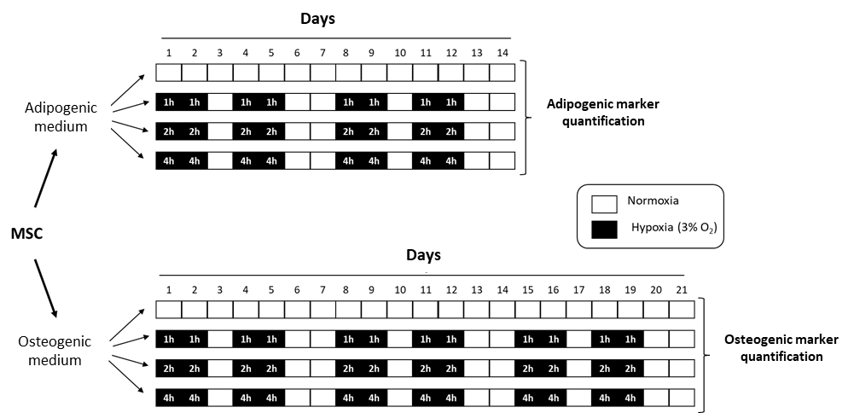
Figure 1 Temporal distribution of mesenchymal stem cells cyclic hypoxia-treatments. Mesenchymal stem cells induce to differentiate into adipocytes or osteoblasts were exposed to CH during 1, 2 or 4 h/d (3% O₂), four days per week. Cultures kept in continuous normoxia were use as controls. MSC: Mesenchymal stem cells.

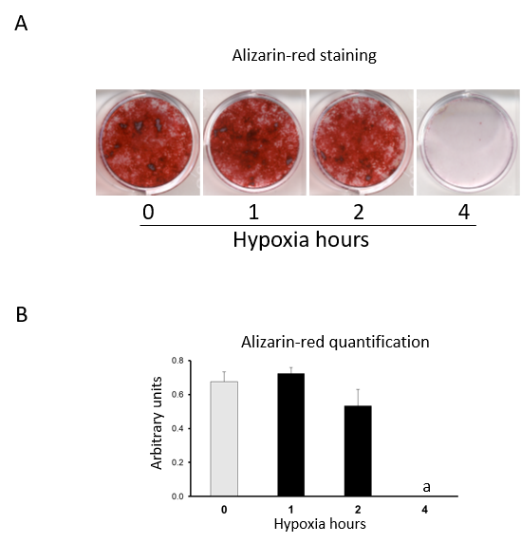
Figure 2 Increased hypoxia time in cyclic hypoxia inhibits extracellular matrix mineralization. Mesenchymal stem cells induced to differentiate into osteoblasts were exposed to cyclic hypoxia during 1, 2 or 4 h/d (3% O₂), four days per week. At day 21, the extracellular matrix mineralization of the cultures was stained with alizarin red. A: Representative images of alizarin-red staining of cultures differentiating into osteoblasts, in normoxia or cyclic hypoxia, after 1, 2 or 4 h of hypoxia; and B: Alizarin-red quantification. ªP < 0.05 vs normoxia (0 h of hypoxia).
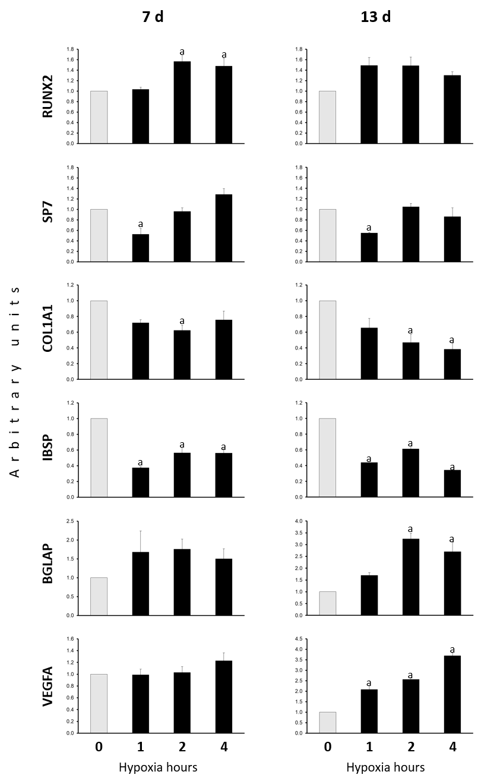
Figure 3 Quantification of gene expressions. The ones of osteoblastic markers (Runt-related transcription factor 2, Osterix, Collagen, type I, alpha 1, Integrin-binding sialoprotein and BGLAP) and Vascular endothelial growth factor A were measured in mesenchymal stem cells induce to differentiate into osteoblasts, in normoxia (0 hypoxia h) or cyclic hypoxia, at days 7 and 13 of osteogenic induction. ªP < 0.05 vs normoxia (0 h of hypoxia). RUNX2: Runt-related transcription factor 2; SP7: Osterix; COL1A1: Collagen, type I, alpha 1; IBSP: Integrin-binding sialoprotein; and VEGFA: Vascular endothelial growth factor A.
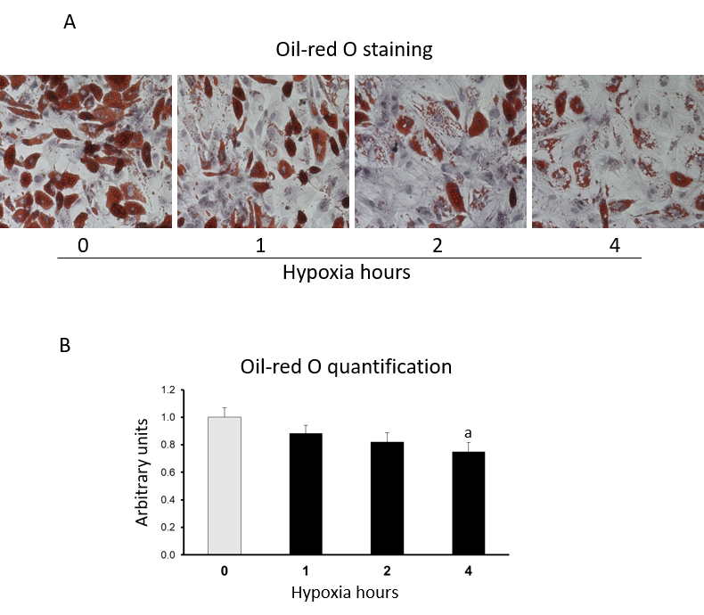
Figure 4 Increased hypoxia time in cyclic hypoxia inhibits lipid-droplet formation. Mesenchymal stem cells induced to differentiate into adipocytes were exposed to cyclic hypoxia during 1, 2 or 4 h/d (3% O₂), four days per week. Cultures were stained with oil-red O to reveal lipid droplets at day 13. A: representative images of oil-red O staining of cultures differentiating into adipocytes, in normoxia or cyclic hypoxia with 1, 2 or 4 h of hypoxia; and B: Oil-red O quantification. ªP < 0.05 vs normoxia (0 h of hypoxia).
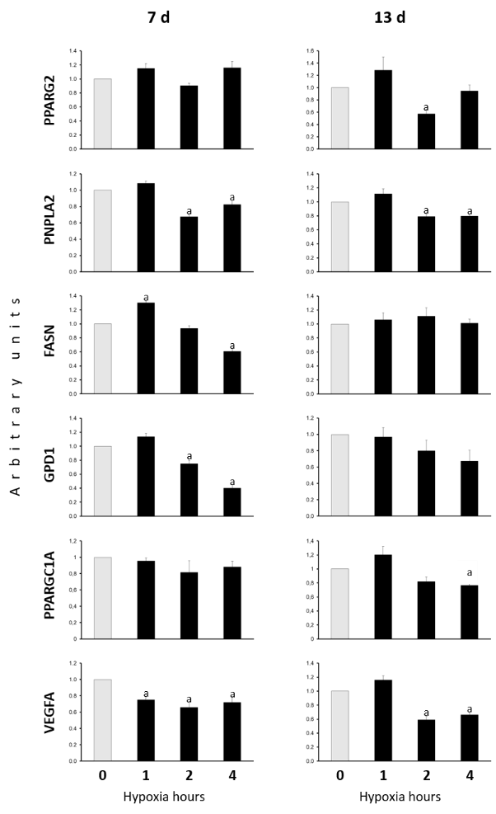
Figure 5 Expressions of adipogenic marker and vascular endothelial growth factor A genes. The ones encoding adipogenic markers (Peroxisome proliferator-activated receptor gamma 2, patatin-like phospholipase domain-containing protein 2, Fatty acid synthase, Glycerol-3-Phosphate Dehydrogenase 1 and Peroxisome proliferator-activated receptor gamma, coactivator 1 alpha) and vascular endothelial growth factor A were measured in mesenchymal stem cells induce to differentiate into adipocytes. Experiments were carried out in normoxia (0 hypoxia h) or cyclic hypoxia, at days 7 and 13, after adipogenic induction. ªP < 0.05 vs normoxia (0 h of hypoxia). VEGFA: Vascular endothelial growth factor A; PPARG2: Peroxisome proliferator-activated receptor gamma 2; PNPLA2: Patatin-like phospholipase domain-containing protein 2; FASN: Fatty acid synthase; GPD1: Glycerol-3-phosphate dehydrogenase 1; and PPARGC1A: Peroxisome proliferator-activated receptor gamma, coactivator 1 alpha.

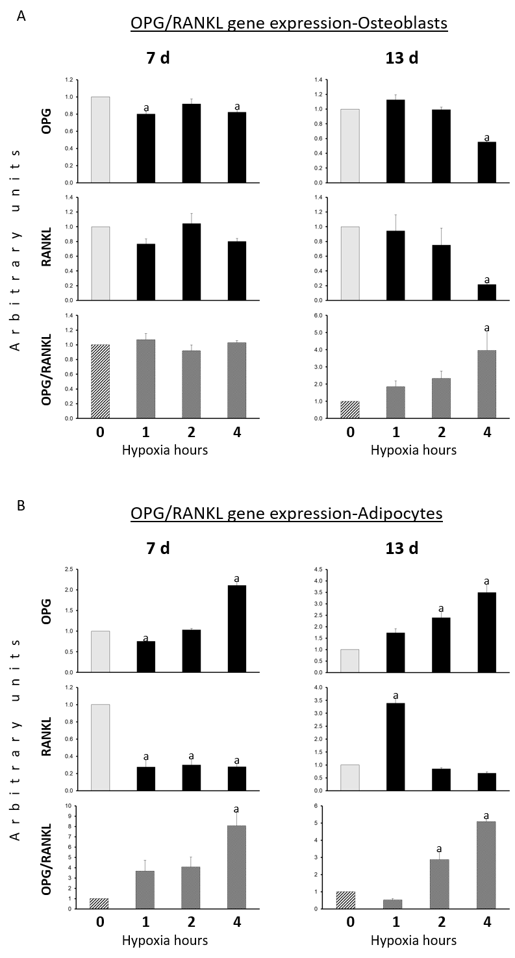
Figure 6 Expressions of osteoprotegerin and receptor activator for nuclear factor kappa B ligand genes. They were quantified at days 7 and 13 in mesenchymal stem cells differentiating into (A) osteoblasts or (B) adipocytes, in normoxia or different cyclic hypoxia conditions. ªP < 0.05 vs normoxia (0 h of hypoxia). OPG: Osteoprotegerin; and RANKL: Receptor activator for nuclear factor kappa B ligand.
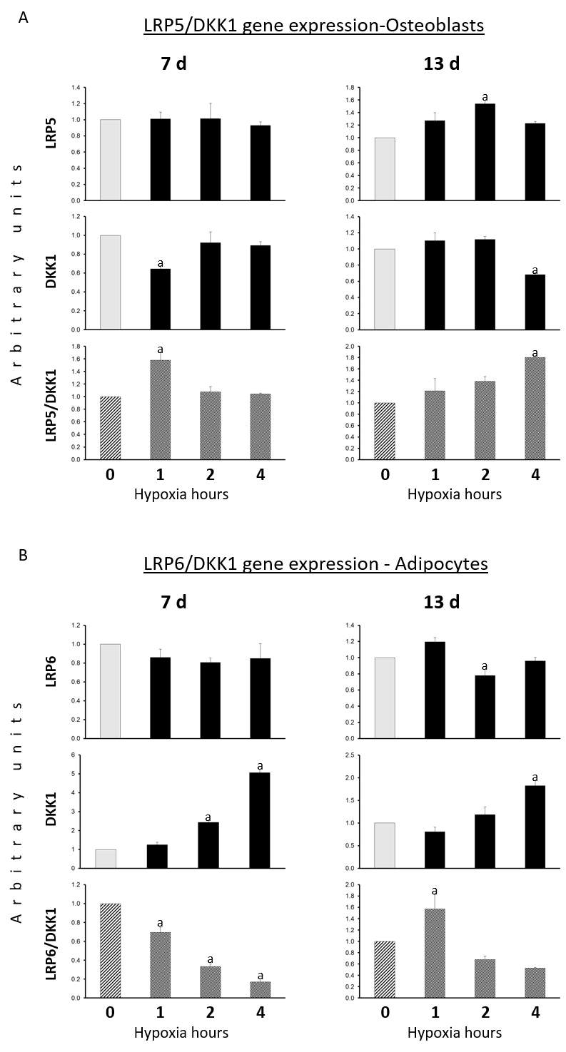
Figure 7 Expressions of low-density lipoprotein receptor related protein 5, low-density lipoprotein receptor related protein 6 and Dickkopf Wnt signaling pathway inhibitor 1 genes. They were quantified at days 7 and 13, in mesenchymal stem cells differentiating into (A) osteoblasts or (B) adipocytes, exposed to normoxia or different cyclic hypoxia conditions. ªP < 0.05 vs normoxia (0 h of hypoxia). DKK1: Dickkopf Wnt signaling pathway inhibitor 1; LRP6: Low-density lipoprotein receptor related protein 6; and LRP5: Low-density lipoprotein receptor related protein 5.
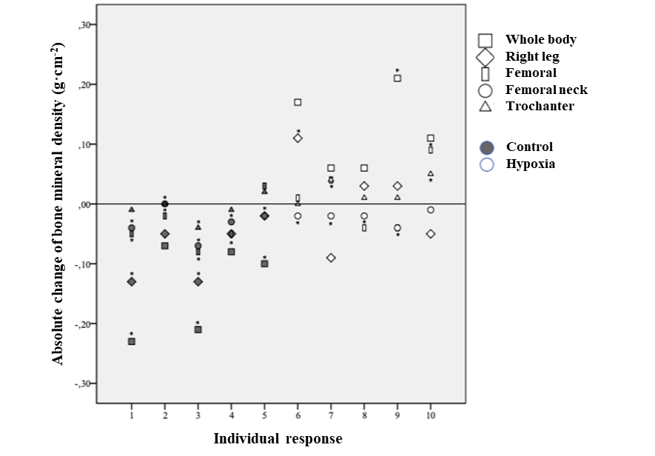
Figure 8 Individual response of bone mineral density. Changes were recorded after 18 wk of normal daily activities (control) or hypoxia exposure. Intra-individual difference equal or greater than minimum detectable change (i.e., 0.10 g ∙ cm^{–2} of whole-body bone mineral density in relation to hypoxia group).

Table 1 Primer sequences and product sizes
Gene | Primer sequence (5’ —> 3’) | Product size (bp)
Runt-related transcription factor 2 (RUNX2) | TGGTTAATCTCCGCAGGTCAC; ACTGTGCTGAAGAGGCTGTTTG | 143
Osterix (SP7) | AGCCAGAAGCTGTGAAACCTC; AGCTGCAAGCTCTCCATAACC | 163
Collagen, type I, alpha 1 (COL1A1) | CGCTGGCCCCAAAGGATCTCCTG; GGGGTCCGGGAACACCTCGCTC | 263
Integrin-binding sialoprotein (IBSP) | AGGGCAGTAGTGACTCATCCG; CGTCCTCTCCATAGCCCAGTGTTG | 171
Osteocalcin (BGLAP) | CCATGAGAGCCCTCACACTCC; GGTCAGCCAACTCGTCACAGTC | 258
Vascular endothelial growth factor A (VEGFA) | GCGAGCAGCGAAAGCGACAGG; CGTCAGCGCGACTGGTC | 114
Peroxisome proliferator-activated receptor gamma 2 (PPARG2) | GCGATTCCTTCACTGATACACTG; GAGTGGGAGTGGTCTTCCATTAC | 136
Fatty acid synthase (FASN) | AAGCTGAAGGACCTGTCTAGG; CGGAGTGAATCTGGGTTGATG | 146
Adipose triglyceride lipase (ATGL) or patatin-like phospholipase domain-containing protein 2 (PNPLA2) | CCAACACCAGCATCCAGTTCA; ATCCCTGCTTGCACATCTCTC | 102
Glycerol-3-Phosphate Dehydrogenase 1 (GPD1) | ATACAGCATCCTCCAGCACAAG; GGATGATTCTGCAGGCAGTG | 120
Peroxisome proliferator-activated receptor gamma, coactivator 1 alpha (PPARGC1A) | CTGGTTGCCTGCATGAGTGTG; GGGCAAAGAGGCTGGTCTTCAC | 173
Osteoprotegerin (OPG) | GGCGCTACCTTGAGATAGAGTTCTG; TGTTTTCTACAGGGTGCTTTAGATGAC | 160
Receptor activator for nuclear factor kappa B ligand (RANKL) | CGTCGCCCTGTTCTTCTATTTC; AAATGCAGTGAGTGCCATCTTC | 74
Low-density lipoprotein receptor related protein 5 (LRP5) | TACTGGACAGACTGGCAGACC; GTGTAGAAAGGCTCGCTTGG | 209
Low-density lipoprotein receptor related protein 6 (LRP6) | TACTGGCCAAATGGACTGACT; TGTTGCAAGCCAAAATGGAGT | 211
Dickkopf Wnt signaling pathway inhibitor 1 (DKK1) | ATGCGTCACGCTATGTGCT; GGAATACCCATCCAAGGTGCTA | 144
Polymerase RNA II polypeptide A (POLR2A) | TTTTGGTGACGACTTGAACTGC; CCATCTTGTCCACCACCTCTTC | 125

Table 2 Baseline characteristics of participants
Parameter | HYP (n = 5)  mean ± SD | CON (n = 5)  mean ± SD | p value
Age (yr) | 83.00 ± 5.79 | 80.00 ± 4.06 | 0.371
Height (m) | 1.61 ± 0.06 | 1.61 ± 0.06 | 0.960
Weight (kg) | 62.00 ± 7.35 | 65.50 ± 2.87 | 0.350
BMI (kg ∙ m⁻²) | 23.82 ± 2.68 | 25.26 ± 1.72 | 0.340
TUGT (s) | 9.25 ± 0.87 | 10.47 ± 1.61 | 0.174
Diseases (n) | 1.60 ± 1.52 | 2.20 ± 0.84 | 0.461
Medication (n) | 5.60 ± 5.98 | 1.80 ± 0.45 | 0.194
HYP: Hypoxic exposure group; CON: Control group; BMI: Body mass index; TUGT: Timed up and go test.

Table 3 Dual-energy X-ray absorptiometry measurements at baseline (PRE) and after 18 wk (POST) for hypoxia exposure (n = 5) and control (n = 5) groups
Parameter |  | PRE  (mean ± SD) | % | POST  (mean ± SD) | Cohen’s d measure | MDC (%) | Wilcoxon’s test | Man Whitney U’s test
Fat mass (%)
Whole body | HYP | 31.74 ± 10.08 | –5.23 | 30.08 ± 12.47 | 0.15 | 12.38 | 0.225 | 0.841
 | CON | 36.39 ± 6.32 | –1.37 | 35.89 ± 5.87 | 0.08 | 4.18 | 0.225
Trunk | HYP | 25.13 ± 6.08 | 8.40 | 27.24 ± 12.27 | 0.23 | 34.74 | 0.500 | 0.841
 | CON | 33.45 ± 7.66 | 7.23 | 35.87 ± 9.08 | 0.29 | 33.27 | 0.893
Bone mineral density (g ∙ cm^{–2})
Whole body | HYP | 0.880 ± 0.145 | 7.04$ | 0.942 ± 0.205 | 0.35 | 11.42 | 0.043 | 0.008
 | CON | 0.986 ± 0.053 | –6.29 | 0.924 ± 0.052 | 1.18 | 5.37 | 0.042
Right leg | HYP | 0.908 ± 0.149 | 0.44 | 0.912 ± 0.186 | 0.02 | 9.55 | 0.892 | 0.310
 | CON | 0.994 ± 0.071 | –3.22 | 0.962 ± 0.068 | 0.46 | 4.98 | 0.109
Femoral | HYP | 0.744 ± 0.118 | 0.81 | 0.750 ± 0.126 | 0.05 | 3.79 | 0.705 | 0.095
 | CON | 0.844 ± 0.042 | –1.18 | 0.834 ± 0.051 | 0.22 | 2.06 | 0.129
Femoral neck | HYP | 0.686 ± 0.106 | –2.92 | 0.666 ± 0.108 | 0.19 | 1.96 | 0.041 | 1.000
 | CON | 0.752 ± 0.067 | –2.39 | 0.734 ± 0.068 | 0.27 | 2.11 | 0.059
Trochanter | HYP | 0.568 ± 0.097 | 3.17 | 0.586 ± 0.093 | 0.19 | 5.20 | 0.109 | 0.056
 | CON | 0.654 ± 0.064 | –1.22 | 0.646 ± 0.069 | 0.12 | 4.66 | 0.461
HYP: Hypoxic exposure group; CON: Control group; %: Percentage of change between PRE and POST measurement outcomes; MDC: Minimum detectable change.

