Name of Journal: World Journal of Cardiology
Manuscript NO: 40751
Manuscript Type: EDITORIAL

Thin and crush: The new mantra in left main stenting?

Rigatelli G et al. Left main double stenting

Gianluca Rigatelli, Marco Zuin, Debradata Dash

Gianluca Rigatelli, Section of Cardiovascular Diagnosis and Endoluminal Interventions, Rovigo General Hospital, Rovigo 45100, Italy

Marco Zuin, Section of Internal and Cardiopulmonary Medicine, Department of Medical Science, University of Ferrara, Ferrara 44124, Italy

Debradata Dash, Interventional cardiology, Thumbay Hospital, Ajman 415555, UAE

ORCID number: Gianluca Rigatelli (0000-0002-7318-3640); Marco Zuin (0000-0002-4559-1292); Debradata Dash (0000-0003-1354-3808).

Author contributions: Rigatelli G, Zuin M and Dash D conceived the study and drafted the manuscript; both authors approved the final version of the article.

Conflict-of-interest statement: The authors have no conflict of interest to declare.

Open-Access: This article is an open-access article which was selected by an in-house editor and fully peer-reviewed by external reviewers. It is distributed in accordance with the Creative Commons Attribution Non Commercial (CC BY-NC 4.0) license, which permits others to distribute, remix, adapt, build upon this work non-commercially, and license their derivative works on different terms, provided the original work is properly cited and the use is non-commercial. See: http://creativecommons.org/licenses/by-nc/4.0/

Manuscript source: Invited Manuscript

Correspondence to: Gianluca Rigatelli, FACC, FACP, MD, PhD, Assistant Professor, Section of Cardiovascular Diagnosis and Endoluminal Interventions, Rovigo General Hospital, Viale Tre Martiri 140, Rovigo 45100, Italy. jackyheart@libero.it
Telephone:+39-42-5394509
Fax: +39-42-5394513

Received: July 11, 2018
Peer-review started: July 11, 2018
First decision: August 2, 2018
Revised: August 23, 2018
Accepted: October 9, 2018
Article in press:
Published online:

Abstract
Complex bifurcations have been suggested to be better approached by a planned double stent technique, although recent randomized trials have shown better outcomes of provisional compared to planned two-stent strategy, in terms of both short-term efficacy and safety. In left main (LM) bifurcations, DK-Crush has provided evidences of its superiority over Culotte and provisional-T in terms of restenosis and stent thrombosis, gaining respect as one of the most performant techniques for bifurcations stenting. On the other hand, the Nano-Crush technique has recently became part of the repertoire of double stenting techniques, providing evidences that the use of ultrathin strut stents and very minimal crush would be beneficial for both the physiological and rheological properties of the complex bifurcations even in LM scenario, leading to a lower rate of thrombosis and restenosis at both side branch and true carena. Finally last generation ultrathin strut stents are gaining a reputation of safe and effective use in LM treatment thanks to improved design with increased expansion rate capable of LM treatment up to 5-6 mm diameter. The modern crush techniques such as DK-Crush and Nano-Crush, are providing excellent results on mid and long-term follow up, suggesting that a minimal crushing obtained using ultra-thin stents is on the good way to obtain surgical-like outcomes in the treatment of complex LM bifurcation disease.

Key words: Coronary bifurcation; Percutaneous coronary intervention; Stent; Crush; Interventional cardiology

© The Author(s) 2018. Published by Baishideng Publishing Group Inc. All rights reserved.

Core tip: The modern crush techniques such as DK-Crush and Nano-Crush, are providing excellent results on mid and long-term follow up, suggesting that a minimal crushing obtained using ultra-thin stents is on the good way to obtain surgical-like outcomes in the treatment of complex left main bifurcation disease.

Rigatelli G, Zuin M, Dash D. Thin and crush: The new mantra in left main stenting? World J Cardiol 2018; In press

INTRODUCTION
Complex bifurcations have been suggested to be better approached by a planned double stent technique^{[1-2]}, although recent randomized trials have shown better outcomes of provisional compared to planned two-stent strategy, in terms of both short-term efficacy and safety^{[3-4]}.The total amount of metal layers at both the carina and bifurcation angle after double stenting techniques^{[5-6]} appeared important issues to achieve favorable short- and long-term outcomes.
Left main (LM) bifurcation disease is probably the only real important bifurcation in human vascular tree. Then DEFINITION trial^{[7]} has given a practical definition of what is complex and what it is not in the treatment of coronary artery bifurcation disease. Indeed, a length of the left circumflex coronary artery (LCx) > 10 mm has been already identified as a predictor of complex LM bifurcation probably requiring a double stenting strategy.
To achieve post procedural results similar, or even better, from a rheolytic point of view, to those guarantee by surgical treatment, the use of intravenous ultrasound is mandatory^{[8]} in order to assess properly the size and length of the disease in both branches and in the LM body, allowing an accurate selection of the most appropriate stenting technique and stents.
Culotte, mini-Culotte, DK-Crush, T-stent and Protrusion (TAP) are currently the most used double stenting technique (Table 1)^{[9]}. Recently DK-Crush has provided evidences of its superiority over Culotte^{[10]} and provisional-T^{[11]} in terms of restenosis and stent thrombosis, gaining respect as one of the most performant techniques for bifurcations stenting.
Even more recently the Nano-Crush technique^{[12-13]} became part of therepertoire of double stenting techniques, providing evidences that the use of ultrathin strut stents and very minimal crush would be beneficial for both the physiological and rheological properties of the complex bifurcations. Leading to a lower rate of thrombosis and restenosis at both side branch (SB) and true carena^{[14]}.

TECHNICAL COMPARISON AMONG NANO-CRUSH, DK-CRUSH AND OTHERS
Compared to the classical Crush technique introduced by Colombo et al^{[15]}, both the Nano- and DK–Crush represent a further modern development of the former. Both these latter techniques require a wiring and pre-dilation of both branches and in both SB stenting before the main branch (MB) stenting. One of different strands is represented by the entity of the SB stent protrusion which is minimal, with only one ring if possible, in the Nano-Crush, while it appears greater, with at least 3-4 mm of protrusion, in the DK-Crush technique.
The length of protrusion if the SB stent explains why a kissing, the first one, is required when DK-Crush is adopted. In the classical DK-Crush, after the MB stenting, while until recently rewiring of the SB generally represented the next step, now the use of proximal optimization technique (POT) has been recommended, as in Nano-Crush, where POT facilitates the LCx rewiring. Subsequently, both techniques included akind of kissing balloon: classical for the DK and with snuggle configuration in Nano-Crush. Moreover, the classical DK-Crush technique has been modified introducing a POT as final step, as in Nano-Crush (Figure 1).
Differently form DK-Crush, in which the ostium circumference is completely covered by the SB stent, in the Nano-Crush, the ostium is covered at the carena by the SB stent strut and at the opposite site of the carena by the MB struts opened by the POT into the SB ostium, providing a complete circumferentialcoverage, especially in case of tight angles, in which the ostium coverage might be incomplete at the carena.
Among these two stenting techniques, one real huge difference is represented by the most appropriate stent to implant. Indeed, DK-Crush, virtually every kind of stent can be usedwhile the Nano-Crush has been created to fit with the concept of less metal in the carena, so the ideal stent should have the thinnest struts possible, at least 60 to 80 micron.
TAP or standard T usually leave SB stent strut floating into the MB: that cause a non-physiologic flowwhich may induce lower wall shear stress and turbulent flow leading to thrombosis and in-stent restenosis^{[16]}. On the other hand the culotte usually leaves, also in the “Mini” version, two or three metal layers into the carena for a length ranging from 5 to 15 mm.

AMOUNT OF METAL INTO THE CARENA: IT REALLY MATTERS?
The lack or excess of the amount of metal layers at the carena has been suggested a potential cause of stent restenosis and thrombosis, respectively^{[17]}. As recently suggested by our group, using computed fluid dynamic, Culotte and in general all the techniques which leaves a huge amount of metal at the carena, impacted unfavorably on the bifurcation rheology, causing an increase in the lower wall shear stress (WSS) also in the SB. Indeed, as well known, low WSS are potential substrate for restenosis and thrombosis (Figure 2).
Ideally, to achieve the more physiological flow profile, there should be less metal coverage in the carina side and full metal coverage in the area opposite to the carina and the ostium of the SB. DK-Crush and Nano–Crush are likely to work differently in terms of lowering WSS areas depending on the LM bifurcation. The distribution of metal and the coverage of the carena by the struts strictly depends on the angles: Sharp angles tend to increase the amount of metal at the carena specially when a generous portion of the SB stent is protruding and should be crushed, whereas if the portion of the stent to be crushed is shorterand the angle is wider, the amount of the metal would be less, and coverage might be even incomplete. Obviously, the use of ultra-thin stent struts in DK-Crush, or any other techniques, would potentially improve both safety and long-term outcomes.

STENT ENGINEERING CONSIDERATIONS
The Orsiro (Biotronic AG, BÜlach, Switzerland) stent is considered thestent with the thinnest struts commercially available. In the most recent European randomized trials, this stent demonstrated a very good safety and efficacy profile. Indeed, its low rate of stent thrombosis reached the non-inferiority statistical significance compared to Xience Prime stent (Abbott Inc, United States)^{[18-19]} with a faster strut endothelium coverage evaluated by optical coherence tomography in respect to the competitors^{[20]}. These results could be achieved even overcoming the major intrinsic structural limitation to the stent’s design such as the longitudinal shortening^{[21]}. Nowadays other stents have been designed with similar ultra-thin struts such as the Resolute Onyx stent by Medtronic Inc or the Ultimaster by Terumo Inc. which are currently being evaluated in the real-world scenario but promise to maintain the line of predecessor or even do better in terms of strut neointima coverage.
Nowadays stent size working in most LM should be not inferior to 4.5 mm and all modern techniques imply the use of POT at high pressure: all these issues might have an impact of stent deformation, polimer rupture which all can influence the thrombosis and restenosis rates. The availability of thin struts and sizes stents useful to treat LM bifurcation, maintaining a good radial force and minimal shortening will represent a mandatory goal to be accomplished by companies in the market in the near future (Table 2).

THE NEW MANTRA OF LM STENTING
Nowadays LM stenting has gaining respect as alternative to surgical treatment^{[22-24]} but the treatment of complex LM disease distal/bifurcation disease remains the real obstacle to overcome to really achieve satisfactory results. In such disease double stenting technique would provide a more reliable strategy as supported by the numerous evidences coming from both clinical and virtual studies about the benefits provided by the thin strut stent technology.
The modern crush techniques such as DK-Crush and Nano-Crush are providing excellent results on mid and long-term follow up, suggesting that a minimal crushing obtained using ultra-thin stents is on the good way to obtain surgical-like outcomesin the treatment of complex LM bifurcation disease.

REFERENCES
1 Behan MW, Holm NR, de Belder AJ, Cockburn J, Erglis A, Curzen NP, Niemelä M, Oldroyd KG, Kervinen K, Kumsars I, Gunnes P, Stables RH, Maeng M, Ravkilde J, Jensen JS, Christiansen EH, Cooter N, Steigen TK, Vikman S, Thuesen L, Lassen JF, Hildick-Smith D. Coronary bifurcation lesions treated with simple or complex stenting: 5-year survival from patient-level pooled analysis of the Nordic Bifurcation Study and the British Bifurcation Coronary Study. Eur Heart J 2016; 37: 1923-1928 [PMID: 27161619 DOI: 10.1093/eurheartj/ehw170]
2 Hildick-Smith D, Behan MW, Lassen JF, Chieffo A, Lefèvre T, Stankovic G, Burzotta F, Pan M, Ferenc M, Bennett L, Hovasse T, Spence MJ, Oldroyd K, Brunel P, Carrie D, Baumbach A, Maeng M, Skipper N, Louvard Y. The EBC TWO Study (European Bifurcation Coronary TWO): A Randomized Comparison of Provisional T-Stenting Versus a Systematic 2 Stent Culotte Strategy in Large Caliber True Bifurcations. Circ Cardiovasc Interv 2016; 9: [PMID: 27578839 DOI: 10.1161/CIRCINTERVENTIONS.115.003643]
3 Zhang JJ, Gao XF, Han YL, Kan J, Tao L, Ge Z, Tresukosol D, Lu S, Ma LK, Li F, Yang S, Zhang J, Munawar M, Li L, Zhang RY, Zeng HS, Santoso T, Xie P, Jin ZN, Han L, Yin WH, Qian XS, Li QH, Hong L, Paiboon C, Wang Y, Liu LJ, Zhou L, Wu XM, Wen SY, Lu QH, Yuan JQ, Chen LL, Lavarra F, Rodríguez AE, Zhou LM, Ding SQ, Vichairuangthum K, Zhu YS, Yu MY, Chen C, Sheiban I, Xia Y, Tian YL, Shang ZL, Jiang Q, Zhen YH, Wang X, Ye F, Tian NL, Lin S, Liu ZZ, Chen SL. Treatment effects of systematic two-stent and provisional stenting techniques in patients with complex coronary bifurcation lesions: rationale and design of a prospective, randomised and multicentre DEFINITION II trial. BMJ Open 2018; 8: e020019 [PMID: 29511018 DOI: 10.1136/bmjopen-2017-020019]
4 Chen SL, Santoso T, Zhang JJ, Ye F, Xu YW, Fu Q, Kan J, Zhang FF, Zhou Y, Xie DJ, Kwan TW. Clinical Outcome of Double Kissing Crush Versus Provisional Stenting of Coronary Artery Bifurcation Lesions: The 5-Year Follow-Up Results From a Randomized and Multicenter DKCRUSH-II Study (Randomized Study on Double Kissing Crush Technique Versus Provisional Stenting Technique for Coronary Artery Bifurcation Lesions). Circ Cardiovasc Interv 2017; 10: [PMID: 28122805 DOI: 10.1161/CIRCINTERVENTIONS.116.004497]
5 Beier S, Ormiston J, Webster M, Cater J, Norris S, Medrano-Gracia P, Young A, Cowan B. Impact of bifurcation angle and other anatomical characteristics on blood flow - A computational study of non-stented and stented coronary arteries. J Biomech 2016; 49: 1570-1582 [PMID: 27062590 DOI: 10.1016/j.jbiomech.2016.03.038]
6 Ormiston JA, Webster MW, Webber B, Stewart JT, Ruygrok PN, Hatrick RI. The "crush" technique for coronary artery bifurcation stenting: insights from micro-computed tomographic imaging of bench deployments. JACC Cardiovasc Interv 2008; 1: 351-357 [PMID: 19463329 DOI: 10.1016/j.jcin.2008.06.003]
7 Chen SL, Sheiban I, Xu B, Jepson N, Paiboon C, Zhang JJ, Ye F, Sansoto T, Kwan TW, Lee M, Han YL, Lv SZ, Wen SY, Zhang Q, Wang HC, Jiang TM, Wang Y, Chen LL, Tian NL, Cao F, Qiu CG, Zhang YJ, Leon MB. Impact of the complexity of bifurcation lesions treated with drug-eluting stents: the DEFINITION study (Definitions and impact of complEx biFurcation lesIons on clinical outcomes after percutaNeous coronary IntervenTIOn using drug-eluting steNts). JACC Cardiovasc Interv 2014; 7: 1266-1276 [PMID: 25326748 DOI: 10.1016/j.jcin.2014.04.026]
8 Wang Y, Mintz GS, Gu Z, Qi Y, Wang Y, Liu M, Wu X. Meta-analysis and systematic review of intravascular ultrasound versus angiography-guided drug eluting stent implantation in left main coronary disease in 4592 patients. BMC Cardiovasc Disord 2018; 18: 115 [PMID: 29898668 DOI: 10.1186/s12872-018-0843-z]
9 Rab T, Sheiban I, Louvard Y, Sawaya FJ, Zhang JJ, Chen SL. Current Interventions for the Left Main Bifurcation. JACC Cardiovasc Interv 2017; 10: 849-865 [PMID: 28473107 DOI: 10.1016/j.jcin.2017.02.037]
10 Chen SL, Zhang JJ, Han Y, Kan J, Chen L, Qiu C, Jiang T, Tao L, Zeng H, Li L, Xia Y, Gao C, Santoso T, Paiboon C, Wang Y, Kwan TW, Ye F, Tian N, Liu Z, Lin S, Lu C, Wen S, Hong L, Zhang Q, Sheiban I, Xu Y, Wang L, Rab TS, Li Z, Cheng G, Cui L, Leon MB, Stone GW. Double Kissing Crush Versus Provisional Stenting for Left Main Distal Bifurcation Lesions: DKCRUSH-V Randomized Trial. J Am Coll Cardiol 2017; 70: 2605-2617 [PMID: 29096915 DOI: 10.1016/j.jacc.2017.09.1066]
11 Chen SL, Xu B, Han YL, Sheiban I, Zhang JJ, Ye F, Kwan TW, Paiboon C, Zhou YJ, Lv SZ, Dangas GD, Xu YW, Wen SY, Hong L, Zhang RY, Wang HC, Jiang TM, Wang Y, Sansoto T, Chen F, Yuan ZY, Li WM, Leon MB. Clinical Outcome After DK Crush Versus Culotte Stenting of Distal Left Main Bifurcation Lesions: The 3-Year Follow-Up Results of the DKCRUSH-III Study. JACC Cardiovasc Interv 2015; 8: 1335-1342 [PMID: 26315736 DOI: 10.1016/j.jcin.2015.05.017]
12 Rigatelli G, Dell'Avvocata F, Zuin M, Vassiliev D, Mazza A, Dinh HD. Complex coronary bifurcation revascularization by means of very minimal crushing and ultrathin biodegradable polymer DES: Feasibility and 1-year outcomes of the "Nano-crush" technique. Cardiovasc Revasc Med 2017; 18: 22-27 [PMID: 27566904 DOI: 10.1016/j.carrev.2016.07.003]
13 Rigatelli G, Zuin M, Dell'Avvocata F, Vassilev D, Daggubati R, Nguyen T, Nguyễn MTN, Foin N. Complex coronary bifurcation treatment by a novel stenting technique: Bench test, fluid dynamic study and clinical outcomes. Catheter Cardiovasc Interv 2018; [PMID: 29368394 DOI: 10.1002/ccd.27494]
14 Rigatelli G, Dell'Avvocata F, Zuin M, Giatti S, Duong K, Pham T, Tuan NS, Vassiliev D, Daggubati R, Nguyen T. Comparative Computed Flow Dynamic Analysis of Different Optimization Techniques in Left Main Either Provisional or Culotte Stenting. J Transl Int Med 2017; 5: 205-212 [PMID: 29340277 DOI: 10.1515/jtim-2017-0035]
15 Colombo A. Bifurcational lesions and the "crush" technique: understanding why it works and why it doesn't-a kiss is not just a kiss. Catheter Cardiovasc Interv 2004; 63: 337-338 [PMID: 15505834 DOI: 10.1002/ccd.20148]
16 Katritsis DG, Theodorakakos A, Pantos I, Gavaises M, Karcanias N, Efstathopoulos EP. Flow patterns at stented coronary bifurcations: computational fluid dynamics analysis. Circ Cardiovasc Interv 2012; 5: 530-539 [PMID: 22763345 DOI: 10.1161/CIRCINTERVENTIONS.112.968347]
17 Hu ZY, Chen SL, Zhang JJ, Shan SJ, Liu ZZ, Ye F, Kan J, Xu HM, Nguyen K, Kwan T, Nguyen T, Hoang T. Distribution and magnitude of shear stress after coronary bifurcation lesions stenting with the classical crush technique: a new predictor for in-stent restenosis. J Interv Cardiol 2010; 23: 330-340 [PMID: 20642479 DOI: 10.1111/j.1540-8183.2010.00571.x]
18 Lefèvre T, Haude M, Neumann FJ, Stangl K, Skurk C, Slagboom T, Sabaté M, Goicolea J, Barragan P, Cook S, Macia JC, Windecker S. Comparison of a Novel Biodegradable Polymer Sirolimus-Eluting Stent With a Durable Polymer Everolimus-Eluting Stent: 5-Year Outcomes of the Randomized BIOFLOW-II Trial. JACC Cardiovasc Interv 2018; 11: 995-1002 [PMID: 29798778 DOI: 10.1016/j.jcin.2018.04.014]
19 Kandzari DE, Mauri L, Koolen JJ, Massaro JM, Doros G, Garcia-Garcia HM, Bennett J, Roguin A, Gharib EG, Cutlip DE, Waksman R; BIOFLOW V Investigators. Ultrathin, bioresorbable polymer sirolimus-eluting stents versus thin, durable polymer everolimus-eluting stents in patients undergoing coronary revascularisation (BIOFLOW V): a randomised trial. Lancet 2017; 390: 1843-1852 [PMID: 28851504 DOI: 10.1016/S0140-6736(17)32249-3]
20 Kretov Е, Naryshkin I, Baystrukov V, Grazhdankin I, Prokhorikhin A, Zubarev D, Biryukov A, Verin V, Boykov A, Malaev D, Pokushalov E, Romanov A, Bergmann MW. Three-months optical coherence tomography analysis of a biodegradable polymer, sirolimus-eluting stent. J Interv Cardiol 2018; 31: 442-449 [PMID: 29651802 DOI: 10.1111/joic.12510]
21 Guler A, Guler Y, Acar E, Aung SM, Efe SC, Kilicgedik A, Karabay CY, Barutcu S, Tigen MK, Pala S, İzgi A, Esen AM, Kirma C. Clinical, angiographic and procedural characteristics of longitudinal stent deformation. Int J Cardiovasc Imaging 2016; 32: 1163-1170 [PMID: 27198891 DOI: 10.1007/s10554-016-0905-1]
22 De Rosa S, Polimeni A, Sabatino J, Indolfi C. Long-term outcomes of coronary artery bypass grafting versus stent-PCI for unprotected left main disease: a meta-analysis. BMC Cardiovasc Disord 2017; 17: 240 [PMID: 28877676 DOI: 10.1186/s12872-017-0664-5]
23 Campos CM, Christiansen EH, Stone GW, Serruys PW. The EXCEL and NOBLE trials: similarities, contrasts and future perspectives for left main revascularisation. EuroIntervention 2015; 11 Suppl V: V115-V119 [PMID: 25983143 DOI: 10.4244/EIJV11SVA26]
24 Sawaya FJ, Lefèvre T, Chevalier B, Garot P, Hovasse T, Morice MC, Rab T, Louvard Y. Contemporary Approach to Coronary Bifurcation Lesion Treatment. JACC Cardiovasc Interv 2016; 9: 1861-1878 [PMID: 27659563 DOI: 10.1016/j.jcin.2016.06.056]

P-Reviewer: Vidal-Perez R, Akin I, Barik R S-Editor: Dou Y L-Editor: E-Editor:

Specialty type: Cardiac and cardiovascular systems
Country of origin: Italy
Peer-review report classification
Grade A (Excellent): 0
Grade B (Very good): B
Grade C (Good): C, C
Grade D (Fair): 0
Grade E (Poor): 0

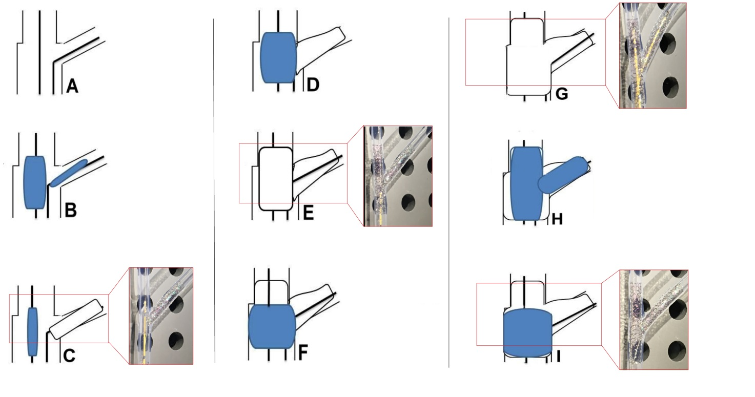Figure 1 Key steps of the Nano-Crush stenting technique. As both branches are wired (A), both branches are predicated with non-compliant balloons (B) and the stent at side branch is deployed (C: bench test correlate image). Then the balloon of the deployed stent is withdrawn and the main branch balloon is inflated in the MB at high atmosphere (D); The MB stent of the diameter of the distal reference diameter (3.0 mm) is placed in position and deployed (E: bench test correlate image); Proximal optimization technique (POT) with non-compliant balloon of the same diameter of the MB is performed at high atmosphere (F) and then after rewiring of the side branch (G: bench test correlate image), a snuggle kissing is performed with non-compliant balloons (H); Finally a re-POT is performed with a non-compliant balloon at high atmosphere atm (I: bench test correlate image).

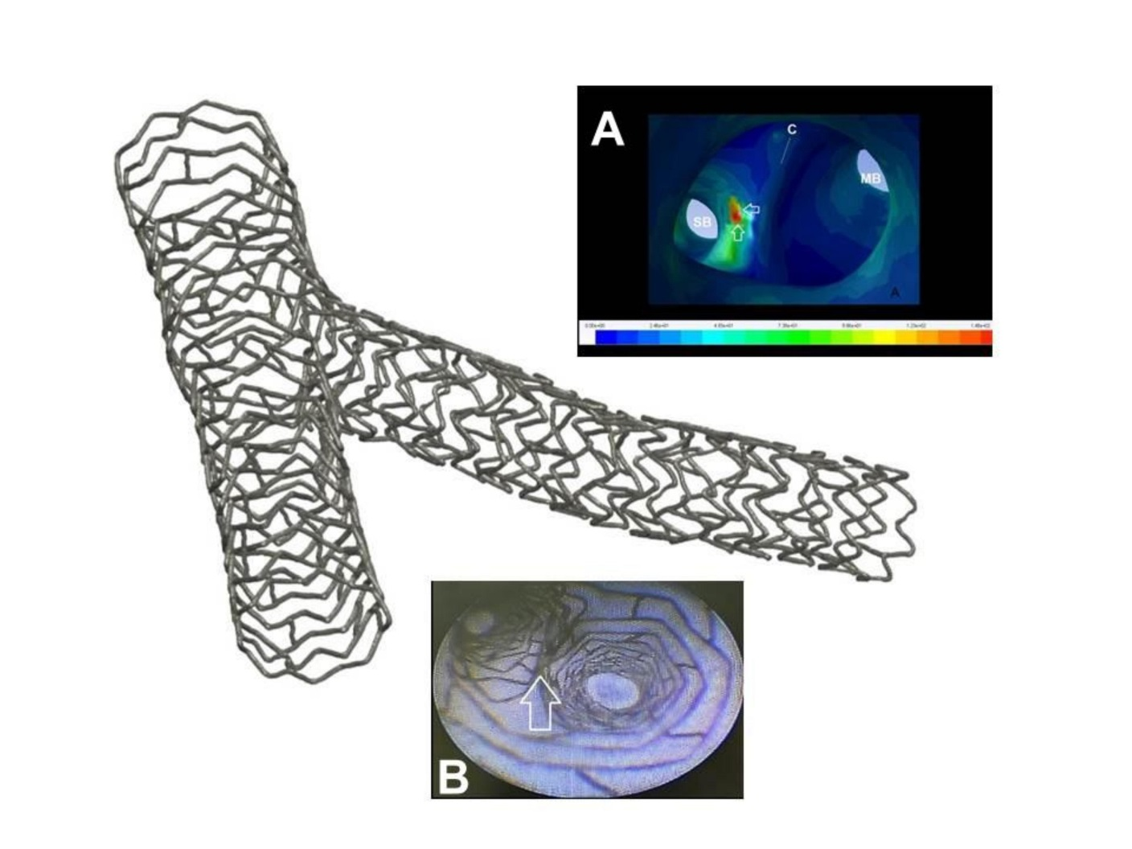Figure 2 Micro computed tomography picture of a bifurcation treated by Nano-Crush technique. A: Region of the carena investigated by computed fluid dynamic showing from inside of the vessel a region of high wall shear stress (red zone, white arrows) located at the side branch (SB) portion of the carena which potentially should be in favor of less restenosis and thrombosis at that site; B: Angioscopic image of the same region showing a very smooth transition of the wall at the bifurcatyion with a very minimal (Nano) apposition of two stent layer.

Table 1 Available techniques for left main interventions
Single stent | Double stent
Cross over-provisional | T-stenting
 | T and protrusion
 | Mini-Crush
 | Culotte and Mini-culotte
 | DK crush
 | Nano-Crush

Table 2 Thinnest struts stents and their maximum expansion for left main interventions
Stent type | Strut thickness (µ) | Max size achievable (mm)
Orsiro Biotronik, Sui | 60-80 | 5.3 (3.5 stent)
Onyx Medtronic, US | 70 | 6 (4.0 stent)
Ultimaster Terumo, Japan | 80 | 5.8 (3.5 stent)
Biomime Meril | 65 | 5.3 (4.5 stent)*
Synergy Boston Scientific, US | 74 | 5.7 (4.0 stent)
Data of maximum expansion retrieved from Sawaya FJ et al^{[24]}. * Not verified in bench test.

