Name of Journal: World Journal of Gastroenterology
Manuscript NO: 63186
Manuscript Type: ORIGINAL ARTICLE

Clinical Trials Study
Responses to faecal microbiota transplantation in female and male patients with irritable bowel syndrome

El-Salhy M et al. FMT in IBS patients

Magdy El-Salhy, Christina Casen, Jørgen Valeur, Trygve Hausken, Jan Gunnar Hatlebakk

Magdy El-Salhy, Department of Medicine, Stord Helse-Fonna Hospital, Stord 5416, Norway

Magdy El-Salhy, Trygve Hausken, Jan Gunnar Hatlebakk, Department of Clinical Medicine, University of Bergen, Bergen 5020, Norway

Magdy El-Salhy, Trygve Hausken, Jan Gunnar Hatlebakk, National Centre for Functional Gastrointestinal Disorders, Department of Medicine, Haukeland University Hospital, Bergen 5020, Norway

Christina Casen, Genetic Analysis AS, Oslo 0485, Norway

Jørgen Valeur, Unger-Vetlesen Institute, Lovisenberg Diaconal Hospital, Oslo 0440, Norway

Author contributions: El-Salhy M designed the study, obtained the funding, administered the study, recruited the patients, performed faecal microbiota transplantation, collected, analyzed and interpreted the data, and drafted the manuscript; Casen C contributed to the design of the study, analyzed the faecal bacteria and critically revised the manuscript for important intellectual content; Valeur J contributed to the design of the study, analyzed the short-chain fatty acids and critically revised the manuscript for important intellectual content; Hausken T and Hatlebakk JG contributed to the design of the study and to the analysis and interpretation of the data, and critically revised the manuscript for important intellectual content.

Corresponding author: Magdy El-Salhy, BSc, MD, PhD, Chief Doctor, Professor, Department of Medicine, Stord Helse-Fonna Hospital, Tysevegen 64, Stord 5416, Norway. magdy.elsalhy@sklbb.no

Received: January 25, 2021
Revised: March 13, 2021
Accepted: April 22, 2021
Published online: May 14, 2021

Abstract
BACKGROUND
Faecal microbiota transplantation (FMT) seems to be a promising treatment for irritable bowel syndrome (IBS) patients. In Western countries (United States and Europe), there is a female predominance in IBS. A sex difference in the response to FMT has been reported recently in IBS patients. This study investigated whether there was a sex difference in the response to FMT in the IBS patients who were included in our previous randomized controlled trial of the efficacy of FMT.

AIM
To investigate whether there was a sex difference in the response to FMT in the IBS patients who were included in our previous randomized controlled trial of the efficacy of FMT.

METHODS
The study included 164 IBS patients who participated in our previous randomized controlled trial. These patients had moderate-to-severe IBS symptoms belonging to the IBS-D (diarrhoea-predominant), IBS-C (constipation-predominant) and IBS-M (mixed) subtypes, and had not responded to the National Institute for Health and Care Excellence (NICE)-modified diet. They belonged in three groups: placebo (own faeces), and active treated group (30-g or 60-g superdonor faeces). The patients completed the IBS severity scoring system (IBS-SSS), Fatigue Assessment Scale (FAS) and the IBS quality of life scale (IBS-QoL) questionnaires at the baseline and 2 wk, 1 mo and 3 mo after FMT. They also provided faecal samples at the baseline and 1 mo after FMT. The faecal bacteria profile and dysbiosis were determined using the 16S rRNA gene polymerase chain reaction DNA amplification covering V3-V9; probe labelling by single nucleotide extension and signal detection. The levels of short-chain fatty acids (SCFAs) were determined by gas chromatography and flame ionization.

RESULTS
There was no sex difference in the response to FMT either in the placebo group or active treated group. There was no difference between females and males in either the placebo group or actively treated groups in the total score on the IBS-SSS, FAS or IBS-QoL, in dysbiosis, or in the faecal bacteria or SCFA level. However, the response rate was significantly higher in females with diarrhoea-predominant (IBS-D) than that of males at 1 mo, and 3 mo after FMT. Moreover, IBS-SSS total score was significantly lower in female patients with IBS-D than that of male patients both 1 mo and 3 mo after FMT.

CONCLUSION
There was no sex difference in the response to FMT among IBS patients with moderate-to-severe symptoms who had previously not responded to NICE-modified diet. However, female patients with IBS-D respond better and have higher reduction of symptoms than males after FMT.

Key Words: Dysbiosis; Fatigue; Microbiome; Quality of life; Short-chain fatty acids; Superdonor

©The Author(s) 2021. Published by Baishideng Publishing Group Inc. All rights reserved.

Citation: El-Salhy M, Casen C, Valeur J, Hausken T, Hatlebakk JG. Responses to faecal microbiota transplantation in female and male patients with irritable bowel syndrome. World J Gastroenterol 2021; 27(18): 2219-2237
URL: https://www.wjgnet.com/1007-9327/full/v27/i18/2219.htm
DOI: https://dx.doi.org/10.3748/wjg.v27.i18.2219

Core Tip: A sex difference in the response to faecal microbiota transplantation (FMT) was previous reported for a subgroup of refractory irritable bowel syndrome (IBS) patients with severe bloating who had not responded to at least three conventional therapies for IBS. This subgroup only contained patients with diarrhoea-predominant (IBS-D) or mixed (IBS-M) IBS. The present study found no sex difference in the response to FMT among IBS patients with moderate-to-severe symptoms of IBS-D, constipation-predominant (IBS-C) and IBS-M. However, female patients with IBS-D respond better and have higher reduction of symptoms than males after FMT.
INTRODUCTION
The gut microbiota plays an important role in the pathophysiology of irritable bowel syndrome (IBS)^{[1,2]}. The composition of the gut bacteria in IBS patients differs from that of healthy subjects^{[2-6]}. IBS patients have lower abundances of the butyrate-producing bacteria, Erysipelotrichaceae and Ruminococcaceae compared with healthy controls^{[7,8]}. Methane-producing bacteria, Methanobacteriales were found to be more abundant in IBS patients with constipation as a predominant symptom (IBS-C) and less abundant in IBS patients with diarrhoea as a predominant symptom (IBS-D) compared with healthy individuals^{[7,8]}. Moreover, IBS patients have been found to have increased abundances of Veillonella, Lactobacillus and Ruminococcus bacteria and decreased abundances of Bifidobacterium, Faecalibacterium and Erysipelotrichaceae methanogens^{[7,8]}. IBS patients also have a lower diversity of gut bacteria (dysbiosis) than healthy subjects^{[4-6,9]}.
Faecal microbiota transplantation (FMT) has previously been performed in IBS patients in seven randomized controlled trials (RCTs)^{[10-16]}. Four of these RCTs showed that FMT had good effects on symptoms and the quality of life^{[10,12,15,16]}. while the other three RCTs found no effects^{[11,13,14]}. It soon became clear that carefully selecting the donor based on clinical and microbial criteria as well as the dose of the transplant are important for a successful outcome of FMT^{[17]}.
In Western countries (United States and Europe) there is a sex difference in IBS, with a female:male ratio of 2:1^{[18-20]}. However, in Asia there is no such female predominance^{[21-24]}. A recently published RCT on FMT in IBS found that females responded better to FMT than did males^{[16]}. A recent RCT of IBS patients performed by our group found that FMT led to marked reductions in IBS symptoms and fatigue and an improvement in the quality of life^{[12]}. These improvements were accompanied by marked changes in the faecal bacteria profile and the profile of short-chain fatty acids (SCFAs) of the patients^{[12,25]}.
The present study investigated whether there is a sex difference in the response to FMT in terms of symptoms, dysbiosis, and bacteria and SCFA profiles in the same cohort of patients that we had investigated in our previous study^{[12]}.

MATERIALS AND METHODS
Study design and randomization of patients
The design of this study has been described in detail previously^{[12]}. In brief, patients completed three questionnaires to assess their symptoms and quality of life at the baseline and 2 wk, 1 mo and 3 mo after FMT. They also provided faecal samples at the baseline and 1 mo after FMT. Polyethylene glycol and loperamide were allowed as rescue medication during the study. The patients were randomized 1:1:1 to placebo (own faeces), 30-g (superdonor faeces) or 60-g (superdonor faeces) FMT^{[12]}. The 30- and 60-g superdonor-faeces groups were pooled together and called the active treated group in order to increase the sample size and reduce the probability of type-II statistical errors.

Patients
This study included 164 patients who had participated in our previous study^{[12]}. The characteristics of these patients are given in Table 1. The patients enrolled in this study have been described in detail previously^{[12]}. In brief, patients attending the outpatient clinic at Stord Hospital who fulfilled the Rome IV criteria for a diagnosis of IBS were recruited. All of the recruited patients had previously not responded to consuming the National Institute for Health and Care Excellence (NICE)-modified diet for at least 3 mo^{[12]}. They also received a course of IBS treatment that slightly improved their symptoms.
The inclusion criteria were being aged between 18 and 75 years and having moderate-to-severe IBS symptoms, as indicated by a score of 175 on the IBS severity scoring system (IBS-SSS). The exclusion criteria were being pregnant or planning pregnancy, lactating, the presence of systemic disease, having immune deficiency or being treated by immune-modulating medication, or having a psychiatric illness, excessive alcohol consumption or drug abuse. Patients who took probiotics, antibiotics or IBS medications within 8 wk prior to study inclusion were also excluded^{[12]}.

Donor
The single superdonor used in this study has been described in detail previously^{[12]}. Briefly, he was screened according to the European guidelines for FMT donors^{[26]}. He was a healthy 36-year-old male, non-smoker, not taking any medication regularly and had a normal body mass index. He had been born via a vaginal delivery, breastfed and had taken only a few courses of antibiotics during his life. He exercised regularly and took sport-specific dietary supplements, which made his diet richer than average in protein, fibre, minerals and vitamins. He was normobiotic, but his faecal bacteria profile deviated from the healthy subjects abundance in 14 of the 39 bacteria markers^{[12]}.

Collection, preparation and administration of faecal samples
Faecal samples were frozen immediately and kept at -20 °C until they were delivered frozen to the laboratory, where they were kept at -80 °C. The process of FMT has been described in detail previously^{[12]}. In brief, the patients randomized to the placebo FMT group received 30 g of their own faeces (autologous), while those in the 30-g and 60-g FMT groups received 30 g and 60 g of the superdonor’s faeces (allogenic), respectively. The transplant was administered to the distal duodenum via a gastroscope^{[12]}.

Symptom and quality-of-life assessments
Symptoms were assessed using the IBS-SSS and the Fatigue Assessment Scale (FAS)^{[27-31]}. Quality of life was measured using the IBS quality of life scale (IBS-QoL)^{[32-34]}. Response was defined as a decrease of ≥ 50 points in the IBS-SSS total score after FMT.

Microbiome analysis and dysbiosis index
The faecal bacteria profile and dysbiosis were determined by the GA-map Dysbiosis Test (Genetic Analysis, Oslo, Norway) using the 16S rRNA gene polymerase chain reaction DNA amplification covering V3-V9; probe labelling by single nucleotide extension and signal detection by BioCode 1000A 128-Plex Analyzer (Applied BioCode, Santa Fe Springs, CA, United States)^{[6]}. The bacterial markers used detected bacteria within 5 phyla (Firmicutes, Proteobacteria, Bacteroidetes, Tenericutes and Verrucomicrobia) that cover 10 bacterial classes, 36 genera and 32 species^{[6]}. This test assesses > 300 bacteria at different taxonomic levels^{[9]}. The dysbiosis index (DI) was measured on a 5-point scale from 1 to 5, where DI values 1-2 indicates normobiosis, 3-5 indicates dysbiosis^{[6]}.

Determination of faecal SCFA levels
The method used to determine faecal SCFA levels has been described in detail previously^{[25]}. Briefly, the faecal samples were homogenized with a solution containing 3 mmol/L 2-ethylbutyric acid and 0.5 mmol/L H₂SO₄. The homogenate was vacuum distilled, and the SCFA levels were determined by gas chromatography (Agilent 7890 A, Agilent, CA, United States) using a capillary column (serial no. USE400345H, Agilent J&W GC columns, Agilent) and flame ionization^{[35,36]} levels of total SCFAs, acetic, propionic, iso-butyric, n-butyric, iso-valeric, n-valeric acid, isocapronic and n-capronic acids, were determined and were expressed in units of mmol/kg wet weight.

Statistical analysis
The sample size required in each arm of the previously published trial was calculated by assuming that a placebo effect was 40% and an effect response was 80%. The total sample size was estimated to be 60 patients, with 20 in each arm (α = 0.05, 1-β = 0.80)^{[12]}. In the present study a new calculation for the sample size was done based on the response rates obtained from our previous RCT^{[12]}. Thus, assuming that the females’ response is 90% and males’ response is 60%, The total sample size was estimated to be 22 with 11 females and 11 males (α = 0.05, 1-β = 0.80). The 30- and 60-g superdonor-faeces groups were pooled together and called the active treated group in order to increase the sample size and reduce the probability of type-II statistical errors. Differences in response and dysbiosis between females and males in the placebo and the active treated group were analyzed using the χ² test. Differences between females and males in the total scores on the IBS-SSS, FAS and IBS-QoL, and in faecal bacteria and SCFA levels were analyzed using the Mann-Whitney test. These analyses were performed using GraphPad Prism (version 8, La Jolla, CA, United States).

Ethics
The Regional Committee for Medical and Health Research Ethics West, Bergen, Norway approved the study (approval No. 2017/1197/REK vest). All subjects provided both oral and written consents to participate. The study was registered at www.clinicaltrials.gov (NCT03822299) and www.cristin.no (ID657402).

RESULTS
Symptom and quality-of-life assessments
In the placebo group, the response did not differ between females and males at 2 wk, 1 mo and 3 mo after FMT (P = 0.4, 0.9 and 0.8, respectively). The responses in the active treated group did not differ between females and males after 2 wk, 1 mo and 3 mo (P = 0.6, 0.8 and 0.3, respectively) (Figure 1). The response rate was significantly higher in females with IBS-D than that of males at 1 mo, and 3 mo after FMT (Table 2 and Figure 2). There was no significant difference of response rates between female and male patients with either moderate or severe IBS symptoms (Table 3 and Figure 3).
The IBS-SSS total score did not differ significantly between female and male IBS patients in either the placebo or the active treated group (Table 4 and Figure 4). However, IBS-SSS total score was significantly lower in female patients with IBS-D than that of male patients both 1 mo and 3 mo after FMT (Table 5 and Figure 5). The IBS-SSS total score did not differ significantly between females and males in patients with moderate or severe IBS symptoms (Table 6 and Figure 3).
The FAS total score also did not differ significantly between female and male IBS patients in the active treated group (Table 7 and Figure 6), but it was lower in males than females in the placebo group at 3 mo after FMT. This could have been due to a type-I statistical error. There was no significant difference between female and male IBS patients belonging to different IBS-subtypes IBS symptoms (Table 8 and Figure 7). However, the FAS total score was lower in males IBS patients with IBS-D than that of females 2 wk after FMT.
The IBS-QoL total score did differ between females and males in both the placebo and active treated groups (Table 9 and Figure 8), being higher in males than in females at the baseline. IBS-QoL total scores did not differ significantly between female and male patients belonging to different IBS-subtypes (Table 10 and Figure 9).

Microbiome analysis
The faecal bacteria levels in the placebo group did not differ between female and male IBS patients at the baseline and 1 mo after FMT (Table 11 and Figure 10). Similarly, there were no differences in the faecal bacteria levels between female and male IBS patients in the active treated group (Table 12 and Figure 11).
In the placebo group, 26 females (55%) and 4 males (50%) had dysbiosis (P = 0.8) at the baseline, while 25 females (53%) and 4 males (50%) had dysbiosis (P = 0.9) at 1 mo after FMT. In the active treated group, 52 females (61%) and 13 males (54%) had dysbiosis (P = 0.3) at the baseline, while 41 females (48%) and 9 males (38%) had dysbiosis (P = 0.2) at 1 mo after FMT.

Faecal SCFA levels
The faecal levels of total SCFAs and acetic, propionic, isobutyric, butyric, isovaleric, valeric, isocapronic and capronic acids did not differ between female and males IBS patients in both the placebo and active treated groups at the baseline and 1 mo after FMT (Table 13 and Figure 12).

DISCUSSION
The present study found that the response to FMT did not differ between females and males. Furthermore, the total scores on the IBS-SSS, FAS and IBS-QoL did not differ between females and males in the active treated groups before FMT and at different times after FMT. In the placebo group, the total score of IBS-QoL was higher in males than males and the FAS total score was lower in males than females 3 mo after FMT. This indicates that the effects of active treated FMT did not differ between males and females regarding IBS symptoms, fatigue and quality of life. Moreover, there was no difference between females and males regarding dysbiosis or the faecal bacteria.
SCFA profiles following FMT did not differ between females and males in both the placebo and the active treated groups. SCFAs regulate intestinal motility and the secretion and absorption of water and electrolytes^{[37,38]}. Moreover, SCFAs increase also the secretion and up-regulate the gene expression of peptide YY (PYY)^{[39,40]}. PYY is a mediator of the ileal brake and stimulates the absorption of water and electrolytes in the colon^{[37]}. The faecal level of total SCFAs increased significantly in IBS patients after 1 mo and remained elevated at 1 year after FMT^{[25]}. Similarly, the faecal level of butyric acid increased in IBS patients after 1 mo and remained elevated at 1 year after FMT^{[25]}. Butyrate is a major energy source for colonic epithelial cells, interacts with the immune response, modulates the oxidative stress, and decreases both intestinal-cell permeability and intestinal motility^{[41]}. Butyrate modulates also colonic hypersensitivity^{[42-44]}. At 1 year after FMT levels of isobutyric and isovaleric acids were increased in IBS patients, indicating a shift in microbial fermentation from a saccharolytic to a proteolytic pattern^{[45]}. It is worthy of note that in IBS patients, who adhered to a low-FODMAPs (fermentable oligosaccharides, disaccharides, monosaccharides, and polyols) diet an increase in the levels of isobutyric and isovaleric acids have been found^{[46]}. Moreover, the level of acetic acid which induces visceral hypersensitivity decreased significantly at 1 year after FMT^{[47]}.These changes in SCFAs after FMT appear to be one of the mechanisms underlying the effects seen in IBS patients after FMT. That is why the difference between females and males regarding the changes in SCFAs was assessed.
Holvoet et al^{[16]} reported that females responded better to FMT than did males. That RCT differed from the present study in terms of the characteristics of the included patients, the size of the patient cohort and the dose of the faecal transplants^{[16]}. The trial of Holvoet et al^{[16]} included a subgroup of refractory IBS patients with severe bloating who had not responded to at least three conventional therapies for IBS. This subgroup contained only patients with the IBS-D or mixed (IBS-M) subtypes. The patients included in the present study had moderate-to-severe IBS symptoms belonging to the IBS-D, IBS-C and IBS-M subtypes, and had not responded to the NICE-modified diet. The patient cohort investigated by Holvoet et al^{[16]} included 62 patients: 19 in the placebo group and 43 in the active treated group. The present study investigated a cohort of 164 patients: 55 in the placebo group and 109 in the active treated group. It is worthy of note that in the trial of Holvoet et al^{[16]} included 30 females and 13 males in the active treated group and 8 females and 11 males in the placebo group. The present study included 85 females and 24 males in the active treated group and included 47 females and 8 males in the placebo group. Thus, this makes the present study less constrained than the RCT of Holvoet et al^{[16]} regarding power and sample sizes. Moreover, the dose of the faecal transplant from the donor was not reported for the RCT by Holvoet et al^{[16]}, while in the present study the active treated group received either 30 g or 60 g of a superdonor transplant. In our previously published RCT we showed that the response rates increased with increased dose^{[12]}. These differences make it difficult to compare the outcomes of the present study with those of Holvoet et al^{[16]}. However, in the present study, female patients with IBS-D had a significant higher response rate to FMT and lower IBS-SSS score after FMT than males. These observations could explain the discrepancy between the findings of Holvoet et al^{[16]} and the present study as in Holvoet et al^{[16]} study the cohort of patients included were only IBS-D and IBS-M IBS-subtypes.

CONCLUSION
In conclusion, there is no sex difference in the response to FMT in IBS patients with moderate-to-severe IBS symptoms belonging to the three of IBS subtypes of IBS-C and IBS-M in patients who did not responded to NICE-modified diet. Female patients with IBS-D had a significant higher response rate to FMT and lower IBS-SSS score after FMT than males.

ARTICLE HIGHLIGHTS
Research background
Irritable bowel syndrome (IBS) is a common chronic disorder, where intestinal microbiota plays a pivotal role in its pathophysiology. Faecal microbiota transplantation for IBS appears to be a promising treatment of IBS.

Research motivation
In Western countries, there is a female predominance in IBS with female:male ratio of 2:1. In a recent randomized double-blind placebo-controlled trial on faecal microbiota transplantation (FMT) in IBS females responded better to FMT than did males.

Research objectives
We aimed to investigate whether there is a sex difference in the response to FMT in terms of symptoms, dysbiosis, and bacteria and short-chain fatty acids (SCFAs) profiles in the same cohort of patients that we had investigated in our previous randomized controlled trial.

Research methods
This study included 164 patients who fulfilled the Rome IV criteria for the diagnosis of IBS. These patient´s cohort included IBS diarrhoea-predominant (IBS-D), IBS-constipation predominant (IBS-C) and mixed diarrhoea and constipation (IBS-M) subtypes. They were randomized to placebo (own faeces), 30 g or 60 g donor´s faeces at a ratio of 1:1:1. The faecal transplant was administered via gastroscope to the duodenum. Patients completed IBS severity scoring system (IBS-SSS), the Fatigue Assessment Scale (FAS) and the IBS quality of life scale (IBS-QoL) questionnaires at the baseline and 2 wk, 1 mo and 3 mo after FMT. They also provided faecal samples at the baseline and 1 mo after FMT. Response was defined as a decrease of ≥ 50 points in the IBS-SSS total score after FMT. The faecal bacteria profile and dysbiosis were determined by the GA-map Dysbiosis Test (Genetic Analysis, Oslo, Norway) using the 16S rRNA gene. The levels of faecal SCFAs were determined by gas chromatography.

Research results
There was no sex difference in the response to FMT either in the placebo group or active treated group. There was no difference between females and males in either the placebo group or actively treated groups in the total score on the IBS-SSS, FAS or IBS-QoL, in dysbiosis, or in the faecal bacteria or SCFA level. However, the response rate was significantly higher in females with IBS-D than that of males at 1 mo, and 3 mo after FMT. Moreover, IBS-SSS total score was significantly lower in female patients with IBS-D than that of male patients both 1 mo and 3 mo after FMT.

Research conclusions
There is no sex difference in the response to FMT in IBS patients with moderate-to-severe IBS symptoms belonging to the three of IBS subtypes of IBS-C and IBS-M in patients who did not responded to National Institute for Health and Care Excellence-modified diet. However, female patients with IBS-D had a significant higher response rate to FMT and lower IBS-SSS score after FMT than males.

Research perspectives
The present observation that female patients with IBS-D respond better to FMT than males raise several questions as to the cause of this difference. Further studies are needed to explore the difference in diet and life style between females and males as possible causes for this difference.

REFERENCES
1 El-Salhy M. Recent developments in the pathophysiology of irritable bowel syndrome. World J Gastroenterol 2015; 21: 7621-7636 [PMID: 26167065 DOI: 10.3748/wjg.v21.i25.7621]
2 Ohman L, Simrén M. Intestinal microbiota and its role in irritable bowel syndrome (IBS). Curr Gastroenterol Rep 2013; 15: 323 [PMID: 23580243 DOI: 10.1007/s11894-013-0323-7]
3 Öhman L, Törnblom H, Simrén M. Crosstalk at the mucosal border: importance of the gut microenvironment in IBS. Nat Rev Gastroenterol Hepatol 2015; 12: 36-49 [PMID: 25446728 DOI: 10.1038/nrgastro.2014.200]
4 Wilson BC, Vatanen T, Cutfield WS, O'Sullivan JM. The Super-Donor Phenomenon in Fecal Microbiota Transplantation. Front Cell Infect Microbiol 2019; 9: 2 [PMID: 30719428 DOI: 10.3389/fcimb.2019.00002]
5 Maier L, Pruteanu M, Kuhn M, Zeller G, Telzerow A, Anderson EE, Brochado AR, Fernandez KC, Dose H, Mori H, Patil KR, Bork P, Typas A. Extensive impact of non-antibiotic drugs on human gut bacteria. Nature 2018; 555: 623-628 [PMID: 29555994 DOI: 10.1038/nature25979]
6 Casén C, Vebø HC, Sekelja M, Hegge FT, Karlsson MK, Ciemniejewska E, Dzankovic S, Frøyland C, Nestestog R, Engstrand L, Munkholm P, Nielsen OH, Rogler G, Simrén M, Öhman L, Vatn MH, Rudi K. Deviations in human gut microbiota: a novel diagnostic test for determining dysbiosis in patients with IBS or IBD. Aliment Pharmacol Ther 2015; 42: 71-83 [PMID: 25973666 DOI: 10.1111/apt.13236]
7 Pozuelo M, Panda S, Santiago A, Mendez S, Accarino A, Santos J, Guarner F, Azpiroz F, Manichanh C. Reduction of butyrate- and methane-producing microorganisms in patients with Irritable Bowel Syndrome. Sci Rep 2015; 5: 12693 [PMID: 26239401 DOI: 10.1038/srep12693]
8 Chong PP, Chin VK, Looi CY, Wong WF, Madhavan P, Yong VC. The Microbiome and Irritable Bowel Syndrome - A Review on the Pathophysiology, Current Research and Future Therapy. Front Microbiol 2019; 10: 1136 [PMID: 31244784 DOI: 10.3389/fmicb.2019.01136]
9 Enck P, Mazurak N. Dysbiosis in Functional Bowel Disorders. Ann Nutr Metab 2018; 72: 296-306 [PMID: 29694952 DOI: 10.1159/000488773]
10 Johnsen PH, Hilpüsch F, Cavanagh JP, Leikanger IS, Kolstad C, Valle PC, Goll R. Faecal microbiota transplantation vs placebo for moderate-to-severe irritable bowel syndrome: a double-blind, randomised, placebo-controlled, parallel-group, single-centre trial. Lancet Gastroenterol Hepatol 2018; 3: 17-24 [PMID: 29100842 DOI: 10.1016/S2468-1253(17)30338-2]
11 Halkjær SI, Christensen AH, Lo BZS, Browne PD, Günther S, Hansen LH, Petersen AM. Faecal microbiota transplantation alters gut microbiota in patients with irritable bowel syndrome: results from a randomised, double-blind placebo-controlled study. Gut 2018; 67: 2107-2115 [PMID: 29980607 DOI: 10.1136/gutjnl-2018-316434]
12 El-Salhy M, Hatlebakk JG, Gilja OH, Bråthen Kristoffersen A, Hausken T. Efficacy of faecal microbiota transplantation for patients with irritable bowel syndrome in a randomised, double-blind, placebo-controlled study. Gut 2020; 69: 859-867 [PMID: 31852769 DOI: 10.1136/gutjnl-2019-319630]
13 Aroniadis OC, Brandt LJ, Oneto C, Feuerstadt P, Sherman A, Wolkoff AW, Kassam Z, Sadovsky RG, Elliott RJ, Budree S, Kim M, Keller MJ. Faecal microbiota transplantation for diarrhoea-predominant irritable bowel syndrome: a double-blind, randomised, placebo-controlled trial. Lancet Gastroenterol Hepatol 2019; 4: 675-685 [PMID: 31326345 DOI: 10.1016/S2468-1253(19)30198-0]
14 Holster S, Lindqvist CM, Repsilber D, Salonen A, de Vos WM, König J, Brummer RJ. The Effect of Allogenic Versus Autologous Fecal Microbiota Transfer on Symptoms, Visceral Perception and Fecal and Mucosal Microbiota in Irritable Bowel Syndrome: A Randomized Controlled Study. Clin Transl Gastroenterol 2019; 10: e00034 [PMID: 31009405 DOI: 10.14309/ctg.0000000000000034]
15 Lahtinen P, Jalanka J, Hartikainen A, Mattila E, Hillilä M, Punkkinen J, Koskenpato J, Anttila VJ, Tillonen J, Satokari R, Arkkila P. Randomised clinical trial: faecal microbiota transplantation vs autologous placebo administered via colonoscopy in irritable bowel syndrome. Aliment Pharmacol Ther 2020; 51: 1321-1331 [PMID: 32343000 DOI: 10.1111/apt.15740]
16 Holvoet T, Joossens M, Vázquez-Castellanos JF, Christiaens E, Heyerick L, Boelens J, Verhasselt B, van Vlierberghe H, De Vos M, Raes J, De Looze D. Fecal Microbiota Transplantation Reduces Symptoms in Some Patients With Irritable Bowel Syndrome With Predominant Abdominal Bloating: Short- and Long-term Results From a Placebo-Controlled Randomized Trial. Gastroenterology 2021; 160: 145-157.e8 [PMID: 32681922 DOI: 10.1053/j.gastro.2020.07.013]
17 Benech N, Sokol H. Fecal microbiota transplantation in gastrointestinal disorders: time for precision medicine. Genome Med 2020; 12: 58 [PMID: 32605650 DOI: 10.1186/s13073-020-00757-y]
18 Grundmann O, Yoon SL. Irritable bowel syndrome: epidemiology, diagnosis and treatment: an update for health-care practitioners. J Gastroenterol Hepatol 2010; 25: 691-699 [PMID: 20074154 DOI: 10.1111/j.1440-1746.2009.06120.x]
19 Camilleri M. Diagnosis and Treatment of Irritable Bowel Syndrome: A Review. JAMA 2021; 325: 865-877 [PMID: 33651094 DOI: 10.1001/jama.2020.22532]
20 Canavan C, West J, Card T. The epidemiology of irritable bowel syndrome. Clin Epidemiol 2014; 6: 71-80 [PMID: 24523597 DOI: 10.2147/CLEP.S40245]
21 Kwan AC, Hu WH, Chan YK, Yeung YW, Lai TS, Yuen H. Prevalence of irritable bowel syndrome in Hong Kong. J Gastroenterol Hepatol 2002; 17: 1180-1186 [PMID: 12453277 DOI: 10.1046/j.1440-1746.2002.02871.x]
22 Husain N, Chaudhry IB, Jafri F, Niaz SK, Tomenson B, Creed F. A population-based study of irritable bowel syndrome in a non-Western population. Neurogastroenterol Motil 2008; 20: 1022-1029 [PMID: 18492027 DOI: 10.1111/j.1365-2982.2008.01143.x]
23 Xiong LS, Chen MH, Chen HX, Xu AG, Wang WA, Hu PJ. A population-based epidemiologic study of irritable bowel syndrome in South China: stratified randomized study by cluster sampling. Aliment Pharmacol Ther 2004; 19: 1217-1224 [PMID: 15153175 DOI: 10.1111/j.1365-2036.2004.01939.x]
24 Chang FY, Lu CL, Chen TS. The current prevalence of irritable bowel syndrome in Asia. J Neurogastroenterol Motil 2010; 16: 389-400 [PMID: 21103420 DOI: 10.5056/jnm.2010.16.4.389]
25 El-Salhy M, Valeur J, Hausken T, Gunnar Hatlebakk J. Changes in fecal short-chain fatty acids following fecal microbiota transplantation in patients with irritable bowel syndrome. Neurogastroenterol Motil 2021; 33: e13983 [PMID: 32945066 DOI: 10.1111/nmo.13983]
26 Cammarota G, Ianiro G, Tilg H, Rajilić-Stojanović M, Kump P, Satokari R, Sokol H, Arkkila P, Pintus C, Hart A, Segal J, Aloi M, Masucci L, Molinaro A, Scaldaferri F, Gasbarrini G, Lopez-Sanroman A, Link A, de Groot P, de Vos WM, Högenauer C, Malfertheiner P, Mattila E, Milosavljević T, Nieuwdorp M, Sanguinetti M, Simren M, Gasbarrini A; European FMT Working Group. European consensus conference on faecal microbiota transplantation in clinical practice. Gut 2017; 66: 569-580 [PMID: 28087657 DOI: 10.1136/gutjnl-2016-313017]
27 Francis CY, Morris J, Whorwell PJ. The irritable bowel severity scoring system: a simple method of monitoring irritable bowel syndrome and its progress. Aliment Pharmacol Ther 1997; 11: 395-402 [PMID: 9146781 DOI: 10.1046/j.1365-2036.1997.142318000.x]
28 Roalfe AK, Roberts LM, Wilson S. Evaluation of the Birmingham IBS symptom questionnaire. BMC Gastroenterol 2008; 8: 30 [PMID: 18651941 DOI: 10.1186/1471-230X-8-30]
29 Hendriks C, Drent M, Elfferich M, De Vries J. The Fatigue Assessment Scale: quality and availability in sarcoidosis and other diseases. Curr Opin Pulm Med 2018; 24: 495-503 [PMID: 29889115 DOI: 10.1097/MCP.0000000000000496]
30 Drent M, Lower EE, De Vries J. Sarcoidosis-associated fatigue. Eur Respir J 2012; 40: 255-263 [PMID: 22441750 DOI: 10.1183/09031936.00002512]
31 Atkins C, Fordham R, Clark AB, Stockl A, Jones AP, Wilson AM. Feasibility study of a randomised controlled trial to investigate the treatment of sarcoidosis-associated fatigue with methylphenidate (FaST-MP): a study protocol. BMJ Open 2017; 7: e018532 [PMID: 29208618 DOI: 10.1136/bmjopen-2017-018532]
32 Drossman DA, Patrick DL, Whitehead WE, Toner BB, Diamant NE, Hu Y, Jia H, Bangdiwala SI. Further validation of the IBS-QOL: a disease-specific quality-of-life questionnaire. Am J Gastroenterol 2000; 95: 999-1007 [PMID: 10763950 DOI: 10.1111/j.1572-0241.2000.01941.x]
33 Wong RK, Drossman DA. Quality of life measures in irritable bowel syndrome. Expert Rev Gastroenterol Hepatol 2010; 4: 277-284 [PMID: 20528115 DOI: 10.1586/egh.10.19]
34 Arslan G, Lind R, Olafsson S, Florvaag E, Berstad A. Quality of life in patients with subjective food hypersensitivity: applicability of the 10-item short form of the Nepean Dyspepsia Index. Dig Dis Sci 2004; 49: 680-687 [PMID: 15185878 DOI: 10.1023/b:ddas.0000026318.81635.3b]
35 Zijlstra JB, Beukema J, Wolthers BG, Byrne BM, Groen A, Dankert J. Pretreatment methods prior to gaschromatographic analysis of volatile fatty acids from faecal samples. Clin Chim Acta 1977; 78: 243-250 [PMID: 884859 DOI: 10.1016/0009-8981(77)90312-6]
36 Høverstad T, Fausa O, Bjørneklett A, Bøhmer T. Short-chain fatty acids in the normal human feces. Scand J Gastroenterol 1984; 19: 375-381 [PMID: 6740214]
37 Soret R, Chevalier J, De Coppet P, Poupeau G, Derkinderen P, Segain JP, Neunlist M. Short-chain fatty acids regulate the enteric neurons and control gastrointestinal motility in rats. Gastroenterology 2010; 138: 1772-1782 [PMID: 20152836 DOI: 10.1053/j.gastro.2010.01.053]
38 Hamer HM, Jonkers D, Venema K, Vanhoutvin S, Troost FJ, Brummer RJ. Review article: the role of butyrate on colonic function. Aliment Pharmacol Ther 2008; 27: 104-119 [PMID: 17973645 DOI: 10.1111/j.1365-2036.2007.03562.x]
39 Zhou J, Martin RJ, Tulley RT, Raggio AM, McCutcheon KL, Shen L, Danna SC, Tripathy S, Hegsted M, Keenan MJ. Dietary resistant starch upregulates total GLP-1 and PYY in a sustained day-long manner through fermentation in rodents. Am J Physiol Endocrinol Metab 2008; 295: E1160-E1166 [PMID: 18796545 DOI: 10.1152/ajpendo.90637.2008]
40 Karaki S, Mitsui R, Hayashi H, Kato I, Sugiya H, Iwanaga T, Furness JB, Kuwahara A. Short-chain fatty acid receptor, GPR43, is expressed by enteroendocrine cells and mucosal mast cells in rat intestine. Cell Tissue Res 2006; 324: 353-360 [PMID: 16453106 DOI: 10.1007/s00441-005-0140-x]
41 Zhou J, Martin RJ, Raggio AM, Shen L, McCutcheon K, Keenan MJ. The importance of GLP-1 and PYY in resistant starch's effect on body fat in mice. Mol Nutr Food Res 2015; 59: 1000-1003 [PMID: 25631638 DOI: 10.1002/mnfr.201400904]
42 Zhang J, Song L, Wang Y, Liu C, Zhang L, Zhu S, Liu S, Duan L. Beneficial effect of butyrate-producing Lachnospiraceae on stress-induced visceral hypersensitivity in rats. J Gastroenterol Hepatol 2019; 34: 1368-1376 [PMID: 30402954 DOI: 10.1111/jgh.14536]
43 Long X, Li M, Li LX, Sun YY, Zhang WX, Zhao DY, Li YQ. Butyrate promotes visceral hypersensitivity in an IBS-like model via enteric glial cell-derived nerve growth factor. Neurogastroenterol Motil 2018; 30: e13227 [PMID: 29052293 DOI: 10.1111/nmo.13227]
44 Banasiewicz T, Krokowicz Ł, Stojcev Z, Kaczmarek BF, Kaczmarek E, Maik J, Marciniak R, Krokowicz P, Walkowiak J, Drews M. Microencapsulated sodium butyrate reduces the frequency of abdominal pain in patients with irritable bowel syndrome. Colorectal Dis 2013; 15: 204-209 [PMID: 22738315 DOI: 10.1111/j.1463-1318.2012.03152.x]
45 Tana C, Umesaki Y, Imaoka A, Handa T, Kanazawa M, Fukudo S. Altered profiles of intestinal microbiota and organic acids may be the origin of symptoms in irritable bowel syndrome. Neurogastroenterol Motil 2010; 22: 512-519, e114-e115 [PMID: 19903265 DOI: 10.1111/j.1365-2982.2009.01427.x]
46 Valeur J, Røseth AG, Knudsen T, Malmstrøm GH, Fiennes JT, Midtvedt T, Berstad A. Fecal Fermentation in Irritable Bowel Syndrome: Influence of Dietary Restriction of Fermentable Oligosaccharides, Disaccharides, Monosaccharides and Polyols. Digestion 2016; 94: 50-56 [PMID: 27487397 DOI: 10.1159/000448280]
47 Winston J, Shenoy M, Medley D, Naniwadekar A, Pasricha PJ. The vanilloid receptor initiates and maintains colonic hypersensitivity induced by neonatal colon irritation in rats. Gastroenterology 2007; 132: 615-627 [PMID: 17258716 DOI: 10.1053/j.gastro.2006.11.014]

Footnotes
Institutional review board statement: The study was reviewed and approved by the Institutional Review Board of the University of Bergen.

Clinical trial registration statement: This study is registered at www.clinicaltrials.gov (NCT03822299) and www.cristin.no (ID657402).

Informed consent statement: All study participants, or their legal guardian, provided informed written consent prior to study enrolment.

Conflict-of-interest statement: The authors declare that they have no conflict of interest.

Data sharing statement: No additional data are available.

CONSORT 2010 statement: The authors have read the CONSORT 2010 statement, and the manuscript was prepared and revised according to the CONSORT 2010 statement.

Open-Access: This article is an open-access article that was selected by an in-house editor and fully peer-reviewed by external reviewers. It is distributed in accordance with the Creative Commons Attribution NonCommercial (CC BY-NC 4.0) license, which permits others to distribute, remix, adapt, build upon this work non-commercially, and license their derivative works on different terms, provided the original work is properly cited and the use is non-commercial. See: http://creativecommons.org/Licenses/by-nc/4.0/

Manuscript source: Invited manuscript

Peer-review started: January 25, 2021
First decision: February 27, 2021
Article in press: April 22, 2021

Specialty type: Gastroenterology and hepatology
Country/Territory of origin: Norway
Peer-review report’s scientific quality classification
Grade A (Excellent): 0
Grade B (Very good): B
Grade C (Good): 0
Grade D (Fair): D
Grade E (Poor): 0

P-Reviewer: Huang MC, Melchior C S-Editor: Gao CC L-Editor: A P-Editor: Liu JH

Figure Legends
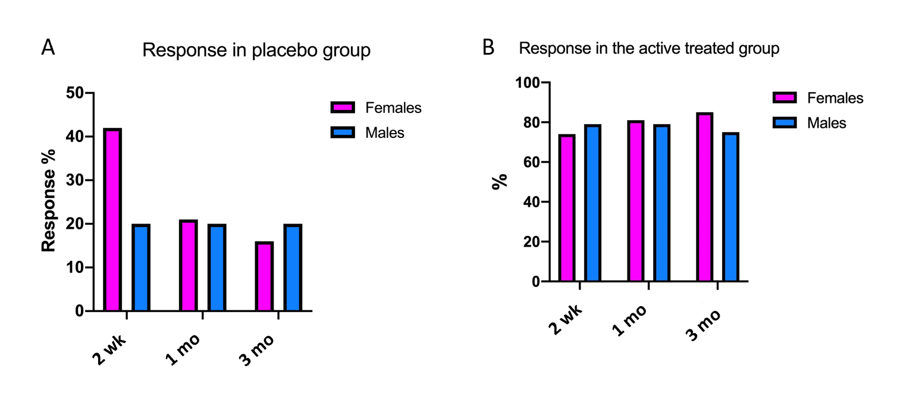
Figure 1 Response to faecal microbiota transplantation in females and males at different intervals after faecal microbiota transplantation in the two groups. A: Placebo group; B: Active treated group.
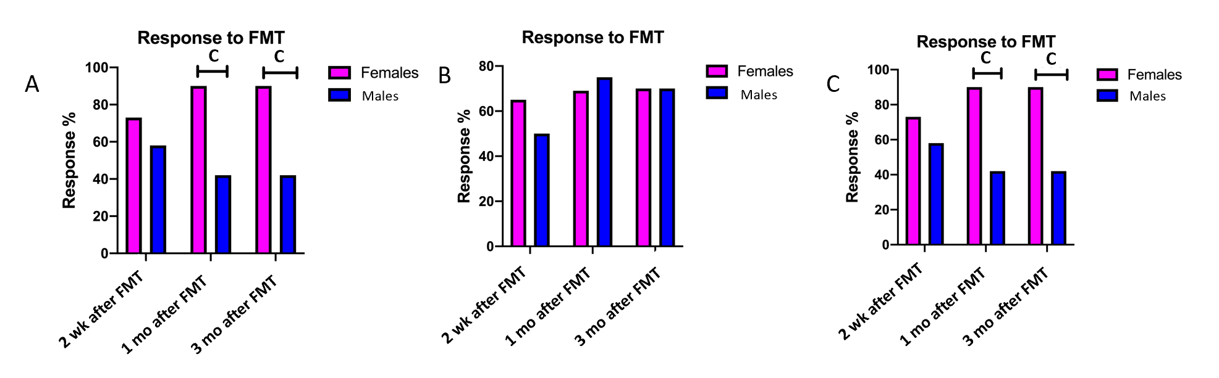
Figure 2 Response rates to faecal microbiota transplantation of female and male irritable bowel syndrome patients. A: Irritable bowel syndrome with diarrhoea-predominant; B: Irritable bowel syndrome with constipation-predominant; C: Irritable bowel syndrome with mixed diarrhoea and constipation. ^{c}P < 0.001. FMT: Faecal microbiota transplantation.
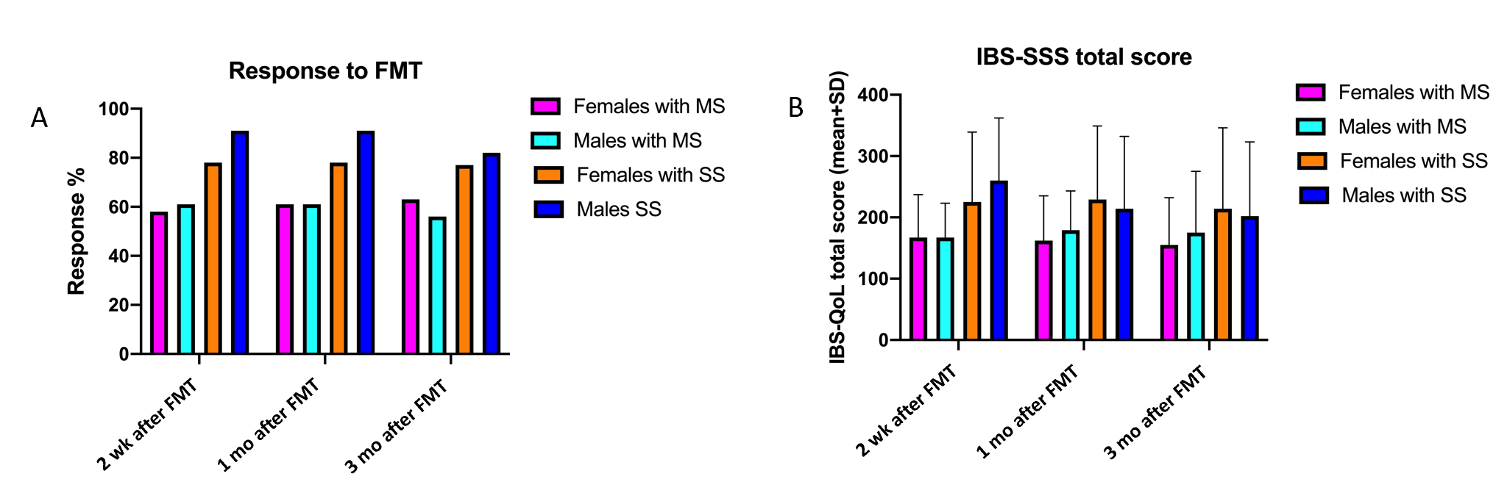
Figure 3 Response rates to faecal microbiota transplantation and the total irritable bowel syndrome-severity scoring system scores of irritable bowel syndrome patients with moderate irritable bowel syndrome symptoms (irritable bowel syndrome-severity scoring system total score between 175 and 300) and with severe irritable bowel syndrome symptoms (irritable bowel syndrome-severity scoring system total score of ≥ 300). A: Faecal microbiota transplantation; B: Irritable bowel syndrome severity scoring system total score. MS: Moderate irritable bowel syndrome symptoms; SS: Severe irritable bowel syndrome symptoms; FMT: Faecal microbiota transplantation.
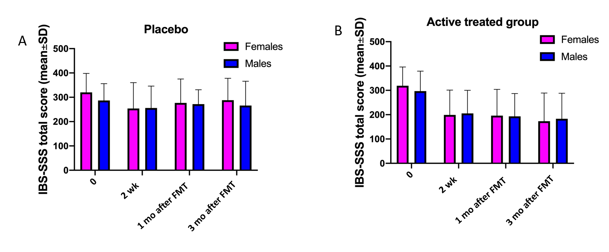
Figure 4 The total irritable bowel syndrome-severity scoring system scores in females and males. A: Placebo group; B: Active treated group. FMT: Faecal microbiota transplantation.

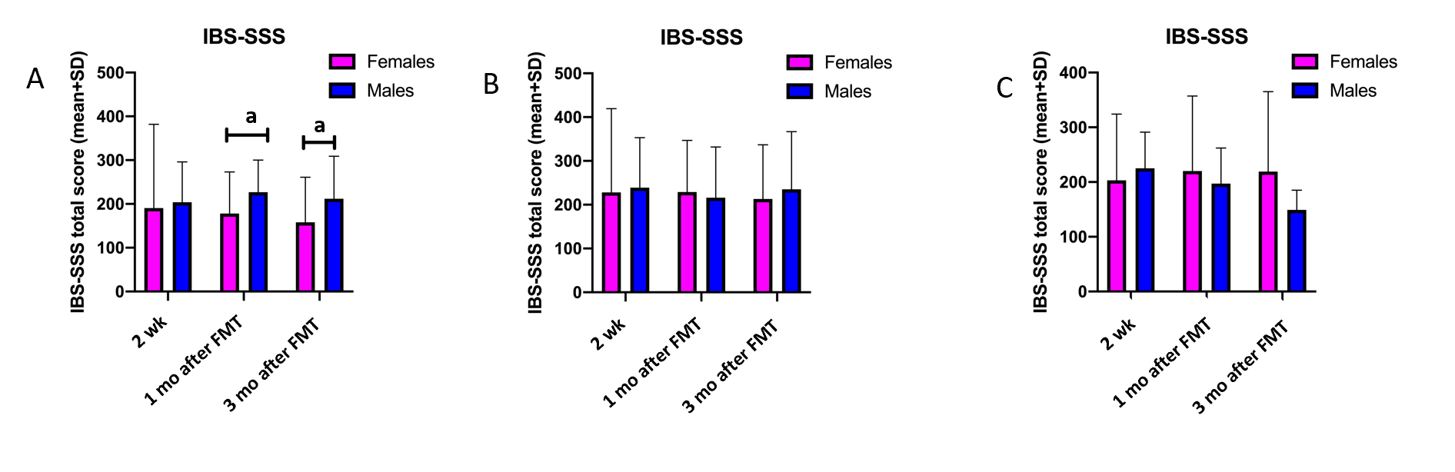
Figure 5 The total irritable bowel syndrome-severity scoring system scores in females and males. A: Irritable bowel syndrome with diarrhoea-predominant; B: Irritable bowel syndrome with constipation-predominant; C: Irritable bowel syndrome with mixed diarrhoea and constipation. ªP < 0.05. IBD-SSS: Irritable bowel syndrome-severity scoring system; FMT: Faecal microbiota transplantation.
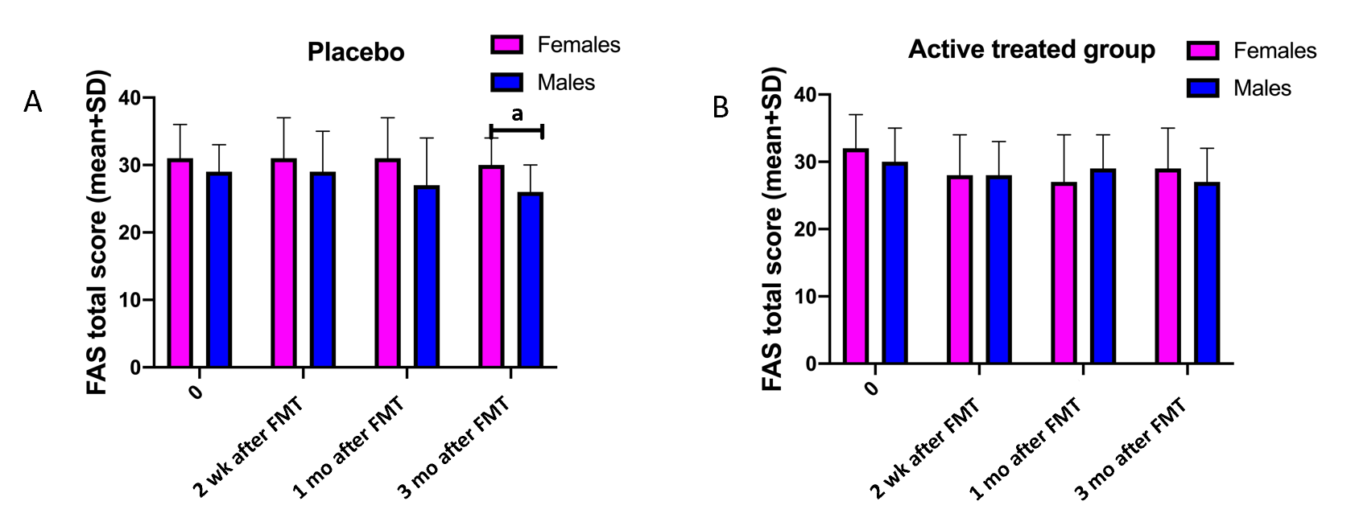
Figure 6 The total Fatigue Assessment Scale scores in female and male irritable bowel syndrome patients. A: Placebo group; B: Active treated group. ªP < 0.05. FAS: Fatigue Assessment Scale; FMT: Faecal microbiota transplantation.
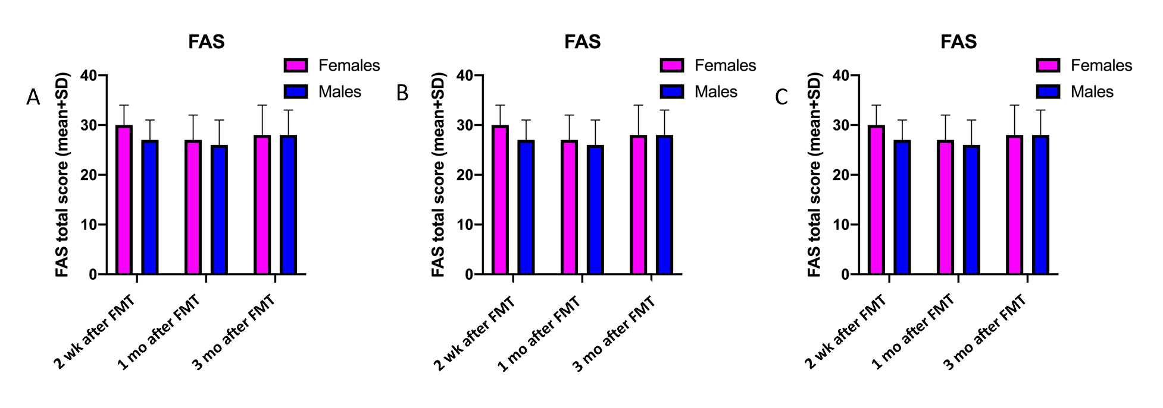
Figure 7 Total Fatigue Assessment Scale scores in female and male patients. A: Irritable bowel syndrome with diarrhoea-predominant; B: Irritable bowel syndrome with constipation-predominant; C: Irritable bowel syndrome with mixed diarrhoea and constipation. FAS: Fatigue Assessment Scale; FMT: Faecal microbiota transplantation.
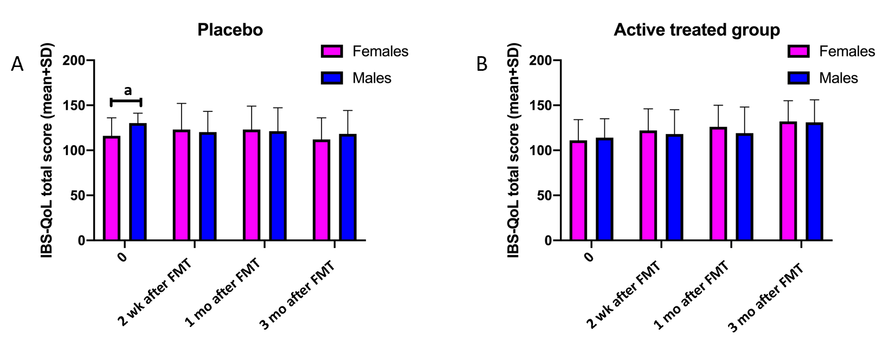
Figure 8 Total irritable bowel syndrome quality of life scale scores in female and male patients. A: Placebo group; B: Active treated group. ªP < 0.05. IBS-QoL: Irritable bowel syndrome quality of life scale; FMT: Faecal microbiota transplantation.
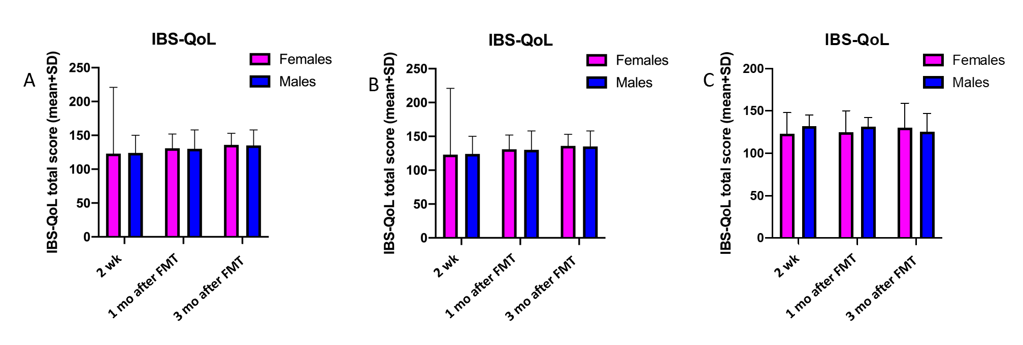
Figure 9 Total irritable bowel syndrome quality of life scale scores in females and males. A: Irritable bowel syndrome with diarrhoea-predominant; B: Irritable bowel syndrome with constipation-predominant; C: Irritable bowel syndrome with mixed diarrhoea and constipation. IBS-QoL: Irritable bowel syndrome quality of life scale; FMT: Faecal microbiota transplantation.
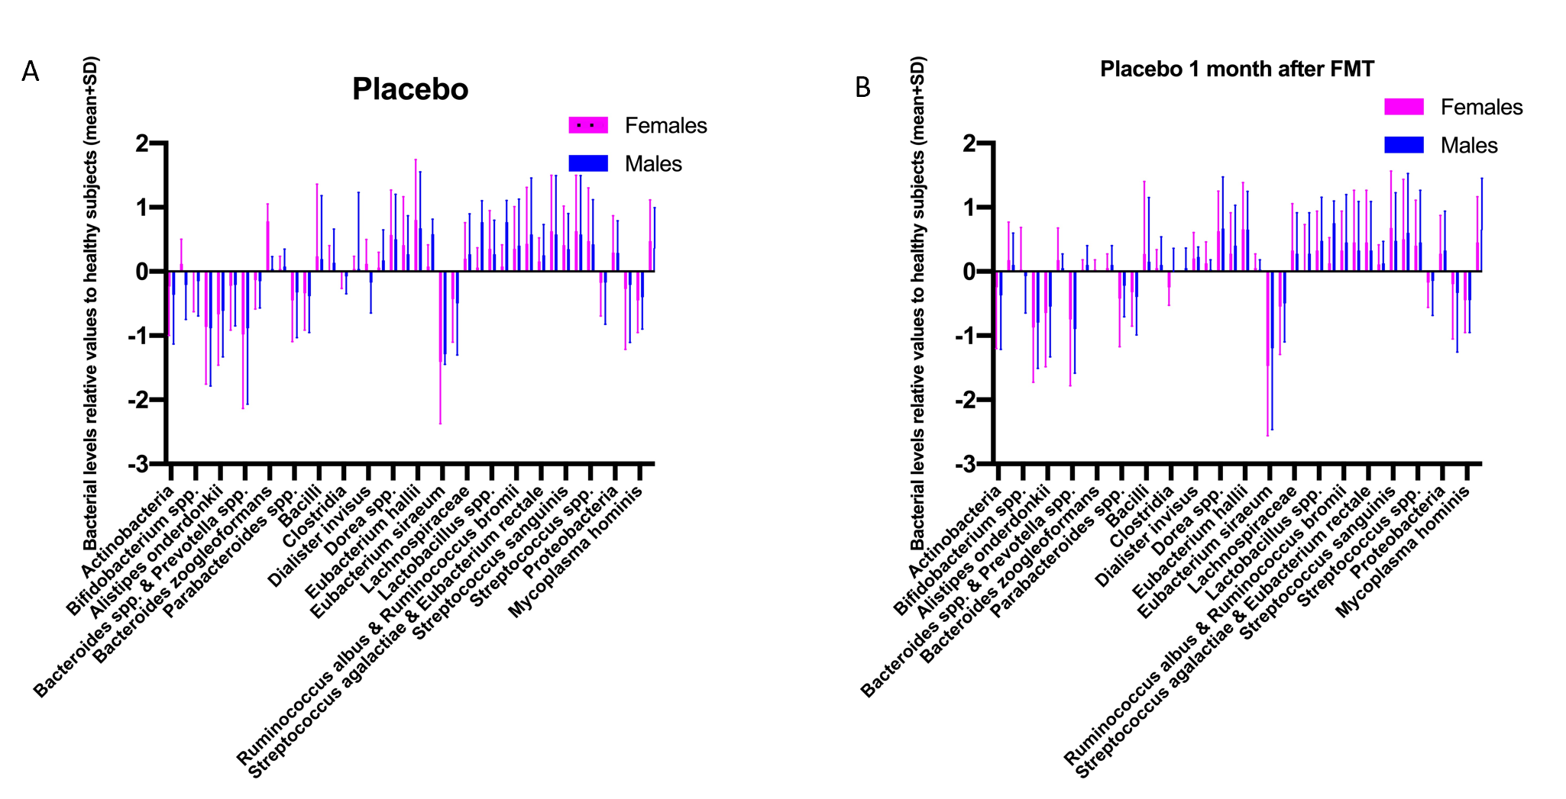
Figure 10 Bacteria levels in the faeces of female and male irritable bowel syndrome patients in the placebo group at the baseline and 1 mo after faecal microbiota transplantation. A: Baseline; B: 1 mo after faecal microbiota transplantation. The bacterial levels are relative values to a normobiotic microbiota profile of 165 healthy subjects. FMT: Faecal microbiota transplantation.
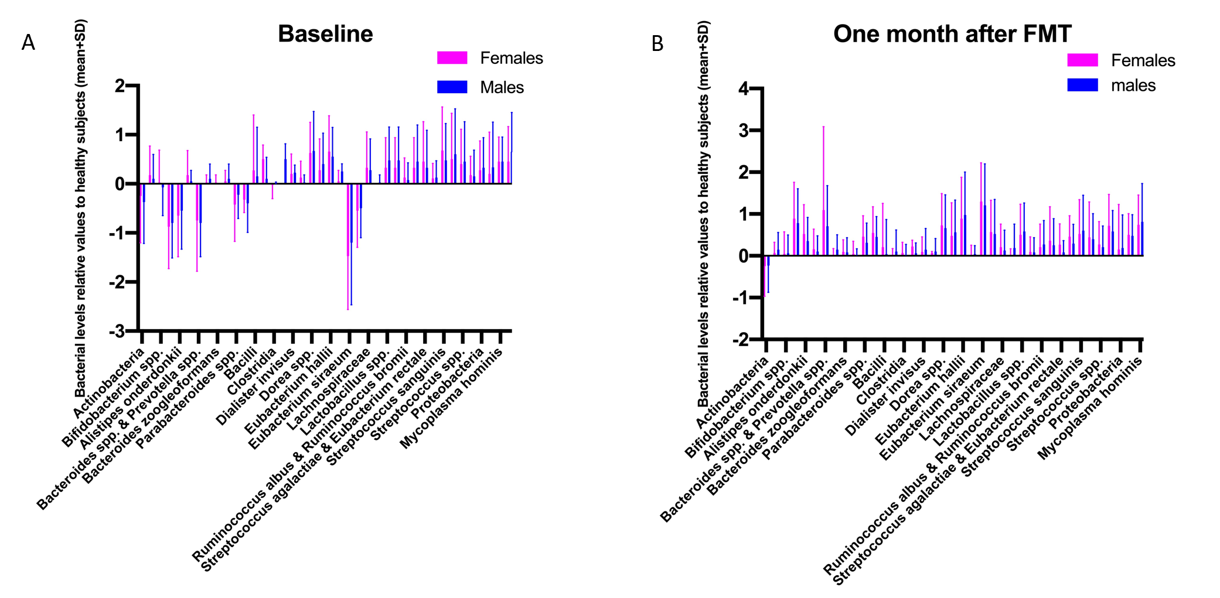
Figure 11 Faecal bacteria levels in the female and male irritable bowel syndrome patients in the active treated group at the baseline and 1 mo after faecal microbiota transplantation. A: Baseline; B: 1 mo after faecal microbiota transplantation. The bacterial levels are expressed as in Figure 10. FMT: Faecal microbiota transplantation.
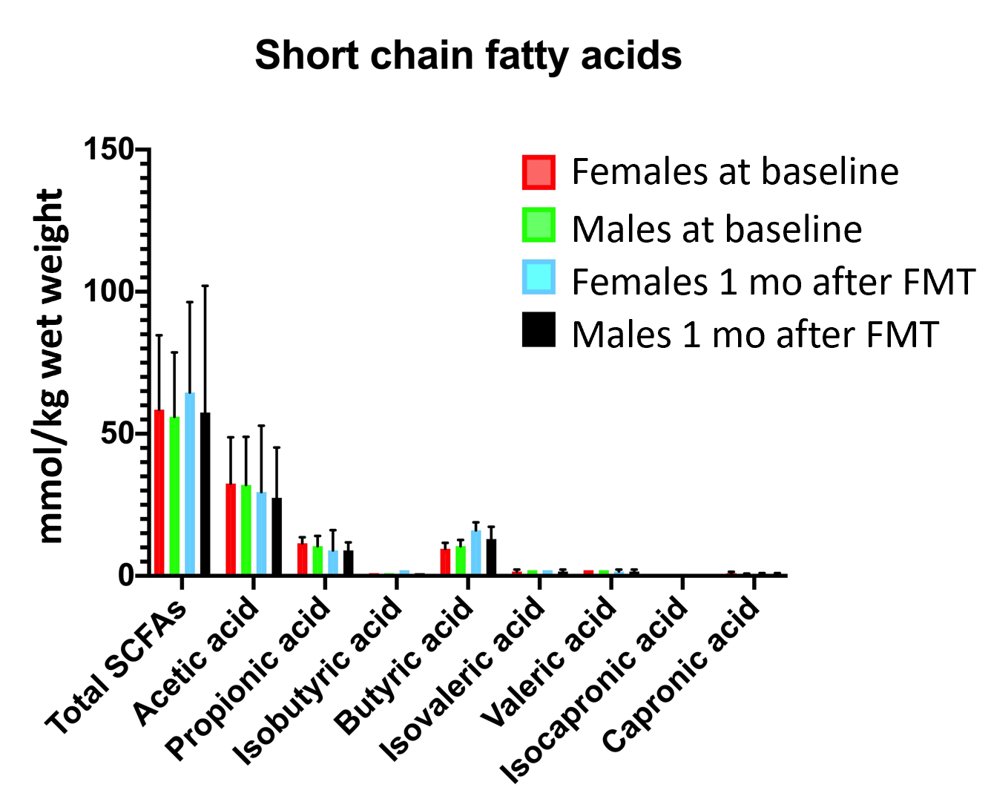
Figure 12 The faecal short chain fatty acids concentration of female and male patients in both the placebo and active treated groups at the baseline and 1 mo after faecal microbiota transplantation. The values were expressed as mmol/kg wet weight (mean ± SD).
Table 1 Characteristics of the patients in the placebo and active treated groups
 | Placebo |  |  | P value | Active treated |  |  | P value
 | Total | Females | Males |  | Total | Females | Males
n | 55 | 47 | 8 |  | 109 | 85 | 24
Age, yr (median, range) | 38.5 (18-75) | 38.0 (18-73) | 47.0 (20-75) | 0.3 | 39.0 (18-73) | 40.0 (18-73) | 32.0 (21-65) | 0.07
IBS-D | 21 | 19 | 2 | 0.7 | 42 | 30 | 12 | 0.4
IBS-C | 22 | 18 | 4 |  | 40 | 32 | 8
IBS-M | 12 | 10 | 2 |  | 27 | 23 | 4
IBS duration, yr | 15.5 ± 7.9 | 16.2 ± 8.0 | 15.0 ± 9.0 | 0.9 | 17.3 ± 8.9 | 16.8 ± 8.2 | 18.0 ± 9.2 | 0.9
Age at IBS onset, yr (median, range) | 20.0 (15-35) | 20.5 (16-35) | 19.0 (15-30) | 0.4 | 20.0 (15-36) | 20.0 (16-35) | 20 (15-33) | 0.6
IBS-SSS total score | 315.2 ± 77.1 | 320.1 ± 77.8 | 286.9 ± 69.3 | 0.5 | 312.9 ± 82.0 | 319.1 ± 77.3 | 297.7 ± 82.0 | 0.4
Moderate symptoms¹ (%) | 23 (42) | 17 (36) | 6 (75) | 0.06 | 45 (41) | 30 (35) | 13 (54) | 0.1
Severe symptoms² (%) | 32 (58) | 30 (64) | 2 (25) |  | 64 (59) | 55 (65) | 11 (46)
Data are n, n (%) or mean ± SD values.
¹Irritable bowel syndrome severity scoring system total score between 175 and 300.
²Irritable bowel syndrome severity scoring system total score of ≥ 300. IBS: Irritable bowel syndrome; IBS-D: Irritable bowel syndrome with diarrhoea-predominant; IBS-C: Irritable bowel syndrome with constipation-predominant; IBS-M: Irritable bowel syndrome with mixed diarrhoea and constipation; IBS-SSS: Irritable bowel syndrome severity scoring system.
Table 2 The response rates of females and males in different irritable bowel syndrome-subtypes at different intervals after faecal microbiota transplantation
Time after FMT | IBS-D |  |  | IBS-C |  |  | IBS-M
 | Females | Males | P value | Females | Males | P value | Females | Males | P value
2 wk (%) | 73 | 58 | 0.3 | 65 | 50 | 0.7 | 72 | 55 | 0.3
1 mo (%) | 90 | 42 | 0.0003 | 69 | 75 | 0.7 | 65 | 60 | 0.9
3 mo (%) | 90 | 42 | 0.0003 | 70 | 75 | 0.3 | 63 | 80 | 0.6
IBS-D: Irritable bowel syndrome with diarrhoea-predominant symptom; IBS-C: Irritable bowel syndrome with constipation-predominant symptom; IBS-M: Irritable bowel syndrome with mixed diarrhoea and constipation; FMT: Faecal microbiota transplantation.
Table 3 The response rates in females and males with either moderate or severe irritable bowel syndrome symptoms
Time after FMT | Moderate symptoms¹ |  |  | Severe symptoms²
 | Females | Males | P value | Females | Males | P value
2 wk (%) | 58 | 61 | 0.999 | 78 | 91 | 0.4
1 mo (%) | 61 | 61 | 0.999 | 78 | 91 | 0.4
3 mo (%) | 63 | 56 | 0.778 | 77 | 82 | 0.999
¹Irritable bowel syndrome severity scoring system total score between 175 and 300.
²Irritable bowel syndrome severity scoring system total score of ≥ 300. FMT: Faecal microbiota transplantation.
Table 4 Irritable bowel syndrome severity scoring system total scores of females and males in the two study groups at different times after faecal microbiota transplantation
Time | Placebo |  | P value | Active treated |  | P value
 | Females | Males |  | Females | Males
0 | 320 ± 78 | 287 ± 69 | 0.2 | 319 ± 77 | 297 ± 82 | 0.3
2 wk | 254 ± 106 | 256 ± 90 | 0.9 | 199 ± 102 | 205 ± 95 | 0.6
1 mo | 277 ± 98 | 272 ± 89 | 0.8 | 196 ± 108 | 193 ± 94 | 0.9
3 mo | 288 ± 90 | 266 ± 100 | 0.6 | 173 ± 116 | 183 ± 105 | 0.5
Data are mean ± SD values.
Table 5 The irritable bowel syndrome severity scoring system total scores in females and males belonging to different irritable bowel syndrome-sub-types
Time after FMT | IBS-D |  |  | IBS-C |  |  | IBS-M
 | Females | Males | P value | Females | Males | P value | Females | Males | P value
2 wk | 190.5 ± 191.4 | 204.0 ± 92.2 | 0.6 | 228.1 ± 116.2 | 239.2 ± 113.8 | 0.5 | 202.8 ± 121.3 | 225.0 ± 65.8 | 0.5
1 mo | 177.8 ± 94.9 | 226.9 ± 73.3 | 0.02 | 228.8 ± 118.1 | 215.8 ± 115.7 | 0.6 | 219.9 ± 136.6 | 197.0 ± 65.2 | 0.8
3 mo | 157.8 ± 102.9 | 212.3 ± 96.9 | 0.03 | 212.8 ± 124.0 | 234.6 ± 131.8 | 0.5 | 219.2 ± 146.3 | 149.0 ± 36.0 | 0.5
Data are mean ± SD values. IBS-D: Irritable bowel syndrome with diarrhoea-predominant symptom; IBS-C: Irritable bowel syndrome with constipation-predominant symptom; IBS-M: Irritable bowel syndrome with mixed diarrhoea and constipation; FMT: Faecal microbiota transplantation.
Table 6 Irritable bowel syndrome severity scoring system total scores in females and males with moderate or severe irritable bowel syndrome symptoms
Time after FMT | Moderate symptoms¹ |  |  | Severe symptoms²
 | Females | Males | P value | Females | Males | P value
2 wk | 166.5 ± 70.0 | 167.2 ± 55.8 | 0.8 | 225.1 ± 114.0 | 259.5 ± 102.3 | 0.3
1 mo | 162.1 ± 73.1 | 179.4 ± 63.8 | 0.5 | 229.2 ± 120.2 | 214.1 ± 118.1 | 0.7
3 mo | 155.3 ± 76.9 | 175.3 ± 100.2 | 0.5 | 214.6 ± 131.8 | 202.3 ± 120.6 | 0.8
Data are mean ± SD values.
¹Irritable bowel syndrome severity scoring system total score between 175 and 300.
²Irritable bowel syndrome severity scoring system total score of ≥ 300. FMT: Faecal microbiota transplantation.
Table 7 Fatigue Assessment Scale total scores of females and males in the two study groups at different times after faecal microbiota transplantation
Time | Placebo |  |  | Active treated
 | Females | Males | P value | Females | Males | P value
0 | 31 ± 5 | 29 ± 4 | 0.3 | 32 ± 5 | 30 ± 5 | 0.09
2 wk | 31 ± 6 | 29 ± 6 | 0.2 | 28 ± 6 | 28 ± 5 | 0.5
1 mo | 31 ± 6 | 27 ± 7 | 0.1 | 27 ± 7 | 29 ± 5 | 0.5
3 mo | 30 ± 4 | 26 ± 4 | 0.01 | 29 ± 6 | 27 ± 5 | 0.7
Data mean ± SD values.
Table 8 Fatigue Assessment Scale total scores of females and males irritable bowel syndrome patients belonging to different irritable bowel syndrome-subtypes
Time after FMT | IBS-D |  |  | IBS-C |  |  | IBS-M
 | Females | Males | P value | Females | Males | P value | Females | Males | P value
2 wk | 30.1 ± 3.6 | 27.0 ± 3.6 | 0.04 | 28.0 ± 6.3 | 29.3 ± 7.4 | 0.5 | 26.7 ± 5.4 | 26.3 ± 2.1 | 0.9
1 mo | 27.1 ± 5.2 | 26.6 ± 4.6 | 0.6 | 27.1 ± 6.7 | 31.3 ± 6.1 | 0.1 | 28.3 ± 8.3 | 28.3 ± 4.0 | 0.9
3 mo | 27.5 ± 5.7 | 27.8 ± 5.0 | 0.4 | 26.0 ± 6.2 | 29.2 ± 5.0 | 0.2 | 26.8 ± 7.6 | 24.8 ± 2.2 | 0.7
Data are mean ± SD values. IBS-D: Irritable bowel syndrome with diarrhoea-predominant symptom; IBS-C: Irritable bowel syndrome with constipation-predominant symptom; IBS-M: Irritable bowel syndrome with mixed diarrhoea and constipation; FMT: Faecal microbiota transplantation.
Table 9 Irritable bowel syndrome quality of life scale total scores of females and males in the two study groups at different times after faecal microbiota transplantation
Time | Placebo |  |  | Active treated
 | Females | Males | P value | Females | Males | P value
0 | 116 ± 20 | 130 ± 11 | 0.03 | 111 ± 23 | 114 ± 21 | 0.9
2 wk | 123 ± 29 | 120 ± 23 | 0.7 | 122 ± 24 | 118 ± 27 | 0.6
1 mo | 123 ± 26 | 121 ± 26 | 0.8 | 126 ± 24 | 119 ± 29 | 0.4
3 mo | 112 ± 24 | 118 ± 26 | 0.2 | 132 ± 23 | 131 ± 25 | 0.9
Data are mean ± SD values.
Table 10 Irritable bowel syndrome quality of life scale total scores of females and males irritable bowel syndrome patients belonging to different irritable bowel syndrome-subtypes
Time after FMT | IBS-D |  |  | IBS-C |  |  | IBS-M
 | Females | Males | P value | Females | Males | P value | Females | Males | P value
2 wk | 123.3 ± 98 | 123.7 ± 25.5 | 0.8 | 120.5 ± 23.1 | 102.4 ± 28.0 | 0.06 | 123.1 ± 24.6 | 131.5 ± 13.0 | 0.4
1 mo | 131.3 ± 20.8 | 129.6 ± 28.2 | 0.9 | 121.9 ± 24.4 | 111.4 ± 29.1 | 01 | 125.4 ± 25.2 | 130.5 ± 11.3 | 0.8
3 mo | 136.4 ± 16.6 | 134.5 ± 22.7 | 0.9 | 128.7 ± 24.4 | 129.1 ± 31.3 | 0.6 | 129.5 ± 28.6 | 124.8 ± 22.0 | 0.5
Data are mean ± SD values. IBS-D: Irritable bowel syndrome with diarrhoea-predominant symptom; IBS-C: Irritable bowel syndrome with constipation-predominant symptom; IBS-M: Irritable bowel syndrome with mixed diarrhoea and constipation; FMT: Faecal microbiota transplantation.
Table 11 Faecal bacteria levels in the female and male irritable bowel syndrome patients in the placebo group at the baseline and 1 mo after faecal microbiota transplantation
Bacteria | Baseline |  | 1 mo after FMT
 | Females | Males | Females | Males
Actinobacteria | -0.235 ± 0.763 | -0.365 ± 0.768 | -0.250 ± 0.954 | -0.375 ± 0.838
Actinomycetales | 0.118 ± 0.382 | -0.212 ± 0.536 | 0.175 ± 0.594 | 0.100 ± 0.496
Bifidobacterium spp. | -0.020 ± 0.607 | -0.154 ± 0.539 | 0.025 ± 0.660 | -0.075 ± 0.572
Alistipes | -0.863 ± 0.895 | -0.885 ± 0.900 | -0.875 ± 0.853 | -0.800 ± 0.709
Alistipes onderdonkii | -0.667 ± 0.792 | -0.615 ± 0.718 | -0.650 ± 0.834 | -0.550 ± 0.783
Bacteroides fragilis | -0.255 ± 0.689 | -0.212 ± 0.637 | 0.175 ± 0.501 | 0.050 ± 0.221
Bacteroides spp. and Prevotella spp. | -0.980 ± 1.157 | -0.885 ± 1.182 | -0.750 ± 1.032 | -0.900 ± 0.687
Bacteroides stercoris | -0.137 ± 0.448 | -0.154 ± 0.415 | 0.025 ± 0.158 | 0.100 ± 0.304
Bacteroides zoogleoformans | 0.078 ± 0.272 | 0.038 ± 0.194 | 0.025 ± 0.158 | 0 ± 0
Parabacteroides johnsonii | 0.039 ± 0.196 | 0.077 ± 0.269 | 0.050 ± 0.221 | 0.100 ± 0.304
Parabacteroides spp. | -0.451 ± 0.642 | -0.327 ± 0.706 | -0.425 ± 0.747 | -0.225 ± 0.480
Firmicutes | -0.431 ± 0.575 | -0.385 ± 0.566 | -0.325 ± 0.526 | -0.400 ± 0.591
Bacilli | 0.235 ± 1.124 | 0.192 ± 0.991 | 0.271 ± 1.132 | 0.150 ± 1.001
Catenibacterium mitsuokai | 0.000 ± 0.400 | 0.135 ± 0.525 | 0.050 ± 0.289 | 0.100 ± 0.441
Clostridia | -0.020 ± 0.244 | -0.077 ± 0.269 | -0.025 ± 0.276 | 0.0 ± 0.036
Clostridium spp. | 0.039 ± 0.196 | 0.038 ± 0.194 | 0.0 ± 0.0 | 0.050 ± 0.316
Dialister invisus | 0.118 ± 0.381 | -0.173 ± 0.474 | 0.200 ± 0.405 | 0.225 ± 0.158
Dialister invisus and Megasphaera micronuciformis | 0.059 ± 0.238 | 0.173 ± 0.474 | 0.125 ± 0.335 | 0.025 ± 0.158
Dorea spp. | 0.569 ± 0.700 | 0.500 ± 0.700 | 0.625 ± 0.628 | 0.667 ± 0.806
Eubacterium biforme | 0.412 ± 0.753 | 0.269 ± 0.598 | 0.275 ± 0.640 | 0.400 ± 0.633
Eubacterium hallii | 0.804 ± 0.939 | 0.673 ± 0.879 | 0.655 ± 0.730 | 0.650 ± 0.597
Eubacterium rectale | 0.078 ± 0.337 | 0.058 ± 0.235 | 0.050 ± 0.221 | 0.025 ± 0.158
Eubacterium siraeum | -1.412 ± 0.963 | -1.288 ± 0.161 | -1.475 ± 1.086 | -1.200 ± 1.265
Faecalibacterium prausnitzii | -0.431 ± 0.671 | -0.500 ± 0.804 | -0.550 ± 0.745 | -0.500 ± 0.599
Lachnospiraceae | 0.196 ± 0.566 | 0.269 ± 0.630 | 0.325 ± 0.730 | 0.275 ± 0.640
Lactobacillus ruminis and Pediococcus acidilactici | 0.059 ± 0.311 | 0.077 ± 0.334 | 0.0 ± 0.0 | 0.025 ± 0.158
Lactobacillus spp. | 0.353 ± 0.594 | 0.269 ± 0.528 | 0.325 ± 0.616 | 0.475 ± 0.680
Phascolarctobacterium spp. | 0.078 ± 0337 | 0.077 ± 0.337 | 0.125 ± 0.404 | 0.075 ± 0.350
Ruminococcus albus and Ruminococcus bromii | 0.353 ± 0.658 | 0.404 ± 0.721 | 0.325 ± 0.616 | 0.450 ± 0.749
Ruminococcus gnavus | 0.431 ± 0.878 | 0.577 ± 0.878 | 0.450 ± 0.815 | 0.325 ± 0.764
Streptococcus agalactiae & Eubacterium rectale | 0.157 ± 0.367 | 0.250 ± 0.480 | 0.110 ± 0.304 | 0.125 ± 0.345
Streptococcus salivarius ssp. Thermophilus and Streptococcus sanguinis | 0.412 ± 0.606 | 0.346 ± 0.556 | 0.675 ± 0.888 | 0.475 ± 0.751
Streptococcus salivarius ssp. thermophilus | 0.628 ± 0.871 | 0.577 ± 0.915 | 0.500 ± 0.934 | 0.600 ± 0.928
Streptococcus spp. | 0.471 ± 0.833 | 0.423 ± 0.696 | 0.400 ± 0.709 | 0.450 ± 0.815
Veillonella spp. | -0.177 ± 0.518 | -0.173 ± 0.648 | -0.175 ± 0.385 | -0.150 ± 0.534
Proteobacteria | 0.294 ± 0.576 | 0.289 ± 0.499 | 0.275 ± 0.599 | 0.325 ± 0.616
Shigella spp. and Escherichia spp. | -0.275 ± 0.940 | -0.212 ± 0.893 | -0.200 ± 0.853 | -0.335 ± 0.920
Mycoplasma hominis | -0.451 ± 0.503 | -0.404 ± 0.496 | -0.450 ± 0.504 | -0.450 ± 0.503
Akkermansia muciniphila | 0.471 ± 0.644 | 0.365 ± 0.627 | 0.450 ± 0.714 | 0.650 ± 0.802
The bacterial levels are mean ± SD relative values to a normobiotic microbiota profile of 165 healthy subjects. FMT: Faecal microbiota transplantation.
Table 12 Gut bacteria levels in female and male irritable bowel syndrome patients in the active treated group at the baseline and 1 mo after faecal microbiota transplantation
Bacteria | Baseline |  | 1 mo after FMT
 | Females | Males | Females | Males
Actinobacteria | -0.250 ± 0.954 | -0.375 ± 0.838 | -0.250 ± 0.719 | -0.2350 ± 0.636
Actinomycetales | 0.175 ± 0.594 | 0.100 ± 0.496 | 0.068 ± 0255 | 0.145 ± 0.412
Bifidobacterium spp. | 0.025 ± 0.660 | -0.075 ± 0.572 | -0.045 ± 0.526 | -0.063 ± 0.433
Alistipes | -0.875 ± 0.853 | -0.800 ± 0.709 | -0.886 ± 0.869 | -0.783 ± 0.821
Alistipes onderdonkii | -0.650 ± 0.834 | -0.550 ± 0.783 | -0.523 ± 0.699 | -0.354 ± 0.565
Bacteroides fragilis | 0.175 ± 0.501 | 0.050 ± 0.221 | 0.159 ± 0.480 | 0.104 ± 0.371
Bacteroides spp. and Prevotella spp. | -0.750 ± 1.032 | -0.800 ± 0.687 | -1.091 ± 1.996 | -0.708 ± 0.967
Bacteroides stercoris | 0.025 ± 0.158 | 0.100 ± 0.304 | 0.023 ± 0.151 | 0.146 ± 0.357
Bacteroides zoogleoformans | 0.025 ± 0.158 | 0 ± 0 | 0.091 ± 0.291 | 0.083 ± 0.347
Parabacteroides johnsonii | 0.050 ± 0.221 | 0.100 ± 0.304 | 0.045 ± 0.302 | 0.021 ± 0.144
Parabacteroides spp. | -0.425 ± 0.747 | -0.225 ± 0.480 | -0.455 ± 0.504 | -0.313 ± 0.468
Firmicutes | -0.325 ± 0.526 | -0.400 ± 0.591 | -0.546 ± 0.627 | -0.454 ± 0.483
Bacilli | 0.271 ± 1.132 | 0.150 ± 1.001 | 0.205 ± 1.047 | 0.042 ± 0.824
Catenibacterium mitsuokai | 0.050 ± 0.289 | 0.100 ± 0.441 | 0.023 ± 0.151 | 0.104 ± 0.515
Clostridia | -0.025 ± 0.276 | 0.0 ± 0.036 | 0.068 ± 0.255 | 0.021 ± 252
Clostridium spp. | 0.0 ± 0.0 | 0.050 ± 0.316 | 0.223 ± 0.151 | 0.063 ± 0.245
Dialister invisus | 0.200 ± 0.405 | 0.225 ± 0.158 | 0.091 ± 0.362 | 0.146 ± 0.505
Dialister invisus and Megasphaera micronuciformis | 0.125 ± 0.335 | 0.025 ± 0.158 | 0.068 ± 0.034 | 0.104 ± 0.308
Dorea spp. | 0.625 ± 0.628 | 0.667 ± 0.806 | 0.727 ± 0.758 | 0.663 ± 0.796
Eubacterium biforme | 0.275 ± 0.640 | 0.400 ± 0.633 | 0.477 ± 0.791 | 0.563 ± 0.769
Eubacterium hallii | 0.655 ± 0.730 | 0.550 ± 0.597 | 0.886 ± 0.993 | 0.979 ± 1.021
Eubacterium rectale | 0.050 ± 0.221 | 0.025 ± 0.158 | 0-068 ± 0.255 | 0.042 ± 0.202
Eubacterium siraeum | -1.475 ± 1.086 | -1.200 ± 1.265 | -1.295 ± 0.930 | -1.208 ± 0.988
Faecalibacterium prausnitzii | -0.550 ± 0.745 | -0.500 ± 0.599 | -0.568 ± 0.759 | -0.521 ± 0.825
Lachnospiraceae | 0.325 ± 0.730 | 0.275 ± 0.640 | 0.205 ± 0.553 | 0.125 ± 0.489
Lactobacillus ruminis and Pediococcus acidilactici | 0.0 ± 0.0 | 0.025 ± 0.158 | 0.021 ± 0.146 | 0.188 ± 0.571
Lactobacillus spp. | 0.325 ± 0.616 | 0.475 ± 0.680 | 0.500 ± 0.731 | 0.583 ± 0.679
Phascolarctobacterium spp. | 0.125 ± 0.404 | 0.075 ± 0.350 | 0.091 ± 0.362 | 0.083 ± 0.347
Ruminococcus albus and Ruminococcus bromii | 0.325 ± 0.616 | 0.450 ± 0.749 | 0.205 ± 0.553 | 0.271 ± 0.574
Ruminococcus gnavus | 0.450 ± 0.815 | 0.325 ± 0.764 | 0.364 ± 0.810 | 0.250 ± 0.636
Streptococcus agalactiae & Eubacterium rectale | 0.110 ± 0.304 | 0.125 ± 0.345 | 0.267 ± 0.495 | 0.083 ± 0.279
Streptococcus salivarius ssp. thermophilus and Streptococcus sanguinis | 0.675 ± 0.888 | 0.475 ± 0.751 | 0.455 ± 0.504 | 0.292 ± 0.459
Streptococcus salivarius ssp. thermophilus | 0.500 ± 0.934 | 0.600 ± 0.928 | 0.523 ± 0.821 | 0.604 ± 0.844
Streptococcus spp. | 0.400 ± 709 | 0.450 ± 0.815 | 0.444 ± 0.841 | 0.396 ± 0.610
Veillonella spp. | -0.175 ± 0.385 | -0.150 ± 0.534 | -0.273 ± 0.544 | -0.208 ± 0.504
Proteobacteria | 0.275 ± 0.599 | 0.325 ± 0.616 | 0.717 ± 0.750 | 0.583 ± 0.498
Shigella spp. and Escherichia spp. | -0.200 ± 0.853 | -0.335 ± 0.920 | -0.151 ± 1.077 | -0.188 ± 0.790
Mycoplasma hominis | -0.450 ± 0.504 | -0.450 ± 0.503 | -0.500 ± 0.506 | -0.479 ± 0.505
Akkermansia muciniphila | 0.450 ± 0.714 | 0.650 ± 0.802 | 0.741 ± 0.713 | 0.813 ± 0.915
The bacterial levels are relative values to a normobiotic microbiota profile of 165 healthy subjects (mean ± SD). FMT: Faecal microbiota transplantation.
Table 13 The short-chain fatty acids concentration in the faeces of the placebo group and the patients that received donor’s faecs (faecal microbiota transplantation) at the baseline and 1 mo after faecal microbiota transplantation
Acids | Placebo |  |  |  | Active treated
 | Baseline |  | 1 mo after FMT |  | Baseline |  | 1 mo after FMT
 | Females | Males | Females | Males | Females | Males | Females | Males
Total SCFAs | 72 ± 37 | 69 ± 23. | 73 ± 37 | 69 ± 23 | 77 ± 40 | 72 ± 40 | 87 ± 42 | 89 ± 26
Acetic acid | 42 ± 18 | 40 ± 15 | 41 ± 17 | 40 ± 14 | 44 ± 21 | 44 ± 20 | 46 ± 13 | 40.2 ± 15.0
Propionic acid | 12 ± 8 | 11 ± 5 | 12 ± 8 | 11 ± 5 | 13 ± 10 | 13 ± 8 | 14 ± 4 | 11 ± 7
Iso-butyric acid | 2 ± 2 | 1 ± 1 | 1 ± 2 | 1 ± 1 | 1 ± 1 | 1 ± 1 | 2 ± 2 | 1 ± 1
Butyric acid | 14 ± 9 | 12 ± 6 | 13 ± 8 | 12 ± 6 | 11 ± 8 | 12 ± 9 | 18 ± 14 | 16 ± 10
Iso-valeric acid | 2 ± 2 | 2 ± 1 | 2 ± 2 | 2 ± 1 | 2 ± 1 | 2 ± 2 | 2 ± 2 | 2 ± 1
Valeric acid | 2 ± 2 | 1 ± 1 | 2 ± 2 | 1 ± 1 | 2 ± 2 | 2 ± 2 | 2 ± 1 | 2 ± 1
Iso-capronic acid | 0.1 ± 0.04 | 0.01 ± 0.07 | 0.5 ± 0.7 | 0.4 ± 0.7 | 0.0 ± 0.0 | 0.02 ± 0.08 | 0.01 ± 0.04 | 0.0 ± 0.0
Capronic acid | 0.5 ± 0.7 | 0.5 ± 0.7 | 0.01 ± 0.04 | 0.1 ± 0.08 | 0.7 ± 1.3 | 0.6 ± 0.8 | 0.6 ± 0.9 | 0.5 ± 0.9
The values were expressed as mmol/kg wet weight (mean ± SD). FMT: Faecal microbiota transplantation; SCFAs: Short-chain fatty acids.

Published by Baishideng Publishing Group Inc
7041 Koll Center Parkway, Suite 160, Pleasanton, CA 94566, USA
Telephone: +1-925-3991568
E-mail: bpgoffice@wjgnet.com
Help Desk: https://www.f6publishing.com/helpdesk
https://www.wjgnet.com

© 2021 Baishideng Publishing Group Inc. All rights reserved.

