Name of Journal: World Journal of Clinical Cases
Manuscript NO: 69727
Manuscript Type: CASE REPORT

Clinical algorithm for preventing missed diagnoses of occult cervical spine instability after acute trauma: A case report

Zhu C et al. Clinical algorithm for cervical spine instability

Ce Zhu, Hui-Liang Yang, Gi Hye Im, Li-Min Liu, Chun-Guang Zhou, Yue-Ming Song

Ce Zhu, Hui-Liang Yang, Li-Min Liu, Chun-Guang Zhou, Yue-Ming Song, Department of Orthopedic Surgery and Orthopedics Research Institute, West China Hospital of Sichuan University, Chengdu 610041, Sichuan Province, China

Gi Hye Im, Department of Emergency Medicine, Rhode Island Hospital, Warren Alpert Medical School of Brown University, Providence, RI 02903, United States

Author contributions: Zhu C and Yang HL conceived the study design, carried out the study, and drafted the manuscript; Im GH and Liu LM carried out the initial analyses and reviewed and revised the manuscript; Zhou CG and Song YM coordinated and supervised data collection and critically reviewed and revised the manuscript for important intellectual content; all authors approved the final manuscript as submitted and agree to be accountable for all aspects of the work; Im GH is a native English speaker and refined the language of the manuscript; Zhu C and Yang HL contributed equally to this work.

Supported by grants from China Postdoctoral Science Foundation General Program No. 2019M653417; Sichuan Science and Technology Program, No. 2020YJ0025, No. 2017SZ0046, and No. 2017SZDZX0021; Post-Doctor Research Project, Sichuan University, No. 2019SCU12043; and International Postdoctoral Exchange Fellowship Program, No. PC2019060.

Corresponding author: Chun-Guang Zhou, MD, PhD, Assistant Professor, Department of Orthopedic Surgery and Orthopedics Research Institute, West China Hospital of Sichuan University, No. 37 Guoxue Road, Chengdu 610041, Sichuan Province, China. zcg_spine@163.com

Received: July 9, 2021
Revised: July 29, 2021
Accepted: September 10, 2021
Published online: November 26, 2021

Abstract
BACKGROUND
Missed or delayed diagnosis of cervical spine instability after acute trauma can have catastrophic consequences for the patient, resulting in severe neurological impairment. Currently, however, there is no consensus on the optimal strategy for diagnosing occult cervical spine instability. Thus, we present a case of occult cervical spine instability and provide a clinical algorithm to aid physicians in diagnosing occult instability of the cervical spine.

CASE SUMMARY
A 57-year-old man presented with cervical spine pain and inability to stand following a serious fall from a height of 2 m. No obvious vertebral fracture or dislocation was found at the time on standard lateral X-ray, computed tomography, and magnetic resonance imaging (MRI). Subsequently, the initial surgical plan was unilateral open-door laminoplasty (C3-7) with alternative levels of centerpiece mini-plate fixation (C3, 5, and 7). However, the intraoperative C-arm fluoroscopic X-rays revealed significantly increased intervertebral space at C5-6, indicating instability at this level that was previously unrecognized on preoperative imaging. We finally performed lateral mass fixation and fusion at the C5-6 level. Looking back at the preoperative images, we found that the preoperative T2 MRI showed non-obvious high signal intensity at the C5-6 intervertebral disc and posterior interspinous ligament.

CONCLUSION
MRI of cervical spine trauma patients should be carefully reviewed to detect disco-ligamentous injury, which will lead to further cervical spine instability. In patients with highly suspected cervical spine instability indicated on MRI, lateral X-ray under traction or after anesthesia and muscle relaxation needs to be performed to avoid missed diagnoses of occult cervical instability.

Key Words: Clinical algorithm; Missed diagnoses; Occult cervical spine instability; Case report

©The Author(s) 2021. Published by Baishideng Publishing Group Inc. All rights reserved.

Citation: Zhu C, Yang HL, Im GH, Liu LM, Zhou CG, Song YM. Clinical algorithm for preventing missed diagnoses of occult cervical spine instability after acute trauma: A case report. World J Clin Cases 2021; 9(33): 10369-10373
URL: https://www.wjgnet.com/2307-8960/full/v9/i33/10369.htm
DOI: https://dx.doi.org/10.12998/wjcc.v9.i33.10369

Core Tip: Currently, there is no consensus on the optimal strategy for diagnosing occult cervical spine instability. We present a case of occult cervical spine instability and provide a clinical algorithm for diagnosing occult instability of the cervical spine. In this clinical algorithm, we recommend bedside lateral X-ray under traction or lateral X-ray after anesthesia and muscle relaxation prior to surgery as an effective, safe, and efficient method for detecting highly suspected instability of the cervical spine. We believe that this clinical algorithm will aid physicians in preventing missed diagnoses of occult instability of the cervical spine.

INTRODUCTION
Cervical spine instability can result from injury to vertebral bone, intervertebral disc or ligament, or other soft tissue. Investigating cervical spine instability after acute trauma is important. Missed or delayed diagnosis can have catastrophic consequences for the patient, resulting in severe neurological impairment^{[1,2]}. Multiple radiological techniques are used to evaluate the stability of the cervical spine, such as X-ray, computed tomography (CT), and magnetic resonance imaging (MRI). Currently, however, there is no consensus on the optimal strategy for diagnosis of occult cervical spine instability. Only a few cases have been reported in the literature regarding the diagnosis and treatment of unrecognized cervical spine instability^{[3-5]}. Here, we present a case of occult cervical spine instability and provide a clinical algorithm to aid physicians with diagnosis of occult instability of the cervical spine.

CASE PRESENTATION
Chief complaints
A 57-year-old man presented with cervical spine pain and inability to stand following a serious fall from a height of 2 m.

History of present illness
The patient had no prior history with regard to the lesion.

History of past illness
The patient had no specific history of past illness.

Personal and family history
The patient had no known personal or family medical history.

Physical examination
Physical examination revealed cervical spine tenderness and neurological deficits. He had grade 2/5 muscle strength in his right upper extremity and grade 0/5 muscle strength in his other extremities. He also had dysesthesia below bilateral C5 dermatomes.

Laboratory examinations
All ordered laboratory tests (complete blood count, basic metabolic panel, lipid panel, liver panel, coagulation tests, urinalysis, and stool analysis) were normal.

Imaging examinations
No obvious vertebral fracture or dislocation was found at the time on standard lateral X-ray, CT, and MRI (Figure 1A and B). No other injuries or comorbidities were found.

FINAL DIAGNOSIS
The patient was diagnosed with hyperextension injury of the cervical spinal cord and cervical spinal canal stenosis.

TREATMENT
The initial surgical plan was unilateral open-door laminoplasty (C3-7) with alternative levels of centerpiece mini-plate fixation (C3, 5, and 7). However, after the above procedures were completed, intraoperative C arm fluoroscopic X-rays revealed significantly increased intervertebral space at C5-6, indicating instability at this level (Figure 1C) that was previously unrecognized on preoperative imaging. Therefore, after obtaining consent from the patient’s family, we removed the centerpiece mini-plate on C5 and then performed lateral mass fixation and fusion at the C5-6 level.

OUTCOME AND FOLLOW-UP
There were no neurological or other major surgical complications. When the patient was discharged from the hospital, he had regained some motor function in his upper extremities: grade 3/5 muscle strength in the right upper extremity and grade 2/5 muscle strength in the left upper extremity. He continued to have grade 0/5 muscle strength in his lower extremities and dysesthesia below bilateral C5 dermatomes.
Looking back at the preoperative images, we found that the MRI at the time of admission showed non-obvious high signal intensity at the C5-6 intervertebral disc and posterior interspinous ligament on T2 MRI (Figure 1B). This, in conjunction with a preoperative lateral X-ray, either under traction at the bedside or in the operating room after anesthesia and muscle relaxation prior to surgery, could have identified the occult cervical spine instability earlier rather than intraoperatively.

DISCUSSION
Medical history, physical examination, and multiple radiological techniques are used to diagnose instability of the cervical spine after acute traumatic injury. For patients with cervical spine tenderness and/or neurological deficit, static lateral X-ray is the first-line imaging modality for assessing obvious fractures or dislocation of the cervical spine. CT is the gold standard for detecting occult cervical spine fractures but is unable to detect instability in the cervical spine caused by injury to the intervertebral disc, ligament, or other soft tissue^{[6,7]}. MRI provides detailed soft-tissue imaging but has a sensitivity of only 75% in detecting ligamentous injury^{[7,8]}. Therefore, a more accurate and efficient protocol needs to be developed in order to prevent missed diagnoses of occult cervical spine instability.
Preoperative lateral X-ray under traction or after anesthesia and muscle relaxation should be used to evaluate occult instability of the cervical spine. Unlike in a standard lateral X-ray, lateral X-ray under axial traction provides the benefit of elongating the soft tissue of the neck, thus reducing muscle spasms that may obscure cervical spine instability on a standard lateral X-ray^{[9]}. For patients who require concomitant trauma surgery, lateral X-ray can be obtained after anesthesia and muscle relaxation prior to surgery to assess the stability of the cervical spine. Some physicians may recommend getting flexion/extension lateral X-rays, which unlike static lateral X-rays, may detect instability of the cervical spine from a subtle disc or ligamentous injury^{[10,11]}. However, the use of flexion/extension X-rays after acute cervical spine trauma is debated since this movement of the neck may aggravate the injury^{[12]}. Generally, however, it is not advisable to use flexion/extension X-rays for patients with neurological deficits after acute trauma or for patients who have limited ability to flex or extend the cervical spine due to pain or muscle spasm. Therefore, we recommend a lateral X-ray under traction or after anesthesia and muscle relaxation as a safe and effective method for identifying occult cervical spine instability.
To help prevent missed diagnoses, we created a clinical algorithm to assist physicians with diagnosis of occult cervical spine instability (Figure 2). Upon patient presentation, medical history should be obtained, careful physical examination should be performed, and static lateral cervical spine X-ray, CT, and MRI should be performed to assess cervical spine instability. If lateral X-ray and CT do not show signs of cervical spine instability, but MRI suggests possible instability caused by soft-tissue injury, bedside lateral X-ray under traction needs to be performed to determine whether there is indeed instability. If the patient requires concomitant trauma surgery, lateral X-ray after anesthesia and muscle relaxation should be obtained prior to surgical incision to evaluate stability of the cervical spine. To avoid missed diagnosis, careful review of preoperative MRI and lateral X-ray under traction or after anesthesia and muscle relaxation is necessary.

CONCLUSION
MRI of cervical spine trauma should be carefully reviewed to detect disco-ligamentous injury, which leads to further cervical spine instability. In patients with highly suspected cervical spine instability indicated on MRI, lateral X-ray needs to be performed under traction or after anesthesia and muscle relaxation to avoid missed diagnosis of occult cervical instability.

REFERENCES
1 Haider Z, Rossiter D, Shafafy R, Kieffer W, Thomas M. How not to miss major spinal pathology in neck pain. Br J Hosp Med (Lond) 2018; 79: C98-C102 [PMID: 29995537 DOI: 10.12968/hmed.2018.79.7.C98]
2 Schoenfeld AJ, Beck AW, Harris MB, Anderson PA. Evaluating the Cervical Spine in the Blunt Trauma Patient. J Am Acad Orthop Surg 2019; 27: 633-641 [PMID: 31135560 DOI: 10.5435/JAAOS-D-18-00695]
3 Folman Y, Gepstein R. Secondary neurologic deficit due to unrecognized spine instability in multitrauma casualties: a report of three cases. J Orthop Trauma 2004; 18: 450-454 [PMID: 15289693 DOI: 10.1097/00005131-200408000-00011]
4 Seijas R, Ares O, Casamitjana J. Occult ligamentous injury of the cervical spine associated with cervical spine fracture. Acta Orthop Belg 2005; 71: 746-749 [PMID: 16459871]
5 Dusseldorp JR, Ow-Yang M, Mobbs RJ. Unrecognized ligamentous instability due to high-energy, low-velocity mechanism of injury. J Clin Neurosci 2010; 17: 139-141 [PMID: 19875291 DOI: 10.1016/j.jocn.2009.02.031]
6 Fennessy J, Wick J, Scott F, Roberto R, Javidan Y, Klineberg E. The Utility of Magnetic Resonance Imaging for Detecting Unstable Cervical Spine Injuries in the Neurologically Intact Traumatized Patient Following Negative Computed Tomography Imaging. Int J Spine Surg 2020; 14: 901-907 [PMID: 33560249 DOI: 10.14444/7138]
7 Janssen I, Sollmann N, Barz M, Baum T, Schaller K, Zimmer C, Ryang YM, Kirschke JS, Meyer B. Occult Disco-Ligamentous Lesions of the Subaxial c-Spine-A Comparison of Preoperative Imaging Findings and Intraoperative Site Inspection. Diagnostics (Basel) 2021; 11 [PMID: 33807826 DOI: 10.3390/diagnostics11030447]
8 Bednar DA, Toorani B, Denkers M, Abdelbary H. Assessment of stability of the cervical spine in blunt trauma patients: review of the literature, with presentation and preliminary results of a modified traction test protocol. Can J Surg 2004; 47: 338-342 [PMID: 15540685 DOI: 10.1002/bjs.4827]
9 Kalantar BS, Hipp JA, Reitman CA, Dreiangel N, Ben-Galim P. Diagnosis of unstable cervical spine injuries: laboratory support for the use of axial traction to diagnose cervical spine instability. J Trauma 2010; 69: 889-895 [PMID: 20130489 DOI: 10.1097/TA.0b013e3181bbd660]
10 McCracken B, Klineberg E, Pickard B, Wisner DH. Flexion and extension radiographic evaluation for the clearance of potential cervical spine injures in trauma patients. Eur Spine J 2013; 22: 1467-1473 [PMID: 23404352 DOI: 10.1007/s00586-012-2598-z]
11 Nasir S, Hussain M, Mahmud R. Flexion/extension cervical spine views in blunt cervical trauma. Chin J Traumatol 2012; 15: 166-169 [PMID: 22663912 DOI: 10.3760/cma.j.issn.1008-1275.2012.03.008]
12 Yeo CG, Jeon I, Kim SW. Delayed or Missed Diagnosis of Cervical Instability after Traumatic Injury: Usefulness of Dynamic Flexion and Extension Radiographs. Korean J Spine 2015; 12: 146-149 [PMID: 26512270 DOI: 10.14245/kjs.2015.12.3.146]

Footnotes
Informed consent statement: Written informed consent was obtained from the patient for publication of this case report and any accompanying images.

Conflict-of-interest statement: The authors declare they have no conflicts of interest.

CARE Checklist (2016) statement: The authors have read the CARE Checklist (2016), and the manuscript was prepared and revised according to the CARE Checklist (2016).

Open-Access: This article is an open-access article that was selected by an in-house editor and fully peer-reviewed by external reviewers. It is distributed in accordance with the Creative Commons Attribution NonCommercial (CC BY-NC 4.0) license, which permits others to distribute, remix, adapt, build upon this work non-commercially, and license their derivative works on different terms, provided the original work is properly cited and the use is non-commercial. See: http://creativecommons.org/Licenses/by-nc/4.0/

Provenance and peer review: Unsolicited article; Externally peer reviewed.

Peer-review started: July 9, 2021
First decision: July 26, 2021
Article in press: September 10, 2021

Specialty type: Orthopedics
Country/Territory of origin: China
Peer-review report’s scientific quality classification
Grade A (Excellent): A
Grade B (Very good): 0
Grade C (Good): C
Grade D (Fair): 0
Grade E (Poor): 0

P-Reviewer: Awad AK, Khodabandeh M S-Editor: Yan JP L-Editor: Filipodia P-Editor: Xing YX
Figure Legends
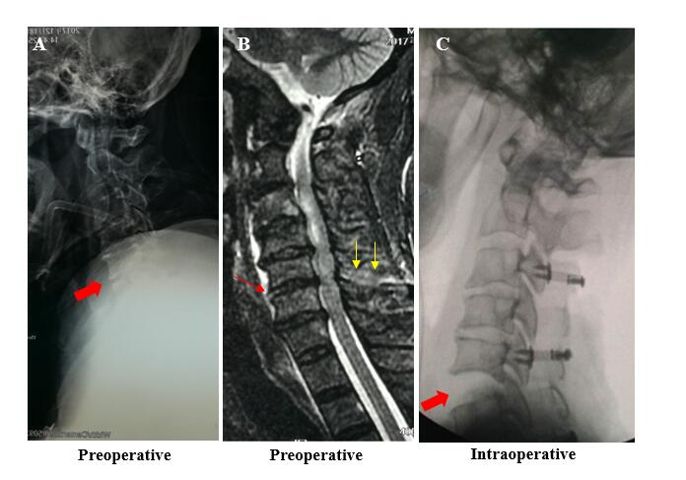
Figure 1 A case of occult cervical spine instability. A: The standard lateral X-ray at admission showed no obvious instability of the cervical spine; B: The magnetic resonance imaging at admission showed injuries involving the disc (orange arrow) and posterior interspinous ligament (yellow arrows) at the C5-6 level; C: The intraoperative C-arm fluoroscopic X-ray after anesthesia and muscle relaxation revealed significantly increased intervertebral space at C5-6, indicating instability at this level.

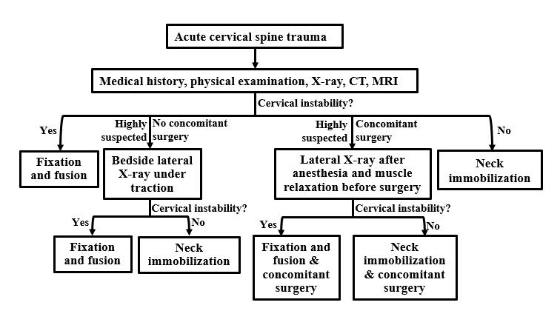
Figure 2 Clinical algorithm for diagnosing occult cervical spine instability. CT: Computed tomography; MRI: Magnetic resonance imaging.

Published by Baishideng Publishing Group Inc
7041 Koll Center Parkway, Suite 160, Pleasanton, CA 94566, USA
Telephone: +1-925-3991568
E-mail: bpgoffice@wjgnet.com
Help Desk: https://www.f6publishing.com/helpdesk
https://www.wjgnet.com

© 2021 Baishideng Publishing Group Inc. All rights reserved.

