Name of Journal: World Journal of Gastroenterology
ESPS Manuscript NO: 16601
Columns: ORIGINAL ARTICLE
Observational Study
Comparison of gastric mucosa in Mongolian and Japanese patients with reference to gastric cancer and Helicobacter pylori infection

Matsuhisa T et al. Gastric mucosa in Mongolians and Japanese

Takeshi Matsuhisa, Yoshio Yamaoka, Tomohisa Uchida, Davaadorj Duger, Battulga Adiyasuren, Oyuntsetseg Khasag, Tserentogtokh Tegshee, Byambajav Tsogt-Ochir

Takeshi Matsuhisa, Department of Gastroenterology, Tama-Nagayama University Hospital, Nippon Medical School, Tokyo 206-8512, Japan

Yoshio Yamaoka, Department of Environmental and Preventive Medicine, Oita University of Medicine, Oita 879-5593, Japan

Tomohisa Uchida, Department of Molecular Pathology, Oita University of Medicine, Oita 879-5593, Japan

Davaadorj Duger, Vice President of Mongolian National University of Medical Sciences and President of Mongolian Society of Gastroenterology, Ulaanbaatar 14210, Mongolia

Battulga Adiyasuren, Department of Endoscopy, Ulaanbaatar Songdo Hospital, Ulaanbaatar 14210, Mongolia

Oyuntsetseg Khasag, Byambajav Tsogt-Ochir, Department of Gastroenterology, Mongolian National University of Medical Sciences, Ulaanbaatar 14210, Mongolia

Tserentogtokh Tegshee, Department of Gastroenterology, Third Central State Hospital, Ulaanbaatar 16081, Mongolia

Author contributions: Matsuhisa T and Yamaoka Y contributed to study conception and design, data interpretation, and writing, editing, review and approval of the article; Matsuhisa T, Yamaoka Y, Uchida T, Duger D, Adiyasuren B, Khasag O, Tegshee T and Tsogt-Ochir B contributed to data acquisition.

Supported by (in part) National Institutes of Health, No. DK62813; and Grants-in-Aid for Scientific Research from the Ministry of Education, Culture, Sports, Science and Technology (MEXT) of Japan, No. 24406015, No. 24659200, No. 25293104 and No. 26640114.

Ethics approval: This study was reviewed and approved by the ethics committees of Nippon Medical School, Tokyo, Japan; Oita University, Oita, Japan; Mongolian National University of Medical Sciences, Ulaanbaatar, Mongolia; Ulaanbaatar Songdo Hospital, Ulaanbaatar, Mongolia; and Third Central State Hospital, Ulaanbaatar, Mongolia.

Informed consent: All study participants, or their legal guardian, provided informed written consent prior to study enrollment.

Conflict-of-interest: Matsuhisa T has received research funding from Eisai Co., Ltd as a part of this study.

Data sharing: The technical appendix, statistical code, and dataset are available from the corresponding author at matuhisa@nms.ac.jp.

Open-Access: This article is an open-access article which was selected by an in-house editor and fully peer-reviewed by external reviewers. It is distributed in accordance with the Creative Commons Attribution Non Commercial (CC BY-NC 4.0) license, which permits others to distribute, remix, adapt, build upon this work non-commercially, and license their derivative works on different terms, provided the original work is properly cited and the use is non-commercial. See: http://creativecommons.org/licenses/by-nc/4.0/

Correspondence to: Takeshi Matsuhisa, MD, Professor, Department of Gastroenterology, Tama-Nagayama University Hospital, Nippon Medical School, Tama, Tokyo 206-8512, Japan. matuhisa@nms.ac.jp

Telephone: +81-42-3712111
Fax: +81-42-3727381
Received: January 24, 2015
Peer-review started: January 25, 2015
First discussion: March 10, 2015
Revised: March 30, 2015
Accepted: May 20, 2015

Article in press:
Published online:

abstract
AIM: To investigate the characteristics of gastric cancer and gastric mucosa in the Mongolian populations by comparison with the Japanese population.

METHODS: A total of 484 Mongolian patients with gastric cancer were enrolled to study gastric cancer characteristics in Mongolians. In addition, a total of 208 Mongolian and 3205 Japanese consecutive outpatients who underwent endoscopy, had abdominal complaints and had no history of gastric operation or Helicobacter pylori (H. pylori) eradication treatment and no use of gastric secretion inhibitors such as histamine H₂-receptor antagonists and proton pump inhibitors were enrolled. This study was conducted with the approval of the ethics committees of all hospitals. The triple-site biopsy method was used for the histological diagnosis of gastritis and H. pylori infection in all Mongolians and Japanese cases. The infection rate of H. pylori and the status of gastric mucosa in H. pylori-infected patients were compared between Mongolian and Japanese subjects. Age (± 5 years), gender and endoscopic diagnosis were matched between the two countries.

RESULTS: Approximately 70% of Mongolians with gastric cancer were in their 50-s, 60-s and 70-s, and approximately half of the Mongolian cancers were located in the upper part of the stomach. Histologically, 65.7% of early cancers exhibited differentiated adenocarcinoma, whereas 73.9% of advanced cancers displayed undifferentiated adenocarcinoma. The infection rate of H. pylori was higher in Mongolians than Japanese (75.9% and 48.3%, respectively, P < 0.0001). When stratified by age group, the prevalence was highest among young people and tended to decrease in people aged 50 years or older. The anti-East Asian CagA-specific antibody was negative in 99.4% of H. pylori positive Mongolians. Chronic inflammation, neutrophil activity, glandular atrophy and intestinal metaplasia scores were significantly lower in Mongolians than Japanese H. pylori-positive patients (P < 0.0001), with the exception of the intestinal metaplasia score of specimen #2 (greater curvature of the upper body). The type of gastritis changed from antrum-predominant gastritis to corpus-predominant gastritis with age in both populations.

CONCLUSION: Approximately half of the gastric cancer in Mongolian patients was located in the upper part of the stomach. Mongolians were infected with non-East Asian-type H. pylori strains.

Key words: Gastric cancer; Helicobacter pylori; Non-East Asian-type strain; Chronic inflammation; Neutrophile activity; Glandular atrophy; Intestinal metaplasia; Mongolians; Japanese

© The Author(s) 2015. Published by Baishideng Publishing Group Inc. All rights reserved.

Core tip: Characteristics of gastric cancer and gastric mucosa in Mongolian patients were observed. Approximatery half of the Mongolian cancers were located in the upper part of the stomach. The infection rate of Helicobacter pylori (H. pylori) was higher in Mongolians than Japanese (75.9% and 48.3%, respectively, P < 0.0001). Mongolians were infected with non-East Asian-type H. pylori strains. Both atrophic score and intestinal metaplasia score were lower in H. pylori infected Mongolians than in Japanese (P < 0.0001). The type of gastritis changed from antrum-predominant gastritis to corpus-predominant gastritis with age in both populations.

Matsuhisa T, Yamaoka Y, Uchida T, Duger D, Adiyasuren B, Khasag O, Tegshee T, Tsogt-Ochir B. Comparison of gastric mucosa in Mongolian and Japanese patients with reference to gastric cancer and Helicobacter pylori infection. World J Gastroenterol 2015; In press

INTRODUCTION
Helicobacter pylori (H. pylori) infections cause not only peptic ulcer disease (PUD), but also gastric cancer^{[1,2]}. Among H. pylori strains, there is a Western-type and an East Asian-type; the East Asian-type strain greatly influences the development of atrophic gastritis and gastric cancer. Mongolia, South Korea and Japan are located in Eastern Asia and have the highest incidence of gastric cancer in the world (age-standardized incidence rates (ASR): 47.4, 62.3, and 45.8 cases per 100000 males, respectively)^{[3]}. In spite of the high prevalence of H. pylori infection in Bangladeshi^{[4,5]}, Thai^{[6]}, and Indian populations, the incidence of gastric cancer in these countries is extremely low. These trends have been denoted Asian enigmas^{[7]} or the Asian Paradox^{[8]}. In this report, the characteristics of gastric cancer in Mongolian patients, H. pylori infection and gastric mucosa in Mongolians and Japanese populations were observed and compared.

MATERIALS AND METHODS
Patients
Between January 2011 and December 2013, 484 consecutive gastric cancer patients (aged 26 to 93 years, with a mean age of 60.5 years, male-to-female ratio of 1:0.51) in the Department of Endoscopy of Ulaanbaatar Songdo Hospital (Ulaanbaatar, Mongolia) were enrolled to study the characteristics of gastric cancer in Mongolian patients.
In addition, we performed endoscopy on 208 consecutive outpatients (aged 17 to 79 years, with a mean age of 41.6 years, male-to-female ratio of 1:1.89) in the Department of Gastroenterology, Health Sciences University of Mongolia; the Department of Endoscopy, Ulaanbaatar Songdo Hospital; and the Department of Gastroenterology, Third Central State Hospital, November 2013 in Ulaanbaatar, Mongolia. The data were compared with our independent endoscopy survey of 3205 consecutive outpatients (aged 14 to 93 years, with a mean age of 55.1 years, male-to-female ratio of 1:0.73) at Nippon Medical School between January 2008 and March 2014 in Tokyo, Japan. All patients in both countries had abdominal complaints, no history of gastric operation or H. pylori eradication treatment, and no use of gastric secretion inhibitors such as histamine H₂-receptor antagonists and proton pump inhibitors.
This study was conducted with the approval of the ethics committees of all hospitals. Written informed consent to participate in the study was obtained from all patients except minors, whose consent was obtained from the guardian. All endoscopy procedures in Mongolian patients were performed by Matsuhisa T. and Yamaoka Y. using the same criteria used for the Japanese patients. All endoscopy procedures in Japanese patients were performed by Matsuhisa T.

Classification of gastric cancer
The 3rd English edition of Japanese Classification of Gastric Carcinoma was used for histological classification and to describe the location of the gastric cancer [Upper (U), Middle (M), and Lower (L)]^{[9]}. Cancer lesions involved in more than 2 regions were excluded. Among gastric cardia cancers, cancers in the stomach less than 2 cm distal to the esophagogastric junction (EGJ) were included in the cases of the U region. Nishi’s criterion (in Japanese) was used for the definition of gastric cardia cancer (esophagogastric cancer). According to this criterion, the tumor center must be located in the stomach or esophagus within 2 cm of the EGJ irrespective of histology. This criterion is also included in the 3rd English edition of Japanese Classification of Gastric Carcinoma^{[9]}. The location of gastric cancers was diagnosed by Mongolian doctors (Tegshee T and Adiyasuren B).
Cancer limited to mucosa or submucosa was defined as early gastric cancer, regardless of the presence or absence of lymph node metastases^{[9]}. Advanced gastric cancer was defined as cancer that has infiltrated a deeper layer than the muscularis propria^{[9]}.
Papillary adenocarcinoma (pap), well-differentiated type (tub1), and moderately-differentiated type (tub2) were considered differentiated adenocarcinoma; poorly differentiated adenocarcinoma (por), signet-ring cell carcinoma (sig), and mucinous adenocarcinoma (muc) were considered undifferentiated adenocarcinoma^{[9]}. Gastric cancer in Mongolian patients included endoscopically operated patients (endoscopic submucosal dissection or endoscopic mucosal resection), surgically operated patients, patients not operated on, and inoperable patients. Biopsy specimens were used for the histological diagnosis of gastric cancer. Cancers were diagnosed by a single Mongolian pathologist (Baldandorj T).

Diagnosis of gastritis and H. pylori infection
The triple-site biopsy method (Figure 1)^{[5,6,10,11]} was used for the histological diagnosis of gastritis and H. pylori infection in all Mongolians and Japanese cases. Chronic inflammation, neutrophil activity, glandular atrophy, intestinal metaplasia and H. pylori were scored using a 4-point scale ranging from 0 to 3 (0: none, 1: mild, 2: moderate and 3: severe) based on the Updated Sydney system^{[12]}. Specimen #1 was taken from the greater curvature of the lower antrum (Antrum), specimen #2 was taken from the greater curvature of the upper corpus (Corpus), and specimen #3 was taken from the lesser curvature of the lower corpus (Angulus). Specimen #4 and others were taken from ulcers or cancer lesions.
In Mongolian endoscopy cases, all biopsy specimens were subjected to hematoxylin-eosin staining, Giemsa staining, and anti-East Asian CagA-specific antibody (α-EAS Ab) staining in Japan^{[13]}. α-EAS Ab is specifically immunoreactive with East Asian CagA but not Western CagA. All Japanese cases were subjected to hematoxylin-eosin staining and Giemsa staining. One pathologist (Yamada N) diagnosed all sections to minimize any bias in the histological diagnoses.
In total, 203 pairs of 406 patients from 208 Mongolian and 3205 Japanese patients matched by age (± 5 years), gender and endoscopic diagnosis were used to compare the prevalence of H. pylori infection between the 2 countries.
From 158 H. pylori-positive Mongolian and 1,736 H. pylori-positive Japanese patients matched by age (± 5 years), gender and endoscopic diagnosis, 137 pairs of 274 H. pylori-positive patients were used to compare the characteristics of gastric mucosa.

C/A ratio
The ratio of the Corpus activity score (C) (#2, Figure 1) to the Antrum activity score (A) (#1, Figure 1) (C/A ratio), was used to diagnose the type of gastritis in H. pylori-positive patients^{[10,11]}. The C/A ratio in every age group was calculated using the mean score of C divided by the mean score of A. Patients with a C/A ratio of less than 1 were assessed as having antrum-predominant gastritis and those with a C/A ratio of greater than 1 were assessed as having corpus-predominant gastritis.

Statistical analysis
McNemar’s test was used to compare the prevalence of H. pylori infection, and the Mann-Whitney U-test was used to compare the gastric mucosa. P< 0.05 was considered significant.

RESULTS
Characteristics of gastric cancer in Mongolians
In 484 consecutive cases of gastric cancer in Mongolian patients, early gastric cancer accounted for 29.5% (143/484). When stratified by age group, total gastric cancer, early gastric cancer and advanced gastric cancer were most frequent in patients in their 60-s, followed by those in their 50-s and then 70-s; in total, patients in their 50-s, 60-s and 70-s accounted for 71.9%, 72.0%, and 71.8% of these cancers, respectively (Figure 2). Moreover, 6.5%-9.8% of gastric cancer presented in young adults ages 39 and younger (Figure 2). The male-to-female ratio was 1:0.51.
The percentages of the sites most affected by total gastric cancer were 46.5% in the U region, followed by 28.1% in the L region, and 25.4% in the M region (Figure 3). Lesions occurring 2 or 3 regions (UM region: 91 cases, ML region: 16 cases, UML region: 7 cases; all were advanced gastric cancer) were excluded. The affected area of early gastric cancer and advanced gastric cancer was also largest in the U region (47.5% and 45.8%, respectively) (Figure 3). Among gastric cancer in Mongolian patients, gastric cardia cancer accounted for 3.9% (19/484) of total gastric cancer.
A greater percentage of total gastric cancer cases were undifferentiated adenocarcinoma (61.8%) than differentiated adenocarcinoma (37.2%). Similarly, in advanced gastric cancer, cases of undifferentiated adenocarcinoma (73.9%) were greater than those of differentiated adenocarcinoma (25.2%) (Figure 4). By contrast, in early gastric cancer, differentiated adenocarcinoma (65.7%) was more prevalent than undifferentiated adenocarcinoma (32.9%) (Figure 4).

Infection rate of H. pylori
The infection rate of H. pylori was 76.0% (158 out of 208 patients) in Mongolian patients. When stratified by ages, H. pylori infection was highest among young people (younger than 19 years: 88.9%, 20 to 29 years: 76.9%, 30 to 39 years: 89.7%) and tended to decrease in people ages 50 and older (50 to 59 years: 68.4%, 60 to 69 years: 61.5%, 70 years or older: 71.4%) (Figure 5).
The infection rate of H. pylori was higher in Mongolian than in Japanese patients (75.9% and 48.3%, respectively, P < 0.0001).

α-EAS Ab positivity
α-EAS Ab was negative in 99.4% (157 of 158 patients) of H. pylori-positive Mongolians.

Gastric mucosa
The mean scores for gastritis and H. pylori in the H. pylori-positive cases were all significantly lower in Mongolians than Japanese patients. The only exception was the intestinal metaplasia scores of specimen #2, which did not differ significantly between Mongolian and Japanese patients (all except intestinal metaplasia of #2: P < 0.0001; intestinal metaplasia of #2: P = 0.1907) (Table 1).

C/A ratio
The C/A ratio in 137 matched pairs of 274 H. pylori infected Mongolians and Japanese patients revealed antrum-predominant gastritis in age groups younger than 49 and 39 years, respectively, and corpus-predominant gastritis in age groups older than 50 and 40 years, respectively (Figure 6). The mean C/A ratio of the Japanese patients over 60 years of age was higher than that of the Mongolian patients (1.43, 1.01, respectively, P <0.01).

DISCUSSION
The incidence and mortality of gastric cancer are high in Eastern Asia and Central and Eastern Europe. According to the age-adjusted cancer incidence in Mongolian males, the liver is the most common cancer site (ASR: 97.8 cases per 100000 males), followed by the stomach (47.4), lungs (27.7), esophagus (21.2), and colorectum (5.7) (Globocan 2012)^{[3]}. By contrast, in Japanese males, the stomach is the most common cancer site (45.8), followed by the colorectum (42.1), lungs (38.8), prostate (30.4) and liver (14.6)^{[3]}. In South Korean males, the stomach is also the most common cancer site (62.3)^{[3]}. South Korea, Mongolia, and Japan have the highest incidences of gastric cancer in the world. We previously examined gastric mucosa in relation to H. pylori infection in South Koreans^{[14]}, Chinese^{[6,11]}, Vietnamese^{[6,11]}, Thais^{[6,11]}, Burmese (Lecture, Nay Pyi Daw, Myanmar, 2008), Bangladeshi^{[4,5]}, and Nepalese^{[11]} patient, and reported that atrophic score and intestinal metaplasia score were very high in Japanese and South Koreans. In this study, we investigated the characteristics of gastric cancer and the gastric mucosa in the context of H. pylori infection in Mongolians, who belong to the East Asian population, and compared them with those of Japanese patients.

Characteristics of gastric cancer in Mongolians
Other than incidence and mortality, very few data relating to Mongolians with gastric cancer are available via PubMed. Therefore, we determined the ratio of early gastric cancer to total gastric cancer, age group frequency, and region and histological type in gastric cancer in Mongolian patients. Globally, gastric cancer is more common in men than women^{[3]}, and this was also true for Mongolians (male-to-female ratio 1:0.51). The percentage of early gastric cancer among total gastric cancer was 29.5% in Mongolians, lower than that in Japanese (80%)^{[15]}; the delayed spread of gastric examination screening, endoscopy devices and early gastric cancer diagnostics in Mongolia may be a determining factors. In addition, because of H. pylori testing is not widespread in Mongolia, it is not clear if these cases included in this study were infected with H. pylori.
In countries and regions with a high incidence of gastric cancer, gastric cancer occurs more frequently in the distal portion of the stomach; in countries and regions with a low incidence, gastric cancer occurs more frequently in the proximal portion^{[16]}. Approximately half of the Japanese with cases of gastric cancer occurred in the M region, (M region > L region > U region)^{[15]}, while approximately half of the Mongolians with gastric cancer cases occurred in the U region, indicating a large considerable difference in the location frequency. Mongolians reportedly have high meat and salt intake (15 g/d). Other common practices include consuming large amounts of hot tea, regular alcohol intake, hurried eating, and low intake of fruit and vegetables^{[17,18]}. Although H. pylori infection is not a risk factor for gastric cardia cancer^{[19]}, obesity is an onset risk factor of gastric cardia cancer^{[20,21]}. Furthermore, obesity may influences the development of early gastric cancer and differentiated adenocarcinoma in males regardless of H. pylori infection^{[22]}. No data regarding the degree of obesity in gastric cancer patients have been reported; however, the percentage of obese Mongolian adults (16.4%) is high compared with Japanese adults (4.5%) according to age-standardized data^{[23]}. In this context, patients with a body mass index (BMI) greater than or equal to 30 kg/m² are defined as obese. Gastric cardia cancer accounted for 3.9% of total gastric cancer in Mongolians, and 3.2% of Japanese gastric cancer patients who underwent either endoscopic surgery or an open surgery in the 2000s^{[24]}. Many cancers were located in the U region, including the cardia, in Mongolians (Figure 7a, b), but the frequency of gastric cardia cancer did not differ compared with that in Japanese patients. Because there are so many advanced cancer cases among Mongolian patients, we must consider the possibility that gastric cardia cancers enlarged in size that were classified as U region cancers. The factors (other than obesity) that contribute to the high incidence of gastric cancer in the U region remain to be determined. A detailed investigation of environmental factors and host factors is also necessary.
In Mongolian patients, the most prevalent histological types of total gastric cancer, early gastric cancer and advanced gastric cancer are undifferentiated adenocarcinoma, differentiated adenocarcinoma and undifferentiated adenocarcinoma, respectively. In Japanese patients, undifferentiated adenocarcinoma was prevalent before the 1970s and differentiated adenocarcinoma has been dominant since the 1980s due to the aging of H. pylori-infected patients^{[15]}. According to a report by Yamada et al^{[15]}, who examined 10132 cases of patients who underwent a surgical treatment in the 2000s by histological type, differentiated adenocarcinoma accounted for 68% and undifferentiated adenocarcinoma accounted for only 32%. The trend of prevalent differentiated adenocarcinoma is weaker in advanced gastric cancer but significantly stronger in early gastric cancer^{[16]}. In Mongolians, differentiated adenocarcinoma is common in early gastric cancer, as in Japanese; however, a different trend was observed for advanced gastric cancer and total gastric cancer. The prevalence of undifferentiated adenocarcinoma in total gastric cancer in Mongolia may be due to differences in the criteria used by pathologist in Mongolia and the lower mean age of gastric cancer in Mongolian patients (60.5 years) compared to the Japanese (64 years)^{[15]}.
Based on the results of our field study in Asian countries, the gastric ulcer which included gastroduodenal ulcer/duodenal ulcer ratio (GU/DU ratio) was different. There are big differences among Asian countries. Japanese^{[14]} and South Korean^{[14]} patients exhibit as GU-predominant (1.69 and 1.75, respectively), whereas Bangladeshi^{[5]} and Nepalese^{[11]} exhibit as DU-predominant (0.31 and 0.25, respectively). According to a personal communication with one Mongolian doctor who previously investigated this topic (Khasag O), Mongolia is a country of GU-predominance (1.9 in 2003 in her unpublished data from Mongolian National University of Medical Sciences). Regarding the relationship between PUD and gastric cancer, a higher GU/DU ratio in a country or region has been associated with a greater incidence of gastric cancer^{[25]}. Furthermore, the development of gastric cancer is positively correlated with GU but negatively correlated with DU^{[26]}. Based on these reports, gastric cancer is likely common among Japanese, South Koreans, and Mongolians.

Infection rate of H. pylori
Approximately half of the world’s population is infected with H. pylori, and the infection rate is higher in developing countries than in developed countries^{[27]}. The infection rate of H. pylori is reported to be 5% or less in people younger than 20 years of age and 40% in people in their 50-s in developed countries^{[27]}. In Japan, the infection rate is decreasing gradually, and the prevalence is 6.4% in children (0-12 years old)^{[28]} and 5.2% in high school students (16 or 17 years old)^{[29]}. In developing countries, the infection rate of H. pylori can be as high as 50% in teenagers and more than 90% in people in their 30-s^{[30]}. Our results indicate that H. pylori infection rates are high (76.0%) in Mongolians and very high in Mongolians aged 17 to 19 years (88.9%), revealing a developing country-type prevalence.

Positive rate of α–EAS Ab
The Japanese are infected with East Asian-type H. pylori, but the type of H. pylori that infects Mongolians has not been determined. Therefore, the Mongolian biopsies were stained with α-EAS Ab, which specifically reacts to East Asian-type H. pylori. In H. pylori-positive Mongolian cases, the rate of α-EAS Ab positivity was 0.6% (1 in 158 H. pylori positive cases), indicating that despite the location of Mongolia in East Asia, Mongolians are not infected with East Asia-type H. pylori (i.e. Western-type cagA or cagA-negative strains). The H. pylori strains are currently being characterized by one of the authors (Yamaoka Y).

Gastric mucosa
The scores for gastritis and H. pylori were significantly lower in H. pylori-infected Mongolians than in Japanese at all gastric sites, with the exception of the intestinal metaplasia score in specimen #2. East Asian-type H. pylori strains induce stronger chronic inflammation and neutrophil activity than Western-type H. pylori strains^{[31]} and are involved in gastric mucosal atrophy and gastric cancer^{[32]}. According to a report by Uemura et al^{[1]}, atrophic changes and intestinal metaplasia are strongly related to the risk of gastric cancer, and severe atrophic change and intestinal metaplasia, in particular, leads to a high risk of both intestinal-type and diffuse-type gastric cancer^{[9]}. Because the South Asian population is infected with Western-type H. pylori^{[33,34]}, glandular atrophy and intestinal metaplasia scores were significantly lower in Bangladeshi^{[5]} and Nepalese^{[12]} in our previously reported results. Therefore, the incidence of gastric cancer is very low in Bangladesh and Nepal (ASR: 7.2 and 7.4 cases per 100000 males, respectively)^{[3]}. Although glandular atrophy and intestinal metaplasia scores are low in Mongolians, the incidence of gastric cancer is high; however, it is important to note that these scores were not obtained from patients with gastric cancer. To address this paradox, the gastric mucosa of Mongolian patients with gastric cancer should be examined. We are planning a gastric mucosal survey of patients with gastric cancer in Uvs, a western province with the highest prevalence of gastric cancer in Mongolia (ASR: 114.6 cases per 100000 males).

C/A ratio
The prevalence of antrum-predominant gastritis tends to decrease in favor of corpus-predominant gastritis in Mongolians and Japanese with aging. The C/A ratio in patients older 60 years was higher in Japanese patients than in Mongolian patients. All age groups of Bangladeshi and Nepalese subjects had antrum-predominant gastritis^{[5,12]}. The risk of gastric cancer is 23.3 times higher for corpus-predominant gastritis than for antrum-predominant gastritis^{[1]}. This report is consistent with the low incidence of gastric cancer in South Asian countries (Bangladesh and Nepal) and the high incidence in East Asian countries (Japan, South Korea and Mongolia). Therefore, a high C/A ratio, indicating corpus-predominant gastritis, is one of the causative factors of gastric cancer.
In conclusion, a comparative analysis of gastric mucosa in Mongolia and Japan, two countries with a high incidence of gastric cancer, was conducted. Gastric cancer occurred most frequently in the U region of Mongolians, and peaked among those in their 60-s. The most prevalent histological types in early gastric cancers and advanced gastric cancers are differentiated adenocarcinoma and undifferentiated adenocarcinoma, respectively. The infection rate of H. pylori was high in Mongolians, particularly those 17-19 years old. The scores for gastric mucosa may have been lower in Mongolians than Japanese because the majority of Mongolians were infected with non-East Asian-type H. pylori strains. H. pylori-positive young Mongolians had antrum-predominant gastritis and developed more corpus-predominant gastritis with aging similar to the Japanese population. Further studies should clarify the reason for the high gastric cancer prevalence in Mongolians infected with non-East Asian-type H. pylori.

ACKNOWLEDGMENTS
We sincerely thank all medical staff at the Department of Gastroenterology, Health Sciences University of Mongolia; Department of Endoscopy, Ulaanbaatar Songdo Hospital; and Department of Gastroenterology, Third Central State Hospital, Ulaanbaatar, Mongolia, for all their work related to endoscopy. We also thank Hidenobu Watanabe, Emeritus Professor at the School of Medicine, Niigata University, Niigata, Japan for the histological criterion of gastric cardia cancer; Nobutaka Yamada, former Assistant Professor in the Department of Pathology, Nippon Medical School, Tokyo, Japan, for the pathological diagnoses of all Japanese biopsy specimens; and Nurse Yumi Sakamoto at Nippon Medical School Hospital, Nurse Kiyomi Suzuki at Daini Kokudou Hospital and Nurse Sonomi Nawata at JR Kyusyu Hospital, for their cooperation.

COMMENTS
Background
Helicobacter pylori (H. pylori) infections cause not only peptic ulcer disease, but also gastric cancer. Mongolia, South Korea and Japan, which are located in Eastern Asia, have the highest incidence of gastric cancer in the world. Other than incidence and mortality, very few data relating to Mongolians with gastric cancer are available in PubMed. The characteristics of gastric cancer in Mongolian patients, H. pylori infection and gastric mucosa were observed and compared between Mongolians and Japanese populations.

Research frontiers
There are Western-type and East Asian-type strain of H. pylori: the East Asian-type strain influences the development of atrophic gastritis and gastric cancer greatly. There are no data about the type of H. pylori strain that tends to infect Mongolians or the gastric mucosa and type of gastritis in Mongolians.

Innovations and breakthroughs
Gastric cancer occurred most frequently in the U region of Mongolians and peaked in those in their 60-s. The most prevalent histological types in early gastric cancers and advanced gastric cancers were differentiated adenocarcinoma and undifferentiated adenocarcinoma, respectively. The infection rate of H. pylori was high in Mongolians, particularly those 17-19 years old. The majority of Mongolians were infected with non-East Asian-type H. pylori strains (99.4%), which may explain the lower gastric mucosa scores of Mongolians compared to Japanese. H. pylori-positive young Mongolians had antrum-predominant gastritis and developed more corpus-predominant gastritis with aging similarly to the Japanese.

Applications
There are many differences between Mongolians and Japanese in the location of gastric cancer, H. pylori strain type, and gastric mucosa. Future studies should clarify the reason for the high gastric cancer prevalence in Mongolians infected with non-East Asian-type H. pylori.

Terminology
Anti-East Asian CagA-specific antibody (α-EAS Ab) is specifically immunoreactive with East Asian CagA but not Western CagA. Patients with a C/A ratio less than 1 were assessed as having antrum-predominant gastritis, and those with a C/A ratio of greater than 1 were assessed as having corpus-predominant gastritis.

Peer-review
In this study, the authors investigated the characteristics of gastric cancer and gastric mucosa in Mongolian patients by comparing the gastric mucosa of Mongolian and Japanese patients. Approximately 70% of older Mongolians had gastric cancer, and approximately half of the Mongolian cancers were located in the upper part of the stomach. Three fourths of advanced cancer displayed undifferentiated adenocarcinoma. Many differences in stomach characteristics were observed in Mongolians compared with Japanese. The prevalence of H. pylori infection was higher in Mongolians than in Japanese (75.9% and 48.3%, respectively, P < 0.0001). The most surprising result was that 99.4% of H. pylori-positive cases were infected with non-East Asian-type H. pylori. In general, this study is novel, interesting and scientific and, importantly, has clinical significance.

REFERENCES
1 Uemura N, Okamoto S, Yamamoto S, Matsumura N, Yamaguchi S, Yamakido M, Taniyama K, Sasaki N, Schlemper RJ. Helicobacter pylori infection and the development of gastric cancer. N Engl J Med 2001; 345: 784-789 [PMID: 11556297 DOI: 10.1056/NEJMoa001999]
2 Fukase K, Kato M, Kikuchi S, Inoue K, Uemura N, Okamoto S, Terao S, Amagai K, Hayashi S, Asaka M. Effect of eradication of Helicobacter pylori on incidence of metachronous gastric carcinoma after endoscopic resection of early gastric cancer: an open-label, randomised controlled trial. Lancet 2008; 372: 392-397 [PMID: 18675689 DOI: 10.1016/S0140-6736(08)61159-9]
3 International Agency for Research on Cancer, World Health Organization. Available from: URL: http: //globocan.iarc.fr/Default.aspx
4 Matsuhisa T, Aftab H. Observation of upper gastrointestinal diseases and gastric mucosa in Bangladeshi population-comparison with Japanese. Bangladesh Med J 2012; 23: 26-34
5 Matsuhisa T, Aftab H. Observation of gastric mucosa in Bangladesh, the country with the lowest incidence of gastric cancer, and Japan, the country with the highest incidence. Helicobacter 2012; 17: 396-401 [PMID: 22967124 DOI: 10.1111/j.1523-5378.2012.00967.x]
6 Matsuhisa TM, Yamada NY, Kato SK, Matsukura NM. Helicobacter pylori infection, mucosal atrophy and intestinal metaplasia in Asian populations: a comparative study in age-, gender- and endoscopic diagnosis-matched subjects. Helicobacter 2003; 8: 29-35 [PMID: 12603614 DOI: 10.1046/j.1523-5378.2003.00121.x]
7 Miwa H, Go MF, Sato N. H. pylori and gastric cancer: the Asian enigma. Am J Gastroenterol 2002; 97: 1106-1112 [PMID: 12014714 DOI: 10.1111/j.1572-0241.2002.05663.x]
8 Matsukura N, Yamada S, Kato S, Tomtitchong P, Tajiri T, Miki M, Matsuhisa T, Yamada N. Genetic differences in interleukin-1 betapolymorphisms among four Asian populations: an analysis of the Asian paradox between H. pylori infection and gastric cancer incidence. J Exp Clin Cancer Res 2003; 22: 47-55 [PMID: 12725322]
9 Japanese Gastric Cancer Association. Japanese classification of gastric carcinoma: 3rd English edition. Gastric Cancer 2011; 14: 101-112 [PMID: 21573743 DOI: 10.1007/s10120-011-0041-5]
10 Matsuhisa T, Matsukura N, Yamada N. Topography of chronic active gastritis in Helicobacter pylori-positive Asian populations: age-, gender-, and endoscopic diagnosis-matched study. J Gastroenterol 2004; 39: 324-328 [PMID: 15168242 DOI: 10.1007/s00535-003-1329-y]
11 Matsuhisa T, Miki M, Yamada N, Sharma SK, Shrestha BM. Helicobacter pylori infection, glandular atrophy, intestinal metaplasia and topography of chronic active gastritis in the Nepalese and Japanese population: the age, gender and endoscopic diagnosis matched study. Kathmandu Univ Med J (KUMJ) 2007; 5: 295-301 [PMID: 18604043]
12 Dixon MF, Genta RM, Yardley JH, Correa P. Classification and grading of gastritis. The updated Sydney System. International Workshop on the Histopathology of Gastritis, Houston 1994. Am J Surg Pathol 1996; 20: 1161-1181 [PMID: 8827022 DOI: 10.1097/00000478-199610000-00001]
13 Uchida T, Kanada R, Tsukamoto Y, Hijiya N, Matsuura K, Yano S, Yokoyama S, Kishida T, Kodama M, Murakami K, Fujioka T, Moriyama M. Immunohistochemical diagnosis of the cagA-gene genotype of Helicobacter pylori with anti-East Asian CagA-specific antibody. Cancer Sci 2007; 98: 521-528 [PMID: 17284255]
14 Matsuhisa T. Helicobacter pylori infection and gastroduodenal diseases in East, Southeast, and South Asian countries. In: Kim BW, Lee JH, editors. Asian Perspective in Helicobacter Research. The 10th Japan-Korea Joint Symposium on Helicobacter pylori Infection. 2013 May 31-June 1; Seoul, South-Korea. 2013: 50-52
15 Yamada M, Oda I, Taniguchi H, Kushima R. Chronological trend in clinicopathological characteristics of gastric cancer. Nihon Rinsho 2012; 70: 1681-1685 [PMID: 23198545]
16 Sin HR, Curado MP, Ferlay J, Heanue M, Edwards B, Strom M. Processing of data. In: Curado MP, Edwards B, Shin HR, Storm H, Ferlay J, Heanue M, Boyle P. Cancer incidence in five continents, Vol. IX. Lyon: IARC Scientific Publications, 2007: 67-94
17 Moore MA, Aitmurzaeva G, Arsykulov ZA, Bozgunchiev M, Dikanbayeva SA, Igisinov G, Igisinov N, Igisinov S, Karzhaubayeva S, Oyunchimeg D, Oyunsuren T, Soipova M, Tumubaatar T. Chronic disease prevention research in Central Asia, the Urals, Siberia and Mongolia - past, present and future. Asian Pac J Cancer Prev 2009; 10: 987-996 [PMID: 20192571]
18 Sandagdorj T, Sanjaajamts E, Tudev U, Oyunchimeg D, Ochir C, Roder D. Cancer incidence and mortality in Mongolia - National Registry Data. Asian Pac J Cancer Prev 2010; 11: 1509-1514 [PMID: 21338189]
19 Huang JQ, Sridhar S, Chen Y, Hunt RH. Meta-analysis of the relationship between Helicobacter pylori seropositivity and gastric cancer. Gastroenterology 1998; 114: 1169-1179 [PMID: 9609753 DOI: 10.1016/S0016-5085(98)70422-6]
20 Kubo A, Corley DA. Body mass index and adenocarcinomas of the esophagus or gastric cardia: a systematic review and meta-analysis. Cancer Epidemiol Biomarkers Prev 2006; 15: 872-878 [PMID: 16702363 DOI: 10.1158/1055-9965.EPI-05-0860]
21 Zhang J, Su XQ, Wu XJ, Liu YH, Wang H, Zong XN, Wang Y, Ji JF. Effect of body mass index on adenocarcinoma of gastric cardia. World J Gastroenterol 2003; 9: 2658-2661 [PMID: 14669307]
22 Kim HJ, Kim N, Kim HY, Lee HS, Yoon H, Shin CM, Park YS, Park DJ, Kim HH, Lee KH, Kim YH, Kim HM, Lee DH. Relationship between body mass index and the risk of early gastric cancer and dysplasia regardless of Helicobacter pylori infection. Gastric Cancer 2014; Epub ahead of print [PMID: 25240409 DOI: 10.1007/s10120-014-0429-0]
23 Mean body mass index trends (age-standardized estimate) Data by country. Available from: URL: http: //apps.who.int/gho/data/node.main.A904
24 Yamada M, Kushima R, Oda I, Taniguchi H, Sekine S, Odagaki T, Abe S, Sou E, Yachida T, Sakamoto T, Nonaka S, Suzuki H, Yoshinaga S, Nakajima T, Matsuda T, Saito Y, Shimoda T. Yearly trends of adenocarcinoma of the esophago-gastric junction and Barrett’s adenocarcinoma, and association with Helicobacter pylori infection. Stomach and Intestine 2011; 46: 1737-1749
25 Chiba T. Helicobacter pylori infection in Asia. Helicobacter Res 2000; 4: 11-15
26 Van Zanten SJ, Dixon MF, Lee A. The gastric transitional zones: neglected links between gastroduodenal pathology and helicobacter ecology. Gastroenterology 1999; 116: 1217-1229 [PMID: 10220514 DOI: 10.1016/S0016-5085(99)70025-9]
27 Megraud F. Epidemiology of Helicobacter pylori infection. In: Rathbone BK, Heatley RV. Helicobacter pylori and gastroduodenal disease. London: Blackwell Scientific Publications. 1993. 107-123
28 Okuda M, Miyashiro E, Koike M, Okuda S, Minami K, Yoshikawa N. Breast-feeding prevents Helicobacter pylori infection in early childhood. Pediatr Int 2001; 43: 714-715 [PMID: 11737758 DOI: 10.1046/j.1442-200X.2001.01481.x]
29 Akamatsu T, Ichikawa S, Okudaira S, Yokosawa S, Iwaya Y, Suga T, Ota H, Tanaka E. Introduction of an examination and treatment for Helicobacter pylori infection in high school health screening. J Gastroenterol 2011; 46: 1353-1360 [PMID: 21853260 DOI: 10.1007/s00535-011-0450-6]
30 Graham DY. Helicobacter pylori: its epidemiology and its role in duodenal ulcer disease. J Gastroenterol Hepatol 1991; 6: 105-113 [PMID: 1912414 DOI: 10.1111/j.1440-1746.1991.tb01448.x]
31 Azuma T. Helicobacter pylori CagA protein variation associated with gastric cancer in Asia. J Gastroenterol 2004; 39: 97-103 [PMID: 15069615 DOI: 10.1007/s00535-003-1279-4]
32 Azuma T, Yamazaki S, Yamakawa A, Ohtani M, Muramatsu A, Suto H, Ito Y, Dojo M, Yamazaki Y, Kuriyama M, Keida Y, Higashi H, Hatakeyama M. Association between diversity in the Src homology 2 domain--containing tyrosine phosphatase binding site of Helicobacter pylori CagA protein and gastric atrophy and cancer. J Infect Dis 2004; 189: 820-827 [PMID: 14976598 DOI: 10.1086/381782]
33 Yamaoka Y, Orito E, Mizokami M, Gutierrez O, Saitou N, Kodama T, Osato MS, Kim JG, Ramirez FC, Mahachai V, Graham DY. Helicobacter pylori in North and South America before Columbus. FEBS Lett 2002; 517: 180-184 [PMID: 12062433 DOI: 10.1016/S0014-5793(02)02617-0]
34 Yamaoka Y. Helicobacter pylori typing as a tool for tracking human migration. Clin Microbiol Infect 2009; 15: 829-834 [PMID: 19702588 DOI: 10.1111/j.1469-0691.2009.02967.x]

P-Reviewer: Shimada H, Zhang ZY S-Editor: Ma YJ L-Editor: E-Editor:

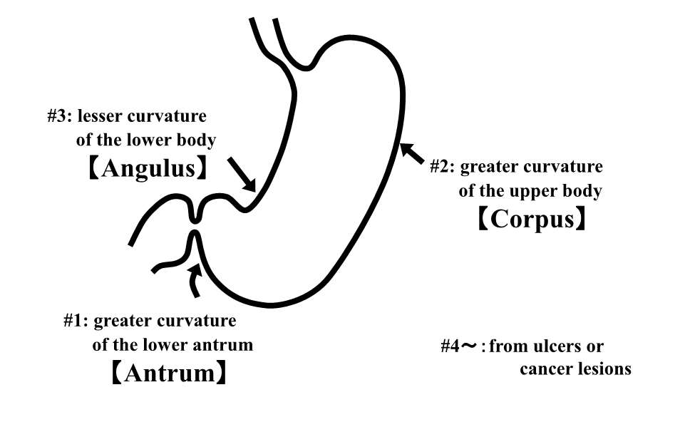
Figure 1 Triple-site biopsy. Triple-site biopsy specimens were used for the histological diagnosis of chronic inflammation, neutrophil activity, glandular atrophy, intestinal metaplasia and Helicobacter pylori in the gastric mucosa. Specimen #1 was taken from the greater curvature of the lower antrum (Antrum), #2 from the greater curvature of the upper corpus (Corpus), and #3 from the lesser curvature of the lower corpus (Angulus). Specimen #4 and others were taken from ulcers or cancer lesions.

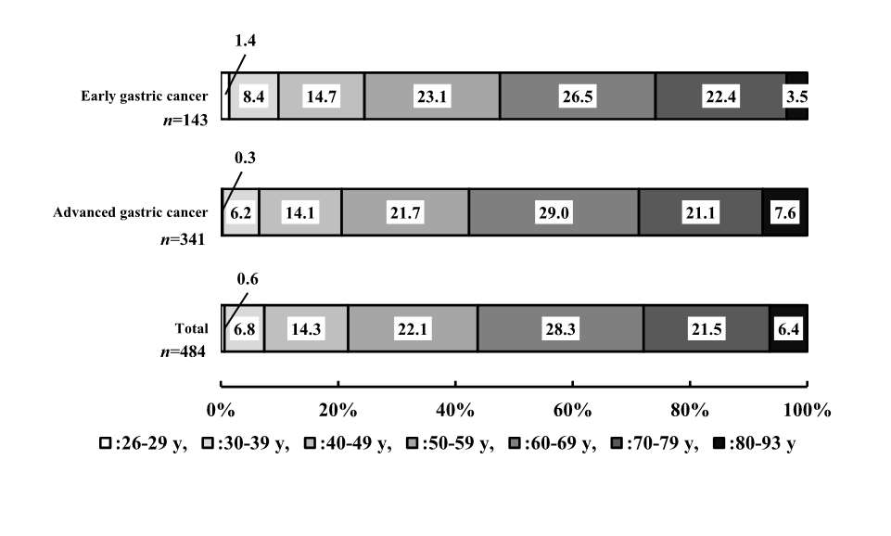
Figure 2 Analysis of gastric cancer in Mongolians. Analysis of gastric cancer cases by age group revealed that for all cases of total gastric cancer, early gastric cancer, and advanced gastric cancer, a peak occurred among those patients in their 60-s, followed by those in their 50-s and 70-s. Patients in their 50-s, 60-s and 70-s accounted for 71.9%, 72.0% and 71.8%, respectively, of these cancers. Moreover, 6.5%-9.8% gastric cancer cases occurred in young adults younger than 39 year.

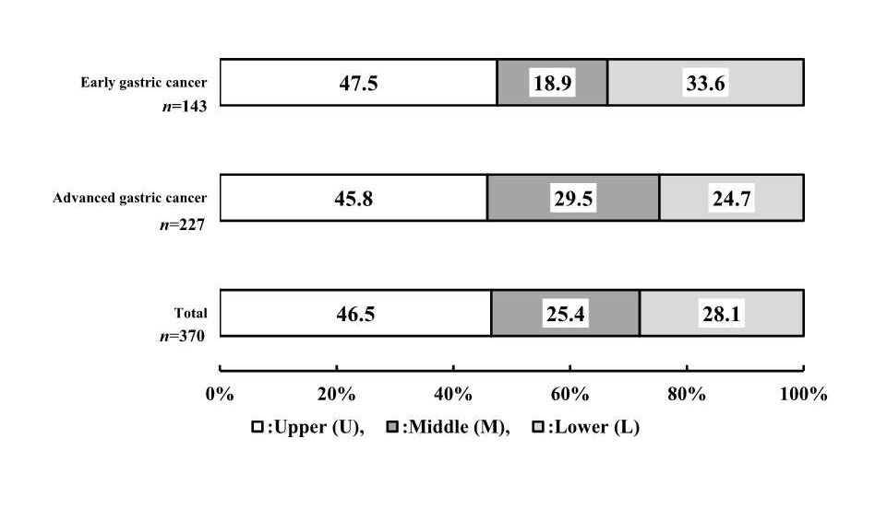
Figure 3 Distribution of gastric cancer in Mongolians. The most affected site in total gastric cancer cases was the U region, 46.5%, followed by the L region, 28.1%, the M region, 25.4%. Lesions involving 2 or 3 regions (UM region: 91 cases, ML region: 16 cases, UML region: 7 cases, all were advanced gastric cancer) were excluded. The most affected area of early gastric cancer and advanced gastric cancer was the U region (47.5% and 45.8%, respectively).

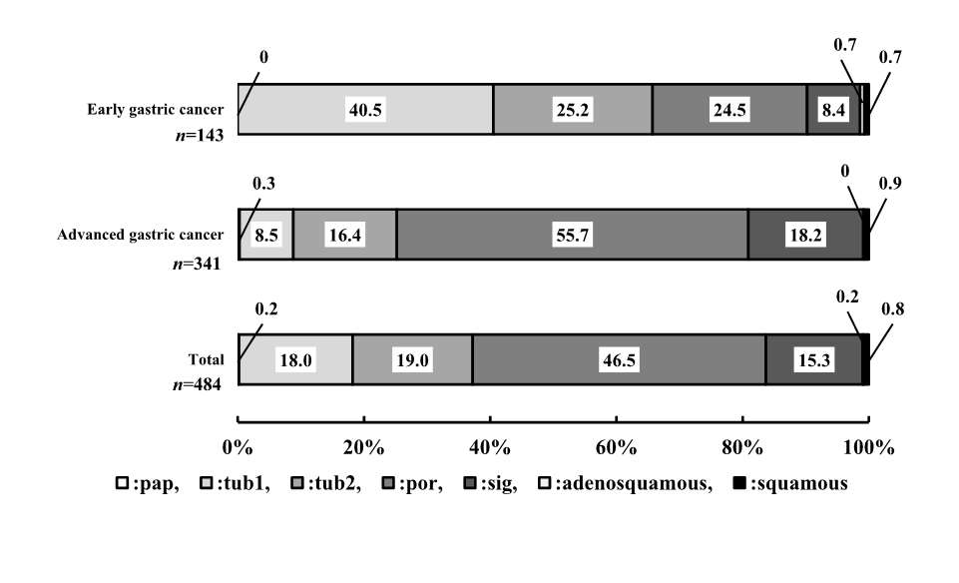
Figure 4 Histological distribution of gastric cancer in Mongolians. Analysis of the percentages of differentiated adenocarcinoma (papillary adenocarcinoma (pap), well-differentiated type (tub1) and moderately differentiated type (tub2)) and undifferentiated adenocarcinoma (poorly differentiated adenocarcinoma (por) and signet-ring cell carcinoma (sig) revealed that undifferentiated adenocarcinoma (61.8%) accounts for a higher proportion of total gastric cancer cases than differentiated adenocarcinoma (37.2%). Similarly, among advanced gastric cancer cases, undifferentiated adenocarcinoma (73.9%) accounts for a higher proportion than differentiated adenocarcinoma (25.2%). By contrast, in early gastric cancer, differentiated adenocarcinoma (65.7%) was more prevalent than undifferentiated adenocarcinoma (32.9%).

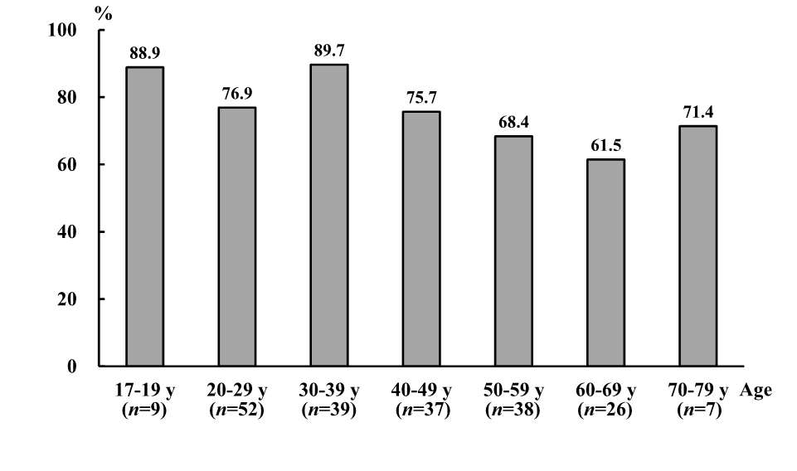
Figure 5 prevalence of Helicobacter pylori infection in Mongolian subjects according to age distribution. The prevalence of Helicobacter pylori infection in Mongolian subjects was highest for ages 17-19, 20-29 and 30-39. The prevalence tended to decrease among patients ages 50 and older (68.4% at ages 50-59, 61.5% at ages 60-69 and 71.4% at ages 70 or older).

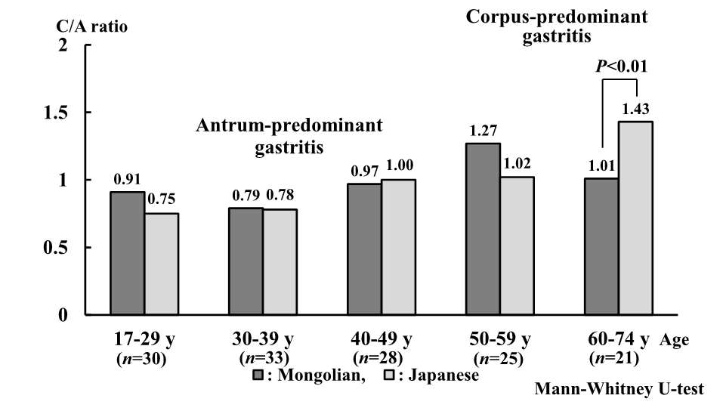
Figure 6 C/A ratio in Helicobacter pylori-positive Mongolians and Japanese matched by age, gender and endoscopic diagnostics. The ratio of the corpus gastritis score to the antrum gastritis score (C/A ratio) was compared between Helicobacter pylori-positive Mongolian and Japanese patients in each age group. Mongolians aged 49 years or younger had a C/A ratio indicating antrum predominant gastritis, whereas those aged 50 years or older had a C/A ratio greater than 1, indicating that older Mongolians had corpus-predominant gastritis rather than antrum-predominant gastritis. Japanese patients aged 39 years or younger exhibited antrum-predominant gastritis, whereas those aged 40 years or older displayed corpus-predominant gastritis. This trend was similar in both countries.

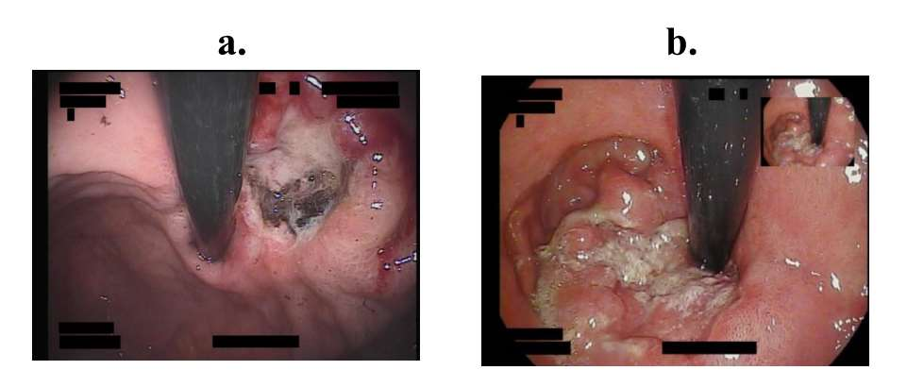
Figure 7 Gastric cancer cases in the U region. A: Sixty-seven-year-old-woman. Cancer located near the cardia (U region), type 2; b: Eighty-eight-year-old-man. Cancer located around the cardia (U region), type 3.

Table 1 Gastritis scores of Helicobacter pylori-positive Mongolians and Japanese matched by age, gender and endoscopic diagnosis
 | Specimen | Chronic inflammation |  | Neutrophil activity |  | Glandular atrophy |  | Intestinal metaplasia |  | Helicobacter pylori
Mongolians | #1 (Antrum) | 1.32 ± 0.59 | P < 0.0001 | 0.38 ± 0.54 | P < 0.0001 | 0.15 ± 0.36 | P < 0.0001 | 0.07 ± 0.40 | P < 0.0001 | 0.93 ± 0.79 | P < 0.0001
Japanese |  | 2.30 ± 0.72 |  | 2.05 ± 1.01 |  | 0.48 ± 1.72 |  | 0.34 ± 0.78 |  | 1.91 ± 1.01
Mongolians | #2 (Corpus) | 1.12 ± 0.50 | P < 0.0001 | 0.26 ± 0.47 | P < 0.0001 | 0.02 ± 0.19 | P < 0.0001 | 0.05 ± 0.35 |  | 1.08 ± 0.84 | P < 0.0001
Japanese |  | 2.03 ± 0.74 |  | 1.93 ± 0.96 |  | 0.28 ± 0.73 |  | 0.10 ± 0.44 |  | 2.20 ± 0.79
Mongolians | #3 (Angulus) | 1.50 ± 0.62 | P < 0.0001 | 0.55 ± 0.61 | P < 0.0001 | 0.16 ± 0.41 | P < 0.0001 | 0.17 ± 0.60 | P < 0.0001 | 1.15 ± 0.87 | P < 0.0001
Japanese |  | 2.21 ± 0.80 |  | 1.93 ± 1.04 |  | 0.81 ± 1.02 |  | 0.59 ± 1.02 |  | 2.07 ± 0.95
The total number is 137, Mann-Whitney U-test.

