Name of Journal: World Journal of Clinical Cases
Manuscript NO: 84458
Manuscript Type: CASE REPORT

Mepolizumab induced palmoplantar psoriasis: A case report

Artosi F et al. Mepolizumab induced palmoplantar psoriasis

Fabio Artosi, Laura Diluvio, Martina Vultaggio, Elena Campione, Luca Bianchi

Fabio Artosi, Martina Vultaggio, Elena Campione, Department of Systems Medicine, University of Rome “Tor Vergata”, Rome 00133, Italy

Laura Diluvio, Department of Dermatology, Dermatology Unit, Policlinico Tor Vergata, Rome 00133 , Italy

Luca Bianchi, Department of Dermatology, University Roma Tor Vergata, Rome 00133, Italy

Author contributions: Artosi F and Diluvio L contributed to conceptualization; Campione E contributed to methodology; Artosi F and Diluvio L contributed to investigation; Artosi F, Diluvio L, and Vultaggio M contributed to data curation; Artosi F contributed to writing and original draft preparation; Diluvio L and Bianchi L contributed to writing review and editing.

Corresponding author: Fabio Artosi, MD, Academic Fellow, Doctor, Department of Systems Medicine, University of Rome “Tor Vergata”, 81 Viale Oxford, Rome 00133, Italy. fabio.artosi994@gmail.com

Received: March 14, 2023
Revised: May 4, 2023
Accepted: May 24, 2023
Published online: September 16, 2023

Abstract
BACKGROUND
Atopic dermatitis and asthma are two diseases whose pathogenesis is largely attributable to the activation, at least in the initial stages, of T helper (Th)-2 Lymphocytes, the related cytokine axis, and B lymphocytes with antibody production. Psoriasis is conversely a pathology resulting from a recruitment of Th-17 and Th-1 lymphocytes, after an initial role of innate immunity. Mepolizumab is a humanized monoclonal antibody directed against interleukin (IL)-5, a central cytokine in the Th-2 axis, therefore involved in the pathogenesis of asthma. Several authors have described the appearance of psoriatic lesions in patients with asthma or atopic dermatitis following the therapy with dupilumab, a monoclonal antibody that blocks the interleukin (IL)-4, another Th-2 cytokine.

CASE SUMMARY
We present the case of a 59-year-old patient who developed psoriasiform lesions on the palms after mepolizumab therapy for asthma, for the activation of the parallel cytokine cascade after the blockade of IL-5. We successfully treated the patient with a topical calcipotriol and betamethasone ointment.

CONCLUSION
We should investigate with further attention the possible impact on the human immunological ecosystem put in place by the inhibition of the activity of individual inflammatory mediators, so as to be able to recognize the initial adverse effects early.

Key Words: Psoriasis; Interleukin-5; Mepolizumab; Asthma; Immunology; Case report

©The Author(s) 2023. Published by Baishideng Publishing Group Inc. All rights reserved.

Citation: Artosi F, Diluvio L, Vultaggio M, Campione E, Bianchi L. Mepolizumab induced palmoplantar psoriasis: A case report. World J Clin Cases 2023; 11(26): 6154-6158
URL: https://www.wjgnet.com/2307-8960/full/v11/i26/6154.htm
DOI: https://dx.doi.org/10.12998/wjcc.v11.i26.6154

Core Tip: We report the case of a 59-year-old patient with severe asthma who developed palmar psoriasis after 6 mo from the initiation of treatment with a humanized monoclonal antibody directed against interleukin-5 (IL-5), mepolizumab. There are several case reports of psoriasis induced by dupilumab therapy in the literature, but this phenomenon has not yet been recognized with modulating IL-5R signalling. This article reports the pathogenetic hypotheses that may underlie this phenomenon.

INTRODUCTION
Despite the lack of a precise overview of the cytokine ecosystem that governs human immune responses, numerous clues suggest that certain types of diseases are more associated with specific cytokine circuits^{[1]}. Extrinsic asthma, atopic dermatitis, and chronic spontaneous urticaria are indeed based on the hyperactivation of the cytokine pathway associated with a predominantly T helper (Th)2-type or humoral response, as confirmed by the efficacy of drugs against inflammatory mediators, including interleukin (IL)-4, IL-5, IL-9, IL-13, IL-31, and thymic stromal lymphopoietin. Often, these conditions are associated with a large production of immunoglobulins E^{[2-5]}.
Psoriasis, on the other hand, is a chronic/relapsing inflammatory skin disease characterized, in an initial phase, by activation of innate immunity, followed by the subsequent involvement of the adaptive counterpart, without the involvement of humoral immunity^{[6]}. Specifically, Th1, Th17, and Th22 lymphocytes are activated in response to the differentiation stimulus of the cytokines IL-12 and IL-23 secreted by the activated dermal dendritic cells. In this context, Th1 cells play an important role in producing interferon-γ and tumor necrosis factor-α, amplifying the inflammatory cascade and supplying proliferative stimuli to the keratinocytes. Th17 cells create a positive feedback circuit to increase the production of IL-17 by themselves promoting epidermal hyperplasia and neutrophil recruitment from blood to the psoriasis-affected derma and epidermis^{[6,7]}. Psoriasis affects 2%-5% of the population, and 2.8%-40.9% of individuals with psoriasis have palmoplantar psoriasis (PPP), which is a variant of psoriasis that affects the palms and/or soles and can start at any age^{[8]}.
In the literature, there have been several reported cases of patients with atopic dermatitis and/or asthma who, once subjected to treatment with dupilumab, a monoclonal antibody that inhibits IL-4/IL-13 signaling, developed a skin picture of psoriasis for an immunological shift from a Th2/humoral to a Th1/cell-mediated pattern^{[9-11]}.
Mepolizumab is a humanized monoclonal antibody directed against IL-5, a central cytokine in the Th-2 axis, therefore involved in the pathogenesis of asthma, is approved by the Food and Drug Administration in 2015. IL-5, secreted by Th2 lymphocytes, has numerous effects on eosinophils, promoting their maturation, activation, survival, and chemotaxis from the bloodstream to the airways^{[12]}. IL-5 acts to increase the likelihood of differentiation of conventional B cells to antibody-secreting plasma cells (ASCs) and synergizes with IL-4^{[13]}.
We report the case of a 59-year-old patient with a family history of psoriasis that developed severe psoriasiform lesions on the palms after 6 mo of mepolizumab therapy for severe asthma. We speculate that the appearance of PPP could be explained by a switch of the immune response from the prevalent antibody-mediated immunopathogenesis to a cell-mediated pathology after IL-5 blockage by mepolizumab, in a similar manner to what has occurred in patients after the use of dupilumab.

CASE PRESENTATION
Chief complaints
A 59-year-old woman came to the Allergy Dermatology Unit at the Tor Vergata Polyclinic for itchy, scaly erythematous lesions on palmar and plantar skin for 6 mo (Figure 1). She denied any previous exposure to irritating substances.

History of present illness
The patient had a past medical history of severe asthmatic disease, which was diagnosed at her age of 20 and treated with mepolizumab, a humanized monoclonal antibody directed against IL-5^{[12]}, for 12 mo with a good clinical response assessed by a pneumologist.

History of past illness
The patient reported that she had no other pathologies.

Personal and family history
The patient had a family history of psoriasis, as her father suffered from moderate-severe chronic plaque psoriasis. She had no family history for atopy.

Physical examination
The patient presented itchy, scaly erythematous lesions on palmar and plantar skin for 6 mo; there were no associated lesions on the body, but the nail apparatus showed splinter haemorrhage and pitting. The patient complained of itching and burning, with an itch visual analogue scale (VAS) score of 6. The hand Physician’s Global Assessment (PGA) score was estimated to be 3.

Laboratory examinations
All other physical findings, as well as blood chemistry, urine analysis, and complete blood count, were found to be normal except for the C-reactive protein (CRP) value, slightly above the threshold limit (0.9 mg/dL; normal range: < 0.5 mg/dL).

Imaging examinations
There was no need for imaging examinations for the dermatologic issue. On dermoscopy, characteristic features of psoriasis lesions were diffuse scaling, white scales, and dotted vessels along with a regular distribution of vessels as shown in Figure 2^{[14]}.

FINAL DIAGNOSIS
By clinical evaluation, a diagnosis of PPP was made.

TREATMENT
A topical calcipotriol and betamethasone ointment was prescribed to the affected areas once daily for 8 wk.

OUTCOME AND FOLLOW-UP
We prescribed control blood tests and set a date for a new dermatological visit after 12 wk. During the control visit, the patient presented almost complete resolution of the skin features and the symptoms of itch and burning. Itch VAS was assessed and the result was 0. The hand PGA score estimated by the clinician was 0.5. The patient showed us the results of the blood analysis which roughly overlapped with the results shown in the first visit, with a slight increase in CRP (0.8 mg/dL) and a slightly increased cholesterol value (205.0 mg/dL). The patient has continued the treatment with mepolizumab. We prescribed a maintenance treatment with calcipotriol alone three times per week for 8 wk and a new date for a control visit after 12 wk.

DISCUSSION
IL-4 is a cytokine secreted by Th2 lymphocytes and may serve as an excellent paradigm to shed light on the modulation of the balance that governs the immune response, being fundamental not only for the differentiation of naïve Th lymphocytes to Th2 lymphocytes, but also for stimulating the production of immunoglobulins by B lymphocytes^{[1,5,15]}.
IL-4 is also implicated in suppressing the effector functions of Th1 lymphocytes in the context of pathologies connected to a de-regulation of the latter, such as delayed hypersensitivity, certainly inducing a transient cessation of Th1-type pro-inflammatory activity^{[1]}. In this regard, there is some evidence that psoriasis can improve in laboratory animals subjected to the administration of human IL-4 at a precise therapeutic range^{[16]}.
In atopic subjects, it is believed that there is an upregulation of the genes that control the release of IL-4 by Th2 Lymphocytes in response to environmental allergens and clinicians have been interfering for years in this altered Th1-Th2 balance through immunotherapy for atopy^{[17,18]}. This therapeutic strategy, consisting in the injection of purified allergens in patients with atopy, can reduce the production of IL-4 by Th-2 Lymphocytes, reducing the reactivity of the memory Th-2 Lymphocytes to these allergens. By the reduction of IL-4 levels, it was possible to find an increase in the mRNA encoding IL-12, secreted by Th1 and antigen-presenting cells. IL-12, in vivo, has been shown to be able to prevent Th2-mediated immune responses and, sometimes, also to convert them into Th1 ones^{[1,18-20]}.
To date, the role that IL-5 can play in regulating the Th1/Th2 or humoral-cellular immunity balance is unknown; however, in the light of the different evidence observed with IL-4 inhibitory antibodies, it is possible to hypothesize that a similar link may also exist in the blockade of IL-5, although it must be recognized that different functions are attributable to IL-4 and IL-5 cytokines, both however involved in the first moments of activation of the Th2 axis^{[21]}.
Indeed, Il-5 is implicated in activating ASC differentiation and is a co-activator for B cell proliferation, enabling humoral immune responses mostly following the activation of Th2 cells^{[13]}, and there is evidence in rats and in vitro studies that IL-5 therapies can treat graft rejection phenomena by reversing autoimmune mechanisms based on Th1 and Th17 activation^{[22]}.
At the same time, we think that in our specific case, there was a similar conversion of the immune response from a predominantly antibody-based one, responsible for the patient’s asthma, to one with a strong cell-mediated component, responsible for the patient’s PPP.

CONCLUSION
Nowadays, given the increasing use of IL inhibitory monoclonal antibodies in numerous pathologies, we should investigate with further attention the possible impact on the human immunological ecosystem put in place by the inhibition of the activity of individual inflammatory mediators, so as to be able to be increasingly aware of the manifestations of pathologies that could arise or be revealed by the treatment itself and therefore recognize the initial lesions early.

REFERENCES
1 Biedermann T, Röcken M, Carballido JM. TH1 and TH2 lymphocyte development and regulation of TH cell-mediated immune responses of the skin. J Investig Dermatol Symp Proc 2004; 9: 5-14 [PMID: 14870978 DOI: 10.1111/j.1087-0024.2004.00829.x]
2 Dubin C, Del Duca E, Guttman-Yassky E. The IL-4, IL-13 and IL-31 pathways in atopic dermatitis. Expert Rev Clin Immunol 2021; 17: 835-852 [PMID: 34106037 DOI: 10.1080/1744666X.2021.1940962]
3 Peebles RS Jr, Aronica MA. Proinflammatory Pathways in the Pathogenesis of Asthma. Clin Chest Med 2019; 40: 29-50 [PMID: 30691715 DOI: 10.1016/j.ccm.2018.10.014]
4 Maurer M, Eyerich K, Eyerich S, Ferrer M, Gutermuth J, Hartmann K, Jakob T, Kapp A, Kolkhir P, Larenas-Linnemann D, Park HS, Pejler G, Sánchez-Borges M, Schäkel K, Simon D, Simon HU, Weller K, Zuberbier T, Metz M. Urticaria: Collegium Internationale Allergologicum (CIA) Update 2020. Int Arch Allergy Immunol 2020; 181: 321-333 [PMID: 32224621 DOI: 10.1159/000507218]
5 Singh VK, Mehrotra S, Agarwal SS. The paradigm of Th1 and Th2 cytokines: its relevance to autoimmunity and allergy. Immunol Res 1999; 20: 147-161 [PMID: 10580639 DOI: 10.1007/BF02786470]
6 Zhou X, Chen Y, Cui L, Shi Y, Guo C. Advances in the pathogenesis of psoriasis: from keratinocyte perspective. Cell Death Dis 2022; 13: 81 [PMID: 35075118 DOI: 10.1038/s41419-022-04523-3]
7 Vecellio M, Hake VX, Davidson C, Carena MC, Wordsworth BP, Selmi C. The IL-17/IL-23 Axis and Its Genetic Contribution to Psoriatic Arthritis. Front Immunol 2020; 11: 596086 [PMID: 33574815 DOI: 10.3389/fimmu.2020.596086]
8 Timotijević ZS, Trajković G, Jankovic J, Relić M, Đorić D, Vukićević D, Relić G, Rašić D, Filipović M, Janković S. How frequently does palmoplantar psoriasis affect the palms and/or soles? A systematic review and meta-analysis. Postepy Dermatol Alergol 2019; 36: 595-603 [PMID: 31839777 DOI: 10.5114/ada.2019.89508]
9 Safa G, Paumier V. Psoriasis induced by dupilumab therapy. Clin Exp Dermatol 2019; 44: e49-e50 [PMID: 30656722 DOI: 10.1111/ced.13901]
10 Kim HS, Yeung J. Psoriasis appearing after dupilumab therapy in atopic dermatitis: A case report. SAGE Open Med Case Rep 2020; 8: 2050313X20940458 [PMID: 32699634 DOI: 10.1177/2050313X20940458]
11 Fowler E, Silverberg JI, Fox JD, Yosipovitch G. Psoriasiform Dermatitis After Initiation of Treatment with Dupilumab for Atopic Dermatitis. Dermatitis 2019; 30: 234-236 [PMID: 31094943 DOI: 10.1097/DER.0000000000000481]
12 Nagase H, Ueki S, Fujieda S. The roles of IL-5 and anti-IL-5 treatment in eosinophilic diseases: Asthma, eosinophilic granulomatosis with polyangiitis, and eosinophilic chronic rhinosinusitis. Allergol Int 2020; 69: 178-186 [PMID: 32139163 DOI: 10.1016/j.alit.2020.02.002]
13 Takatsu K, Nakajima H. IL-5 and eosinophilia. Curr Opin Immunol 2008; 20: 288-294 [PMID: 18511250 DOI: 10.1016/j.coi.2008.04.001]
14 Adabala SS, Doshi BR, Manjunathswamy BS. A Cross-Sectional Study to Assess the Role of Dermoscopy in Differentiating Palmar Psoriasis, Chronic Hand Eczema, and Eczema in Psoriatico. Indian Dermatol Online J 2022; 13: 78-85 [PMID: 35198472 DOI: 10.4103/idoj.IDOJ_782_20]
15 Röcken M, Racke M, Shevach EM. IL-4-induced immune deviation as antigen-specific therapy for inflammatory autoimmune disease. Immunol Today 1996; 17: 225-231 [PMID: 8991384 DOI: 10.1016/0167-5699(96)80556-1]
16 Ghoreschi K, Thomas P, Breit S, Dugas M, Mailhammer R, van Eden W, van der Zee R, Biedermann T, Prinz J, Mack M, Mrowietz U, Christophers E, Schlöndorff D, Plewig G, Sander CA, Röcken M. Interleukin-4 therapy of psoriasis induces Th2 responses and improves human autoimmune disease. Nat Med 2003; 9: 40-46 [PMID: 12461524 DOI: 10.1038/nm804]
17 Biedermann T, Röcken M. Th1/Th2 balance in atopy. Springer Semin Immunopathol 1999; 21: 295-316 [PMID: 10666775 DOI: 10.1007/BF00812259]
18 Bousquet J, Becker WM, Hejjaoui A, Chanal I, Lebel B, Dhivert H, Michel FB. Differences in clinical and immunologic reactivity of patients allergic to grass pollens and to multiple-pollen species. II. Efficacy of a double-blind, placebo-controlled, specific immunotherapy with standardized extracts. J Allergy Clin Immunol 1991; 88: 43-53 [PMID: 2071784 DOI: 10.1016/0091-6749(91)90299-4]
19 Secrist H, Chelen CJ, Wen Y, Marshall JD, Umetsu DT. Allergen immunotherapy decreases interleukin 4 production in CD4+ T cells from allergic individuals. J Exp Med 1993; 178: 2123-2130 [PMID: 7902409 DOI: 10.1084/jem.178.6.2123]
20 Hamid QA, Schotman E, Jacobson MR, Walker SM, Durham SR. Increases in IL-12 messenger RNA+ cells accompany inhibition of allergen-induced late skin responses after successful grass pollen immunotherapy. J Allergy Clin Immunol 1997; 99: 254-260 [PMID: 9042055 DOI: 10.1016/S0091-6749(97)70106-4]
21 Larché M, Robinson DS, Kay AB. The role of T lymphocytes in the pathogenesis of asthma. J Allergy Clin Immunol 2003; 111: 450-63; quiz 464 [PMID: 12642820 DOI: 10.1067/mai.2003.169]
22 Hall BM, Hall RM, Tran GT, Robinson CM, Wilcox PL, Rakesh PK, Wang C, Sharland AF, Verma ND, Hodgkinson SJ. Interleukin-5 (IL-5) Therapy Prevents Allograft Rejection by Promoting CD4(+)CD25(+) Ts2 Regulatory Cells That Are Antigen-Specific and Express IL-5 Receptor. Front Immunol 2021; 12: 714838 [PMID: 34912327 DOI: 10.3389/fimmu.2021.714838]

Footnotes
Informed consent statement: Informed written consent was obtained from the patient for the publication of this report and any accompanying images.

Conflict-of-interest statement: The authors declare that they have no conflict of interest to disclose.

CARE Checklist (2016) statement: The authors have read the CARE Checklist (2016), and the manuscript was prepared and revised according to the CARE Checklist (2016).

Open-Access: This article is an open-access article that was selected by an in-house editor and fully peer-reviewed by external reviewers. It is distributed in accordance with the Creative Commons Attribution NonCommercial (CC BY-NC 4.0) license, which permits others to distribute, remix, adapt, build upon this work non-commercially, and license their derivative works on different terms, provided the original work is properly cited and the use is non-commercial. See: https://creativecommons.org/Licenses/by-nc/4.0/

Provenance and peer review: Unsolicited article; Externally peer reviewed.
Peer-review model: Single blind

Peer-review started: March 14, 2023
First decision: April 11, 2023
Article in press: May 24, 2023

Specialty type: Dermatology
Country/Territory of origin: Italy
Peer-review report’s scientific quality classification
Grade A (Excellent): 0
Grade B (Very good): B
Grade C (Good): C, C
Grade D (Fair): 0
Grade E (Poor): E

P-Reviewer: Bai H, China; Lin L, China; Zhang Y, China S-Editor: Chen YL L-Editor: Wang TQ P-Editor: Chen YL

Figure Legends
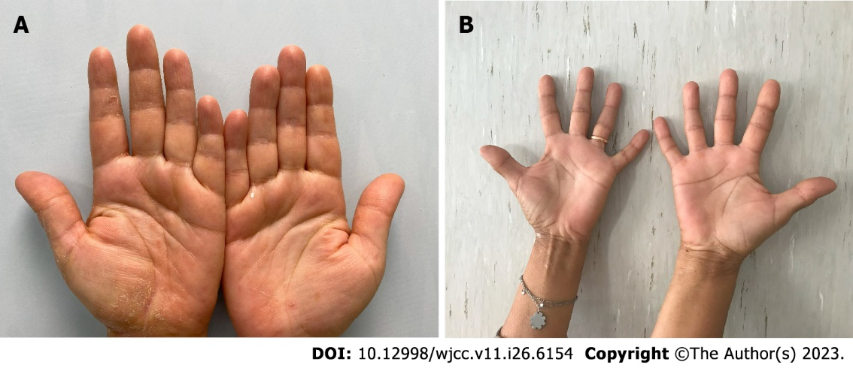
Figure 1 Clinical pictures of affected palms before and after treatment. A: Before treatment; B: After 12 wk.

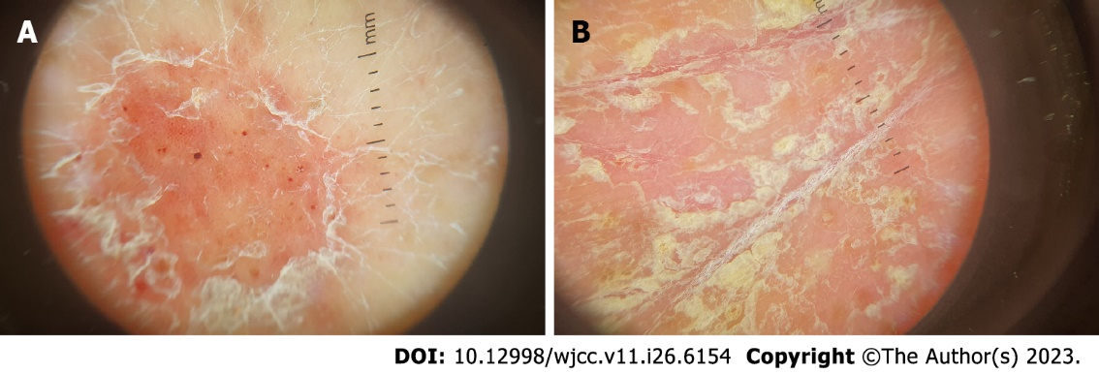
Figure 2 Dermoscopic images. A: Dermoscopic pattern of regularly distributed dotted vessels and white scales; B: Yellow white scales in a thickened hand skin area.

Published by Baishideng Publishing Group Inc
7041 Koll Center Parkway, Suite 160, Pleasanton, CA 94566, USA
Telephone: +1-925-3991568
E-mail: bpgoffice@wjgnet.com
Help Desk: https://www.f6publishing.com/helpdesk
https://www.wjgnet.com

© 2023 Baishideng Publishing Group Inc. All rights reserved.

