Name of journal: World Journal of Gastroenterology
ESPS Manuscript NO: 19688
Manuscript Type: TOPIC HIGHLIGHT

2015 Advances in Cirrhosis
Magnetic resonance imaging of the cirrhotic liver in the era of gadoxetic acid

Agnello F et al. Gadoxetic acid-Enhanced MRI of cirrhotic liver

Francesco Agnello, Marco Dioguardi Burgio, Dario Picone, Federica Vernuccio, Giuseppe Cabibbo, Lydia Giannitrapani, Adele Taibbi, Antonino Agrusa, Tommaso Vincenzo Bartolotta, Massimo Galia, Roberto Lagalla, Massimo Midiri, Giuseppe Brancatelli

Francesco Agnello, Marco Dioguardi Burgio, Dario Picone, Federica Vernuccio, Adele Taibbi, Tommaso Vincenzo Bartolotta, Massimo Galia, Roberto Lagalla, Massimo Midiri, Giuseppe Brancatelli, Section of Radiological Sciences, DIBIMED, University of Palermo, 90127 Palermo, Italy

Giuseppe Cabibbo, Section of Gastroenterology, DIBIMIS, University of Palermo, 90127 Palermo, Italy

Lydia Giannitrapani, Section of Internal Medicine, DIBIMIS, University of Palermo, 90127 Palermo, Italy

Antonino Agrusa, Department of General Surgery, Urgency, and Organ Transplantation, University of Palermo, 90127 Palermo, Italy

Author contributions: Agnello F and Brancatelli G were guarantors of integrity of entire study; Agnello F, Dioguardi Burgio M, Galia M, Midiri M, and Brancatelli G contributed to the manuscript drafting and manuscript revision for important intellectual content; Agnello F, Picone D, Giannitrapani L, Taibbi A, and Vernuccio F contributed to literature research; Agnello F, Cabibbo G, Agrusa A, Bartolotta TV, Lagalla R, and Brancatelli G contributed to the manuscript editing; all authors approve the final version of submitted manuscript

Open-Access: This article is an open-access article which was selected by an in-house editor and fully peer-reviewed by external reviewers. It is distributed in accordance with the Creative Commons Attribution Non Commercial (CC BY-NC 4.0) license, which permits others to distribute, remix, adapt, build upon this work non-commercially, and license their derivative works on different terms, provided the original work is properly cited and the use is non-commercial. See: http://creativecommons.org/licenses/by-nc/4.0/

Correspondence to: Giuseppe Brancatelli, MD, Section of Radiological Sciences, DIBIMED, University of Palermo, Via del Vespro 127, 90127 Palermo, Italy. gbranca@yahoo.com
Telephone: +39-91-6552348
Fax: +39-91-6552324

Received: May 16, 2015
Peer-review started: May 20, 2015
First decision: June 23, 2015
Revised: July 22, 2015
Accepted: September 30, 2015
Article in press:
Published online:

Abstract
Gadoxetic acid improves detection and characterization of focal liver lesions in cirrhotic patients, and can estimate liver function in patients undergoing liver resection. The purpose of this article is to describe the optimal gadoxetic acid study protocol of the liver, the unique characteristics of gadoxetic acid, the differences between gadoxetic acid and extra-cellular gadolium chelates, and the differences in phases of enhancement between cirrhotic and normal liver using gadoxetic acid. We also discuss how to obtain and recognize an adequate hepatobiliary phase.

Key words: Hepatobiliary contrast materials; Gadoxetic acid; Cirrhosis; Magnetic resonance imaging; Liver

© The Author(s) 2015. Published by Baishideng Publishing Group Inc. All rights reserved.

Core tip: Hepatobiliary contrast materials improve detection and characterization of focal liver lesions in cirrhotic patients, and can measure liver function. Familiarity with unique characteristics of gadoxetic acid is crucial to achieve an optimal magnetic resonance examination of the liver. In this review, we discuss the protocol for gadoxetic acid enhanced magnetic resonance imaging of the liver, and describe differences between gadoxetic acid and extra-cellular contrast materials.

Agnello F, Burgio MD, Picone D, Vernuccio F, Cabibbo G, Giannitrapani L, Taibbi A, Agrusa A, Bartolotta TV, Galia M, Lagalla R, Midiri M, Brancatelli G. Magnetic resonance imaging of the cirrhotic liver in the era of gadoxetic acid. World J Gastroenterol 2015; In press

INTRODUCTION
Several studies have demonstrated the added value of hepatobiliary contrast agents in the detection and characterization of focal liver lesions in cirrhotic patients compared with extra-cellular gadolinium chelates and contrast enhanced computed tomography (CT)^{[1-4]}. Hepatobiliary contrast agents first distribute in the extracellular fluid compartment, are subsequently uptaken by functioning hepatocytes and then excreted into the biliary system^{[5,6]}. Thus, hepatobiliary contrast agents can differentiate lesions that contain functioning hepatocytes, such as regenerative nodules and most dysplastic nodules, from hepatocellular lesions without functioning hepatocytes, such as most hepatocellular carcinomas (HCCs), and nonhepatocellular lesions such as cyst, hemangioma, cholangiocarcinoma, metastases, etc^{[7]}.
There are two commercially available hepatobiliary contrast agent: gadolinium ethoxybenzyl diethylenetriamine pentaacetic acid (gadoxetic acid; Eovist/Primovist; Bayer-Healthcare, Germany) and gadobenate dimeglumine (Multihance, Bracco, Italy). Both allow evaluation of lesion vascularity and hepatobiliary function. However, approximately 50% of the injected dose of gadoxetic acid is eliminated by functioning hepatocytes, while only 3%–5% gadobenate dimeglumine undergoes through the same pathway of excretion^{[5,6]}. Using gadoxetic acid, higher hepatobiliary uptake results in greater enhancement of liver parenchyma^{[8]}.
Another unique feature of gadoxetic acid is the rapid hepatocellular uptake (starting at approximately 90 s after injection)^{[1]}, which results in an overlap between extracellular and hepatobiliary phases (the so called “transitional phase”). Rapid uptake of gadoxetic acid allows, however, acquisition of the hepatobiliary phase at 20 min after contrast injection^{[1]}. Hepatocellular uptake of ..gadobenate dimeglumine starts not earlier than 40 min after contrast injection^{[5]}. Therefore, the extracellular phase of gadobenate dimeglumine is “pure” (it shows no overlap with the hepatobiliary phase, similarly to what can be obtained with any extracellular contrast agent), and hepatobiliary phase is typically acquired 60-180 min after contrast injection^{[9]}. Thus, with gadobenate dimeglumine, dynamic and hepatobiliary images are acquired in two separate sessions, increasing examination time and patient discomfort. For these reasons, gadoxetic acid is generally preferred over gadobenate dimeglumine when acquisition of hepatobiliary phase is deemed necessary for the management of patients. The main disadvantage of liver magnetic resonance imaging (MRI) with gadoxetic acid is the contrast cost: the purchase price of gadoxetic acid is approximately double that of gadobenate dimeglumine. As MRI reimbursements in the public sector are fixed, many institutions use gadobenate dimeglumine instead of gadoxetic acid for economic reasons.
In this review, we describe the optimal MRI study protocol of the liver and the differences in phases of enhancement between cirrhotic and normal liver using gadoxetic acid. We also illustrate the differences in phases of enhancement between gadoxetic acid and extracellular contrast agents, and discuss how to obtain and recognize an adequate hepatobiliary phase.

WHY GADOXETIC ACID IN THE CIRRHOTIC LIVER
The need for an accurate detection and characterization of HCC represents the main cause of the increasing use of gadoxetic acid in cirrhotic patients^{[10-12]}. The ability to detect HCC with gadoxetic acid depends on the differences in hepatocellular contrast uptake between HCC and the surrounding liver^{[4]}. On hepatobiliary phase, HCCs are typically hypointense due to the absence of functioning hepatocytes, while the liver parenchyma enhances due to hepatocellar uptake of gadoxetic acid. Consequently, HCC to liver contrast and HCC detection rate are increased^{[4]}.
Hepatobiliary phase hypointensity also helps differentiate HCCs from dysplastic and regenerative nodules. Since hepatocellular uptake of gadoxetic acid decreases during hepatocacinogenis, hepatobiliary phase hypointensity suggests a diagnosis of HCC over that of dysplastic and regenerative nodules, which are typically iso- or hyperintense^{[13-16]}. Typical imaging appearance of HCC includes moderate arterial enhancement and venous wash-out^{[17]}. Using these criteria, however, several small HCCs can be missed because of absence of venous wash-out or, more rarely, arterial enhancement^{[18]}. The hypointensity on hepatobiliary phase helps to correctly characterize small HCCs^{[13-16; 19]}. Hepatobiliary phase hypointensity, however, is not specific for the diagnosis of HCC because it can be found in any non-hepatocyte containing lesion (e.g., hemangiomas, cholangiocarcinomas, metastases, etc)^{[20]}.
Another application of gadoxetic acid is the preoperative evaluation of patients scheduled for liver resection^{[21,22]}. Recent studies have reported that quantitative analysis of hepatocellular uptake of gadoxetic acid can be used to estimate liver function, and to predict the risk of liver failure after major hepatic resection^{[21,22]}. Hepatocellular uptake of gadoxetic acid correlates with indocyanine green clearance and uptake of radiopharmaceutical agents^{[22,23]}. The advantages of gadoxetic acid over traditional methods such as indocyanine green clearance and hepatic scintigraphy with radiopharmaceutical agents include anatomic resolution (i.e., liver function can be evaluated at segmental or subsegmental level) and the absence of ionizing radiations^{[24]}.

OPTIMAL STUDY PROTOCOL OF THE LIVER
An ideal MRI liver protocol should evaluate both liver parenchyma and vessels, and should aid in detection and characterization of hepatic lesions. Typically, MRI liver protocol includes T2-weighted turbo or fast spin-echo (with and without fat saturation) sequences, gradient-recalled echo (GRE) T1-weighted in- and opposed-phase sequence, diffusion-weighted (DW) sequence, and contrast -enhanced three-dimensional T1-weighted GRE sequence with fat suppression. Field-strength magnets of 1.5 Tesla or greater are recommended to obtain high-quality liver imaging^{[25]}. Contrast administration should be performed through a power injector. The use of a saline solution is strongly recommended because it reduces the dose of contrast material remaining in the dead space (e.g., the brachial vein), and shortens the arrival time of contrast material in the hepatic arteries^{[10]}. Contrast enhanced images are obtained on vascular, transitional, and hepatobiliary phases^{[26]}. Vascular phases include the late hepatic arterial and portal venous phases^{[26]}. Late hepatic arterial phase is crucial to detect and characterize hypervascular lesions^{[27]}. Demonstration of moderate enhancement of intrahepatic portal veins, slight enhancement of liver parenchyma, and no enhancement of hepatic veins indicate an appropriate timing^{[28]}. Achieving an adequate arterial phase with gadoxetic acid is more challenging than with conventional extra-cellular contrast materials. Due to the higher T1-relaxivity, gadoxetic acid has one-half lower contrast volume and one fourth lower Gd-content per kg than those of conventional extra-cellular contrast materials^{[29]}. Thus, gadoxetic acid injection duration and time to peak aortic enhancement are shorter than those of conventional extra-cellular contrast materials^{[29]}. In addition, the administration of gadoxetic acid has been associated with acute self-limited dyspnea, and consequent severe motion artifacts^{[30]}. By definition, acute self-limited dyspnea is isolated to the hepatic arterial phase images, and respiratory motion artifacts are absent in other sequences^{[30]}. The exact cause remains unknown. A relationship between higher gadoxetic acid doses and chronic obstructive pulmonary disease have been reported^{[31]}. Because the dyspnea is transient (10-20 seconds), a potential solution in order to overcome the artifacts is to acquire more than one arterial phase images. This approach is advantageous because (1) acquisition of a greater number of phases increases the likelihood to obtain at least one diagnostic arterial phase image; and (2) reducing the acquisition time of each phase minimize the opportunity for motion^{[30]}.
Different methods of contrast material injection are available in order to achieve an optimal hepatic arterial phase. The most frequently used is a fixed delay (approximately 15-20 s) between the start of contrast injection and data acquisition. This method, however, is often inadequate because it does not take into account injection- or patient-related factors (e.g., cardiac output) that influence circulation time. Indeed, arterial phase images are frequently obtained either too early (i.e. before portal venous enhancement) or too late (when contrast is already in the hepatic veins)^{[32]}. Another option is the test bolus technique, in which a small test bolus (1-2 mL) of contrast material is injected to calculate contrast material arrival time. Although this technique is effective with extra-cellular contrast materials, it is not recommended in gadoxetic acid enhanced MRI because hepatocellular uptake of the bolus can increase liver signal intensity, and the removal of bolus volume from the pre-filled syringe can leave insufficient contrast to administer during the dynamic phases of the study. The use of a fluoroscopic system (MR SmartPrep, GE Medical Systems, Milwaukee, WI, USA; CARE Bolus, Siemens Medical Solutions, Erlangen, Germany; Bolus-Track, Philips Medical Systems, Best, The Netherlands) is preferable^{[10]}. This technique is based on real-time monitoring of the bolus arrival at the level of the vessel of interest (typically the suprarenal abdominal aorta) with a 2D fluoroscopic sequence. Arterial phase acquisition can be started manually or automatically with a trigger threshold. The optimal scan delay for late hepatic arterial phase is 15-20 s after the peak aortic enhancement, which corresponds to the time necessary to synchronize the arrival of contrast material in the main portal vein with central k-space filling^{[26]}.
The injection of contrast material breaks k-space homogeneity, and can cause truncation artifacts^{[33]}. These artifacts appear as dark or bright lines at interfaces between high and low signal intensity structures (e.g., enhanced arteries and surrounding liver parenchyma), and alter anatomic details of structures^{[34]}. Several methods in order to minimize truncation artifacts have been proposed. One option is to use a larger volume of contrast material by diluting gadoxetic acid with saline^{[33]}. Alternatively, a slow (1 mL/s) injection rate, which results in natural dilution of the contrast in the vascular space, can be used^{[35]}. In addition, to increase k-space homogeneity, the larger contrast volume provides a wider temporal window of hepatic arterial phase. Tamada et al^{[36]} compared arterial phase images obtained with three different techniques: diluted gadoxetic acid administered at conventional rate of 3 mL/s; undiluted gadoxetic acid administered at conventional rate of 3 mL/s; and undiluted gadoxetic acid administered at a rate of 1 mL/s. They concluded that injection rate of 1 mL/s with undiluted gadoxetic acid is preferable to the other two methods^{[38]}. Portal venous phase is acquired 50-70 s after gadoxetic acid injection. On portal venous phase the liver parenchyma shows intense enhancement, and the portal and hepatic veins are fully and maximally enhanced^{[37]} The interval time (2-5 min after gadoxetic acid injection) between perfusion phase and hepatobiliary phase is termed “transitional phase”, and therefore should not be confused with or referred to as the equilibrium phase that is typically obtained at the same time delay with extracellular contrast agents^{[38]} (Figures 1 and 2) . The transitional phase is obtained 3 min after the start of contrast injection^{[26]}. Gadoxetic acid shows uptake by hepatocytes through a canalicular multispecific organic anion transporting polypeptide 1B3 (OATP1B3) as early as 90 s after contrast injection, but this process takes several minutes before all contrast is uptaken by hepatocytes. Thus, gadoxetic acid “transitates” from interstitial space to intracellular space. That is why we refer to this phase as the transitional phase, indicating the transition of gadoxetic acid from the extra-cellular space to the hepatocellular space^{[38]}. By contrast, extra-cellular contrast materials are equally distributed between vascular spaces and interstitial spaces. Hepatocellular uptake of gadoxetic acid explains higher signal intensity of liver parenchyma with gadoxetic acid than with extracellular contrast materials^{[39]}. Earlier elimination of gadoxetic acid from the vessels leads to earlier de-enhancement and therefore lower signal intensity of intrahepatic vessels with gadoxetic acid than with extra-cellular contrast materials (Figure 2)^{[39]}.
Hepatobiliary phase is acquired 10-20 min after the start of contrast injection. Since the injection of gadoxetic acid does not compromise tissue contrast on T2-weighted images and diffusion-weighted images, these sequences can be acquired in the interval between the three minutes phase and the hepatobiliary phase, thus reducing the total examination time^{[40-42]}. DW images can help to differentiate hypovascular HCC from high-grade dysplastic nodules, and can predict the progression of hypovascular hypointense nodules on hepatobiliary phase into hypervascular HCC^{[43,44]}. That is, hyperintensity on high-b-value DW images suggests a diagnosis of HCC, and is strongly associated with progression of hypovascular nodules into hypervascular HCC^{[43,44]}. The adjunct of DW images, however, does not significantly improve the diagnostic accuracy of MRI with hepatobiliary contrast materials in the detection of HCC^{[45,46]}. Most small HCCs are imperceptible on DW images because they have cellular density and microscopic architecture relatively similar to that of surrounding cirrhotic liver^{[46]}.

DIFFERENCES IN PHASES OF ENHANCEMENT BETWEEN GADOXETIC ACID AND EXTRA-CELLULAR CONTRAST MATERIALS
Although gadoxetic acid allows dynamic imaging during the hepatic arterial, portal venous, and three-minute phases, some enhancement characteristics are different from those of extracellular contrast materials^{[1,39]} (Figure 2). Gadoxetic acid shows a biphasic enhancement pattern in the liver^{[1]}. The first phase (arterial + portal venous) is due to distribution into the vascular compartment. The second phase is due to hepatocellular uptake of gadoxetic acid by the canalicular multispecific OATP1B3 and starts 90 s after injection^{[1]}. Extra-cellular contrast materials distribute in the extracellular fluid compartments, and, as the name implies, they are not uptaken by the hepatocytes^{[1]}. Liver enhancement peaks on portal venous phase and then decreases^{[39]}. Vascular enhancement is higher and longer with extracellular contrast materials than with gadoxetic acid^{[39]}. On hepatic arterial phase, some authors have reported that aorta and liver parenchymal enhancement is weaker with gadoxetic acid than with extra-cellular contrast materials^{[39]}. Since most HCCs are hypervascular, this can influence their detection and characterization^{[1,39]}. On portal venous phase, the signal intensity of liver parenchyma is comparable between gadoxetic acid and extra-cellular contrast materials, but the signal intensity of portal vein is lower with gadoxetic acid than with extra-cellular contrast materials^{[39]}. Thus, the evaluation of portal and hepatic veins can be suboptimal with gadoxetic acid^{[12]}. As HCC invasion into portal or hepatic vein, and portal vein thrombosis influence treatment options and can preclude surgical resection and liver transplantation, vascular evaluation can mitigate the advantages of gadoxetic acid.

DIFFERENCES IN PHASES OF ENHANCEMENT BETWEEN CIRRHOTIC AND NORMAL LIVER WITH GADOXETIC ACID
Cirrhosis is pathologically characterized by distortion of hepatic architecture due to marked bridging hepatic fibrosis and regenerative nodule formation^{[47]}. The number of normal hepatocytes is reduced, and biliary excretion is impaired^{[34,48]}. Cirrhosis alters liver perfusion with a reduction in portal inflow and a compensatory increase of arterial inflow^{[11]}. Thus, on hepatic arterial phase, liver enhancement is higher in cirrhotic patients than in normal-liver patients^{[49]}. On portal venous phase, however, liver enhancement is superimposable in cirrhotic patients and normal-liver patients^{[49]}. At three minutes and in the hepatobiliary phases, liver enhancement is higher in normal patients than in cirrhotic patients, and shows an inverse correlation with the severity of cirrhosis^{[49]}. This is because hepatic fibrotic and reduced number of functioning hepatocytes decrease the hepatocellular uptake of gadoxetic acid^{[49]}. Pharmococynetic analysis demonstrated that liver signal intensity shows a stepwise increase from the hepatic arterial phase to hepatobiliary phase in patients with normal liver and in patients with Child-Pugh class A and B cirrhosis (Figure 1); while it does not significantly change from portal venous phase to 20-min hepatobiliary phase in patients with Child-Pugh class C cirrhosis^{[49]} (Figure 3). The consequence is that oftentimes, at 20 min, the vessels will not be “dark” enough in patients with Child-Pugh class C cirrhosis, resulting in a suboptimal hepatobiliary phase. Thus, in our practice, acquisition of hepatobiliary phase beyond the conventional 20 min delay may be useful in patients with impaired hepatic function in order to allow the hepatocytes more time to uptake contrast from the extracellular space^{[50,51]}. Conversely, in normal-liver patients, a hepatobiliary delay of 10 min after gadoxetic acid injection is sufficient^{[52]}. Unlike normal liver, cirrhotic liver can show heterogeneous enhancement on the hepatobiliary phase, which can further complicate the detection and characterization of hepatic nodules^{[49]}. The heterogeneity directly correlates with Child-Pugh class^{[49]}. Enhancement of biliary tree is delayed in patients with cirrhosis, compared to normal-liver patients^{[48]}.
Tschirch compared the visualization of biliary tree between cirrhotic patients and normal-liver patients and found that 16/40 (40%) of cirrhotic patients showed sufficient visualization of the biliary tree within 30 min after injection, and 21/40 (53%) cirrhotic patients showed sufficient visualization of the biliary tree within 180 min after injection^{[48]}. By contrast, in their series, all normal-liver patients showed sufficient visualization of the biliary tree within 30 min after injection^{[48]}.

ADEQUACY OF HEPATOBILIARY PHASE
In patients with normal hepatic function, gadoxetic acid is equally eliminated by biliary excretion and glomerular filtration^{[6]}. Impaired hepatic function results in a compensatory increase of renal elimination and more prolonged plasma half-life of gadoxetic acid in cirrhotic patients than in normal-liver patients^{[36]}. The consequence is typically a decrease of contrast between liver parenchyma and portal vein^{[53]}. Visual evaluation of the signal intensity of the liver relative to the portal vein or kidney can help radiologists to asses adequacy of the hepatobiliary phase^{[34,37]}. Specifically, brighter signal intensity of the liver parenchyma compared to the portal vein and kidney indicates an adequate hepatobiliary phase, while persistent contrast within the portal vein and brighter or equal signal intensity of the kidney compared to the liver parenchyma indicates an inadequate hepatobiliary phase^{[36,39]} (Figures 3 and 4). Opacification of the biliary tree shows no correlation with the severity of cirrhosis, and cannot be used alone to evaluate adequacy of the hepatobiliary phase^{[48]} (Figure 4).
The uptake of gadoxetic acid does not depend only on the hepatic function, but also on the hepatic blood flow^{[33]}. Motosugi et al^{[33]} reported that most patients with Child Pugh Class A cirrhosis and inadequate hepatobiliary phase had considerable arterial-portal and portal-systemic shunts. The shunts decrease the hepatic blood flow and hepatic retention of gadoxetic acid^{[33]}. Other causes of reduced hepatobiliary phase enhancement include severe steatosis (Figure 5), hepatic fibrosis, and iron overload^{[54-57]}. An inadequate hepatobiliary phase may impair detection and characterization of focal liver lesions because the contrast between focal liver lesions and liver parenchyma is reduced^{[58]}. These patients should be evaluated with alternative modalities such as contrast-enhanced CT and contrast-enhanced ultrasound in order to avoid misdiagnosis. To date, however, no liver function test can predict whether the hepatobiliary phase will result adequate.
Recent studies have demonstrated that increasing the flip-angle from 10°-15° to 30°-40° can improve detection and conspicuity of focal hepatic lesion, particularly of small lesions^{[44-46]}. Larger flip angle maximizes T1-contrast, and results in better differentiation between tissues with short T1-relaxation times such as liver parenchyma with gadoxetic acid uptake and tissues with long T1-relaxation times such as lesions without functioning hepatocytes^{[59-61]}. Larger flip angle, however, increases specific absorption rate (SAR) in patient tissue^{[59]}.

CONCLUSION
Gadoxetic acid enhanced liver MRI is emerging as a powerful tool in the diagnostic workup of cirrhotic patients, and provides unique information related to lesion vascularity and hepatobiliary function. Use of gadoxetic acid improves detection and characterization of focal liver lesions, and the hepatocellular uptake can be used as a measure of liver function. Thus, radiologists involved in liver imaging need to be familiar with state-of-art MRI study protocol of the liver, and unique characteristics of gadoxetic acid.

REFERENCES
1 Vogl TJ, Kümmel S, Hammerstingl R, Schellenbeck M, Schumacher G, Balzer T, Schwarz W, Müller PK, Bechstein WO, Mack MG, Söllner O, Felix R. Liver tumors: comparison of MR imaging with Gd-EOB-DTPA and Gd-DTPA. Radiology 1996; 200: 59-67 [PMID: 8657946]
2 Di Martino M, Marin D, Guerrisi A, Baski M, Galati F, Rossi M, Brozzetti S, Masciangelo R, Passariello R, Catalano C. Intraindividual comparison of gadoxetate disodium-enhanced MR imaging and 64-section multidetector CT in the Detection of hepatocellular carcinoma in patients with cirrhosis. Radiology 2010; 256: 806-816 [PMID: 20720069 DOI: 10.1148/radiol.10091334]
3 Marin D, Di Martino M, Guerrisi A, De Filippis G, Rossi M, Ginanni Corradini S, Masciangelo R, Catalano C, Passariello R. Hepatocellular carcinoma in patients with cirrhosis: qualitative comparison of gadobenate dimeglumine-enhanced MR imaging and multiphasic 64-section CT. Radiology 2009; 251: 85-95 [PMID: 19332848 DOI: 10.1148/radiol.2511080400]
4 Huppertz A, Balzer T, Blakeborough A, Breuer J, Giovagnoni A, Heinz-Peer G, Laniado M, Manfredi RM, Mathieu DG, Mueller D, Reimer P, Robinson PJ, Strotzer M, Taupitz M, Vogl TJ. Improved detection of focal liver lesions at MR imaging: multicenter comparison of gadoxetic acid-enhanced MR images with intraoperative findings. Radiology 2004; 230: 266-275 [PMID: 14695400]
5 Spinazzi A, Lorusso V, Pirovano G, Kirchin M. Safety, tolerance, biodistribution, and MR imaging enhancement of the liver with gadobenate dimeglumine: results of clinical pharmacologic and pilot imaging studies in nonpatient and patient volunteers. Acad Radiol 1999; 6: 282-291 [PMID: 10228617]
6 Hamm B, Staks T, Mühler A, Bollow M, Taupitz M, Frenzel T, Wolf KJ, Weinmann HJ, Lange L. Phase I clinical evaluation of Gd-EOB-DTPA as a hepatobiliary MR contrast agent: safety, pharmacokinetics, and MR imaging. Radiology 1995; 195: 785-792 [PMID: 7754011]
7 Huppertz A, Haraida S, Kraus A, Zech CJ, Scheidler J, Breuer J, Helmberger TK, Reiser MF. Enhancement of focal liver lesions at gadoxetic acid-enhanced MR imaging: correlation with histopathologic findings and spiral CT--initial observations. Radiology 2005; 234: 468-478 [PMID: 15591431]
8 Filippone A, Blakeborough A, Breuer J, Grazioli L, Gschwend S, Hammerstingl R, Heinz-Peer G, Kittner T, Laghi A, Leen E, Lencioni R, Lucidarme O, Remplik P, Robinson PJ, Ruehm SG, Schaefer F, Stoupis C, Tombach B, Valette PJ, Zech CJ, Huppertz A. Enhancement of liver parenchyma after injection of hepatocyte-specific MRI contrast media: a comparison of gadoxetic acid and gadobenate dimeglumine. J Magn Reson Imaging 2010; 31: 356-364 [PMID: 20099349 DOI: 10.1002/jmri.22054]
9 Tanimoto A, Kuwatsuru R, Kadoya M, Ohtomo K, Hirohashi S, Murakami T, Hiramatsu K, Yoshikawa K, Katayama H. Evaluation of gadobenate dimeglumine in hepatocellular carcinoma: results from phase II and phase III clinical trials in Japan. J Magn Reson Imaging 1999; 10: 450-460 [PMID: 10508308]
10 Tanimoto A, Lee JM, Murakami T, Huppertz A, Kudo M, Grazioli L. Consensus report of the 2nd International Forum for Liver MRI. Eur Radiol 2009; 19 Suppl 5: S975-S989 [PMID: 19851766 DOI: 10.1007/s00330-009-1624-y]
11 Malone D, Zech CJ, Ayuso C. Magnetic resonance imaging of the liver: consensus statement from the 1st International Primovist User Meeting. European Radiology Supplements 2008; 18: 849-864
12 Zech CJ, Bartolozzi C, Bioulac-Sage P, Chow PK, Forner A, Grazioli L, Huppertz A, Laumonier H, Min Lee J, Murakami T, Ricke J, Sirlin CB. Consensus report of the Fifth International Forum for Liver MRI. AJR Am J Roentgenol 2013; 201: 97-107 [PMID: 23789662 DOI: 10.2214/AJR.12.9491]
13 Narita M, Hatano E, Arizono S, Miyagawa-Hayashino A, Isoda H, Kitamura K, Taura K, Yasuchika K, Nitta T, Ikai I, Uemoto S. Expression of OATP1B3 determines uptake of Gd-EOB-DTPA in hepatocellular carcinoma. J Gastroenterol 2009; 44: 793-798 [PMID: 19404564 DOI: 10.1007/s00535-009-0056-4]
14 Kitao A, Matsui O, Yoneda N, Kozaka K, Kobayashi S, Koda W, Gabata T, Yamashita T, Kaneko S, Nakanuma Y, Kita R, Arii S. Hypervascular hepatocellular carcinoma: correlation between biologic features and signal intensity on gadoxetic acid-enhanced MR images. Radiology 2012; 265: 780-789 [PMID: 23175543 DOI: 10.1148/radiol.12120226]
15 Bartolozzi C, Crocetti L, Lencioni R, Cioni D, Della Pina C, Campani D. Biliary and reticuloendothelial impairment in hepatocarcinogenesis: the diagnostic role of tissue-specific MR contrast media. Eur Radiol 2007; 17: 2519-2530 [PMID: 17429640]
16 Lee MH, Kim SH, Park MJ, Park CK, Rhim H. Gadoxetic acid-enhanced hepatobiliary phase MRI and high-b-value diffusion-weighted imaging to distinguish well-differentiated hepatocellular carcinomas from benign nodules in patients with chronic liver disease. AJR Am J Roentgenol 2011; 197: W868-W875 [PMID: 22021534 DOI: 10.2214/AJR.10.6237]
17 Cruite I, Tang A, Sirlin CB. Imaging-based diagnostic systems for hepatocellular carcinoma. AJR Am J Roentgenol 2013; 201: 41-55 [PMID: 23789657 DOI: 10.2214/AJR.13.10570]
18 Forner A, Vilana R, Ayuso C, Bianchi L, Solé M, Ayuso JR, Boix L, Sala M, Varela M, Llovet JM, Brú C, Bruix J. Diagnosis of hepatic nodules 20 mm or smaller in cirrhosis: Prospective validation of the noninvasive diagnostic criteria for hepatocellular carcinoma. Hepatology 2008; 47: 97-104 [PMID: 18069697]
19 Ahn SS, Kim MJ, Lim JS, Hong HS, Chung YE, Choi JY. Added value of gadoxetic acid-enhanced hepatobiliary phase MR imaging in the diagnosis of hepatocellular carcinoma. Radiology 2010; 255: 459-466 [PMID: 20413759 DOI: 10.1148/radiol.10091388]
20 Seale MK, Catalano OA, Saini S, Hahn PF, Sahani DV. Hepatobiliary-specific MR contrast agents: role in imaging the liver and biliary tree. Radiographics 2009; 29: 1725-1748 [PMID: 19959518 DOI: 10.1148/rg.296095515]
21 Yamada A, Hara T, Li F, Fujinaga Y, Ueda K, Kadoya M, Doi K. Quantitative evaluation of liver function with use of gadoxetate disodium-enhanced MR imaging. Radiology 2011; 260: 727-733 [PMID: 21712472 DOI: 10.1148/radiol.11100586]
22 Cho SH, Kang UR, Kim JD, Han YS, Choi DL. The value of gadoxetate disodium-enhanced MR imaging for predicting posthepatectomy liver failure after major hepatic resection: a preliminary study. Eur J Radiol 2011; 80: e195-e200 [PMID: 21908121 DOI: 0.1016/j.ejrad.2011.08.008]
23 Geisel D, Lüdemann L, Fröling V, Malinowski M, Stockmann M, Baron A, Gebauer B, Seehofer D, Prasad V, Denecke T. Imaging-based evaluation of liver function: comparison of ⁹⁹mTc-mebrofenin hepatobiliary scintigraphy and Gd-EOB-DTPA-enhanced MRI. Eur Radiol 2015; 25: 1384-1391 [PMID: 25447973 DOI: 10.1007/s00330-014-3536-8]
24 Van Beers BE, Pastor CM, Hussain HK. Primovist, Eovist: what to expect? J Hepatol 2012; 57: 421-429 [PMID: 22504332 DOI: 10.1016/j.jhep.2012.01.031]
25 Wald C, Russo MW, Heimbach JK, Hussain HK, Pomfret EA, Bruix J. New OPTN/UNOS policy for liver transplant allocation: standardization of liver imaging, diagnosis, classification, and reporting of hepatocellular carcinoma. Radiology 2013; 266: 376-382 [PMID: 23362092 DOI: 10.1148/radiol.12121698]
26 Ringe KI, Husarik DB, Sirlin CB, Merkle EM. Gadoxetate disodium-enhanced MRI of the liver: part 1, protocol optimization and lesion appearance in the noncirrhotic liver. AJR Am J Roentgenol 2010; 195: 13-28 [PMID: 20566794 DOI: 10.2214/AJR.10.4392]
27 Goshima S, Kanematsu M, Kondo H, Watanabe H, Kawada H, Moriyama N, Bae KT. Evaluation of optimal scan delay for gadoxetate disodium-enhanced hepatic arterial phase MRI using MR fluoroscopic triggering and slow injection technique. AJR Am J Roentgenol 2013; 201: 578-582 [PMID: 23971449 DOI: 10.2214/AJR.12.10034]
28 Goshima S, Kanematsu M, Kondo H, Shiratori Y, Onozuka M, Moriyama N, Bae KT. Optimal acquisition delay for dynamic contrast-enhanced MRI of hypervascular hepatocellular carcinoma. AJR Am J Roentgenol 2009; 192: 686-692 [PMID: 19234264 DOI: 10.2214/AJR.08.1255]
29 Rohrer M, Bauer H, Mintorovitch J, Requardt M, Weinmann HJ. Comparison of magnetic properties of MRI contrast media solutions at different magnetic field strengths. Invest Radiol 2005; 40: 715-724 [PMID: 16230904]
30 Pietryga JA, Burke LM, Marin D, Jaffe TA, Bashir MR. Respiratory motion artifact affecting hepatic arterial phase imaging with gadoxetate disodium: examination recovery with a multiple arterial phase acquisition. Radiology 2014; 271: 426-434 [PMID: 24475864 DOI: 10.1148/radiol.13131988]
31 Davenport MS, Bashir MR, Pietryga JA, Weber JT, Khalatbari S, Hussain HK. Dose-toxicity relationship of gadoxetate disodium and transient severe respiratory motion artifact. AJR Am J Roentgenol 2014; 203: 796-802 [PMID: 25055154 DOI: 10.2214/AJR.13.11587]
32 Earls JP, Rofsky NM, DeCorato DR, Krinsky GA, Weinreb JC. Hepatic arterial-phase dynamic gadolinium-enhanced MR imaging: optimization with a test examination and a power injector. Radiology 1997; 202: 268-273 [PMID: 8988222]
33 Motosugi U, Ichikawa T, Sou H, Sano K, Ichikawa S, Tominaga L, Araki T. Dilution method of gadolinium ethoxybenzyl diethylenetriaminepentaacetic acid (Gd-EOB-DTPA)-enhanced magnetic resonance imaging (MRI). J Magn Reson Imaging 2009; 30: 849-854 [PMID: 19787734 DOI: 10.1002/jmri.21913]
34 Czervionke LF, Czervionke JM, Daniels DL, Haughton VM. Characteristic features of MR truncation artifacts. AJR Am J Roentgenol 1988; 151: 1219-1228 [PMID: 3263776]
35 Haradome H, Grazioli L, Tsunoo M, Tinti R, Frittoli B, Gambarini S, Morone M, Motosugi U, Colagrande S. Can MR fluoroscopic triggering technique and slow rate injection provide appropriate arterial phase images with reducing artifacts on gadoxetic acid-DTPA (Gd-EOB-DTPA)-enhanced hepatic MR imaging? J Magn Reson Imaging 2010; 32: 334-340 [PMID: 20677259 DOI: 10.1002/jmri.22241]
36 Tamada T, Ito K, Sone T, Kanki A, Sato T, Higashi H. Gd-EOB-DTPA enhanced MR imaging: evaluation of biliary and renal excretion in normal and cirrhotic livers. Eur J Radiol 2011; 80: e207-e211 [PMID: 20869827 DOI: 10.1016/j.ejrad.2010.08.033]
37 LI-RADS algorithm, Atlas, and Lexicon. Available from: URL: http://www.acr.org/media/ACR/Documents/PDF/QualitySafety/Resources/LIRADS /lirads v20131 w note.pdf
38 Nakamura Y, Toyota N, Date S, Oda S, Namimoto T, Yamashita Y, Beppu T, Awai K. Clinical significance of the transitional phase at gadoxetate disodium-enhanced hepatic MRI for the diagnosis of hepatocellular carcinoma: preliminary results. J Comput Assist Tomogr 2011; 35: 723-727 [PMID: 22082543 DOI: 10.1097/RCT.0b013e3182372c40]
39 Tamada T, Ito K, Sone T, Yamamoto A, Yoshida K, Kakuba K, Tanimoto D, Higashi H, Yamashita T. Dynamic contrast-enhanced magnetic resonance imaging of abdominal solid organ and major vessel: comparison of enhancement effect between Gd-EOB-DTPA and Gd-DTPA. J Magn Reson Imaging 2009; 29: 636-640 [PMID: 19243060 DOI: 10.1002/jmri.21689]
40 Tamada T, Ito K, Yoshida K, Sone T, Murakami K, Kanki A, Watanabe S, Higashi H, Yamashita T. T2-weighted magnetic resonance imaging of the liver: evaluation of the effect in signal intensity after Gd-EOB-DTPA enhancement. J Comput Assist Tomogr 2010; 34: 182-186 [PMID: 20351500 DOI: 10.1097/RCT.0b013e3181bc961b]
41 Muhi A, Ichikawa T, Motosugi U, Sou H, Sano K, Araki T. Diffusion- and T₂-weighted MR imaging of the liver: effect of intravenous administration of gadoxetic acid disodium. Magn Reson Med Sci 2012; 11: 185-191 [PMID: 23037563]
42 Choi JS, Kim MJ, Choi JY, Park MS, Lim JS, Kim KW. Diffusion-weighted MR imaging of liver on 3.0-Tesla system: effect of intravenous administration of gadoxetic acid disodium. Eur Radiol 2010; 20: 1052-1060 [PMID: 19915849 DOI: 10.1007/s00330-009-1651-8]
43 Hwang J, Kim YK, Jeong WK, Choi D, Rhim H, Lee WJ. Nonhypervascular Hypointense Nodules at Gadoxetic Acid-enhanced MR Imaging in Chronic Liver Disease: Diffusion-weighted Imaging for Characterization. Radiology 2015; 276: 137-146 [PMID: 25734551 DOI: 10.1148/radiol.15141350]
44 Kim YK, Lee WJ, Park MJ, Kim SH, Rhim H, Choi D. Hypovascular hypointense nodules on hepatobiliary phase gadoxetic acid-enhanced MR images in patients with cirrhosis: potential of DW imaging in predicting progression to hypervascular HCC. Radiology 2012; 265: 104-114 [PMID: 22891358]
45 Kim YK, Kim CS, Han YM, Lee YH. Detection of liver malignancy with gadoxetic acid-enhanced MRI: is addition of diffusion-weighted MRI beneficial? Clin Radiol 2011; 66: 489-496 [PMID: 21367403 DOI: 10.1016/j.crad.2010.09.007]
46 Di Martino M, Di Miscio R, De Filippis G, Lombardo CV, Saba L, Geiger D, Catalano C. Detection of small (≤2 cm) HCC in cirrhotic patients: added value of diffusion MR-imaging. Abdom Imaging 2013; 38: 1254-1262 [PMID: 23857505 DOI: 10.1007/s00261-013-0009-5]
47 Ishak K, Baptista A, Bianchi L, Callea F, De Groote J, Gudat F, Denk H, Desmet V, Korb G, MacSween RN. Histological grading and staging of chronic hepatitis. J Hepatol 1995; 22: 696-699 [PMID: 7560864]
48 Annet L, Materne R, Danse E, Jamart J, Horsmans Y, Van Beers BE. Hepatic flow parameters measured with MR imaging and Doppler US: correlations with degree of cirrhosis and portal hypertension. Radiology 2003; 229: 409-414 [PMID: 12970464]
49 Tamada T, Ito K, Higaki A, Yoshida K, Kanki A, Sato T, Higashi H, Sone T. Gd-EOB-DTPA-enhanced MR imaging: evaluation of hepatic enhancement effects in normal and cirrhotic livers. Eur J Radiol 2011; 80: e311-e316 [PMID: 21315529]
50 Cruite I, Schroeder M, Merkle EM, Sirlin CB. Gadoxetate disodium-enhanced MRI of the liver: part 2, protocol optimization and lesion appearance in the cirrhotic liver. AJR Am J Roentgenol 2010; 195: 29-41 [PMID: 20566795 DOI: 10.2214/AJR.10.4538]
51 van Kessel CS, Veldhuis WB, van den Bosch MA, van Leeuwen MS. MR liver imaging with Gd-EOB-DTPA: a delay time of 10 minutes is sufficient for lesion characterisation. Eur Radiol 2012; 22: 2153-2160 [PMID: 22645040 DOI: 10.1007/s00330-012-2486-2]
52 Tschirch FT, Struwe A, Petrowsky H, Kakales I, Marincek B, Weishaupt D. Contrast-enhanced MR cholangiography with Gd-EOB-DTPA in patients with liver cirrhosis: visualization of the biliary ducts in comparison with patients with normal liver parenchyma. Eur Radiol 2008; 18: 1577-1586 [PMID: 18369632 DOI: 10.1007]
53 Lee NK, Kim S, Kim GH, Heo J, Seo HI, Kim TU, Kang DH. Significance of the "delayed hyperintense portal vein sign" in the hepatobiliary phase MRI obtained with Gd-EOB-DTPA. J Magn Reson Imaging 2012; 36: 678-685 [PMID: 22649000 DOI: 10.1002/jmri.23700]
54 Watanabe H, Kanematsu M, Goshima S, Kondo H, Onozuka M, Moriyama N, Bae KT. Radiology 2011; 259: 142-150 [PMID: 21248234 DOI: 10.1148/radiol.10100621]
55 Feier D, Balassy C, Bastati N, Stift J, Badea R, Ba-Ssalamah A. Liver fibrosis: histopathologic and biochemical influences on diagnostic efficacy of hepatobiliary contrast-enhanced MR imaging in staging. Radiology 2013; 269: 460-468 [PMID: 23878281 DOI: 10.1148/radiol.13122482]
56 Onishi H, Theisen D, Dietrich O, Reiser MF, Zech CJ. Hepatic steatosis: effect on hepatocyte enhancement with gadoxetate disodium-enhanced liver MR imaging. J Magn Reson Imaging 2014; 39: 42-50 [PMID: 24339365 DOI: 10.1002/jmri.24136]
57 Choi JY, Lee JM, Sirlin CB. CT and MR imaging diagnosis and staging of hepatocellular carcinoma: part II. Extracellular agents, hepatobiliary agents, and ancillary imaging features. Radiology 2014; 273: 30-50 [PMID: 25247563 DOI: 10.1148/radiol.14132362]
58 Higaki A, Tamada T, Sone T, Kanki A, Sato T, Tanimoto D, Higashi H, Ito K. Potential clinical factors affecting hepatobiliary enhancement at Gd-EOB-DTPA-enhanced MR imaging. Magn Reson Imaging 2012; 30: 689-693 [PMID: 22459437 DOI: 10.1016/j.mri.2012.01.004]
59 Bashir MR, Merkle EM. Improved liver lesion conspicuity by increasing the flip angle during hepatocyte phase MR imaging. Eur Radiol 2011; 21: 291-294 [PMID: 20686771 DOI: 10.1007/s00330-010-1917-1]
60 Haradome H, Grazioli L, Al manea K, Tsunoo M, Motosugi U, Kwee TC, Takaraha T. Gadoxetic acid disodium-enhanced hepatocyte phase MRI: can increasing the flip angle improve focal liver lesion detection? J Magn Reson Imaging 2012; 35: 132-139 [PMID: 21960465 DOI: 10.1002/jmri.22805]
61 Cho ES, Yu JS, Park AY, Woo S, Kim JH, Chung JJ. Feasibility of 5-minute delayed transition phase imaging with 30° flip angle in gadoxetic acid-enhanced 3D gradient-echo MRI of liver, compared with 20-minute delayed hepatocyte phase MRI with standard 10° flip angle. AJR Am J Roentgenol 2015; 204: 69-75 [PMID: 25539239 DOI: 10.2214/AJR.13.11903]
P-Reviewer: De Robertis R, Sirli R S-Editor: Yu J L-Editor: E-Editor:

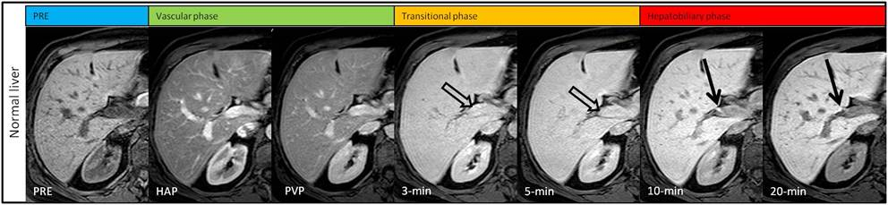
Figure 1 Gadoxetic acid contrast-enhanced magnetic resonance images obtained in a 46 year-old woman with normal liver. Contrast-enhanced magnetic resonance images show a stepwise intensity increase of the liver parenchyma from the hepatic arterial phase to hepatobiliary phase. On hepatic arterial and portal venous phases (vascular phase) the intrahepatic vessels show intense and homogeneous enhancement. On 3-min late and 5-min late phases (transitional phase) the intrahepatic vessels (open arrows) show isointensity to the liver, indicating the transition of gadoxetic acid from the extra-cellular spaces to the hepatocellular-spaces. On 10-min and 20-min phase (hepatobiliary phase) the intrahepatic vessels show hypointensity to the liver, while the bile ducts (arrows) show hyperintensity; these findings indicate an adequate hepatobiliary phase. Also note kidney hypointensity to the liver, which indicates normal hepatobiliary elimination of gadoxetic acid and adequate hepatobilary phase. PRE: Precontrast. HAP: Late hepatic arterial phase. PVP: Portal venous phase.

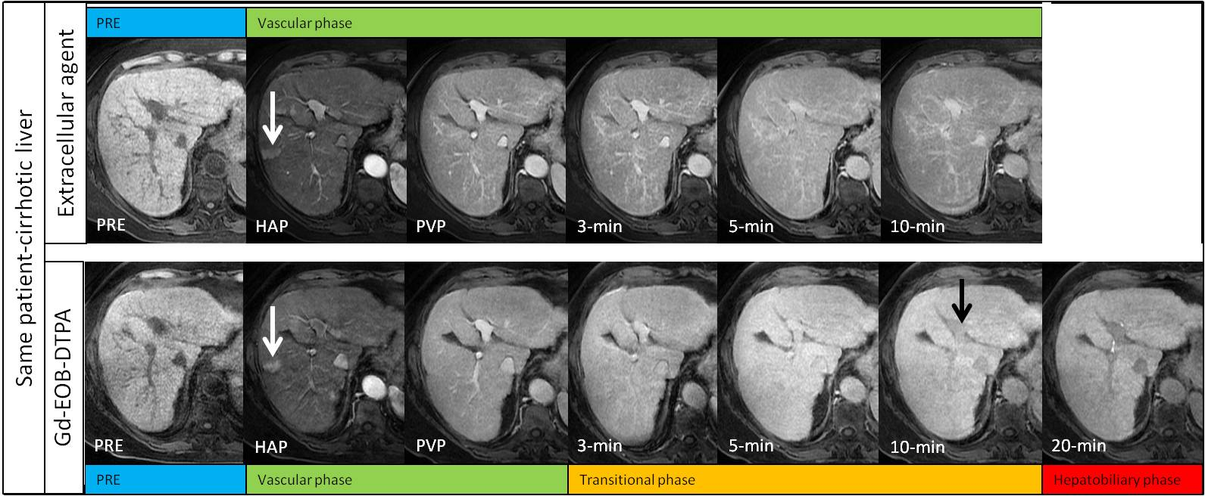
Figure 2 Intraindividual differences in hepatic enhancement in cirrhotic liver between extra-cellular contrast agent (top row) and gadoxetic acid (bottom row) in a 69-year-old woman with hepatitis C virus-related cirrhosis. On contrast-enhanced MR images obtained with an extracellular agent liver enhancement peaks on portal venous phase, and then slightly decreases. On contrast-enhanced magnetic resonance images obtained with gadoxetic acid, liver enhancement shows a stepwise increase from the hepatic arterial phase to 20-min phase. Vascular enhancement is more prolonged with extra-cellular agent than with gadoxetic acid, indicating a slower vascular elimination. On 10-min the intrahepatic vessels (black arrow) show slight hypointensity to the liver, and the bile ducts are not opacified. These findings indicate hepatic dysfunction and a prolonged transitional phase. Also note a wedge shaped enhancing area in the hepatic arterial phase (white arrow), with lack of washout on portal venous phase and isointensity on hepatobiliary phase, due to arterioportal shunt. PRE: Precontrast; HAP: Late hepatic arterial phase; PVP: Portal venous phase.

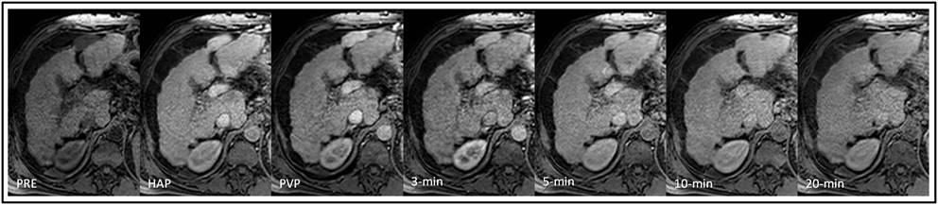
Figure 3 Gadoxetic acid contrast-enhanced magnetic resonance images obtained in a 57-year-old man with Child-Pugh C hepatitis C virus-related cirrhosis. Contrast-enhanced magnetic resonance images show slight decrease of liver enhancement after the portal venous phase. On hepatic arterial and portal venous phases the intrahepatic vessels show intense and homogeneous enhancement, which persists on 3-min, 5-min, and 10-min phase. On 20-min phase the intrahepatic vessels show isointensity to the liver. Prolonged retention of the contrast in intrahepatic vessels indicates impaired hepatic function and an inadequate hepatobiliary phase. Twenty-minutes phase corresponds in this case to the transitional phase observed in normal liver patient due to prolonged retention of gadoxetic acid in intrahepatic vessels. Also note that the kidney shows isointensity to the liver on 10-min and 20-min phases, indicating a compensatory increase of renal elimination of gadoxetic acid and an inadequate hepatobiliary phase. PRE: Precontrast; HAP: Late hepatic arterial phase. PVP: Portal venous phase.

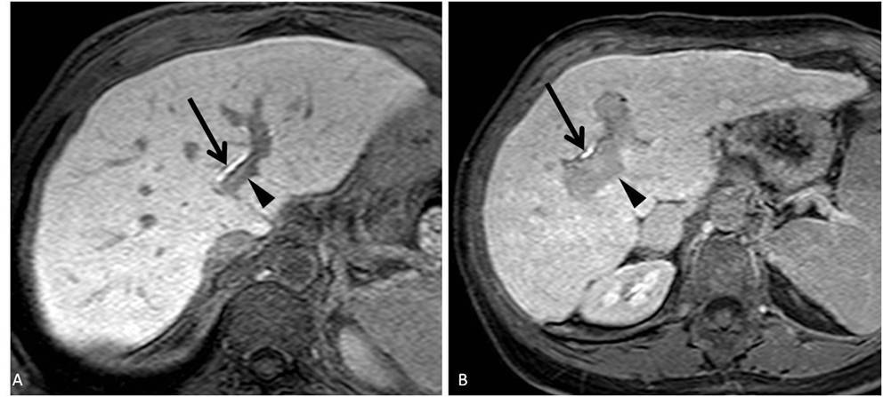
Figure 4 Twenty-minute hepatobiliary phase gadoxetic acid enhanced magnetic resonance imaging obtained in a 67 year-old man with Child-Pugh class A hepatitis C virus-related cirrhosis (A), and in a 67-year-old woman with Child-Pugh class B hepatitis C virus-related cirrhosis (B). A: The liver shows high signal intensity compared to the portal vein (arrowhead), which shows hypointensity. B: The liver shows relative high signal intensity compared to the portal vein (arrowhead), which shows “less” hypointensity if compared to A. Visual comparison of signal intensity of the liver relative to the portal vein can be used to evaluate adequacy of hepatobiliary phase. Enhancement of bile ducts, noted in both A and B (arrows), cannot be used alone to indicate adequacy of hepatobiliary phase.

A
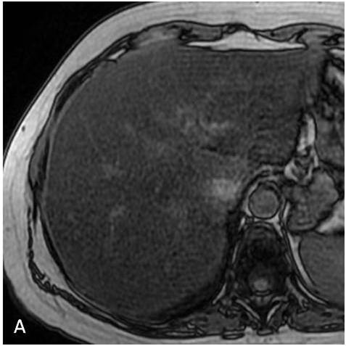
B
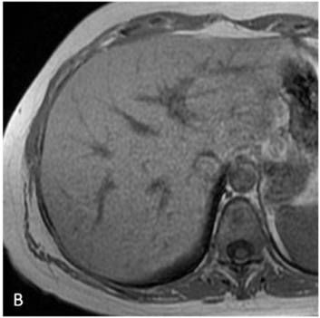
C
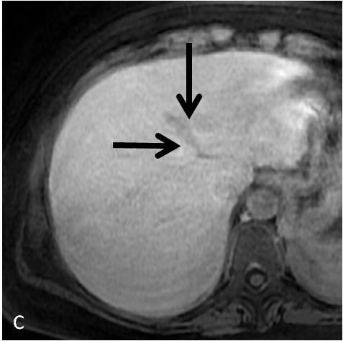
D
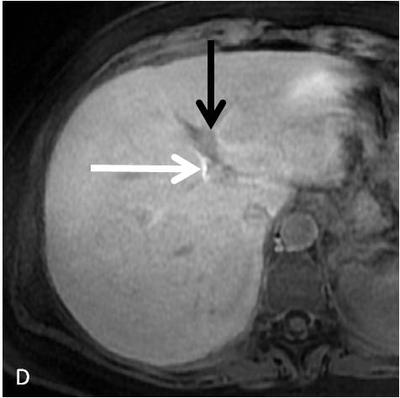
Figure 5 Reduced hepatobiliary phase enhancement due to severe hepatic steatosis in a 42 year-old woman with hepatitis C virus-related chronic hepatitis. A, B: T1-weighted gradient-echo images show diffuse signal intensity decrease of the liver on out-of-phase (A) image compared to that on the in-phase image (B), indicating severe hepatic steatosis; C: On 10-min hepatobiliary phase gadoxetic acid enhanced magnetic resonance imaging, left portal vein (black arrow) shows iso to hypointensity to liver parenchima. D: On 20-min hepatobiliary phase left portal vein shows slight hypointensity to liver parenchima. Enhancement of bile ducts (white arrows) is less intense on 10-min hepatobiliary phase than that on 20-min hepatobiliary phase, indicating delayed biliary elimination of gadoxetic acid.

