Name of Journal: World Journal of Clinical Cases
Manuscript NO: 70306
Manuscript Type: CASE REPORT

Ectopic peritoneal paragonimiasis mimicking tuberculous peritonitis: A care report

Choi JW et al. Ectopic peritoneal paragonimiasis mimicking tuberculous peritonitis

Jung Woo Choi, Chang Min Lee, Seong Je Kim, Se In Hah, Ji Yoon Kwak, Hyun Chin Cho, Chang Yoon Ha, Woon Tae Jung, Ok Jae Lee

Jung Woo Choi, Chang Min Lee, Seong Je Kim, Se In Hah, Ji Yoon Kwak, Hyun Chin Cho, Chang Yoon Ha, Woon Tae Jung, Ok Jae Lee, Department of Internal Medicine, Gyeongsang National University College of Medicine and Gyeongsang National University Hospital, Jinju 52727, South Korea

Chang Min Lee, Hyun Chin Cho, Chang Yoon Ha, Woon Tae Jung, Ok Jae Lee, Institute of Health Sciences, Gyeongsang National University, Jinju 52828, South Korea

Author contributions: Lee CM contributed to the collection and organization of data; Choi JW wrote the draft; Kim SJ, Hah SI, and Kwak JY, Cho HC, Ha CY, Jung WT, and Lee OJ revised the manuscript for important intellectual content; All authors have read and approved the final manuscript.

Corresponding author: Chang Min Lee, MD, Assistant Professor, Department of Internal Medicine, Gyeongsang National University College of Medicine and Gyeongsang National University Hospital, Gangnamro 79, Jinju 52727, South Korea. cmleesam@gnuh.co.kr

Received: August 7, 2021
Revised: October 7, 2021
Accepted: April 3, 2022
Published online: June 6, 2022

Abstract
BACKGROUND
The most common site of paragonimiasis is in the lungs. The migratory route passes through the duodenal wall, peritoneum, and diaphragm to the lungs; thus, the thoracic cavity and central nervous system, as well as the liver, intestine, and abdominal cavity may be involved. Here, we present a case of intraperitoneal paragonimiasis without other organ involvement, mimicking tuberculous peritonitis.

CASE SUMMARY
A 57-year-old man presented with recurrent abdominal pain for 4 wk. Physical examination revealed tenderness in the right lower quadrant. Laboratory findings showed complete blood counts within the normal range without eosinophilia. Multiple reactive lymph nodes and diffuse peritoneal infiltration were noted on abdominal computed tomography (CT). There were no abnormalities on chest CT or colonoscopy. Intraoperative findings of diagnostic laparoscopy for the differential diagnosis of tuberculous peritonitis and peritoneal carcinomatosis included multiple small whitish nodules and an abscess in the peritoneum. Pathological reports confirmed the presence of numerous eggs of Paragonimus westermani (P. westermani). A postoperative serum enzyme-linked immunosorbent assay revealed P. westermani positivity. Persistent and repetitive history-taking led him to retrospectively recall the consumption of freshwater crab. After 3 d of treatment with praziquantel (1800 mg; 25 mg/kg), he recovered from all symptoms.

CONCLUSION
In patients who require diagnostic laparoscopy for the differential diagnosis of tuberculous peritonitis and peritoneal carcinomatosis, repetitive history-taking and preoperative serologic antibody tests against Paragonimus may be helpful in diagnosing intraperitoneal paragonimiasis without other organ involvement.

Key Words: Differential diagnoses; Intraperitoneal abscess; Paragonimiasis; Paragonimus westermani; Peritonitis; Tuberculosis; Case report

©The Author(s) 2022. Published by Baishideng Publishing Group Inc. All rights reserved.

Citation: Choi JW, Lee CM, Kim SJ, Hah SI, Kwak JY, Cho HC, Ha CY, Jung WT, Lee OJ. Ectopic peritoneal paragonimiasis mimicking tuberculous peritonitis: A care report. World J Clin Cases 2022; 10(16): 5359-5364
URL: https://www.wjgnet.com/2307-8960/full/v10/i16/5359.htm
DOI: https://dx.doi.org/10.12998/wjcc.v10.i16.5359

Core Tip: Intraperitoneal Paragonimus without lung involvement can be misdiagnosed for tuberculous peritonitis, even with a negative stool test and normal eosinophil counts. In this case, a positive result on the preoperative serum antibody test for P. westmani may help patients recall history of crustacean consumption and prevent unnecessary surgery.

INTRODUCTION
Infestation with Paragonimus species is the diagnosis of paragonimiasis. Although Paragonimus westermani (P. westermani) infested the lungs most commonly, in rare cases, they can be found only in other organs without the involvement of the lungs. In the case of Involvement of the lungs, it is diagnosed by the identification of P. westermani eggs in stool or sputum examination. The diagnosis of ectopic infection can be made when worms or eggs of characteristic shape are found on tissue. Enzyme-linked immunosorbent assay (ELISA) for antibodies or molecular identification by polymerase chain reaction (PCR) can be helpful for diagnosis.
The nervous system and gastrointestinal system are other areas that can be infested other than the lungs. Humans are infected with P. westermani in form of metacercariae by eating raw freshwater crustaceans. The metacercariae exocyst in the duodenum, and then pass through the intestinal wall, peritoneal cavity, diaphragm, and pleural cavity to the lung. Due to this migratory route, ectopic infections can occur such as peritoneum. Intraperitoneal paragonimiasis without lung involvement may be misdiagnosed as tuberculous peritonitis. However, in most cases, it can be differentiated through eosinophilia, a positive stool test, and typical medical history of crustacean consumption.
Here, we present a case of intraperitoneal paragonimiasis mimicking tuberculous peritonitis with no involvement of lungs, no eosinophilia, and a negative stool test.

CASE PRESENTATION
Chief complaints
A 57-year-old man was admitted for the evaluation of recurrent lower abdominal pain that had persisted for 2 mo.

History of present illness
He received intermittent medications for abdominal pain in a private clinic for 2 mo. Two days before the visit, he underwent abdominal computed tomography (CT) at another hospital and was transferred for the differential diagnosis of tuberculous peritonitis and peritoneal carcinomatosis.

History of past illness
He received a diagnosis of a 5-mm-sized rectal neuroendocrine tumor at another hospital one year prior and underwent endoscopic mucosal resection.

Personal and family history
He has smoked 1 pack a day for 30 years. He has consumed approximately 57 g of alcohol per week.

Physical examination
Physical examination revealed mild tenderness in the right lower quadrant. The patient’s temperature was 36.4 °C, heart rate was 72 bpm, respiratory rate was 18 breaths per minute, blood pressure was 125/85 mmHg

Laboratory examinations
The white blood cell count was 4960/mm³ (reference, 4000-10000/mm³), the proportion of eosinophils was 4.4% (reference, 1%-5%), and there were no abnormal findings in the laboratory findings. The C-reactive protein level was 1.7 mg/L, which was within the normal range (reference, 0-5 mg/L). The carcinoembryonic antigen was 1.43 ng/mL (reference, 0-3.4 ng/mL) and carbohydrate antigen 19-9 was 13.98 U/mL (reference, 0-34 U/mL). The interferon-gamma release assay test result was negative, and the results of tuberculosis tests, including sputum stain, culture, and PCR, were all negative. The stool examination result was negative.

Imaging examinations
Diffuse peritoneal infiltration and subtle wall thickening of the right colon with multiple reactive lymph nodes were found on abdominal CT (Figure 1). Meanwhile, no lung lesions were observed on chest CT, and no enlarged lymph nodes were observed. On colonoscopy, a scar caused by a previous mucosal resection was observed 2 cm above the anal valve, and there was no evidence of recurrence. Only atrophic gastritis was found on esophagogastroduodenoscopy.

Further diagnostic work-up
Exploratory laparoscopy was performed to determine the cause of the peritoneal lesions. Intraoperative findings showed multiple small whitish nodules and an abscess in the peritoneum (Figure 2). Peritoneal nodules 1-2 mm in size were observed throughout the abdominal cavity, and excisional biopsy was performed. During right pelvic wall dissection, abscess pockets with pus surrounded by the omentum were observed. Omentectomy was performed for some of the omentum. An incidental appendectomy was also performed.
Based on the pathological reports, numerous eggs of P. westermani were confirmed in all specimens of the excisional biopsy, omentectomy, and appendectomy (Figure 3).
A postoperative ELISA revealed positivity for antibodies against P. westermani in the serum. There were no specific findings on brain CT.
During retrograde history-taking, it was reported that he often consumed food consisting of raw freshwater crab several months prior.

FINAL DIAGNOSIS
The final diagnosis was intraperitoneal paragonimiasis without other organ involvement.

TREATMENT
He was given a total of 1800 mg (25 mg/kg) of praziquantel in 3 divided doses per day for 3 d and he recovered from all symptoms. He was discharged on the 10th day of hospitalization.

OUTCOME AND FOLLOW-UP
Recurrence was not observed in the subsequent 2 years.

DISCUSSION
This case was intraperitoneal paragonimiasis, which was difficult to differentiate from tuberculous peritonitis and peritoneal carcinomatosis. This is because he denied crustacean consumption during his first history-taking, the stool test result was negative, and there was no eosinophilia or lung involvement.
There have been previous reports of intraperitoneal paragonimiasis, but with differentiating points, such as intrathoracic lesions^{[1]}, intraperitoneal calcifications^{[2,3]}, and eosinophilia^{[4]}, whereas no signs of paragonimiasis, such as calcification or eosinophilia, were observed in the present case. In a Korean case report^{[5]}, similar to the present case, a 57-year-old woman presented with paragonimiasis mimicking omental seeding nodules and transverse colonic wall thickening without eosinophilia and lung involvement, and an intraoperative frozen biopsy was performed for diagnosis. She was treated with praziquantel for 2 d.
In addition, despite the denial of the possibility of parasitic infestation at the time of history-taking in the present case, he recalled that he had consumed soy sauce crab several months before being diagnosed with paragonimiasis through surgery. Soy sauce crab is a dish that commonly causes paragonimiasis in Korea.
For the differential diagnosis of tuberculous peritonitis mimicking peritoneal infiltration without eosinophilia and other involvement, especially with a negative latent tuberculosis test result, serologic ELISAs for antibodies against Paragonimus can be helpful. If serologic antibody tests for parasitic infestations had been performed before diagnostic laparoscopy, unnecessary surgery may have been avoided through repeated medical history taking. He was treated with praziquantel for 3 d after receiving the diagnosis of intraperitoneal paragonimiasis, and no recurrence was observed for 2 years thereafter.

CONCLUSION
Even with normal stool tests and eosinophil counts on complete blood count, preoperative serologic antibody tests against Paragonimus may be helpful in diagnosing intraperitoneal paragonimiasis without other organ involvement in patients who require diagnostic laparoscopy for the differential diagnosis of tuberculous peritonitis and peritoneal carcinomatosis.

REFERENCES
1 Kim AY. [Heterotopic paragonimiasis presented by intra-abdominal masses]. Korean J Gastroenterol 2013; 61: 351-353 [PMID: 24040689 DOI: 10.4166/kjg.2013.61.6.351]
2 Jeong WK, Kim Y, Kim YS, Park DW, Park CK, Baek HK, Park YW. Heterotopic paragonimiasis in the omentum. J Comput Assist Tomogr 2002; 26: 1019-1021 [PMID: 12488753 DOI: 10.1097/00004728-200211000-00028]
3 Kim MJ, Kim SH, Lee SO, Choi SH, Kim YS, Woo JH, Yoon YS, Kim KW, Cho J, Chai JY, Chong YP. A Case of Ectopic Peritoneal Paragonimiasis Mimicking Diverticulitis or Abdominal Abscess. Korean J Parasitol 2017; 55: 313-317 [PMID: 28719956 DOI: 10.3347/kjp.2017.55.3.313]
4 Kim JY, Kang CM, Choi GH, Yang WI, Sim SB, Kwon JE, Kim KS, Choi JS, Lee WJ, Kim BR. Laparoscopic excision of intra-abdominal paragonimiasis. Surg Laparosc Endosc Percutan Tech 2007; 17: 556-558 [PMID: 18097324 DOI: 10.1097/SLE.0b013e31813738c7]
5 Lee CH, Kim JH, Moon WS, Lee MR. Paragonimiasis in the abdominal cavity and subcutaneous tissue: report of 3 cases. Korean J Parasitol 2012; 50: 345-347 [PMID: 23230333 DOI: 10.3347/kjp.2012.50.4.345]

Footnotes
Informed consent statement: A patient was not required to give informed consent for the study because this is a study that analyzed data retrospectively at a specific point that had already been completed in the treatment process. In the entire research process, including clinical data collection, analysis, and manuscript preparation, the possibility of infringing on the human rights of the subject patient is judged to be minimal, and the confidentiality of the subject patient’s personal information has been thoroughly maintained. Therefore, it is considered that the procedure for obtaining written consent from the subject patient can be omitted.

Conflict-of-interest statement: No conflicts exist for any author.

CARE Checklist (2016) statement: The authors have read the CARE Checklist (2016), and the manuscript was prepared and revised according to the CARE Checklist (2016).

Open-Access: This article is an open-access article that was selected by an in-house editor and fully peer-reviewed by external reviewers. It is distributed in accordance with the Creative Commons Attribution NonCommercial (CC BY-NC 4.0) license, which permits others to distribute, remix, adapt, build upon this work non-commercially, and license their derivative works on different terms, provided the original work is properly cited and the use is non-commercial. See: https://creativecommons.org/Licenses/by-nc/4.0/

Provenance and peer review: Unsolicited article; Externally peer reviewed.
Peer-review model: Single blind

Peer-review started: August 7, 2021
First decision: October 2, 2021
Article in press:

Specialty type: Gastroenterology and Hepatology
Country/Territory of origin: South Korea
Peer-review report’s scientific quality classification
Grade A (Excellent): 0
Grade B (Very good): 0
Grade C (Good): C
Grade D (Fair): 0
Grade E (Poor): 0

P-Reviewer: Liu YC, China S-Editor: Chang KL L-Editor: A P-Editor: Chang KL

Figure Legends
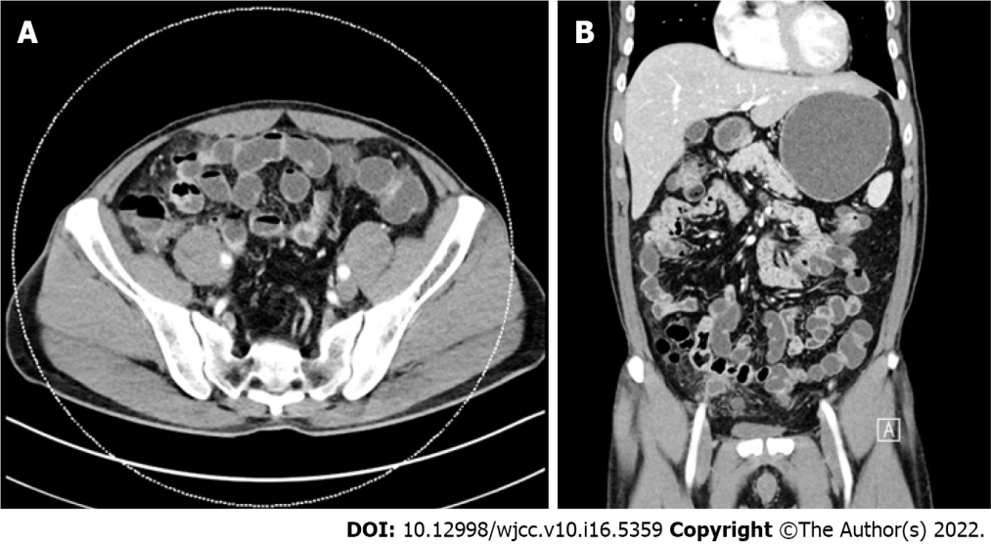
Figure 1 Abdominal computed tomography. There are diffuse omental infiltrates and some peritoneal thickening with small lymph nodes in common hepatic, hepaticoduodenal, small bowel mesenteric, and para-aortic areas. A: Axial view; B: Coronal view.

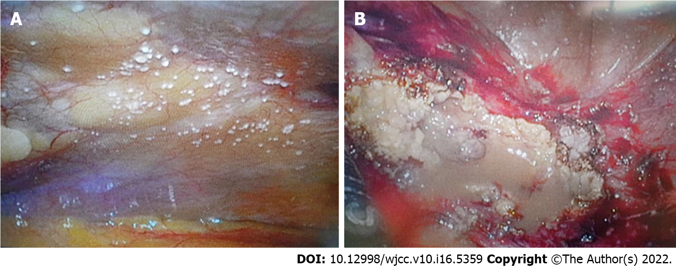
Figure 2 Laparoscopic findings. A: Peritoneal nodules mimicked tuberculous nodules; B: Abscess pocket of the omentum is noted in the right pelvic wall around the anteroiliac area.

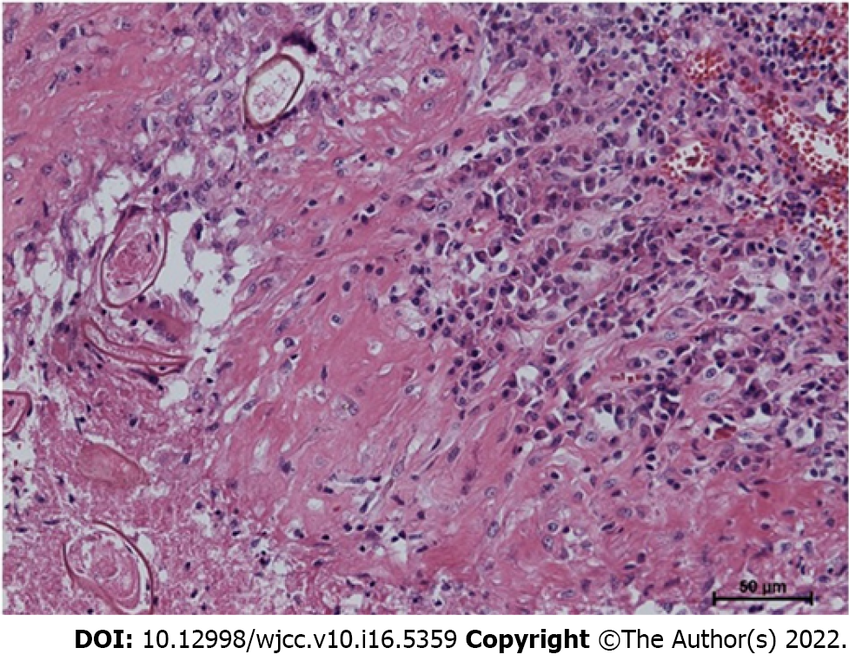
Figure 3 Pathological finding. The parasite eggs are shown (hematoxylin and eosin stain, × 50).

Published by Baishideng Publishing Group Inc
7041 Koll Center Parkway, Suite 160, Pleasanton, CA 94566, USA
Telephone: +1-925-3991568
E-mail: bpgoffice@wjgnet.com
Help Desk: https://www.f6publishing.com/helpdesk
https://www.wjgnet.com

© 2022 Baishideng Publishing Group Inc. All rights reserved.

