Name of Journal: World Journal of Gastroenterology
ESPS Manuscript NO: 21627
Manuscript Type: CASE REPORT

rare type of pancreatitis as the first presentation of anti-neutrophil cytoplasmic antibody-related vasculitis

Iida T et al. Rare type of ANCA-related vasculitis

Tomoya Iida, Takeya Adachi, Tetsuya Tabeya, Suguru Nakagaki, Takashi Yabana, Akira Goto, Yoshihiro Kondo, Kiyoshi Kasai

Tomoya Iida, Takeya Adachi, Suguru Nakagaki, Takashi Yabana, Akira Goto, Yoshihiro Kondo, Department of Gastroenterology, Otaru City General Hospital, Otaru, Hokkaido 047-8550, Japan

Tetsuya Tabeya, Department of Internal Medicine of Connective Tissue Disease, Otaru City General Hospital, Otaru, Hokkaido 047-8550, Japan

Kiyoshi Kasai, Department of Diagnostic Pathology, Otaru City General Hospital, Otaru, Hokkaido 047-8550, Japan

Author contributions: All authors helped to perform the research; Iida T wrote the paper; all authors have approved the final draft of the manuscript.

Supported by Otaru City General Hospital, Otaru, Hokkaido, Japan

Institutional review board statement: Otaru City General Hospital Institutional Review Board for Conduction and Submission of the study.

Informed consent statement: The patient provided informed consent prior to study enrollment.

Conflict-of-interest statement: To the best of our knowledge, no conflict of interest, financial or other, exists for any authors listed in this manuscript.

Open-Access: This article is an open-access article which was selected by an in-house editor and fully peer-reviewed by external reviewers. It is distributed in accordance with the Creative Commons Attribution Non Commercial (CC BY-NC 4.0) license, which permits others to distribute, remix, adapt, build upon this work non-commercially, and license their derivative works on different terms, provided the original work is properly cited and the use is non-commercial. See: http://creativecommons.org/licenses/by-nc/4.0/

Correspondence to: Tomoya Iida, MD, Department of Gastroenterology, Otaru City General Hospital, 1-1 1-chome, Wakamatu-cho, Otaru, Hokkaido 047-8550, Japan. tomoya.iida.0306@gmail.com
Telephone: +81-134-251211
Fax: +81-134-326424

Received: July 22, 2015
Peer-review started: July 30, 2015
First decision: August 28, 2015
Revised: September 11, 2015
Accepted: December 12, 2015
Article in press:
Published online:

Abstract
A pancreatic tumor was suspected on the abdominal ultrasound of a 72-year-old man. Abdominal computed tomography showed pancreatic enlargement as well as a diffuse, poorly enhanced area in the pancreas; endoscopic ultrasound-guided fine needle aspiration biopsy and endoscopic retrograde cholangiopancreatography failed to provide a definitive diagnosis. Based on the trend of improvement of the pancreatic enlargement, the treatment plan involved follow-up examinations. Later, he was hospitalized with an alveolar hemorrhage and rapidly progressive glomerulonephritis; he tested positive for myeloperoxidase-anti-neutrophil cytoplasmic antibody (MPO-ANCA) and was diagnosed with ANCA-related vasculitis, specifically microscopic polyangiitis. It appears that factors such as thrombus formation caused by the vasculitis in the early stages of ANCA-related vasculitis cause abnormal distribution of the pancreatic blood flow, resulting in non-uniform pancreatitis. Pancreatic lesions in ANCA-related vasculitis are very rare. Only a few cases have been reported previously. Therefore, we report our case and a review of the literature.

Key words: pancreas; Pancreatitis; Antibodies; Anti-neutrophil cytoplasmic; Vasculitis; Microscopic polyangiitis

© The Author(s) 2015. Published by Baishideng Publishing Group Inc. All rights reserved.

Core tip: Pancreatic lesions in anti-neutrophil cytoplasmic antibody (ANCA)-related vasculitis are very rare. Only few cases of pancreatic lesions in ANCA-related vasculitis have been reported previously. We encountered a case presenting with pancreatic enlargement and a diffuse, poorly enhanced area in the pancreas during the early stages of ANCA-related vasculitis. In light of the clinical course, it appears that factors such as thrombus formation caused by the vasculitis during the early stages of ANCA-related vasculitis cause abnormal distribution of pancreatic blood flow, resulting in non-uniform pancreatitis manifested in the imaging findings.

Iida T, Adachi T, Tabeya T, Nakagaki S, Yabana T, Goto A, Kondo Y. rare type of pancreatitis as the first presentation of anti-neutrophil cytoplasmic antibody-related vasculitis. World J Gastroenterol 2015; In press

INTRODUCTION
Pancreatic lesions in anti-neutrophil cytoplasmic antibody (ANCA)-related vasculitis are very rare. We encountered a patient presenting with pancreatic enlargement and a diffuse, poorly enhanced area in the pancreas during the early stages of ANCA-related vasculitis. Although it is difficult to histopathologically prove findings of vasculitis in the pancreas with endoscopic ultrasound-guided fine needle aspiration biopsy (EUS-FNA) or endoscopic retrograde pancreatography (ERP), in light of the clinical course, it appears that factors such as thrombus formation caused by the vasculitis in the early stages of ANCA-related vasculitis cause to be abnormal distribution of pancreatic blood flow, resulting in non-uniform pancreatitis manifested in the imaging findings described herein. Our report also includes a discussion of the related literature, since there are few previous reports on patients with pancreatic lesions in ANCA-related vasculitis presenting with pancreatitis or nodular shadows in the pancreas.

CASE REPORT
A 72-year-old man had been regularly visiting a clinic for diabetes exhibited weight loss and exacerbation of his diabetes; a pancreatic tumor was suspected on a subsequent abdominal ultrasound, and he was referred to our department in April 2014.
Upon admission, his height and weight were 175 cm and 63.7 kg, respectively; the following were also measured: blood pressure, 130/80 mmHg; pulse, 80 beats/min (regular); and body temperature, 37.0 °C. He was in a lucid state of consciousness with no neurological abnormalities. There was no anemia in the palpebral conjunctiva or yellowing of the bulbar conjunctiva. Superficial lymph nodes were not palpated. Lung and heart sounds were free of abnormal findings. The abdomen was flat, soft, and without tenderness. There was no lower leg edema.
The laboratory findings upon admission indicated that amylase and lipase were normal (59 IU/L and 53 IU/L, respectively), while trypsin level was slightly elevated (723 ng/mL; normal, 100–500 ng/mL). Findings also indicated mild inflammation: white blood cell count, 10100/μL and C-reactive protein level, 0.97 mg/dL. IgG4 level was normal, and the level of antinuclear antibodies increased 80-fold; carcinoembryonic antigen and cancer antigen 19-9 levels were normal at 2.6 ng/mL and 3.6 U/mL, respectively. Hemoglobin A1c was somewhat elevated at 10.8%.
On chest radiography, a reticular shadow from both hilar areas to the lower lung field was observed.
On abdominal ultrasonography, there was mild swelling from the pancreatic body to the tail, with irregular hypoechoic masses observed in both the margins and interior of the same sites. The splenic artery had traveled through the inside of the tumor; however, the boundary was clear, and there was no obvious invasion into the surrounding adipose tissue. In the pancreatic body, the pancreatic duct was disrupted, but there was no dilation of the cephalic main pancreatic duct.
Contrast-enhanced abdominal/pelvic computed tomography (CT) (Figure 1A-C) showed pancreatic enlargement with a diffuse, poorly enhanced area in the uncinate process and pancreatic body tail.
On magnetic resonance cholangiopancreatography, the path of the main pancreatic duct in the body tail could not be identified, but dilation of the cephalic main pancreatic duct was not observed. Diffusion-weighted images showed diffuse signal changes in the pancreatic body tail.
On EUS (Figure 2), a hypoechoic mass was noted in a form in which the pancreatic lobe structure was maintained in the uncinate process and from the pancreatic body to the tail.
On EUS-FNA, the hypoechoic masses of the uncinate process and pancreatic tail were each punctured three times with a 22G puncture needle (ExpectTM, Boston Scientific, Tokyo, Japan); malignant cells were not detected, and the diagnosis was nonspecific pancreatitis.
On ERP (Figure 3A-C), a slight disparity of the opening diameter was noted in the main pancreatic duct, but localized stenosis or diffuse narrowing were not observed. No abnormality was observed in the papilla of Vater, but the biopsy revealed thrombus formation.
The patient was suspected of having pancreatic cancer presenting with a special distribution, malignant lymphoma, tumor-forming pancreatitis, or autoimmune pancreatitis (AIP); however, despite the various laboratory tests, a definitive diagnosis was not reached. A contrast-enhanced CT performed in May 2014 showed improvement in the pancreatic enlargement (Figure 4); therefore, it was believed to be nonspecific pancreatitis, and follow-up observation was the chosen strategy. Blood collection and CT scans were subsequently performed every three months, but these did not demonstrate any major changes. However, in January 2015, he was admitted to our hospital's respiratory medicine department for an alveolar hemorrhage and pneumonia (Figure 5); in addition to rapidly progressive glomerulonephritis, he tested positive for myeloperoxidase-ANCA, and he was diagnosed with ANCA-related vasculitis, specifically microscopic polyangiitis (MPA). Contrast-enhanced CT performed during the same period showed that the pancreatic enlargement and poorly enhanced area had disappeared. Despite immunosuppressive therapy with steroids, his respiratory condition worsened, and he passed away in April 2015.

DISCUSSION
The Chapel Hill Consensus Conference (CHCC) published in 1994 classifies the ten diseases of primary vasculitis into three categories by affected vessel size (large vessels, medium vessels, and small vessels)^{[1]}. Although this classification has been widely used around the world, nearly 20 years have passed, and as research on the etiology and pathological condition of vasculitis has advanced, issues with the classification have arisen. A new classification and definitions have been developed and published in January 2013 as “CHCC2012”^{[2]}, in which four categories of 16 diseases, including secondary vasculitis and others, have been added to the original three categories of large-vessel vasculitis, medium-vessel vasculitis, and small-vessel vasculitis; the current understanding of vasculitis now encompasses diverse concepts.
In the CHCC2012, MPA belongs to small-vessel vasculitis, with the definition that "MPA is necrotizing vasculitis, with few or no immune deposits, predominantly affecting small vessels (i.e., capillaries, venules, or arterioles). Necrotizing arteritis involving small and medium arteries might be present. Necrotizing glomerulonephritis is very common. Pulmonary capillaritis often occurs. Granulomatous inflammation is absent^{[2]}. The onset of MPA often occurs at ≥ 50 years of age, and it occurs more frequently in men (male-to-female ratio, 1.5:1)^{[3]}. Sixty percent of cases are positive for myeloperoxidase-ANCA^{[4]}, and 51%–94% of cases are reportedly positive for all ANCAs, including PR3-ANCA^{[4,5]}. There are two basic types of findings: those based on bleeding, infarction, and other vascular disorders caused by the rupture of blood vessels and those based on inflammation such as fever and elevated C-reactive protein levels. The main target organs are the kidneys or lungs, with lesions also observed in the skin, muscles, and brain; 30%–50% of lesions are also reportedly observed in the digestive tract^{[3,6]}, but it is rare for lesions to be found in the pancreas.
In the present case, it was difficult to histopathologically prove findings of vasculitis in the pancreas with EUS-FNA or endoscopic retrograde cholangiopancreatography; however, lung lesions progressed later, and it is characteristic that imaging showed abnormalities in the pancreas before the diagnosis of ANCA-related vasculitis could be determined. Initially, ANCA was not measured, and the differential diagnoses included pancreatic cancer, malignant lymphoma, autoimmune pancreatitis, and tumor-forming pancreatitis. Irregular, hypoechoic masses were observed in the pancreas, and carcinoembryonic antigen and cancer antigen 19-9 levels were elevated; however, any findings of pancreatic cancer were negated by the fact that no abnormality was observed in the pancreatic ducts and the lesions were scattered (regarding a diagnosis of cancer of the entire pancreas). Malignant lymphoma was considered as a differential disease in part because the artery penetrated the lesion, but enlarged lymph nodes were not observed, and a pathologically definitive diagnosis could not be reached. The diagnosis of AIP was rejected because, although pancreatic enlargement was observed, the diffuse poorly enhanced area was nonspecific, and hyper-IgG4 disease, irregular narrowing of the main pancreatic duct in ERP, or extrapancreatic lesions were not observed. Regarding tumor-forming pancreatitis, tumor signs were not localized, and the pancreatic duct images also showed no abnormalities; therefore, it could not be said to be typical. Although the abdominal pain was not clear, his mild inflammatory reaction, elevated trypsin levels, and pancreatic enlargement suggested pancreatitis. In light of his clinical course, it appears that factors such as thrombus formation caused by the vasculitis in the early stages of ANCA-related vasculitis caused pancreatic blood flow to be abnormally distributed, resulting in non-uniform pancreatitis and manifesting in the presentation of the imaging findings. In AIP, IgG4-positive cells are reportedly detected from the papilla of Vater in a high proportion of biopsies^{[7]}; in the present case, the papilla of Vater was biopsied to exclude AIP even though no abnormalities were observed endoscopically. IgG4-positive cells were not observed, but thrombus formation was present (Figure 3B); conceivably, this also occurred in the peripancreatic vessels, causing an abnormal distribution of the pancreatic blood flow and producing irregular pancreatitis.
When PubMed was searched for previous reports published between 1990 and 2015 of ANCA-related vasculitis presenting with pancreatic lesions, 12 cases were found^{[8-19]} (Table 1). The mean age was 55.2 years (20–84 years), with a male-to-female ratio of 6:7; 11 cases were ANCA-positive, and granulomatosis with polyangiitis was the most frequent diagnosis (9 cases), while there were 4 cases of MPA and no cases of eosinophilic granulomatosis with polyangiitis. In 6 cases, symptoms were accompanied by findings of pancreatitis on imaging; 5 cases presented with nodular shadows that were difficult to differentiate from tumors in the pancreas, and no antemortem pancreatic lesions were indicated, but postmortem autopsy indicated pancreatic lesions in 2 cases. Regarding pathologically definitive diagnoses of pancreatic lesions, 3 cases were diagnosed following a surgical procedure because of the difficulty differentiating the lesions from a tumor, 3 cases were diagnosed by postmortem autopsy, and 7 cases had a diagnosis indirectly proven by biopsies from other organs because a definitive diagnosis could not be reached for the pancreas. None of the cases had a definitive diagnosis of ANCA-related vasculitis based on pancreatic lesions before treatment. Thus, similar to the present case, pancreatic lesions in ANCA-related vasculitis are extremely difficult to diagnose by endoscopic biopsy or similar methods before treatment, and it is important to indirectly diagnose the condition from the involvement of other organs.
Regarding the treatment of pancreatic lesions, of the 6 cases that presented with findings of pancreatitis on imaging, 5 were successfully treated with conservative treatment. Therefore, it is possible that pancreatitis caused by ANCA-related vasculitis could follow a transient course; however, there are few reports in which ANCA-related vasculitis resolved spontaneously^{[20]}, and this remains largely speculative. Despite the possibility that the pancreatitis is transient, remission of pancreatitis has been followed by organ failure in other cases owing to the manifestation of ANCA-related vasculitis in other organs such as the kidneys or lungs, and the patient died, as in the present case. Therefore, we believe that ANCA-related vasculitis should be differentially included as a cause of pancreatitis of unknown etiology, and an early and appropriate diagnosis is required, followed by the start of treatment.
In addition to cases with ANCA-related vasculitis, some cases with Kawasaki disease, polyarteritis nodosa, or other types of vasculitis have presented with pancreatitis or nodules in the pancreas^{[21,22]}. As already described, although the CHCC2012 classifies vasculitis by vascular diameter, there is considerable overlap in the vessels invaded in each group, and vessels of any size can be affected; therefore, we feel that care should be taken regarding the relationship with pancreatic lesions in all forms of vasculitis, including ANCA-related vasculitis. However, because there are so few previous reports regarding vasculitis and pancreatic lesions, the details of the relationship remain unclear, and additional cases will need to be described.

COMMENTS
Case characteristics
Pancreatic lesions in anti-neutrophil cytoplasmic antibody (ANCA)-related vasculitis are very rare. This is a case of rare type of pancreatitis as the first presentation of anti-neutrophil cytoplasmic antibody-related vasculitis.

Clinical diagnosis
Factors such as thrombus formation caused by the vasculitis in the early stages of ANCA-related vasculitis cause abnormal distribution of the pancreatic blood flow, resulting in non-uniform pancreatitis.

Differential diagnosis
The patient was suspected of having pancreatic cancer presenting with a special distribution, malignant lymphoma, tumor-forming pancreatitis, or autoimmune pancreatitis.

Laboratory diagnosis
On second admission, myeloperoxidase-ANCA was positive.

Imaging diagnosis
First, it was believed to be nonspecific pancreatitis because of improvement in the pancreatic enlargement.

Pathological diagnosis
On endoscopic ultrasound-guided fine needle aspiration biopsy, malignant cells were not detected, and the diagnosis was nonspecific pancreatitis. On endoscopic retrograde pancreatography, no abnormality was observed in the papilla of Vater, but the biopsy revealed thrombus formation.

Treatment
First, it was believed to be nonspecific pancreatitis, and computed tomography showed improvement in the pancreatic enlargement, follow-up observation was the chosen strategy. For an alveolar hemorrhage and pneumonia, immunosuppressive therapy with steroids was performed.

Related reports
ANCA-related vasculitis presenting with pancreatic lesions published between 1990 and 2015 were found 12 cases in PubMed.

Experiences and lessons
ANCA-related vasculitis should be differentially included as a cause of pancreatitis of unknown etiology, and an early and appropriate diagnosis is required, followed by the start of treatment.

Peer-review
The case report by Iida T and co-workers describes a rare case of ANCA-related vasculitis with pancreatic involvement. It is a well-constructed case report and a short but good review of the corresponding literature.
REFERENCES
1 Jennette JC, Falk RJ, Andrassy K, Bacon PA, Churg J, Gross WL, Hagen EC, Hoffman GS, Hunder GG, Kallenberg CG, McCluskey RT, Sinico RA, Rees AJ, van Es LA, Waldherr R, Wiik A. Nomenclature of systemic vasculitides. Proposal of an international consensus conference. Arthritis Rheum 1994; 37: 187-192 [PMID: 8129773 DOI: 10.1002/art.1780370206]
2 Jennette JC, Falk RJ, Bacon PA, Basu N, Cid MC, Ferrario F, Flores-Suarez LF, Gross WL, Guillevin L, Hagen EC, Hoffman GS, Jayne DR, Kallenberg CG, Lamprecht P, Langford CA, Luqmani RA, Mahr AD, Matteson EL, Merkel PA, Ozen S, Pusey CD, Rasmussen N, Rees AJ, Scott DG, Specks U, Stone JH, Takahashi K, Watts RA. 2012 revised International Chapel Hill Consensus Conference Nomenclature of Vasculitides. Arthritis Rheum 2013; 65: 1-11 [PMID: 23045170 DOI: 10.1002/art.37715]
3 Villiger PM, Guillevin L. Microscopic polyangiitis: Clinical presentation. Autoimmun Rev 2010; 9: 812-819 [PMID: 20656070 DOI: 10.1016/j.autrev.2010.07.009]
4 Kallenberg CG, Heeringa P, Stegeman CA. Mechanisms of Disease: pathogenesis and treatment of ANCA-associated vasculitides. Nat Clin Pract Rheumatol 2006; 2: 661-670 [PMID: 17133251 DOI: 10.1038/ncprheum0355]
5 Vamvakopoulos J, Savage CO, Harper L. ANCA-associated vasculitides-lessons from the adult literature. Pediatr Nephrol 2010; 25: 1397-1407 [PMID: 20358231 DOI: 10.1007/s00467-010-1496-z]
6 Fukushima M, Inoue S, Ono Y, Tamaki Y, Yoshimura H, Imai Y, Inokuma T. Microscopic polyangiitis complicated with ileal involvement detected by double-balloon endoscopy: a case report. BMC Gastroenterol 2013; 13: 42 [PMID: 23452722 DOI: 10.1186/1471-230X-13-42]
7 Kamisawa T, Tu Y, Egawa N, Tsuruta K, Okamoto A. A new diagnostic endoscopic tool for autoimmune pancreatitis. Gastrointest Endosc 2008; 68: 358-361 [PMID: 18513718 DOI: 10.1016/j.gie.2008.02.018]
8 O'Neil KM, Jones DM, Lawson JM. Wegener's granulomatosis masquerading as pancreatic carcinoma. Dig Dis Sci 1992; 37: 702-704 [PMID: 1563310 DOI: 10.1007/BF01296425]
9 Stuckey SL, Smart PJ. Wegener's granulomatosis: parotid involvement and associated pancreatitis with C.T. findings. Australas Radiol 1992; 36: 343-346 [PMID: 1299199 DOI: 10.1111/j.1440-1673.1992.tb03217.x]
10 Berney T, Persoz C, Leski M, Morel P. Antineutrophil cytoplasmic antibodies and acute pancreatitis. Pancreas 1997; 15: 106-107 [PMID: 9211500 DOI: 10.1097/00006676-199707000-00015]
11 Matsubayashi H, Seki T, Niki S, Mizumura Y, Taguchi Y, Moriyasu F, Go K. Wegener's granulomatosis with onset of acute pancreatitis and rapid progress. A case report. Pancreatology 2001; 1: 263-266 [PMID: 12120205 DOI: 10.1159/000055821]
12 Christl SU, Borchard F, Keller R, Engemann R, Fischbach W. [Pancreatic tail tumor as an unusual first manifestation of Wegener's disease]. Z Gastroenterol 2004; 42: 513-516 [PMID: 15190447 DOI: 10.1055/s-2004-813113]
13 Iwasa S, Katoh R. Autopsy case of microscopic polyangiitis with crescentic glomerulonephritis and necrotizing pancreatitis. Pathol Int 2005; 55: 520–523 [PMID: 15998382 DOI: 10.1111/j.1440-1827.2005.01863.x]
14 Haraguchi K, Gunji K, Ito Y, Yokomori N, Kawaguchi A, Ohomori M, Inoue H, Shimura H, Saito T, Kobayashi T. Extensive pancreatic necrosis in microscopic polyangiitis. Clin Exp Nephrol 2005; 9: 326-331 [PMID: 16362161 DOI: 10.1007/s10157-005-0378-3]
15 Tinazzi I, Caramaschi P, Parisi A, Faccioli N, Capelli P, Biasi D. Pancreatic granulomatous necrotizing vasculitis: a case report and review of the literature. Rheumatol Int 2007; 27: 989-991 [PMID: 17265156 DOI: 10.1007/s00296-007-0314-9]
16 Joshipura VP, Haribhakti SP, Pandya SC, Soni HN, Patel NR. Wegener's granulomatosis--an etiology of acute pancreatitis. Indian J Gastroenterol 2007; 26: 89-90 [PMID: 17558075]
17 Abu-Hilal M, Abu-Hilal M, McPhail MJ, Zeidan B, Bryant T, Bateman A, Johnson CD. Acute pancreatitis as the first presentation of Wegener's granulomatosis. JOP 2008; 9: 300-304 [PMID: 18469442]
18 Chawla S, Atten MJ, Attar BM. Acute pancreatitis as a rare initial manifestation of Wegener's granulomatosis. A case based review of literature. JOP 2011; 12: 167-169 [PMID: 21386646]
19 Valerieva Y, Golemanov B, Tzolova N, Mitova R. Pancreatic mass as an initial presentation of severe Wegener's granulomatosis. Ann Gastroenterol 2013; 26: 267-269 [PMID: 24714250]
20 Yanagawa T, Andoh T, Ikushima S, Akiyama O, Oritsu M, Takemura T. [A case of Wegener's granulomatosis which showed early spontaneous remission]. Nihon Kokyuki Gakkai Zasshi 1998; 36: 256-261 [PMID: 9656673]
21 Reynaud-Mendel B, Lemann M, David F, Menasché S, Bachelez H, Dubertret L. Adult Kawasaki disease complicated by pancreatitis. Am J Gastroenterol 1997; 92: 1239-1240 [PMID: 9219820]
22 Yokoi Y, Nakamura I, Kaneko T, Sawayanagi T, Watahiki Y, Kuroda M. Pancreatic mass as an initial manifestation of polyarteritis nodosa: a case report and review of the literature. World J Gastroenterol 2015; 21: 1014-1019 [PMID: 25624739 DOI: 10.3748/wjg.v21.i3.1014]
P-Reviewer: Goetze TO, Kleeff J, Ramia JM S-Editor: Gong ZM
L-Editor: E-Editor:

A B
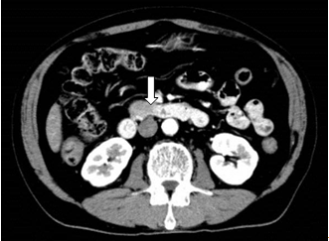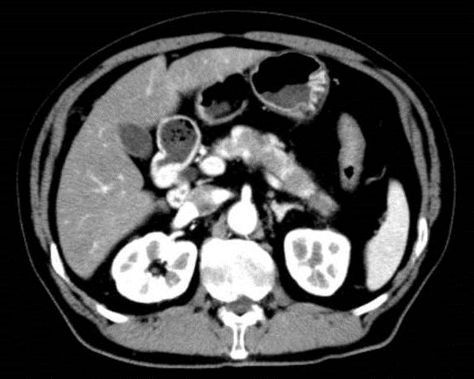
C
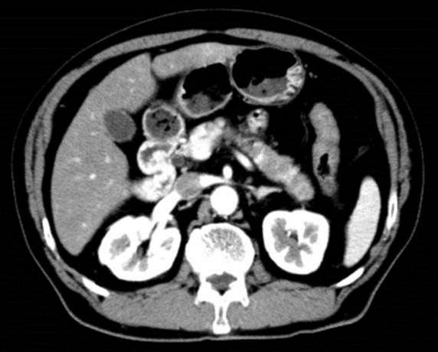
Figure 1 Contrast-enhanced abdominal/pelvic computed tomography showing pancreatic enlargement with a diffuse, poorly enhanced area in the uncinate process (white arrow) and pancreatic body tail (A-C).

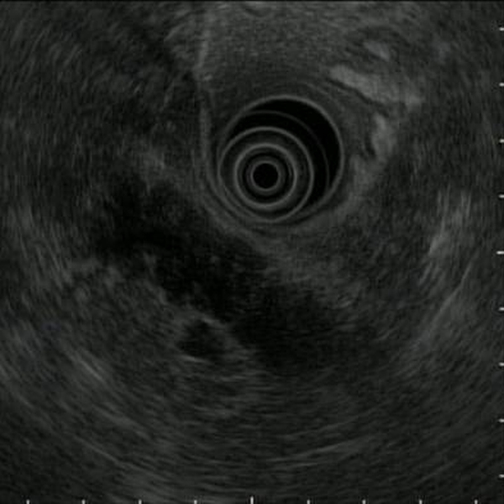
Figure 2 On endoscopic ultrasound, a hypoechoic mass in a form in which the pancreatic lobe structure was maintained in the uncinate process and from the pancreatic body to the tail.

A B
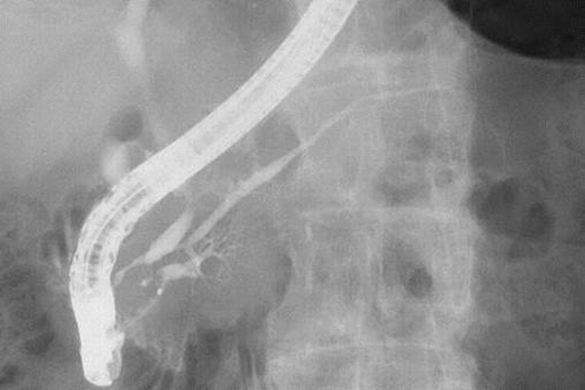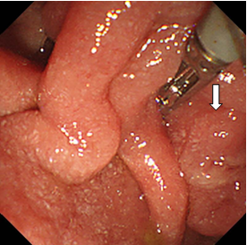
C
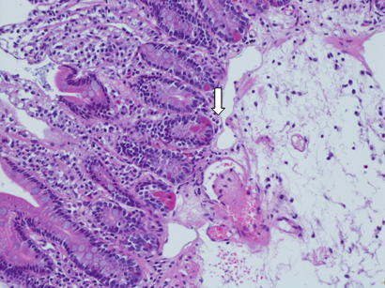
Figure 3 Endoscopic retrograde pancreatography. A: A slight disparity of the opening diameter in the main pancreatic duct, but no localized stenosis or diffuse narrowing observed. B: No abnormality in the papilla of Vater (white arrow). C: The biopsy reveals thrombus formation (white arrow).

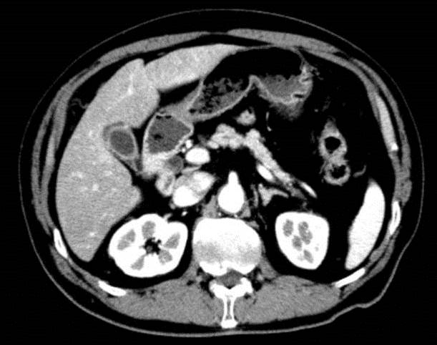
Figure 4 Contrast-enhanced abdominal/pelvic computed tomography performed in May 2014 showing a trend of improvement in the pancreatic enlargement.

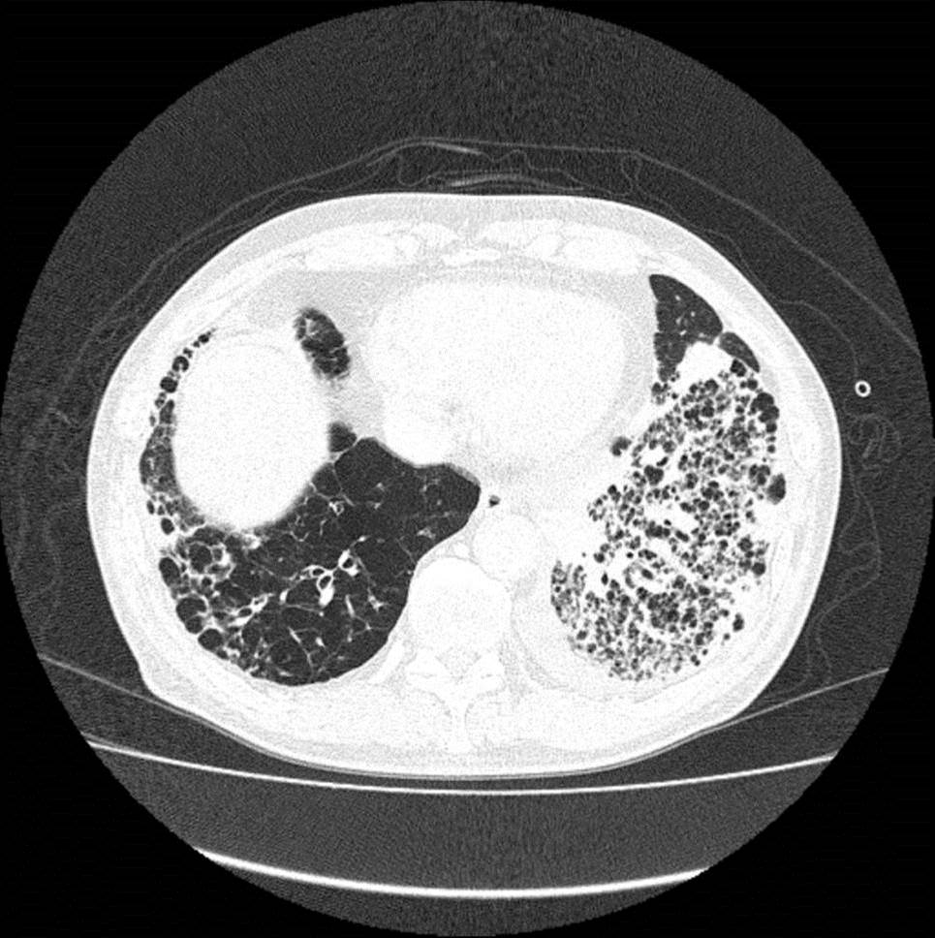
Figure 5 Chest computed tomography demonstrating an alveolar hemorrhage and pneumonia.

Table 1 Cases presented for pancreatic lesion in anti-neutrophil cytoplasmic antibody-related vasculitis
Authors | Year | Age (yr), sex | Symptoms | Pancreatic  enzyme | ANCA | Vasculitis | Pancreatic lesion | Diagnostic  method | Other organ  disorder | Treatment | Outcome
 |  |  |  |  |  |  | Imaging |  |  | Pancreas | Pancreas
 |  |  |  |  |  |  |  |  |  | Other organ | Other organ
O'Neil et al^{[8]} | 1992 | 44, M | Jaundice | ND | ＋ | GPA | Ph tumor susp | Renal biopsy | Kidney Nose | Treated | Alive
 |  |  |  |  |  |  | US: hypoechoic  CT: 3 cm mass |  |  | PSL, CYC | Improved
 |  |  |  |  |  |  |  |  |  | PSL, CYC | Improved
Stuckey et al^{[9]} | 1992 | 45, M | Epigastric pain  Nausea | AMY: 55 | - | GPA | Pancreatitis susp | Parotid gland biopsy | Lung | Treated | Alive
 |  |  |  |  |  |  | CT:enlargement, sporadic  low density lesions |  |  | Conservative | Improved
 |  |  |  |  |  |  |  |  |  | PSL, CYC | Improved
Berney et al^{[10]} | 1997 | 32, M | Epigastric pain | Raised of  AMY, Lipase | PR3 | MPA | Pancreatitis susp | Renal biopsy | Kidney | Treated | Alive
 |  |  |  |  |  |  | CT: edematous |  |  | Conservative | Improved spontaneously
 |  |  |  |  |  |  |  |  |  | PSL, CYC | Improved
Matsubayashi et al^{[11]} | 2001 | 65, M | Left abdominal pain | Trypsin: 550  Elastase-I:  440 | PR3 | GPA | Pbt tumor susp | Autopsy | Kidney Lung  Spleen | None | Died
 |  |  |  |  |  |  | CT: enlargement, sporadic  low density lesions |  |  | None | Necrotizing pancreatitis
 |  |  |  |  |  |  |  |  |  | None | Hemorrhagic pneumonia
Christl et al^{[12]} | 2004 | 55, F | Abdominal pain  Weight loss | ND | PR3 | GPA | Pt tumor susp | Postoperative  pathology  Renal biopsy | Kidney | Treated | Alive
 |  |  |  |  |  |  | CT: enlargement, sporadic  low density lesions |  |  | Ope | Improved
 |  |  |  |  |  |  |  |  |  | PSL, CYC | Improved
Iwasa et al^{[13]} | 2005 | 84, F | Hematuria  Fever | N.D. | MPO | MPA | Normal | Autopsy | Kidney Lung | Treated | Died
 |  |  |  |  |  |  |  |  |  | PSL | Necrotizing pancreatitis
 |  |  |  |  |  |  |  |  |  | PSL | Lung hemorrhage
Haraguchi et al^{[14]} | 2005 | 84, F | Fever | AMY: 130 | MPO | MPA | Normal | Autopsy | Kidney  Lung | Treated | Died
 |  |  |  |  |  |  |  |  |  | PSL | Necrotizing pancreatitis
 |  |  |  |  |  |  |  |  |  | PSL | Lung hemorrhage
Tinazzi et al^{[15]} | 2007 | 48, F | Epigastric pain | N.D. | － | GPA | Ph tumor susp | Postoperative  pathology | － | Treated | Alive
 |  |  |  |  |  |  | US: 2cm, mass, hypoechoic  MRCP: obstruction of MPD |  |  | Ope, PSL, CYC, MTX | Improved
 |  |  |  |  |  |  |  |  |  | － | －
Joshipura et al^{[16]} | 2007 | 47, M | Epigastric pain  Fever | AMY: 874  Lipase: 1294 | PR3 | GPA | Pancreatitis susp | Turbinate  biopsy | Nose | Treated | Alive
 |  |  |  |  |  |  | CT: Pbt edematous |  |  | PSL, CYC | Improved
 |  |  |  |  |  |  |  |  |  | PSL, CYC | Improved
Mohammed et al^{[17]} | 2008 | 20, F | Epigastric pain  Nausea | Normal | PR3 | GPA | Pancreatitis susp | Renal biopsy | Kidney  Lung  Skin  Intestine | Treated | Died
 |  |  |  |  |  |  | CT: Pt edematous |  |  | Conservative | Improved spontaneously
 |  |  |  |  |  |  |  |  |  | PSL, CYC | Lung hemorrhage
Saurabh et al^{[18]} | 2011 | 60, F | Epigastric pain  Nausea | Lipase: 1316 | PR3 | GPA | Pancreatitis susp | Renal biopsy | Kidney  Lung  Heart | Treated | Alive
 |  |  |  |  |  |  | CT: diffusely edematous,  Ph hypo attenuated lesion |  |  | Conservative | Improved spontaneously
 |  |  |  |  |  |  |  |  |  | PSL, CYC, AZA | Improved
Valerieva et al^{[19]} | 2013 | 62, F | Epigastric pain | Normal | PR3 | GPA | Pt tumor susp | Postoperative  pathology | － | Treated | Alive
 |  |  |  |  |  |  | CT: Pt, 3cm, mass |  |  | Ope, PSL, AZA | Improved
 |  |  |  |  |  |  |  |  |  | －
Iida et al (Our case) | 2015 | 72, M | Weight loss | Trypsin: 723 | MPO | MPA | Pancreatitis susp | Labo data  Imaging  Vater biopsy | Kidney  Lung | Treated | Died
 |  |  |  |  |  |  | CT: enlargement, multiple  hypo attenuated lesions |  |  | Conservative | Improved spontaneously
 |  |  |  |  |  |  |  |  |  | PSL, CYC | Lung hemorrhage
ANCA: Anti-neutrophil cytoplasmic antibody; ND: No data; AMY: Amylase; Ph: Pancreas head; Pbt: Pancreas body and tail; Pt: Pancreas tail; MRCP: Magnetic resonance cholangiopancreatography; MPD: Main pancreatic duct; PSL: Prednisolone; CYC: Cyclophosphamide; Ope: Operation; MTX: Methotrexate AZA: Azathioprine; M: Male; F: Female.

