Name of journal: World Journal of Gastroenterology
ESPS Manuscript NO: 17012
Columns: CASE REPORT

Endoscopic snare papillectomy for a solitary Peutz–Jeghers type polyp in the duodenum with ingrowth into the common bile duct: Case report

Suzuki K et al. Solitary Peutz–Jeghers polyp in the CBD

Keiichi Suzuki, Hajime Higuchi, Sayaka Shimizu, Masaru Nakano, Hiroshi Serizawa, Shojiro Morinaga

Keiichi Suzuki, Department of Surgery, Kitasato Institute Hospital, Tokyo 108-8642, Japan

Hajime Higuchi, Sayaka Shimizu, Masaru Nakano, Hiroshi Serizawa, Department of Internal Medicine, Kitasato Institute Hospital, Tokyo 108-8642, Japan

Shojiro Morinaga, Department of Diagnostic Pathology, Kitasato Institute Hospital, Tokyo 108-8642, Japan

Author contributions: Suzuki K and Higuchi H were participated in endoscopic treatment; Shimizu S was the physician in charge; Morinaga S made the histopathological diagnosis; Nakano M and Serizawa H contributed as an administrator of the endoscopic center; Suzuki K performed data analysis and wrote the manuscript; all authors read and approved the final manuscript.

Ethics approval: The study was reviewed and approved by the Kitasato Institute Hospital Institutional Review Board.

Informed consent: All study participants, or their legal guardian, provided informed written consent prior to study enrollment.

Conflict-of-interest: The authors declare no conflict of interest.

Open-Access: This article is an open-access article which was selected by an in-house editor and fully peer-reviewed by external reviewers. It is distributed in accordance with the Creative Commons Attribution Non Commercial (CC BY-NC 4.0) license, which permits others to distribute, remix, adapt, build upon this work non-commercially, and license their derivative works on different terms, provided the original work is properly cited and the use is non-commercial. See: http://creativecommons.org/licenses/by-nc/4.0/

Correspondence to: Keiichi Suzuki, MD, PhD, Department of Surgery, Kitasato Institute Hospital, 5-9-1, Shirogane, Minato-ku, Tokyo 108-8642, Japan. k1suzuki@me.com
Telephone: +81-3-34446161
Fax: +81-3-34480553
Received: February 6, 2015
Peer-review started: February 9, 2015
First decision: April 13, 2015
Revised: May 7, 2015
Accepted: May 27, 2015

Article in press:
Published online:

Abstract
Solitary duodenal Peutz–Jeghers (PJ) type hamartomatous polyps are rare and considered a different disease entity than classic PJ syndrome. We describe an 89-year-old man admitted to our emergency department with symptoms of acute cholangitis, liver dysfunction and slight jaundice. Magnetic resonance imaging showed multiple signal voids, reflecting choledocholithiasis, and an oval shaped tumor in the common bile duct (CBD). Following endoscopic retrograde cholangiopancreatography, the patient was diagnosed with a lower CBD tumor 20 mm in diameter. Endoscopic sphincterotomy was performed for choledocholithotomy, resulting in the expulsion of a large tumor with a stalk connected to the papilla of Vater. The tumor was successfully excised en bloc by endoscopic snare papillectomy (ESP). Histopathological examination showed that the tumor was a PJ type hamartomatous polyp. No mucocutaneous pigmentation of the skin was evident and the patient’s family history was negative. Solitary duodenal PJ type hamartomatous polyps are usually diagnosed incidentally during endoscopy for other indications, because most of these tumors are asymptomatic or have nonspecific presentations. To our knowledge, this is the first reported solitary PJ type polyp with intra-CBD growth treated by ESP.

Key words: Hamartoma; Duodenum polyp; Peutz–Jeghers polyp; Acute cholangitis; Jaundice

© The Author(s) 2015. Published by Baishideng Publishing Group Inc. All rights reserved.

Core tip: Solitary duodenal Peutz–Jeghers (PJ) type hamartomatous polyp is rare. This polyp is usually diagnosed incidentally during endoscopy, because its presentation is nonspecific. Thus, it is interesting that acute cholangitis was shown as initial symptoms of PJ type hamartomatous polyp due to intra-common bile duct growth. This is the first reported solitary duodenal PJ type hamartomatous polyp treated by endoscopic snare papillectomy. PJ-type polyps should be distinguished as being solitary or an incomplete type of PJS. These polyps should be treated by endoscopic or surgical resection due to its malignant potential.

Suzuki K, Higuchi H, Shimizu S, Nakano M, Serizawa H, Morinaga S. Endoscopic snare papillectomy for a solitary Peutz–Jeghers type polyp in the duodenum with ingrowth into the common bile duct: Case report. World J Gastroenterol 2015; In press

INTRODUSTION
Hamartomatous polyps are usually associated with Peutz–Jeghers syndrome (PJS)^{[1]}, which is characterized by gastrointestinal polyposis and mucocutaneous pigmentation. Solitary hamartomatous polyps have been considered a variant or a separate disease entity without the features of PJS^{[2]}. Solitary duodenal hamartomas are even less common. These lesions are usually accompanied by nonspecific symptoms, with most diagnosed incidentally during endoscopy. We describe the successful use of endoscopic snare papillectomy to remove a solitary Peutz–Jeghers (PJ) type polyp on the papilla of Vater. To our knowledge, this is the first patient to be described with a solitary PJ type hamartomatous polyp showing ingrowth into the common bile duct (CBD).

CASE REPORT
An 89 year-old man with a chief compliant of left brachium paresis was referred to our hospital and admitted to the emergency department. The patient had no significant medical history except for hypertension, atrial fibrillation and chronic gastritis, and no significant family history. On admission, he showed evidence of an inflammatory reaction, with elevated WBC (10310/μL) and CRP (4.62 mg/dL). Liver dysfunction and slight jaundice were also observed, with elevated levels of AST (152 IU/L), ALT (68 IU/L), LDH (551 IU/L), γGTP (84 IU/L) and T-Bil. (2.32 mg/dL). Tumor markers, including CEA, CA19-9 and AFP, were within normal limits. Plain abdominal computed tomography demonstrated choledocholithiasis with multiple calcified stones in the dilated CBD and a tumor in the lower CBD (Figure 1). Magnetic resonance imaging (MRI) with cholangiopancreatography showed multiple signal voids in the CBD reflecting tiny stones (Figure 2A). An oval shaped tumor 20 mm in diameter in the lower CBD was detected by high intensity signals on T2-weighted imaging and diffusion-weighted imaging (Figure 2B). Following a diagnosis of jaundice due to choledocholithiasis and CBD tumor, endoscopic retrograde cholangiopancreatography (ERCP) was performed. The lateral view showed a slight swelling of the papilla of Vater (Figure 3A), as well as multiple filling defects in the CBD. The largest defect, with a diameter of 4 cm, was located at the inferior extremity of the CBD without flexibility (Figure 3A). Intraductal ultrasound showed soft tissue echogenicity, suggesting that the defect was a neoplasm growing into the CBD (Figure 3B). Endoscopic sphincterotomy was performed and a plastic tube stent was inserted. A second ERCP, performed one week later, showed inversion and exclusion of the tumor (Figure 3C). The tumor, which had a stalk growing from the major duodenal papilla, was excised en bloc by ESP (Figure 3C).
Histopathologic examination of the resected specimen showed a large polypoid neoplasm, 4.8 × 1.9 × 1.8 cm in size, with a lobular surface and epithelialized with intestinal type mucosa (Figure 4A). The polyp contained irregular hyperplastic crypts with focal cystic dilatation, especially in the lower layer, and branching bundles of smooth muscle extending from the muscularis mucosae. The epithelium was hyperplastic in nature but not dysplastic, resulting in a diagnosis of PJ type hamartomatous polyp (Figure 4B).
The patient had no mucocutaneous pigmentation or family history of PJS. Upper gastrointestinal endoscopy and colonoscopy did not reveal any other PJ type polyp. Thus, the final diagnosis was solitary PJ type hamartomatous polyp of the major duodenal papilla.

DISCUSSION
PJS is a rare autosomal dominant disorder associated with mucocutaneous pigmentation (buccal mucosa, lips, fingers, and toes) and a family history of this condition^{[3]}. Solitary PJ type polyps, defined as hamartomatous polyps without any of the clinical symptoms of PJS, are characterized histologically by tree-like branching of smooth muscle fibers, with a core of smooth muscle, covered by mucosal tissue of near-normal appearance^{[4]}. It is truly difficult to determine whether these solitary duodenal hamartomatous polyps are an incomplete type or initial clinical manifestation of PJS^{[2]}. This entity may be differentiated from PJS based on information from previous studies, including: the lack of perioral or perianal mucocutaneous pigmentation and lack of family history; symptom onset usually occurring past the sixth and seventh decades of life; and lower risk of local cancer development than hamartomatous polyps in patients with PJS. The findings in our patient are consistent with these characteristics.
A search of case reports on the MEDLINE database up to 2014, using the terms “solitary”, “duodenum” and “hamartomatous polyp”, but without PJS, identified 19 patients in 13 studies, published in English, with solitary PJ type polyps in the duodenum, including the patient described here^{[2,5-15]} (Table 1). Age at onset ranged from 23–89 years (mean ± SD; 60.3 ± 20.1 years). The most frequent polyp site was the second portion of the duodenum, followed by the duodenal bulb. Maximum polyp diameter ranged from 5–70 mm (mean ± SD; 26.4 ± 16.6 mm). The predominant presentation was asymptomatic, with other patients having nonspecific symptoms. Most patients underwent endoscopic resection, although some patients with large polyps (> 50 mm) required surgery. Of the 19 polyps, four showed malignant transformation.
Duodenal solitary PJ type hamartomatous polyp is usually diagnosed incidentally during gastroduodenal endoscopy. Its presentation is nonspecific and resembles common conditions, such as peptic ulcer disease^{[13]}. Our patient was the first to report acute cholangitis and jaundice as chief compliants. Moreover, this was the first solitary PJ type hamartomatous polyp showing ingrowth into the CBD, although a solitary hamartomatous polyp in the CBD was reported in a patient after hepatoduodenostomy without PJS^{[16]}. The mechanism of ingrowth into the CBD in our patient is undetermined. However, a polyp that initially developed on the papilla of Vater may have invaginated accidentally into the CBD while still tiny due to peristaltic motion. This polyp may then have grown in the CBD.
The characterization of PJ type polyps as having a low risk of cancer is unclear. To our knowledge, 4 of 19 such lesions showed malignant transformation. The mean age of patient with malignancy was 70.5 years, higher than that of all 19 patients (60.3 years). In contrast, the maximum diameter may be non-indicative of malignancy, as patient 13 had a small malignant polyp only 10 mm in diameter. There is no definitive guideline for treatment of Solitary duodenal PJ type hamartomatous polyps. In general, like as other common gastroduodenal polyp, solitary PJ type polyp with features of large size, sessile type, presence of induration, or with suspicion of submucosal invasion, should be considered for surgical resection. Since the differential diagnosis by morphological features is difficult, endoscopic biopsies must be done to make a decision of therapeutic strategy. When finding form biopsy was malignant, surgery should be done according to the depth of tumor invasion. Endoscopic ultrasonography is useful. Meanwhile, comprehensive and cautious decision of surgical indication is required by consideration of patient characteristics, such as age, past histories, and general conditions.
In conclusion, associated signs and symptoms should be evaluated in patients with duodenal PJ type hamartomatous polyps. In addition, they should undergo upper intestinal endoscopy, colonoscopy and whole body screening. Solitary PJ-type hamartomatous polyps should be distinguished as being solitary or an incomplete type of PJS. These polyps should be treated by endoscopic or surgical resection.

COMMENTS
Case characteristics
An 89-years-old male with solitary duodenal Peutz–Jeghers (PJ) type hamartomatous polyp which has ingrown into the common bile duct (CBD).

Clinical diagnosis
Expulsion of a large tumor with a stalk connected to the papilla of Vater after endoscopic snare papillectomy (ESP).

Differential diagnosis
Papillary-expanding type cholangiocarcinoma, Polypoid type carcinoma of the papilla of Vater.

Laboratory diagnosis
WBC 1,0310/μL; CRP 4.62 mg/dL; AST 152 IU/L; ALT 68 IU/L; LDH 551 IU/L; γGTP 84 IU/L; T-Bil. 2.32 mg/dL; inflammatory reaction with liver dysfunction and slight jaundice.

Imaging diagnosis
Computed tomography and magnetic resonance imaging revealed choledocholithiasis with multiple calcified stones in the dilated CBD and a tumor in the lower CBD.

Pathological findings
Histopathologic examination showed a large polypoid neoplasm with a lobular surface and epithelialized with intestinal type mucosa, containing irregular hyperplastic crypts with focal cystic dilatation, and branching bundles of smooth muscle extending from the muscularis mucosae.

Treatment
The tumor with a stalk growing from the major duodenal papilla, and which was inverted and excluded form CBD, was excised en bloc by ESP.

Related reports
There are a few cases of solitary duodenal PJ type hamartomatous polyp have been reported in the literature, however, our case was the first to report showing ingrowth into the CBD with acute cholangitis and jaundice.

Term explanation
ESP is the endoscopic excision technique for a benign and/or low-grade malignant tumor of the papilla of the Vater, using snare loop to enable en bloc resection.

Experience and lessons
This case report not only represents the diagnosis and therapeutic strategy of solitary duodenal PJ type hamartomatous polyp, but also introduces the usefulness of ESP for a large pedunculated polyp adjacent to the papilla of Vater.

Peer-review
This article presented a rare case of solitary duodenal PJ type hamartomatous polyp grown from the CBD, and also addresses a critical clinical question integrating an extended review of literatures.
REFERENCES
1 Kopacova M, Tacheci I, Rejchrt S, Bures J. Peutz-Jeghers syndrome: diagnostic and therapeutic approach. World J Gastroenterol 2009; 15: 5397-5408 [PMID: 19916169 DOI: 10.3748/wjg.15.5397]
2 Acea Nebril B, Taboada Filgueira L, Parajó Calvo A, Gayoso García R, Gómez Rodríguez D, Sánchez González F, Sogo Manzano C. Solitary hamartomatous duodenal polyp; a different entity: report of a case and review of the literature. Surg Today 1993; 23: 1074-1077 [PMID: 8118121]
3 JEGHERS H, McKUSICK VA, KATZ KH. Generalized intestinal polyposis and melanin spots of the oral mucosa, lips and digits; a syndrome of diagnostic significance. N Engl J Med 1949; 241: 1031-1036 [PMID: 15398245 DOI: 10.1056/NEJM194912292412601]
4 Nakayama H, Fujii M, Kimura A, Kajihara H. A solitary Peutz-Jeghers-type hamartomatous polyp of the rectum: report of a case and review of the literature. Jpn J Clin Oncol 1996; 26: 273-276 [PMID: 8765188 DOI: 10.1093/oxfordjournals.jjco.a023227]
5 Bott SJ, Hanks JB, Stone DD. Solitary hamartomatous polyp of the duodenum in the absence of familial polyposis. Am J Gastroenterol 1986; 81: 993-994 [PMID: 3020975]
6 Naitoh H, Sumiyoshi Y, Kumashiro R, Inutsuka S, Fujita K, Yamamoto T, Murayama H. A solitary Peutz-Jeghers type hamartomatous polyp in the duodenum--a case report. Jpn J Surg 1988; 18: 475-477 [PMID: 3172591 DOI: 10.1007/BF02471476]
7 Tanaka H, Iida M, Kohrogi N, Matsui T, Yasunami Y, Yao T, Nakamura K, Fujishma M. Endoscopic removal of solitary hamartomatous polyps of the duodenum. Gastrointest Endosc 1990; 36: 640-642 [PMID: 2279680 DOI: 10.1016/S0016-5107(90)71207-2]
8 Ichiyoshi Y, Yao T, Nagasaki S, Sugimachi K. Solitary Peutz-Jeghers type polyp of the duodenum containing a focus of adenocarcinoma. Ital J Gastroenterol 1996; 28: 95-97 [PMID: 8782002]
9 Oncel M, Remzi FH, Church JM, Goldblum JR, Zutshi M, Fazio VW. Course and follow-up of solitary Peutz-Jeghers polyps: a case series. Int J Colorectal Dis 2003; 18: 33-35 [PMID: 12458378 DOI: 10.1007/s00384-002-0411-x]
10 Kitaoka F, Shiogama T, Mizutani A, Tsurunaga Y, Fukui H, Higami Y, Shimokawa I, Taguchi T, Kanematsu T. A solitary Peutz-Jeghers-type hamartomatous polyp in the duodenum. A case report including results of mutation analysis. Digestion 2004; 69: 79-82 [PMID: 15031625 DOI: 10.1159/000077392]
11 Itaba S, Namoto M, Somada S, Nakamura K, Kumashiro Y, Nakamura N, Yao T. Two cases of solitary Peutz-Jeghers-type hamartoma of the duodenum. Endoscopy 2006; 38 Suppl 2: E32-E33 [PMID: 17366396 DOI: 10.1055/s-2006-944647]
12 Suzuki S, Hirasaki S, Ikeda F, Yumoto E, Yamane H, Matsubara M. Three cases of Solitary Peutz-Jeghers-type hamartomatous polyp in the duodenum. World J Gastroenterol 2008; 14: 944-947 [PMID: 18240356]
13 Jamaludin AZ, Telisinghe PU, Yapp SK, Chong VH. Solitary duodenal hamartomatous polyp with malignant transformation: report of a case. Surg Today 2009; 39: 527-532 [PMID: 19468811 DOI: 10.1007/s00595-008-3873-9]
14 Kantarcioglu M, Kilciler G, Turan I, Ercin CN, Karslioglu Y, Guvenc I, Polat Z, Bagci S. Solitary Peutz-Jeghers-type hamartomatous polyp as a cause of recurrent acute pancreatitis. Endoscopy 2009; 41 Suppl 2: E117-E118 [PMID: 19544255 DOI: 10.1055/s-0029-1214666]
15 Sekino Y, Inamori M, Hirai M, Suzuki K, Tsuzawa K, Akimoto K, Takahata A, Fujisawa N, Saito K, Tsunemi A, Tanaka M, Iida H, Sakamoto Y, Takahashi H, Koide T, Tokoro C, Abe Y, Nakajima A, Maeda S, Koyama S. Solitary Peutz-Jeghers type hamartomatous polyps in the duodenum are not always associated with a low risk of cancer: two case reports. J Med Case Rep 2011; 5: 240 [PMID: 21707968 DOI: 10.1186/1752-1947-5-240]
16 Solakoglu T, Akin E, Yavuz SH, Ersoy O. Endoscopic treatment of a solitary hamartomatous polyp in the intrahepatic biliary duct. Endoscopy 2013; 45 Suppl 2 UCTN: E356-E357 [PMID: 24285045 DOI: 10.1055/s-0033-1344417]
P-Reviewer: Armakolas A S-Editor: Yu J L-Editor: E-Editor:
A
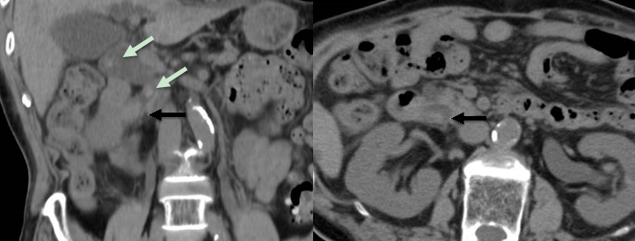
Figure 1 Computed tomography on admission. Plain abdominal computed tomography of our patient, showing choledocholithiasis with multiple calcified stones (green arrows) in the dilated common bile duct (CBD) and a round shaped tumor in the lower CBD (black arrows).

A
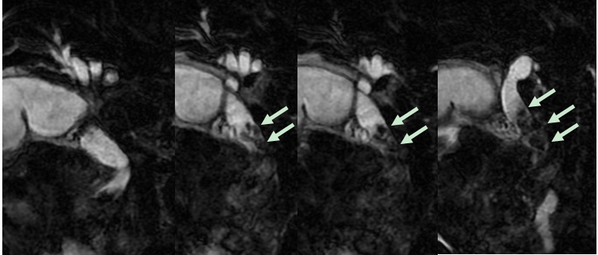
B
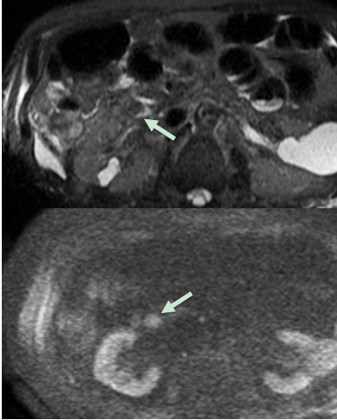
Figure 2 Magnetic resonance imaging showed multiple stones and an oval shaped tumor in the common bile duct. A: Magnetic resonance imaging (MRI) with cholangiopancreatography showing multiple signal voids in the common bile duct (CBD) reflecting tiny stones; B: T2-weighted MRI image showing an oval shaped tumor 20 mm in diameter in the lower CBD with high intensity signal (upper row); and a diffusion-weighted image showing a mass lesion in the lower CBD with round high signal intensity (lower row).

A
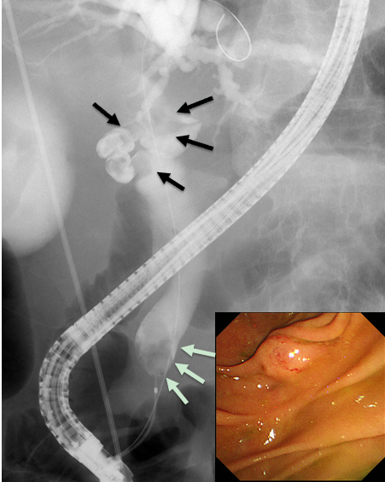
B
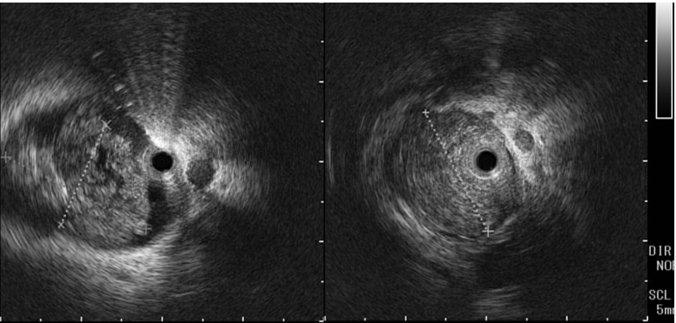
C
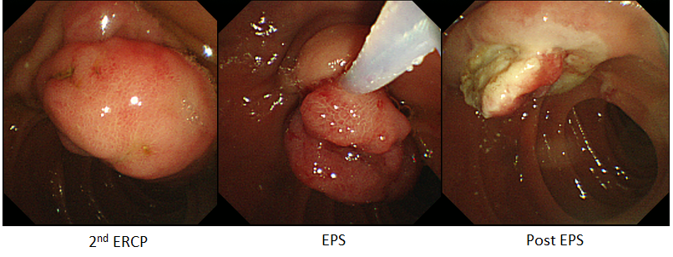
Figure 3 The tumor was resected successfully by endoscopic snare papillectomy. A: Endoscopic retrograde cholangiopancreatography (ERCP), showing several filling defects in the upper part of the CBD (black arrows), and an oval shaped defect in the intra-pancreatic CBD (green arrows). Endoscopic picture during ERCP did not show any remarkable findings without juxtapapillary duodenal diverticula; B: Intraductal ultrasonography confirming that the lower filling defect was a papillary-growing tumor in the CBD; C: Second ERCP, performed one week later, showing inversion and exclusion of the tumor after endoscopic sphincterotomy. The tumor was a pedunculated polyp, enabling en bloc resection by endoscopic snare papillectomy.

A
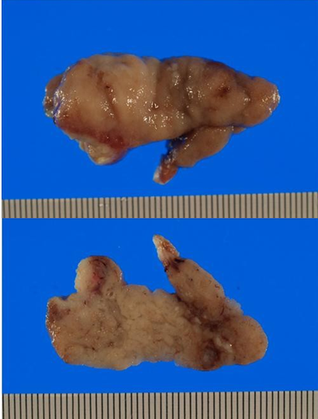
B
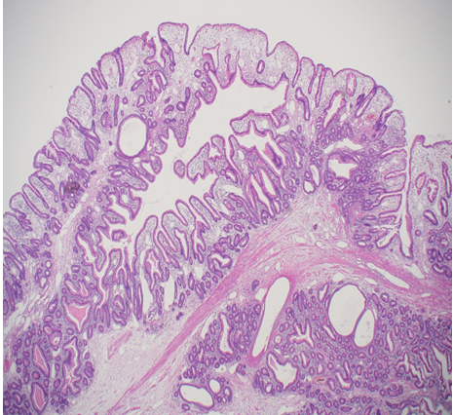
Figure 4 Histopathological findings. A: View of the surgical specimen, showing that it was 4.8×1.9×1.8 cm in diameter with lobular surfaces, which were epithelialized with intestinal type mucosa; B: Histopathological examination, showed features suggesting a hamartoma. For example, the polyp contained irregular hyperplastic crypts with focal cystic dilatation and branching bundles of smooth muscle extending from the muscularis mucosae. The epithelium was hyperplastic.

