Name of Journal: World Journal of Clinical Cases
Manuscript NO: 64376
Manuscript Type: CASE REPORT

Schwannoma mimicking pancreatic carcinoma: A case report

Kimura K et al. Schwannoma in pancreatic body

Koichi Kimura, Eisuke Adachi, Ayako Toyohara, Sachie Omori, Kaoru Ezaki, Ryo Ihara, Takahiro Higashi, Kippei Ohgaki, Shuhei Ito, Shin-ichiro Maehara, Toshihiko Nakamura, Fumiyoshi Fushimi, Yoshihiko Maehara

Koichi Kimura, Eisuke Adachi, Ayako Toyohara, Sachie Omori, Takahiro Higashi, Kippei Ohgaki, Shuhei Ito, Shin-ichiro Maehara, Toshihiko Nakamura, Yoshihiko Maehara, Department of Surgery, Kyushu Central Hospital of the Mutual Aid Association of Public School Teachers, Fukuoka 815-8588, Japan

Kaoru Ezaki, Ryo Ihara, Department of Internal Medicine, Kyushu Central Hospital of the Mutual Aid Association of Public School Teachers, Fukuoka 815-8588, Japan

Fumiyoshi Fushimi, Department of Histopathology, Kyushu Central Hospital of the Mutual Aid Association of Public School Teachers, Fukuoka 815-8588, Japan

Author contributions: Kimura K was responsible for the study conception, design and drafting of the manuscript; Toyohara A, Omori S, Ezaki K, Ihara R, Higashi T, Ohgaki K, Ito S, Maehara S, Nakamura T and Fushimi F were responsible for data collection; Adachi E and Maehara Y were responsible for critical revision of the manuscript; all authors issued final approval for the version to be submitted.

Corresponding author: Koichi Kimura, MD, PhD, Doctor, Department of Surgery, Kyushu Central Hospital of the Mutual Aid Association of Public School Teachers, 3-23-1 Shiobaru, Minamiku, Fukuoka 815-8588, Japan. cubicseal@gmail.com

Received: February 16, 2021
Revised: March 7, 2021
Accepted: March 29, 2021
Published online: June 16, 2021

Abstract
BACKGROUND
Schwannoma of the pancreas is extremely rare. We report a case of pancreatic schwannoma that was difficult to distinguish from pancreatic carcinoma before surgery.

CASE SUMMARY
A 66-year-old male underwent a right-lobe hepatectomy for hepatocellular carcinoma. Post-surgical computed tomography showed a 10 mm long solid mass with ischemia, with no expansion into the main pancreatic duct. Upon magnetic resonance cholangiopancreatography, the tumor had high signal intensity in diffusion weighted images, consistent with pancreatic carcinoma. Endoscopic ultrasound (EUS) was performed to obtain more information about the tumor, and showed a 14 mm solid and hypoechoic mass in the pancreatic body. Contrast enhanced EUS revealed that the tumor showed a hyperechoic mass in the early phase, and the contrasting effect continuation was very short; findings also consistent with pancreatic carcinoma. Thus, we preoperatively diagnosed his condition as a pancreatic carcinoma and performed distal pancreatectomy with splenectomy. Microscopic examination showed that the tumor was in fact a benign schwannoma. Histology showed a proliferation of spindle-shaped cell in a vague fascicular and haphazard pattern, with palisading arrangement.

CONCLUSION
Schwannoma of the pancreas is very rare, however, clinicians should consider schwannoma as the differential diagnosis for pancreatic tumors.

Key Words: Schwannoma; Pancreatic body; Pancreatic carcinoma; Pancreatic tumor; Distal pancreatectomy; Case report

©The Author(s) 2021. Published by Baishideng Publishing Group Inc. All rights reserved.

Citation: Kimura K, Adachi E, Toyohara A, Omori A, Ezaki K, Ihara R, Higashi T, Ohgaki K, Ito S, Maehara S, Nakamura T, Fushimi F, Maehara Y. Schwannoma mimicking pancreatic carcinoma: A case report. World J Clin Cases 2021; 9(17): 4453-4459
URL: https://www.wjgnet.com/2307-8960/full/v9/i17/4453.htm
DOI: https://dx.doi.org/10.12998/wjcc.v9.i17.4453

Core Tip: Schwannoma of the pancreas is extremely rare, with 68 cases reported in the literature. On the other hand, preoperative diagnosis of schwannomas can be difficult, as schwannomas have no specific imaging findings, thus the preoperative diagnosis is not easy to confirm. We have experienced a case of schwannoma in pancreatic body mimicking pancreatic carcinoma, and performed surgical treatment. Clinicians should consider nonepithelial tumors as a part of the differential diagnosis for pancreatic tumors despite their low frequency.

INTRODUCTION
Schwannomas are usually benign nerve sheath tumors that originate from the Schwann cells and can arise in any aspect of the peripheral nerves^{[1]}. Schwannomas are often found in the head and neck area, major nerve trunks. Intracavitary schwannomas are found in the retroperitoneum and posterior mediastinum, however, they are found in the gastrointestinal trac occasionally^{[2]}. Moreover, schwannomas in pancreas are extremely rare. For the last 40 years, less than 70 cases of pancreatic schwannomas have been reported in English literature^{[3]}. Preoperative diagnosis of pancreatic schwannoma is very difficult because of the wide variety of imaging findings. It has been reported that degenerative changes are found in approximately two-thirds of pancreatic schwannomas^{[4]}. In general, pancreatic schwannomas are often benign tumors and surgical treatment is definitive, while in rare cases they develop into a malignant form^{[5]}. Some reports have revealed that the malignant form of schwannoma occurs in about 5% of von Recklinghausen's disease cases^{[6]}.
Herein, we present a review of the literature and a novel case of a pancreatic schwannoma that was initially diagnosed as a pancreatic carcinoma, in a patient who underwent a distal pancreatectomy with splenectomy.

CASE PRESENTATION
Chief complaints
A 66-year-old male who was followed-up after right lobe hepatectomy for hepatocellular carcinoma (pT2N0M0 stage II) secondary to a hepatitis B infection for ten years and six months. He was found pancreatic tumor accidentally in ultrasonography on a health examination.

History of present illness
Ultrasonography revealed a 10 mm tumor in the pancreas.

History of past illness
The patient had a history of right lobe hepatectomy for S5/6 hepatocellular (pathological stage: PT2N0M0 stage II carcinoma ten years and six months ago, and followed up for five years after hepatectomy.

Personal and family history
There is no history of his family.

Physical examination
He had no physical abnormity, general condition was almost good.

Laboratory examinations
Laboratory findings indicated that white blood counts were 4000/μL (reference range 3500-8400/μL), alkaline phosphatase 217 U/L (reference range 115-359 U/L), gamma-glutamyl transpeptidase 17 U/L (reference range 10-47 U/L), C-reactive protein 0.04 mg/dL (reference range < 0.2 mg/dL), carcinoembryonic antigen 2.0 ng/mL (reference range < 5.0 ng/mL), CA19-9 antigen 0.4 U/mL (reference range < 37.0 U/mL), and immunoglobulin G4 21 mg/dL (reference range 5-117 mg/dL).

Imaging examinations
Computed tomography (CT) showed a 10 mm tumor with low density in the early phase (Figure 1A) and isodensity with pancreatic parenchyma in the late phase (Figure 1B). There was no expansion into the main pancreatic duct, and no swollen lymph nodes. Magnetic resonance cholangiopancreatography (MRI) revealed a 9 mm tumor in the pancreatic body. The tumor showed low intensity in T1-weighted images (Figure 2A) and showed slightly higher intensity in T2-weighted images (Figure 2B). The tumor also demonstrated high signal in diffusion weighted images (Figure 2C) and almost the same isodensity in an apparent diffusion coefficient-map phase (Figure 2D). Endoscopic ultrasound (EUS) was performed to obtain more information about the tumor. EUS images showed a 14 mm solid and low echoic mass in the pancreatic body (Figure 3A), EUS elastography showed a strain ratio < 0.05 (Figure 3B), and contrast enhanced EUS showed short term contrast effects in the early phase that washed out quickly (Figure 3C).

FINAL DIAGNOSIS
The patient was diagnosed with pancreatic carcinoma.

TREATMENT
He underwent a distal pancreatectomy with splenectomy. During surgery, there was no ascites, no peritoneal or liver metastasis, and no macroscopic lymphadenopathy. Distal pancreatectomy with splenectomy and lymphadenectomy of lymph nodes 8, 9, 10, 11, 14, 15, 18 were performed (Figure 4).

OUTCOME AND FOLLOW-UP
Histopathologic examination after surgery showed a proliferation of spindle-shaped cells in a vague fascicular and haphazard pattern, with palisading arrangement (Figure 5A and B). Mitotic figures were not evident. These features were consistent with schwannoma, not pancreatic carcinoma. There was in fact no evidence of malignancy. Immunohistochemical staining of S100 was positive (Figure 5C and D), and AE1/AE3, spinal muscular atrophy (SMA), and CD34 were all negative. There was no lymph node metastasis. As a result, the final diagnosis of the tumor proved to be a pancreatic schwannoma (11 mm × 8 mm). Although the patient developed a grade B pancreatic fistula after surgery, this was resolved by conservative treatment.

DISCUSSION
We present a patient with a pancreatic schwannoma who underwent a distal pancreatectomy and splenectomy with a working diagnosis of pancreatic carcinoma. In the abdominal cavity, the retroperitoneum and stomach are the most frequently involved sites for schwannomas. On the other hand, other intraperitoneal organ schwannomas have been previously reported, such as in the gallbladder^{[7]} and intrahepatic duodenal ligament^{[8]}. To the best of our knowledge, less than 70 cases of schwannomas in the pancreas have been reported^{[3]}. Schwannomas are histopathologically composed of spindle cells in a nuclear palisade arrangement and Verocay body formation^{[9]}. Immunohistochemically, schwannomas are positive for S-100, and negative for desmin, smooth muscle myosin, SMA, CD34 and CD117^{[4]}. Immunohistochemical examination in our case showed that S-100 was positive and the other markers were negative.
Preoperative diagnosis of schwannomas can be difficult, as schwannomas have no specific imaging findings, thus the preoperative diagnosis is not easy to confirm. Several imaging modalities such as ultrasonography, CT, MRI, and EUS may be useful in diagnosing. Contrast enhanced CT shows well-defined hypodense lesions with encapsulation and/or cystic degeneration^{[8]}, and MRI shows hypointensity on T1-weighted images and lack of homogeneity and hyperintensity on T2-weighted images^{[10]}. Crinò et al^{[11]} reported that EUS is useful to diagnose pancreatic schwannoma. They also reported that contrast enhanced EUS can help achieve the diagnosis^{[11]}. It has been reported that degenerative changes are found in almost 70% of schwannomas in pancreas^{[4]}. Degenerative changes lead to the presence of obvious variety in the appearance and size of the tumors. Schwannomas are capsulated tumors that, at imaging, are generally round or oval and show well-defined margins. Histologically, schwannomas are comprised of two areas: Antoni A, characterized by packed spindle cells and a vascular component, and Antoni B, characterized by hypocellularity and occupied by loose stroma. The latter area may be the subject of degenerative changes, such as cyst formation, hemorrhage, necrosis, and calcification. Pancreatic schwannomas may mimic other, more common pancreatic lesions. Therefore, pancreatic schwannomas have a very high rate of misdiagnosis. In this case, imaging findings of contrast enhanced CT and MRI did not conflict with the above standard findings; however, imaging findings from EUS were consistent with pancreatic carcinoma. We compared the histology of the tumor to leiomyoma and a gastrointestinal stromal tumor. However, immunohistochemical staining of SMA was negative, and S100 was positive. These findings contradicted those tumors.
Most pancreatic schwannomas are benign, however there are some reports that show malignant transformation^{[4,12]}. Some researchers have attempted to correlate the characteristics of the schwannomas on imaging examination with its malignant potential. Ma et al^{[3]} suggested that larger tumors correlated with greater malignant potential. The management of schwannomas in pancreas should be decided by location and histological findings. Most pancreatic schwannomas are benign and malignant transformation is extremely rare. As such, enucleation is often the first-line procedure if tumor pathology is confirmed pre-operation. In cases of large tumors expressing malignant behavior, such as malignancy in frozen sections or invasion to major vessels, an oncological resection is recommended.

CONCLUSION
Incidental detection of pancreatic schwannoma is predicted to increase due to the widespread use of CT and MRI. It is important to consider this tumor type in the differential diagnosis of pancreatic tumors. Pancreatic schwannoma is extremely rare, but in centers performing large numbers of pancreatic surgeries, the possibility of this diagnosis is still reasonable.

REFERENCES
1 Pilavaki M, Chourmouzi D, Kiziridou A, Skordalaki A, Zarampoukas T, Drevelengas A. Imaging of peripheral nerve sheath tumors with pathologic correlation: pictorial review. Eur J Radiol 2004; 52: 229-239 [PMID: 15544900 DOI: 10.1016/j.ejrad.2003.12.001]
2 Ercan M, Aziret M, Bal A, Şentürk A, Karaman K, Kahyaoğlu Z, Koçer HB, Bostancı B, Akoğlu M. Pancreatic schwannoma: A rare case and a brief literature review. Int J Surg Case Rep 2016; 22: 101-104 [PMID: 27084984 DOI: 10.1016/j.ijscr.2016.03.014]
3 Ma Y, Shen B, Jia Y, Luo Y, Tian Y, Dong Z, Chen W, Li ZP, Feng ST. Pancreatic schwannoma: a case report and an updated 40-year review of the literature yielding 68 cases. BMC Cancer 2017; 17: 853 [PMID: 29241452 DOI: 10.1186/s12885-017-3856-6]
4 Stojanovic MP, Radojkovic M, Jeremic LM, Zlatic AV, Stanojevic GZ, Jovanovic MA, Kostov MS, Katic VP. Malignant schwannoma of the pancreas involving transversal colon treated with en-bloc resection. World J Gastroenterol 2010; 16: 119-122 [PMID: 20039458 DOI: 10.3748/wjg.v16.i1.119]
5 Witkowski G, Kołos M, Nasierowska-Guttmejer A, Durlik M. Neuroma (schwannoma). A rare pancreatic tumor. Pol Przegl Chir 2019; 92: 48-51 [PMID: 32312928 DOI: 10.5604/01.3001.0012.8558]
6 Aggarwal G, Satsangi B, Shukla S, Lahoti BK, Mathur RK, Maheshwari A. Rare asymptomatic presentations of schwannomas in early adolescence: three cases with review of literature. Int J Surg 2010; 8: 203-206 [PMID: 20167297 DOI: 10.1016/j.ijsu.2010.01.012]
7 Tajiri T, Hayashi H, Higashi T, Yamao T, Takematsu T, Uemura N, Yamamura K, Imai K, Yamashita YI, Baba H. Coexisting schwannoma of the gallbladder and sarcoidosis: a case report. Surg Case Rep 2020; 6: 76 [PMID: 32307608 DOI: 10.1186/s40792-020-00839-4]
8 Xu SY, Sun K, Xie HY, Zhou L, Zheng SS, Wang WL. Schwannoma in the hepatoduodenal ligament: A case report and literature review. World J Gastroenterol 2016; 22: 10260-10266 [PMID: 28028376 DOI: 10.3748/wjg.v22.i46.10260]
9 Joshi R. Learning from eponyms: Jose Verocay and Verocay bodies, Antoni A and B areas, Nils Antoni and Schwannomas. Indian Dermatol Online J 2012; 3: 215-219 [PMID: 23189261 DOI: 10.4103/2229-5178.101826]
10 Rha SE, Byun JY, Jung SE, Chun HJ, Lee HG, Lee JM. Neurogenic tumors in the abdomen: tumor types and imaging characteristics. Radiographics 2003; 23: 29-43 [PMID: 12533638 DOI: 10.1148/rg.231025050]
11 Crinò SF, Bernardoni L, Manfrin E, Parisi A, Gabbrielli A. Endoscopic ultrasound features of pancreatic schwannoma. Endosc Ultrasound 2016; 5: 396-398 [PMID: 28000633 DOI: 10.4103/2303-9027.195873]
12 Liegl B, Bodo K, Martin D, Tsybrovskyy O, Lackner K, Beham A. Microcystic/reticular schwannoma of the pancreas: a potential diagnostic pitfall. Pathol Int 2011; 61: 88-92 [PMID: 21255185 DOI: 10.1111/j.1440-1827.2010.02614.x]

Footnotes
Informed consent statement: Informed written consent was obtained from the patient for publication of this report and any accompanying images.

Conflict-of-interest statement: The authors declare that they have no conflict of interest.

CARE Checklist (2016) statement: The authors have read the CARE Checklist (2016), and the manuscript was prepared and revised according to the CARE Checklist (2016).

Open-Access: This article is an open-access article that was selected by an in-house editor and fully peer-reviewed by external reviewers. It is distributed in accordance with the Creative Commons Attribution NonCommercial (CC BY-NC 4.0) license, which permits others to distribute, remix, adapt, build upon this work non-commercially, and license their derivative works on different terms, provided the original work is properly cited and the use is non-commercial. See: http://creativecommons.org/Licenses/by-nc/4.0/

Manuscript source: Unsolicited manuscript

Peer-review started: February 19, 2021
First decision: March 7, 2021
Article in press: March 29, 2021

Specialty type: Medicine, research and experimental
Country/Territory of origin: Japan
Peer-review report’s scientific quality classification
Grade A (Excellent): 0
Grade B (Very good): 0
Grade C (Good): C
Grade D (Fair): 0
Grade E (Poor): 0

P-Reviewer: Zhu CF S-Editor: Fan JR L-Editor: A P-Editor: Li JH

Figure Legends
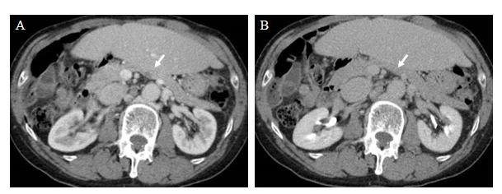
Figure 1 Computed tomography images. A: A 10 mm tumor that was hyperintense with ischemia in the early phase (white arrowhead); B: A 10 mm tumor that was isodense with pancreatic parenchyma in late phase (white arrowhead).
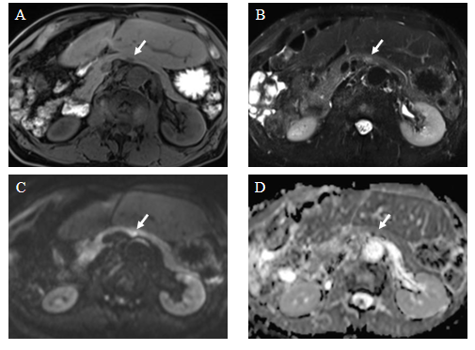
Figure 2 Magnetic resonance cholangiopancreatography images. A: The tumor showed low intensity in T1-weighted images (white arrowhead); B: The tumor showed moderately high intensity in T2-weighted images (white arrowhead); C: The tumor demonstrated high signal in diffusion weighted images (white arrowhead); D: The tumor showed almost the same isodensity in an apparent diffusion coefficient-map phase (white arrowhead).
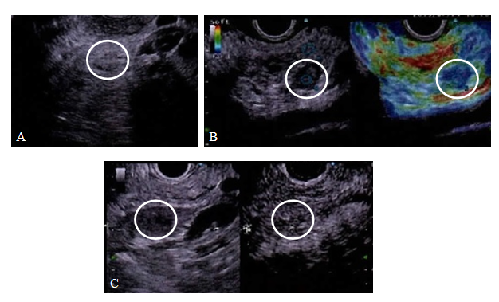
Figure 3 Endoscopic ultrasound images. A: The tumor showed a 14 mm solid and low echoic mass in the pancreatic body (white circle); B: Endoscopic ultrasound (EUS) elastography showed a strain ratio < 0.05 (white circle, right image: Elastography image); C: Contrast enhanced EUS showed short term contrast effects in the early phase and washed out quickly (white circle, right image: Sonazoid mode of delay phase).
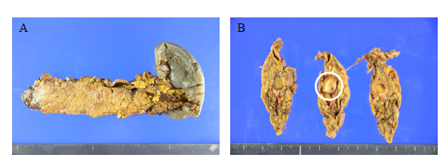
Figure 4 Macroscopic pathological findings of specimen. A: Specimen pathology; B: White circle shows tumor.
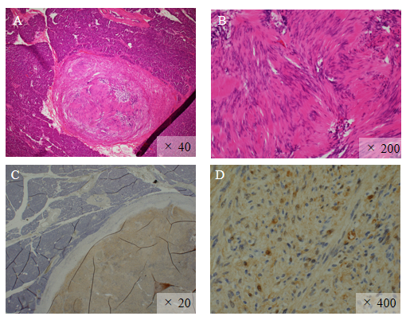
Figure 5 Microscopic histopathological findings. A and B: Hematoxylin and eosin staining showed a proliferation of spindle-shaped cells in a vague fascicular and haphazard pattern, with palisading arrangement; C and D: Immunohistochemical staining of S100 was positive.

Published by Baishideng Publishing Group Inc
7041 Koll Center Parkway, Suite 160, Pleasanton, CA 94566, USA
Telephone: +1-925-3991568
E-mail: bpgoffice@wjgnet.com
Help Desk: https://www.f6publishing.com/helpdesk
https://www.wjgnet.com

© 2021 Baishideng Publishing Group Inc. All rights reserved.

