Name of journal: World Journal of Clinical Oncology
ESPS Manuscript NO: 8178
Columns: TOPIC HIGHLIGHT

WJCO 5th Anniversary Special Issues (2): Breast Cancer

Toremifene in the treatment of breast cancer

Mustonen MVJ et al. Antiestrogens in breast cancer

Mika VJ Mustonen, Seppo Pyrhönen, Pirkko-Liisa Kellokumpu-Lehtinen

Mika VJ Mustonen, Orion Corporation, Orion Pharma, FIN-02101, Espoo, Finland

Seppo Pyrhönen, Department of Oncology and Radiotherapy, Turku University Hospital and University of Turku, FIN-20520, Turku, Finland

Pirkko-Liisa Kellokumpu-Lehtinen, Department of Oncology, University of Tampere, School of Medicine, Tampere University Hospital, FIN-33520, Tampere, Finland

Author contributions: All the authors contributed to the acquisition of data, preparation of the manuscript, reviewing and amending for intellectual content.

Correspondence to: Mika VJ Mustonen, PhD, Orion Corporation, Orion Pharma, Orionintie 1, FIN-02101, Espoo, Finland. mika.mustonen@orionpharma.com

Telephone: +358-50-9664804 Fax: +358-50-9664804

Received: December 18, 2013 Revised: April 8, 2014
Accepted: May 28, 2014

Published online:

Abstract
Although more widespread screening and routine adjuvant therapy has improved the outcome for breast cancer patients in recent years, there remains considerable scope for improving the efficacy, safety and tolerability of adjuvant therapy in the early stage disease and the treatment of advanced disease. Toremifene is a selective estrogen receptor modifier (SERM) that has been widely used for decades in hormone receptor positive breast cancer both in early and late stage disease. Its efficacy has been well established in nine prospective randomized phase III trials compared to tamoxifen involving more than 5500 patients, as well as several large uncontrolled and non-randomized studies. Although most studies show therapeutic equivalence between the two SERMs, some show an advantage for toremifene. Several meta-analyses have also confirmed that the efficacy of toremifene is at least as good as that of tamoxifen. In terms of safety and tolerability toremifene is broadly similar to tamoxifen although there is some evidence that toremifene is less likely to cause uterine neoplasms, serious vascular events and it has a more positive effect on serum lipids than does tamoxifen. Toremifene is therefore effective and safe in the treatment of breast cancer. It provides not only a useful therapeutic alternative to tamoxifen, but may bring specific benefits.

© 2014 Baishideng Publishing Group Inc. All rights reserved.

Key words: Breast cancer; Toremifene; tamoxifen; Adjuvant treatment; Advanced breast cancer

Core tip: Toremifene is safe and effective in the treatment of breast cancer. Toremifene and tamoxifen are equivalently effective in the treatment of breast cancer, although some studies show an advantage for toremifene. Safety and tolerability is also broadly equivalent, although toremifene may cause fewer uterine neoplasms, serious vascular adverse events and has a more beneficial effect on plasma lipids than does tamoxifen.

Mustonen MVJ, Pyrhönen S, Kellokumpu-Lehtinen PL. Toremifene in the treatment of breast cancer. World J ClinOncol 2014; In press

INTRODUCTION

Despite improvements in screening and treatment, breast cancer remains a significant cause of morbidity and mortality; accounting for almost one-third of all cancer diagnoses in the US and is second only to lung cancer as a cause of cancer mortality[^{1]}. Over a million women are diagnosed each year worldwide and almost half a million deaths due to breast cancer are recorded each year^{[2]}. Whilst incidence rates are considerably higher in developed than in developing countries, survival rates are low in developing countries, probably due to the lack of screening and systematic use of adjuvant therapy[²]. Historically low rates of breast cancer in, for example, the Eastern World have shown a rapid increase in recent years^{[3,4]}. Although typically a disease of later life, breast cancer among younger, pre-menopausal women appears to be more common than in the Western World[5^{,6}]. Breast cancer among young women, although comprising only around 7% of diagnosed cases, is associated with later presentation, high grade tumors, hormone receptor negativity and human epidermal growth factor receptor 2 (HER2 overexpression; factors that lead to a poorer overall prognosis^{[7]}.
The place of estrogen receptor modifiers (SERMs) in the treatment of breast cancer is now well established. Survival in breast cancer patients in the developed world has increased considerably over the past several decades, due principally to more widespread screening and the systematic use of adjuvant therapy^{[8,9]}. Whilst adjuvant therapy with SERMs, aromatase inhibitors, cytotoxic agents, monoclonal antibodies and other agents has transformed the outlook for breast cancer patients, there remains considerable unmet need for improvements in both efficacy and tolerability.

Toremifene
The first SERM to be introduced, tamoxifen, provided a revolutionary new treatment option for patients with hormone receptor positive breast cancer. With more than 30 years of experience now available this treatment modality has shown itself to be effective and physicians have learned how to manage its side effects. The mixed agonist/antagonist properties of SERMs define both their therapeutic effects and their undesirable effects. The different structural properties of different SERMS appears to influence their oncogenicity in both laboratory^{[10,11]} and clinical studies^{[12-19]}.
The structure of toremifene differs from that of tamoxifen in that a chlorine atom replaces one of the hydrogen atoms in the ethyl side chain. This difference may modify the metabolism of toremifene such that the production of DNA adducts may be prevented or reduced compared with tamoxifen^{[20,21].}
Almost 25 years have elapsed since the first marketing authorization of toremifene and during that time considerable clinical experience has accumulated indicting its efficacy, safety and good tolerability. Indeed, so good was the safety and tolerability that the initially registered dose (60 mg per day) has been widely increased to 240 mg per day.

Toremifene dosage
As shown in Table 1 and Table 2 a variety of doses of toremifene are, or have been, in common use. Although some early dose finding studies failed to distinguish between a wide range of doses from 20 mg to 200 mg^{[22]}, 60 mg was chosen as the most appropriate balance between anti-estrogenic effects and tolerability in Phase II studies; significant side effects being observed at the highest doses tested (680 mg)[²³]. Dose finding and other studies suggested that 60 mg was safe and effective in breast cancer[2⁴⁻²⁶] and more effective than 20 mg[^{27,28}]. However, extrapolation from animal studies suggested that even higher doses would be well tolerated; phase I studies showed that 460 mg daily for five consecutive days was the highest fully tolerated dose[2³]. A conservative approach led to 240 mg being chosen for the high dose formulation. Subsequent phase III clinical trials appear to bear out the enhanced efficacy of the higher dose formulations of toremifene[²⁹-31].

Randomized studies with toremifene
There have been ten randomized controlled studies comparing toremifene with tamoxifen[2⁹-³⁹]. Collectively, these studies, which include a total of more than 5500 patients show rather clearly that toremifene is not less effective than tamoxifen. These studies are summarized in Table 1.

Toremifene in advanced breast cancer
An early double-blind, Japanese study in 114 women with advanced or recurrent breast cancer found toremifene 40 mg and tamoxifen 20 mg resulted in similar response rates (26.3% vs 28.1%) and duration of response (155.0 vs 154.5 d)[⁴⁰]. However, the time to onset of complete response was significantly shorter with toremifene than with tamoxifen (91 vs 169 d; P < 0.05).
A Nordic study compared toremifene 60 mg with tamoxifen 40 mg in 415 postmenopausal women with advanced breast cancer in a double-blind randomized manner[32]. Response rates were similar in toremifene and tamoxifen groups (31.5% vs 37.3%). Time to treatment failure and median overall survival were also similar.
An open study conducted in Eastern Europe compared toremifene 60 and 240 mg, with tamoxifen 40 mg in 463 postmenopausal women with advanced breast cancer[31]. Response rates of 20.4% and 20.8% were achieved with toremifene 60 mg and tamoxifen, respectively. Although the response rate with the higher dose of toremifene was slightly higher (28.7%), it did not differ significantly from the other treatments. The findings were similar for time to progression and overall survival, quality of life, as assessed by changes in the Eastern Cooperative Oncology Group (ECOG) scale, was better with toremifene 60 mg than with tamoxifen.
A four-way randomized study was undertaken in 541 women in Russia comparing two doses of toremifene (60 mg and 240 mg) with tamoxifen (20 mg) and letrozole (2.5 mg)[^{35]} Objective responses were most frequent in the toremifene 240 mg group (41.5%); objective responses were lower (though not statistically significantly so) in the toremifene 60 mg and letrozole groups (33.0% and 35.4% respectively). The proportion of responses in the tamoxifen group was statistically significantly lower than in the other three treatment groups. Similarly, the median duration of remission was longest in the toremifene 240 mg group (14.5 mo), shortest in the tamoxifen group (9.2 mo) and intermediate in the toremifene 60 mg and letrozole groups (11.3 and 13.1 mo, respectively), the difference between tamoxifen and the other treatments was statistically significant.
Another open study, carried out in the United States, compared toremifene 60 mg and 200 mg with tamoxifen 20 mg in 648 post- or peri-menopausal women with metastatic breast cancer^{[35]}. As in the previous studies, there were no significant differences between the treatments with regard to response rates (21%, 23% and 19% with toremifene 60 mg, toremifene 200 mg and tamoxifen, respectively), time to progression, response duration or overall survival. There was again a suggestion that the 60 mg dose of toremifene resulted in the greatest improvement in quality of life, although the differences were not statistically significant. Compared with tamoxifen, more patients given toremifene 60 mg reported an improvement in enjoyment of life, pain and mood.
A Spanish double-blind, randomized study in 217 postmenopausal women with advanced breast cancer reported a somewhat higher response rate with toremifene 60 mg than with tamoxifen 40 mg (64% vs 52%), although the difference did not achieve statistical significance[34]. Time to progression and overall survival rates were similar in the two groups.
The most recent randomized study reported in 2013 and compared toremifene 120 mg with the aromatase inhibitor exemestane in 91 post-menopausal women with non-steroidal aromatase inhibitor-resistant breast cancer[38]. After a median 16.9 mo follow-up there were advantages for toremifene over exemestane in clinical benefit [41.3% vs 26.7% respectively (ns)], objective response rate [10.8% vs 2.2% respectively (ns)], progression-free survival (7.3 mo vs 3.7 mo respectively; P = 0.045) and overall survival [32.3 vs 21.9 mo respectively (ns)].

Toremifene in early stage breast cancer
The International Breast Cancer Study group combined the results from two studies with almost identical protocols in which a total of 1035 peri- or post-menopausal women with breast cancer received either toremifene 60 mg or tamoxifen 40 mg[35]. In common with other similar studies the efficacy of toremifene and tamoxifen were approximately equal; 5-year disease-free survival was 72% and 69% respectively and 5-year overall survival was 85% and 81%. Likewise, in an even larger randomized study in [North American Fareston versus Tamoxifen Adjuvant (NAFTA) trial] 1813 peri- or post- menopausal women with invasive breast cancer toremifene 60 mg and tamoxifen 20 performed similarly (5-year disease-free survival 92.2% in both groups)
After a median follow-up of 3.4 years a Finnish study found a number of efficacy parameters showing advantages for toremifene compared with tamoxifen, although none achieved statistical significance. Overall, time to recurrence, recurrence rate, recurrence at distant sites and the number of patients dying during follow-up were similar in toremifene- and tamoxifen- treated patients. Although the Kaplan-Meir analysis of the time to recurrence or the time to progression or disease free survival in this study (Figure 1) appears to show a separation between toremifene and tamoxifen from 3 years onwards, the difference is not statistically significant (hazard ratio toremifene:tamoxifen 0.88 (95%CI: 0.70-1.09). The respective 5-year survival rates were 70.3% vs 65.6% (also not statistically significantly different)[33].
Whilst most randomized controlled studies of toremifene have been performed in patients with advanced or metastatic disease, another small study has been undertaken in an adjuvant setting in women with early stage breast cancer; 91 post-menopausal women with early stage, lymph node negative breast cancer were randomized to adjuvant treatment with toremifene 120 mg or tamoxifen 20 mg[37]. Five-year survival (97% and 96.7% respectively), cumulative disease-free survival (97.5% and 97.3% respectively) and cumulative disease-free survival (88.5% and 90.6% respectively) were very similar between the two groups after 66.5 mo follow-up.

Non-randomized trials
Whilst there are at least 14 published non-randomized studies of toremifene in advanced breast cancer many include rather few patients or have imperfect methodologies. However, there are two recent retrospective studies that merit further description
The study of Gu et al[⁴¹] reviewed the records of 810 women with early invasive breast cancer and identified 240 eligible patients who had received tamoxifen and 212 who had received toremifene. Following median follow-up times of 50.8 mo, although 5-year overall survival rates were similar (100% for toremifene and 98.4% for tamoxifen), recurrence-free survival was significantly longer in the toremifene group than in the tamoxifen (97.2% and 90.4% respectively, P = 0.022).
Another retrospective study, this time including 1847 pre-menopausal women who had undergone surgery followed by chemotherapy toremifene or tamoxifen similarly found no significant differences between the treatments[⁴²]. All survival figure were identical between toremifene and tamoxifen; disease-free survival (10.3 years in both groups). Five-year disease-free survival (87% vs 85%, respectively) and 5-year overall survival (94.3% vs 93.5%, respectively)

META-ANALYSES
Whilst individual clinical trials can provide invaluable data on the efficacy of a medication in restricted populations, meta-analysis can provide information about more generalized patient populations and increase statistical power. The randomized clinical trials described above have been the subject of several meta-analyses. The earliest combined two randomized studies comparing toremifene (200 or 240 mg) and tamoxifen (20 or 40 mg) and included a total of 733 patients with advanced breast cancer[⁴³]. Response rates were higher in toremifene patients than in tamoxifen patients (25.2% vs 19.8%), but not statistically significantly (P = 0.87). Disease progression and survival also showed no statistically significant differences between toremifene and tamoxifen.
A subsequent meta-analysis in 1999 included results from the five randomized studies completed to that date[⁴⁴]. This meta-analysis represented 1421 postmenopausal patients with previously untreated, locally advanced or metastatic breast cancer that were treated with either toremifene 40-60 mg (n = 725) or tamoxifen 20-40 mg (n = 696). As in the previous meta-analysis toremifene and tamoxifen proved to be broadly equivalent in terms of response rate (24.0% vs 25.3%, respectively), time to treatment failure (4.9 vs 5.3 mo) and survival (31.0 vs 33.1 mo).
Another meta-analysis has been performed on the disease-free and overall survival findings from two pivotal randomized studies comparing toremifene and tamoxifen in an early breast cancer[33,35] (data on file, Orion). As shown in Figure 2, there are indications that toremifene may be superior to tamoxifen, most notably in estrogen-receptor-positive patients. In this subgroup of patients, the combined data showed a significant (P = 0.037) benefit for toremifene with regard to disease-free survival, although the difference with regard to overall survival did not achieve statistical significance (P = 0.059).
A more recent meta-analysis using somewhat more restrictive criteria for inclusion analyzed three eligible randomized comparisons with tamoxifen[⁴⁵]. However, the overall results were similar in that no significant differences in efficacy between toremifene and tamoxifen were identified with risk ratios close to unity for overall survival and disease-free survival.
A recent meta-analysis identified 23 randomized clinical trials comparing toremifene with tamoxifen involving a total of 7242 patients with breast cancer[⁴⁶]. This large study found that although for most efficacy parameters there were no significant differences between toremifene and tamoxifen, toremifene was significantly more effective in terms of 5-year survival (odds ratio 1.25; 95%CI: 1.04-1.50) among patients with early stage breast cancer
A Cochrane review on toremifene vs tamoxifen for advanced breast cancer compared randomized controlled comparisons providing data on objective response rate, time to progression and overall survival[^{47]}.
The review identified 2061 patients from seven studies (1226 patients received toremifene and 835 patients received tamoxifen). The pooled risk ratio for the objective risk ratio was 1.02 suggesting that there was no statistically significant difference between toremifene and tamoxifen [objective risk ratios (ORR) were 25.8% vs 26.9%, respectively]. Similarly the hazard ratio for time to progression was 1.08, again, implying no statistically significant difference between toremifene and tamoxifen (time to progression 6.1 mo and 5.8 mo respectively). Overall survival also showed equivalence between the two medications [hazard ratio (HR) 1.02; overall survival 27.8 mo and 27.6 mo, respectively]. The authors conclude that toremifene and tamoxifen are equally effective in the first-line treatment of patients with advanced breast cancer.
The results of the randomized clinical trials are remarkably consistent and supported by both meta-analyses and retrospective studies; toremifene is at least as effective as tamoxifen in the treatment of breast cancer. Rather few studies find significant differences between the two SERMS, those that do differentiate between the two treatments find significant differences in favor of toremifene[³⁵,38,3⁹]. None find significant advantages for tamoxifen.

Safety and tolerability
Toremifene and tamoxifen have similar adverse event profiles and are well tolerated, both in women with advanced breast cancer and in those receiving adjuvant therapy. Hot flushes, sweating, nausea and vaginal discharge are among the most common adverse effects and serious adverse events are rare.
A large retrospective analysis of 1847 breast cancer patients treated with toremifene or tamoxifen showed the expected pattern of adverse events with sweating and nausea/vomiting as the most common undesirable effects (Table 3). Although the great majority of adverse effects occurred at similar rates in toremifene- and tamoxifen- treated patients, irregular menses were significantly more common in the tamoxifen group (10% vs 6.3%, P = 0.025)[41].
In the largest randomized study comparing tamoxifen and toremifene there were few differences in thromboembolic, gynecological and ocular adverse events between the two treatment groups. Fever and chills were significantly more common among tamoxifen-treated patients[36].
A safety analysis in the Finnish Breast Cancer Study Group data also illustrates the similar tolerability and safety profiles of toremifene; sweating and hot flashes being observed in more than half of the patients, followed by vaginal dryness and discharge with itching and depression observed in more than 20% of patients[33]. (Table 4) In no case were significant differences between toremifene and tamoxifen observed. There was similarly little difference in the incidence or pattern of serious adverse events between toremifene and tamoxifen (Table 5).
The above described studies were conducted with the low dose toremifene (60 mg), however high dose toremifene 200 or 240 mg is not associated with a significantly increased incidence, or different profile, of adverse events compared with the 60 mg dose[³¹,35]. For example, in a randomized study that involved 648 women with metastatic breast cancer, with the exception of a slightly greater incidence of nausea in the high dose group, the incidence of the most common side effects was similar with toremifene 60 mg and 200 mg[^{35]}. Similarly, there were no significant differences between the incidence of side effects with toremifene 60 mg and 240 mg in a randomized study of 463 women with advanced breast cancer[31]. In a pooled-analysis of two studies involving 733 women with advanced breast cancer[42], high-dose toremifene 200 or 240 mg was tolerated as well as tamoxifen 20 or 40 mg.
In a meta-analysis of five studies significantly more tamoxifen- than toremifene-treated patients discontinued treatment prematurely (19.6% vs 13.7%; P = 0.007), predominantly due to greater non-compliance and protocol violations in the tamoxifen group[43]. Not every study shows identical tolerability; in the Nordic study[32], the percentage of patients discontinuing treatment prematurely was significantly lower with toremifene than with tamoxifen (14% vs 20% respectively; P = 0.011), mainly due to fewer adverse events/patients’ refusals, loss to follow-up and deaths.
The recent meta-analysis of Chi et al[45] however, showed that compared with tamoxifen, toremifene was associated with more vaginal discharge in patients with early stage breast cancer and more vaginal bleeding in patients with advanced disease, although the both drugs had a similar overall effect on quality of life.

Lipids
As the long-term prognosis for breast cancer patients improve, increasing attention has been focused on continuing quality of life and morbidity from other causes. This is particularly important when SERMs are used in an adjuvant setting in early-stage breast cancer where the probability of long-term survival is high. In this context, an attractive property of SERMs is their ability to improve cardiovascular risk factors. Toremifene reduces both total and low-density lipoprotein (LDL) cholesterol and increases high-density lipoprotein (HDL) cholesterol (Figure 3)[⁴⁸⁻⁵¹]. Particularly persuasive are the results from a crossover trial in which 197 women receiving adjuvant therapy with toremifene or tamoxifen were monitored for lipid levels[⁵²]. After one year of treatment the total cholesterol had decreased in both groups, but HDL-cholesterol increased only in the toremifene group (P < 0.001); indeed, HDL cholesterol significantly decreased in the tamoxifen-treated patients (P < 0.001). After one year of therapy patients who still had abnormal lipid levels were switched to the other medication. In patients switched from tamoxifen to toremifene total- and HDL–cholesterol increased and triglycerides decreased to pre-treatment levels whilst in the patients switched from toremifene to tamoxifen total cholesterol decreased and triglycerides increased. The authors conclude that the lipid profile changes associated with toremifene are better than those associated with tamoxifen[51]. This finding was supported by the results of a recent meta-analysis of 23 clinical trials in which toremifene and tamoxifen were compared[45]. In an early stage breast cancer patients’ triglyceride levels were reduced more and HDL-cholesterol levels increased more by toremifene than by tamoxifen, although tamoxifen was more effective in reducing LDL-cholesterol. In patients with advanced disease toremifene also reduced triglyceride levels more than tamoxifen. Similar beneficial changes have also been reported from an extended randomized controlled investigation of the effects of toremifene versus the aromatase inhibitor anastrozole on lipid profile[⁵³].
The evidence seems rather clear that the effect of toremifene on patients’ lipid profile is generally positive and better than that of the comparator treatments so far investigated.

Bone mineral density in breast cancer patients
Toremifene improves bone mineral density (BMD) and helps prevent osteoporosis in postmenopausal breast cancer patients. These effects are similar to those of tamoxifen. Comparative studies have shown that both toremifene and tamoxifen prevent reductions in BMD in the lumbar spine and proximal femur, and that these effects are reflected by changes in a wide range of bone biochemistry markers such as pyridinoline, deoxypyridinoline and urinary cross-linked aminoterminal telopeptide of type I collagen[⁵⁴⁻⁵⁶]. Toremifene and tamoxifen have also been used successfully in combination with the bisphosphonate clodronate, with no significant differences between them[⁵⁷,⁵⁸].
Some beneficial effects on BMD have been observed in premenopausal women at high risk for developing breast cancer taking toremifene 60 mg as chemoprevention, therefore making an attractive alternative to tamoxifen. A double-blind, placebo- controlled pilot study in 259 healthy premenopausal and postmenopausal women at high risk for breast cancer found a trend for a sustained increase in lumbar spine BMD after one year of toremifene therapy in premenopausal women[⁵⁹].

LONG TERM SAFETY
The long-term safety profile of toremifene was evaluated in detail in a review of all preclinical and clinical safety data from 1978 to 2004 and comparative clinical safety data between October 1995 and the end of 2004[⁶⁰]. At the time of this review, information was available from more than 350000 patient treatment years. The evidence indicated that toremifene has good long-term safety, with a lower incidence of endometrial cancer, stroke, pulmonary embolism, deep vein thrombosis and cataracts than tamoxifen.
A 3-year study specifically designed to compare the gynecological effects of toremifene 40 mg and tamoxifen 20 mg in 167 postmenopausal breast cancer patients showed that the incidence of proliferative endometrium was increased to a significantly (P < 0.0001) lesser extent by toremifene (from 20.0% to 32.2%) than by tamoxifen (from 20.4% to 46.8%)[⁶¹].

Endometrial cancer
The finding that tamoxifen at high doses caused liver tumors in rats[⁶²] raised concern that it may be mutagenic in humans. The mechanism of this effect in laboratory animals was believed to be due to DNA adduct formation by metabolites of tamoxifen, although this has more recently been questioned[⁶³]. Nevertheless, endometrial cancer rates are increased in women taking tamoxifen[¹³]. The chlorine substitution in the structure of toremifene alters its metabolism such that DNA adducts are much less likely to form[6⁴⁻⁶⁷] and a case-control study based on records of 38000 Finnish breast cancer patients appears to suggest that toremifene is considerably less frequently associated with endometrial cancer than is tamoxifen [odds ratio (OR) 2.9; 95%CI: 0.3-3.9 vs 0.9; 95%CI: 0.3-3.9)[¹⁷]. However, a recent meta-analysis of studies involving a total of 7242 patients with early or advanced breast cancer found no difference in the number of endometrial cancers between patients treated with toremifene or tamoxifen, although the follow-up was relatively short in the majority of studies. There is clearly still much to be discovered concerning the oncogenicity of SERMs, but both laboratory and clinical evidence suggests an advantage for toremifene over tamoxifen in this regard.

Thromboembolic effects
A retrospective analysis of the serious vascular events reported in the manufacturer’s Drug Safety Database[⁶⁸] revealed that cerebrovascular and thromboembolic events overall were significantly higher in tamoxifen than in toremifene-treated patients (Figure 4).
Other evidence suggests that toremifene may be associated with a lower risk of such thromboembolic events[⁵⁰]. A retrospective analysis of adjuvant treatment trials with toremifene 40 or 60 mg and tamoxifen 20 mg in more than 2500 postmenopausal women revealed a significantly lower incidence of ischemic stroke, total cerebrovascular events and total thromboembolic events with toremifene compared with tamoxifen.

DISCUSSION
For obvious ethical reasons the great majority of randomized clinical trials of toremifene have been undertaken with tamoxifen as the comparator, rather than placebo. The results of these studies, and the several meta-analyses that are based upon them, appear to characterize toremifene as being at least as effective as tamoxifen in the treatment of breast cancer both in the adjuvant setting and in patients with advanced and metastatic disease. Of the ten randomized controlled trials described in Table 1 all found toremifene to be at least as effective as tamoxifen. In some studies and for some parameters there was a statistically significant advantage for toremifene over tamoxifen; a shorter time to onset of complete response in Nomura et al[3⁹] 1993, a higher rate of objective response in Zejnalov et al[^{35]} 2006 and a longer progression-free survival in Yamamato et al[38] 2013. There were no statistically significant efficacy advantages for tamoxifen in these studies. However, whilst it is tempting to claim at least a trend for better efficacy for toremifene, some statistically significant differences are likely to arise by chance when a large number of parameters are compared in several studies (68 individual parameters are represented in Table 1 far more were examined in the studies cited). So far as the efficacy of toremifene is concerned, the conclusion is that it is at least as effective as tamoxifen is reasonable seems conservative and reasonable. In addition, toremifene has been the subject of a number of meta-analyses using different criteria for inclusion of studies and all have come to the same conclusion that the efficacy of toremifene and tamoxifen are not statistically significantly different.
Modern hormonal treatment for breast cancer emphasizes continuing therapy with an anti-estrogen, or an anti-estrogen followed by a switch to an aromatase inhibitor after longer or shorter periods. Whilst toremifene appears to behave similarly to tamoxifen, there is a relative dearth of information on its use in these switch or extended adjuvant contexts.
So far as safety and tolerability are concerned, the simple substitution of a chlorine atom for a hydrogen atom appears to make a considerable difference. The altered pattern of metabolite formation with its strongly reduced DNA adduct formation is reflected in a lower incidence of endometrial cancer-a recent meta-analysis of studies involving a total of 7242 patients with early or advanced breast cancer found no difference in the number of endometrial cancers between patients treated with toremifene or tamoxifen, although the follow-up was relatively short in the majority of studies[45]. On the other hand, the pattern of serum lipids is more favorably affected by toremifene with lower triglycerides, and an improved HDL/total cholesterol ratio. Thromboembolic events also show benefits in favor of toremifene. Overall, toremifene is well tolerated and the pattern of adverse events reported in clinical trials is rather similar between the two SERMs.
Taken together, the findings of clinical trials, meta-analyses and studies on specific aspects of the pharmacology of toremifene suggest that it is an effective and well tolerated agent for the treatment of early and advanced breast cancer. In comparison with tamoxifen, toremifene is at least as effective in all therapeutic contexts so far investigated and may have tolerability and safety advantages.

ACKNOWLEDGMENTS
Editorial assistance was provided by Dr. JF Stolz. This assistance was reimbursed by Orion Pharma, Espoo, Finland.

REFERENCES
1 DeSantis C, Siegel R, Bandi P, Jemal A. Breast cancer statistics, 2011. CA Cancer J Clin ; 61: 409-418 [PMID: 21969133 DOI: 10.3322/caac.20134]
2 Youlden DR, Cramb SM, Dunn NA, Muller JM, Pyke CM, Baade PD. The descriptive epidemiology of female breast cancer: an international comparison of screening, incidence, survival and mortality. Cancer Epidemiol 2012; 36: 237-248 [PMID: 22459198 DOI: 10.1016/j.canep.2012.02.007]
3 Leung GM, Thach TQ, Lam TH, Hedley AJ, Foo W, Fielding R, Yip PS, Lau EM, Wong CM. Trends in breast cancer incidence in Hong Kong between 1973 and 1999: an age-period-cohort analysis. Br J Cancer 2002; 87: 982-988 [PMID: 12434289 DOI: 10.1038/sj.bjc.6600583]
4 Nagata C, Kawakami N, Shimizu H. Trends in the incidence rate and risk factors for breast cancer in Japan. Breast Cancer Res Treat 1997; 44: 75-82 [PMID: 9164680 DOI: 10.1023/A: 1005726110649]
5 Lim SE, Back M, Quek E, Iau P, Putti T, Wong JE. Clinical observations from a breast cancer registry in Asian women. World J Surg 2007; 31: 1387-1392 [PMID: 17510768 DOI: 10.1007/s00268-007-9086-3]
6 Lester J. Breast cancer in 2007: incidence, risk assessment, and risk reduction strategies. Clin J Oncol Nurs 2007; 11: 619-622 [PMID: 17962169 DOI: 10.1188/07.CJON.619-622]
7 Assi HA, Khoury KE, Dbouk H, Khalil LE, Mouhieddine TH, El Saghir NS. Epidemiology and prognosis of breast cancer in young women. J Thorac Dis 2013; 5: S2-S8 [PMID: 23819024]
8 Clegg LX, Li FP, Hankey BF, Chu K, Edwards BK. Cancer survival among US whites and minorities: a SEER (Surveillance, Epidemiology, and End Results) Program population-based study. Arch Intern Med 2002; 162: 1985-1993 [PMID: 12230422 DOI: 10.1001/archinte.162.17.1985]
9 Sant M, Capocaccia R, Coleman MP, Berrino F, Gatta G, Micheli A, Verdecchia A, Faivre J, Hakulinen T, Coebergh JW, Martinez-Garcia C, Forman D, Zappone A. Cancer survival increases in Europe, but international differences remain wide. Eur J Cancer 2001; 37: 1659-1667 [PMID: 11527693]
10 Williams GM, Iatropoulos MJ, Djordjevic MV, Kaltenberg OP. The triphenylethylene drug tamoxifen is a strong liver carcinogen in the rat. Carcinogenesis 1993; 14: 315-317 [PMID: 8435874 DOI: 10.1093/carcin/14.2.315]
11 Greaves P, Goonetilleke R, Nunn G, Topham J, Orton T. Two-year carcinogenicity study of tamoxifen in Alderley Park Wistar-derived rats. Cancer Res 1993; 53: 3919-3924 [PMID: 8358718]
12 Bernstein L, Deapen D, Cerhan JR, Schwartz SM, Liff J, McGann-Maloney E, Perlman JA, Ford L. Tamoxifen therapy for breast cancer and endometrial cancer risk. J Natl Cancer Inst 1999; 91: 1654-1662 [PMID: 10511593]
13 Fisher B, Costantino JP, Redmond CK, Fisher ER, Wickerham DL, Cronin WM. Endometrial cancer in tamoxifen-treated breast cancer patients: findings from the National Surgical Adjuvant Breast and Bowel Project (NSABP) B-14. J Natl Cancer Inst 1994; 86: 527-537 [PMID: 8133536]
14 Rutqvist LE, Cedermark B, Glas U, Mattsson A, Skoog L, Somell A, Theve T, Wilking N, Askergren J, Hjalmar ML. Contralateral primary tumors in breast cancer patients in a randomized trial of adjuvant tamoxifen therapy. J Natl Cancer Inst 1991; 83: 1299-1306 [PMID: 1886157 DOI: 10.1093/jnci/83.18.1299]
15 Rutqvist LE, Johansson H, Signomklao T, Johansson U, Fornander T, Wilking N. Adjuvant tamoxifen therapy for early stage breast cancer and second primary malignancies. Stockholm Breast Cancer Study Group. J Natl Cancer Inst 1995; 87: 645-651 [PMID: 7752269]
16 Matsuyama Y, Tominaga T, Nomura Y, Koyama H, Kimura M, Sano M, Miura S, Takashima S, Mitsuyama S, Ueo H, Ohashi Y. Second cancers after adjuvant tamoxifen therapy for breast cancer in Japan. Ann Oncol 2000; 11: 1537-1543 [PMID: 11205460]
17 Pukkala E, Kyyrönen P, Sankila R, Holli K. Tamoxifen and toremifene treatment of breast cancer and risk of subsequent endometrial cancer: a population-based case-control study. Int J Cancer 2002; 100: 337-341 [PMID: 12115550]
18 Wilking N, Isaksson E, von Schoultz E. Tamoxifen and secondary tumours. An update. Drug Saf 1997; 16: 104-117 [PMID: 9067122]
19 Braithwaite RS, Chlebowski RT, Lau J, George S, Hess R, Col NF. Meta-analysis of vascular and neoplastic events associated with tamoxifen. J Gen Intern Med 2003; 18: 937-947 [PMID: 14687281 DOI: 10.1046/j.1525-1497.2003.20724.x]
20 Hellmann-Blumberg U, Cartner MG, Wurz GT, DeGregorio MW. Intrinsic reactivity of tamoxifen and toremifene metabolites with DNA. Breast Cancer Res Treat 1998; 50: 135-141 [PMID: 9822218 DOI: 10.1023/A: 1006002324995]
21 Kuramochi H. Conformational studies and electronic structures of tamoxifen and toremifene and their allylic carbocations proposed as reactive intermediates leading to DNA adduct formation. J Med Chem 1996; 39: 2877-2886 [PMID: 8709121 DOI: 10.1021/jm960255g]
22 Homesley HD, Shemano I, Gams RA, Harry DS, Hickox PG, Rebar RW, Bump RC, Mullin TJ, Wentz AC, O'Toole RV. Antiestrogenic potency of toremifene and tamoxifen in postmenopausal women. Am J Clin Oncol 1993; 16: 117-122 [PMID: 8452102 DOI: 10.1097/00000421-199304000-00007]
23 Kivinen S, Mäenpää J. Effect of toremifene on clinical chemistry, hematology and hormone levels at different doses in healthy postmenopausal volunteers: phase I study. J Steroid Biochem 1990; 36: 217-220 [PMID: 2142236 DOI: 10.1016/0022-4731(90)90008-G]
24 Valavaara R, Pyrhönen S, Heikkinen M, Rissanen P, Blanco G, Thölix E, Nordman E, Taskinen P, Holsti L, Hajba A. Toremifene, a new antiestrogenic compound, for treatment of advanced breast cancer. Phase II study. Eur J Cancer Clin Oncol 1988; 24: 785-790 [PMID: 2968265 DOI: 10.1016/0277-5379(88)90316-1]
25 Modig H, Borgström S, Nilsson I, Westman G. Phase II clinical study of toremifene in patients with metastatic breast cancer. Preliminary communication. J Steroid Biochem 1990; 36: 235-236 [PMID: 2142242]
26 Gundersen S. Toremifene, a new antiestrogenic compound in the treatment of metastatic mammary cancer. A phase II study. J Steroid Biochem 1990; 36: 233-234 [PMID: 2142241]
27 Pyrhönen S, Valavaara R, Heikkinen M, Rissanen P, Blanco G, Nordman E, Holsti LR, Hajba A. Treatment of advanced breast cancer with 20 mg toremifene, a phase II study. Preliminary communication. J Steroid Biochem 1990; 36: 227-228 [PMID: 2142239 DOI: 10.1016/0022-4731(90)90011-G]
28 Valavaara R, Pyrhönen S. Low-dose toremifene in the treatment of estrogen-receptor-positive advanced breast cancer in postmenopausal women. Curr Ther Res 1989; 46: 966-973
30 Hayes DF, Van Zyl JA, Hacking A, Goedhals L, Bezwoda WR, Mailliard JA, Jones SE, Vogel CL, Berris RF, Shemano I. Randomized comparison of tamoxifen and two separate doses of toremifene in postmenopausal patients with metastatic breast cancer. J Clin Oncol 1995; 13: 2556-2566 [PMID: 7595707]
31 Zejnalov RS, Musaev IN, Giyasbejli SR, Dadasheva NR, Gasanzade DA, Yusifov AI, Akhadova NA. Comparative analysis of the efficacy of toremifeine, tamoxifen and letrozole in treatment of patients with disseminated breast cancer. Onkologiya 2006; 8: 1-4
32 Gershanovich M, Garin A, Baltina D, Kurvet A, Kangas L, Ellmén J. A phase III comparison of two toremifene doses to tamoxifen in postmenopausal women with advanced breast cancer. Eastern European Study Group. Breast Cancer Res Treat 1997; 45: 251-262 [PMID: 9386869 DOI: 10.1023/A: 1005891506092]
33 Pyrhönen S, Valavaara R, Modig H, Pawlicki M, Pienkowski T, Gundersen S, Bauer J, Westman G, Lundgren S, Blanco G, Mella O, Nilsson I, Hietanen T, Hindy I, Vuorinen J, Hajba A. Comparison of toremifene and tamoxifen in post-menopausal patients with advanced breast cancer: a randomized double-blind, the 'nordic' phase III study. Br J Cancer 1997; 76: 270-277 [PMID: 9231932 DOI: 10.1038/bjc.1997.375]
34 Holli K, Valavaara R, Blanco G, Kataja V, Hietanen P, Flander M, Pukkala E, Joensuu H. Safety and efficacy results of a randomized trial comparing adjuvant toremifene and tamoxifen in postmenopausal patients with node-positive breast cancer. Finnish Breast Cancer Group. J Clin Oncol 2000; 18: 3487-3494 [PMID: 11032589]
35 Milla-Santos A, Milla L, Rallo L, Solano V. Phase III randomized trial of toremifene vs tamoxifen in hormonodependant advanced breast cancer. Breast Cancer Res Treat 2001; 65: 119-124 [PMID: 11261827 DOI: 10.1023/A: 1006440802709]
36 Zejnalov RS, Musaev IN, Giyasbejli SR, Dadasheva NR, Gasanzade DA, Yusifov AI, Akhadova NA. Comparative analysis of the efficacy of toremifeine, tamoxifen and letrozole in treatment of patients with disseminated breast cancer. Onkologiya 2006; 8: 1-4
37 Pagani O, Gelber S, Price K, Zahrieh D, Gelber R, Simoncini E, Castiglione-Gertsch M, Coates AS, Goldhirsch A. Toremifene and tamoxifen are equally effective for early-stage breast cancer: first results of International Breast Cancer Study Group Trials 12-93 and 14-93. Ann Oncol 2004; 15: 1749-1759 [PMID: 15550579]
38 Lewis JD, Chagpar AB, Shaughnessy EA, Nurko J, McMasters K, Edwards MJ. Excellent outcomes with adjuvant toremifene or tamoxifen in early stage breast cancer. Cancer 2010; 116: 2307-2315 [PMID: 20209619]
39 Kimura M, Tominaga T, Kimijima I, Takatsuka Y, Takashima S, Nomura Y, Kasumi F, Yamaguchi A, Masuda N, Noguchi S, Eshima N. Phase III randomized trial of toremifene versus tamoxifen for Japanese postmenopausal patients with early breast cancer. Breast Cancer 2014; 21: 275-283 [PMID: 22968626]
40 . Randomized controlled trial of toremifene 120 mg compared with exemestane 25 mg after prior treatment with a non-steroidal aromatase inhibitor in postmenopausal women with hormone receptor-positive metastatic breast cancer. BMC Cancer 2013; 13: 239 [PMID: 23679192]
41 Nomura Y, Tominaga T, Abe O, Izuo M, Ogawa N. [Clinical evaluation of NK 622 (toremifene citrate) in advanced or recurrent breast cancer--a comparative study by a double blind method with tamoxifen]. Gan To Kagaku Ryoho 1993; 20: 247-258 [PMID: 8434963]
42 Gu R, Jia W, Zeng Y, Rao N, Hu Y, Li S, Wu J, Jin L, Chen L, Long M, Chen K, Chen L, Xiao Q, Wu M, Song E, Su F. A comparison of survival outcomes and side effects of toremifene or tamoxifen therapy in premenopausal estrogen and progesterone receptor positive breast cancer patients: a retrospective cohort study. BMC Cancer 2012; 12: 161 [PMID: 22548922]
43 Qin T, Yuan ZY, Peng RJ, Zeng YD, Shi YX, Teng XY, Liu DG, Bai B, Wang SS. Efficacy and tolerability of toremifene and tamoxifen therapy in premenopausal patients with operable breast cancer: a retrospective analysis. Curr Oncol 2013; 20: 196-204 [PMID: 23904760]
44 Gershanovich M, Hayes DF, Ellmén J, Vuorinen J. High-dose toremifene vs tamoxifen in postmenopausal advanced breast cancer. Oncology (Williston Park) 1997; 11: 29-36 [PMID: 9165504]
45 Pyrhönen S, Ellmén J, Vuorinen J, Gershanovich M, Tominaga T, Kaufmann M, Hayes DF. Meta-analysis of trials comparing toremifene with tamoxifen and factors predicting outcome of antiestrogen therapy in postmenopausal women with breast cancer. Breast Cancer Res Treat 1999; 56: 133-143 [PMID: 10573106 DOI: 10.1023/A: 1006250213357]
46 Zhou WB, Ding Q, Chen L, Liu XA, Wang S. Toremifene is an effective and safe alternative to tamoxifen in adjuvant endocrine therapy for breast cancer: results of four randomized trials. Breast Cancer Res Treat 2011; 128: 625-631 [PMID: 21553116]
47 Chi F, Wu R, Zeng Y, Xing R, Liu Y, Xu Z. Effects of toremifene versus tamoxifen on breast cancer patients: a meta-analysis. Breast Cancer 2013; 20: 111-122 [PMID: 23266963]
48 Mao C, Yang ZY, He BF, Liu S, Zhou JH, Luo RC, Chen Q, Tang JL. Toremifene versus tamoxifen for advanced breast cancer. Cochrane Database Syst Rev 2012; 7: CD008926 [PMID: 22786516]
49 Gylling H, Pyrhönen S, Mäntylä E, Mäenpää H, Kangas L, Miettinen TA. Tamoxifen and toremifene lower serum cholesterol by inhibition of delta 8-cholesterol conversion to lathosterol in women with breast cancer. J Clin Oncol 1995; 13: 2900-2905 [PMID: 8523053]
50 Saarto T, Blomqvist C, Ehnholm C, Taskinen MR, Elomaa I. Antiatherogenic effects of adjuvant antiestrogens: a randomized trial comparing the effects of tamoxifen and toremifene on plasma lipid levels in postmenopausal women with node-positive breast cancer. J Clin Oncol 1996; 14: 429-433 [PMID: 8636753]
51 Joensuu H, Holli K, Oksanen H, Valavaara R. Serum lipid levels during and after adjuvant toremifene or tamoxifen therapy for breast cancer. Breast Cancer Res Treat 2000; 63: 225-234 [PMID: 11110056]
52 Kusama M, Miyauchi K, Aoyama H, Sano M, Kimura M, Mitsuyama S, Komaki K, Doihara H. Effects of toremifene (TOR) and tamoxifen (TAM) on serum lipids in postmenopausal patients with breast cancer. Breast Cancer Res Treat 2004; 88: 1-8 [PMID: 15538040]
53 Kusama M, Kaise H, Nakayama S, Ota D, Misaka T, Aoki T. Crossover trial for lipid abnormality in postmenopausal breast cancer patients during selective estrogen receptor modulators (SERMs) administrations. Breast Cancer Res Treat 2004; 88: 9-16 [PMID: 15538041]
54 Anan K, Mitsuyama S, Yanagita Y, Kimura M, Doihara H, Komaki K, Kusama M, Ikeda T. Effects of toremifene and anastrozole on serum lipids and bone metabolism in postmenopausal females with estrogen receptor-positive breast cancer: the results of a 2-year multicenter open randomized study. Breast Cancer Res Treat 2011; 128: 775-781 [PMID: 21638048]
55 Marttunen MB, Hietanen P, Tiitinen A, Ylikorkala O. Comparison of effects of tamoxifen and toremifene on bone biochemistry and bone mineral density in postmenopausal breast cancer patients. J Clin Endocrinol Metab 1998; 83: 1158-1162 [PMID: 9543133]
56 Marttunen MB, Hietanen P, Titinen A, Roth HJ, Viinikka L, Ylikorkala O. Effects of tamoxifen and toremifene on urinary excretion of pyridinoline and deoxypyridinoline and bone density in postmenopausal patients with breast cancer. Calcif Tissue Int 1999; 65: 365-368 [PMID: 10541761]
57 Tiitinen A, Nikander E, Hietanen P, Metsä-Heikkilä M, Ylikorkala O. Changes in bone mineral density during and after 3 years' use of tamoxifen or toremifene. Maturitas 2004; 48: 321-327 [PMID: 15207898 DOI: 10.1016/j.maturitas.2004.02.018]
58 Saarto T, Blomqvist C, Välimäki M, Mäkelä P, Sarna S, Elomaa I. Clodronate improves bone mineral density in post-menopausal breast cancer patients treated with adjuvant antioestrogens. Br J Cancer 1997; 75: 602-605 [PMID: 9052418 DOI: 10.1038/bjc.1997.105]
59 Saarto T, Vehmanen L, Elomaa I, Välimäki M, Mäkelä P, Blomqvist C. The effect of clodronate and antioestrogens on bone loss associated with oestrogen withdrawal in postmenopausal women with breast cancer. Br J Cancer 2001; 84: 1047-1051 [PMID: 11308252 DOI: 10.1054/bjoc.2001.1729]
60 Erkkola R, Mattila L, Powles T, Heikkinen J, Toivola B, Korhonen P, Mustonen M. Bone mineral density and lipid changes during 5 years of follow-up in a study of prevention of breast cancer with toremifene in healthy, high-risk pre- and post-menopausal women. Breast Cancer Res Treat 2005; 93: 277-287 [PMID: 16172794 DOI: 10.1007/s10549-005-5701-x]
61 Harvey HA, Kimura M, Hajba A. Toremifene: an evaluation of its safety profile. Breast 2006; 15: 142-157 [PMID: 16289904 DOI: 10.1016/j.breast.2005.09.007]
62 Marttunen MB, Cacciatore B, Hietanen P, Pyrhönen S, Tiitinen A, Wahlström T, Ylikorkala O. Prospective study on gynaecological effects of two antioestrogens tamoxifen and toremifene in postmenopausal women. Br J Cancer 2001; 84: 897-902 [PMID: 11286468 DOI: 10.1054/bjoc.2001.1703]
63 Hirsimäki P, Hirsimäki Y, Nieminen L, Payne BJ. Tamoxifen induces hepatocellular carcinoma in rat liver: a 1-year study with two antiestrogens. Arch Toxicol 1993; 67: 49-54 [PMID: 8452480 DOI: 10.1007/BF02072035]
64 Brown K. Is tamoxifen a genotoxic carcinogen in women? Mutagenesis 2009; 24: 391-404 [PMID: 19505894 DOI: 10.1093/mutage/gep022]
66 Hard GC, Iatropoulos MJ, Jordan K, Radi L, Kaltenberg OP, Imondi AR, Williams GM. Major difference in the hepatocarcinogenicity and DNA adduct forming ability between toremifene and tamoxifen in female Crl: CD(BR) rats. Cancer Res 1993; 53: 4534-4541 [PMID: 8402624]
67 Hemminki K, Widlak P, Hou SM. DNA adducts caused by tamoxifen and toremifene in human microsomal system and lymphocytes in vitro. Carcinogenesis 1995; 16: 1661-1664 [PMID: 7614704 DOI: 10.1093/carcin/16.7.1661]
68 Shibutani S, Ravindernath A, Terashima I, Suzuki N, Laxmi YR, Kanno Y, Suzuki M, Apak TI, Sheng JJ, Duffel MW. Mechanism of lower genotoxicity of toremifene compared with tamoxifen. Cancer Res 2001; 61: 3925-3931 [PMID: 11358807]
69 Gamboa da Costa G, Pereira PC, Churchwell MI, Beland FA, Marques MM. DNA adduct formation in the livers of female Sprague-Dawley rats treated with toremifene or alpha-hydroxytoremifene. Chem Res Toxicol 2007; 20: 300-310 [PMID: 17261033]
71 Harvey H, Hajba A. Stroke incidence with toremifene is lower than with tamoxifen in breast cancer patients. Proc ASCO 2003; 22: 741 (Abstract 2981)
73 Asaishi K, Tominaga T, Abe O, Izuo M, Nomura Y. [Efficacy and safety of high dose NK 622 (toremifene citrate) in tamoxifen failed patients with breast cancer]. Gan To Kagaku Ryoho 1993; 20: 91-99 [PMID: 8422190]
74 Gams RA, Hajba A. High-dose toremifene in the management of advanced breast cancer refractory to tamoxifen and other therapies. ASCO, Orlando, Florida, USA. May 18-21 2002
75 Pyrhönen S, Valavaara R, Vuorinen J, Hajba A. High dose toremifene in advanced breast cancer resistant to or relapsed during tamoxifen treatment. Breast Cancer Res Treat 1994; 29: 223-228 [PMID: 8049456 DOI: 10.1007/BF00666475]
76 Hietanen T, Hakala T, Baltina D, Johansson R, Numminen S, Helle L, Valavaara R, Thölix E. Open phase II study of high-dose toremifene as first-line therapy for advanced breast cancer. Oncology (Williston Park) 1997; 11: 37-40 [PMID: 9165505]
77 Yamamoto Y, Kawazoe T, Iwase H. [Experience of high-dose toremifene treatment for postmenopausal women with metastatic breast cancer]. Gan To Kagaku Ryoho 2005; 32: 1415-1419 [PMID: 16227740]
78 Ohtake T, Yasuda M, Watanabe K, Ito T, Ito J, Miyamoto K, Yoshida S, Abe N, Ishigame T, Ishii M, Kimijima I, Takenoshita S. [Efficacy and safety of high-dose toremifene for hormone-responsive advanced or metastatic breast cancer patients with failed prior treatment by aromatase inhibitors]. Gan To Kagaku Ryoho 2009; 36: 1459-1463 [PMID: 19755813]
79 Okita A, Saeki T, Aogi K, Osumi S, Takashima S, Okita R, Taira N, Kakishita T, Kurita A. Efficacy and tolerability of weekly paclitaxel in combination with high-dose toremifene citrate in patients with metastatic breast cancer. Acta Med Okayama 2009; 63: 187-194 [PMID: 19727203]
80 Koyama H, Iesato A, Fukushima Y, Okada T, Watanabe T, Harada M, Ito T, Maeno K, Mochizuki Y, Ito K, Amano J. [A retrospective study of high-dose toremifene treatment for patients with aromatase inhibitor refractory advanced or metastatic hormone receptor-positive breast cancer]. Gan To Kagaku Ryoho 2011; 38: 1123-1126 [PMID: 21772095]
81 . High-dose toremifene as first-line treatment of metastatic breast cancer resistant to adjuvant aromatase inhibitor: A multicenter phase II study. Oncol Lett 2012; 3: 61-65 [PMID: 22740857]
82 Tokura H, Fujisaki M, Takahashi T, Takigawa Y, Onouchi S, Matsuda K, Hirata A. [A study of the efficacy of high-dose toremifene in advanced and recurrent breast cancer]. Gan To Kagaku Ryoho 2012; 39: 1071-1073 [PMID: 22790041]
83 Koike K, Edo M, Higaki M, Kitahara K, Satou S, Noshiro H. The clinical benefit of high-dose toremifene for metastatic breast cancer. Gan To Kagaku Ryoho 2013; 40: 877-880 [PMID: 23863727]
84 Ogata H, Okamoto Y, Arima Y, Fukushima H, Takeyama H, Yamashita A, Kinoshita M, Suzuki N, Sawada T, Koshida Y, Matsui A, Tachibana A, Nakayama H, Oishi Y, Nogi H, Uchida K. Phase II clinical trial of high-dose toremifene as primary hormone therapy in aromatase inhibitor-resistant breast cancer. Gan To Kagaku Ryoho 2013; 40: 749-753 [PMID: 23863651]

P-Reviewers: Markopoulos C, Vetvicka V S-Editor: Ji FF L-Editor: E-Editor:

Table 1 Randomized controlled clinical trials
Ref. | Type | Pts | Diagnosis | Receptor status | Follow-up | Treatment | Results
Nomura et al[3⁹] 1993 | DB | 114 women | Advanced or recurrent breast cancer | NS | NS |  | RR |  |  |  |  | Time to onset of CR |  |  |  |  |  | Duration of efficacy
 |  |  |  |  |  | TOR 40 mg | 26.3% |  |  |  |  | 91 d |  |  |  |  |  | 155 d
 |  |  |  |  |  | TAM 20 mg | 28.1% |  |  |  |  | 169 d (P < 0.05) |  |  |  |  |  | 154.5 d
Hayes et al[2⁹] 1995 | OL | 648 post- or peri-menopausal women | Metastatic breast cancer | Positive or unknown | NS |  | Overall RR |  |  |  |  | CR+PR |  |  |  |  |  | PFS
 |  |  |  |  |  | TOR 60 mg | 50% |  |  |  |  | 21% |  |  |  |  |  | 5.6 mo
 |  |  |  |  |  | TOR 200 mg | 48% |  |  |  |  | 23% |  |  |  |  |  | 5.6 mo
 |  |  |  |  |  | TAM 20 mg | 44% (ns) |  |  |  |  | 19% (ns) |  |  |  |  |  | 5.8 mo (ns)
Gershanovich[31] 1997 | OL | 463 Post-menopausal women | Advanced breast cancer | Positive or unknown | Median 20.5 mo |  | RR |  |  |  |  |  |  | PFS
 |  |  |  |  |  | TOR 60 mg | 20.4% |  |  |  |  |  |  | 49
 |  |  |  |  |  | TOR 240 mg | 28.7% |  |  |  |  |  |  | 61
 |  |  |  |  |  | TAM 40 mg | 20.8% |  |  |  |  |  |  | 50
Pyrhonen[³²] 1997 | DB | 415 Post-menopausal women | Advanced breast cancer | Negative or unknown | Median 20.5 mo |  | CR+PR |  | TTF |  |  |  |  | TTP |  |  |  |  | Median OS
 |  |  |  |  |  | TOR 60 mg | 31.3% |  | 6.3 mo |  |  |  |  | 7.3 mo |  |  |  |  | 33 mo
 |  |  |  |  |  | TAM 40 mg | 37.3% |  | 8.5 mo |  |  |  |  | 10.2 mo |  |  |  |  | 38.7 mo
Holli et al[³³] 2000 | OL | 899 Post-menopausal women | Early invasive breast cancer (adjuvant treatment) | Any | Median 3.4 yr |  | Time to recurrence |  |  | Overall recurrence rate |  |  |  |  | Recurrence rate |  |  |  |  | Died during follow-up
 |  |  |  |  |  | TOR 40 mg | 21.6 mo |  |  | 23.1% |  |  |  |  | 20.3% |  |  |  |  | 18.5%
 |  |  |  |  |  | TAM 20 mg | 23.5 mo |  |  | 26.1% |  |  |  |  | 24.3% |  |  |  |  | 20.7%
Milla Santos[3⁴] 2001 | DB | 217 women | Advanced breast cancer | Positive | NS |  | CR  (mo) | PR  (mo) |  |  |  |  | SD  (mo) |  |  | Median TTP (mo) |  |  |  |  | Median Survival (mo)
 |  |  |  |  |  | TOR 60 mg | 12..2 | 25.4 |  |  |  |  | 26.4 |  |  | 11.9 |  |  |  |  | 15.4
 |  |  |  |  |  | TAM 40 mg | 8.1 | 24.3 |  |  |  |  | 19.6 |  |  | 9.2 (ns) |  |  |  |  | 12.3 (ns)
Pagani[3⁵] 2004 | OL | 1035 peri- or post- menopausal women | Lymph node positive breast cancer (adjuvant treatment) | ER positive | 5.5 yr |  | 5-Yr DFS |  |  |  |  |  |  | 5-Yr OS
 |  |  |  |  |  | TOR 60 mg | 72% |  |  |  |  |  |  | 85%
 |  |  |  |  |  | TAM 40 mg | 69% |  |  |  |  |  |  | 81%
Zejnalov[3⁵] 2006 | OL | 541 post-menopausal women | Disseminated breast cancer | Positive | NS |  | CR + PR |  |  |  |  |  |  | Median duration of remission
 |  |  |  |  |  | TAM 20 mg | 25.6%  (P < 0.05 compared with three other treatments |  |  |  |  |  |  | 9.2 mo
 |  |  |  |  |  | TOR 60 mg | 33.0% |  |  |  |  |  |  | 11.3 mo
 |  |  |  |  |  | TOR 240 mg | 41.5% |  |  |  |  |  |  | 14.5 mo
 |  |  |  |  |  | LTZ 2.5 mg | 35.4% |  |  |  |  |  |  | 13.1 mo
Lewis et al[3⁶] 2010 | OL | 1813 peri- or post- menopausal women | Stage I or II Early primary invasive breast cancer (adjuvant treatment) | Positive | Median 59 mo |  | 5-Yr DFS
 |  |  |  |  |  | TOR 60 mg | 91.2%
 |  |  |  |  |  | TAM 20 mg | 91.2%
Kimura et al[3⁷] 2012 | OL | 253 post-menopausal women | Early phase breast cancer (adjuvant treatment) | Positive or unknown | Median 66.5 mo |  | 5-Yr survival |  |  |  | Cumulative OS |  |  |  |  |  | Cumulative DFS
 |  |  |  |  |  | TOR 40 mg | 97% |  |  |  | 97.5% |  |  |  |  |  | 88.4%
 |  |  |  |  |  | TAM 20 mg | 96.7% |  |  |  | 97.3% |  |  |  |  |  | 90.6%
Yamamoto et al[3⁸] 2013 | OL | 91 Post-menopausal women | Advanced, Non-steroidal aromatase inhibitor resistant in metastatic breast cancer | Positive | Median 16.9 mo |  | CB |  | ORR |  |  |  |  | PFS |  |  |  |  | OS
 |  |  |  |  |  | TOR 120 mg | 41.3% |  | 10.8% |  |  |  |  | 7.3 mo |  |  |  |  | 32.3 mon
 |  |  |  |  |  | Exemestane 25 mg | 26.7%  (ns) |  | 2.2%  (ns) |  |  |  |  | 3.7 mo  (P = 0.045) |  |  |  |  | 12.9 mo  (ns)

DB: Double blind; CR: Complete response; PR: Partial response; SD: Stable disease; LSD: Long stable disease; TOR: Toremifene; TAM: Tamoxifen; DFS: Disease-free survival; OS: Overall survival; (O)RR: (Objective) response rate; CB: Clinical benefit; DFS: Disease-free survival; PFS progression-free survival; R: Randomized; OL: Open label; UC: Uncontrolled; RA: Retrospective analysis; CC: Case control; Pr: Prospective; CS: Cohort study; AIU: Aromatase inhibitor; TTP: Time to progression.

Table 2 Non-randomized clinical trials (case reports or series with fewer than 10 patients excluded)
Ref. | Pts | Study type | Diagnosis | Treatment | Results
Asaihasi[⁶⁹] 1993 | 51 women | Not stated | Advanced breast cancer refractory to TAM |  | CR+PR |  |  | SD > 6 mo |  |  |  | Median duration of response |  |  |  | Median duration of SD > 6 mo
 |  |  |  | TOR 120 mg | 11.8% |  |  | 15.7% |  |  |  | 127 d |  |  |  | 238.5 d
Vogel[⁷⁰] 1993 | 102 women peri- or post-menopausal women | Pr | Advanced breast cancer refractory to TAM |  | OR |  |  |  |  |  |  | SD
 |  |  |  | TOR 200 mg | 5%  (TTF 10.9 mo) |  |  |  |  |  |  | 23%  (TTF 7.8 mo)
Pyrhonen[⁷¹] 1994 | 50 Women | Pr | Advanced breast cancer refractory to TAM |  | RR |  |  |  | Mixed response |  |  |  |  | SD
 |  |  |  | TOR 240 mg | 4% |  |  |  | 6% |  |  |  |  | 18% < 5 mo  26% >5 mo
Hietane[⁷²] 1997 | 73 post-menopausal women | Pr | Advanced breast cancer |  | OR (CR+PR) |  |  |  | NC |  |  |  |  | PD
 |  |  |  | TOR 240 mg | 59% |  |  |  | 29% |  |  |  |  | 12%
Yamamoto[⁷³] 2005 | 10 Women | RA | Metastatic breast cancer |  | OR |  |  | CB |  |  |  | Media TTP |  |  |  | Median OS
 |  |  |  | TOR 120 mg | 30% |  |  | 70% |  |  |  | 9 mo |  |  |  | 21.5 mo
Ohtake et al[⁷⁴] 2009 | 12 post-menopausal women who had failed AI therapy | RA | Advanced/recurrent breast cancer |  | CR |  |  |  | CB |  |  |  |  |  | Mean TTP
 |  |  |  | TOR 120 mg | 16.7% |  |  |  | 58.3% |  |  |  |  |  | 33.8 wk
Okita et al[⁷⁵] 2009 | 15 women | Pr | Metastatic breast cancer |  | CR | PR |  |  | No change |  |  | Stable > 6 mo |  |  | PD |  |  |  | Mean TTF
 |  |  |  | TOR 120 mg  Paclitaxel 80 mg/m² on 5 d | 0% | 6.7% |  |  | 66.7%, |  |  | 26.7% |  |  | 26.7% |  |  |  | 2.7 mo
Koyama et al[⁷⁶] 2011 | 19 Postmenopausal women | RA | Advanced or metastatic breast cancer |  | OR |  |  |  |  |  |  | CB
 |  |  |  | TOR 120 mg | 36.8% (1 CR, 6 PR 6) |  |  |  |  |  |  | 47.4%
Gu et al 2012[⁴⁰] | 810 Pre-menopausal women | RA | Early invasive breast cancer (adjuvant treatment) |  | 5-yr OS |  |  |  |  |  |  | DFS
 |  |  |  | TOR 60 mg | 100% |  |  |  |  |  |  | 97.2%
 |  |  |  | TAM 20 mg | 98.4 (ns)% |  |  |  |  |  |  | 90.4% (P = 0.022)
Sawaki et al[⁷⁷] 2012 | 13 Post-menopausal women | Pr | Adjuvant aromatase inhibitor resistant metastatic breast cancer |  | CR |  | SD |  |  | PD |  |  | CB |  |  |  |  | PFS
 |  |  |  | TOR 120 mg | 7.7% |  | 53.8% |  |  | 38.5% |  |  | 46.2% |  |  |  |  | 5.9 mo
Tokura et al 2012[⁷⁸] | 18 women | Pr | Advanced/recurrent breast cancer |  | CB |  |  |  |  |  | PD |  |  |  |  |  | Media PFS
 |  |  |  | TOR 120 mg | 58%  (5 PR, 5 long SD) |  |  |  |  |  | 22% |  |  |  |  |  | 5.5 mo
Koike et al 2013[⁷⁹] | 21 | Pr | Recurrent or metastatic breast cancer |  | CR  (12 wk) |  |  |  |  |  |  | PR/SD  (12 wk)
 |  |  |  | TOR 120 mg | 0% |  |  |  |  |  |  | 21.1%/47.4%
Ogata et al 2013[⁸⁰] | 23 women | Pr | Recurrent breast cancer who were receiving or had received adjuvant aromatase inhibitor therapy |  | PR |  |  | SD |  |  |  | CB |  |  |  | Median TTP
 |  |  |  | TOR 120 mg | 13% |  |  | 62% |  |  |  | 78.3% |  |  |  | 8.1 mo
Qin et al 2013[41] | 1847 Pre-menopausal women | RA | Operable breast cancer (adjuvant treatment) |  | DFS |  |  |  | 5-Yr DFS |  |  |  |  |  | 5-Yr OS
 |  |  |  | TOR 60 mg | 10.3 yr |  |  |  | 87% |  |  |  |  |  | 94.3%
 |  |  |  | TAM 20 mg | 10.3 yr |  |  |  | 85% |  |  |  |  |  | 93.5%

DB: Double blind; CR: Complete response; PR: Partial response; SD: Stable disease; LSD: Long stable disease; TOR: Toremifene; TAM: Tamoxifen; DFS: Disease-free survival; OS: Overall survival; (O)RR: (Objective) response rate; CB: Clinical benefit; DFS: Disease-free survival; PFS progression-free survival; R: Randomized; OL: Open label; UC: Uncontrolled; RA: Retrospective analysis; CC: Case control; Pr: Prospective; CS: Cohort study; AIU: Aromatase inhibitor; TTP: Time to progression.

Table 3 Incidence of adverse events among 1847 women with invasive breast cancer treated with tamoxifen or toremifene[41]
 | Adverse event incidence (%)
Adverse event | Tamoxifen (n = 1451) | Toremifene (n = 396) | P value
Flushing | 480 (33.1) | 39 (35.1) | 0.450
Sweating | 295 (20.3) | 82 (20.7) | 0.869
Nausea or vomiting | 213 (14.7) | 57 (14.4) | 0.881
Fatigue | 74 (5.1) | 18 (4.5) | 0.653
Insomnia | 62 (4.3) | 14 (3.5) | 0.513
Dizziness | 14 (1.0) | 6 (1.5) | 0.408
Dry eyes | 60 (4.1) | 17 (4.3) | 1.0
Blurred vision | 40 (2.8) | 9 (2.3) | 0.595
Cataracts | 7 (0.5) | 2 (0.5) | 1.0
Weight gain | 68 (4.7) | 17 (4.3) | 0.74
Vaginal discharge | 241 (16.6) | 69 (17.4) | 0.701
Irregular menses | 145 (10) | 25 (6.3) | 0.025
Endometrial cancer | 1 (0.1) | 0 (0) | 0.601
Ovarian cyst | 20 (1.4) | 4 (1.0) | 0.631
Thromboembolic events | 22 (1.5) | 5 (1.3) | 0.709
Hypertriglyceridemia | 76 (5.2) | 19 (4.8) | 0.725
Hyper-LDL cholesterolemia | 65 (4.5) | 16 (4.0) | 0.783
Fatty liver | 64 (4.4) | 13 (3.3) | 0.32
Elevated ast | 59 (4.1) | 15 (3.8) | 0.802
Elevated alp | 33 (2.3) | 7 (1.8) | 0.571
Hepatic cyst | 29 (2.0) | 6 (1.5) | 0.55
Bilirubin | 27 (1.9 | 8 (2.0) | 1.0

Table 4 Frequency of subjective adverse events among 499 patients with invasive breast cancer randomised to adjuvant toremifene or tamoxifen therapy[3³]
 | Toremifene |  | Tamoxifen
 | Number of patients | % | Number of patients | %
Sweating | 247 | 53.8 | 225 | 51.1
Hot flashes | 237 | 51.6 | 209 | 47.5
Vaginal discharge | 193 | 42.0 | 156 | 35.5
Vaginal dryness | 120 | 26.1 | 117 | 26.6
Itching | 118 | 25.7 |  | 27.0
Depression | 112 | 24.4 | 119 | 27.0
Rash | 90 | 19.6 | 75 | 17.0
Nausea | 78 | 17.0 | 85 | 19.3
Vaginal bleeding | 40 | 8.7 | 37 | 8.4
Diarrhea | 37 | 8.1 | 51 | 11.6
Weight increase | 23 | 5.0 | 4.3 | 4.3
Table 5 Frequency of serious adverse events among 499 patients with invasive breast cancer randomised to adjuvant toremifene or tamoxifen therapy[³³]
 | Toremifene |  | Tamoxifen
 | Number of patients | % | Number of patients | %
Serious adverse events | 72 | 15.7 | 74 | 16.8
Cardiac events | 9 | 2.0 | 6 | 1.4
Myocardial infarctions | 7 | 1.5 | 5 | 1.1
Angina pectoris | 2 | 0.4 | 1 | 0.2
Thromboembolic events | 16 | 3.5 | 26 | 5.9
Pulmonary embolisms | 3 | 0.7 | 3 | 0.7
Deep vein thrombosis | 8 | 1.7 | 11 | 2.5
Cerebrovascular events | 5 | 1.1 | 12 | 2.7
Endometrial events | 17 | 3.7 | 19 | 4.3
Polyps | 8 | 1.7 | 7 | 1.6
Hemorrhage | 2 | 0.4 | 3 | 0.7
Disorders | 7 | 1.5 | 9 | 2.0
Subsequent cancers | 12 | 2.6 | 8 | 1.8
Breast | 3 | 0.7 | 1 | 0.2
Uterine |  |  | 2 | 0.5
Gastrointestinal | 3 | 0.7 | 1 | 0.2
Other | 6 | 1.3 | 4 | 0.2
Cataracts | 3 | 0.7 | 8 | 1.8
Increased liver enzyme levels | 2 | 0.4 | 2 | 0.5
Bone fractures | 13 | 2.8 | 5 | 1.1
Osteoporotic | 2 | 0.4 | 3 | 0.7

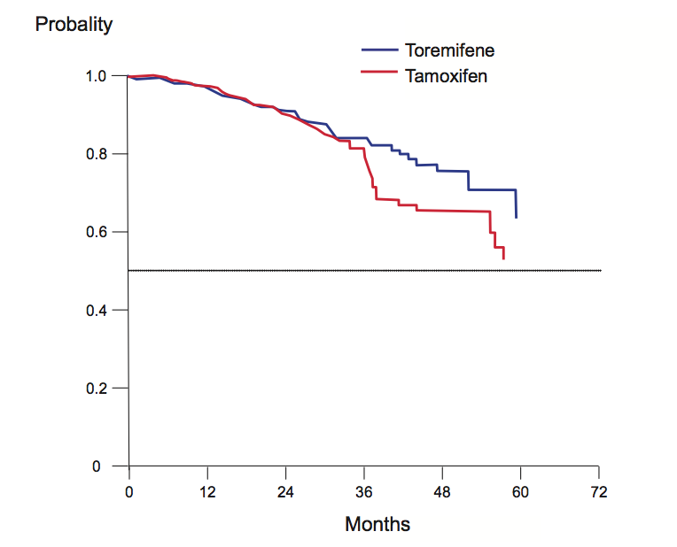
Figure 1 Time from randomization to recurrence in estrogen-receptor positive invasive breast cancer patients receiving adjuvant toremifene or tamoxifen[³³].

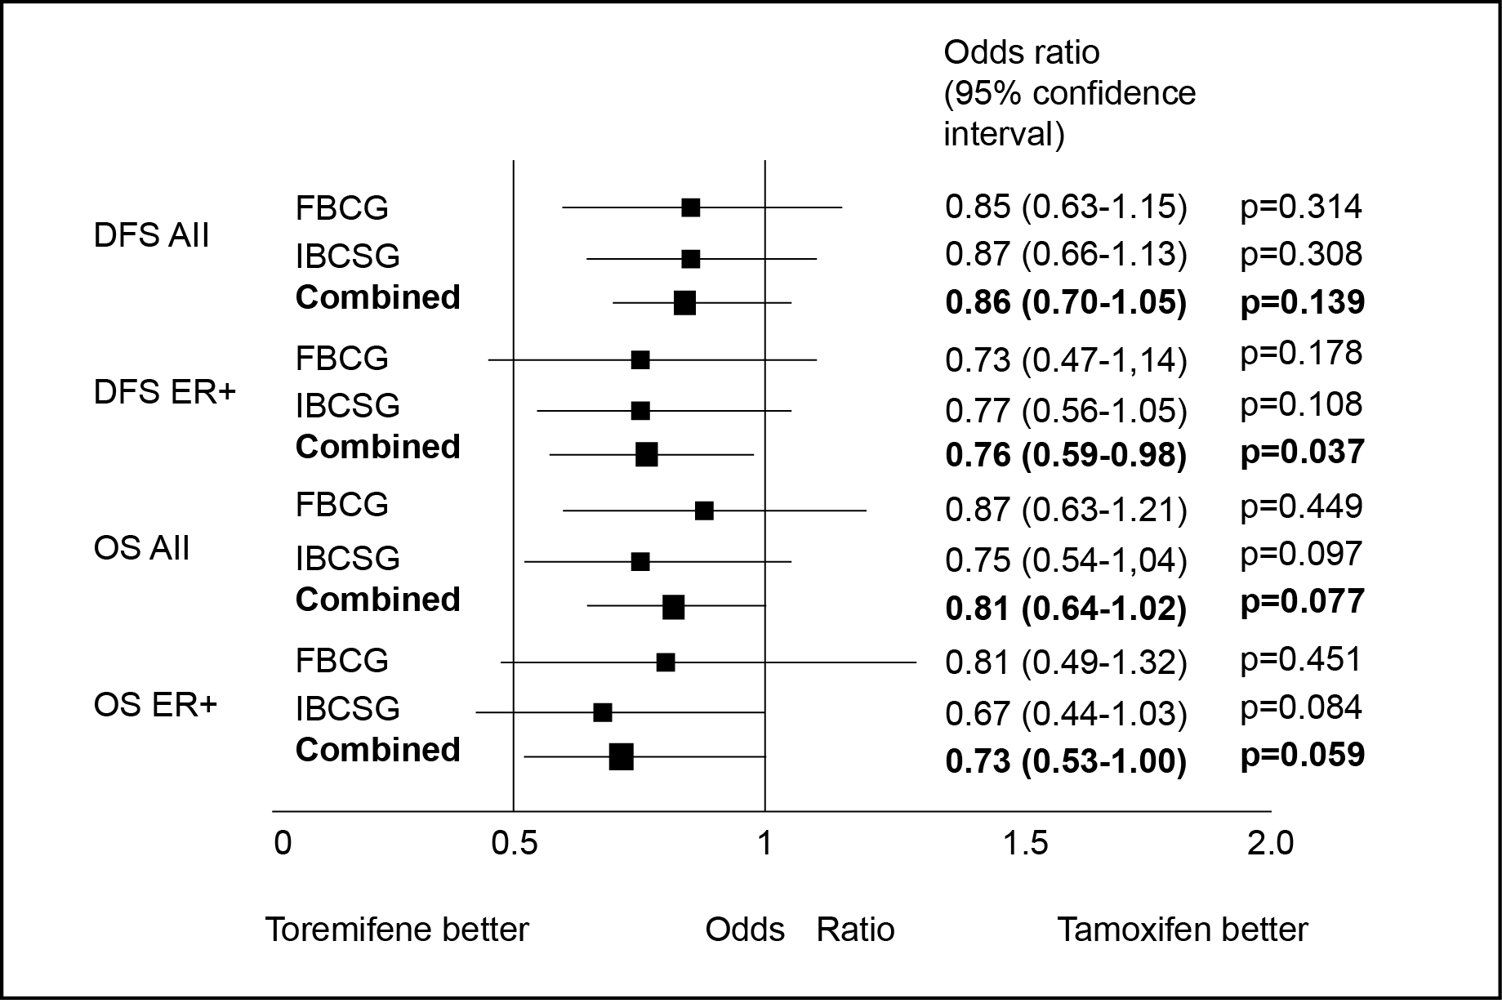
Figure 2 Disease-free survival and overall survival in patients receiving adjuvant toremifene and tamoxifen: meta-analysis of the Finnish Breast Cancer Group[3³] and International Breast Cancer Study Group[3⁵] (data on file). DFS: Disease-free survival; OS: Overall survival; IBCSG: International Breast Cancer Study Group; FBCG: Finnish Breast Cancer Group.

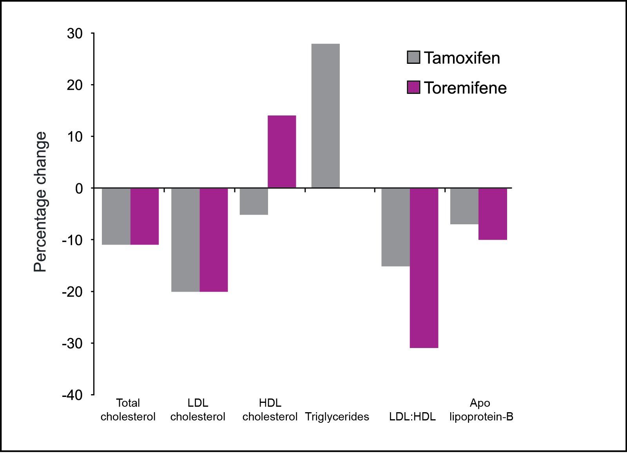
Figure 3 Percentage change in lipid parameters after one year with toremifene and tamoxifen[4⁸].

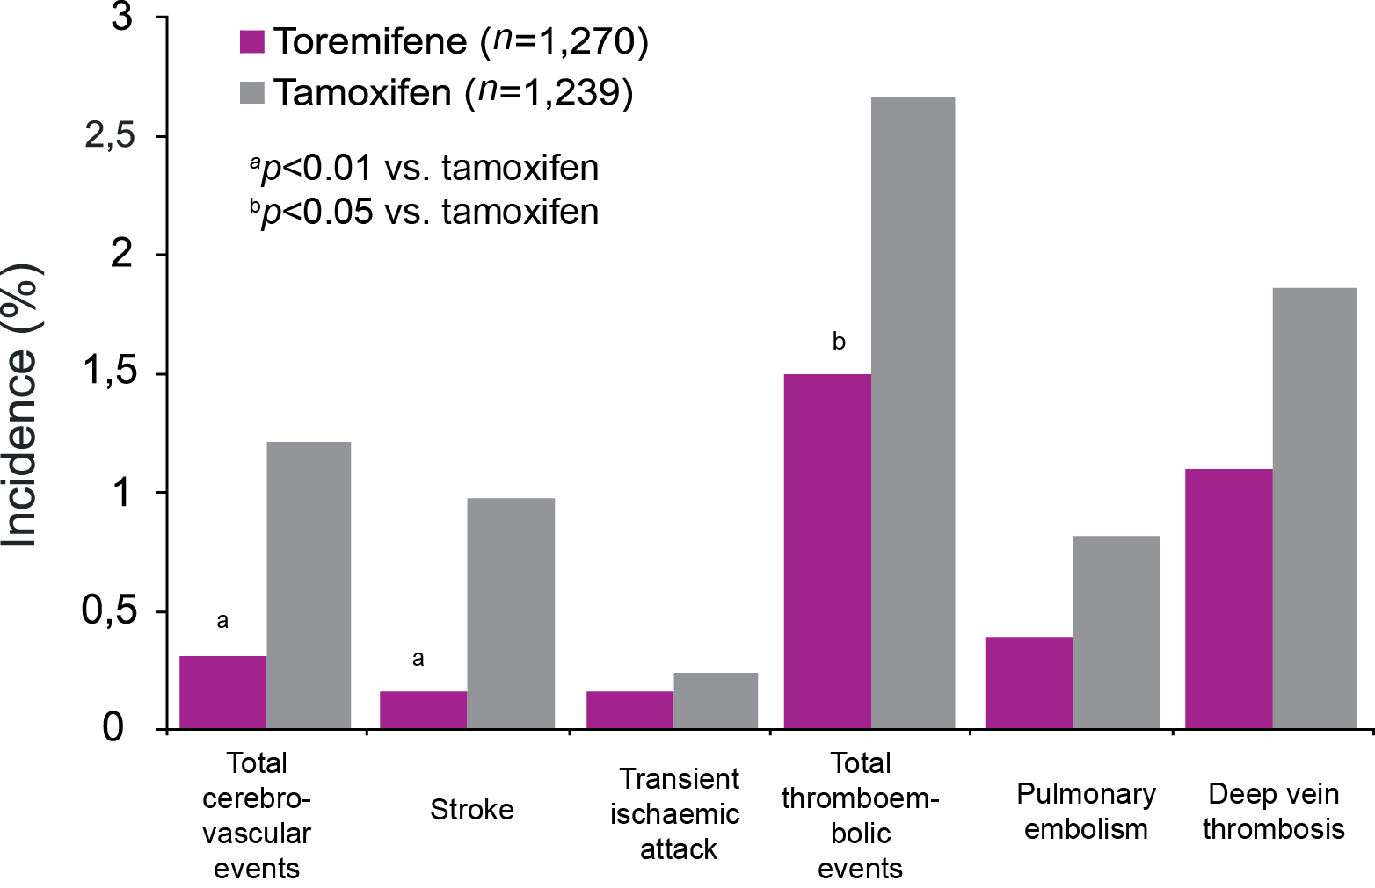
Figure 4 Incidence of serious vascular events in patients randomized to toremifene or tamoxifen adjuvant therapy in post-menopausal women[1⁷].

