Name of Journal: World Journal of Gastroenterology
Manuscript NO: 64209
Manuscript Type: CASE REPORT

Autoimmune enteropathy and primary biliary cholangitis after proctocolectomy for ulcerative colitis: A case report and review of the literature

Zhou QY et al. UC complicated with AIE and PBC

Qing-Yang Zhou, Wei-Xun Zhou, Xi-Yu Sun, Bin Wu, Wei-Yang Zheng, Yue Li, Jia-Ming Qian

Qing-Yang Zhou, Wei-Yang Zheng, Yue Li, Jia-Ming Qian, Department of Gastroenterology, Peking Union Medical College Hospital, Peking Union Medical College and Chinese Academy of Medical Sciences, Beijing 100730, China

Wei-Xun Zhou, Department of Pathology, Peking Union Medical College Hospital, Peking Union Medical College and Chinese Academy of Medical Sciences, Beijing 100730, China

Xi-Yu Sun, Bin Wu, Department of General Surgery, Peking Union Medical College Hospital, Peking Union Medical College and Chinese Academy of Medical Sciences, Beijing 100730, China

Author contributions: Zhou QY drafted the manuscript; Zhou WX collected the pathological data and interpret the histological examination; Zhou QY, Zheng WY, and Li Y contributed to clinical data collection and follow up; Wu B and Sun XY performed the operation; Li Y and Qian JM critically revised the manuscript; all authors have read and approved the final manuscript.

Supported by Chinese Academy of Medical Sciences Innovation Fund for Medical Sciences (CIFMS), No. 2017-I2M-3-017.

Corresponding author: Yue Li, MD, Associate Professor, Department of Gastroenterology, Peking Union Medical College Hospital, Peking Union Medical College and Chinese Academy of Medical Sciences, No. 1 Shuaifuyuan, Dongcheng District, Beijing 100730, China. yuelee76@gmail.com

Received: February 25, 2021
Revised: April 29, 2021
Accepted: July 13, 2021
Published online:

Abstract
BACKGROUND
Autoimmune enteropathy (AIE) and primary biliary cholangitis (PBC) are both immune-mediated diseases. AIE or PBC complicated with ulcerative colitis (UC) are rare. There are no cases of AIE and PBC diagnosed after proctocolectomy for UC reported before, and the pathogenesis of these comorbidities has not been revealed.

CASE SUMMARY
A middle-aged woman diagnosed with UC underwent subtotal colectomy and ileostomy due to the steroid-resistant refractory disease, and a restorative proctectomy with ileal pouch-anal anastomosis and proximal neoileostomy was postponed due to active residual rectal inflammation in January 2016. A few months after the neoileostomy, she began to suffer from recurrent episodes of watery diarrhea. She was diagnosed with postcolectomy enteritis and stoma closure acquired a good therapeutic effect. However, her symptoms of diarrhea relapsed in 2019, with different histological features of endoscopic biopsies compared with 2016, which showed apoptotic bodies, a lack of goblet and Paneth cells, and villous blunting. A diagnosis of AIE was established, and the patient’s stool volume decreased dramatically with the treatment of methylprednisolone 60 mg/d for 1 wk and tacrolimus 3 mg/d for 4 d. Meanwhile, her constantly evaluated cholestatic enzymes and high titers of antimitochondrial antibodies indicated the diagnosis of PBC, and treatment with ursodeoxycholic acid (16 mg/kg per day) achieved satisfactory results.

CONCLUSION
Some immune-mediated diseases may be promoted by operation due to microbial alterations in UC patients. Continuous follow-up is essential for UC patients with postoperative complications.

Key Words: Autoimmune enteropathy; Primary biliary cholangitis; Ulcerative colitis; Proctocolectomy; Bacterial translocation; Case report

Zhou QY, Zhou WX, Sun XY, Wu B, Zheng WY, Li Y, Qian JM. Autoimmune enteropathy and primary biliary cholangitis after proctocolectomy for ulcerative colitis: A case report and review of the literature. World J Gastroenterol 2021; In press

Core Tip: This is the first case report of autoimmune enteropathy and primary biliary cholangitis complicated with ulcerative colitis, and the female patient in this case suffered from a tortuous process of diagnosis and treatment. It is speculated that a microbial shift and subsequent immune response are involved in the pathogenesis of these comorbidities, and surgery may facilitate the progression of coexisting diseases. Understanding the progression of these diseases may help with their early recognition and treatment.
INTRODUCTION
Ulcerative colitis (UC) is a chronic inflammatory bowel disease (IBD) affecting the colon and rectum. Dysregulated immune responses to microbial changes and epithelial barrier defects are reported to contribute to the pathogenesis of UC. Small bowel involvement in UC is usually characterized by backwash ileitis or pouchitis^{[1]}. Diffuse and severe enteritis occurring after colectomy for UC, which is referred to as postcolectomy enteritis, has been sporadically reported in the literature^{[2-5]}. The pathogenesis and prognosis remain obscure. A case of postcolectomy enteritis previously reported by our team^{[3]} recently presented recurrent large-volume watery diarrhea and typical pathological features of autoimmune enteropathy (AIE) along with high titers of antimitochondrial antibodies (AMAs) and increased cholestatic enzymes. The association of UC with primary sclerosing cholangitis (PSC) has been commonly reported^{[6]}, whereas UC with primary biliary cholangitis (PBC) has been rarely reported, and the underlying pathogenesis may be different. In this report, we present a rare case of progressive AIE and PBC after colectomy for UC and propose a hypothesis to explain the potential associations of these coexisting diseases.

CASE PRESENTATION
Chief complaints
A 54-year-old woman presented to the Emergency Department complaining of large-volume watery diarrhea.

History of present illness
The patient was diagnosed with moderate to severe extensive UC at the age of 49 in December 2014. Subtotal colectomy and ileostomy were performed in February 2015 due to steroid-resistant refractory disease. The UC diagnosis was pathologically confirmed in resected specimens without ileitis. Her general condition improved greatly after ileostomy. A restorative proctectomy with ileal pouch-anal anastomosis and proximal neoileostomy was postponed until January 2016 due to active residual rectal inflammation. Within 3 mo after the neoileostomy, the patient noticed that watery stool from the stoma gradually increased up to 3-4 L per 24 h. She was admitted to our hospital for hypovolemic shock, electrolyte and acid-base disturbances, and acute kidney injury. Laboratory tests showed numerous leucocytes in liquid stool but negative pathogenic culture and Clostridium difficile toxin results. Her stoma output did not respond to empiric antibiotics but decreased significantly with IV hydrocortisone (50 mg q6h). Endoscopy showed a normal gross appearance of the stomach, duodenum, and prestomal ileum (Figure 1). Pathological examinations of the endoscopic biopsy from the duodenum and prestomal ileum revealed enteritis, which manifested as moderate villous atrophy, decreased goblet cells, cryptitis, and destroyed crypts, without clear apoptotic bodies or intraepithelial lymphocytosis (Figure 2). Postcolectomy enteritis was confirmed, and the decision to close the stoma was made by our multidisciplinary team to re-establish fecal stasis. Two months after stoma closure, her stool volume gradually decreased to less than 1 L/d, and azathioprine 50 mg/d was added as maintenance treatment during prednisone tapering. Follow-up endoscopy and biopsy histology in March 2018 revealed a normal mucosal appearance and the recovery of villous atrophy, cryptitis, and inflammation in the lamina propria. She made the decision to stop azathioprine in 2018 on her own. In November 2019, she presented with recurrent hypovolemic shock secondary to large-volume watery diarrhea under no obvious predisposing causes, which had been worsened to 2-3 L liquid stool every 24 h in the last month. She also mentioned poor appetite and a body weight loss of 8 kg within a month.

History of past illness
The patient had a past medical history of poliomyelitis.

Personal and family history
Unremarkable.

Physical examination
The patient was in serious weakness with cold limbs when admitted. Her vital signs were as follows: Temperature was 36.1 °C, heart rate was 109 bpm, respiratory rate was 20 breaths/min, blood pressure was 87/66 mmHg, and oxygen saturation in room air was 99%. The clinical physical examination revealed hyperactive bowel sounds 7-8 times/min, and no abdominal tenderness during palpation.

Laboratory examinations
Blood analysis revealed hemoglobin 181 g/L, platelets 274 × 10⁹/L, white blood cells 11.63 × 10⁹/L, neutrophils 68.7%, and lymphocytes 20.6%. Blood biochemical values were abnormal, with alanine aminotransferase (ALT) 22 U/L, total bilirubin 22.4 μmol/L, albumin 48 g/L, creatinine 206 μmol/L, urea 10.15 mmol/L, serum potassium 5.1 mmol/L, and serum sodium 128 mmol/L. Her arterial blood gas parameters were: pH 7.55, partial pressure CO₂ 23 mmHg, partial pressure O₂ 113 mmHg, bicarbonate 20.1 mmol/L, base excess 0.3 mmol/L, and lactic acid 3.1 mmol/L. Serum C-reactive protein was increased at 24.55 mg/L (normal range ≤ 8 mg/L) and erythrocyte sedimentation rate at 34 mm/h. Routine stool test showed 6-8 white blood cells per high power field and occult blood was noted. Stool pathogen screening was negative except for Candida albicans in stool culture.

Imaging examinations
No significantly abnormal signs were found on abdominal and pelvic computed tomography (CT). Endoscopy revealed an intact mucosa with diffuse villous atrophy in the duodenum, ileum, and ileal pouch (Figure 3). Histopathological findings of biopsies showed apoptotic bodies, a lack of goblet and Paneth cells, and villous blunting, which were not prominent in 2016 (Figure 4).

FINAL DIAGNOSIS
The principal clinical manifestation of AIE was refractory diarrhea with no response to dietary modification. Characteristic histological features included villous blunting or atrophy, apoptotic bodies, and lymphocytic infiltration in the crypt epithelium. The absence of goblet and Paneth cells also supported a diagnosis of AIE^{[7]}. Given the typical clinical and histological features strongly supporting AIE and no evidence for other diseases causing villous atrophy and mucosal inflammation in this case, a diagnosis of AIE was established. As the sensitivity and specificity of AMA-M2 for PBC diagnosis are both 90%-95%^{[8]}, positive AMA-M2 made the diagnosis of PBC definitive. Despite having no signs of extrahepatic biliary obstruction on magnetic resonance cholangiopancreatography, small duct PSC could not be excluded completely due to a lack of histologic evidence. A previous case report showed the overlap of PBC and small duct PSC^{[9]}, indicating that typical onion-skin lesions in biliary ducts, with concentric fibrosis, can be seen in small duct PSC with MRI negativity. As a result, liver biopsy is needed to confirm the diagnosis of PBC, if possible.

TREATMENT
Supportive treatments with intravenous infusions, vasoactive drugs, and regulating electrolyte disturbances were performed timely to maintain the stable vital signs. Methylprednisolone 60 mg/d was given intravenously for 1 wk, and tacrolimus 3 mg/d (target blood concentration 3-10 ng/mL) was given to maintain the treatment response when steroids were tapered. As for PBC, ursodeoxycholic acid 16mg/kg per day was prescribed.

OUTCOME AND FOLLOW-UP
The patient’s vital signs became stable under sufficient supportive treatments. After treatment with methylprednisolone 60 mg/d for 1 wk, her stool volume gradually decreased to less than 1.5 L/d. After taking tacrolimus for 4 d, the stool volume decreased to approximately 0.5 L/d and solid components could be seen in the liquid stool. The levels of ALT, aspartate aminotransferase, alkaline phosphatase, gamma-glutamyl transferase, and serum total bilirubin decreased gradually compared with the peak levels (109 U/L to 67 U/L, 87 U/L to 30 U/L, 404 U/L to 87 U/L, 659 U/L to 137 U/L, and 161.8 μmol/L to 20.3 μmol/L, respectively).

DISCUSSION
We searched the PubMed and Embase databases for case reports published in English or with an English abstract before June 22, 2020, with the keywords “ulcerative colitis”, “autoimmune enteropathy”, and “primary biliary cholangitis” (or “primary biliary cirrhosis”). There is only one case of AIE in a UC patient^{[10]} and 20 cases of PBC in UC patients^{[11-13]}. Therefore, our patient is the first case of UC complicated with AIE and PBC after colectomy.
This patient presented similar watery diarrhea in 2019 as in 2016, and the pathological features of the small intestine progressed. The diagnosis of postcolectomy enteritis was based on clinical manifestations of diffuse, superficial mucosal inflammation of the small bowel after colectomy in a UC patient, and the underlying pathogenesis remains unknown. In this case, with recurrent enteritis, typical pathological features of AIE were noticed during relapse, and we speculate that this progression was mediated by the same pathogenic mechanisms. We review the 23 previous cases of postcolectomy enteritis in UC (from an English database, including two cases in Japanese with English abstracts)^{[2,3]} and summarize the histological characteristics of small intestinal biopsies^{[2,4,5,14-25]} (Table 1). A large proportion of these cases exhibited typical features of UC, with inflammatory infiltration of the lamina propria by lymphocytes, plasma cells, monocytes, or a few neutrophils found in 19 cases and cryptitis or crypt abscess in 9 cases. Typical features of AIE, including apoptotic bodies and decreased goblet cells (3 and 1 cases, respectively), were also reported in these patients^{[4,5]}. Above all, we propose a hypothesis that these pathological features are present at different stages in a dysregulated immune condition triggered by a microbial shift after colectomy. It is possible that three cases of postcolectomy enteritis with features of AIE (apoptotic bodies)^{[4,5]} may progress to AIE during follow-up because these cases presented with severe clinical manifestations similar to our patient, with one of them even worse (dying of multiorgan failure).
The nature of the relationship between PBC and UC is unexplained. Immune-pathogenic mechanisms may be implicated in the pathogenesis of UC complicated with autoimmune hepatobiliary disorders^{[26]}. Lymphocytic infiltration of portal tracts and the presence of circulating antibodies that react with bile ducts^{[7,27]} suggest that the two diseases share common immunological pathways. Our patient initially suffered from refractory and progressive disease after colectomy in 2016, which suggests that surgery may be a potential factor that promotes disease progression. A widely accepted hypothesis regarding the pathogenesis of IBD indicates that the mucosal immune system exhibits an aberrant response towards luminal antigens, including commensal bacteria^{[28,29]}. Meanwhile, some researchers have proposed that molecular mimicry may be a potential pathogenic mechanism underlying immune-mediated biliary damage. Antibodies that bind to the mitochondrial E2 subunit of the pyruvate dehydrogenase complex (PDC-E2) also cross-react with conserved bacterial proteins, including microbes found on mucosal surfaces and in the feces^{[26]}. Such bacterial mimics of PDC-E2 were believed to trigger AMA-M2 formation in the early stage of PBC pathogenesis^{[29]}. Another “leaky gut” hypothesis proposed to explain the disease process in PSC inspired us to investigate the pathogenesis of hepatobiliary disorders. The disruption of bowel permeability may lead to bacterial translocation and bile colonization and subsequently activate the inflammatory response and fibrosis in the liver by activating cholangiocytes^{[30]}. A case report described a female patient with UC who developed PBC after proctocolectomy^{[31]}. Whether the occurrence of AIE and PBC after proctocolectomy in this patient was accidental or predestined based on the genetic, microbial, and immune background is worthy of further investigation.

CONCLUSION
We have reported a patient with UC complicated with AIE and PBC and hypothesized the possible underlying pathogenesis. Although there is insufficient clear evidence of the mechanism, this case offers us a new explanation for the spectrum of immune-mediated diseases. Proctocolectomy may promote the progression of UC due to microbial alterations, leading to complications in other target organs. For UC patients with postoperative complications, continuous follow-up is essential for early recognition and comprehensive treatment.

REFERENCES
1 Ungaro R, Mehandru S, Allen PB, Peyrin-Biroulet L, Colombel JF. Ulcerative colitis. Lancet 2017; 389: 1756-1770 [PMID: 27914657 DOI: 10.1016/S0140-6736(16)32126-2]
2 Corporaal S, Karrenbeld A, van der Linde K, Voskuil JH, Kleibeuker JH, Dijkstra G. Diffuse enteritis after colectomy for ulcerative colitis: two case reports and review of the literature. Eur J Gastroenterol Hepatol 2009; 21: 710-715 [PMID: 19282770 DOI: 10.1097/MEG.0b013e32831bc400]
3 Yang Y, Liu Y, Zheng W, Zhou W, Wu B, Sun X, Chen W, Guo T, Li X, Yang H, Qian J, Li Y. A literature review and case report of severe and refractory post-colectomy enteritis. BMC Gastroenterol 2019; 19: 61 [PMID: 31023233 DOI: 10.1186/s12876-019-0974-4]
4 Feuerstein JD, Shah S, Najarian R, Nagle D, Moss AC. A fatal case of diffuse enteritis after colectomy for ulcerative colitis: a case report and review of the literature. Am J Gastroenterol 2014; 109: 1086-1089 [PMID: 24989103 DOI: 10.1038/ajg.2014.118]
5 Nakajima M, Nakashima H, Kiyohara K, Sakatoku M, Fujimori H, Terahata S, Nobata H. [Case with diffuse duodenitis and enteritis following total colectomy for ulcerative colitis]. Nihon Shokakibyo Gakkai Zasshi 2008; 105: 382-390 [PMID: 18332603]
6 Fousekis FS, Theopistos VI, Katsanos KH, Tsianos EV, Christodoulou DK. Hepatobiliary Manifestations and Complications in Inflammatory Bowel Disease: A Review. Gastroenterology Res 2018; 11: 83-94 [PMID: 29707074 DOI: 10.14740/gr990w]
7 Umetsu SE, Brown I, Langner C, Lauwers GY. Autoimmune enteropathies. Virchows Arch 2018; 472: 55-66 [PMID: 29022145 DOI: 10.1007/s00428-017-2243-7]
8 Leuschner U. Primary biliary cirrhosis--presentation and diagnosis. Clin Liver Dis 2003; 7: 741-758 [PMID: 14594129 DOI: 10.1016/s1089-3261(03)00101-6]
9 Oliveira EM, Oliveira PM, Becker V, Dellavance A, Andrade LE, Lanzoni V, Silva AE, Ferraz ML. Overlapping of primary biliary cirrhosis and small duct primary sclerosing cholangitis: first case report. J Clin Med Res 2012; 4: 429-433 [PMID: 23226177 DOI: 10.4021/jocmr1060w]
10 Rodriguez NJ, Gupta N, Gibson J. Autoimmune Enteropathy in an Ulcerative Colitis Patient. ACG Case Rep J 2018; 5: e78 [PMID: 30465008 DOI: 10.14309/crj.2018.78]
11 Tada F, Abe M, Nunoi H, Azemoto N, Mashiba T, Furukawa S, Kumagi T, Murakami H, Ikeda Y, Matsuura B, Hiasa Y, Onji M. Ulcerative colitis complicated with primary biliary cirrhosis. Intern Med 2011; 50: 2323-2327 [PMID: 22001458 DOI: 10.2169/internalmedicine.50.5919]
12 Polychronopoulou E, Lygoura V, Gatselis NK, Dalekos GN. Increased cholestatic enzymes in two patients with long-term history of ulcerative colitis: consider primary biliary cholangitis not always primary sclerosing cholangitis. BMJ Case Rep 2017; 2017 [PMID: 28951510 DOI: 10.1136/bcr-2017-220824]
13 Liberal R, Gaspar R, Lopes S, Macedo G. Primary biliary cholangitis in patients with inflammatory bowel disease. Clin Res Hepatol Gastroenterol 2020; 44: e5-e9 [PMID: 31171469 DOI: 10.1016/j.clinre.2019.05.002]
14 Gooding IR, Springall R, Talbot IC, Silk DB. Idiopathic small-intestinal inflammation after colectomy for ulcerative colitis. Clin Gastroenterol Hepatol 2008; 6: 707-709 [PMID: 18467187 DOI: 10.1016/j.cgh.2008.02.031]
15 Ikeuchi H, Hori K, Nishigami T, Nakano H, Uchino M, Nakamura M, Kaibe N, Noda M, Yanagi H, Yamamura T. Diffuse gastroduodenitis and pouchitis associated with ulcerative colitis. World J Gastroenterol 2006; 12: 5913-5915 [PMID: 17007066 DOI: 10.3748/wjg.v12.i36.5913]
16 Kawai K, Watanabe T, Nakayama H, Roberts-Thomson I, Nagawa H. Images of interest. Gastrointestinal: small bowel inflammation and ulcerative colitis. J Gastroenterol Hepatol 2005; 20: 1791 [PMID: 16246204 DOI: 10.1111/j.1440-1746.2005.04162.x]
17 Rubenstein J, Sherif A, Appelman H, Chey WD. Ulcerative colitis associated enteritis: is ulcerative colitis always confined to the colon? J Clin Gastroenterol 2004; 38: 46-51 [PMID: 14679327 DOI: 10.1097/00004836-200401000-00011]
18 Nakayama S, Matsuoka M, Yoshida Y, Hayakawa K, Fukuchi S, Matsukuma S. [A case of pouchitis, duodenitis and pancreatitis showing diffuse irregular narrowing of main pancreatic duct after total colectomy for ulcerative colitis]. Nihon Shokakibyo Gakkai Zasshi 2004; 101: 389-396 [PMID: 15114835]
19 Terashima S, Hoshino Y, Kanzaki N, Kogure M, Gotoh M. Ulcerative duodenitis accompanying ulcerative colitis. J Clin Gastroenterol 2001; 32: 172-175 [PMID: 11205658 DOI: 10.1097/00004836-200102000-00018]
20 Valdez R, Appelman HD, Bronner MP, Greenson JK. Diffuse duodenitis associated with ulcerative colitis. Am J Surg Pathol 2000; 24: 1407-1413 [PMID: 11023103 DOI: 10.1097/00000478-200010000-00011]
21 Annese V, Caruso N, Bisceglia M, Lombardi G, Clemente R, Modola G, Tardio B, Villani MR, Andriulli A. Fatal ulcerative panenteritis following colectomy in a patient with ulcerative colitis. Dig Dis Sci 1999; 44: 1189-1195 [PMID: 10389695 DOI: 10.1023/a:1026688526551]
22 Hoentjen F, Hanauer SB, Hart J, Rubin DT. Long-term treatment of patients with a history of ulcerative colitis who develop gastritis and pan-enteritis after colectomy. J Clin Gastroenterol 2013; 47: 52-57 [PMID: 22858512 DOI: 10.1097/MCG.0b013e3182582c1d]
23 Uchino M, Ikeuchi H, Bando T, Matsuoka H, Hirata A, Takahashi Y, Takesue Y, Inoue S, Tomita N. Diffuse gastroduodenitis and enteritis associated with ulcerative colitis and concomitant cytomegalovirus reactivation after total colectomy: report of a case. Surg Today 2013; 43: 321-324 [PMID: 22965486 DOI: 10.1007/s00595-012-0329-z]
24 Rush B, Berger L, Rosenfeld G, Bressler B. Tacrolimus Therapy for Ulcerative Colitis-Associated Post-Colectomy Enteritis. ACG Case Rep J 2014; 2: 33-35 [PMID: 26157899 DOI: 10.14309/crj.2014.76]
25 Rosenfeld GA, Freeman H, Brown M, Steinbrecher UP. Severe and extensive enteritis following colectomy for ulcerative colitis. Can J Gastroenterol 2012; 26: 866-867 [PMID: 23248782 DOI: 10.1155/2012/415640]
26 Mattner J. Impact of Microbes on the Pathogenesis of Primary Biliary Cirrhosis (PBC) and Primary Sclerosing Cholangitis (PSC). Int J Mol Sci 2016; 17 [PMID: 27834858 DOI: 10.3390/ijms17111864]
27 Kaplan MM, Gershwin ME. Primary biliary cirrhosis. N Engl J Med 2005; 353: 1261-1273 [PMID: 16177252 DOI: 10.1056/NEJMra043898]
28 Podolsky DK. Inflammatory bowel disease. N Engl J Med 2002; 347: 417-429 [PMID: 12167685 DOI: 10.1056/NEJMra020831]
29 Shimoda S, Nakamura M, Ishibashi H, Kawano A, Kamihira T, Sakamoto N, Matsushita S, Tanaka A, Worman HJ, Gershwin ME, Harada M. Molecular mimicry of mitochondrial and nuclear autoantigens in primary biliary cirrhosis. Gastroenterology 2003; 124: 1915-1925 [PMID: 12806624 DOI: 10.1016/s0016-5085(03)00387-1]
30 Pontecorvi V, Carbone M, Invernizzi P. The "gut microbiota" hypothesis in primary sclerosing cholangitis. Ann Transl Med 2016; 4: 512 [PMID: 28149874 DOI: 10.21037/atm.2016.12.43]
31 Ohge H, Takesue Y, Yokoyama T, Hiyama E, Murakami Y, Imamura Y, Shimamoto F, Matsuura Y. Progression of primary biliary cirrhosis after proctocolectomy for ulcerative colitis. J Gastroenterol 2000; 35: 870-872 [PMID: 11085498 DOI: 10.1007/s005350070026]

Footnotes
Informed consent statement: Written informed consent was obtained from the patient for publication of this case report.

Conflict-of-interest statement: Dr. Li Y reports grants from Chinese Academy of Medical Sciences Innovation Fund for Medical Sciences, during the conduct of the study.

CARE Checklist (2016) statement: The authors have read the CARE Checklist (2016), and the manuscript was prepared and revised according to the CARE Checklist (2016).

Open-Access: This article is an open-access article that was selected by an in-house editor and fully peer-reviewed by external reviewers. It is distributed in accordance with the Creative Commons Attribution NonCommercial (CC BY-NC 4.0) license, which permits others to distribute, remix, adapt, build upon this work non-commercially, and license their derivative works on different terms, provided the original work is properly cited and the use is non-commercial. See: http://creativecommons.org/Licenses/by-nc/4.0/

Manuscript source: Unsolicited manuscript

Peer-review started: February 25, 2021
First decision: April 18, 2021
Article in press:

Specialty type: Gastroenterology and hepatology
Country/Territory of origin: China
Peer-review report’s scientific quality classification
Grade A (Excellent): A
Grade B (Very good): B
Grade C (Good): C
Grade D (Fair): 0
Grade E (Poor): 0

P-Reviewer: Cibor D, Itabashi M, Naswhan AJ S-Editor: Gao CC L-Editor: Wang TQ P-Editor:
Figure Legends
A
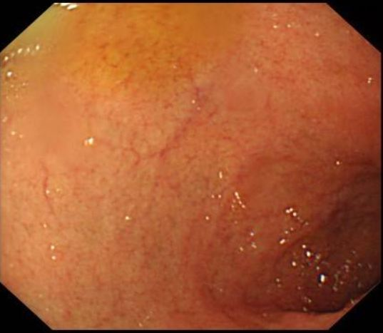
B
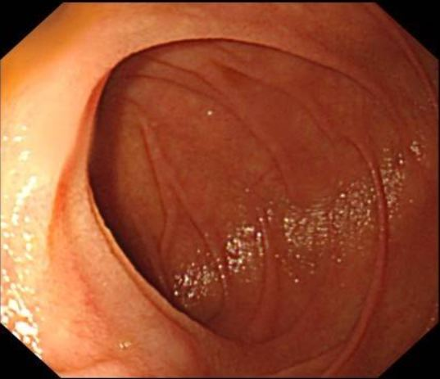
C
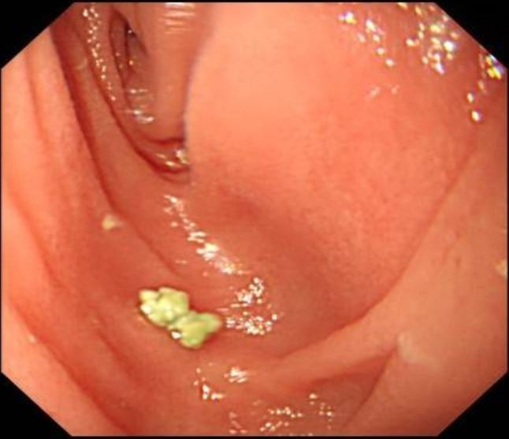
D
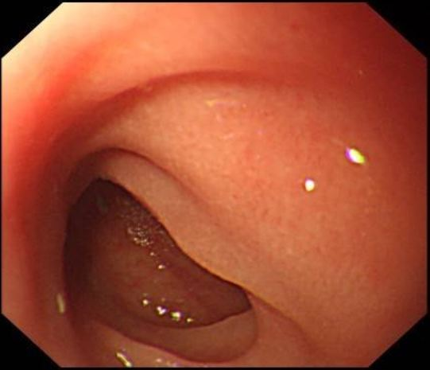
Figure 1 Endoscopic images at the onset of postcolectomy enteritis in 2016. A: Gastroscopy showing a normal duodenal bulb; B: Gastroscopy showing a normal descending duodenum; C and D: Endoscopy with loop ileostomy showing a normal appearance of the neoileum.
A
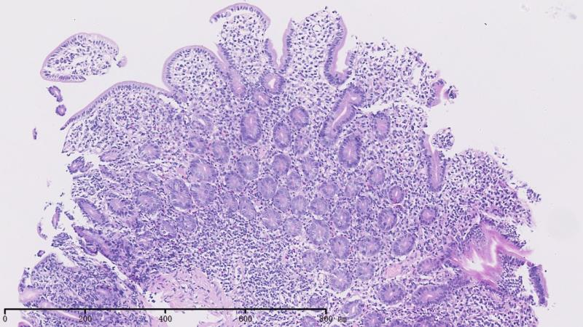
B
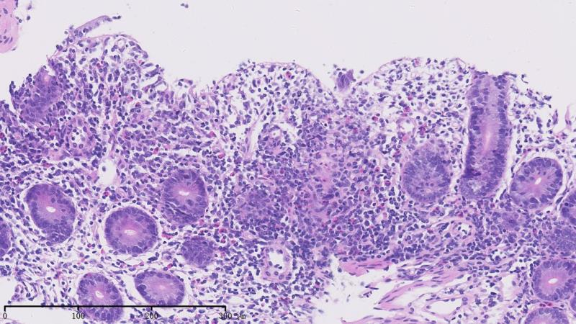
Figure 2 Pathological findings at the onset of postcolectomy enteritis in 2016. A: The biopsy from the duodenum showed chronic inflammation, moderate villous atrophy, and decreased goblet cells (× 40); B: Active inflammation, cryptitis, and destroyed crypts were observed in some areas (× 100).
A
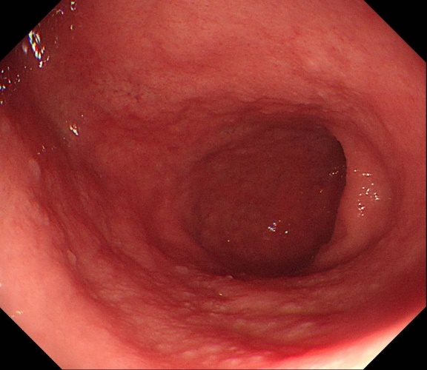
B
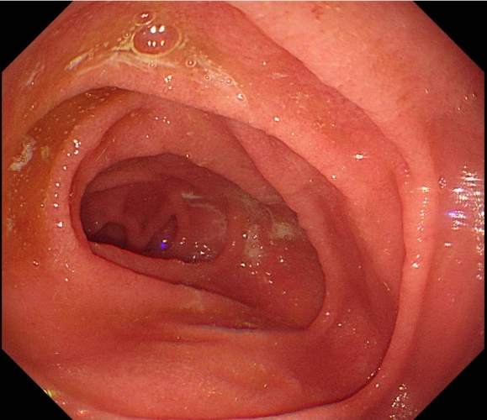
C
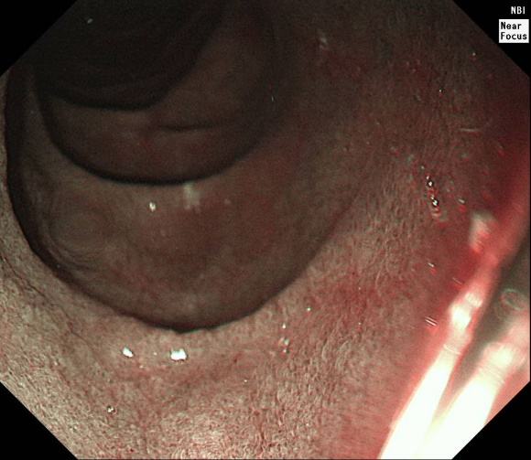

D
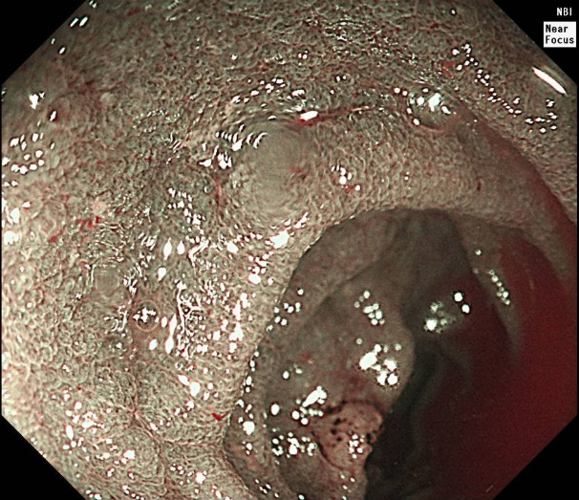
E
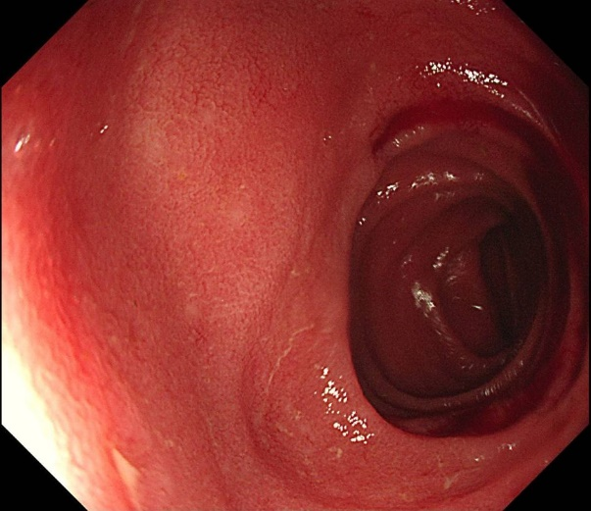
F
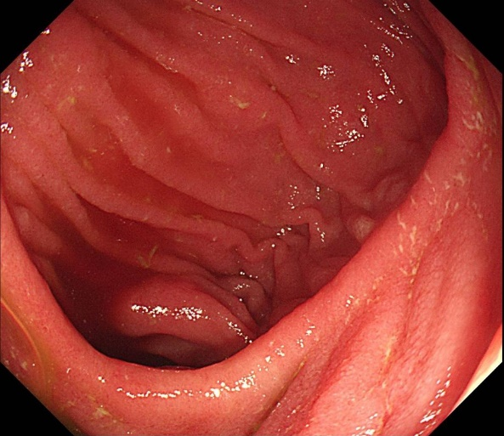

G
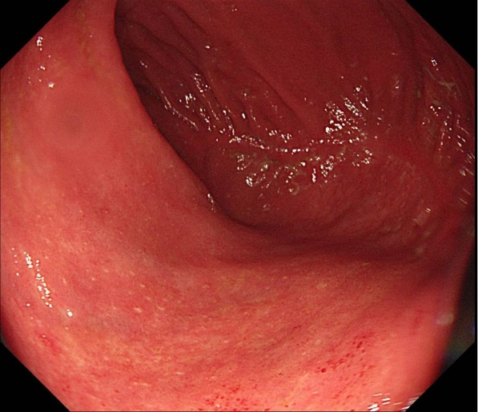
Figure 3 Endoscopic images at the onset of autoimmune enteropathy in 2019. A: Gastroscopy showing diffuse villous atrophy in the mucosa of the duodenal bulb; B and C: Gastroscopy showing diffuse villous atrophy in the mucosa of the descending duodenum; D and E: Enteroscopy showing diffuse villous atrophy in the mucosa of the ileum; F and G: Enteroscopy showing diffuse villous atrophy in the mucosa of the ileal pouch.
A
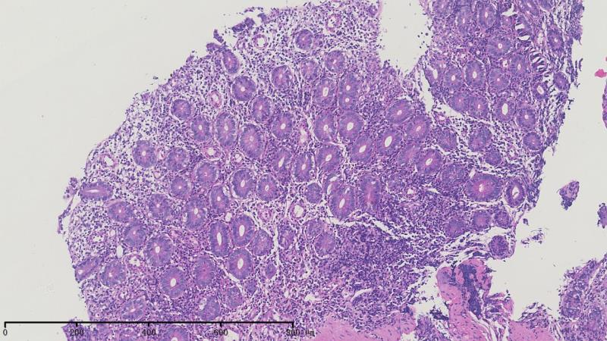
B
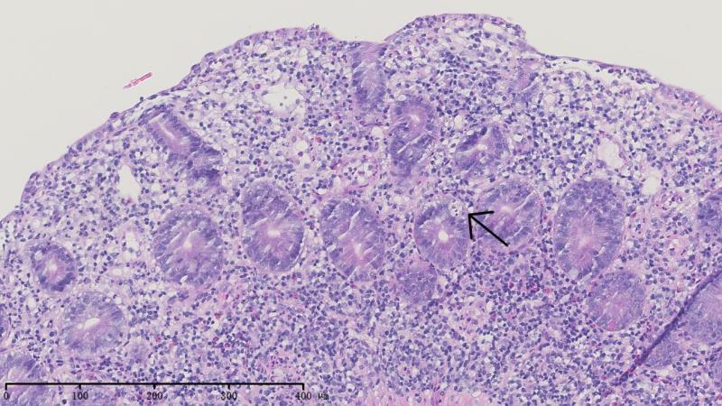
Figure 4 Pathological findings at the onset of autoimmune enteropathy in 2019. The biopsy showed prominent chronic inflammation, flat villi, and a lack of goblet and Paneth cells (A), and apoptosis bodies were found (arrow) (B).
Table 1 Summary of cases of postcolectomy enteritis from the English databases
Ref. | Age¹/sex | Extent of UC | Onset of enteritis² | Extent of enteritis | Histological characteristics of biopsies
Corporaal et al^{[2]} | 23/M | Extended left sided | 2 wk after colectomy | J, I | Marked apoptosis of epithelial cells, lamina propria with lymphoplasma cellular infiltrate with eosinophilic and neutrophilic granulocytes
Corporaal et al^{[2]} | 61/M | Pancolitis | 1 mo after colectomy | S, D, J, I | Diffuse active chronic inflammatory infiltrate with (sub) total villous atrophy (D), an increase in the apoptosis of crypt epithelial cells (I), and dense active chronic inflammation (S)
Gooding et al^{[14]} | 52/M | Pancolitis | 116 d after colectomy | D, I | Infiltration of the lamina propria by lymphocytes, plasma cells, and neutrophils; cryptitis and small numbers of neutrophils within the upper-crypt lamina and on the surface (D); shortening and irregularity of villi; mild, diffuse, chronic inflammatory cell infiltration; and mild activity with cryptitis (I)
Ikeuchi et al^{[15]} | 29/F | Left sided | 6 yr after colectomy | S, D, I | Severe infiltration of inflammatory cells in the mucosa (I, S) and crypt abscess in the mucous glandules (S), dense, acute, and chronic inflammatory infiltrates accompanied with cryptitis (D)
Kawai et al^{[16]} | Young (unknown)/M | Pancolitis | 12 yr after colectomy | D | Lymphoplasmacytic infiltration of the duodenal mucosa without granuloma formation
Kawai et al^{[16]} | Unknown/M | Unknown | 2 yr after colectomy | I | Unknown
Rubenstein et al^{[17]} | 38/M | Pancolitis | Immediately after colectomy | D, J, I | Diffuse mucosal inflammation with the distortion of the crypt architecture and plasmacytosis
Nakayama et al^{[18]} | 41/M | Pancolitis | 3.5 yr after colectomy | D, I | Inflammatory infiltration by neutrophils, eosinophils, lymphocytes, and plasma cells
Terashima et al^{[19]} | 30/M | Left sided | 7 mo after colectomy, immediately after closure of ileostoma | D | Severe lymphoplasmacytic infiltration with  cryptitis
Valdez et al^{[20]} | 5/F | Pancolitis | 17 mo after colectomy | D | Diffuse mucosal inflammation, cryptitis, and architectural distortion
Valdez et al^{[20]} | 17/F | Pancolitis | 9 mo after colectomy | D, I | Diffuse mucosal inflammation, cryptitis, and architectural distortion
Valdez et al^{[20]} | 58/F | Pancolitis | 6 mo after colectomy | D, J | Typical microscopic features of UC (no other details)
Valdez et al^{[20]} | 17/M | Pancolitis | 8 d after colectomy | D, I | UC-like active, diffuse duodenitis and ileitis (no other details)
Annese et al^{[21]} | 37/M | Pancolitis | 1 mo after colectomy | D, J, I | Architectural disarray and dense inflammatory infiltrate extending beyond the muscularis mucosae, mainly comprised of plasma cells and lymphocytes (D, J). Distorted villi and a heavily inflamed lamina propria with mononuclear cell inflammatory infiltrate (I)
Feuerstein et al^{[4]} | 56/F | Left sided | 26 d after colectomy | D, J, I | Severe, active enteritis with ulceration and prominent epithelial cell, apoptotic debris
Nakajima et al^{[5]} | 25/F | Pancolitis | Immediately after colectomy | D, J, I | Infiltration of inflammatory cells in the mucosa and decreased goblet cells
Hoentjen et al^{[22]} | 23/M | Pancolitis | 3 mo after colectomy | S, D, I | Severe active inflammation with significant neutrophil infiltration in the epithelium and lamina propria
Hoentjen et al^{[22]} | 24/F | Pancolitis | 4 mo after colectomy | S, D, I | Mixed cell infiltrates in the lamina propria, including a prominent component of plasma cells and clusters of neutrophils, negative for crypt cell apoptosis and decreased goblet cells
Hoentjen et al^{[22]} | 27/M | Pancolitis | 25 yr after colectomy | S, D, I | Active inflammation with prominent eosinophils in the lamina propria (S, D) and remarkable architectural distortion (I)
Hoentjen et al^{[22]} | 57/M | Pancolitis | 27 mo after colectomy | S, D, I | Diffuse and active Helicobacter pylori-negative gastritis, duodenitis and ileitis (no other details)
Uchino et al^{[23]} | 19/M | Pancolitis | 12 d after colectomy | S, D, I | Neutrophil infiltration and crypt abscess
Rush et al^{[24]} | 43/F | Pancolitis | 3 mo after colectomy | S, D, J, I | Moderate to marked active chronic inflammation with cryptitis
Rosenfeld et al^{[25]} | 47/F | Pancolitis | 4 mo after colectomy | D, J | Moderate to severe active inflammatory changes in the small bowel mucosa with cryptitis
¹Age at the onset of postcolectomy enteritis. ²Interval between colectomy and the onset of enteritis symptoms. S: Stomach; D: Duodenum; J: Jejunum; I: Ileum; UC: Ulcerative colitis; F: Female; M: Male.

