Name of Journal: World Journal of Radiology
Manuscript NO: 73755
Manuscript Type: ORIGINAL ARTICLE

Retrospective Study
Outcome of percutaneous drainage for septic complications coexisted with COVID-19

Deif MA et al. Drainage of septic complications of COVID-19

Mohamed A Deif, Ahmad M Mounir, Sherif A Abo-Hedibah, Ahmed M Abdel Khalek, Ali H Elmokadem

Mohamed A Deif, Department of Radiology, National Liver Institute, Menoufia University, Shibin Al Kawm 32521, Egypt

Ahmad M Mounir, Ahmed M Abdel Khalek, Ali H Elmokadem, Department of Radiology, Mansoura University, Mansoura 35516, Egypt

Sherif A Abo-Hedibah, Department of Radiology, Cairo university, Cairo 12613, Egypt

Author contributions: Deif MA and Elmokadem AH designed the research study; Deif MA and Mounir AM performed the research; Elmokadem AH, Abo-Hedibah SA and Abdel Khalek AM analyzed the data and wrote the manuscript; all authors have read and approved the final manuscript.

Corresponding author: Ali H Elmokadem, MD, PhD, Associate Professor, Department of Radiology, Mansoura University, Elgomhoria St, Mansoura 35516, Egypt. mokadem83@yahoo.com

Received: December 29, 2021
Revised: March 13, 2022
Accepted: April 9, 2022
Published online:

Abstract
BACKGROUND
The resulting tissue hypoxia and increased inflammation secondary to severe coronavirus disease 2019 (COVID-19) combined with viral load, and other baseline risk factors contribute to an increased risk of severe sepsis or co-existed septic condition exaggeration.

AIM
To describe the clinical, radiological, and laboratory characteristics of a small cohort of patients infected by severe acute respiratory syndrome coronavirus 2 who underwent percutaneous drainage for septic complications and their post-procedural outcomes.

METHODS
This retrospective study consisted of 11 patients who were confirmed to have COVID-19 by RT-PCR test and required drain placement for septic complications. The mean age ± SD of the patients was 48.5 ± 14 years (range 30-72 years). Three patients underwent cholecystostomy for acute acalculous cholecystitis. Percutaneous drainage was performed in seven patients; two peripancreatic collections; two infected leaks after hepatic resection; one recurrent hepatic abscess, one psoas abscess and one lumbar abscess. One patient underwent a percutaneous nephrostomy for acute pyelonephritis.

RESULTS
Technical success was achieved in 100% of patients, while clinical success was achieved in 4 out of 11 patients (36.3%). Six patients (54.5%) died despite proper percutaneous drainage and adequate antibiotic coverage. One patient (9%) needed operative intervention. Two patients (18.2%) had two drainage procedures to drain multiple fluid collections. Two patients (18.2%) had repeat drainage procedures due to recurrent fluid collections. The average volume of the drained fluid immediately after tube insertion was 85 mL. Follow-up scans show a reduction of the retained content and associated inflammatory changes after tube insertion in all patients. There was no significant statistical difference (P = 0.6 and 0.4) between the mean of WBCs and neutrophils count before drainage and seven days after drainage. The lymphocyte count shows significant increased seven days after drainage (P = 0.03).

CONCLUSION
In this study, patients having septic complications associated with COVID-19 showed relatively poor clinical outcomes despite technically successful percutaneous drainage.

Key Words: COVID-19; SARS-CoV-2; Coronavirus; Sepsis; Drainage; Abscess

Deif MA, Mounir AM, Abo-Hedibah SA, Abdel Khalek AM, Elmokadem AH. Outcome of percutaneous drainage for septic complications coexisted with COVID-19. World J Radiol 2022; In press

Core Tip: This article highlights the relationship between coronavirus disease 2019 (COVID-19) and sepsis. COVID-19 is associated with high risk of severe sepsis or exaggeration of co-existed septic condition. Percutaneous drainage of septic complications co-existed with COVID-19 associated with relatively poor clinical outcomes despite technically successful procedures.
INTRODUCTION
Sepsis is defined as a life-threatening organ dysfunction that happens due to dysregulated host response to an infection^{[1]}. In the bacterial type of sepsis, which is the most frequent etiology, early and rapid therapy by the appropriate antibiotic is essential to reduce the incidence of complications and mortality rates. Most patients infected by severe acute respiratory syndrome coronavirus 2 (SARS-CoV-2) present no severe symptomatology, but almost 5% of patients show severe lung injury or even multiple organ dysfunction syndrome, with mortality at the ICUs between 8% and 38% depending on the country^{[2,3]}. Patients admitted to ICU showed a dysregulated host response in the form of hyperinflammation, changes in the coagulation profile, and dysregulation in the immune response^{[4]}, similar to what happens in bacterial sepsis^{[5,6]}. The body’s adaptive protection mechanism is formed by a moderate inflammatory response and immune suppression, and if any of them become excessive or uncontrolled, this protective compensation will transform into destructive and decompensated status, then sepsis develops^{[7-9]}. Accordingly, most deaths in critically ill coronavirus disease 2019 (COVID-19) patients are caused by sepsis^{[10,11]}.
Hematological examinations for COVID-19 patients show elevated cytokines, C-reactive protein (CRP), abnormal liver and myocardial enzymes decreased lymphocytes, declined platelets, and increased D-dimmer^{[12]}. These findings are similar to sepsis caused by bacterial infections. So, severe COVID-19 could be a sepsis-induced by viral infection causing severe systemic inflammatory response (so-called inflammatory storm)^{[13,14]}. Inflammatory storms are not unique to COVID-19 but also happen in other respiratory viral infections that mimic COVID-19^{[15,16]}, such as influenza, SARS, avian influenza, swine flu, and MERS^{[17-19]}. Additionally, specimen cultures in about 80% of COVID-19 patients with septic complications show no bacterial or fungal infection, and the viral infection seems to be the only cause for sepsis^{[20,21]}. Accordingly, sepsis is expected to be responsible for worsening the clinical conditions of these critically ill COVID-19 patients. Our objective was to describe the clinical, radiological, and laboratory characteristics of a small cohort of patients infected by SARS-CoV-2 who underwent percutaneous drainage and their post-procedural outcomes. We hypothesized that septic complication associated with severe COVID-19 has a poor outcome despite adequate percutaneous drainage and antibiotic therapy.

MATERIALS AND METHODS
Patient selection
A local institutional review board approved this retrospective study, and waivers of consent of medical record review were received. COVID-19 patients who underwent image-guided percutaneous drainage for suspected septic complications were identified. Patient demographics and clinical and radiological reports were obtained through electronic medical records and picture archiving and communication system (PACS). The severity of the pulmonary parenchymal involvement and distribution of the pulmonary lesions secondary to COVID-19 was assessed by chest X-ray in 4 patients and chest CT in 7 patients. Flow chart of the study is shown in Figure 1.

Patients demographics
Eleven patients (10 males and 1 female) who were confirmed to have COVID-19 by RT-PCR test required drain placement for septic complications. The mean age ± SD of the patients was 48.5 ± 14 years (range 30-72 years). Three patients underwent cholecystostomy for acute acalculous cholecystitis (Figure 2). Percutaneous drainage was performed in seven patients; two peripancreatic collections (Figure 3); two infected bile leaks in hepatic donor and after resection of hepatic hemangioma; one recurrent hepatic abscess after eight days of surgical evacuation (Figure 4), one psoas abscess (Figure 5) and one lumbar abscess. One patient underwent percutaneous nephrostomy for acute pyelonephritis (Figure 6).

Study outcomes
The primary outcome measures were technical and clinical success. The technical success was achieved by completion of the procedure without procedural complications, while the definition of clinical success was the resolution of symptoms without the subsequent need for operative drainage or patient mortality secondary to related sepsis. Secondary outcomes included the amount of drained fluid, microbial analysis of drained fluid, the period of tube drainage, and changes in laboratory findings before and after drainage.

Percutaneous drainage procedures
Septic complications were diagnosed by ultrasonography, computed tomography, or magnetic resonance imaging. Two interventional radiologists at two institutions with 10 and 13 years of experience performed all percutaneous drainage procedures. All procedures were done after administration of local anesthesia. Percutaneous access into the collections, inflamed gall bladder, or kidney was achieved under sonographic guidance with an 18- or 21-gauge needle. Using the Seldinger technique and micro-puncture set, following serial dilatations, a drainage catheter was placed. The drainage catheters used ranged from 8-French to 10-French. In all cases, no immediate complications were noted.
Antibiotic therapy was started once the symptoms of septic complications presented on the patients. The antibiotics regimen was readjusted according to the drained fluid culture results. The drained fluid for each patient was analyzed regarding its character and maximum possible volume when the tubes were initially placed. Then a fluid sample was sent for bacterial culture and gram stain evaluation. Patients were observed for any major complications requiring surgical intervention till the last date of follow-up.

Statistical analysis
Data were analyzed with SPSS® V. 21 (IBM Corp., New York, NY, United States; formerly SPSS Inc., Chicago, IL, United States). The normality of data was first tested with the Shapiro test. Qualitative data were described using numbers and percentages. Continuous variables were presented as mean ± SD for parametric data and median (range) for non-parametric data. Finally, the laboratory findings were compared with Wilcoxon test.

RESULTS
Fever and abdominal pain were the most common presenting symptoms, and acute kidney injury (AKI) was the most frequent comorbidity. Technical success was achieved in 100% of patients, while clinical success was achieved only in 4 of 11 patients (36.4%). Despite percutaneous drainage, one patient (9%) needed exploratory laparotomy five days after drainage that revealed perforated sigmoid colon, which was managed by resection followed by patient improvement and discharge after 18 d. Six other patients (54.5%) died within a month after proper percutaneous drainage and adequate antibiotic coverage, all of them were admitted to ICU and put under mechanical ventilation. The cause of death was overlapped between COVID-19 related respiratory failure and sepsis. One patient needed cystogasterostomy for peripancreatic collection after 21 d of tube insertion. Two patients (18.2%) had two drainage procedures to drain multiple fluid collections. Two patients (18.2%) had recurrent fluid collections and repeated percutaneous drainage procedures. The average volume of the drained fluid immediately after tube insertion was 85 mL. The average duration of drainage was 16 d. Follow-up scans showed a reduction of the retained content and associated inflammatory changes after tube insertion in all patients. Patient demographics, comorbidities, and outcomes are listed in Table 1.
The nature of drained fluid was reported in all cases. The fluid was reported as “dark green” or “pus” in cholecystostomy cases, “serosanguinous” and “infected bile” in complicated hepatic resection cases, “brownish” in the peripancreatic collection, “clotted blood” in the hepatic abscess, and “pus” in the other collections. After all procedures, samples from drained fluid samples were sent for microbial analysis. Peripheral blood culture was performed for 9 out of 11 patients. In three cases (27.3%), fluid culture results were negative for bacterial growth; however, in one of them, the peripheral blood culture was positive for Klebsiella pneumonia. Eight cases (72.7%) were found to have positive fluid culture, with Escherichia coli being the most common isolated pathogen followed by Klebsiella pneumonia.
Only three patients had imaging features of severe pulmonary parenchymal disease attributed to COVID-19 at drainage tome, nevertheless three other patients were admitted to ICU and put under ventilator due to progression of respiratory symptoms. The parenchymal lesions were ground-glass opacities and consolidations with the basal and peripheral predominant distribution. In addition, pleural effusion was reported in three patients. The median time between confirmed diagnosis of COVID-19 by RT-PCR test and drainage of septic complications (time to drainage) was 8 d (range 0 d to 48 d). Table 2 shows data of drainage procedure, drained fluid, outcome, and chest imaging.
The mean WBCs and neutrophil counts show reduction 1 d and 7 d after drainage however there was no significant statistical difference (P = 0.6) between the mean of WBCs count before drainage (15.4 × 10⁹/L) and seven days after drainage (12.1 × 10⁹/L) and between the mean count of neutrophil (P = 0.4) before drainage (82.8 × 10⁹/L) and seven days after drainage (70.9 × 10⁹/L). The lymphocyte count shows significant increased seven days after drainage (P = 0.03). Five patients had AKI manifested by elevation of the serum creatinine and urea levels. Total bilirubin level was elevated in eight patients and showed no significant reduction after drainage (P = 0.2). The CRP values were not significantly different (P = 0.06) before (182.0 mg/dL) and one week after tube insertion (133.0 mg/dL). Other inflammatory markers as D-dimer, procalcitonin and LDH were elevated in all patients before drainage and showed variable degree of non-statistically reduction and increase after drainage. The laboratory findings are listed in Table 3.

DISCUSSION
This study presents the clinical, radiological, and laboratory data for patients who underwent percutaneous drainage to manage septic complications associated with COVID-19 infection. The main finding is that patients with suspected septic complications associated with COVID-19 show relatively poor outcomes with 36.4% clinical success of percutaneous drainage despite 100% technical success. This finding was confirmed by the insignificant difference between the inflammatory markers before and after tube drainage insertion. Severe sepsis related to COVID-19 viral infection may be related to a decrease in mitochondrial efficiency and dysfunction of the respiratory chain^{[22,23]}. In addition, autopsies have confirmed hyperinflammatory state with organ fibrosis, especially in high metabolic cells with high mitochondrial volume such as pneumocytes, endothelial cells, hepatocytes, and renal cells^{[24]}. The resulting tissue hypoxia and increased inflammation, viral load, and other baseline risk factors contribute to an increased risk of severe sepsis or co-existed septic condition exaggeration.
This study included different types of septic complications as acute acalculous cholecystitis, acute pancreatitis, post-operative infection, abscesses in different locations, and acute pyelonephritis. Several reports described acute acalculous cholecystitis in COVID-19 patients^{[25-30]} and raised the possibility of underlying dysregulated immune response or presence of viral RNA within the gall bladder wall as a culprit factor^{[28-30]}. Percutaneous cholecystostomy for COVID-19 patients is recommended by multi-society position statement in case of surgical contraindication and after the failure of conservative therapy with antibiotics^{[31]}. It is generally a preferred non-surgical procedure due to its relative safety, simplicity of execution, and reduced costs. Mattone et al^{[25]} reported clinical failure of percutaneous cholecystostomy after 3-d from tube insertion; the patient was shifted to surgery that revealed gangrenous cholecystitis. In this study, clinical success was reported only in one of three patients had cholecystostomy drainage of acute cholecystitis. Contrary to this result, cholecystostomy improved the clinical status of patients presented by acute acalculous cholecystitis co-existed with COVID-19^{[26,27]}; however, the period of hospitalization was prolonged (25-67 d) compared to the mean hospitalization period in non-COVID-19 patients (10.5 d)^{[32]}.
COVID-19 associated pancreatic injury and acute pancreatitis are thought to be a result of direct cytopathic effect mediated by local viral replication or indirect mechanism related to either a systemic response to a harmful immune response or respiratory failure induced by the SARS-CoV-2^{[33]}. COVID-19 patients with acute pancreatitis are more likely to experience admission to the ICU, peripancreatic fluid collections, pancreatic necrosis, persistent organ failure, prolonged hospital stay, and higher than usually reported 30-d mortality^{[34]}. We encountered two cases of pancreatitis in the current study, one of them died 28 days after drainage.
In a meta-analysis performed by Abate et al^{[35]}, twenty-three articles with 2947 participants were included. The meta-analysis showed a very high global rate of postoperative mortality among COVID-19 patients of 20%. Percutaneous drainage was performed for two patients after complicated hepatic resection for hemangioma and liver donor, only the second patient survived and was discharged 18 days after drainage. The good outcome in this patient is attributed to the non-inflammatory nature of the drained fluid, lower inflammatory marker and less severity of COVID-19 as compared to the other patient.
Hepatic abscesses have been described in association with COVID-19^{[36,37]}. While García Virosta et al^{[36]} reported clinically successful percutaneous drainage for hepatic abscess and patient discharge after ten days from tube insertion, Elliot et al^{[37]} reported a rapidly progressive severe acute respiratory distress syndrome, which was complicated by multiorgan failure and severe sepsis that ended by death after percutaneous drainage of hepatic abscess in a patient with COVID-19. One patient in this study presented with a large lumbar region abscess secondary to sigmoid colon perforation as proved by laparotomy. Bowel perforation secondary to COVID-19 has been attributed to microcirculation thrombosis^{[38]} or direct insult to the colonic cells by the SARS-CoV-2 itself^{[39]}.
There is scanty literature on the association between COVID-19 and acute pyelonephritis. van 't Hof et al^{[40]} described an unusual course of acute pyelonephritis in a young female with persistent fever and multiple blood clotting and hemorrhagic events one week after recovery from COVID-19. Similar to our results, pyelonephritis was managed successfully by percutaneous nephrostomy. More frequently, AKI is encountered among critically ill patients with COVID-19, affecting approximately 20%-40% of patients admitted to the hospital and particularly to the ICU^{[41]}. AKI was the most frequent comorbidity (5/11) in this study. A significantly higher in-hospital death rate for patients with kidney abnormalities and AKI was reported by a study consisting of 701 SARS-CoV-2 positive patients^{[42]}.
COVID-19 requires a multidisciplinary approach to treatment with interventional radiology procedures that have contributed to worldwide patient care. In a study consisting of 92 patients who underwent 124 interventional procedures^{[43]} [abscess drainage (12), percutaneous cholecystostomy (8), and nephrostomy tube (4)], the mortality rate in this study was 16.3 % (15/92). However, there was no specific data as regards clinical, laboratory, and radiological data of the included patients or correlation between specific IR procedures and mortality. In this study the poor outcome was related to the combined burden of severe COVID-19 pneumonia, presence of other co-morbidities and extent of sepsis.
This study has several limitations. First, our study cohort is small. Second, this study was retrospective in nature. Third, our results were not compared to a negative SARS-CoV-2 group with matched age, complication, and comorbidities; this may have overestimated the poor outcome of percutaneous drainage in this study group.

CONCLUSION
The current study demonstrates relatively poor clinical outcomes for patients having suspected septic complications associated with COVID-19 despite technically successful tube drainage and adequate antibiotic therapy. This study emphasizes the need for a large-scale comparative study on the relationship between septic complications, COVID-19, and comorbidities that might lead to poor clinical outcomes and clarifies the necessary precautions for percutaneous drainage in such patients.

ARTICLE HIGHLIGHTS
Research background
The resulting tissue hypoxia and increased inflammation secondary to severe coronavirus disease 2019 (COVID-19) combined with viral load, and other baseline risk factors contribute to an increased risk of severe sepsis or co-existed septic condition exaggeration.

Research motivation
We performed percutaneous drainage for septic complications of COVID-19 and wanted to report our experience.

Research objectives
To describe the clinical, radiological, and laboratory characteristics of a small cohort of patients infected by severe acute respiratory syndrome coronavirus 2 who underwent percutaneous drainage for septic complications and their post-procedural outcomes.

Research methods
This retrospective study consisted of 11 patients who were confirmed to have COVID-19 by RT-PCR test and required drain placement for septic complications. The mean age ± SD of the patients was 48.5 ± 14 years (range 30-72 years). Three patients underwent cholecystostomy for acute acalculous cholecystitis. Percutaneous drainage was performed in seven patients; two peripancreatic collections; two infected leaks after hepatic resection; one recurrent hepatic abscess, one psoas abscess and one lumbar abscess. One patient underwent a percutaneous nephrostomy for acute pyelonephritis.

Research results
Technical success was achieved in 100% of patients, while clinical success was achieved in 4 out of 11 patients (36.3%). Six patients (54.5%) died despite proper percutaneous drainage and adequate antibiotic coverage. One patient (9%) needed operative intervention. Two patients (18.2%) had two drainage procedures to drain multiple fluid collections. Two patients (18.2%) had repeat drainage procedures due to recurrent fluid collections. The average volume of the drained fluid immediately after tube insertion was 85 mL. Follow-up scans show a reduction of the retained content and associated inflammatory changes after tube insertion in all patients. There was no significant statistical difference (P = 0.6 and 0.4) between the mean of WBCs and neutrophils count before drainage and seven days after drainage. The lymphocyte count shows significant increased seven days after drainage (P = 0.03).

Research conclusions
In this study, patients having septic complications associated with COVID-19 showed relatively poor clinical outcomes despite technically successful percutaneous drainage.

Research perspectives
Prospective, larger multicentric study is needed to validate our results.

REFERENCES
1 Singer M, Deutschman CS, Seymour CW, Shankar-Hari M, Annane D, Bauer M, Bellomo R, Bernard GR, Chiche JD, Coopersmith CM, Hotchkiss RS, Levy MM, Marshall JC, Martin GS, Opal SM, Rubenfeld GD, van der Poll T, Vincent JL, Angus DC. The Third International Consensus Definitions for Sepsis and Septic Shock (Sepsis-3). JAMA 2016; 315: 801-810 [PMID: 26903338 DOI: 10.1001/jama.2016.0287]
2 Carter C, Notter J. COVID-19 disease: a critical care perspective. Clin Integr Care 2020; 1: 100003
3 Quah P, Li A, Phua J. Mortality rates of patients with COVID-19 in the intensive care unit: a systematic review of the emerging literature. Crit Care 2020; 24: 285 [PMID: 32498689 DOI: 10.1186/s13054-020-03006-1]
4 Mehta P, McAuley DF, Brown M, Sanchez E, Tattersall RS, Manson JJ; HLH Across Speciality Collaboration, UK. COVID-19: consider cytokine storm syndromes and immunosuppression. Lancet 2020; 395: 1033-1034 [PMID: 32192578 DOI: 10.1016/S0140-6736(20)30628-0]
5 Ding R, Meng Y, Ma X. The Central Role of the Inflammatory Response in Understanding the Heterogeneity of Sepsis-3. Biomed Res Int 2018; 2018: 5086516 [PMID: 29977913 DOI: 10.1155/2018/5086516]
6 Nedeva C, Menassa J, Puthalakath H. Sepsis: Inflammation Is a Necessary Evil. Front Cell Dev Biol 2019; 7: 108 [PMID: 31281814 DOI: 10.3389/fcell.2019.00108]
7 Gentile LF, Cuenca AG, Efron PA, Ang D, Bihorac A, McKinley BA, Moldawer LL, Moore FA. Persistent inflammation and immunosuppression: a common syndrome and new horizon for surgical intensive care. J Trauma Acute Care Surg 2012; 72: 1491-1501 [PMID: 22695412 DOI: 10.1097/TA.0b013e318256e000]
8 Rosenthal MD, Kamel AY, Rosenthal CM, Brakenridge S, Croft CA, Moore FA. Chronic Critical Illness: Application of What We Know. Nutr Clin Pract 2018; 33: 39-45 [PMID: 29323761 DOI: 10.1002/ncp.10024]
9 Liu Y, Mao B, Liang S, Yang JW, Lu HW, Chai YH, Wang L, Zhang L, Li QH, Zhao L, He Y, Gu XL, Ji XB, Li L, Jie ZJ, Li Q, Li XY, Lu HZ, Zhang WH, Song YL, Qu JM, Xu JF; Shanghai Clinical Treatment Experts Group for COVID-19. Association between age and clinical characteristics and outcomes of COVID-19. Eur Respir J 2020; 55 [PMID: 32312864 DOI: 10.1183/13993003.01112-2020]
10 Thomas-Rüddel D, Winning J, Dickmann P, Ouart D, Kortgen A, Janssens U, Bauer M. [Coronavirus disease 2019 (COVID-19): update for anesthesiologists and intensivists March 2020]. Anaesthesist 2020; 69: 225-235 [PMID: 32189015 DOI: 10.1007/s00101-020-00758-x]
11 Alhazzani W, Møller MH, Arabi YM, Loeb M, Gong MN, Fan E, Oczkowski S, Levy MM, Derde L, Dzierba A, Du B, Aboodi M, Wunsch H, Cecconi M, Koh Y, Chertow DS, Maitland K, Alshamsi F, Belley-Cote E, Greco M, Laundy M, Morgan JS, Kesecioglu J, McGeer A, Mermel L, Mammen MJ, Alexander PE, Arrington A, Centofanti JE, Citerio G, Baw B, Memish ZA, Hammond N, Hayden FG, Evans L, Rhodes A. Surviving Sepsis Campaign: guidelines on the management of critically ill adults with Coronavirus Disease 2019 (COVID-19). Intensive Care Med 2020; 46: 854-887 [PMID: 32222812 DOI: 10.1007/s00134-020-06022-5]
12 Guan WJ, Ni ZY, Hu Y, Liang WH, Ou CQ, He JX, Liu L, Shan H, Lei CL, Hui DSC, Du B, Li LJ, Zeng G, Yuen KY, Chen RC, Tang CL, Wang T, Chen PY, Xiang J, Li SY, Wang JL, Liang ZJ, Peng YX, Wei L, Liu Y, Hu YH, Peng P, Wang JM, Liu JY, Chen Z, Li G, Zheng ZJ, Qiu SQ, Luo J, Ye CJ, Zhu SY, Zhong NS; China Medical Treatment Expert Group for Covid-19. Clinical Characteristics of Coronavirus Disease 2019 in China. N Engl J Med 2020; 382: 1708-1720 [PMID: 32109013 DOI: 10.1056/NEJMoa2002032]
13 Huang C, Wang Y, Li X, Ren L, Zhao J, Hu Y, Zhang L, Fan G, Xu J, Gu X, Cheng Z, Yu T, Xia J, Wei Y, Wu W, Xie X, Yin W, Li H, Liu M, Xiao Y, Gao H, Guo L, Xie J, Wang G, Jiang R, Gao Z, Jin Q, Wang J, Cao B. Clinical features of patients infected with 2019 novel coronavirus in Wuhan, China. Lancet 2020; 395: 497-506 [PMID: 31986264 DOI: 10.1016/S0140-6736(20)30183-5]
14 Wu Z, McGoogan JM. Characteristics of and Important Lessons From the Coronavirus Disease 2019 (COVID-19) Outbreak in China: Summary of a Report of 72 314 Cases From the Chinese Center for Disease Control and Prevention. JAMA 2020; 323: 1239-1242 [PMID: 32091533 DOI: 10.1001/jama.2020.2648]
15 Elmokadem AH, Batouty NM, Bayoumi D, Gadelhak BN, Abdel-Wahab RM, Zaky M, Abo-Hedibah SA, Ehab A, El-Morsy A. Mimickers of novel coronavirus disease 2019 (COVID-19) on chest CT: spectrum of CT and clinical features. Insights Imaging 2021; 12: 12 [PMID: 33533965 DOI: 10.1186/s13244-020-00956-6]
16 Elmokadem AH, Bayoumi D, Abo-Hedibah SA, El-Morsy A. Diagnostic performance of chest CT in differentiating COVID-19 from other causes of ground-glass opacities. EJRN 2021; 52: 1-10 [DOI: 10.1186/s43055-020-00398-6]
17 Penn R, David-Sanchez RY, Long J, Barclay W. Aberrant RNA replication products of highly pathogenic avian influenza viruses and its impact in the mammalian associated cytokine storm. Access Microbiol 2019; 1 [DOI: 10.1099/acmi.ac2019.po0457]
18 Spencer JV, Religa P, Lehmann MH. Editorial: Cytokine-Mediated Organ Dysfunction and Tissue Damage Induced by Viruses. Front Immunol 2020; 11: 2 [PMID: 32038654 DOI: 10.3389/fimmu.2020.00002]
19 Boomer JS, To K, Chang KC, Takasu O, Osborne DF, Walton AH, Bricker TL, Jarman SD 2nd, Kreisel D, Krupnick AS, Srivastava A, Swanson PE, Green JM, Hotchkiss RS. Immunosuppression in patients who die of sepsis and multiple organ failure. JAMA 2011; 306: 2594-2605 [PMID: 22187279 DOI: 10.1001/jama.2011.1829]
20 Zhou F, Yu T, Du R, Fan G, Liu Y, Liu Z, Xiang J, Wang Y, Song B, Gu X, Guan L, Wei Y, Li H, Wu X, Xu J, Tu S, Zhang Y, Chen H, Cao B. Clinical course and risk factors for mortality of adult inpatients with COVID-19 in Wuhan, China: a retrospective cohort study. Lancet 2020; 395: 1054-1062 [PMID: 32171076 DOI: 10.1016/S0140-6736(20)30566-3]
21 Abo-Hedibah SA, Tharwat N, Elmokadem AH. Is chest X-ray severity scoring for COVID-19 pneumonia reliable? Pol J Radiol 2021; 86: e432-e439 [PMID: 34429790 DOI: 10.5114/pjr.2021.108172]
22 Brealey D, Brand M, Hargreaves I, Heales S, Land J, Smolenski R, Davies NA, Cooper CE, Singer M. Association between mitochondrial dysfunction and severity and outcome of septic shock. Lancet 2002; 360: 219-223 [PMID: 12133657 DOI: 10.1016/S0140-6736(02)09459-X]
23 Singer M. The role of mitochondrial dysfunction in sepsis-induced multi-organ failure. Virulence 2014; 5: 66-72 [PMID: 24185508 DOI: 10.4161/viru.26907]
24 Shenoy S. Coronavirus (Covid-19) sepsis: revisiting mitochondrial dysfunction in pathogenesis, aging, inflammation, and mortality. Inflamm Res 2020; 69: 1077-1085 [PMID: 32767095 DOI: 10.1007/s00011-020-01389-z]
25 Mattone E, Sofia M, Schembari E, Palumbo V, Bonaccorso R, Randazzo V, La Greca G, Iacobello C, Russello D, Latteri S. Acute acalculous cholecystitis on a COVID-19 patient: a case report. Ann Med Surg (Lond) 2020; 58: 73-75 [PMID: 32895611 DOI: 10.1016/j.amsu.2020.08.027]
26 Ying M, Lu B, Pan J, Lu G, Zhou S, Wang D, Li L, Shen J, Shu J; From the COVID-19 Investigating and Research Team. COVID-19 with acute cholecystitis: a case report. BMC Infect Dis 2020; 20: 437 [PMID: 32571224 DOI: 10.1186/s12879-020-05164-7]
27 Wahid N, Bhardwaj T, Borinsky C, Tavakkoli M, Wan D, Wong T. Acute Acalculous Cholecystitis During Severe COVID-19 Hospitalizations. Am J Gastroenterol 2020; 115: S794 [DOI: 10.14309/01.ajg.0000708300.51603.f0]
28 Alhassan SM, Iqbal P, Fikrey L, Mohamed Ibrahim MI, Qamar MS, Chaponda M, Munir W. Post COVID 19 acute acalculous cholecystitis raising the possibility of underlying dysregulated immune response, a case report. Ann Med Surg (Lond) 2020; 60: 434-437 [PMID: 33224493 DOI: 10.1016/j.amsu.2020.11.031]
29 Bruni A, Garofalo E, Zuccalà V, Currò G, Torti C, Navarra G, De Sarro G, Navalesi P, Longhini F, Ammendola M. Histopathological findings in a COVID-19 patient affected by ischemic gangrenous cholecystitis. World J Emerg Surg 2020; 15: 43 [PMID: 32615987 DOI: 10.1186/s13017-020-00320-5]
30 Balaphas A, Gkoufa K, Meyer J, Peloso A, Bornand A, McKee TA, Toso C, Popeskou SG. COVID-19 can mimic acute cholecystitis and is associated with the presence of viral RNA in the gallbladder wall. J Hepatol 2020; 73: 1566-1568 [PMID: 32890595 DOI: 10.1016/j.jhep.2020.08.020]
31 Campanile FC, Podda M, Arezzo A, Botteri E, Sartori A, Guerrieri M, Cassinotti E, Muttillo I, Pisano M, Brachet Contul R, D'Ambrosio G, Cuccurullo D, Bergamini C, Allaix ME, Caracino V, Petz WL, Milone M, Silecchia G, Anania G, Agrusa A, Di Saverio S, Casarano S, Cicala C, Narilli P, Federici S, Carlini M, Paganini A, Bianchi PP, Salaj A, Mazzari A, Meniconi RL, Puzziello A, Terrosu G, De Simone B, Coccolini F, Catena F, Agresta F. Acute cholecystitis during COVID-19 pandemic: a multisocietary position statement. World J Emerg Surg 2020; 15: 38 [PMID: 32513287 DOI: 10.1186/s13017-020-00317-0]
32 Popowicz A, Lundell L, Gerber P, Gustafsson U, Pieniowski E, Sinabulya H, Sjödahl K, Tsekrekos A, Sandblom G. Cholecystostomy as Bridge to Surgery and as Definitive Treatment or Acute Cholecystectomy in Patients with Acute Cholecystitis. Gastroenterol Res Pract 2016; 2016: 3672416 [PMID: 26839538 DOI: 10.1155/2016/3672416]
33 Wang F, Wang H, Fan J, Zhang Y, Wang H, Zhao Q. Pancreatic Injury Patterns in Patients With Coronavirus Disease 19 Pneumonia. Gastroenterology 2020; 159: 367-370 [PMID: 32247022 DOI: 10.1053/j.gastro.2020.03.055]
34 Pandanaboyana S, Moir J, Leeds JS, Oppong K, Kanwar A, Marzouk A, Belgaumkar A, Gupta A, Siriwardena AK, Haque AR, Awan A, Balakrishnan A, Rawashdeh A, Ivanov B, Parmar C, M Halloran C, Caruana C, Borg CM, Gomez D, Damaskos D, Karavias D, Finch G, Ebied H, K Pine J, R A Skipworth J, Milburn J, Latif J, Ratnam Apollos J, El Kafsi J, Windsor JA, Roberts K, Wang K, Ravi K, V Coats M, Hollyman M, Phillips M, Okocha M, Sj Wilson M, A Ameer N, Kumar N, Shah N, Lapolla P, Magee C, Al-Sarireh B, Lunevicius R, Benhmida R, Singhal R, Balachandra S, Demirli Atıcı S, Jaunoo S, Dwerryhouse S, Boyce T, Charalampakis V, Kanakala V, Abbas Z, Nayar M; COVID PAN collaborative group. SARS-CoV-2 infection in acute pancreatitis increases disease severity and 30-day mortality: COVID PAN collaborative study. Gut 2021; 70: 1061-1069 [PMID: 33547182 DOI: 10.1136/gutjnl-2020-323364]
35 Abate SM, Mantefardo B, Basu B. Postoperative mortality among surgical patients with COVID-19: a systematic review and meta-analysis. Patient Saf Surg 2020; 14: 37 [PMID: 33062056 DOI: 10.1186/s13037-020-00262-6]
36 García Virosta M, Ortega I, Ferrero E, Picardo AL. Diagnostic Delay During the COVID-19 Pandemic: Liver Abscess Secondary to Acute Lithiasic Cholecystitis. Cir Esp (Engl Ed) 2020; 98: 409 [PMID: 32408994 DOI: 10.1016/j.ciresp.2020.04.010]
37 Elliott R, Ohene Baah N, Grossman VA, Sharma AK. COVID-19 Related Mortality During Management of a Hepatic Abscess. J Radiol Nurs 2020; 39: 271-274 [PMID: 32982611 DOI: 10.1016/j.jradnu.2020.09.001]
38 Nahas SC, Meira-JÚnior JD, Sobrado LF, Sorbello M, Segatelli V, Abdala E, Ribeiro-JÚnior U, Cecconello I. Intestinal perforation caused by COVID-19. Arq Bras Cir Dig 2020; 33: e1515 [PMID: 33237160 DOI: 10.1590/0102-672020190001e1515]
39 De Nardi P, Parolini DC, Ripa M, Racca S, Rosati R. Bowel perforation in a Covid-19 patient: case report. Int J Colorectal Dis 2020; 35: 1797-1800 [PMID: 32458395 DOI: 10.1007/s00384-020-03627-6]
40 van 't Hof LJ, Pellikaan L, Soonawala D, Roshani H. An Unusual Presentation of Pyelonephritis: Is It COVID-19 Related? SN Compr Clin Med 2021: 1-6 [PMID: 33937632 DOI: 10.1007/s42399-021-00909-0]
41 Revzin MV, Raza S, Srivastava NC, Warshawsky R, D'Agostino C, Malhotra A, Bader AS, Patel RD, Chen K, Kyriakakos C, Pellerito JS. Multisystem Imaging Manifestations of COVID-19, Part 2: From Cardiac Complications to Pediatric Manifestations. Radiographics 2020; 40: 1866-1892 [PMID: 33136488 DOI: 10.1148/rg.2020200195]
42 Cheng Y, Luo R, Wang K, Zhang M, Wang Z, Dong L, Li J, Yao Y, Ge S, Xu G. Kidney disease is associated with in-hospital death of patients with COVID-19. Kidney Int 2020; 97: 829-838 [PMID: 32247631 DOI: 10.1016/j.kint.2020.03.005]
43 Lee KS, Talenfeld AD, Browne WF, Holzwanger DJ, Harnain C, Kesselman A, Pua BB. Role of interventional radiology in the treatment of COVID-19 patients: Early experience from an epicenter. Clin Imaging 2021; 71: 143-146 [PMID: 33259979 DOI: 10.1016/j.clinimag.2020.10.048]

Footnotes
Institutional review board statement: The study was reviewed and approved by the Mansoura university Institutional Review Board (R.21.12-1545).

Informed consent statement: A local institutional review board approved this retrospective study, and waivers of consent of medical record review were received.

Conflict-of-interest statement: All authors declare no conflict of interest.

Data sharing statement: Technical appendix, statistical code, and dataset available from the corresponding author at mokadem83@yahoo.com.

Open-Access: This article is an open-access article that was selected by an in-house editor and fully peer-reviewed by external reviewers. It is distributed in accordance with the Creative Commons Attribution NonCommercial (CC BY-NC 4.0) license, which permits others to distribute, remix, adapt, build upon this work non-commercially, and license their derivative works on different terms, provided the original work is properly cited and the use is non-commercial. See: https://creativecommons.org/Licenses/by-nc/4.0/

Provenance and peer review: Invited article; Externally peer reviewed.
Peer-review model: Single blind

Peer-review started: December 29, 2021
First decision: February 21, 2022
Article in press:

Specialty type: Radiology, nuclear medicine and medical imaging
Country/Territory of origin: Egypt
Peer-review report’s scientific quality classification
Grade A (Excellent): 0
Grade B (Very good): B, B
Grade C (Good): 0
Grade D (Fair): 0
Grade E (Poor): 0

P-Reviewer: Wang CY, Taiwan; Wang D, Thailand S-Editor: Gao CC L-Editor: P-Editor:

Figure Legends
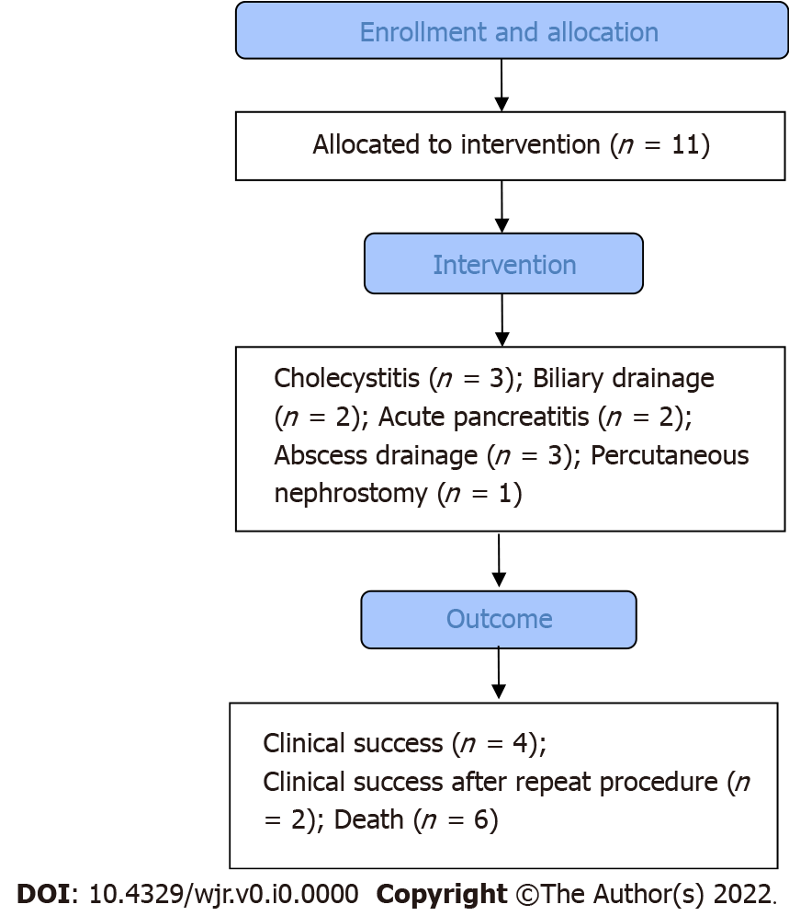
Figure 1 Flow chart of the study.

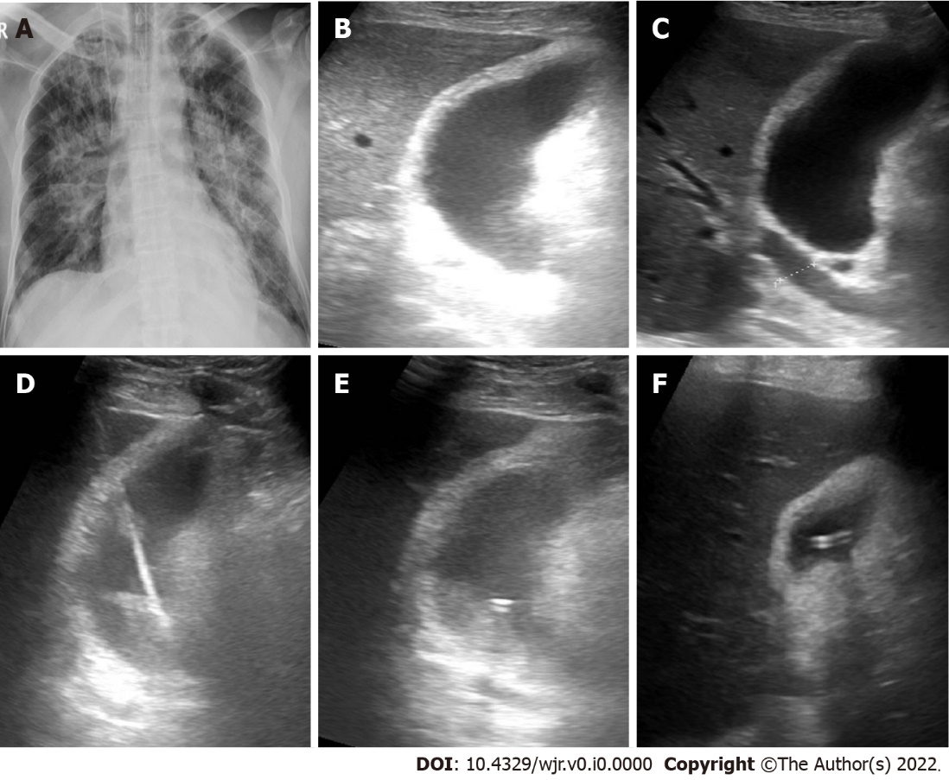
Figure 2 Cholecystostomy in a 72-yr-old male presented by acute cholecystitis. A: Frontal chest X-ray shows opacities involving both lungs with central predominance; B and C: B-mode ultrasound images show distended thick-walled gall bladder with biliary dilatation; D: B-mode ultrasound image show puncture needle through the gall bladder; E: B-mode ultrasound image tube inside the gall bladder; F: B-mode ultrasound image of the gall bladder after drainage.

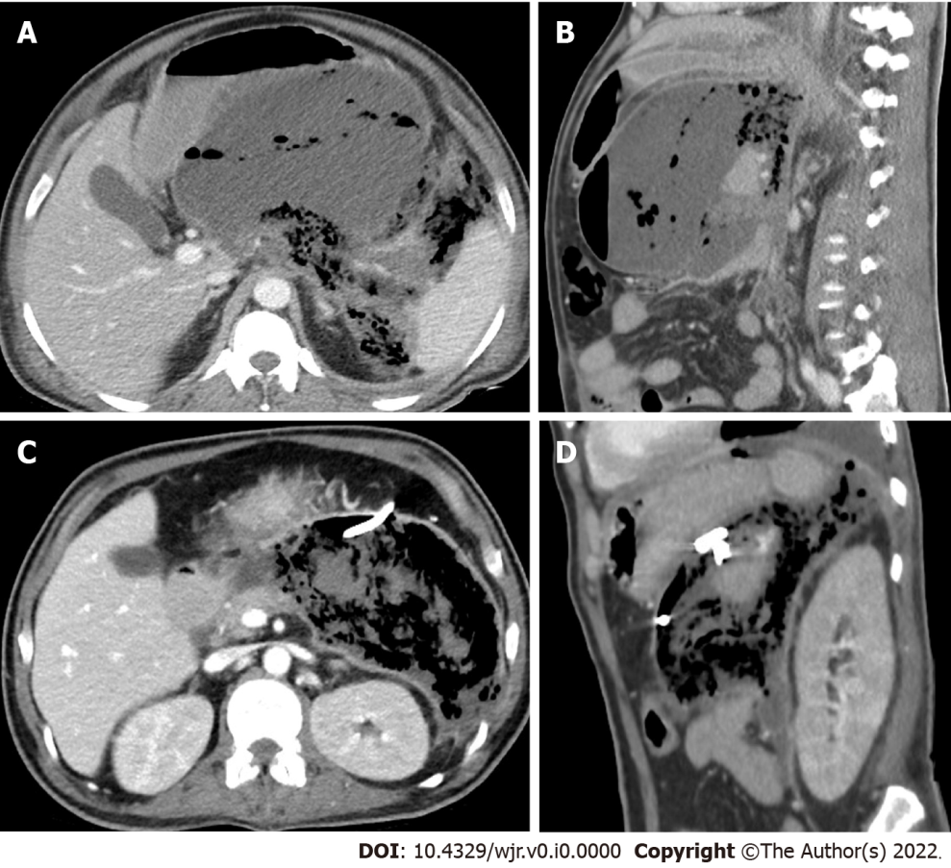
Figure 3 Percutaneous drainage of peripancreatic collection in a 43-yr-old male presented by acute pancreatitis. A and B: Axial and sagittal contrast enhanced computed tomography (CT) images show large peripancreatic collection/walled-off necrosis. The collection is mixed with pockets of gas inside and there is extension of the gas density into the retroperitoneal and perisplenic spaces; C and D: Axial and sagittal contrast enhanced CT images 22 d after tube insertion show reduction of the collection size with increased amount of gas within the collection.

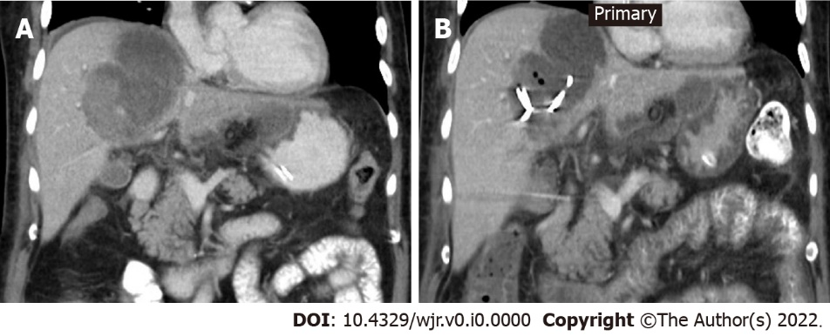
Figure 4 Percutaneous drainage of hepatic abscess in a 63-yr-old male. A: Coronal contrast enhanced computed tomography (CT) image shows thick-walled hepatic abscess with dependent high density inside secondary to clotted blood, a rim of perihepatic fluid is also noted; B: Coronal contrast enhanced CT image 6 d after tube insertion show reduction of the abscess size with few foci of gas density.

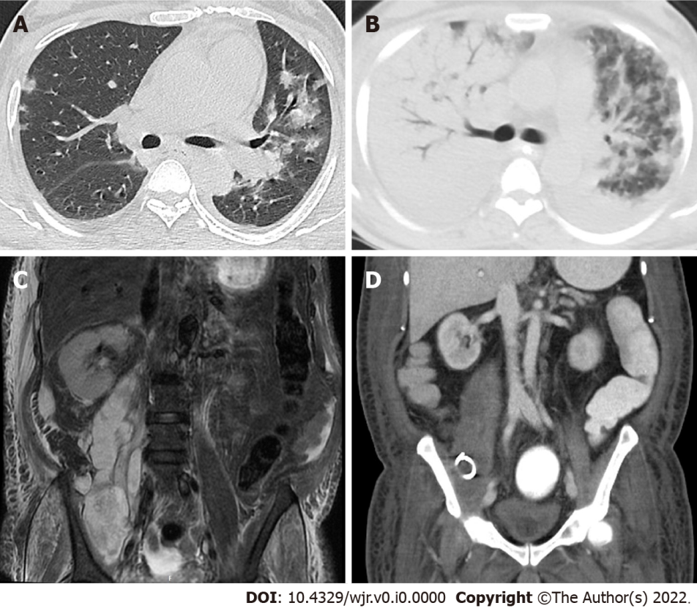
Figure 5 Percutaneous drainage of right psoas major abscess in a 60-yr-old male. A: Axial chest computed tomography (CT) image in pulmonary window shows bilateral ground-glass opacities (GGOs) and minimal bilateral pleural effusion; B: Axial chest CT image in pulmonary window 11 d after initial CT shows bilateral consolidation involving most of the right lung and GGOs in the remaining left lung parenchyma; C: Coronal T2 FAT SAT image shows large multi-locular psoas major abscess associated with muscular and subcutaneous soft tissue edema; D: Coronal contrast enhanced CT images 8 d after tube insertion show reduction of the collection size with regression of the associated soft tissue edema.

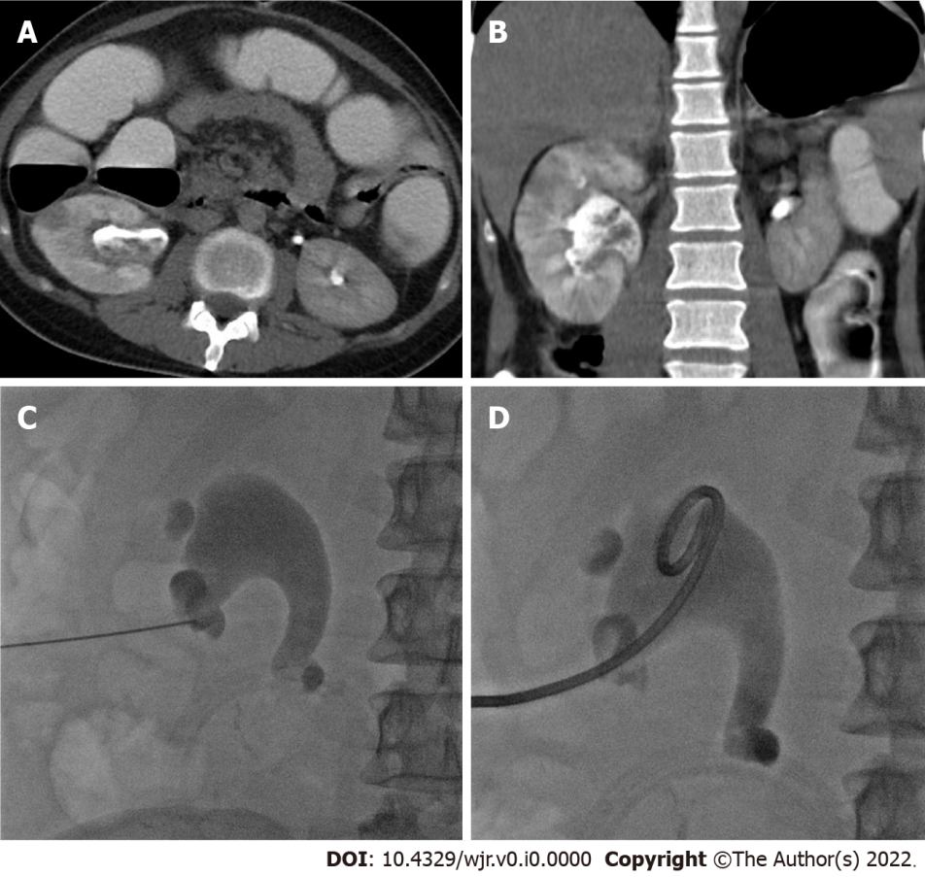
Figure 6 Percutaneous nephrostomy in a 30-yr-old male presented with acute pyelonephritis. A and B: Axial and coronal computed tomography images in excretory phase show characteristic features of acute pyelonephritis in the form of focal hypoenhnacing areas (striated nephrogram) and debris in dilated renal pelvis; C and D: Frontal fluoroscopic images show puncture needle in the lower calyces and successful insertion of nephrostomy tube.

Table 1 Patients’ demographics, comorbidities and outcome
 | Cause of sepsis | Procedures | Age (yr) | Sex | Presentation | Co-morbidities | Ventilator | Tracheostomy | Outcome
Patient 1 | Acute cholecystitis | Cholecystostomy | 72 | Male | Fever | IHD. AKI | 40 d before drain | 20 d before drain | Died 8 d post drain
Patient 2 | Cholangitis and cholecystitis | Cholecystostomy | 61 | Male | Fever | Jaundice. AKI (on dialysis) | 1 d before drain | 12 d post drain | Died 16 d post drain
Patient 3 | Acute cholecystitis | Cholecystostomy | 55 | Male | Abdominal pain | DM | No | No | Discharged 4 d post drain.
Patient 4 | Post-operative biliary leakage resection of hemangioma | U/S guided drain | 48 | Female | Fever | DM. Septic shock | 10 d post drain | No | Died 12 d post drain
Patient 5 | Post-operative biliary leakage after liver resection for transplant | U/S guided drain | 30 | Male | Fever | No | No | No | Discharged 18 d post drain
Patient 6 | Acute pancreatitis | CT-guided drain and EUS cystogastrostomy | 43 | Male | Abdominal pain | HTN. Hyperlipidemia | 27 d post drain | No | Died 28 d post drain
Patient 7 | Acute pancreatitis | U/S guided drain | 41 | Male | Abdominal pain | GB stones. Biliary obst. AKI | No | No | Discharged 10 d post drain
Patient 8 | Recurrent hepatic abscess after surgical evacuation | U/S guided drain (2 tubes) | 63 | Male | Abdominal pain | DM. AKI | 1 d before drain | 1 d before drain | Died 19 d post drain
Patient 9 | Right ilio-psoas and perivetebral abscesses | CT-guided drain then tube upsizing | 60 | Male | Abdominal pain | HTN. DM, AKI | 3 d before drain | 7 d post drain | Died 13 d post drain
Patient 10 | Left lumbar region abscess and unhealthy sigmoid colon | CT-guided drainage. Sigmoid resection | 31 | Male | Abdominal pain and distension | Crohn’s disease. Achalasia. GJ. Esophageal dilatation | No | No | Clinical failure after 18 d followed by another tube insertion and sigmoid resection. Discharged 48 d
Patient 11 | Right pyelonephritis | Rt PCN | 30 | Male | Abdominal pain | Right hemicolectomy | No | No | Discharged 9 d post drain. Recurrence after 39 d and managed by tube exchange
U/S: Ultrasonography; EUS: Endoscopic ultrasound; PCN: Percutaneous nephrostomy; IHD: Ischemic heart disease; AKI: Acute kidney injury; DM: Diabetes mellitus; HTN: Hypertension; GB: Gall bladder; GJ: Gastrojejunostomy.
Table 2 Data of drainage procedure, drained fluid, and chest imaging
 | IR procedure | Drain | Guide | Puncture | Drained fluid | Culture |  | Chest imaging | COVID-19 severity | Lesion distribution | Time between PCR test and drainage
 |  |  |  |  |  | Drain | Peripheral blood
Patient 1 | Cholecystostomy | 1 (8 Fr) | U/S | 18G needle | Dark green | -ve | MDR (Klebsiella) | X-ray | Severe | Bilateral consolidation | 48 d
Patient 2 | Cholecystostomy | 1 (8 Fr) | U/S | 18G needle | Dark green | E.coli and Klebsiella pneumoniae | -ve | CT | Mild | Bilateral basal GGO with minimal effusion | 3 d
Patient 3 | Cholecystostomy | 1 (8 Fr) | U/S | 18G needle | Pus | P. aeruginoa. MRSA. E.coli | -ve | X-ray | Normal | Normal | 5 d
Patient 4 | Percutaneous drainage | 1 (10 Fr) | U/S | 18G needle | Infected bile | E.coli | -ve | CT | Sever | Bilateral consolidation with mild effusion | 8 d
Patient 5 | Percutaneous drainage | 1 (8 Fr) | U/S | 18G needle | Sero-sanginous | -ve | -ve | CT | Mild | Mild right pleural effusion | 3 d
Patient 6 | Percutaneous drainage | 1 (10 Fr) | CT | 21G needle | Brownish | E.coli and Klebsiella pneumoniae | -ve | CT | Mild | Left minimal effusion and basal GGO | 17 d
Patient 7 | Percutaneous drainage | 1 (8 Fr) | CT | 18G needle | Brownish | E.coli | -ve | CT | Mild | Bilateral basal GGO | 2 d
Patient 8 | Percutaneous drainage | 2 (8 Fr) | U/S | 18G needle | Clotted blood | -ve | -ve | X-ray | Normal | Mild right side pleural effusion | 9 d
Patient 9 | Percutaneous drainage | 1 (10 Fr). 1 (8 Fr) | CT and US | 21G needle | Pus | MRSA and staph aureus | -ve | CT | Severe | Bilateral GGO and consolidations | 15 d
Patient 10 | Percutaneous drainage | 2 (8 Fr) | CT | 21G needle | Pus | E.coli and Ent. Foecalis | NA | CT | Mild | Right side GGO | 0 d
Patient 11 | Right PCN | 2 (8 Fr) | U/S and fluoro | 21G needle | Pus | Klebsiella pneumoniae | -ve | X-ray | Normal | Normal | 12 d
CT: Computed tomography; U/S: Ultrasonography; GGO: Ground-glass opacity; NA: Not available.

Table 3 Median (inter-quartile range) for laboratory findings before drainage, 1 d and 7 d after drainage
 | Pre drain | D1 | D7 | P value
WBCs × 10⁹/L | 15.4 (12.50-17.40) | 18.8 (10.6-22.1) | 12.1 (10.3-21.8) | 0.656
Neutrophil × 10⁹/L | 82.8 (72.3-91.8) | 86.6 (70.4-94.2) | 70.9 (60.9-92.3) | 0.091
Lymphocyte × 10⁹/L | 6.8 (3.7-9.9) | 7.10 (2.8-11.2) | 10.9 (2.9-19.2) | 0.032ª
CRP (mg/L) | 182.0 (91.0-368.0) | 166.0 (32.0-80.0) | 133.0 (26.0-170.0) | 0.061
Creatinine (μmol/L) | 122.0 (70.0-353.0) | 109.0 (54.0-426.0) | 97.0 (56.0-364.0) | 0.789
Urea (mmol/L) | 9.2 (5.8-19.7) | 8.6 (3.6-22.4) | 9.1 (2.8-28.2) | 0.574
Bilirubin (μmol/L) | 19.1 (15.0-28.4) | 14.4 (29.9-12.4) | 15.5 (12.5-21.8) | 0.247
D-Dimer (ng/mL) | 1441.0 (620.0-3340.0) | 1363.0 (460.0-2780.0) | 1413.0 (380.0-3560.0) | 0.373
Procalcitonin (ng/mL) | 1.5 (1.1-3.0) | 1.87 (0.85-3.56) | 1.5800 (0.31-3.11) | 0.398
LDH (IU/L) | 359.0 (194.0-750.0) | 397.0 (155.0-768.0) | 438.0 (144.0-798.0) | 0.929
ªP < 0.05. CRP: C-reactive protein; WBC: White blood cell; LDH: Lactate dehydrogenase.

