Name of journal: World Journal of Radiology
ESPS Manuscript NO: 8591
Columns: Review

Imaging of community-acquired pneumonia: Roles of imaging examinations, imaging diagnosis of specific pathogens and discrimination from noninfectious diseases

Nambu A et al. Imaging of community-acquired pneumonia

Atsushi Nambu, Katsura Ozawa, Noriko Kobayashi, Masao Tago

Atsushi Nambu, Noriko Kobayashi, Masao Tago, Department of Radiology, Teikyo University Mizonokuchi Hospital, Kawasaki City, Kanagawa 213-8507, Japan

Katsura Ozawa, Department of Internal Medicine, Kofu Municipal Hospital, Kofu City, Yamanashi Prefecture 400-0832, Japan

Author contributions: All the authors contributed to this paper.

Correspondence to: Atsushi Nambu, MD, PhD, Department of Radiology, Teikyo University Mizonokuchi Hospital, 3-8-3 Mizonokuchi Takatsu-ku, Kawasaki City, Kanagawa 213-8507, Japan. nambu-a@gray.plala.or.jp

Telephone: +81-44-8443333 Fax: +81-44-8443340

Received: December 29, 2013 Revised: July 14, 2014
Accepted: September 04, 2014

Published online:

Abstract
This article reviews roles of imaging examinations in the management of community-acquired pneumonia (CAP), imaging diagnosis of specific CAP and discrimination between CAP and noninfectious diseases. Chest radiography is usually enough to confirm the diagnosis of CAP, whereas computed tomography is required to suggest specific pathogens and to discriminate from noninfectious diseases. Mycoplasma pneumoniae pneumonia, tuberculosis, Pneumocystis jirovecii pneumonia and some cases of viral pneumonia sometimes show specific imaging findings. Peribronchial nodules, especially tree-in-bud appearance, are fairly specific for infection. Evidences of organization, such as concavity of the opacities, traction bronchiectasis, visualization of air bronchograms over the entire length of the bronchi, or mild parenchymal distortion are suggestive of organizing pneumonia. We will introduce tips to effectively make use of imaging examinations in the management of CAP.

© 2014 Baishideng Publishing Group Inc. All rights reserved.

Key words: Community-acquired pneumonia; Computed tomography; Infection; Pneumonia; Lung disease

Core tip: This review article discusses imaging diagnosis of community-acquired pneumonia (CAP). As imaging findings of CAP are considered nonspecific, this topic is rarely focused on in radiology journals. However, I believe that imaging examinations contribute much more than generally considered if detailed evaluation of the imaging findings is made. In this article, I will introduce tips to effectively make use of imaging examinations in the management of CAP.

Nambu A, Ozawa K, Kobayashi N, Tago M. Imaging of community-acquired pneumonia: Roles of imaging examinations, imaging diagnosis of specific pathogens and discrimination from noninfectious diseases. World J Radiol 2014; In press

INTRODUCTION
Community-acquired pneumonia (CAP) is defined as infectious pneumonia that is acquired in the social community^{[1]}. This term is opposed to hospital-acquired pneumonia (synonym for nosocomial pneumonia), which is infected in the hospital (24 h later after the hospitalization)^{[2]}. The third term, nursing home acquired pneumonia that is acquired in the nursing home, has recently been proposed, which has intermediate characteristics between community-acquired and hospital-acquired pneumonia^{[3]}. The pathogens of CAP include a wide variety of microbes, including not only ordinary bacteria but also mycobacteria, viruses, or fungi ^{[4]}. They manifest as pneumonia in various forms, and their imaging findings are often nonspecific^{[4]}. However, characteristic imaging findings of several pathogens are sometimes suggestive of the diagnosis of specific pneumonia. In addition, imaging examinations sometimes offer clues for the differentiation between infectious pneumonia and noninfectious diseases. In this article, we discuss the roles of imaging examinations, and illustrate characteristic imaging findings of several pathogens and differences between infectious pneumonia and non-infectious diseases.

CLINICAL ASPECTS OF CAP
Appropriate clinical assessment is the first step for the diagnosis of CAP^{[1]}. Patients with CAP usually complain of fever, cough, sputum, difficulty breathing or chest pain^{[1]}. Chest pain is indicative of associated pleuritis. Heckerling et al^{[5]} proposed 5 criteria that suggest infectious pneumonia: temperature > 37.8 °C, pulse > 100 beats/min, crackles, decreased breath sounds and the absence of asthma. According to their nomogram for determining the probability of having pneumonia, when assuming a 10% prevalence of pneumonia in the patient population, if these five criteria are met, the probability of pneumonia reaches 70%^{[5]}. Heckerling also suggested in another report that patients with an acute asthma attack or the absence of abnormal auscultatory findings should not undergo chest radiography because the probability of pneumonia is low in these settings^{[6]}.
When clinical findings are suggestive of CAP, blood test, various tests for determining the causative pathogen and chest radiography are performed^{[7]}. Laboratory data usually show an elevation of white blood cell count, C reactive protein and erythrocyte sedimentation rate.
Tests for pathogens include sputum culture, blood culture (in case of suspected sepsis), various antigen tests including pharyngeal swab test for influenza viruses or urine antigen tests for Legionella pneumophila and Streptococcus pneumoniae, antibody tests, gram stain, paired serum tests and cold agglutination test^{[7]}.
Pneumonia with relatively mild clinical symptoms, atypical clinical symptoms such as arthralgia, skin rash or headache, or lack of leukocytosis is referred to as atypical pneumonia^{[8]}. The causative pathogens of atypical pneumonia include Mycoplasma pneumoniae, Chlamydophila pneumoniae, various viruses and Legionella pneumophila.

ROLES OF IMAGING EXAMINATIONS
Imaging examinations are indispensable for the management of CAP. The primary role of imaging examinations is to confirm the diagnosis of pneumonia^{[4]}. If a patient has clinical symptoms suggestive of infection pneumonia, such as fever, cough or sputum, and the imaging findings are consistent with pneumonia, a definitive diagnosis of infectious pneumonia can be made. Imaging examinations also play a complementary role for the evaluation of treatment effects of antibiotics although treatment effects may be determined based solely on clinical findings^{[9]}. It is generally difficult to determine specific pathogens of infectious pneumonia based only on the imaging findings. However, as characteristic imaging findings of several pathogens have been reported, they may help choose subsequent examinations or first antibiotics. This is especially true for the exclusion of tuberculosis, which requires quite different treatment strategies from those of ordinary bacterial pneumonia. As tests for tuberculosis are not routine in most institutions, imaging examinations can be the first opportunity to suggest the possibility of tuberculosis. Also, as many tests for pathogens take some time, they are not in time for the determination of the initial treatment for CAP which is critical for controlling the disease. Suggesting possible diagnoses of specific pneumonia on imaging examinations helps determine the initial treatment. Imaging examinations may also be usable for differentiating noninfectious diseases from infectious pneumonia. As the imaging findings of noninfectious diseases have extensively investigated, they may provide enough information to suspect a certain disease although direct comparative studies between infectious pneumonia and noninfectious diseases are limited. Imaging examinations may also reveal underlying diseases that result in pneumonia or complications. Chest radiography is usually enough to confirm the diagnosis of pneumonia and to evaluate treatment effects, whereas CT is required to suggest causative pathogens, to exclude noninfectious pneumonia and to reveal underlying diseases.

INDICATIONS FOR CT IN THE MANAGEMENT OF CAP
There has been little evidence for the validity of CT in the management of CAP so far^{[9]}. Japanese guideline of imaging diagnosis for CAP has given a grade C recommendation (lacking direct evidence) for the use of CT only in the situation where chest radiograph is negative for the presence of pneumonia despite a strong clinical suspicion^{[9]}. General indications of CT for CAP include severe or complex pneumonia, pneumonia in immune-compromised patients, pneumonia intractable to antibiotics, recurrent or non-resolving pneumonia, patients with clinical suspicion of pneumonia but normal or questionable chest radiographic findings, and pneumonia with a suspicion of underlying diseases^{[4]}. However, in clinical practice indications of CT are evaluated for each individual case depending on the severity of pneumonia, or the probability of tuberculosis or noninfectious diseases. It should also be noted that the prevalence of non-infectious diseases or tuberculosis in patients with respiratory symptoms is relatively high in referral hospitals as patients with atypical clinical presentations are more likely referred to these hospitals.

IMAGING FINDINGS OF CAP
Patterns of imaging findings
CAP usually appears as one of three distinctive patterns on imaging examinations, namely consolidation (alveolar/lobar pneumonia), peribronchial nodules (bronchopneumonia) and ground-glass opacity (GGO)^{[4,10]}. The fourth, a unique uncommon pattern of CAP is random nodules, suggestive of hematogenous pulmonary infection or granulomatous infection.
In fact, many pathogens can cause pneumonia with more than one pattern. In addition, consolidation, peribronchial nodules and GGO can often coexist in a case of pneumonia although one of these findings usually predominates. Virulence, amount or size of pathogens, affinity to certain cells, and immune response of hosts may relate to the different manifestations of CAP on imaging examinations. However, the reason why CAP has different patterns of imaging findings is unknown.

Consolidation predominant pattern (alveolar/ lobar pneumonia)
Consolidation predominant pneumonia is referred to as alveolar pneumonia (Figures 1-4). When it affects almost an entire lung lobe, it is called “lobar pneumonia”. This consolidation is believed to be formed by the spread of inflammation through pores of Kohn or canals of Lambert at the periphery of the lung. Thus, it usually appears in a nonsegmental consolidation in the early stage of disease^{[10]}. Most bacterial pneumonias exemplified by Streptococcus and Klebsiella pneumonia appear in consolidation predominant pattern ^{[4]}.

Peribronchial nodules predominant pattern (bronchopneumonia)
This pattern is characterized by the predominance of peribronchial nodules including centrilobular nodules with or without peribronchial consolidations (Figure 5)^{[4,10]}. In contrast to consolidation predominant pattern, these consolidations are probably formed by enlargement and coalescence of the peribronchial nodules. Bronchial wall thickening is often associated. Pneumonia with this pattern is called bronchopneumonia. However, bronchopneumonia is sometimes indistinguishable from alveolar pneumonia. When centrilobular nodules predominate, namely when bronchioles and peribronchiolar areas are mainly affected, it may be referred to as infectious bronchiolitis (Figures 6-9) ^{[4]}. Hemophilus influenzae, Mycoplasma pneumoniae, Chlamydophila pneumoniae, and viruses are the representative pathogens of this disease entity ^{[4]}. Tuberculosis and atypical mycobacterial infection also fall in this category. However, in fact, most pathogens can take this pattern of pneumonia ^{[4]}.
Bronchopneumonia may follow a chronic clinical course. In such a case, bronchiectasis, prominent reticular opacities or architectural distortion, indicative of chronic process of the disease, are usually present (Figures 7-9).

GROUND-GLASS OPACITY PREDOMINANT PATTERN
Infectious pneumonia sometimes appears as predominantly ground-glass opacities (GGO) (Figures 10-14). Pathologically these GGO may correspond to incomplete alveolar filling by inflammatory cells or exudate, pulmonary edema secondary to infection leaving air in the alveoli, or interstitial infiltrates of inflammatory cells (interstitial pneumonia). This pattern of infectious pneumonia is sometimes referred to as interstitial pneumonia ^{[4,10]}.
Viruses, Mycoplasma pneumoniae and Pneumocystis jirovecii are the representative pathogens of pneumonia with this pattern ^{[4]}.
It should also be noted that resolving alveolar pneumonia can also appear in GGO predominant pattern because alveolar aeration gets restored as pneumonia diminishes.

RANDOM NODULES PREDOMINANT
The fourth pattern distinctive from common pneumonias is random nodules. Random nodules are probably produced by hematogenous spread of the disease^{[1]} or granulomatous infection. Some viral pneumonia epitomized by varicella-zoster pneumonia can assume this pattern (Figure 15)^{[11]}. Hematogenous dissemination of pathogens such as military tuberculosis (Figure16)^{[12]} or septic emboli (Figure 17)^{[13]} also falls in this category.
Granulomatous infection, such as tuberculosis, nontuberculous mycobacterial infection or fungal infection (Figure18), sometimes take a form of nodules that are unrelated to bronchovascular bundles on imaging examinations. The nodules are usually larger and sparser than those of pneumonia caused by hematogenous spread.

IMAGING FINDINGS OF REPRESENTATIVE CAP CAUSED BY SPECIFIC PATHOGENS (TABLE 1)
Streptococcus pneumoniae pneumonia
Streptococcus pneumoniae pneumonia is the most common CAP, accounting for 40% of CAP ^{[4]}. It usually appears in alveolar/lobar pneumonia on chest radiograph and CT (Figure 1)^{[4,14-16]}. Lower lobe is preferentially involved but multi-lobe involvement is also common^{[14]}. Bilateral lung disease is seen in about half of cases ^{[14]}.

Mycoplasma pneumoniae pneumonia
Mycoplasma pneumoniae pneumonia commonly affects young people ^{[4, 16]}. It is clinically characterized by dry cough, fever, and general fatigue ^{[8]}. Chest radiograph shows reticulonodular opacities or patchy consolidations ^{[17]}. On CT, centrilobular nodules and lobular to acinar areas of consolidation or GGO with bronchial wall thickening are the most common findings (Figure 5) ^{[4, 14 16, 17]}. These findings are consistent with bronchopneumonia. The bronchial wall thickening is often seen in central bronchi. This finding may be related to the fact that Mycoplasma pneumoniae targets bronchial epithelium ^{[14]}. Bronchopneumonia with central bronchial wall thickening in children and young adults are fairly specific findings for Mycoplasma pneumonia. However, extensive GGO (Figure 10) or consolidation (Figure 2) is also not uncommon ^{[16]}. GGO predominance in Mycoplasma pneumoniae pneumonia may represent permeability edema rather than cellular infiltrates with edema. Acute respiratory distress syndrome may ensue^{[18]}.

Chlamydophila pneumoniae pneumonia
It has been well known that Chlamydophila pneumoniae pneumonia often appears as part of co-infection. Therefore, strict diagnostic criteria should be used to diagnose this pneumonia. We have been using the diagnostic criteria for acute infection of Chlamydophila pneumoniae using ELISA kit established by Kishimoto et al^{[19,20]}; Chlamydophila pneumoniae pneumonia is considered to be present when IgA or IgG index exceeds over 3.0, or there is interval increase more than 1.0 in IgA or 1.35 in IgG in paired serum specimens. These criteria were proved to be accurate for acute Chlamydophila pneumoniae infection, yielding a specificity of 93.4% (i.e., 7.6% of healthy population shows more than this cut-off value) and sensitivity of 64.9%^{[19]}.
Chest radiograph shows patchy consolidations or reticular opacities (Figure 3, Figure 7)^{[21]}. At the time of reinfection, reticular opacities predominate ^{[21]}. On CT, various patters are seen, including alveolar pneumonia (Figure 3), bronchopneumonia (Figure 7) and GGO predominant pneumonia (Figure 11)^{[16,22]}. Consequently, imaging findings of Chlamydophila pneumoniae pneumonia is virtually non-specific. However, bronchopneumonia or infectious bronchiolitis in elderly patients with pulmonary emphysema or other chronic debilitating lung disease may be one of the characteristic manifestations of Chlamydophila pneumoniae pneumonia^{[16]}.

Legionella pneumophila pneumonia
Legionella pneumophila pneumonia is a fatal pneumonia, and therefore, early diagnosis and treatment is crucial ^{[23]}. Chest radiographic findings include unilateral nonsegmental poorly defined airspace consolidation ^{[24]}. CT findings consist mainly of consolidation and GGO ^{[25]}. Bilateral lung disease is seen in two thirds of cases ^{[25]}. It has been reported that sharply marinated peribronchial consolidations within GGO are characteristic of Legionella pneumonia seen in about one third of the cases (Figure 12) ^{[25]}.

Viral pneumonia
There are innumerable causative viruses for pneumonia. Therefore, the imaging findings of virus pneumonia are diverse. Viral pneumonia can virtually take any form of the above mentioned patterns. Among them, bronchopneumonia and GGO predominance are the most common presentations of viral pneumonia (Figure 13) ^{[4]}. Random nodule pattern is characteristic of varicella-zoster (VZ) pneumonia (Figure 15)^{[11]} although military tuberculosis or mycosis, or bacterial emboli shares this finding. It is conceivable that random nodules seen in VZ pneumonia are due to the fact that VZ hematogenously infects the lung^{[26]}. Scattered small nodules with calcification are also sometimes seen in patients with a past history of VZ pneumonia^{[11, 26]}.
Mixed infection, namely accompanying bacterial pneumonia, is also common in viral pneumonia. In such a case, consolidation often predominates. However, pure viral pneumonia may also demonstrate consolidations. Therefore, it is difficult to make a diagnosis of mixed infection with imaging examinations alone.

TUBERCULOSIS
Although tuberculosis is distinct from common bacterial pneumonia in terms of clinical presentation and treatment, it can manifest as CAP^{[4]}. Tuberculosis is classified into two forms in terms of clinical manifestation, namely primary and postprimary tuberculosis. On CT, primary tuberculosis shows hilar and mediastinal lymphadenopathy, pleural effusion and pulmonary nodules or consolidations^{[27]}, while postprimary tuberculosis demonstrates centrilobular nodules with tree-in-bud appearance, and relatively large nodules suggestive of granulomas with or without cavities^{[28-30]}. Tuberculosis shows finer and denser branching opacities than bronchopneumonia of common bacteria, which pathologically correspond to filling of bronchioles with caseous material (Figure 6)^{[29]}. This appearance is named “tree-in-bud appearance”^{[29]}. Tuberculosis sometimes appears in alveolar pneumonia (tuberculous pneumonia or caseous pneumonia)^{[31]}. In this case, tuberculosis mimics alveolar pneumonia caused by common bacteria. Tuberculous pneumonia, however, shows mildly dilated air bronchograms within the consolidation (Figure 4). Tuberculosis may assume nodules that are larger than centrilobular nodules and has no particular relation with the structures of secondary lobule with or without cavitation. These nodules are referred to as tuberculoma, representing granuloma on pathology^{[32]}. Tuberculosis may also appear as random miliary nodules (miliary tuberculosis) ^{[12]}(Figure 16).

FUNGUS INFECTION
Fungal pneumonia is usually seen in patients with immune suppression. Therefore, it is relatively uncommon to manifest as CAP. However, cryptococcosis can occur in nearly immunocompetent patients^{[4]}. Fungal pneumonia may appear in alveolar pneumonia, bronchopneumonia, or more commonly nodular lesions with or without cavities, suggestive of granulomas (Figure 18)^{[33]}.
Pneumocystis that infects human was reclassified as fungus and was renamed Pneumocystis jirovecii from Pneumocystis carinii^{[4]}. It is a common pathogen of opportunistic infection. However, it should be noted that Pneumocystis jirovecii pneumonia can occur in mildly immunocompromised patients, such as those with diabetes or with steroid medication. Therefore, it may be encountered in the clinical settings of CAP. Pneumocystis jirovecii pneumonia is radiologically characterized by bilateral patchy GGO with or without a paraxial distribution (Figure 14) ^{[34]}. Unless the patient is treated, the GGO may progress to consolidations^{[34]}. On CT, bilateral symmetric GGO are the most common finding (Figure 14) ^{[35, 36]}. Small nodules, foci of consolidation, and linear opacities may be seen ^{[35, 36]}. Cysts may also be seen ^{[35, 36]}.

PARTICULAR CLINICAL CONDITIONS RELATED TO COMMUNITY-ACQUIRED PNEUMONIA (TABLE 2)
Aspiration pneumonia
Aspiration pneumonia is caused by inhalation of bacteria, food, gastric acid or other materials that provoke pulmonary inflammation or edema (e.g., paraffin liquid)^{[37]}, Therefore, aspiration pneumonia has several different pathophysiological aspects, namely bacterial pneumonia caused by oral flora (usually anaerobic bacteria), chemical pneumonitis caused by gastric acid or exogenous lipid, and granulomatous reaction to foreign bodies^{[37]}. Aspiration pneumonia commonly occurs in patients with deteriorated consciousness, chronic debilitating disease, and tracheal or gastric tubes^{[37-40]}. Therefore, it more commonly appears in hospital-acquired pneumonia^{[37-40]}. However, postoperative status for esophageal or gastric cancer and reflux esophagitis are also known risk factors of aspiration pneumonia and thus aspiration pneumonia may manifest as CAP^{[37-40]}.
It commonly affects dorsal parts of the lung (S2, S1+2, S6 and S10) and demonstrates findings of bronchopneumonia or infectious bronchiolitis (Figure 19)^{[37-40]} . Aspirated materials are sometimes seen in the bronchial lumens (Figure 19)^{[40]}. Patchy GGO with peribronchial distribution are also common manifestation (Figure 20). This finding is considered to be related to permeability edema due to endothelial injury by aspirated gastric acid. Acute respiratory distress syndrome (ARDS) may result from aspiration and is referred to as Mendelson’s syndrome^{[41]} .
Chronic infectious bronchiolitis radiologically mimicking diffuse panbronchiolitis is named diffuse aspiration bronchiolitis (Figure 8)^{[42]}

Sinobronchial syndrome
Sinobronchial syndrome is defined as chronic and repeated infection of the lower respiratory tract and paranasal sinuses, which includes diffuse panbronchiolitis^{[43]}. It was once believed to be caused by aspiration of purulent discharge in the paranasal sinuses. However, altered immune status is now considered to lead to both paranasal sinusitis and infectious bronchiolitis^{[43]}. Chest radiograph shows reticulonodular opacities with lower lung field predominance (Figure 9). On CT, centrilobular or peribronchial nodules with bronchial wall thickening and mucus in the bronchi are seen (Figure 9). There are usually evidences of chronic and repeated infection, such as bronchiectasis, parenchymal distortion or reticular opacities. Comparison with previous imaging examinations is essential to make a diagnosis of acute exacerbation of infection.

Pneumonia on a background of pulmonary emphysema
When pneumonia develops on a background of pulmonary emphysema, parenchymal consolidations caused by pneumonia appear to have multiple cavities due to underlying low attenuation areas (Figure 21)^{[10][7]}. This appearance is referred to as “Swiss cheese appearance” ^{[10]}. If low attenuation areas predominate, it may mimics honeycombing (Figure 22). These pseudocavitations and pseudohoneycombing must be distinguished from true cavities and honeycombing. Also, resolution is delayed in pneumonia associated with pulmonary emphysema. It should also be noted that infection is the most common cause of acute exacerbation of chronic obstructive pulmonary disease ^{[44]}.

REPRESENTATIVE DIFFERENTIAL DIAGNOSES OF COMMUNITY-ACQUIRED PNEUMONIA (TABLE 3)
General consideration
There is no imaging finding that is 100% specific for infectious pneumonia. Consolidation and GGO are virtually non-specific. However, peribronchial nodules, especially tree-in-bud appearance are fairly specific for infection^{[4]}. When viewed with CT, consolidation, GGO and peribronchial nodules are coexistent in most cases of infectious pneumonia. Therefore, peribronchial nodules can often be a diagnostic clue for infectious pneumonia.

Cryptogenic organizing pneumonia
Cryptogenic organizing pneumonia (COP) (formerly bronchiolitis obliterans organizing pneumonia) is clinically characterized by dry cough and dyspnea that continue for a couple of months^{[45]}. A typical clinical scenario is that the respiratory symptoms do not improve despite medication with antibiotics^{[45]}. On imaging examinations, it typically shows patchy consolidations which sometimes predispose peribronchial areas with or without extensive areas of GGO^{[44-47]}. Nodules are not uncommon^{[45-48]}. There are often evidences of organization, such as concavity of the opacities, traction bronchiectasis, visualization of air bronchograms over the entire length of the bronchi, or mild parenchymal distortion (Figure 23). Reversed halo sign or atoll sign is also suggestive of COP (Figure 24)^{[48]}. This sign indicates a central GGO surrounded by a ring of consolidation with a thickness of 2 mm or more (just like the reverse of halo sign or atoll in the sea)^{[48]}. It is seen in 20% of patients with COP^{[48]}. Although this sign was first considered specific for COP, it has been shown that other diseases may demonstrate reversed halo sign since then. These diseases include invasive pulmonary fungal infections, paracoccidioidomycosis, Pneumocystis jirovecii pneumonia, tuberculosis, lymphomatoid granulomatosis, Wegener granulomatosis, lipoid pneumonia and sarcoidosis. It is also seen in pulmonary neoplasms and infarction, and following radiation therapy and radiofrequency ablation of pulmonary malignancies^{[49, 50]}. However, as it has not been reported that reversed halo was seen in CAP so far, it is considered useful to differentiate COP from CAP^{[50]}.
Organizing pneumonia that is histologically identical to COP may develop secondary to infectious pneumonia, organ transplantation, drug use or in association with collagen vascular disease^{[45]} . The imaging findings are the essentially the same as COP. However, associated findings related to the primary diseases may be seen, such as findings of bronchopneumonia or honeycombing.

Chronic eosinophilic pneumonia
Chronic eosinophilic pneumonia (CEP) is defined as eosinophilic pneumonia for more than 2 wk and is the most common subtype in eosinophilic lung diseases^{[51,52]}. It is clinically characterized by eosinophilia, and coexistence of atopic medial otitis and asthma^{[51,52]}.
Chest radiograph typically shows bilateral nonsegmental consolidations with peripheral predominance^{[51,52]}. This appearance is referred to as “the photographic negative of pulmonary edema” (Figure 25)^{[51,52]}. On CT, bilateral or unilateral peripheral consolidations and GGO are seen^{[47,53]}. Linear or band-like opacities parallel to the pleura may be seen at the later stage of the disease^{[47, 53]}. CEP may mimic COP. Thickening of interlobular septa is more commonly seen in CEP, whereas nodules and peribronchial distribution of the opacities are more common in COP^{[47]}.

Neoplasm
Invasive mucinous adenocarcinoma (formerly mucinous bronchioloalveolar carcinoma) and malignant lymphoma may appear in alveolar consolidations, and thus may mimic alveolar pneumonia (Figure 26, 27)^{[54-56]}. These neoplasms lack evidence of inflammation on the laboratory data, or if any, the values of inflammatory markers are milder than expected from the extent of disease on imaging examinations. On CT, bronchi in the consolidation are stretched or narrowed, and the consolidation may have a bulging contour at the interlobar fissures in invasive mucinous adenocarcinoma (Figure 26)^{[55]}. It has also been reported that focal areas of the parenchymal opacification on CT may suggest infectious pneumonia rather than invasive mucinous adenocarcinoma when they show bronchial wall thickening proximal to the lesion and pleural thickening associated with the lesion, whereas invasive mucinous adenocarcinoma is characterized as the presence of a bubble-like low attenuation area within the tumor^{[56]}.
Malignant lymphoma often assumes an infiltrative growth, which may appear as halo sign (ground-glass opacities around the nodule or consolidation)^{[57]} or as surrounding miliary nodules or thickening of surrounding vessels (Figure 27).

Lipoid pneumonia
Lipoid pneumonia is divided into endogenous and exogenous type. Exogenous lipoid pneumonia results from the chronic aspiration or inhalation of animal, vegetable or petrolleum-based oils or fats^{[58]}. Exogenous lipoid pneumonia is considered as a subtype of aspiration pneumonia. CT shows consolidations and GGO with reticular opacities (crazy-paving appearance). The consolidations may have CT values indicative of fat (-150-300HU) (Figure 28)^{[57]}. Visual assessment for the presence of fat is also essential as consolidation even without fat may apparently have areas of low CT value comparable to that of fat due to volume averaging between air and inflammatory infiltrates or exudate.

CONCLUSION
Imaging findings of CAP are varied and often nonspecific. However, some characteristic findings are sometimes suggestive of specific pathogens. In addition, imaging examinations, especially CT, can offer clues to the differentiation between infectious pneumonia and noninfectious diseases. To accomplish this differentiation, familiarity with imaging characteristics of CAP as well as those of noninfectious diseases is indispensable.

REFERENCES
1 Niederman MS, Bass JB, Campbell GD, Fein AM, Grossman RF, Mandell LA, Marrie TJ, Sarosi GA, Torres A, Yu VL. Guidelines for the initial management of adults with community-acquired pneumonia: diagnosis, assessment of severity, and initial antimicrobial therapy. American Thoracic Society. Medical Section of the American Lung Association. Am Rev Respir Dis 1993; 148: 1418-1426 [PMID: 8239186]
2 Hospital-acquired pneumonia in adults: diagnosis, assessment of severity, initial antimicrobial therapy, and preventive strategies. A consensus statement, American Thoracic Society, November 1995. Am J Respir Crit Care Med 1996; 153: 1711-1725 [PMID: 8630626]
3 Guay DR. Guidelines for the management of adults with health care-associated pneumonia: implications for nursing facility residents. Consult Pharm 2006; 21: 719-725 [PMID: 17069468]
4 Müller NL, Franquet T, Lee KS. In: McAllister L eds. Imaging of pulmonary infections. Philadelphia, Pa: Wolters Kluwer/Lipponcott Williams ＆ Wilkins; 2007
5 Heckerling PS, Tape TG, Wigton RS, Hissong KK, Leikin JB, Ornato JP, Cameron JL, Racht EM. Clinical prediction rule for pulmonary infiltrates. Ann Intern Med 1990; 113: 664-670 [PMID: 2221647]
6 Heckerling PS. The need for chest roentgenograms in adults with acute respiratory illness. Clinical predictors. Arch Intern Med 1986; 146: 1321-1324 [PMID: 3718128]
7 Freifeld AG, Bow EJ, Sepkowitz KA, Boeckh MJ, Ito JI, Mullen CA, Raad II, Rolston KV, Young JA, Wingard. JRInfectious Diseases Society of America. Clinical practice guideline for the use of antimicrobial agents in neutropenic patients with cancer: 2010 Update by the Infectious Diseases Society of America. Clin Infect Dis 2011; 52: 427-431 [DOI: 10.1093/cid/cir073]
8 Bragg F. Primary Atypical Pneumonia. AJPH 1944; 34: 347-357
9 Ashizawa K, Arakawa H, Takahashi M, Tanaka N, Fujimoto K. Japanese guideline for imaging diagnosis of adult community-acquired pneumonia, Japanese Radiological Society and Japanese College of Radiology; 2007
10 Fraser RS, Pare JAP, Fraser RG, Pare PD. Infectious disease of the lungs. Synopsis of diseases of the chest . 2nd ed. W.B. Saunders company; 1994. P. 287-391
11 Kim JS, Ryu CW, Lee SI, Sung DW, Park CK. High-resolution CT findings of varicella-zoster pneumonia. AJR Am J Roentgenol 1999; 172: 113-116 [PMID: 9888749]
12 Oh YW, Kim YH, Lee NJ, Kim JH, Chung KB, Suh WH, Yoo SW. High-resolution CT appearance of miliary tuberculosis. J Comput Assist Tomogr 1994; 18: 862-866 [PMID: 7962790]
13 Kuhlman JE, Fishman EK, Teigen C. Pulmonary septic emboli: diagnosis with CT. Radiology 1990; 174: 211-213 [PMID: 2294550]
14 Tanaka N, Matsumoto T, Kuramitsu T, Nakaki H, Ito K, Uchisako H, Miura G, Matsunaga N, Yamakawa K. High resolution CT findings in community-acquired pneumonia. J Comput Assist Tomogr 1996; 20: 600-608 [PMID: 8708064]
15 Reittner P, Ward S, Heyneman L, Johkoh T, Müller NL. Pneumonia: high-resolution CT findings in 114 patients. Eur Radiol 2003; 13: 515-521 [PMID: 12594553]
16 Nambu A, Saito A, Araki T, Ozawa K, Hiejima Y, Akao M, Ohki Z, Yamaguchi H. Chlamydia pneumoniae: comparison with findings of Mycoplasma pneumoniae and Streptococcus pneumoniae at thin-section CT. Radiology 2006; 238: 330-338 [PMID: 16304082]
17 Reittner P, Müller NL, Heyneman L, Johkoh T, Park JS, Lee KS, Honda O, Tomiyama N. Mycoplasma pneumoniae pneumonia: radiographic and high-resolution CT features in 28 patients. AJR Am J Roentgenol 2000; 174: 37-41 [PMID: 10628450]
18 Radisic M, Torn A, Gutierrez P, Defranchi HA, Pardo P. Severe acute lung injury caused by Mycoplasma pneumoniae: potential role for steroid pulses in treatment. Clin Infect Dis 2000; 31: 1507-1511 [PMID: 11096025]
19 Kishimoto T, Kubota Y, Matsushima T, Izutsu H, Matsumoto A, Soejima R, Morikawa T, Kawagoe K. [Assay of specific anti-Chlamydia pneumoniae antibodies by ELISA method. 1. Evaluation of ELISA kit using outer membrane complex]. Kansenshogaku Zasshi 1996; 70: 821-829 [PMID: 8890550]
20 Kishimoto T, Matsushima T, Morikawa T, Kawagoe K. [Assay of specific anti-Chlamydia pneumoniae antibodies by ELISA method. 3. Setting of serological criteria]. Kansenshogaku Zasshi 1999; 73: 457-466 [PMID: 10386026]
21 McConnell CT, Plouffe JF, File TM, Mueller CF, Wong KH, Skelton SK, Marston BJ, Breiman RF. Radiographic appearance of Chlamydia pneumoniae (TWAR strain) respiratory infections. CBPIS Study Group. Community-based Pneumonia Incidence Study. Radiology 1994; 192: 819-824 [PMID: 8058954]
22 Okada F, Ando Y, Wakisaka M, Matsumoto S, Mori H. Chlamydia pneumoniae pneumonia and Mycoplasma pneumoniae pneumonia: comparison of clinical findings and CT findings. J Comput Assist Tomogr 2005; 29: 626-632 [PMID: 16163032]
23 Burdet C, Lepeule R, Duval X, Caseris M, Rioux C, Lucet JC, Yazdanpanah Y. Quinolones versus macrolides in the treatment of legionellosis: a systematic review and meta-analysis. J Antimicrob Chemother 2014; 69: 2354-2360 [PMID: 24827889]
24 Kirby BD, Peck H, Meyer RD. Radiographic features of Legionnaires' disease. Chest 1979; 76: 562-565 [PMID: 498829]
25 Sakai F, Tokuda H, Goto H, Tateda K, Johkoh T, Nakamura H, Matsuoka T, Fujita A, Nakamori Y, Aoki S, Ohdama S. Computed tomographic features of Legionella pneumophila pneumonia in 38 cases. J Comput Assist Tomogr 2007; 31: 125-131 [PMID: 17259844]
26 Mohsen AH, McKendrick M. Varicella pneumonia in adults. Eur Respir J 2003; 21: 886-891 [PMID: 12765439]
27 Leung AN, Müller NL, Pineda PR, FitzGerald JM. Primary tuberculosis in childhood: radiographic manifestations. Radiology 1992; 182: 87-91 [PMID: 1727316]
28 Lee KS, Song KS, Lim TH, Kim PN, Kim IY, Lee BH. Adult-onset pulmonary tuberculosis: findings on chest radiographs and CT scans. AJR Am J Roentgenol 1993; 160: 753-758 [PMID: 8456658]
29 Im JG, Itoh H, Shim YS, Lee JH, Ahn J, Han MC, Noma S. Pulmonary tuberculosis: CT findings--early active disease and sequential change with antituberculous therapy. Radiology 1993; 186: 653-660 [PMID: 8430169]
30 Im JG, Itoh H, Lee KS, Han MC. CT-pathology correlation of pulmonary tuberculosis. Crit Rev Diagn Imaging 1995; 36: 227-285 [PMID: 7546270]
31 Lee KS, Kim YH, Kim WS, Hwang SH, Kim PN, Lee BH. Endobronchial tuberculosis: CT features. J Comput Assist Tomogr 1991; 15: 424-428 [PMID: 2026803]
32 Murayama S, Murakami J, Hashimoto S, Torii Y, Masuda K. Noncalcified pulmonary tuberculomas: CT enhancement patterns with histological correlation. J Thorac Imaging 1995; 10: 91-95 [PMID: 7769636]
33 Fox DL, Müller NL. Pulmonary cryptococcosis in immunocompetent patients: CT findings in 12 patients. AJR Am J Roentgenol 2005; 185: 622-626 [PMID: 16120909]
34 Lyon R, Haque AK, Asmuth DM, Woods GL. Changing patterns of infections in patients with AIDS: a study of 279 autopsies of prison inmates and nonincarcerated patients at a university hospital in eastern Texas, 1984-1993. Clin Infect Dis 1996; 23: 241-247 [PMID: 8842257]
35 Feurestein IM, Archer A, Pluda JM, Francis PS, Falloon J, Masur H, Pass HI, Travis WD. Thin-walled cavities, cysts, and pneumothorax in Pneumocystis carinii pneumonia: further observations with histopathologic correlation. Radiology 1990; 174: 697-702 [PMID: 2305052]
36 Kuhlman JE, Kavuru M, Fishman EK, Siegelman SS. Pneumocystis carinii pneumonia: spectrum of parenchymal CT findings. Radiology 1990; 175: 711-714 [PMID: 2343118]
37 Marik PE. Aspiration pneumonitis and aspiration pneumonia. N Engl J Med 2001; 344: 665-671 [PMID: 11228282]
38 DePaso WJ. Aspiration pneumonia. Clin Chest Med 1991; 12: 269-284 [PMID: 1855371]
39 Marom EM, McAdams HP, Erasmus JJ, Goodman PC. The many faces of pulmonary aspiration. AJR Am J Roentgenol 1999; 172: 121-128 [PMID: 9888751]
40 Franquet T, Giménez A, Rosón N, Torrubia S, Sabaté JM, Pérez C. Aspiration diseases: findings, pitfalls, and differential diagnosis. Radiographics 2000; 20: 673-685 [PMID: 10835120]
41 BERRIS B, KASLER D. PULMONARY ASPIRATION OF GASTRIC ACID--MENDELSON'S SYNDROME. Can Med Assoc J 1965; 92: 905-907 [PMID: 14289137]
42 Okada F, Ando Y, Yoshitake S, Ono A, Tanoue S, Matsumoto S, Wakisaka M, Maeda T, Mori H. Clinical/pathologic correlations in 553 patients with primary centrilobular findings on high-resolution CT scan of the thorax. Chest 2007; 132: 1939-1948 [PMID: 18079227]
43 Kadowaki T, Yano S, Kobayashi K, Araki K, Tokushima T, Yamadori I. Pulmonary capillary hemangiomatosis-like foci detected by high resolution computed tomography. Intern Med 2010; 49: 175-178 [PMID: 20075585]
44 Huerta A, Crisafulli E, Menéndez R, Martínez R, Soler N, Guerrero M, Montull B, Torres A. Pneumonic and nonpneumonic exacerbations of COPD: inflammatory response and clinical characteristics. Chest 2013; 144: 1134-1142 [PMID: 23828375 DOI: 10.1378/chest.13-0488]
45 Cordier JF. Cryptogenic organising pneumonia. Eur Respir J 2006; 28: 422-446 [PMID: 16880372]
46 Lee KS, Kullnig P, Hartman TE, Müller NL. Cryptogenic organizing pneumonia: CT findings in 43 patients. AJR Am J Roentgenol 1994; 162: 543-546 [PMID: 8109493]
47 Arakawa H, Kurihara Y, Niimi H, Nakajima Y, Johkoh T, Nakamura H. Bronchiolitis obliterans with organizing pneumonia versus chronic eosinophilic pneumonia: high-resolution CT findings in 81 patients. AJR Am J Roentgenol 2001; 176: 1053-1058 [PMID: 11264110]
48 Kim SJ, Lee KS, Ryu YH, Yoon YC, Choe KO, Kim TS, Sung KJ. Reversed halo sign on high-resolution CT of cryptogenic organizing pneumonia: diagnostic implications. AJR Am J Roentgenol 2003; 180: 1251-1254 [PMID: 12704033]
49 Godoy MC, Viswanathan C, Marchiori E, Truong MT, Benveniste MF, Rossi S, Marom EM. The reversed halo sign: update and differential diagnosis. Br J Radiol 2012; 85: 1226-1235 [PMID: 22553298]
50 Maturu VN, Agarwal R. Reversed Halo Sign: A Systematic Review. Respir Care 2014; 59(9): 1440-1449 [PMID: 24782557]
51 Akuthota P, Weller PF. Eosinophilic pneumonias. Clin Microbiol Rev 2012; 25: 649-660 [PMID: 23034324]
52 Cottin V, Cordier JF. Eosinophilic lung diseases. Immunol Allergy Clin North Am 2012; 32: 557-586 [PMID: 23102066]
53 Mayo JR, Müller NL, Road J, Sisler J, Lillington G. Chronic eosinophilic pneumonia: CT findings in six cases. AJR Am J Roentgenol 1989; 153: 727-730 [PMID: 2773727]
54 Lewis ER, Caskey CI, Fishman EK. Lymphoma of the lung: CT findings in 31 patients. AJR Am J Roentgenol 1991; 156: 711-714 [PMID: 2003430]
55 Jung JI, Kim H, Park SH, Kim HH, Ahn MI, Kim HS, Kim KJ, Chung MH, Choi BG. CT differentiation of pneumonic-type bronchioloalveolar cell carcinoma and infectious pneumonia. Br J Radiol 2001; 74: 490-494 [PMID: 11459727]
56 Kim TH, Kim SJ, Ryu YH, Chung SY, Seo JS, Kim YJ, Choi BW, Lee SH, Cho SH. Differential CT features of infectious pneumonia versus bronchioloalveolar carcinoma (BAC) mimicking pneumonia. Eur Radiol 2006; 16: 1763-1768 [PMID: 16418864]
57 Kim Y, Lee KS, Jung KJ, Han J, Kim JS, Suh JS. Halo sign on high resolution CT: findings in spectrum of pulmonary diseases with pathologic correlation. J Comput Assist Tomogr 1999; 23: 622-626 [PMID: 10433297]
58 Gondouin A, Manzoni P, Ranfaing E, Brun J, Cadranel J, Sadoun D, Cordier JF, Depierre A, Dalphin JC. Exogenous lipid pneumonia: a retrospective multicentre study of 44 cases in France. Eur Respir J 1996; 9: 1463-1469 [PMID: 8836660]

P-Reviewer: Boots RJ, Fujita J, Kelesidis T S-Editor: Song XX
L-Editor: E-Editor:

Table 1 Specific imaging findings¹ of representative pathogens for community-acquired pneumonia
Pathogens | Specific imaging appearances
Streptococcus pneumoniae | Alveolar/lobar pneumonia
Mycoplasma pneumoniae | Bronchopneumonia with bronchial wall thickening affecting central bronchi
Chlamydophila pneumoniae | Infectious bronchiolitis with bronchial dilatation
Legionella pneumophila | Sharply marinated peribronchial consolidations within ground-glass opacities
varicella-zoster | Scattered nodules with a random distribution
Tubercle bacillus | Tree-in-bud appearance with finer and denser branching opacities than bronchopneumonia of common bacteria (postprimary tuberculosis)
Cryptococcus neoformans | Multiple nodules/masses with or without cavities in the same pulmonary lobe
Pneumocystis jirovecii | Bilateral patchy ground-glass opacities with a geographic distribution
¹Note that these imaging findings may be fairly specific but are not sensitive (i.e., other imaging findings may be seen.) for these pathogens.

Pathophysiological conditions | Imaging findings
Aspiration pneumonia | Bronchopneumonia or patchy ground-glass opacities at dorsal parts of the lung (S2, S1+2, S6 and S10)  intrabronchial materials
Sinobronchial syndrome | Centrilobular or peribronchial nodules with bronchial wall thickening with bronchiectasis and mucus in the bronchi  findings of paranasal sinusitis
Pneumonia on a background of penumonia | Consolidation with pseudocavities or pseudohoneycombing, delayed resolution
Table 2 Particular clinical conditions related to community-acquired pneumonia

Table 3 Representative differential diagnoses of community-acquired pneumonia
 | Discriminators from community-acquired pneumonia
Cryptogenic organizing pneumonia | Relatively chronic clinical course (often for more than one month), evidences of organization (concavity of the opacities, traction bronchiectasis, clear visualization of peripheral air bronchograms, or mild parenchymal distortion), reversed halo sign
Chronic eosinophilic pneumonia | Bilateral nonsegmental consolidations with peripheral predominance
Neoplasm  Mucinous invasive adenocarcinoma  Malignang lymphoma | Lack of inflammatory response on laboratory data, chronic clinical course  bulging contour, stretching or thinning of bronchi, cavities  Infiltrative spread around the consolidation (halo sign, galaxy sign, or thickening of surrounding vessels, etc.)
Lipoid pneumonia | Presence of fat within the consolidation on both visual assessment and CT value measurement
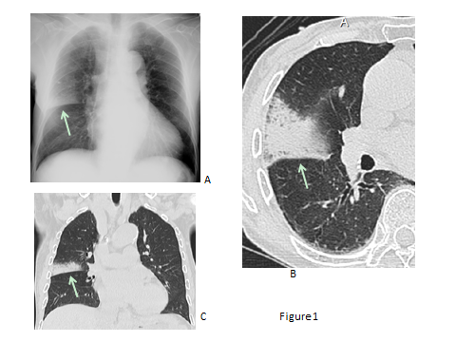
Figure 1 Streptococcus pneumoniae pneumonia showing alveolar pneumonia in a man in his 80s. A: Chest radiograph shows a nonsegmental consolidation in the right middle lung field, which is demarcated by the minor fissure suggestive of upper lobe pneumonia (arrow); B, C: Thin-section CT (B) and a coronal reformatted image (C) demonstrate a nonsegmental consolidation with air bronchograms suggestive of alveolar pneumonia (arrows).

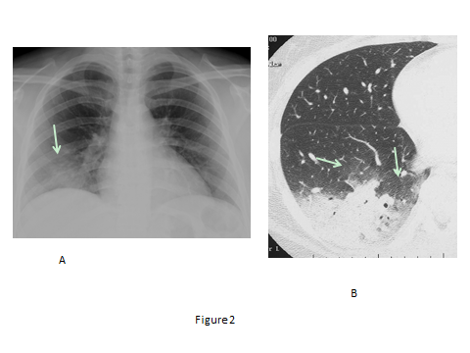
Figure 2 Mycoplasma pneumoniae pneumonia showing alveolar pneumonia in a woman in her 30s. A: Chest radiograph demonstrates ill-defined consolidation in the right lower lung field (arrow); B. Thin-section CT reveals a non-segmental consolidation with air bronchograms at the dorsal aspect of the right lower lobe. Areas of GGO are also noted around the consolidation.

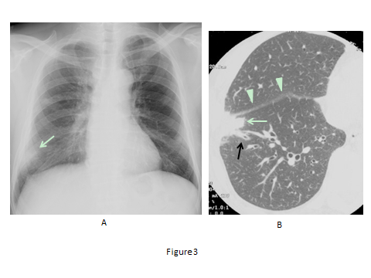
Figure 3 Chlamydophila pneumoniae pneumonia showing alveolar pneumonia in a man in his 60s. A: Chest radiograph shows an ill-defined consolidation at the right lower lung field (arrow); B. On thin-section CT, a subpleural focal consolidation is seen at the right S8 of the right lower lobe, partially extending into the middle lobe. The interlobular fissure is mildly thickened (arrow heads). Mild bronchial wall thickening is also noted (black arrow).

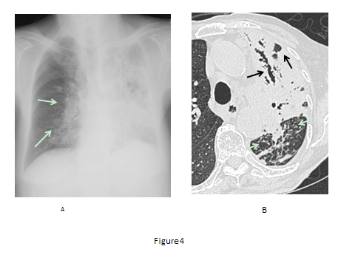
Figure 4 Tuberculous pneumonia in a woman in her 80s. A: Chest radiograph shows extensive consolidations with poor aeration of the left lung and peribronchovascular consolidations of the right lung (arrow); B: Thin-section CT reveals extensive consolidation with air bronchograms and cavities in the left upper lobe (black arrows). Note that the bronchi in the consolidation are dilated. Dense centrilobular nodules are seen in the left lower lobe (arrows).

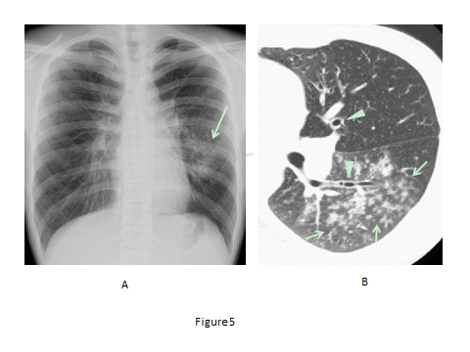
Figure 5 Mycoplasma pneumoniae pneumonia showing bronchopneumonia in a man in his 10s. A: Chest radiograph shows reticulonodular opacities and focal consolidation in the left middle to lower lung field (arrow). The left pulmonary hilum appears enlarged; B: Thin-section CT demonstrates fluffy centrilobular nodules with surrounding GGO in the left lower lobe (arrows). Note that central bronchial wall is thickened (arrow heads).

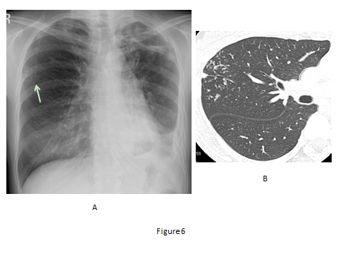
Figure 6 Postprimary tuberculosis in a woman in her 40s. A: Chest radiograph shows faint nodular opacities in the right middle lung field (arrow). There is also volume loss of the left lung with patchy consolidations and thickening of the pleura and possible left pleural effusion, indicative of old tuberculosis; B: Thin-section CT demonstrates centrilobular branching opacities (tree-in-bud appearance) in the right upper lobe (arrows). The branching opacities are denser, more distinct and more peripherally located than those of ordinary bronchopneumonia (compare with Figure 3).

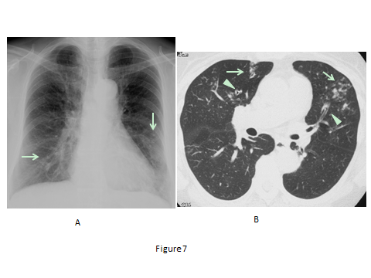
Figure 7 Chlamydophila pneumoniae pneumonia showing infectious bronchiolitis in a woman in her 60s. A: Chest radiograph shows faint reticulonodular opacities in both lower lung fields (arrows); B: Thin-section CT reveals centrilobular nodules (arrows) with bronchiectasis (arrow heads) in the middle lobe and lingula.

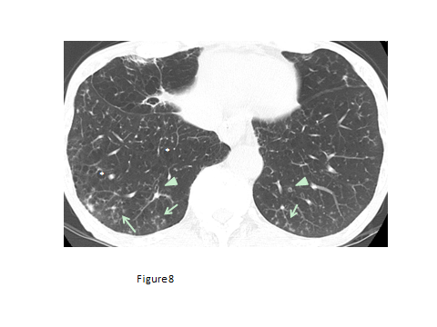
Figure 8 Chronic transbronchial infection (diffuse aspiration bronchiolitis) in a man in his 70s. This patient had a history of esophageal carcinoma and associated repeated aspiration. Thin-section CT at the level of lung base shows centrilobular nodules (arrows) with bronchiectasis (arrow heads). Low attenuation areas suggestive of pulmonary emphysema are also present (*).

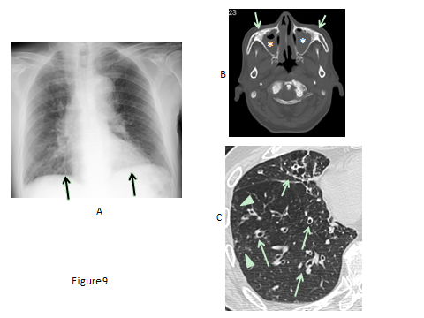
Figure 9 Sinobronchial syndrome in a man in his 70s. A: Chest radiograph shows bilateral reticulonodular opacities in both lower lung fields (arrows); B: CT at the level of maxillary sinus demonstrates opacification of the maxillary sinuses (*) and bone sclerosis of the sinus walls (arrows), suggestive of chronic paranasal sinusitis; C: Thin-section CT reveals bronchial wall thickening with bronchiectasis (arrows) and minimal centrilobular opacities (arrow heads).

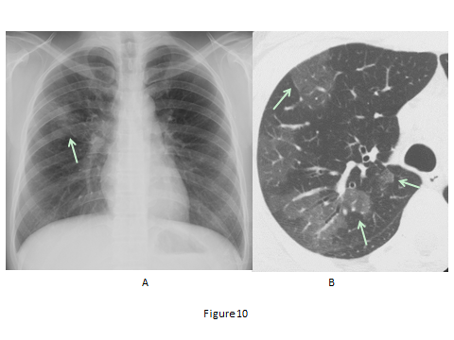
Figure 10 Mycoplasma pneumoniae pneumonia showing ground-glass opacity predominant pneumonia in a woman in her 30s. A: Chest radiograph shows patchy GGO with peribronchial nodules in the right middle lung field (arrow); B: Thin-section CT reveals areas of GGO in the right upper lobe. Note that the GGO are partly demarcated by interlobular septa (arrows).

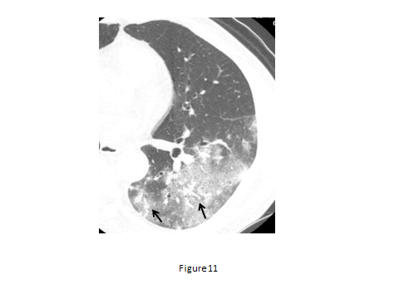
Figure 11 Chlamydophila pneumoniae pneumonia showing ground-glass opacity predominant pneumonia in a man in her 60s. Thin-section CT shows patchy GGO in the left lower lobe, in which thickened bronchovascular bundles are present (arrows).

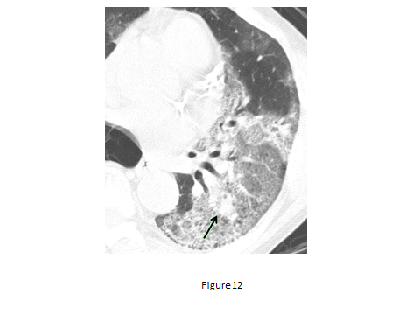
Figure 12 Legionella pneumophila pneumonia in a man in his 50s. Thin-section CT shows extensive GGO in the left lower lobe intermingled with focal consolidations that are sharply demarcated from the surrounding GGO (arrow).

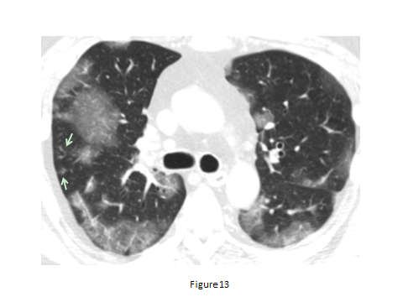
Figure 13 H1N1 influenza pneumonia in a man in his 40s. Thin-section CT shows patchy GGO that are sharply demarcated from the surrounding lung parenchyma by interlobular septa (geographic distribution) in both lungs. Faint centrilobular nodules are also seen (arrow).

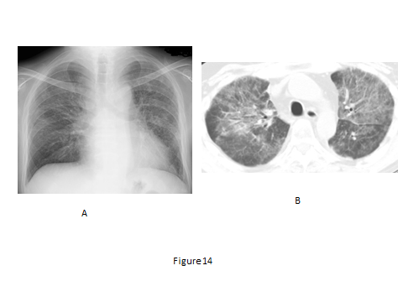
Figure 14 Pneumocystis jirovecii pneumonia in a man in his 20s. A: Chest radiograph shows bilateral reticulonodular opacities; B: Chest CT with a 5 mm slice thickness demonstrates bilateral GGO with reticulations.

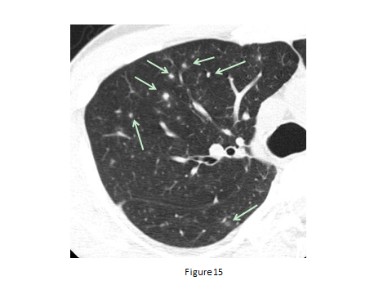
Figure 15 Random nodules predominant pneumonia (varicella-zoster pneumonia) in a man in his 30s. Thin-section CT demonstrates scattered small solid or GGO nodules which are unrelated to centrilobular structures.

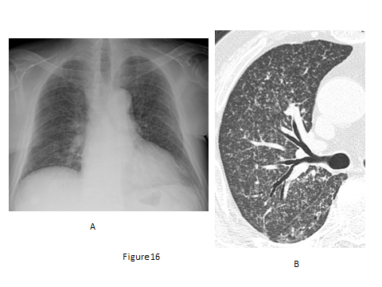
Figure 16 Miliary tuberculosis in a man in his 60s. A: Chest radiograph diffuse reticulonodular opacities in both lungs; B: Thin-section CT demonstrates diffuse military nodules with a random distribution.

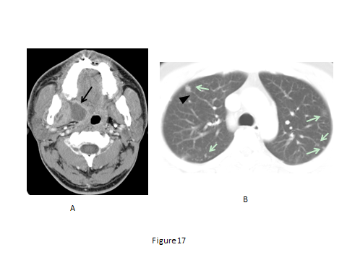
Figure 17 Pulmonary septic emboli from paratonsillar abscess in a man in his 20s. A: Enhanced CT at the level of oropharynx shows an abscess at the right paratonsillar region; B: Chest CT with a 5 mm slice thickness reveals small nodules in both lungs (arrows), some of which are in contact with the periphery of pulmonary vessels.

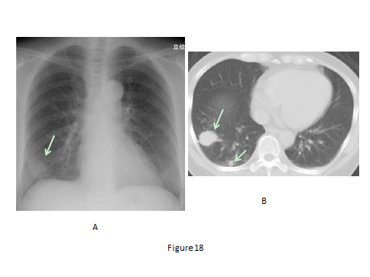
Figure 18 Cryptococcus neoformans pneumonia in a woman in her 50s. A: Chest radiograph shows a mass in the right lung base (arrow); B: Chest CT with a 5 mm slice thickness shows a mass and nodule in the right lower lobe (arrows). Multiple nodules/masses in the same pulmonary lobe are considered characteristic findings of Cryptococcus pneumonia.

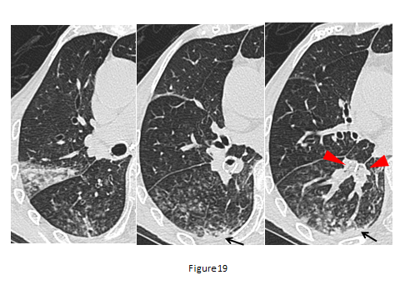
Figure 19 Aspiration pneumonia in a woman in her 70s (causative pathogen unknown). Thin-section CT images show centrilobular nodules with surrounding ground-glass opacities and subpleural non-segmental consolidations (arrows) at the dorsal portions of the right lung. Note that the lumens of segmental bronchi are filled with aspirated materials (arrow heads).

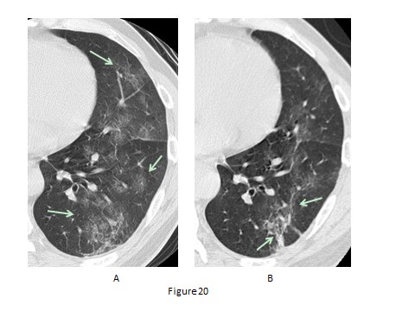
Figure 20 Pneumonia caused by aspiration of gastric fluid in a man in his 50s. A: Initial thin-section CT shows patchy GGO in the left lung with reticulations; B: Thin-section CT 2 days later demonstrates partly increased attenuation with concaved margin of the opacities as well as a general resolution of pneumonia.

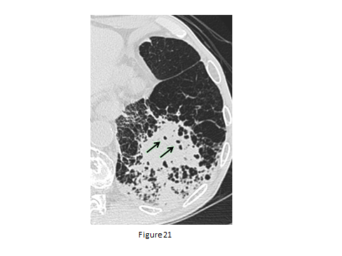
Figure 21 Pneumonia on a background of pulmonary emphysema in a man in his 70s (causative pathogen unknown). Thin-section CT shows patchy consolidations with small air-containing spaces consistent with preexistent low attenuation areas in the left lower lobe.

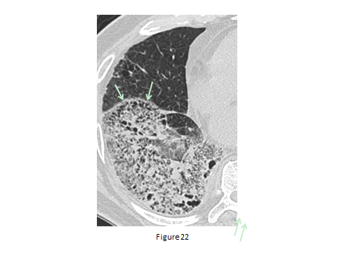
Figure 22 Pneumonia on a background of pulmonary emphysema mimicking honeycombing in a man in his 60s (causative pathogen unknown). Thin-section CT shows an extensive area of GGO intermingled with consolidation in the right lower lobe. Pseudohoneycombing is seen along the interlobar fissure (arrows).

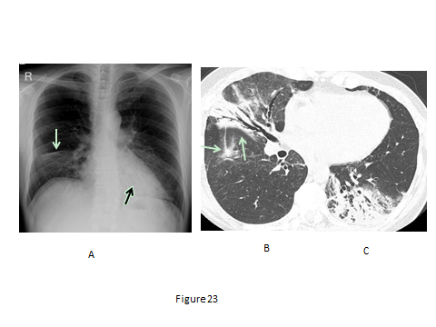
Figure 23 Cryptogenic organizing pneumonia in a woman in her 50s. A: Chest radiograph shows a consolidation in the right lower lung field with depression of the right minor fissure suggestive of volume loss of the middle lobe (arrow). Retrocardiac consolidation is marginally seen (black arrow); B, C: Thin-section CT of the right lung (B) and left lung (C) demonstrate consolidations with air bronchograms in both lungs. Note that the bronchi within the consolidations are mildly dilated and that the consolidations have concaved margins (arrows), suggesting organization of the disease.

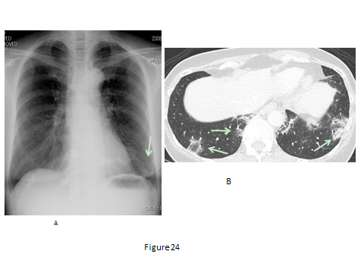
Figure 24 Cryptogenic organizing pneumonia with reversed halo sign in a woman in her 50s: courtesy of Dr. Takahiro Haruyama and Dr. Asako Yamamoto, attending radiologists at the department of Radiology, Teikyo University School of Medicine. A: Chest radiograph shows an ill-defined consolidation in the left lower lung field (arrow); B: Thin-section CT reveals bibasilar GGO with a ring of consolidation (reversed halo sign (arrows).

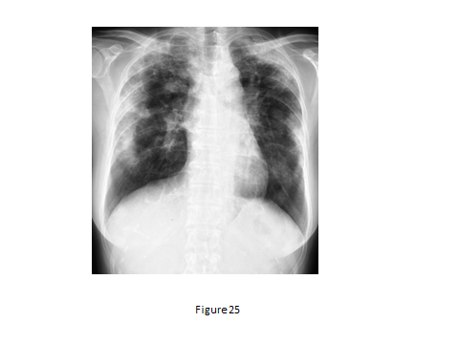
Figure 25 Chronic eosinophilic pneumonia in a woman in her 30s. Chest radiograph shows bilateral subpleural consolidations with central and basilar areas, consistent with the appearance, “the photographic negative of pulmonary edema”.

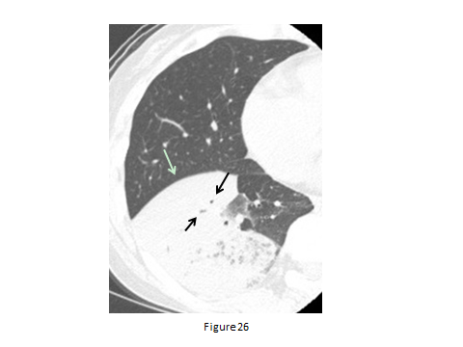
Figure 26 Invasive mucinous adenocarcinoma (formerly mucinous bronchioloalveolar carcinoma) in a woman in her 60s. Thin-section CT shows a nonsegmental consolidation with a bulging fissure (arrow) and narrowed air bronchograms (black arrows).

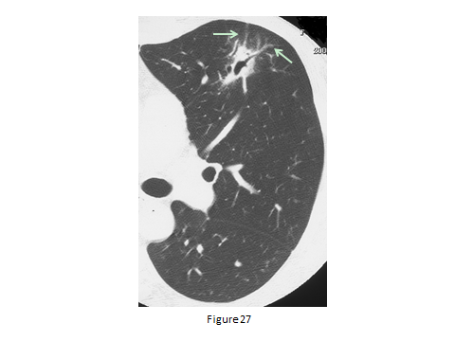
Figure 27 Pulmonary malignant lymphoma (mucosa associated lymphoid tissue lymphoma) in a woman in her 30s. Thin-section CT shows a focal consolidation with dilated air bronchograms in the lingula of the left upper lobe. Note mild thickening of the vessels penetrating the consolidation (arrows), suggestive of infiltrative growth of malignant lymphoma along the vessels.

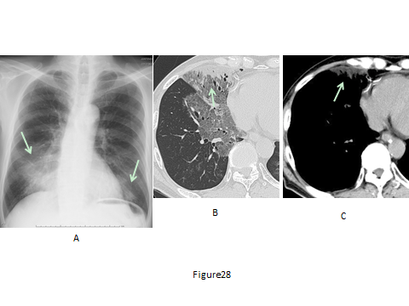
Figure 28 Exogenous lipoid pneumonia in a woman in her 30s: courtesy of Dr. Kazuhiro Suzuki, an attending radiologist, at the department of Radiology, Juntendo University School of Medicine. This patient had been taking petrolatum (paraffin) for intractable constipation. The presence of lipid was confirmed by transbronchial lung biopsy. A: Chest radiograph shows bilateral consolidations in the lower lung fields (arrows); B: Thin-section CT demonstrates an area of clearly demarcated GGO with a subpleural consolidation (arrow); C: Chest CT with a mediastinal window setting reveals the subpleural consolidation to be of fat attenuation (arrow, mean CT value -45HU).

