Name of journal: World Journal of Gastroenterology
ESPS Manuscript NO: 26976
Manuscript Type: ORIGINAL ARTICLE

Basic Study
Effects of Lizhong Tang on gastrointestinal motility in mice

Lee MC et al. Lizhong Tang and GI motility

Min Cheol Lee, Wooram Ha, Jinhyeong Park, Junghoon Kim, Yunjin Jung, Byung Joo Kim

Min Cheol Lee, Byung Joo Kim, Division of Longevity and Biofunctional Medicine, Healthy Aging Korean Medical Research Center, School of Korean Medicine, Pusan National University, Yangsan 50612, South Korea

Wooram Ha, Jinhyeong Park, Junghoon Kim, Division of Pharmacology, School of Korean Medicine, Pusan National University, Yangsan 50612, South Korea

Yunjin Jung, College of Pharmacy, Pusan National University, Busan 46241, South Korea

Author Contributions: Lee MC and Kim BJ designed the research; Lee MC, Ha W, Park J and Kim J performed the experiments; Jung Y and Kim BJ analyzed the data; and Lee MC and Kim BJ wrote the paper.

Supported by National Research Foundation of Korea Grant funded by the Korea Government, No. 2014R1A5A2009936.

Institutional animal care and use committee statement: Animal care and experiments were conducted in accordance with the guidelines issued by the Institutional Animal Care and Use Committee (IACUC) of Pusan National University (Busan, Republic of Korea; Approval No. PNU-2015-1036) and the Guide for the Care and Use of Laboratory Animals from the National Institutes of Health.

Conflict-of-interest statement: The authors declared that they have no conflicts of interest to this work.

Data sharing statement: No additional data are available.

Open-Access: This article is an open-access article which was selected by an in-house editor and fully peer-reviewed by external reviewers. It is distributed in accordance with the Creative Commons Attribution Non Commercial (CC BY-NC 4.0) license, which permits others to distribute, remix, adapt, build upon this work non-commercially, and license their derivative works on different terms, provided the original work is properly cited and the use is non-commercial. See: http://creativecommons.org/licenses/by-nc/4.0/

Manuscript source: Invited manuscript

Correspondence to : Byung Joo Kim, PhD, Associate Professor, Division of Longevity and Biofunctional Medicine, School of Korean Medicine, Pusan National University, Beomeori, Mulgeum-eup, Yangsan, Gyeongsangnamdo, 50612, South Korea. vision@pusan.ac.kr
Telephone: +82-51-5108469
Fax: +82-51-5108420

Received: May 2, 2016
Peer-review started: May 2, 2016
First decision: May 27, 2016
Revised: June 7, 2016
Accepted: July 31, 2016
Article in press:
Published online:

Abstract
AIM: To investigate the effects of Lizhong Tang, a traditional Chinese medicine formula, on gastrointestinal motility in mice.

METHODS: The in vivo effects of Lizhong Tang on GI motility were investigated by measuring the intestinal transit rates (ITRs) and gastric emptying (GE) values in normal mice and in mice with experimentally induced GI motility dysfunction (GMD).

RESULTS: In normal ICR mice, the ITR and GE values were significantly and dose-dependently increased by Lizhong Tang (ITR values: 54.4 ± 1.9% vs 65.2 ± 1.8%, P < 0.01 with 0.1 g/kg Lizhong Tang and 54.4 ± 1.9% vs 83.8 ± 1.9%, P < 0.01 with 1 g/kg Lizhong Tang; GE values: 60.7 ± 1.9% vs 66.8 ± 2.1%, P < 0.05 with 0.1 g/kg Lizhong Tang and 60.7 ± 1.9% vs 72.5 ± 1.7%, P < 0.01 with 1 g/kg Lizhong Tang). The ITRs of the GMD mice were significantly reduced compared with those of the normal mice, which were significantly and dose-dependently reversed by Lizhong Tang. Additionally, in loperamide- and cisplatin-induced models of GE delay, Lizhong Tang administration reversed the GE deficits.

CONCLUSION: These results suggest that Lizhong Tang may be a novel candidate for development as a prokinetic treatment for the GI tract.

Key words: Lizhong Tang; Gastrointestinal disorders; Motility; Intestinal transit rate; Gastric emptying

© The Author(s) 2016. Published by Baishideng Publishing Group Inc. All rights reserved.

Core tip: Lizhong Tang, a traditional Chinese medicinal formula, has been widely used in China, Japan, and Korea for many years to ameliorate gastrointestinal (GI) disorders. Our data suggest that Lizhong Tang is a novel candidate for development as a prokinetic agent for treatment of GI motility dysfunctions in man.

Lee MC, Ha W, Park J, Kim J, Jung Y, and Kim BJ. Effects of Lizhong Tang on gastrointestinal motility in mice. World J Gastroenterol 2016; In press

INTRODUCTION
Lizhong Tang, also known as Yijung-tang or Richu-to, is a traditional Chinese medicine (TCM) formula^{[1]} and is composed of Radix Ginseng (Panax ginseng C.A. Meyer), Rhizoma Zingiberis (Zingiber officinale Roscoe), Rhizoma Atractylodis Macrocephalae (Atractylodes macrocephala Koidz.), and Radix Glycyrrhizae (Glycyrrhiza uralensis Fisch)^{[2]}. Lizhong Tang is widely used in traditional medicine to treat gastrointestinal (GI) disorders, such as vomiting, diarrhea, stomach pain, chronic gastritis, stomach bleeding, and GI ulceration, in China, Japan, and Korea^{[1-3]}. However, no studies have been conducted to evaluate the effect of Lizhong Tang on GI motility.
Prokinetic agents are medications that enhance coordinated GI motility and the transit of content in the GI tract mainly by amplifying and coordinating the GI muscular contractions. In addition, prokinetic therapy should be considered as a means to improve gastric emptying and symptoms of gastroparesis, balancing the benefits and risks of treatment^{[4]}. Recently, prokinetic therapy has been shown to improve the symptoms and quality of life in patients with GI motility disorders^{[5]}. Therefore, there has been an increasing need to develop safer and more effective gastroprokinetic agents.
In our previous report, we investigated the effects of Lizhong Tang on mouse small intestine interstitial cells of Cajal (ICC)^{[6]}. These cells are the pacemaker cells of GI muscles and generate rhythmic oscillations in membrane potentials known as slow waves^{[7-9]} by activating Ca²⁺ entry through L-type Ca²⁺ channels in smooth muscles to initiate GI contractions^{[10,11]}. In this report, we found that Lizhong Tang affected GI motility by modulating pacemaker activity in ICC through internal Ca²⁺- and phospholipase (PLC)-dependent pathways^{[6]}. However, despite the widespread use of Lizhong Tang to treat GI disorders, little is known about its regulatory effects on GI motility. Therefore, we performed this study to investigate the effects of Lizhong Tang on the mouse GI tract in vivo.

MATERIALS AND METHODS
Preparation of the standard solutions and sample extracts
Liquiritin, 6-gingerol, ononin, glycyrrhizin, ginsenoside Rg1, isoliquiritin, and atractylenolide III were accurately weighed and dissolved in methanol (all at 100 μg/mL) to prepare standard solutions. Lizhong Tang powder was dissolved in the water and then filtered through a 0.2 μm syringe filter (BioFACTTM, Korea) prior to injection in the HPLC.

Chromatographic conditions
An Agilent 1200 (Agilent Technologies, Palo Alto, CA, United States) equipped with an autosampler, degasser, quaternary solvent pump, and diode array detector (DAD) was used for the analysis. The data were acquired using ChemStation software (Agilent Technologies, Palo Alto, CA, United States). Separation was performed on a Capcell Pak Mg II C₁₈ column (4.6 mm × 250 mm, 5 μm; Shiseido, Tokyo, Japan) at 35 °C. The mobile phase consisted of water containing 0.1% trifluoroacetic acid (A) and acetonitrile (B), and gradient elution was conducted as follows: 5% (B) for 0–1 min; 5%–10% (B) for 1–5 min and held for 5 min; 10%–15% (B) for 10–12 min and held for 4 min; 15%–20% (B) for 16–18 min and held for 4 min; 20%–23% (B) for 22–25 min and held for 6 min; 23%–28% (B) for 31–32 min and held for 8 min; and 28–65% (B) for 40–80 min and held for 2 min. The column was then re–equilibrated using 5% (B) for the subsequent analyses. The flow rate was set at 1.0 ml/min, and the detection wavelengths were 205, 230, 250, 280, and 360 nm.

Animals
Male ICR mice (Samtako BioKorea Co., Ltd., Osan, Republic of Korea) weighing 23–30 g were used to investigate the effects of the Lizhong Tang extract on the GI tract in vivo. The animals were maintained under controlled conditions (21 ± 3°C, relative humidity 50 ± 6%, lights on 6 a.m.–6 p.m.). The mice were allowed free access to a commercial diet and tap water, but were fasted for 24 h before the experiments. All experiments were conducted between 10 a.m. and 6 p.m.

Measurement of ITR using Evans blue staining
We used Evans blue solution (5%, w/v, in distilled water (DW)) to determine the ITRs of the Lizhong Tang extract in vivo. The Evans blue solution was administered (0.1 mL/kg of body weight; i.g.) through an orogastric tube 30 min after the Lizhong Tang extract was intragastrically (i.g.) administered to the normal ICR mice. The animals were sacrificed 30 min after Evans blue administration, and the intestinal transit distances of the dye were determined by measuring the distance the Evans blue dye had migrated in the intestine from the pylorus to its most distal point. Intestinal transit was quantified using the intestinal transit rates (ITR) (%), which were calculated by expressing the distance the Evans blue dye traveled in 30 min as a percentage of the total small intestine length (from the pylorus to the ileal terminus).

Induction of GI motility dysfunction in mice
Two experimental GI motility dysfunction models were used: an acetic acid (AA)-induced peritoneal irritation mouse model and a STZ-induced diabetic mouse model. For the AA model, peritoneal irritation was induced by administering AA to ICR mice 30 min after the i.g. administration of the Lizhong Tang extract (or DW as vehicle) by intraperitoneally (i.p.) injecting 10 ml/kg AA (0.6%, w/v, in saline) as previously described^{[12-14]}. After injecting AA, the mice were placed in individual cages and allowed to recover for 30 min. Male ICR mice (aged 5 wk) were used for the STZ-induced diabetic mouse model. The mice were randomly allocated to two groups: a control group or a diabetic group. The mice were fasted overnight and an STZ (Sigma-Aldrich, St. Louis, MO) solution was administered i.p. on the following day to produce diabetes. Fresh STZ was prepared in 0.1 mol/L ice-cold citrate buffer (pH 4.0) and administered at 200 mg/kg body weight^{[15]}. The control mice were i.p. administered the same volume of 0.1 mol/L citrate buffer. The animals had free access to food and water and were maintained under standard conditions (24–27 °C, RH 60%–65%) under a 12 h light/dark cycle. Two months after the STZ injection, blood was withdrawn from a tail vein after an 8 h fast and the blood glucose concentrations were measured using a ONE-TOUCH Select Simple kit (Johnson and Johnson Medical Company). Diabetes was defined as a blood glucose level of > 16 mmol/L. No mortality occurred during the study period, and no mouse recovered from STZ-induced diabetes.

Evaluation of gastric emptying
As previously described by Scarpignato et al^{[16]}, the mice were fasted for 24 h with free access to water^{[14]}. Gastric emptying (GE) was performed by administering a 0.05% (w/v) phenol red solution (0.5 mL/mouse) 30 min after treatment with the Lizhong Tang extract. Twenty min later, the mice were sacrificed and the stomachs were immediately removed, cut into several pieces, placed into 5 mL of 0.01 N NaOH, and homogenized. The homogenates were treated with 0.2 mL of 20% trichloroacetic acid per mL of homogenate. The mixtures were centrifuged for 10 min at 1050 × g, and the supernatants (0.05 mL) were added to 0.5 N NaOH (0.2 mL). The absorbances of these mixtures were measured using a spectrometer at 560 nm. The GE value (%) was calculated as 100-(A/B) × 100, where A is the test stomach absorbance (560 nm) and B is the control stomach absorbance (560 nm) immediately after phenol red administration.

Drugs
All drugs were purchased from Sigma-Aldrich (Sigma-Aldrich, St. Louis, MO). In addition, an aqueous extract of the dried immature fruit of Poncirus trifoliate Raf. (PF) was prepared as previously described^{[17,18]} and its prokinetic activities were compared with the Lizhong Tang extract. PF is one of the most popular traditional folk medicines used in Korea and is obtained from Rutaceae fruits. PF has been shown to possess unique, potent prokinetic activities in normal rodents and rodents with GI motility dysfunction (GMD)^{[13,17]}.

Statistical analysis
The results are expressed as the means ± SE. Statistical analysis was performed using Student's t test or analysis of variance followed by Tukey's multiple comparison test, as appropriate. Statistical significance was accepted for P values < 0.05.

RESULTS
Identification of standard compounds in the Lizhong Tang extract
The following components of the Lizhong Tang extract were detected by HPLC using commercial standards (retention time): liquiritin (25.1 min); ononin (35.9 min); isoliquiritin (36.2 min); ginsenoside Rg1 (36.7 min); glycyrrhizin (58.2 min); 6-gingerol (63.0 min); and atractylenolide III (65.8 min) (Figure 1).

Effects of the Lizhong Tang extract on ITR in normal mice
After 30 min, the mean ITR (%) for Evans blue in normal mice was 54.4 ± 1.9% (Figure 2). PF (1 g/kg), which has been shown to have prokinetic activity in the GI tract^{[17,18]}, significantly accelerated the ITR [79.4 ± 2.3% (P < 0.01)], similar to the Lizhong Tang extract, which dose-dependently increased the ITR (%) [ITR values at 0.01, 0.1 and 1 g/kg were 56.1 ± 2.1%, 65.2 ± 1.8% (P < 0.01) and 83.8 ± 1.9% (P < 0.01), respectively; Figure 2]. Loperamide decreased the ITR (%), which is consistent with previous reports^{[19]}, and the Lizhong Tang extract inhibited this loperamide-induced decrease in ITR [ITR value for loperamide was 56.1 ± 2.1%; and ITR value for loperamide with the Lizhong Tang extract was 65.2 ± 1.8% (P < 0.01); Figure 2].

Effects of the Lizhong Tang extract on ITR in mice with GMD
We used the AA and STZ-induced diabetic mouse models of experimental GMD to examine the effect of the Lizhong Tang extract on GI motility. As mentioned above, the AA mouse model showed a significant retardation of ITR (%) [23.2 ± 1.5% (P < 0.01 vs normal); Figure 3]. However, a significant inhibition of this retardation was observed when the mice were intragastrically administered 0.01, 0.1, or 1 g/kg of the Lizhong Tang extract [25.3 ± 2.4%, 34.5 ± 2.1% (P < 0.01) and 51.8 ± 5.7% (P < 0.01), respectively; Figure 3]. No abnormal clinical signs or changes were observed in the AA mice after administration of the Lizhong Tang extract. In addition, loperamide decreased the ITR (%) in the AA mice [13.5 ± 2.4% (P < 0.01)], and the Lizhong Tang extract increased this value [26.7 ± 2.1% (P < 0.01); Figure 3]. Furthermore, the STZ-induced diabetic mice also showed a significant ITR (%) retardation (44.1 ± 3.5%; Figure 4), which was also significantly inhibited by treatment with the Lizhong Tang extract at 0.01, 0.1 or 1 g/kg [53.8 ± 1.5% (P < 0.01), 57.7 ± 1.4% (P < 0.01) and 71.5 ± 3.0% (P < 0.01), respectively; Figure 4]. No abnormal clinical signs or changes were observed in the STZ-induced diabetic mice after the administration of the Lizhong Tang extract. In addition, loperamide decreased the ITR in the STZ-induced diabetic mice [20.6 ± 1.8% (P < 0.01)], and the Lizhong Tang extract increased this value [40.6 ± 2.2% (P < 0.01); Figure 4]. These results indicate that the Lizhong Tang extract increased the ITR in mice with GMD.

Effect of the Lizhong Tang extract on accelerating GE
In normal mice, the groups treated with the Lizhong Tang extract (0.01, 0.1 and 1 g/kg) showed significantly enhanced GE (%) values compared to that of the normal group [the GE values with 0.01, 0.1 and 1 g/kg of the Lizhong Tang extract were 61.7 ± 1.6%, 66.8 ± 2.1% (P < 0.05) and 72.5 ± 1.7% (P < 0.01), respectively; Figure 5]. Its effects were dose-dependent in the dosage range from 0.01 g/kg to 1 g/kg, and 1 g/kg of the Lizhong Tang extract displayed effects similar to those of 5 mg/kg mosapride [74.4 ± 3.3% (P < 0.01)] and 5 mg/kg domperidone [72.9 ± 1.9% (P < 0.01)] (Figure 5). Next, we examined loperamide-induced and cisplatin-induced models of GE delay to determine whether the Lizhong Tang extract could increase GE in abnormally depressed GE models. In the loperamide-induced model of GE delay, the GE value was lower than normal [40.9 ± 1.6% (P < 0.01); Figure 6], and this decrease was recovered by treatment with the Lizhong Tang extract at doses from 0.01 to 1 g/kg [the GE values for the Lizhong Tang extract at 0.01, 0.1 and 1 g/kg were 41.8 ± 2.2%, 47.8 ± 1.2% (P < 0.01) and 59.4 ± 1.5% (P < 0.01), respectively; Figure 6]. The maximal effect was obtained at 1 g/kg, and at this dose, the effect of the Lizhong Tang extract was comparable to that of 5 mg/kg mosapride [61.4 ± 2.3% (P < 0.01)] or 5 mg/kg domperidone [61.5 ± 1.7% (P < 0.01)] (Figure 6). In addition, in the cisplatin-induced model of GE delay, the decreased GE was recovered by treatment with the Lizhong Tang extract (0.01, 0.1 and 1 g/kg) [GE values of the Lizhong Tang extract at 0.01, 0.1 and 1 g/kg were 31.7 ± 1.3%, 43.1 ± 2.1% (P < 0.01) and 60.8 ± 1.7% (P < 0.01), respectively; Figure 7]. The maximal effect was obtained at 1 g/kg, and at this level, the effect of the Lizhong Tang extract was comparable to that of 5 mg/kg mosapride [65.6 ± 1.4% (P < 0.01)] or 5 mg/kg domperidone [63.7 ± 1.2% (P < 0.01)] (Figure 7).

DISCUSSION
GI motility results from the coordinated contractions of the tunica muscularis, which forms the outer wall of the alimentary canal from the distal esophagus to the external anal sphincter^{[20]}. The pathogeneses of primary intestinal motility disorders is probably multifactorial and includes structural and biochemical abnormalities, forms of intestinal pseudo-obstruction, and mucosal inflammation^{[21]}.
The GI tract exhibits spontaneous mechanical contractions and electrical pacemaker potentials^{[7,8]}, and these pacemaker potentials are the basic determinant of GI smooth muscle activity^{[7,8]}. Recent studies have shown that ICC act as the pacemakers and conductors of electrical slow waves in the GI tract^{[7,8]}.
In our previous report, we investigated the effects of Lizhong Tang on ICC in the GI tract^{[6]}. Lizhong Tang induced pacemaker potential depolarizations that were mediated by non-selective cationic channels, intracellular calcium release, and PLC-dependent pathways. Therefore, we suggested that Lizhong Tang might have gastroprokinetic effects on ICC^{[6]}. In addition, many scientists have studied the effects of Lizhong Tang. For example, Lizhong Tang has been shown to have therapeutic effects, such as immunomodulatory, anticancer, antitoxic, and antioxidant effects, and to modulate gastric acid secretion^{[22-24]}. Furthermore, in traditional medicine, it is used to treat the spleen or kidney deficiencies associated with the common symptoms of many diseases, such as pasty loose stools, heavy menstrual bleeding, soreness, and weakness of the lower back and knees^{[2,25,26]}. Moreover, Lizhong Tang possesses potent anti-osteoporotic activity and has been suggested for use in the treatment of postmenopausal osteoporosis^{[3]}. In addition, Lizhong Tang protects the gastric mucosa from acute ethanol-induced gastric injury and has been suggested as a treatment for acute gastric injury^{[1]}. However, despite the considerable use of Lizhong Tang, little is known about its regulatory effects on GI motility in vivo.
In this study, the Lizhong Tang extract significantly and dose-dependently accelerated ITR (Figure 2). In experimental GMD (AA mouse and STZ-induced diabetic mouse) models, the Lizhong Tang extract significantly inhibited GMD-induced retardation (Figures 3 and 4), and Lizhong Tang extract-treated mice had significantly greater GE values than normal mice; 1 g/kg of the Lizhong Tang extract displayed effects similar to those of mosapride and domperidone (Figure 5). Furthermore, in abnormally depressed (loperamide- and cisplatin-induced) GE models, the Lizhong Tang extract increased GE (Figure 6 and 7).
Prokinetic drugs, which enhance GI motor function by acting on a variety of neurotransmitter receptors, have been used to treat patients with GI motility disorders^{[27]} and are regarded as one of the most efficacious therapeutics for this disorder^{[28,29]}. Cholinergic agonists, the original promotility agents, stimulated muscarinic M₂-type receptors on the smooth muscle cells, but their effectiveness in motility disorders is inconsistent^{[30]}. Metoclopramide and domperidone, dopamine antagonists, have been the most widely used as prokinetic agents^{[31]}, but their long-term use has been complicated by a trend toward tolerance and a significant incidence of central nervous system (CNS) side effects^{[32]}. Cisapride was shown to promote esophageal peristalsis, augment lower esophageal sphincter pressure, and accelerate gastric emptying^{[33]}. However, the use of this drug is now restricted due to serious cardiac arrhythmias related to a prolonged QT interval^{[34]}. Mosapride, a selective 5-HT₄ agonist, is available as a prokinetic agent in a number of Asian countries, but the efficacy data are contradictory^{[35]}. Itopride is a dopamine D₂ antagonist with prokinetic effects that is devoid of CNS or cardiovascular side effects and causes minimal elevations of prolactin levels^{[36]}. In this study, we did not directly compare the GE and intestine motility rates with these prokinetics agents. However, in a previous study, we showed that Lizhong Tang depolarized the pacemaker potentials through G-protein-, PLC- and Ca²⁺-dependent pathways. Moreover, the nonselective cationic cation channel was involved in these effects^{[6]}. Therefore, we believe that Lizhong Tang might mimic the major excitatory neurotransmitters of the GI tract and act as a gastroprokinetic agent. Additionally, herbal products may be an attractive alternative based on the perception of their ‘natural’ approach and their low risk of side effects^{[37]}. Therefore, we believe that Lizhong Tang may be a good gastroprokinetic agent, and in the future, we should compare the experimental results with those of known prokinetics and analyze the side effects.
In summary, in normal ICR mice, both the ITR and GE values were significantly and dose-dependently increased by treatment with the Lizhong Tang extract. Furthermore, the ITRs of GMD mice were significantly reduced compared with those of the normal mice, and these reductions were significantly and dose-dependently reversed by treatment with the Lizhong Tang extract. In addition, in the loperamide-induced and cisplatin-induced model of GE delay, the Lizhong Tang extract prevented the observed GE delays. Taken together, our results suggest that Lizhong Tang is a good candidate for the development of a gastroprokinetic agent.

COMMENTS
Background
Lizhong Tang [composed of Radix Ginseng (Panax ginseng C.A. Meyer), Rhizoma Zingiberis (Zingiber officinale Roscoe), Rhizoma Atractylodis Macrocephalae (Atractylodes macrocephala Koidz.) and Radix Glycyrrhizae (Glycyrrhiza uralensis Fisch.)] is a traditional Chinese medicinal formula that has been widely used in China, Japan and Korea for many years to ameliorate the symptoms of gastrointestinal (GI) disorders. However, despite the considerable use of Lizhong Tang in traditional medicine to treat GI dysfunction, little was known of its regulatory effects on GI motility in vivo.

Research frontiers
Lizhong Tang is a good candidate for development as a gastroprokinetic agent.

Innovations and breakthroughs
In normal ICR mice, both the ITRs and GE values were significantly and dose-dependently increased by treatment with Lizhong Tang (0.1-1 g/kg). The ITRs of the GMD mice were significantly reduced compared with those of the normal mice, and the values were significantly and dose-dependently reversed by treatment with Lizhong Tang (0.1-1 g/kg). Moreover, in loperamide-induced and cisplatin-induced models of GE delay, Lizhong Tang prevented the observed GE delays.

Applications
Lizhong Tang may be a new target or a novel candidate prokinetic agent for the pharmacological treatment of GI motility disorders.

Terminology
GI motility: movements of the digestive system and the transit of contents within the digestive system; ITRs: rate of passage of food (sometimes in the form of a test meal) through the GI tract; Gastric emptying: to empty the stomach contents

Peer-review
This study is relevant, interesting, is written in suitable english, and have a correct methodological design. It is important to emphasize the contribution that this study provides for integration between western and eastern medicine, which is fundamental to the advancement of modern science.

REFERENCES
1 Shin IS, Lee MY, Lim HS, Seo CS, Ha HK, Shin HK. Gastroprotective effects of Leejung-tang, an oriental traditional herbal formula, on ethanol-induced acute gastric injury in rats. Afr J Tradit Complement Altern Med 2013; 10: 324-330 [PMID: 24146457 DOI: 10.4314/ajtcam.v10i2.18]
2 Zhao N, Zhang W, Guo Y, Jia H, Zha Q, Liu Z, Xu S, Lu A. Effects on neuroendocrinoimmune network of Lizhong Pill in the reserpine induced rats with spleen deficiency in traditional Chinese medicine. J Ethnopharmacol 2011; 133: 454-459 [PMID: 20951788 DOI: 10.1016/j.jep.2010.10.016]
3 Kim T, Ha H, Shim KS, Cho WK, Ma JY. The anti-osteoporotic effect of Yijung-tang in an ovariectomized rat model mediated by inhibition of osteoclast differentiation. J Ethnopharmacol 2013; 146: 83-89 [PMID: 23219731 DOI: 10.1016/j.jep.2012.11.037]
4 Acosta A, Camilleri M. Prokinetics in gastroparesis. Gastroenterol Clin North Am 2015; 44: 97-111 [PMID: 25667026 DOI: 10.1016/j.gtc.2014.11.008]
5 Cutts TF, Abell TL, Karas JG, Kuns J. Symptom improvement from prokinetic therapy corresponds to improved quality of life in patients with severe dyspepsia. Dig Dis Sci 1996; 41: 1369-1378 [PMID: 8689913 DOI: 10.1007/bf02088561]
6 Hwang MW, Kim JN, Song HJ, Lim B, Kwon YK, Kim BJ. Effects of Lizhong Tang on cultured mouse small intestine interstitial cells of Cajal. World J Gastroenterol 2013; 19: 2249-2255 [PMID: 23599652 DOI: 10.3748/wjg.v19.i14.2249]
7 Huizinga JD, Thuneberg L, Klüppel M, Malysz J, Mikkelsen HB, Bernstein A. W/kit gene required for interstitial cells of Cajal and for intestinal pacemaker activity. Nature 1995; 373: 347-349 [PMID: 7530333 DOI: 10.1038/373347a0]
8 Sanders KM. A case for interstitial cells of Cajal as pacemakers and mediators of neurotransmission in the gastrointestinal tract. Gastroenterology 1996; 111: 492-515 [PMID: 8690216 DOI: 10.1053/gast.1996.v111]
9 Kim BJ, Park KJ, Kim HW, Choi S, Jun JY, Chang IY, Jeon JH, So I, Kim SJ. Identification of TRPM7 channels in human intestinal interstitial cells of Cajal. World J Gastroenterol 2009; 15: 5799-5804 [PMID: 19998500 DOI: 10.3748/wjg.15.5799]
10 Kim BJ, Lim HH, Yang DK, Jun JY, Chang IY, Park CS, So I, Stanfield PR, Kim KW. Melastatin-type transient receptor potential channel 7 is required for intestinal pacemaking activity. Gastroenterology 2005; 129: 1504-1517 [PMID: 16285951 DOI: 10.1053/j.gastro.2005.08.016]
11 Koh SD, Sanders KM, Ward SM. Spontaneous electrical rhythmicity in cultured interstitial cells of cajal from the murine small intestine. J Physiol 1998; 513 (Pt 1): 203-213 [PMID: 9782170 DOI: 10.1111/j.1469-7793.1998.203by.x]
12 Friese N, Chevalier E, Angel F, Pascaud X, Junien JL, Dahl SG, Riviere PJ. Reversal by kappa-agonists of peritoneal irritation-induced ileus and visceral pain in rats. Life Sci 1997; 60: 625-634 [PMID: 9048965 DOI: 10.1016/S0024-3205(96)00647-9]
13 Lyu JH, Lee HT. Effects of dried Citrus unshiu peels on gastrointestinal motility in rodents. Arch Pharm Res 2013; 36: 641-648 [PMID: 23463336 DOI: 10.1007/s12272-013-0080-z]
14 Ahn TS, Kim DG, Hong NR, Park HS, Kim H, Ha KT, Jeon JH, So I, Kim BJ. Effects of Schisandra chinensis extract on gastrointestinal motility in mice. J Ethnopharmacol 2015; 169: 163-169 [PMID: 25862968 DOI: 10.1016/j.jep.2015.03.071]
15 Wu YS, Lu HL, Huang X, Liu DH, Meng XM, Guo X, Kim YC, Xu WX. Diabetes-induced loss of gastric ICC accompanied by up-regulation of natriuretic peptide signaling pathways in STZ-induced diabetic mice. Peptides 2013; 40: 104-111 [PMID: 23352981 DOI: 10.1016/j.peptides.2012.12.024]
16 Scarpignato C, Capovilla T, Bertaccini G. Action of caerulein on gastric emptying of the conscious rat. Arch Int Pharmacodyn Ther 1980; 246: 286-294 [PMID: 7436633]
17 Kim BJ, Kim HW, Lee GS, Choi S, Jun JY, So I, Kim SJ. Poncirus trifoliate fruit modulates pacemaker activity in interstitial cells of Cajal from the murine small intestine. J Ethnopharmacol 2013; 149: 668-675 [PMID: 23911946 DOI: 10.1016/j.jep.2013.07.017]
18 Kim HJ, Park SY, Kim DG, Park SH, Lee H, Hwang DY, Jung MH, Ha KT, Kim BJ. Effects of the roots of Liriope Platyphylla Wang Et tang on gastrointestinal motility function. J Ethnopharmacol 2016; 184: 144-153 [PMID: 26969403 DOI: 10.1016/j.jep.2016.03.012]
19 Tan-No K, Niijima F, Nakagawasai O, Sato T, Satoh S, Tadano T. Development of tolerance to the inhibitory effect of loperamide on gastrointestinal transit in mice. Eur J Pharm Sci 2003; 20: 357-363 [PMID: 14592702 DOI: 10.1016/j.ejps.2003.08.004]
20 Sanders KM, Koh SD, Ro S, Ward SM. Regulation of gastrointestinal motility--insights from smooth muscle biology. Nat Rev Gastroenterol Hepatol 2012; 9: 633-645 [PMID: 22965426 DOI: 10.1038/nrgastro.2012.168]
21 Wouters MM, Vicario M, Santos J. The role of mast cells in functional GI disorders. Gut 2016; 65: 155-168 [PMID: 26194403 DOI: 10.1136/gutjnl-2015-309151]
22 Kim TG, Park SM, Kang H, Shim BS, Kim SH, Choi SH, Ahn KS. Effect of Baekhasuoyijungtang on mouse T-cell cytokines. Kor J Orien Physiol Pathol 2008; 22: 754-761
23 Seo HY, Han JK, Kim YH. The effect of Li Zhong Tang on the suppression of Th2 differentiation by IFN-γ response in IgE hyperproduction and atopic dermatitis-like lesions induced NC/Nga mouse. J Kor Orien Pediat 2009; 23: 1-22
24 Du QQ, Zhang X, Song FR, Liu ZQ, Liu SY. [Change of the content of chemical constituents and anti-oxidative action of the decoction of radix ginseng combined with Flos Lonicerae, radix Polygoni Multiflori and Radix Astragali]. Yao Xue Xue Bao 2010; 45: 756-760 [PMID: 20939186]
25 Izumi T, Piskula MK, Osawa S, Obata A, Tobe K, Saito M, Kataoka S, Kubota Y, Kikuchi M. Soy isoflavone aglycones are absorbed faster and in higher amounts than their glucosides in humans. J Nutr 2000; 130: 1695-1699 [PMID: 10867038]
26 Zhao X, Wang Y, Yang S, Zhang W, Zu C, Zhang T, Tang B, Zhang B, Li G, Deng B, Cai D. Underlying mechanism of aconitum lizhong acting on experimental hypothermia with indigestion in rats: role of ghrelin. Evid Based Complement Alternat Med 2012; 2012: 542461 [PMID: 22899955 DOI: 10.1155/2012/542461]
27 Galligan JJ, Vanner S. Basic and clinical pharmacology of new motility promoting agents. Neurogastroenterol Motil 2005; 17: 643-653 [PMID: 16185302 DOI: 10.1111/j.1365-2982.2005.00675.x]
28 Hiyama T, Yoshihara M, Matsuo K, Kusunoki H, Kamada T, Ito M, Tanaka S, Nishi N, Chayama K, Haruma K. Meta-analysis of the effects of prokinetic agents in patients with functional dyspepsia. J Gastroenterol Hepatol 2007; 22: 304-310 [PMID: 17295758 DOI: 10.1111/j.1440-1746.2006.04493.x]
29 Lee TH, Choi JJ, Kim DH, Choi S, Lee KR, Son M, Jin M. Gastroprokinetic effects of DA-9701, a new prokinetic agent formulated with Pharbitis Semen and Corydalis Tuber. Phytomedicine 2008; 15: 836-843 [PMID: 18490147 DOI: 10.1016/j.phymed.2008.02.019]
30 Malagelada JR, Rees WD, Mazzotta LJ, Go VL. Gastric motor abnormalities in diabetic and postvagotomy gastroparesis: effect of metoclopramide and bethanechol. Gastroenterology 1980; 78: 286-293 [PMID: 7350052]
31 Halter F, Staub P, Hammer B, Guyot J, Miazza BM. Study with two prokinetics in functional dyspepsia and GORD: domperidone vs. cisapride. J Physiol Pharmacol 1997; 48: 185-192 [PMID: 9223023]
32 Lata PF, Pigarelli DL. Chronic metoclopramide therapy for diabetic gastroparesis. Ann Pharmacother 2003; 37: 122-126 [PMID: 12503946 DOI: 10.1345/aph.1c118]
33 Abell TL, Camilleri M, DiMagno EP, Hench VS, Zinsmeister AR, Malagelada JR. Long-term efficacy of oral cisapride in symptomatic upper gut dysmotility. Dig Dis Sci 1991; 36: 616-620 [PMID: 2022163 DOI: 10.1007/bf01297028]
34 Wang SH, Lin CY, Huang TY, Wu WS, Chen CC, Tsai SH. QT interval effects of cisapride in the clinical setting. Int J Cardiol 2001; 80: 179-183 [PMID: 11578711 DOI: 10.1016/s0167-5273(01)00485-5]
35 Hallerbäck BI, Bommelaer G, Bredberg E, Campbell M, Hellblom M, Lauritsen K, Wienbeck M, Holmgren LL. Dose finding study of mosapride in functional dyspepsia: a placebo-controlled, randomized study. Aliment Pharmacol Ther 2002; 16: 959-967 [PMID: 11966505 DOI: 10.1046/j.1365-2036.2002.01236.x]
36 Huang X, Lv B, Zhang S, Fan YH, Meng LN. Itopride therapy for functional dyspepsia: a meta-analysis. World J Gastroenterol 2012; 18: 7371-7377 [PMID: 23326147 DOI: 10.3748/wjg.v18.i48.7371]
37 Suzuki H, Inadomi JM, Hibi T. Japanese herbal medicine in functional gastrointestinal disorders. Neurogastroenterol Motil 2009; 21: 688-696 [PMID: 19563404 DOI: 10.1111/j.1365-2982.2009.01290.x.]

P-Reviewer: Soares RLS, Chan V, Demir Y S-Editor: Qi Y L-Editor: E-Editor:

Specialty Type: Gastroenterology and Hepatology
Country of Origin: South Korea
Peer-Review Report Classification
Grade A (Excellent): 0
Grade B (Very good): B, B
Grade C (Good): C
Grade D (Fair): 0
Grade E (Poor): 0

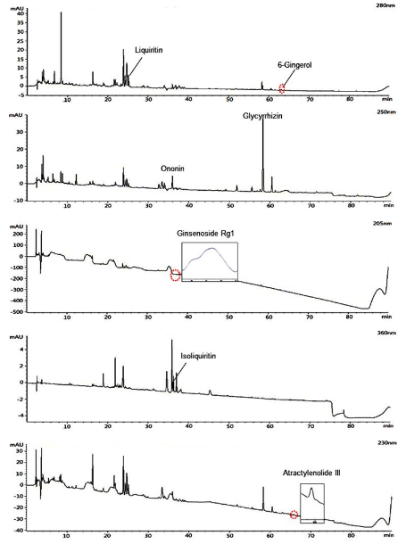
Figure 1 Chromatograms of liquiritin, 6-gingerol, ononin, glycyrrhizin, ginsenoside Rg1, isoliquiritin, and atractylenolide III in Lizhong Tang extract.
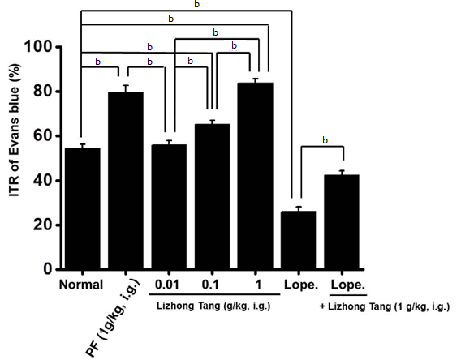
Figure 2 Effects of the Lizhong Tang extract on the intestinal transit rates (%) in normal mice. Intestinal transit rates (ITRs) (%) values of normal mice that were pretreated with the Lizhong Tang extract prior to Evans blue administration (n = 15 for each bar). The bars represent mean values ± SE. ^{b}P < 0.01; Significantly different from the normal controls. PF: Poncirus trifoliate Raf; Lope: Loperamide.
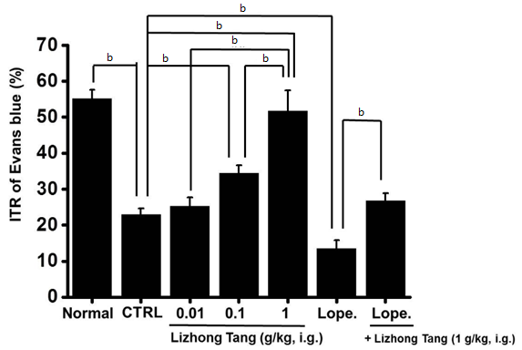
Figure 3 Effects of the Lizhong Tang extract on the intestinal transit rates (%) in AA mice. Intestinal transit rates (ITRs) (%) values of AA mice induced 30 min before the i.g. administration of Evans blue (n = 12 per bar). The bars represent mean values ± SE. ^{b}P < 0.01; significantly different from the AA controls. CTRL: Control; Lope: Loperamide.
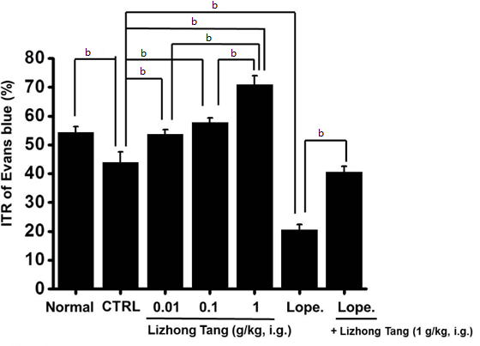
Figure 4 Effects of the Lizhong Tang extract on the Intestinal transit rates (%) values in STZ-induced diabetic mice. Intestinal transit rates (ITRs) (%) values of the STZ mice induced 2 months before the i.g. administration of Evans blue (n = 12 per bar). The bars represent mean values ± SE. ^{b}P < 0.01; significantly different from the STZ-induced diabetic controls. CTRL: Control. Lope: Loperamide.
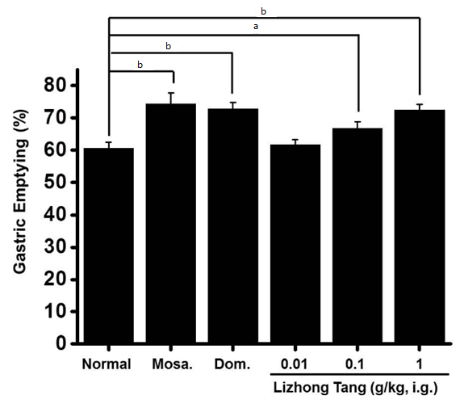
Figure 5 Effect of the Lizhong Tang extract on accelerating gastric emptying. After a 24 h fast, the animals (n = 7/each group) were orally administered the indicated dosages of the Lizhong Tang extract, 5 mg/kg of a 5-HT₄ receptor agonist (mosapride), 5 mg/kg of a dopamine receptor antagonist (domperidone), or distilled water (DW; controls). The GE percentages were calculated as described in the Materials and Methods. The bars represent means ± SE. ªP < 0.05; ^{b}P < 0.01; significantly different from the normal controls. Mosa.: Mosapride. Dom.: Domperidone.
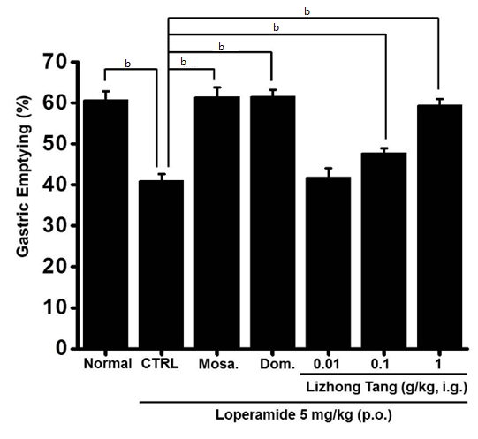
Figure 6 Lizhong Tang extract ameliorates loperamide-induced delays in gastric emptying (GE). After a 24 h fast, the animals (n = 6/each group) were orally administered the indicated dosages of the Lizhong Tang extract, 5 mg/kg of a 5-HT₄ receptor agonist (mosapride), 5 mg/kg of a dopamine receptor antagonist (domperidone), or distilled water (DW; control). The loperamide-induced gastric emptying (GE) delay was inhibited by the Lizhong Tang extract. The GE percentages were calculated as described in the Materials and Methods. The bars represent means ± SE. ^{b}P < 0.01; significantly different from the normal controls. Mosa: Mosapride; Dom: Domperidone; p.o.: per os.
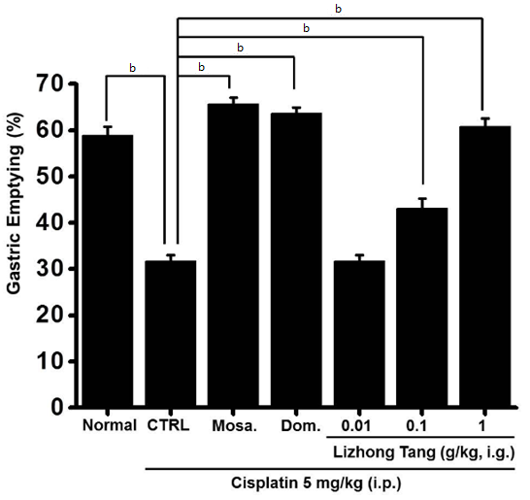
Figure 7 Lizhong Tang extract ameliorated cisplatin-induced delays in gastric emptying. After a 24 h fast, the animals (n = 6/each group) were orally administered the indicated dosages of the Lizhong Tang extract, 5 mg/kg of a 5-HT₄ receptor agonist (mosapride), 5 mg/kg of a dopamine receptor antagonist (domperidone), or distilled water (DW; control). The Lizhong Tang pretreatment prevented the cisplatin-induced GE delay. The GE percentages were calculated as described in the Materials and Methods. The bars represent mean values ± SE. ^{b}P < 0.01; significantly different from the normal controls. Mosa: Mosapride; Dom: Domperidone; i.p: intraperitoneally.

