Title: Thiopurine Use Associated with Reduced B and Natural Killer Cells in IBD

Running Title: Thiopurines Reduce B and NK Cells

Authorship: James D. Lord, MD, PhD, and Donna M. Shows
Institution: Translational Research Program at the Benaroya Research Institute at Virginia Mason, Seattle Washington, United States of America
Author Contributions: Lord JD designed experiments, analyzed data, and wrote the paper. Shows DM performed cell purification, culture and flow cytometry experiments.
Supportive Foundation Acknowledgement: Supported by Virginia Mason Medical Center, Digestive Disease Institute Research Grant Award 0506812-2011
IRB Statement: The study was reviewed and approved by the Virginia Mason Medical Center/Benaroya Research Institute Institutional Review Board.
Conflict of Interest Statement: All authors report no potential conflicts of interest with the data in this manuscript.
Data Sharing Statement: FCS files of flow cytometry data used to generate this manuscript are available upon request from the corresponding author (below).
Correspondence: James D. Lord
1201 Ninth Avenue
Seattle, WA 98101
FAX: 206-287-5682
Tel: 206-287-1088
Email: jlord@benaroyaresearch.org

Abstract:
Background: The thiopurines azathioprine and 6-mercaptopurine have been a mainstay of IBD therapy for decades, but their mechanism of action in vivo remains obscure. Although thiopurines are lymphotoxic at high doses, and have been reported to cause T cell apoptosis, their ability control IBD at lower doses suggests that they may selectively deplete particular lymphocyte populations. Methods: Blood cells from 19 IBD patients on a thiopurine, 19 IBD patients not on a thiopurine, and 38 matched healthy control subjects were analyzed by multiple multicolor flow cytometry panels to quantify the immune cell subsets contained therein, both as a percent of cells, and as an absolute cell count. Results: Use of thiopurines was associated with reduced lymphocyte, but not monocyte or granulocyte counts. This reduction was restricted to CD3-negative lymphocytes, wherein both NK and B cells were significantly reduced among thiopurine recipients. Among CD19+ cells, the transitional B cells were particularly depleted, in both blood and colon biopsies of thiopurine recipients. No differences were associated with thiopurine use in CD8+ T cells, MAIT cells, iNKT cells, gamma/delta T cells, Th1, Th17, Treg or naïve CD4+ T cells. However, patients with IBD had significantly more circulating FOXP3+, Helios+ Tregs and fewer iNKT and MAIT cells than healthy controls. Conclusions: Thiopurine use is associated with reduced B and NK cell, but not T cell, subpopulations in the blood of IBD patients. These findings suggest a mechanism by which thiopurines reduce anti-drug antibodies and increase the risk of neoplasia, respectively.

Aim: To determine if and how thiopurine use is associated with depletion of specific lymphocyte populations.

Introduction:
The thiopurine medications azathioprine and 6-mercaptopurine (6-MP) have been used to treat IBD since the 1960’s(1) as an effective maintenance therapy for both Crohn’s disease(2) and ulcerative colitis (UC)(3). In more recent years, these agents have demonstrated utility as cotherapy with biopharmaceuticals, reducing the incidence of anti-drug antibodies and increasing treatment success rates (4, 5). While appealing for their oral delivery and relatively low cost, thiopurines are challenging to use, with a narrow therapeutic dose window, slow onset of efficacy(6) and a number needed to treat in the 4-6 range(2, 3). This benefit is balanced against a number of potential risks, including infections, and certain neoplasms(7).
The mechanisms by which thiopurines maintain IBD remission and prevent anti-biopharmaceutical antibody formation remain obscure. 6-thioguanine nucleotides (6-TGN) are thought to be the active metabolites of both azathioprine and 6-MP, and originally were believed to function by incorporating into cellular nucleic acids to damage their structure(8) and thus inhibit T cell proliferation(9). In vitro studies also demonstrated that thiopurines mediate apoptosis(10), and specifically the 6-thioguanine triphosphate (6-thio-GTP) metabolite may stimulate T cell apoptosis through inhibition of Rac1 activation, thus preventing CD28 costimulation from inducing Bcl-x_{L} expression in these cells upon activation(11). Leukopenia is a known effect of azathioprine therapy(12), and has been associated with therapeutic efficacy(13). However, this association appears to be due to decreased neutrophil counts seen during the early phase of thiopurine use, with lymphopenia demonstrating no correlation with therapeutic efficacy(14). Thus, if azathioprine suppresses the inflammation of IBD through anti-proliferative or pro-apoptotic effects on lymphocytes, these effects must be subtle, affecting only specific minor lymphocyte subpopulations, clonotypes, or anatomically sequestered populations not evident in the peripheral blood.
Early studies of azathioprine in UC showed that it reduced total plasma cell counts in the rectal mucosa(15) to levels resembling healthy controls(16). However, it is unclear whether this is a specific effect of azathioprine versus simply a reflection of reduced lymphocytic infiltration as a consequence of decreased inflammation. These studies also demonstrated less antibody-dependent cell mediated cytotoxicity (ADCC) in the blood of azathioprine recipients(15-17), a phenomenon that is classically attributed to natural killer (NK) cells. More recent research comparing the mRNA transcripts of peripheral blood from Crohn’s patients revealed reduced expression of genes commonly expressed by NK and other cytotoxic lymphocytes in thiopurine recipients(18), suggesting that thiopurines may function through selective depletion of NK cells. One small study of Crohn’s patients prospectively examined the effect of azathioprine on immune cell subsets over a year, and found it to reduce total lymphocyte counts, but with no significant effect upon the percent of these lymphocytes expressing the NK markers CD16 and CD56(19).
Curiously, this study also found azathioprine to significantly increase the percent of lymphocytes expressing CD25(19). Among CD4+ T cells, CD25 is a marker of FOXP3+ regulatory T cells (Tregs), which are known to play a central role in preventing intestinal inflammation in mice(20) and humans(21, 22). Although CD25+, FOXP3+ Tregs are not deficient in IBD patients(23), their frequency in the blood has been reported to be reduced in active versus quiescent disease, and their frequency in the intestinal mucosa, while enriched in inflammation(24, 25), may be relatively low compared to other causes of intestinal inflammation(26). Thus, an alternative mechanism by which thiopurines could control IBD may be by selectively sparing, and thus enriching, Tregs in the intestinal lamina propria (LP).
We evaluated IBD patients on or off thiopurines to correlate the use of these medications with changes in B, T, and NK cells, and compared them with lymphocyte subsets in matched healthy control subjects. In the peripheral blood, we found more FOXP3+ Helios+ Tregs and fewer MAIT and iNKT cells in IBD patients than controls, but thiopurine use correlated with no changes in any T cell subpopulations. Thiopurine use was instead significantly associated with reduced B and NK cells, and particularly CD38+ transitional B cells, but not memory B cells or plasmablasts.
Materials and Methods:
Ethical Considerations: Clinical data, including complete blood cell (CBC) counts presented in figure 1, and specimens detailed below, were archived from consenting participants in a biorepository program at the Benaroya Research Institute, as authorized by an IRB-approved protocol in accordance with the declaration of Helsinki.
Patients and Specimens: 42 IBD patients (31 Crohn’s, 10 UC, 1 indeterminate colitis) on azathioprine (n=34) or 6-mercaptopurine (n=8) and 168 IBD patients (105 Crohn’s, 61 UC, 2 indeterminate colitis) on no thiopurines provided CBC data in figure 1.
Live, frozen peripheral blood mononuclear cells (PBMC) were obtained from 19 of the above IBD patients (14 Crohn’s, 5 UC) on azathioprine (n=16) or 6-mercaptopurine (n=3), and 19 IBD patients (also 14 Crohn’s, 5 UC) on no thiopurine medications, but matched in terms of whether or not taking a 5’ aminosalicylate agent. Also, PBMC were obtained from 38 healthy controls, age and gender-matched to each of these IBD patients. None of these blood donors were on glucocorticoids, biopharmaceuticals, or other systemic immunosuppressive agents at the time of phlebotomy.
Live, frozen, colonoscopic biopsies were obtained from 17 IBD patients (13 Crohn’s, 4 UC) on azathioprine (n=14) or 6-mercaptopurine (n=3), and 17 IBD patients (also 13 Crohn’s, 4 UC) on no thiopurines at the time of colonoscopy. 7 patients in each group were on an anti-TNF biopharmaceutical, and 3 patients in each group were on a glucocorticoid. 6 patients in the thiopurine group and 8 in the no thiopurine group were on a 5’ aminosalicylate agent. The colonic mucosa biopsied was deemed by the colonoscopist to be actively inflamed in 6 of the patients on thiopurines and 7 of the patients on no thiopurines.
Flow Cytometry: Samples were thawed and colon biopsies were digested in a vortex at 37 degrees centigrade for 30 minutes in media containing collagenase and DNAse to liberate single cells. Cells were then filtered, washed, and stained extracellularly with panels of fluorophor-conjugated antibodies. Monoclonal antibodies against CD3 (clone SK7), CD4 (RPA-T4), CD8 (RPA-T8), CD19 (HIB19), CD25 (M-A251), CD27 (L128), CD38 (HIT2), CD49d (9F10), CD56 (NCAM16.2), CTLA4 (BNI3), and Ki67 (B56) were obtained from BD Biosciences (San Jose, CA, USA). Monoclonal antibodies against CD3 (SK7), CD4 (RPA-T4), CD8 (RPA-T8), CD16 (3G10), CD19 (HIB19), CD20 (2H7), CD45RA (HI100), CD49d (9F10), CD56 (HCD56), CD161 (HP-3G10), NKG2D (1D11), IFN gamma (4S.B3), IgD (1A6-2), IgM (MHM-88), TCRva24-Ja18 (6B11), TCRva7.2 (3C10), FOXP3 (236A/E7), and Helios (22F6) were obtained from BioLegend (San Diego, CA, USA). Monoclonal antibodies against CD8 (RPA-T8), NKp46 (9E2), integrin beta 7 (FIB504), gamma delta TCR (B1.1), and IL17A (eBio64DEC17) were obtained from eBiosciences (San Diego, CA, USA). Intracellular staining was performed with a FOXP3 staining kit (eBiosciences). For intracellular cytokine staining (ICCS), cells were first incubated overnight with PMA, ionomycin and brefeldin A. Stained cells were evaluated on either a FACSCanto (BD Biosciences) or, for ICCS, a FACS Calibur (BD Biosciences) flow cytometer. Data was analyzed with FlowJo (FlowJo, LLC, Ashland, OR) Excel (Microsoft, Inc, Redmond, WA), and GraphPad Prism (Graph Pad Software, Inc., La Jolla, CA) software.
Results:
Lymphopenia associated with thiopurine use is not due to selective T cell subset depletion: Comparing the CBC differentials of IBD patients revealed that patients chronically on thiopurines had significantly fewer circulating lymphocytes than patients not on thiopurines, although no differences in monocytes or granulocytes were evident (figure 1a), as has been reported previously in IBD(16). Thiopurine use was not associated with any significant reduction in total CD3+ T cells, or the CD4+ or CD8+ subsets thereof (figure 1b). While this does not exclude the possibility that thiopurines selectively affect a minor T cell subpopulation, thiopurine use was not associated with any changes in the number of TCRγδ+ T cells, TCRvα24/jα18+ invariant NKT cells, or CD161+, CD4-, TCRvα7.2+ mucosa-associated invariant T (MAIT) cells in circulation, although fewer circulating CD161+ iNKT (p=0.00843) and MAIT cells (p=0.00423) were seen in IBD patients than controls (supplemental digital content 1. Graphed frequencies of rare T cell subsets).
To determine if a reported increase in CD25+ CD4+ T cells associated with thiopurine use(19) reflects an increase in FOXP3+ Treg populations, the above PBMC were also stained intracellularly for FOXP3 and the “natural” Treg (nTreg) marker Helios(27). The Helios+ FOXP3+ nTreg fraction of circulating CD4+ T cells was significantly larger in untreated IBD patients than controls (p<0.0012), but the Helios- FOXP3+ fraction was not, and there was no correlation between either Treg population and thiopurine use among IBD patients (figure 1c). Both Treg populations and conventional FOXP3- T cells showed no difference in expression of the naïve T cell marker CD45RA, the inhibitory receptor CTLA4, the IL-2 receptor CD25 , or the proliferation marker Ki67 between IBD patients on versus off thiopurines, and between total IBD patients and controls (supplemental digital content 2a-d. Graphed expression of these markers by lymphocyte populations).
CD4+ effector T cells that make IFN-γ (Th1), IL-17 (Th17) or both (TH1/17) have been proposed to play a pathogenic role in IBD. Through intracellular cytokine staining, we found Th17 cells were rare in PBMC, but more common in IBD patients on no thiopurines than controls (p=0.0338) (figure 2a). While the IBD patients on thiopurines had a mean Th17 frequency much closer to that of controls, it was not significantly different from that of IBD patients not on thiopurines (p=0.0951). Thiopurine use also had no significant correlation with Th1 (figure 2b) or Th1/17 frequency (figure 2c), which additionally were no different between IBD patients and controls. However, thiopurine use did correlate with an increased fraction of CD8+ T cells expressing IFN-γ (p=0.0282) (figure 2d).
Thiopurine use is associated with fewer circulating NK and B cells: In contrast to T cells, CD3- lymphocytes were significantly reduced in the blood of IBD patients relative to controls (p=0.0145), particularly if taking thiopurines (figure 3a). As this population contains both NK and B cells, we evaluated these populations independently. As with the total CD3- lymphocyte numbers, NK cells were significantly less numerous in IBD patients than controls (p=0.0089), and less numerous in thiopurine recipients (p=0.0047), regardless of whether they were defined by the marker CD56 alone (figure 3b), or more strictly with CD56 in combination with CD16 or NKp46 (data not shown). Although some of this reduction simply parallels the overall reduced lymphocyte counts associated with thiopurine use (figure 1a), among IBD patients there were also significantly fewer CD56+ NK cells in thiopurine recipients when analyzed as a percentage of CD3-, CD19- lymphocytes (p=0.0189).
B cell counts were likewise reduced in thiopurine recipients (p=0.0005, figure 3c). This difference was evident among the naïve (CD27-, CD38-, IgD+, p=0.001, figure 3d), but not memory B cells (CD27+, p=0.1836, figure 3e), although memory B cells were less numerous in the blood of IBD patients than controls (p=0.0081). The latter difference was seen in both switched (IgD-) and unswitched (IgD+) memory B cells (data not shown). The most striking effect of thiopurines on B cells was in the transitional (CD38+, CD27-, IgD+) population, which was almost completely obliterated in all thiopurine recipients (p=0.0009, figure 3f). Restricting analyses to B cells bearing the gut-homing integrin α4β7 did not change whether or not these differences were significant (data not shown), suggesting that the effect of thiopurines on circulating B cells was not mediated by altering B cell trafficking to the gut. The number of plasmablasts (CD27+, CD38+, CD20-, IgD-) in circulation was low in all subjects, and did not correlate with either the diagnosis of IBD or the use of thiopurines (data not shown), indicating that the effect of thiopurines on transitional B cells was not due to a global suppression of CD38 expression.
Thiopurine use is associated with decreased B, but not T or NK cell, frequency in the intestinal mucosa: Colon biopsies from IBD patients on as compared to those not on thiopurine, or from healthy screening colonoscopy recipients, were collagenase digested and evaluated by flow cytometry. In IBD patient biopsies, as in blood, thiopurine use had no effect on the mucosal CD3+ T cell fraction of live lymphocytes (p=0.94, figure 4a), nor on the CD4:CD8 ratio therein (p=0.23, figure 4b). The latter was lower (p=0.016) and the percent of CD8+ T cells expressing CD103 was higher (p=0.0041) in healthy controls than in IBD patients off thiopurines, but these findings likely just reflect a generally lower ratio of epithelium to lamina propria in IBD, as the E-cadherin binding integrin CD103 is expressed by intraepithelial lymphocytes (IEL), most of which are CD8+.
NK cells were more difficult to define in intestinal biopsies than in blood, as only a small minority of CD56+, CD3- lymphocytes expressed CD16 or CD161 (data not shown). However, the fraction of CD3- lymphocytes expressing the NK marker CD56 did not correlate with thiopurine use in IBD patients (p=0.69, data not shown).
In contrast, the use of thiopurines by IBD patients was associated with a smaller fraction of intramucosal lymphocytes being B cells (p=0.0308, figure 4c), as in blood. Transitional B cells were, again, significantly reduced as a fraction of total B cells in the setting of thiopurine use (p=0.0278), although their frequency among thiopurine recipients resembled that of healthy controls, who had significantly fewer transitional B cells than untreated IBD patients (p=0.0017, figure 4d). No significant associations with thiopurine use among IBD patients were observed in the fraction of B cells resembling memory (p=0.83), naïve (p=.33) or plasma cells (p=0.20) (data not shown). However, thiopurine use was associated with significantly more IgM+ cells in the memory B cell (p=0.011, figure 4e) and plasma cell (p=0.0087, figure 4f) compartments in IBD samples, suggesting that it may impair immunoglobin class-switching.

Discussion:
We performed a thorough characterization of lymphocyte subpopulations in well-matched cohorts of IBD patients on versus not on thiopurine immunosuppressants to determine if the lymphopenia associated with chronic use of these medications is attributable to selective depletion of a particular cell type. We found that NK and B cells, but not T cell populations, are reduced in the peripheral blood of IBD patients taking thiopurines, with the B cell depletion also being evident in intestinal samples. In particular, the transitional B cell compartment was depleted in the setting of thiopurine use.
Thiopurines have a relatively long history as monotherapy for IBD(1-3, 12). However, in recent years this role has been somewhat supplanted by their use concomitant with anti-TNF biopharmaceuticals, as a consequence of comparative efficacy trials demonstrating clear benefit of dual therapy with both a thiopurine and anti-TNF agent over monotherapy with either agent alone for IBD(4, 5). In this setting, a roughly 15% absolute increase in efficacy with dual therapy over anti-TNF monotherapy was paralleled by a roughly 15% absolute decrease in patients generating anti-drug antibodies (ADA’s) directed against the biopharmaceutical, as well as higher anti-TNF serum levels(4, 5). As ADA’s have clearly been associated with increased biopharmaceutical clearance, as well as hazardous infusion reactions(28), it is believed that the prevention of ADA’s is a primary mechanism by which thiopurines increase the safety and efficacy of anti-TNF therapy.
Our data suggests that thiopurines may shrink the pool of naïve and, particularly, transitional B cells to prevent these cells from ultimately becoming ADA-producing plasma cells upon de novo exposure to foreign biopharmaceutical proteins, while leaving intact pre-existing antigen-experienced memory B cells and plasma cells. Transitional B cells represent an early stage in B cell development, at which immature B cells that have undergone primary negative selection and receptor editing exit the bone marrow to become mature, but naïve, B cells in the spleen. As such, they retain a susceptibility to B cell receptor (BCR)-mediated apoptosis common to immature B cells, making them vulnerable to negative selection(29). As thiopurine metabolites have been shown to enhance T cell susceptibility to antigen receptor-mediated apoptosis in vitro(11), they may likewise lower the threshold for negative selection in apoptosis-prone transitional B cells in vivo, perhaps to such a level that nearly all nascent transitional B cells entering the periphery are spontaneously deleted, consistent with our findings (figure 3f). Over time, this would result in a similar depletion of the naïve B cells derived from transitional B cells, which we observed (figure 3d).
We also observed a decrease in circulating NK cells associated with thiopurine use. NK cells play an important role in providing an antiviral immune response and immune surveillance against tumors. Consequently, our findings may explain why thiopurine recipients are at increased risk of certain types of cancer, particularly lymphoma mediated by Epstein-Barr virus(30), or cervical cancer mediated by the human papilloma virus(31). However, our study was not powered to capture such rare events and thus determine if NK cell frequency could be a biomarker for cancer susceptibility in thiopurine recipients.
Given in vitro mechanistic data suggesting that T cells are the primary target of thiopurines(11), we focused particularly upon T cell populations, including rare T cell subsets to exclude the possibility that a subtle effect of thiopurines could be selectively hidden therein. However, we found no selective depletion of any T cell population associated with thiopurine use in IBD patients. We did find that, regardless of thiopurine use, IBD patients have paradoxically more Helios+ FOXP3+ CD4+ T cells, resembling thymically-derived, “natural” Tregs(27), in their blood than matched healthy controls. While this could suggest that these immunoregulatory cells are being excluded from the bowel to facilitate intestinal inflammation, we have previously shown that, in UC, there is likewise a paradoxically higher frequency of Helios+ nTregs in the inflamed colonic mucosa than in controls(32). Thus, we hypothesize that Tregs are ineffective at controlling the inflammation of IBD, rather than being numerically deficient, as they are in the enteropathy of the IPEX syndrome(21, 33). However, no significant differences were found between IBD patients and controls in the phenotype of these Tregs (See supplemental digital content 2).
In contrast to nTregs, we found a lower frequency of circulating iNKT and MAIT cells in IBD patient relative to controls. Decreased circulating MAIT cells in IBD have been previously reported(34). Although these MAIT cells are known to express high levels of the multi-drug resistance gene ABCB1(35), which facilitates resistance to chemotherapeutic drugs(36) such as thiopurines, MAIT cells were not selectively enriched by thiopurine use in either the peripheral blood (See supplemental digital content 1) or intestine (data not shown) of IBD patients.
In summary, we have demonstrated that a relative lymphopenia associated with thiopurine use is attributable to decreased NK and B cells, rather than T cell depletion. Future studies associating them with clinical outcomes, such as ADA formation, may provide useful biomarkers to guide therapy for IBD patients. Furthermore, exploring the mechanism by which such changes occur may elucidate more selective means with which to tailor therapy while reducing the risk of off-target toxicities currently associated with thiopurine medications.

Acknowledgments: We would like to thank the Digestive Disease Institute and its associated doctors, nurses and staff at Virginia Mason Hospital for funding these studies and allowing patient interactions. We thank Kassidy Benoscek and Melissa Peda for recruiting and consenting subjects to the biorepository used for this work. We thank Thien-Son Nguyen for biorepository management. We thank “Aru” K. Arumuganathan and Katharine Schwedhelm for assistance with flow cytometry. We thank Brenda Norris for assistance with manuscript preparation.

Reference List

1. Brooke BN, Hoffmann DC, Swarbrick ET. Azathioprine for Crohn's disease. Lancet. 1969;2(7621):612-4.
2. Prefontaine E, Sutherland LR, Macdonald JK, et al. Azathioprine or 6-mercaptopurine for maintenance of remission in Crohn's disease. Cochrane Database Syst Rev. 2009(1):CD000067.
3. Timmer A, McDonald JW, Tsoulis DJ, et al. Azathioprine and 6-mercaptopurine for maintenance of remission in ulcerative colitis. Cochrane Database Syst Rev. 2012;9:CD000478.
4. Colombel JF, Sandborn WJ, Reinisch W, et al. Infliximab, azathioprine, or combination therapy for Crohn's disease. N Engl J Med. 2010;362(15):1383-95.
5. Panaccione R, Ghosh S, Middleton S, et al. Combination therapy with infliximab and azathioprine is superior to monotherapy with either agent in ulcerative colitis. Gastroenterology. 2014;146(2):392-400.
6. Pearson DC, May GR, Fick GH, et al. Azathioprine and 6-mercaptopurine in Crohn disease. A meta-analysis. Ann Intern Med. 1995;123(2):132-42.
7. de Boer NK, van Bodegraven AA, Jharap B, et al. Drug Insight: pharmacology and toxicity of thiopurine therapy in patients with IBD. Nat Clin Pract Gastroenterol Hepatol. 2007;4(12):686-94.
8. Marathias VM, Sawicki MJ, Bolton PH. 6-Thioguanine alters the structure and stability of duplex DNA and inhibits quadruplex DNA formation. Nucleic Acids Res. 1999;27(14):2860-7.
9. Smith SR, Terminelli C, Kipilman CT, et al. Comparative effects of azathioprine, cyclophosphamide and frentizole on cellular immunity in mice. J Immunopharmacol. 1981;3(2):133-70.
10. Quemeneur L, Gerland LM, Flacher M, et al. Differential control of cell cycle, proliferation, and survival of primary T lymphocytes by purine and pyrimidine nucleotides. J Immunol. 2003;170(10):4986-95.
11. Tiede I, Fritz G, Strand S, et al. CD28-dependent Rac1 activation is the molecular target of azathioprine in primary human CD4+ T lymphocytes. J Clin Invest. 2003;111(8):1133-45.
12. Candy S, Wright J, Gerber M, et al. A controlled double blind study of azathioprine in the management of Crohn's disease. Gut. 1995;37(5):674-8.
13. Colonna T, Korelitz BI. The role of leukopenia in the 6-mercaptopurine-induced remission of refractory Crohn's disease. Am J Gastroenterol. 1994;89(3):362-6.
14. Fraser AG, Orchard TR, Jewell DP. The efficacy of azathioprine for the treatment of inflammatory bowel disease: a 30 year review. Gut. 2002;50(4):485-9.
15. Campbell AC, Skinner JM, Hersey P, et al. Immunosuppression in the treatment of inflammatory bowel disease. I. Changes in lymphoid sub-populations in the blood and rectal mucosa following cessation of treatment with azathioprine. Clin Exp Immunol. 1974;16(4):521-33.
16. Campbell AC, Skinner JM, MacLennan IC, et al. Immunosuppression in the treatment of inflammatory bowel disease. II. The effects of azathioprine on lymphoid cell populations in a double blind trial in ulcerative colitis. Clin Exp Immunol. 1976;24(2):249-58.
17. Eckhardt R, Kloos P, Dierich MP, et al. K-lymphocytes (killer-cells) in Crohn's disease and acute virus B-hepatitis. Gut. 1977;18(12):1010-6.
18. Bouma G, Baggen JM, van Bodegraven AA, et al. Thiopurine treatment in patients with Crohn's disease leads to a selective reduction of an effector cytotoxic gene expression signature revealed by whole-genome expression profiling. Mol Immunol. 2013;54(3-4):472-81.
19. Cattan S, Lemann M, Thuillier F, et al. [6-mercaptopurine levels and study of blood lymphocyte subsets during azathioprine treatment of Crohn's disease]. Gastroenterol Clin Biol. 1998;22(2):160-7.
20. Ziegler SF. FOXP3: of mice and men. Annu Rev Immunol. 2006;24:209-26.
21. Bennett CL, Christie J, Ramsdell F, et al. The immune dysregulation, polyendocrinopathy, enteropathy, X-linked syndrome (IPEX) is caused by mutations of FOXP3. Nat Genet. 2001;27(1):20-1.
22. Wildin RS, Ramsdell F, Peake J, et al. X-linked neonatal diabetes mellitus, enteropathy and endocrinopathy syndrome is the human equivalent of mouse scurfy. Nat Genet. 2001;27(1):18-20.
23. Makita S, Kanai T, Oshima S, et al. CD4+CD25bright T cells in human intestinal lamina propria as regulatory cells. J Immunol. 2004;173(5):3119-30.
24. Saruta M, Yu QT, Fleshner PR, et al. Characterization of FOXP3+CD4+ regulatory T cells in Crohn's disease. Clin Immunol. 2007;125(3):281-90.
25. Yu QT, Saruta M, Avanesyan A, et al. Expression and functional characterization of FOXP3+ CD4+ regulatory T cells in ulcerative colitis. Inflamm Bowel Dis. 2007;13(2):191-9.
26. Maul J, Loddenkemper C, Mundt P, et al. Peripheral and intestinal regulatory CD4+ CD25(high) T cells in inflammatory bowel disease. Gastroenterology. 2005;128(7):1868-78.
27. Thornton AM, Korty PE, Tran DQ, et al. Expression of Helios, an Ikaros transcription factor family member, differentiates thymic-derived from peripherally induced Foxp3+ T regulatory cells. J Immunol. 2010;184(7):3433-41.
28. Baert F, Noman M, Vermeire S, et al. Influence of immunogenicity on the long-term efficacy of infliximab in Crohn's disease. N Engl J Med. 2003;348(7):601-8.
29. Chung JB, Silverman M, Monroe JG. Transitional B cells: step by step towards immune competence. Trends Immunol. 2003;24(6):343-9.
30. Vos AC, Bakkal N, Minnee RC, et al. Risk of malignant lymphoma in patients with inflammatory bowel diseases: a Dutch nationwide study. Inflamm Bowel Dis. 2011;17(9):1837-45.
31. Dugue PA, Rebolj M, Hallas J, et al. Risk of cervical cancer in women with autoimmune diseases, in relation with their use of immunosuppressants and screening: population-based cohort study. Int J Cancer. 2015;136(6):E711-E9.
32. Lord J, Chen J, Thirlby RC, et al. T-cell Receptor Sequencing Reveals the Clonal Diversity and Overlap of Colonic Effector and FOXP3+ T Cells in Ulcerative Colitis. Inflamm Bowel Dis. 2015;21(1):19-30.
33. Gambineri E, Torgerson TR, Ochs HD. Immune dysregulation, polyendocrinopathy, enteropathy, and X-linked inheritance (IPEX), a syndrome of systemic autoimmunity caused by mutations of FOXP3, a critical regulator of T-cell homeostasis. Curr Opin Rheumatol. 2003;15(4):430-5.
34. Serriari NE, Eoche M, Lamotte L, et al. Innate mucosal-associated invariant T (MAIT) cells are activated in inflammatory bowel diseases. Clin Exp Immunol. 2014;176(2):266-74.
35. Dusseaux M, Martin E, Serriari N, et al. Human MAIT cells are xenobiotic-resistant, tissue-targeted, CD161hi IL-17-secreting T cells. Blood. 2011;117(4):1250-9.
36. Nooter K, Herweijer H. Multidrug resistance (mdr) genes in human cancer. Br J Cancer. 1991;63(5):663-9.
37. Kaldjian E, McCarthy SA, Sharrow SO, et al. Nonequivalent effects of PKC activation by PMA on murine CD4 and CD8 cell-surface expression. FASEB J. 1988;2(12):2801-6.

Figure Legends:
Figure 1: Thiopurine use associated with lymphopenia, but not T cell depletion. (a) Leukocyte subsets from clinical CBC differentials are shown for IBD patients on or not on a thiopurine medication at the time of sampling. Total (b) and regulatory (c) T cell subsets per ml of blood were calculated from flow cytometry performed on PBMC from healthy controls (open grey circles) versus IBD patients on (black triangles) versus not on thiopurines (grey squares). NS=p>0.05.
Figure 2: Thiopurines do not alter CD4+ helper T cell subsets. PBMC from healthy controls (open grey circles) versus IBD patients on (black triangles) versus not on thiopurines (grey squares) were stimulated and stained for ICCS as per materials and methods. As CD4 is down-regulated in response to PMA(37), CD3+, CD8- T cells were analyzed as a surrogate for CD4 expression. The percent of such cells expressing IL-17 (a, Th17 cells), IFN-γ (b, Th1 cells) or both (c, Th1/17 cells), and the percent of CD3+, CD8+ T cells expressing IFN-γ (c) is shown for each cohort.
Figure 3: Thiopurine-associated lymphopenia is due to decreased B and NK cells. CD3- lymphocytes (a) and subsets thereof (b-f) per ml of blood were calculated from flow cytometry performed on PBMC from healthy controls (open grey circles) versus IBD patients on (black triangles) versus not on thiopurines (grey squares). Total CD56+ NK (b) and CD19+ B cell (c) counts were compared between cohorts, as were CD19+, CD27-, IgD+, CD38- naïve B cells (d), CD19+, CD27+ memory B cells (e), and CD19+, CD27-, IgD+, CD38+ transitional B cells.
Figure 4: Intestinal B, but not T cells, are reduced in thiopurine recipients. Collagenase-digested colon biopsies from healthy controls (open grey circles) versus IBD patients on (black triangles) versus not on thiopurines (grey squares) underwent flow cytometry. The percent of lymphocytes expressing the T cell marker CD3 (a) and the CD4:CD8 ratio thereof (b) is shown for each cohort. The percent of lymphocytes expressing the B cell marker CD19 (c) and the CD27-, CD38+, IgD+ fraction thereof resembling transitional B cells (d) is shown. The fraction of CD27+ memory B cells (e) and CD27+, CD38+, CD20-, IgD- plasma cells (f) expressing surface IgM is shown.
Supplemental Figure 1. Graphed frequencies of rare T cell subsets
Supplemental Figure 2. Graphed expression of Treg markers by lymphocyte populations

Figure 1

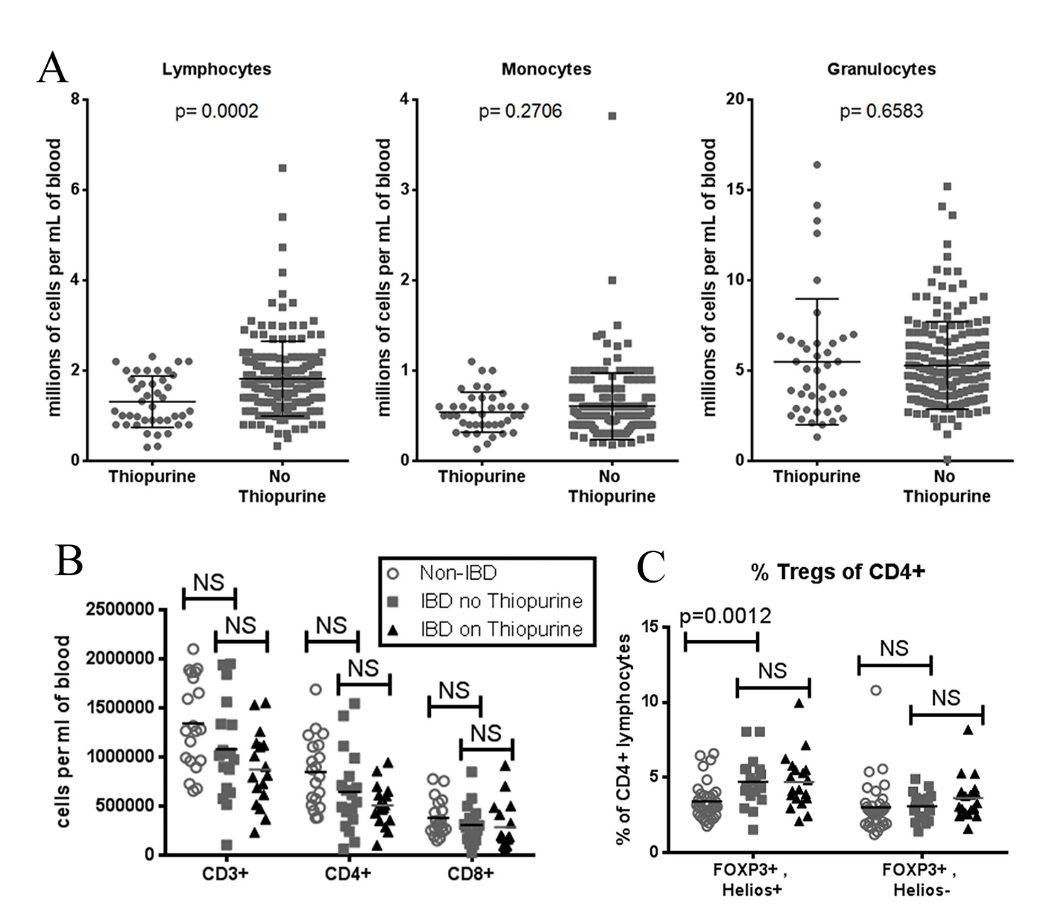

Figure 2
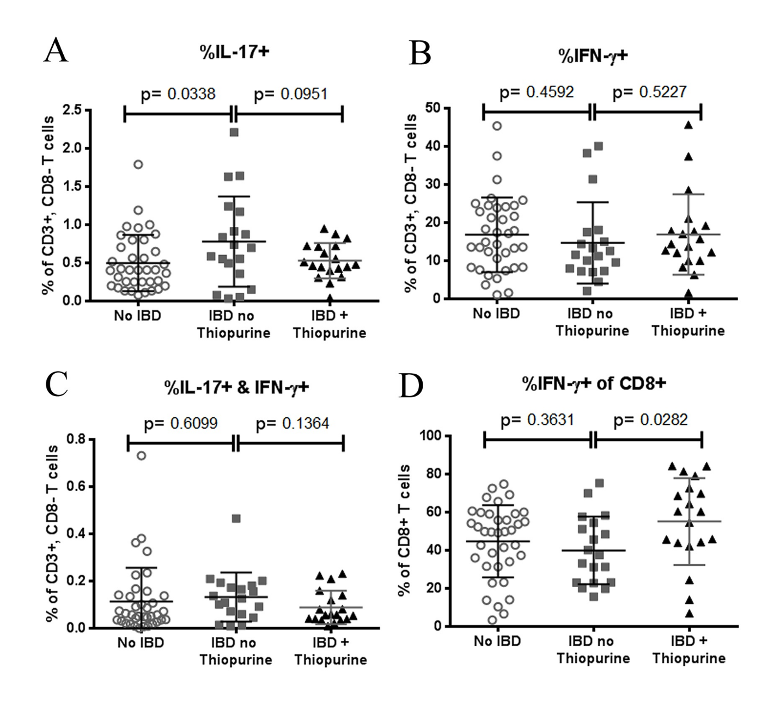

Figure 3
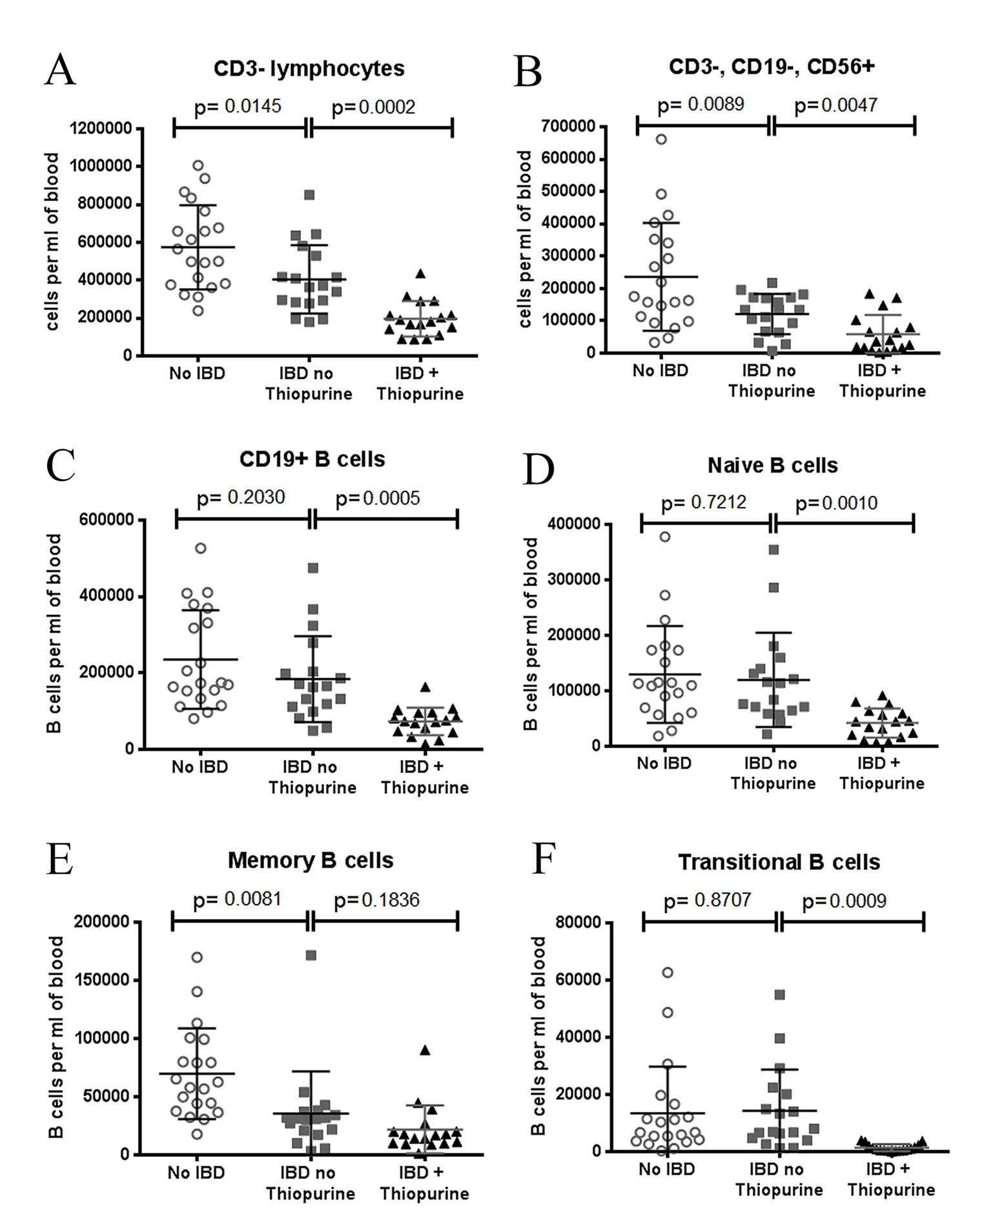

Figure 4
