Name of Journal: World Journal of Gastroenterology
Manuscript NO: 62981
Manuscript Type: CASE REPORT

Gastric schwannoma treated by endoscopic full-thickness resection and endoscopic purse-string suture: A case report

Lu ZY et al. Gastric schwannomas

Zhi-Yu Lu, Dun-Yong Zhao

Zhi-Yu Lu, Dun-Yong Zhao, Departments of Gastroenterology, Institute of Digestive, Southwest Hospital, Army Military Medical University, Chongqing 400038, China

Author contributions: Lu ZY reviewed the literature and was responsible for manuscript drafting and organization of illustrations and contributed to the interpretation of the imaging findings and endoscopic findings; Zhao DY analyzed and interpreted the pathological findings, immunohistochemical findings, and genetic mutation and was responsible for the revision of the manuscript for important intellectual content; All authors issued final approval for the version to be submitted.

Corresponding author: Dun-Yong Zhao, MM, Associate Chief Physician, Department of Gastroenterology, Institute of Digestive, Southwest Hospital, Army Military Medical University, No. 30 Gaotanyan Main Street, Shapingba District, Chongqing 400038, China. 872083291@qq.com

Received: January 22, 2021
Revised: March 2, 2021
Accepted: April 21, 2021
Published online:
Abstract
BACKGROUND
Schwannomas, also known as neurinomas, are tumors that derive from Schwann cells. Gastrointestinal schwannomas are extremely rare, but the stomach is the most common site. Gastric schwannomas are usually asymptomatic. Endoscopy and imaging modalities might offer useful preliminary diagnostic information. However, to diagnose schwannoma, the immunohistochemical positivity for S-100 protein is essential, whereas CD117, CD34, SMA, desmin, and DOG-1 are negative.

CASE SUMMARY
A 45-year-old female was found to have a gastric mass during a medical examination, which was diagnosed as a gastric schwannoma. We performed endoscopic full-thickness resection and endoscopic purse-string suture. Pathology and immunohistochemical staining confirmed the diagnosis of gastric schwannoma through the positivity of S-100 protein. Furthermore, to exclude the misdiagnosis of gastrointestinal stromal tumor, we performed a mutational detection of the c-Kit and PDGFRA genes. Postoperative follow-up revealed that the patient recovered well.

CONCLUSION
Immunohistochemical staining is essential for the diagnosis of schwannoma. Endoscopic full-thickness resection is an effective treatment method for gastric schwannoma.

Key Words: Gastric schwannoma; Endoscopic full-thickness resection; Endoscopic purse-string suture; Immunohistochemical staining; Gene mutational analysis; Case report

Lu ZY, Zhao DY. Gastric schwannoma treated by endoscopic full-thickness resection and endoscopic purse-string suture: A case report. World J Gastroenterol 2021; In press

Core Tip: Schwannomas can occur in any part of the digestive tract but are most common in the stomach. Gastric schwannomas are typically asymptomatic, and it is difficult to make a precise preoperative diagnosis. The final diagnosis of schwannoma is based on immunohistochemical staining. We performed endoscopic full-thickness resection and endoscopic purse-string suture. We report a case diagnosed with gastric schwannoma.

INTRODUCTION
Schwannomas, which are also known as neurinomas, were first described in 1910 by Verocay and are rarely observed in the gastrointestinal tract^{[1,2]}. The stomach is the site with the highest incidence of schwannomas in the gastrointestinal tract^{[3]}. Gastric schwannomas are typically asymptomatic, and the most common symptoms are stomachache, abdominal mass, and gastrointestinal hemorrhage^{[4,5]}.
Although endoscopy and imaging modalities, such as computed tomography (CT), magnetic resonance imaging, positron emission tomography-CT, might offer useful preliminary diagnostic information, it is still difficult to achieve the precise preoperative diagnosis of gastric schwannomas. Immunohistochemical positivity of S-100 protein is essential for the final diagnosis of schwannoma, whereas CD117, CD34, SMA, desmin, and DOG-1 are negative^{[6,7]}. Gastric schwannomas are almost always benign with no recurrence or metastasis^{[6,8]}, and the optimal treatment for gastric schwannoma is surgical resection.
In our case, the schwannoma was discovered incidentally by abdominal CT. Gastroscopy and endoscopic ultrasonography (EUS) were then performed. Endoscopic full-thickness resection and endoscopic purse-string suture were performed. Finally, the diagnosis of gastric schwannoma was confirmed by histological, immunohistochemical, and gene mutational investigations.

CASE PRESENTATION
Chief complaints
A 45-year-old female had a gastric mass during a medical examination.

History of present illness
A 45-year-old female visited a local hospital for a regular health examination without any symptoms. The patient had an abdominal CT scan, which revealed a rounded mass arising from the greater curvature of the gastric body, suggesting a gastrointestinal stromal tumor (GIST) as a likely diagnosis. For further diagnosis and treatment, she was admitted to the Department of Gastroenterology at our hospital.

History of past illness
There was no other significant medical history. The patient had no history of prior gastroenterological symptoms. There was no relevant history including past interventions and outcomes.

Personal and family history
The patient had no history of smoking or drinking alcohol. Her occupation was a housewife. There was no relevant family history.

Physical examination
All vital signs of the patient were stable, and physical examination revealed no noteworthy positive sign.

Laboratory examinations
The levels of the tumor markers AFP, CA125, and CEA were in the normal range. Blood tests, fecal examinations, and coagulation function all demonstrated normal results.

Imaging examinations
Nine days before admission, the patient underwent abdominal CT scanning for a medical examination, and it revealed a 24.9 mm × 23.9 mm rounded mass arising from the greater curvature of the gastric body with slight internal contrast enhancement (Figure 1), suggesting a GIST as a likely diagnosis. No enlarged pericolic lymph nodes were observed.

Endoscopic examinations
Gastroscopy demonstrated a 2.0 cm × 1.8 cm hemispherical protrusion lesion of the gastric body, and EUS revealed hypoechoic and homogeneous echo lesions originating from the muscularis propria (Figure 2).

Pathological findings and immunohistochemical staining
Pathological analysis and immunohistochemical staining (Figure 3) confirmed the diagnosis of gastric schwannoma through positivity for S-100 protein, whereas CD117, CD34, α-SMA, desmin, and DOG-1 were negative.

Gene mutational analysis
To provide evidence for the differential diagnosis of GIST, we performed a mutational detection of the c-Kit and PDGFRA genes (Figure 4), and the results showed that no mutations were detected in the sample.

FINAL DIAGNOSIS
The final diagnosis of the presented case was gastric schwannoma.

TREATMENT
Endoscopic full-thickness resection and endoscopic purse-string suture were performed (Figure 5). Postoperatively, acid suppression, hemostasis, protection of the gastric mucosa, and nutritional support were administered.

OUTCOME AND FOLLOW-UP
The patient was well recovered and was discharged on her seventh day post operation. The patient was followed up for 16 mo after the operation. Gastroscopy was performed (Figure 6), and the results indicated that the incision recovered well.

DISCUSSION
Schwannomas are tumors originating from Schwann cells that usually affect the subcutaneous tissue of the distal limbs^{[9]}. Schwannomas of the gastrointestinal tract represent approximately 3% of all mesenchymal tumors of the gastrointestinal tract^{[10]}. In the gastrointestinal tract, the stomach is the site with the highest incidence of schwannomas followed by the colon^{[11]}. The small intestine and esophagus are the most infrequently affected sites^{[12,13]}. Gastric schwannomas account for 0.2% of all gastric tumors^{[9]}.
Diagnostic methods for gastric schwannomas, such as endoscopy, EUS, CT, magnetic resonance imaging, and positron emission tomography, have recently been proposed. On endoscopy, gastric schwannomas appear as elevated submucosal masses, with or without a central ulcer^{[14]}. Endoscopic biopsy is not as effective as expected, as it can lead to false negative results^{[9]}. On EUS evaluation, a rounded submucosal mass, a well-defined margin, heterogeneous hypoechogenicity or isoechogenicity, and deficiency of cystic change and calcification are significant for the diagnosis of gastric schwannoma^{[15-17]}.
Previous studies demonstrated that gastric schwannomas showed well-demarcated masses that are heterogeneous or homogeneous contrast enhancement on CT^{[14,18]}. Ji et al^{[19]} and Wang et al^{[20]} reported that homogeneous progressive enhancement on dynamic CT was a characteristic finding of gastric schwannoma. On magnetic resonance imaging examination, the signal intensity of most gastric schwannomas is low to medium on T1-weighted images and high on T2-weighted images^{[21]}. Recently, several cases of gastric schwannoma that were found with an increased uptake of fluorodeoxyglucose on positron emission tomography were reported^{[22]}. Even with the above modern imaging modalities, it is still difficult to achieve the precise preoperative diagnosis of gastric schwannomas.
In our case, the schwannoma was discovered incidentally by abdominal CT, suggesting GIST as a likely diagnosis. Gastroscopy and EUS provided the same primary diagnosis. The tumor was misdiagnosed as a GIST until the immunohistochemical findings and mutational analysis were revealed.
Gastric schwannomas are almost uniformly benign without recurrence or metastasis, and no malignant variant was found in previous follow-up studies^{[6,8]}. The optimal treatment for gastric schwannoma is surgical resection, which should follow the same principles with GISTs^{[23]}.
However, in recent years, therapies for gastric submucosal tumor resection have rapidly developed, and less invasive endoscopic techniques, such as snare polypectomy, endoscopic submucosal dissection, and endoscopic full-thickness resection (EFTR), have been considered and used more often. Zhai et al^{[24]} conducted a 5-year retrospective study in consecutive patients who underwent endoscopic resection for gastric schwannoma at a large tertiary center, and the results indicated that endoscopic resection was effective and safe for patients with gastric schwannoma with favorable long-term outcomes. Jain et al^{[25]} reported a systematic review of EFTR techniques for gastric tumors that originate from the muscularis propria and concluded that EFTR has a high success rate and low complication rate, which was a minimally invasive technique for gastric submucosal tumors.
In our case, the gastric schwannoma was treated by EFTR. To close the gastric perforation, endoscopic purse-string suture was performed. The patient had an uneventful recovery with no major complications.

CONCLUSION
Gastric schwannomas are relatively rare. Even with endoscopy and modern imaging modalities, the precise preoperative diagnosis of gastric schwannomas remains difficult. The final diagnosis of schwannoma is based on pathological and immunohistochemical examination. Gastric schwannomas are almost always benign, and patients with this type of tumor often have a favorable prognosis. Surgical resection is the optimal treatment for gastric schwannoma. Recently, minimally invasive techniques such as EFTR have been more widely considered and employed and are a safe and feasible treatment for gastric schwannomas.
REFERENCES
1 Baek SJ, Hwangbo W, Kim J, Kim IS. A case of benign schwannoma of the ascending colon treated with laparoscopic-assisted wedge resection. Int Surg 2013; 98: 315-318 [PMID: 24229016 DOI: 10.9738/INTSURG-D-13-00015.1]
2 Melvin WS, Wilkinson MG. Gastric schwannoma. Clinical and pathologic considerations. Am Surg 1993; 59: 293-296 [PMID: 8489097]
3 Agaimy A, Märkl B, Kitz J, Wünsch PH, Arnholdt H, Füzesi L, Hartmann A, Chetty R. Peripheral nerve sheath tumors of the gastrointestinal tract: a multicenter study of 58 patients including NF1-associated gastric schwannoma and unusual morphologic variants. Virchows Arch 2010; 456: 411-422 [PMID: 20155280 DOI: 10.1007/s00428-010-0886-8]
4 Pu C, Zhang K. Gastric schwannoma: a case report and literature review. J Int Med Res 2020; 48: 300060520957828 [PMID: 32962485 DOI: 10.1177/0300060520957828]
5 Mekras A, Krenn V, Perrakis A, Croner RS, Kalles V, Atamer C, Grützmann R, Vassos N. Gastrointestinal schwannomas: a rare but important differential diagnosis of mesenchymal tumors of gastrointestinal tract. BMC Surg 2018; 18: 47 [PMID: 30045739 DOI: 10.1186/s12893-018-0379-2]
6 Voltaggio L, Murray R, Lasota J, Miettinen M. Gastric schwannoma: a clinicopathologic study of 51 cases and critical review of the literature. Hum Pathol 2012; 43: 650-659 [PMID: 22137423 DOI: 10.1016/j.humpath.2011.07.006]
7 Wu X, Li B, Zheng C, He X. Clinical Characteristics and Surgical Management of Gastrointestinal Schwannomas. Biomed Res Int 2020; 2020: 9606807 [PMID: 32685549 DOI: 10.1155/2020/9606807]
8 Hong X, Wu W, Wang M, Liao Q, Zhao Y. Benign gastric schwannoma: how long should we follow up to monitor the recurrence? A case report and comprehensive review of literature of 137 cases. Int Surg 2015; 100: 744-747 [PMID: 25875559 DOI: 10.9738/INTSURG-D-14-00106.1]
9 Lin CS, Hsu HS, Tsai CH, Li WY, Huang MH. Gastric schwannoma. J Chin Med Assoc 2004; 67: 583-586 [PMID: 15720074]
10 Hou YY, Tan YS, Xu JF, Wang XN, Lu SH, Ji Y, Wang J, Zhu XZ. Schwannoma of the gastrointestinal tract: a clinicopathological, immunohistochemical and ultrastructural study of 33 cases. Histopathology 2006; 48: 536-545 [PMID: 16623779 DOI: 10.1111/j.1365-2559.2006.02370.x]
11 Braumann C, Guenther N, Menenakos C, Junghans T. Schwannoma of the colon mimicking carcinoma: a case report and literature review. Int J Colorectal Dis 2007; 22: 1547-1548 [PMID: 17242938 DOI: 10.1007/s00384-006-0264-9]
12 Kitada M, Matsuda Y, Hayashi S, Ishibashi K, Oikawa K, Miyokawa N. Esophageal schwannoma: a case report. World J Surg Oncol 2013; 11: 253 [PMID: 24088647 DOI: 10.1186/1477-7819-11-253]
13 Fukushima N, Aoki H, Fukazawa N, Ogawa M, Yoshida K, Yanaga K. Schwannoma of the Small Intestine. Case Rep Gastroenterol 2019; 13: 294-298 [PMID: 31341461 DOI: 10.1159/000501065]
14 Hong HS, Ha HK, Won HJ, Byun JH, Shin YM, Kim AY, Kim PN, Lee MG, Lee GH, Kim MJ. Gastric schwannomas: radiological features with endoscopic and pathological correlation. Clin Radiol 2008; 63: 536-542 [PMID: 18374717 DOI: 10.1016/j.crad.2007.05.026]
15 Jung MK, Jeon SW, Cho CM, Tak WY, Kweon YO, Kim SK, Choi YH, Bae HI. Gastric schwannomas: endosonographic characteristics. Abdom Imaging 2008; 33: 388-390 [PMID: 17647053 DOI: 10.1007/s00261-007-9291-4]
16 Okai T, Minamoto T, Ohtsubo K, Minato H, Kurumaya H, Oda Y, Mai M, Sawabu N. Endosonographic evaluation of c-kit-positive gastrointestinal stromal tumor. Abdom Imaging 2003; 28: 301-307 [PMID: 12719898 DOI: 10.1007/s00261-002-0055-x]
17 Zhong DD, Wang CH, Xu JH, Chen MY, Cai JT. Endoscopic ultrasound features of gastric schwannomas with radiological correlation: a case series report. World J Gastroenterol 2012; 18: 7397-7401 [PMID: 23326151 DOI: 10.3748/wjg.v18.i48.7397]
18 Levy AD, Quiles AM, Miettinen M, Sobin LH. Gastrointestinal schwannomas: CT features with clinicopathologic correlation. AJR Am J Roentgenol 2005; 184: 797-802 [PMID: 15728600 DOI: 10.2214/ajr.184.3.01840797]
19 Ji JS, Lu CY, Mao WB, Wang ZF, Xu M. Gastric schwannoma: CT findings and clinicopathologic correlation. Abdom Imaging 2015; 40: 1164-1169 [PMID: 25316564 DOI: 10.1007/s00261-014-0260-4]
20 Wang W, Cao K, Han Y, Zhu X, Ding J, Peng W. Computed tomographic characteristics of gastric schwannoma. J Int Med Res 2019; 47: 1975-1986 [PMID: 30871392 DOI: 10.1177/0300060519833539]
21 Takeda M, Amano Y, Machida T, Kato S, Naito Z, Kumita S. CT, MRI, and PET findings of gastric schwannoma. Jpn J Radiol 2012; 30: 602-605 [PMID: 22660866 DOI: 10.1007/s11604-012-0093-4]
22 Ohno T, Ogata K, Kogure N, Ando H, Aihara R, Mochiki E, Zai H, Sano A, Kato T, Sakurai S, Oyama T, Asao T, Kuwano H. Gastric schwannomas show an obviously increased fluorodeoxyglucose uptake in positron emission tomography: report of two cases. Surg Today 2011; 41: 1133-1137 [PMID: 21773906 DOI: 10.1007/s00595-010-4401-2]
23 Williamson JM, Wadley MS, Shepherd NA, Dwerryhouse S. Gastric schwannoma: a benign tumour often mistaken clinically, radiologically and histopathologically for a gastrointestinal stromal tumour--a case series. Ann R Coll Surg Engl 2012; 94: 245-249 [PMID: 22613302 DOI: 10.1308/003588412X13171221590935]
24 Zhai YQ, Chai NL, Li HK, Lu ZS, Feng XX, Zhang WG, Liu SZ, Linghu EQ. Endoscopic submucosal excavation and endoscopic full-thickness resection for gastric schwannoma: five-year experience from a large tertiary center in China. Surg Endosc 2020; 34: 4943-4949 [PMID: 31811454 DOI: 10.1007/s00464-019-07285-w]
25 Jain D, Mahmood E, Desai A, Singhal S. Endoscopic full thickness resection for gastric tumors originating from muscularis propria. World J Gastrointest Endosc 2016; 8: 489-495 [PMID: 27499831 DOI: 10.4253/wjge.v8.i14.489]

Footnotes
Informed consent statement: Informed written consent was obtained from the patient for publication of this report and any accompanying images.

Conflict-of-interest statement: The authors declare that they have no conflict of interest.

CARE Checklist (2016) statement: The authors have read the CARE Checklist (2016), and the manuscript was prepared and revised according to the CARE Checklist (2016).

Open-Access: This article is an open-access article that was selected by an in-house editor and fully peer-reviewed by external reviewers. It is distributed in accordance with the Creative Commons Attribution NonCommercial (CC BY-NC 4.0) license, which permits others to distribute, remix, adapt, build upon this work non-commercially, and license their derivative works on different terms, provided the original work is properly cited and the use is non-commercial. See: http://creativecommons.org/Licenses/by-nc/4.0/

Manuscript source: Unsolicited manuscript

Peer-review started: January 22, 2021
First decision: February 28, 2021
Article in press:

Specialty type: Gastroenterology and hepatology
Country/Territory of origin: China
Peer-review report’s scientific quality classification
Grade A (Excellent): A
Grade B (Very good): B
Grade C (Good): 0
Grade D (Fair): 0
Grade E (Poor): 0

P-Reviewer: Naem A S-Editor: Zhang H L-Editor: Filipodia P-Editor:

Figure Legends
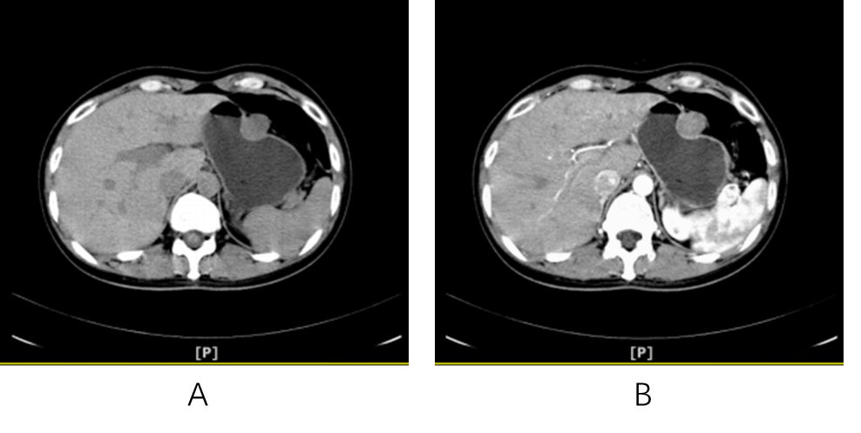
Figure 1 Abdominal computed tomography scanning. A: Computed tomography scan revealed a rounded mass arising from the greater curvature of the gastric body; B: The gastric mass exhibited slight internal contrast enhancement.
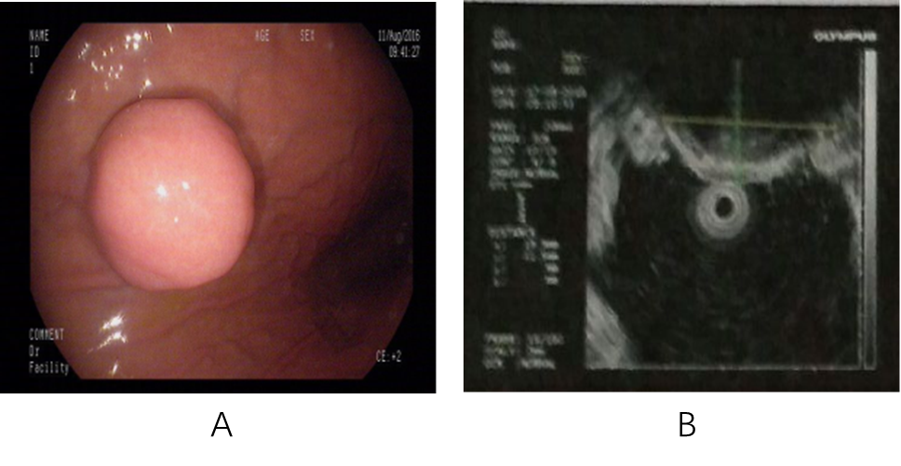
Figure 2 Gastroscopy and endoscopic ultrasonography. A: Gastroscopy demonstrated a hemispherical protrusion lesion of the gastric body; B: Endoscopic ultrasonography showed that the lesion arose from the muscularis propria.
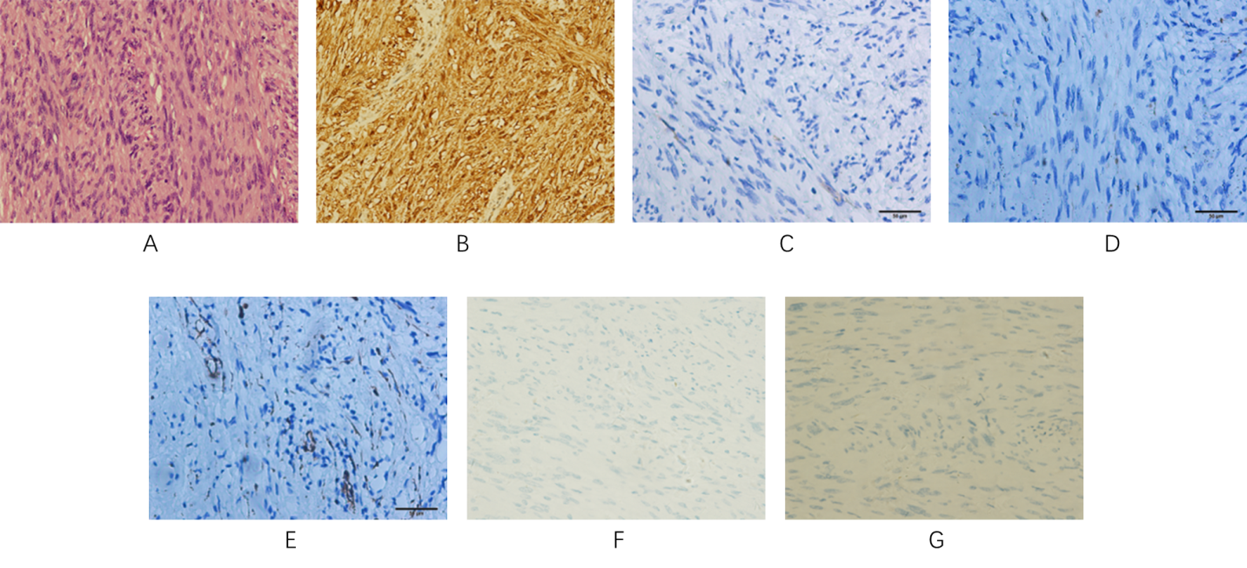
Figure 3 Pathological analysis and immunohistochemical staining. A: Hematoxylin and eosin staining revealed spindle cell tumors with mild cells, mitotic figures 1-2/50 high-power field, local inflammatory cell infiltration, and no necrosis. Combined with immunohistochemistry and gene detection results, the results were consistent with schwannoma; B-G: Immunohistochemical staining of the gastric mass confirmed a gastric schwannoma through positive staining for S-100 protein (B), whereas CD117 (C), CD34 (D), α-smooth muscle actin (E), desmin (F), and DOG1 (G) were negative.
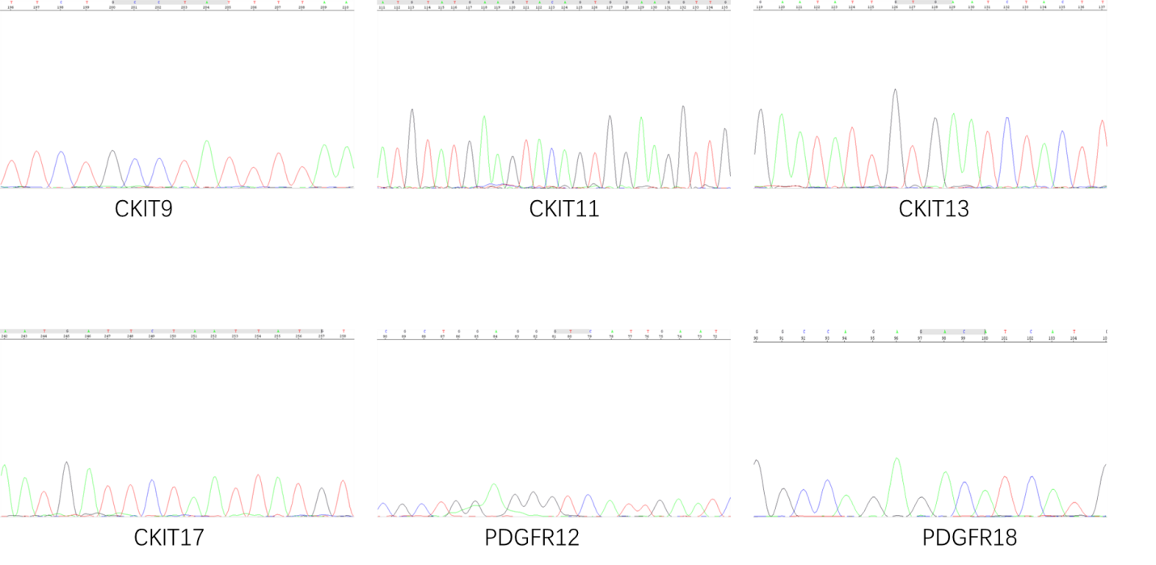
Figure 4 c-Kit and PDGFRA gene mutational analysis. DNA sequencing electropherograms revealed an absence of mutations in exons 9, 11, 13, and 17 of the c-Kit gene and exons 12 and 18 of the PDGFRA gene.
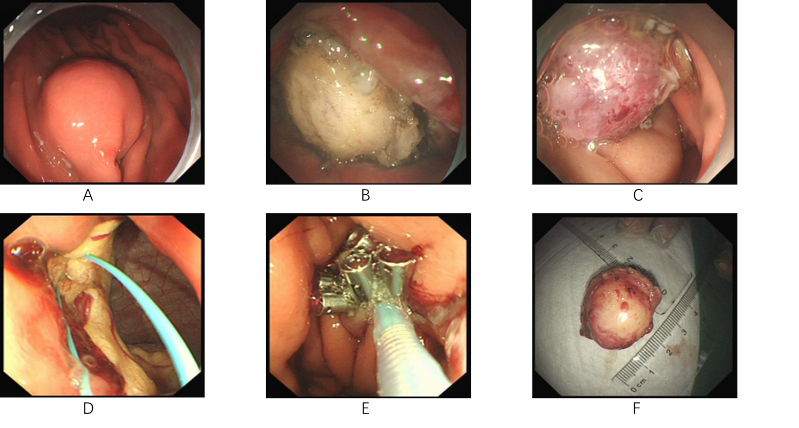
Figure 5 Endoscopic full-thickness resection operative process. A: Marked the lesion with argon plasma coagulation; B and C: Application of the insulated-tip knife to isolate the stromal tumor along its periphery; D and E: An “artificial perforation” observed after stromal tumor resection and sealed the perforation by endoscopic purse-string suture; F: The resected tumor.
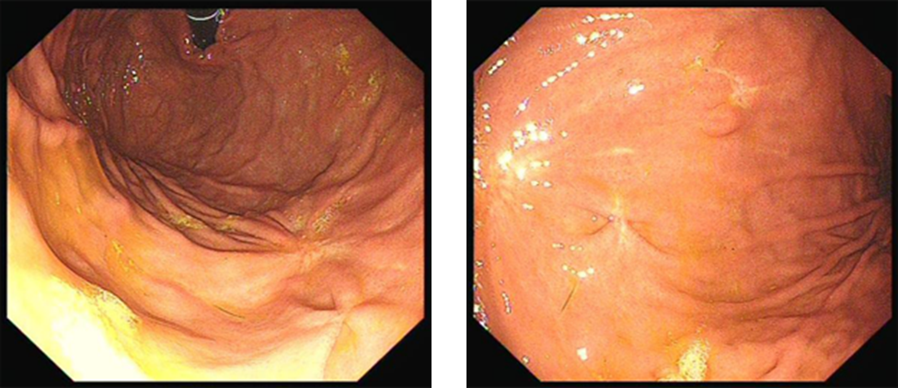
Figure 6 Gastroscopy at 16 mo after the operation revealed that the incision recovered well and that there was no recurrence.

