Name of Journal: World Journal of Clinical Cases
Manuscript NO: 84006
Manuscript Type: CASE REPORT

Diagnosis based on electromagnetic navigational bronchoscopy-guided biopsied peripheral lung lesions in a 10-year-old girl: A case report

Meng FZ et al. ENB, peripheral lesion, child

Fan-Zheng Meng, Qiong-Hua Chen, Man Gao, Li'e Zeng, Jie-Ru Lin, Jing-Yang Zheng

Fan-Zheng Meng, Man Gao, Department of Pediatrics, The First Hospital of Jilin University, Changchun 130021, Jilin Province, China

Qiong-Hua Chen, Department of Respiratory Medicine, The Third Clinical Medical College, Fujian Medical University, Quanzhou Women's and Children's Hospital, Quanzhou 362000, Fujian Province, China

Li'e Zeng, Jie-Ru Lin, Department of Respiratory Medicine, Quanzhou Women's and Children's Hospital, Quanzhou 362000, Fujian Province, China

Jing-Yang Zheng, Department of Respiratory Medicine, Quanzhou Women's and Children's Hospital, The Third Clinical Medical College, Fujian Medical University, Quanzhou 362000, Fujian Province, China

Author contributions: Meng FZ and Chen QH were the first authors of this manuscript; Meng FZ and Zheng JY performed the operation; Chen QH, Zeng L and Lin JR collected clinical data and data interpretation; Meng FZ, Gao M, and Zheng JY helped revise the manuscript; Chen QH drafted the manuscript; all authors have read and approved the final manuscript.

Supported by The Natural Science Foundation of Jilin Province, No. 20200201475JC.

Corresponding author: Jing-Yang Zheng, MD, Professor, Department of Respiratory Medicine, Quanzhou Women's and Children's Hospital, The Third Clinical Medical College, Fujian Medical University, No. 700 Fengze Street, Fengze District, Quanzhou 362000, Fujian Province, China. 279277481@qq.com

Received: February 21, 2023
Revised: April 13, 2023
Accepted: April 19, 2023
Published online:

Abstract
BACKGROUND
Electromagnetic navigational bronchoscopy (ENB) is an emerging diagnostic tool that enables practitioners to biopsy peripheral lung tissues that were previously only accessible under computed tomography (CT) guidance. However, few studies have investigated ENB use in children. Here, we report a case of a 10-year-old girl with peripheral lung lesions who complained of a 7-d persistent fever. She was diagnosed with Streptococcus parasanguinis infection based on findings obtained using ENB-guided transbronchial lung biopsy (TBLB).

CASE SUMMARY
A 10-year-old girl presented with constitutional symptoms of cough and fever of 7 days’ duration. Chest CT scans detected peripheral lung lesions and no endobronchial lesions. TBLB performed under the guidance of an ENB Lungpro navigation system was safe, well-tolerated, and effective for biopsying peripheral lung lesions. Examination of biopsied samples indicated the patient had a pulmonary Streptococcus parasanguinis infection, which was treated with antibiotics instead of more invasive treatment interventions. The patient’s symptoms resolved after she received a 3-wk course of oral linezolid. Comparisons of pre-treatment and post-treatment CT scans revealed absorption of some lung lesions within 7 mo of hospital discharge.

CONCLUSION
ENB-guided TBLB biopsying of peripheral lung lesions in this child is a safe, well-tolerated, and effective alternative to conventional interventions.

Key Words: Electromagnetic navigational bronchoscopy; Lungpro; Transbronchial lung biopsy; Child; Diagnosis; Case report

Meng FZ, Chen QH, Gao M, Zeng L, Lin JR, Zheng JY. Diagnosis based on electromagnetic navigational bronchoscopy-guided biopsied peripheral lung lesions in a 10-year-old girl: A case report. World J Clin Cases 2023; In press

Core Tip: Electromagnetic navigational bronchoscopy-guided transbronchial lung biopsy is used to diagnose and treat pulmonary disorders in adults worldwide, but very few were reported in children. Moreover, diagnosing patients with peripheral lung lesions is still challenging, due to difficulties related to existing biopsy procedures. Here we present a case study conducted in China that demonstrated that electromagnetic navigational bronchoscopy-guided transbronchial lung biopsy is safe and effective when used to diagnose pediatric patients afflicted with peripheral pulmonary lesion-inducing disorders. Ultimately, clinicians adopting this procedure will be able to diagnose pulmonary disease cases without subjecting patients to invasive and risky surgical interventions.

INTRODUCTION
With the development of auxiliary navigation equipment, such as the Lungpro navigation system, electromagnetic navigational bronchoscopy (ENB) has been increasingly applied in pulmonary clinical practice. Importantly, ENB can be used to guide transbronchial lung biopsying (TBLB) of peripheral lung tissues that were previously only accessible by computed tomography (CT)-guided conventional bronchoscopy. To perform this function, ENB systems are used to virtually plan the lung bronchoscopic path in advance and to navigationally guide the bronchoscope in real time to ensure accurate localization of the disease focus during the biopsy. Although ENB has been shown to improve success rates of TBLB in adults with pulmonary diseases^{[1]}, this technology has been infrequently used to diagnose pediatric pulmonary diseases. In fact, a search of medical literature^{[2,3]} revealed only one report of a Chinese pediatric patient with pulmonary lesions who was successfully diagnosed using ENB-guided TBLB, which permitted physicians to safely obtain biopsied tissues to distinguish between lung infection and lung tumor metastasis when diagnosing the patient^{[3]}. Here, we report the clinical application of ENB for diagnosing a second Chinese pediatric patient with pulmonary lesions.

CASE PRESENTATION
Chief complaints
A 7-d history of fever and cough.

History of present illness
A ten-year old girl presented to our hospital with a fever and cough of 7 days’ duration. Her temperature peaked at 39.2°C. She had been initially admitted to a local hospital, where she was diagnosed with community-acquired pneumonia and treated with intravenous antibiotics that did not resolve her fever and cough. Due to lingering symptoms, she sought further treatment at our hospital.

History of past illness
Her medical history was unremarkable.

Personal and family history
The patient had no relevant personal or family history.

Physical examination
At admission, the patient’s weight was 34.0 kg and her vital signs were as follows: Body temperature, 37.0°C; blood pressure, 90/62 mmHg; heart rate, 130 beats/min; respiratory rate, 20 breaths/min; oxygen saturation, 98% in room air. At the time of admission, moderate and fine moist rales were heard in both lungs with no wheezing observed.

Laboratory examinations
Infection index white blood cell count, 17.52 × 10⁹/L; platelet count, 256 × 10⁹/L; erythrocyte sedimentation rate, 30 mm/h; C-reactive protein, 60.65 mg/L (0.00-5.00 mg/L) (December 16, 2021). Immune function was normal. Liver function: Alanine aminotransferase, 29 U/L (0-40 U/L); aspartate aminotransferase, 33U/L (0-40 U/L). A positive culture result for Streptococcus parasanguiniswas obtained, with no fungal growth detected.

Imaging examinations
During her first stay at our hospital, the patient underwent electronic lung bronchoscopy, which detected endobronchial inflammation in the left upper lobe proper segment and left lower lobe basal segment (Figure 1A). Results of CT retesting obtained 7 d later (Figure 1B) revealed growing, dense masses within lung tissues, as evidenced by darker shadows on the scan coinciding with the position of the outer basal segment of the lower lobe of the left lung that indicated the presence of multiple cystic translucent lesions. Moreover, various lesions of different sizes, multilocular thin-walled air-filled cavities, and patchy and highly dense shadows were observed that lacked clear boundaries and had approximate dimensions of 72 mm × 60 mm × 42 mm. The child was subsequently discharged with oral amoxicillin clavulanate potassium and advised to undergo an enhanced pulmonary CT scan 2 wk after discharge. The CT results revealed that the previously noted multiple cystic lesions within the lower left lung lobe and the dense mass within the basal segment outside that lobe remained unchanged in appearance. In contrast, the inflammatory lesions within the middle and lower lobes of the right lung were larger than before (Figure 1C). Due to the fact that the pathological nature of the peripheral lung lesion could not be determined from these findings, the patient underwent a TBLB procedure to ensure that appropriate treatment would be administered to treat the disorder.
The entire procedure was conducted using the following steps. Prior to TBLB, inspiratory and expiratory CT images were uploaded to the Lungpro system (LungPoint VBN, version 3,4, Broncus Medical Inc, CA, United States), which was used to construct a virtual airway leading to the above-mentioned peripheral lesions. Next, picture archiving and communication system-based integration was conducted to build a virtual three-dimensional image of the patient’s lungs. Then, a bronchial centerline was used as a frame of reference to help the bronchoscope operator plan a path to the airway wall puncture point or focus point.
After the patient was prepared for the procedure, she was administered local anesthesia and intravenous midazolam, a mild sedative. Endobronchial occlusion was then performed using a bronchoscope (BF-P260, Olympus Ltd.). The patient was placed in the supine position and was administered oxygen through a nasal catheter. Using a nasal point of entry, the optimal navigational path to pulmonary lesions was selected, and the reconstructed three-dimensional image was superimposed onto the image as viewed under the bronchoscope. During real-time navigation, the position of the bronchoscope and the distance from the pleura and the focus were displayed.
Finally, Lungpro-guided TBLB was performed using a bronchoscope with a working channel diameter of 2.8 mm (Figure 2, Figure 3A). Biopsy samples taken from the posterior basal segment of the left lower lobe were sent to the hospital pathology department for microscopic examination (Figure 3B). The patient experienced no complications after the procedure.

FINAL DIAGNOSIS
Streptococcus parasanguinis infection of the lung.

TREATMENT
During the patient’s first stay at our hospital, her fever decreased after intravenous antibiotic therapy (intravenous amoxicillin clavulanate potassium, oral azithromycin) and anti-inflammatory therapy (intravenous methylprednisolone). Results of ENB-guided TBLB performance (which utilized the Lungpro navigation system) indicated lung infection with Streptococcus parasanguinis. Based on this finding, the patient was treated with a 3-wk course of oral linezolid.

OUTCOME AND FOLLOW-UP
The patient’s symptoms disappeared after a 3-wk oral linezolid treatment, after which the patient’s health status was monitored through regular follow-up visits. A second chest CT scan obtained at seven months post-treatment revealed increased transparency of the basal segment of the left lower lobe, multiple lesions of unequal size, and multilocular thin-walled air-filled cavities. A comparison of the first and second chest CT scans suggested that some lesions were absorbed before the 7-mo follow-up visit (Figure 3C).

DISCUSSION
Modern imaging techniques have led to increased detection of peripheral lung lesions, of which the vast majority often require tissue biopsies for diagnosis. Barber et al^{[4]} retrospectively analyzed etiologies of 88 pediatric cases with pulmonary nodules. They found that most nodules were caused by infections, while etiologies of the others included autoimmune diseases, hematologic diseases, vasculitis, and Crohn's disease. Nevertheless, diagnosing patients with peripheral lung lesions is still challenging due to difficulties related to existing biopsy procedures. The child described in this case report presented with cough and fever symptoms and rales. Chest high-resolution computed tomography (HRCT) imaging revealed a dense mass, as evidenced by a dark area on the HRCT scan after the child had received regular antibiotic therapy. However, the lesion was located within the anterior segment of the left lower lobe in an area close to the anterior artery and thus would be inaccessible by conventional electronic bronchoscopy and require CT-guided percutaneous lung puncture treatment. As a major disadvantage, this procedure can lead to severe lung tissue damage, increasing the risk of intraoperative and postoperative bleeding and pneumothorax and leaving local skin wounds. To avoid these issues, we performed ENB-guided TBLB to obtain an accurate diagnosis for our patient.
Several bronchoscopic approaches are currently adopted to biopsy tissues in order to obtain diagnostic tissue samples, with pros and cons associated with each approach. Importantly, Bronchoscopy-guided modalities are increasingly being used to biopsy peripheral lung lesions, due to greater safety and superior diagnostic results obtained using these methods over results obtained using alternative biopsy techniques, such as percutaneous lung puncture, radial endobronchial ultrasound (EBUS), CT-guide flexible bronchoscopy, and combinations of these techniques^{[5,6]}. In fact, a review of papers related to this topic suggests that diagnostic yields of peripheral lung nodule biopsies performed using conventional bronchoscopy range from 43% to 65%, while diagnostic yields of procedures used to biopsy smaller peripheral lung lesions are lower, from 14% to 31%^{[7]}. Although bronchoscopy with navigation provides the lowest overall diagnostic yield of the three procedures (70%), this procedure has the best safety profile, as evidenced by its low rate of pneumothorax requiring a chest tube (1%)^{[8]}.
CT is currently considered the gold standard imaging technique for guiding bronchoscopic biopsies of pulmonary lesions, due to its effectiveness as a diagnostic tool and ability to target a bronchoscope to a selected cytologic sampling site accurately. Nevertheless, CT-guided transthoracic biopsy has several disadvantages, such as exposure to ionizing radiation, the need to move the patient to a radiology unit, and prolonged execution time. Moreover, this modality requires an accessible path for biopsy needle insertion and is associated with increased risks of pneumothorax, significant hemorrhaging, and respiratory failure.
Alternatively, radial EBUS is a current method to precisely locate peripheral lung lesions that are not visible by fluoroscopy, while it also provides clues regarding their internal structures. However, the effective use of this method requires careful patient selection, since the ultrasound wave does not easily penetrate aerated pulmonary parenchyma. Therefore, EBUS is used to locate peripheral pulmonary nodules that are not separated by areas of aerated pulmonary parenchyma, which would induce excessive acoustic impedance that would reflect the ultrasound wave. In addition, ultrasound is technically applicable for imaging peripheral pulmonary nodules that adhere to visceral pleura, detecting direct pleural infiltration, and detecting atelectasis involving subpleural lung parenchyma. Nonetheless, EBUS cannot target specific types of peripheral lesions that may be targeted using a navigational system.
TBLB, an important method used to clinically diagnose pulmonary lesion-associated disorders, offers advantages over conventional bronchoscopic biopsy methods that provide low diagnostic yields due to inaccurate targeting of lesions with biopsy forceps^{[9]}. However, during TBLB operation, misalignments (offsets) between actual and virtual bronchoscopic images can occur when the bronchoscope is rotated as it advances to the target site, which can lead to lesion-targeting errors. Furthermore, rapid realignment of the virtual bronchoscopic image to actual bronchial branch points is not easily accomplished after the bronchoscope moves unexpectedly (e.g., when the patient moves or coughs)^{[10]}. To address these issues^{[10,11]}, the Lungpro system was recently developed to serve as a virtual navigation device that can display virtual bronchoscopic images adjacent to actual video images (Video 1), thus enabling the operator to overlay an electronic pathway onto the endoscopic image and maintain their alignment in real-time. In practice, the identified lesion shape is initially overlaid onto the airway wall near the target location (as indicated on the aligned actual and virtual bronchoscopic images) to provide further biopsy site localization guidance. Importantly, this method can be applied to quickly and accurately guide the bronchoscope to the focus without puncturing blood vessels, thus making it possible to more effectively biopsy lung lesions present outside the airway^{[10,12]}. Notably, when this procedure was used to biopsy our patient, no adverse events, such as pneumothorax or hemorrhage, occurred during or after the procedure.
Ultimately, the biopsy results obtained for our pediatric patient suggested that the child’s lungs were infected with S. parasanguinis, a gram-positive, non-motile, catalase-negative organism belonging to the sanguinis group of viridans streptococci. Although this organism is not viewed as an important human pathogen, it has been isolated from human blood, urine, and throat samples^{[13]}, is a primary colonizer of teeth that supports biofilm formation on tooth surfaces^{[14]}, and is a common cause of native and prosthetic valve endocarditis. S. parasanguinis-induced endocarditis has been shown to begin with bacterial colonization on heart valve surfaces that is followed by biofilm formation that leads to colonization in valves with small surface aggregates of bacteria. These aggregates grow into rounded bacterial colonies that promote the deposition of a layer of fibrin and platelets on their surfaces that ultimately supports biofilm formation. This biofilm then shields the bacteria from antibiotics, thus making their eradication difficult despite the fact that the organisms are sensitive to vancomycin, linezolid, daptomycin, quinupristin–dalfopristin, clindamycin, and levofloxacin^{[15]}. Notably, an analysis of 50 cancer patients with streptococcal infections revealed that 5 patients harbored S. parasanguinis with intermediate resistance to penicillin and azithromycin and susceptibility to vancomycin, linezolid, quinupristin–dalfopristin, and ceftriaxone^{[16]}. These results were consistent with S. parasanguinis antibiotic responsiveness as observed in the current case study. In our patient, inflammatory lesions increased in size after treatment with amoxicillin clavulanate potassium and subsequently shrank significantly after 3 wk of oral linezolid treatment. Our results thus highlight the bacteriological and therapeutic challenges associated with pneumonia caused by Streptococcus parasanguinis infection.

CONCLUSION
Worldwide, ENB-guided TBLB is used to diagnose and treat pulmonary disorders in adults but has been infrequently performed in children as its effectiveness and safety in pediatric patients remains unknown. Meanwhile, ENB technology is expensive, and ENB systems are not available in all countries of regions. Here we present a case study conducted in China that demonstrated that ENB-guided transbronchial lung biopsy is safe and effective when used to diagnose pediatric patients afflicted with peripheral pulmonary lesion-inducing disorders. Ultimately, clinicians adopting this procedure may help diagnose pulmonary disease cases without subjecting patients to invasive and risky surgical interventions.

REFERENCES
1 Tamiya M, Okamoto N, Sasada S, Shiroyama T, Morishita N, Suzuki H, Yoshida E, Hirashima T, Kawahara K, Kawase I. Diagnostic yield of combined bronchoscopy and endobronchial ultrasonography, under LungPoint guidance for small peripheral pulmonary lesions. Respirology 2013; 18: 834-839 [PMID: 23586738 DOI: 10.1111/resp.12095]
2 Piccione J, Hysinger EB, Vicencio AG. Pediatric advanced diagnostic and interventional bronchoscopy. Semin Pediatr Surg 2021; 30: 151065 [PMID: 34172210 DOI: 10.1016/j.sempedsurg.2021.151065]
3 Yang H, Turgon E, Pan Y, Wen X, Zhang X, Shen Y, Wang F. Pilot study of archimedes virtual bronchoscopic navigation system-guided biopsy to diagnose lung nodules in children. Front Pediatr 2022; 10: 1053289 [PMID: 36819191 DOI: 10.3389/fped.2022.1053289]
4 Barber A, Passarelli P, Dworsky ZD, Gatcliffe C, Ryu J, Lesser DJ. Clinical implications of pulmonary nodules detected in children. PediatrPulmonol 2021; 56: 203-210 [PMID: 33118698 DOI: 10.1002/ppul.25146]
5 Ishida T, Asano F, Yamazaki K, Shinagawa N, Oizumi S, Moriya H, Munakata M, Nishimura M; Virtual Navigation in Japan Trial Group. Virtual bronchoscopic navigation combined with endobronchial ultrasound to diagnose small peripheral pulmonary lesions: a randomised trial. Thorax 2011; 66: 1072-1077 [PMID: 21749984 DOI: 10.1136/thx.2010.145490]
6 Eberhardt R, Anantham D, Ernst A, Feller-Kopman D, Herth F. Multimodality bronchoscopic diagnosis of peripheral lung lesions: a randomized controlled trial. Am J Respir Crit Care Med 2007; 176: 36-41 [PMID: 17379850 DOI: 10.1164/rccm.200612-1866oc]
7 Kalanjeri S, Holladay RC, Gildea TR. State-of-the-Art Modalities for Peripheral Lung Nodule Biopsy. Clin Chest Med 2018; 39: 125-138 [PMID: 29433709 DOI: 10.1016/j.ccm.2017.11.007]
8 Wang Memoli JS, Nietert PJ, Silvestri GA. Meta-analysis of guided bronchoscopy for the evaluation of the pulmonary nodule. Chest 2012; 142: 385-393 [PMID: 21980059 DOI: 10.1378/chest.11-1764]
9 Han Y, Kim HJ, Kong KA, Kim SJ, Lee SH, Ryu YJ, Lee JH, Kim Y, Shim SS, Chang JH. Diagnosis of small pulmonary lesions by transbronchial lung biopsy with radial endobronchial ultrasound and virtual bronchoscopic navigation versus CT-guided transthoracic needle biopsy: A systematic review and meta-analysis. PLoS One 2018; 13: e0191590 [PMID: 29357388 DOI: 10.1371/journal.pone.0191590]
10 Eberhardt R, Kahn N, Gompelmann D, Schumann M, Heussel CP, Herth FJ. LungPoint--a new approach to peripheral lesions. J Thorac Oncol 2010; 5: 1559-1563 [PMID: 20802352 DOI: 10.1097/JTO.0b013e3181e8b308]
11 Merritt SA, Gibbs JD, Yu KC, Patel V, Rai L, Cornish DC, Bascom R, Higgins WE. Image-guided bronchoscopy for peripheral lung lesions: a phantom study. Chest 2008; 134: 1017-1026 [PMID: 18583513 DOI: 10.1378/chest.08-0603]
12 Silvestri GA, Herth FJ, Keast T, Rai L, Gibbs J, Wibowo H, Sterman DH. Feasibility and safety of bronchoscopictransparenchymal nodule access in canines: a new real-time image-guided approach to lung lesions. Chest 2014; 145: 833-838 [PMID: 24202737 DOI: 10.1378/chest.13-1971]
13 Fernández-Garayzábal JF, Fernández E, Las Heras A, Pascual C, Collins MD, Domínguez L. Streptococcus parasanguinis: new pathogen associated with asymptomatic mastitis in sheep. Emerg Infect Dis 1998; 4: 645-647 [PMID: 9866743 DOI: 10.3201/eid0404.980417]
14 Chen Q, Wu H, Fives-Taylor PM. Investigating the role of secA2 in secretion and glycosylation of a fimbrial adhesin in Streptococcus parasanguis FW213. Mol Microbiol 2004; 53: 843-856 [PMID: 15255897 DOI: 10.1111/j.1365-2958.2004.04116.x]
15 Sader HS, Streit JM, Fritsche TR, Jones RN. Antimicrobial susceptibility of gram-positive bacteria isolated from European medical centres: results of the Daptomycin Surveillance Programme (2002-2004). Clin Microbiol Infect 2006; 12: 844-852 [PMID: 16882289 DOI: 10.1111/j.1469-0691.2006.01550.x]
16 Sadjadi SA, Ali H. Streptococcus parasanguis peritonitis: report of a case and review of the literature. Perit Dial Int 2011; 31: 603-604 [PMID: 21976479 DOI: 10.3747/pdi.2011.00011]

Footnotes
Informed consent statement: All study participants, or their legal guardian, provided informed written consent prior to study enrollment.

Conflict-of-interest statement: The authors declare they have no competing interests.

CARE Checklist (2016) statement: The authors have read the CARE Checklist (2016), and the manuscript was prepared and revised according to the CARE Checklist (2016).

Open-Access: This article is an open-access article that was selected by an in-house editor and fully peer-reviewed by external reviewers. It is distributed in accordance with the Creative Commons Attribution NonCommercial (CC BY-NC 4.0) license, which permits others to distribute, remix, adapt, build upon this work non-commercially, and license their derivative works on different terms, provided the original work is properly cited and the use is non-commercial. See: https://creativecommons.org/Licenses/by-nc/4.0/

Provenance and peer review: Unsolicited article; Externally peer reviewed.
Peer-review model: Single blind

Peer-review started: February 21, 2023
First decision: April 10, 2023
Article in press:

Specialty type: Pediatrics
Country/Territory of origin: China
Peer-review report’s scientific quality classification
Grade A (Excellent): 0
Grade B (Very good): B
Grade C (Good): C
Grade D (Fair): 0
Grade E (Poor): 0

P-Reviewer: Kwiecień I, Poland; Zeng C, United States S-Editor: Ma YJ L-Editor: A P-Editor:
Figure Legends
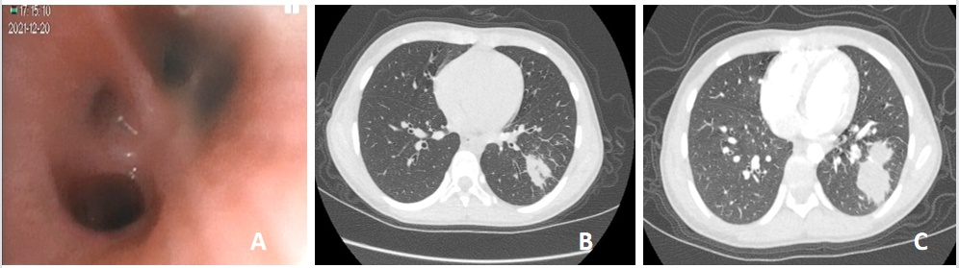
Figure 1 Bronchoscopy and computed tomography images at different stages of treatment. A: Basal segment of the lower lobe of the left lung under conventional bronchoscopy during the first hospitalization; B: Computed tomography (CT) scan showed a lesion in the outer basal segment of the lower lobe of the left lung grew bigger during the first hospitalization; C: CT scan showed a lesion in the outer basal segment of the lower lobe of the left lung grew bigger after the first hospitalization.

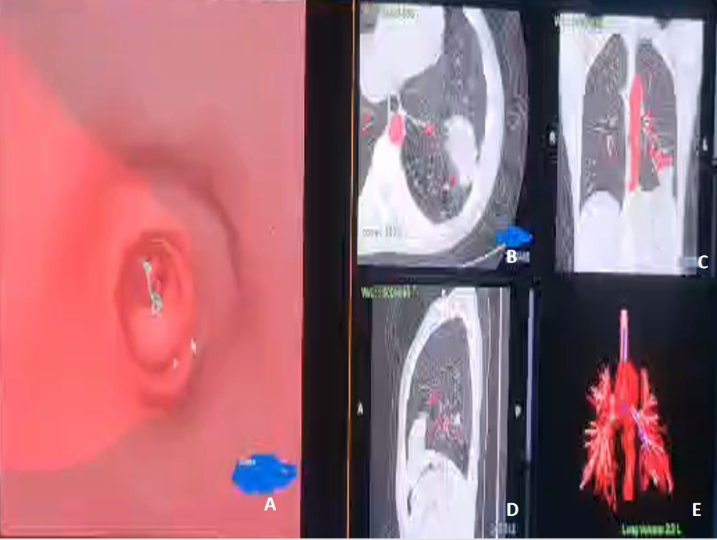
Figure 2 Three-dimensional reconstruction of thoracic computed tomography with the bronchial tree, tunnel path, and peripheral lung lesions location. A: Virtual bronchoscopic navigation images on LungPro indicate a bronchial route; B: Cross-sectional view; C: Coronal reconstruction view; D: Sagittal view; E: Three-dimensional view.

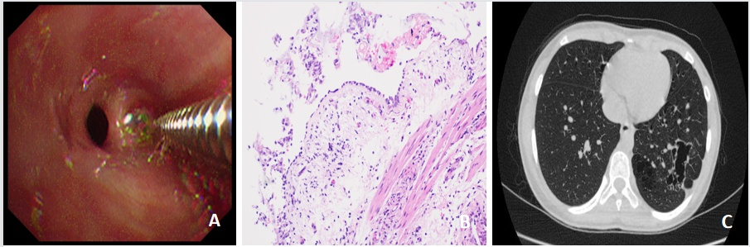
Figure 3 Transbronchial lung biopsy, postoperative pathological examination and computed tomography image results after treatment. A: Transbronchial lung biopsy under bronchoscopy; B: Endotracheal biopsy showing bacterial colonization, 200× magnification; C: High-resolution computed tomography (HRCT) obtained after treatment. Chest HRCT scans show the transparency of the basal segment of the left lower lobe increased, multiple lesions of unequal size, multilocular thin-walled air bag cavity can be seen. Compared with the former chest CT, some lesions are absorbed.

