Name of Journal: World Journal of Gastroenterology

Manuscript NO: 33350

Manuscript Type: CASE REPORT

Endoscopic occlusion with silicone spigots for the closure of refractory esophago-bronchiole fistula after esophagectomy

Uesato M et al. Occlusion with spigots for fistula

Masaya Uesato, Tsuguaki Kono, Yasunori Akutsu, Kentarou Murakami, Akiko Kagaya, Yorihiko Muto, Akira Nakano, Mizuho Aikawa, Tomohide Tamachi, Hiroyuki Amagai, Takahiro Arasawa, Yasuhide Muto, Hisahiro Matsubara

Masaya Uesato, Tsuguaki Kono, Yasunori Akutsu, Kentarou Murakami, Akiko Kagaya, Yorihiko Muto, Akira Nakano, Mizuho Aikawa, Tomohide Tamachi, Hiroyuki Amagai, Takahiro Arasawa, Yasuhide Muto, Hisahiro Matsubara, Department of Frontier Surgery, Chiba University Graduate School of Medicine, Chiba 260-8677, Japan

Author contributions: Uesato M wrote the manuscript; Uesato M, Kono T, Akutsu Y, Murakami K, Kagaya A, Muto Y, Nakano A, Aikawa M, Tamachi T, Amagai H, Arasawa T, Muto Y diagnosed and treated; all authors discussed the results and commented on the manuscript.

Informed consent statement: The patient involved in this study gave his written informed consent authorizing use and disclosure of his protected health information.

Conflict-of-interest statement: The authors state that they have no conflict of interest regarding this case report.

Open-Access: This article is an open-access article which was selected by an in-house editor and fully peer-reviewed by external reviewers. It is distributed in accordance with the Creative Commons Attribution Non Commercial (CC BY-NC 4.0) license, which permits others to distribute, remix, adapt, build upon this work non-commercially, and license their derivative works on different terms, provided the original work is properly cited and the use is non-commercial. See: http://creativecommons.org/licenses/by-nc/4.0/

Manuscript source: Unsolicited manuscript

Correspondence to: Masaya Uesato, MD, Department of Frontier Surgery, Chiba University Graduate School of Medicine, 1-8-1 Inohana, Chuo-ku, Chiba-shi, Chiba 260-8670, Japan. uesato@faculty.chiba-u.jp
Telephone: +81-43-2262110
Fax: +81-43-2262113

Received: February 3, 2017
Peer-review started: February 9, 2017
First decision: April 21, 2017
Revised: May 4, 2017
Accepted: June 9, 2017
Article in press:
Published online:

Abstract
A 65-year-old man with cT1bN0M0 stage I middle thoracic esophageal cancer underwent subtotal esophagectomy and gastric tube reconstruction through the posterior mediastinal route after preoperative carbon-ion radiotherapy and chemotherapy in a clinical trial. Anastomotic leakage occurred, but it spontaneously improved. At six months after the operation, he was rehospitalized with a cough and dysphagia. An esophago-bronchiole fistula and stenosis of the gastric tube were observed. He first underwent stent placement in the gastric tube. Two weeks later, the syringeal epithelium was burned by argon plasma coagulation after stent removal. Endoscopic occlusion was then performed for the fistula with two guidewire-assisted silicone spigots. Two weeks later, he was discharged on an oral diet, and he has not developed recurrence of the fistula or cancer for three years. This is the first report of endoscopic occlusion with a guidewire-assisted silicone spigot through the esophagus.

Key words: endobronchial watanabe spigot; endoscopic occlusion; guidewire; fistula; leakage; esophagectomy; esophageal cancer

© The Author(s) 2017. Published by Baishideng Publishing Group Inc. All rights reserved.

Core tip: Anastomotic leakage, which is a complication of esophagectomy, sometimes causes a refractory fistula. An esophago-bronchiole fistula (EBF) is a relatively rare but serious complication. We performed endoscopic occlusion using an endobronchial Watanabe spigot (EWS), a type of silicone bronchial blocker that is widely used in the respiratory field to treat pulmonary air leak, hemoptysis and bronchopleural fistula. We herein report a new and unique technique using the EWS to close a refractory EBF after esophagectomy. This report is the first to show that endoscopic occlusion using the EWS through the esophagus can simply and safely repair a refractory fistula.

Uesato M, Kono T, Akutsu Y, Murakami K, Kagaya A, Muto Y, Nakano A, Aikawa M, Tamachi T, Amagai H, Arasawa T, Muto Y, Matsubara H. Endoscopic occlusion with silicone spigots for the closure of refractory esophago-bronchiole fistula after esophagectomy. World J Gastroenterol 2017; In press
Introduction
Anastomotic leakage, which is a complication of esophagectomy, sometimes causes a refractory fistula^{[1]}. An esophago-bronchiole fistula (EBF) is a relatively rare but serious complication. Conventional therapy, such as hemoclipping, fibrin glue and stenting, are often performed^{[2-4]}. However, surgical repair may be ultimately performed. We herein report a new and unique technique using an endobronchial Watanabe spigot (EWS) through the esophagus to close a refractory EBF after esophagectomy.

Case Report
A 65-year-old man with cT1bN0M0 stage I middle thoracic esophageal cancer underwent subtotal esophagectomy and gastric tube reconstruction through the posterior mediastinal route after preoperative carbon-ion radiotherapy and chemotherapy in a clinical trial. Anastomotic leakage occurred, but it spontaneously improved. There was no residual cancer in the resected specimen. At six months after the operation, he was rehospitalized with a cough and dysphagia. An EBF at the right B1 bronchiole and stenosis of the gastric tube were observed (Figure 1). The region of the anastomotic leakage and the region of EBF were same. The patient first underwent full-covered stent (Flexella-J; ELLA-CS, s.r.o., Hradec Kralove, Czech Republic) placement in the gastric tube under fluoroscopic guidance. Two weeks later, we recognized the release of the stenosis with the persistent EBF after the stent removal. Hemoclipping was performed for the fistula but failed. We next burned the syringeal epithelium by argon plasma coagulation (Figure 2). At the same time, endoscopic occlusion was performed. Under fluoroscopic guidance, a 0.035-inch guidewire (Jagwire; Boston Scientific, Natick, MA, United States) was inserted into the EBF through an ultrathin endoscope (EG-580NW; FUJIFILM, Tokyo, Japan). After the endoscope was removed, a 5-mm endobronchial Watanabe spigot (EWS; Novatech, La Ciotat, France) was penetrated through its long axis using the guidewire (Figure 3A). After inserting a snaretube (MAJ-10; OLYMPUS, Tokyo, Japan) to the endoscope channel, the guidewire was retrogradely passed to the endoscope through the tube. Under fluoroscopic and endoscopic guidance, the EWS was wedged into the EBF (Figure 3B). Another 7-mm EWS was additionally inserted in a similar manner. The image just after the insertion showed the fistula occluded by the EWS (Figure 4A and B). Two weeks later, he was discharged on an oral diet, and he has not developed recurrence of the fistula or cancer for three years (Figure 5A-C).

Discussion
A new and unique technique using a guidewire-assisted EWS through the esophagus proved useful for closing a refractory EBF after esophagectomy.
The patient in the present case had not only an EBF but also stenosis of the upper gastric tube. Upper gastric tube is the periphery of the blood flow, had approximately 5 cm stenosis. We therefore suspect that the cause of the fistula was the anastomotic leakage occurred by ischemia. A refractory fistula commuting with the airway system often causes pneumonia and respiratory failure. A number of minimally invasive treatments have been proposed for treating a refractory fistula, including hemoclipping^{[2]}, stenting^{[4]}, polyglycolic acid sheets and fibrin glue ^{[3]} and over-the-scope clipping^{[4]}. In addition, since these therapies failed in the present case, surgery with a musculo-cutaneous flap was considered.
Before performing invasive treatment, we attempted endoscopic occlusion with an EWS, a type of silicone bronchial blocker^{[5]} that is widely used in the respiratory field to treat pulmonary air leak^{[6]}, hemoptysis^{[7]} and bronchopleural fistula^{[8]}. We selected EWS occlusion through the esophagus to blockade the nearest portion of the EBF. The spigot is typically grasped with forceps and inserted into the affected bronchus using a flexible bronchoscope^{[5]}. However, because fistulas of the digestive system are more irregular than those in the tracheal route, it can be difficult to insert the EWS using forceps. Therefore, in the present case, a guidewire was first inserted, and then the EWS was placed along the guidewire.
In 2003, Miyazawa et al^{[9]} first reported the “Push & Slide” method in Japanese. Recently, the usefulness of endobronchial occlusion for massive hemoptysis with a guidewire-assisted custom-made silicone spigot was reported^{[7]}. We recommend this method, as the EWS can be inserted precisely. There are three kinds of size in the EWS (short axis/ long axis: 5/8.5 mm, 6/10.5, 7/12.5)^{[6]}. A fistula to the respiratory tract exceeding its size seems to be out of the indication. In an esophago-bronchial or tracheal fistula, the spigot may fall into the airway. Therefore, the best indication of the fistula could be occluded by the EWS is an esophago-bronchiole fistula has the length longer than approximately 10 mm. In addition, coagulating the syringeal epithelium by argon plasma coagulation before the EWS insertion might accelerate the occlusion of the EBF^{[2]}.
In conclusion, we successfully performed EWS occlusion through the esophagus for an EBF without complications. We therefore recommend EWS occlusion as a potential treatment for a refractory EBF after esophagectomy. This is the first report of the successful closure of a refractory fistula, although EWS occlusion through the gastrointestinal tract needs further exploration.

COMMENTS
Case characteristics
A 65-year-old man with esophageal cancer underwent subtotal esophagectomy and gastric tube reconstruction. At six months after the operation, he was rehospitalized with a cough and dysphagia.

Clinical diagnosis
An esophago-bronchiole fistula was observed.

Differential diagnosis
Aspiration pneumonitis

Imaging diagnosis
An esophago-bronchiole fistula at the right B1 bronchiole and stenosis of the gastric tube were observed.

Treatment
He first underwent stent placement in the gastric tube. Two weeks later, the syringeal epithelium was burned by argon plasma coagulation after stent removal. Endoscopic occlusion was then performed for the fistula with two guidewire-assisted silicone spigots.

Experiences and lessons
A new and unique technique using a guidewire-assisted endobronchial Watanabe spigot through the esophagus proved useful for closing a refractory esophago-bronchiole fistula after esophagectomy.

Peer-review
The authors showed a new and unique technique using a guidemoire-assisted endobronchial Watanabe spigot through the esophagus proved useful for closing a refractory esophago-bronchial fistula after esophagectomy. The technique is new and original. The text is well-written.

References
1 Yamana I, Takeno S, Yamada T, Sato K, Hashimoto T, Yamashita Y. The Risk Factors for Refractory Fistula after Esophagectomy with Gastric Tube Reconstruction in Patients with Esophageal Cancer. Dig Surg 2017; 34: 18-24 [PMID: 27336465 DOI: 10.1159/000447603]
2 van Bodegraven AA, Kuipers EJ, Bonenkamp HJ, Meuwissen SG. Esophagopleural fistula treated endoscopically with argon beam electrocoagulation and clips. Gastrointest Endosc 1999; 50: 407-409 [PMID: 10462666 DOI: 10.1053/ge.1999.v50.97234]
3 Matsuura N, Hanaoka N, Ishihara R, Sugimura K, Motoori M, Miyata H, Yano M. Polyglycolic acid sheets for closure of refractory esophago-pulmonary fistula after esophagectomy. Endoscopy 2016; 48 Suppl 1 UCTN: E78-E79 [PMID: 26951471 DOI: 10.1055/s-0042-102452]
4 Bertani H, Grande G, Mirante VG, Franco I, Mangiafico S, Manta R, Conigliaro RL. Multimodal endoscopic treatment of primary esophago-pleural fistula. Endoscopy 2016; 48: E298-E299 [PMID: 27669530]
5 Watanabe Y, Matsuo K, Tamaoki A, Kamoto R, Hiraki S. Bronchial occlusion with Endobronchial Watanabe Spigot. J Bronchol 2003; 10: 264-267 [DOI: 10.1097/00128594-200310000-00005]
6 Sasada S, Tamura K, Chang YS, Okamoto N, Matsuura Y, Tamiya M, Suzuki H, Uehara N, Kobayashi M, Hirashima T, Kawase I. Clinical evaluation of endoscopic bronchial occlusion with silicone spigots for the management of persistent pulmonary air leaks. Intern Med 2011; 50: 1169-1173 [PMID: 21628931 DOI: 10.2169/internalmedicine.50.5016]
7 Coiffard B, Laroumagne S, Plojoux J, Astoul P, Dutau H. Endobronchial occlusion for massive hemoptysis with a guidewire-assisted custom-made silicone spigot: a new technique. J Bronchology Interv Pulmonol 2014; 21: 366-368 [PMID: 25321461 DOI: 10.1097/LBR.0000000000000106]
8 Dalar L, Kosar F, Eryuksel E, Karasulu L, Altin S. Endobronchial Watanabe spigot embolisation in the treatment of bronchopleural fistula due to tuberculous empyema in intensive care unit. Ann Thorac Cardiovasc Surg 2013; 19: 140-143 [PMID: 22785549 DOI: 10.5761/atcs.cr.11.01760]
9 Miyazawa H, Shinno H, Noto H, Fujisaka S, Taniguchi H, Izumi S. Bronchial Occlusion Using EWS (Endoscopic Watanabe Spigot) by Push & Slide Method and a Pilot Study of Bronchoscopic Lung Volume Reduction Using EWS for Severe Emphysema. J Jpn Soc Respir Endosc 2003; 25: 695-703 [DOI: 10.18907/jjsre.25.8_695]
P-Reviewer: Sugimura K, Tsubosa Y S-Editor: Gong ZM
L-Editor: E-Editor:
Specialty type: Gastroenterology and hepatology
Country of origin: Japan
Peer-review report classification
Grade A (Excellent): 0
Grade B (Very good): B
Grade C (Good): C
Grade D (Fair): 0
Grade E (Poor): 0

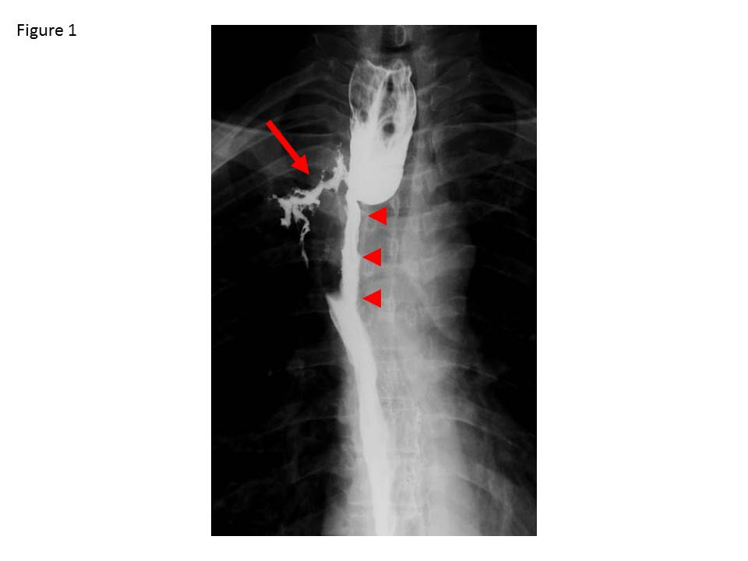
Figure 1 The radiographic image showed an esophago-bronchiole fistula from the anastomose to the right B1 bronchiole (arrow) and approximately 5 cm stenosis of the upper gastric tube (arrowhead).

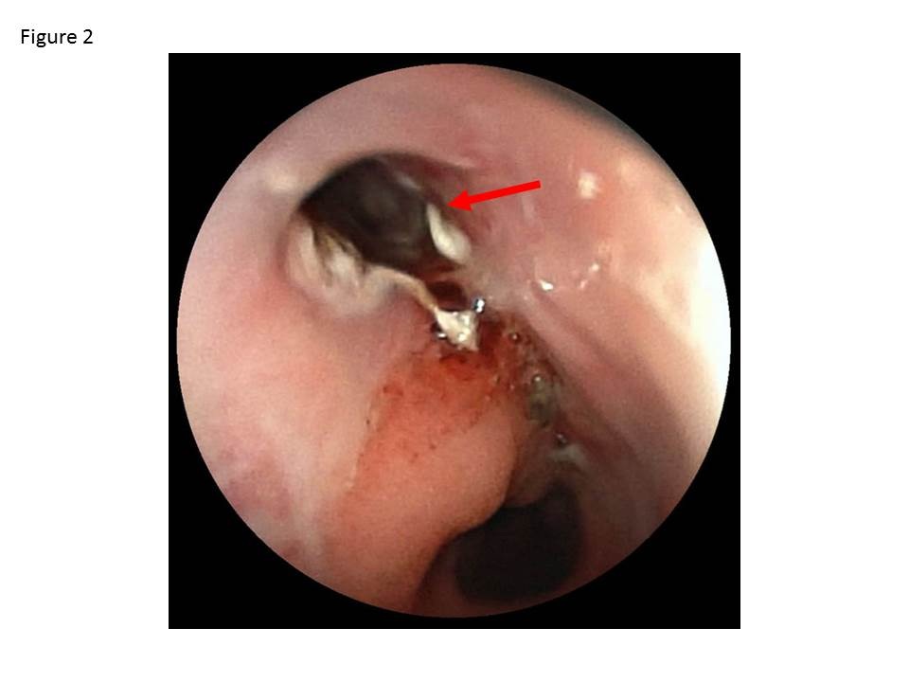
Figure 2 The epithelium of the esophago-bronchiole fistula was burned using argon plasma coagulation (arrow).

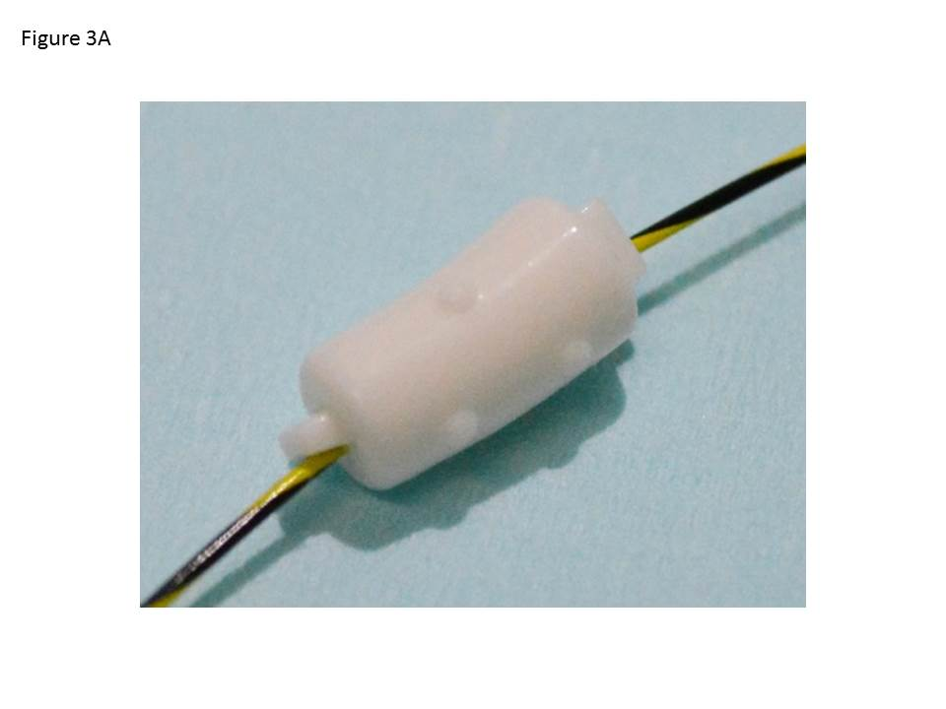
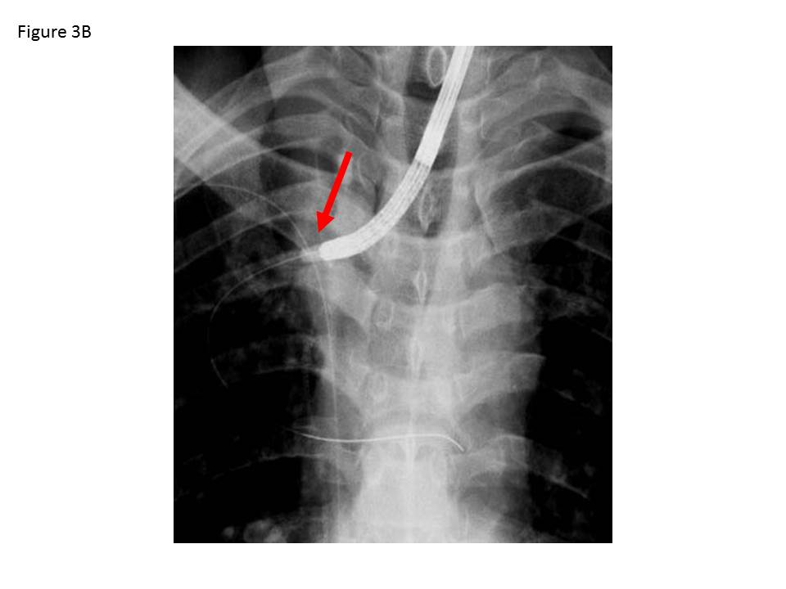
Figure 3 The endobronchial Watanabe spigot was penetrated through its long axis by the guidewire (A) (Push & Slide method^{[9]}. B: under fluoroscopic and endoscopic guidance, the endobronchial Watanabe spigot (arrow) was wedged into the esophago-bronchiole fistula.

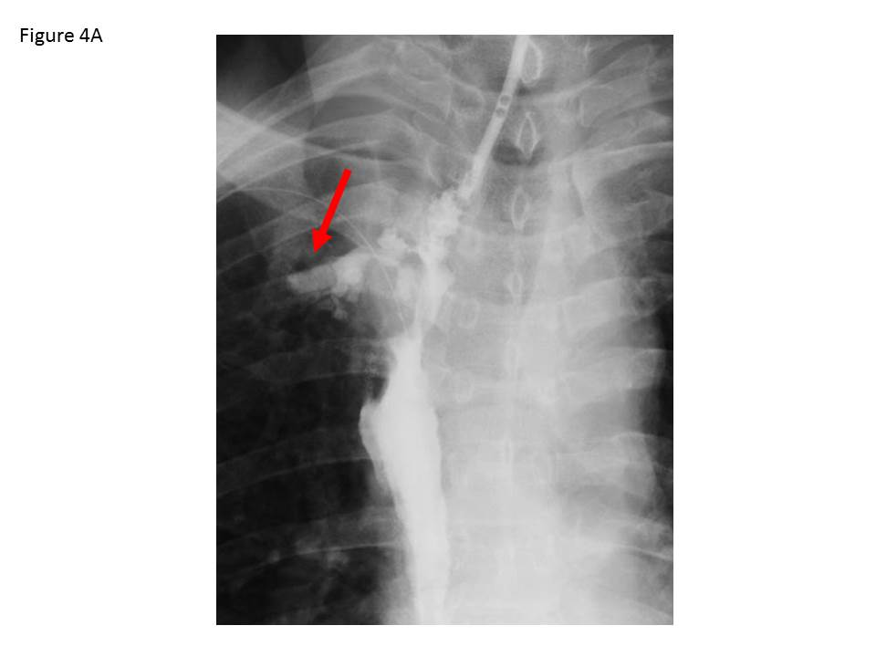
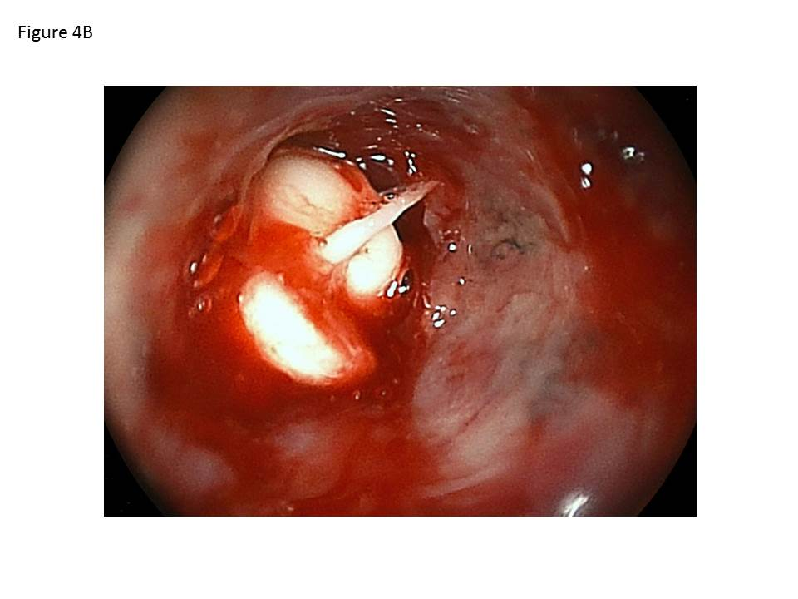
Figure 4 The radiographic image just after the insertion showed the fistula occluded by the endobronchial Watanabe spigot (A, arrow). B: In the endoscopic image just after occlusion, it was confirmed that the endobronchial Watanabe spigot is in the target fistula.

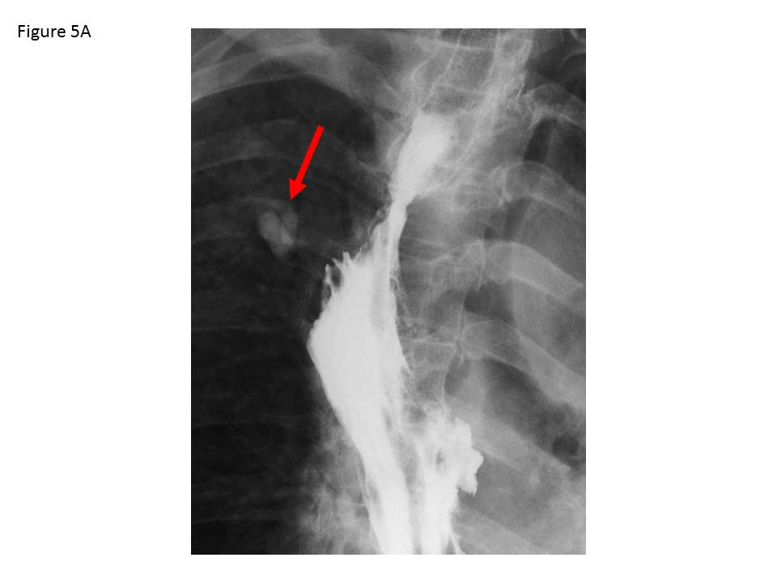
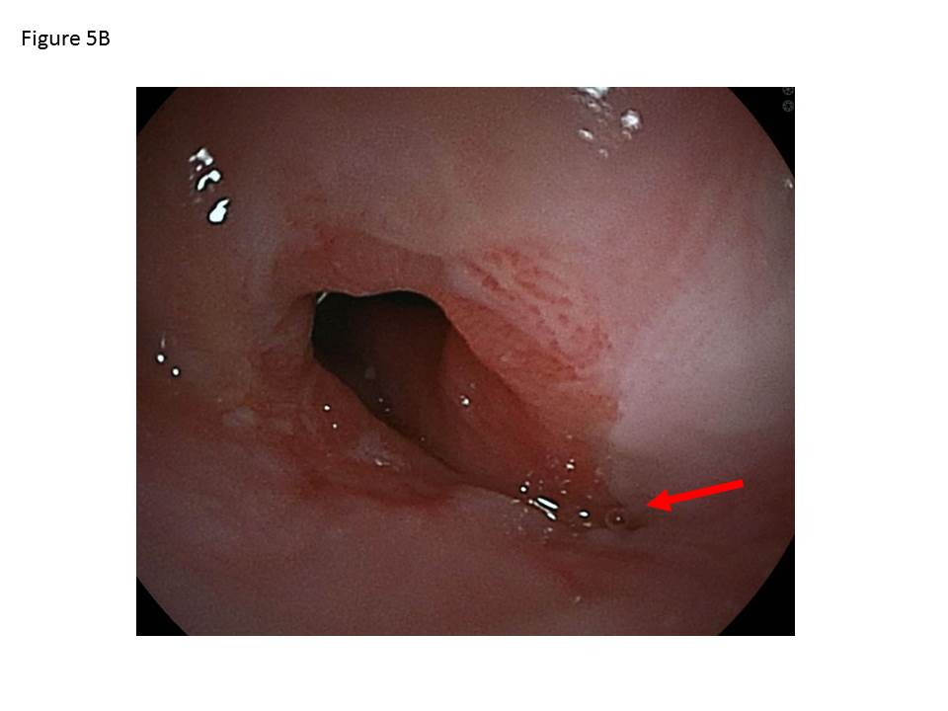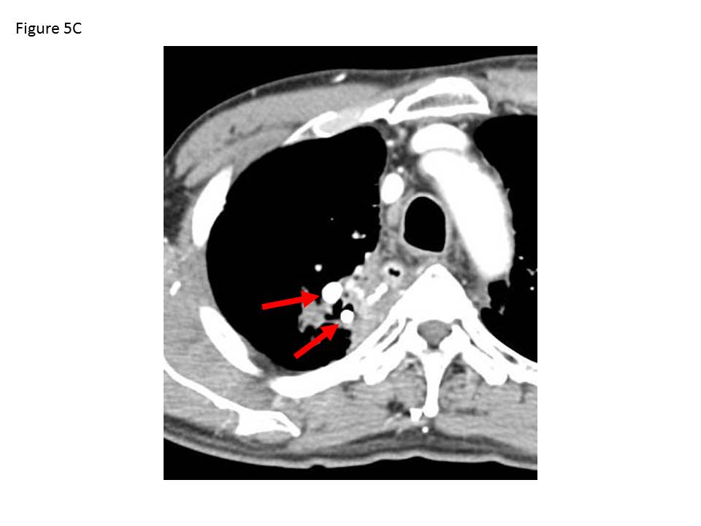

Figure 5 Since the endoscopic occlusion, the patient has not developed recurrence of the fistula for three years. Two endobronchial Watanabe spigots remain (A, arrow). B: In the endoscopic image passed for three years after occlusion, the fistula has disappeared. C: In computed tomography passed for three years after occlusion, two endobronchial Watanabe spigots remain (arrow).

