Name of Journal: World Journal of Clinical Cases
Manuscript NO: 79808
Manuscript Type: CASE REPORT

Repair of a giant inguinoscrotal hernia with herniation of the ileum and sigmoid colon: A case report

Liu SH et al. Giant inguinoscrotal hernia

Shih-Hung Liu, Ching-Hen Yen, Hsu-Ping Tseng, Je-Ming Hu, Ching-Han Chang, Ta-Wei Pu

Shih-Hung Liu, Hsu-Ping Tseng, Department of Surgery, Tri-Service General Hospital, National Defense Medical Center, Taipei 11490, Taiwan

Ching-Hen Yen, Division of Urological Surgery, Department of Surgery, Songshan Branch, Tri-Service General Hospital, National Defense Medical Center, Taipei 10581, Taiwan

Je-Ming Hu, Division of Colon and Rectal Surgery, Department of Surgery, Tri-Service General Hospital, National Defense Medical Center, Taipei 11490, Taiwan

Ching-Han Chang, Department of Surgery, Kaohsiung Armed Forces General Hospital, Kaohsiung 802, Taiwan

Ta-Wei Pu, Division of Colon and Rectal Surgery, Department of Surgery, Songshan Branch, Tri-Service General Hospital, National Defense Medical Center, Taipei 10581, Taiwan

Author contributions: Liu SH and Yen CH contributed to the drafting of the manuscript; Pu TW contributed to revising the final draft. Tseng HP contributed to the acquisition of data; Chang CH and Hu JM contributed to the investigation and interpretation of the data; All authors have read and approved the manuscript.

Corresponding author: Ta-Wei Pu, MD, Lecturer, Department of Surgery, Songshan Branch, Tri-Service General Hospital, National Defense Medical Center, No. 131, Jiankang Rd., Songshan District, Taipei 10581, Taiwan. tawei0131@gmail.com

Received: September 25, 2022
Revised: November 11, 2022
Accepted: December 19, 2022
Published online:

Abstract
BACKGROUND
Giant inguinoscrotal hernias are huge inguinal hernias that extend below the midpoint of the inner thigh in the standing posture. Giant inguinoscrotal hernias are rare in developed countries because of their better medical resources and early treatment. However, they can develop in patients who refuse surgery or ignore their condition. Intervention is inevitable because strangulation and organ perforation can occur, leading to peritonitis and sepsis. Common surgical approaches include open abdominal and inguinal approaches or a combination of both.

CASE SUMMARY
We present the case of a 73-year-old man who visited our emergency department with a huge mass in his left scrotum and septic complications. Abdominal computed tomography revealed a large left inguinoscrotal hernia that contained small bowel loops and the colon. Emergency surgical intervention was performed immediately because intestinal strangulation was highly suspected. The operative repair was performed using a combination of mini-exploratory laparotomy and the inguinal approach. The incarcerated organs, which included the ileum and sigmoid colon, had relatively good intestinal perfusion without perforation or ischemic changes. They were successfully reduced into the abdomen, and bowel resection was not necessary. A tension-free prosthetic mesh was used for the hernia repair. Two weeks after the initial surgery, and with adequate antimicrobial therapy, the patient recovered and was discharged from our hospital. No evidence of hernia relapse was noted during the outpatient follow-up examination 3 mo after surgery.

CONCLUSION
Emergency surgery involving combined mini-exploratory laparotomy and the inguinal approach should be performed for serious incarcerated giant inguinoscrotal hernias.

Key Words: Inguinal hernia; Ileum; Sigmoid colon; Sepsis; Hernia repair; Case report

Liu SH, Yen CH, Tseng HP, Hu JM, Chang CH, Pu TW. Repair of a giant inguinoscrotal hernia with herniation of the ileum and sigmoid colon: A case report. World J Clin Cases 2022; In press

Core Tip: Giant inguinoscrotal hernias are defined as hernias extending below the midpoint of the inner thigh of the patient in the standing position. Symptoms may vary, and serious complications, including intestinal obstruction and strangulation, may cause peritonitis and sepsis. Emergency surgery should be performed because of the risks of strangulation, perforation, and progressive necrosis. In this case, it was surprising to find the simultaneous existence of the ileum and sigmoid colon in the large inguinal hernia sac. The use of the inguinal approach combined with mini-exploratory laparotomy for giant hernial repair is beneficial and should be considered.

INTRODUCTION
Giant inguinoscrotal hernias are defined as huge inguinal hernias that extend below the midpoint of the inner thigh in the standing posture^{[1]}. Although rare, giant inguinoscrotal hernias still exist in developed countries. The main problem with inguinal hernias is their increasing size, which necessitates early surgical intervention. Giant inguinoscrotal hernias may develop in patients who refuse surgery or ignore their disease for a long time. Treatment of inguinoscrotal hernias is inevitable because strangulation and organ perforation can occur, resulting in further peritonitis and sepsis^{[2]}. The World Society of Emergency Surgery (WSES) guidelines for emergency repair of complicated abdominal wall hernias suggest that patients should undergo emergency hernial repair immediately if intestinal strangulation is suspected^{[3]}. Additionally, it has been proven that emergency surgical interventions are associated with higher rates of postoperative complications and adverse outcomes compared to early elective procedures^{[3,4]}. We report the case of a patient with a giant inguinoscrotal hernia and herniation of the ileum and sigmoid colon without early surgical intervention who presented with sepsis and suspected bowel strangulation. The emergency repair was performed using a combination of mini-exploratory laparotomy and the inguinal approach.

CASE PRESENTATION
Chief complaints
A 73-year-old man visited the emergency department of our hospital because of a huge mass in his left scrotum and intolerable lower abdominal and groin pain for a duration of approximately 2 wk.

History of present illness
Approximately 20 mo prior, the patient was diagnosed with a huge left inguinoscrotal hernia at our outpatient department; however, he refused early surgical intervention. Several days before the patient presented to the emergency department, he also experienced general weakness and decreased urine output.

History of past illness
Other than the previous diagnosis of left inguinal hernia, the patient had no history of chronic diseases or surgeries.

Personal and family history
The patient had been working as a security guard at an apartment for more than 10 years. Part of his job involved lifting and carrying packages received by the residents. No relevant family history was noted.

Physical examination
His vital signs were as follows: Body temperature, 36°C; blood pressure, 106/73 mmHg; heart rate, 95 beats/min, and respiratory rate, 22 breaths/min. The results of the physical examination revealed pitting edema of the bilateral lower limbs, tenderness in the left lower abdomen and inguinal region, a large irreducible inguinoscrotal hernia on the left side that measured approximately 14 cm x 16 cm in the supine position, and bilateral inguinal ecchymosis (Figure 1).

Laboratory examinations
Laboratory serum examinations revealed a white blood cell count of 21.57 × 10³/μL, 92.3% neutrophils, and thrombocytopenia with a platelet count of 90 × 10³/μL. C-reactive protein and procalcitonin levels were 35.32 mg/dL and 24.96 ng/mL, respectively. The serum creatinine level was 2.3 mg/dL.

Imaging examinations
Abdominal computed tomography (CT) scanning was performed without contrast because of decreased renal function, suggesting a huge left inguinal hernia with herniation of the small intestine and colon as well as a small number of ascites (Figure 2).

FINAL DIAGNOSIS
Physical and laboratory serum test results and radiographic findings indicated the presence of a large incarcerated inguinal hernia with sepsis.

TREATMENT
After diagnosing, we intravenously administered antibiotics comprising Flomoxef 1g every 12 h. Flomoxef was chosen because of its efficacy for intra-abdominal infections. The dosage was adjusted according to the patient’s creatinine clearance rate. Because of the risks of strangulation, perforation, and further profound septic shock, emergency surgery was performed.
The patient was placed in the supine position under general anesthesia. An inguinal incision on the left side revealed that the hernial sac was filled with ileum and sigmoid colon. Because of the failure to reduce the contents into the abdominal cavity, even with enlargement of the internal ring, a mini-midline incision was made. The incarcerated organs were carefully pulled out, and the adhesion between the hernial contents was separated. The hernial contents were grossly inflamed, with mild swelling and an erythematous appearance (Figure 3A). The incarcerated organs, with relatively good intestinal perfusion and no perforation or ischemic changes following a thorough examination, were successfully reduced into the abdomen (Figure 3B). The hernial repair was performed using tension-free techniques with unabsorbable polypropylene mesh sutured on the posterior wall of the inguinal canal. Finally, a Jackson-Pratt drain was placed in the left inguinal canal. The patient was transferred to the intensive care unit after surgery to closely monitor the end-organ function.

OUTCOME AND FOLLOW-UP
The patient experienced no complications during the early postoperative period. Two weeks after the initial surgery, with adequate infection control, the patient recovered and was discharged. The patient was able to remain in the standing position without evidence of relapse of the hernia at the time of the outpatient follow-up examination 3 mo after surgery.

DISCUSSION
Giant inguinoscrotal hernias are rare in developed countries. However, they can occur as a complication of an inguinal hernia. Other complications of an inguinal hernia include hernial enlargement, increasing pain, and incarceration or strangulation. They often result from patient neglect and the rejection of the suggested surgery for a hernia. For our patient, the risk factors for inguinal hernia were identified as his age, sex, and occupation^{[5]}. Giant inguinoscrotal hernias are more common in less developed countries that lack medical resources. The size of the hernia often negatively affects daily activities. The penis buried in the enlarged scrotum can result in urine dribbling over the scrotal skin, potentially leading to skin damage, ulceration, and further infections^{[6]}. Giant inguinoscrotal hernias accompanied by acute kidney injury resulting from urinary tract obstruction have been reported^{[7,8]}. In the present case, the CT scan did not reveal obstructive uropathy such as hydronephrosis. Hence, we suspected that renal impairment with the clinical presentation of decreased urine output in our case occurred as a result of sepsis. Hernial contents that cannot be reduced into the abdominal cavity are referred to as incarcerated hernias. Bowel obstruction and strangulation of the bowel contents with a compromised blood supply are serious results of incarceration. The common contents of the hernial sac are the small intestine and omentum. In some cases, the stomach, appendix, cecum, kidney, urinary bladder, ovaries, and sigmoid colon have been found in the hernial sac^{[9,10]}. In the present case, the simultaneous existence of the ileum and sigmoid colon in a large inguinal hernia sac was observed.
In our patient with a giant inguinoscrotal hernia, sepsis occurred with impaired renal function and coagulation according to the Sequential Organ Failure Assessment score^{[11]}. We performed surgery immediately because of the risk of strangulation and progressive necrosis, which could be fatal according to the WSES guidelines for emergency repair of complicated abdominal wall hernias^{[3]}.
A sudden increase in intra-abdominal pressure may occur after the majority of the hernial organs have been reduced into the abdominal cavity^{[12]}. Abdominal compartment syndrome can develop, leading to respiratory compromise attributable to an increase in intrathoracic pressure^{[13]}. To avoid compromising respiratory and cardiac functions and enable successful recovery, a complete preoperative evaluation and careful postoperative monitoring are important.
Several surgical interventions have been developed for this purpose, and they all share the common strategy of relocating the hernial organs into the abdominal cavity, adapting to a relative emptiness. Two approaches can be employed. First, the abdominal cavity can be increased by artificially inducing progressive pneumoperitoneum^{[14,15]}or creating an anterior abdominal wall defect and performing mesh repair and flap techniques^{[16,17]}. Second, reduction of abdominal or hernial contents can be performed to relocate the reduced abdominal organs^{[18]}.
In the present case, bowel resection was not necessary because the patient maintained an acceptable abdominal space without excessive tension and airway pressure perioperatively. Furthermore, his vital signs and urine output were closely monitored postoperatively because of the high risk of increased intra-abdominal pressure. Although measuring the intravesical pressure is a common method used to identify intra-abdominal pressure, we did not use this for our patient because of its relatively invasive nature despite the minimally invasive implementation requirements. Orchiectomy was not performed because dissection of the spermatic cord was not problematic. The scrotal skin was not resected because it was not infected. We successfully predicted that the skin would be able to recover after the removal of additional tension caused by the giant inguinoscrotal hernia.
We used an inguinal approach combined with a mini-midline incision. This method of management has several advantages. First, it results in an easier reduction of the ileum and sigmoid colon into the abdominal cavity through the defect. Second, it allowed us to carefully examine the bowel condition to determine the presence of perforation or ischemic changes. Finally, a Jackson-Pratt drain could be placed to ensure adequate drainage. Because hernial defects are large, the risk of recurrence of giant inguinoscrotal hernias is much higher than that of other inguinoscrotal hernias. The use of tension-free techniques whenever possible is recommended for hernial repairs^{[19]}. Most importantly, in addition to the initial surgical intervention, appropriate antimicrobial therapy was fundamental for our patient with sepsis.

CONCLUSION
In modern surgical practice, giant inguinoscrotal hernias are uncommon. When they do occur, they present challenges for the attending surgeon because they can cause fatal complications. For patients presenting with sepsis, emergency surgery should be performed if there is significant incarceration or strangulation. Adequate preoperative planning as well as intraoperative and postoperative monitoring are essential for these patients. The use of a combination of mini-exploratory laparotomy and the inguinal approach is worthy of further investigation. Enlargement of the abdominal cavity or debulking of the abdominal organs should be avoided if the abdominal cavity is sufficient. Relocation of the incarcerated organs using proper and early antimicrobial therapy was the cornerstone of successful treatment for this case.

REFERENCES
1 Hodgkinson DJ, McIlrath DC. Scrotal reconstruction for giant inguinal hernias. Surg Clin North Am 1984; 64: 307-313 [PMID: 6233734 DOI: 10.1016/s0039-6109(16)43287-1]
2 Gaedcke J, Schüler P, Brinker J, Quintel M, Ghadimi M. Emergency repair of giant inguinoscrotal hernia in a septic patient. J Gastrointest Surg 2013; 17: 837-839 [PMID: 23299222 DOI: 10.1007/s11605-012-2136-7]
3 Birindelli A, Sartelli M, Di Saverio S, Coccolini F, Ansaloni L, van Ramshorst GH, Campanelli G, Khokha V, Moore EE, Peitzman A, Velmahos G, Moore FA, Leppaniemi A, Burlew CC, Biffl WL, Koike K, Kluger Y, Fraga GP, Ordonez CA, Novello M, Agresta F, Sakakushev B, Gerych I, Wani I, Kelly MD, Gomes CA, Faro MP Jr, Tarasconi A, Demetrashvili Z, Lee JG, Vettoretto N, Guercioni G, Persiani R, Tranà C, Cui Y, Kok KYY, Ghnnam WM, Abbas AE, Sato N, Marwah S, Rangarajan M, Ben-Ishay O, Adesunkanmi ARK, Lohse HAS, Kenig J, Mandalà S, Coimbra R, Bhangu A, Suggett N, Biondi A, Portolani N, Baiocchi G, Kirkpatrick AW, Scibé R, Sugrue M, Chiara O, Catena F. 2017 update of the WSES guidelines for emergency repair of complicated abdominal wall hernias. World J Emerg Surg 2017; 12: 37 [PMID: 28804507 DOI: 10.1186/s13017-017-0149-y]
4 Primatesta P, Goldacre MJ. Inguinal hernia repair: incidence of elective and emergency surgery, readmission and mortality. Int J Epidemiol 1996; 25: 835-839 [PMID: 8921464 DOI: 10.1093/ije/25.4.835]
5 HerniaSurge Group.. International guidelines for groin hernia management. Hernia 2018; 22: 1-165 [PMID: 29330835 DOI: 10.1007/s10029-017-1668-x]
6 Serpell JW, Polglase AL, Anstee EJ. Giant inguinal hernia. Aust N Z J Surg 1988; 58: 831-834 [PMID: 3250419 DOI: 10.1111/j.1445-2197.1988.tb00988.x]
7 Goonetilleke K, McIlroy B. Giant inguinoscrotal hernia presenting with acute renal failure: a case report and review of literature. Ann R Coll Surg Engl 2010; 92: W21-W23 [PMID: 20501004 DOI: 10.1308/147870810X12659688852158]
8 Szymański MW, Hellmann AR, Patel A, Proczko-Stepaniak M, Kaska Ł. Acute Renal Failure Caused by Giant Inguinoscrotal Bladder Hernia. Urology 2020; 141: 24-26 [PMID: 32289360 DOI: 10.1016/j.urology.2020.03.031]
9 Tahir M, Ahmed FU, Seenu V. Giant inguinoscrotal hernia: case report and management principles. Int J Surg 2008; 6: 495-497 [PMID: 19059158 DOI: 10.1016/j.ijsu.2006.08.001]
10 Weitzenfeld MB, Brown BT, Morillo G, Block NL. Scrotal kidney and ureter: an unusual hernia. J Urol 1980; 123: 437-438 [PMID: 7359652 DOI: 10.1016/s0022-5347(17)55973-x]
11 Singer M, Deutschman CS, Seymour CW, Shankar-Hari M, Annane D, Bauer M, Bellomo R, Bernard GR, Chiche JD, Coopersmith CM, Hotchkiss RS, Levy MM, Marshall JC, Martin GS, Opal SM, Rubenfeld GD, van der Poll T, Vincent JL, Angus DC. The Third International Consensus Definitions for Sepsis and Septic Shock (Sepsis-3). JAMA 2016; 315: 801-810 [PMID: 26903338 DOI: 10.1001/jama.2016.0287]
12 Parker SG, Halligan S, Blackburn S, Plumb AAO, Archer L, Mallett S, Windsor ACJ. What Exactly is Meant by "Loss of Domain" for Ventral Hernia? Systematic Review of Definitions. World J Surg 2019; 43: 396-404 [PMID: 30187090 DOI: 10.1007/s00268-018-4783-7]
13 Papavramidis TS, Marinis AD, Pliakos I, Kesisoglou I, Papavramidou N. Abdominal compartment syndrome - Intra-abdominal hypertension: Defining, diagnosing, and managing. J Emerg Trauma Shock 2011; 4: 279-291 [PMID: 21769216 DOI: 10.4103/0974-2700.82224]
14 Mcadory RS, Cobb WS, Carbonell AM. Progressive preoperative pneumoperitoneum for hernias with loss of domain. Am Surg 2009; 75: 504-509 [PMID: 19545099]
15 Caldironi MW, Romano M, Bozza F, Pluchinotta AM, Pelizzo MR, Toniato A, Ranzato R. Progressive pneumoperitoneum in the management of giant incisional hernias: a study of 41 patients. Br J Surg 1990; 77: 306-307 [PMID: 2322795 DOI: 10.1002/bjs.1800770322]
16 El-Dessouki NI. Preperitoneal mesh hernioplasty in giant inguinoscrotal hernias: a new technique with dual benefit in repair and abdominal rooming. Hernia 2001; 5: 177-181 [PMID: 12003044 DOI: 10.1007/s10029-001-0030-4]
17 Valliattu AJ, Kingsnorth AN. Single-stage repair of giant inguinoscrotal hernias using the abdominal wall component separation technique. Hernia 2008; 12: 329-330 [PMID: 18253806 DOI: 10.1007/s10029-008-0346-4]
18 Vasiliadis K, Knaebel HP, Djakovic N, Nyarangi-Dix J, Schmidt J, Büchler M. Challenging surgical management of a giant inguinoscrotal hernia: report of a case. Surg Today 2010; 40: 684-687 [PMID: 20582525 DOI: 10.1007/s00595-009-4125-3]
19 Amid PK. Groin hernia repair: open techniques. World J Surg 2005; 29: 1046-1051 [PMID: 15983714 DOI: 10.1007/s00268-005-7967-x]

Footnotes
Informed consent statement: Informed written consent was obtained from the patient for the publication of this report and any accompanying images.

Conflict-of-interest statement: The authors declare that they have no conflict of interest to disclose.

CARE Checklist (2016) statement: The authors have read the CARE Checklist (2016), and the manuscript was prepared and revised according to the CARE Checklist (2016).

Open-Access: This article is an open-access article that was selected by an in-house editor and fully peer-reviewed by external reviewers. It is distributed in accordance with the Creative Commons Attribution NonCommercial (CC BY-NC 4.0) license, which permits others to distribute, remix, adapt, build upon this work non-commercially, and license their derivative works on different terms, provided the original work is properly cited and the use is non-commercial. See: https://creativecommons.org/Licenses/by-nc/4.0/

Provenance and peer review: Unsolicited article; Externally peer reviewed.

Peer-review model: Single blind

Peer-review started: September 25, 2022
First decision: October 18, 2022
Article in press:

Specialty type: Medicine, research and experimental
Country/Territory of origin: Taiwan
Peer-review report’s scientific quality classification
Grade A (Excellent): 0
Grade B (Very good): 0
Grade C (Good): C, C
Grade D (Fair): D
Grade E (Poor): 0

P-Reviewer: Sintusek P, Thailand; Sultan AAEA, Egypt; Tangsuwanaruk T, Thailand S-Editor: Liu GL L-Editor: A P-Editor: Liu GL

Figure Legends
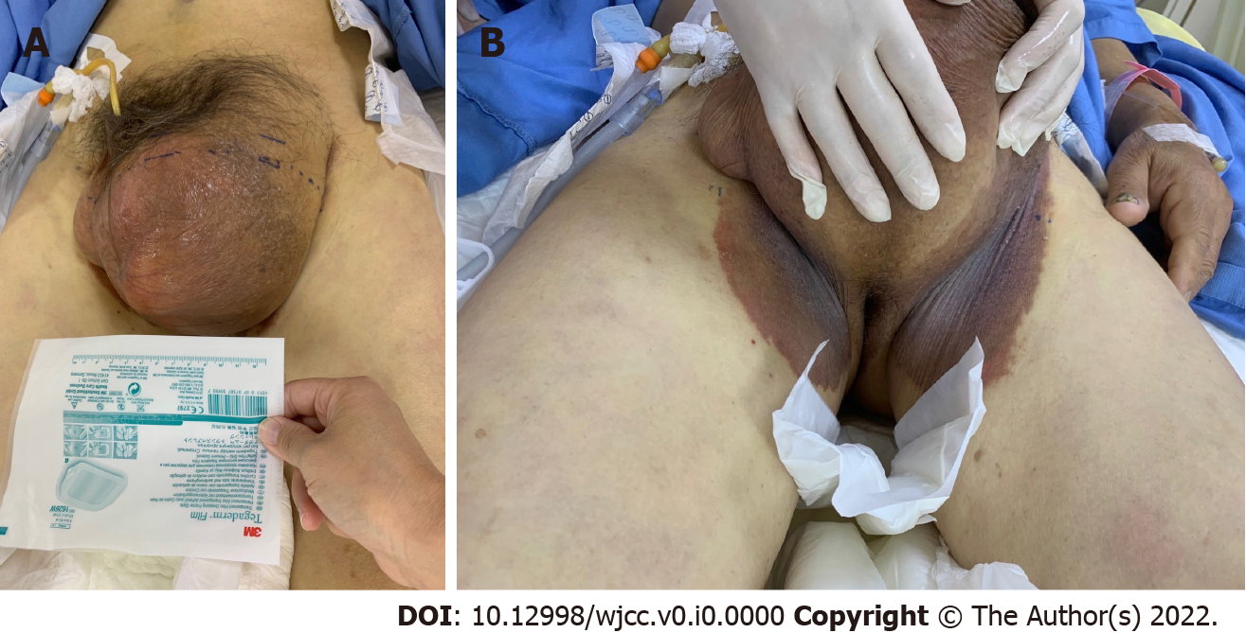
Figure 1 Left-side giant inguinoscrotal hernia. A: Huge irreducible inguinoscrotal hernia with the penis buried within the enlarged scrotum; B: Ecchymosis formation in the bilateral inguinal region.
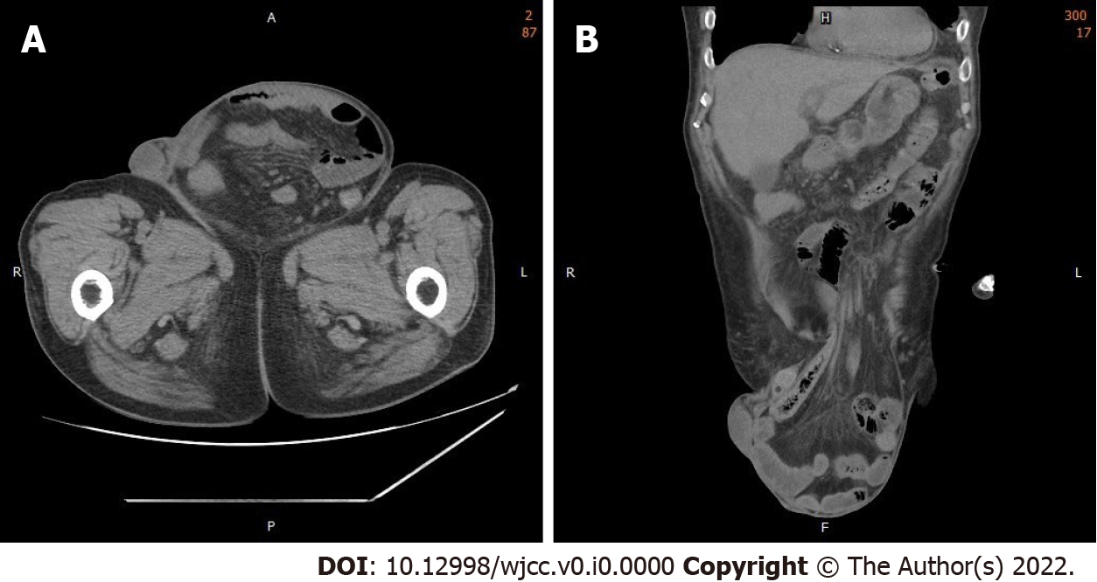
Figure 2 Abdominal computed tomography scan. A: Computed tomography (CT) of the abdomen (axial section); B: CT scan of the abdomen (coronal section) revealing a large left-side inguinal hernia containing small bowel loops as well as the colon.
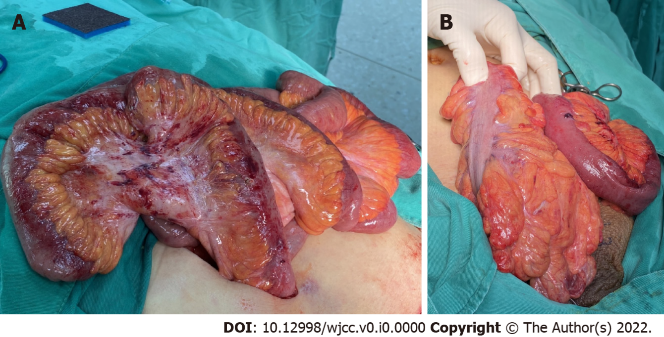
Figure 3 Intraoperative findings. A: Hernial contents are grossly inflamed, with mild swelling and an erythematous appearance; B: The ileum and sigmoid colon from the hernial sac with relatively good perfusion.

