Name of Journal: World Journal of Methodology
Manuscript NO: 83248
Manuscript Type: META-ANALYSIS

Microvessel density in patients with gastrointestinal stromal tumors: A systematic review and meta-analysis

Perivoliotis et al. Microvessel density in GISTs

Konstantinos Perivoliotis, Ioannis Baloyiannis, Athina A Samara, Prodromos Koutoukoglou, Panagiotis Ntellas, Katerina Dadouli, Maria Ioannou, Konstantinos Tepetes

Konstantinos Perivoliotis, Ioannis Baloyiannis, Athina A Samara, Konstantinos Tepetes, Department of Surgery, University Hospital of Larissa, Larissa 41110, Greece

Prodromos Koutoukoglou, Katerina Dadouli, Research Methodology in Biomedicine, Biostatistics and Clinical Bioinformatics, University of Thessaly, 41110 41110, Greece

Panagiotis Ntellas, Maria Ioannou, Department of Pathology, University Hospital of Larissa, Larissa 41110, Greece

Author contributions: Perivoliotis K, Ntellas P, Baloyiannis I contributed to study conception and design; Dadouli K, Koutoukoglou P contributed to acquisition of data; Perivoliotis K, Ntellas P, Samara A contributed to analysis and interpretation of data; Perivoliotis K, Ntellas P contributed to drafting of manuscript; Ioannou M, Tepetes K contributed to critical revision.

Corresponding author: Athina A Samara, MD, Surgeon, Department of Surgery, University Hospital of Larissa, Mezourlo Hill, Larissa 41110, Greece. at.samara93@gmail.com

Received: January 14, 2023
Revised: April 30, 2023
Accepted: May 16, 2023
Published online: June 20, 2023

Abstract
BACKGROUND
Gastrointestinal stromal tumors (GISTs) are considered the most common mesenchymal tumors of the gastrointestinal tract. Microvessel density (MVD) constitutes a direct method of vascularity quantification and has been associated with survival rates in multiple malignancies.

AIM
To appraise the effect of MVD on the survival of patients with GIST.

METHODS
This study adhered to Systematic reviews and Meta-Analyses guidelines and the Cochrane Handbook for Systematic Reviews of Interventions. Electronic scholar databases and grey literature repositories were systematically screened. The Fixed Effects or Random Effects models were used according to the Cochran Q test.

RESULTS
In total, 6 eligible studies were identified. The pooled hazard ratio (HR) for disease free survival (DFS) was 8.52 (95%CI: 1.69-42.84, P = 0.009). The odds ratios of disease-free survival between high and low MVD groups at 12 and 60 mo did not reach statistical significance. Significant superiority of the low MVD group in terms of DFS was documented at 36 and 120 mo (OR: 8.46 P < 0.0001 and OR: 22.71 P = 0.0003, respectively) as well as at metastases rate (OR: 0.11 P = 0.0003).

CONCLUSION
MVD significantly correlates with the HR of DFS and overall survival rates at 36 and 120 mo. Further prospective studies of higher methodological quality are required.

Key Words: Vascularity; Microvessel density; Gastrointestinal stromal; Survival; Meta-analysis

©The Author(s) 2023. Published by Baishideng Publishing Group Inc. All rights reserved.

Citation: Perivoliotis K, Baloyiannis I, Samara AA, Koutoukoglou P, Ntellas P, Dadouli K, Ioannou M, Tepetes K. Microvessel density in patients with gastrointestinal stromal tumors: A systematic review and meta-analysis. World J Methodol 2023; 13(3): 153-165
URL: https://www.wjgnet.com/2222-0682/full/v13/i3/153.htm
DOI: https://dx.doi.org/10.5662/wjm.v13.i3.153

Core Tip: This systematic review and meta-analysis summarize all available data regarding the prognostic role of microvessel density (MVD) in gastrointestinal stromal tumors (GISTs). MVD measurement affects long term GIST survival. However, further prospective studies are necessary.

INTRODUCTION
Gastrointestinal stromal tumours (GISTs) are the most common mesenchymal tumours of the gastrointestinal (GI) tract. According to existing literature, the average GIST incidence is estimated at 10 to 15 cases per million, ranging from 4.3 to 22/1000000 between different geographical locations^{[1,2]}. Furthermore, although the age of reported cases spans from 10 to 100 years, the median GIST presentation appears during the mid-60 years of age, with no discrepancies in terms of gender allocation^{[1,2]}.
Based on recent studies, the origin of these tumours can be traced to the interstitial cell of Cajal, a myenteric plexus pacemaker^{[2-4]}. The most frequent GIST locations are the stomach (55.6%), small (31.8%) and large intestine (6%). Further primary sites include the oesophagus, the omentum, the mesentery and the retroperitoneum^{[1-2,5]}. Regarding morphological characteristics, GISTs are classified in spindle cell, epithelioid cell and mixed type histological subgroups^{[6]}.
The majority of GISTs have been found to express KIT, a proto-oncogene protein^{[7]}. Specifically, KIT or c-kit is positive through immunohistochemical staining in almost 95% of all GISTs^{[6]}, while KIT-negative GISTs have been demonstrated to harbour mutations of platelet-derived growth factor receptor-alpha^{[6,8,9]}. Alteration of the function of these receptor tyrosine kinases is considered of major importance in the GIST oncogenesis, through the RAS-RAF-MAPK and PI3K-AKT-mTOR pathways^{[6]}. Surgical excision is considered the gold standard treatment for GISTs. However, kinase inhibitor adjuvant therapy (i.e. imatinib and sunitinib) has been introduced for treatment of advanced and metastatic disease^{[10–15]}, improving the overall survival (OS) and time to progression rates. Despite this, treatment resistance and disease recurrence rates still remain a significant problem^{[11,13]}.
To prognose the therapy outcomes, various risk grading systems have emerged, including those proposed by Fletcher et al^{[16]} and Miettinen et al^{[17]}. Several clinical and histopathologic factors been investigated such as tumor size, mitotic activity, anatomical origin, tumor rupture, tumor mutation type, predominant cell type, cellular density, p53, Ki-67, neutrophil to lymphocyte ratio and blood vessel invasion^{[6,11,13,18-20]}.
Microvessel density (MVD) assessment technique, based on the original work of Weidner et al^{[21]}, constitutes a direct method of vascularity quantification, since it represents the number of small blood vessels in tumoral tissue. Estimation of the vasculature is achieved through the application of various immunohistochemical endothelium labelling stains, such as cluster of differentiation (CD) 31, CD34, CD105 and von Willebrand Factor (vWF). The correlation between tumoral MVD and overall survival outcome in GIST patients has been extensively researched^{[8-9,22-25]}. However, to the best of our knowledge, there is still no study assessing overall prognostic value of MVD in these neoplasms.
Considering the above, a systematic literature review and meta-analysis of the reported outcomes was designed to estimate the pooled effect of tumor vascularity on survival of GIST patients, based on MVD measurements.

MATERIALS AND METHODS
Study protocol
The present meta-analysis was conducted based on the Cochrane Handbook for Systematic Reviews of Interventions and Systematic reviews and Meta-Analyses (PRISMA) guidelines^{[26]}. The study was not registered in current electronic databases.

Primary endpoint
The primary endpoint of the present meta-analysis was considered the Hazard Ratio (HR) of Disease-Free Survival (DFS) between low and high MVD measurements in patients suffering from GISTS. Pooled HR > 1 denoted a higher risk of death in patients with high MVD, compared to patients with low MVD.

Secondary endpoints
The secondary endpoints included pooled odds ratios (ORs) of DFS between high and low MVD measurements, at four specific time points (12, 36, 60 and 120 mo) of follow-up. Moreover, the pooled OR between high and low MVD tumours of the presence of metastases in GIST patients was estimated. A pooled OR > 1 suggested superiority of low MVD tumours when compared to respective high MVD tumours, in terms of survival endpoints. On the contrary, concerning the metastases endpoint the opposite applied.

Eligibility criteria
Eligible studies were prospective or retrospective trials with a study population consisting of GIST patients, whose outcomes of interest were reported in English and were retrievable. Specifically, the study design must have incorporated a primary tumor MVD assessment.
Exclusion criteria consisted of studies written in a language other than English, with no endpoint of interest, insufficient survival data and no human studies. Furthermore, studies in the format of a letter, conference abstract, expert opinion or duplicate trials were not incorporated in the meta-analysis.

Literature search
A systematic literature search in electronic scholar databases (Medline, CENTRAL, Scopus and Web of Science) and grey literature repositories (OpenGrey.eu and medRxiv) was performed to identify eligible studies. The last search date was December 2022. The literature search included the following search keywords: ‘gist’, ‘gastrointestinal stromal tumor’, ‘stromal tumor’, ‘mvd’, ‘microvessel density’ and ‘microvascular density’.

Study selection and data collection
The first step of screening included removing duplicate entries. Subsequently, titles and abstracts of the remaining studies were assessed based on the inclusion criteria. A full text review of accepted entries was then performed, to validate consistency with the eligibility criteria. The electronic database screening, study selection, data extraction as well as methodological and quality assessment were performed in duplicate and blindly by two independent investigators (K.P. and P.K.). To reach consensus, disagreements were resolved by mutual revision and discussion. If discrepancies were not resolved, the opinion of a third investigator (K.D) was considered.
The Newcastle-Ottawa Scale (NOS)^{[27]} was utilized to perform rigorous quality and methodological evaluation of eligible studies. NOS evaluates non-RCT trials in certain endpoints, such as selection and comparability of study groups and confirmation of the exposure. Each included study was rated with a score ranging from 0 to 9. Cohen’s k statistic was also calculated.

Statistical analysis
Data analysis and statistical computations were performed using Cochrane Collaboration RevMan version 5.3 and IBM SPSS version 23. The primary and secondary endpoints were reported in the form of HR and OR, respectively. Results of the analyses were presented with the corresponding 95% Confidence Interval (95%CI).
If eligible trials did not directly provide the HR or OR in the article results, they were estimated based on the algorithm proposed by Parmar et al^{[28]} and Tierney et al^{[29]}. Specifically, required data for the meta-analysis of trials endpoints were reconstructed from the Kaplan-Meier curves provided^{[30]}. The precision of extracted coordinates was enhanced through utilization of a digitizing software (Digitizelt)^{[31]}.
If included trials did not provide the mean and standard deviation (SD) of continuous variables, they were estimated from the median and the Interquartile Range (IR) based on the algorithm described by Hozo et al^{[32]}. Given a sample size of >25, the mean was considered equal to the median. For a sample of < 70, the SD was regarded as IR/4. In the other case, the SD was calculated as IR/6.
The statistical method applied was Mantel-Haenszel (MH) and the Inverse Variance for OR and HR, respectively. Both the Fixed Effects and Random Effects (RE) model were calculated. The final model that was estimated was based on the Cochran Q test. If statistically significant heterogeneity was present (Q test P < 0.1), then the RE model was applied. A further quantification of the heterogeneity was performed through the calculation of I². Statistical significance was considered at the level of P < 0.05.

Risk of bias across studies
To estimate the publication bias of included studies, the funnel plot of the primary outcome was visually inspected. Regarding the primary outcome, Egger’s test was also performed.

RESULTS
Study selection
Through the above-mentioned search algorithm (Figure 1), 994 citations were retrieved (Medline: 412, Web of Science: 526, Scopus: 31, CENTRAL: 1, OpenGrey.eu: 15, medRxiv: 9). The next step included the removal of 340 duplicate records. A total of 654 records underwent title and abstract screening, resulting in the exclusion of 631 entries (17 reviews/ meta-analyses, 2 conference abstracts, 4 paediatric studies, 608 irrelevant records). Examination of compliance with eligibility criteria extended to the full text articles of the previously accepted records. In total, 5 studies with inadequate survival data and 12 irrelevant studies were excluded. Subsequently, 6 studies^{[8-9,22–25]} were included in the present meta-analysis.

Study characteristics
Table 1 summarizes the characteristics of included studies. Regarding study type, all trials had a retrospective design. Furthermore, all except one trial^{[9]} were single centre, with sample size ranging from 53 to 124. More specific information regarding the analysis and total specimen sample are reported in Table 1. Mean patient age and gender allocation are also displayed in Table 1. Mean follow-up period extended from 2.5 years in the study by Waengertner et al^{[24]}, up to 81.7 mo in the study by Takahashi et al^{[23]}.
Concerning the MVD assessment method that was applied, the majority of included trials described the use of light microscopy and immunochemistry, implementing the technique proposed by Weidner et al^{[21]} (Table 2). Exceptions to this were trials by Imamura et al^{[8]} and Waengertner et al^{[24]} which reported the application of a modified Horak technique and Chalkley method, respectively. Despite the fact that the majority of eligible trials used CD31 antibodies, Zhao et al^{[25]} utilized the CD34 antibody. Heterogeneity was identified in the reported level of magnification. More specifically, the applied magnification spanned from 40X up to 400X. Furthermore, non-uniformity was discovered in the number of spots examined, which ranged from 3 to 10 spots. Only two trials^{[8,9]} confirmed blinded estimation of microvessel density by two independent observers, and none provided information about the existence of separate count for intratumoral and peritumoral vessels. All researchers except Zhao et al^{[25]} included the MVD cut-off value in their study articles.
Table 3 summarizes the data regarding the risk classification of included tumours. Moreover, the localization of GISTs included: 9 in the oesophagus, 284 in the stomach, 127 in the small intestine and 28 in the anatomic area of the colon and rectum. According to Table 4, only the study group of Chen et al^{[22]} recorded tumor complications like necrosis (37%) and haemorrhage (72.6%). Table 4 incorporates histopathologic characteristics, such as the mitotic count and the tumor size of included GISTs. From the eligible trials, tumor cell type categorization was performed in only 3^{[8,24,25]} studies. In total, 29 epithelioid, 222 spindle and 25 mixed tumours were identified. Finally, inconsistent data were provided by the included trials in terms of the operation performed and chemotherapy type administered.

Risk of bias within studies
Regarding the assessment based on the NOS scale, most studies achieved a 5-star score. The trial by Chen et al^{[22]} was an exception, as it appointed a 6 star score. Inter-rater agreement was estimated to be in a very good level (Cohen’s k statistic: 86.8%, P < 0.001)

Primary endpoint
Data regarding the HR of DFS were extracted from 4 studies (Figure 2). Meta-analysis of these data showed a statistically significant (P = 0.009) hazard ratio of DFS (HR: 8.52, 95%CI: 1.69-42.84), in favour of the low MVD group. Since heterogeneity was significant (Q test P < 0.001, I² = 90%), a RE model was applied.
Due to the high heterogeneity level, further statistical investigation was performed. The first step included a sensitivity analysis for the effect of each study separately. The overall heterogeneity level was not affected by any study. Meta-regression (Supplementary Material Tables) for the variables sample size, age and follow-up duration did not identify any statistically significant factor. Subgroup analysis regarding the number of study centres and the antibody used were identical to the above-mentioned sensitivity analysis. Analysis of studies implementing the Weidner MVD assessment method showed a statistically significant hazard ratio. Similarly, exclusion of the two studies which did not report blinded MVD evaluation did not influence heterogeneity. Further explanatory analyses (Supplementary Material Tables) included meta-regression of the primary outcome with the number of spots examined, the percentage of high-risk tumours, gastric and small intestine tumours, large size tumours (≥ 5 cm) and spindle cell malignancies. A significant correlation was not confirmed with any of the previously mentioned variables.

Secondary endpoints
In total, 3 studies provided data concerning the comparison between high and low MVD groups for DFS at 12 mo (Figure 3). Meta-analysis of these data showed no statistically significant difference (P = 0.13) of DFS (OR: 1.91, 95%CI: 0.83-4.41) at 12 mo between the two study groups. However, a statistically significant difference (P < 0.001) of DFS (OR: 8.46, 95%CI: 3.54-20.19) in favour of the low MVD group was estimated at 36 mo. Although there was no difference (P = 0.58) of DFS rates (Figure 4) at 60 mo (OR: 2.31, 95%CI: 0.12-44.82), the low MVD group displayed a higher (P = 0.0003) DFS rate (Figure 3) at 120 mo (OR: 22.71, 95%CI: 4.11-125.57).
Finally, two studies provided data concerning the development of metastases (Figure 3). Meta-analysis of these data showed a statistically significant (P = 0.0003) lower ratio of metastases (OR: 0.11, 95%CI: 0.03-0.36) in the low MVD group. Heterogeneity was not significant in this analysis (Q test P = 0.29, I² =10).

Risk of bias across studies
Visual inspection of the funnel plot suggested that studies by Wang et al^{[8]} and Waengertner et al^{[23]} lie beyond the 95%CI limits. Based on Egger’s test, there was no statistically significant publication bias (P = 0.517). Exclusion of the above-mentioned trials resulted in a statistically significant HR (7.71 95%CI: 4.02-14.8, P < 0.001) in favour of the low MVD group, though with a limited degree of heterogeneity (Q test P = 0.64, I² = 0%).

DISCUSSION
Since GISTs are the most frequently occurring parenchymal neoplasms of the GI tract, research is focused on improving prognosis, introducing novel chemotherapeutic agents and refining current surgical approaches^{[11-15,33]}. Since a few decades ago conventional chemotherapy and radiotherapy did not yield satisfactory results, a R0 resection of the tumor was considered the only therapeutic option for adequate long-term survival^{[33]}. The discovery of the c-kit proto-oncogene mutation and ligand independent activation of the KIT receptor tyrosine kinase in GISTs, resulted in subsequent development of the tyrosine kinase inhibitors imatinib and sunitinib. This led to the onset of targeted molecular therapy of these neoplasms^{[11,13,33]}. In a cohort study by Guller et al^{[34]}, the Surveillance, Epidemiology and End Results database was screened, with 5,138 GIST patients included. Data analysis revealed that recent advancements in treatment resulted in a significant increase in survival rates of both metastatic (3-year OS: 54.7%, cancer-specific survival: 61.9%) and non-metastatic disease (3-year OS: 88.6%, cancer-specific survival: 92.2%)^{[34]}.
It must be noted that despite the above-mentioned novelties, the mortality rate – particularly for the metastatic group - remains high. As a result, various risk grading tools have been developed to quantify the risk and provide accurate prognosis regarding survival endpoints. The study group of Fletcher et al^{[16]} proposed the use of primary tumor size and mitotic count as grading parameters, which classified GISTs in four successive categories based on risk of aggressive behaviour. Due to a discrepancy in the metastatic risk between gastric and intestinal GISTs of different grading scores, the primary tumor location was also incorporated^{[17]}. Exporting data from the SSG XVIII trial and using the Z9001 study as a validation tool, Joensuu et al^{[18]} suggested that high tumor mitotic count, non-gastric location, large size and tumor rupture were significantly and independently related to a suboptimal recurrence-free survival (RFS).
Besides these grading tools, various independent tumor histopathological factors have been studied for their prognostic value. Specifically, GISTs with an epithelioid or mixed cell type have been associated with a significantly lower 5-year recurrence free survival, when compared with the respective spindle cell tumours (23% vs 49%)^{[35]}. Moreover, according to Martin et al^{[36]}, high tumor cellularity was characterized as a significant poor RFS prognostic factor. Overexpression of Ki67, a nuclear marker abundant in proliferating cells, was found to have an increased incidence in the high risk group^{[19]}. On the contrary, expression levels of p53 in GISTs were not significantly associated with clinical outcomes^{[37,38]}. A pooled analysis from Luo et al^{[20]} showed that an elevated neutrophil to lymphocyte ratio was associated with decreased DFS/RFS (HR: 2.18, 95%CI: 1.30-3.67). Furthermore, blood vessel invasion in the primary tumor was suggested as a predictor of liver metastasis and an aggressive behaviour^{[39]}.
Angiogenesis in GISTs is considered of the utmost importance for the neoplasm growth and metastasis process^{[8]}. Proliferation of tumor vasculature is achieved via the paracrine release of angiogenic molecules and growth factors from tumor and stromal cells^{[8]}. In a recent study by Zhao et al^{[25]}, the altered expression and secretion of proliferating and angiogenic agents like PI3K, Akt, PTEN, MMP9 and VEGF were directly associated with the DFS in GIST patients. Regarding VEGF, higher serum VEGF values were found in GIST patients when compared to healthy controls, while a positive VEGF expression rate was found in high risk groups^{[9]}. A considerable number of clinical trials have correlated high VEGF levels with poor prognosis^{[9,23,25,40]}. Another angiogenic factor, PDGF, has been related to GIST vasculogenesis at both theoretical and clinical levels^{[41,42]}. As tumor angiogenesis often progresses through a hypoxic drive, researchers have correlated the expression levels of respective markers (e.g. HIF-1α) with survival outcomes^{[22,43]}. Finally, vasculogenic mimicry (VM) which is a novel pattern of angiogenesis and defined as the formation of fluid conducting channels by highly invasive and dysregulated tumor cells, has also been studied in GISTs^{[44,45]}. MMP-2 and MMP-9 were found to be contributing factors in VM; a significant association between VM, a high mitotic rate and liver metastases was confirmed^{[44]}.
Microvessel density is a direct method of quantifying and assessing intratumoral vasculature, and consequently angiogenesis potential. Due to the above-mentioned correlation between tumor vascularity and clinicopathological endpoints, various trials investigated GIST MVD. According to Imamura et al^{[8]} and Waengertner et al^{[24]}, a statistically significant difference of survival rates in favour of low MVD GISTs was reported. Furthermore, Wang et al^{[9]} stated that higher MVD values were found in high mitotic count and recurrence groups. Similar results were published by Zhao et al^{[25]}, where a significant hazard ratio for DFS was found. A retrospective study by Takahashi et al^{[23]} suggested that while high MVD displayed a significant relationship with liver metastases, it did not influence the survival outcome at 10 years.
The results of our meta-analysis validated the significance of the MVD value effect on survival. Specifically, higher intratumoral MVD measurements were associated with a lower DFS rate at 36 and 120 mo of follow-up. These were not confirmed at the intermediate endpoints of 12 and 60 mo. The enhanced malignant potential of high vascularized GISTs was also depicted by the significant association among metastatic rate and MVD values.
The usefulness of these results involve extensive approaches in the clinical outcome prognosis^{[8-9,23,25,43]}. Consolino et al^{[46]} showed that in dynamic contrast-enhanced magnetic resonance imaging (DCE-MRI), imatinib-resistant tumors had an increased vessel density and permeability, with these attributes significantly correlated with MVD and MDD, respectively. Contrast enhanced endoscopic ultrasound has also demonstrated the ability to assess GIST vascularity, and subsequently, malignant potential^{[47]}. Furthermore, since MVD is a direct tumor vasculature marker, it has been used as an indicator of the angiogenesis inhibition, as well as the overall response to novel medical treatment^{[48]}.
Besides GIST, MVD assessment has been extensively researched as a means of solid tumor vasculature quantification. Researchers have attempted to identify and estimate the presence of a correlation between microvessel density and survival outcomes in malignancies of the prostate^{[49]}, cervix^{[50]}, ovaries^{[51]}, breast^{[52]}, pancreas^{[53]}, kidney^{[54]} and lung^{[55]}. Moreover, in two recent meta-analyses from our study group concerning cutaneous melanoma and patients with differentiated thyroid cancer, high intratumoral MVD was related to poor survival outcomes^{[56,57]}. According to current literature, the majority of studies validate the presence of a significant correlation between intratumoral MVD and prognosis in solid tumors^{[58]}. However, a discrepancy exists since a minority of publications question the significance of the above-mentioned correlation^{[58]}.
Heterogeneity of various clinicopathological endpoints (survival, metastasis, local recurrence, response to treatment, etc.) in the reported results has been widely attributed to certain methodological variations^{[58]}. Among these, selection of the hot-spot examination technique is the most important, due to the variability rates and dependence on the assessor training and experience^{[59,60]}. Furthermore, the MVD assessment technique includes various modifications, such as Weidner’s hot-spot method^{[21]}, the lumen method^{[61]}, Chalkley’s method^{[62]} and the computerized image analysis system^{[63]}. Another field of methodological diversity is considered the selection of the endothelial marker, where a variety of choices such as pan-endothelial cell markers (CD31, CD34, vWF) and selective for the activated endothelium factors (CD105) are described. Finally, technical discrepancies are also reported in other methodological fields, such as type of fixative, vasculature estimation, the MVD cut-off value, level of magnification and overall field size^{[58]}. Our study highlighted this heterogeneity; the use of different assessment methods and definitions of high and low MVD tumours prohibited the calculation of a pooled cut-off point.
Certain limitations should be taken into consideration, prior to appraising results of the present meta-analysis. Firstly, significant levels of heterogeneity were identified; despite conducting explanatory analyses, the validity of study conclusions may be compromised. Furthermore, all eligible studies were designed using a retrospective methodology and included a small sample size, thus allowing the introduction of bias. Moreover, diversity among included studies regarding methodological characteristics of the MVD assessment technique should be also acknowledged. The implementation of different assessment methods and different cut-off points prohibited the strict definition of high and low MVD GISTs. Furthermore, heterogeneity in terms of tumor location, risk classification, histopathological characteristics and cell subtype jeopardized the significance of our outcomes. Inconsistency in surgical or medical treatment could also be an influencing factor on survival endpoints. Finally, since in most trials the raw survival data had to be extracted and reconstructed from the provided Kaplan-Meier curves, a certain amount of bias was introduced, although this procedure has been extensively described and applied in the literature.

CONCLUSION
To the best of our knowledge, the present study is the first attempt to provide an overall estimation of the impact of MVD on survival rates of GIST patients. According to the pooled results of the meta-analysis, GIST allocation between high and low MVD values significantly influenced the DFS hazard ratio. Moreover, high MVD GISTs demonstrated a statistically significant lower DFS at 36 and 120 mo of follow-up, while no difference was found at 12 and 60 mo. Moreover, high MVD tumours were associated with a significantly higher rate of metastases. Based on the above-mentioned results and given several limitations, further studies with a larger sample size and adequate methodology are required.

ARTICLE HIGHLIGHTS
Research background
Several clinical and histopathologic factors have been investigated as prognostic indicators of survival in patients with gastrointestinal stromal tumours (GISTs).

Research motivation
Microvessel density (MVD) has been extensively applied as a direct method of tumour vascularity assessment.

Research objectives
This meta-analysis attempted to estimate the pooled effect of tumoral vascularity based on MVD assessment on the survival of patients with GISTs.

Research methods
The present meta-analysis adhered to the Systematic reviews and Meta-Analyses guidelines and the Cochrane Handbook for Systematic Reviews of Interventions.

Research results
Low vascularized tumours were associated with improved pooled disease-free survival. GISTs with lower MVD values displayed a reduced risk of metastases.

Research conclusions
MVD is significantly associated with the survival outcomes of GIST patients.

Research perspectives
Further prospective randomized controlled trials are required to delineate the exact correlation between MVD and prognosis outcomes in GIST patients.
REFERENCES
1 Søreide K, Sandvik OM, Søreide JA, Giljaca V, Jureckova A, Bulusu VR. Global epidemiology of gastrointestinal stromal tumours (GIST): A systematic review of population-based cohort studies. Cancer Epidemiol 2016; 40: 39-46 [PMID: 26618334 DOI: 10.1016/j.canep.2015.10.031]
2 Diamantis A, Samara AA, Symeonidis D, Baloyiannis I, Vasdeki D, Tolia M, Volakakis G, Mavrovounis G, Tepetes K. Gastrointestinal stromal tumors (GISTs) and synchronous intra-abdominal malignancies: case series of a single institution's experience. Oncotarget 2020; 11: 4813-4821 [PMID: 33447349 DOI: 10.18632/oncotarget.27853]
3 Min KW, Leabu M. Interstitial cells of Cajal (ICC) and gastrointestinal stromal tumor (GIST): facts, speculations, and myths. J Cell Mol Med 2006; 10: 995-1013 [PMID: 17125601 DOI: 10.1111/j.1582-4934.2006.tb00541.x]
4 Kindblom LG, Remotti HE, Aldenborg F, Meis-Kindblom JM. Gastrointestinal pacemaker cell tumor (GIPACT): gastrointestinal stromal tumors show phenotypic characteristics of the interstitial cells of Cajal. Am J Pathol 1998; 152: 1259-1269 [PMID: 9588894]
5 Laurini JA, Carter JE. Gastrointestinal stromal tumors: a review of the literature. Arch Pathol Lab Med 2010; 134: 134-141 [PMID: 20073618 DOI: 10.5858/2008-0083-RSR2.1]
6 Yamamoto H, Oda Y. Gastrointestinal stromal tumor: recent advances in pathology and genetics. Pathol Int 2015; 65: 9-18 [PMID: 25414046 DOI: 10.1111/pin.12230]
7 Miettinen M, Lasota J. Gastrointestinal stromal tumors--definition, clinical, histological, immunohistochemical, and molecular genetic features and differential diagnosis. Virchows Arch 2001; 438: 1-12 [PMID: 11213830 DOI: 10.1007/s004280000338]
8 Imamura M, Yamamoto H, Nakamura N, Oda Y, Yao T, Kakeji Y, Baba H, Maehara Y, Tsuneyoshi M. Prognostic significance of angiogenesis in gastrointestinal stromal tumor. Mod Pathol 2007; 20: 529-537 [PMID: 17334345 DOI: 10.1038/modpathol.3800767]
9 Wang TB, Qiu WS, Wei B, Deng MH, Wei HB, Dong WG. Serum vascular endothelial growth factor and angiogenesis are related to the prognosis of patients with gastrointestinal stromal tumors. Ir J Med Sci 2009; 178: 315-320 [PMID: 19367428 DOI: 10.1007/s11845-009-0315-7]
10 Poveda A, García Del Muro X, López-Guerrero JA, Cubedo R, Martínez V, Romero I, Serrano C, Valverde C, Martín-Broto J; GEIS (Grupo Español de Investigación en Sarcomas/Spanish Group for Sarcoma Research). GEIS guidelines for gastrointestinal sarcomas (GIST). Cancer Treat Rev 2017; 55: 107-119 [PMID: 28351781 DOI: 10.1016/j.ctrv.2016.11.011]
11 Duffaud F, Le Cesne A. Recent advances in managing gastrointestinal stromal tumor. F1000Res 2017; 6: 1689 [PMID: 28928967 DOI: 10.12688/f1000research.11118.1]
12 El-Menyar A, Mekkodathil A, Al-Thani H. Diagnosis and management of gastrointestinal stromal tumors: An up-to-date literature review. J Cancer Res Ther 2017; 13: 889-900 [PMID: 29237949 DOI: 10.4103/0973-1482.177499]
13 Szucs Z, Thway K, Fisher C, Bulusu R, Constantinidou A, Benson C, van der Graaf WT, Jones RL. Molecular subtypes of gastrointestinal stromal tumors and their prognostic and therapeutic implications. Future Oncol 2017; 13: 93-107 [PMID: 27600498 DOI: 10.2217/fon-2016-0192]
14 ESMO/European Sarcoma Network Working Group. Gastrointestinal stromal tumours: ESMO Clinical Practice Guidelines for diagnosis, treatment and follow-up. Ann Oncol 2014; 25 Suppl 3: iii21-iii26 [PMID: 25210085 DOI: 10.1093/annonc/mdu255]
15 von Mehren M, Randall RL, Benjamin RS, Boles S, Bui MM, Conrad EU 3rd, Ganjoo KN, George S, Gonzalez RJ, Heslin MJ, Kane JM 3rd, Koon H, Mayerson J, McCarter M, McGarry SV, Meyer C, O'Donnell RJ, Pappo AS, Paz IB, Petersen IA, Pfeifer JD, Riedel RF, Schuetze S, Schupak KD, Schwartz HS, Tap WD, Wayne JD, Bergman MA, Scavone J. Soft Tissue Sarcoma, Version 2.2016, NCCN Clinical Practice Guidelines in Oncology. J Natl Compr Canc Netw 2016; 14: 758-786 [PMID: 27283169 DOI: 10.6004/jnccn.2016.0078]
16 Fletcher CD, Berman JJ, Corless C, Gorstein F, Lasota J, Longley BJ, Miettinen M, O'Leary TJ, Remotti H, Rubin BP, Shmookler B, Sobin LH, Weiss SW. Diagnosis of gastrointestinal stromal tumors: A consensus approach. Hum Pathol 2002; 33: 459-465 [PMID: 12094370 DOI: 10.1053/hupa.2002.123545]
17 Miettinen M, Lasota J. Gastrointestinal stromal tumors: pathology and prognosis at different sites. Semin Diagn Pathol 2006; 23: 70-83 [PMID: 17193820 DOI: 10.1053/j.semdp.2006.09.001]
18 Joensuu H, Eriksson M, Hall KS, Hartmann JT, Pink D, Schütte J, Ramadori G, Hohenberger P, Duyster J, Al-Batran SE, Schlemmer M, Bauer S, Wardelmann E, Sarlomo-Rikala M, Nilsson B, Sihto H, Ballman KV, Leinonen M, DeMatteo RP, Reichardt P. Risk factors for gastrointestinal stromal tumor recurrence in patients treated with adjuvant imatinib. Cancer 2014; 120: 2325-2333 [PMID: 24737415 DOI: 10.1002/cncr.28669]
19 Zhou Y, Hu W, Chen P, Abe M, Shi L, Tan SY, Li Y, Zong L. Ki67 is a biological marker of malignant risk of gastrointestinal stromal tumors: A systematic review and meta-analysis. Medicine (Baltimore) 2017; 96: e7911 [PMID: 28834915 DOI: 10.1097/MD.0000000000007911]
20 Luo XF, Zhou LH. Prognostic significance of neutrophil to lymphocyte ratio in patients with gastrointestinal stromal tumors: A meta-analysis. Clin Chim Acta 2018; 477: 7-12 [PMID: 29175648 DOI: 10.1016/j.cca.2017.11.029]
21 Weidner N, Semple JP, Welch WR, Folkman J. Tumor angiogenesis and metastasis--correlation in invasive breast carcinoma. N Engl J Med 1991; 324: 1-8 [PMID: 1701519 DOI: 10.1056/NEJM199101033240101]
22 Chen WT, Huang CJ, Wu MT, Yang SF, Su YC, Chai CY. Hypoxia-inducible factor-1alpha is associated with risk of aggressive behavior and tumor angiogenesis in gastrointestinal stromal tumor. Jpn J Clin Oncol 2005; 35: 207-213 [PMID: 15845570 DOI: 10.1093/jjco/hyi067]
23 Takahashi R, Tanaka S, Kitadai Y, Sumii M, Yoshihara M, Haruma K, Chayama K. Expression of vascular endothelial growth factor and angiogenesis in gastrointestinal stromal tumor of the stomach. Oncology 2003; 64: 266-274 [PMID: 12697968 DOI: 10.1159/000069316]
24 Waengertner LE, Meurer L, Cerski MR. Microvessel Density (Chalkley Method) in a Series of 79 Gastrointestinal Stromal Tumors. Gastroenterology Res 2011; 4: 252-256 [PMID: 27957024 DOI: 10.4021/gr373w]
25 Zhao Y, Wang Q, Deng X, Zhao Y. Altered angiogenesis gene expression in gastrointestinal stromal tumors: potential use in diagnosis, outcome prediction, and treatment. Neoplasma 2012; 59: 384-392 [PMID: 22489693 DOI: 10.4149/neo_2012_050]
26 Moher D, Liberati A, Tetzlaff J, Altman DG; PRISMA Group. Preferred reporting items for systematic reviews and meta-analyses: the PRISMA statement. PLoS Med 2009; 6: e1000097 [PMID: 19621072 DOI: 10.1371/journal.pmed.1000097]
27 Wells G, Shea B, O’Connell D, Peterson je, Welch V, Losos M, Tugwell P. The Newcastle–Ottawa Scale (NOS) for Assessing the Quality of Non-Randomized Studies in Meta-Analysis. 2000 [DOI: 10.7717/peerj.14320/supp-5]
28 Parmar MK, Torri V, Stewart L. Extracting summary statistics to perform meta-analyses of the published literature for survival endpoints. Stat Med 1998; 17: 2815-2834 [PMID: 9921604 DOI: 10.1002/(sici)1097-0258(19981230)17:24<2815::aid-sim110>3.0.co;2-8]
29 Tierney JF, Stewart LA, Ghersi D, Burdett S, Sydes MR. Practical methods for incorporating summary time-to-event data into meta-analysis. Trials 2007; 8: 16 [PMID: 17555582 DOI: 10.1186/1745-6215-8-16]
30 Guyot P, Ades AE, Ouwens MJ, Welton NJ. Enhanced secondary analysis of survival data: reconstructing the data from published Kaplan-Meier survival curves. BMC Med Res Methodol 2012; 12: 9 [PMID: 22297116 DOI: 10.1186/1471-2288-12-9]
31 Bormann I. DigitizeIt 2.2. Digitizer Software—Digitize a Scanned Graph or Chart Into (x, y) Data, 2016
32 Hozo SP, Djulbegovic B, Hozo I. Estimating the mean and variance from the median, range, and the size of a sample. BMC Med Res Methodol 2005; 5: 13 [PMID: 15840177 DOI: 10.1186/1471-2288-5-13]
33 Dematteo RP, Heinrich MC, El-Rifai WM, Demetri G. Clinical management of gastrointestinal stromal tumors: before and after STI-571. Hum Pathol 2002; 33: 466-477 [PMID: 12094371 DOI: 10.1053/hupa.2002.124122]
34 Güller U, Tarantino I, Cerny T, Schmied BM, Warschkow R. Population-based SEER trend analysis of overall and cancer-specific survival in 5138 patients with gastrointestinal stromal tumor. BMC Cancer 2015; 15: 557 [PMID: 26223313 DOI: 10.1186/s12885-015-1554-9]
35 Singer S, Rubin BP, Lux ML, Chen CJ, Demetri GD, Fletcher CD, Fletcher JA. Prognostic value of KIT mutation type, mitotic activity, and histologic subtype in gastrointestinal stromal tumors. J Clin Oncol 2002; 20: 3898-3905 [PMID: 12228211 DOI: 10.1200/JCO.2002.03.095]
36 Martín J, Poveda A, Llombart-Bosch A, Ramos R, López-Guerrero JA, García del Muro J, Maurel J, Calabuig S, Gutierrez A, González de Sande JL, Martínez J, De Juan A, Laínez N, Losa F, Alija V, Escudero P, Casado A, García P, Blanco R, Buesa JM; Spanish Group for Sarcoma Research. Deletions affecting codons 557-558 of the c-KIT gene indicate a poor prognosis in patients with completely resected gastrointestinal stromal tumors: a study by the Spanish Group for Sarcoma Research (GEIS). J Clin Oncol 2005; 23: 6190-6198 [PMID: 16135486 DOI: 10.1200/jco.2005.19.554]
37 Wallander ML, Layfield LJ, Tripp SR, Schmidt RL. Gastrointestinal stromal tumors: clinical significance of p53 expression, MDM2 amplification, and KIT mutation status. Appl Immunohistochem Mol Morphol 2013; 21: 308-312 [PMID: 23060298 DOI: 10.1097/PAI.0b013e31826ea7c0]
38 Neves LR, Oshima CT, Artigiani-Neto R, Yanaguibashi G, Lourenço LG, Forones NM. Ki67 and p53 in gastrointestinal stromal tumors--GIST. Arq Gastroenterol 2009; 46: 116-120 [PMID: 19578612 DOI: 10.1590/s0004-28032009000200008]
39 Yamamoto H, Kojima A, Miyasaka Y, Imamura M, Nakamura N, Yao T, Tsuneyoshi M, Oda Y. Prognostic impact of blood vessel invasion in gastrointestinal stromal tumor of the stomach. Hum Pathol 2010; 41: 1422-1430 [PMID: 20573370 DOI: 10.1016/j.humpath.2010.02.013]
40 Basilio-de-Oliveira RP, Pannain VL. Prognostic angiogenic markers (endoglin, VEGF, CD31) and tumor cell proliferation (Ki67) for gastrointestinal stromal tumors. World J Gastroenterol 2015; 21: 6924-6930 [PMID: 26078569 DOI: 10.3748/wjg.v21.i22.6924]
41 Trairatphisan P, Wiesinger M, Bahlawane C, Haan S, Sauter T. A Probabilistic Boolean Network Approach for the Analysis of Cancer-Specific Signalling: A Case Study of Deregulated PDGF Signalling in GIST. PLoS One 2016; 11: e0156223 [PMID: 27232499 DOI: 10.1371/journal.pone.0156223]
42 Nannini M, Astolfi A, Paterini P, Urbini M, Santini D, Catena F, Indio V, Casadio R, Pinna AD, Biasco G, Pantaleo MA. Expression of IGF-1 receptor in KIT/PDGF receptor-α wild-type gastrointestinal stromal tumors with succinate dehydrogenase complex dysfunction. Future Oncol 2013; 9: 121-126 [PMID: 23252569 DOI: 10.2217/fon.12.170]
43 Takahashi R, Tanaka S, Hiyama T, Ito M, Kitadai Y, Sumii M, Haruma K, Chayama K. Hypoxia-inducible factor-1alpha expression and angiogenesis in gastrointestinal stromal tumor of the stomach. Oncol Rep 2003; 10: 797-802 [PMID: 12792726]
44 Sun B, Qie S, Zhang S, Sun T, Zhao X, Gao S, Ni C, Wang X, Liu Y, Zhang L. Role and mechanism of vasculogenic mimicry in gastrointestinal stromal tumors. Hum Pathol 2008; 39: 444-451 [PMID: 18261629 DOI: 10.1016/j.humpath.2007.07.018]
45 Zhao H, Gu XM. Study on vasculogenic mimicry in malignant esophageal stromal tumors. World J Gastroenterol 2008; 14: 2430-2433 [PMID: 18416475 DOI: 10.3748/wjg.14.2430]
46 Consolino L, Longo DL, Sciortino M, Dastrù W, Cabodi S, Giovenzana GB, Aime S. Assessing tumor vascularization as a potential biomarker of imatinib resistance in gastrointestinal stromal tumors by dynamic contrast-enhanced magnetic resonance imaging. Gastric Cancer 2017; 20: 629-639 [PMID: 27995483 DOI: 10.1007/s10120-016-0672-7]
47 Sakamoto H, Kitano M, Matsui S, Kamata K, Komaki T, Imai H, Dote K, Kudo M. Estimation of malignant potential of GI stromal tumors by contrast-enhanced harmonic EUS (with videos). Gastrointest Endosc 2011; 73: 227-237 [PMID: 21295636 DOI: 10.1016/j.gie.2010.10.011]
48 Wang TB, Wei XQ, Lin WH, Shi HP, Dong WG. The inhibition of Endostar on the angiogenesis and growth of gastrointestinal stromal tumor xenograft. Clin Exp Med 2012; 12: 89-95 [PMID: 21660447 DOI: 10.1007/s10238-011-0143-8]
49 Miyata Y, Sakai H. Reconsideration of the clinical and histopathological significance of angiogenesis in prostate cancer: Usefulness and limitations of microvessel density measurement. Int J Urol 2015; 22: 806-815 [PMID: 26153072 DOI: 10.1111/iju.12840]
50 Saijo Y, Furumoto H, Yoshida K, Nishimura M, Irahara M. Clinical Significance of Vascular Endothelial Growth Factor Expression and Microvessel Density in Invasive Cervical Cancer. J Med Invest 2015; 62: 154-160 [PMID: 26399340 DOI: 10.2152/jmi.62.154]
51 He L, Wang Q, Zhao X. Microvessel density as a prognostic factor in ovarian cancer: a systematic review and meta-analysis. Asian Pac J Cancer Prev 2015; 16: 869-874 [PMID: 25735375 DOI: 10.7314/apjcp.2015.16.3.869]
52 Mohammed ZM, Orange C, McMillan DC, Mallon E, Doughty JC, Edwards J, Going JJ. Comparison of visual and automated assessment of microvessel density and their impact on outcome in primary operable invasive ductal breast cancer. Hum Pathol 2013; 44: 1688-1695 [PMID: 23574778 DOI: 10.1016/j.humpath.2012.11.023]
53 Jureidini R, da Cunha JE, Takeda F, Namur GN, Ribeiro TC, Patzina R, Figueira ER, Ribeiro U Jr, Bacchella T, Cecconello I. Evaluation of microvessel density and p53 expression in pancreatic adenocarcinoma. Clinics (Sao Paulo) 2016; 71: 315-319 [PMID: 27438564 DOI: 10.6061/clinics/2016(06)05]
54 Cheng SH, Liu JM, Liu QY, Luo DY, Liao BH, Li H, Wang KJ. Prognostic role of microvessel density in patients with renal cell carcinoma: a meta-analysis. Int J Clin Exp Pathol 2014; 7: 5855-5863 [PMID: 25337227]
55 Zhai XJ, Cheng HR, Long HL, Mao WK, Cao L, Xiao BR, Li RQ. Effects of docetaxel plus three-dimensional conformal radiation therapy on microvessel density and apoptosis expression in local advanced squamous non-small-cell lung cancer. Genet Mol Res 2015; 14: 5399-5406 [PMID: 26125735 DOI: 10.4238/2015.May.22.9]
56 Perivoliotis K, Ntellas P, Dadouli K, Koutoukoglou P, Ioannou M, Tepetes K. Microvessel Density in Patients with Cutaneous Melanoma: An Up-to-Date Systematic Review and Meta-Analysis. J Skin Cancer 2017; 2017: 2049140 [PMID: 29441208 DOI: 10.1155/2017/2049140]
57 Perivoliotis K, Samara AA, Koutoukoglou P, Ntellas P, Dadouli K, Sotiriou S, Ioannou M, Tepetes K. Microvessel density in differentiated thyroid carcinoma: A systematic review and meta-analysis. World J Methodol 2022; 12: 448-458 [PMID: 36186751 DOI: 10.5662/wjm.v12.i5.448]
58 Hasan J, Byers R, Jayson GC. Intra-tumoural microvessel density in human solid tumours. Br J Cancer 2002; 86: 1566-1577 [PMID: 12085206 DOI: 10.1038/sj.bjc.6600315]
59 Vermeulen PB, Gasparini G, Fox SB, Colpaert C, Marson LP, Gion M, Beliën JA, de Waal RM, Van Marck E, Magnani E, Weidner N, Harris AL, Dirix LY. Second international consensus on the methodology and criteria of evaluation of angiogenesis quantification in solid human tumours. Eur J Cancer 2002; 38: 1564-1579 [PMID: 12142044 DOI: 10.1016/s0959-8049(02)00094-1]
60 Ranieri G, Gasparini G. Surrogate markers of angiogenesis and metastasis. Methods Mol Med 2001; 57: 99-113 [PMID: 21340893 DOI: 10.1385/1-59259-136-1:99]
61 Takagi K, Takada T, Amano H. A high peripheral microvessel density count correlates with a poor prognosis in pancreatic cancer. J Gastroenterol 2005; 40: 402-408 [PMID: 15870976 DOI: 10.1007/s00535-004-1556-x]
62 Fox SB, Leek RD, Weekes MP, Whitehouse RM, Gatter KC, Harris AL. Quantitation and prognostic value of breast cancer angiogenesis: comparison of microvessel density, Chalkley count, and computer image analysis. J Pathol 1995; 177: 275-283 [PMID: 8551390 DOI: 10.1002/path.1711770310]
63 Beliën JA, Somi S, de Jong JS, van Diest PJ, Baak JP. Fully automated microvessel counting and hot spot selection by image processing of whole tumour sections in invasive breast cancer. J Clin Pathol 1999; 52: 184-192 [PMID: 10450177 DOI: 10.1136/jcp.52.3.184]

Footnotes
Conflict-of-interest statement: The authors declare no potential conflicts of interest.

PRISMA 2009 Checklist statement: The authors have read the PRISMA 2009 Checklist, and the manuscript was prepared and revised according to the PRISMA 2009 Checklist.

Open-Access: This article is an open-access article that was selected by an in-house editor and fully peer-reviewed by external reviewers. It is distributed in accordance with the Creative Commons Attribution NonCommercial (CC BY-NC 4.0) license, which permits others to distribute, remix, adapt, build upon this work non-commercially, and license their derivative works on different terms, provided the original work is properly cited and the use is non-commercial. See: https://creativecommons.org/Licenses/by-nc/4.0/

Provenance and peer review: Invited article; Externally peer reviewed.
Peer-review model: Single blind

Peer-review started: January 14, 2023
First decision: April 13, 2023
Article in press: May 16, 2023

Specialty type: Oncology
Country/Territory of origin: Greece
Peer-review report’s scientific quality classification
Grade A (Excellent): 0
Grade B (Very good): B, B
Grade C (Good): 0
Grade D (Fair): 0
Grade E (Poor): 0

P-Reviewer: Guo F, China; Shi H, China S-Editor: Liu JH L-Editor: A P-Editor: Zhang XD
Figure Legends
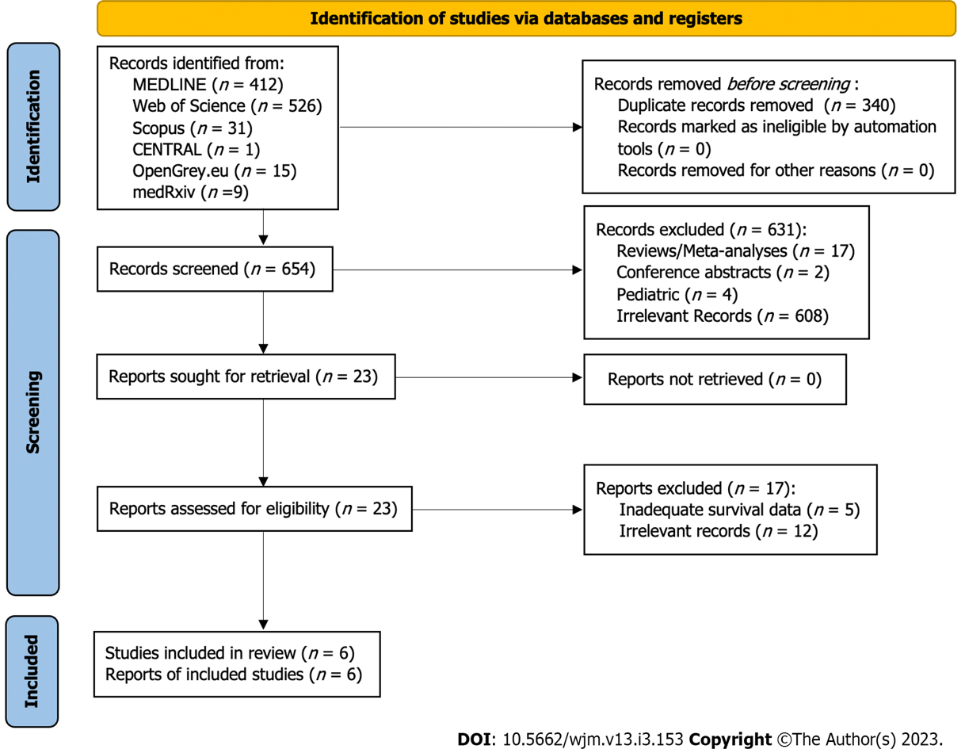
Figure 1 PRISMA flow chart.

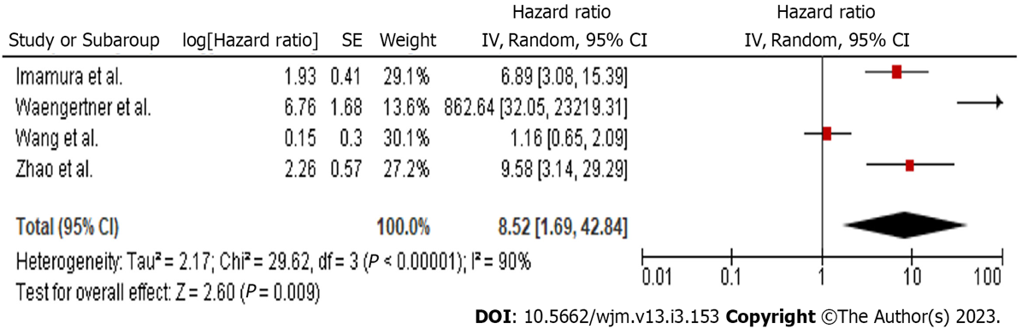
Figure 2 Hazard ratio of disease free survival.

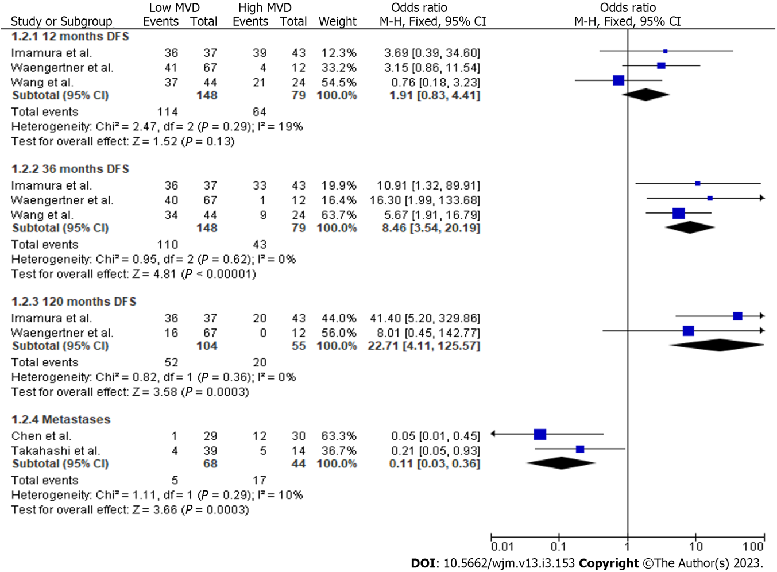
Figure 3 Odds ratios of disease free survival and metastases.
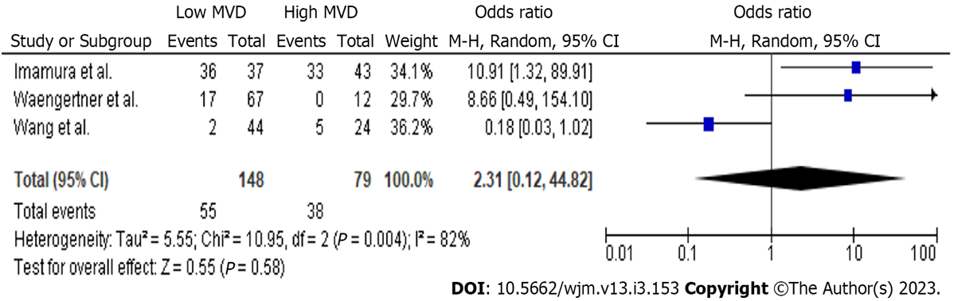
Figure 4 Sixty months disease free survival.

Table 1 Study characteristics, n (%)
Ref. | Type of study | Country | Centre | Sample (patients) | Analysis sample | Specimens | Age | Gender (male/female) | Follow-up
Chen et al^{[22]}, 2005 | Retrospective | Taiwan | Single centre | 62 | 59 (3 cases lost to follow-up) | 62 | 24 (38.7) ≤ 61 yr; 38 (61.3) > 61 yr | 34 (54.8)/28 (45.2) | 50.5 (31) mo for 59 cases
Imamura et al^{[8]}, 2007 | Retrospective | Japan | Single centre | 95 | 95 (80 from the K-M curves) | 95 | 64 (11.667) yr | 48 (50.5)/47 (49.5) | 48.4 (26.1833) mo for 80 cases
Takahashi et al^{[23]}, 2003 | Retrospective | Japan | Single centre | 53 | 53 | 53 | 59.5 (13.3) yr | 32 (60.3)/21 (39.6) | 81.7 (63.2) mo
Waengertner et al^{[24]}, 2011 | Retrospective | Brazil | Single centre | 79 | 79 | 79 | 58.9 (13) yr | 42 (53.2)/37 (46.8) | 2.5 (2.8) yr
Wang et al^{[9]}, 2009 | Retrospective | China | Multicentre | 68 | 68 | 68 | 56.8 (14.75) yr | 38 (55.9)/30 (44.1) | 42.9 (14) mo for 64 patients
Zhao et al^{[25]}, 2012 | Retrospective | China | Single centre | 124 | 124 | 124 | 54.6 (11.667) yr | 64 (51.6)/60 (48.4) | 52 (32.333) mo

Table 2 Microvessel density assessment
Ref. | MVD assessment method | Antibody | Magnification used | Spots examined | Blinded reading | Observers | Separate count for intra/peritumoral vessels | MVD cut off
Chen et al^{[22]} | Light microscopy, immunohistochemistry | CD31 | 10X; 20X; 100X | 3 | N/A | N/A | N/A | 15/HPF
Imamura et al^{[8]} | Light microscopy, immunohistochemistry, slight modification of Horak et al. technique | CD31 | 40X; 200X | 10 | Yes | 2 | N/A | 7/0.95 mm²
Takahashi et al^{[23]} | Light microscopy, immunohistochemistry | CD31 | 40X;100X; 400X | 3 | N/A | N/A | N/A | 19/HPF
Waengertner et al^{[24]} | Light microscopy, immunohistochemistry, modified Chalkley method | CD31 | 200X | 3 to 5 | N/A | N/A | N/A | 6 vessels
Wang et al^{[9]} | Light microscopy, immunohistochemistry | CD31 | 200X | 4 | Yes | 2 | N/A | 10.54/200HPF
Zhao et al^{[25]} | Light microscopy, immunohistochemistry, Weidner technique | CD34 | 100X; 200X | 5 | N/A | N/A | N/A | N/A
MVD: Microvessel density; N/A: Not applicable.

Table 3 Tumor classification, n (%)

Ref. | Risk |  |  |  | Location
 | Very low risk | Low risk | Intermediate risk | High risk | Stomach | Small intestine | Colon | Rectum | Esophagus
Chen et al^{[22]} | 0 (0) | 31 (50) | 0 (0) | 31 (50) | 41 (66) | 18 (29) | 3 (4.8) | 0 (0) | 0 (0)
Imamura et al^{[8]} | 7 (7.3) | 22 (23.2) | 38 (40) | 28 (29.5) | 64 (67.4) | 31 (32.6) | 0 (0) | 0 (0) | 0 (0)
Takahashi et al^{[23]} | 16 (30.1) |  | 10 (18.8) | 27(50.9) | 53 (100) | 0 (0) | 0 (0) | 0 (0) | 0 (0)
Waengertner et al^{[24]} | 12 (15.4) | 11 (13.8) | 18 (23.1) | 38 (47.7) | 36 (45.6) | 30 (38) | 0 (0) | 0 (0) | 0 (0)
Wang et al^{[9]} | 0 (0) | 20 (29.4) | 0 (0) | 48 (70.6) | 28 (41.2) | 20 (29.4) | 11 (16.2) | 0 (0) | 0 (0)
Zhao et al^{[25]} | 6 (4.8) | 20 (16.1) | 37 (29.8) | 61 (49.3) | 62 (50) | 28 (22.6) | 14 (11.3) |  | 9 (7.3)

Table 4 Tumor and treatment characteristics, n (%)
 | Necrosis |  | Hemorrhage |  | Mitotic count |  | Tumor size |  | Pcna index |  | Cell type |  |  | Treatment
Ref. | Yes | No | Yes | No |  |  |  |  | ≤ 10% | > 10% | Epithelioid | Spindle | Mixed | Surgery | Surgery type | Chemotherapy | Chemotherapy type
Chen et al^{[22]} | 23 (37) | 39 (63) | 45 (72.6) | 17 (27.4) | 36 (58) < 2/10 HPF | 26 (42) ≥ 2/10 HPF | 32 (51.6) < 5 cm | 30 (48.4) ≥ 5 cm | 32 (51.6) | 30 (48.4) | N/A | N/A | N/A | Yes | Subtotal gastrectomy, complete tumor resection or segmental enterectomy | Yes (some of them) | See comments
Imamura et al^{[8]} | N/A | N/A | N/A | N/A | 55 (57.9) < 5/50 HPF | 40 (42.1) ≥ 5/50 HPF | 39 (41.05) < 5 cm | 56 (58.95) ≥ 5 cm | N/A | N/A | 1 (1.05) | 92 (96.85) | 2 (2.1) | Yes | Resection with negative margins | N/A | N/A
Takahashi et al^{[23]} | N/A | N/A | N/A | N/A | 33 (62.2) < 3/50 HPF | 20 (37.7) ≥ 3/50 HPF | 21 (39.6) ≤ 3 cm | 32 (60.3) > 3 cm | N/A | N/A | N/A | N/A | N/A | Yes | Surgical resection | N/A | N/A
Waengertner et al^{[24]} | N/A | N/A | N/A | N/A | N/A | N/A | N/A, varies from 0.5 to 25 cm (median 4.8 cm) |  | N/A | N/A | N/A | 57 (72.2%) | N/A | N/A | N/A | Yes | Adjuvant therapy with tyrosine kinase inhibitors (400mg/daily) for no longer than 3 months
Wang et al^{[9]} | N/A | N/A | N/A | N/A | 45 (66.2) < 2/10 HPF | 23 (33.8) ≥ 2/10 HPF | 24 (35.3) ≤ 5 cm | 44 (64.7) > 5 cm | N/A | N/A | N/A | N/A | N/A | Yes | N/A | No | No
Zhao et al^{[25]} | N/A | N/A | N/A | N/A | N/A | N/A | N/A | N/A | N/A | N/A | 28 (22.58) | 73 (58.87) | 23 (18.55) | Yes | Only biopsy, palliative resection, radical resection | Yes | Postoperative
N/A: Not applicable.

Published by Baishideng Publishing Group Inc
7041 Koll Center Parkway, Suite 160, Pleasanton, CA 94566, USA
Telephone: +1-925-3991568
E-mail: bpgoffice@wjgnet.com
Help Desk: https://www.f6publishing.com/helpdesk
https://www.wjgnet.com

© 2023 Baishideng Publishing Group Inc. All rights reserved.

